# General Project Information

* **Chartstrings containing a project code are considered project chartstrings. Activity for Project chartstrings can only be viewed on project reports** (not on department reports):
  + - “Project Budget Summary” Report
    - “Budget Overview” Report
    - “Project Transaction Detail” Report
* 4 Project types broken into 2 categories.
  + - 1. SPONSORED

1. NGRCT – Grants & Contracts
   1. The Grants Office (OGCA) is responsible for setting up and managing grants.
   2. For holder changes, contact OGCA
   3. The second character in the Grant code indicates the funding source:
      * G**S**XXXX = State Funded
      * G**F**XXXX = Federally Funded
      * G**P**XXXX = Private Foundation Funded
        1. NON-SPONSORED
2. NDISC – Discretionary
   1. Examples: Faculty IDC/overhead, Faculty Start Up Costs, Non-IDC Faculty revenues
3. NFCAP – Capital
   1. Used for Construction projects
   2. Construction projects are set up by System
4. NINTP – Internal Projects
   1. UNT Sponsored Research

* Projects are reported life-to-date. The reports do not close at year end.
  + - * To view transactions for a particular year, run the Project Transaction Detail report 🡪 export it to excel 🡪 turn on filters 🡪 filter on the “Fiscal Year” column to view a single year at a time.
* Signature Authority (aka approval) is held at the Org-Dept level and at the Project level.

# Running the “Project Budget Summary” Report

1. My.unt.edu 🡪 log in using your UNT credentials
   1. Select the Reports tab in the top center of the screen.
   2. Locate the Financial Reporting section. 
   3. Click on “More…” to view all the available report options.

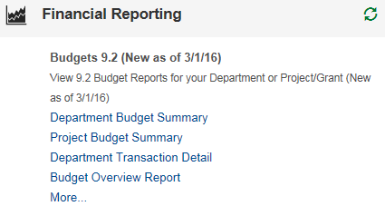

* 1. Click on the “Project Budget Summary” Report. You will be routed to the report prompt page.

1. 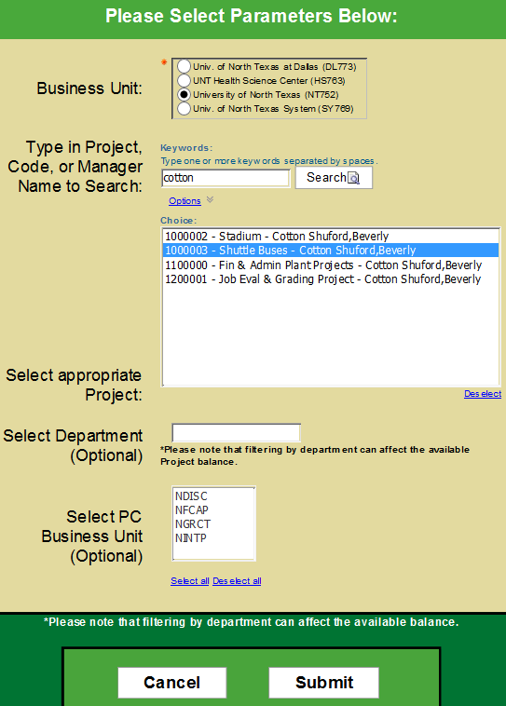From the prompt page of the report, select the report parameters:
   1. To run the report for a specific project:
      1. *Business Unit*: University of North Texas (NT752)
      2. *Type in Project Code, or Manager Name to Search*: Search by the project value or by the project holder’s first name or last name, or by the project name.
      3. *Select appropriate Project*: Click on your project. **The Project must be selected (highlighted blue) for the report to run for that project**.
      4. *Select Department*: Leave Blank.
      5. *Select PC Business Unit*: Leave Blank.
      6. 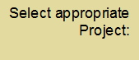Press “Submit” to view all chartstrings associated with the particular project.
   2. To obtain all the faculty discretionary funds associated with a specific department:
      1. *Business Unit*: University of North Texas (NT752)
      2. *Type in Project Code, or Manager Name to Search*: Leave Blank
      3. *Select appropriate Project*: Leave Blank
      4. *Select Department*: Enter the Org Dept code for the department
      5. *Select PC Business Unit*: Select NDISC.
      6. Press “Submit” to view all faculty discretionary funds associated with a particular department.
2. Reading the Report
   1. The report contains six columns:



* Actual: Reflects actual cash received (for revenues) or actual expenses incurred.
* Pre-Encumbrance: Occurs when a Requisition is entered. When the requisition is approved, the balance will move from this column to the Encumbrance column.
* Encumbrance: Occurs when the Purchase Order is generated (upon approval of the requisition). Upon paying the invoice, the balance will move from this column to the Actual column.
  1. All values in blue are hyperlinks and can be drilled through for additional information.
  2. To return to the prompt page, click on the blue triangle  in the ribbon at the top right of the screen.
  3. To export the report to excel, click on the HTML icon  in the ribbon, Export to “Excel 2007 Data” format.