Presentation Format

This lesson:
- Is designed to help adults understand the potential dangers associated with munitions in general, particularly unexploded ordnance (UXO), and the steps they should take to keep themselves, their families, friends, and community safe.
- Provides the information adults need to recognize munitions, understand the associated dangers and react in a responsible and safe manner.
- Provides links to additional resources.

Approximate Presentation Duration: 15-20 minutes

To Gain Attention and Provide Motivation:
- Display posters in the presentation area.
- Provide handouts and other material, as needed, for adults to take home.

All of the printed materials can be downloaded and printed locally and many can be obtained by submitting a request through the "Contact Us" tab on the 3Rs website (www.denix.osd.mil\uxo).

To Present Information
- Necessary--Use a computer, projector and display screen to deliver the PowerPoint presentation. (Note: Presentation may be used for self-paced learning.)
- Additional--Play selected YouTube videos from DENIX webpage to reinforce lesson information.

NOTES:

- Videos can be accessed on YouTube through the DENIX webpage. If you will not be able to access the webpage during the presentation, contact DENIX via the “Contact Us” tab on the 3Rs website (www.denix.osd.mil\uxo) to arrange for videos to be sent to you.
- Remember munitions shown and addressed should only be mentioned in a general fashion (grenade, projectile, bomb).

Audience Participation - Encourage audience participation through use of:
- Open, directed questions
- Open discussion

Objectives - After completing this lesson, adults will be able to:
- Discuss and define key terminology associated with the 3Rs Explosives Safety Education Program.
- Apply the steps associated with 3Rs of Explosives Safety: Recognize, Retreat, Report.
- Stress the importance of the 3Rs of Explosive Safety:
  - Recognize – when you may have encountered a munition and that munitions are dangerous;
  - Retreat – do not go approach, touch, move, or disturb it, but carefully leave the area;
  - Report – call 911 and advise the police of what you saw and where you saw it.

Lesson Summation:
- Conclude with a review of important points.
- Encourage adults to:
- Use the DENIX website (www.denix.osd.mil/UXO/) and resources.
- Share what they have learned with other adults, and their family and friends.

 | 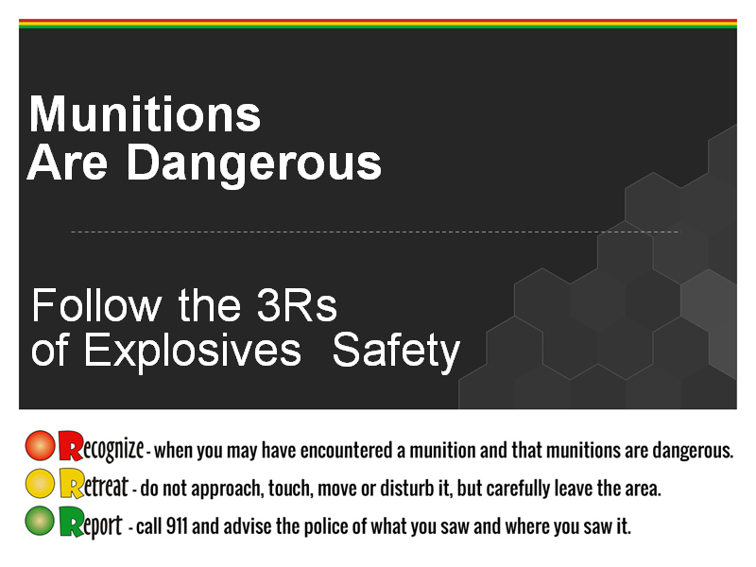 | Instructor Actions:  - Print and display below posters from: www.denix.osd.mil/uxo/EducationalResources/Posters.cfm, and  www.denix.osd.mil/uxo/SafetyTopics/Soldiers.cfm  - 3Rs Poster –Souvenir Vertical 01  - 3Rs Poster – Souvenir Old Photo  - 3Rs Poster – SGT Woof  - Play three or more of the below YouTube videos (use the most appropriate) from: www.denix.osd.mil/uxo/EducationalResources/Videos.cfm, and www.denix.osd.mil/uxo/SafetyTopics/Soldiers.cfm  - 3Rs Video – Learn the 3Rs of UXO  - 3Rs Video – Soldiers UXO  - 3Rs Video – USACE – Message A  - 3Rs Video – Message B (beach)  - 3Rs Video – Soldiers – Do You Feel Lucky  - 3Rs Video – Soldiers – Souvenir 1  - 3Rs Video – Soldiers – Souvenir 2  - Print:  - 3Rs Factsheet – UXO Safety from www.denix.osd.mil/uxo/EducationalResources/FactSheets.cfm  - 3Rs Guide – Military Families Safety Guide from www.denix.osd.mil/uxo/EducationalResources/SafetyGuides.cfm  - Introduce lesson and read notes  Notes:  Explain: The purposes of this presentation is to:  - Describe munitions, including UXO and discarded military munitions;  - Describe the reason munitions, particularly UXO, are dangerous;  - State the 3Rs of Explosives Safety and their meaning.  Stress: The importance of the 3Rs of explosives safety:  - Recognize – when you may have encountered a munition and that munitions are dangerous;  - Retreat – do not approach, touch, move, or disturb it, but carefully leave the area; and  - Report – call 911 and advise the police of what you saw and where you saw it.  (continue next page)  Advise audience they must:  - Be aware of the dangers munitions, particularly UXO, pose  - Know the actions to take to protect themselves, their families, friends and communities.  Hand outs: 3Rs Guide – Fort Bragg, 3Rs Guide – Military Families
 | 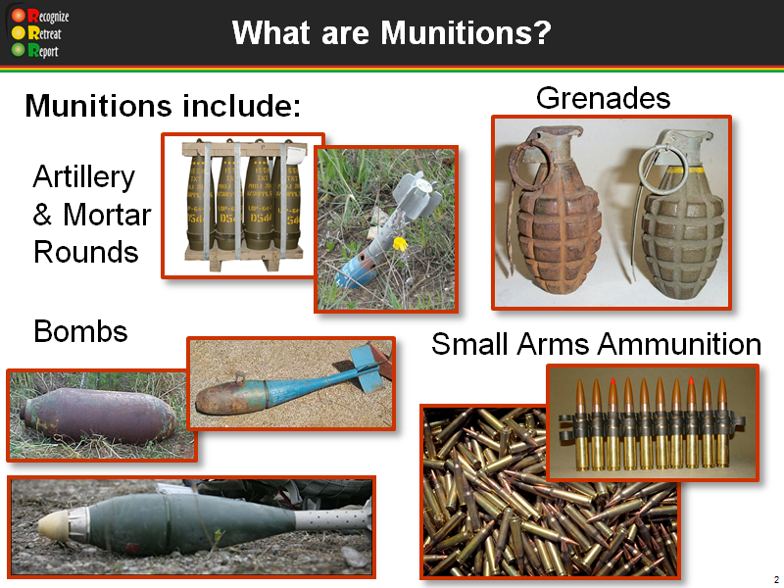 | Instructor Actions:  - Read notes  Notes:  Explain:  - This presentation focuses on DoD military munitions; however, the concepts also apply to foreign and commercial munitions.  - The term DoD military munitions is interchangeable with ammunition and explosives. Military munitions may also be referred to as ordnance or munitions. Although this presentation uses  “munitions,” the other terms may be used in resource materials.  - Most munitions are designed to kill or injure people or damage equipment and buildings. Even practice and training munitions may contain a small propellant or explosive charge that can be dangerous.  - Munitions come in many sizes and shapes. They can be:  - Small, like the small arms ammunition (.50 caliber and below) used in personal weapons (e.g., pistols, rifles);  - Small, medium or large projectiles that are fired from mortars, tanks, or artillery pieces;  - Bombs dropped from aircraft;  - Missiles, rockets or torpedoes.  Ask: What are some other examples of munitions with which you are familiar?  Answer: Possible answers include: grenades, mines, rockets, mortars, RPGs, cannon balls and torpedoes.
 | 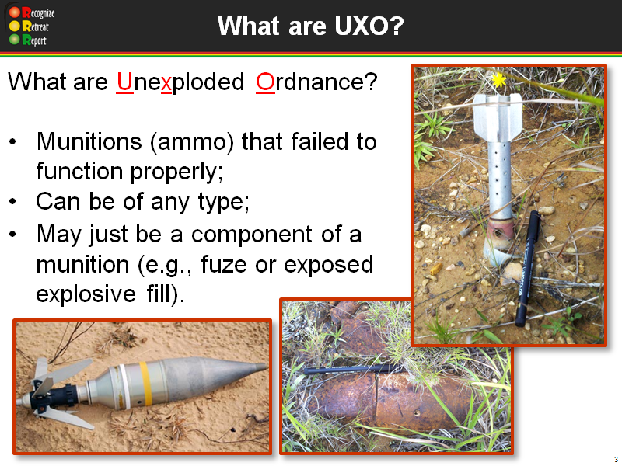 | Instructor Actions:  - Read notes  - Play video  Notes:  Explain: UXO stands for Unexploded Ordnance. What are unexploded ordnance?  - Munitions (ammo) that failed to function properly;  - Can be of any type;  - May just be a component of a munition (e.g., fuze or exposed explosive fill).  Play: 3Rs Video – Learn the 3Rs of UXO (3:31 minutes)
 | 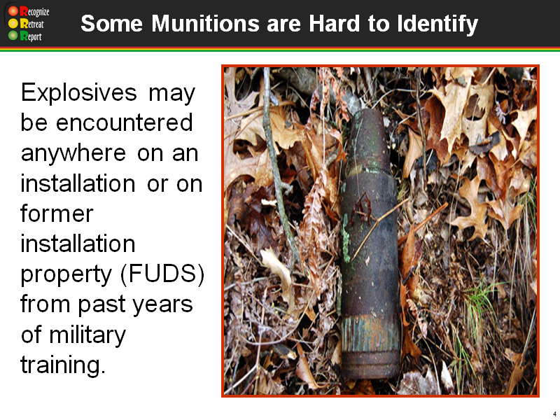 | Instructor Action:  - Read notes  Notes:  Explain: UXO can be encountered anywhere. Although military munitions will most likely be encountered in areas the military currently uses (e.g., operational ranges, tactical areas, area of operations), they may also be encountered in areas once used (former ranges) for live-fire training or testing, or that were once the site of tactical operations.  Discuss:  Another example:  While in Iraq, two soldiers cleaning up the front yard of their living area dug up a “yellow pipe approximately ten inches long.” The “pipe” had a thick covering of dirt, which one of the soldiers attempted to remove by striking it against a wall. The detonation killed one soldier and seriously injured the other. From debris at the scene, EOD confirmed that the item that functioned was a submunition. What you don’t recognize can kill you.
 | 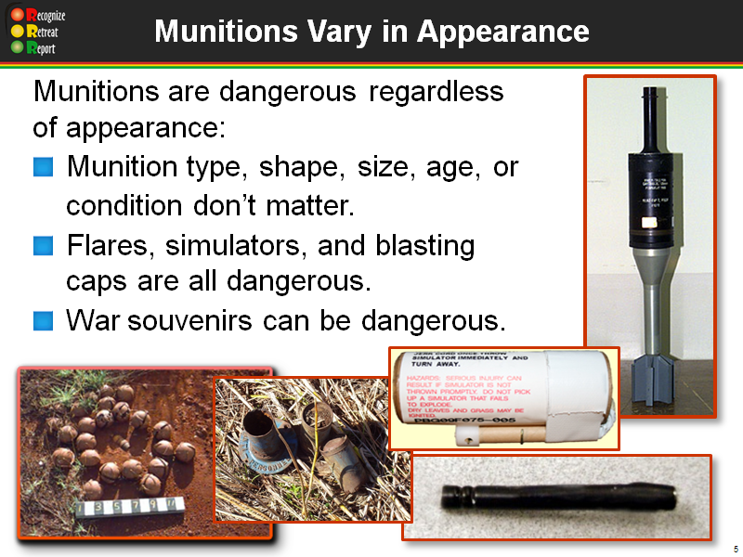 | Instructor Action:  - Read notes  Notes:  As you can see, munitions vary in appearance. For this reason, you should never pick up anything that you know or suspect may be a munition. In fact, it is best not to pick up anything that you did not drop.  Discuss: Munitions, such as those pictured here and throughout the presentation, vary in type, shape, size, age, and condition; consequently, they may be hard to identify as munitions.  - DoD military munitions and foreign munitions:  - Come in many shapes, sizes and types;  - May not look like a munition (e.g., a projectile, grenade or bomb);  - May be partially or completely buried in the dirt or covered by vegetation, sand or other material; or partially or fully submerged in water.  - Use or natural phenomena (e.g., weather, corrosion) can alter a munition’s appearance.  - In recent years, Civil War munitions have claimed lives. Although such munitions have remained unexploded for decades, aging does not make them safer.  - Munitions marked with the word “simulator” or “practice” should be considered dangerous because most contain a small explosive charge that can cause serious injuries.  - Assume munitions and suspect munitions that you may encounter outside DoD’s military munitions logistical system are UXO.
 | 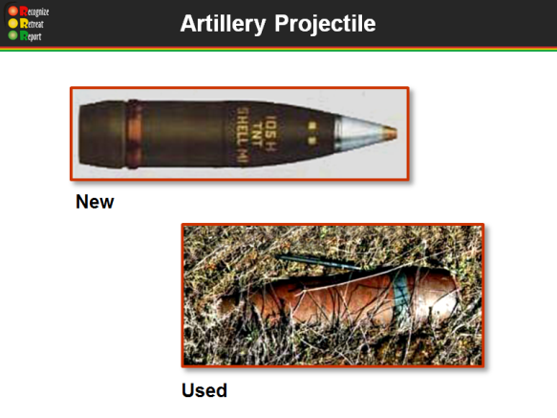 | Instructor Action:  - Read notes  Notes: Slide provides an example of a munition before and after use.  Discuss: This is an example of a munition before and after use.  The picture on the top shows a new, unused 105 mm projectile. The picture on the bottom shows a projectile that was fired, but failed to function as intended - a UXO.  When a 105 mm projectile detonates, metal pieces (fragments) from the projectile body travel at high speeds to distances up to 1,939 feet - the length of 6½ football fields! Anyone within this area could be severely injured or killed.
 | 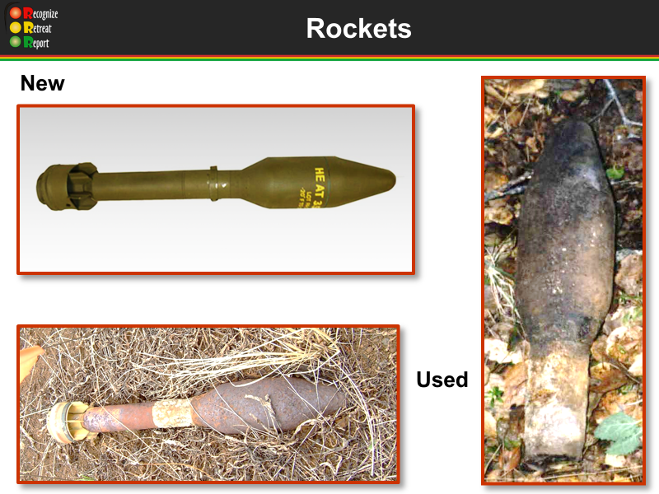 | Instructor Action:  - Read notes  Notes: Slide provides another example of a munition before and after use.  Discuss: The picture on the top shows a new rocket. The other two pictures show a rocket after use.  Explain: A rocket consists of a rocket motor (or engine) and a warhead. The rocket motor contains propellant or fuel that projects the rocket. The warhead contains explosives.  Upon detonation either on use or if disturbed as a UXO, people need to be 1,420 feet (almost five football fields) away to be safe from the blast and fragments! Anyone closer could be killed or severely injured.
 | 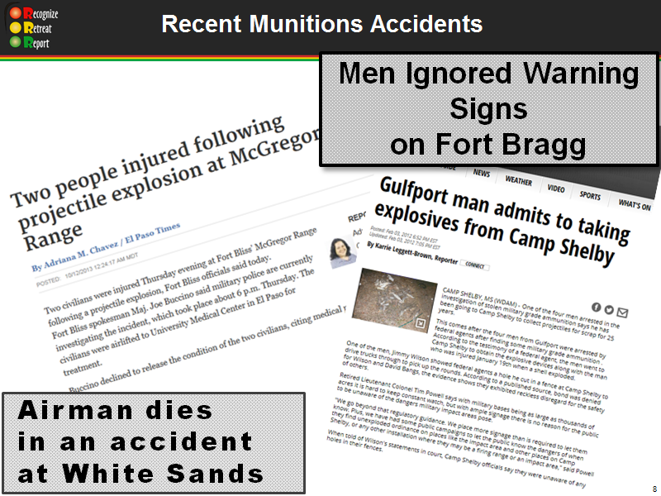 | Instructor Actions:  - Read notes  - Discuss handout if audience is appropriate: 3Rs Guide – Military Families  - Play video  Notes:  Discuss: Taking or collecting munitions as souvenirs poses real dangers to you, your family and the public. Souvenir munitions, even Civil War cannon balls that may have been kept by a family and handled for years, can be deadly. If you have taken or collected munitions as souvenirs, keepsakes, or war trophies, call local law enforcement to request EOD support or turn them in under the amnesty program (e.g., place them in amnesty box).  Discuss the munitions incidents related in this slide.  In 2012, five men trespassed onto another military installation range to collect metal. One of the men was handling some metal when it exploded. He was badly injured, losing an eye and crushing bones in his hands.  Play: 3Rs Video – Soldiers – UXO (31 seconds)
 | 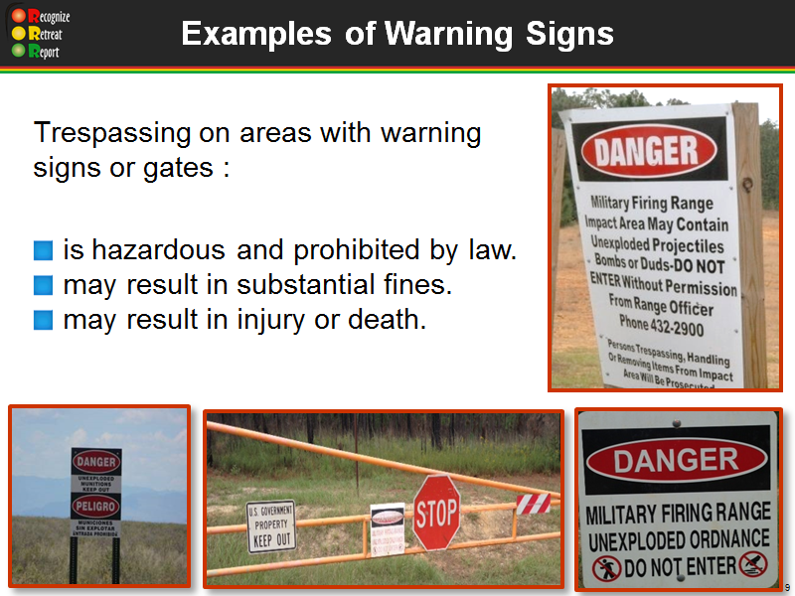 | Instructor Prep Notes: Write notes about how gates and signage are used on active and formerly used installations.  Instructor Action:  - Read notes.  Notes:  Explain: How gates and signage is used on active and former installation  property.
 | 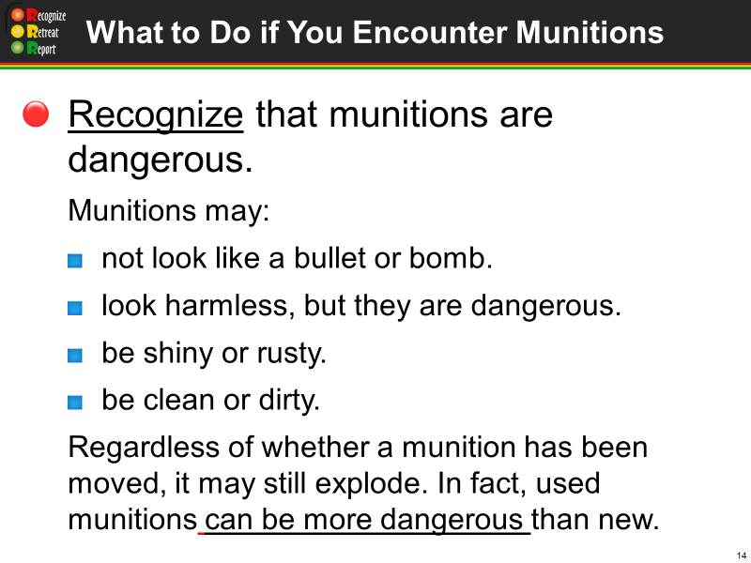 | Instructor Action:  - Read notes  Notes:  What do you do if you encounter a munition outside of the DoD munitions management system? Follow the 3Rs of Explosives Safety:  - Recognize – when you may have encountered a munition and that munitions are dangerous;  - Retreat – do not approach, touch, move or disturb it, but carefully leave the area;  - Report – call 911 and advise the police of what you saw and where you saw it.  The first step is to Recognize that munitions are dangerous. If it looks like a bullet or bomb, treat it like it is one. Leave it alone! Recognize the potential danger!  Remember, munitions may not be easy to recognize; and even small explosive devices, including simulators, can cause severe injuries or be deadly.  Discuss: The possible conditions a munition may be found in and the hazards with both new and used munitions.
 | 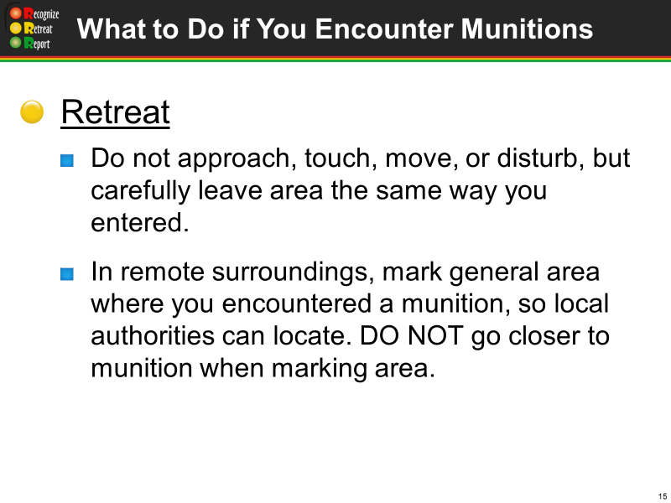 | Instructor Action:  - Read notes  Notes:  Discuss: The second step is to Retreat - Do not approach, touch, move or disturb a munition or suspect munition. Carefully leaving the area the same way in which you entered may prevent disturbing it or other items that might be in the area. If possible, as you leave the area, mark it in some manner so that it can be found more easily later.
 | 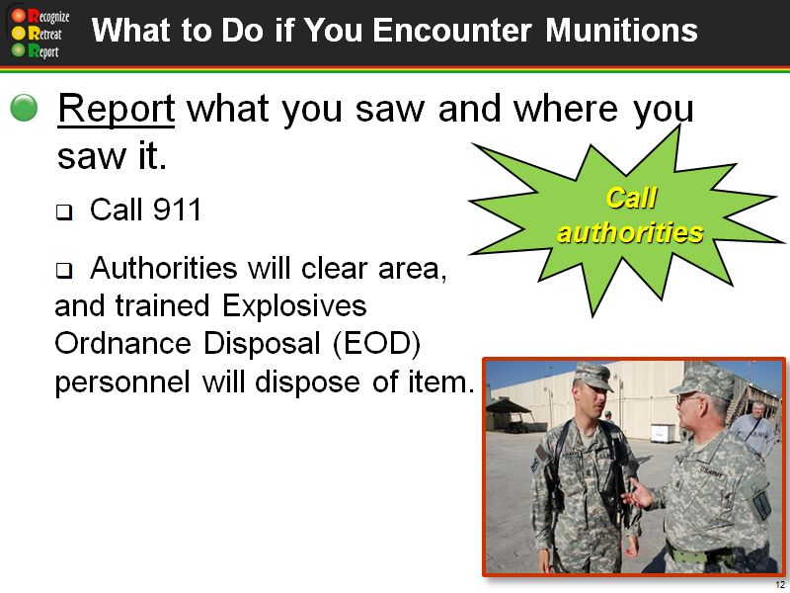 | Instructor Action:  - Read notes  Notes:  - Explain: The last step is to Report. On installation training areas, immediately report by calling 911. Describe what you saw and where you saw it. Trained Explosives Ordnance Disposal (EOD) personnel will dispose of the item.
 | 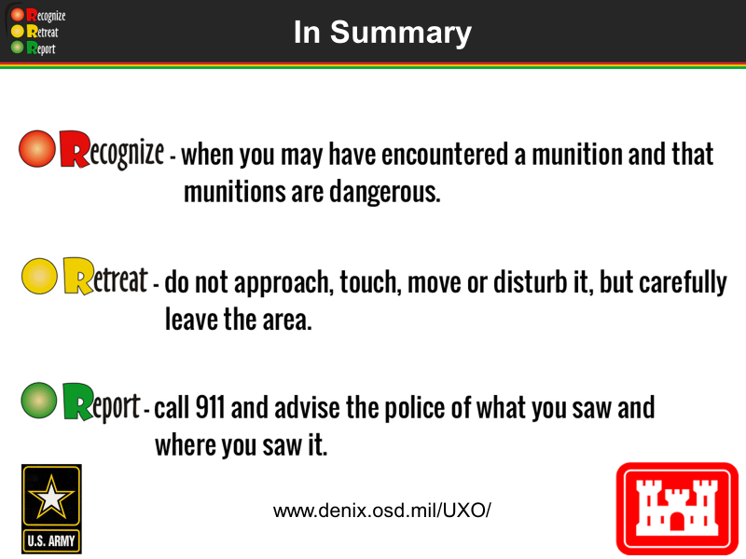 | Trainer Actions:  - Read notes  - Ask if anyone has questions  - Demonstrate going to the website, if you have internet access  Notes:  Review:  - Munitions, including UXO, come in many shapes and sizes.  - Munitions are designed to kill or injure people or destroy or damage equipment.  - Exposure to the environment may change a munition’s appearance.  - Because munitions are dangerous and their fuzing may become more sensitive over time, do not assume a munition is safe.  - If you or someone else encounters something that might be a munition, follow the 3Rs (Recognize, Retreat, Report) of Explosives Safety.  Explain: If you would like to review this information go to www.denix.osd.mil/uxo/. This website is an excellent resource for downloading presentations, videos, photos, handouts and a number of other resources.  To help protect yourself, your family and your friends, share the 3Rs message and what you learned with your family and your friends.  Provide: A thank you and closing appropriate to your audience and setting.

Updated July 2015

