U.S. Census Bureau
U.S. Bureau of Economic Analysis

NEWS

U.S. Department of Commerce • Washington, DC 20230

For Immediate Release
8:30 A.M. EDT Thursday, October 11, 2012

For information on goods contact: |  | For information on services contact:
U.S. Census Bureau: |  | U.S. Bureau of Economic Analysis:
Matthew Przybocki | 301-763-3148 | Technical: Edward Dozier | 202-606-9559
Maria Iseman | 301-763-2311 | Media: Ralph Stewart | 202-606-2649
 |  | CB12-193, BEA12-46, FT-900 (12-08)

U.S. INTERNATIONAL TRADE IN GOODS AND SERVICES

August 2012

Goods and Services

The U.S. Census Bureau and the U.S. Bureau of Economic Analysis, through the Department of Commerce, announced today that total August exports of $181.3 billion and imports of $225.5 billion resulted in a goods and services deficit of $44.2 billion, up from $42.5 billion in July, revised. August exports were $1.9 billion less than July exports of $183.2 billion. August imports were $0.2 billion less than July imports of $225.7 billion.

In August, the goods deficit increased $1.5 billion from July to $59.3 billion, and the services surplus decreased $0.3 billion from July to $15.1 billion. Exports of goods decreased $2.1 billion to $128.5 billion, and imports of goods decreased $0.7 billion to $187.8 billion. Exports of services increased $0.2 billion to $52.8 billion, and imports of services increased $0.5 billion to $37.7 billion.

The goods and services deficit decreased $0.6 billion from August 2011 to August 2012. Exports were up $2.9 billion, or 1.6 percent, and imports were up $2.3 billion, or 1.0 percent.

Goods (Census Basis)

The July to August decrease in exports of goods reflected decreases in industrial supplies and materials ($1.2 billion); foods, feeds, and beverages ($1.1 billion); consumer goods ($0.4 billion); and automotive vehicles, parts, and engines ($0.1 billion). Increases occurred in capital goods ($0.4 billion) and other goods ($0.2 billion).
NOTE: Total goods data are reported on a balance of payments basis unless otherwise specified. Commodity and country data for goods are on a Census basis. Monthly statistics are seasonally adjusted unless otherwise specified. For information on data sources and definitions, see the information section on page A-1 of this release, or at www.census.gov/ft900 or www.bea.gov/newsreleases/international/trade/tradnewsrelease.htm. The next FT-900 release is November 8, 2012.

newsrelease.htm. The next FT-900 release is March 9, 2012.
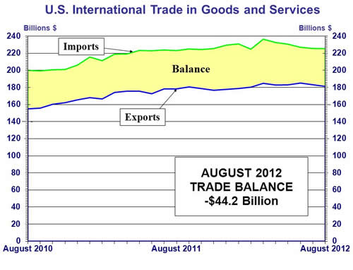

The July to August decrease in imports of goods reflected decreases in consumer goods ($1.2 billion); automotive vehicles, parts, and engines ($0.8 billion); and capital goods ($0.5 billion). Increases occurred in industrial supplies and materials ($1.5 billion); other goods ($0.2 billion); and foods, feeds, and beverages ($0.1 billion).

The August 2011 to August 2012 increase in exports of goods reflected increases in capital goods ($2.8 billion); foods, feeds, and beverages ($1.3 billion); automotive vehicles, parts, and engines ($1.1 billion); other goods ($0.3 billion) and consumer goods ($0.3 billion). A decrease occurred in industrial supplies and materials ($3.9 billion).

The August 2011 to August 2012 increase in imports of goods reflected increases in automotive vehicles, parts, and engines ($3.9 billion); capital goods ($2.1 billion); foods, feeds, and beverages ($0.3 billion); and other goods ($0.1 billion). Decreases occurred in industrial supplies and materials ($4.2 billion) and consumer goods ($0.7 billion).

Services

Exports of services increased $0.2 billion from July to August. The increase was mostly accounted for by increases in other private services ($0.1 billion), which includes items such as business, professional, and technical services, insurance services, and financial services, and in other transportation ($0.1 billion), which includes freight and port services. Changes in the other categories of services exports were small.

Imports of services increased $0.5 billion from July to August. The increase was more than accounted for by an increase in royalties and license fees ($0.5 billion), which included an increased amount for the rights to broadcast the portion of the 2012 Summer Olympic Games that occurred in August. July imports include a smaller amount for the portion of the Games that occurred in July. Changes in the other categories of services imports were small.

The August 2011 to August 2012 increase in exports of services was $0.9 billion. The largest increases were in travel ($0.5 billion) and other private services ($0.5 billion). Within other private services, the largest increase was in business, professional, and technical services.

The August 2011 to August 2012 increase in imports of services was $1.2 billion. The largest increases were in royalties and license fees ($1.1 billion) and travel ($0.5 billion). The increase in royalties and license fees was mostly accounted for by payments for the rights to broadcast the 2012 Summer Olympic Games.

Goods and Services Moving Average

For the three months ending in August, exports of goods and services averaged $183.2 billion, while imports of goods and services averaged $226.1 billion, resulting in an average trade deficit of $42.9 billion. For the three months ending in July, the average trade deficit was $44.0 billion, reflecting average exports of $183.8 billion and average imports of $227.8 billion.
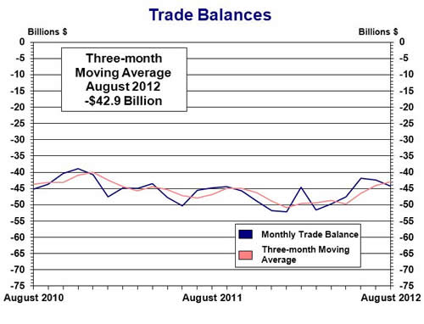

Scheduled release dates through February 2013 are located on page A-5
Selected Not Seasonally Adjusted Goods Details

The August figures show surpluses, in billions of dollars, with Hong Kong $2.1 ($1.8 for July), Australia $1.8 ($2.1), Singapore $0.9 ($0.7), and Egypt $0.2 ($0.2). Deficits were recorded, in billions of dollars, with China $28.7 ($29.4), European Union $11.7 ($12.0), OPEC $8.1 ($8.4), Japan $6.7 ($6.8), Germany $5.7 ($4.9), Mexico $4.5 ($5.0), Canada $2.4 ($2.1), Ireland $2.4 ($2.6), Venezuela $2.2 ($1.4), Korea $1.6 ($1.9), Taiwan $1.4 ($1.5), and Nigeria $1.1 ($0.8).

Advanced technology products exports were $25.5 billion in August and imports were $32.3 billion, resulting in a deficit of $6.7 billion. August exports were $0.7 billion more than the $24.8 billion in July, while August imports were $0.7 billion less than the $33.0 billion in July.

Revisions

Census Basis (not seasonally adjusted)

For July, exports of goods were revised down $0.1 billion and imports of goods were revised up $0.5 billion. Goods carry-over in August was $0.1 billion (0.1 percent) for exports and $1.3 billion (0.6 percent) for imports. For July, revised export and import carry-over were virtually zero.

Balance of Payments Basis (seasonally adjusted)

For July, exports of goods were revised down $0.1 billion and imports of goods were revised up $0.4 billion.

For July, exports of services were revised up $0.1 billion, reflecting small upward revisions to several categories. For July, imports of services were virtually unrevised.

Table of Contents

Seasonally Adjusted

Exhibit 1 | U.S. International Trade in Goods and Services . . . . . . . . . . . . . . . . . . . . . . . . . . . . . . . . | 1
Exhibit 2 | U.S. International Trade in Goods and Services Three-month Moving Averages . . . . . . . | 2
Exhibit 3 | U.S. Services by Major Category – Exports . . . . . . . . . . . . . . . . . . . . . . . . . . . . . . . . . . . | 3
Exhibit 4 | U.S. Services by Major Category – Imports . . . . . . . . . . . . . . . . . . . . . . . . . . . . . . . . . . . | 4
Exhibit 5 | U.S. Trade in Goods . . . . . . . . . . . . . . . . . . . . . . . . . . . . . . . . . . . . . . . . . . . . . . . . . . . . . . | 5
Exhibit 6 | Exports and Imports of Goods by Principal End-Use Category . . . . . . . . . . . . . . . . . . . . | 6
Exhibit 7 | Exports of Goods by End-Use Category and Commodity . . . . . . . . . . . . . . . . . . . . . . . . . | 7
Exhibit 8 | Imports of Goods by End-Use Category and Commodity . . . . . . . . . . . . . . . . . . . . . . . . . | 9
Exhibit 9 | Exports, Imports, and Balance of Goods, Petroleum and Non-Petroleum End-Use Category Totals . . . . . . . . . . . . . . . . . . . . . . . . . . . . . . . . . . . . . . . . . . . . . . . . . . . . . . . . . | 11
Exhibit 10 | Real Exports and Imports of Goods by Principal End-Use Category - Chained (2005) Dollars . . . . . . . . . . . . . . . . . . . . . . . . . . . . . . . . . . . . . . . . . . . . . . . . . . . . . . . . | 12
Exhibit 11 | Real Exports, Imports, and Balance of Goods, Petroleum and Non-Petroleum End-Use Commodity Category Totals - Chained (2005) Dollars . . . . . . . . . . . . . . . . . . . . . . | 13

Not Seasonally Adjusted

Exhibit 12 | U.S. Trade in Goods . . . . . . . . . . . . . . . . . . . . . . . . . . . . . . . . . . . . . . . . . . . . . . . . . . . . . . | 14
Exhibit 13 | Exports and Imports of Goods by Principal End-Use Category . . . . . . . . . . . . . . . . . . . . | 15
Exhibit 14 | Exports, Imports, and Balance of Goods by Selected Countries and Areas . . . . . . . . . . . . | 16
Exhibit 15 | Exports and Imports of Goods by Principal SITC Commodities . . . . . . . . . . . . . . . . . . . . | 18
Exhibit 16 | Exports, Imports, and Balance of Advanced Technology Products . . . . . . . . . . . . . . . . . . | 20
Exhibit 16a | Exports, Imports, and Balance of Advanced Technology Products by Technology  Group and Selected Countries and Areas . . . . . . . . . . . . . . . . . . . . . . . . . . . . . . . . . . . . . . | 21
Exhibit 17 | Imports of Energy-Related Petroleum Products, Including Crude Oil . . . . . . . . . . . . . . . | 22
Exhibit 18 | Exports and Imports of Motor Vehicles and Parts by Selected Countries . . . . . . . . . . . . . | 23
Information on Goods and Services . . . . . . . . . . . . . . . . . . . . . . . . . . . . . . . . . . . . . . . . . . . . . . . . . . . . . . |  | A-1

