NATIONAL ASSESSMENT OF
VOCATIONAL EDUCATION

FINAL REPORT TO CONGRESS

2004

Marsha Silverberg
Elizabeth Warner
Michael Fong
David Goodwin

U.S. Department of Education
Office of the Under Secretary
Policy and Program Studies Service
U.S. Department of Education
Rod Paige
Secretary

Policy and Program Studies Service
Alan Ginsburg
Director

Program and Analytic Studies Division
David Goodwin
Director

June 2004

This report is in the public domain. Authorization to reproduce it in whole or in part is granted. While permission to reprint this publication is not necessary, the citation should be: U.S. Department of Education, Office of the Under Secretary, Policy and Program Studies Service, National Assessment of Vocational Education: Final Report to Congress, Washington, D.C., 2004.

To obtain copies of this report,

write to: ED Pubs, Education Publications Center, U.S. Department of Education, P.O. Box 1398, Jessup, MD 20794-1398;

or fax your request to: (301) 470-1244;

or e-mail your request to: edpubs@inet.ed.gov.

or call in your request toll-free: 1-877-433-7827 (1-877-4-ED-PUBS). If 877 service is not yet available in your area, call 1-800-872-5327 (1-800-USA-LEARN). Those who use a telecommunications device for the deaf (TDD) or a teletypewriter (TTY), should call 1-800-437-0833.

or order online at: www.ed.gov/pubs/edpubs.html.

This report is also available on the Department’s Web site at: www.ed.gov/rschstat/eval/sectech/nave/reports.html.

On request, this publication is available in alternate formats, such as Braille, large print, audiotape or computer diskette. For more information, please contact the Department’s Alternate Format Center (202) 260-9895 or (202) 205-8113.

Contents

Page
List of Tables v
List of Figures xiii
Acknowledgments xvii
Executive Summary xix

Chapter 1 Introduction 1
A. 1998 Perkins Act 2
B. Context for Evaluating Federal Support for Vocational Education 6
C. National Assessment of Vocational Education 12
D. Overview of this Final Report to Congress 15

Chapter 2 Secondary Vocational Education 17
A. Organization of Vocational Education at the Secondary Level 19
B. Access and Participation 24
C. Implementation: Program Quality and Improvement Efforts 52
D. Coordination with Other Reforms 93
E. Outcomes and Effects 99

Chapter 3 Postsecondary Vocational Education 123
A. Organization of Vocational Education at the Postsecondary Level 125
B. Access and Participation 129
C. Implementation: Program Quality and Improvement Efforts 148
D. Coordination with Workforce Investment Act 158
E. Outcomes and Effects 165

Chapter 4 Tech-Prep Education 183
A. Organization of Tech-Prep 184
B. Access and Participation 186
C. Implementation 195
D. Outcomes and Effects 206

Chapter 5 Program Management: Funding and Accountability 209
A. Overview of Perkins Funding and Accountability Provisions 211
B. Perkins State Grant Funding at the Secondary Level 220
C. Perkins State Grant Funding at the Postsecondary Level 241
D. Perkins Tech-Prep Grant Funding 252
E. Perkins Accountability Systems and Their Implementation 259

Chapter 6 Conclusions and Potential Future Directions for the Perkins Act 281
A. Conclusions 281
B. Options for Future Directions 299

References 315
Independent Advisory Panel 329
NAVE Study Reports 333

List of Tables

Table Page
Executive Summary
1 Value-Added Effects of Vocational Education on Student Outcomes: Summary of Recent Research Evidence xxi
2 Percentage of Occupational Concentrators and Non-concentrators Completing the “New Basics” Core Academic Curriculum and a College Prep Curriculum: 1990 and 2000 xxiv
3 Percentage of 1982 and 1992 High School Graduates Who Enrolled in Postsecondary Education or Training within Two Years after Graduation: 1984 and 1994 xxvii
4 Adjusted Percentage Difference in Earnings between Postsecondary Vocational Program Participants and High School Graduates, by Gender: 2000 xxxi
5 Grant Amounts Awarded to Secondary and Postsecondary Recipients: 1992 and 2001 xxxv
6 Average Perkins Grant Amounts, Adjusted for Student Enrollments, by LEA Poverty Level: 1992 and 2001 xxxvi
7 Overview of Specific Strategies to Improve Vocational Program Performance, by Federal Priority xli

Chapter 1 Introduction
1.1 Overview of Previous Federal Vocational Legislation 2
1.2 Perkins III Legislated Outcomes 9
1.3 Key NAVE Research Questions 13
1.4 Outline of Final Report 15

Chapter 2 Secondary Vocational Education
2.1 Percentage of Public High School Institutions, by Type, Locale, and Percentage Offering Selected Occupational Programs: 1999 20
2.2 Student Perspectives on Reasons for Participating in Vocational Education 30
2.3 Changes in Vocational Education Participation Measures, by Change in State Graduation Requirements: 1990 to 1998 32

Table Page
2.4 Percentage of High School Graduates Earning Credits in Work Experience Courses, by Type of Course: Selected Years 1990–1998 38
2.5 Measures Used to Define Special Population Groups 39
2.6 Participation Measures, by Student Characteristics: 1990 to 1998 41
2.7 Percentage of High School Graduates Who Concentrated in Selected Occupational Programs, by Student Characteristics: 1998 43
2.8 Definitions of Vocational Programs and Strategies Used to Measure Access 48
2.9 Percentage of High Schools Offering Special Vocational Education Programs and Activities, by School Characteristics: 2000 50
2.10 Percentage of Seniors in Eight States Engaging in Applied Academic Activities in Vocational Classes: 1996 and 2000 54
2.11 Percentage of Academic and Vocational Teachers Who Have Opportunities to Collaborate: 2001 55
2.12 Selected Items from the Florida Department of Education, Student Performance Standards for Introduction to Agri-science, Technology, and Environmental Science Program: 2002 58
2.13 Percentage of Vocational Teachers Reporting That Various Student Activities Occur Frequently, by Whether Class Is Linked to a Career and Technical Student Organization (CTSO): 2001 60
2.14 Percentage of Secondary Teachers Who Interact Frequently with Postsecondary Faculty or Staff, by Type of Activity: 2001 62
2.15 Percentage of High Schools Offering Various Types of Career Development Activities: 1996 and 2000 65
2.16 Percentage of Seniors Who Participated in Various School Activities and the Perceived Value of the Activities in Helping to Clarify Those Students’ Career Goals: 1998 66
2.17 Number of States Using Different Measures of Vocational-Technical Skill Attainment for Federal Performance Reporting: 2001 69
2.18 Percentage of High Schools with Occupational Programs Indicating That Industry Provided Input in the Development or Adoption of the Programs’ Skill Competency Lists: 1999 71

Table Page
2.19 Percentage of Vocational Teachers Reporting That the Condition of Technology in Their Class Is a Serious or Moderate Problem: 2001 73
2.20 Percentage of Vocational Teachers Receiving New or Updated Materials, Instruments, and Equipment in Last Several Years: 2001 74
2.21 Percentage of Vocational Teachers Reporting Use of Computer- and Technology-Related Instructional Activities in Their Class: 2001 75
2.22 Percentage of Teachers with Frequent Contact with Representatives of Business, Industry, and Labor, by Type of Activity: 2001 77
2.23 Percentage of Vocational Teachers Reporting Moderate or Great Employer Input in Their Class: 2001 79
2.24 Percentage of New High School Teachers with Industry Experience as Main Activity in Previous Year, by Teaching Assignment: 1991 and 2000 81
2.25 Percentage of High School Teachers with Less Than a Baccalaureate Degree, by Teaching Assignment and School Type: Selected Years 1991–2000 82
2.26 Percentage of States with Specific Requirements for Vocational Education Teaching Certification, by Region: 1988 and 1998 83
2.27 Percentage of New High School Teachers without Teacher Certification, by Teaching Assignment: 1991 and 2000 85
2.28 Average Class Size for High School Teachers, by Teaching Assignment and School Type: Selected Years 1991–2000 87
2.29 Percentage of High Schools Reporting It Was Very Difficult or Impossible to Fill Teacher Vacancies, by Teaching Field: 1991 and 2000 88
2.30 Percentage of Teachers Reporting on and Average Hours Spent in Professional Development on Selected Topics: 2001 90
2.31 Percentage of Teachers Reporting Student Instructional Activity Occurs Frequently, by Teaching Assignment: 2001 92
2.32 Percentage of Teachers Assigning Homework and Average Number of Hours Assigned, by Teaching Assignment: 1992 and 2001 93
2.33 Number of States Reporting Similar High School Graduation Standards for Vocational vs. College-Prep Students: 2001 96

Table Page
2.34 Number of States Reporting Little Coordination between ESEA and Perkins Accountability Reporting: 2001 97
2.35 Value-Added Effects of Vocational Education on Student Outcomes: Summary of Recent Research Evidence 99
2.36 Number of Core Academic Credits Earned by High School Graduates and Percentage of Students Meeting the “New Basics”: 1990 and 2000 101
2.37 Percentage of Occupational Concentrators and Non-concentrators Earning Credits in Rigorous Academic Courses: 2000 103
2.38 Change between 1994 and 1998 in NAEP Reading Scores for Occupational Concentrators and Non-concentrators, by Student Characteristics 106
2.39 Difference in Adjusted 12th-Grade Test Scores between Students Taking a High Academic Credit Program and Students in Other Programs of Study: 1992 Seniors 108
2.40 Percentage of Short- and Medium-Run Postsecondary Education Outcomes for Various Samples of High School Graduates: 1992 and 1998 112
2.41 Percentage of High School Graduates Who Enrolled in Postsecondary Education or Training within Two Years after Graduation, by Curriculum Path: 1982 and 1992 113

Chapter 3 Postsecondary Vocational Education
3.1 Percentage Distribution of Adults Participating in For-credit and Noncredit Job-Related Courses, by Type of Provider: 1999 127
3.2 Percentage Distribution of Baccalaureate and Sub-baccalaureate Students, by High School Test Score Quartiles and Program: 1992 138
3.3 Percentage of Sub-baccalaureate Students, by Type of Program and Highest Prior Degree: 1996 and 2000 and 1995 and 1999 139
3.4 Percentage of Students Enrolled in Vocational Fields of Study Preparing Them for High-Wage Occupations, by Gender: 1996 and 2000 143
3.5 Percentage of Postsecondary Students with Various Attendance Patterns, by Program: 2000 145
3.6 Percentage of Students and Percentage of Faculty in Two-Year Institutions, by Vocational Field: Selected Years 1990–2000 157
3.7 Service Emphases: 2000 162
Table Page
3.8 Percentage of Students according to Highest Credential Attainment within Five Years, by Program and Stated Goal: 1994 168
3.9 Percentage Difference in Likelihood of Successful Completion among Beginning Postsecondary Sub-baccalaureate Students (Pursuing Vocational vs. Academic Associate Degrees): 1994 170
3.10 Percentage Differences in Likelihood of Successful Completion, by Select Sub-populations (Pursuing Vocational vs. Academic Associate Degrees): 1994 and 2000 173
3.11 Adjusted Percentage Difference in Earnings between Postsecondary Vocational Program Participants and High School Graduates: 1986 and 2000 176
3.12 Rate of Return to Participation in Postsecondary Education Compared to Completion of High School, by Special Sub-populations: 1994 and 2000 180

Chapter 4 Tech-Prep Education
4.1 Number of States Reporting Each Criterion Must Be True for a Student to Be Defined as “in Tech-Prep” 189
4.2 Total Number of Secondary Tech-Prep Students Reported and Percentage of Students as a Share of All High School Students: 1993, 1995, and 2001 191
4.3 Percentage of High Schools Offering Tech-Prep, by School Characteristics: 2000 194
4.4 Percentage of Vocational Teachers Involved in Articulation: 2001 197
4.5 Number of States Specifying Workplace Experiences as a Key Tech-Prep Element 201
4.6 Number of States Reporting Specific Approaches Must Be Used by Local Tech-Prep Consortia at the Secondary and Postsecondary Levels:
1997 and 2001 203
4.7 Summary of Evaluation Findings about Tech-Prep Students’ Transition to Postsecondary Education, Compared to the Transitions of Other Students 207

Chapter 5 Program Management: Funding and Accountability
5.1 Perkins III Funding Provisions 212
5.2 Amounts of Perkins State Grant Allocations and Reservations: 1992 and 2001 216
5.3 Perkins III Accountability Provisions 219
Table Page
5.4 Percentage of Perkins Grant Funds Allocated to Secondary and Postsecondary Vocational Education: 1992 and 2001 222
5.5 Number and Amount of Secondary Grants Awarded and Percentage Change: 1992 and 2001 224
5.6 Average, Maximum, and Minimum Secondary Grant Amounts, by State: 2001 226
5.7 Percentage of Eligible Districts Awarded Perkins Funds: 1992 and 2001 228
5.8 Percentage of Local Secondary Perkins Funds Allocated, by School/Program Type: 2001 229
5.9 Number of States Using Perkins Funding Flexibility Provisions: 2001 231
5.10 Use of the Reserve Fund, by State: 2001 232
5.11 Average Perkins Grant Amounts per Secondary Student and Distribution of Perkins Funds, by LEA Poverty Level: 1992 and 2001 234
5.12 Average Perkins Grant Amounts per Secondary Student and Distribution of Perkins Funds, by Locale: 1992 and 2001 236
5.13 Average Perkins Grant Amounts per Secondary Student and Distribution of Perkins Funds, by LEA Size: 1992 and 2001 237
5.14 Percentage of Perkins State Leadership Funds Spent for Secondary Vocational Education, by Activity: 2001 239
5.15 Number of States with Gender Equity and/or Special Populations Coordinators at the Secondary Level: 2001 240
5.16 Number and Amount of Postsecondary Grants Awarded: 1992 and 2001 242
5.17 Average, Maximum, and Minimum Postsecondary Grant Amounts, by State: 2001 244
5.18 Percentage of Postsecondary Institutions Awarded Perkins Grants: 1992 and 2001 246
5.19 Percentage of Local Postsecondary Perkins Funds Allocated, by Institution/Program Type: 2001 247
5.20 Number of States Using Perkins Funding Flexibility Provisions: 2001 248
5.21 Percentage of Perkins State Leadership Funds Spent for Postsecondary Vocational Education, by Activity: 2001 250

Table Page
5.22 Number of States with Gender Equity and/or Special Populations Coordinators at the Postsecondary Level: 2001 251
5.23 Amounts for Tech-Prep State Grant Allotments: 1992 and 2001 252
5.24 Number of States Using Various Methods to Award Grants to Local Tech-Prep Consortia: 2001 254
5.25 Factors States Used in Formulas for Awarding Local Tech-Prep Grants: 2001 255
5.26 Number of Tech-Prep Consortium Grants and Average Grant Amounts: 1994, 1996, and 2001 256
5.27 Average, Maximum, and Minimum Size of Tech-Prep Grants Awarded to Grantees and Number of Grantees, by State: FY 2001 257
5.28 Key Accountability Terms 259
5.29 Number of States Adopting Various Measurement Approaches for Reporting Secondary and Postsecondary Vocational Education Performance: 2001 262
5.30 Number of States Indicating the Level of Difficulty in Collecting Perkins Performance Data: 2001 267
5.31 ED-Approved State Baseline Data in 1999–2000 and Improvement Targets for Secondary Performance Reporting in 2000–2001 269
5.32 ED-Approved State Baseline Data in 1999–2000 and Improvement Targets for Postsecondary Performance Reporting in 2000–2001 270
5.33 States Meeting or Exceeding ED-Negotiated Performance Levels for Selected Secondary Indicators: 2000–2001 272
5.34 Number of States Indicating That They Identified Individual Schools and Districts as in Need of Improvement Based on Performance Data: 2001 276
5.35 Number of States Reporting “None” or “Not Very Much” Coordination Between Perkins and Related Federal Legislation on Specific Accountability System Elements: 2001 278
5.36 State-Reported Costs of Establishing and Maintaining Accountability Systems at the State Level: FY 2001 280

Table Page
Chapter 6 Conclusions and Potential Future Directions for the Perkins Act
6.1 Value-Added Effects of Vocational Education on Student Outcomes: Summary of Recent Research Evidence 283
6.2 Percentage of Occupational Concentrators and Non-concentrators Completing the “New Basics” Core Academic Curriculum and a College Prep Curriculum: 1990 and 2000 286
6.3 Percentage of 1982 and 1992 High School Graduates Who Enrolled in Postsecondary Education or Training within Two Years after Graduation: 1984 and 1994 289
6.4 Adjusted Percentage Difference in Earnings between Postsecondary Vocational Program Participants and High School Graduates, by Gender: 2000 294
6.5 Grant Amounts Awarded to Secondary and Postsecondary Recipients: 1992 and 2001 297
6.6 Average Perkins Grant Amounts, Adjusted for Student Enrollments, by LEA Poverty Level: 1992 and 2001 298
6.7 Overview of Specific Strategies to Improve Vocational Program Performance, by Federal Priority 305

List of Figures

Figure Page
Executive Summary
1 Average Earnings of 1992 High School Graduates, with and without an Extra Occupational Course: First Year and a Half and Seventh Year after Graduation xxii
2 Change in NAEP 12th-Grade Test Scores for Concentrators and Non-concentrators: Reading 1994–1998 and Mathematics 1990–2000 xxv
3 Percentage of Concentrators and Non-concentrators Scoring at or above Proficiency on NAEP 12th-Grade Test Scores: Reading 1994–1998 and Mathematics 1990–2000 xxvi
4 Average Credits Earned by High School Students, by Type of Course Work: 1982–2000 xxviii
5 PRAXIS (Preservice) Reading and Mathematics Scores, by Type of Prospective Teacher: 1994–1999 xxix
6 Highest Credential Attained by Postsecondary Vocational Participants within Five Years, by Stated Goal: 1994 xxxii
7 Percentage Distribution of Postsecondary Vocational Students, by Age and Reported Primary Goal: 1996 xxxiii

Chapter 1 Introduction
1.1 Perkins Vocational Education Funding (Appropriations) as a Percentage of Total U.S. Department of Education Budgets: 1980–2004 8
1.2 Selected U.S. Department of Education Spending on High Schools: FY 2001 8

Chapter 2 Secondary Vocational Education
2.1 Vocational-Technical Course Taxonomy 22
2.2 Percentage of Students Participating in Vocational Education: 1982–2000 26
2.3 Average Credits Earned by High School Students, by Type of Course Work: 1982–2000 27
2.4 Average Credits Earned by High School Students, by Subject Area: 2000 28

Figure Page
2.5 Percentage of Occupational Investors Who “Concentrate” Their Occupational Courses in a Single Program Area: 1982–2000 29
2.6 Percentage Distribution of All Vocational Credits Earned, by Grade Level: 1982, 1990, and 1998 33
2.7a Percentage of Students Concentrating in Various Occupational Programs:
1982 and 1998 35
2.7b Percentage Change from 1983 to 1996 in Number of Jobs, by Occupational Grouping 36
2.8 Average PRAXIS I Test Scores, by Type of Teacher Candidate: 1994–1999 84
2.9 Change in NAEP 12th-Grade Test Scores for Concentrators and Non-concentrators: Reading 1994–1998 and Mathematics 1990–2000 104
2.10 Percentage of Concentrators and Non-concentrators Scoring at or above Proficiency on NAEP 12th-Grade Test Scores: Reading 1994–1998 and Mathematics 1990–2000 107
2.11 Average Earnings of 1992 High School Graduates, with and without an Extra Occupational Course: First Year and a Half and Seventh Year after Graduation 118

Chapter 3 Postsecondary Vocational Education
3.1 Percentage Distribution of Students, by Degree Level and Program Type: 2000 130
3.2a Percentage Distribution of Students Enrolled in Vocational Associate Degree Programs, by Field of Study: 1990 and 1996 133
3.2b Percentage Change in Number of Jobs, by Selected Occupational Fields Requiring a Vocational Associate Degree: 1986–1996 134
3.3 Percentage Distribution of Postsecondary Students According to Age, by Major: 2000 136
3.4 Percentage Distribution of Sub-baccalaureate Students, by Major and Parents’ Highest Education Level: 2000 141
3.5 Percentage Distribution of Sub-baccalaureate Students in Credit and Noncredit Courses, by Race/Ethnicity: 1999 and 2000 144
3.6 Percentage Distribution of Sub-baccalaureate Students, by Major and Reported Primary Goal: 1996 and 2000 147
3.7 Percentage Distribution of Sub-baccalaureate Faculty Members, by Program and Highest Credential Attained: 1999 154
Figure Page
3.8 Percentage Distribution of Postsecondary Students in Vocational and Academic Programs, by Amount of Participation over a Five-Year Period: 1994 166

Chapter 6 Conclusions and Potential Future Directions for the Perkins Act
6.1 Average Earnings of 1992 High School Graduates, with and without an Extra Occupational Course: First Year and a Half and Seventh Year after Graduation 284
6.2 Change in NAEP 12th-Grade Test Scores for Concentrators and Non-concentrators: Reading 1994–1998 and Mathematics 1990–2000 287
6.3 Percentage of Concentrators and Non-concentrators Scoring at or above Proficiency on NAEP 12th-Grade Test Scores: Reading 1994–1998 and Mathematics 1990–2000 288
6.4 Average Credits Earned by High Schools Students, by Type of Course Work: 1982–2000 290
6.5 PRAXIS (Preservice) Reading and Mathematics Scores, by Type of Prospective Teacher: 1994–1999 292
6.6 Highest Credential Attained by Postsecondary Vocational Participants within Five Years, by Stated Goal: 1994 295
6.7 Percentage Distribution of Postsecondary Vocational Students, by Age and Reported Primary Goal: 1996 296

►Acknowledgments

This final report of the National Assessment of Vocational Education (NAVE) benefited from the contributions of many persons, both inside the U.S. Department of Education and in other organizations. The NAVE staff would like to extend their appreciation to all of these individuals and to acknowledge those whose assistance was particularly crucial.

First, the work of the NAVE was conducted under the guidance of an Independent Advisory Panel, whose names and affiliations appear at the back of this report. Their insights and support were invaluable, and their constructive advice made both the interim and final NAVE reports better products.

Several colleagues at the Department played important roles. At the Office of Vocational and Adult Education (OVAE), we are especially grateful for the input and cooperation provided by Assistant Secretary Susan Sclafani, former Assistant Secretary Carol D’Amico, Deputy Assistant Secretary Hans Meeder, Dennis Berry, special assistant for research, Sharon Belli, OVAE’s original liaison to NAVE, and Braden Goetz in OVAE’s policy group. Our partnership with Lisa Hudson at the National Center for Education Statistics (NCES) was extremely productive. We also received useful advice from Alan Ginsburg, director of the Policy and Program Studies Service (PPSS) in the Office of the Under Secretary.

The foundation of this report is the analysis undertaken by a variety of contractors with whom we collaborated closely. For their careful work with the data and their help in interpreting results we would like to thank, in particular: (1) Karen Levesque, Gary Hoachlander, Denise Bradby, Bob Fitzgerald, Paula Hudis, Steve Klein, and Rosio Bugarin at MPR Associates, (2) Roberto Agodini, Joshua Haimson, John Deke, Tim Novak, and Stacey Uhl at Mathematica Policy Research, Inc., (3) Tom Bailey and his team at Teachers College, Columbia University, (4) Ivan Charner and Robin White at the Academy for Educational Development, and (5) Cathy Stasz and Sue Bodilly at the RAND Corporation.

We also appreciate the efforts of all those who helped with the production of the report. Angela Clarke and Ann Nawaz from PPSS assisted with early document preparation and report dissemination. Barbara Kridl, Andrea Livingston, Leslie Retallick, and the publishing staff of MPR Associates are responsible for editing the report and providing the cover and layout design. Edward Ohnemus in the Department’s Office of Public Affairs reviewed the report for publication.

Finally, we owe our gratitude to the many students and vocational educators across the country on whom our data and analyses are based. This report is written with sincere appreciation for their efforts.

In the end, the judgments expressed in this report are those of the authors. While they are employees of PPSS in the Office of the Under Secretary, this assessment is an independent study, as called for by law, and does not necessarily reflect the official views or policies of the U.S. Department of Education.

Marsha Silverberg
Elizabeth Warner
Michael Fong
David Goodwin

►Executive Summary

Eighty-five years ago the federal government first committed to vocational education as a national priority. Since then, the enterprise has grown to encompass a wide variety of activities, participants, and purposes. Currently, nearly half of all high school students and about one-third of college students are involved in vocational programs as a major part of their studies. Perhaps as many as 40 million adults—one in four—engage in short-term, postsecondary occupational training (Darkenwald and Kim 1998). These individuals come to vocational education for different reasons, participate in different ways, and take different paths afterwards. In an era in which strong skills and lifelong learning are rewarded, the nature and impact of student experiences in vocational education could have important implications for the nation’s workforce and America’s place in the global economy.

Federal efforts to improve the quality and availability of vocational programs are articulated, most recently, in the Carl D. Perkins Vocational and Technical Education Act (Perkins III). Passed in October 1998, this act reflects both continuity with previous vocational legislation and some substantive departures, specifically in funding and accountability. As policymakers begin to consider further changes in law—in anticipation of reauthorization scheduled for 2004—they will be examining vocational education as a field in transition, prompted by sweeping changes in federal, state, and local education and training priorities. This final report of the congressionally-mandated National Assessment of Vocational Education (NAVE) provides information to enable new policy to be responsive to these shifts.

A. Key Findings

The National Assessment of Vocational Education (NAVE) was charged with evaluating the status of vocational education and the impact of Perkins III. After more than three years of study NAVE finds that:

► Vocational education has important short- and medium-run earning benefits for most students at both the secondary and postsecondary levels, and these benefits extend to those who are economically disadvantaged.

► Over the last decade of academic reforms, secondary students who participate in vocational programs have increased their academic course taking and achievement, making them better prepared for both college and careers than were their peers in the past. In fact, students who take both a strong academic curriculum and a vocational program of study—still only 13 percent of high school graduates—may have better outcomes than those who pursue one or the other.

► While positive change is certainly happening at the high school level, secondary vocational education itself is not likely to be a widely effective strategy for improving academic achievement or college attendance without substantial modifications to policy, curriculum, and teacher training. The current legislative approach of encouraging “integration” as a way to move secondary vocational education toward supporting academics has been slow to produce significant reforms.

In large part, the pace and path of improvement are hampered by a lack of clarity over the program’s fundamental purpose and goal. Perkins III offers a conflicted picture of federal priorities for vocational education improvement—academic achievement, technical skills, high school completion, postsecondary enrollment and degree completion, and employment and earnings. Without a clearer focus for the federal investment—amounting to about 5 percent of local spending—around which to rally the commitment and efforts of vocational teachers, counselors, and administrators, ongoing program progress in any particular direction is less certain.

This overall assessment draws on evidence addressing three key NAVE questions:

1. How does, or can, vocational education improve the outcomes of secondary students who choose to enroll in vocational and technical programs?

2. What is the nature and impact of vocational education at the sub-baccalaureate level, and what is its relationship to current workforce development efforts?

3. Is the policy shift from set-asides and legislative prescription to flexibility and accountability likely to improve program quality and student outcomes? How do special populations fare?

1. How does, or can, vocational education improve the outcomes of secondary students who choose to enroll in vocational and technical programs?

Perkins III and its legislative predecessors have largely focused on improving the prospects for students who take vocational education in high school, a group that has historically been considered low achieving and noncollege-bound. However, students who participate most intensively in vocational programs—those we call occupational “concentrators”—are actually quite diverse; certainly, about a quarter never enroll in postsecondary education, but a substantial number (18 percent) go on to complete at least a baccalaureate degree. The vocational courses most high school students take improve their later earnings but have no effect on other outcomes that have become central to the mission of secondary education—such as improving academic achievement or college transitions (Table 1). Whether the program as currently supported by federal legislation is judged successful depends on which outcomes are most important to policymakers.

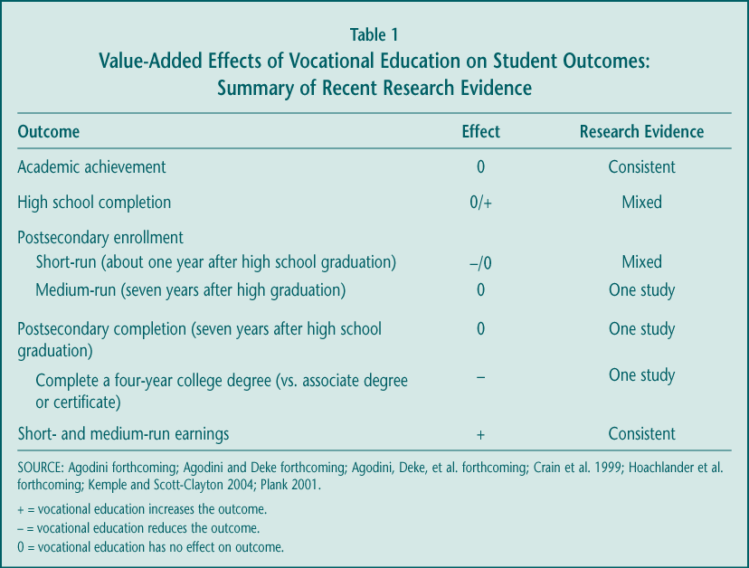

► The short- and medium-term benefits of vocational education are most clear when it comes to its longstanding measure of success—earnings. Several recent studies highlight the positive average effects of vocational course taking on annual earnings, measured just over a year or several years after high school graduation. Seven years after graduation, for example, students earned almost 2 percent more for each extra high school occupational course they took. That translates into about $450 per course, based on average earnings of about $24,000 (Figure 1); the benefit would be $1,350 more for the 45 percent of all high school graduates who take at least three occupational courses, including the quarter of graduates who concentrate their course taking in one program area (occupational concentrators).

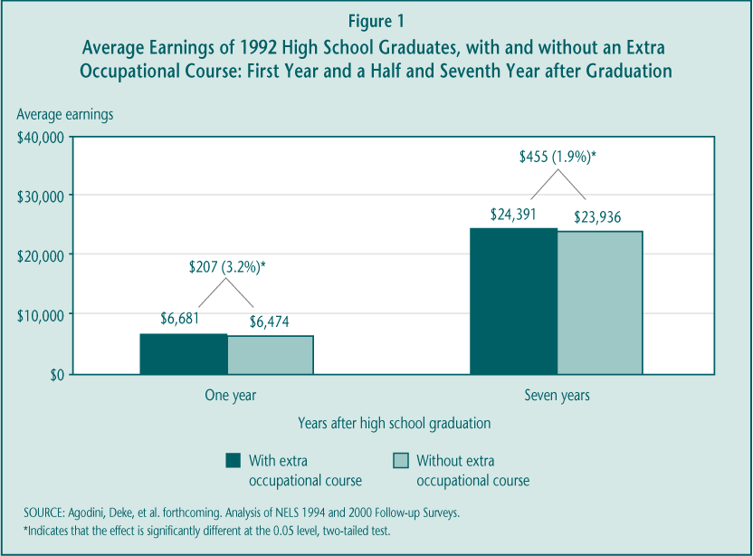

To varying extents, the studies indicate that these benefits extend to the large group of high school graduates who enroll in postsecondary education and training, to both economically and educationally disadvantaged students, to those with disabilities, and to both men and women. In addition, students who complete the “New Basics” academic curriculum as well as a concentration of occupational courses—about 13 percent of all graduates—earn more than similar students who complete the New Basics and little vocational education. However, the studies are more mixed on whether secondary vocational courses benefit the one-quarter of high school graduates who never enroll in postsecondary education, a group that has historically been the focus of vocational policy. There are also some important caveats to these earnings results. The evidence that vocational education increases wages—a proxy for a “better” job—is weaker, and it is likely that the benefits will continue to decline over time.

► Students in vocational programs of study have significantly increased their academic course taking and achievement over the last decade, although gaps remain. During the 1990s, successive groups of occupational concentrators took more, and more rigorous, academic courses along side their vocational curriculum (Table 2). By the end of the decade, the academic credit gap between them and students who took little or no vocational education had narrowed substantially. However, there were still differences between concentrators (51.1 percent) and non-concentrators (60.3 percent) in the proportion who completed the extensive New Basics core academic curriculum and larger gaps in the percent that completed a rigorous college preparatory curriculum (29.2 percent versus 46.2 percent).

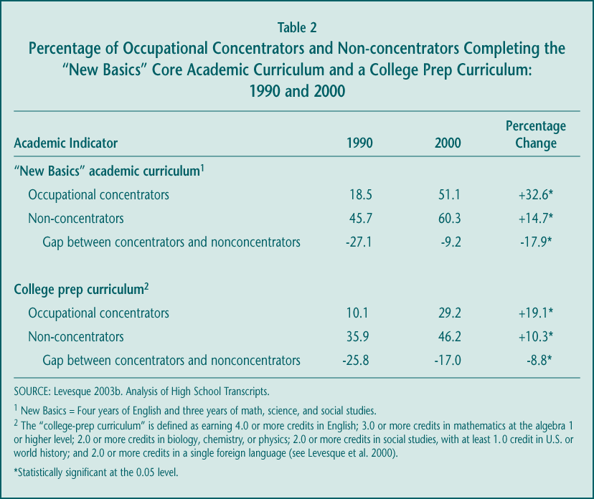

More importantly, occupational concentrators also made substantial progress on academic achievement (Figure 2). The National Assessment of Educational Progress (NAEP) 12th-grade test scores of occupational concentrators increased during the decade, by about 8 scale points in reading and 11 scale points in math. Students who took little or no vocational education increased their reading achievement by about 4 points in reading and experienced no increase in math achievement. As a result of these trends, the gap between concentrators and non-concentrators remained roughly stable in reading, while the gap in math achievement was reduced significantly.

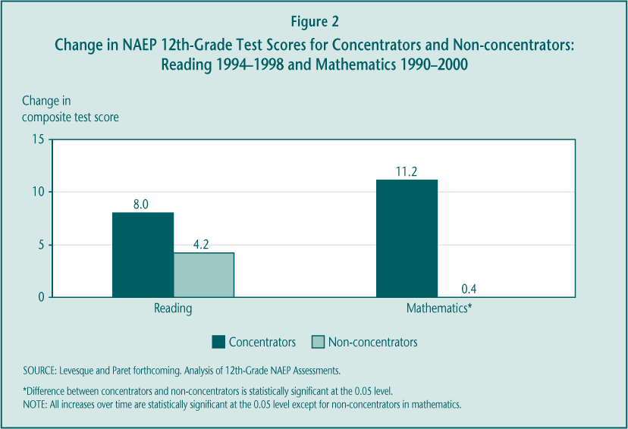

The NAEP assessments indicate that there has been substantial progress, but more work is necessary to raise the achievement levels of all students, particularly those in vocational programs. Most importantly, occupational concentrators are far less likely than non-concentrators to be proficient in reading or math, as defined by their most recent NAEP test scores (Figure 3). If proficiency on the 12th-grade NAEP assessments is associated with readiness for postsecondary education or success in the labor market, then these figures suggest a greater focus on academic improvement is needed.

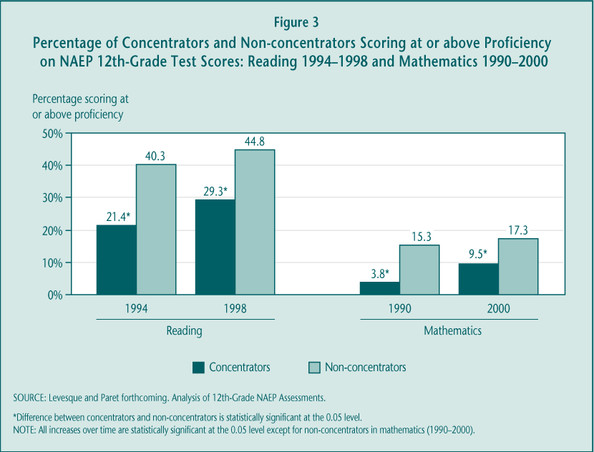

► There is little evidence that vocational courses contribute to improving academic outcomes. The noted improvements in academic performance are likely due to higher academic graduation requirements and increased emphasis on academic reforms. Both analyses of high school student data and randomized controlled studies indicate that, on average, vocational courses and programs do not themselves “add value” to academic achievement as measured by test scores. Not surprisingly, substituting additional academic courses for occupational courses does raise achievement. Moreover, although there is mixed evidence that vocational education reduces dropping out of school, the more rigorous studies suggest there is no effect.

► Postsecondary transition rates have increased; vocational courses neither hurt nor help most students’ chances of going on to college but are associated with a shift from earning a bachelor’s degree to earning an associate’s degree or certificate. Vocational education has long been stigmatized as for the “noncollege bound” or as a deterrent to college, although NAVE finds that neither of these concerns is well founded. The best available national trend data indicate that higher proportions of occupational concentrators are moving on to some form of postsecondary education or training, although they still participate overall at lower rates than do other students and in particular in four-year colleges and universities (Table 3). Many concentrators enroll later, so that by seven years after graduation nearly three-quarters versus 90 percent of all other students have participated to some extent.

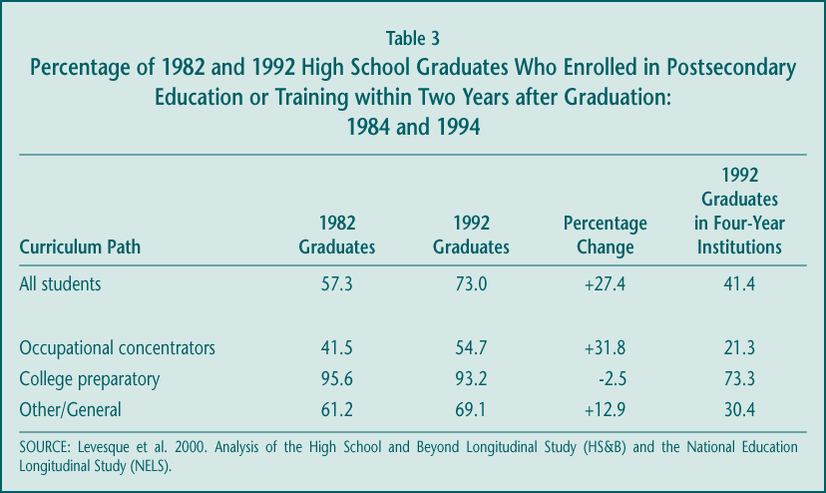

However, improvements in postsecondary enrollment do not appear related to vocational course taking. Studies of graduates in both the early and later 1990s indicate that vocational education itself has no effect on whether students ever attend postsecondary education or training. Moreover, among those who enroll, high school vocational education is associated with a lower likelihood of completing a bachelor’s degree program and a corresponding higher likelihood of completing an associate’s degree or certificate program.

► Secondary vocational education is a large component of high school course taking and serves a diverse set of students, but it is an increasingly smaller share of the overall curriculum. Nearly every student (96.6 percent) leaves high school having taken some vocational education, although the extent of student involvement varies. By almost any measure, participation remained stable during the last decade after an earlier period of decline, withstanding schools’ ongoing focus on academic improvement. While there was little change in the amount of vocational course work taken by high school students during the 1990s, students earned more academic credits, thus lowering vocational education’s share of the overall high school curriculum—from 21.8 percent in 1982 to 17.8 percent in 1990 to 16.2 percent in 2000 (Figure 4). Still, high school students earn, on average, more credits in vocational education (4.0) than in math (3.4) or science (3.1).

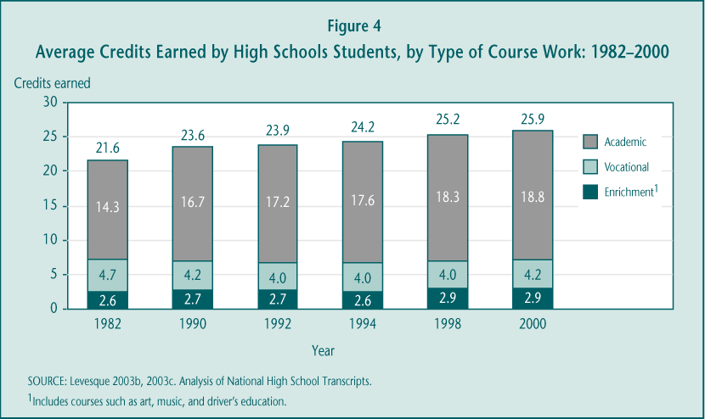

Those who participate most intensively—occupational concentrators—are a varied set of students. However, those who have disabilities or are male, come from lower-income or rural schools, or arrive at high school with low academic achievement participate more substantially than do other students. These patterns were generally stable during the last decade, although vocational education appeared to attract more academically talented students during the 1990s. Less progress was made on overcoming gender differences in vocational course participation.

► The Perkins quality improvement strategies may be too vague to drive change without clear direction. Perkins III carried over a variety of strategies from Perkins II—such as integration of academic and vocational instruction, an all aspects of the industry emphasis, linkages between secondary and postsecondary programs, collaboration with employers, and expanding the use of technology. Several of these strategies, including integration, are ill defined and that may be a barrier to wider implementation. In addition, little is known about their effectiveness in improving student outcomes. Perhaps more importantly, the practices are potentially targeted toward different outcomes: for example, technology might be expected to affect occupational-technical skills, integration to affect students’ academic achievement. The list does not reflect a focused purpose to the federal investment.

► Improving teacher quality will be important if vocational education is expected to alter its mission. Teachers have the most direct impact on instruction and the earnings benefits for many vocational students may suggest that this instruction is valued in the labor market. However, federal legislation over the past decade has tried to guide vocational education toward providing greater support for academic achievement; student outcomes and program implementation suggest that these efforts have been less successful. Current vocational teachers are less likely than academic teachers to have bachelors’ degrees and many do not feel they have received sufficient professional development on the key strategy of integration. Moreover, prospective high school vocational teachers (in vocational teacher training programs) score lower on basic reading and writing tests than do those preparing to be elementary school teachers and lower on math tests than other secondary teachers (Figure 5). Substantial investments in new recruitment and in-service training approaches may be required if federal legislation continues to make supporting academic achievement a priority for vocational education.

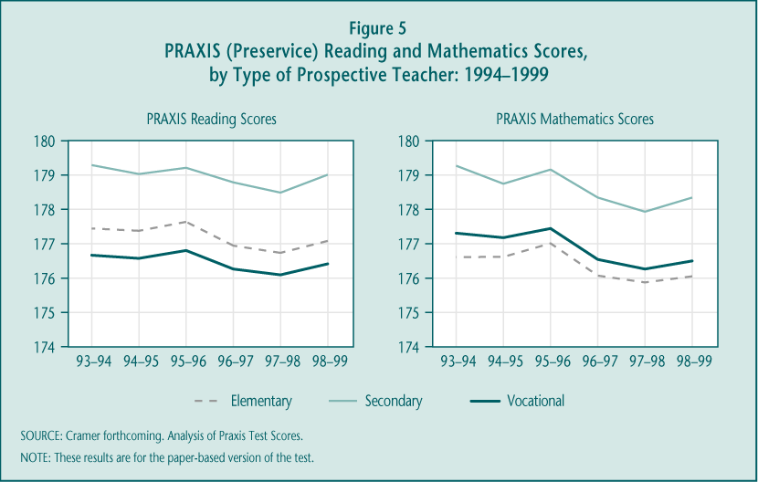

► Tech-Prep was a catalyst for certain vocational reform activities but, because few schools implement it as a comprehensive program of study, it is now playing less of a distinctive role. Efforts to promote both integration of academic and vocational instruction and articulation between secondary and postsecondary education were stimulated by the Tech-Prep Education Act in Perkins II. However, 12 years later, few schools implement Tech-Prep as a structured program with at least two years of clearly linked high school course work and at least two years of related postsecondary course work (the “two-plus-two” design). The most recent estimates suggest that about 10 percent of Tech-Prep consortia, representing 5 percent of Tech-Prep students overall, may be promoting this comprehensive two-plus-two approach. In 2001, only seven states reported that they require local grantees to implement Tech-Prep as a distinct program.

More typically schools implement individual components of the Tech-Prep model—maintaining articulation agreements, providing professional development on integration to academic or vocational teachers, or improving career guidance and planning. Many of these activities are becoming part of secondary vocational education more broadly, and little change has occurred at the postsecondary level to accommodate Tech-Prep students. As a result, Tech-Prep efforts now overlap substantially with those of regular vocational education.

2. What is the nature and impact of vocational education at the sub-baccalaureate level, and what is its relationship to current workforce development efforts?

Given the labor market value of college credentials, “lifelong learning,” and flexibility in skills, the role of sub-baccalaureate vocational education is increasingly important. Many different types of students, with different intentions, cross the doors of community colleges and other Perkins-eligible postsecondary institutions; even with this diversity, the institutions provide services from which most participating students benefit. Relatively low rates of retention are a concern, however, not only because federal policy has long encouraged postsecondary degree completion as a strategy for maintaining American economic competitiveness, but also because individual participants would reap much greater earnings advantage from staying long enough to earn a credential. An emphasis on degree completion may be at odds with the shorter-term training emphasized by the Workforce Investment Act (WIA). But at least so far, integration of decision-making and services between Perkins and WIA has been limited in most states.

► There are significant economic returns to postsecondary vocational education, with the greatest benefits for those who earn a credential. As was true at the secondary level, vocational education in community colleges appears to produce a substantial positive effect on earnings for the vast majority of participants. There are differences in these returns, depending on how much course work is completed (Table 4). Some postsecondary vocational participants do benefit from a year’s worth of vocational course taking even without attaining a credential, earning between 5 and 8 percent more than do high school graduates with similar characteristics. However, much higher economic rewards go to those who pursue significant amounts of postsecondary vocational education and earn a degree or certificate; female associate’s degree holders, for example, earn 47 percent more than similar students with a high school degree and males earn 30 percent more. These results represent the average effects of earning postsecondary degrees. Although many economists argue that the effects vary widely by occupational field, the available data did not permit fields of study to be analyzed separately.

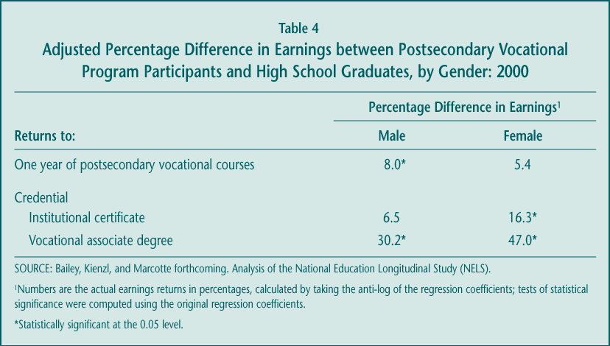

► Fewer than half of postsecondary vocational participants seeking a degree or certificate take enough courses to earn a credential. Like their academic counterparts, many vocational participants leave sub-baccalaureate institutions and programs having completed few courses; more than two-thirds of vocational majors complete the equivalent of a year or less of course work within a five-year time period. Even among those who enroll with the goal of earning a degree or certificate, fewer than half actually complete a credential of any kind (Figure 6). Taking student goals and characteristics into account, the completion rate for vocational majors is similar to that of academic majors, although vocational participants are more likely to earn a shorter-term credential (e.g., certificate) than they originally set out to attain. The relatively low completion rate among postsecondary vocational students is consistent across categories of students, including those in special population groups.

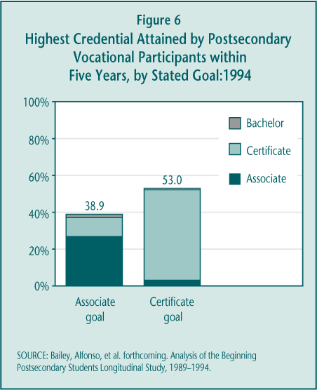

► Postsecondary vocational education serves a large and diverse population with varied expectations. About one-third of all students in undergraduate postsecondary education are considered to be in postsecondary vocational programs. These sub-baccalaureate vocational students vary in age, income, work experience, and previous college activity. Not surprisingly, then, they enroll with different goals—to get an associate’s degree or institutional certificate, to transfer and pursue a bachelor’s degree, to enhance their job skills, or to engage in personal enrichment activities; older students are more interested in obtaining job skills while younger students are more likely to aim for a credential (Figure 7). To accommodate this diversity, community colleges have to be particularly flexible institutions. Perkins III funds, which represent just 2 percent of vocational education expenditures in public two-year and less-than-two-year colleges, can be used to support almost any part of the enterprise.

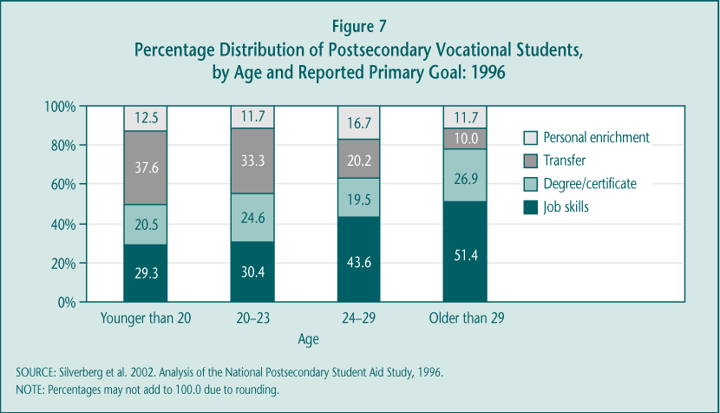

► Community colleges have had limited involvement in early implementation of WIA, citing both low emphasis on training and reporting requirements as disincentives. Early WIA implementation, during a period of economic expansion and job growth, primarily emphasized the development of new procedures and the delivery of employment information over the kinds of training activities Perkins-eligible institutions typically provide. There is some evidence that, with the recent economic downturn, both the availability of training vouchers and policy interest in training are increasing, but the lack of coordination between WIA and Perkins accountability measures reportedly still leads to substantial burden for participating institutions.

3. Is the policy shift from set-asides and legislative prescription to flexibility and accountability likely to improve program quality and student outcomes? How do special populations fare?

The funding and accountability changes enacted under Perkins III have been partially successful in addressing policymakers’ objectives, although much is still in development. Local grantees are receiving larger dollar amounts and case studies suggest they are able to distribute secondary Perkins funds to more schools, outcomes consistent with the goal of directing more money to the local rather than state levels. However, both the traditional ways in which grantees use their funds and early implementation of the higher stakes accountability system forecast at best slow change in vocational program quality. Despite serious commitment among state administrators, technical measurement and data quality problems hinder widespread use of performance data for program management at either the state or local levels. Given these deficiencies, it seems unlikely that, in the short run, the accountability system will have particular benefits for special population students, especially since identifying and collecting data on these students has proven to be particularly difficult for state and local officials. The effects of eliminating targeted set-asides intended to promote gender equity is currently unknown.

► The new law succeeded in sending a higher share of funds to the local level. The average size of local grants grew substantially between Perkins II and Perkins III (approximately 34 percent for secondary and 26 percent for postsecondary grantees) (Table 5). These increases cannot be fully explained by increases in federal appropriations that go to state grants (just over 15 percent) or a reduction in the number of grants awarded.

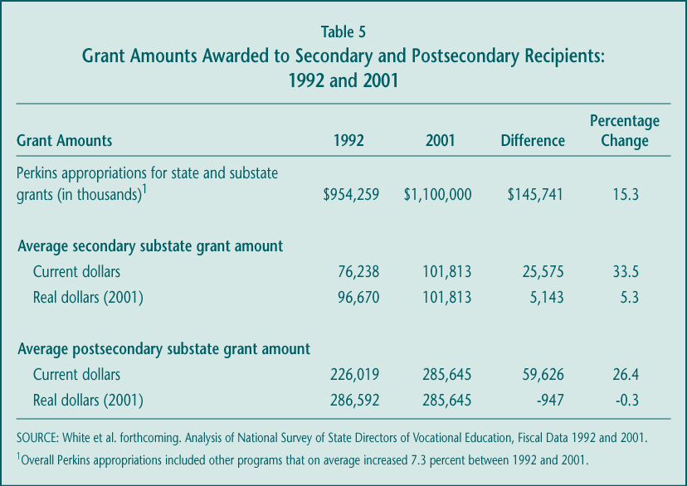

► Flexibility provisions are popular, but may be weakening the targeting of funds to high-poverty communities. Nearly 30 states at the secondary level and 20 at the postsecondary level use at least one of the flexibility provisions in Perkins III. The most common choice is the newly established “reserve fund” provision, which allows states to award 10 percent of local funds to programs in rural and other areas without using the poverty-weighted legislated formula. Perhaps as a result, the dollar advantage of high-poverty districts has declined since Perkins II (Table 6).

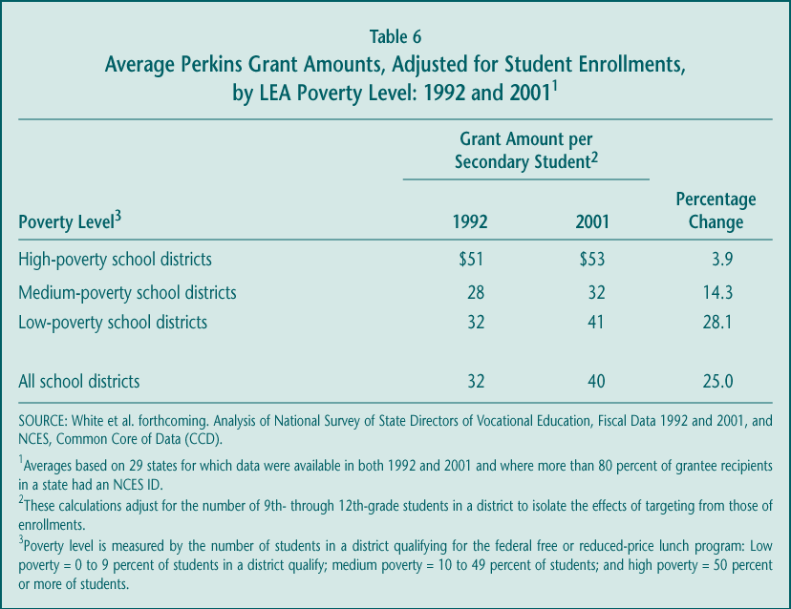

Perkins III also included several options to allow states to better coordinate federal vocational funds and activities with those of other federal programs. Only one state submitted to ED a “consolidated” plan to integrate vocational education with other education programs, and 12 states submitted “unified” plans in which they described their expected activities under some combination of the Perkins, WIA, Adult Education, and Vocational Rehabilitation laws. Although, under the ED Flex program, states received the authority to waive Perkins requirements, states generally did not exercise that authority.

► Implementation is progressing, but so far the performance measurement system is rarely viewed as a tool for program improvement. The current system, perhaps the first legislated accountability effort with significant “teeth,” is still evolving and state officials have demonstrated a serious commitment to it. However, several factors limit its likely impact on vocational programs and student outcomes in the next few years: (1) difficulty collecting data, (2) lack of validity or reliability of many adopted performance measures, and (3) inconsistent approaches to data collection and reporting within states. Certainly, the current system cannot provide a reliable, national picture of vocational education performance. Overall, the quality and reach of the Perkins accountability measures vary considerably by indicator, by state, within state, and sometimes even within local grantees’ programs. It is therefore unsurprising that relatively few states or districts use the performance data for consequential decision-making.

► Although there have been some cutbacks in staffing dedicated to special population services, the full effects on programs and students are unknown. Even with the elimination of the gender equity set-asides and coordinator requirements, many states continued to support these efforts, though the amount of staff time seems to have declined. In 2001, 23 states reported having at least one gender equity coordinator working full- or part-time, but case studies suggest these figures represent reductions from Perkins II. There were fewer observed effects at the local level, with other funding sources sometimes making up for the loss of Perkins gender equity grants. There were cutbacks in targeted programs and services in some communities, but how these might affect student outcomes cannot be known for several more years.

B. Options for Future Directions

Despite the current strengths of the vocational education system supported by Perkins III, there remain ongoing challenges for further improvement. Policymakers may wish to consider a variety of ways—encompassing broad or more specific strategies—in which to shape the course of these improvements.

1. Broad Strategies for Promoting Change

There are several possible options that have implications for the structure of a new or revised law. These broad strategies share a common goal of providing a clearer focus to federal priorities.

Transform Perkins into a program with clear, focused, and limited objectives.

The Perkins legislation authorizes a stream of funds that provides wide latitude to state and local grantees in terms of implementation and goals. The law’s reporting requirements reflect the historical accumulation of purposes that have been laid out for vocational education: improving students’ academic and technical skills, enhancing high school completion, promoting postsecondary enrollment and completion, and ensuring successful labor market entry and retention. All of these, it could be argued, are worthy objectives for federal policy to address at either the high school or college level, or both.

However, it is reasonable to question the capacity of any single law or any single program strategy to succeed on all of these fronts. The diffuse nature of federal priorities for this stream of funds both reflects and contributes to ambivalence among policymakers and educators about what “problem” is being addressed by the Perkins legislation, and impedes efforts to develop clear, focused, and tested education interventions designed to ameliorate the identified problem.

The federal investment could be more effective if directed toward a narrower set of goals around which program improvement strategies and accountability systems could be developed. There are some choices in moving in that direction:

► Emphasize immediate goal of education or workforce development. Decision-makers may want to weigh whether vocational education, or the activities the Perkins legislation supports, should most directly and immediately contribute to:

• Education, in which the emphasis is primarily on learning academic or occupational skills (or both) while enrolled in school; or

• Workforce development, in which the emphasis is primarily on job and other post-school outcomes.

These various objectives are certainly interrelated and clarifying the priorities does not imply that vocational education cannot also have other benefits. Studies clearly link higher levels of learning and of educational attainment to success in the work- place (see NAVE Interim Report [Silverberg et al. 2002]). The language in Perkins III and of vocational advocacy groups suggest that effective technical skills rest on a strong foundation of academic proficiency. The question is, however, which of these goals is most critical for Perkins-funded activities? A focus is important for the federal role of promoting continuing improvement.

► Separate the high school and postsecondary components of the Perkins Act versus keeping them joined in the structure of the law. In some sense, secondary and postsecondary vocational education share many qualities. Both are elective choices for students rather than a required curriculum. Both serve an increasingly diverse set of students, who have widely varying purposes for participating and hopes for what they will accomplish. When secondary vocational education was clearly a program for developing occupational skills and preparing for immediate employment, the strategies at the two levels were similar. However, that may no longer be the case. Because the mission of high schools and community and technical colleges differ, as do the challenges they face, policymakers may decide that federal vocational education should play a different role at each level. For example, although federal policy may charge secondary vocational education with reinforcing high schools’ learning objectives, policy may choose to more clearly tie postsecondary vocational education to workforce development outcomes.

Establishing separate policies and goals for vocational education at the two levels need not undermine the current federal emphasis on developing clear pathways from high school to postsecondary education. On the contrary, with two separate titles or sections, the law could more clearly articulate the specific responsibilities of secondary and postsecondary institutions to create and maintain those pathways.

Eliminate Tech-Prep as a separate title, folding its key activities into postsecondary institutions’ responsibilities.

Tech-Prep has spurred some important efforts but has not lived up to its promise of creating rigorous programs of technical study. The Tech-Prep title of the Perkins Act has become a funding stream like the larger state grant title in Perkins, allowing local consortia to supplement vocational education or other efforts associated generally with the spirit of the law (e.g., career development). Rarely are funds focused on developing the well-defined two-plus-two (2+2) programs that early Tech-Prep advocates promoted: integrated high school academic and vocational curricula that are “articulated”—linked through credit transfer agreements—to postsecondary programs. Instead, integration and articulation have been implemented more on a course-by-course basis. Moreover, these two key components of Tech-Prep have become more common priorities for vocational education generally, diminishing the distinctive role that Tech-Prep efforts might play. Finally, there is some evidence that Tech-Prep funds are not as well targeted to high-poverty areas as are the formula-driven basic grant funds under the Perkins Act.

Despite these limitations, Tech-Prep remains the catalyst for some initiatives and strategies that many consider worth preserving. Two, in particular—convening local partners to collaborate on postsecondary transition issues and updating articulation agreements—could instead become required activities for postsecondary Perkins grantees, many of whom already play this role as part of Tech-Prep consortia.

This strategy could, in effect, focus the Perkins-funded efforts of eligible postsecondary institutions on serving their younger students (those transitioning from high school) rather than on the older adult population. Such an emphasis might be warranted, because the younger students are less likely to be on a stable trajectory toward labor market success: they have more limited work histories and previous college or job training experience, and there is some evidence that earning a credential matters more for them than for older students. Given that Perkins grants represent about 2 percent of local community college spending on occupational education, a focus for federal funds on younger students might also strengthen current efforts to develop rigorous cross-level course sequences, pathways, or programs of study.

Streamline accountability requirements to align with the more focused objectives.

The current accountability provisions in Perkins III require secondary and postsecondary grantees to report on a broad array of student outcomes, both those that students achieve while in school (academic achievement, occupational-technical skill development, school completion) and those that define their paths after they leave (further education or training and employment). There are two reasons for reducing the number of indicators:

► To limit burden and improve performance data quality. Many states are finding it burdensome to meet all of the reporting obligations and their current performance measures and data collection approaches have limited validity and reliability, impeding reliance on them for significant program management decisions. Improvements in data quality and use are more likely if state and local grantees could concentrate their efforts on a smaller set of indicators.

► To focus program improvement activities. The accountability system is intended to motivate states, districts, and postsecondary institutions to manage their programs more effectively. A more limited set of performance indicators, closely aligned to policymakers’ priorities for the federal investment, could encourage more targeted improvement efforts.

2. Specific Strategies for Improved Performance

Although there are broad changes to the structure of the law that policymakers could pursue, there are also individual practices and strategies new legislation could promote that might improve particular outcomes (Table 7). Ideally, one set of strategies would be emphasized, tied to a clear declaration of federal priorities. However, the strategies could also be implemented in combination.

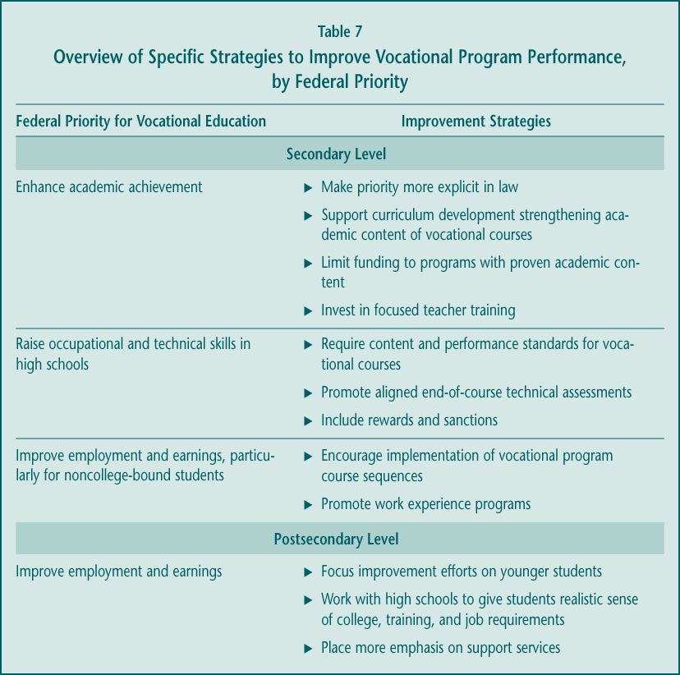

These specific approaches—summarized in Table 7—draw to a large extent on current research and evaluation analyses, most conducted under the NAVE.

3. Closing

Vocational education, increasingly known as career and technical education, is a longstanding program whose place in American education continues to evolve. The broadening of its goals, the ongoing diversity of participants, and the changing education and labor market climate in which it operates, suggest vocational education is a flexible option for schools and students.

With this flexibility comes some challenges, however. At the high school level, participation in vocational education is an elective choice that faces increasing pressure from emphasis on academic improvement. For both secondary and postsecondary vocational education, the wide range of participants and objectives raises a question about how effective a role federal policy plays and whether that policy can or should promote a clearer set of priorities. This final NAVE report is designed to contribute to that discussion, by providing the most up-to-date and comprehensive assessment of vocational education in the United States and of the effects of the Carl D. Perkins Vocational and Technical Education Act of 1998.

1. Introduction

Eighty-five years ago the federal government first committed to vocational education as a national priority. Since then, the enterprise has grown to encompass a wide variety of activities, participants, and purposes. Currently, nearly half of all high school students and about one-third of college students are involved in vocational education programs as a major part of their studies. Perhaps as many as 40 million adults—one in four—engage in short-term postsecondary occupational training (Darkenwald and Kim 1998). These individuals enter vocational education for different reasons, participate in different ways, and take different paths after completing their courses and programs. In an era in which strong skills and lifelong learning are rewarded, the nature and impact of students’ experiences in vocational education could have important implications for the nation’s workforce and America’s place in the global economy.

Federal efforts to improve the quality and availability of vocational programs are most recently articulated in the Carl D. Perkins Vocational and Technical Education Act. Passed in October 1998, this act reflects both continuity with previous vocational legislation and some substantive departures. As policymakers begin to consider further changes in law—in anticipation of the scheduled reauthorization—they will be examining vocational education as a field in transition, prompted by sweeping changes in federal, state, and local education and training priorities. This final report of the National Assessment of Vocational Education (NAVE) provides information to enable new policy to be responsive to these shifts.

A. 1998 Perkins Act

Signed into law on October 31, 1998, the Carl D. Perkins Vocational and Technical Education Act (referred to as “Perkins III”) represented almost four years of deliberations over how to modify federal vocational legislation. Previous periods of legislative change had focused on particular policy concerns (Table 1.1). Over time, these changes increasingly promoted educational equity, improvements in program quality, and a shift away from vocational education’s origins as a separate program or “track.” These objectives were also evident in the Perkins III debates, but in passing the 1998 law, Congress sought to address additional concerns and to do so in different ways.
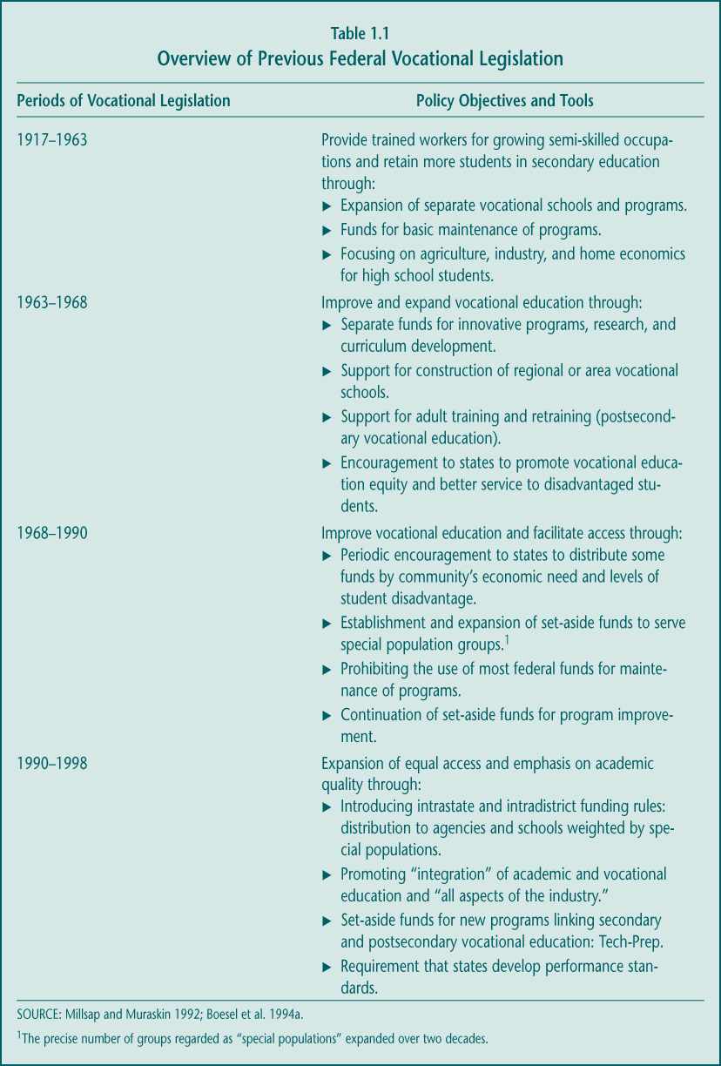

1. Key Changes

Congress made several important substantive changes to the Perkins Act in 1998. These changes reflected certain themes or priorities for education and the role of the federal government in education policy:

► Increased emphasis on academics: Continuing the trend begun in earlier legislation, Perkins III further focused attention on improving the academic performance of vocational students; the stated purpose of the 1998 law suggests that federal vocational education funds be directed toward improving both academic and vocational-technical skills, and new accountability provisions require state and local grantees to ensure that vocational students are held to the same academic standards as other students.

► Greater flexibility in the use of funds: The new law released state and local agencies from certain federal rules governing how Perkins grants were allocated and used for program improvement; set-aside funding streams for gender equity were eliminated, as were most other funding distribution requirements weighted toward “special population groups” (e.g., students with disabilities).

► More funds directed to the local level: Congress wanted a larger share of funds to be allocated to local programs, expecting that additional resources would reach the classroom and could affect student outcomes more directly; elimination of the set-asides allowed a higher proportion of Perkins funds to pass to local districts, schools, and postsecondary institutions.

► Creation of a “higher-stakes” accountability system: Although states had been expected to gather information on the outcomes of vocational students since 1990, Perkins III imposed requirements for state reporting to the U.S. Department of Education (ED), including disaggregated reporting for special populations; the new law also introduced potential rewards and consequences for states that do and do not improve student performance.

► Improved coordination with related initiatives: After debating but discarding the option of combining the two laws, Congress enacted Perkins III immediately after passing the Workforce Investment Act (WIA); both laws were intended to provide opportunities to integrate postsecondary education institutions into state and local systems for workforce development and job training.

2. Continuity with the 1990 Perkins Act Amendments

Congress did not alter the basic structure of the Perkins Act in the 1998 reauthorization, however. Perkins remains primarily a formula grant program. Funds are still distributed to states based on population counts, while states allocate grants to local secondary and postsecondary institutions based largely on the numbers of low-income students the institutions serve. States continue to have discretion to determine the proportion of their state grant that will be allocated to secondary versus postsecondary vocational education.

Moreover, Perkins III continued to emphasize the major program strategies reflected in the 1990 Perkins amendments (Perkins II). Specifically, the law promotes the following:

► Integration of academic and vocational education, by implementing coherent sequences of academic and vocational and technical instruction.

► Broadening the focus of vocational education content to emphasize industries and careers in place of entry-level, job-specific training.

► Strengthening the links between secondary and postsecondary education through Tech-Prep and other strategies.

3. Unresolved Policy Debates

While the strategies outlined in the 1998 Perkins Act can be interpreted as reflecting policymakers’ current priorities and guidance for vocational education, the legislation did not settle fundamental questions that have been raised about its future role in the education and training systems. Both in congressional deliberations before passage of Perkins III and in continuing discussions in the education community, several issues remain unresolved that could have implications for reauthorization:

► At what education level is specialized vocational education appropriate? More and more, the priorities of high schools and policymakers have turned to improving students’ academic achievement and encouraging their entry into college, with this emphasis strongly supported by the recent No Child Left Behind Act of 2001, which reauthorized the Elementary and Secondary Education Act. Perhaps as a result, vocational programs have become a smaller share of the high school curriculum (see Chapter 2). At the same time, postsecondary institutions, particularly community colleges, have assumed a much larger role in preparing students for careers. Given this trend, the limited federal resources available for high schools, and the costs of keeping both secondary and postsecondary vocational programs up-to-date, some question whether vocational education as a program of study belongs in high school or whether this type of specialization should occur at the college level.

► Whom should secondary vocational education serve and what is its purpose? With its emphasis on preparing students for the labor market, vocational education has long been supported, in part, as an important strategy for high school students with weaker academic skills or little interest in pursuing college credentials. Over the last decade, however, federal legislation and most state agencies have promoted the notion of vocational education as preparation for high-tech, high-skill careers, those in which the academic skills required may be substantial. Consistent with that objective, states and local programs have sought to attract more academically talented students into vocational education programs. Although current law defines vocational education as preparation for careers requiring less than baccalaureate degrees, this definition is increasingly at odds with the goals and interests of participating students and the actual paths they take after high school (see Chapter 2).

► What is the federal role in postsecondary vocational education? Many interpret the Perkins Act as providing a set of strategies designed to improve secondary vocational education. Policymakers have mostly been concerned with secondary vocational education, providing little direction for the specific goals or problems federal Perkins funds are expected to address at the postsecondary level. Currently, Perkins grants can be used for a wide array of offerings that eligible institutions provide and to support varied learning and training objectives pursued by those who participate in postsecondary vocational education. One issue policymakers may consider is whether Perkins can, or should, address all of these populations and purposes or whether federal resources should be more clearly focused.

► Should vocational education be “education” or “training”? For the past decade, the Perkins Act has emphasized teaching about “all aspects of the industry”—focusing on a comprehensive understanding of the industry rather than just specific skills needed for an entry-level job. Although state officials are increasingly interested in broadening vocational programs into what they call “career clusters,” much of vocational education has been organized around traditional occupational categories (Hoachlander 1998). In the past few years, many schools have been attracted to—and policymakers have touted—vocational programs offered by high-tech firms such as Microsoft and Cisco; to some, this emphasis on product-specific skill training seems inconsistent with the broader approaches promoted in federal policy. At the postsecondary level, the provisions of Perkins have signaled some preference for occupational programs that offer for-credit courses and culminate in an associate degree (education), as compared to short-term, noncredit training courses. But some groups who report growth in noncredit enrollments have wondered whether this federal emphasis is appropriate.

► What is the best way to help special populations? Deep concerns that different groups have uneven access to high-quality education, including vocational education, initially led policymakers to set aside funds for underserved groups. In 1998, that approach was replaced by one that focused on holding grantees accountable for improving the educational outcomes of all vocational education participants, including targeted special populations. However, it may be many years before the full effects of performance reporting will be known.

These debates are as much philosophical as empirical, reflecting diverse opinions about the role of federal vocational education policy and the specific objectives it addresses. Research and data can contribute to and inform these discussions but are not likely to settle them. Federal policymakers may choose to address these issues directly or leave them up to the discretion of state and local agencies, as is currently the case.

B. Context for Evaluating Federal Support for Vocational Education

Each time Congress has considered federal aid for vocational education the outcome reflected an understanding of the economic and educational concerns of the time and the nature of the federal role in education. Legislative actions often have sought to push vocational education in new directions. The upcoming reauthorization of Perkins III is likely to be no exception. Several factors are likely to shape policymakers’ deliberations over new vocational education legislation (see the NAVE Interim Report to Congress [Silverberg et al. 2002] for a more detailed discussion of these issues).

Education, labor market, and funding trends suggest shifts in policy priorities.

Vocational education has long straddled the education and job-training systems, secondary and postsecondary institutions, and local, state, and federal agencies. Vocational legislation is therefore always influenced by larger education, labor market, and policy developments.

► High schools increasingly emphasize academic reform and college preparation. Due to the poor performance of seniors on national and international proficiency tests, declining graduation rates, and high rates of college remediation, many have been concerned about the academic achievement of high school students. Partly in response, nearly every state has set higher academic standards for high school graduation, and many have begun to include exit exams. The challenge many students, including some in vocational programs, face in meeting the new standards has raised questions about the role of high school courses lacking clear academic focus. These concerns also have led to a hypothesis that student enrollments in elective courses such as vocational education will decline sharply.

► Good jobs require at least some postsecondary education. Both high- and low-paying jobs are available in the labor market, but a college credential of some kind is needed for most better-paying jobs. Employment growth in occupations requiring a vocational associate degree is projected to be higher (30 percent) than overall employment growth (14 percent) through 2008 (Erard forthcoming). Thus, demand for postsecondary vocational education is likely to remain strong.

► For the past 20 years, Perkins has represented a declining share of federal education budgets, but it is still the largest single source of U.S. Department of Education (ED) funds spent on high schools. Perhaps because the primary objective of vocational education has not appeared well-aligned with other priorities, appropriations for the Perkins Act and its predecessors have not kept pace with either inflation or the expansion of other ED programs and the Department’s overall budget. In fiscal year 1980, funding for vocational education represented about 6 percent of total ED appropriations, while in 2004 it represented less than 3 percent (Figure 1.1). Despite its relative declining share, Perkins III remains the largest single source of federal education funds used to support high schools. Comparing dollars spent at the high school level, vocational education appears to be of equal federal priority as the combined funding of other programs focused on raising academic achievement (Title I) and preparing students for college (TRIO) (Figure 1.2).

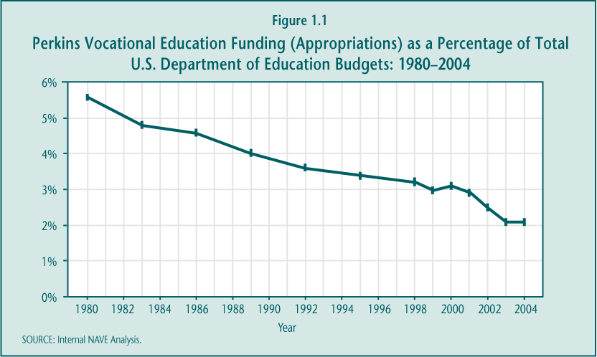

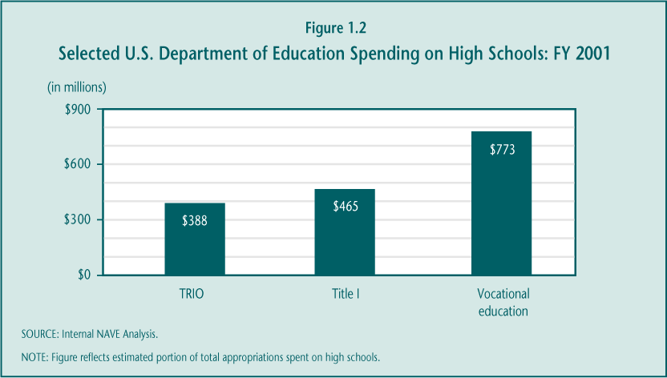

Current vocational policy attempts to promote many diverse goals and objectives.

Evolving priorities clearly have moved federal support for vocational education toward fulfilling a broader set of objectives than training students for work in factories and on farms after high school, the original aim of federal vocational legislation at the turn of the 20th century (Table 1.2). The stated purpose of the 1998 Perkins III Act is to enhance not only the vocational and technical skills of students who choose to participate in vocational education but also their academic skills. The law’s accountability provisions suggest that vocational education is also expected to contribute to high school completion, entry into postsecondary education and training, postsecondary degree completion, and employment and earnings. Programs funded under the law are expected to increase participation and success in programs leading to nontraditional training and employment. Finally, to some extent, Perkins III continues the emphasis on special populations that began several decades earlier, shifting from a concern about access to one of improved performance for the identified groups.

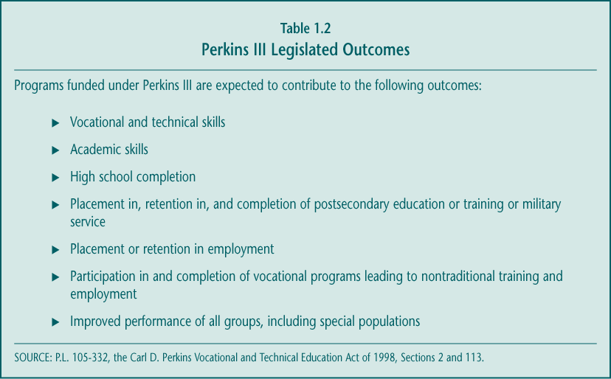

While all of these outcomes are desirable, it is unclear whether they can be achieved simultaneously. Since federal policy currently allows states, school districts, and postsecondary institutions to decide which objectives are the highest priority for Perkins spending, the law provides great flexibility—but little focus—for the direction of program improvement. In contrast, Title I of the recently enacted No Child Left Behind Act, with funding in 2003 approximately 10 times greater than that of the Perkins Act, is clearly focused on one core mission: raising the academic achievement of disadvantaged students.

Several initiatives targeted to vocational education are beginning to move it in new directions.

In most communities, the vocational education of today looks far different than it did a generation ago. Particularly over the past decade, federal legislation and emerging trends have encouraged the field to develop courses and programs reflecting the wider set of missions, and to target a broader group of students. Aimed primarily at the secondary level, many of these efforts are intended to reduce the stigma traditionally associated with vocational education and to encourage broad career preparation as a beneficial option for all students. Among these vocational initiatives and strategies are the following:

► High Schools That Work (HSTW). Originally designed by the Southern Regional Education Board (SREB) as a strategy to improve the academic achievement of “career-bound” students, HSTW emphasizes raising academic graduation requirements for all students, students’ completion of either an academic or career major or both, new guidance and advising systems, and tutorial assistance for students who need extra help. According to the SREB, HSTW began with 28 sites in 13 states in 1987, while in 2002 it was adopted as either a vocational education or comprehensive school reform strategy by more than 1,100 schools in 36 states.

► Career academies. Developed in the 1970s as a dropout prevention strategy targeted to students who are at risk of school failure, career academies now serve a more diverse set of goals and students. Academies are typically implemented as a school-within-a-school program of two to four years that offers students a sequence of vocational and college-preparatory academic course work organized around broad career themes. In collaboration with an academy business partner, students may obtain work experiences, take field trips, or complete school assignments based on a designated career theme. The results from a 1999 survey suggest that as many as one-quarter of U.S. high schools offered at least one career academy (Levesque forthcoming).

► Skill standards and certification. For nearly a decade, efforts to develop national skill standards and portable credentials for many occupations have received federal, industry, and labor support. These standards were intended to identify the skills required in particular fields and provide a focus for efforts to update vocational curricula. Employers were expected to value the certificates that students earned in the upgraded vocational programs. While the results of the National Skill Standards Board have been limited so far, some national, state, and regional industry groups have produced their own sets of standards, which local programs report using. The findings from a 1998 survey of School-to-Work partnerships nationwide suggest that 14.6 percent of secondary schools offered students in some vocational programs certificates denoting mastery of skills identified by industry groups at the partnership, regional, state, or national level (Hulsey, Van Noy, and Silverberg 1999).

Skill standards and certifications recently have emerged in both new ways and fields. Perhaps the most prominent new offerings in vocational education are the high-tech Cisco Academies and Microsoft A+ and Novell certification programs, which emphasize the high-wage, high-demand end of vocational education offerings. These programs have grown in popularity and are increasingly attracting a more academically talented group of high school students to vocational education (Haimson and Van Noy forthcoming).

► Tech-Prep articulation. Tech-Prep was originally designed as a four-year program of related academic and vocational course work spanning the last two years of high school and first two years of community college in order to prepare students for technical careers. Rarely implemented in this form, many schools instead have focused on establishing articulation agreements that allow students to earn college credit for high school vocational course work that meets college standards; in some cases, articulation is leading to the upgrading of high school vocational courses (Hershey et al. 1998). Since 1990, Perkins legislation has set aside specific funds to support Tech-Prep. The most recent evidence suggests that nearly half of all high schools offer something they call “Tech-Prep” (Levesque forthcoming).

The result of these varied vocational efforts is a field that continues to evolve. New terminology abounds; in fact, many in the field now refer to it as “Career and Technical Education (CTE)” rather than vocational education. Several program strategies overlap; many are implemented in combination or as separate options within the same school or program. Despite the federal definition of vocational education as “preparation for careers requiring less than baccalaureate degrees,” many of the newer offerings are designed to attract students who intend to pursue a four-year degree after high school.

The different initiatives are aimed toward different objectives: some are designed to improve the academic achievement of vocational students, some to improve their occupational and technical skills, others to promote students’ entry into college or their acquisition of general employability skills recommended by the Secretary’s Commission on Achieving Necessary Skills (SCANS). Certainly, vocational education course offerings have moved beyond “shop” class, and most communities can point to at least one “high-profile” partnership program with employers, usually in a high-technology or high-demand field such as health care or information technology. Policymakers will need to consider whether these developments, discussed in more detail in the next chapters, are of sufficient extent and impact to be leading vocational education on a consistent path toward meeting federal priorities.

C. National Assessment of Vocational Education

Evidence on the nature of vocational education and the context in which it operates is an important source of policy information. As was true with previous vocational legislation, Perkins III directed the secretary of education to complete an “independent evaluation and assessment of vocational and technical education programs under this Act” (Section 114(c)(3)). The National Assessment of Vocational Education (NAVE) is intended to support the broad goals of improving vocational education and to provide Congress with information to guide reauthorization of the Perkins Act.

1. Independent Advisory Panel

Following earlier legislative tradition, Perkins III directed the secretary of education to appoint an Independent Advisory Panel to provide advice on conducting NAVE. Such a panel was selected in mid-1999 and included employers, secondary school and district administrators, representatives of postsecondary institutions, state directors of vocational education at both the secondary and postsecondary levels, union representatives, education and workforce development policy experts, and researchers with experience in relevant fields.

This panel met on seven occasions to (1) identify the key policy and research questions NAVE will address, (2) review the analytic framework and study designs, and (3) receive and help interpret results from NAVE analyses, including those described in this final report. Perkins III required the panel to submit to Congress and the secretary of education its own independent analysis of NAVE findings and recommendations. The Advisory Panel’s report to Congress has been transmitted in a separate document.

2. Research Objectives and Questions

As a key source of policy information, NAVE examined the status of vocational education across the country and, to the extent possible, the early impacts of the 1998 law on vocational education practice. The research agenda took into account the wide range of topics Congress mandated in Perkins III (Section 114), including (1) implementation of state and local programs; (2) the impact of changes in federal funding formulas; (3) teacher quality and teacher supply and demand; (4) student participation in vocational education; (5) academic and employment outcomes; (6) employer involvement and satisfaction with vocational education programs; (7) education technology and distance learning; and (8) the effect of accountability requirements on program performance.

At a broader level, however, NAVE was guided by three key policy issues (Table 1.3).

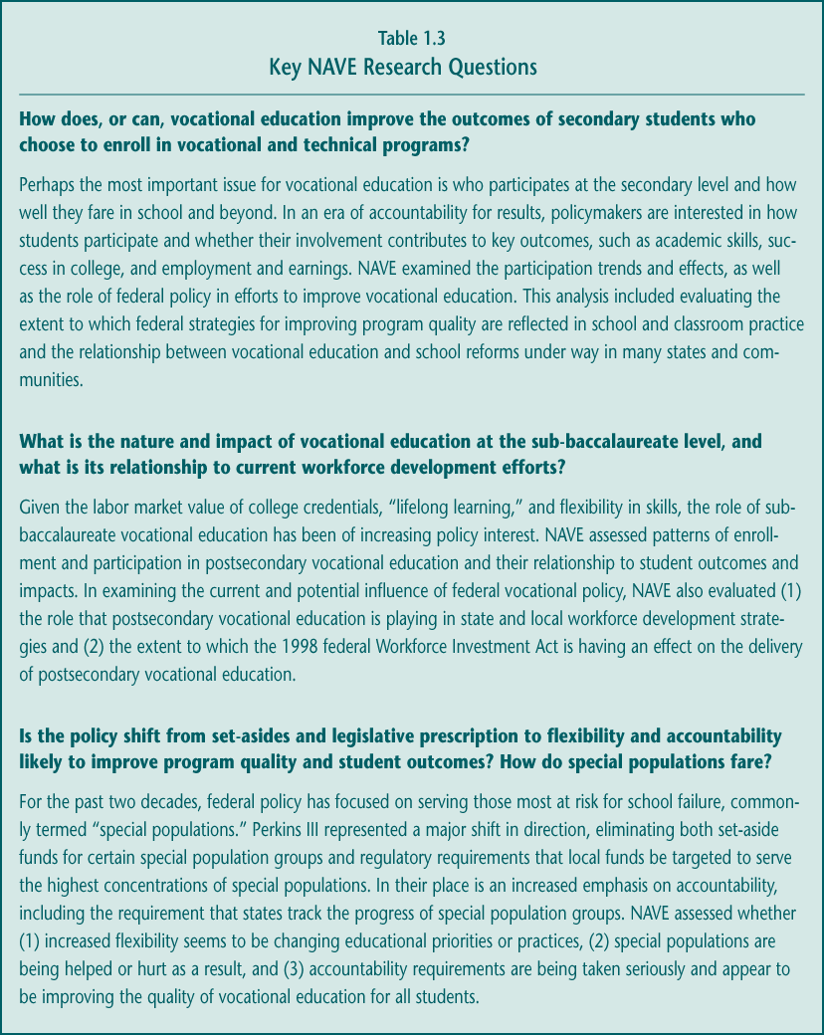

3. Evaluation Strategies and Limitations

Addressing the key vocational research and policy questions required a set of interrelated but distinct studies (see NAVE Study Reports at the end of the report). These studies involved the use of diverse data collection and analysis methods, including qualitative case studies, national surveys, state administrative databases, and both descriptive statistics and sophisticated econometric estimation of program effects. This report integrates information from both these NAVE-funded assessments and relevant, high-quality studies sponsored by other organizations and federal agencies.

NAVE’s short time frame and the nature of Perkins III ultimately affect the particular studies undertaken and the ways in which the information can be used. First, due to the resources needed to conduct national surveys, student transcript collection and coding, and student assessments, NAVE often had to rely on existing data for national estimates. Available national data, mostly from the National Center for Education Statistics (NCES) of the Department of Education, are often not as current or detailed as needed for timely decision making about policy. The late release of data from several sources delayed important NAVE analyses and the submission of this report.

Second, as with other studies of federal legislation, NAVE operated at a time when many of the important changes in Perkins III had just begun. Most states opted for “transitional plans,” which, in effect, deferred implementation of Perkins III provisions until fall 2000. Given the reporting dates for NAVE, new data had to be collected primarily in 2001 and therefore reflect very early efforts made in response to new legislative provisions.

Finally, several factors make it challenging to identify the specific impact of this law on vocational education implementation or to disentangle the influences of Perkins III from those of other state and local initiatives. The Perkins Act contributes funds to a broad, ongoing state and local education program; the legislation does not designate a clearly defined or discrete model program. In addition, a significant share of the nation’s secondary districts and sub-baccalaureate institutions do receive, and have received for some time, grants under the act, making implementation differences between Perkins II and Perkins III difficult to detect (see Chapter 5).

Despite these limitations and challenges, however, NAVE analyses provide the most up-to-date and comprehensive assessment of vocational education in the United States and of the effects of the Carl D. Perkins Vocational and Technical Education Act of 1998.

D. Overview of this Final Report to Congress

This report presents a synthesis of evidence on the implementation and outcomes of vocational education and of the 1998 Perkins Act, as outlined below (Table 1.4). It examines questions about the effectiveness of vocational education in improving student outcomes, the consequences of new funding and accountability provisions for programs and participants, the implementation and quality of vocational education, and the extent of its alignment with other reform efforts. The report also provides options for the future direction of vocational education legislation.

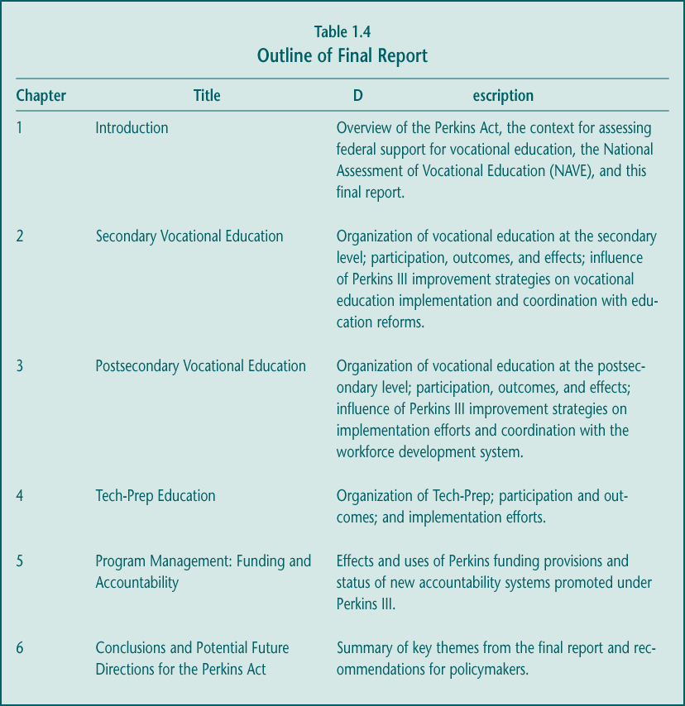

2. Secondary Vocational Education

Vocational education has long been a part of the American high school experience. From its origins as an alternative to the college preparatory curriculum, vocational education has become for most high school students a set of electives to be taken alongside required academic courses. As these academic requirements grow in number, rigor, and importance, the role of secondary vocational education—and of federal vocational education policy—may also be evolving.

This chapter aims to examine this issue by first describing how vocational education is organized (Section A) and then addressing four key research questions:

1. Has the nature of vocational course taking changed and who participates in it? (Section B)
2. How is vocational education implemented and to what extent are federal improvement strategies reflected in classroom practice and school organization? (Section C)
3. How well aligned is vocational education with other education reform efforts? (Section D)
4. How do vocational students fare both in and after high school, and does vocational education contribute to student outcomes? (Section E)

Key Findings

► Over the last decade, vocational students have made significant academic progress—both in their achievement and the number of credits earned—although there is little evidence that vocational course taking is responsible for these promising outcomes.
During the 1990s, students who pursued a focused vocational program of study (“occupational concentrators”) took more, and more rigorous, academic courses, and their average 12th-grade reading and math skills increased. By the end of the decade, the academic course gap between them and students with little or no vocational education had narrowed to less than 1.0 Carnegie credit. However, these improvements are likely due to higher academic graduation requirements and emphasis on upgrading academic courses. Analyses of high school student data and recent randomized controlled studies suggest that, on average, vocational courses and programs do not in themselves contribute or “add value” to academic achievement. Although the evidence is mixed, the most rigorous evaluations indicate that vocational education also has no effect on high school completion.

► Vocational courses probably neither hurt nor help students’ chances of entering or completing postsecondary education.
Vocational education has long been stigmatized as for the “noncollege bound” or as a deterrent to college, although NAVE finds neither concern well-founded. Higher proportions of occupational concentrators have enrolled in college over the last several decades. Moreover, analyses suggest that participating in vocational education has no effect on whether a student engages in postsecondary education or training, partly because many vocational students do enroll, just later than other students. However, vocational course taking is associated with a shift from earning a baccalaureate degree to earning an associate’s degree.

► The benefits of vocational education are clearer when examining its most longstanding measure of success—earnings.
Recent studies indicate a positive average effect of vocational education on annual earnings, measured just over a year or several years after high school graduation. Seven years after graduation, for example, students earned almost 2 percent (about $450) more for each additional high school vocational course they took, or just over $1,350 more for occupational concentrators. These benefits appear to extend to students who go to college, to those who have economic and educational disadvantages, to those with disabilities, and to both men and women; studies differ over whether there are earnings advantages for students who never attend college, an increasingly small group. Students who complete the “New Basics” academic curriculum as well as occupational courses earn more than similar students who complete the “New Basics” and little vocational education. However, the evidence is mixed on whether earnings benefits come from students’ working more hours or from higher wages. Moreover, the medium-run earnings advantage of high school vocational education is not likely to persist over time.

► Secondary vocational education is a large component of high school course taking but an increasingly smaller share of the overall curriculum.
Nearly every student (96.6 percent) leaves public high school having taken some vocational education, although the extent of involvement varies. By almost any measure, participation remained stable during the last decade after a period of decline in the 1980s, withstanding schools’ ongoing focus on academic improvement. While the amount of vocational course work taken changed little during the 1990s, students earned more academic credits, thus lowering vocational education’s share of the overall high school curriculum—from 21.8 percent in 1982, to 17.8 percent in 1990, to 16.2 percent in 2000. Still, high school students earn, on average, more credits in vocational education (4.2) than in math (3.5) or science (3.2).

► Vocational education students represent a diverse group, including those from special populations.
Vocational education serves an array of students, with most from the middle range of academic and income advantage. However, those who have disabilities or are male, come from lower-income or rural schools, or enter high school with low academic achievement participate more substantially than do other students. These patterns were generally stable during the last decade, although vocational education appeared to be attracting relatively more academically talented students. There was less progress on overcoming gender differences in the particular vocational courses students choose.

► Implementation of Perkins improvement strategies is progressing, with wide variation in their intensity.
Perkins III carried over program improvement strategies from Perkins II, several of which are being emphasized in high schools and area vocational centers nationwide. For example, articulation agreements and technology upgrades are growing. Integration of academic and vocational education remains a priority at the state level (accounting for nearly one-fifth of state leadership funds nationally) and is increasing locally, but is still neither broadly nor deeply implemented.

► Vocational education is responding to state academic reforms, with more consensus and action at the state than local levels so far.
Emphasis on academic reforms is prompting changes in vocational education in some states and communities. Many states have developed vocational curriculum guidelines, which increasingly include academic content. Local practice has not yet been broadly affected due partly to the lack of consensus among vocational teachers about their responsibility for improving academic outcomes. Other effects of reform include (1) more use of vocational course time for academic test preparation; (2) reports of reduced vocational enrollments where “high-stakes” assessments have recently been implemented; and (3) efforts by vocational administrators and initiatives (e.g., High Schools That Work) to promote smaller learning communities, alternative scheduling, and the elimination of the general education track. Moreover, Perkins remains the primary federal legislation that supports collaboration between secondary and postsecondary institutions, with the goal of encouraging more students to make successful transitions into college.

A. Organization of Vocational Education at the Secondary Level

Vocational education at the secondary level is a large and complex system. Like academic subjects, vocational courses are available at various grade levels and include both introductory and advanced offerings. But far more so than academic subjects, secondary vocational education is provided in diverse institutions. Understanding where and how vocational courses are offered provides important context for interpreting who participates in vocational education, how it is implemented, and what are its outcomes.

Secondary vocational education is provided in a variety of settings.

Because nearly all public high school graduates earn credits in vocational education, it follows that most secondary schools offer at least some form of career learning. Recent evidence suggests that at least 11,000 high schools, more than two-thirds of such schools nationally (Table 2.1), provide at least one of the common occupational programs. These schools include the following:

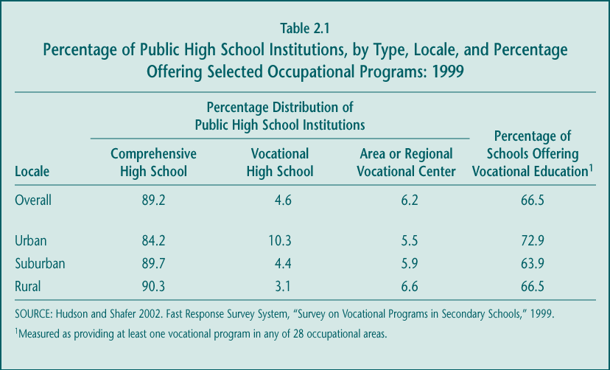

► Close to 9,500 comprehensive high schools: Comprehensive high schools typically have an academic focus, but some have large vocational programs. Charter schools, many of which have career or occupational themes, are also included in this category.

► About 1,000 vocational high schools: These schools emphasize vocational instruction but also offer the full set of academic courses required in a high school curriculum; students spend a full day at the school.

► About 800 area or regional vocational schools (AVSs): They usually provide only vocational instruction; students typically attend part-time and receive their academic instruction at their home high school.

Compared to comprehensive high schools, both types of vocational schools are considered to offer higher-quality occupational instruction because of their superior equipment and facilities and the greater depth and breadth of training these specialized institutions provide. However, most secondary vocational education is provided in comprehensive high schools (Boesel et al. 1994b, p. 3), with some courses also offered in middle schools.

Secondary vocational education encompasses three types of courses.

Regardless of where it is offered, secondary vocational education comprises three types of courses (top of Figure 2.1):

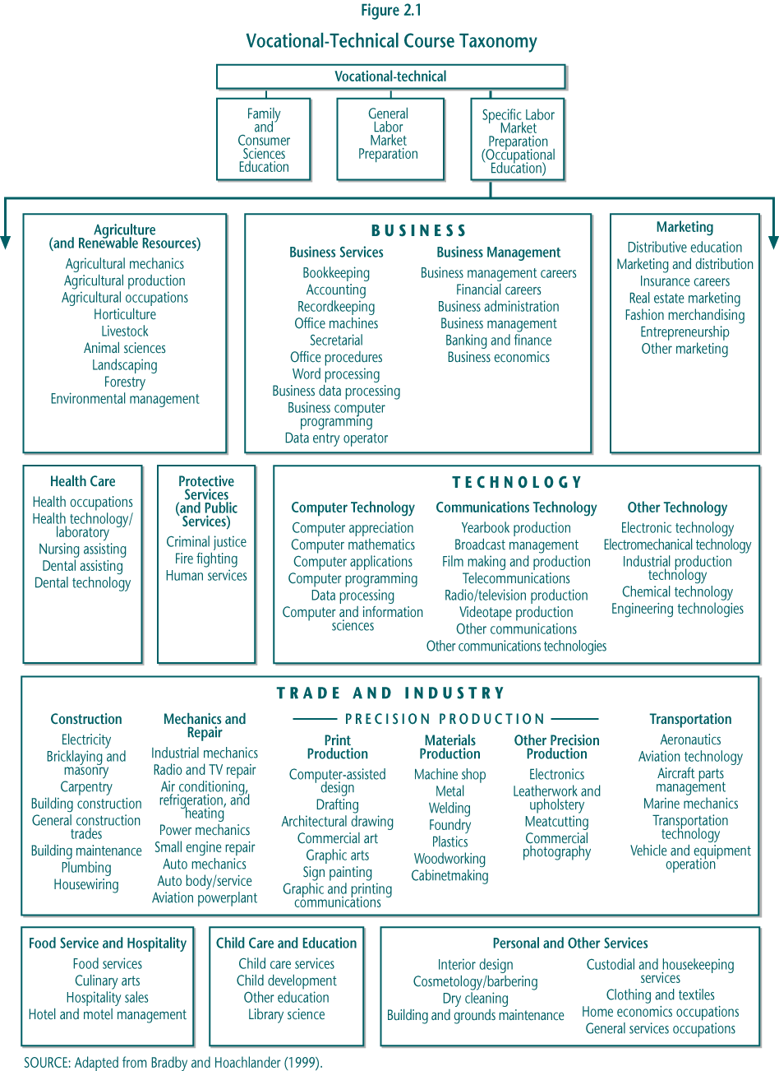

► Specific Labor Market Preparation (“occupational education”): Teaches skills and knowledge required in a particular occupation or set of related occupations—such as health, business, and food service and hospitality—included in the 10 broad occupational program areas defined by the National Center for Education Statistics (NCES), some with subspecialty areas. This category includes cooperative education, in which students earn school credit for work experience related to a specific occupational program.

► General Labor Market Preparation (GLMP): Provides general employment skills that are not specific to any particular occupational area, such as courses in typing or keyboarding, introductory technology education, career education, and general work experience.

► Family and Consumer Sciences Education (FCSE): Intended to prepare students for family and consumer roles outside the paid labor market, including consumer and home economics.

These courses can be expected to attract different types of students across various grade levels.

The sequence and organization of vocational courses vary for each student.

Vocational education is an option for high school students. With input from parents, students choose to enroll in a vocational high school or area vocational school, if one is available; at comprehensive high schools, they choose to take vocational courses in place of study hall or other elective offerings, such as art, music, or more advanced academic courses. The elective nature of vocational education has important implications for policy because efforts to improve the rigor or structure of vocational education will likely affect how many and which students participate.

Students can also choose to, and do, take vocational courses in varying numbers and with different objectives in mind. Many schools offer sequences (“programs”) of related, increasingly advanced courses in one or several specific occupational areas (e.g., health, drafting, child care). However, actual course taking does not necessarily follow these organized offerings. Most vocational courses and programs have no prerequisites, with students being free to enroll in courses across occupational areas and levels, although some choose to focus on a single occupation (Boesel et al. 1994b, pp. 85–87). The exceptions are specialty career preparation programs like career academies and youth apprenticeships, in which students’ decisions to enroll are at least tentative commitments to follow the programs’ defined sequences of vocational and academic courses.

Because involvement in vocational education varies, it is difficult to identify a group for evaluation purposes whose participation and outcomes would be best to measure. There are several possibilities:

► Vocational Course Taker: Graduate earning any credits in any form of vocational education

• Occupational Investor: Graduate earning three or more credits in occupational courses, regardless of how these credits are organized; made up of two subgroups (concentrators and explorers).

• Occupational Concentrator: Graduate earning three or more occupational credits but in a single program area (e.g., health care or business services).

• Occupational Explorer: Graduate earning three or more occupational credits but in more than one program area (e.g., business services and agriculture).

Previous research has focused on “occupational concentrators”—students who take three or more credits (corresponding to approximately three, year-long, single-period courses) within a single occupational program area. This group of students has received attention because they are the closest proxy to program completers and are thought to be most intent on preparing for a job or career.

From a policy perspective, however, concentrators are not the only group of interest. The larger population of all students (44.5 percent) who earn three or more occupational credits, of which concentrators are a subset, is also important. Perkins grants are distributed to institutions—districts and schools—to fund courses and programs not individual students. Therefore the federal investment is similar whether students concentrate their vocational course taking in a single occupational program area (26.0 percent) or “explore” across several areas (18.5 percent). Together, concentrators and explorers account for the vast majority of credits earned in vocational or occupational education. Each of these groups was examined in NAVE analyses.

B. Access and Participation

For the last several decades, virtually every student has left high school having completed at least one vocational course and some have taken many. Some aspects of vocational participation are changing, however. School reforms, evolving social and economic conditions, and other factors are helping to shape the availability of and interest in vocational education programs. Patterns of participation provide some indication of the vitality of vocational education at the secondary level and the extent to which these courses and programs serve populations of policy interest.

1. Overall Trends in Vocational Education Enrollments

Enrollment trends reflect both continuing interest in vocational education and its changing role. How much, and how, students participate over time is one signal of the future direction of career preparation in high schools.

There is little evidence of an ongoing drop in students’ participation in vocational education.

A common concern in the vocational education community has been that increasing college aspirations and emphasis on academic improvement might reduce students’ participation in vocational education (Levesque et al. 2000). However, at least through 2000, students’ involvement has not decreased as dramatically as predicted. The most commonly used measure of participation indicates that the decade of decline through the 1980s appears to have leveled off; the share of occupational concentrators fell substantially between 1982 and 1992 but has been fairly steady since then, at about one-quarter of all high school graduates (Figure 2.2). That figure translates into more than 725,000 students nationally who have pursued what might be called a “vocational program of study.”

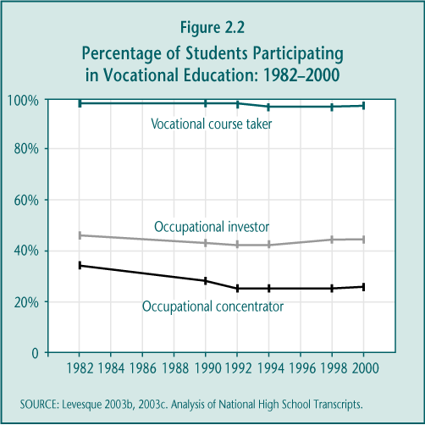

Perhaps more importantly, researchers have typically ignored the larger share of students who take at least 3.0 occupational credits (“occupational investors”), of which occupational concentrators are only a subset. Examining the trends in this broader measure suggests that, in fact, there has been little change over the past 15 years. Between 42.0 and 46.2 percent of all high school graduates since 1982 have invested in vocational education in this way, or more than 1.2 million seniors in 2000 (see footnote 5). In part, this level of participation in occupational courses has been maintained because increasing numbers of students are taking at least one computer technology course, at the same time that enrollments in some other occupational program areas have declined.

Secondary vocational education is a large component of high school course taking but an increasingly smaller share of the overall curriculum.

Despite relatively stable student participation rates over the last decade, however, vocational education is becoming a smaller share of the way students spend their time in high school (Figure 2.3). The number of average credits earned in vocational education fell from 4.7 in 1982 to 4.2 in 1990 (mostly the result of fewer keyboarding or typing classes in high school) and remained steady at between 4.0 and 4.2 through 2000. At the same time, academic credits increased substantially—from 14.3 to 18.8, making total credits rise. As a result, vocational education’s share of total credits dropped from 21.8 percent in 1982 to 17.9 percent in 1990 and to 16.2 percent in 2000.

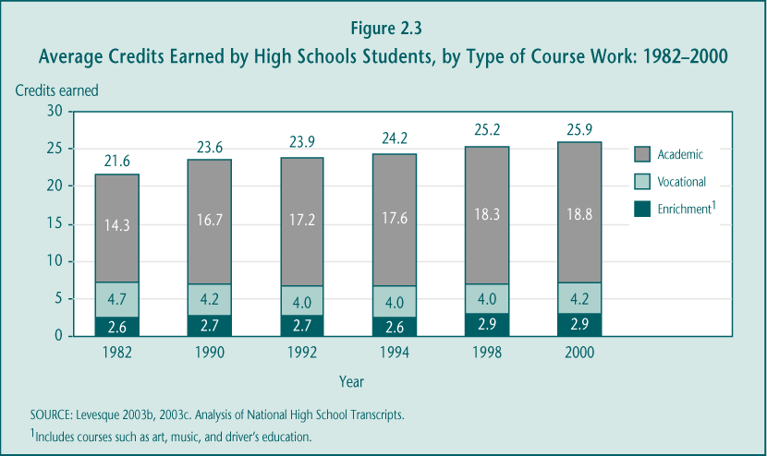

Despite the overall declining share of vocational education credits, high school students still earn more credits in vocational education (4.2) than in math (3.5), science (3.2), or social studies (3.8) (Figure 2.4). Moreover, in 2000, the 4.4 English credits students earned on average are not statistically different from the credits they earned in vocational education. These findings are particularly striking, given the emphasis that has been placed on academic reforms and higher graduation requirements during the last two decades.

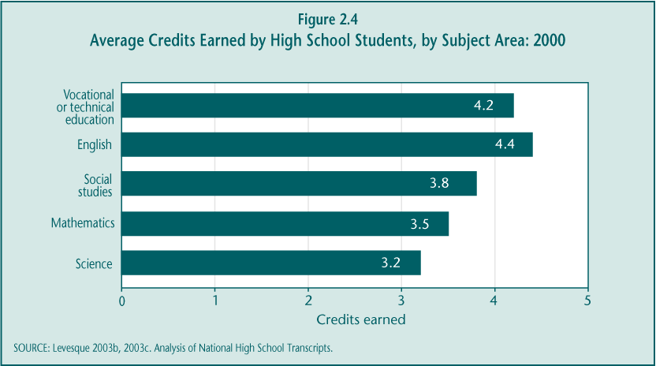

Students may now be taking vocational education for different reasons.

Historically, students enrolled in vocational education to prepare for entry-level jobs after high school. Meeting this objective called for developing skills in a particular occupational area and likely encouraged students to “concentrate” their course taking as a way to maximize their appeal to potential employers. Federal law, particularly in Perkins II and III, supported this goal by promoting school implementation of, and student participation in, “sequences” of related vocational courses.

Despite these efforts, however, the clear trend in vocational course taking has been toward “exploring” across occupational program areas rather than “concentrating” (Figure 2.5). Among students who earn at least 3.0 occupational credits (investors), concentrating was a less common way to organize course work in 2000 (58.3 percent) than it was in 1982 (72.8 percent), when a higher proportion of students were taking three or more credits in multiple program areas. Similarly, students were much less likely to take advanced course work in their area of concentration than in 1982 (Levesque 2003b).

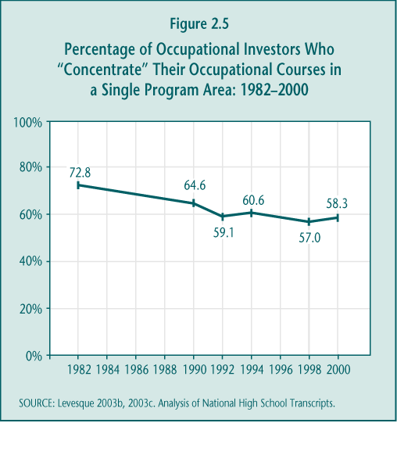
These data suggest that fewer students may now view developing skills in a specific program area as their main objective for enrolling in vocational education. Focus group discussions with students in vocational courses suggest a variety of other reasons for their participation: to gain career exposure, to help them select or prepare for a college major, to use as a fallback if college or other career plans fail to materialize, to pursue a leisure interest, or to take courses that present less of an intellectual challenge than do other courses (Table 2.2).



There are also several possible, alternative explanations for the change in vocational course-taking patterns. First, there is some evidence that schools may be increasingly less likely to offer full sequences of related courses, perhaps choosing to trade depth in the programs they offer for giving students more breadth across program areas (Branch forthcoming). It is also possible, however, that recent vocational course taking reflects broader conceptions of career preparation. Students may be organizing what appears to them and to their counselors to be a logical sequence of occupational courses representing different program areas as classified by NCES. For example, a student who wants to run a landscaping firm might appropriately enroll in both agriculture and business courses, while a student interested in pediatric nursing could view both child care and health care skills as important preparation for later college courses.

As of yet, the full effects of school improvement policies on vocational participation have not been felt, but future declines are possible.

Most of the decline in vocational course taking occurred between 1982 and 1990, before many would consider the policies associated with academic reforms fully implemented. During the decade of reform since then, vocational participation in the aggregate remained relatively stable, suggesting that these efforts have not had much of an effect on vocational enrollments. Looking beyond tabulations of the aggregate participation measures tells a slightly different story, however, which foreshadows possible declines in future vocational education course taking.

► Course graduation requirements increased only slightly during the 1990s and not across the board. While the 1990s often have been referred to as the “decade of school reform,” certain reform policies that might be expected to affect vocational participation were not as evident during this period. Between 1980 and 1990, approximately 39 states increased their total course graduation requirements, and participation in vocational education did decline substantially during that time. However, only 12 states increased their graduation requirements between 1990 and 1998 (Education Commission of the States 1990; Snyder et al. 2001).

Moreover, the six states that increased their requirements by 2.0 credits or more between 1990 and 1998 exhibited (1) a significant decrease of 1.0 vocational credits earned by high school students and (2) a decline of 9.6 percent in the proportion of occupational concentrators, both statistically significant results (Table 2.3). Many factors could account for this decline in vocational participation in these states, but the significant increase in graduation requirements is certainly a strong hypothesis. Further efforts to raise graduation requirements may well reduce participation in vocational education.

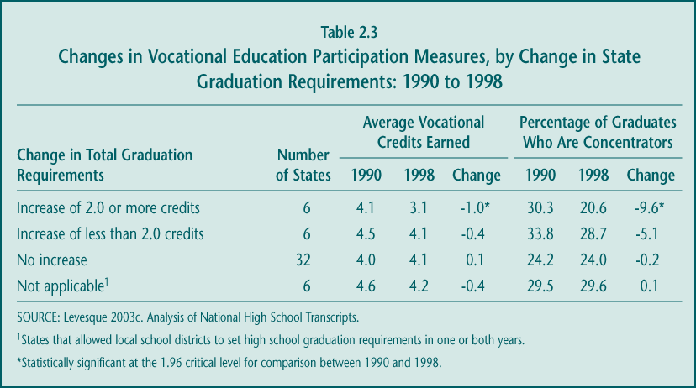

► Students mostly maintained their participation in vocational education by expanding the total number of credits earned. Nationally since 1990, high school students greatly increased their academic course taking, while vocational credits remained relatively steady. If the increase in academic credits reflects schools’ emphasis on academic improvement, vocational course taking might have fallen further, if not for the fact that students could make room for additional academic courses by increasing their total credits earned. However, such expansion may have reached its limits by 2000; students on average earned a total of 25.9 credits, out of a likely 28 possible credits in a traditional school schedule (Figure 2.3). On the other hand, alternative “block-scheduling” approaches may allow students to increase their total credits further.

► Shifts in vocational course taking do not yet reflect an emphasis on preparation for academic assessments. A major reform policy that could have a direct effect on vocational participation is the introduction of state assessments for graduation. By the 1998–1999 school year, nearly 20 states had introduced exit exams required for high school graduation, typically offered first at the end of 10th grade so that students who fail have several opportunities to retake the tests (Council of Chief State School Officers 2000). One hypothesis was that schools would increasingly focus students in the early high school grades on academic courses and preparation for the assessments, potentially crowding out vocational courses until later in the high school years. Such a shift was not evident between 1990 and 1998, however. During that period, vocational credits earned in 11th grade declined somewhat. As a result, students were taking a similar, or slightly higher, share of their vocational credits before the typical 10th-grade state assessment (Figure 2.6).

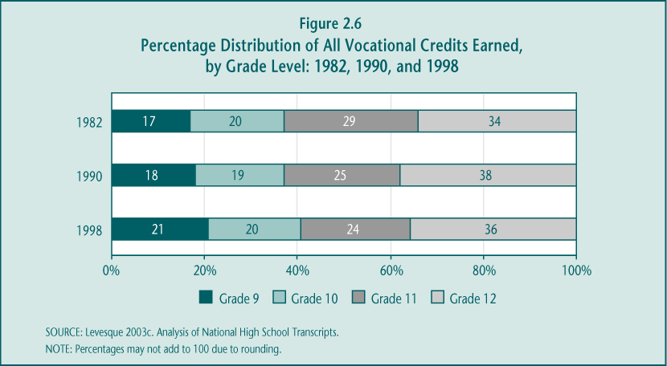

These patterns may reflect the fact that, at the end of the decade, relatively few states had yet phased in the consequences for students who passed or failed to pass statewide assessments. The aggregate decline in 11th-grade vocational participation is more likely due to increased graduation requirements in those 12 states that raised them, leading to more academic rather than vocational course taking in grade 11. However, under the No Child Left Behind Act of 2001, all states must assess students’ academic skills at least once during high school and states must first identify, and then ultimately may sanction, schools receiving federal funds that fail to improve aggregate test scores over time. As assessments become more fully implemented, and if states maintain their high standards for passing, the hypothetical decline in vocational participation is much more likely.

2. Participation by Type of Vocational Course Work

Examining vocational education by type of course is important for several reasons. First, different categories of vocational education may yield different benefits for students. For example, there is a presumption about the quality of vocational programs in various fields: program areas that prepare students for jobs that require high skills and pay high wages are generally considered more beneficial than those that prepare students for jobs with fewer skill demands and lower pay. In addition, policymakers have long been concerned that students who invest in vocational education be able to find jobs. Therefore, some match between vocational program offerings and labor market needs is desirable.

Changes in participation by occupational program are consistent with labor market trends.

Policymakers have long called for stronger linkages between employers and vocational educators, in part to ensure that the availability and quality of vocational programs reflect employer needs. Perkins III, for example, authorizes funding for national and state-level entities to coordinate and disseminate occupational and employment information. However, labor market demand may do more than influence administrative judgments about program offerings: students may be more likely to take courses or concentrate in vocational program areas that prepare them for occupations with increasing job opportunities.

A recent NCES analysis (Hurst and Hudson 2000) supports the hypothesis that vocational course taking may respond somewhat to labor market demand (Figures 2.7a and 2.7b). A substantial portion of the change occurring in the proportion of concentrators in specific occupational program areas between 1982 and 1998 appears to coincide with projected job growth from 1983 to 1996:

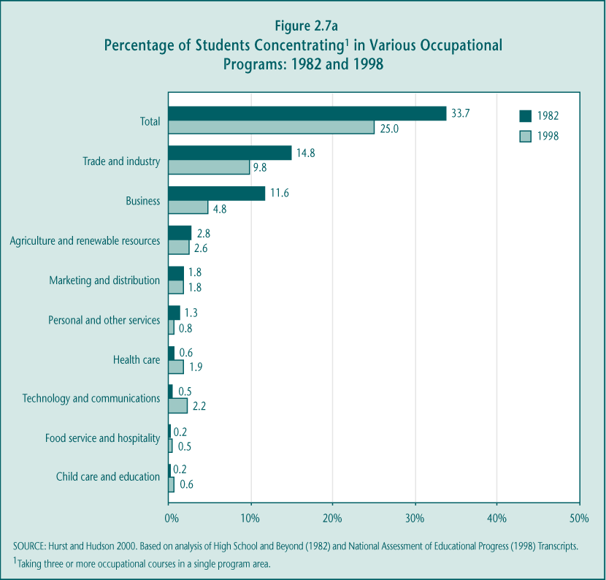

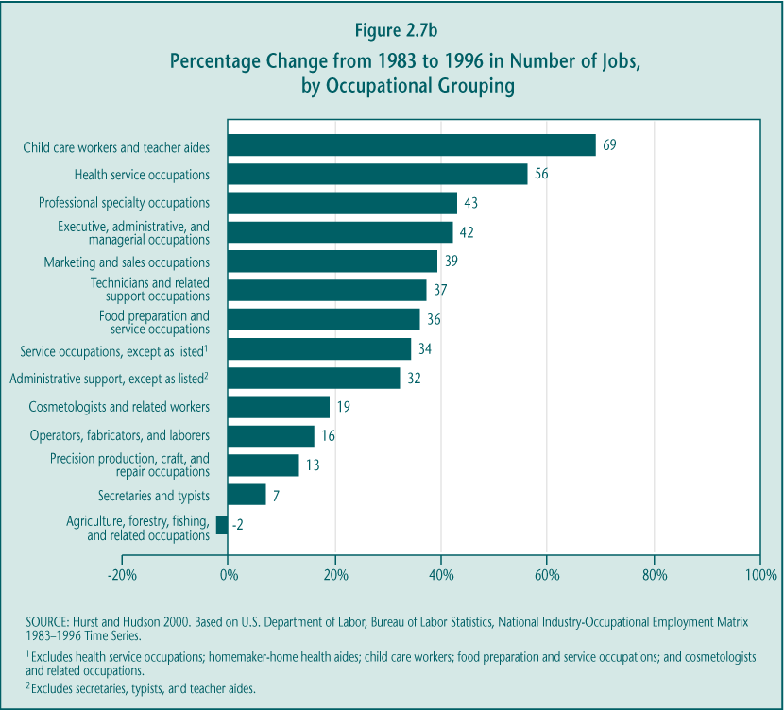

► Increases in enrollment and job growth in four key areas. Four programs experienced the largest gains in the proportion of concentrators: health care, child care and education, food service and hospitality, and technology and communication. During the same period, the corresponding job categories—health service occupations, child care workers and teacher aides, food preparation and service occupations, and technicians and related support occupations—had higher than average employment growth.

► Decreases in trade and industry and business. The largest declines in occupational concentrators were in the trade and industry and business program areas; these areas approximately correspond to occupations that had experienced below average projected growth rates since the early 1980s.

While some responsiveness to employment trends is desirable, it is worth noting that a substantial share of the recent growth in vocational participation and jobs has been in low-wage sectors. There can be great variation in wages and earnings within each occupational grouping, particularly in the technology and communications fields. However, recent data indicate that in 2000, average annual earnings were $21,040 for health care support workers, $16,070 for food preparation and service workers, $18,770 for teacher assistants, and $16,350 for child care workers (Bureau of Labor Statistics 2001). These occupations are certainly important to society, but the data provide little evidence that vocational education is concentrating on preparing individuals for jobs that require high skill levels and pay high wages as promoted in Perkins III (Section 122(c)(1)(c)).

Participation in cooperative education and other work experience programs remains steady.

Opportunities for students to obtain work experience as part of their vocational training have existed since the early 20th century. Many years later, throughout the 1990s, just under one-third of all high school graduates enrolled in work experience courses for credit (Table 2.4). Both the rates of student participation and the average credits earned in these courses remained stable during the decade. Participation was divided relatively evenly between general work experience activities, which are typically unconnected to a student’s occupational program, and more formal cooperative education (co-op) experiences in which students are generally expected to alternate work placement and class time related to their occupational course work. These figures suggest that approximately 435,000 high school graduates participated in co-op experiences, a number consistent with that reported in the previous NAVE (Boesel et al. 1994b).

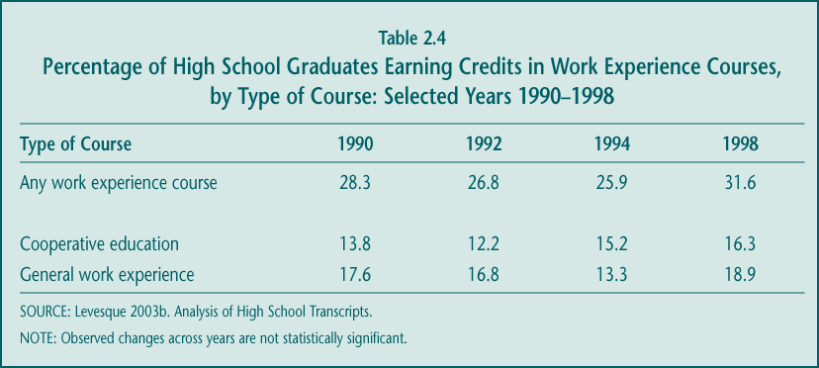

3. Characteristics of Participants: Special Populations and Other Students

Who participates in vocational education has been a continuing policy concern. While federal legislation in the 1960s and 1970s aimed to improve access to vocational education for certain special populations, the current debate is whether vulnerable groups are overrepresented in and well-served by vocational education. Some previous reports suggested that, by the early 1990s, vocational education had come to be stigmatized as a high school track for students with low levels of academic achievement, special needs, or behavioral problems (Boesel et al. 1994b).

During the last decade, however, career education has been given new prominence by several initiatives targeted to students other than those traditionally served by vocational programs. In addition, some states and districts have worked to strengthen the appeal of vocational courses—for example, moving away from training for what used to be considered blue-collar jobs, such as manufacturing, secretarial work, and child care, toward programs in pre-engineering, information technology, and education.

Policymakers and educators remain committed to providing students from special populations access to vocational education. However, many believe that the quality of vocational programs is unlikely to improve without attracting a broader segment of the student population or that the participation of a more diverse set of students will signal that quality improvements are being made.

For these reasons, it is important to examine the characteristics of students involved in vocational education. While a variety of characteristics were analyzed for the purposes of this report, particular attention was paid to those that define the special population groups named in Perkins III (P.L. 105-332, Section 3(23)) and that can be identified in available data (Table 2.5). The participation of two other groups defined in the law—single parents and displaced homemakers—could not be addressed with the current data and are probably more important to examine at the postsecondary level.

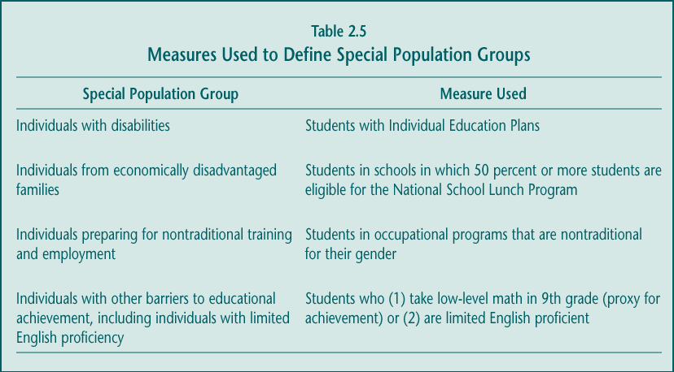

Vocational education continues to serve a somewhat disproportionate share of students with disabilities and does so in the more traditional program areas.

In 1998, students with disabilities represented 2.8 percent of all high school graduates, but 4.2 percent of all occupational concentrators (Levesque 2003a). As in previous years, these students were much more likely to become concentrators (37.5 percent) and to earn substantially more credits in vocational education (5.9 credits) than did students without disabilities (24.6 percent and 3.9 credits) (Table 2.6). In fact, students with disabilities took a much higher share of their total credits in vocational education (23.5 percent) than did other students (15.7 percent) (Levesque 2003a). This course taking emphasis may shift as the No Child Left Behind Act becomes fully implemented and states are required to more consistently include special needs students in academic assessment reporting.

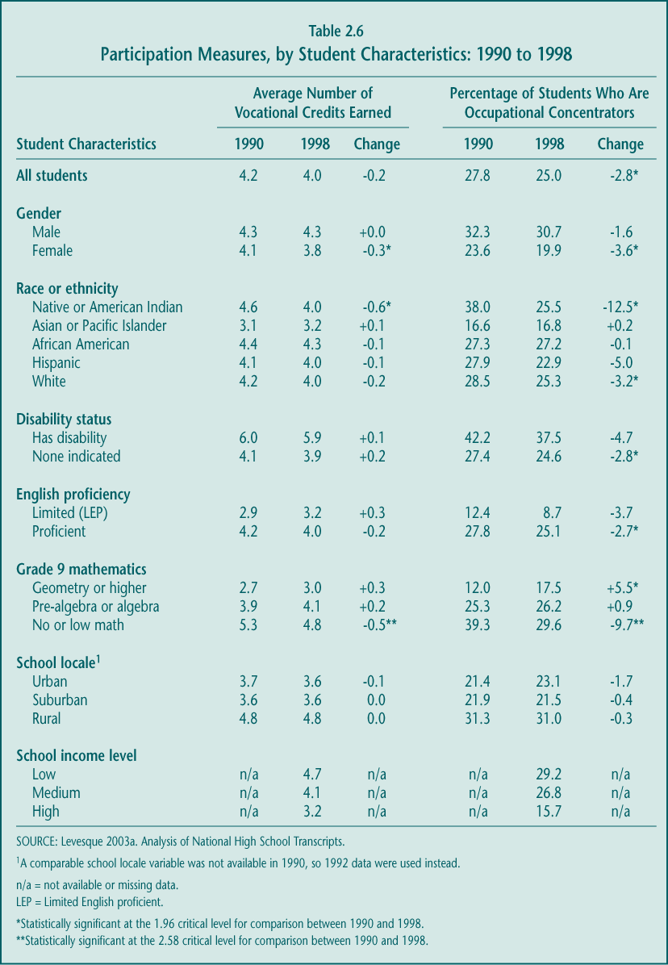

There is little recent support, however, for a prediction made in a report produced under the previous NAVE (Boesel et al. 1994a) that students with disabilities are becoming more concentrated in vocational education. Although data between 1982 and 1990 show a modest trend in that direction, it is not sustained during the 1990s. In addition, with special needs students accounting for less than 5 percent of all concentrators nationally, the notion of vocational education in general as a “dumping ground” for these students is not warranted. Moreover, although students with disabilities are overrepresented in some of the more traditional vocational program areas—e.g., agriculture, construction, mechanics and repair, and materials production (Table 2.7)—some of these areas prepare students for occupations with substantial job growth, earnings, or both. For example, automotive mechanics, electricians, and welders all had earnings in 2000 above the median and are projected to experience above average employment growth as well (Bureau of Labor Statistics 2001).

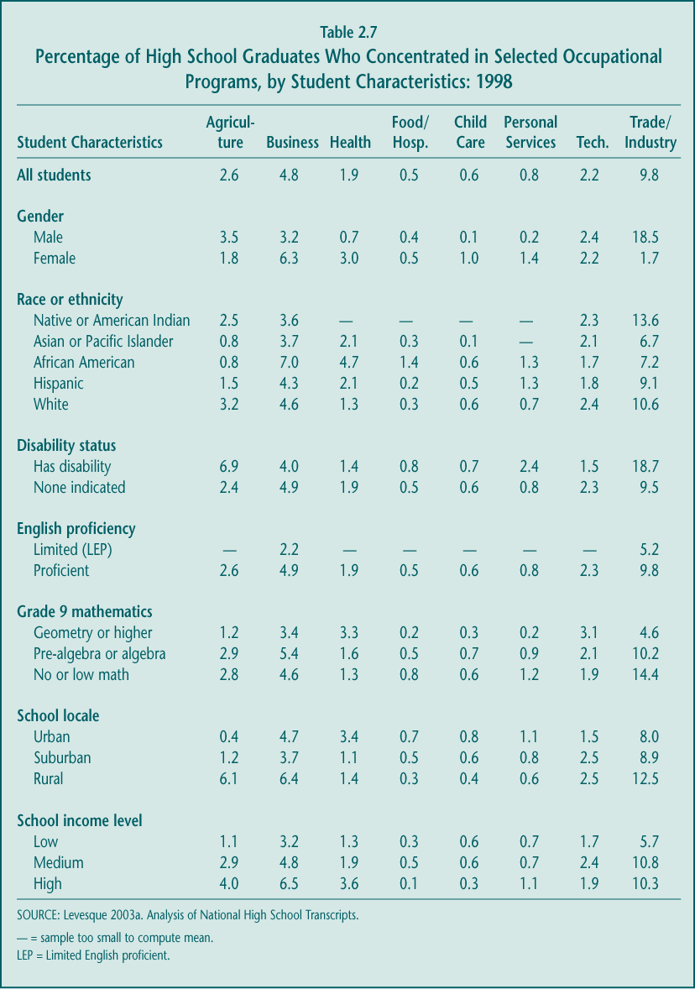

Participation in vocational education is highest in low-income schools.

Despite reform efforts during the 1990s that targeted low-income schools for academic improvement, students in these schools were taking more vocational education than students in the most advantaged schools. In 1998, students in schools with more than 50.0 percent of students eligible for the federal free or reduced-price lunch program earned 4.7 vocational credits, while students in schools with 5.0 percent or less eligible for this program earned only 3.2 credits. Students in “moderate-income” schools earned 4.1 vocational credits, an amount that is statistically similar to that for students in the lowest-income schools. The proportion of students who concentrate in an occupational program also follows this pattern. Changes in either the average vocational credits earned or the percentage of concentrators between 1994 and 1998—the only years for which comparable data on school poverty are available—are not statistically significant.

While students in low-income schools are involved in vocational education at high rates, their participation does not appear to be concentrated in the traditional vocational program areas or in those that prepare students for generally low-wage jobs. That is, economically disadvantaged students are no more likely than more advantaged students to concentrate in construction, materials production, mechanics and repair, personal and other services, or food service and hospitality. Moreover, disadvantaged students are as likely, if not slightly more likely, to concentrate in the growing fields of health care and computer technology.

Some progress has been made, although substantial disparities remain, in students’ participation in vocational education by gender.

Overall the vocational course taking of females has declined since 1990, while their academic course taking has risen substantially. In 1998, females earned a lower share of their total credits in vocational education (14.9 percent) than did males (17.1 percent). This difference in course taking is consistent with the higher levels of reading achievement and rates of college attendance for young women, compared to young men in 1998 (Wirt et al. 2000, p. 23 [Indicator 13] and p. 49 [Indicator 32]).

On average, high school preparation for occupations and careers has become neither more nor less gender balanced, despite the goals of Perkins gender equity provisions. Females still dominate enrollments in programs that prepare students for occupations such as health care, child care and education, and personal and other services (e.g., cosmetology). Males continue to dominate participation in agriculture and the traditional trade and industry programs (e.g., construction, mechanics and repair, print and materials production), fields that generally command higher wages than those for which female high school students prepare. However, there are two notable program areas in which the gap in participation rates between males and females appears to have narrowed:

► Computer technology: The gender difference in credits earned in computer technology has become smaller. In 1998, females earned .30 credits, while males earned .32 credits, a statistically insignificant gap of 6.7 percent, down from 17.9 percent in 1990. This narrowing of the gap was accomplished largely by an increase in the rates of participation in this vocational field among females, while those of their male peers remained relatively steady.

Despite this progress, there is evidence that females’ rates of participation in computer technology courses are not evenly distributed. A case study of popular new information technology (IT) certification courses organized by such firms as Cisco, Microsoft, and Novell, and implemented in high schools and vocational schools nationwide, suggests that females are underrepresented in these courses. Among the 10 schools with IT programs included in the study, females made up only 10 percent of the participants. A potential explanation for the low participation rates of females is that these particular IT courses are geared toward networking, a subfield of computers that has traditionally attracted more males (Haimson and Van Noy forthcoming).

► Business services: A reverse trend has occurred in business services. Females have become increasingly less likely, while males have become more likely, to concentrate in this program area. One hypothesis is that interest in secretarial training has declined, while computer-related business courses (e.g., spreadsheets, business data processing), which might have more appeal to males, have become increasingly available.

Students in rural schools are more likely to be involved in vocational education than are students in other locales.

As historically has been the case, vocational education is more prevalent in small, generally rural communities than in other locales. Although rural schools serve 32.3 percent of all public high school graduates across the nation, these same schools serve 40.1 percent of all occupational concentrators. In contrast, urban and suburban schools account for 26.2 and 33.8 percent of concentrators, respectively (compared to 28.4 percent and 39.3 percent of all graduates) (Levesque 2003a). The numbers of vocational credits earned remained steady across all types of locales since 1990, but students in rural schools still earned more credits (4.8) in 1998 than did students in urban and suburban schools (each group averaged 3.6 credits) (Table 2.6).

Not surprisingly, given differences in local labor markets, rural students tend to focus their vocational studies in different occupational programs than do urban or suburban students (Table 2.7). A much higher share of rural students concentrate their vocational course taking in agriculture and, to a lesser extent, in construction and business than do students who live in other locales. On the other hand, rural students are less likely to concentrate in marketing, food service and hospitality, and personal and other services—all occupations with relatively low annual earnings. Rural students are also much less likely than urban students to concentrate in the growing field of health care, although they do so at rates similar to those of their suburban peers. In other occupational program areas, there are no statistically significant differences among students who live in urban, suburban, or rural areas in terms of the extent to which they concentrate in these fields.

African American students participate in vocational education somewhat more, and Asian students somewhat less, than students in other racial or ethnic groups.

There is little evidence of any statistically significant change in participation in vocational education by race or ethnicity during the last decade (Table 2.6). However, in 1998 African American students earned more credits in vocational education (4.3 credits) and Asian students earned fewer credits (3.2) than did students from other racial or ethnic groups (4.0 credits each for Hispanic, white, and Native American students). Among all students in 1998, African Americans earned a higher share of their total credits in vocational education (17.4 percent) than did Asians (12.6 percent), and Asian students earned a lower share than did students from all other racial and ethnic groups (Levesque 2003a).

There were also some differences according to race and ethnicity in terms of the specific programs in which students participated during the last decade (Table 2.7). African American students, for example, were more likely to concentrate their vocational studies in health, food service and hospitality, personal services (such as cosmetology) and business services—occupations with projected job growth but below average earnings—and less likely to concentrate in agriculture. Comparatively high proportions of Hispanic students concentrated in agriculture, marketing, personal services, and health. Asian students were most likely to focus their course taking in health programs and much less likely to do so in agriculture or trade and industry programs, including construction.

Students with limited English proficiency (LEP) are much less likely than other students to participate in an occupational program.

The participation of LEP students in vocational education has fluctuated since 1990 (when data on this group first became available), perhaps because the small sample of these students who can be identified in the data makes trend analysis less reliable. However, the data indicate that LEP students in 12th grade earned significantly fewer credits in vocational education (3.2) in 1998 and were much less likely to be occupational concentrators (8.7 percent) than were 12th-grade students with English language proficiency (who earned 4.0 credits and of whom 25.1 percent were concentrators) (Table 2.6).

Vocational education may be attracting more academically talented students than ever before.

During the past two decades, students overall entered high school more prepared to take higher-level math than they had been previously. In large part, this trend is due to the higher proportion of students taking algebra in middle school—one consequence of the efforts of many states to raise academic standards.

Students who become occupational concentrators are no exception to this trend. Proportionally more concentrators entered high school taking high-level ninth-grade mathematics (geometry or higher) in 1998 than in 1990, an increase similar to that of non-concentrators (Table 2.6). Perhaps more importantly, the increase in middle-level ninth-grade math course taking (pre-algebra and algebra 1) was greater for occupational concentrators than for other students. Conversely, the proportion of occupational concentrators taking low-level mathematics in ninth grade declined more between 1990 and 1998 than did the proportion of other students taking low-level math.

These trends suggest that, over time, vocational education may be serving relatively more academically advantaged students. Certainly, data from a NAVE collaboration with Texas and Florida suggest that the eighth-grade test scores of 1998 concentrators were relatively evenly distributed across quartiles of achievement—indicating that vocational education in those two states is drawing an academically diverse group of students (Hoachlander et al. forthcoming). These patterns are consistent with efforts during the 1990s to broaden the appeal of vocational education, as described in Chapter 1.

Overall, the data indicate that vocational education serves a diverse group of students, with most coming from the middle range of academic and income advantage. As described, some groups of students are more likely to participate substantially, although most characteristics of the vocational student population were relatively stable throughout the 1990s (Table 2.6). These participation patterns may be viewed as reassuring or of concern, depending on whether vocational education improves student outcomes in general and specifically for those who participate at high rates (discussed later in this chapter).

4. Access to Vocational Education

For the past several decades, federal legislation has sought to ensure that students have equal access to vocational education activities. Perkins III does so as well, in part by requiring states to report on the participation and performance of students in the legislated special population groups. Such information cannot tell the whole story, however, because participation, overall and by subgroup, is a function of both students’ interest and the courses schools choose to offer. The latter is more important in determining whether students with diverse characteristics and backgrounds can actually participate in vocational education.

With nearly all high school graduates earning at least 1.0 vocational credit, issues of equity are increasingly about access to high-quality vocational education rather than vocational education in general. While there is little research that conclusively identifies the characteristics of vocational program quality, as described in the next section, the Perkins legislation and the vocational education community identify promising strategies and practices considered to promote student success (Table 2.8). The breadth and depth of vocational program offerings in a school is also an important component of access. The availability of some of these efforts for particular groups of students is described below.

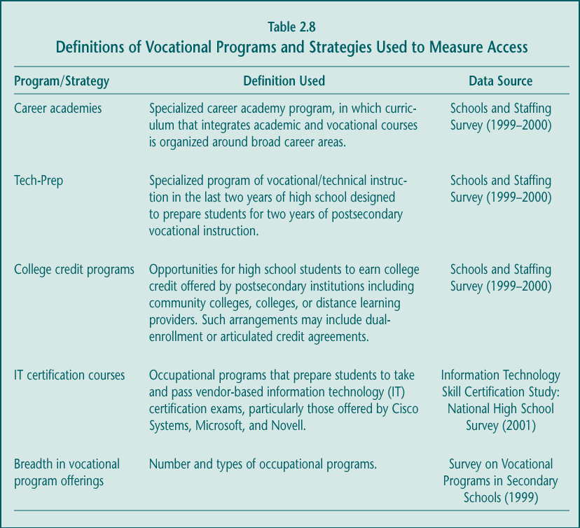

Students in schools with high concentrations of poverty and students from racial or ethnic minority groups have less access to some, but not all, vocational programs and practices presumed to be of high quality.

Congressional concern about access has typically focused on underresourced schools, many of which also serve high numbers of students from racial or ethnic minority groups. Particularly high participation rates among racial or ethnic minority students and those in low-income schools (see earlier section) suggest that their access to vocational education in general is not limited. However, some specialty career preparation programs and strategies are not as available to these students. Compared to schools with poverty levels in the middle range (those with between 5 and 50 percent of students eligible for the federal free and reduced-price lunch program), schools with high concentrations of poverty are less likely to offer Tech-Prep, workplace activities for credit, and college credit for courses completed in high school (Table 2.9). Schools with high proportions of racial or ethnic minorities follow the same pattern.

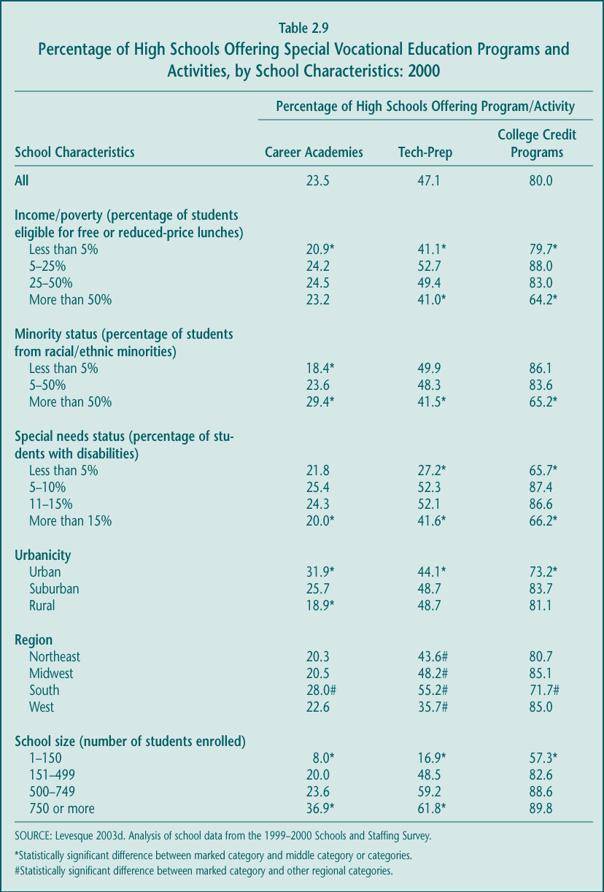

At the same time, however, schools with high concentrations of poverty and racial or ethnic minorities are as likely as more advantaged schools to offer other popular vocational strategies. For example, access to career academies is similar across schools with different poverty levels. Moreover, a new study of IT certification programs suggests that students from low-income and minority racial or ethnic backgrounds have as much access to these courses and programs as do students from other backgrounds (Haimson and Van Noy forthcoming). Without evidence of the effectiveness of the different programs and practices, it is not possible to draw conclusions about the relative disadvantage that low-income and minority students face in pursuing vocational education.

Compared to urban and suburban schools, those in rural areas offer fewer specialty programs.

Conventional wisdom suggests that because rural schools, and the local labor markets they serve, are smaller, they are less able to offer a diverse set of vocational options. Such a perception is generally true, according to the data. Schools in rural areas are much less likely than those in suburban and urban areas to offer career academies (18.9 percent, compared to 25.7 and 31.9 percent, respectively). IT certification programs are also less available in rural areas: rural schools make up 38 percent of all high schools nationally but only 28 percent of the schools that offer IT programs (Haimson and Van Noy forthcoming). Moreover, according to a recent NCES issue brief, rural schools offer fewer different occupational programs (an average of 3.7) than do suburban and urban schools (approximately 4.8 each) and are less likely to make programs available for fast-growing occupations such as computer technicians, graphic designers, nurses, or food service managers (Hudson and Shafer 2002).

Urbanicity is much less a factor, and rural locale less a disadvantage, in a school’s likelihood of offering Tech-Prep and course work for college credit (Table 2.9). However, the more limited availability of vocational offerings in rural areas suggests that distant learning strategies may become a more attractive option for schools in those areas.

Schools with high concentrations of special needs students are somewhat less likely than other schools to make special career-prep programs available.

Overall, students with disabilities participate substantially in vocational education relative to their representation in the high school population. However, schools with high proportions of special needs students (more than 15 percent) are less likely than most other schools to offer the special programs and strategies presumed to reflect high-quality vocational education, including career academies and Tech-Prep (Table 2.9). On the other hand, these activities are also less available in schools with few special needs students (less than 5 percent), many of which are special admissions schools that screen for academic performance and emphasize enrollment in selective four-year colleges.

Students may not have access to their first choice of vocational courses or to a full sequence of courses in their preferred career area.

The issue of access to vocational education has various dimensions, including whether students can actually take the courses they want and in which they are interested. Whether students are either fully informed about their choices or committed to a particular program area is unclear. However, some evidence suggests that they face barriers to pursuing their preferences. For example, focus group discussions conducted with vocational students in 2002 indicate that the courses they had planned to take were often eliminated unexpectedly, particularly the more advanced courses in a sequence. In fact, some appeared to end up in courses for reasons that had little to do with their professed interest in an occupational area. The following quotes from students illustrate what appeared to be a frequent situation for students who were interviewed (Branch forthcoming):

I was taking cosmetology [courses], but they cut [them] so I was only in [them] until the 10th grade.
I wanted to be a chef. When [those courses] got cut, I wanted something challenging so I chose CAD.

They [enrolled me in] child care [courses], which I didn’t want, when cosmetology was cut.

I came here because they were supposed to have auto tech, but it had been dropped by the time I came. I ended up taking building maintenance, which they also dropped, so I got stuck with computers.

I was in cosmetology, but it was dropped and they [enrolled] me in home health aide [courses].

These student perspectives are consistent with the decline in the “concentration” of occupational course taking noted earlier and suggest other strategies may be necessary for high school students to have greater options or to pursue advanced vocational course work. “Dual-enrollment” policies that allow students to take college courses for which they also receive high school credit is one possibility, discussed in more detail in the section below.

C. Implementation: Program Quality and Improvement Efforts

While previous laws had other priorities, the two most recent Perkins acts (Perkins II and III) have largely been viewed as efforts to upgrade the quality of vocational education. Federal funds were to be used to improve vocational programs rather than to maintain them, with the latter more clearly a state and local function. To encourage program improvement, Perkins II specified a set of promising strategies and practices that were continued in Perkins III. Although the justification for these approaches in some cases came from early developmental studies, little is known about the effectiveness of these strategies in improving the outcomes of students in vocational programs.

It is nevertheless important to examine the extent to which the Perkins quality improvement approaches have been implemented in schools and classrooms around the country. The prevalence of these strategies is one indicator of the impact of federal vocational policy.

1. Integration of Academic and Vocational Education

“Integration” of academic and vocational education was the cornerstone of Perkins II and remains a major emphasis in Perkins III. This strategy was intended to both improve students’ academic and technical skills and move vocational programs closer to mainstream education objectives. The impetus for including integration in the 1990 law was derived from cognitive science studies suggesting that students learn theoretical concepts best “in context” (Silverberg 1993).

Perkins III does not, however, define integration or clarify its primary goal. As a result, over the last decade, a variety of approaches have sprung up under the “integration” banner, encompassing a wide array of activities with sometimes quite different objectives (Grubb et al. 1991; Medrich, Calderon, and Hoachlander 2002). Integration can include strengthening the academic content of vocational classes, providing academic teachers with new, more “applied” ways to deliver instruction, helping students (academic or vocational) develop critical-thinking or problem-solving skills, and other efforts. The flexibility in approach, however, does not guarantee that integration is a core feature of vocational programs.

State agencies, as encouraged by Perkins, continue to place priority on forms of integration.

For the most part, state vocational officials support the concept of integration and state-level activities that promote it. They sponsor professional development conferences and curriculum development efforts and disseminate relevant products. Many states adopt or support particular vocational reform models that advocate integration as a key component, such as the Southern Regional Education Board’s (SREB) High Schools That Work (HSTW) initiative or career academies (Stasz and Bodilly forthcoming). Most importantly, states have begun to reference or encourage academic content in vocational course guidelines, as discussed in more detail below. States spend the highest share of state leadership funds—nearly 20 percent nationally—to promote integration (White et al. forthcoming).

At the local level, integration is not widespread but appears to be increasing.

Despite legislative and state encouragement, there is little evidence that integrated curricula are being widely developed or used at the local level or that there is school-based support for integration (Stasz and Bodilly forthcoming). Even so, data from surveys of seniors in eight states suggest that the frequency of activities that draw upon academic skills in vocational classes has been expanding somewhat (Table 2.10). The level or rigor of the academic skills students referred to in these surveys is unknown and, certainly, a single essay or math-related assignment is unlikely to enhance students’ academic skills—the goal of these efforts. However, compared to four years earlier, higher shares of seniors in 2000 used their oral, written, or math skills to complete multiple assignments in their vocational classes.

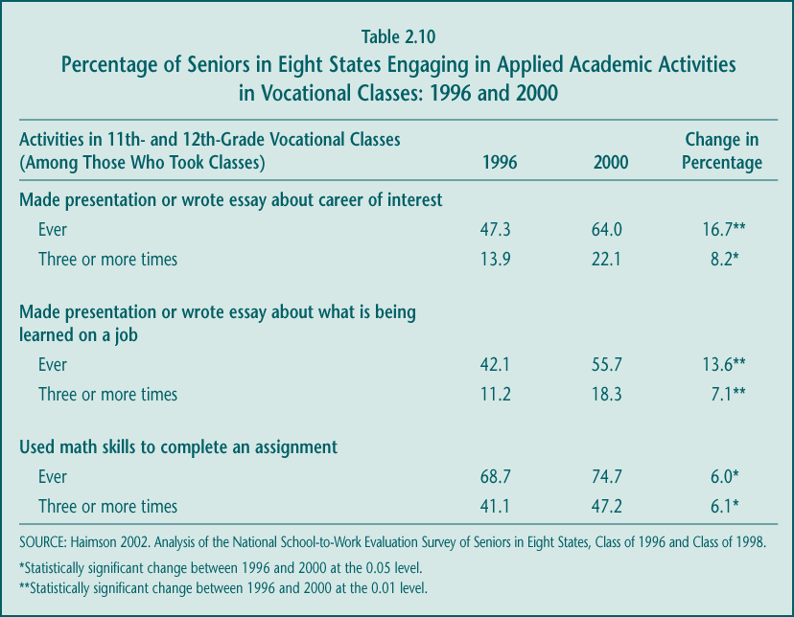

Integration is not a more common practice, for several reasons:

► Implementing a special program does not necessarily mean emphasizing all of its components. Many high schools report having adopted career academies (23.5 percent) or Tech-Prep (47.1 percent), and SREB reports that more than 1,100 schools in 36 states have adopted the HSTW model. But various studies suggest that implementing these integration-oriented initiatives may not actually result in substantial changes in classroom instruction (Kemple 2001; Hershey et al. 1998; Bottoms 2002).

► Team-teaching and common planning periods that could support integration are relatively rare. Just about one-tenth of high school teachers reported in 2001 that they taught a course jointly with a teacher of another subject. Less than one-quarter of both academic and vocational teachers reported that their school provides weekly planning time during the school day when teachers might collaborate on integration (Table 2.11).

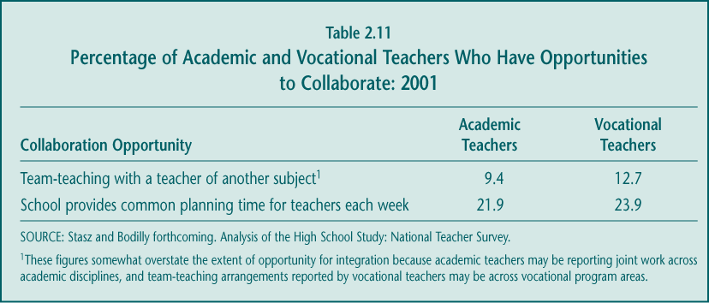

► Vocational teachers disagree about the role of academics in vocational curricula, and academic faculty place priority on meeting state academic standards. Case studies suggest that integration suffers because the two groups of teachers who can best move it forward are not strongly committed to doing so (Stasz and Bodilly forthcoming). Vocational teachers agree that some fundamental math, reading, and science knowledge is required for students to be successful in vocational courses and in the labor market, but many do not believe that vocational courses should bear significant responsibility for delivering academic content and improving academic achievement. Perhaps as a result, with the exception of basic math skills, vocational teachers across the country are much less likely than academic teachers to report that students’ academic competencies (in advanced math, basic and advanced reading, and writing skills) contribute to their grades in the classes they teach. At the same time, academic teachers feel pressured to meet state academic standards, making them less receptive to alternative instructional approaches such as those promoted by advocates of integration.

► There are other barriers to expanding integration. Teachers also cite as further barriers the lack of professional development and, where area vocational schools are concerned, the separation of academic and vocational teachers into different facilities (Stasz and Bodilly forthcoming). A recent survey of vocational teachers in the HSTW network revealed that almost one-half said they needed more training in how to integrate reading, writing, math, and science content into their courses; during the previous three years, fewer than 10 percent of them had received more than 20 hours of such training (Bottoms 2002). Even when professional development has been provided to vocational teachers, it often results in their preparing a single project or two- to three-day lesson rather than transforming classroom instruction (Stasz and Bodilly forthcoming, p. 91; Hershey et al. 1999).

While several obstacles hinder further expansion of integrated curricula in American high schools, European nations do not seem to face these same barriers. A recent study suggests that typical vocational curricula in the United States appear to have far less and less rigorous integrated academic content than do comparable curricula from some of Europe’s “dual-system” countries (specifically Austria, Germany, and Switzerland), countries that allow students to choose either a technical preparation or a college preparation path for schooling after completion of compulsory education at age 16. These same European countries not only send a majority of youths of high school age to two- to four-year vocational training programs after completing the equivalent of 10th grade, but they also exceed or match U.S. performance on recent international tests of math and science in the equivalent of 12th grade (King forthcoming). One important difference, however, is that the European systems can offer deeper, more rigorous vocational programs because these programs are a separate pathway explicitly chosen by students. In contrast, American students view vocational courses as electives, ones that must be fit into an increasingly rigorous load of academic courses.

School reform is prompting efforts to further strengthen the academic content of vocational activities, and states are responding with new strategies.

State academic reforms are clearly beginning to have an effect on vocational education, as will be discussed in more detail below. Case studies indicate vocational teachers in communities with high school exit exams are often encouraged to set aside class time for academic test preparation (Stasz and Bodilly forthcoming). Perhaps more importantly as a sign for the future, many state agencies have adopted specific policies that may lead to the addition of more academic content in vocational education, whether it is integrated or not:

► More and more, state vocational curriculum guidelines clearly refer to academic skills. Many states have developed curriculum guidelines or frameworks for at least some of their vocational programs, although most are voluntary. Within the last several years, an increasing number of states have strengthened their efforts to incorporate academic skills in certain ways:

• Reminders and Web links to the state’s academic standards as part of vocational curriculum outlines. Several states list their state academic standards in their vocational curriculum guidelines. A few states, including Arizona and Pennsylvania, have just begun to “crosswalk” (identify commonalities between) a small number of vocational course or program outlines with the state’s academic standards. Alternatively, Virginia outlines duties and tasks for each vocational course and has a separate “Related Standards of Learning” (academic skills) list and a document that provides links between the two. Ohio’s StandardsPlus Web site (www.ohiorc.org/career_tech) connects the state’s academic and technical content standards with Web-based instructional materials available to both academic and occupational teachers.

• Inclusion of generic basic skills in vocational standards. For example, all of Georgia’s curriculum frameworks feature the same basic skills requirements, such as “performs and applies numerical concepts and calculations and solves problems by choosing appropriately from a variety of mathematical techniques using mental, manual, and technological methods”(www.doe.k12.ga.us/edtech/frameworks.html).

• Identification of specific academic skills that students are expected to learn in occupational programs. The Florida standards for the early course components of the Commercial Food and Culinary Arts program have such sections as “Demonstrate Appropriate Math Skills: (1) solve problems for volume, weight, area, circumference, and perimeter measurement for rectangles, squares, and cylinders, (2) add, subtract, multiply, and divide using fractions, decimals, and whole numbers, and (3) determine the correct purchase price, to include sales tax, for a materials list containing a minimum of six items, and (4) demonstrate an understanding of federal, state, and local taxes and their computation”
(http://www.firn.edu/doe/dwdframe/fc/pdf/20040103.pdf).

► Some states certify vocational courses for academic credit. In part to allow students to meet academic graduation requirements without sacrificing vocational enrollments, a number of states have policies that allow at least some vocational courses to count for academic credit. However, the manner in which these policies are implemented is probably key to whether academic content is truly strengthened at the local level. New York State’s new approach, which began in September 2001, is exemplary for its rigorous district and state approval process. For a course to be certified for even partial academic credit in New York, it must be jointly planned and delivered by academic and vocational teachers, who must provide a curriculum map to document clearly how the courses meet the core academic requirements of the Regents exams. Oklahoma has a similarly stringent review process: academic standards must be clearly identified in the vocational curriculum, and both academic and vocational staff at the district and state levels must concur before the state board of education approves a vocational course as counting for academic credit. As of 2002, one course had been approved under these state guidelines. On the other hand, in at least one state where individual school boards determined which vocational courses would qualify for academic credit, inconsistencies in how the policy was applied led to its elimination.

States integrate the “all aspects of an industry” approach into their reform efforts, but it does not receive much direct attention.

Both Perkins II and Perkins III called for efforts to move vocational education away from narrow occupational skills training, in part by promoting broader awareness of the careers and industries relevant to a particular vocational program. Under Perkins III, state and local grantees are required to describe in their plans how they will provide students with strong experience in, and understanding of, all aspects of an industry the students are preparing to enter (Section 122). This strategy has largely been interpreted as integrating into vocational courses such topics as planning, management, finance, technical and production skills, underlying principles of technology, labor issues, community, environmental and social issues, and health and safety concerns.

Case studies found little evidence of the use of the term “all aspects of an industry” or initiatives that specifically promote it at the state and local levels (Stasz and Bodilly forthcoming). However, the concept seems to be embedded in other policies and strategies, most notably in state vocational curriculum guidelines where they exist. Florida’s performance standards for the introduction to agriscience, technology, and environmental science program offers one example (Table 2.12), but the same general components are included in standards for many of the state’s other programs, such as heating and air conditioning technology or commercial foods and culinary arts. Other states with curriculum guidelines also cover these dimensions of industry to varying degrees (review of state Web sites).

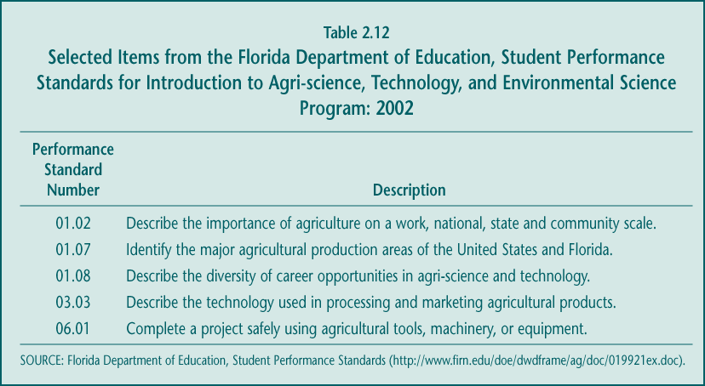

The “all aspects of the industry” approach is also evident in a recent initiative undertaken by state directors of vocational education to identify the competencies and skills needed for 16 broad career clusters, with the intent of making them available for voluntary use as skill standards (see careerclusters.org/). Whether and how these various state-level activities influence local implementation is less clear.

Career and Technical Student Organizations (CTSOs) are regarded as an important integration strategy.

Linked through 10 national associations, state and local CTSO affiliates have long been a popular component of many vocational programs. The organizations provide skill competitions, training, and other after-school activities, as well as classroom resources and strategies that CTSOs encourage participating teachers to integrate into their vocational courses. CTSO efforts are designed to emphasize both building technical skills and developing other competencies, such as teamwork, leadership, communication, critical thinking, and basic academic proficiency. States are permitted to use Perkins funds to support CTSO activities, but they devote a relatively small share—about 7 percent—of their state leadership allocations to do so (see Chapter 5).

Many vocational education teachers are involved in CTSO efforts at the local level, and they emphasize some integration approaches more so than do other teachers. Nationally, more than two-thirds of all vocational teachers report that their classes are linked to a CTSO in some way (Stasz and Bodilly forthcoming). Teachers who are involved with a CTSO are more likely than other teachers to have students listen to lectures, write paragraphs, take tests or quizzes, and engage in discussion or exploration of careers. CTSO involvement is not associated with other instructional practices, however (Table 2.13).

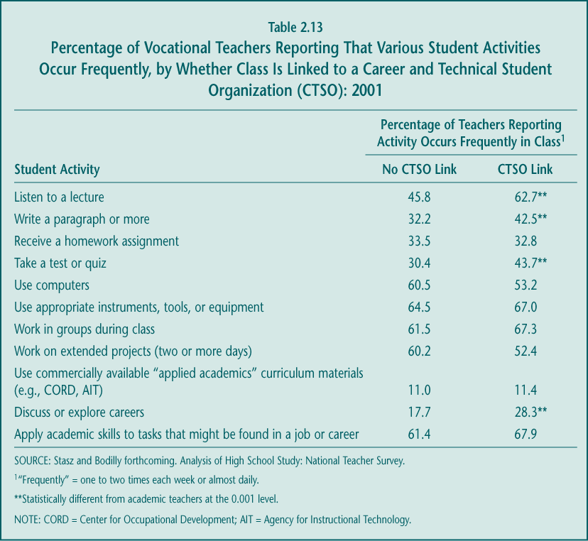

2. Linkages between Secondary and Postsecondary Education

Along with integration, Perkins III emphasizes the linking of secondary and postsecondary education as a way to fulfill the purpose of the act (Section 2). Such efforts were expected to have two benefits: to improve the quality of secondary vocational education and to provide students with encouragement and incentive to pursue college and advanced training. In practice, these linkages have included collaborations between secondary and postsecondary faculty, arrangements that allow high school students to earn college credit, and various forms of career development and planning.

While Title II, the Tech-Prep Education Act, is the main vehicle in Perkins III for developing these linkages (discussed in Chapter 4), the law encourages strengthening connections across levels more broadly. Many of the components of Tech-Prep, for example, are allowable activities under state and local uses of the basic state grant. State officials spend about 11 percent of basic grant state leadership funds on promoting secondary-postsecondary linkages (see Chapter 5).

Secondary vocational teachers have stronger connections to postsecondary faculty than do academic teachers.

The Perkins Act is the only federal legislation that encourages and provides financial assistance for collaboration between members of secondary and postsecondary faculty, and these efforts have had some measurable results. Nationally, vocational teachers report more collaboration with their postsecondary colleagues than do secondary academic teachers (Table 2.14). These differences are even more pronounced when “any interaction” is counted; for example, 35.3 percent of vocational teachers, compared to 20.9 percent of academic teachers, reported having worked with postsecondary faculty at least once on course curricula during the 2001 school year (Stasz and Bodilly forthcoming). Case studies, however, turned up far fewer examples of these types of activities and less extensive collaboration than suggested by the national survey. At the local level, the most visible type of collaboration was in developing and maintaining articulation agreements (Stasz and Bodilly forthcoming).
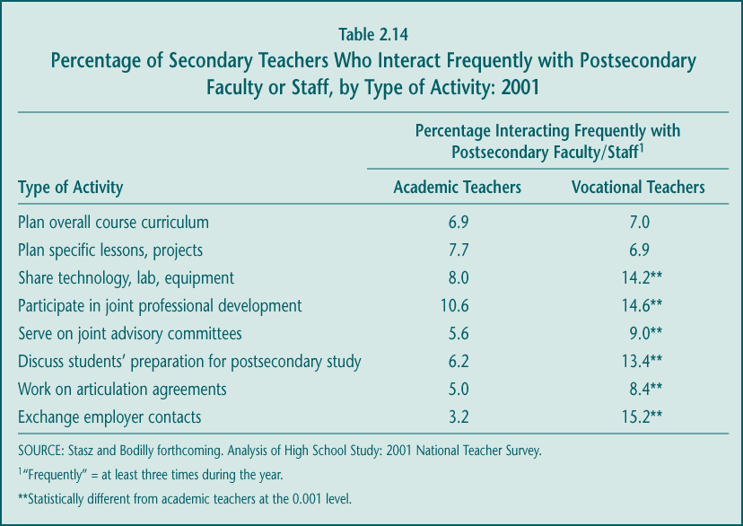

Where these coordination activities are most extensive, however, they seem to offer several benefits (Hershey et al. 1998). Opportunities to meet across education levels—and within groups organized by vocational program area—can reduce the isolation of secondary vocational teachers, increase their professional growth, and provide them with channels for exchanging information on successful practices. The process of articulating courses can result in the upgrading and standardization of vocational curricula, because high school vocational educators are encouraged to adopt the course outlines and competencies of community college programs.

Articulation agreements and “dual-enrollment” programs are becoming more common, but few vocational students are taking advantage of these options.

While neither articulation nor dual-enrollment arrangements are new, there is some evidence that these strategies, which are designed to help students earn college credits while they are still in high school, are becoming more prevalent (Bailey, Hughes, and Karp 2002):

► Articulation agreements allow a student to earn college credit or advanced standing in a postsecondary program for skills acquired in high school courses. Typically, high school courses are “articulated” when their content is aligned with or made similar to that of comparable community college courses. More than one-third of all high school vocational teachers report that their first course of the day has an articulation agreement (Stasz and Bodilly forthcoming), but information provided on state Web sites suggests articulation covers a much larger share of vocational courses.

► Dual enrollment enables a student to enroll in a course on a college campus while he or she is still in high school and receive both high school and college credit for the course. These opportunities are touted as a way for students to increase the rigor of their high school curriculum and to experience the demands of college-level work. Although dual-enrollment programs generally open the door to higher-level academic courses, some have argued that the programs could also provide access to more advanced vocational course work, particularly in light of secondary school budget pressures that may reduce the availability of higher-cost vocational courses. All but three states offer some form of dual-enrollment program (Education Commission of the States 2001), and approximately 80 percent of all public high schools report offering opportunities for students to earn college credit from local postsecondary institutions or distance learning providers (Levesque forthcoming).

Although these two options are already broadly and increasingly available, neither seems to benefit large numbers of vocational students. While no national data exist, studies suggest that dual-enrollment programs typically serve the most academically talented high school students in primarily academic courses (Bailey, Hughes, and Karp 2002). These studies also indicate that most students enrolled in high school articulated vocational courses are either unaware of or fail to take the steps necessary to be awarded the articulated college credit (Hershey et al. 1998; Bragg 2001). According to the last national estimate, only about 15 percent of students in articulated vocational courses earned college credit (Hershey et al. 1999). It appears that more work on implementation will be necessary for these secondary-postsecondary linkages to serve substantial numbers of vocational students. Little is known so far about the impact of articulation and dual enrollment on students’ enrollment decisions.

College and career planning activities are widely available in schools, but their utility is uncertain.

Perkins III supports career development efforts in a variety of ways. Most directly, Perkins funds a state network of entities—now called “America’s Career Resource Network” (ACRN)—that gathers and provides schools with information on occupations and employment (Section 118). States are permitted to use state leadership funds to improve career guidance, and about 9 percent of these funds nationally are used for these purposes (see Chapter 5). Unlike Perkins II and its predecessors, however, the 1998 law does not set aside funds specifically for career counseling and development activities; instead local districts are free to use their Perkins grants for those activities.

In part because of the emphasis on these activities in prior Perkins legislation and the School-to-Work Opportunities Act of 1994, many career development activities are being offered in American high schools, and some practices appear to be growing (Table 2.15). Job shadowing and worksite visits were particularly emphasized in school-to-work implementation (Hershey et al. 1999), so it is not surprising to find these activities increasingly prevalent in the latter part of the decade.

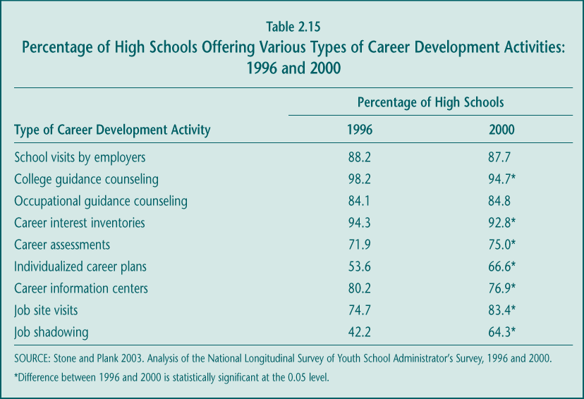

The value of these and other school activities in helping students plan for careers is unclear, however. A study of 1998 high school seniors in eight states suggests that some of the most prevalent activities—e.g., career interest inventories, business and industry speakers—are not particularly helpful to students (Table 2.16). On the other hand, more than half of the students who took vocational courses in their junior or senior years of high school considered those courses to be “very helpful” in clarifying their career goals. Students also found some workplace activities, such as job shadowing and paid jobs or internships, to be helpful. Although counselors, educators, and parents have debated the importance of having students choose a career path in high school, in fact, many high school students have already made some career decisions. In a recent national poll, almost three-quarters of high school juniors and seniors said they had tentatively picked out a career to pursue upon leaving high school or college (Ferris State University 2002).

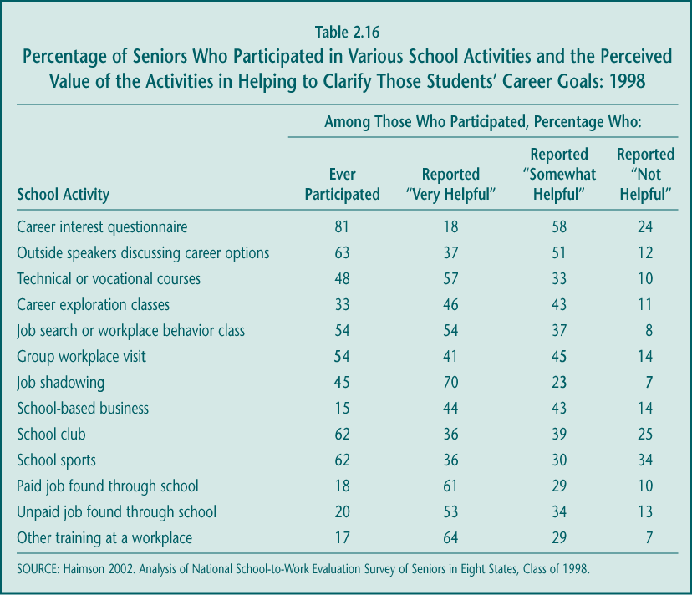

In many states, college scholarship programs for “high-performing” vocational students are credited with expanding students’ horizons and the image of vocational education.

Many states have scholarship programs open to all high school students who qualify (regardless of program of study), but several states (e.g., Florida) have a particularly promising strategy that is credited with raising the stature and performance of vocational students. To be eligible for the Florida Gold Seal Vocational Scholars Award, a student must earn the following (see http://www.firn.edu/doe/bin00072/gsvrequire.htm):

► A 3.5 grade-point average (GPA) across a minimum of 3.0 occupational credits in one vocational program area (e.g., the student must be an “occupational concentrator”);
► A cumulative GPA of 3.0 in 15 required core academic courses; and
► A minimum score on the standard college entrance exams (e.g., ACT, SAT).

Recipients can receive up to a two-year scholarship award equal to 75 percent of the tuition and fees at a Florida public postsecondary institution. To receive the award in their second year of college, students must maintain a cumulative GPA of 2.75. In FY 2000, more than $5 million was disbursed in scholarships to 4,102 students, although the actual impact on students’ college enrollment decisions is unknown. Arkansas and Washington State have similar merit scholarship programs for vocational students. These types of scholarship programs can underscore that vocational education can be a pathway to college and that high achievement in both vocational and academic courses is desirable and worth rewarding.

3. Challenging Vocational and Technical Skill Standards

Unlike the 1994 Amendments to Elementary and Secondary Education Act or the 2001 No Child Left Behind Act, Perkins III does not explicitly require states to develop standards for vocational courses and programs. However, the law does mandate state reporting to ED on core performance indicators, including “student attainment of challenging State-established academic and vocational and technical skill proficiencies” (Section 113(b)(2)). This language implies that states must have some kind of standard against which to judge individual students’ vocational skill attainment and some way to measure that attainment. Given that state standards and related skill assessments have become the foundation of federal policy to improve academic achievement, the Perkins provisions may be read as a step toward using a similar model for vocational education.

Standards and guidelines are not new to vocational education and training. They have their origins in the craft guilds of the early colonial days and since then have been developed with business and industry, the military, educators, and state and federal officials playing substantial roles at various times but not always in coordinated fashion (Chung forthcoming). More recently, there has been such an abundance of occupational standards that the field has been characterized as “an embarrassment of riches” (Wonacott 2000). The larger issues are how these standards are organized and whether they can improve the quality of instruction and student performance.

Until recently, standards-based reform has not been a major effort in vocational education.

Most states have been engaged to some extent in establishing occupational skill standards during the last two decades. In doing so, states have taken a variety of routes: developing their own standards, endorsing those created by business and industry groups, adopting guidelines created by multistate consortia, or a combination of these approaches (Sheets forthcoming; Chung forthcoming). The standards themselves can be at the level of courses (e.g., introduction to word processing), occupations (e.g., office assistant), or clusters of occupations (e.g., business). Some are broad statements of knowledge and skills required, while others are more commonly divided into job-specific duties or task lists of activities that students should be able to perform for entry-level employment following their completion of a course or program. This diverse approach is similar to that used for academic standards. But several factors have prevented states from promoting systemic reform in vocational education with standards as the centerpiece:

► Most states have some vocational curriculum guidelines, but often they are not mandatory. In contrast to academic standards, vocational standards are mandated in only a few states. Other states regard their occupational standards as models or recommended frameworks for developing curriculum at the local level. These states adopt different approaches to encourage use by local Perkins grantees, mostly through “approving” programs for state or federal funding or for special certification status. In some states, the primary incentive is that schools offering programs designed around state standards can award students extra credentials—state skill certificates or “endorsements” on their high school diplomas—if the students meet or exceed the standards.

► “Coverage” of the standards is variable. Although many national or regional industry groups have developed guidelines for entry-level workers, there are other occupational areas in which no industry standards exist. Similarly, states with curriculum guidelines rarely have them for all of the secondary occupational programs offered. Two states are exceptions: Alabama has developed guidelines for 140 courses of study, and Virginia has created task lists for all 225 secondary vocational courses approved in the state. When only a share of programs are covered by standards or curriculum guidelines, it is difficult to impose a standards-based reform structure where states hold local programs accountable for meeting defined skill benchmarks (Chung forthcoming).

► Assessments are underdeveloped. Far fewer states have assessments than have standards, particularly statewide, external procedures for ensuring that students attain the identified competencies. Some states have rubrics to help teachers judge students’ skills against the duty or task lists. But in many other states, individual instructors are responsible for assessing whether a student has demonstrated enough of the listed competencies at an appropriate level of skill. One reflection of the relative lack of state vocational assessments is the way in which states report to ED on the vocational-technical skill performance indicator: 38 states rely on GPA and course or program completion or their own local assessment procedures, approaches that federal policymakers have considered unreliable when it comes to measuring the progress of academic reforms (Table 2.17).

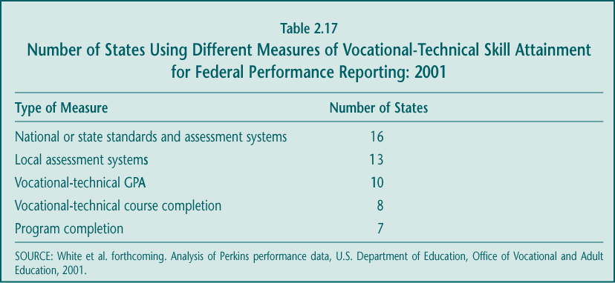

Some states have comprehensive or nearly comprehensive vocational testing. Pennsylvania, for example, uses tests developed by the National Occupational Competency Testing Institute (NOCTI) for 90 of its 140 programs, and industry certification and state licensure exams for the rest of its vocational testing. For several years, North Carolina has been developing an online system of test items that local grantees can administer to students at the end of their courses; by 2002 it included items based on course blueprints for over 95 percent of all state-approved and funded vocational courses and programs (Sheets forthcoming).

► Vocational courses are elective not required courses. Despite a desire to improve programs and provide marketable credentials to students, state officials point out that there are limits to how rigorous vocational programs can be. If vocational courses have too many prerequisites or require too high a level of technical or academic skill, students who might benefit from occupational training would be left out and enrollments could decline. A report on the implementation of national skill standards in a small number of schools suggests that upgrading the quality of vocational programs will require more careful screening and selection of participants, an outcome somewhat inconsistent with the Perkins priority on providing broad access to vocational programs (Haimson and Hulsey 1999).

► Resources to support the development and implementation of standards are limited. According to state officials, federal support for vocational skill standards has declined (Chung forthcoming). The Vocational-Technical Education Amendments of 1984 (Perkins I) allowed states to use substantial amounts of Perkins funds for program improvement and innovation including developing skill standards. Perkins II in 1990 restricted these discretionary funds at the state level but provided resources to establish a National Skill Standards Board (NSSB), intended to do much of the work involved in establishing occupational standards. However, by the time Perkins III was passed in 1998, the NSSB had released only one set of skill standards, and the list of activities states were required to support under Perkins had grown. These required activities did not specifically include the setting of standards, although such efforts could be accommodated.

Even states with state-level support for standards consider it difficult to find the time and resources to convene industry and teacher representatives, to set or upgrade standards and develop assessments, and to provide the necessary professional development to teachers (Sheets forthcoming). Smaller states, with small Perkins allocations and often very limited state vocational education budgets, place developing and implementing standards lower on their priority lists because of resource constraints (Chung forthcoming).

State interest in using standards and external assessments to improve vocational education is growing.

There are, of course, states that have already surmounted these challenges to some extent and others that have committed to doing so. For example, Florida and Utah have moved toward performance-based funding of vocational programs. North Carolina’s test-item bank and online, secure process for assessing its programs is now being implemented (Sheets forthcoming). A large share of states report that in the next few years they intend to use accountability data to reward and sanction districts or schools for the performance of their vocational programs (see Chapter 5).

Perhaps most indicative of this movement toward using standards and assessments is the undertaking of the National Association of State Directors of Career and Technical Education. The Career Clusters Initiative will ultimately identify a set of knowledge and skills and related assessments for 16 broad groupings of occupations (“clusters”) that states or individual programs can voluntarily adopt. Current partners in these efforts include the American Institute of Architects, the National Aeronautics and Space Administration (NASA), Sony Electronics, as well as numerous postsecondary institutions (see careerclusters.org/index.htm). Although built upon industry and existing state standards, this effort is likely to take some years to come to fruition.

The role of industry in vocational standards may be shifting.

For several decades, vocational legislation has promoted the involvement of employers in local programs as a way to ensure quality instruction (see Section 5 below). However, the nature and level of that involvement appears to be changing, from local to state or even national participation.

► Local employers provide relatively little input in competency lists and standards. Case studies suggest employer involvement varies across states and communities. Nationally, however, vocational school staff do not report that business and industry play a particularly influential role in shaping competency lists that provide the standards for classroom instruction (Table 2.18). Because these lists are often provided to programs by state vocational officials, local practitioners may be unaware of the contributions that employers at the state level make.

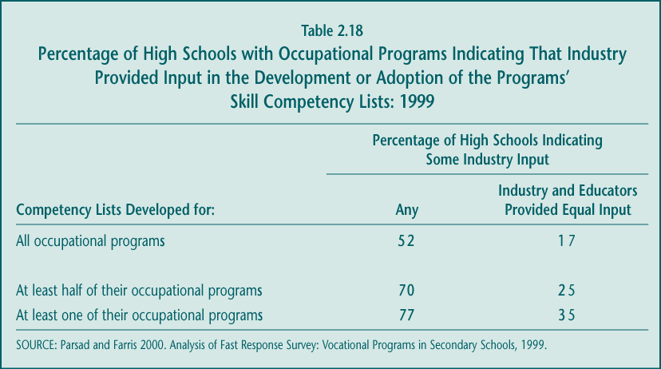

► States generally include employers in developing state vocational standards. Many states report working to adopt industry standards as the foundation for some vocational programs (Stasz and Bodilly forthcoming). Where states have developed standards on their own, they have typically convened groups of business and industry representatives with vocational educators to do so (Chung forthcoming). Over time, then, employers may have a larger impact on shaping curriculum at the state level than at the local level.

► Industry certification programs are popular, involving employers at the national level. Perkins II, by encouraging the development of national skill standards, also emphasized national industry efforts. Although the NSSB’s output has been modest (Chung forthcoming), other employer groups have promulgated competency guidelines, and vocational teachers are beginning to respond to them. In fact, just under one-quarter of all vocational teachers say that industry standards exist for at least one of their courses (Stasz and Bodilly forthcoming). But in the case of these standards, most of the work of employers was at either the regional or national level.

This shift in the role of employers may reflect a trend, first promoted in the School-to-Work Opportunities Act, toward providing “portable” credentials to students who complete vocational programs. In a national economy constantly responding to global competition, it was argued that workers may need or want to move outside of their local communities to pursue job prospects. Vocational programs would therefore need to ensure that the skills they impart to students are desired by a broad set of employers in industry and that any certificates students earn when they complete a program will have currency in the larger labor market.

4. Enhancing Use of Technology

Technology has long been a mainstay of vocational education programs and a common concern among educators and policymakers (Boesel et al. 1994a). Vocational programs have been criticized for failing to keep up-to-date with the equipment and technological demands of the labor market, while vocational educators have often argued that doing so in a continuously changing economy requires substantial resources. Perkins III places additional importance on technology, encouraging teacher training on “state-of-the art” technology (Section 135) and the availability of vocational programs that prepare students for fields that require high-level skills and pay high wages (Section 122).

Perkins has substantial influence on expanding and upgrading technology and equipment.

In many ways, Perkins III has its most direct effect on this area of program improvement. At the local level, the majority of Perkins funds are spent on upgrading equipment and instructional materials to keep them current (see Chapter 5), as are a substantial share of Tech-Prep funds (Hershey et al. 1998). Moreover, state officials spend about 11 percent of their state leadership funds on expanding the use of technology (White et al. forthcoming).

States have made the expansion, development, and use of technology in education a priority, although much of this effort is not specific to vocational education. In fact, many state technology policies apply to all students or represent efforts not necessarily connected to vocational education (Stasz and Bodilly forthcoming). For example, initiatives such as the “Digital High Schools” in California or “Virtual High Schools” in Florida are not targeted to students interested in technology careers or intended to be more than strong academic programs, even with a technology emphasis. High schools in general have sought to ensure computer access for all students. Vocational courses may or may not benefit from these efforts.

Keeping technology current and well-maintained remains somewhat of a problem, but many programs have recently received new equipment and materials.

There are many dimensions to providing “high-quality” technology in vocational courses, and some of them present an ongoing challenge (Table 2.19). Nationally, the highest proportions of vocational educators report a substantial problem with ensuring that technology is current or state-of-the-art (40.7 percent), well-maintained (38.0 percent), and available in numbers adequate to serve the students in the class (37.2 percent).

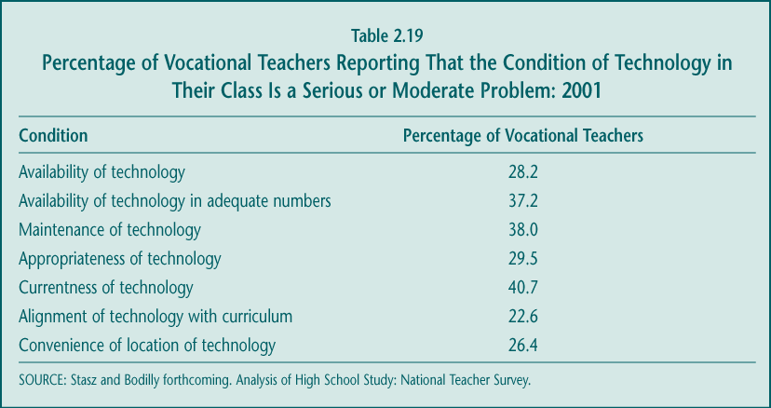

At the same time, however, the survey results do not suggest dire technology deficits or a lack of attention to the material needs of vocational programs. Almost three-quarters of vocational teachers have received new or updated equipment, tools, and instruments in the last two years, suggesting that many programs have recently had opportunities to upgrade their technology (Table 2.20).

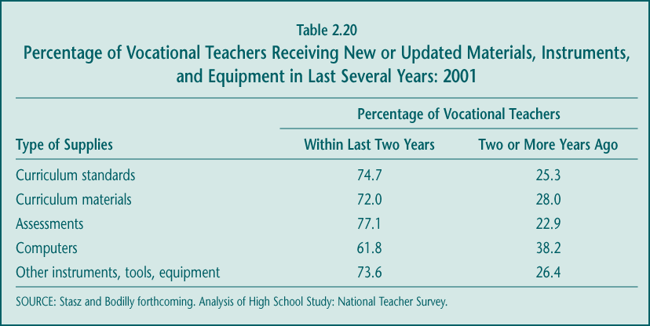

These current figures may reflect that the availability of technology and equipment for vocational programs has improved in the last decade. Fewer vocational teachers in 2001 than in 1992 considered “access to computers” (22.5 percent vs. 34 percent) or “adequacy of equipment” (26.1 percent vs. 39 percent) a “serious” or “moderate” problem (Stasz and Bodilly forthcoming).

Use of the Internet seems to be growing, but distance learning has not been applied as a common strategy so far.

Policymakers and educators generally agree about the importance of building a computer literate society, and vocational education is clearly key to that effort. On average, 54.5 percent of vocational teachers report that students in their classes use computers “frequently” (e.g., one to two times each week or almost daily) (Table 2.21). Among vocational teachers, those who teach agriculture and home economics were least likely to have students use computers “frequently,” while those who teach technical and technology education or industrial arts were most likely to have students using computers as part of instruction. Other fields (e.g., business, health, marketing) fall somewhere in-between (Stasz and Bodilly forthcoming).

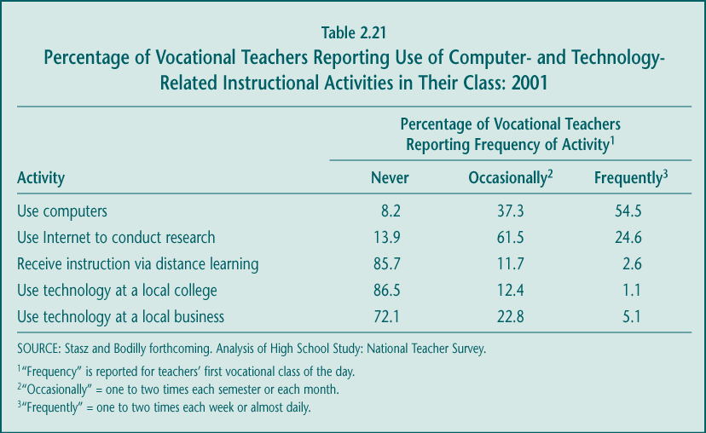

Certain newer forms of computer use and technology are of particular interest to policymakers, primarily because of their ability to expand educators’ capacity to provide instruction. About one-quarter of vocational teachers report that they “frequently” have students use the Internet to conduct research (Table 2.21), a proportion that may be roughly comparable to that reported by academic high school teachers.

Distance learning also has potential applications for vocational education, particularly in providing students with greater choice of and access to courses. However, national survey results suggest that relatively few vocational teachers ever have their students receive instruction over the Internet or other communication media, and only 2.6 percent do so “frequently.” This level of use stands in sharp contrast to the prevalence of online technical training for adults in the military and the private sector, where it has been demonstrated that it is both feasible and practical for students to learn occupational competencies in other than a strictly traditional classroom setting (DuBois 2002). Distance education is a growing component of postsecondary education, and increasingly used by workers seeking to upgrade their skills (Greene and Meek 1998). At the high school level, however, more attention has been directed to “Virtual High Schools,” such as those in Florida, and other efforts focused on making high-level academic course work available to broader groups of students.

5. Employer Involvement

For several decades, federal policy has sought to expand the involvement of employers in vocational programs. Because local employers are, in many ways, still considered the primary consumers of secondary vocational education, they are expected to have an incentive to ensure the technical quality of vocational programs. Perkins III encourages local grantees to involve employers in designing, implementing, and evaluating programs, and in providing workplace experiences for students (Section 135).

In defining skill needs for high school students, however, the priorities of employers have become less clear. Some large trade groups traditionally supportive of vocational education invoke the value of basic academic skills, higher-order thinking skills, and such “soft” skills as communication, teamwork, and work ethic. When these employers call for more technical skills or a more highly skilled workforce, they often refer to the number of college graduates completing degrees in math, science, and technology, not the number of high school graduates with vocational training. For example, a recent survey conducted by the National Association of Manufacturers concludes that “the major areas of concern have shifted from technology skills back to the fundamentals, with basic employability skills cited as the number one deficiency for both current hourly workers and applicants for hourly positions. Poor reading, writing, math, and communication skills were also cited as significant concerns” (National Association of Manufacturers 2001).

There are, of course, other perspectives on the relative importance of basic skills versus occupational skills. Smaller businesses, which make up a large share of U.S. employers and have fewer in-house training resources, have typically drawn more heavily on high school vocational programs for new employees. The shifting priorities, however, may have implications for the evolving nature of vocational education and the role of employers.

Vocational educators report interacting with local employers in a variety of ways.

Not surprisingly, vocational teachers have significantly greater contact with representatives of business, industry, and labor than do academic teachers. For vocational teachers, the most common forms of collaboration include referring students for job placements, having employers make presentations to students in class, having students visit employer work sites, and discussing workplace skill requirements with representatives from business and industry (Table 2.22). Compared to the small proportion of high school vocational teachers (8.1 percent), a large share of academic teachers (41.9 percent) had no interaction with employers or labor groups in 2001. Vocational teachers in vocational high schools and area vocational centers had more contact with employers than did teachers in comprehensive high schools (Stasz and Bodilly forthcoming).

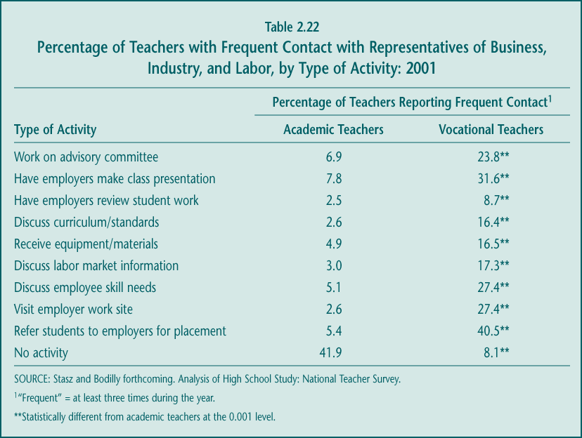

The existence and vitality of local advisory committees of employers vary across and within states.

One of the most traditional forms of employer involvement has been serving on vocational advisory committees. Some states reported in 2001 that they continued to require school- and program-level advisory committees (Stasz and Bodilly forthcoming), although Perkins III no longer requires such committees. According to the National Employer Survey conducted by the Census Bureau in 2000, 14.1 percent of all employers reported being a member of a vocational advisory committee, although the survey did not distinguish between participation in secondary or postsecondary vocational programs (Bureau of the Census 2002).

At the local secondary level, vocational advisory committees are common but not uniform in their existence or the extent of their activities. Just over half (57.5 percent) of vocational teachers reported “ever working” with employers on an advisory committee in 2001 (Stasz and Bodilly forthcoming), and only 23.8 percent say they do so “frequently” (Table 2.22). Case studies suggest that advisory committee activity is more consistent in states that have emphasized employer involvement (e.g., Michigan and Ohio), and more variable in states that do not consider this strategy a priority (Stasz and Bodilly forthcoming).

Local employers play a limited role in shaping vocational programs.

Despite some participation through advisory committees or other forums, local employers do not appear to have a significant effect on local vocational programs. As noted in an earlier section, based on one survey, local employers do not contribute substantially to developing or adopting skill lists or curriculum standards. Another survey suggests a similar result: only about one-quarter or fewer vocational teachers report that they received a “moderate” or “great” amount of employer input on various aspects of their class, such as the selection of instructional materials or equipment, standards or competencies for the course, or information on industry skill requirements that could be reflected in course activities (Table 2.23). This is an important finding, because many have argued that consulting with local employers is the best way for vocational education to prepare students for local jobs.

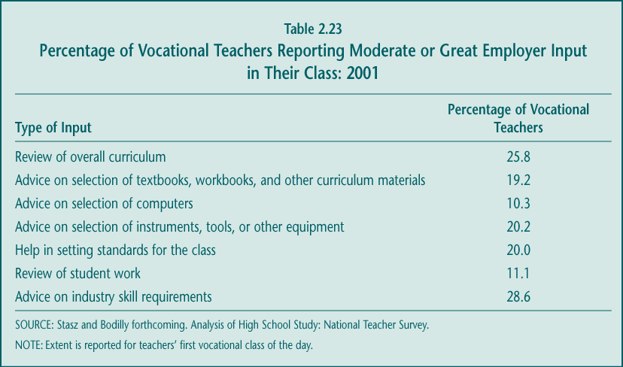

The limited amount of local employer involvement in guiding instruction may reflect the way in which vocational educators are responding to several factors. First, as noted earlier, states have expanded their development and dissemination of vocational skill standards—sometimes including guidance on equipment, student work, and expected skill outcomes—and much of this work was accomplished with employer input at the state level (Stasz and Bodilly forthcoming). Knowing that their competency skill lists were derived from either state- or national-level skill standards, teachers may not believe local employer advice is necessary to fine-tune instruction. Second, the increase in articulation agreements, particularly those that are statewide, may be leading to greater standardization of vocational curricula (Hershey et al. 1998), which may also lessen the extent to which teachers feel they need to—or can—modify instruction to meet local employer needs. Finally, because many vocational students plan to attend college (some out of state), teachers may not view their programs as primarily preparing students for the local labor market. This situation contrasts sharply with vocational education at the postsecondary level, where participants are more clearly engaged in training in the same community in which they work and where employer involvement is considerably deeper (see Chapter 3). For these reasons, it is unclear exactly how vital local employer involvement is at the secondary level.

6. Teacher Quality

Teacher quality has increasingly become a focus of policymakers’ interest in regular K–12 education, but less attention has been paid to how well vocational teachers are being prepared for their jobs. The availability, experience, priorities, and practices of teachers can be expected to affect the quality of instruction and therefore of vocational education overall. Perkins III, like its predecessors, underscores the value of the vocational teaching workforce largely by requiring state and local grantees to provide professional development to vocational educators. This professional development can, however, include both in-service and preservice training (Section 135).

Larger issues concerning the preparation and hiring of vocational educators have become increasingly important as the economy and federal vocational policy have changed. Over the last decade, federal legislation has tried to guide secondary vocational programs in new directions—to strengthen linkages with postsecondary programs, to integrate academic and vocational instruction, to broaden instruction beyond narrow job skills training, and to coordinate with business and industry. Perkins III also contains accountability provisions that place greater emphasis on helping vocational students meet state academic standards and enter postsecondary education not just obtain entry-level jobs. These policy objectives potentially require both vocational teachers seeking entry into the profession and those already employed to assume new roles and learn new skills. During the same period, the labor market for skilled workers fluctuated substantially, possibly making the alternatives to teaching vocational education more appealing. These issues of teacher supply and qualifications are important to the ongoing development of the field.

Not surprisingly, vocational teachers are more likely to have industry experience than other secondary teachers but continue to be less academically prepared.

Unlike the specifications for academic teachers in the No Child Left Behind Act, the Perkins Act does not require grantees to define a highly qualified vocational teacher or to set goals for ensuring that students in vocational programs have access to one. Two factors that might be important in those qualifications are industry experience and academic background. Because vocational education is rooted in training for jobs and family life directly after high school, it historically placed great value on teachers’ occupational skills; educational background was considered less important than practical experience. Current federal vocational policy, however, emphasizes improving the academic achievement of vocational students. In this climate, the academic skills of vocational teachers may be of increasing importance, although it is not known how these skills translate into effective teaching practice and student achievement in a vocational setting.

► Among new teachers, those who are in vocational fields are more likely to come from industry. Vocational teaching continues to draw men and women with other work experiences. More than one-third of new vocational teachers were working (“had industry experience”) as their main activity during the year before being hired, compared to 9.7 percent of new teachers in other fields (Table 2.24). Statistically, these proportions did not change over the last decade, but their accumulation would result in a much higher share of vocational teachers overall having come from industry, compared with teachers of other subjects. However, including both new entrants and those more experienced, similar proportions (about one-quarter) of vocational and nonvocational teachers had at least some work experience outside of teaching during the previous school year or summer (Levesque forthcoming).

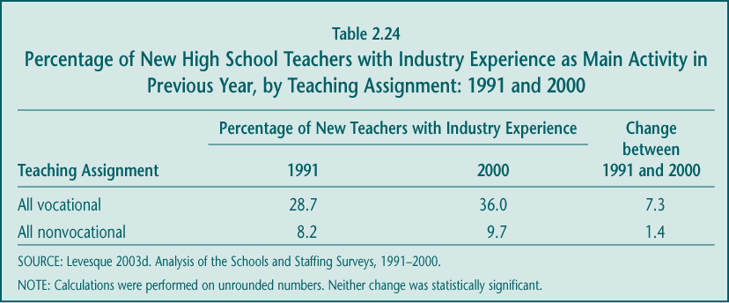

► Vocational teachers remain less likely than other high school teachers to hold a baccalaureate degree. Although not a perfect proxy, having a baccalaureate degree or higher can be considered an indicator of academic competency. While virtually all nonvocational high school teachers possess those credentials, about 9 percent of the vocational teacher workforce does not—a proportion that has held steady over the last decade (Table 2.25). Vocational teachers without this educational credential are concentrated in vocational high schools and area vocational centers, where the emphasis on vocational instruction is more intensive.

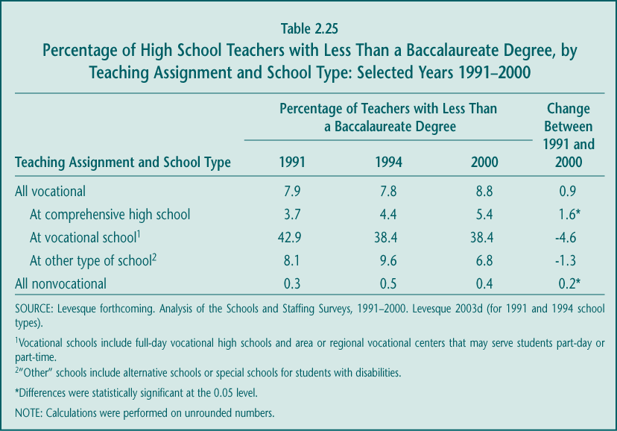

These patterns suggest a possible conflict between federal objectives and state and local hiring policies. The federal emphasis on academic support in vocational education appeared as early as the 1990 Perkins II. Yet during the last decade states appear to have relaxed their baccalaureate degree requirements for certification, for either all or specific subgroups of vocational teachers (Table 2.26). Nationally, the proportion of states requiring that vocational teachers have at least a baccalaureate degree fell from 40.2 percent in 1988 to 23.8 percent in 1998. The lowering of state requirements may be a response to perceived shortages of vocational teachers, as discussed later.

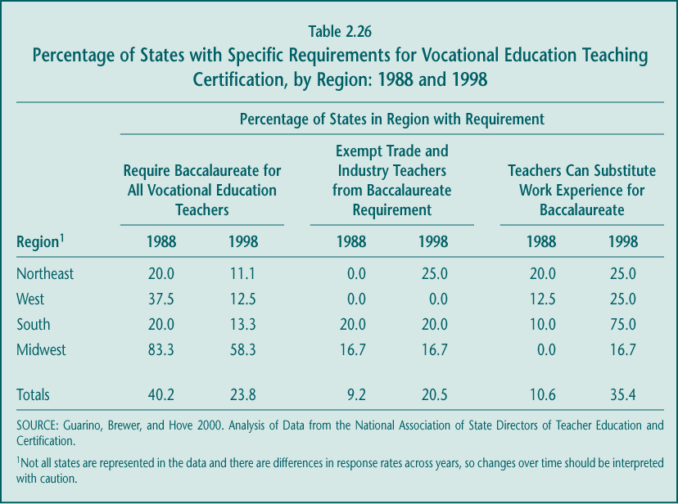

► Candidates for vocational teaching positions are less academically prepared than their counterparts who seek other teaching jobs. Given the way that federal policy has evolved, it appears increasingly important to attract new vocational teachers who can support students’ academic learning. However, recent data on the PRAXIS—a series of tests administered by the Educational Testing Service and required for state teacher licensure in 31 states—indicate that candidates for vocational teaching jobs consistently score lower in reading, writing (not shown), and mathematics than candidates for other secondary subjects (Figure 2.8). In reading and writing, in fact, prospective secondary vocational teachers have lower scores than those planning to teach at the elementary school level. Compared to other secondary teachers, vocational teacher candidates also have lower undergraduate GPAs and lower pass rates on the basic skill PRAXIS assessments based on the score their states set (Cramer forthcoming).

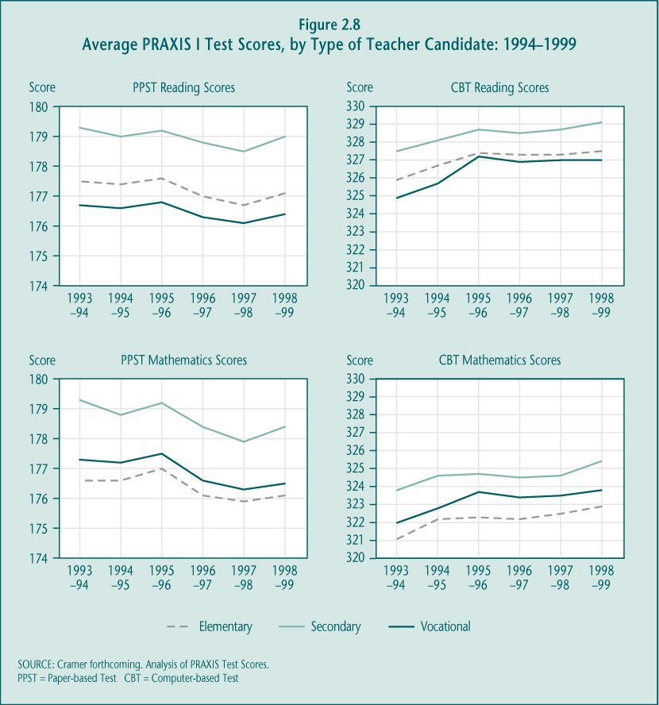

Case studies suggest that these assessments probably do not include individuals entering the profession laterally from industry (Stasz and Bodilly forthcoming). Florida, Massachusetts, North Carolina, and Ohio, for example, allow lateral entry on the condition that vocational teachers take additional course work in teaching methods during their probationary or provisional period. However, none of these states appear to require these teachers to qualify on the exams required for other teachers’ certification. Whether new vocational teachers from industry have stronger or weaker reading, writing, and math skills than do those who have completed teacher preparation programs has never been tested. These results suggest that there may be substantial practical constraints to setting a “higher bar” for the academic skills of entering vocational teachers.

A high and increasing share of vocational teachers come through alternative certification routes, but there is no evidence to suggest how this affects students.

Past research has stressed the importance of teacher education training and a teaching certificate as indicators of quality, although that notion has been challenged (Goldhaber and Brewer 2000). This debate is particularly relevant for vocational education, where industry experience has long been presumed to be an equitable, if not better, tradeoff for more traditional credentials such as a college degree and certification.

Perhaps due to teacher shortages or the expansion of alternative entry routes, an increasing share of high school teachers were working without regular or standard certification over the last decade. In particular, new teachers were far more likely to enter high schools without certification in 2000 than in 1991 (Table 2.27). The proportion of both new vocational and new nonvocational teachers who were not certified about doubled during that period. Some evidence suggests that a higher share of new vocational teachers were drawn directly from industry, perhaps entering through alternative certification routes (Levesque forthcoming).

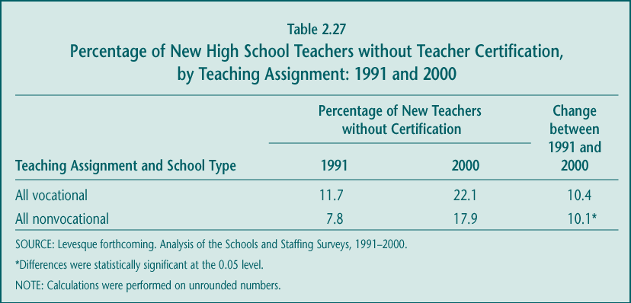

There is currently little research to evaluate the relative or unique contributions of teacher certification and industry experience to vocational teaching. No rigorous evaluations have examined the relationship between the credentials of vocational teachers and the occupational and technical competencies of their students. One recent survey indicates that, compared to those with a baccalaureate or postbaccalaureate degree, new vocational teachers who have alternative certifications are less likely to feel confident about pedagogy but more likely to feel well-prepared in their vocational subject area. There were no differences, however, between the two types of teachers in terms of their confidence in their classroom skills, ability to work with special populations, or plans to remain in teaching (Ruhland and Bremer 2002). A review of research on the importance of industry experience in predicting vocational teacher quality reports that “there is no reliable correlation between years of occupational experience or scores on occupational competency tests and such variables as teacher qualifications, satisfaction, or effectiveness” (Lynch 1998, p. 47).

The decline in standard forms of teacher certification and other factors may be signals of a vocational teacher shortage.

Some states and local communities report teacher shortages, often blaming the lack of vocational teacher training programs in state universities (Stasz and Bodilly forthcoming). Recent evidence suggests that the number of colleges and universities offering vocational teacher training programs has declined by about 10 percent over the last decade (Bruening et al. 2001), but the increase in teachers entering the profession through alternative certification routes suggests that preservice programs are not necessarily a constraint. However, national data do suggest a gap between the supply of and demand for vocational teachers (Levesque forthcoming):

► Growth in high school enrollments, combined with little change in vocational course taking among students, leads to an increased demand for vocational seats. The number of students in high school grew by 17.9 percent between 1991 and 2000, while the average number of vocational courses taken remained constant at approximately 4.0 credits per student. Together, these trends suggest that the total number of vocational courses taken by students increased during the decade.

► Schools absorbed some increased demand through more hiring and larger class sizes. During the last decade, the proportion of vocational teachers at retirement age remained steady while the proportion of new hires increased. These trends resulted in a substantial net gain of teachers into vocational classrooms: between 1991 and 2000, an estimated 55,000 new vocational teachers were added to the workforce. These new hires were concentrated in areas of increased student enrollment—computer science and health care, for example—while the number of new teachers in business, trade and industry, and industrial arts declined, which was also consistent with student enrollment.

At the same time, vocational class sizes, which had declined in the late 1980s, began to increase in 1991 following a pattern similar to that of academic high school classes (Table 2.28). During the 1990s, the average size of a vocational class increased by more than two students (18.1 to 20.5) but, in 2000, vocational classes still contained fewer students than academic classes by about four students (20.5 compared to 23.6). The average number of classes taught by vocational teachers (about five) did not change measurably.

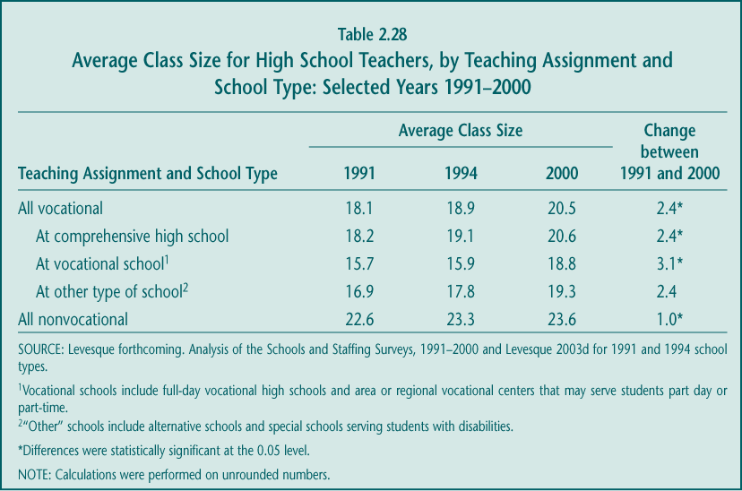

► More schools report that vacancies are difficult to fill. The proportion of high schools seeking vocational teachers remained the same between 1991 and 2000 (at about one-third), while the share of schools with vacancies for academic teachers and special education teachers increased substantially. Schools reported growing difficulty filling vacancies in all subjects, but the proportion that found it very difficult or impossible to fill vocational teacher vacancies more than doubled, similar only to the increase for math and special education vacancies (Table 2.29). By 2000, one out of 15 schools did not fill their vocational teacher vacancies, one possible signal of teacher shortages. Another indicator of excess demand was that average salaries (adjusted for inflation) increased more for vocational teachers than for academic teachers (Levesque forthcoming).

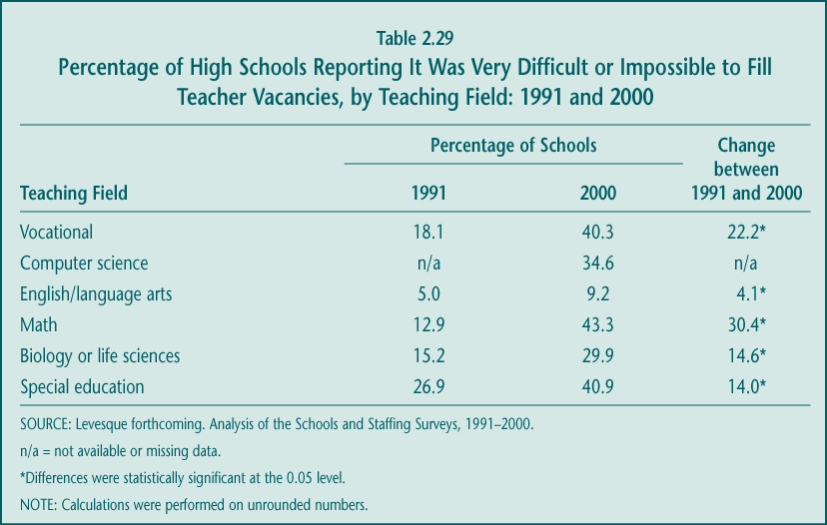

Vocational teachers receive professional development on topics consistent with federal policy, most of it provided by state agencies with Perkins funds.

Professional development remains an important strategy to improve vocational education. According to case studies, teachers indicate that state agencies rather than districts or schools are the main providers of training. Such an emphasis is not surprising, given that professional development is a required state activity under Perkins III, and nationally states report spending approximately one-quarter of all state leadership funds on these activities (White et al. forthcoming).

States support professional development through state conferences or state funding of specific vocational models (e.g., High Schools That Work, career academies). Many states also have programs that encourage teachers to participate in “externships” with industry. Massachusetts, for example, uses a unique strategy: as part of its local planning for Perkins funds, each district grantee is required to set aside 15 percent of its grant for professional development and other state funds provide for general professional development for each school. This effort allows the state’s schools (particularly the regional vocational schools) a sizable and stable pool for vocational teacher training (Stasz and Bodilly forthcoming).

Consistent with the case study findings, national data suggest that the majority of vocational teachers participate in professional development and, in 2001, did so in a wide range of topics promoted by Perkins III (Table 2.30). Some topics were particularly prominent, as noted earlier:

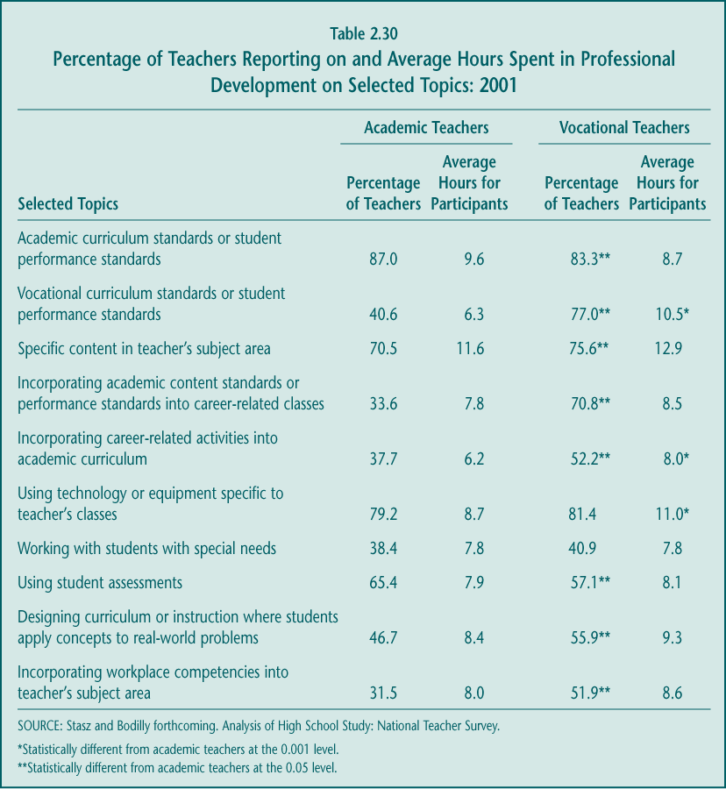

► Standards are an important theme for vocational teachers. Most vocational teachers received training in 2001 on both academic and vocational standards. In fact, according to the survey, on average, vocational teachers received almost as much training (8.7 hours) on academic standards as did academic teachers (9.6 hours), suggesting that some effort is being made to align vocational education with general school improvement. Still, the time spent on academic standards amount to just a little over one day of in-service activity during the year.

► Subject matter and technology training are common to both academic and vocational teachers. Despite the emphasis on academic reform, vocational and academic teachers receive professional development in their specific content areas at roughly comparable rates. Both sets of teachers are equally likely to participate in technology training, although the time spent in it by vocational teachers is longer.

► Integration remains a key focus of professional development. As discussed in an earlier section, much professional development activity is targeted at integrating academic and vocational education in all its various forms. For example, 70.8 percent of vocational teachers received just over a day of professional development on incorporating academic content into vocational curriculum. More than half (55.9 percent) of vocational teachers worked on designing instruction that uses real-world examples.

While vocational teachers appear to have access to a broad set of training options, case studies suggest that vocational counselors and administrators do not receive the same level of support (Stasz and Bodilly forthcoming).

The teaching practices of vocational and academic teachers differ.

Many of the improvement strategies in Perkins III and its predecessors have implications for vocational instruction. Such approaches as curriculum integration, use of technology, working with employers, and raising the technical rigor of vocational courses are likely to involve instructional practices that differ from those of academic teachers.

► Academic teachers are more likely to use traditional didactic instruction while vocational teachers are more likely to use hands-on activities. There is little question that academic and vocational teachers use different methods to deliver instruction (Table 2.31). Academic teachers are more likely to report having students listen to a lecture, write a paragraph, do homework, or take a test or quiz. In contrast, vocational teachers report that their students engage in more applied activities—working on extended projects, using applied curriculum, performing technology-related tasks, and engaging in career exploration activities. Also, vocational teachers differ in the types of instructional activities they use: those who teach in comprehensive high schools are more likely to include writing and test-taking in their instruction, while those in vocational schools are more likely to provide hands-on activities. Vocational teachers in the two settings are equally likely to lecture and to have students work in groups, however (Stasz and Bodilly forthcoming).

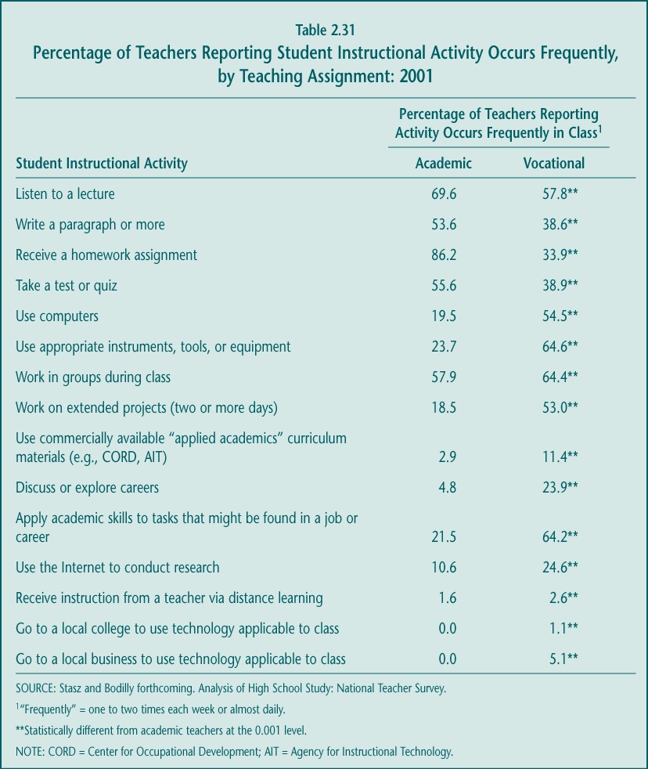

The types of instructional approaches that vocational teachers favor may have changed over time. When comparing teacher practices reported in the NAVE’s 2001 national teacher survey with those reported in a 1992 national survey conducted for the previous NAVE, vocational teachers are currently less likely to lecture in class and more likely to use computers. Academic teachers also increased their use of computers over time, as well as their use of assessments and tests (Stasz and Bodilly forthcoming).

► Academic teachers give significantly more homework than do vocational teachers. Academic teachers are not only more likely to assign homework, but the homework is more extensive (2.9 hours) than that assigned by vocational teachers (1.4 hours). However, comparing the two NAVE teacher surveys suggest that more vocational teachers are assigning homework than they did in the past (Table 2.32).

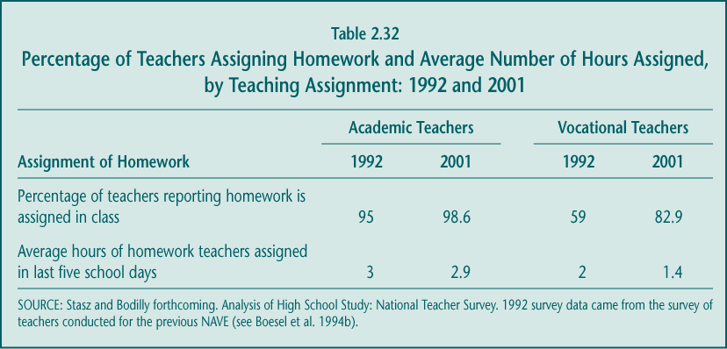

D. Coordination with Other Reforms

Without question, the principal focus of recent education reforms has been on improving students’ academic achievement and increasing their opportunities to attend college. Perkins III provides explicit instruction to grantees to coordinate with these reform efforts by “building on the efforts of States and localities to develop challenging academic standards . . .” (Section 2). In addition, Perkins accountability systems require states to help vocational students meet state-established academic proficiencies (Sections 113 and 122(c)(5)(B)).

Federal vocational policy now places priority on ensuring that students in vocational programs are academically well-prepared for success in both postsecondary education and the labor market. How vocational education fits into state and local academic improvement efforts, or influences those efforts, may well affect the viability of career preparation programs in the future.

Vocational officials and initiatives have taken the lead on some important aspects of high school reform.

Although the direct influence of Perkins is unclear, the key role that many state and local vocational administrators have played in promoting high school change is not. Several practices that are quite common in high schools across the country were spurred by the interest and efforts of vocational educators, concerned in part about the academic performance of students in vocational programs. These strategies include the following:

► Smaller learning communities. Evidence on the benefits of small schools has been growing for some time, as has interest in the idea of using careers as an organizing principle for clustering students in classes. Career academies are one example of these efforts, increasingly viewed as a high school reform model but one with a career preparation or vocational component (Kemple 2001).

► Flexible scheduling. The need for new scheduling arrangements was evident in early Tech-Prep efforts to increase the time available for vocational courses and the extent of “hands-on instruction” in both vocational and academic classes (Hershey, Owens, and Silverberg 1996). Block scheduling, in which the school day is divided into four 90-minute class periods rather than the typical seven 45-minute periods, is now used to some extent in nearly half of the public high schools in the country (Levesque forthcoming). It is also a key strategy of the High Schools That Work (HSTW) initiative to increase the amount of time available for learning by lengthening the time in classes and reducing the number of changes between them (Hoachlander, Alt, and Beltranena 2001).

► Linkages with postsecondary institutions and faculty. There is little doubt that the introduction of Tech-Prep stimulated major investments in the development of articulation agreements and ways of collaborating more generally with postsecondary institutions (Hershey et al. 1998). The Perkins Act remains the only federal legislation that supports these types of cooperative efforts between secondary and postsecondary institutions and their faculty.

► Eliminating the general education track. Reducing the availability of low-level academic courses that make up the general education curriculum had been a goal of early Tech-Prep advocates and remains a central component of the HSTW initiative. Spurred, in part, by HSTW leaders, state vocational officials, such as those in North Carolina and Maryland, have teamed with their academic counterparts to encourage more rigorous standards for high school graduation requirements.

All of these efforts were presumed to benefit students in vocational programs as well as those who pursued little vocational education.

So far, there are mixed views on whether and how vocational education should be responsible for students’ academic competency.

Despite the support for school improvement efforts, coordination between academic and vocational education reforms depends largely on the initiative of those who will carry out the reforms. Although few vocational educators would argue that stronger academic skills are unnecessary in the labor market, some disagree about whose responsibility it is to ensure that students meet state academic standards (Stasz and Bodilly forthcoming).

► State vocational officials generally supportive. At the state level, most officials agree that, in order to succeed as adults, graduating students now need higher levels of language arts and math skills than they had in the past and that academic assessment is one strategy for encouraging those improvements. In fact, nationally, state directors of vocational education ranked the Perkins core performance indicator “attainment of challenging state-established academic standards” as of equal importance as “attainment of vocational and technical skill proficiencies” (White et al. forthcoming). However these same officials were concerned about finding the appropriate balance between academic and vocational instruction, both in students’ overall course schedules and in individual vocational course content.

► Substantial concern about emphasis on academic improvement among local vocational educators. According to case studies, “by and large, the local sites’ reactions to academic testing regimes were overwhelmingly negative, even in states where testing is voluntary” (Stasz and Bodilly forthcoming, p. 69). Some local vocational educators are concerned that rigorous academic standards and assessments will drive out students who have been academically unsuccessful, many of whom are well-served in vocational education. Others fear that expanding the academic content of vocational courses, a process beginning in many states, will reduce the intensity of technical training and therefore the benefits to employers. In addition, some states are considering further increases in academic graduation requirements; both state and local vocational officials expressed concern that these changes may limit the amount of time students have to take elective vocational courses.

Academic improvement policies are influencing vocational education in a variety of ways.

The accumulation of academic reforms over the last decade is clearly having an effect on vocational education. While opinions may differ about the benefits of some of these outcomes, they are certainly consistent with the direction of federal vocational education policy even if not caused by it.

► Stronger emphasis on academics in vocational courses. Such changes are only beginning to take place at the local level, as described in an earlier section. However, the focus on academic standards in recent state vocational curriculum guidelines suggests there may be more change ahead.

► Vocational students held to same academic standards as other students. In the past, some states and districts had different graduation requirements for students in vocational programs, special education programs, and other education pathways including the college-prep track. Increasingly, however, state education reforms have sought to establish minimum requirements to which all students would be held; by 2001, most states required students in vocational programs to meet the same course and exit exam requirements as other students (Table 2.33). Although initially in some states with “high-stakes” exams (e.g., New York and Massachusetts) local educators lobbied for different test standards for vocational students (e.g., lower passing scores, smaller number of subjects tested, or performance-based vs. multiple-choice assessments), the states resisted these efforts to establish separate benchmarks.

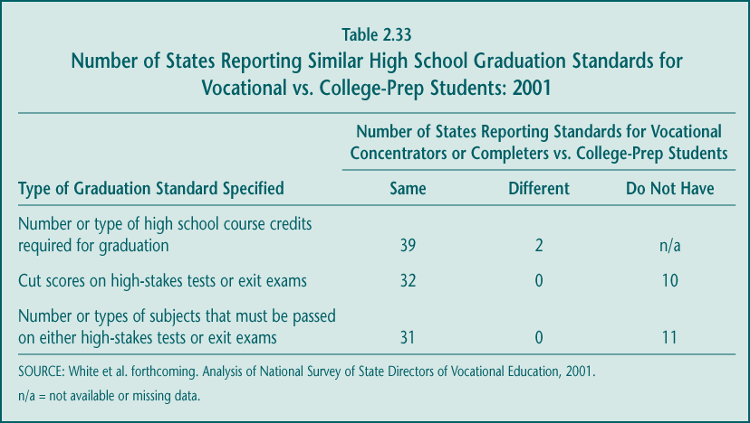

► Opportunity to help with dropout prevention. States’ use of high-stakes academic assessments have led to concern about students’ dropping out of school (Chudowsky et al. 2002). Many vocational educators share those concerns as well as misgivings about the effect the tests may have on vocational enrollments. Most vocational teachers feel that vocational education can contribute to school reform, in part, by keeping students engaged and interested in school (Stasz and Bodilly forthcoming), although empirical analyses are less conclusive about that contribution (see Section E).

► Reduced enrollments and technical content in vocational courses. Although aggregate national data through the year 2000 do not show measurable declines in vocational participation (see Section B), many vocational educators report more recent reductions in enrollments, particularly as high-stakes exams are being phased in (Stasz and Bodilly forthcoming). Some states or schools have implemented strategies to maintain these enrollments in the face of increased academic credit requirements; full-day area vocational centers in Ohio (called “joint vocational schools”), for example, increased the number of academic courses offered so that students could meet their graduation requirements.

Mechanisms for reporting vocational performance remain mostly separate from those relating to academic performance.

Perhaps left over from the Vocational Education Data System (VEDS) requirements in previous laws, most current vocational data collection systems have been developed independently of those that maintain academic outcomes. Still, state vocational officials have been largely successful in tapping into state academic assessment systems to meet Perkins III performance-reporting provisions. In fact, relatively few states (20 percent) reported in 2001 that obtaining data on the academic proficiencies of vocational students was very difficult (see Chapter 5). About half of the states say that ESEA Title I and Perkins programs use common data systems to at least some extent. At the same time, that leaves another half of states in which little or no coordination in data systems occurs at the local level (Table 2.34).

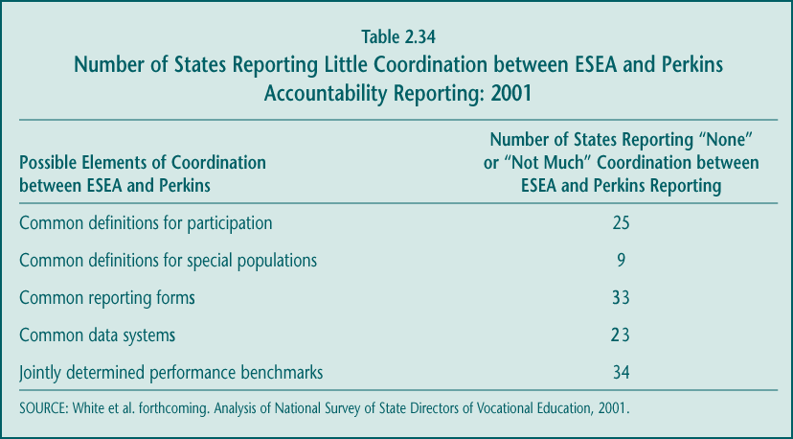

The incentives to integrate academic and vocational data systems are not particularly strong, however. Even in states with vocational assessment programs of some kind (e.g., North Carolina and Ohio), the vocational results are not included in state high school accountability systems. Nor are students in vocational programs a subgroup for academic assessment reporting on school report cards, although those who invest in vocational education (take at least 3.0 credits) make up almost half of the high school population. There remains potential for further streamlining of state data and reporting systems.

E. Outcomes and Effects

Perhaps the most important issue for vocational education, and for federal policy, is how well students who participate fare in school and beyond. Analysis of this issue involves looking at two dimensions of vocational education: (1) the basic outcomes of participants and whether progress is being made over time and (2) the “value added” of vocational education, comparing those who participate to similar students who do not participate as a way of measuring what might have happened in the absence of vocational course taking and programs. The first type of analysis tracks the performance of vocational students, while the second type examines whether vocational education itself contributes to that performance. Although both analyses are important, the value-added assessments provide policymakers with a better indication of the effectiveness of the program (Table 2.35).

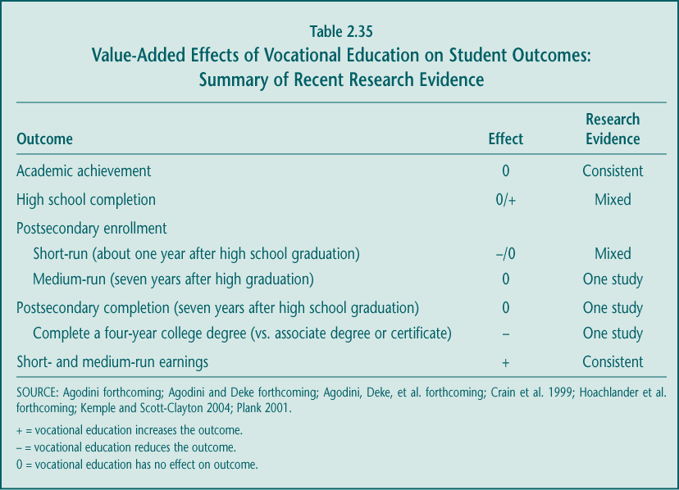

In both cases, changing priorities at the secondary level and the many performance objectives called for in Perkins III require an examination of a broad set of outcomes and effects. These include not only the traditional labor market outcomes associated with vocational education but also academic achievement, high school completion, and postsecondary enrollment. Unfortunately, it is difficult to examine either the progress on or contribution of vocational education to its most direct outcome—occupational or technical competency—because few good measures of those skills exist.

Finally, it is important to note that, although vocational education is comprised of several types of courses, most researchers examining the relationship between vocational education and key outcomes have focused on occupational education courses. This emphasis reflects the fact that occupational courses represent the majority of all vocational course taking (on average, nearly three out of four credits earned in vocational education) and previous studies have suggested that they offer the greatest potential benefit, particularly in predicting employment and earnings (Boesel et al. 1994b).

1. In-School Outcomes: Academic Achievement and High School Completion

With academic improvement increasingly the marker of a high school’s success, policymakers have sought to ensure that students who participate in vocational education are not left behind. Perkins III accountability provisions, for example, require states to report and make progress on increasing the proportion of vocational students who meet state-established academic standards. Improvement strategies in Perkins III encourage vocational programs to integrate and support academic learning.

Vocational educators and their academic colleagues face challenges in meeting these goals, however. Historically, many of the occupational concentrators and other students who pursue vocational programs of study (i.e., take at least 3.0 credits of occupational education) have entered high school with lower levels of academic achievement than other students, although in at least some states that seems to be changing. In part because of their relatively lower academic achievement, those who are inclined to become vocational students may be at higher risk for dropping out of high school than are other groups of students. Moreover, some fraction of students will choose to enroll in vocational programs because they view themselves as academically unsuccessful, are disinterested in academic subjects, or want to prepare for work right after high school rather than pursue postsecondary education. It therefore should not be surprising if the path some vocational students take through high school differs from that of other students.

Students in vocational programs are earning significantly more core academic credits than in the past, and the gap between them and other students is decreasing.

More than a decade of attention to school reform appears to have helped increase the academic course taking of all students, including those who participate in vocational education. Public high school graduates earned almost one additional core academic credit—in English or language arts, mathematics, science, or social studies—in 2000 than they did in 1990 (Table 2.36). This increase is equivalent to more than one full-year academic course.

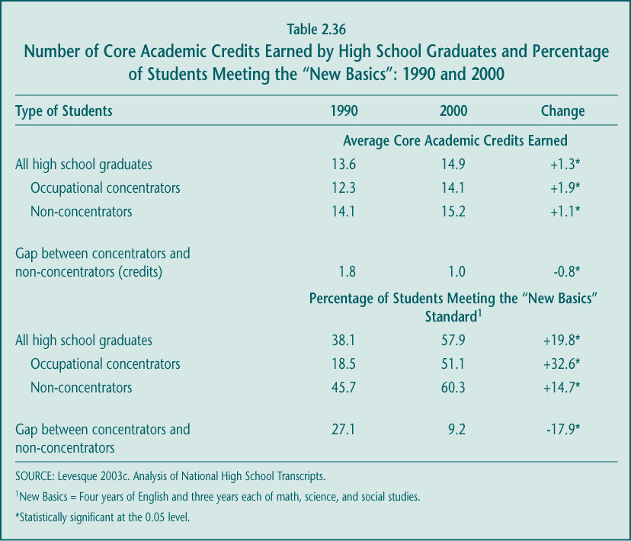

Occupational concentrators increased their academic course taking even more than other students, perhaps because they had farther to go in meeting new graduation requirements. As a result, by 2000 the gap between occupational concentrators and non-concentrators in the number of academic credits earned had narrowed significantly, from 1.8 to 1.0 credits (the equivalent of a 44.4 percent decrease). Most of the remaining gap is due to differences in science course taking.

Other indicators of academic course taking also show substantial progress. In a 1996 book entitled Teaching the New Basics Skills: Principles for Educating Children to Thrive in a Changing Economy, Murnane and Levy argued for both more academic course taking and better development of such “soft skills” as communication and problem-solving. The core academic curriculum they proposed included four years of English and three years each of math, science, and social studies as a way to upgrade students’ academic competencies and preparation for both college and work. This core curriculum has become known as the “New Basics,” and it is increasingly the standard for graduation requirements toward which many states have moved. Not only has the proportion of occupational concentrators meeting this standard more than doubled (from 18.5 percent to 51.1 percent) between 1990 and 2000, but the gap between concentrators and non-concentrators in meeting these standards declined by two-thirds (Table 2.36).

Still, while the increase in meeting the “New Basics” course standard among concentrators has been quite significant, those concentrators who meet the standard represent a small proportion of the overall student population. Students who both concentrated in an occupational program and completed the “New Basics” curriculum (those who have been called “dual concentrators”) represented only 13.3 percent of all high school graduates in 2000, up from 5.1 percent of graduates in 1990.

Differences in the rigor of academic course taking are also narrowing but remain.

There has been some success not only in increasing the number of academic courses that vocational students take but, to a lesser degree, in narrowing the gap in the types of courses they take. During the 1990s, concentrators and other students became more alike in terms of the rigor of their course taking, particularly in their completion of such “gatekeeper” courses as algebra 1. However, at the end of the decade, occupational concentrators were still much less likely than non-concentrators to complete a more demanding college-prep curriculum or to take advanced math, advanced science, or high-level English course work (Table 2.37).

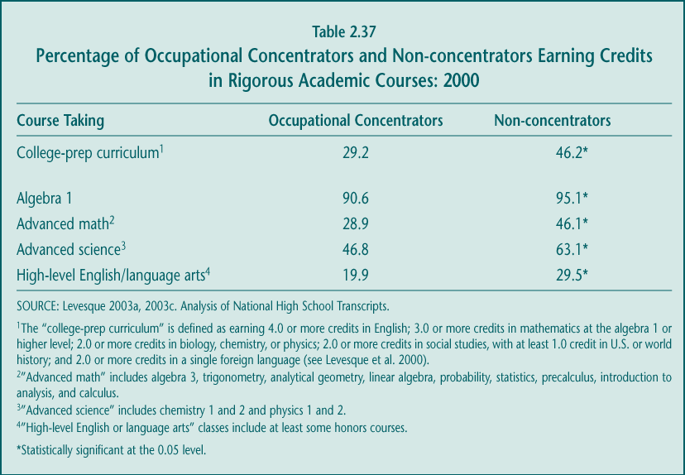

This disparity in the rigor of course taking raises some concern. Because many students who concentrate in vocational education begin high school with lower levels of academic achievement, if they then take less challenging academic courses, they may have difficulty passing state academic assessments required for graduation. This problem was evident in a few states, where some local educators sought a separate set of passing standards or what they viewed as more relevant tests for vocational students. The comparatively low rate at which vocational students complete a college-prep curriculum is also important to consider when looking at the future of vocational education, as more and more students are aspiring to earn baccalaureate degrees.

The achievement levels of vocational students improved substantially during the 1990s.

The increase in the number and rigor of academic courses taken by vocational students over time appears to have paid off. Over the last decade, successive groups of students who pursued a vocational program of study—occupational concentrators—had higher reading and math skills than the concentrators who came before them. Perhaps because they had farther to go in raising levels of achievement, concentrators experienced bigger increases in test scores than did non-concentrators in the same periods (Figure 2.9).

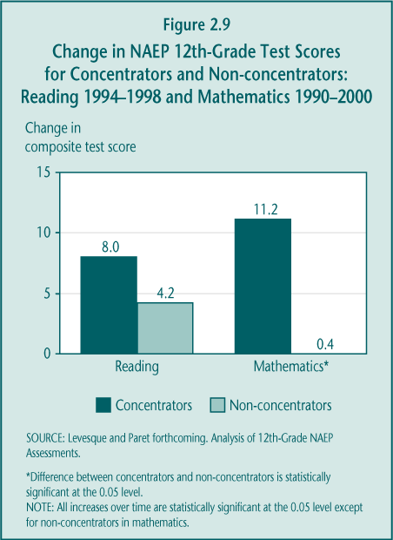

With regard to math skills, the increases in test scores for concentrators from 1990 to 2000 significantly reduced the gap between them and other students. The average NAEP composite math score for concentrators was 11 scale points higher in 2000 than in 1990, while there was no increase during that period for non-concentrators (Figure 2.9). As a result, the gap between concentrators and non-concentrators narrowed from 20 scale points to only 9 scale points. The gap became smaller for students with varying characteristics, including both men and women, those from minority racial-ethnic groups and from schools with very high proportions of students eligible for free and reduced-price lunches (Levesque and Paret forthcoming).

The difference in reading achievement between concentrators and non-concentrators did not change significantly, in a statistical sense. Comparable NAEP reading scores are available only for 1994 and 1998. Although the average NAEP composite reading score of occupational concentrators increased by more (8.0 scale points) than did the scores of non-concentrators (4.2 scale points), the reduction in the gap between concentrators and non-concentrators—from 15.7 points to 12.0 points—was not statistically significant. Vocational students in most of the special population groups experienced increases in their reading scores as well (Table 2.38).

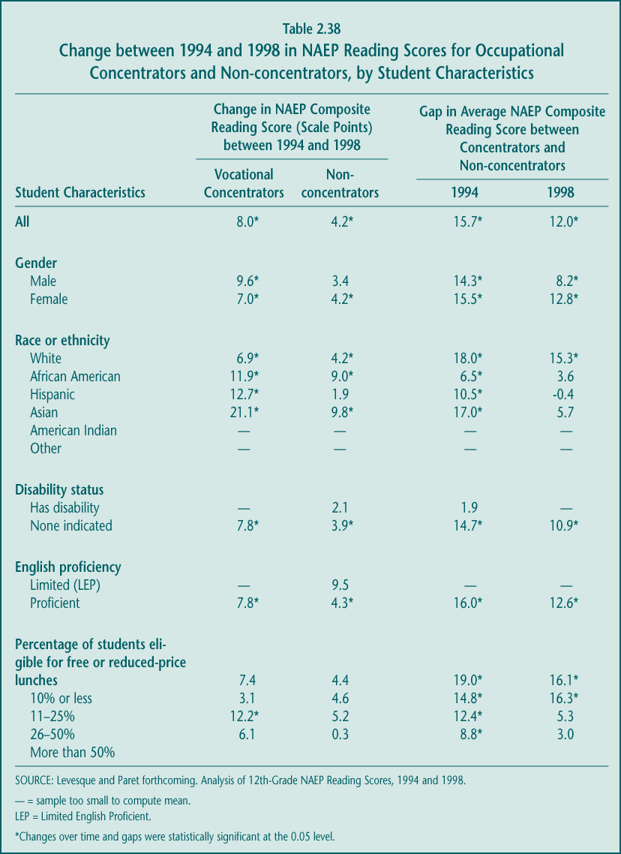

The NAEP assessments indicate that there has been substantial progress, but more work is necessary to raise the achievement levels of all students, particularly those in vocational programs. Most importantly, significantly smaller shares of concentrators than other students are “proficient” in reading or math, as defined by their most recent NAEP test scores (Figure 2.10). In 1998, for example, only 29.3 percent of concentrators, compared to 44.8 percent of non-concentrators, scored at or above the “proficiency” level in 12th-grade reading. In math in 2000, the proportions achieving proficiency are much lower for both groups of students but the gap between them, though much smaller, is still large. If proficiency on the 12th-grade NAEP assessments is associated with readiness for postsecondary education or success in the labor market, then these figures suggest a greater focus on academic improvement is needed.

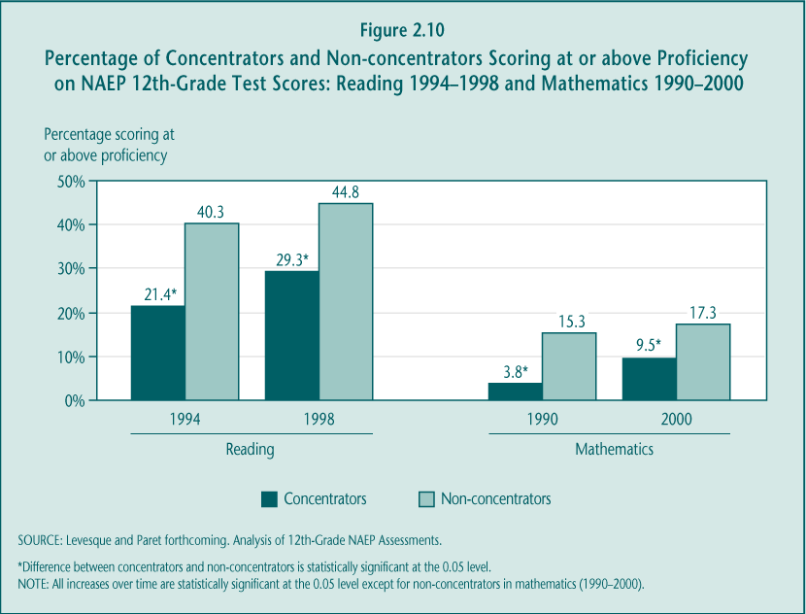

But, on average, vocational courses as currently structured do not appear to contribute to an increase in students’ academic achievement.

Despite the marked improvement in the academic course taking and reading achievement of successive groups of vocational students, the best available data suggest that, on average, these gains have been made without the help of vocational courses and programs. Analyses of high school student assessments in both the early and late 1990s indicate that vocational courses did not generally contribute or “add value” to students’ academic achievement.

► Completing a vocational program in the early 1990s produced achievement gains similar to those of completing a general education program. Studies using the National Education Longitudinal Study (NELS) database of 1992 high school graduates suggest that, after adjusting for demographic characteristics and prior academic achievement, students who pursued an occupational concentration did no better in reading, math, and science achievement between 8th and 12th grade than students who were in the general education program (Plank 2001; Agodini forthcoming). However, compared with students who pursued a program with a high number of academic credits and little occupational education, concentrators had significantly lower achievement gains in high school. The studies also found that students who pursued both an occupational concentration and a high academic credit curriculum experienced achievement gains in high school that were only slightly lower than those of students who only pursued a high academic curriculum (Table 2.39).

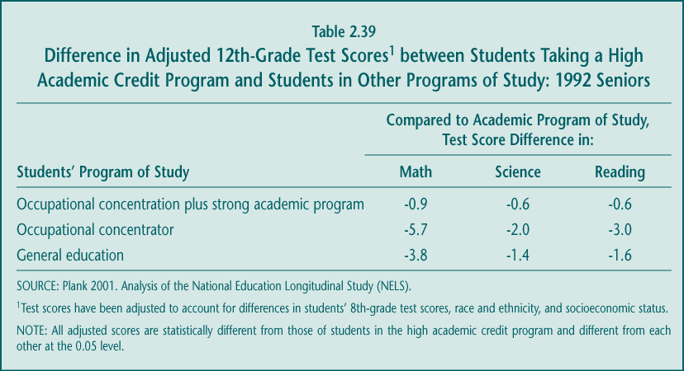

► Participating in a career academies (vocational) program in the late 1990s had no impact on test scores. Career academies are a strategy to integrate the best of career preparation courses and college preparatory academics and were therefore thought to have the best chances of producing strong academic and labor market impacts. However, a recent randomized controlled evaluation of selected career academies updates the NELS findings for a group of students who were scheduled to graduate from high school in 1997 or 1998. According to the study, the main difference in the curriculum of students randomly assigned to the career academy and those assigned to their regular high school program was that the career academy students earned significantly more vocational credits. However, when comparing gains in 8th- to 12th-grade academic test scores, there were no differences between the academy participants and those assigned to the nonacademy control group (Kemple 2001). While some part of the academy “treatment” extended beyond the vocational course taking, this rigorous evaluation does not provide support for the view that vocational courses help improve academic achievement. Similarly, an earlier randomized controlled study of high school career magnet programs in New York City found that participating in these programs had no impact on reading scores and had a negative impact on math test scores (Crain et al. 1999).

► Individual vocational courses have no effect on academic achievement. Students who participate in various high school programs of study differ by more than their vocational course taking. Agodini (forthcoming) isolated the achievement effects of individual vocational courses—holding academic course taking constant—and found that, on average, taking an additional vocational course (occupational, general labor market preparation, or family and consumer sciences) neither contributes to nor weakens academic achievement. However, substituting academic courses for vocational courses would increase academic achievement.

► Participation in vocational education did not affect the achievement of special populations or other subgroups. Students who were educationally disadvantaged (defined by having low 8th-grade achievement or not having plans to attend college), in urban or rural schools, disabled, or from racial or ethnic minority groups received neither a benefit nor a loss in terms of math, science, or reading achievement from completing a vocational program or taking additional vocational individual courses.

► Preliminary analyses suggest that participation in a CTSO is not associated with improved academic achievement. The full range of activities that career and technical student organizations offer could affect academic achievement as well as other outcomes, but no studies have previously addressed these questions in a rigorous manner. Analysis of 1992 graduates suggests that participating in a CTSO either has no relationship to academic achievement gains or decreases them (Agodini forthcoming). One hypothesis for these outcomes may be that participation in CTSO activities, some of which are held after school, leaves less time for students to do their homework. However, because the available measure of student participation is a rather weak one, further investigation is needed.

These newer findings about the effects of vocational courses or programs on academic achievement are consistent with the results of previous studies. For example, the authors of the 1994 NAVE report (Boesel et al. 1994b) came to the same conclusion, drawing on a review of the earlier literature on this subject and earlier studies of the NELS data. As was true in the Agodini analyses, the earlier studies concluded that students give up academic achievement gains by taking vocational courses instead of academic courses, although the studies differ in the magnitude of the effects. Other efforts to track the academic outcomes of vocational students, such as those published by the HSTW network, provide important information on the progress of students in those schools but cannot be used to isolate how vocational courses themselves contribute to academic achievement.

There is mixed evidence that participation in vocational education reduces a student’s likelihood of dropping out of high school.

Vocational educators have long advocated occupational courses as an effective strategy for keeping in school students who are at risk of dropping out. Studies of vocationally oriented programs in the 1970s and 1980s appeared to support this claim (e.g., Wonacott 2002), but because most of these studies have substantial methodological limitations, one cannot draw conclusions about the findings with confidence. More recent studies of vocational course taking provide mixed results, and the more rigorous analyses do not support the compelling anecdotal evidence.

Two studies of students who were scheduled to graduate in 1992 suggest positive effects for vocational education. The first (Rasinski and Pedlow 1994) concludes that taking vocational courses in 9th or 10th grade reduces students’ probability of dropping out later in high school, largely because students earn higher grades in vocational courses, which in turn raises their class rank and self-esteem and makes them less likely to leave school. Another analysis (Plank 2001) finds that, up to a point, the higher the ratio of vocational to academic courses students take, the lower is their probability of dropping out of school. The lowest probability occurs when students take three vocational courses for every four academic courses, a ratio difficult to achieve under current academic graduation requirements in most states. The study indicates that students most at risk—those with low levels of 8th-grade academic achievement and low grades—benefit most from vocational education. Both studies combined all forms of vocational education in their analyses—specific labor market preparation (occupational education), general labor market preparation, and family and consumer sciences.

However, three studies conclude that vocational programs have no effect, or perhaps even a negative effect, on dropping out of high school. A recent examination of the 1992 graduates uses a more comprehensive statistical methodology—but focused only on occupational courses—and controls for characteristics known to be predictors of dropping out, such as having a sibling who has dropped out and living in a single-parent family (Agodini and Deke forthcoming). The analysis finds that occupational course taking has neither a positive nor negative effect on high school completion and explicitly tests what happens when students combine three occupational courses for every four academic courses—a critical point according to an earlier study—and finds no effect. According to the results of this analysis, vocational course taking does not reduce or increase the likelihood of dropping out, even for students who enter high school with low levels of academic achievement, who do not plan to go to college, or who attend schools with high concentrations of poverty.

Perhaps more importantly, the two most rigorous evaluations conducted—one of career academies and the other of career magnet programs in New York City—did not find that these vocationally oriented programs reduce dropout rates. The first finds that participation in career academies has no impact on high school graduation, even among at-risk students (Kemple and Scott-Clayton 2004). The second study shows that participation in career magnet programs actually negatively affected (i.e., reduced the rate of) graduating on time (Crain et al. 1999). These two studies must be given greater weight, because the methodology of using a randomized controlled trial (a lottery) to create the participant group and a control group of nonparticipants is the only way to eliminate any bias in results from comparing groups.

2. Postsecondary Education and Training

Obtaining a postsecondary education credential remains an important goal for students and a longstanding objective of federal education investments. By almost any measure, the rate at which high school students participate in postsecondary education has been increasing over the last decade (Snyder et al. 1999), as has the proportion of students who want to attend college—at either a two- or four-year institution (Ferris State University 2002). As a result, the group toward which vocational policy has historically been directed—the “noncollege bound”—is getting smaller. Still, at least a third of high school graduates either never enrolls or fails to complete a postsecondary program and earn a credential (Table 2.40).

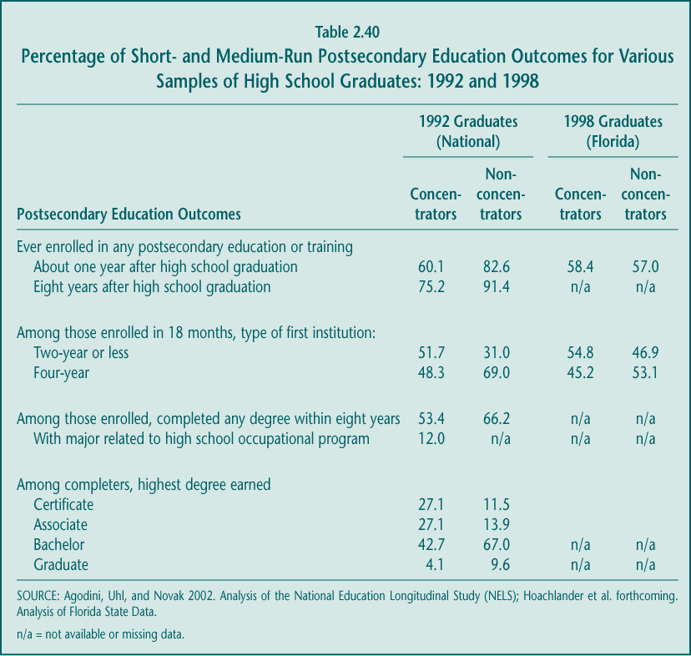

These trends are acknowledged to some extent in the Perkins Act. The law’s performance indicators include enrollment in, retention in, and completion of postsecondary education and training as measures of vocational program success. Although the law stipulates that vocational education prepare students only for occupations that require a sub-baccalaureate degree, as will be clear, a substantial share of occupational concentrators (researchers’ proxy for vocational “program completers”) attend institutions that grant baccalaureate degrees. Therefore, the relationship between vocational education and a variety of postsecondary educational outcomes is examined.

Postsecondary enrollment rates have grown faster for occupational concentrators than for other students.

The best available national data—unfortunately, not particularly current—suggest that a much higher share of vocational students in the 1990s entered college and postsecondary training activities than did in the 1980s. Although enrollment rates have risen for almost all students, they have grown at the fastest rate for those who had the farthest to go: while only 41.5 percent of occupational concentrators in 1982 enrolled within two years of high school graduation, a decade later, enrollment for that group rose to 54.7 percent (Table 2.41). Concentrators still have the lowest enrollment rates, however, perhaps reflecting that some who participate in high school vocational education do so because they plan to work rather than continue their schooling after graduation. Students’ characteristics and motivation, not just their high school program, play a role in determining the paths they take.

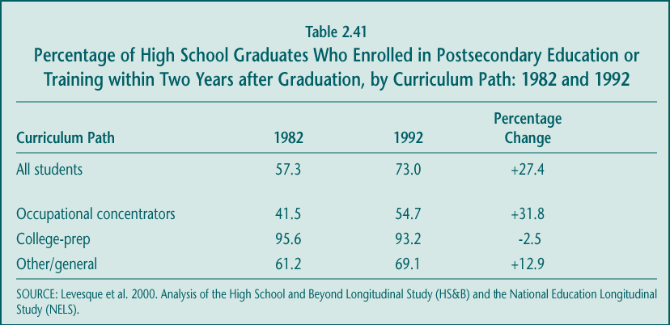

Taking vocational courses and programs probably has no effect on enrolling in postsecondary education over the longer run.

Although vocational education has long been stigmatized as being for the noncollege-bound (Stasz and Bodilly forthcoming), the evidence suggests that students and parents have less cause for concern that taking vocational education deters enrollment in postsecondary education. In the short run, there appears to be some negative relationship between vocational course taking and college going, but it dissipates over time: adjusting for student characteristics and early achievement, after eight years, students who took high school vocational courses catch up. These results hold when “college” attendance is viewed broadly, including enrollment in a program that awards any type of credential after high school.

► Vocational course taking may either have no effect on or reduce the probability of attending college in the short run. Conventional wisdom suggests that students who do not attend college within a few years of graduating high school often never enroll. However, perhaps because vocational students know they can earn more than other students when they leave high school (see below), many choose not to directly enroll in further education. Studies of students in both the early and late 1990s indicate that those who were concentrators or who took an extra high school occupational course might lower their chances of attending college or training within the first year and a half after graduation (Agodini, Deke, et al. forthcoming; Hoachlander et al. forthcoming; Plank 2001). In addition, the randomized controlled study of career academies suggests that participating in that program has no impact on college enrollment in the first year after high school (Kemple 2001). Moreover, given a choice between taking one occupational credit versus one low-level math or science credit, an average student would increase the probability of enrolling from about 78 percent to almost 81 percent (an increase of 2.7 percentage points) if that student chooses the academic option (Agodini, Deke, et al. forthcoming). These findings suggest that increasing academic course taking—for example, by encouraging students to complete the “New Basics” curriculum—may well raise their transition rates into college.

► On average, taking vocational courses neither hurts nor improves students’ chances of enrolling in postsecondary education in the medium-run. Over time, many students who participated in high school vocational courses and programs eventually do enroll in postsecondary education or training; however, they do so later than other students. The rigorous evaluation of career academies, for example, found that this program linking academic and career courses had no impact on education attainment, measured four years after scheduled high school graduation (Kemple and Scott-Clayton 2004). Eight years after high school graduation, although the rates at which students “ever” enrolled in college are different—75 percent for vocational concentrators and 91 percent for other students (Table 2.40), the difference disappears when the characteristics of students and other predictors of attending college are taken into account to isolate the effects of taking occupational courses. Moreover, low-level academic courses and occupational courses both have a very small medium-term effect on the probability of “ever” enrolling in college (Agodini, Deke, et al. forthcoming).

► Participating in high school vocational education does not reduce the probability of early “stopping out.” Research suggests a relationship between intermittent postsecondary attendance (i.e., periodic “stopping out”) and lower earnings (Scott and Bernhardt 1999). One hypothesis is that vocational students who do enter college would be more “directed” as a result of their high school career preparation and thus might be less likely to “stop out” of postsecondary education and training, but that does not appear to be the case. Moreover, substituting low-level academic courses for occupational ones in high school is associated with lower rates of stopping out of college in the first year and a half after enrolling (Agodini, Deke, et al. forthcoming). Again, this result may reflect the relatively higher opportunity cost (lost earnings) of staying in college for students who invested in vocational education in high school.

► Among concentrators, participating in a CTSO is not associated with higher postsecondary enrollment but may be related to higher completion rates. Many types of students participate in CTSOs, including those who take only one or two vocational courses. However, even when focusing only on “occupational concentrators” (those who earn at least 3.0 occupational credits in the same program area), both those who do and do not participate in CTSOs have the same rates of college transition, and regression analysis to adjust for student characteristics does not change these results. On the other hand, among students who did attend postsecondary institutions, concentrators who participated in a CTSO were more likely to earn a degree (62.2 percent) than concentrators who did not participate (50.3 percent). These findings must be interpreted with caution, however, because students who do and do not participate in a CTSO may differ on many other factors that could not be controlled for in these analyses (Agodini, Deke, et al. forthcoming).

► Vocational course taking affects students from special populations in much the same way as other students. Looking across studies, the results on short- and medium-term enrollment in postsecondary education generally hold true for educationally disadvantaged students (including LEP and migrant students and those with low achievement in 8th grade); economically disadvantaged students; students with disabilities; and both men and women (Agodini, Deke, et al. forthcoming; Hoachlander et al. forthcoming). The numbers of students from these groups in the data are too small to examine other postsecondary education effects.

Vocational education is associated with a shift from earning a baccalaureate degree to earning an associate’s degree or certificate.

Although student aspirations for baccalaureate degrees are high, many in the vocational education community argue that completing a technical associate’s degree or certificate is at least as valuable in the labor market and more so than spending a few years at a four-year institution without earning a credential. It is certainly true that projected demand for occupations requiring a vocational associate degree remain among the highest of job growth categories (see Chapter 1).

The evidence indicates that the more students invest in vocational education in high school the more likely they are, compared to other similar students, to complete a two-year or lesser degree instead of a baccalaureate degree (Agodini, Deke, et al. forthcoming). For the average student who enrolls in any type of postsecondary education within seven years of high school graduation, taking an additional occupational course in high school decreases the probability of earning a baccalaureate degree by 2 percentage points (from about 73 percent to 71 percent), and increases the probability of earning an associate degree or certificate by the same amount. In contrast, taking additional low-level math or science courses raises students’ chances of earning a baccalaureate degree, perhaps because doing so makes students more eligible for or more prepared to complete four-year degree programs.

3. Employment and Earnings

Vocational education has long been viewed as preparation for jobs and careers. As a result practitioners and researchers have judged its success primarily in terms of employment and earnings benefits, and often just for those who do not enroll in postsecondary education. Currently, however, many students who take vocational education courses in high school do go on to college, and a large share combine college and work. Students who do and do not participate in vocational education in high school complete their postsecondary programs at different rates and at different times. These different pathways, and the way they affect students’ length of time in the labor market, make it challenging to estimate the effects of vocational education on earnings. Still, although Congress chose not to include earnings in the Perkins III accountability measures, for many it remains the most important long-term indicator of the effectiveness of vocational programs.

Earnings, however, are a function of both wages and the number of hours worked. On the one hand, the distinction between these two factors may not matter—higher earnings, regardless of how they are obtained, are presumed to allow a higher quality of life. On the other hand, a higher wage is often viewed as reflecting a “better” job, while more hours worked means additional effort. In assessing the benefits of vocational education, higher earnings that result from higher wages rather than more hours worked are a more desirable outcome, although most data sets available for analysis cannot adequately separate these components.

Vocational education has little effect on employment.

A variety of studies confirm high employment rates for students in the 1990s, both immediately after high school graduation and later in life. More than 90 percent of 1992 graduates who pursued vocational, general education, and only academic programs of study worked during the first year and a half after graduating, and a similar proportion held jobs in 2000, eight years later (Agodini, Uhl, and Novak 2002). The career academies evaluation found similar short-run results for 1997 and 1998 graduates (Kemple 2001). These high levels of employment provide little opportunity for students’ high school program of study to affect whether they get jobs.

Vocational courses are associated with two other employment measures, although the magnitude of the results may be too small to be policy-relevant. For example, taking an additional occupational course appears to reduce the amount of time it takes students to get their first job by about two-and-a-half days; in other words, students would need to complete 12 more occupational courses (or half of the typical high school course load) to reduce the time it takes to get their first job by one month. Similarly, taking an additional occupational course is associated with a 1 percentage point increase in the percentage of months worked in the first year and a half after graduation.

Occupational courses and programs are associated with significant short-term earnings benefits for students overall.

While there is little consensus within the vocational education community about whether vocational education should contribute to academic achievement or college going, there is a strong belief that vocational courses and programs provide students with substantial earnings advantages. That belief is confirmed by analyses of both national and state data, for groups of high school graduates in the early and late 1990s, and particularly when considering earnings in the first year or so after high school graduation. For 1992 high school graduates, for example, taking an additional occupational course is associated with a 3.2 percent (or $207) increase in earnings in the year or so after graduation (Figure 2.11).

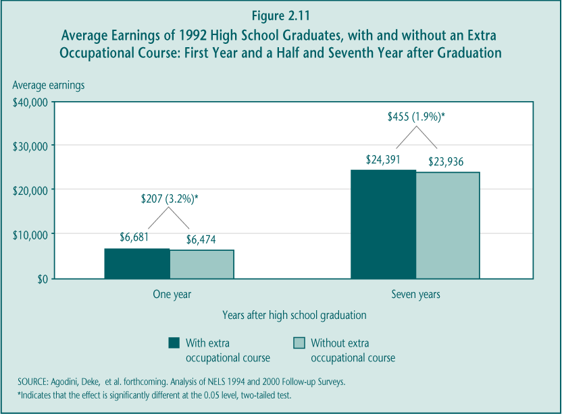

► Taking high school vocational courses raises early earnings of college students who work. The evidence suggests that students who combine postsecondary education and employment in the first year or so after high school benefit from having taken vocational courses in high school: an extra occupational course increases their earnings by between 3 and 5 percent (Agodini, Deke, et al. forthcoming; Hoachlander et al. forthcoming).

► For students who do not attend college within a year or two after high school, the advantages of vocational education are uncertain. Students who go to work directly after high school instead of enrolling in postsecondary education are considered to face challenges in achieving long-term labor market success. Two recent studies suggest conflicting evidence about these students’ short-term transitions. Hoachlander et al. (forthcoming) examined late 1990s high school graduates in two states and found that, among noncollege students, having taken an additional occupational course in high school increased their earnings in the year or so after graduation by between 2 and 8 percent. However, a study analyzing the national sample of 1992 high school graduates found no relationship between occupational courses (or other vocational courses) and earnings for students who do not enroll in postsecondary education within two years after high school. Taking additional low-level academic courses in place of occupational courses also had no effect on earnings, although substituting advanced math for occupational courses would generate higher earnings. These mixed findings are consistent with the accumulation of earlier studies on the same subject, which generally found no earnings effects for noncollege students overall but some advantages for young women (particularly if they took courses in the health field) (Boesel et al. 1994b).

► Students from special populations generally benefit from vocational education. Looking across studies, vocational course taking appears to contribute to short-term earnings for economically and educationally disadvantaged students, students with disabilities, and for both men and women.

► The relationship between specialization in a vocational program area and higher earnings is unclear. Studies examining the benefits of “concentrating” vocational course taking have produced mixed results. Analyses of data in two states for graduates in the late 1990s suggest that the economic benefits of vocational education are correlated with the degree to which students focus their occupational course taking in one field. That is, compared to similar students who took no or few courses, students who took at least 3.0 occupational credits and concentrated them in a single program area earned more than did similar students who took the same number of credits but took them across multiple program areas (Hoachlander et al. forthcoming). In contrast, an examination of national, but earlier, data on high school students indicate that there is no statistically significant difference in earning effects for students who take their 3.0 or more credits in a single occupational program area or across several different programs (Agodini, Deke, et al. forthcoming).

► Participation in co-op education is associated with higher short-run earnings. Co-op is a longstanding, for-credit work experience program in which about 16 percent of high school students participate nationally. Data from one state (Florida) indicate that involvement in these experiences provides an earnings advantage for students during the first year or so after high school (Hoachlander et al. forthcoming).

The earnings advantage of high school vocational education still appears significant for some groups in the medium term, but the long-run effects are unclear.

Two recent studies suggest that secondary vocational courses and programs offer benefits that are sustained several years after high school. For example, the rigorous evaluation of career academy programs found that, for young men, participating in those programs had a significant impact on students’ earnings four years after high school graduation; young men randomly assigned in high school to participate earned 18.3 percent more than did men randomly assigned to a control group who did not participate. There were no earnings impacts for young women, however (Kemple and Scott-Clayton 2004). Because career academy programs include a broad set of activities (e.g., job shadowing and internships), the impacts on earnings cannot be definitively attributed to the higher levels of vocational or career course taking among participants; that is one hypothesis, however.

Vocational education courses are also associated with higher earnings for some students seven years after high school graduation, although the evidence is not as strong as it is for short-term earnings (Agodini, Deke, et al. forthcoming). As a proportion of current earnings, the benefits are smaller (1.9 percent per extra course) after seven years than they were just a year or so after graduation (3.2 percent per course). Still, that 1.9 percent translates into approximately $455 per additional occupational course, or a more than $1,350 earnings advantage for vocational concentrators over similar students who did not take 3.0 occupational credits (see Figure 2.11). However, unlike the short-run, substituting occupational courses for low-level academic courses in high school would have no effect on earnings; only high-level math courses would raise earnings by more than vocational courses. As was true for the effects on short-term earnings, however, these positive results do not hold for nearly one-quarter of high schools students who never enrolled in postsecondary education or training.

The analysis of the relationship between vocational education and medium-run earning also suggests:

► The benefits of vocational courses come from students’ working more, although higher wages may also play a role. Estimating the separate effects of vocational education courses on wages and hours worked suggests that, overall, the earnings advantage comes from students’ working more hours rather than obtaining a “better” job, as measured by their wages. Among individuals working seven years after graduation, taking an additional occupational course increased the number of hours worked in a year by 25 hours; there was no effect on hourly wages for students overall. However, taking occupational courses in high school may be associated with higher wages for young men and for students who are economically disadvantaged (attend low-income schools) or educationally disadvantaged (entered high school with low levels of academic achievement) (Agodini, Deke, et al. forthcoming). Moreover, the career academies evaluation found that four years after graduation, young male participants earned higher wages ($9.75) than did the control group ($9.01) (Kemple and Scott-Clayton 2004). Thus, for some students, high school vocational course taking may lead to higher wage jobs.

► Special populations receive similar benefits. The evidence suggests that vocational course taking increases medium-run earnings for students in some special population groups, as well as for students overall.

► Students who take an extensive academic core (“New Basics”) curriculum earn more if they also take occupational courses. It is possible to complete both a solid core academic curriculum and an occupational concentration; as noted in an earlier section, 13.3 percent of all high school graduates do so. Among students who meet the “New Basics” standards—four years of English or language arts and three years each of math, science, and social studies—those who take an additional occupational course or who are occupational concentrators earn more than students who do not participate or participate very little in vocational education (Agodini, Deke, et al. forthcoming). Given that increased academic course taking raises postsecondary enrollment rates, at least in the short-run, while occupational course taking improves earnings, combining these two curriculum patterns may well produce the broadest range of benefits for high school students.

Whether the medium-run benefits of high school vocational course taking will persist over time is unclear. The earnings premium soon after high school graduation was 3.2 percent, but 1.9 percent seven years later. Moreover, medium-run estimates, a major contribution of the NAVE analysis, must be viewed in tandem with the postsecondary education results. First, to isolate the effects of vocational course taking in high school, multivariate analysis must control for not only the demographics and achievement of students but also their education pathways after graduation; using these methods, earnings are statistically compared for students who had similar characteristics and achievement in high school and who attained the same level of education after high school. Thus, the finding that vocational course taking is associated with reduced enrollment in four-year colleges is not taken into account in the earnings calculations—which the research literature suggests would decrease earnings in the long run.

Moreover, having only seven years of post-high school employment data precludes obtaining a complete picture of course-taking effects. Students who invested in vocational education in high school are likely to have completed less postsecondary education (see above) and therefore have been employed longer than other similar students, allowing them to accumulate earnings and valuable labor market experience. On the other hand, within the seven-year window of data, students who completed a baccalaureate degree or higher (i.e., those who were less likely to have taken high school vocational courses) have only just begun working full-time and have relatively little work experience. In other words, the power of their higher credentials on earnings has not been fully realized.

Most research indicates that, in the long run, each additional year of college produces an earnings premium, suggesting that high school course taking that encourages higher educational attainment may be most beneficial. Clearly, then, it is important to ensure that students are able to attend and succeed in postsecondary education, even if some students choose not to follow that path.

3. Postsecondary Vocational Education

Vocational education is offered at both the postsecondary and high school levels, but at each level the mission of the educational institutions that provide it and the objectives of the students who participate are quite different. In reauthorizing the Perkins Act, policymakers may therefore wish to consider (1) whether postsecondary vocational education is sufficiently distinct from secondary vocational education to warrant separate treatment in the legislation, and (2) if a new law should focus on particular problems in postsecondary vocational education (e.g., improving students’ completion rates or easing their transitions from high school), or as is currently the case, allow grantees to decide. These issues are particularly important if postsecondary vocational education is to be better coordinated with the workforce development system, an outcome Congress promoted in Perkins III.

To help inform these overarching policy concerns, this chapter provides background on how postsecondary vocational education is organized (Section A) and addresses four main questions:

1. Who enrolls in postsecondary vocational education and what are their objectives? (Section B)
2. To what extent are the strategies promoted in Perkins III implemented at postsecondary institutions that provide vocational education? (Section C)
3. What role does postsecondary vocational education play in formulating state and local workforce development strategies? (Section D)
4. What are the economic benefits of participating in postsecondary vocational education? (Section E)

Key Findings

► Postsecondary vocational education provides economic benefits to most participants, with the minority who earn a credential reaping the greatest benefits.
Important economic benefits are associated with participation in postsecondary vocational education. Even those who leave occupational programs without obtaining a degree or certificate earn between 5 and 8 percent more per year for each year they participate in postsecondary vocational education than do high school graduates with similar characteristics. However, credentials do matter. The benefits of completing a vocational associate degree are significantly higher: females who have such a degree earn nearly 47 percent more than females with a high school diploma, and their male counterparts earn 30 percent more. In addition, entry into fast-growing fields such as health care and information technology increasingly depends upon completing some type of credential—either a college degree or an industry-based certificate.

Despite the added economic advantage associated with earning a credential, less than half of all postsecondary vocational participants earn a credential of any kind—an institutional certificate or associate or baccalaureate degree. Most (68.3 percent) complete a year or less of course work. Although about half of the students appear to be seeking a certificate or degree, many others may not enroll with that objective in mind. Taking student goals and characteristics into account, the completion rate for vocational majors is similar to that of academic majors, although vocational participants are more likely to earn a shorter-term credential (e.g., certificate) than the one they originally sought.

► Postsecondary vocational education serves a large, diverse population with varied needs and objectives.
The postsecondary vocational education enterprise is large, serving nearly one-third of all undergraduates and two-thirds of students enrolled at community and technical colleges who have declared a major. A significant proportion of these students are “economically disadvantaged” (21.2 percent are from households in which the annual family income is less than $20,000) or are “academically disadvantaged,” while others have previously earned postsecondary credentials, most commonly certificates (30.4 percent). Nationally, about half enroll in postsecondary vocational education within a few years of graduating high school, while the other half are more than 23 years old. Given their diverse characteristics, it is no surprise that these students enroll with different objectives in mind. About half are specifically seeking a credential (certificate, associate degree, or a baccalaureate degree), while one-third say they enrolled to obtain job skills; the remainder participate for personal enrichment purposes. Understanding why students choose to enroll in postsecondary vocational education is crucial to determining what they subsequently accomplish and whether those outcomes are adequate.

► Some Perkins improvement strategies are consistent with vocational education practice in postsecondary institutions, but the extent to which Perkins “drives” these strategies is unclear.
A number of improvement strategies promoted in both Perkins II and Perkins III—e.g., the involvement of employers, use of current technology, articulation agreements—are standard in many community and technical colleges. Other strategies, such as the integration of academic and vocational education, receive less emphasis. The prevalence of these practices, however, may be mostly related to how postsecondary institutions carry out their training missions. Several factors are likely to limit the impact of Perkins legislation on the implementation of postsecondary vocational education: (1) the small amount of Perkins funds received by any individual postsecondary institution (on average 2 percent of their yearly expenditures); (2) the perception that improvement strategies emphasized in Perkins III are based on the needs of high schools; and (3) the historic independence of postsecondary institutions, in some cases even from state agencies.

► Community and technical colleges had limited involvement in the early implementation of the Workforce Investment Act (WIA), citing low emphasis on training and reporting requirements as disincentives.
In the early stages of WIA implementation—during a period of economic expansion and job growth—the emphasis was primarily on organization and the delivery of job information rather than the kinds of training activities Perkins-eligible institutions typically provide. For example, in 2000, nearly three-quarters of those who participated in the previous federal job training system (the Job Training Partnership Act) received training, while only one-third of WIA registrants did so. There is some evidence that, with the recent economic downturn, the proportion of training vouchers is increasing, as is policy interest in training. However, the lack of coordination—primarily at the state and local levels—between WIA and Perkins accountability measures still entails substantial costs for participating institutions.

A. Organization of Vocational Education at the Postsecondary Level

The Perkins Act primarily funds community and technical colleges, but the postsecondary vocational education enterprise as a whole includes many other providers—business, industry associations, unions, and for-profit schools. This broad group of institutions offers a wide range of postsecondary training opportunities including credit and noncredit courses offered in programs of varying length. Increasingly students also can decide whether they want to receive their instruction in conventional classroom settings or online. This diverse and evolving environment, though, presents challenges for federal policy.

The Perkins Act defines vocational education as programs preparing individuals for occupations requiring less than a baccalaureate degree (P.L. 105-332, Section 3(29)). Based on this definition, two key terms are most relevant for examining vocational education at the postsecondary level:

► All sub-baccalaureate: Refers to programs offered in less-than-four-year institutions or those that lead to less than a baccalaureate degree (including no degree) at a four-year institution. Sub-baccalaureate students are those who participate in these programs. Because of the stipulation in Perkins policy, this level of activity is the main focus of NAVE analysis.

► Sub-baccalaureate vocational students: Defined as sub-baccalaureate students by their major, according to the National Center for Education Statistics (NCES) classifications.

Postsecondary vocational education consists of credit and noncredit courses offered at a variety of institutions.

Vocational education at the postsecondary level is a complex enterprise with many types of providers, only some of which are eligible to receive Perkins funding. Postsecondary vocational education includes for-credit programs leading to various credentials, in addition to single, noncredit courses to fulfill the diverse objectives of participants. Most providers, including those eligible for Perkins grants, offer a full array of these offerings and can determine which of the many choices to support with Perkins funds, including those that do not lead to a credential.

► Perkins-funded institutions, especially community colleges, are the main providers of for-credit vocational programs, while institutions not eligible for Perkins grants are the main providers of noncredit courses. Based on student counts in 1999, 40.4 percent of those participating in for-credit vocational courses—those that could lead to a postsecondary credential—did so at a community college (Table 3.1). Fewer participated in for-credit courses at proprietary institutions (22.6 percent) or at any other type of postsecondary institution. In contrast, business or industry was the single most important provider of the noncredit, job-related classes, seminars, and training programs offered nationally (36.7 percent of participants took advantage of these offerings). Only a small share of job-related noncredit participants reported taking their courses at “formal” postsecondary education institutions, such as a four-year college or university (11.9 percent), a community college (4.3 percent), or a public two-year vocational or technical school (1.9 percent).

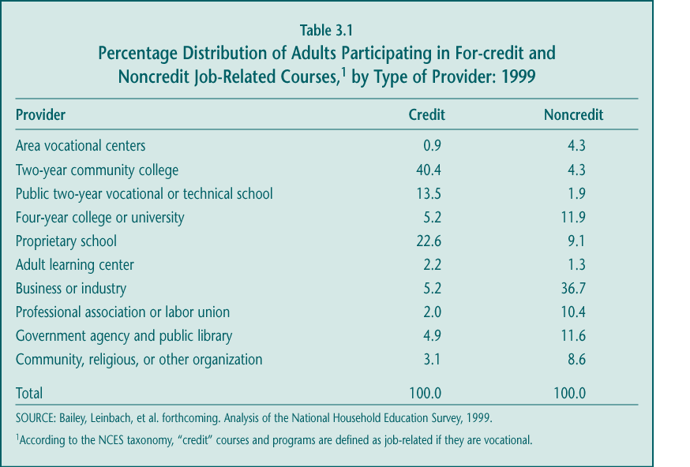

► Institutions that receive Perkins funds (primarily community colleges) predominantly serve vocational students through for-credit courses and programs. About two-thirds of students with a vocational emphasis at community colleges enroll in for-credit courses. Noncredit offerings at these institutions, although significant, do not represent their primary business activity.

The following describes the vocational programs and courses usually offered by postsecondary vocational providers, including those that receive funds under the Perkins Act.

► Associate degree programs (terminal or transfer-up): Generally made up of both academic and vocational for-credit course work (totaling roughly 60 credits), these programs can take two or more years to complete, depending on how many credits students earn each semester.

► Institutional certificate programs: Typically designed to upgrade job-related skills, these programs usually require about one year’s worth of full-time instruction in for-credit courses (24–30 credits), and compared to associate degree programs, involve far less, if any, academic courses. However, certificates can be of varied duration and can be earned for quite diverse activities. They are distinct from the increasingly popular industry skill certificates described below.

► Industry skill certifications: Developed and recognized by industry, these certificates are designed to signal proficiencies and are awarded to students based on their demonstrating well-defined skills (often through a test). Although postsecondary institutions and other training providers offer preparation for these tests, self-study is also a frequent strategy. An industry association or employer group, not the training provider, grants the certificates.

► Noncredit course work: Intended mostly to accommodate those seeking specific job-related skills—e.g., Introduction to Windows (three hours) and Real Estate License Exam Preparation (20 hours)—or personal enrichment activities—e.g., ceramics or aerobics. Like courses within certificate programs, noncredit courses are diverse in their content and contact time. These can be stand-alone courses or sequenced courses in a nondegree-granting program (sometimes similar or even indistinguishable from for-credit courses offered in vocational degree or certificate programs). Under Perkins III, funds can be directed only at programs that consist of a sequence of courses and that include competency-based learning (Section 3(29); Sections 134 and 135); thus, single courses and most enrichment activities are technically no longer supported by federal grants.

It is important to distinguish between for-credit and noncredit offerings at Perkins-eligible institutions because Perkins policy appears to favor for-credit course work. First, postsecondary Perkins grants are allocated within states to postsecondary institutions based on a formula weighted toward the number of Pell grant (federal financial aid) recipients the institutions serve. This provision has the effect of placing greater emphasis on institutions that promote degrees and credentials because Pell grants are available only to income-eligible students who pursue for-credit (degree-oriented) course work. Second, Perkins III accountability provisions include “completion of a postsecondary degree or credential” as a key measure of performance (P.L. 105-332, Section 113(b)). However, there is no explicit language in the law that prevents institutions from using Perkins funds to support noncredit vocational course work or participants, as long as participation is in a sequence of courses that meets the federal requirements (Sections 134 and 135). Thus, this chapter examines both credit and noncredit participation to some extent.

B. Access and Participation

An increasing number of occupations require education beyond high school, and, for many students, postsecondary vocational education provides an avenue to enter them. The most recent Bureau of Labor Statistics (BLS) projections indicate that occupations requiring a postsecondary vocational credential accounted for 29 percent of all jobs in 2000 but will represent 42 percent of the total job growth from 2000 to 2010 (Hecker 2001). The extent to which postsecondary vocational enrollments match labor market needs and include those who have historically faced barriers to employment success is of considerable policy interest.

1. Trends and Patterns of Enrollment

Although a majority of high school students aspire to earning bachelors’ degrees (Sanderson et al. 1996), by some key measures, 6 out of 10 postsecondary students actually enroll in sub-baccalaureate programs including vocational ones. About 3 in 10 undergraduates major in a vocational field at the sub-baccalaureate level.

Sub-baccalaureate vocational programs continue to be a significant part of postsecondary education and of community college enrollments.

In 2000, just under one-third of all postsecondary undergraduates in for-credit programs (Figure 3.1)—an estimated 4.9 million youths and adults—were enrolled in sub-baccalaureate vocational education.

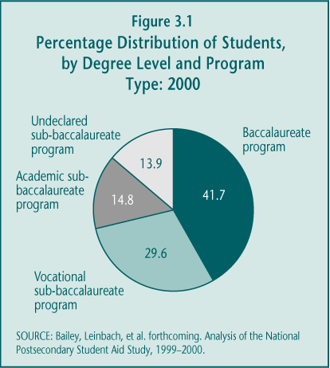

► All sub-baccalaureate students outnumber baccalaureate students. Among those pursuing for-credit course work, a higher proportion of students participate in sub-baccalaureate programs (58.3 percent, the combined total of students in vocational, academic, and undeclared sub-baccalaureate programs) than in baccalaureate programs (41.7 percent). If noncredit participants were included, then the share of all postsecondary students who are enrolled in sub-baccalaureate education would be even greater.

► At the sub-baccalaureate level, more students enroll in a vocational than in an academic major. Among sub-baccalaureate students, twice as many (50.8 percent) choose a vocational major as an academic major (25.4 percent). The remaining are “undeclared” (23.9 percent), a category that has been growing somewhat since the early 1990s (up from 18.0 percent in 1996) (Silverberg et al. 2002).

Postsecondary vocational participants are more likely to enroll in associate degree programs than in institutional certificate programs.

Postsecondary institutions supported by Perkins grants traditionally have offered both associate degree and institutional certificate programs, each resulting in a different credential based on institutional and, in some cases, state requirements. Both credentials are conferred by higher education institutions and are included in the data collection efforts of NCES. Although the number of industry-developed certificates conferred has increased over time, they are not included in NCES collection efforts because educational institutions do not confer such credentials.

► Enrollment in associate degree programs far exceeds that of institutional certificate programs. Among students declaring a vocational major, two-thirds aim to obtain associate degrees, while only one-third intend to pursue institutional certificates. Although the proportion of vocational students seeking an institutional certificate appears to have grown between 1996 and 2000 (from 29.8 percent to 33.3 percent), the difference is not statistically significant (Bailey, Leinbach, et al. forthcoming; Silverberg et al. 2002).

► Although the number of industry-developed certificates conferred is growing, the role of Perkins-eligible institutions in this growth is unclear. Although NCES data do not provide information on certificates conferred by employers or by national industry, trade, and professional associations, the groups themselves report that the number of certificates offered and granted is increasing. For example, there was nearly a tenfold increase in Microsoft Certified Systems Engineer (MCSE) certificates awarded between 1997 and 2000—from about 35,000 to more than 280,000. Much of this activity, however, may be taking place outside of Perkins-eligible postsecondary institutions.

Enrollments in vocational associate degree programs appear to respond somewhat to shifts in the labor market.

The primary purpose of postsecondary vocational education is to prepare individuals to enter and succeed in specific occupations in the labor market. The ability of postsecondary institutions to offer up-to-date programs that respond to fluctuations in employment supply and demand is crucial to maintaining program quality. Of course, student demand—i.e., enrollments—is an important factor in the choices that institutions make. Therefore, examining the relationship between national labor market trends and patterns of enrollment in postsecondary vocational education provides a measure of that responsiveness.

► Enrollments in vocational programs have grown substantially since the 1980s. Overall enrollments in postsecondary education have increased since the early 1980s, with enrollments at the sub-baccalaureate level remaining consistent with that trend. Between 1989–1990 and 1995–1996, enrollments in various vocational associate degree programs grew (Figure 3.2a) by 27.0 percent overall, perhaps in response to strong employment growth during that period in fields that require such training (Silverberg et al. 2002). More recent data suggest that postsecondary enrollments in general and, for the most part, those in sub-baccalaureate vocational programs, leveled off between 1990 and 2000.

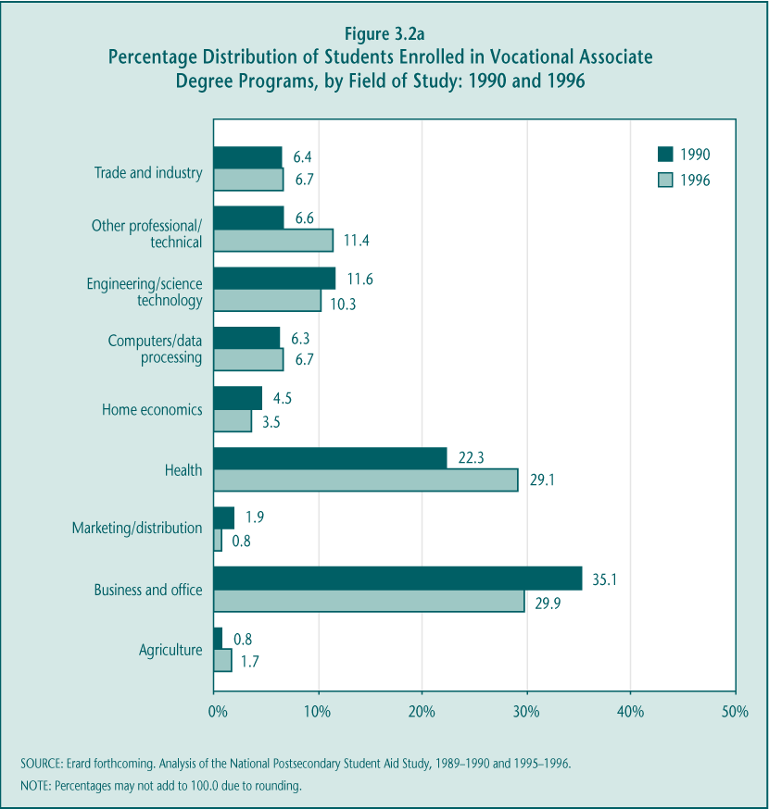

► Postsecondary vocational enrollment patterns are generally consistent with labor market shifts by occupational field. The most recent analysis of the correspondence between enrollments in postsecondary vocational education and job growth focused on changes that occurred between 1990 and 1996 in particular fields of study and occupations (Erard forthcoming). Both health- and computer-related fields experienced substantial job growth from 1986 to 1996 (Figure 3.2b) and, perhaps in anticipation of robust employment opportunities, the proportion of sub-baccalaureate vocational students enrolled in these programs also increased (Figure 3.2a). Fields with relatively slow or even declining job growth between 1986 and 1996—such as business—experienced declines in their postsecondary vocational enrollments.

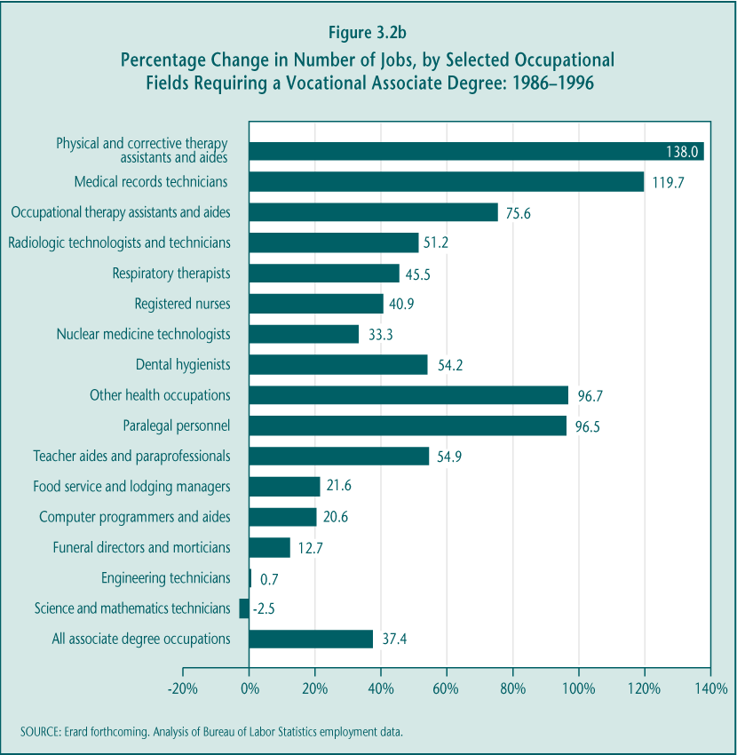

More recent data generally show consistent patterns in enrollment and labor market demand. For example, enrollments in computer and data processing associate degree programs nearly doubled between 1996 and 2000, possibly in response to past and projected job growth. Health, a large sub-baccalaureate program, may be a notable exception. Despite continued favorable employment projections, enrollments have remained relatively steady since 1996 (Hecker 2001; Bailey, Leinbach, et al. forthcoming).

2. Characteristics of Participants: Special Populations and Other Students

Postsecondary vocational programs serve a diverse group of students. Participants include students of all ages as well as those identified as “special populations” in Perkins III (more detail on these students is provided below and in Chapter 2). If policymakers choose to reexamine the role of Perkins at the postsecondary level, it will be important to have an accurate picture of the kinds of students vocational programs serve.

Sub-baccalaureate students differ from students in bachelor degree programs in several important ways. They are older, somewhat more disadvantaged (both academically and economically), and more likely to pursue postsecondary education at any time (not just immediately following high school) and to pursue it with less intensity and continuity. In contrast, there are fewer differences between sub-baccalaureate students who choose vocational rather than academic programs.

Postsecondary vocational students are older than students in either baccalaureate or other sub-baccalaureate programs.

Postsecondary vocational programs serve both students who recently graduated from high school and older students who may have substantial work experience and prior postsecondary education (Figure 3.3). This diversity in students’ age, employment experiences, and educational backgrounds, as discussed later, has implications for the programs they seek and their goals in doing so.

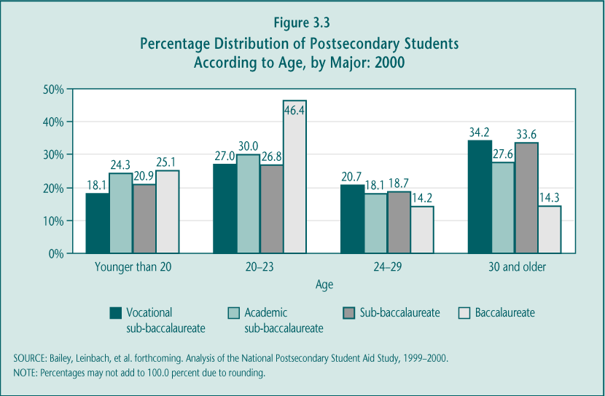

► Vocational programs serve younger and older students at similar rates. More than half (54.9 percent) of students who declare a vocational major are age 24 and older, with students age 30 and older making up 34.2 percent of all vocational students. These figures leave a similar and sizable proportion of students (45.1 percent) who are younger and have made a recent transition into postsecondary vocational education from high school. Perhaps most important for federal policy, the younger students represent 56.3 percent of those who enrolled in degree or certificate programs, excluding participants who have returned for a second (or even third) credential.

► Sub-baccalaureate participants are significantly older than baccalaureate participants. Combining both vocational and academic majors, just over half (52.3 percent) of sub-baccalaureate students are age 24 and older. This proportion stands in sharp contrast to that of baccalaureate students (28.5 percent) who are in that age category. Together, percentage distributions by age suggest that sub-baccalaureate institutions, and vocational programs in particular, serve a much broader population than do four-year colleges and universities.

Academically disadvantaged students are slightly more likely to enroll in vocational programs than in academic sub-baccalaureate programs.

Sub-baccalaureate students, overall, often enter college lacking the necessary academic skills to succeed (Coley 2000). For example, nearly two-thirds of students enrolled in community colleges take some remedial courses (Wirt et al. 2000, p. 152). These statistics signal educational needs that are particularly important for federal policy to address, because academic ability and prior academic preparation are among the strongest predictors of the rates at which students persist in and complete postsecondary education (Horn and Kojaku 2001). Postsecondary vocational students, at least those in for-credit courses and programs, may face some particular challenges.

► Younger postsecondary vocational students tend to enter programs with lower levels of academic achievement and preparation than their counterparts in academic programs. Among younger sub-baccalaureate students, those who enter vocational programs are more likely (66.5 percent) than those who enter academic programs (56.2 percent) to have tested in the bottom half (lowest two quartiles) on a 12th-grade academic skills assessment.

In addition, like their academic peers, vocational students in sub-baccalaureate programs have not typically taken the rigorous academic curriculum that is required for those who pursue baccalaureate programs. Although most sub-baccalaureate students met the “New Basics” standard for high school academic course taking—a total of 81.1 percent, including those who were enrolled in a high school vocational program (10.0 percent) and those who were not (71.1 percent)—postsecondary vocational majors were less likely (79.0 percent) than their academic counterparts (84.7 percent) to have met the standards. The proportions of both vocational and academic sub-baccalaureate students who met the “New Basics” requirements are well below that of their baccalaureate counterparts (94.5 percent) (Table 3.2).

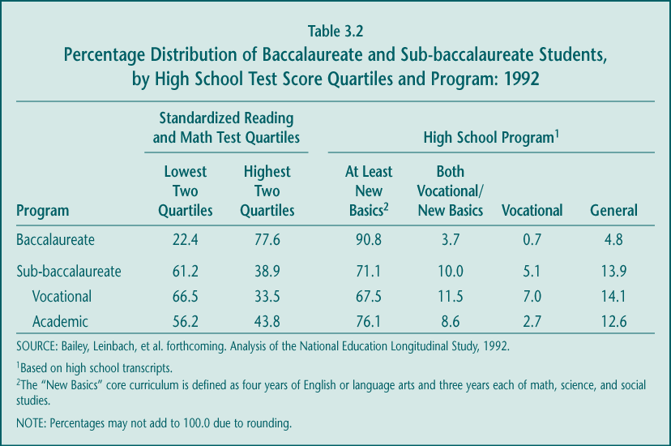

► An increasing percentage of postsecondary students with vocational majors already possess a postsecondary credential. Federal education policy has long promoted students’ attainment of a postsecondary credential, although some have argued that such a goal is less relevant for federal vocational policy because so many participants already possess a credential. In fact, between 1996 and 2000, the percentage of students in sub-baccalaureate vocational programs who had already earned a degree (baccalaureate or associate) or certificate increased from 22.8 percent to 30.4 percent (Table 3.3). Sub-baccalaureate students in academic programs were less likely to already possess a postsecondary credential, and this pattern has held steady.

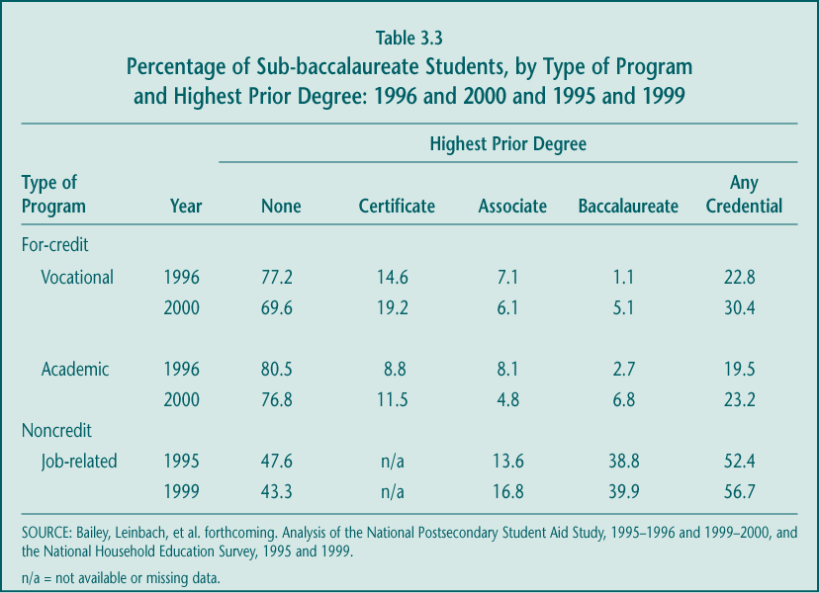

Although just under a third of vocational students in credit programs already have postsecondary credentials, an increasing share have already earned a baccalaureate degree. In 1996, only 1.1 percent of postsecondary vocational program participants entered with a baccalaureate degree, but that figure rose to 5.1 percent in 2000. The proportion who entered with a certificate also increased, from 14.6 percent to 19.2 percent, and the certificate remains by far the most commonly held postsecondary credential among those pursuing for-credit vocational course work. In contrast, more than a third of those enrolled in noncredit courses at postsecondary institutions report their highest educational attainment as a baccalaureate degree or higher.

Vocational students are slightly more economically disadvantaged than academic sub-baccalaureate students.

Perkins III emphasizes serving students in special populations, such as those who are economically disadvantaged. Although financial aid is the primary legislative tool to support these students, by encouraging the provision of special support services, Perkins III may encourage low-income students to become successful participants in postsecondary vocational education.

► Vocational programs serve a somewhat higher share of economically disadvantaged students than do academic programs. Among dependent students—those who live with their parents—a greater proportion pursuing vocational programs (21.2 percent) than academic programs (15.8 percent) live in low-income households (earning less than $20,000 a year). Among independent students, similar proportions of low-income students participate in vocational programs (43.5 percent) as in academic programs (44.6 percent) (Bailey, Leinbach, et al. forthcoming).

► Many vocational students are the first in their families to attend college. Being the first in the family to attend college is highly associated with limited economic resources and significant barriers to postsecondary enrollment and success (Warburton, Bugarin, and Nuñez 2001). Vocational students are more likely than their academic counterparts at the sub-baccalaureate or baccalaureate levels to be first-generation postsecondary students (Figure 3.4). However, the proportion of first-generation students in postsecondary vocational programs has declined since 1996 (from 55.9 percent to 47.5 percent) (Silverberg et al. 2002).

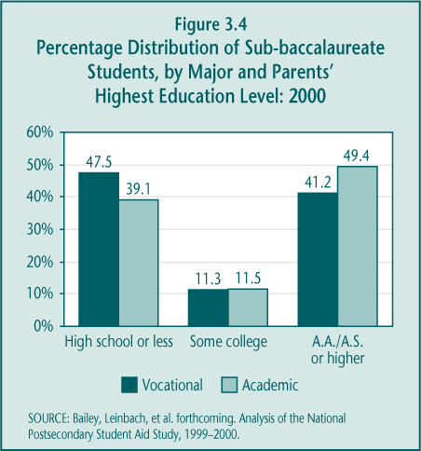

Students from other special population groups are well-represented in vocational programs.

For nearly four decades, federal vocational policy has encouraged students from specific groups that Congress believed to be underserved or facing particular barriers to involvement in postsecondary education to participate in vocational programs and ultimately in the labor market. Whether due to these legislative provisions or simply individuals’ personal preferences and circumstances, in the 1990s many of the “special populations” were well-represented in sub-baccalaureate vocational programs as well as in academic programs.

As described in Chapter 2, these designated “special populations” include individuals with disabilities, individuals from economically disadvantaged families, individuals preparing for nontraditional training and employment, single parents, displaced homemakers, and individuals with other barriers to educational achievement, including limited-English proficiency. Nationally representative data on the postsecondary participation of each of these groups are limited and available only for those students taking for-credit courses.

► Vocational programs are more likely than academic programs to serve single parents. A higher share of sub-baccalaureate vocational students (19.7 percent) than academic students (12.0 percent) were single parents in 2000, a group that until the passage of Perkins III in 1998, was the focus of targeted programs with set-aside funding. Single parents represented an increasing share of vocational program participants in 2000, up from 16.1 percent in 1996 (Silverberg et al. 2002; Bailey, Leinbach, et al. forthcoming).

► Students with disabilities are about equally likely to be enrolled in a vocational program as in an academic program. Students with disabilities make up a small share of either baccalaureate or sub-baccalaureate students (less than 2 percent each). These students participated in vocational and academic sub-baccalaureate programs at similar rates in both 1996 and 2000.

► Enrollments in vocational programs preparing students for “high-wage” sub-baccalaureate occupations follow traditional patterns by gender, but neither males nor females are clearly advantaged. Females increasingly dominate enrollments in fields such as nursing and social work, while males continue to dominate enrollments in engineering, mechanics, and electronics. However, among other majors that prepare students for high-wage occupations (such as finance, mortuary science, and graphic illustration, industrial, interior, or product design), enrollment is fairly balanced by gender, and that balance has not changed substantially between 1996 and 2000 (Table 3.4).

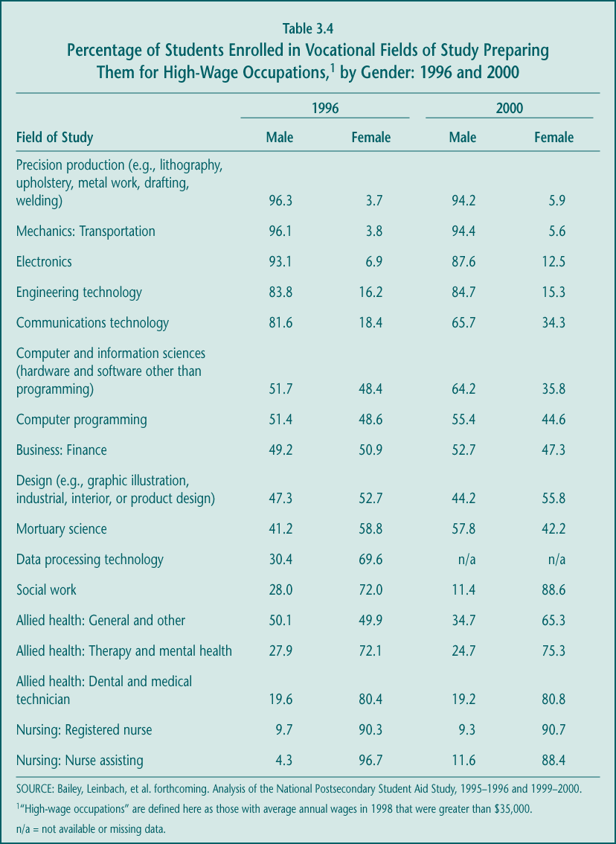

In the rapidly growing and generally lucrative field of computer and information sciences (often referred to as information technology (IT)), female enrollments have not kept pace with male enrollments. By 2000, the share of males participating in IT programs was twice that of females. Further evidence from a survey of two-year colleges indicates that only about a fifth of those enrolled in some of the most popular IT certification programs (Novell, Cisco, or Microsoft programs) are female (Haimson and Van Noy forthcoming). Only a small fraction of community colleges (about 1 in 20) have programs in which the proportions of males and females enrolled are about equal.

► Sub-baccalaureate students are racially and ethnically diverse, although vocational programs enroll higher shares of students from racial and ethnic minority groups. A higher proportion of black students in 2000 chose to enroll in sub-baccalaureate vocational programs (17.3 percent) than in academic programs (11.8 percent). Hispanic students, however, were just as likely to pursue academic programs (14.1 percent) as vocational programs (12.7 percent), representing a slight relative shift among Hispanic students between 1996 and 2000 toward participation in vocational programs. Asian or Pacific Islander students and those in other racial groups (such as Native Americans) continued to be just as likely to enroll in academic as vocational sub-baccalaureate programs. Many of the noncredit vocational participants were white (76.6 percent), compared to 61.4 percent of vocational students in for-credit courses (Figure 3.5).

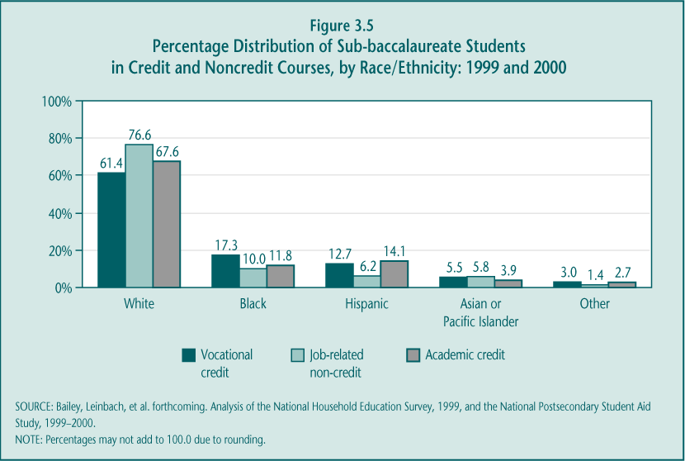

3. Goals and Pathways of Participants through Postsecondary Vocational Education

Many people, perhaps including policymakers, view “college participation” in a traditional way. They picture participants as 18-year-olds who attend college in the fall immediately following high school graduation and who continue to attend full-time until they obtain baccalaureate degrees approximately four years later. However, this description of college participation does not describe the majority of sub-baccalaureate students or of vocational students in particular. Vocational students typically delay entering college after high school graduation, are enrolled part-time and intermittently, and attend multiple postsecondary institutions. Each of these traits is a well-documented barrier to credential completion.

Postsecondary vocational students have primarily “nontraditional” attendance patterns.

Students participating in sub-baccalaureate programs—both academic and vocational—do not typically follow the attendance patterns often associated with “college” enrollment. “Nontraditional attendance”—part-time, at multiple institutions, with interruption—is common (Table 3.5) (Bailey, Leinbach, et al. forthcoming).

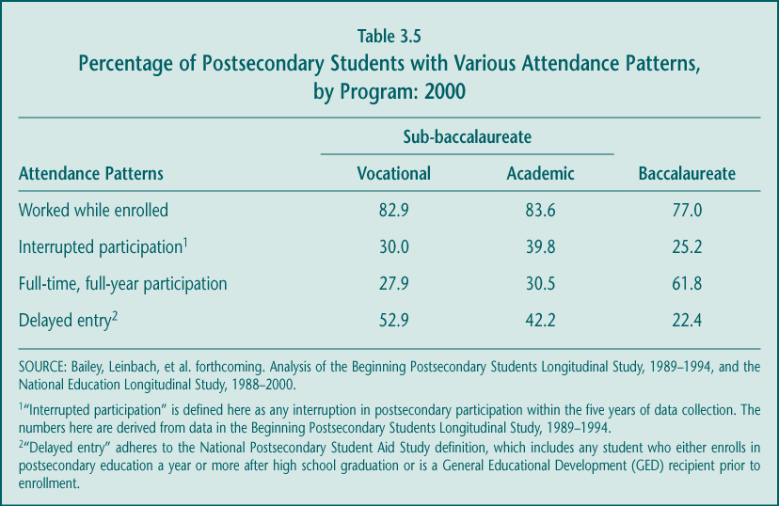

► Most postsecondary students, including those in vocational programs, work while enrolled; half of sub-baccalaureate students consider themselves workers first, and students second. A large proportion of students—about four out of five students at any level (baccalaureate or sub-baccalaureate) or major (vocational or academic)—are employed while in postsecondary education. Baccalaureate students describe themselves as primarily students (over 80 percent) and thus are likely working to defray expenses. In contrast, just over half of the employed sub-baccalaureate students describe themselves as workers who are studying.

► Increasingly vocational as well as academic students interrupt their postsecondary education. About a third of vocational (30.0 percent) and 39.8 percent of academic sub-baccalaureate students interrupt their postsecondary attendance at least once during a five-year period. Furthermore, among participants younger than age 24, the rate of interruption has doubled since the 1980s (from 15.9 percent in 1982 to 33.3 percent in 1990).

► Delayed entry into postsecondary sub-baccalaureate education is common, as is part-time attendance, often in multiple institutions. Just over half of vocational program participants (52.9 percent) begin postsecondary education more than a year after graduation from high school. This delayed entry is more likely among vocational (52.9 percent) than academic (42.2 percent) sub-baccalaureate students, but the likelihood of doing so is even greater for baccalaureate than sub-baccalaureate students (22.4 percent and 49.8 percent, respectively). Just over one-fourth of either vocational or academic students in sub-baccalaureate programs attend full-time, full-year, compared to 61.8 percent of baccalaureate participants. Recent analyses of traditional age students (ages 18 to 24) indicate that nearly half of those who started in community colleges actually attended more than one institution as an undergraduate (Adelman 2003).

On the one hand, the ability of students to attend postsecondary institutions part-time when they can and at the most convenient campus are all hallmarks of sub-baccalaureate institutions. On the other hand, these attendance patterns raise concerns about the labor market prospects for sub-baccalaureate students, including those in vocational programs, because research indicates a relationship between nontraditional enrollment patterns and lower earnings (Scott and Bernhardt 1999; Light 1995). To the extent that completion is an important factor in this relationship, federal policy may wish to continue to emphasize completion, whether defined as “credential attainment” (as is currently promoted through the accountability provisions) or something else.

Objectives of postsecondary vocational students vary, but most report seeking a credential.

Given the diversity of those who participate in sub-baccalaureate vocational education—in age, employment status, income, and other characteristics—it is not surprising that vocational courses serve a variety of purposes. Recent surveys asked students to report the primary reason they enrolled in postsecondary course work, requesting them to choose from several fixed response categories: job skills, degree or certificate completion, transfer (to a higher-level educational institution), or personal enrichment. Understanding the variation in students’ goals and expectations is useful for judging the success of both students and institutions (Figure 3.6) (Bailey, Leinbach, et al. forthcoming).

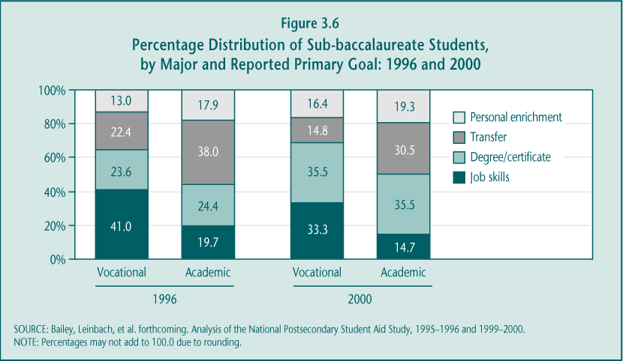

► Obtaining a sub-baccalaureate credential or transferring is a common objective for vocational students but less so for academic students. Just over half of all those enrolled in postsecondary vocational programs in 2000 reported wanting to earn a degree or certificate (35.5 percent) or to transfer (14.8 percent). This pattern represents a change from 1996, with less emphasis in 2000 on transferring (down from 22.4 percent) and more emphasis on attaining a sub-baccalaureate credential (up from 23.6 percent) as a primary goal. Younger students are most likely to be seeking these objectives: in 2000 most vocational majors younger than age 20 reported earning a credential (33.9 percent) or transferring to further education (26.7 percent) as their primary reason for participating.

The goal of obtaining a degree or certificate or of transferring to another institution is even more common among students in sub-baccalaureate academic majors than in vocational majors (a total of 66.0 percent compared to 50.3 percent). The biggest difference by major is that fewer vocational students (14.8 percent) than academic students (30.5 percent) cite transferring as their primary reason for enrolling in postsecondary vocational programs. These differences in objectives are consistent with differences in students’ stated educational aspirations. Vocational students are less likely (74.0 percent) than academic students (88.4 percent) to expect to complete baccalaureate-level or higher degrees. Instead, those who enroll in postsecondary vocational programs more frequently aspire to earn certificates or associate degrees. Between 1996 and 2000, there was no statistically significant shift in the aspirations of either vocational or academic participants.

► Many students enrolled in sub-baccalaureate vocational programs want to increase their job skills. Among those choosing a vocational major, a significant share (33.3 percent) do so to enhance their job skills, probably with the intention of obtaining better employment. In contrast, only 14.7 percent of academic students cite improving their job skills as their primary reason for enrolling.

Older vocational students are most likely to pursue this goal. Still, less than half (41.6 percent) of those age 30 and older cite increasing their job skills as their primary reason for participating in vocational courses and programs. For many older students (39.7 percent) obtaining a credential is still important (Bailey, Leinbach, et al. forthcoming).

► Some vocational students participate for enrichment purposes. Far fewer students, both vocational (16.4 percent) and academic (19.3 percent), cite personal enrichment as their primary reason for enrolling in postsecondary course work.

C. Implementation: Program Quality and Improvement Efforts

Perkins III provides funding to improve the quality of vocational programs at both the secondary and postsecondary levels and offers a set of strategies intended to aid in that progress. However, the effects of the law at the postsecondary level are difficult to assess for several reasons. First, postsecondary institutions are historically autonomous—from each other and from state agencies—yet Perkins policy is intended to be promoted through state efforts. Second, Perkins funds represent a very small share—about 2 percent—of these institutions’ yearly expenditures. Finally, at the postsecondary level, where participants pay to receive their education and training, vocational programs are most likely driven by rapidly changing labor market needs. Postsecondary institutions’ response to the challenge of providing up-to-date technical training and education may be consistent with federal policy but not largely affected by it.

Still it is worth examining the prevalence of Perkins program improvement strategies. Among the most relevant for postsecondary programs are the integration of academic and vocational instruction, links between secondary and postsecondary institutions, employer involvement, education standards, upgrading technology, and assistance for special populations. Professional development and other efforts to promote teacher quality are also important and frequently supported with Perkins funds.

Employer involvement takes many forms, largely influenced by labor market trends.

Employer involvement in postsecondary vocational programs is considered particularly important because it helps ensure that the content and focus of these programs are relevant to the labor markets they serve. Unlike high school vocational students, many of whom will pursue postsecondary education and eventually jobs outside their local areas, community college students are likely to work and live in their communities. Therefore, most postsecondary vocational institutions try to pursue strategies that are consistent with what will be rewarded in their local labor markets.

► Employer involvement in community college advisory committees may be growing. Industry- or community-based advisory committees, while not new to these institutions, appear to be gaining influence. The proportion of employers reporting that they participated in these committees at the secondary or postsecondary level increased from 12.4 percent in 1993 (Boesel et al. 1994b) to 14.1 percent in 2000, although evidence from case studies suggests that much of the increase has been at community colleges. Advisory committees actively contribute to vocational programs by providing advice on individual courses and programs as well as offering off-campus learning experiences for students and faculty. This level of employer involvement is in contrast to that provided by previous advisory committees that only met once or twice a year and had little influence over program design or curricular content.

► Employers increasingly use community colleges for customized contract training. As part of a growing emphasis on economic and workforce development, community colleges have increased their customized contract training. The proportion of employers reporting their use of such training increased significantly during the 1990s, from 9.9 percent in 1993 (Boesel et al. 1994b) to 17.2 percent in 2000. Although customized contract training is often distinct from postsecondary vocational education programs, because training is conducted at another part of campus, uses separate funds, and is often taught by a different faculty, the general trend may be indicative of a broader effort by community colleges to meet local labor market needs.

► Employer collaboration on curriculum is geared more toward local needs than national skill standards. According to case studies, community college curriculum is shaped mostly by a determination of which skills contribute to employability in the local area (Hudis, Blakely, and Bugarin forthcoming). National skill standards matter, but only if they have value in the marketplace. So, while community colleges have been quick to create course work that complements information technology networking certifications that are nationally recognized, such as Microsoft’s or Cisco’s, the colleges have been much less likely to organize curricula around Microsoft’s Microsoft Office User Specialist (MOUS) certification program, a credential that lacks employer support.

Upgrading equipment remains a focus of community college efforts, but the contribution of Perkins is proportionately less than it is at the secondary level.

“Developing, improving or expanding the use of technology in vocational and technical education” is a required activity for states and postsecondary institutions that receive federal vocational funds (Section 135(b)). Given the pervasiveness of new technologies in the workplace, there is constant need for technological resources and technology instruction in community colleges and adult vocational schools. Employers increasingly demand technological skills and expect graduates of sub-baccalaureate courses and programs to have knowledge of and facility with these technologies (Hudis, Blakely, and Bugarin forthcoming). Meeting these demands and expectations, though, is a primary mission of these colleges.

► Perkins funds are a relatively small contribution to postsecondary equipment budgets. Postsecondary vocational institutions, in contrast to vocational programs at the secondary level, typically have a substantial technology budget. Therefore, ongoing equipment needs are largely funded by private donations, business partners, state grants, and college revenues, while state and local Perkins funds are simply additional but not central contributions. In addition, community colleges combine Perkins funds with other federal grants to train faculty to use the new equipment.

► Some states use Perkins funds to support distance learning or development activities such as planning for emerging occupational areas. For example, North Carolina has made distance learning a priority in its community colleges, reaching more than 12,500 students via the Internet, satellite transmission, and teleconferencing. In Michigan, some Perkins state leadership funds are used to fund Emerging Technologies Consortium Grants, which are intended to encourage vocational programs to plan for new occupations in high-technology or other emerging occupational areas.

Support for special populations generally continues.

Previous vocational legislation placed special emphasis on serving particular groups of students known as “special populations.” In Perkins III, Congress continued this focus but through accountability provisions rather than funding set-asides. The emphasis on these groups persists among postsecondary institutions, which often refer to Perkins funds as their “special populations” money (see Chapter 5 for more information on funding and accountability). Preliminary evidence suggests that, in general, the goal of serving special populations has been institutionalized. At the local level, where most activities supporting special populations take place, many programs continue to serve their special needs, and these activities have not changed much even with the elimination of the set-aside funding streams under Perkins III (Hudis, Blakely, and Bugarin forthcoming).

► Support services for special populations funded by Perkins cover a broad range of activities at both the local and state levels. Most postsecondary institutions assist existing special population students rather than conduct outreach, because they view access as best provided through student aid. Both states and local institutions also provide professional development support and activities for faculty serving special population students. A primary focus of local institutions is to help students successfully complete courses and programs through basic academic support services, such as tutoring, note-taking services, testing, and the provision of interpreters. Additional services—such as childcare and transportation—are more focused on the needs of particular populations.

► Postsecondary institutions provide services to help special population students make the transition into employment. These services, typical of community colleges, include career counseling, job seminars, and skill-training programs, but they are often tailored to meet the special needs of particular groups and funded at least in part by Perkins. Florida and Texas have developed accountability systems to make sure that community colleges are placing special population students in good jobs. At the local level, for example, a North Carolina community college offers classes that give students a broad orientation to the labor market to meet the needs of older students who are making transitions into the workforce for the first time (e.g., students on welfare, displaced homemakers, and single mothers) (Hudis, Blakely, and Bugarin forthcoming).

► Elimination of set-asides appears to have made services available to a broader population. Some local practitioners indicate that, because of the new legislation, special vocational programs and services can now serve GED students, economically disadvantaged students, and individuals with limited English proficiency, in addition to single parents or single pregnant women and individuals preparing for nontraditional employment.

Other program improvement strategies emphasized in the law are not emphasized at the postsecondary level.

In addition to the strategies discussed above, Perkins promotes linkages between secondary and postsecondary education and the use of curriculum integration. However, Tech-Prep and articulation agreements between high schools and community colleges, in addition to integrating academic and vocational curricula, are largely viewed by postsecondary staff as high school programs and strategies designed to raise expectations among secondary vocational students.

► Limited linkages exist between secondary and postsecondary education. Community colleges have played active roles in developing and updating articulation agreements as part of Tech-Prep, but few of them have actually changed their offerings or activities as a result of this initiative (see Chapter 4). Other types of coordination, such as outreach activities—e.g., bringing students to campus and arranging meetings between college and high school personnel to discuss student test scores and required preparation for college—are generally low intensity (Hudis, Blakely, and Bugarin forthcoming). Perkins-funded state leadership spending at the postsecondary level suggests that secondary-postsecondary linkages (7.7 percent of these funds nationally) are not as high a priority as other activities (e.g., more than 15 percent of state leadership funds are used for each of these efforts: upgrading technology, integration, and data reporting; White et al. forthcoming).

► Dual enrollment is so far a limited, but promising, strategy for linking secondary and postsecondary vocational education. Although neither widely taken advantage of by high school students nor exclusively or specifically designed for students in vocational programs, this strategy is increasing in popularity (Bailey, Hughes, and Karp 2002). High school students can enroll in courses at community colleges that allow them to earn both secondary and postsecondary credit. As a result, they can have a wider selection of courses and learn more about community college life and course expectations.

► Curriculum integration remains relatively rare at the postsecondary level, despite continued emphasis in the law and reported state activities. Certainly, some states and community colleges are using Perkins funds for faculty workshops on integrating curriculum. Nationally, strengthening integration of academic and vocational content is one of the top two expenditure categories of state leadership funds (15.3 percent). For example, Michigan awarded grants to produce new curricula, and Florida is developing new certificate programs that require an integrated course curriculum. One Michigan grant, for example, brought together 80 faculty members from 15 community colleges to work on producing integrated curricula that they could use in classrooms. California has also used state leadership funds to support statewide conferences and workshops on curriculum integration. However, these efforts have not translated into widespread action. According to site visits, most community colleges and their faculties lack the curriculum materials or professional development opportunities to achieve meaningful integration (Hudis, Blakely, and Bugarin forthcoming).

Improving the quality of vocational faculty, a goal that Perkins supports to some extent, remains a challenge.

Perkins III encourages professional development as a way to improve teacher quality. States, in particular, but also individual postsecondary institutions, at times combine Perkins funds with workforce development and general education funds to compensate teachers for time and expenses spent at professional meetings, to offer workshops and conferences, and to support teacher externships. However, many of the most crucial issues involve hiring and retaining faculty with the appropriate mix of skills, and doing so in a way that is responsive to labor market demands. It is less clear what kind of role Perkins can assume in those efforts.

► Some individual institutions and states use Perkins funds to offer professional development activities to promote technical and teaching skills. These efforts are limited and often primarily include state-sponsored conferences covering a wide array of professional development issues. Few faculty members from any single institution appear to participate, and such once-a-year professional development activities are often considered fairly ineffective. In short, there is little evidence of systematic professional development efforts on behalf of vocational faculties (Hudis, Blakely, and Bugarin forthcoming).

► Sub-baccalaureate vocational faculties have lower academic credentials than academic faculties. In 1999, a significant share of vocational faculty members (46.0 percent), compared to their academic peers (14.4 percent), had bachelors’ degrees or less. Academic faculty members were far more likely than vocational faculty members to have masters’ degrees, Ph.D.s, or first-professional degrees (85.6 percent compared to 54.1 percent). These percentages have remained unchanged between 1993 and 1999 (Figure 3.7).

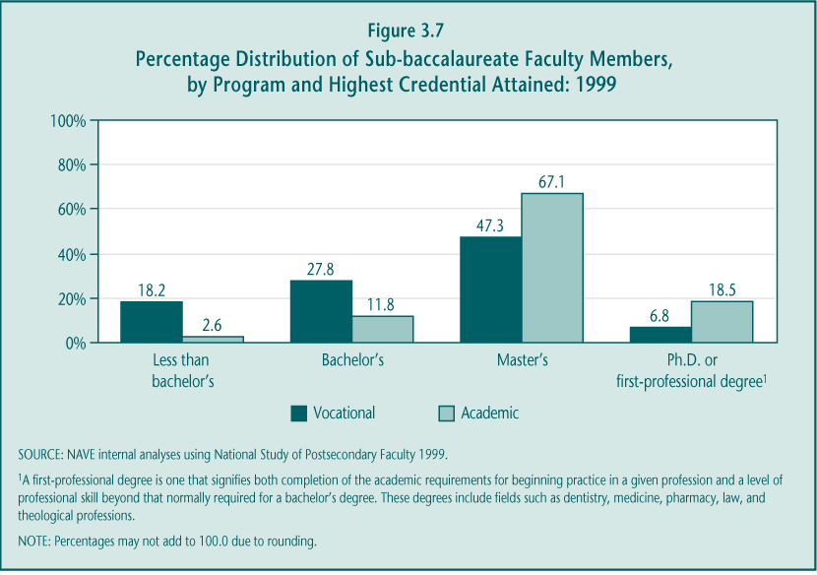

In vocational fields, a conflict exists between the need for academic skills and the need for hands-on technical skills for high-quality teaching. Industry skill certifications may be equally or even more important for instructors than academic credentials, particularly in fields such as information technology and automotive repair. On-the-job experience or teaching while employed are important ways for faculty to keep technical skills current, especially because local institutions seem to have few systems in place to support ongoing professional development. However, in an environment of increasing academic sophistication in many vocational fields, academic qualifications may become more important.

► Many vocational instructors, like their academic counterparts, teach part-time, have multiple jobs, and may work in jobs related to the courses they teach. In 1999, the majority of vocational (60.0 percent) and academic (66.3 percent) sub-baccalaureate faculty members taught part-time. These proportions have not changed since 1993. Among part-time vocational instructors, most reported a preference for teaching part-time (80.7 percent).

Teaching part-time is often thought to be an indicator of lower teacher quality, reflecting poorer qualifications or more tenuous connections to the sub-baccalaureate institution. In the case of vocational education, though, working part-time may allow vocational faculty members to remain employed in jobs related to the courses they teach. In fact, the majority of vocational faculty reported having another job (71.1 percent), and most said they work outside of postsecondary institutions (92.6 percent). Although information about these other jobs is limited, many may be employed in occupations in their teaching field (e.g., 49.4 percent of health faculty worked in a hospital as their additional job).

► Changes in faculty composition and student enrollment are consistent with labor market trends—growth in information technology and declines in business, engineering, and home economics. Two-year institutions, and community colleges in particular, are often thought to be especially adept at adjusting their offerings in response to fluctuating enrollment shifts, which often reflect changing labor market trends. The ability to hire and retain faculty in sufficient numbers, particularly in high-demand fields, to maintain reasonable student-to-faculty ratios is crucial to maintaining the quality of postsecondary vocational education.

Data from the National Postsecondary Student Aid Study (NPSAS) and National Study of Postsecondary Faculty (NSOPF) confirm a link between changes in the percentage of faculty who teach and students who enroll in two-year institutions by vocational field (Table 3.6). Since 1993, the rates of enrollment in information technology (IT) and trade and industry have increased, as have the proportions of vocational faculty teaching IT and trade and industry courses, presumably in response to increases in enrollment. Between 1993 and 1999, vocational enrollments shifted away from business, home economics, and engineering—most likely reflecting reduced demand for occupations requiring such training. Correspondingly, during that period, the percentage of vocational faculty teaching in each of these three fields declined. In other fields—health and agriculture—no significant changes were observed in the proportions of students and faculty in two-year institutions.

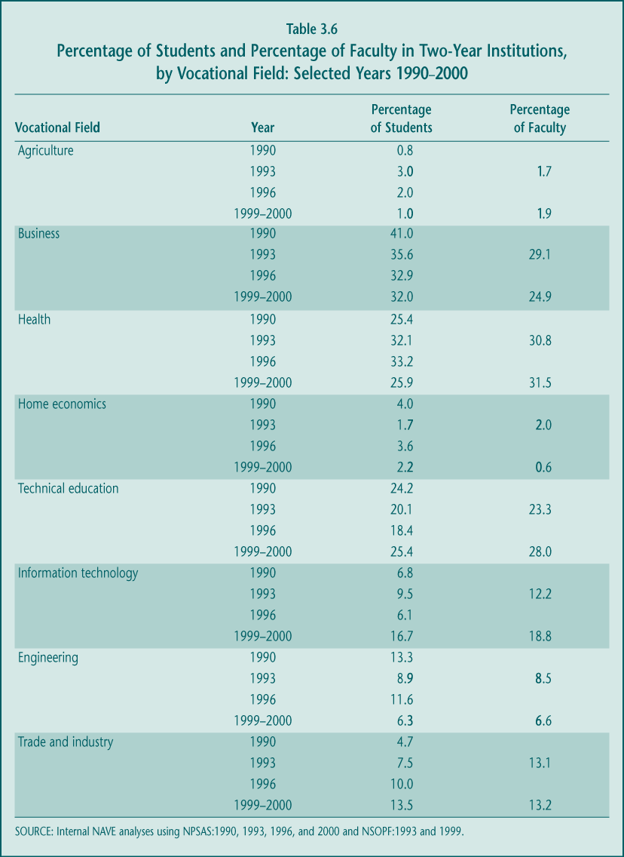

► The proportion of vocational faculty members at two-year institutions declined, and academic faculty members increased during the 1990s. Although both academic and vocational enrollments in community colleges leveled off in the 1990s after a decade of growth, the number and proportion of vocational faculty members at two-year institutions declined by 8 percent (from 98,741 to 90,771), while the proportion and number of academic instructors increased by 20 percent (from 160,831 to 193,333). There are several potential explanations for this shift in resources. First, there may have been a change toward having academic faculty teach the academic course work required in vocational programs rather than offering these courses as “applied” academic courses taught by vocational faculty. Second, in recent years, some institutions have paid more attention to providing students with options to transfer to a baccalaureate degree program, which may also have increased academic offerings and thus faculty. Finally, an increase in academic faculty may reflect a growing need for faculty to teach developmental education courses.

It is hard to gauge the implications of these changes. On the one hand, the quality and rigor of academic courses may be superior and thus more beneficial to vocational students. On the other hand, if such courses are less likely to be connected to particular vocational learning requirements, then it is unclear whether vocational students, who often have not been successful in traditional academic course work, will be able to benefit from the shift in emphasis.

D. Coordination with the Workforce Investment Act

Coordinating vocational programs with workforce development efforts is a major issue at the postsecondary level. When Congress enacted both the Perkins III and the Workforce Investment (WIA) Acts in 1998, it responded to GAO reports that multiple job training programs created an excessive administrative burden upon states and discouraged individual access to services (U.S. General Accounting Office 1994a, 1994b, 1994c, 2000). Many policymakers argued that the system—and, in particular, federal funding—needed streamlining, and Congress considered combining the two laws. In the end, however, Congress passed separate acts with provisions to encourage coordination between activities funded under WIA Title I and Perkins III. The extent of that coordination, even at this early stage of implementation, is worth examining.

Several features of WIA can affect postsecondary vocational education.

► State Workforce Investment Boards: These boards assist in the development of the WIA state plans, and the law includes the chief executive officers from community colleges among the list of required members (Section 111(b)).

► One-Stop Career Centers: Governed by Workforce Investment Boards (WIBs) at both the state and local levels, these centers are expected to provide information to job seekers and access to a broad array of employment and training services. Although in some states and localities postsecondary vocational institutions were involved with past workforce development efforts under the old Job Training Partnership Act (JTPA), WIA requires that these institutions be included in the WIBs. Including them provides new opportunities for previously nonparticipating postsecondary institutions to become involved with workforce development. Their involvement as one of the required partners in One-Stop centers is an indicator that at least some coordination should exist between postsecondary vocational education and workforce development systems.

► Available services: Up to three possible types of services are now provided sequentially, depending on individual needs and eligibility: (1) core services—primarily information on job options—are available to all individuals; (2) intensive services, for those needing more assistance, include individualized assessments, case management services, and short-term prevocational services such as basic adult education courses; and (3) training services are primarily offered to income-eligible individuals for whom the two previous services are not sufficient in helping them obtain employment. This sequencing of services places greater emphasis on job placement, in contrast to the past emphasis on increasing an individual’s human capital through job training. Individuals eligible for job training are provided Individual Training Accounts (ITAs) that can be used to purchase training from any eligible provider. This practice contrasts with the past one of offering individuals prepaid negotiated training services. It is not yet clear whether this new structure is more or less conducive to the involvement of postsecondary vocational education in workforce development.

Perkins institutions have not played a major role in WIA decision making and management in most states.

In the first few years since the passage of WIA, states have primarily directed their attention to establishing organizational structures to implement the act—e.g., state and local workforce investment boards and One-Stop centers. The role that postsecondary vocational institutions played in these decisions is likely to affect their participation in future workforce development activities.

► Postsecondary vocational institutions generally were not involved in early efforts to establish the infrastructure of One-Stop Career Centers. As required in the law, states did include representatives from community colleges to serve in the new WIBs. However, in most states and localities, past relationships formed under JTPA determined the organization and governance for the workforce development system under WIA. An early Department of Labor report (D’Amico et al. 2001) indicates that half of the states simply adopted their existing state workforce investment board, although most local boards were more likely to be newly formed.

In states where community colleges historically had played a significant role in either JTPA or economic development (e.g., North Carolina and Florida), the relationship generally has continued and made seamless service delivery systems more likely, although the extent of local participation even in these states is idiosyncratic. In most cases, though, community colleges and the postsecondary education system have played a more limited role in setting up the workforce development system and its rules of governance. For example, the Massachusetts State Board of Higher Education that oversees community colleges was not included among the partner organizations that established the workforce development system. Similarly, in California, the Community College Chancellor’s Office envisions participating in the system only after it is implemented (Hudis, Blakely, and Bugarin forthcoming).

► Most One-Stop centers are operated without much involvement from postsecondary institutions. Most states are neutral about having community colleges become managers of and service providers for One-Stop centers. But some have discouraged that participation. Despite initial plans for two-year colleges to be given major responsibilities in planning the new system, Texas curtailed postsecondary involvement by prohibiting operators of local One-Stop centers from providing both core and training services; thus, if two-year colleges want to provide training, they cannot operate a One-Stop center. In Massachusetts, none of the centers are operated by community colleges. Although the state established a competitive process to select One-Stop center operators, none of the 15 community college and 16 WIB service delivery areas overlap, perhaps accounting for the colleges’ limited participation. In contrast, in both Florida and North Carolina, where community colleges are key local participants in the workforce system, these institutions are well-represented among those operating One-Stop centers; for example, in 2000 a quarter of the centers in North Carolina were located on community college campuses, and close to 20 percent of Florida’s centers were administrated or operated by community colleges (Hudis, Blakely, and Bugarin forthcoming).

Involvement in a One-Stop partnership can be important because it can lead to many referrals for training, although that has not occurred in most communities. The services available at One-Stop centers allow individuals to find out about various educational options. Even if individuals do not use individual training accounts, they may pursue postsecondary education using other resources such as Pell grants and student loans (King 2002).

► Historical participation in training programs influences the extent of WIA participation. The strongest predictor of a community college’s participation in WIA is its previous involvement in JTPA-funded training activities. Postsecondary institutions that were active and major providers of services under JTPA generally have continued to play important roles under WIA. For example, a Massachusetts community college that was a significant training provider under JTPA continues to work closely with the workforce system despite the fact that a smaller number of students are served under WIA. Even in states with systems favorable to community colleges, such as Florida and North Carolina, there appears to be a strong correlation between current participation in WIA and past participation in JTPA (Hudis, Blakely, and Bugarin forthcoming).

Involvement of Perkins institutions in providing WIA services has been limited.

Postsecondary vocational education generally has yet to become actively involved in providing WIA services. Because community colleges primarily provide education and training, and early WIA implementation emphasized job search and other core services, community college participation and interest in WIA activities have been limited.

► Early emphasis on core services favored the involvement of entities other than vocational postsecondary institutions. Core services—providing information about job opportunities and available support services—are not a primary part of the mission of community colleges. Even intensive services (e.g., aptitude and occupational interest testing and very short-term prevocational services) are not central services that postsecondary educational institutions offer. Early indications are that most WIA resources were used for these services as well as to create the new infrastructure, leaving little money for vocational training supported by individual training accounts—the most natural activity for Perkins postsecondary institutions. When comparing JTPA carryover and WIA services provided in 2000, at least two-thirds of JTPA client carryovers in the adult programs (73.6 percent) and dislocated worker programs (65.8 percent) received training services. By comparison, only about a third in either program (32.3 percent and 39.6 percent, respectively) received training under WIA (Table 3.7).

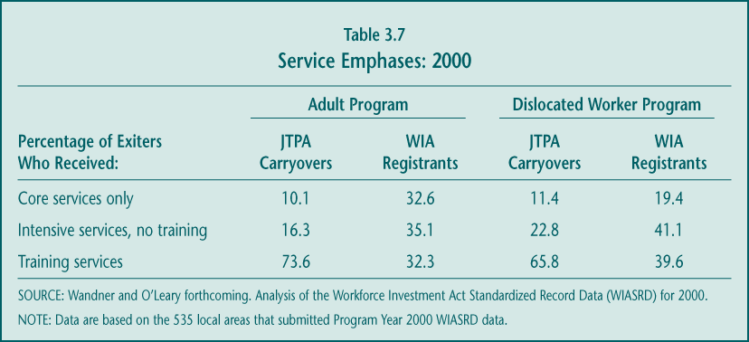

In general, community colleges report being sent few students with ITAs. For example, in 1999, only 12 students with ITAs were referred to a California campus, although a North Carolina community college reported 170 WIA referrals (Hudis, Blakely, and Bugarin forthcoming). On the other hand, some states—including Michigan and California—report serving large numbers of potentially WIA-eligible individuals in community colleges. However, these students are not referred by One-Stop centers and are not using ITAs.

► Several factors may to lead to greater community college participation in providing WIA services. Although the number of ITAs issued in the first few years since the passage of WIA has been limited, several trends are beginning to make training more of a priority. First, states have mostly completed creating the WIA infrastructure (WIBs, One-Stops centers, contracting mechanisms), making it possible for them to focus on other activities and services. Second, in some states and communities, an emphasis on “work-first” is giving way to greater balance in determining the appropriate emphasis on training (Barnow and King 2003). Finally, as unemployment has risen in 2001 and 2002, making employment for the most “unemployable” more difficult, the number of ITAs issued appears to be increasing (Administrative Data Research and Evaluation (ADARE) Project 2003).

Divergent accountability systems, poor state data systems, and limited awareness among participating agencies hinder efforts to coordinate Perkins and WIA.

Accountability systems serve as the foundation for both Perkins III and WIA. Federal law stopped short of folding Perkins into WIA or explicitly aligning WIA and Perkins accountability provisions, although the intention was for states to coordinate them (see Chapter 5 for more detail on accountability under Perkins).

► Differences in Perkins and WIA accountability measures are a disincentive for community colleges to participate in workforce systems. First, despite the shared emphasis on accountability and the intention to coordinate, the two laws mandated somewhat different outcome indicators; for example, WIA requires reporting of employment and earnings outcomes, while Perkins requires reporting of educational, skill attainment, and employment outcomes. Even where the indicators overlap—e.g., employment indicators—the measures states have required local programs to use for Perkins and WIA performance reporting are often different. For example, Section 136 of WIA specifies a six-month follow-up period to verify employment retention, whereas Perkins allows states to determine the follow-up period, and many states have chosen periods other than six months. This lack of coordination results in an increased data collection burden for institutions that are both participating WIA providers and receive Perkins funding (Hudis, Blakely, and Bugarin forthcoming; White et al. forthcoming).

► Extensive recertification requirements are also a disincentive to participation. Most Perkins institutions were determined to be eligible training providers in the first year of WIA implementation. However, in subsequent years, performance and training cost information provided by the institutions was required to determine eligibility. Many colleges claimed that the small number of WIA participants they received, juxtaposed with the costs of the additional WIA accountability recertification requirements, acted as a strong disincentive to their continued participation in the workforce system support by WIA (Hudis, Blakely, and Bugarin forthcoming).

► Many states lack adequate structures to support extensive data collection. Although collecting extensive accountability data can be costly, such costs are compounded in states without central data collection systems. Meeting WIA reporting requirements to provide performance data by program and campus is difficult compared to what postsecondary institutions routinely have reported in the past. Typically, community colleges in states with extensive data collection supports have been far less critical of the accountability system. Even if they had not previously been collecting the specific data elements now required, the existing data collection capacity enabled them to adapt more readily (Hudis, Blakely, and Bugarin forthcoming).

► Participating state agencies are generally not coordinated. So far, the agencies involved in workforce development continue to operate as separate entities within their state governments. Despite the fact that some states earned WIA incentive payments for adequate performance, interviews with these states revealed that their successful records were built on effective performance by individual agencies rather than any coordinated effort. Agencies tend to be unaware of each other’s goals, accomplishments, and performance.

In summary, early implementation of WIA has involved substantial development of workforce investment boards, One-Stop centers, and other service delivery infrastructure. Even in states where a transition to a WIA-like system took place in the early 1990s, many elements still needed to be constructed. Even where One-Stop centers and their partners were in place before WIA, it was necessary to develop eligible provider certification and recertification requirements and accountability measures consistent with the new law. Finally, developing management information systems, from scratch or by adapting existing systems, to reflect the integrated nature of the new law required a substantial effort. Nonetheless, progress on all these fronts has been made (D’Amico et al. 2001).

E. Outcomes and Effects

Vocational education at the postsecondary level has a fairly clear objective—to provide or improve job-related skills that enable individuals to enter the labor market, switch jobs, or advance in their current field. Policy encourages participants to complete a postsecondary program and earn a certificate, associate degree, or higher degree as a way to enhance their earnings.

A significant amount of debate surrounds the importance of attaining a credential, particularly for some participants. Some critics contend that the labor market places far less value on credentials for occupations at the sub-baccalaureate level than for occupations requiring a four-year degree, and, therefore, a policy or institutional focus on credential attainment is misplaced. They argue that even postsecondary participation in small amounts is beneficial and should be encouraged. Thus, it is important to look at who actually participates in postsecondary vocational programs and the amount of postsecondary vocational education they pursue as well as to examine their educational and earnings outcomes.

1. Attainment of a Postsecondary Credential

Federal policy has long supported the goals of postsecondary program completion and credential attainment. Federal student financial aid (Pell grants) and the TRIO programs established in the 1960s are designed to promote participants’ access to and attainment of a college degree. In the case of postsecondary vocational education, that would include completion of a certificate or associate degree or transfer in order to earn a baccalaureate degree.

Most (69.6 percent) of postsecondary vocational students have no prior postsecondary credential of any kind and over a third are younger than age 24, with little or no previous experience in the world of work. Some have argued that these participants, in particular, are unlikely to be well-served by small amounts of course work and may benefit most from attaining a credential (Grubb 2002).

Postsecondary vocational participants have lower rates of persistence and completion than do academic participants.

Many students, both vocational and academic, leave sub-baccalaureate institutions and programs having completed few courses (Figure 3.8). However, students in vocational sub-baccalaureate programs appear to complete fewer courses than those in academic programs.

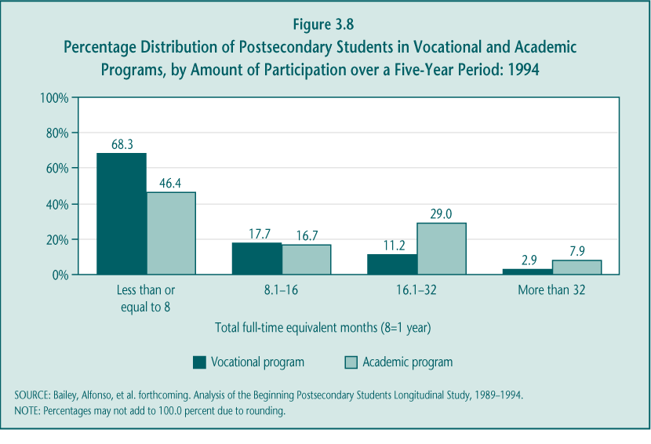

► Many postsecondary vocational students complete less than a year’s worth of courses. Most postsecondary vocational students (68.3 percent) complete a year or less of courses within a five-year period, compared to 46.4 percent of academic students (Figure 3.8). Given these low rates of participation, a large share of both groups will fail to obtain any credential or to earn sufficient credits for transferring to a baccalaureate program.

► Less than half of vocational participants complete a credential of any kind. For example, among students who enroll in and state a goal of completing at least an associate degree, considerably fewer vocational participants than academic participants can be considered “successful” completers. Only 38.9 percent complete a credential of any kind (a quarter of which are certificates, less than their original goal), and an additional 8.0 percent transfer to earn a baccalaureate degree within five years of first enrolling. In comparison, 52.9 percent of their academic counterparts complete some credential, and an additional 8.6 percent transfer to a baccalaureate program during the same period. In addition, among those with a bachelor degree goal, vocational students are less likely to attain any credential (27.5 percent compared to 32.4 percent) and far less likely to have transferred to a baccalaureate program (19.6 percent compared to 32.6 percent) (Table 3.8).

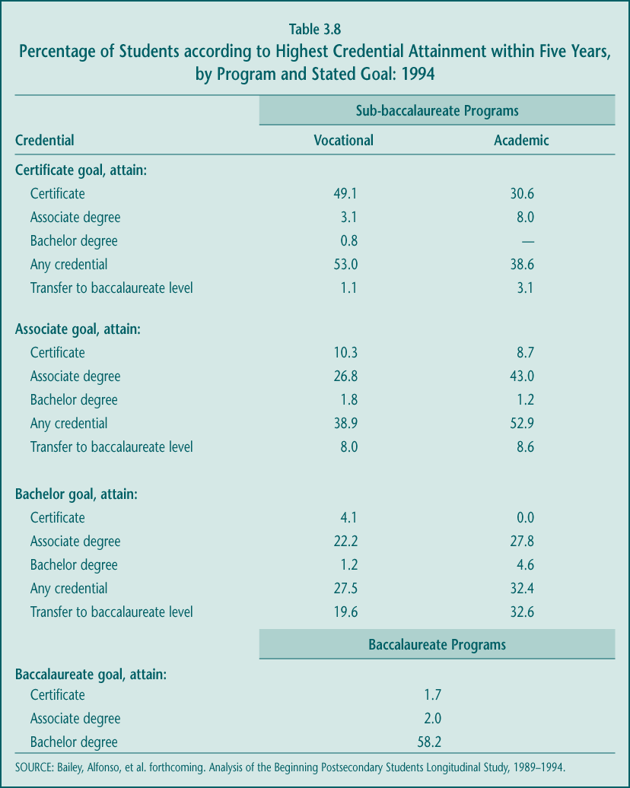

Not surprisingly, completion rates are higher for vocational students in certificate programs than for those in associate degree programs. This pattern is largely due to the fact that certificate programs are shorter in duration than associate degree programs and generally require less rigorous academic preparation and course work. Even so, almost half (47.0 percent) of those who enroll in vocational certificate programs and state that they intend to attain a certificate still do not attain a credential within five years.

In contrast to the pattern for sub-baccalaureate students, students in baccalaureate programs are more likely to complete a credential even though the program is longer. Among those enrolled in a bachelor degree program, more than half (58.2 percent) attain that degree, 3.7 percent attain either a certificate or an associate degree, and an additional 19.1 percent are still enrolled five years later. A total of 81.0 percent are either still enrolled or have attained an academic credential.

The characteristics and goals of postsecondary vocational participants cannot fully explain their lower completion or persistence rates.

It is useful to examine the extent to which differences in the persistence and completion rates of academic and vocational majors are attributable to differences between the two populations of students. Some argue that vocational students spend less time than their academic counterparts in postsecondary education because they seek job skills rather than a longer-term education program culminating in a degree. Because credentials vary in length and difficulty, it makes the most sense to compare students who are pursuing similar credentials. It is not particularly meaningful to compare academic and vocational students among those seeking a certificate because almost all certificates are vocational. However, it is possible to analyze the gap in persistence and completion between academic and vocational students who pursue associate degrees.

As discussed in a previous section, even more so than their academic counterparts, vocational students have many characteristics that are traditionally linked to low persistence in and completion of postsecondary education (e.g., lower socioeconomic status (SES) and levels of academic preparation, more sporadic attendance, and less ambitious credential objectives). In addition, vocational students are much more likely to report wanting to upgrade their job skills as a primary reason for participating; earning a credential may not be part of their plans. The data suggest that these factors can affect the probability of completing a degree, but in many cases, the differences between academic and vocational students on these characteristics are not as substantial as many would think.

The following analyses look at the independent effect of various factors on the successful completion of educational objectives (Table 3.9). “Successful completion” is defined here as completing one’s stated degree objective of an associate degree or transferring into a baccalaureate program. In the main, attaining an institutional certificate is not considered “a success” because the education it requires generally falls short of the originally stated goal of an associate degree. On the other hand, a transfer is considered “a success” based on the assumption that this puts the student on a path toward a higher degree. Sensitivity testing of this definition—for example, including certificate attainment as a successful completion—suggests that, at least among the younger participants, vocational students are just as likely as their academic counterparts to attain a credential; however, they are more likely to attain a credential that requires fewer years of education than their originally stated objective (Bailey, Alfonso, et al. forthcoming).

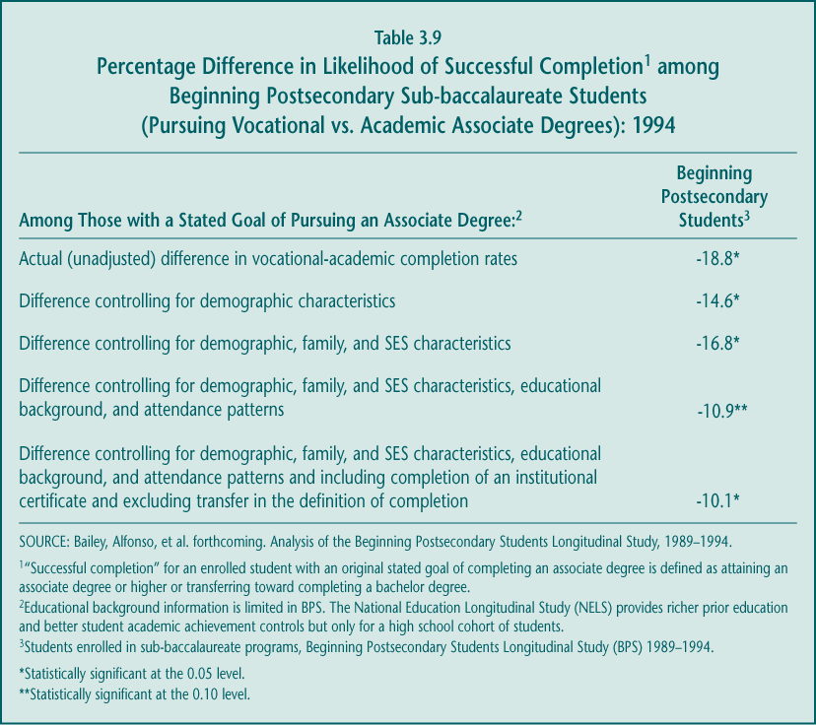

► Student demographic, family, and SES characteristics: Vocational students are more likely to be older and in the lowest SES quartile, have a parent who has attained less than a bachelor degree, and have more family responsibilities—all characteristics, based on previous research, that are associated with lower persistence and credential attainment. After taking these characteristics into account, however, the difference in rates of completion between vocational and academic students is largely unaffected (-16.8 percent vs. -18.8 percent) (Table 3.9).

► Attendance patterns: Enrolling less than full-time and interrupting one’s postsecondary education each decrease the estimated probability that sub-baccalaureate students will complete an associate degree. Less than full-time enrollment decreases the likelihood of completion (by 28.3 percent), as do interrupted enrollment and delaying enrollment for at least a year (-10.7 percent and -22.6 percent, respectively). Surprisingly, working students, even those who work more than half of the time they are enrolled, do not have a lower likelihood of completion. Taking all of these attendance patterns into account reduces differences in rates of completion between students pursuing vocational and academic associate degrees by almost half (from -18.8 percent to -10.9 percent), but the difference is still statistically significant (Table 3.9).

► Student high school preparation: Among sub-baccalaureate participants in associate degree programs, students who pursued an academic track in high school were one-fifth to one-third more likely than those who pursued a vocational or general track to attain either a vocational or academic associate degree. However, because vocational and academic sub-baccalaureate students are almost equally likely to have pursued an academic track in high school, differences in high school preparation do not affect the completion gap between vocational and academic students, at least among younger students.

► Student objectives: In the most recent NCES BPS survey (1996–98), students were asked to report their primary reason for enrolling in postsecondary education out of three possible reasons: “job skills,” “degree attainment or transfer,” or “personal enrichment.” As expected, students who cite “job skills” or “personal enrichment” are less likely (between
-11.4 and -18.1 percent) to persist toward attaining a credential. Despite the fact that vocational students are more likely to report these motivations, which might indicate that they were not seeking a degree, controlling for the reason students cite for participating in postsecondary education has no statistically significant influence on differences in persistence between academic and vocational students.

► Varying the definition of “successful completion”: Including attainment of an institutional certificate and excluding transfer in the definition of “successful completion” have no statistically significant effect on differences in rates of completion between vocational and academic associate degree students. Specifically, vocational students are still 10.1 percent less likely to “complete” than academic students after considering all student characteristic adjustments (Table 3.9). However, when focusing on younger sub-baccalaureate students—those attending shortly after high school—differences in completion by major disappear. At least among younger students who state they want to earn an associate degree, vocational majors are more likely than academic majors to attain a certificate and less likely than academic majors to transfer. They are equally likely, though, to attain a credential (Bailey, Alfonso, et al. forthcoming).

Completion of a credential has long been a goal of federal policy. However, this preference is based largely on existing evidence about the importance of a bachelor degree for long-term success in the labor market. It is less clear whether a similar preference for credentials holds for sub-baccalaureate participants. In contrast to those pursuing a bachelor degree, many sub-baccalaureate students are older and already have substantial experience in the workforce. The importance the labor market places on a obtaining credential or even completing a substantial amount of course work is an empirical question that will be addressed in the next section.

Also, of potential interest is the finding that vocational students, especially younger ones, are more likely than their peers in academic programs to attain a credential that requires fewer years of education than they originally expected. Because academic students are more likely than vocational students to continue their education by transferring to a four-year institution, differences in attainment are mostly attributable to differences in transfer rates. Further analyses, however, do not attribute these differences in transferring to differences in educational aspirations. An alternative explanation may be that course work in many vocational programs, in contrast to that in academic programs, is not accepted for transfer credit. It also turns out that vocational students who decide to shorten their education before attaining an associate degree may not have to leave “empty-handed”: they may have earned enough credits to attain an institutional certificate. Earning a credential for completed course work short of an associate degree is simply not an option in most academic programs.

Sub-populations among postsecondary vocational participants, including those designated as “special populations,” have completion rates that are similar to those of other participants.

Federal policy has encouraged the postsecondary vocational participation of students from specific groups—those who are economically and academically disadvantaged, individuals preparing for nontraditional training and employment, single parents, displaced homemakers, and individuals with other barriers to educational achievement, including limited English proficiency. Nationally representative data on some of these groups are limited, because the numbers of students with these characteristics in the population and in national surveys are small and only available for those students taking for-credit courses. The educational outcomes of younger participants are also of interest to policymakers given the efforts of Tech-Prep to improve outcomes among traditional-age participants (Table 3.10).

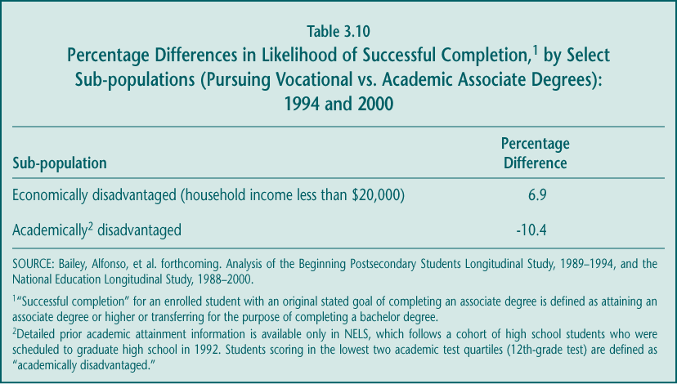

► Economically disadvantaged vocational students complete at low rates but do at least as well as their academic counterparts. Economically disadvantaged students—vocational or academic—are less likely than economically advantaged students to complete a credential (Bailey, Alfonso, et al. forthcoming). However, this disadvantage appears to affect those in vocational and academic programs about equally; among economically disadvantaged students, the difference between those in a vocational and an academic program in their probability of completing is not statistically significant (-10.4 percent) (Table 3.10).

► Among academically disadvantaged students, academic and vocational students are equally likely to complete to a credential. As is true for economically disadvantaged students, there is little difference between academically disadvantaged students in vocational versus academic programs in their completion rates. Among students who scored in the lower half of the distribution on a 12th-grade academic achievement test, the likelihood of completion does not differ statistically between academic and vocational students (-10.4 percent) (Table 3.10).

► Differences in completion rates for special population groups are likely to mirror overall differences between sub-baccalaureate students seeking an associate degree. Separate analyses for other special populations of interest are not generally possible due to the small numbers of these students in national data. However, being a single parent and having disabilities have no statistically significant effect on the completion rate of sub-baccalaureate students after controlling for other differences in background and educational preparation.

2. Earnings Benefits

Increasing earnings is a primary objective for many, if not all, students who participate in postsecondary education. Past research has generally shown that postsecondary participation enhances earnings; however, the majority of this evidence is based on the benefits of having a baccalaureate degree. Very little research focuses on those students who pursue sub-baccalaureate programs, and even fewer studies address the economic returns to vocational programs. And yet, vocational programs, by their very nature, are designed to prepare students for work. Whether or not postsecondary vocational course work increases the earnings of participants beyond those of a high school graduate is potentially an important measure of the success of vocational programs.

Analyses of the economic returns to education typically require data that follow program participants over a long period of time. If education enhances labor market skills that lead to better career opportunities, the economic benefits accrue over time with both higher earnings growth and potential. Because young people, in particular, can take several years to settle into their long-term career paths, their initial earnings are not a good indicator of their earnings potential and thus the rate of return to education. Instead, to obtain a more accurate picture of the economic returns to postsecondary education, it is necessary to gather information about an individual’s income many years after he or she enters the labor market. Therefore, the analysis here is restricted to graduates from the high school class of 1992. Although these data cover the early years of the cohort’s career path, they provide a reasonable first snapshot of the benefits of postsecondary education.

Whether small amounts of postsecondary vocational course work (without attaining a credential) provide benefits depends on gender.

Because the majority of sub-baccalaureate students take relatively few courses and most do not attain a credential, it is worthwhile to examine whether more limited participation does indeed generate economic benefits (Table 3.11). These earnings returns to education were measured up to six years after a student’s scheduled graduation from a two-year program. Analyses are conducted separately for male and female students because schooling and work decisions differ by gender.

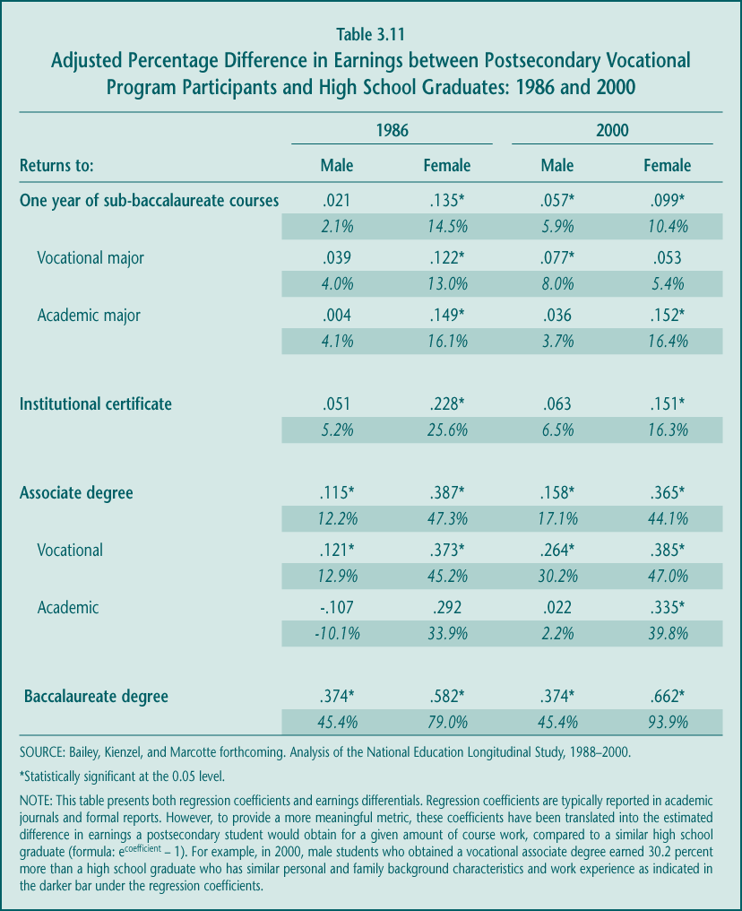

► Even without a credential, a year’s worth of postsecondary credits for male vocational students now pays off. In 2000, male vocational students who did not attain a certificate or degree still earned 8.0 percent more per year of postsecondary education than did similar high school graduates. This finding represents a shift from 1986, when a year of courses without earning a credential provided no real economic return for males. Perhaps newer offerings, such as IT courses, are more easily recognized and more highly valued in the current labor market than the individual courses were more than 15 years ago. In neither year did male students in academic sub-baccalaureate programs who took a year of courses but did not earn a degree do better than a high school graduate.

► Female vocational students who pursue a year’s worth of credits without receiving a credential do not reap economic benefits. For female students in 2000, taking a year of course work led to earnings that were higher but not statistically different from those of female high school graduates. This finding also contrasts with the pattern 15 years ago, when course work without earning a credential did produce economic advantages. One possible reason for the change is that females enroll predominantly in health and business programs, fields in which state licensing and other credentials have become more important gateways to jobs; it is possible that it is harder now to participate in those credentialing processes without an institutional certificate. On the other hand, there appear to be large returns for females pursuing one or two years of sub-baccalaureate study in an academic field.

Those who pursue significant amounts of postsecondary education and earn a credential reap the greatest economic rewards.

Federal policy places substantial importance on attaining a postsecondary degree, in part, because of the expected economic benefits of holding that credential. However, many in the sub-baccalaureate community argue that in an environment of lifelong learning, students pursue additional education a few courses at a time, and as they can, and they may not always be seeking a formal degree or certificate. Given the potential gap between federal objectives and actual student participation, it is important to examine the relative economic benefits of earning a postsecondary vocational credential.

The evidence suggests that, for some, there are benefits to participation even if a student does not attain a credential, but those effects are relatively modest. Substantial additional income gains occur for those who attain a credential, bolstering the policy goal of credential attainment, at least among young participants (Table 3.11). There is also evidence that the importance of a credential in the labor market may be increasing for both male and female students.

► Female vocational students generally need a credential to benefit from their postsecondary vocational education. In 2000, female students who attained a vocational associate degree increased their earnings above and beyond female students with only a high school degree by 47.0 percent. These figures represent a significant benefit over completing the amount of course work necessary for the degree but not the credential itself—earnings of only 11.2 percent more than a high school graduate (derived by doubling the coefficient for a year of course work [.053] and using that coefficient in the following formula: e.053 * 2 - 1= 11.2 percent).

In 2000, female students also reaped an earnings benefit over female high school graduates when they attained a certificate (16.3 percent). That benefit is higher than that of simply completing a year’s worth of courses, approximately the amount needed for a certificate (5.4 percent), but the differences are not statistically significant, perhaps because of small sample sizes.

The importance of obtaining both types of credentials may be increasing. Compared to their counterparts in 1986, female vocational students in 2000 were economically much better off when they attained a certificate or associate degree than when they completed the approximate course work needed but did not get the credential.

► Credentials seem to matter less for male vocational students. Although the general pattern for male vocational students appears similar to that for females, the results are not statistically significant. Estimates suggest that the rate of return for male vocational students who attain a degree is greater (30.2 percent) than for male participants who complete two years of course work without attaining a degree (16.6 percent). The earnings returns to completing a certificate also seem higher than the returns for one year of course work. However, we cannot conclude that, on average, the degree produces higher economic benefits or that the credential itself adds to earnings.

On the other hand, the data suggest that the importance of a credential for male vocational students, as was true for female students, increased between 1986 and 2000. That is, the economic returns to a vocational associate degree more than doubled for men during that period (from 12.9 percent more than a high school graduate to 30.2 percent more). The returns to completing course work without a credential also increased, but not by as much.

Taken together, the findings indicate that there is economic value to postsecondary vocational education and that the value increases for both male and female participants as they earn more credits. The greatest earnings are obtained by those completing an associate degree, and to a lesser extent a certificate. Because these findings are based on students who are among the younger sub-baccalaureate participants, additional analyses were conducted with data that include a broader cross-section of students, although there was a shorter follow-up period to examine earnings. The patterns in these additional analyses are generally consistent with the findings from the younger cohort.

Economic benefits are similar across the diverse populations served by postsecondary vocational education.

Current Perkins policy potentially affects all vocational programs and all of its participants. However, the effects of vocational education among special populations are of particular policy interest. In addition, separate funding for Tech-Prep (Title II of Perkins III) implies an extra policy concern for younger participants making the transition between high school and postsecondary education. The next section addresses the economic benefits for many of these sub-populations.

As is true for postsecondary vocational students generally, the evidence suggests that various groups of students are mostly well-served by vocational education, especially those who complete significant amounts of vocational course work (Table 3.12).

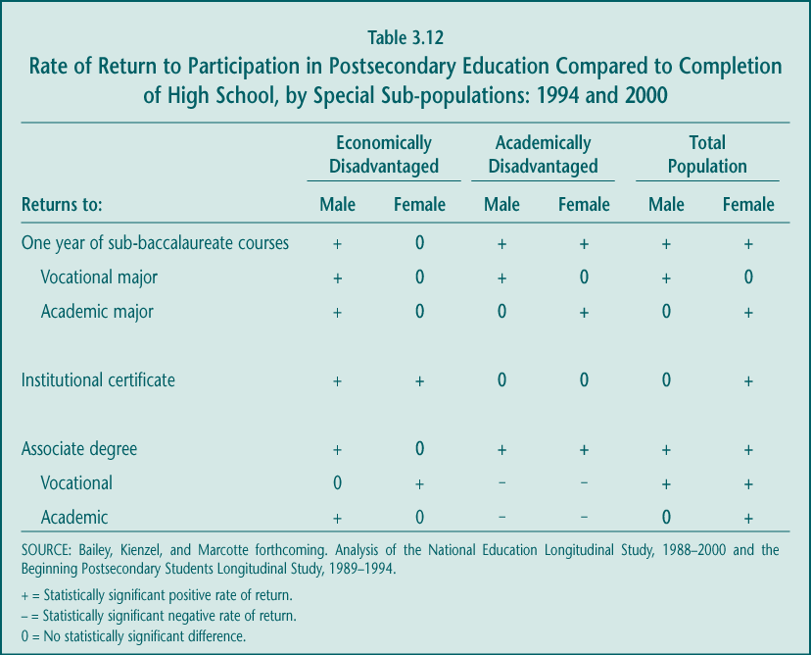

► Economically disadvantaged students: Similar to the findings for all vocational students, students in the lowest SES quartile benefit from participating in postsecondary vocational programs. Males benefit whether they attain a credential or not. Only females who attain a credential—certificate or associate degree—have statistically significant higher earnings than their counterparts who only earn a high school diploma.

► Academically disadvantaged students: Similar to the overall findings, male, but not female, academically disadvantaged students who take a year of vocational course work increase their earnings beyond what they would earn with only a high school diploma. Both academically disadvantaged male and female students benefit from attaining an associate degree, although there are insufficient data to distinguish between the economic returns to vocational and academic associate degrees for these students. There is also no statistically significant difference in earnings between academically disadvantaged students who obtain a certificate and those with only a high school diploma, again possibly due to the small sample size.

► Students from other special populations: The number of vocational participants in other sub-populations of interest is small, making separate analyses within these groups impossible. However, in analyses of the total population, the rate of return to vocational education is basically unchanged when these characteristics (single parent, LEP, or disability status) are taken into consideration.

► Younger students: Among students younger than age 24, vocational courses are still economically beneficial, and particularly so for those who earn a credential. Analysis of administrative records in two states suggests that earnings gains are significantly higher for those who earn a credential. In contrast, there are no statistically significant earnings gains for students who pursue sub-baccalaureate academic programs (Hoachlander et al. forthcoming).

The first federal legislation supporting vocational education was the Smith-Hughes Act of 1917.
Other federal programs, such as student financial aid, tax credits, and the Workforce Investment Act, help provide individuals with access to occupational training at the postsecondary level; the Perkins Act provides support to institutions and programs.
About 62 percent of Perkins funds are spent at the high school level.
Occupational concentrators are defined as students who earn at least 3.0 occupational credits in one program area.
The “New Basics” academic curriculum, as measured here, is equivalent to four years of English or language arts, and three years each of math, science, and social studies. Many states are moving to this standard for core high school graduation requirements.
Some students enroll in high school vocational education because they do not plan to attend college, so a negative relationship between vocational courses and postsecondary education might be expected. However, even controlling for college plans and other student characteristics, vocational courses have no effect, on average, on postsecondary enrollment.
The comparable completion rate for students entering four-year postsecondary programs seeking bachelor’s degrees is 61.9 percent; that is, almost two-thirds of students who enter these longer degree programs actually earn a credential of some kind (including less than a baccalaureate degree), compared to about half of students who enter shorter-term vocational associate degree programs.
Perkins III requires the NAVE to provide “findings and recommendations resulting from the assessment” (Section 114(c)).
Since federal vocational education legislation was enacted in 1917, the law has responded to changing needs and acquired new objectives. Initially, it was a way to prepare immigrant and rural populations to work in factories and on farms. At some point it became a form of training that might appeal to less academically oriented students, perhaps helping to keep them in school by engaging them in activities most relevant to future employment. Over time vocational education was supported as a strategy to keep the United States internationally competitive, by delivering advanced technical training to meet the needs of an increasingly high-tech economy. More recently, vocational education has been promoted as a strategy to enhance academic learning and provide a clearer pathway to success in college.
Requiring postsecondary institutions to be responsible would not preclude other Perkins institutions—secondary districts, high schools, area vocational centers, adult centers—from playing major roles in these activities, as is appropriate. However, designating the lead institutions in law may help ensure that the activities are a focus of funded efforts.
The first federal legislation supporting vocational education was the Smith-Hughes Act of 1917.
Other federal programs, such as student financial aid, tax credits, and the Workforce Investment Act (WIA), help provide students with access to occupational training at the postsecondary level; Perkins provides support to institutions and programs.
The Perkins Act contains some set-asides (e.g., 1.25 percent of appropriations for grants to Native American tribes and tribal organizations), which are awarded by the U.S. Department of Education through a competitive grant program. In addition, funds allocated to states by formula under Title II of Perkins III, the Tech-Prep Education Act, can be awarded to local grantees using either a formula or a competitive grant process.
Under Perkins III, however, federal funds can no longer be used to support programs consisting of a single course or those that do not include “competency-based learning” (i.e., most leisure- or personal interest-related programs could not receive Perkins support).
The NAVE Interim Report to Congress (2002) is available at http://www.ed.gov/rschstat/eval/sectech/nave/reports.html.
In the case of the Perkins Act and Title I, the amount of federal funds spent on high school activities is determined by state and local agencies. Estimates of national high school spending for these programs were calculated using the most recently available evaluation data regarding the relative split of funds across education levels.
These initiatives were supported in various ways by the federal School-to-Work Opportunities Act of 1994. This grant program provided states and local partnerships of educators, employers, and community groups with “venture capital” to initiate strategies that help students develop better educational foundations for long-term career preparation. Although the legislation has expired, many School-to-Work tenets can be found in the “new vocational” strategies.
The National Skill Standards Board (NSSB), created as part of the federal Goals 2000 Act (1994), was charged with developing a voluntary national system of skill standards, assessments, and certifications. Even before the NSSB was formed, the U.S. Departments of Education and Labor funded 22 industry groups with similar objectives
This figure represents an undercount of the total proportion and number of schools offering vocational education because the survey on which it is based asked about only 28 occupational programs; some schools may provide only other forms of vocational education (e.g., general home economics), as described below.
The law allows funds to be spent on vocational education in seventh or eighth grade. However, such a small proportion of Perkins grants (less than 1 percent) are allocated to middle school programs that vocational offerings below the high school level are not a focus of NAVE analysis.
The National Association of State Directors of Career and Technical Education is currently leading an effort to reorganize occupational groupings into 16 broad career clusters. However, a “crosswalk” between that re-categorization and national course lists for coding transcripts was not available.
Historically, students could be clearly distinguished by the “track” or set of courses in which they participated—college preparatory, vocational, and general. However, these labels and the patterns of course participation they represent are no longer clear cut.
According to the 2002 Digest of Education Statistics (nces.ed.gov/programs/digest/d02/tables/dt038.asp, Table 38), there were 2,799,484 12th-grade students in 2000. If we assume all of those students graduated that year, the 26.0 percent who were occupational concentrators amount to 727,899 students. These students are included in the 44.5 percent of graduates who were occupational investors, with the larger group amounting to 1,245,770 students.
Between 1982 and 2000, General Labor Market Preparation courses declined from 1.0 credits to 0.7 credits at the high school level (Levesque 2003c). In particular, fewer students are taking keyboarding or typing courses in high school, perhaps because these courses are now offered in middle school. In contrast, average credits earned in occupational education—courses such as health, business, trade, and industry—have been relatively constant since 1982.
The maximum of 28 credits was calculated based on the assumption that most high schools offer seven periods of courses each day (1 credit for each year-long course) over four years, for a total of 28 credits. New “block-scheduling” approaches can increase the total possible number of credits earned to 32.
Most states, for example, increased the years of math or science (or both) required from two to three, which would most likely affect 11th-grade course taking (Education Commission of the States 1990; Snyder et al. 2001).
The data on which national course-taking trends are based, transcripts collected as part of the National Assessment of Educational Progress (NAEP), cannot adequately assess quality, so some judgment about program areas is necessary.
Perkins III requires that state plans describe how “vocational and technical education relates to state and regional occupational opportunities” (Sec. 122(c)(15)) but does not require states or local programs to focus their activities on preparing students for occupations for which there is current or projected unmet demand in the labor market.
It is unclear whether the consistency in course taking and job growth reflects changes in school program offerings, changes in student preferences, or both.
Although enrollments in these program areas grew significantly in relative terms, the absolute number of students participating in these programs is still small
Co-op is offered mostly in the vocational areas of marketing, trade and industry, and business. Although more than 16 percent of 1998 graduates earned co-op credits, only about half of these—9.3 percent of all graduates—were clearly in co-op related to a specific occupational program (Levesque 2003b).
Unfortunately, the NAEP transcripts do not contain many indicators of student characteristics; some measures were constructed based on the characteristics of the students’ schools.
Area and regional vocational schools, in particular, report serving disproportionate numbers of students with disabilities, but trends in these schools’ participation cannot be separated from those of other schools serving students in vocational education
The small samples of LEP students in national data preclude analysis of their participation by occupational program area. Also, the national data sample is of 12th-grade students, with the classification of LEP based on students’ proficiency in their senior year. Students who are LEP in 12th grade are likely to be a small percentage of all high school students who were ever limited English proficient or who were limited proficient at some point in high school.
Perkins III also requires states to include in their state plans, submitted for review to the U.S. Department of Education, Office of Vocational and Adult Education, a description of how individuals who are members of special populations will be provided with equal access to activities under the act (Section 122(c)(8)).
High-income schools and those with low proportions of racial or ethnic minorities, some of which require students to pass entry exams or focus exclusively on preparing students for admission to selective colleges, are also less likely to offer many of the specialty vocational programs and strategies.
In 1998–1999, average student enrollment in rural public high schools was 437, compared to 1,120 for schools in urban and suburban areas (Hudson and Shafer 2002).
These strategies are conveyed in the Purpose (Section 2), State Plan (Section 122), State Leadership Activities (Section 124), and Local Plan (Section 134) components of the legislation.
Rigorous experimental evaluations have not been conducted to determine the impact of various forms of integration, articulation agreements, efforts to broaden the curriculum to include “all aspects of the industry,” greater employer involvement, and so on. The Office of Vocational and Adult Education (OVAE) plans to address some of these gaps by funding experimental studies of particular vocational strategies in the future.
Integration is, for example, mentioned as a core strategy for addressing the purpose of the law (Section 2).
The “dual systems” require students to complete a core academic curriculum by age 16 and then to choose between two tracks for further education and training: undergraduate academic degree programs and apprenticeships for occupational training, which typically combine classroom academic and technical course work with alternating days of workplace experience.
Upward Bound, one of the federal TRIO programs that promotes college enrollment and persistence among low-income high school students, does not typically involve collaboration between high school and college academic faculty. Moreover, that program serves a relatively small number of students.
Articulation has been in practice in some states since the 1920s and was promoted by the National Institute of Education (a part of the U.S. Department of Health, Education and Welfare) in the early 1970s (Hershey et al. 1999). Dual-enrollment programs have been in existence for more than 30 years (Bailey, Hughes, and Karp 2002).
In some states and communities, after completing an articulated high school course, students may have to pass a college competency test, complete a certain number of college credits, or enroll in a related community college program in order to receive the articulated college credit. Students who attend a postsecondary institution outside the scope of the articulation agreement do not receive articulated college credit.
Students may also attend a private postsecondary institution in Florida, but the scholarship award is fixed at 75 percent of the average tuition and fees at a comparable Florida public institution.
National data, for example, suggest that many “high-performing” vocational students—even those who do not have access to special state scholarship programs—enroll in college (Agodini et al. forthcoming).
Although not based on a directly comparable survey, data from NCES suggests that about 40 percent of all secondary teachers have students perform Internet research “to a moderate or large extent.” This figure includes both middle and high school teachers, and both academic and vocational teachers. Moreover, the NCES estimate is more inclusive of both “frequent” and “less frequent” activity (see Rowand 2000).
As discussed previously, for example, students in rural areas appear to have access to a smaller range of occupational programs and practices
Although it appears that the proportion of new vocational teachers who had industry experience increased between 1991 and 2000, because the sample sizes are small, the differences are not statistically significant. Similarly, the sample sizes were too small to estimate differences in industry experience between teachers in comprehensive and vocational schools.
In fact, the overall proportion of vocational teachers without baccalaureate degrees is likely to be higher than 9 percent. The sample on which the teacher surveys are based somewhat underrepresents area vocational centers, which are more likely to hire teachers without that credential.
See http://ets.org/praxis/index.html.
It is important to note that “other secondary” teacher candidates include those intending to teach math or English and language arts, who might be expected to have stronger skills in those subjects than teachers intending to teach other types of secondary courses including vocational classes.
In both surveys, teachers were asked to report on the first class of the day. However, the 1992 survey asked teachers to indicate whether they used particular instructional practices when the class last met, while the 2001 survey asked about the frequency of the activities during the school year.
Value-added analysis is the most rigorous approach for estimating the effects of participating in vocational courses. A randomized controlled trial is the preferred approach, where students would be assigned by lottery to either participate in vocational courses or not to participate. However, schools cannot deny students entry into vocational courses so that evaluation method is not feasible. Randomized controlled trials (lotteries) have been used to evaluate two career-related specialty programs—career academies and career magnets. Results from these studies are included under the “value-added” heading.
These objectives, as noted in Chapter 1, are contained in the stated purpose and accountability provisions of the law. They are examined here in the order in which the law calls for them.
In addition to occupational courses, termed “specific labor market preparation,” vocational education includes general labor market preparation and family and consumer sciences.
Recent analysis suggests that the eighth- or ninth-grade test scores of students who become occupational concentrators in Texas and Florida are very similar to the scores of other high school students who do not become concentrators (Hoachlander et al. forthcoming).
In 2000, occupational concentrators represented 26.0 percent of all high school graduates and, according to Table 2.36, just over half (51.1 percent) of those students met the New Basics standard. The proportion of graduates who both concentrated and met the standards is therefore 13.3 percent (.260 * .511).
Another explanation for the improved achievement of 12th-grade concentrators over time may be that the groups of students who pursued vocational programs of study changed during the decade. As noted in Section B, vocational education appeared to be attracting relatively more academically talented students during the 1990s.
Although a NAEP reading assessment was also administered in 1990, the nature of the assessment changed substantially between 1990 and 1994 so that scores cannot be reliably compared.
Some advocates suggest that vocational education is not intended to affect academic achievement; on the other hand, the National Association of State Directors of Career and Technical Education highlight in their mission statement that vocational education is “an integral component of the total education mission, contributing to the goals of high academic achievement. . .” (see National Association of State Directors of Career and Technical Education undated, p. 3).
Both studies separated occupational concentrators who also pursued a strong academic program (“dual concentrators”) from concentrators who did not meet those academic requirements. The studies concluded that dual concentrators experienced higher achievement gains than did general education students, while the occupational concentrators only experienced lower gains. Combining both groups of occupational concentrators produces gains that are similar to those of general education students.
The academic “program” or concentration is defined as one in which a student completed at least the “New Basics” curriculum: four years of English or language arts and three years each of math, science, and social studies.
The evaluation also statistically controlled for student characteristics to account for any differences that remained between the treatment and control groups.
This approach has two drawbacks: it does not include students who drop out in 9th or 10th grade, and it does not examine the effect of course taking in 11th and 12th grades, when much of vocational course taking occurs.
The evaluation of career academies did find, however, that the program seemed to keep students in school longer even if that persistence did not pay off in terms of earning a diploma or a General Education Development (GED) credential (Kemple 2001).
According to the Digest of Education Statistics 1998 (Snyder et al. 1999), college enrollment rates of high school graduates increased from 59.9 percent in 1990 to 65.6 percent in 1998 (Table 186, p. 214). Enrollments in institutions of higher education as a share of 18- to 24-year-olds increased from 32.1 to 36.5 percent, and as a share of high school graduates increased from 37.7 to 45.2 percent (Table 189, p. 216).
Eight years after high school graduation, 53 percent of concentrators and 66 percent of non-concentrators (64 percent overall) had earned a postsecondary degree or certificate; more than one-third of all high school graduates had not earned any postsecondary credential (Table 2.40 and Agodini, Uhl, and Novak 2002).
For the most part, the impact of vocational education on these postsecondary outcomes cannot be measured using the most rigorous analytic methods—randomized controlled trials. Only one study, of career academies, used that technique to examine college enrollment, persistence, and completion. The alternative methods used in most of the vocational course taking analyses cannot account for all types of bias in who does and does not select to participate in vocational education. That is, some students may choose to take vocational education in high school because they do not plan to pursue postsecondary education or because they want to earn a technical associate’s degree rather than a baccalaureate degree. So it is possible that the estimated relationship between vocational education and postsecondary outcomes may include some selection bias. Although the Agodini analyses control for students’ college aspirations and plans, they may not fully eliminate this bias and therefore the findings should be interpreted with caution.
Analysis of Texas data suggests that, when only students who attend college in-state are included, vocational education appears to increase the probability of attending college. However, a similar result with the Florida data disappeared when information on out-of-state college enrollment was obtained. It appears that students who take little vocational education are more likely to attend college out of state, biasing the results in favor of vocational education when those out-of-state students are not included in the analysis.
However, career academies appeared to reduce enrollment in postsecondary education among students who entered the program at the highest risk of dropping out of school.
The net effect, then, is that occupational course taking has no overall impact on postsecondary degree completion.
In addition, the average number of hours worked (about 43 hours per week) in 2000 was also similar across groups (Agodini, Uhl, and Novak 2002).
Studies use different follow-up periods to examine short-term earnings, but they are grouped here as representing approximately 1.5 years after graduation. Analyses of 1992 graduates (NELS:88) have approximately 20 months of earnings information. State data results are based on 15 months of earnings.
Another recent paper (Mane 1998) did find earnings effects for students who did not enroll in postsecondary education in the short-run. However, that paper included in its “noncollege” group students who enrolled in college part-time or for a short period of time, an increasingly large share of postsecondary students. When those part-time students were excluded from the noncollege group, the benefits of high school occupational course taking disappeared (Agodini, Deke, et al. forthcoming).
It is important to note, however, that the career academies who were the subject of the study involved employers more intensively and offered more extensive work-based learning opportunities than is typical in most high school vocational education programs.
Vocational fields include agriculture and natural resources; business, management, marketing, and support services; allied health professions, services, and health technicians; home economics and family and consumer sciences; personal services; legal support services; protective services; computer and information sciences; engineering and related technologies and science technologies; communications technologies; construction; mechanics and repair; precision production; and transportation and materials moving (Levesque et al. 2000).
However, under Perkins III, grantees must use funds to support programs that consist of a sequence of courses and opportunities for competency-based learning. As a result, some offerings (e.g., single-course or limited leisure programs) cannot be funded with Perkins grants.
State financing policies, which vary from state to state, may play a role in the extent of noncredit offerings at public postsecondary institutions. For example, in Arizona, the state does not pay individual institutions for noncredit courses, and perhaps as a result, for-credit enrollments are proportionally higher than in other states. In contrast, Texas reimburses its postsecondary institutions for enrollments in noncredit courses, and participation in these courses is relatively high. The prevalence of noncredit courses varies widely from institution to institution as well. In Florida “supplemental vocational courses”—noncredit courses for people seeking to enhance their job skills—are about 25 percent of a given institution’s headcount (Teitelbaum 2001, descriptive information from Florida state data). In contrast, a community college in Michigan reports that noncredit courses are less than 10 percent of their course offerings and less than half of those are job-related (Jacobs 2001).
NAVE internal analyses of NPSAS 2000.
Descriptive information from Florida state data.
Descriptive information from Florida state data.
Examples range from a floral arranging program lasting only a few weeks to a two-year certificate program in airframe and power plant mechanics.
Descriptive information from Florida state data.
This provision was intended to promote equal access to vocational programs by providing relatively more financial support to institutions serving large numbers of economically disadvantaged students (as approximated by financial aid criteria). Under Section 132(b), the law permits the secretary of education to approve alternative formulas.
National data on postsecondary enrollment are reported in different ways. Most commonly, the figures are based on fall enrollments provided by individual institutions of higher education (e.g., to NCES through the Integrated Postsecondary Education Data System (IPEDS)). However, limiting enrollment data to the fall greatly reduces the number of reported participants at the sub-baccalaureate level because many of these students enroll throughout the year. In addition, IPEDS enrollment data are reported by institution type (four-year and two-year). Because 13.5 percent of sub-baccalaureate programs are offered at four-year institutions, when aggregate IPEDS enrollment figures are reported just for two-year institutions, participation in sub-baccalaureate programs is underreported (Bailey, Leinbach, et al. forthcoming).
Calculation based on 29.6 percent (see Figure 3.1) of the total number of undergraduates. The total number of undergraduates (16,539,461) enrolled in for-credit courses is estimated from NPSAS 2000 (e-mail communication with NCES project officer Andrew Malizio).
At least in the prominent area of information technology (IT), much of the growth in courses occurs outside the formal postsecondary education system (i.e., courses offered by commercial training providers) (Adelman 2000). A recent survey of community colleges (Haimson and Van Noy forthcoming) indicates that only about a quarter offer courses that prepare students for IT certification in Novell, Microsoft, or Cisco.
Findings presented here emphasize associate degree enrollments. Enrollments in institutional certificate programs appear to be somewhat responsive to labor market shifts as well (see Silverberg et al. 2002).
By comparison, less than half (45.7 percent) of the sub-baccalaureate students enrolled in an academic program are age 24 and older, and only 27.6 percent are age 30 and older.
NAVE internal analyses of NPSAS 2000.
Detailed high school preparation and academic test score data are available only for high school students (the National Education Longitudinal Study (NELS)) and therefore do not represent all postsecondary vocational students.
The “New Basics” core curriculum is defined as four years of English or language arts and three years each of math, science, and social studies.
Analyses conducted by the American Association of Community Colleges (AACC) and ACT Inc. suggest that over a quarter of students who enrolled in noncredit courses at community colleges had already attained a bachelor’s degree or higher (Phillippe and Valiga 2000).
“High-wage” occupations in 1998 were defined here as those with annual earnings of more than $35,000.
Even though students were asked to select a primary reason, these reasons may not be mutually exclusive.
Academic majors report similar shifts in objectives.
See Chapter 5 for a discussion of the 2 percent estimate.
See Chapter 2 for a more detailed discussion of these practices and how the law promotes them.
NAVE internal analyses of the National Employer Survey, 2001.
Perkins II required that at least 3 percent be set aside from the basic state grant for programs and services to eliminate gender bias as well as at least 7 percent set aside for programs and services to meet the needs of single parents, displaced homemakers, and single pregnant women. These set-asides were eliminated in the subsequent reauthorization in 1998 (Perkins III) and replaced by accountability provisions that require states to report progress related to educational and employment outcomes for these groups.
It should be noted, though, that some colleges support access to financial aid by providing services—funded by Perkins—to help special population students navigate the complex student financial aid system.
A first-professional degree is one that signifies both completion of the academic requirements for beginning practice in a given profession and a level of professional skill beyond that normally required for a bachelor’s degree. These degrees include fields such as dentistry, medicine, pharmacy, law, and theological professions.
The proportion of faculty with a bachelor’s degree or less is most characteristic of faculty in the trade and industry field (65.8 percent). However, the proportion without advanced degrees is still significant in other vocational fields, ranging from a low of 27.3 percent in business to a high of 43.0 percent in health. Part-time vocational faculty are also the most likely to be without advanced degrees (47.6 percent among part-time and 33.7 percent among full-time faculty) (Internal NAVE analyses of NSOPF 1999).
In 1993, the proportion of vocational faculty members with a bachelor’s or less is 46.5 percent and 19.7 percent for academic faculty members. Similarly, the proportion of vocational instructors with a master’s as their highest credential attained is 45.6 percent and 64.8 percent among academic faculty members (Internal NAVE analyses of NSOPF 1993).
NAVE internal analyses based on National Study of Postsecondary Faculty (NSOPF), 1993 and 1999.
From 1990 to 1993, enrollments at two-year institutions spiked, most likely in response to the 1991 recession. Corresponding to the economic recovery, enrollment figures returned to 1990 levels, with no statistically significant difference between enrollments in 1990, 1996, or 2000.
NAVE internal analyses using NSOPF:1993 and 1999.
Given that the Workforce Investment Act and the reauthorization of Perkins allow for a transition year, the findings discussed in this report are early indicators of the implementation of the two laws.
WIA requires states and local programs to give priority to low-income individuals for intensive training services when funds are limited (Sec. 134(d)(4)E) of WIA).
Florida and, to a lesser extent, North Carolina are again exceptions. In both states, community colleges either played a central role in workforce development (under JTPA) or economic development. Presumably because of these ties, community colleges in these states tended to be involved in WIA beyond training services (e.g., they run One-Stop centers and have greater involvement in state and local WIBs).
Florida is a notable exception in that state policy requires local WIBs to set aside 50 percent of their WIA funds for training (Hudis, Blakely, and Bugarin forthcoming).
Based on the characteristics of recent students, about 10 percent of the for-credit participants have characteristics similar to WIA participants who might receive training services. Although this is a relatively small proportion of the postsecondary population, the absolute number is large (about half a million) (Internal NAVE analyses of NPSAS 2000).
Dec. 17, 1998 Memo from Department of Education and Department of Labor, www.doleta.gov/usworkforce/documents/misc/dol-edu-memo.htm (accessed January 15, 2003).
For example, for Perkins employment reporting, Massachusetts requires information nine months after leaving education, while Michigan requires information after only three months; neither requirement coincides with the WIA six-month definition.
The law guaranteed eligibility as training providers to institutions eligible to receive federal funds under Title IV of the Higher Education Act of 1965. Most community colleges, the main recipients of Perkins postsecondary funds, were therefore automatically eligible.
Recertification requirements vary by state but in general involve substantial paperwork including periodic reporting, tracking, and documentation of outcomes for past participants.
Under WIA, the secretary of labor awards incentive grants to those states that exceed their state-adjusted levels of performance for Title I, Title II, and Perkins III programs to promote innovative practices.
To reduce the reporting burden, most states have used existing Unemployment Insurance (UI) wage data for Perkins employment information. Although UI information is not comprehensive, it represents the most reliable and least burdensome data source currently available. However, efforts to rely on UI data for Perkins performance reporting have been complicated by a recent Department of Education interpretation of the Federal Education Rights and Privacy Act (FERPA), which now limits the extent to which a student’s personal information can be shared without his or her consent between state agencies overseeing higher education and the workforce development systems.
These findings are based on student-reported results from BPS:1989–1994. Transcript analyses of traditional-age community college students provide corroborative evidence that less than half (45.2 percent) of students earned a credential between 1992 and 2000, even after excluding those who earned less than 10 credits (Adelman 2003). Neither analyses include industry-based certifications and are thus likely to understate somewhat potential credentials attained. For example, among case study students surveyed, about 36 percent of IT students participating in an industry-based certification program (Cisco, Microsoft, or Novell) passed a certificate test after completing related courses at a two-year college (Haimson and Van Noy forthcoming).
For purposes of discussion, “successful completion” is defined as attaining an associate degree or higher or transferring for the purpose of completing a bachelor degree. Only students with an original stated goal of completing an associate degree are included in the analyses. Including transfers and excluding institutional certificates may bias completions in favor of academic students. Therefore, additional analyses were conducted and are reported below that include an institutional certificate and exclude transfer as a “success.”
Because the analyses control for part-time status along with amount of work, this finding indicates that if working causes students to attend part-time, then their chances of completion are reduced. However, it is the part-time status, and not their working per se, that reduces their chances.
The National Education Longitudinal Study (NELS), consisting of a 1992 high school cohort of students, is used for these analyses, and these data are not shown in Table 3.9; high school information is not available in BPS.
Interestingly, among those who pursue a postsecondary sub-baccalaureate program, vocational concentrators are less likely than academic students to attain an associate degree, but the reduced likelihood of future success for vocational concentrators is far less than for general track students (only 20.1 percent compared to 32.3 percent for academic students).
The “goals” question was included in surveys starting in 1996. Because these data have only three years of follow-up information, persistence rather than completion analyses were conducted. Persistence, however, is a strong predictor of completion (Tinto 1993; Horn 1996).
However, community colleges are increasing their links with four-year institutions, and such efforts appear to be stronger than those established with local high schools (Hudis, Blakely, and Bugarin forthcoming).
The national data contain insufficient numbers of limited English-proficient (LEP) and disabled students to examine the outcomes of these sub-populations. However, sample sizes in state record data are sufficient to at least look at educational outcomes of LEP students and students with disabilities, and those suggestive findings are reported. Neither national databases nor most state record systems allow analysis of displaced homemakers.
Sample size issues potentially limit these analyses.
Separate analyses of LEP students are possible using state administrative records data. Analyses of LEP students are suggestive of higher completion rates among LEP students who choose a vocational rather than an academic major. Even here, though, sample sizes are relatively small.
Kane and Rouse (1999) provide evidence about the returns to baccalaureate and sub-baccalaureate degrees. Grubb (2002) provides a comprehensive review of existing research on the economic returns to sub-baccalaureate education with and without a degree.
Also, due to limitations in information about postsecondary course work in the fourth follow-up, analyses were only possible for those students who enrolled in postsecondary education within two years—by 1994. Available data do not include information about course of study for those who enrolled after 1994.
Earnings analyses based on data representative of the broader population served by postsecondary sub-baccalaureate programs were conducted as well (BPS:1989–1994 and state administrative records in Texas and Florida). Findings from these analyses, though, are only suggestive because the follow-up period is shortly after students participated in postsecondary education. Earnings fluctuate the most at the early stages of one’s career and thus may not be representative of earnings over a longer time period. Analyses based on the National Longitudinal Survey of Youth (NLSY) indicate that very small amounts (less than four weeks) of school-based training do not appear to benefit workers. In contrast, and not surprisingly, similar amounts of short duration company training (job and company specific) do result in an immediate wage increase (Lengermann 1996).
The findings here are generally consistent with prior studies in the literature: that is, small amounts of postsecondary education provide limited economic benefits (Grubb 2002).
The analyses include 12th-grade test scores and SES or family background variables to correct for biases due to selection. Also, a Hausman test confirmed that neither the instrumental variable (IV) nor Heckman estimates (that correct for selection bias) were significantly different from the estimates listed in Table 3.11. Also, these findings are consistent with those in the literature: that is, associate degrees provide significant economic benefits beyond those of high school diplomas, more so for those who attain the credential and more so for women than men (Grubb 2002).
Substantial participation by females in the field of health may largely explain the heightened importance of attaining a credential for females. Many of the occupations in this field require licensing, which in turn require attainment of an educational credential.
The importance of attaining an associate degree credential may be increasing for female students. In contrast to 1986, there were no earnings benefits for completing vocational course work without a credential in 2000. But in both years, there were benefits to earning the actual degree.
Analyses based on state UI records in Texas and Florida indicate that individuals who attain a certificate generally do significantly increase their earnings. In addition, it is worth highlighting that the certificate credential, although typically a one-year program, includes a fairly diverse set of programs, some of which are much less than a year’s worth of courses serving to dampen the average return to such a credential.
To obtain the two-year coefficient, the one-year coefficient is doubled. The percentage difference in earnings is then calculated using the following formula: ecoefficient –1.
The rate of return for both male and female students who earn a vocational associate degree is nearly double that of completing a comparable amount of course work (two years) without attaining a credential (47.0 percent compared to 11.2 percent for females and 30.2 percent compared to 16.6 percent for males). The program or “sheepskin” effect is only statistically significant, though, for females.
Such analyses, though, are limited due to their short follow-up period. BPS:1990–1994 provides information about students who pursue postsecondary sub-baccalaureate programs, over a quarter of whom were age 24 or older at the beginning of the study; however, income information is gathered at most three years after students’ scheduled graduation from a two-year program; thus, the information offers very short-term estimates of the benefits to postsecondary education. State educational data records linked with UI wage information provide additional and more recent information for a population similar to the national BPS data. These data include students who enrolled in sub-baccalaureate programs beginning in 1997 and include longitudinal information through 2000; both income data prior and subsequent to their postsecondary participation are included in these analyses.
According to findings from the national data, only females obtaining a vocational associate degree realize immediate gains from postsecondary sub-baccalaureate programs. Analyses based on state data, in which the sample size is larger and the data are more recent, indicate that both completers and noncompleters benefit from vocational programs. Again, though, economic benefits based on analyses using state data increase with vocational credit accumulation.

