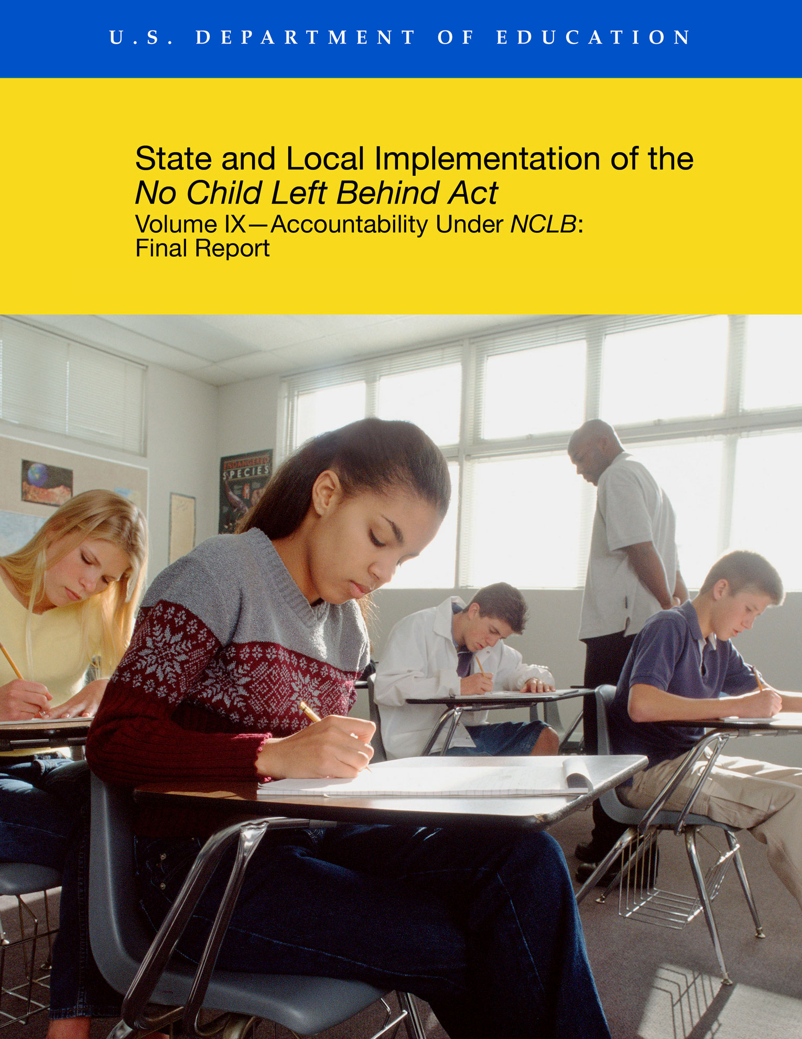

State and Local Implementation of the
No Child Left Behind Act

Volume IX—Accountability Under NCLB: Final Report

A report from the National Longitudinal Study of No Child Left Behind (NLS-NCLB) and the
Study of State Implementation of Accountability and Teacher Quality Under No Child Left Behind (SSI-NCLB)

James Taylor, American Institutes for Research
Brian Stecher, RAND
Jennifer O’Day, American Institutes for Research
Scott Naftel, RAND
Kerstin Carlson Le Floch, American Institutes for Research

----------------
Series Principal Investigators
Georges Vernez, RAND
Beatrice F. Birman, American Institutes for Research
Michael S. Garet, American Institutes for Research
Jennifer O’Day, American Institutes for Research
Prepared for:
U.S. Department of Education
Office of Planning, Evaluation and Policy Development
Policy and Program Studies Service

2010

This report was prepared for the U.S. Department of Education under Contract Number ED00CO0087 with RAND and Contract Number ED-01-CO-0026/0024 with AIR. Stephanie Stullich served as the contracting officer’s representative for the National Longitudinal Study of No Child Left Behind, and Elizabeth Eisner served as contracting officer’s representative for the Study of State Implementation of Accountability and Teacher Quality Under No Child Left Behind. The views expressed herein do not necessarily represent the positions or policies of the Department of Education. No official endorsement by the U.S. Department of Education is intended or should be inferred.

U.S. Department of Education
Arne Duncan
Secretary

Office of Planning, Evaluation and Policy Development
Carmel Martin
Assistant Secretary

Policy and Program Studies Service
Alan Ginsburg
Director

January 2010

This report is in the public domain, except for the cover photo, which was used with permission, © 2008 JupiterImages Corporation. Authorization to reproduce the report in whole or in part is granted. While permission to reprint this publication is not necessary, the suggested citation is: U.S. Department of Education, Office of Planning, Evaluation and Policy Development, Policy and Program Studies Service, State and Local Implementation of the No Child Left Behind Act, Volume IX—Accountability Under NCLB: Final Report, Washington, D.C., 2010.

To obtain copies of this report:

Write to ED Pubs, Education Publications Center, U.S. Department of Education, NTIS, P.O. Box 22207, Alexandria, VA 22304.

Or fax your request to 703-605-6794.

Or e-mail your request to edpubs@inet.ed.gov.

Or call in your request toll free to 1-877-433-7827 (1-877-4-ED-PUBS). Those who use a telecommunications device for the deaf (TDD) or a teletypewriter (TTY) should call 1-877-576-7734. If 877 service is not available in your area, call 1-800-872-5327 (1-800-USA-LEARN).

Or order online at http://edpubs.ed.gov.

This report is also available on the Department’s Web site at: www.ed.gov/about/offices/list/opepd/ppss/reports.html#title.
On request, this publication is available in alternate formats, such as Braille, large print or computer diskette. For more information, contact the Department’s Alternate Format Center at 202-260-0852 or 202-260-0818.

Contents
List of Exhibits………………………………………………………………………...…………v
Preface xv
Acknowledgments xvii
Executive Summary xix
I. Introduction 1
Overview of Accountability Provisions of NCLB 1
Evaluation Questions and Findings From Interim Report 7
Data Sources 8
II. State Standards, Assessments, and Accountability 11
Implementing Standards and Assessments in Reading, Mathematics and Science 11
Cost of Developing and Administering Reading and Mathematics Assessments Under NCLB 17
Including All Students in Assessments 24
Defining Student Proficiency: Academic Achievement Standards 30
Measuring Progress Toward Proficiency: Adequate Yearly Progress 31
State Accountability Systems Beyond NCLB 45
Discussion 47
III. Meeting AYP Targets: Results From Evolving Systems 49
School and District Adequate Yearly Progress 50
Reasons Schools Did Not Make AYP 59
AYP Appeals 70
Discussion 70
IV. Identifying Schools and Districts for Improvement 73
Schools and Districts Identified for Improvement 74
Districts Identified for Improvement 86
Discussion 88
V. Ensuring Progress for Students With Limited English Proficiency: Title III Accountability 89
Title III Provisions Under NCLB 92
Implementing ELP Standards, ELP Assessments, and AMAOs 94
Providing State-Supported Technical Assistance 99
Discussion 101
VI. Providing Information About School Performance to Stakeholders 103
State Data Systems and Reporting 103
State Report Cards 106
Principal and Teacher Knowledge of the Status of Their Schools 109
Discussion 112
VII. School Improvement 113
State Support for School Improvement 114
Technical Assistance for Schools 125
Improvement Initiatives by Schools 132
Interventions For Identified Schools 147
Discussion 153
VIII. District Improvement 155
State Support for Districts 155
Technical Assistance for Districts 157
Improvement Initiatives by Identified Districts 161
Interventions for Title I Districts in Corrective Action 161
Discussion 164
IX. Conclusions 165
References 169
Appendix A Description of NLS-NCLB and SSI-NCLB Methodologies 175
Appendix B State Policy Tables 193
Appendix C Supplemental Exhibits 221
Appendix D Standard Error Exhibits 247

Exhibits
I. Introduction
Exhibit 1 NCLB Strategies to Reach 100 Percent Student Proficiency 2
Exhibit 2 Stages of Identification for School Improvement 5

II. State Standards, Assessments, and Accountability
Exhibit 3 Year in Which 2006–07 Reading, Mathematics and Science Content Standards Were Adopted or Most Recently Revised 13
Exhibit 4 State Approaches to Developing Assessments in Grades 3–8, Reading and Mathematics, in 2006–07 14
Exhibit 5 Average Test-Taking Duration, Reading and Mathematics, Grades 4, 7, and High School, 2006–07 16
Exhibit 6 State-Reported Aggregate Costs of Developing or Modifying Reading and Mathematics Assessments in Grades 3–8 to Comply With NCLB Requirements, in 27 States That Reported Such Data 20
Exhibit 7 State-Reported Annual Per-Pupil Cost of Administering and Maintaining Reading and Mathematics Assessments in Grades 3–8 and High School, 2006–07, in 39 States That Reported Such Data 22
Exhibit 8 Average State-Reported Annual Total Cost and Per-Pupil Cost of Administering and Maintaining Reading and Mathematics Assessments in Grades 3–8 and High School, by State Enrollment Size, 2006–07 23
Exhibit 9 Characteristics of Types of Assessments and Participating Students 25
Exhibit 10 Number of States With Alternate Assessments, by Subject, 2005–06 27
Exhibit 11 State Development of Alternate Assessments Based on Alternate Academic Achievement Standards for NCLB, 2006–07 28
Exhibit 12 Six Most Commonly State-Allowed Accommodations for Students With Limited English Proficiency Taking Content-Area Assessments, 2006–07 29
Exhibit 13 NAEP Scale Equivalents of State Proficiency Standards, by State, for Eighth-Grade Mathematics, 2005 32
Exhibit 14 Annual Graduation Rate Targets for AYP in Four States 35
Exhibit 15 Improvement Needed to Reach 100 Percent Proficient by 2013–14, by Level of Difficulty of State Academic Achievement Standards, for Eighth-Grade Mathematics 37
Exhibit 16 Examples of Stair-Step, Linear, and Mixed-Pattern AMO Trajectories (Mathematics) 38
Exhibit 17 Expected Achievement Growth Based on Different AMO Trajectory Types 39
Exhibit 18 States With Various Minimum n Sizes for Calculating Proficiency of the “All Students” Subgroup, 2006–07 40
Exhibit 19 Percentage of Schools Identified and Not Identified for Improvement Under NCLB, by Accountability Designations Under State or District Accountability Initiatives, 2006–07 46
Exhibit 20 Perceived Benefits and Drawbacks of Having State and/or District Accountability Initiatives in Addition to NCLB, in Districts and Schools That Report Having Them, 2006–07 47

III. Meeting AYP Targets: Results From Evolving Systems
Exhibit 21 Percentage and Number of Schools That Made AYP, by State, 2005–06 51
Exhibit 22 States With the Largest Changes in the Percentage of Schools That Made AYP, 2003–04 to 2005–06 52
Exhibit 23 Percentage of Schools Making AYP, by School Poverty Level, Minority Level, and Urbanicity, 2005–06 55
Exhibit 24 Percentage of Schools Making AYP, by School Grade Level and School Size, 2005–06 56
Exhibit 25 Percentage of Schools That Made AYP, by School Poverty Level and Number of Subgroups, 2005–06 57
Exhibit 26 Percentage of Students in Each Subgroup in Schools Held Accountable for Their Subgroup, by Student Subgroup, 2005–06 58
Exhibit 27 Number and Percentage of Schools Required to Calculate AYP for Each Student Subgroup, 2005–06 59
Exhibit 28 AYP Targets Missed by Schools That Did Not Make Adquate Yearly Progress, 2005–06 60
Exhibit 29 AYP Targets Missed by Schools That Did Not Make Adequate Yearly Progress, 2003–04 to 2005–06 62
Exhibit 30 Percentage of Schools Held Accountable for a Subgroup That Did Not Make AYP for That Subgroup, 2005–06 63
Exhibit 31 Percentage of Schools That Did Not Make AYP for Individual Student Subgroups, by School Poverty Rate, 2005–06 64
Exhibit 32 Percentage of Schools That Did Not Make AYP That Missed Due to the Other Academic Indicator, by School Grade Level, 2005–06 65
Exhibit 33 Percent and Number of Schools With Consistent AYP Designations in 2003–04, 2004–05 and 2005–06 66
Exhibit 34 Percent of Schools That Missed Fewer, the Same, and More AYP Targets Than They Did in the Prior Year, by Number of Targets Missed in the Prior Year 67
Exhibit 35 Number and Percentage of Schools That Did Not Make AYP, by Type of AYP Targets That They Missed, 2003–04, 2004–05 and 2005–06 68
Exhibit 36 Number and Percentage of Schools That Did Not Make AYP Consistently for Each Subgroup, 2003–04, 2004–05, and 2005–06 69

IV. Identifying Schools and Districts for Improvement
Exhibit 37 Number and Percentage of Title I Schools Identified for Improvement 1996–97 to 2006–07 75
Exhibit 38 Number of Title I Schools Identified for Improvement, by Identification Status 2004–05 to 2006–07 76
Exhibit 39 Number and Percentage of Title I Schools Identified for Improvement for 2005–06 That Exited Improvement Status in 2006–07 77
Exhibit 40 Percentage of Title I Schools Identified for Improvement for 2004–05 That Were in Various Stages of School Improvement Status for 2006–07 78
Exhibit 41 Number and Percentage of Schools Identified for Improvement, by State, 2006–07 79
Exhibit 42 Percentage of Districts That Had At Least One Title I School Identified for Improvement, 2001–02 to 2006–07 81
Exhibit 43 Percentage of Districts With At Least One Title I School Identified for Improvement by Number of Identified Schools, 2002–03 to 2005–06 82
Exhibit 44 Number and Percentage of Title I Schools Identified for Improvement and Restructuring in the 15 Districts With the Largest Numbers of Such Schools, 2006–07 83
Exhibit 45 Percentage of Title I Schools Identified for Improvement, by School Poverty Level, Minority Level, and Urbanicity, 2006–07 84
Exhibit 46 Percentage of Title I Schools Identified for Improvement, by School Size, 2006–07 85
Exhibit 47 AYP Targets Missed by Title I Schools That Did Not Make AYP in 2005–06, by Stage of School Improvement Status for 2006–07 86
Exhibit 48 Number and Percentage of Title I Districts Identified for Improvement, by State, 2006–07 87
V. Ensuring Progress for Students With Limited English Proficiency: Title III Accountability
Exhibit 49 Total Number of Enrolled LEP Students, by State, 2005–06 90
Exhibit 50 Title I and Title III Provisions Under NCLB 93
Exhibit 51 Number of States, by First Year ELP Standards Were Implemented 95
Exhibit 52 Number of States by First School Year Assessments Were Implemented 96
Exhibit 53 Percentage of Schools Needing Technical Assistance in 2005–06 or 2006–07 to Meet the Needs of Limited English Proficient Students, by School Characteristic 100

VI. Providing Information About School Performance To Stakeholders
Exhibit 54 Number of States Providing Preliminary and Final Notification of School Improvement Status, by Month of Notification, 2004–05 and 2006–07 105
Exhibit 55 Percentage of Schools Notified of Their AYP and Improvement Status by Month, 2006–07 105
Exhibit 56 Number of States With Data Systems With the Ability to Track Individual Student Test Scores Over Time, 2004–07 106
Exhibit 57 Percentage of School Staff Correctly Reporting Whether Their School Had Made AYP in 2003–04 and 2005–06 or Was Identified for Improvement for 2004–05 and 2006–07 110
Exhibit 58 Percentage of Staff in Title I Schools Correctly Reporting Whether Their Schools Were Identified for Improvement, 2006–07 111

VII. School Improvement
Exhibit 59 Number of States, by Primary Mechanisms of Support, 2006–07 115
Exhibit 60 Number of States, by Focus of Support They Provided, 2006–07 119
Exhibit 61 Number of States, by Extent of Comprehensiveness of Their Systems of Support for Schools, 2004–05 and 2006–07 120
Exhibit 62 Number of States Using Specific Corrective Action and Restructuring Strategies, 2004–05 and 2006–07 123
Exhibit 63 Percentage of Non-Identified and Identified Schools That Reported Needing and Receiving Various Types of Technical Assistance, 2005–06 or 2006–07 126
Exhibit 64 Percentage of Schools Needing Technical Assistance in Four Areas, by School Characteristic, 2005–06 or 2006–07 127
Exhibit 65 Percentage of Schools Needing Technical Assistance in 2005–06 or 2006–07 to Meet the Needs of Students with Disabilities, by School Characteristic 130
Exhibit 66 Percentage of Districts With Identified Schools Reporting That They Provided Technical Assistance to Various Types of Schools in Either 2005–06 or 2006–07 131
Exhibit 67 Percentage of Schools Reporting a Major Focus on Various School Improvement Strategies, 2006–07 133
Exhibit 68 Percentage of General Elementary Teachers Reporting Availability of Various Resources for Aligning Curriculum and Instruction With State Academic Content Standards, 2006–07 135
Exhibit 69 Percentage of General Elementary Teachers Reporting Moderate or Major Challenges to Improving Student Performance, 2006–07 136
Exhibit 70 Percentage of Schools Offering Extended Time Instructional Programs and Percentage of Students Served by Such Programs, 1997–98 and 2006–07 138
Exhibit 71 Average Change in Minutes Per Week for Third-Grade Students, by Academic Subject, 2004–05 to 2006–07 139
Exhibit 72 Percentage of Principals Reporting Changes in Instructional Time for Third-Grade Students, by Academic Subject, 2004–05 to 2006–07 140
Exhibit 73 Percentage of Secondary Schools Increasing Instructional Time for Low-Achieving Students in Various Academic Subjects Between 2004–05 and 2006–07 142
Exhibit 74 Percentage of Schools Reporting Moderate or Extensive Use of State Achievement Tests for Various Purposes, 2006–07 143
Exhibit 75 Percentage of General Elementary Teachers and Secondary English Teachers Using State Reading Assessment Results Moderately or Extensively for Various Purposes, 2006–07 144
Exhibit 76 Percentage of Schools Administering Progress Tests, by School Characteristic, 2006–07 146
Exhibit 77 Percentage of General Elementary Teachers and Secondary English Teachers Administering Progress Tests in Reading Who Use Results Moderately or Extensively for Various Purposes, 2006–07 147
Exhibit 78 Percentage of Title I Schools Experiencing Various Types of Interventions from Their State or District, 2006–07 149
Exhibit 79 Percentage of Districts with Identified Schools Requiring Schools to Enact Various Improvement Efforts, 2006–07 150
Exhibit 80 State Uses of Section 1003(a) Funds for State-Level Activities, 2004–05 152
Exhibit 81 Types of Activities Funded by Section 1003(a) Set-Aside, 2006–07 153
VIII. District Improvement
Exhibit 82 Number of States, by Year in Which They Implemented a Support System for Districts 156
Exhibit 83 Number of States Providing Technical Assistance to Districts, by Focus of Technical Assistance, 2006–07 158
Exhibit 84 Percentage of Districts Needing and Receiving Mandated Technical Assistance and Finding It Sufficient to Meet Their Needs, 2005–06 or 2006–07 159
Exhibit 85 Percentage of Identified Districts Implementing Various Initiatives in Response to Being Identified for Improvement, 2006–07 162
Exhibit 86 Number of States Using Specific Strategies for Title I Districts in Corrective Action, 2006–07 163
Exhibit 87 Percentage of Title I Districts in Corrective Action Experiencing Mandated State Interventions, 2006–07 164

Appendix A. Description of NLS-NCLB and SSI-NCLB Methodologies
Exhibit A.1 Sample Sizes and Survey Completion Rates for National Longitudinal Study of NCLB Surveys, 2004–05 and 2006–07 176
Exhibit A.2 Characteristics of National Longitudinal Study of NCLB District and School Sample Compared With the Universe of Districts and Schools, 2004–05 177
Exhibit A.3 Sample Sizes and Response Rates for National Longitudinal Study of NCLB Parent Surveys 178

Appendix B. State Policy Tables
Exhibit B.1 Features of State Assessment Systems, 2005–06 194
Exhibit B.2 Federal Assessment Grants to States Under Section 6111, Fiscal Years 2002–08 196
Exhibit B.3 Federal Assessment Grants to States Under Section 6111, Fiscal Year 2008 and 2002–08, by State 197
Exhibit B.4 State Implementation of the “1 Percent Rule,” 2003–04 and 2005–06 199
Exhibit B.5 State Use of Other Academic Indicators and Safe Harbor to Determine 2005–06 AYP 201
Exhibit B.6 Key State AYP Provisions, 2005–06 211
Exhibit B.7 State Minimum n Size for AYP Proficiency, Participation and Reporting, 2006–07 213
Exhibit B.8 State Use of Confidence Intervalsª in 2005–06 AYP Determination 216
Exhibit B.9 State Allocation of Section 1003(a) School Improvement Funds, 2004–05 218

Appendix C. Supplemental Exhibits
Exhibit C.1 Percentage and Number of Districts That Made AYP, by State, 2005–06 222
Exhibit C.2 Percentage of Schools That Missed Various Targets (Among Schools That Did Not Make AYP), by State, 2005–06 224
Exhibit C.3 Percentage of Schools That Missed the Additional Academic Indicator, (Among Schools That Did Not Make AYP), by Type of School and by State, 2005–06 226
Exhibit C.4 Percentage of Schools That Missed At Least One Target for Achievement (Among Schools That Did Not Make AYP), by Subject and by State, 2005–06 228
Exhibit C.5 AYP Targets Missed by Schools That Did Not Make Adequate Yearly Progress, 2003–04, 2004–05, and 2005–06 230
Exhibit C.6 Percentage of Schools That Missed AYP Due to Subgroup Achievement and Solely Due to Subgroup Achievement, (Among Schools Held Accountable for Subgroup and At Least One Other Subgroup), by Student Subgroup, 2005–06 231
Exhibit C.7 Number and Percentage of Schools That Did Not Make AYP for the Other Academic Indicator Target by Grade Level, 2003–04, 2004–05 and 2005–06 231
Exhibit C.8 Percentage and Number of Schools That Did Not Make AYP
That Appealed AYP, by State, 2005–06……………………...……………………232

Exhibit C.9 Number and Percentage of Identified Title I Schools, by State, 2004–05 234
Exhibit C.10 Number and Percentage of Identified Schools, by State, 2005–06 236
Exhibit C.11 Percentage of Students in Identified Schools, by Urbanicity Locale, 2006–07 237
Exhibit C.12 Number of Schools Identified for Improvement, and Percentage of Students in Identified Schools, by Subgroups and by State, 2006–07 238
Exhibit C.13 Percentage of Identified Schools, by Other Demographic Characteristics, 2006–07 240
Exhibit C.14 Percentage of Schools Needing and Receiving Technical Assistance to Meet the Needs of LEP Students and Percentage Finding It Sufficient to Meet Their Needs, by School Characteristic, 2006–07 241
Exhibit C.15 Percentage of Schools Needing and Receiving Technical Assistance in 2005–06 or 2006–07 to Meet the Needs of Students with Disabilities and Percentage Finding It Sufficient to Meet Their Needs, by School Characteristic 242
Exhibit C.16 Existence of and Participation in Extended Time Instructional Programs, 2006–07 243
Exhibit C.17 Percentage of Elementary Teachers Who Reported Changing the Amount of Instructional Time That They Spent on Various Subjects From 2004–05 to 2006–07 244
Exhibit C.18 Percentage of Elementary Schools Reporting Increases and Decreases in Instructional Time in Various Subjects Between 2004–05 and 2006–07 245

Appendix D. Standard Error Exhibits
Exhibit D.1 Percentage of Schools Identified and Not Identified for Improvement Under NCLB That Reported Various Accountability Designations Under State or District Accountability Initiatives, 2006–07 247
Exhibit D.2 Perceived Benefits and Drawbacks of Having State and/or District Accountability Initiatives in Addition to NCLB, in Districts and Schools That Report Having Them, 2006–07 247
Exhibit D.3 Percentage of Schools Receiving Notification of AYP Status, by Month 248
Exhibit D.4 Percentage of Staff Correctly Reporting Whether Their School Made AYP or Was Identified for Improvement Based on 2005–06 Test Results 249
Exhibit D.5 Percentage of Staff in Title I Schools Correctly Reporting Whether Their Schools Were Identified for Improvement, 2006–07 250
Exhibit D.6 Percentage of Non-Identified and Identified Schools Reported Needing and Receiving Various Types of Technical Assistance, 2005–06 or 2006–07 251
Exhibit D.7 Percentage of Schools Needing Technical Assistance in Four Areas, by School Characteristic, 2005–06 or 2006–07 252
Exhibit D.8 Percentage of Districts With Identified Schools Reporting That They Provided Technical Assistance to Various Types of Schools in Either 2005–06 or 2006–07 253
Exhibit D.9 Percentage of Schools Reporting Major Focus on Various School Improvement Strategies, 2006–07 254
Exhibit D.10 Percentage of General Elementary Teachers Reporting Availability of Various Resources for Aligning Curriculum and Instruction With State Academic Content Standards, 2006–07 255
Exhibit D.11 Percentage of General Elementary Teachers Reporting Moderate or Major Challenges to Improving Student Performance, 2006–07 255
Exhibit D.12 Average Change in Minutes Per Week for Third-Grade Students From 2004–05 to 2006–07, by Subject 256
Exhibit D.13 Percentage of Schools Changing Instructional Time for Third-Grade Students From 2004–05 to 2006–07, by Subject 256
Exhibit D.14 Percentage of Secondary Schools Increasing Instructional Time for Low-Achieving Students in Various Subjects Between 2004–05 and 2006–07 257
Exhibit D.15 Percentage of Schools Reporting Moderate or Extensive Use of State Achievement Tests for Various Purposes, 2006–07 257
Exhibit D.16 Percentage of General Elementary Teachers and Secondary English Teachers Using State Reading Assessment Results Moderately or Extensively for Various Purposes, 2006–07 258
Exhibit D.17 Percentage of Schools Administering Progress Tests, by School Characteristic, 2006–07 259
Exhibit D.18 Percentage of General Elementary Teachers and Secondary English Teachers Administering Progress Tests in Reading Who Use Results Moderately or Extensively for Various Purposes, 2006–07 260
Exhibit D.19 Percentage of Title I Schools Experiencing Various Types of Interventions From Their State or District, 2006–07 261
Exhibit D.20 Percentage of Districts With Identified Schools Requiring Schools to Enact Various Improvement Efforts, 2006–07 262
Exhibit D.21 Percentage of Districts Needing and Receiving Mandated Technical Assistance and Finding It Sufficient to Meet Their Needs, 2005–06 or 2006–07 263
Exhibit D.22 Percentage of Identified Districts Implementing Various Initiatives in Response to Being Identified for Improvement, 2006–07 264
Exhibit D.23 Percentage of Districts in Corrective Action Experiencing Mandated State Interventions, 2006–07 265

Preface
This report presents findings about accountability from two longitudinal studies, the National Longitudinal Study of No Child Left Behind (NLS-NCLB), and the Study of State Implementation of Accountability and Teacher Quality Under No Child Left Behind (SSI-NCLB). The research teams for these two studies have collaborated to provide an integrated evaluation of the implementation of key NCLB provisions at the state level (SSI-NCLB) and at the district and school levels (NLS-NCLB). Together the two studies are the basis for a series of reports on the topics of accountability, teacher quality, Title I school choice and supplemental educational services, and targeting and resource allocation.
This is the ninth and last volume in this report series. The other eight volumes were:
Volume I—Title I School Choice, Supplemental Educational Services, and Student Achievement
Volume II—Teacher Quality Under NCLB: Interim Report
Volume III—Accountability Under NCLB: Interim Report
Volume IV—Title I School Choice and Supplemental Educational Services: Interim Report
Volume V—Implementation of the 1 Percent Rule and 2 Percent Interim Policy Options
Volume VI—Targeting and Uses of Federal Education Funds
Volume VII—Title I School Choice and Supplemental Educational Services: Final Report
Volume VIII—Teacher Quality Under NCLB: Final Report

Acknowledgments
We wish to thank the many individuals who contributed to the completion of this report. Particularly helpful were several individuals at the U.S. Department of Education. Stephanie Stullich, Elizabeth Eisner, Andrew Abrams and Collette Roney of the Policy and Program Studies Service (PPSS) served as project officers for the two studies that were the data sources for this report. All four project officers provided invaluable substantive guidance and support throughout these studies and the production of this report.
We are also grateful to state accountability directors for their kind cooperation and assistance in participating in interviews and follow-up communications in the 2004–05 data collections. In addition, teachers, principals, and school district staff across the country took time out of their busy schedules to respond to the NLS-NCLB surveys. Without their efforts, this report would not have been possible, and we deeply appreciate their assistance.
The information in this report was provided through two studies done by independent research firms under contract to the U.S. Department of Education:
- The National Longitudinal Study of No Child Left Behind (NLS-NCLB), led by Georges Vernez of the RAND Corporation and Michael Garet and Beatrice Birman of the American Institutes for Research (AIR), assisted by Brian Stecher (accountability team leader), Brian Gill (choice team leader), and Mengli Song (teacher quality team leader). Marie Halverson of the National Opinion Research Center directed data collections for the NLS-NCLB.
- The Study of State Implementation of Accountability and Teacher Quality Under No Child Left Behind (SSI-NCLB), led by Jennifer O’Day and Kerstin Carlson Le Floch of the American Institutes for Research. A team led by Rolf Blank at Council of Chief State School Officers (CCSSO) assisted with state-level data collections.
Other researchers who provided useful assistance for this report include Nina de las Alas of CCSSO; Lindsay Anderson, Steve Hurtburt, Andrea Ramsey, Susan Therriault, Tricia Tulipano and Yu Zhang of AIR.
We would like to acknowledge thoughtful contributions of the members of our Technical Working Group, including Julian Betts, David Francis, Margaret Goertz, Brian Gong, Eric Hanushek, Richard Ingersoll, Phyllis McClure, Paul Peterson, Christine Steele, and Phoebe Winter.
Many Department staff reviewed drafts of this report and provided useful comments and suggestions. We would like to acknowledge the assistance of David Goodwin, former director of program and analytic studies in PPSS, and Daphne Kaplan, PPSS team leader, as well as Millicent Bentley-Memon, Kerri Briggs, Carol Cichowski, Bill Cordes, Tom Corwin, Tim D’Emilio, Sarah Dillard, David Harmon, Stacy Kreppel, Holly Kuzmich, Milagros Lanauze, Kathleen Leos, Jeannette Lim, Meredith Miller, Kay Rigling, Krista Ritacco, Phil Rosenfelt, Grace Ross, Ross Santy, Martha Snyder, Victoria Hammer, and Christine Wolfe.
While we appreciate the assistance and support of all of the above individuals, any errors in judgment or fact are, of course, the responsibility of the authors.

Executive Summary
The No Child Left Behind Act of 2001 (NCLB) is designed to achieve an ambitious goal: All children will be proficient in reading and mathematics by the 2013–14 school year. A key strategy for achieving this goal is accountability. NCLB holds schools and districts accountable for their students’ mastery of state academic content standards, as measured by state tests, including students with limited English proficiency (LEP) and students receiving special education services. NCLB accountability rests on several key premises: that clear definitions and targets for desired academic outcomes and English language proficiency will provide both incentives for and indicators of improvement; that identification of districts and schools not meeting their improvement targets will help focus assistance and interventions in places where they are most needed; that widely available information about student performance will enable parents, educators and other stakeholders to make informed decisions about how best to serve their students or children; and that targeted assistance will stimulate school and district improvement.
Based on findings from two federally funded studies—the Study of State Implementation of Accountability and Teacher Quality Under NCLB (SSI-NCLB) and the National Longitudinal Study of NCLB (NLS-NCLB)—this report describes the progress that states, districts, and schools have made in implementing the accountability provisions of NCLB through 2006–07. Data were collected in state-level interviews; surveys of a nationally representative sample of district officials, principals, and teachers; surveys of parents in eight school districts; and surveys of supplemental educational service providers in 16 districts in 2004–05 and in 2006–07. This report is based on data collected in 2004–05 and 2006–07, and updates findings from the Interim report that were based on data collected in 2004–05.

Focus of the Report
This report presents findings from the SSI-NCLB and NLS-NCLB on state-, district-, and school-level implementation of the accountability provisions of NCLB. It addresses questions in six areas:
- How have states implemented the standards, assessment, and accountability provisions of Title I?
- How are schools and districts performing with respect to making adequate yearly progress (AYP)? What are the reasons why schools do not make AYP? Are there common characteristics among districts and schools identified for improvement?
- How have states implemented the English language proficiency standards, assessment, and accountability provisions of Titles I and III?
- How is information about NCLB, AYP, and identification for improvement communicated to stakeholders, and how well do district and school staff understand the status of their districts and schools?
- In what ways do states support improvements in district and school performance?
- What efforts are being made to improve district and school performance, including technical assistance, mandated interventions, and local initiatives?

Key Findings
States used the flexibility provided by NCLB to establish accountability systems that varied in terms of the rigor of their academic standards, the level at which they set proficiency, the type of assessments they use, and the manner in which they calculated AYP and set their annual proficiency targets. As a result of these differences as well as differences in student achievement, there was a large variation across states in the percentage of schools missing AYP and being identified for improvement. For example, the proportion of schools that made AYP in 2005–06 ranged from less than 30 percent in two states to 90 percent or more in five states.
Overall, three-quarters of the nation’s schools made AYP in 2005–06, a nearly identical proportion as in 2003–04 and 2004–05. In fact, four-fifths of schools had the same AYP designation from one year to the next. Sixty-five percent of schools made AYP in both years, and 16 percent missed AYP in both years. Ten percent of schools’ designations worsened (i.e., moved from making AYP in 2004–05 to missing AYP in 2005–06) and 9 percent of schools’ designations improved.
Among the 27 percent of schools that did not make AYP in 2005–06, more than half (55 percent) did not succeed because the school as a whole (i.e., the “all students” group) or multiple student subgroups did not meet academic achievement standards. One-quarter of schools that did not make AYP met all targets except for the achievement of a single subgroup. More than one-half of the schools that missed for a single subgroup missed targets solely for the students with disabilities subgroup (this represents 14 percent of schools that did not make AYP).
Overall, 20 percent of Title I schools (10,781 schools) were identified for improvement for 2006–07. After a large increase between 2003–04 and 2004–05, the percentage of Title I schools identified for improvement increased more gradually between 2005–06 and 2006–07. Nearly three-fourths of the identified schools at the beginning of 2004–05 remained in improvement status two years later in 2006–07 and nearly half were in corrective action or restructuring. Furthermore, there has been a decline over time in the proportion of identified Title I schools exiting improvement status, from 23 percent in 2004–05 to 12 percent in 2006–07.
Although only 13 percent of Title I districts (1,728) were identified for improvement for 2006–07, these districts enrolled 40 percent of the nation’s students, or about 18 million students. The number of districts identified for improvement for 2006–07 was similar to the previous year, but the number of districts identified for corrective action increased five-fold.
Nearly all states had implemented English language proficiency (ELP) standards and assessments by 2006–07. Over one-half of the states were applying accountability actions to districts that had not met their Annual Measurable Achievement Objectives (AMAOs) for consecutive years, but many states were not yet imposing required consequences due to the extended time needed for standards and assessment development and to recent changes in the assessments used to measure progress.
All states reported having a system of support for schools identified for improvement, and most states (40) reported providing some level of support to all identified schools. Forty-seven states had systems of support for districts in 2006–07, 28 of which were implemented between 2004–05 and 2006–07. States reported challenges associated with meeting the needs of increased numbers of schools identified for improvement and identifying interventions that have been proven to improve the performance of non-proficient students.
Nearly all schools reported making multiple improvement efforts in 2006–07, including improving curriculum and instruction, increasing the use of assessment results for planning, and increasing the amount of instruction in reading and mathematics for low-performing students. Most schools also reported receiving technical assistance that met their needs. However, about one-third of schools needing assistance to improve services to students with disabilities and about one-half of schools needing assistance to address the instructional needs of limited English proficient students did not have these needs fully met.
Required interventions occurred in most Title I schools in Year 1 or Year 2 of identification or in corrective action in 2006–07. However, many Title I schools in restructuring status did not experience any of the four specific interventions named in the law (although it is possible they may have experienced another type of restructuring option). More than one-half of Title I districts in corrective action reported receiving none of the eight interventions specified in the law.

Other Findings

State standards, assessments, and targets
In 2006–07, all states had met NCLB requirements for content standards and were making progress toward meeting NCLB requirements for assessments of all students in all required grades.
In 2006–07, all states had content standards in reading, mathematics and science, but many continued to revise their standards or adopt new standards.
By 2003, all states had received federal approval for the process through which they developed reading and mathematics content standards for the grade spans required under the Improving America’s Schools Act of 1994 (IASA). By 2007, all states, the District of Columbia, and Puerto Rico had submitted evidence to the U.S. Department of Education that they had approved science content standards. In 2006 and 2007, about one state in five was in the process of revising content standards for reading (13 states), mathematics (13 states), or science (13 states).
As of 2006–07, 37 states, the District of Columbia, and Puerto Rico had developed entirely new tests or modified existing assessments in grades 3–8 to comply with NCLB.
Complying with NCLB testing requirements has necessitated substantial test development by states. While 14 states kept their existing tests to meet the requirements of NCLB, the majority developed or modified reading and mathematics tests specifically for NCLB: 16 states indicated they had developed all new assessments in reading and mathematics in grades 3–8, and 21 were able to retain some existing tests or modify existing tests.
By 2005–06, all states had alternate assessments based on alternate academic achievement standards (AA-AAAS) in place for students with the most significant cognitive disabilities, but the U.S. Department of Education’s peer review process found that 38 states’ AA-AAAS did not adequately meet requirements. By January 2009, 13 states’ AA-AAAS did not adequately meet requirements.
Students with disabilities typically participate in proficiency assessments in one of two ways: participation in the general assessment (with or without accommodations) for the majority of students with disabilities, or participation in an AA-AAAS. In 2006–07, all states, the District of Columbia, and Puerto Rico allowed testing accommodations to enable students with disabilities to take the general state assessments and had AA-AAAS in place for use with students with the most significant cognitive disabilities.
The variation in states’ AYP starting points—and thus in how much progress a state must demonstrate by 2014—is strongly related to how high the states set their academic achievement standards for proficiency.
States that set higher performance standards tend to have a lower percentage of students scoring at the proficient level and must therefore make greater progress in student achievement by 2013–14. Put simply, states with higher standards are likely to face more challenges in reaching 100 percent proficiency.

Meeting adequate yearly progress targets: results from evolving systems
Stable national rates of making AYP from 2003–04 to 2005–06 mask the fact that some states’ rates of making AYP rose substantially while others’ rates fell substantially.
Seven states’ proportions of schools that made AYP rose by more than 10 percent while 15 states’ proportions dropped by more than 10 percent from 2003–04 to 2005–06. In five states, 90 percent or more of schools made AYP, while less than 30 percent of schools made AYP in two states. This variability across states may be due to variation in performance or variation in states’ implementation of NCLB accountability requirements.
Most African-American, Hispanic and white students, and most students from low-income families, attended schools in which AYP was calculated for their respective subgroup because the minimum number or percent of students required to constitute a subgroup was met.
At least 83 percent or more of all African-American, Hispanic, and white students, as well as students from low-income families, attended schools where AYP was calculated for these subgroups in 2005–06 because the minimum number or percent of students needed to constitute a subgroup was met. American Indian students and Asian students often did not have school-level AYP calculated for their subgroup, due to a small number of such students in the school, but were included in AYP determinations for the school as a whole.

Identifying schools and districts for improvement
The majority of identified Title I schools were concentrated in just over 1 percent of the nation’s Title I districts.
With four-fifths of districts containing no identified schools and most of the rest containing only one or two identified schools, most identified Title I schools were concentrated in a small number of districts. Over half (53 percent) of all Title I schools identified for improvement were located in the 177 districts that each had 10 or more identified schools in 2006–07.
Title I schools in the more advanced stages of improvement status were more likely to have missed AYP for the achievement of “all students” or for two or more subgroups than other Title I schools.
Specifically, 80 percent of Title I schools identified for corrective action and restructuring for 2006–07 did not make AYP for the “all students” group or for two or more subgroups (based on 2005–06 assessments). In comparison, 59 percent of Title I schools that were identified for improvement for the first year and 42 percent of Title I schools that did not make AYP but were not identified for improvement did not make AYP for the “all students” group or for two or more subgroups.

Ensuring progress for students with limited English proficiency: Title III accountability
States have been moving forward in their development and implementation of their Title III provisions, and have dedicated considerable effort toward putting statewide processes in place for meeting the needs of LEP students.
By 2006–07, nearly all states reported that they had implemented ELP assessments aligned with state ELP standards; almost half the states developed their ELP assessments in collaboration with a multi-state consortium.
Before NCLB, few states used assessments that were appropriate for measuring progress in acquiring English language proficiency. At the start of 2004–05, implementation of ELP assessments aligned with state ELP standards was incomplete in over half (27) of the states. Forty-four states, the District of Columbia, and Puerto Rico implemented their assessments during or after 2004–05.
By 2006–07, 12 states had finalized their AMAO targets, while over half were in the process of revising them.
In 2006–07, 26 states and the District of Columbia were revising their AMAOs, while only 12 had finalized these targets. Thirty-seven states still anticipated amending their AMAOs.

Providing information about school performance to stakeholders
States reported performance results from 2005–06 testing more quickly than from 2003–04 testing.
For example, 44 states, the District of Columbia, and Puerto Rico reported that schools identified for improvement received preliminary notification of their accountability status before September 2006, an increase from 31 states in 2003–04. While the improved timeliness represents an encouraging development, roughly one-third of states were still finalizing calculations and processing appeals well into the school year.
States have made progress since 2004–05 in developing student data systems to measure the progress of individual students.
Although not mandated by NCLB, the capacity to track the progress of individual students helps instructional and policy decisions. In 2006–07, 41 states had data systems with unique student identifiers and could track students across years, up from 32 states in 2005–06 and 16 in 2004–05.
Nearly all principals knew whether their schools made AYP (90 percent) or were identified for improvement (94 percent) in 2006–07.
More teachers knew whether their schools made AYP or were identified for improvement in 2006–07 than in 2004–05, but teachers remained less knowledgeable about their schools’ status than principals.

School improvement
NCLB requires states to establish support systems to help schools and districts that are identified for improvement.
In 2006–07, 40 states had tiered systems of support, compared to 18 in 2004–05.
In a tiered system of support, the intensity and focus of support varies as schools progress to more severe accountability levels. In 2006–07, states were also more likely than in 2004–05 to delegate the responsibility for supporting schools to other levels of government (e.g., county, regional entities, districts), with a particular emphasis on districts providing support to schools.
Both identified and non-identified schools reported needing technical assistance in many areas in 2005–06 or 2006–07, but the need was greater among identified schools.
In most areas, principals of schools identified for improvement reported receiving the technical assistance they needed and reported that it met their needs. On average, identified schools reported receiving about eight days of technical assistance, compared with four days for non-identified schools. However, according to principals, one-third of the schools that needed technical assistance to improve services to students with disabilities did not have their needs fully met. In addition, one-half of schools needing technical assistance to improve services for limited English proficient students did not have their needs fully met.
Improving curriculum and instruction was a major focus of school improvement in both identified and non-identified schools, and almost all teachers had access to materials to align curriculum with standards.
Two-thirds of all schools reported placing a major emphasis in their improvement efforts on aligning curriculum and instruction with state standards, and about one-half placed a major emphasis on improving instructional approaches or improving curriculum in reading and mathematics. In addition, almost all teachers reported using state test results to improve student learning, and about two-thirds of schools reported using periodic progress assessments, as well.
Almost three-quarters of schools offered extended-time instructional programs in 2006–07, which served a small, but increasing, percentage of students.
Schools identified for improvement were more likely to offer extended-time programs than non-identified schools. In addition to extended-time programs, some schools reallocated time during the school day to provide more instruction in reading and mathematics. On average, third-grade teachers reported that students spent about 20 minutes more per week in reading and about 10 minutes more per week in mathematics in 2006–07 than in 2004–05, although the time they reported devoting to other subjects remained virtually unchanged.

District improvement
In 2006–07, most states continued to provide a broad range of technical assistance to all districts.
Compared to 2004–05, more states reported providing assistance for parent involvement activities and to support the needs of LEP students. In states that provided technical assistance specifically to districts identified for improvement, the most common type of technical assistance was developing and implementing district improvement plans (23 states), aligning professional development with the districts’ high-need areas (17 states), and analyzing budgets to align spending with improvement priorities (11 states).
In 2006–07, three-quarters of districts reported receiving the technical assistance they needed in most areas and reported that the assistance met their needs.
However, district officials reported that technical assistance was not always sufficient to meet district needs relating to LEP students, students with disabilities, and professional development for schools that did not make AYP.

Implications for Future Policy
Overall, the findings presented in this report paint a picture of considerable activity and rapid implementation of NCLB requirements. The findings also identify areas in which limited implementation and information present challenges to achieving the goal of proficiency for every student in reading and mathematics by 2014.
- The numbers and percentages of identified schools and districts varied considerably across states, in part due to differences in state standards, assessments, and AYP targets.
- The increasing number of schools identified for improvement and the proportion of identified schools that are moving into corrective action and restructuring present challenges to state and district support systems.
- Little is known about the quality of local improvement efforts or the effectiveness of state and district technical assistance and interventions.
In summary, states, districts, and schools have engaged in a high level of activity and have largely met the NCLB accountability system requirements through 2006–07, but states and districts have reported challenges associated with meeting the needs of increased numbers of schools identified for improvement and identifying interventions that have been proven to improve the performance of non-proficient students.

I. Introduction
The No Child Left Behind Act of 2001 (NCLB) establishes an ambitious goal for the nation’s states, districts, and schools: all children will be proficient in reading and mathematics by the 2013–14 school year. The federal strategy for achieving this goal is multifaceted but at its heart lies a set of performance-based accountability provisions that build on and expand those of its predecessor law, the Improving America’s Schools Act of 1994 (IASA). Both NCLB and IASA are reauthorizations of the most comprehensive federal legislation in K–12 education, the Elementary and Secondary Education Act of 1965 (ESEA). The main performance accountability requirements of ESEA are based on the principle that all children should “have a fair, equal, and significant opportunity to obtain a high quality education” (Sec. 1001) and are contained in two titles of the act:
- Title I outlines the standards, assessment, and accountability requirements intended to guide the instruction of all students in the core academic subjects of reading, mathematics, and science.
- Title III adds provisions to ensure that students with limited English proficiency (LEP) gain the English language skills they need to meet the state standards and be successful in school.
This report describes trends in the ways in which states, districts, and schools are implementing the standards, assessment and accountability provisions of Titles I and III and analyzes the progress the nation is making toward the goal of proficiency for all students. It is based on data collected through two federally funded studies, the Study of State Implementation of Accountability and Teacher Quality Under No Child Left Behind (SSI-NCLB), and the National Longitudinal Study of No Child Left Behind (NLS-NCLB). Data were collected in state-level interviews; surveys of a nationally representative sample of district officials, principals, and teachers; surveys of parents in eight school districts; and surveys of supplemental educational service providers in 16 districts in 2004–05 and in 2006–07. Companion reports, also based on these studies, address NCLB implementation and progress in the areas of teacher quality, Title I school choice and supplemental educational services, and targeting and resource allocation under Title I and certain other federal education programs.

Overview of Accountability Provisions of NCLB
Like other performance-based accountability systems, NCLB accountability rests on several key premises: (1) clear definitions and targets for desired outcomes—in this case, high academic achievement for all students—will provide both incentives and indicators for improvement; (2) identification of districts and schools not meeting their improvement targets will help focus assistance and interventions where they are needed most; (3) widely available information about performance will enable parents, educators, and other stakeholders to make appropriate decisions about how best to serve their students; and (4) targeted assistance and consequences will stimulate school and district improvement.
These premises are not new with NCLB, but NCLB alters or expands their parameters in significant ways. Accountability for school performance has been included as a component of ESEA since the 1988 reauthorization. The IASA first established a comprehensive academic standards-based approach to school improvement and school accountability in federal statute. Building on the IASA, NCLB includes requirements to:
- develop a system of standards, assessments that align to the standards, and accountability measures based on achievement of the standards that applies to all public schools and local education agencies (IASA only required that the system be applied to students served under Title I);
- identify schools and districts that need improvement, based on the performance of all students as well as the performance of designated subgroups of students (under IASA, there was no required disaggregation by subgroups);
- provide useful information about school performance to stakeholders; and
- provide appropriate assistance and require interventions to stimulate school and district improvement.
NCLB accountability strategies are shown in Exhibit 1, and each set of requirements is further described below.

Exhibit 1
NCLB Strategies to Reach 100 Percent Student Proficiency
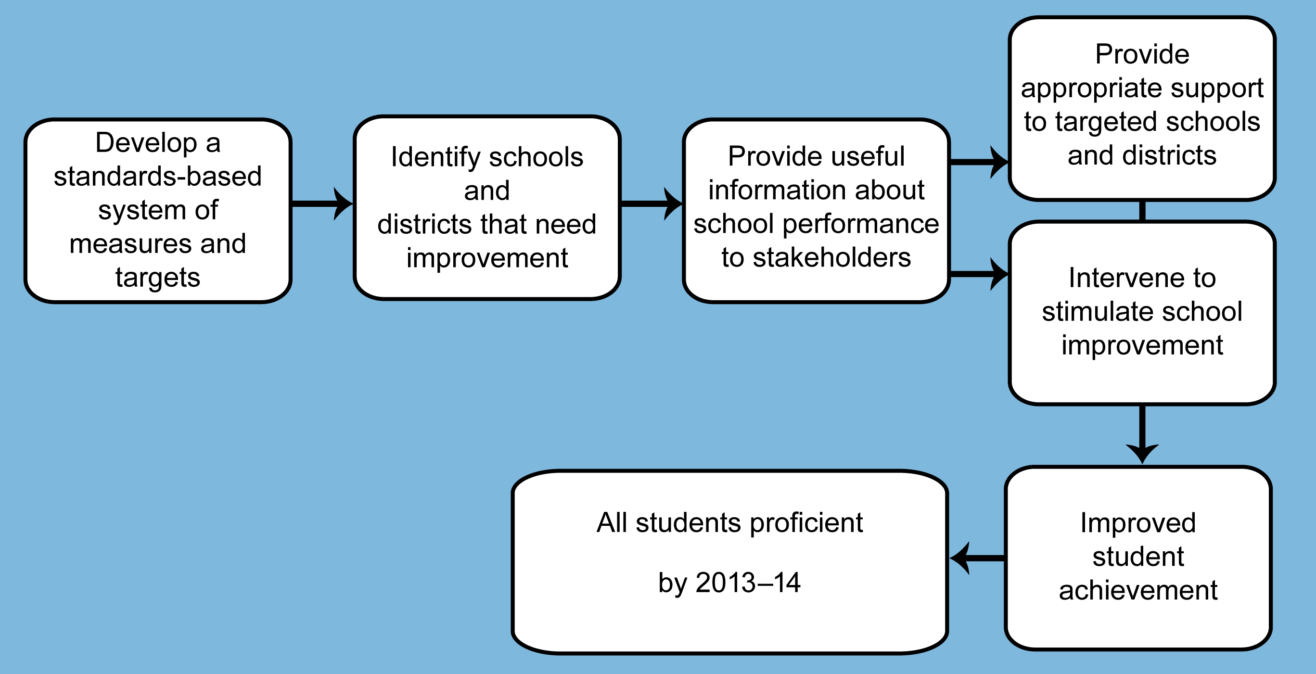
Source: No Child Left Behind Act of 2001, Public Law 107-110-Jan 8, 2002.

Develop a standards-based system of measures and targets
Prior to NCLB, IASA required states to develop and implement challenging content standards, specifying what students should know and be able to do, in reading and mathematics and to administer assessments aligned with those standards at least once in each of three grade spans: grades 3–5, 6–9, and 10–12. Although IASA contemplated that a state would have a standards-based system that applied to all students, if the state did not, IASA only required that standards and assessments be developed for students participating in Title I programs. Building on IASA, NCLB:
- requires either statewide grade-level content standards or statewide specific grade-level expectations instead of content standards only for broad grade spans, as in IASA.
- increases the assessment requirements to include annual testing of all students in grades 3–8 and testing of all students once during high school, in reading and mathematics. To meet this requirement, states were required to develop or adopt assessments for the previously untested grades by 2005–06. As with IASA, the state assessments must be aligned with state academic content standards; however, IASA only required assessment of students participating in Title I programs.
- requires states to develop or adopt science content standards by 2005–06 and to implement science assessments in the three grade spans by 2007–08. IASA did not require standards or assessments in science.
- adds a requirement that states must develop or adopt standards for English language proficiency (ELP) for students with limited English proficiency (LEP) by 2002–03 and annually assess progress of all LEP students toward these standards.
NCLB also builds on the IASA requirement to determine whether a school or school district makes adequate yearly progress (AYP). Under IASA, states set targets for schools and school districts that demonstrated “continuous and substantial yearly improvement…sufficient to achieve the goal of all Title I students meeting the State’s proficient and advanced levels of performance on the assessments aligned with state standards.” NCLB continues the AYP requirement but modifies and expands its specifications.
- NCLB requires a state to measure AYP for each public elementary and secondary school and public school district in the state based on the achievement of all public school students. IASA only required that a state measure AYP for Title I schools based only on students participating in Title I.
- NCLB mandates a uniform timeframe for demonstrating progress of all students toward meeting a state’s proficient standards. While initial starting points may vary by state, AYP targets in every state must reflect the goal of all students performing at proficient levels in reading and mathematics by 2013–14. IASA had no such timeframe.
- NCLB requires that AYP be measured relative to an absolute target (percentage of students at or above proficiency in reading and mathematics). IASA did not specify the form of the target but instead left it up to the states.
- To make AYP, schools and districts must assess 95 percent of students overall and of each relevant subgroup.
- To make AYP, districts and schools must also meet annual measurable objectives (AMOs) for every key subgroup (major racial and ethnic groups, low-income students, students with disabilities, and LEP students) as well as for the district or school as a whole. The participation and subgroup criteria are a centerpiece of NCLB and are included to help ensure that districts and schools are held accountable for meeting the needs of all of their students, not just the majority group. IASA included neither assessment participation criteria nor subgroup targets.
- NCLB requires states to include an “other academic indicator” in definitions of AYP, in addition to proficiency and participation targets on state assessments. IASA allowed for but did not require additional indicators.
- NCLB (Title III) requires states to establish English language proficiency targets (called “annual measurable achievement objectives”) to demonstrate progress of LEP students in learning English, attaining English proficiency, and making AYP for performance in the content areas of reading and mathematics.

Identify schools and districts that need improvement
Establishing standards, assessments, and annual targets is only the first step in performance-based accountability. Equally important is the use of these measures to identify schools and districts that need to improve. For interventions and assistance to be appropriately targeted, the accountability system must reliably and validly determine which schools and districts did not make AYP targets and which require improvement. While identification of Title I schools for improvement predated IASA, the 1994 ESEA statute tied this identification to the failure of Title I schools or districts to make state-established AYP performance targets. Thus, under IASA, Title I schools and districts that did not make AYP for two consecutive years were identified for improvement, and schools that failed for three more years were to receive “corrective actions” from the district. To exit the “identified for improvement” designation, a school or district had to make AYP for two out of three years following identification. NCLB maintained the initial “identified for improvement” criteria (not making AYP for two consecutive years) but changed the exit criteria (making AYP for two consecutive years), and altered the stages and timeline in significant ways.
- Under NCLB, there are five stages of identification (as compared with two under IASA). These are: Identified for Improvement Year 1, Identified for Improvement Year 2, Corrective Action, Restructuring planning, and Restructuring implementation.
- The criteria and timeline for advancing to a more intensive stage of the improvement process are dependent on whether the school did not make AYP for an additional year, not on the absolute number of years the school is in a given stage. The resulting timeline is as follows: After a school does not make AYP for two consecutive years, it is identified for improvement (Year 1). Each time it does not make AYP for an additional year, the school moves into another stage of identification and intervention. Year 2 improvement schools have not made AYP for three (not necessarily consecutive) years. A fourth year of failure to make AYP targets places the school in “corrective action” status; the fifth year of missing AYP places the school in “restructuring planning” status; and the sixth year of missing AYP places the school in “restructuring implementation” status (see Exhibit 2).

Exhibit 2
Stages of Identification for School Improvement
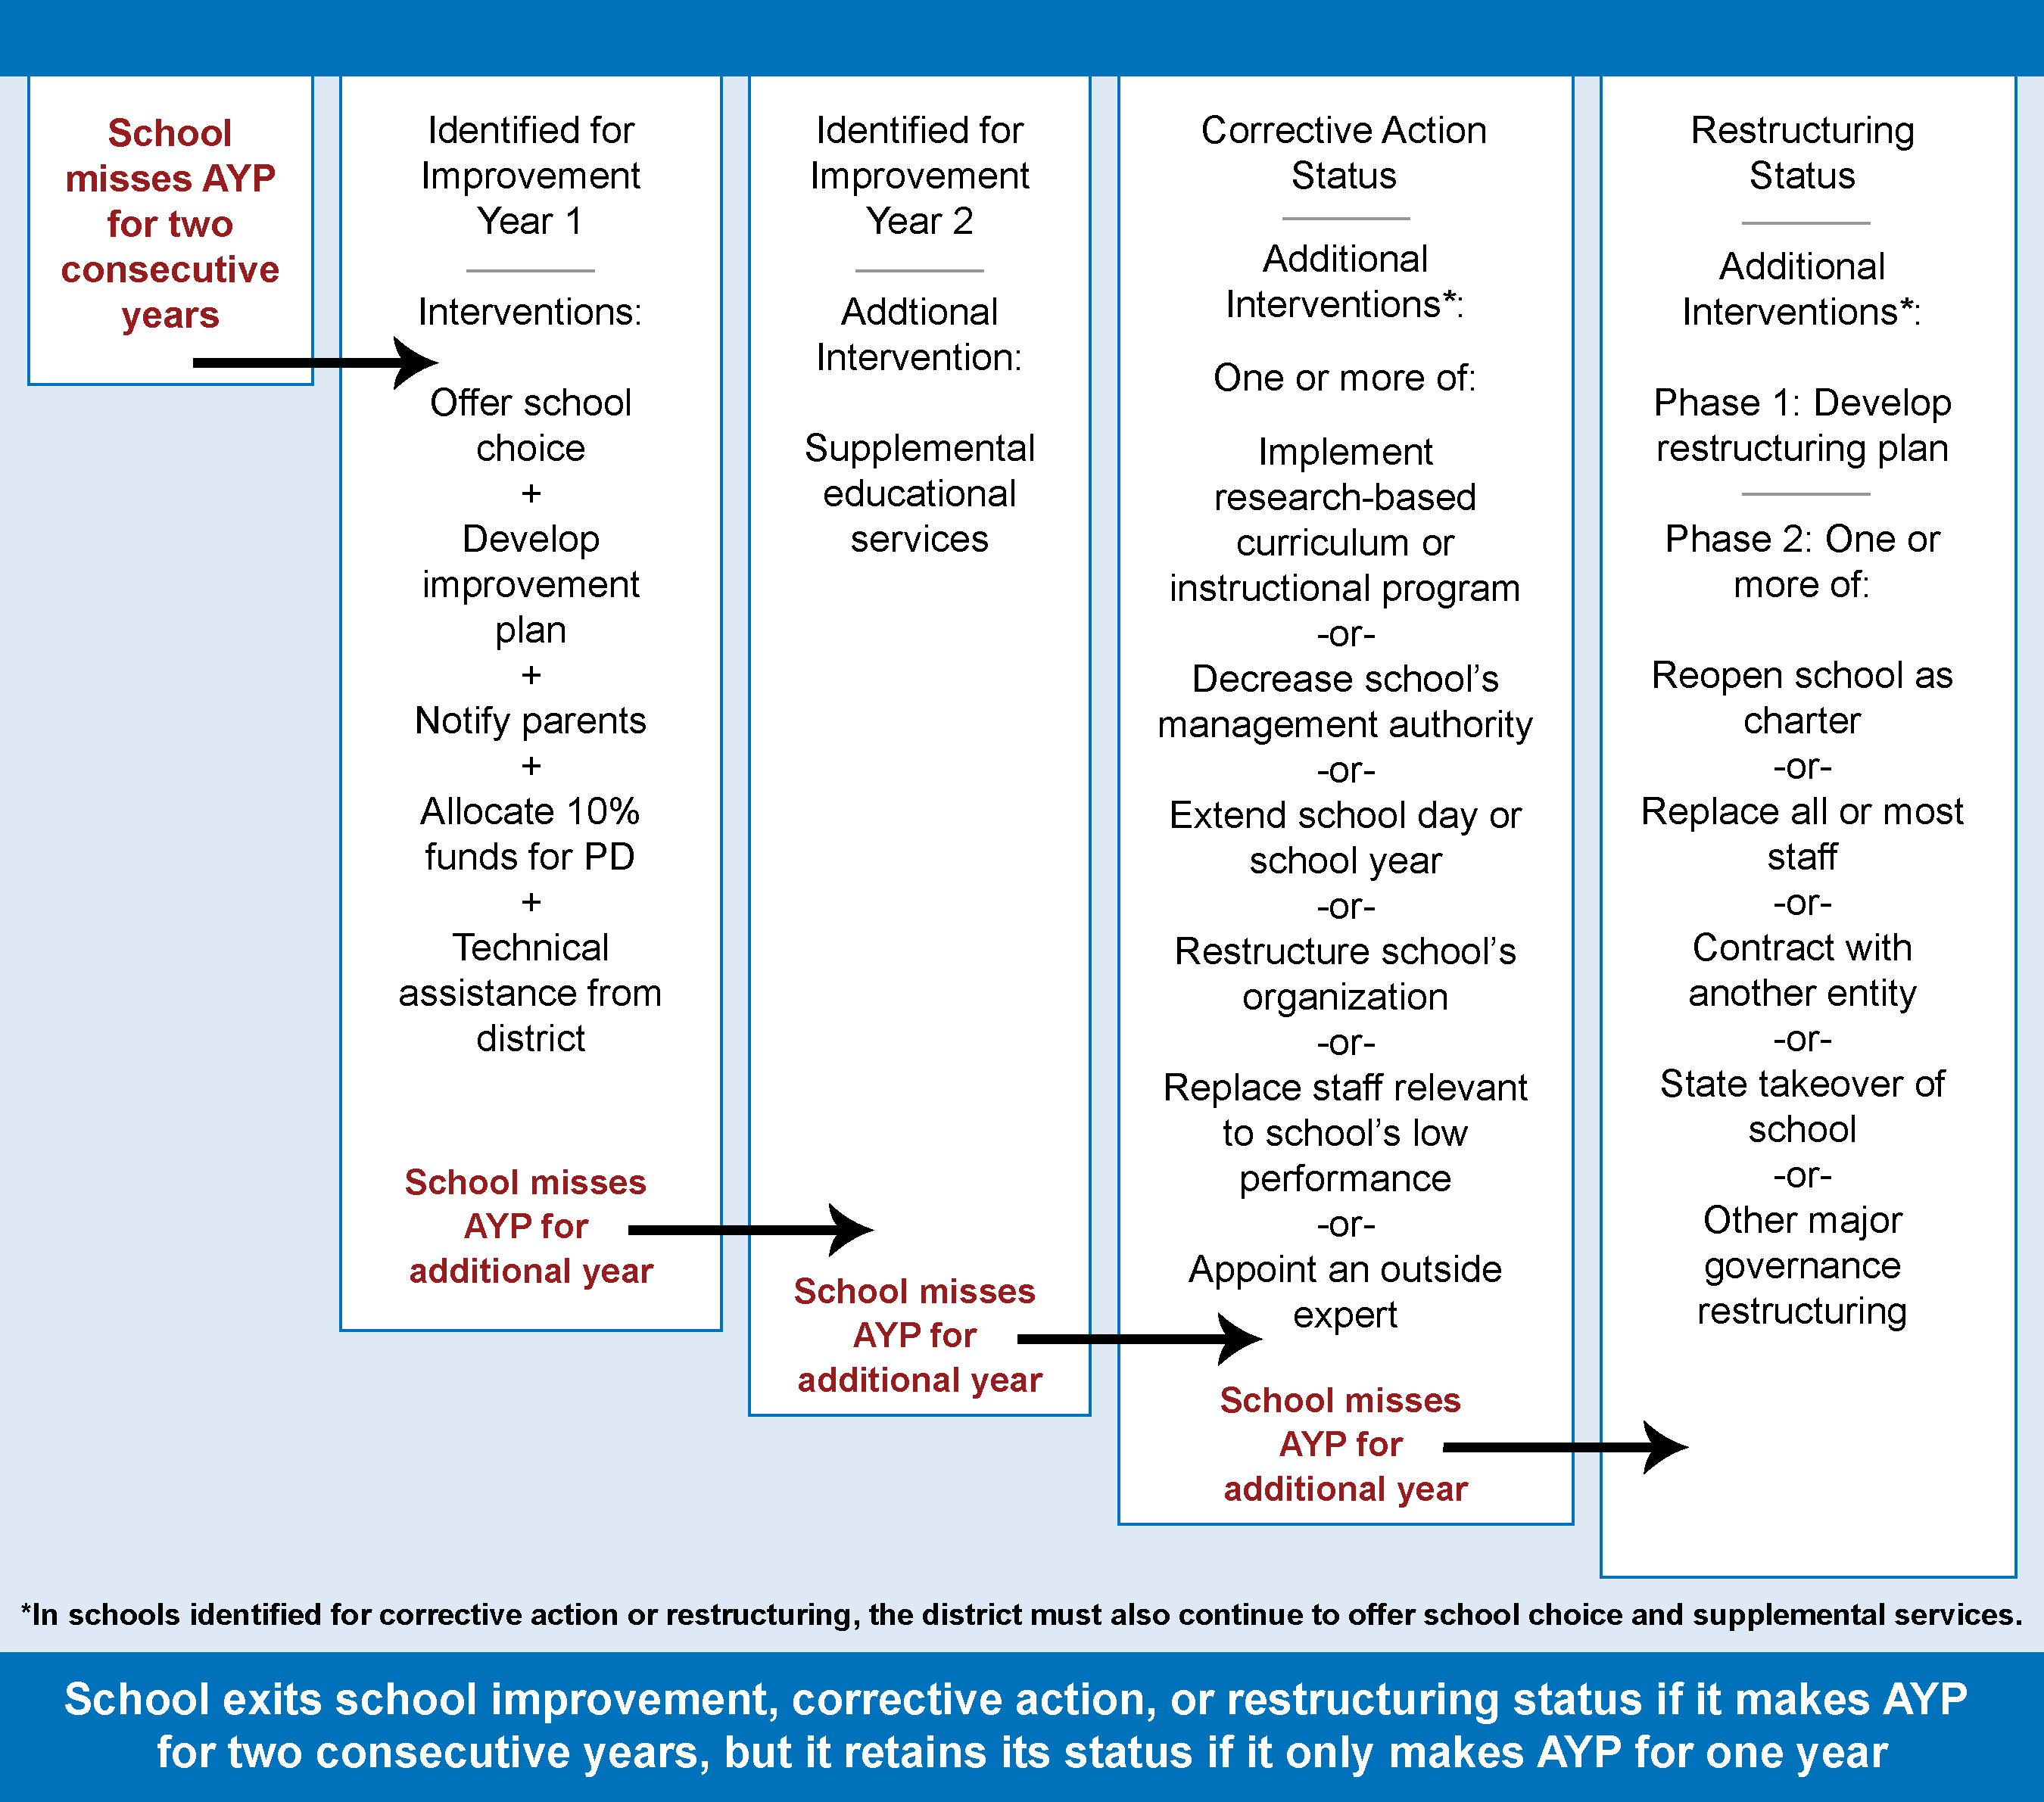

Provide useful information about school performance to stakeholders
A central assumption of performance-based accountability is that, when educators, administrators, parents, and other stakeholders have information about the performance of schools and districts, they will be able to make informed decisions about resources and actions that are in the best interest of students. For this assumption to hold, stakeholders must have access to accurate, reliable, and valid information about the requirements and options specified in the law, about student performance, and about resources and practices likely to result in improved student achievement. NCLB requires states to produce and distribute report cards that include information on AYP, improvement status, and student achievement. It also adds the following requirements:
- Public dissemination of disaggregated achievement data and the percentage of classes taught by highly qualified teachers.
- The information on student and school performance must be made available to schools, districts, and parents in a timely fashion so that parents may take advantage of the school choice and supplemental educational services options and schools may take appropriate improvement actions by the beginning of the school year.

Provide appropriate assistance and require interventions to stimulate school and district improvement
The purpose of identifying schools and districts for improvement is to help ensure that appropriate actions are taken to foster school progress and provide options to students and parents. NCLB is more prescriptive and specific than IASA in the actions that states and districts must take to ensure school improvement.
- NCLB specifies options for parents at each stage of school identification. For a Title I school in Year 1 or any subsequent year of identification, the district must offer all parents the option of transferring their child to another public, non-identified school. Districts must notify parents of their choice options before the start of the school year and provide students with transportation to non-identified schools. (Under IASA, Congress added requirements in 1999 and 2000 that school choice be offered to students in Title I schools identified for improvement, when feasible. However, IASA did not require districts to apply this option to all schools identified for improvement without regard to structural constraints, such as space available, or to provide transportation.)
- For Title I schools beginning in Year 2 of improvement status, districts must also offer students from low-income families the option of receiving supplemental educational services from a state-approved provider.
- For schools in corrective action status, districts must implement at least one of six specified interventions (replacing staff relevant to the failure to make AYP, implementing a new curriculum, decreasing management authority at the site, appointing an outside expert, extending the school day or year, or restructuring the school’s internal organization).
- After not making AYP targets for five years, the school must plan to restructure its governance and, the next year, must restructure by either closing the school and reopening it as a charter school, replacing all or most of the school staff, turning management over to the state or a private agency or some other major form of restructuring (see Exhibit 2).
- NCLB also identifies specific support mechanisms for schools identified for improvement, including technical assistance, school support teams, and distinguished teachers and principals to assist in planning and improvement efforts. States are also required to provide support to districts identified for improvement, including assistance in developing an improvement plan and strategies to work more effectively with schools identified for improvement, and addressing potential challenges related to parent involvement or professional development. Although IASA specified some state strategies, NCLB emphasizes the development of state support systems. NCLB also requires districts to assist schools in analyzing data from state assessments, identifying proven effective strategies for professional development and instruction, and revising school budgets to allocate resources more effectively. Schools identified for improvement under NCLB must spend 10 percent of their allocation of Title I, Part A, funds for the purpose of providing professional development that addresses the reasons the school was identified for improvement. IASA also included many of the same strategies to support school improvement.
To document the ways in which they would comply with the accountability requirements of NCLB, states were required to submit initial accountability plans (often referred to as “accountability workbooks”) to the U.S. Department of Education by January 2003. These plans were approved through a peer review process in spring 2003. Since then, states have had the option of submitting annual amendments to their accountability plans. These amendments require approval by the U.S. Department of Education.

Evaluation Questions and Findings From Interim Report
This final report is based on data collected through the 2006–07 school year and addresses six broad questions relevant to the NCLB accountability provisions outlined above.
- How have states implemented the standards, assessment, and accountability provisions of Title I? (See Chapter II.)
- How are schools and districts performing with respect to making AYP? What are the reasons that schools do not make AYP? Are there common characteristics among districts and schools identified for improvement? (See Chapters III and IV.)
- How have states implemented the English language proficiency standards, assessment, and accountability provisions of Title III? (See Chapter V.)
- How is information about NCLB, AYP, and identification for improvement communicated to stakeholders, and how well do district and school staff understand the status of their districts and schools? (See Chapter VI.)
- In what ways do states support improvements in district and school performance? (See Chapters VII and VIII.)
- What efforts are being made to improve district and school performance, including technical assistance, mandated interventions, and local initiatives? (See Chapters VII and VIII.)
The interim report, issued in October 2007, presented information on NCLB implementation through 2004–05, and revealed the following patterns:

Accountability Policies:
- All states, the District of Columbia, and Puerto Rico had enacted the key accountability provisions required by NCLB and had accountability plans approved the U.S. Department of Education.
- Districts and schools had mostly met the relevant NCLB accountability requirements through 2004–05.
- More than half of states were testing students in all required grades in reading and mathematics in advance of the 2005–06 NCLB deadline. However, 20 states were behind schedule in implementing assessments that measure English language proficiency. A similar number of states were not able to notify schools of their performance on the statewide assessments before the start of the 2004–05 school year.

Adequate Yearly Progress
- Seventy-five percent of the nation’s schools made AYP in 2003–04. Of the 25 percent that did not make AYP, half (51 percent) did not succeed because the school as a whole (i.e., the “all students” group) or multiple student subgroups did not meet academic achievement standards.
- About one-third of schools that did not make AYP did not do so based on the students with disabilities or LEP student subgroups. About two-thirds of those schools reported needing technical assistance to improve instruction for these subgroups.

Identification for Improvement and Improvement Efforts
- Thirteen percent of the nation’s schools were identified for improvement in 2004–05. Those schools were most likely to be high-poverty, high-minority, large, urban schools.
- Nearly all schools reported making multiple improvement efforts. Schools identified for improvement focused on more areas of improvement than non-identified schools. Schools also reported receiving technical assistance that met their needs, with exceptions in two areas. About one-half of schools needing assistance to improve services to students with disabilities and to improve services to LEP students did not have these needs met. States and districts were implementing the required interventions in schools identified for improvement and corrective action, but they were not implementing the required actions in most of the 1,199 schools in restructuring.

Data Sources
To address the above evaluation questions, this report presents findings from two federally funded studies—the Study of State Implementation of Accountability and Teacher Quality Under NCLB (SSI-NCLB) and the National Longitudinal Study of NCLB (NLS-NCLB).
The SSI-NCLB examined state implementation of NCLB in the areas of accountability and teacher quality through analysis of school performance data and state documents (including Web sites and consolidated applications and reports), and telephone interviews with state officials responsible for implementation of the accountability, teacher quality, Title III, and supplemental educational services requirements. Administrators in all 50 states, Puerto Rico, and the District of Columbia were interviewed during the fall and winter of 2004–05 and again in 2006–07.
A national database of the AYP and improvement statuses of all schools in the country was created from data provided by state education officials, reporting on the annual Consolidated State Performance Reports (CSPRs), and for approximately half of the states in 2005–06 provided by state education officials through the Education Data Exchange Network (EDEN). The resulting National AYP and Identification Network (NAYPI) database contains over 89,000 schools (including both Title I and non–Title I schools) in 50 states, the District of Columbia, and Puerto Rico. The database contains AYP results from 2003–04, 2004–05, and 2005–06 and identification for improvement statuses for 2004–05, 2005–06, and 2006–07. AYP data for 2006–07 are currently available at www.ed.gov/nclb/accountability/results/progress/ index.html.
The NLS-NCLB assessed the implementation of NCLB provisions in districts and schools through analysis of survey data collected from a nationally representative sample of 300 districts, within which is a sample of 1,483 schools (of which 248 were non–Title I schools), including a mix of elementary, middle, and high schools. In each school, six general education teachers were randomly selected to receive surveys: one teacher in each grade 1–6 at the elementary school level and three English teachers and three mathematics teachers at the secondary school level. This teacher sample is referred to as “all general education teachers” in this report. In addition, one special education teacher was surveyed in each school and one paraprofessional was surveyed in each Title I school in the study sample. For simplicity, this report uses the term “teachers” to refer to general education teachers as opposed to special education teachers, unless otherwise noted. The NLS-NCLB surveys were administered in 2004–05 and again in 2006–07. Response rates across all groups surveyed ranged from 82 percent to 96 percent in 2004–05 and from 84 percent to 99 percent in 2006–07. See Appendix A for further details about the study sample and response rates in the two waves of data collection.

Technical notes
The following conventions were used when referring to school year in discussions of AYP and identification for improvement. Schools or districts are said to make (or not make) AYP in a particular year based on test results from that same year. However, schools or districts are said to be identified for improvement for a particular year based on test results from the previous year (or years). For example, if 43 percent of the students at Garden Elementary were proficient on tests taken in spring 2005–06 and the state’s AYP target for 2005–06 was 49 percent of students proficient, we would say that Garden Elementary did not make AYP in 2005–06. If the school had also not made AYP the previous year (2004–05), we would say that Garden Elementary was identified for improvement for 2006–07.
This report is primarily descriptive; with few exceptions, we do not have information about the quality of the activities and services that are described.
References to differences between groups or over time that are based on nationally representative samples highlight only those differences that are statistically significant at the 0.05 level. The significance level, or alpha level, reflects the probability that a difference between groups as large as the one observed could arise due to sampling variation, if there were no true difference between groups in the population. The significance tests were conducted differently for different comparisons, and details are described in Appendix A.
Analyses of student achievement data on percentages of schools and districts identified for improvement and reasons for schools not making AYP were based on the full population of schools as reported by each state.
Any survey or interview findings reported without a specific date are based on information collected in the 2006–07 school year.

II. State Standards, Assessments, and Accountability
The No Child Left Behind Act of 2001 (NCLB) requires a system of accountability in which every public school in the country is held responsible for the academic achievement of all of its students. At the heart of this system are state academic content standards that articulate what students should know and be able to do at different grade levels, assessments that measure progress toward meeting those standards, and annual measureable objectives that all schools and districts are expected to meet. Although all levels of the educational system have responsibility for implementing the provisions of the law, states play a particularly important role in that they adopt the standards, implement the assessments, define AYP, and determine the accountability goals for all schools and districts throughout their jurisdictions. This chapter focuses on state policy response to NCLB requirements for standards, assessments, and measuring progress, with particular attention to those provisions that represent a change from prior law.

Key Findings
- In 2006–07, all states had content standards in reading, mathematics and science, but many continued to revise their standards or adopt new standards.
- As of 2006–07, 37 states, the District of Columbia, and Puerto Rico, had developed entirely new tests or modified existing assessments in grades 3–8 to comply with NCLB. By 2006–07, all states had alternate assessments for students with disabilities and one-third of states had developed entirely new alternate assessments based on alternate academic achievement standards.
- The variation in AYP starting points—and hence in how much progress a state must demonstrate by 2014—is strongly related to how high the states set their academic achievement standards for proficiency.
- In 2006–07, dual federal-state accountability initiatives continued in 27 states. Since 2004–05, three states eliminated pre-NCLB elements of their state accountability systems, but an additional six states developed new initiatives that went beyond NCLB.

Implementing Standards and Assessments in Reading, Mathematics, and Science
Content standards and aligned assessments have been core elements of the Elementary and Secondary Education Act of 1965 (ESEA) since its 1994 reauthorization as the Improving America’s Schools Act (IASA). Under IASA, Congress required states to establish content standards in one grade in each of three grade spans (3–5, 6–9, and 10–12), performance standards and aligned assessments in reading and mathematics for students covered by Title I of ESEA. NCLB built on and expanded IASA provisions by requiring states to add either grade-level standards or grade-level expectations to the broader grade-span standards, to annually administer aligned assessments in each of grades 3–8 and once in high school to all public school students, and to add requirements for standards and assessments in science. NCLB also requires that 95 percent of students participate in the assessments of reading and mathematics. This test participation requirement applies to all public elementary and secondary schools, school districts, and up to eight student subgroups within each school and district: five major racial and ethnic groups (African-American, American Indian, Asian, Hispanic, and white), economically disadvantaged students, students with disabilities, and students with limited English proficiency (LEP). Students with disabilities and LEP students must be provided with accommodations or alternate assessments when appropriate.
These requirements and changes in the law have generated a great deal of activity in the five years between the enactment of NCLB (January 2002) and the final collection of the data for this study (2006–07). During this period, states revised existing content standards or adopted new standards in reading, mathematics, and science; developed or adopted new assessments in grades or subjects previously untested; established their definitions and cut scores for their academic achievement standards (e.g., their definitions for basic, proficient, and advanced performance) on statewide tests; and revised accountability workbooks to improve reliability of accountability determinations.

Establishing content standards in reading, mathematics, and science
Both NCLB and its precursor, IASA, required states to establish content standards that “specify what children are expected to know and be able to do” in reading, mathematics, and (in the case of NCLB) science, that “contain coherent and rigorous content” and “encourage the teaching of advanced skills.” Under IASA, states were to have content standards in required grade spans for reading and mathematics and to have their standards development process reviewed and approved by the U.S. Department of Education. The Department’s review of standard-setting processes began in 1998, and by the time NCLB was enacted in 2002, nearly all states had received federal approval for the content standards developed under IASA.
In 2006–07, all states, the District of Columbia, and Puerto Rico had content standards in reading, mathematics and science, but many continued to revise their standards or adopt new standards.
By 2003, all states had received federal approval for the process through which they developed reading and mathematics content standards in the grade spans required under IASA. By 2007, all states, the District of Columbia, and Puerto Rico had submitted science content standards, for which the development processes were reviewed and approved by the U.S. Department of Education. Content standards were frequently revised: thirty states and the District of Columbia reported that their content standards were updated on a regular schedule, often mandated by the state legislature or state board of education. Among these states, standards were typically updated every four to six years. In 2006 and 2007, about one state in five updated or revised content standards for reading (13 states), mathematics (13 states), or science (13 states) (see Exhibit 3).

Expanding student assessment systems
Assessment of student achievement relevant to state standards is a central feature of NCLB, as it was of IASA. Measurement of student progress toward achieving state standards forms the basis on which districts and schools are held accountable; interventions are determined; and additional options, such as school choice and supplemental educational services, are provided.
All states were required to submit documentation about their assessments for peer review to ensure that state assessment systems met federal standards for technical quality, alignment, inclusion, and reporting. To assist states in meeting the requirements for statewide assessments under NCLB, the U.S. Department of Education provided nonregulatory guidance that described the requirements and gave examples of acceptable and unacceptable evidence of compliance. If states did not meet all the requirements, then the peer review teams provided feedback to help states develop comprehensive assessment systems that would provide accurate and valid information for holding districts and schools accountable for student achievement.
Exhibit 3
Year in Which 2006–07 Reading, Mathematics and Science
Content Standards Were Adopted or Most Recently Revised
Exhibit reads: Of the state academic content standards for reading, mathematics, and science in effect in 2006–07, two were developed or most recently revised in 1996.
Note: Three states have revised their K–8 standards and their 9–12 standards in different years and these revisions are counted separately in the table. As a result, the number of adoptions reported may be greater than 52.
Source: SSI-NCLB, Accountability Interviews; Consolidated State Performance Reports; and State Education Agency (SEA) Web sites (n = 50 states, the District of Columbia, and Puerto Rico).
As of 2006–07, 37 states and the District of Columbia had developed entirely new tests or modified existing assessments in grades 3–8 to comply with NCLB.
Complying with NCLB testing requirements has necessitated substantial test development by some states. While 14 states retained their existing tests to meet the requirements of NCLB, the majority developed or modified their reading and mathematics tests specifically for NCLB: 16 states indicated they developed all new assessments in reading and mathematics in grades 3–8, and 17 used a combination of new, modified, and existing assessments (see Exhibit 4). States reported that implementing the additional testing requirements was one of the most substantive challenges they faced in the first three years of NCLB. All of the newly adopted tests were either developed specifically to align with state standards or were off-the-shelf tests that had been augmented to align with state standards.

Features of State Assessment Systems
Exhibit 4
State Approaches to Developing Assessments
in Grades 3–8, Reading and Mathematics,
in 2006–07
 | Number of States
 | Reading | Mathematics
Kept existing assessments, all grades | 14 | 14
Modified existing assessments, all grades | 4 | 4
Developed new assessments, all grades | 16ª | 16ª
Mix of new, modified, and existing assessments | 17 | 17
Exhibit reads: In order to meet the NCLB requirements for state assessments in grades 3 though 8 in reading, 14 states kept existing assessments in all grades.
ª indicates the District of Columbia is included.
Source: SSI-NCLB, Accountability Interviews (n = 50 states and the District of Columbia).
Annual assessments are a central feature of NCLB accountability, and scholars have asserted that the annual testing requirements of NCLB have shaped instructional practices and students’ academic experiences. Yet relatively few national data have been reported on the fundamental features of state assessment systems. Three important features of state assessments that receive attention from school stakeholders—policymakers, administrators, and researchers—include:
- the extent to which assessments for AYP purposes include a mix of multiple choice and open-response items;
- the extent to which teachers and the public have access to questions on past state assessments;
- the amount of time students spend taking tests that are required for AYP.
Each of these features of state assessment systems is described in the sections that follow (see Appendix B, Exhibit B.1 for approaches in specific states).
In 2006–07, reading and mathematics tests in 16 states were composed entirely of multiple choice items. In the other 35 states, the District of Columbia, and Puerto Rico, assessments included a mix of constructed response and multiple choice items.
For reading and mathematics tests in grades three through eight, the number of states that relied entirely on multiple choice questions for AYP purposes has remained relatively stable since NCLB was signed into law. Some states shifted to multiple choice–only test formats (for example, Mississippi and Maryland in 2006–07) to accelerate AYP calculations and the data reporting process. Other states (Alabama and Montana) added extended response or short answer questions to their assessments during the same time period.
Since NCLB, the number of states that release test items to the public increased from 29 in 2001–02 to 40 in 2005–06.
Although not required by law, in 2005–06 most states released at least some of their test items to the general public, most often through the state education Web site but also through publications for teachers and the press. While four states released over 75 percent of their test items in 2005–06, most released a subset of items, generally one full test form. Among the states that did not release items in 2005–06, four had released items in prior years, and others were planning on phasing in item releases in conjunction with a new test being developed.
Overall, states varied greatly in terms of the ways in which they released items, the number of items released, the materials associated with the items released, the number of grades and subjects for which items were released, and the frequency of item releases. For example, Hawaii developed a Web site dedicated to item release, in which teachers could select a grade level, content standard, and even subject strand, and the system would generate the appropriate test items. New York included released items in English but also in Haitian-Creole, Chinese, Korean, and Russian. The Massachusetts Web site included a “question of the day” to which the public could respond and immediately see results. Other states, however, provided little or no material associated with the test items, posted items for a limited number of subjects or grades, or failed to update item releases on an annual or even biannual basis.
Many states release items in an effort to increase the transparency of their testing systems and the instructional utility of assessments. In at least three states, however, item release policies were driven by court mandates. After release, test questions are “retired” and are replaced by updated items. From a test development perspective, two related factors affect item release: item age and item exposure. Item age is detrimental in that item content may become outdated and less familiar to students—for example, older items may contain references to typewriters or other outdated technology or past, rather than current, events. Older items also may be differentially familiar to some groups of students more than to others, increasing the possibility for unintended bias. Item exposure—that is, the extent to which items have been used and thus “exposed” to students in a testing situation—is a problem to the extent that specific test items become familiar to students or teachers and become the object of explicit test preparation. Exposure is more likely to be a concern for certain items that effectively distinguish among students at basic, proficient, and advanced levels. Because such items discriminate so well, they are used more often in tests and are at greater risk of overexposure (Stocking and Lewis, 1998; Davey and Parshall, 1995).
The amount of time that students spent taking NCLB-required assessments in reading and mathematics averaged between four and six hours annually, depending on the grade level.
The average combined testing time for state reading and mathematics assessments administered for NCLB accountability purposes was about five hours, although test duration varied greatly across the 30 states from which data were available: In fourth-grade mathematics, tests were as short as 50 minutes (Idaho) or as long as 270 minutes (in New Hampshire, Rhode Island, and Vermont) (see Appendix B, Exhibit B.1). On average, tests that included only multiple choice items tended to be shorter than tests that included items that required short answer or extended responses (see Exhibit 5).
These estimates are based on testing times listed in states’ test administration manuals, and do not include other activities associated with test-taking such as listening to instructions, responding to sample questions, or breaks between sessions. If students need more time, many states allow them to continue working on the test. Of the 30 states for which data were available, 16 had tests that were untimed, although for scheduling purposes, an expected duration was suggested to test administrators.
Exhibit 5
Average Test-Taking Duration, Reading and Mathematics, Grades 4, 7, and High School, 2006–07
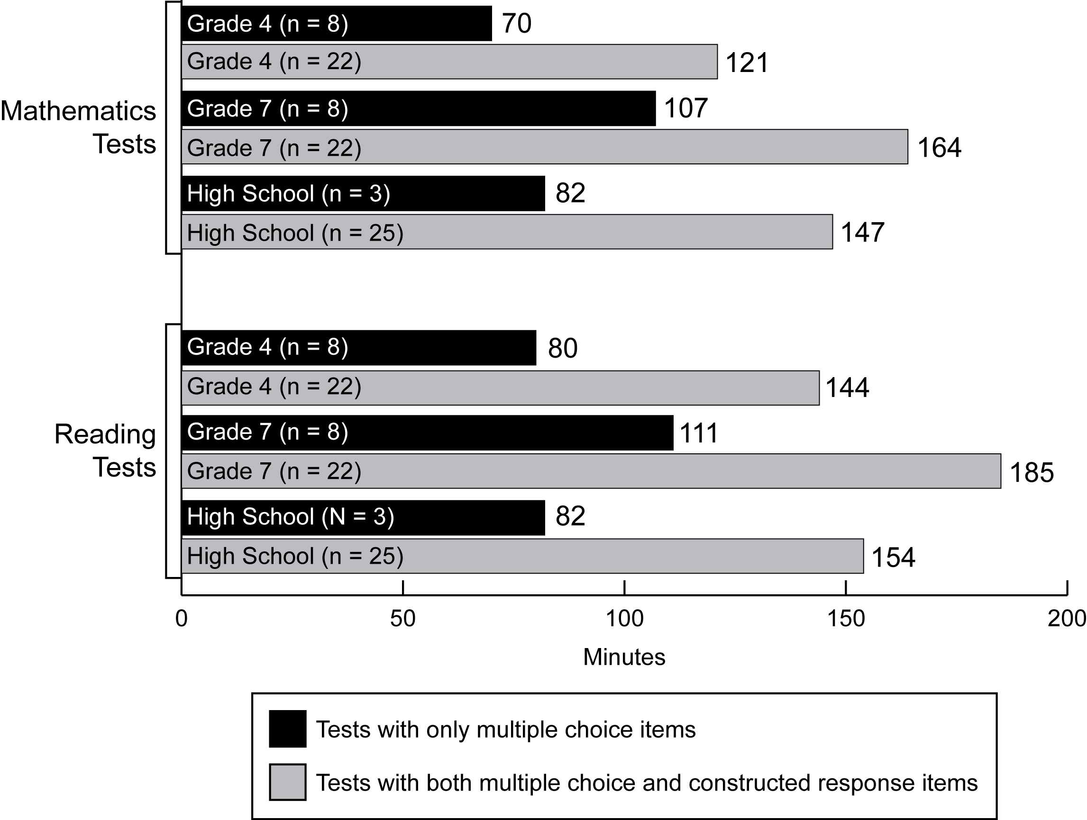
Exhibit reads: In eight states with grade 4 tests composed only of multiple choice items, the average test duration was 70 minutes in 2006–07.
Sources: SSI-NCLB, Title I Assessment and Accountability Interviews and Analysis SEA Documents.
The variation in the duration of state tests reflects a lack of consensus among policymakers, test developers, and researchers regarding the “ideal” test length. Research is inconclusive concerning appropriate test length. Likewise, research on test fatigue is incomplete and inconclusive. Some studies suggest that students have more difficultly responding to questions that appear later in a test (PISA, 2000; Wise, Chia and Park, 1989), while others suggest no differences exist (Rubin and Mott, 1984; Klein and Bolus, 1983; Zwick, 1991), and still others are inconclusive (Davis and Ferdous, 2005).
Since NCLB was signed into law, some observers have suggested that students are spending too much time taking tests. However, the state assessments administered for NCLB purposes require only a portion of the total time students spend taking tests. One national estimate of the amount of time students spend taking tests suggests the average duration of state-administered tests is five days per school year; district-required benchmark and diagnostic tests total four days; and teacher-administered tests in the classroom may account for as many as nine days of class time (about 1.5 days in each of the six, six-week grading periods). States often require testing in addition to what is required under federal law; for example, in 2007, 17 states required all high school students to take tests of college readiness, including the SAT, ACT, or WorkKeys. In the context of all tests administered by states, districts, and teachers, the state assessments administered for NCLB purposes are one component of the total amount of time that students spend taking tests.
The above estimates do not include time spent on test-taking strategies. It is not known to what extent the time that teachers spend on preparing their students for upcoming assessments represents a productive instructional activity or takes time away from higher-quality instructional activities.

Cost of Developing and Administering Reading and Mathematics Assessments Under NCLB
Since fiscal year 2002, states have received assistance from the federal government to support the costs associated with developing tests for NCLB purposes. Specifically, Section 6111 authorizes grants to states to “pay the costs of the development of additional state assessments and standards required by section 1111(b).” For the fiscal years 2002 through 2008, the total federal allocation for all states and outlying territories was $2.8 billion. The annual allocation ranged from $387 million in 2002 to $409 million in 2008 (see Exhibits B.2 and B.3 in Appendix B for annual appropriations and state allocations).
However, we do not know the actual cost to states of complying with the assessment requirements of NCLB. As part of the National Assessment of Title I, Congress called for an examination of the cost of developing assessments in grades 3–8 [Section 1501(a)(2)(C)(i)]. For the purpose of this study, we interpreted this requirement as pertaining to general assessments in reading and mathematics, and we surveyed state assessment directors in all of the states during the 2006–07 school year to ask them to estimate the costs their state had incurred for developing such assessments. This survey also collected information on the costs of administering and maintaining reading and math assessments required under NCLB. We did not include science assessments because NCLB did not require these assessments to be in place until the 2007–08 school year. We also did not include alternate assessments or tests of English language proficiency.
For reporting on test development costs, state officials were asked to aggregate costs over time because test development is a multiyear process. In contrast, costs associated with the administration and maintenance of assessments are recurring annual costs, and state officials were asked to provide estimates of these costs for 2006–07 only.
Costs associated with the development of tests may include, but are not limited to, costs for state education agency (SEA) staff, vendor contracts, and consultants to develop test specifications, write and review items, obtain necessary copyrights, assemble forms, field test, set standards, conduct psychometric analyses, develop special forms to ensure accessibility for all students, and develop systems for reporting results. Development costs generally occur over several years, depending on the number of tests states need to develop and the types of items they use. Indeed, developing high-quality tests is a labor-intensive and technically challenging process. As one scholar commented, “Hundreds of people have to touch every item” (Toch, 2006, p.8). Once test development is largely complete, states may no longer need to spend resources on test development if they reuse the same items and the same forms; however, there are always annual costs associated with test administration and maintenance, and few states reuse all items every year. These costs include, but are not limited to, item renewal (and subsequent field testing and committee review), production of annual test materials, training local staff, scoring tests, and monitoring contractors.
There are many challenges to accurately estimating the additional costs that states must assume as a result of the NCLB requirements, and it may be difficult for states to accurately report on these costs.
Prior to NCLB, some states had assessment systems that went beyond the specific requirements of the previous law and already included some of the components that were newly required under NCLB. For example, some states already were administering annual assessments in each grade from 3 through 8 prior to NCLB. More fundamentally, assessing students is a state role that precedes both NCLB and IASA, and states have periodically revised their assessments or developed entirely new assessment systems. Thus, the cost of assessing students, as well as the cost of developing revised or additional assessments, cannot be entirely attributed to federal requirements.
In addition, it may be difficult for states to isolate the specific costs of developing and administering reading and mathematics assessments in grades 3–8, because these costs may be combined with those of other assessments included in each state’s assessment system. States do not necessarily account separately for the costs of developing assessments in different subjects and different grade levels, and states may have assessments in subjects and grades that are not required under NCLB. Similarly, states may not always account separately for test development and administration costs, particularly when both types of costs are bundled together in a single contract with a testing firm. Finally, states may find it difficult to account accurately for the cost of assessment development and administration work performed by state education staff, district and school officials, and teachers, particularly for those staff who have responsibilities other than state assessments.
Despite these challenges, the following sections summarize the estimates that states reported for the cost of developing and administering assessments required under NCLB.

Costs to develop reading and mathematics assessments in grades 3–8
Considerable variation across states in their assessment development costs may be expected, because states may undertake test development in ways that are more or less complex—with variable costs associated with each approach. States may field test items in ways that are more or less expensive, for example, by using small or large samples of students in different parts of the state, by embedding the field-test items in the “real” test, or by administering a stand-alone field test. In addition, costs may vary based on the number of items, item type, cultural bias reviews, and psychometric analyses. Decisions that impact the rigor, quality, and cost of test development accumulate as tests become more numerous and more complex. Moreover, the maturity and quality of a state testing program prior to NCLB may have implications for post-NCLB costs. For example, states that were under compliance agreements under IASA may have had to make more substantive efforts under NCLB to ensure their assessment system met federal standards.
Thirteen states reported that they used existing assessments in reading and mathematics in grades 3–8 to meet NCLB accountability requirements.
Of the 46 states that provided data, 13 indicated they kept their existing assessments in reading and mathematics in grades 3–8 for accountability under NCLB. While they may have accrued some costs associated with these tests following NCLB, it is difficult to attribute these expenses to the 2001 law given that the tests predated the law.
Twenty-seven states reported costs to develop reading and mathematics assessments required under NCLB in grades 3–8, with a median cost of $9.6 million per state. The test development costs reported by states varied considerably, from a low of $1.3 million to a high of $51.1 million.
Among the 27 states that reported costs of developing or modifying mathematics and reading tests to comply with NCLB, the median expenditure was about $9.6 million per state (see Exhibit 6). States that reported the highest development costs were Arizona ($51.1 million), Ohio ($42.6 million), and West Virginia ($33.2 million). States that reported the lowest development costs were Vermont ($1.3 million), New Hampshire ($2.0 million), and Oregon ($2.5 million).
Each state’s total reported cost for developing these assessments did not appear to be related to the number of tests each state needed to develop to comply with NCLB. For example, many states opted to maintain the tests developed under IASA for selected grades and developed new ones for missing grades. That is, a state may have kept existing tests in grades 4, 6, and 8, in which case the state would only have to develop new tests in 3, 5, and 7, for a total of six new tests. Other states developed entirely new tests for reading and mathematics for all grades 3-8 (for a maximum of 12 newly-developed tests). Of the three states that developed six new tests, the aggregate costs varied from $2.5 million to $14.7 million. Among the states that developed assessments for all grades from 3–8, Vermont spent the least, $1.3 million, while Arizona spent over $51.1 million.
It is possible that per-pupil test development costs might be higher in smaller states than in larger states, if test development involves fixed costs that may be spread over a smaller or larger number of students. Indeed, these data indicate that test development costs per tested pupil were moderately related to state size: among the states that tested more than 500,000 students in grades 3–8, the per-pupil test development costs were $31, while states that tested fewer than 200,000 students in grades 3–8 reported average test development costs of $102 per tested pupil. In addition, the aggregate test development costs that states reported were also moderately related to state size: on average, the larger states reported the highest aggregate costs, while smaller states reported the lowest costs. However, there was a great deal of variation among states in the aggregate amount of costs they reported, and some states with large enrollments (such as Illinois) reported costs that were similar to some states with very low enrollments (such as Maine).

Exhibit 6
State-Reported Aggregate Costs of Developing or Modifying Reading and
Mathematics Assessments in Grades 3–8 to Comply With NCLB Requirements, in 27 States That Reported Such Data
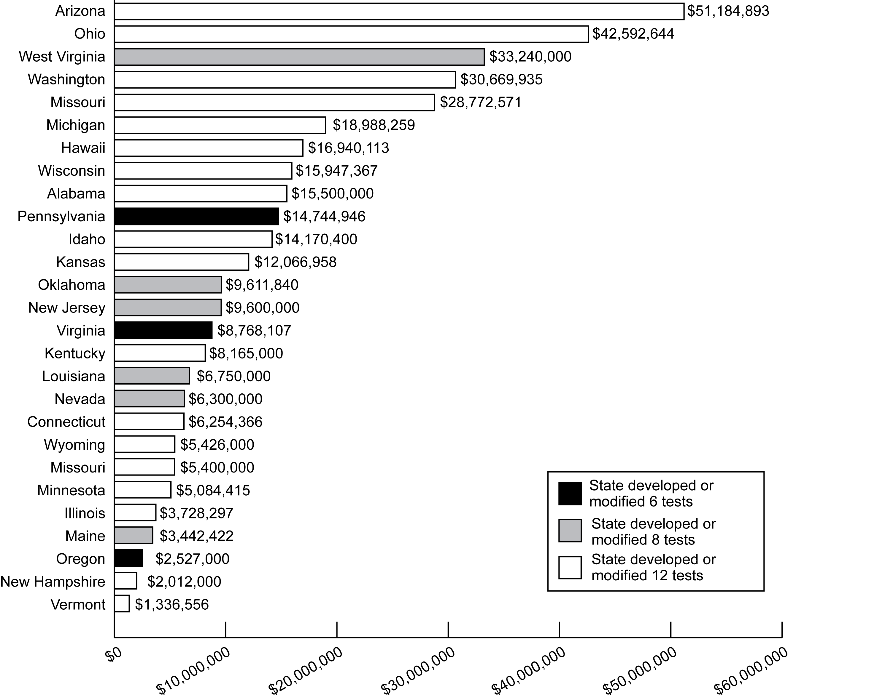

Exhibit reads: Arizona reported spending a total of $51.2 million on the development and modification of reading and mathematics assessments in grades 3–8 in order to comply with NCLB.
Note: State officials were asked to report data on the costs of developing or modifying state assessments in order to comply with the NCLB requirement to assess students in grades 3–8 in reading and mathematics. These data therefore represent multiple years of expenditures, spanning the development of state assessments required under NCLB. These data represent respondents’ best estimates; however, it may be difficult for states to accurately report on these costs and to separate NCLB-related costs from assessment costs that would have occurred in the absence of NCLB. In addition, states may vary in the ways in which they account for these costs and thus the data shown here may not be consistent across states.
Sources: SSI-NCLB, Title I Assessment and Accountability Interviews and Analysis of SEA Documents (n = 27 states).

Costs to administer reading and mathematics assessments in grades 3–8 and high school
In contrast to development costs, test administration and maintenance costs recur on an annual basis. For this study, states were asked to report their test administration costs in 2006–07 and were specifically asked to include costs associated with:
- layout, design, editorial, production, printing, shipping, tracking, scanning, and scoring of tests;
- monitoring of testing contractors;
- training of state users and administrators;
- maintaining test banks; and
- test accommodations, including training and special equipment.
It is important to note that these test administration costs cannot all be considered as costs of complying with NCLB, because states have long administered statewide assessments in at least some of these grades and likely would have continued to do so even in the absence of the NCLB assessment requirements. Also, unlike the previous section on the costs of developing and modifying reading and math assessments, the administration costs covered in the following section include the cost of administering high school assessments as well as assessments in grades 3–8.
In 2006–07, the median cost that states reported for administering reading and mathematics tests in grades 3–8 and high school was $25 per tested pupil.
Across the 39 states that reported these data, the median per-pupil cost to administer and maintain assessments in reading and mathematics in grades 3–8 and high school was $25, ranging from a low of $3 per tested pupil in North Carolina to a high of $99 per pupil in Delaware (see Exhibit 7). Most of the states (29 out of 39) reported costs of between $12 and $42 per pupil. The median reported total cost for test administration and maintenance in 2006–07 was $7.5 million, ranging from a low of $1.2 million in Wyoming to a high of $77 million in California.
Exhibit 7
State-Reported Annual Per-Pupil Costs of Administering and Maintaining Reading and Mathematics Assessments in Grades 3–8 and High School, 2006–07, in 39 States That Reported Such Data
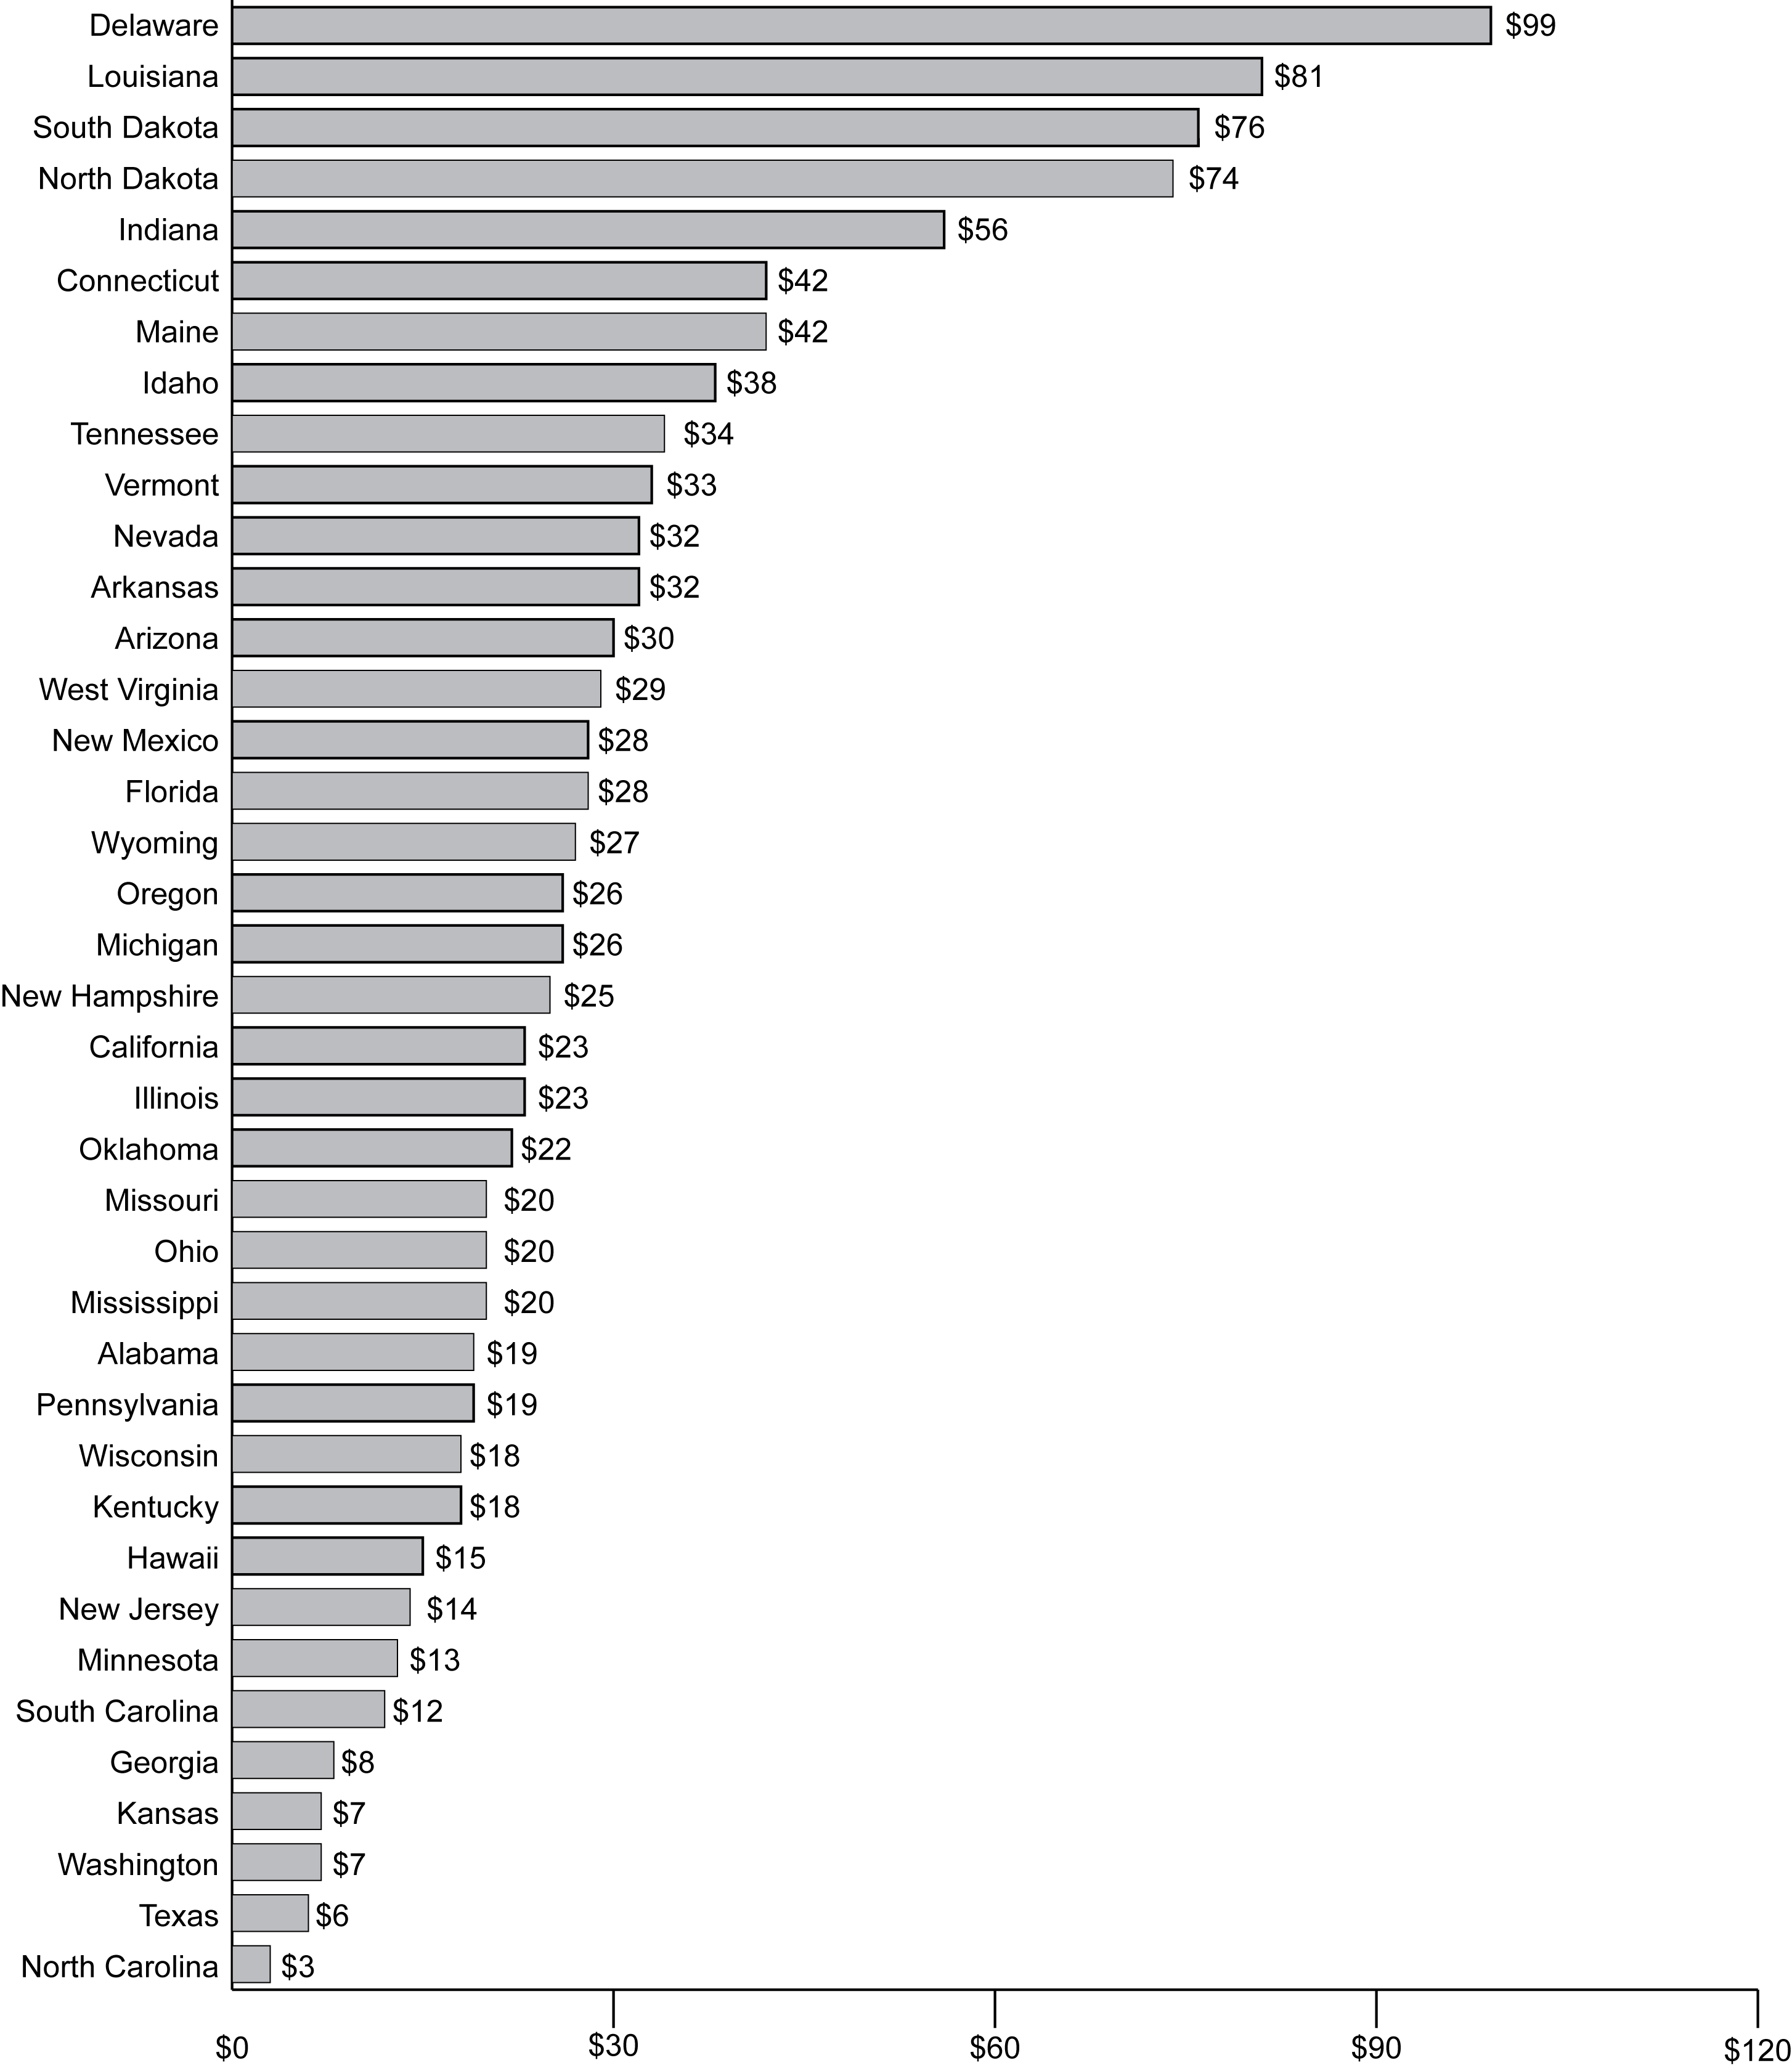
Exhibit reads: In 2006–07, Delaware reported spending an average of $99 per tested pupil to administer and maintain reading and mathematics tests required under NCLB in grades 3–8 and high school.
Note: To calculate per-pupil test administration costs, each state’s reported total cost for administration and maintenance of reading and mathematics assessments in grades 3–8 and high school for 2006–07 was divided by the number of students tested in grades 3–8 and high school, as reported in the Consolidated State Performance Reports. These data represent respondents’ best estimates; however, it may be difficult for states to accurately report on these costs and to separate NCLB-related costs from assessment costs that would have occurred in the absence of NCLB.
Sources: SSI-NCLB, Title I Assessment and Accountability Interviews and Analysis of SEA Documents (n = 39 states).

Smaller states reported incurring higher per-pupil costs for test administration and maintenance than did larger states.
Reported annual costs for test administration and maintenance expenditures varied by state size: annual average administrative and maintenance costs reported by the four states with the highest enrollment were far higher than those reported by the six states with the lowest enrollment ($38.7 million compared to $2.8 million). However, reported average per-pupil costs were higher in the smaller states than in the larger states ($44 per pupil compared to $20 per pupil). Thus, while larger states reported incurring higher administration costs overall, they benefited from economies of scale that resulted in lower per-pupil expenses (see Exhibit 8).
Exhibit 8
Average State-Reported Annual Total Cost and Per-Pupil Cost of Administering and Maintaining Reading and Mathematics Assessments in Grades 3–8 and High School, by State Enrollment Size, 2006–07
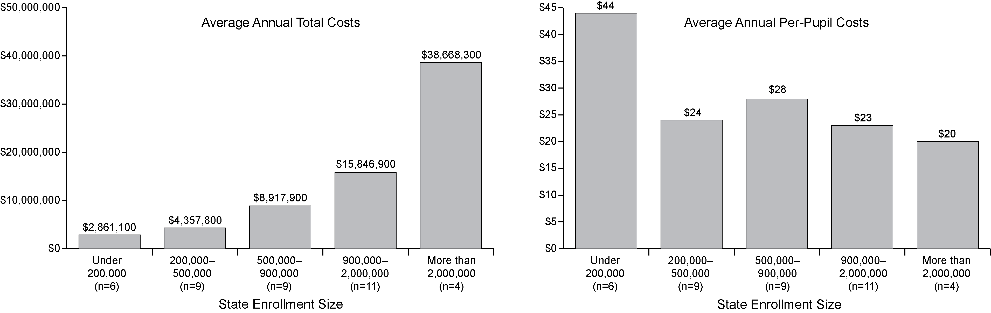
Exhibit reads: In states with fewer than 200,000 students, the average state-reported total expenditures for administering and maintaining state assessments in reading and mathematics in 2006–07 were $2,861,100.
Sources: SSI-NCLB, Title I Assessment and Accountability Interviews and Analysis of SEA Documents (n = 39 states).
Tests with only multiple-choice questions were reported to be less expensive to administer than tests with open-ended item types.
On average, states whose assessments relied entirely on multiple choice items reported that they spent less on test administration compared with states that incorporated a mix of item types, including short answer or extended response items. In states in which the tests were composed entirely of multiple choice items, reported test administration costs averaged $24 per tested pupil, compared with $31 per pupil in states that used a combination of item types. Responses to such questions are not scanned, but must be scored by a trained professional, resulting in additional costs.
Finally, test administration costs were moderately related to the length of the test: In the cluster of states with the shortest tests (shorter than 108 minutes, on average) the average reported cost for test administration and maintenance in 2006–07 was $27 per pupil. In the cluster of states with the longest tests (on average, longer than 180 minutes) the average cost for test administration and maintenance in 2006–07 was $40 per pupil. Overall, however, test duration and administration costs were weakly correlated: from a low of 0.09 for seventh-grade mathematics to a high of 0.37 for high school English.

Including All Students in Assessments
NCLB places great emphasis on the inclusion of all students in statewide assessments. In the case of students with disabilities or limited English proficiency, this inclusion is an essential foundation for ensuring equal opportunity to achieve the state’s common high standards. When large groups of students go untested, the school and the larger system lack needed information to monitor progress, detect low performance, and adjust educational strategies.
Testing all students in a valid, fair, and reliable way presents challenges. While most students with disabilities or limited English proficiency can participate in the general statewide assessments with or without accommodations, others require alternate assessments. In fact, NCLB and the Individuals with Disabilities Education Act (IDEA) require such assessments for students with disabilities; whether alternate assessments are at grade-level or based on alternate academic achievement standards is left up to each state to decide. (With the issuance of final regulations in April 2007, states may also develop alternate assessments based on modified academic achievement standards; information on the development of such assessments is not included in this report.)

Students with disabilities
Federal law requires states to include all students with disabilities in their assessment and accountability systems in a manner that allows these students to receive valid test scores. While federal guidance does not require a particular type of assessment, it does require states to have at least one alternate assessment. Students with disabilities typically participate in proficiency assessments in one of two ways: Participation in the general assessment (with or without accommodations) or participation in an alternate assessment based on alternate academic achievement standards.
All states allowed testing accommodations to enable the majority of students with disabilities to take the general state assessments.
Accommodations are changes made to standard test conditions that mitigate problems unrelated to knowledge of content that a student with a disability may face when taking a test. These changes do not affect the integrity and purpose of the test. In 2006–07, all states allowed testing accommodations for students with disabilities taking the general state assessments. The accommodations most frequently approved by states in 2004–05 included the following (Lazarus et al., 2006):
- presentation accommodations—large-print tests (48 states), sign interpretations of questions (43 states), Braille (44 states), instructions read aloud to student (41 states);
- equipment and material accommodations—magnification equipment (42 states), amplification equipment (39 states), light or acoustics accommodations (33 states);
- response accommodations—computer or machine (25 states), Braille (34 states), write-in test booklets (35 states);
- scheduling and timing accommodations—test administration with breaks (40 states), multiple sessions (23 states), time beneficial to students (37 states);
- setting accommodations—small-group administration (45 states), individual administration (45 states), carrel administration (35 states).
There are several types of alternate assessments (see Exhibit 9), and these assessments may use different methods of measuring student achievement, such as portfolios of student work demonstrating student performance relative to the content standards. With these methods, the progress of students with varying levels of cognitive disabilities can be evaluated based on achievement standards appropriate for their intellectual development, giving states the opportunity to more accurately gauge their academic progress.
Exhibit 9
Characteristics of Types of Assessments and Participating Students
 | General Assessment | Alternate Assessment Based on Grade-Level Achievement Standards | Alternate Assessment Based on Modified Achievement Standards | Alternate Assessment Based on Alternate Achievement Standards
Content standards taught and assessed | Grade level | Grade level | Grade level | Grade level extensions
Achievement standards | Grade level | Grade level | Modified level | Alternate level
Participating students | All general education students, most students with disabilities (with or without accommodations) | Students who need alternate ways to show mastery of grade-level content | Students with disabilities who can make progress toward, but may not reach, grade-level achievement standards in the time frame covered by their IEP | Students with the most significant cognitive disabilities
Source: Adapted from National Alternate Assessment Center, Warlick, K., & Towles-Reeves, E. (July 2005). Current issues in alternate assessment on alternate achievement standards. Presentation at the annual meeting of the Office of Special Education Programs Project Directors’ Conference, Washington, D.C. http://www.naacpartners.org/products/ presentations/national/OSEPprojectDirectors/10000.pdf (accessed Oct. 17, 2008).
Alternate assessments have been required since 2000, and by 2005–06, all states administered some form of alternate assessment for students with disabilities.
The 1997 reauthorization of IDEA required that states include students with disabilities in statewide assessment programs and administer alternate assessments for students with disabilities who cannot participate in the state’s general assessment even with appropriate accommodations. Prior to this federal mandate, such students were frequently excluded from large-scale testing programs. In 1999–2000, 12 states had alternate assessments in place, and 35 were in the process of developing them (Goertz and Duffy, 2001).
Under NCLB, alternate assessments must be “aligned with the [s]tate’s content standards, must yield results separately in both reading/language arts and mathematics, and must be designed and implemented in a manner that supports use of the results as an indicator of AYP.” Alternate assessments may be needed for students who have a broad variety of disabilities; consequently, a state may employ more than one type of alternate assessment (see Exhibit 9). Alternate assessments can measure proficiency based on grade-level achievement standards and can also measure proficiency based on alternate academic achievement standards for students with the most significant cognitive disabilities. Indeed, a “1 percent rule” permits up to 1 percent of students in a state or district to be counted as proficient (for AYP purposes) on an alternate assessment based on alternate achievement standards that are aligned with grade-level content standards. States may also develop modified academic achievement standards and assessments based on those standards for certain students with disabilities. The participants in the alternate assessments based on modified academic achievement standards would be the small group of students with disabilities for whom an alternate assessment based on alternate academic achievement standards would not be appropriate, but whose disability has precluded them from achieving grade-level proficiency on the assessment based on grade-level academic achievement standards and whose progress is such that they will not reach grade-level achievement standards in the current year. Under federal regulations, states and districts are allowed to include in AYP determinations the proficient and advanced scores from assessments based on modified academic achievement standards, subject to a 2 percent cap at the state and district level based on the total number of students in the grades assessed [34 C.F.R. § 200.13 (c)(2)(ii)].
NCLB required all states to have full assessment systems in reading and mathematics in place by 2005–06, including one or more alternate assessments for students with disabilities who could not take the general assessments even with accommodations. Similarly, IDEA requires states to develop an alternate assessment for all statewide tests, not just those required for determining AYP under NCLB. All states made efforts to comply with these statutory requirements. By 2005–06, all 50 states, the District of Columbia and Puerto Rico had alternate assessments in reading and mathematics, although three (Kentucky, Maine, and New Jersey) were missing some of the required grades, that is, grades 3–8 and at least one grade in high school. Thirty states administered alternate assessments in science as well. Some states were still developing alternate assessments in other academic subjects (e.g., science and social studies) as well as topics such as interpersonal skills, technology and recreation or leisure activities (see Exhibit 10).
As of July 2006, peer reviews of state assessment systems found that 38 states had not demonstrated that their alternate assessments based on alternate academic achievement standards (AA-AAAS) met all NCLB requirements. By January 2009, only 13 states had not yet received approval of their AA-AAAS.
Developing AA-AAAS that met peer review standards proved to be a challenge for states. As of late 2006, 38 states had not yet received approval for their AA-AAAS; shortcoming of alternate assessments were among the most common reasons that states’ assessment systems did not receive full approval (however, AA-AAAS were not the only reason that states did not receive full approval). In January 2009, only 13 states continued to face challenges with regard to their AA-AAAS, and two of these had opted to overhaul their assessment systems entirely. The main challenges still faced by states concerned alignment (linkage) with grade-level content and the technical quality of the alternate assessments (including validity and reliability as well as achievement standards setting).

Exhibit 10
Number of States With Alternate Assessments, by Subject, 2005–06
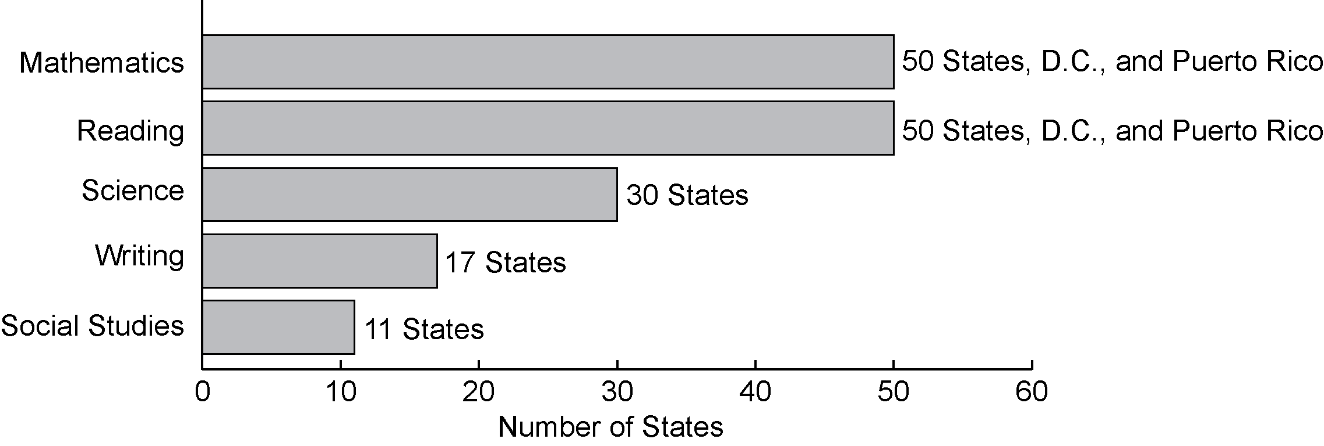
Exhibit reads: Fifty states, the District of Columbia, and Puerto Rico had mathematics alternate assessments in place in the 2005–06 school year.
Note: Alternate assessments in science, writing and social studies are not required under NCLB, but states are required by IDEA to have them if they administer a statewide assessment.
Source: SSI-NCLB, Title I Assessments and Accountability Interviews (n = 50 states, the District of Columbia, and Puerto Rico).
To comply with NCLB requirements, one-third of states reported that they developed entirely new AA-AAAS.
When NCLB was passed in 2001, each state was at a different point in the process of developing AA-AAAS. Whereas some states had alternate assessments in place and either kept or modified their existing test, other states chose to develop entirely new assessments to appropriately test students with the most severe cognitive disabilities. In 2006–07, 18 states (of 42 responding) reported they developed entirely new AA-AAAS in response to NCLB, while 15 states chose to modify their existing AA-AAAS. Officials from nine states reported that they chose to retain their existing AA_AAAS (see Exhibit 11).
Exhibit 11
State Development of Alternate Assessments Based on
Alternate Academic Achievement Standards for NCLB, 2006–07
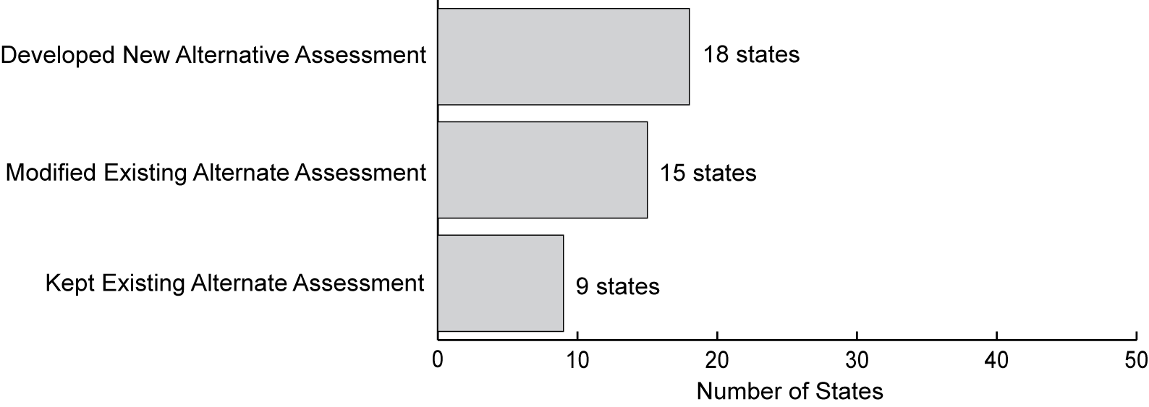
Exhibit reads: Fifteen states developed new alternate assessments based on alternate achievement standards to meet NCLB requirements.
Source: SSI-NCLB, Title I Assessments and Accountability Interviews (n = 42 states).

Students with limited English proficiency
All states allowed LEP students to take assessments with accommodations, but states varied widely in the percentages of students actually using them.
Title I requires that all LEP students—except for those who have been enrolled in schools in the U.S. for less than 12 months—be included in academic content area assessments with reasonable accommodations, including native language versions of the assessments. In 2005–06, all states allowed LEP students to use a variety of accommodations when taking state content assessments, the most common accommodations being small group or individual test administration or reading the directions aloud to students (see Exhibit 12). Accommodations for LEP students fall into the general categories of presentation, setting, timing, and response.
Exhibit 12
Six Most Commonly State-Allowed Accommodations for Students With
Limited English Proficiency Taking Content-Area Assessments, 2006–07
Exhibit reads: Forty-five states used small groups or individual administrations as an accommodation for LEP students taking state content-area tests.
Sources: Biennial Evaluation Report to Congress on the Implementation of the State Formula Grant Program, 2002–04; English Language Acquisition, Language Enhancement and Academic Achievement Act (ESEA, Title III, Part A) (n = 45 states, the District of Columbia, and Puerto Rico).

The percentage of LEP students actually using accommodations varied greatly from state to state. Of the 29 states that tracked and reported this information, the percentage of LEP students who took accommodated reading or mathematics assessments in 2003–04 ranged from 100 percent in Louisiana, North Carolina, and the District of Columbia to 6 percent in Texas and Idaho. The percentage of students assessed using accommodations did not seem to be associated with the total number of LEP students tested in the state; both high and low percentages were reported for states with large and small LEP student populations.
NCLB also allows for the use of native language assessments, provided the assessment is comparable to the English version and aligned to the state content and academic achievement standards. Because native-language assessments are costly and difficult to develop, only 10 states reported having them available. In 2005–06, most of these assessments were in Spanish (eight); however, in addition to Spanish, two states reported that they also administered assessments in additional languages, including Arabic, Chinese, Gujarati, Haitian-Creole, Hmong, Japanese, Korean, Portuguese, Russian, Somali, and Vietnamese.
Even when a state had a native-language assessment in place, the assessment was not available for all grades in all subjects. In 2005–06, for the subjects covered by NCLB, eight states offered native-language assessments in mathematics, four offered them in reading, and one offered them in science. For some states, native-language assessments were offered for grade-level ranges (e.g., 3–8) or separate grade levels.

Defining Student Proficiency: Academic Achievement Standards
NCLB sets the goal of all students reaching proficiency in reading and mathematics by 2013–14, but each state must define the level of student performance that is to be labeled “proficient” on its statewide assessments. Each state’s definition of proficiency is reflected in its academic achievement standards (previously referred to as performance standards under IASA) for each grade level and subject tested.
As described in federal non-regulatory guidance, “Student academic achievement standards (called performance standards under the 1994 reauthorization of the Elementary and Secondary Education Act of 1965) are explicit definitions of what students must know and be able to do to demonstrate proficiency. Achievement standards further define content standards by connecting them to information that describes how well students are acquiring the knowledge and skills contained in academic content standards.” Academic achievement standards include achievement-level descriptors that clarify student skills and anchor the achievement standards to the content standards. For example, one descriptor in Illinois reads: “Students who meet the standard can use correct grammar, spelling, punctuation, capitalization and structure.” States must also determine the “cut scores” on the state assessment that determine each achievement level. Under NCLB, states are required to establish at least three achievement levels—often referred to as basic, proficient, and advanced. However, most states (42 states as of 2003–04) had opted to designate four or five achievement levels, with the additional levels usually, but not always, being set below the basic level.
States determine achievement level cut scores through systematic judgmental processes that often involved committees of psychometric experts, teachers, and administrators. The most frequently employed strategy for setting cut scores is called “bookmarking” (Mitzel, 2005). During this process, participants review test booklets in which items are arranged from least difficult to most difficult. Committee participants then set “bookmarks” to delineate different levels, consistent with the achievement-level descriptors.
Student “proficiency” has little common meaning across states.
Academic achievement standards for proficiency are pivotal to NCLB accountability: schools’ AYP determinations are based on each subgroup of students reaching the state-defined proficiency level. Thus, states’ definitions of academic proficiency play a key role in determining how well the state performs under NCLB. Because states establish academic achievement standards relative to their content standards and assessments, these standards can, and do, vary from state to state.
One way to measure the amount of variation in proficiency standards is to compare each state’s test against a common external benchmark. The only benchmark available across all states is the National Assessment of Educational Progress (NAEP). An analysis examined how state proficiency levels in reading and mathematics for grades 4 and 8 varied against this common metric (National Center for Education Statistics, 2007; see also McLaughlin, Bandeira de Mello, Blankenship, Chaney, Hikawa, Rojas, William, and Wolman, 2007). Using a process called equipercentile mapping, the researchers calculated NAEP scale equivalents for the mathematics and reading standards for proficiency in each state.
States varied widely in the levels at which they set their performance standards in reading and mathematics, when compared to NAEP. Using NAEP as a common external metric, state standards for proficiency in eighth-grade mathematics under NCLB range from a NAEP equivalent score of approximately 230 to 311 (see Exhibit 13). Similar patterns occurred in fourth-grade mathematics and in reading at both grade levels. As a result, a student deemed to be proficient for NCLB purposes in one state might not be considered proficient in another state, and cross-state comparisons and nationwide estimates of the percentage of students who are proficient must be interpreted with caution.
This variation in academic achievement standards should be taken into account in any examination of state variation in the numbers and percentages of schools that make or do not make AYP or are identified for improvement. Relative to one another and to NAEP, states can be categorized as setting their standards for proficiency at low, medium, and high levels of expected performance. Chapter III of this report incorporates these categories in analyses of AYP results across states.

Measuring Progress Toward Proficiency: Adequate Yearly Progress
State measures of AYP are the foundation of NCLB accountability. Both Title I and non–Title I schools must meet AYP targets; AYP is the accountability mechanism with the greatest scope, affecting all public schools in the United States. State AYP accountability mechanisms have three components:
1. AYP indicators—percentage of students performing at the proficient level on statewide assessments in reading and mathematics, student test participation rates, and other academic indicators.
2. AYP targets—starting points, annual measurable objectives, and intermediate goals for percent proficient in reading and mathematics.
Exhibit 13
NAEP Scale Equivalents of State Proficiency Standards,
by State, for Eighth-Grade Mathematics, 2005
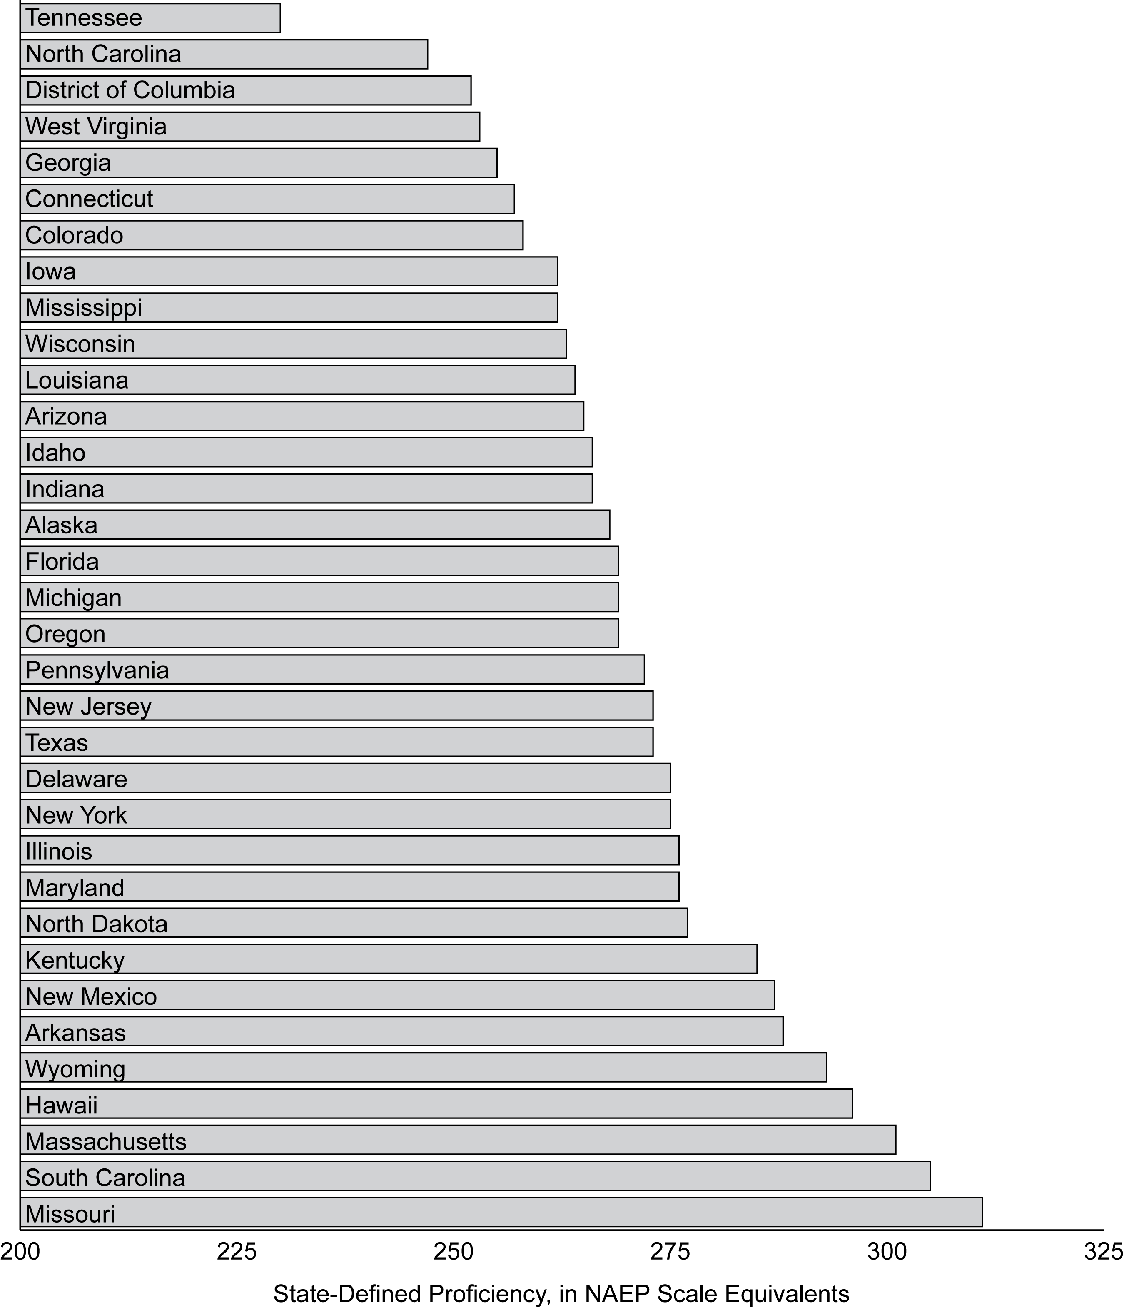
Exhibit reads: On average, students who met the state’s proficient level in Tennessee would be estimated to score 230 or higher on NAEP while students who met the state’s proficient level in Missouri would have an estimated NAEP score of 311 or above.
Note: By matching percentages of students meeting state standards in schools participating in NAEP with the distribution of performance of students in those schools on NAEP, state standards for proficiency may be mapped to scores on the NAEP scale.
Source: National Center for Education Statistics, 2007 (n = 34 states and the District of Columbia).

3. Methods to avoid misclassifying schools—“safe harbor,” minimum n, confidence intervals, and definitions of full academic year.
The U.S. Department of Education permits states to seek amendments to their NCLB accountability plans, including elements of their AYP definitions.

Selecting AYP indicators
NCLB requires states to use five indicators to determine AYP: (1) the percentage of students who are proficient in reading as measured by the state reading assessment; (2) the percentage of students who are proficient in mathematics as measured by the state mathematics assessment; (3) the percentage of students who participate in state reading assessments; (4) the percentage of students who participate in state mathematics assessments; and (5) at least one other academic indicator at each school level (elementary, middle, and high school). Even small differences in the rules for calculating each AYP indicator can affect whether schools or districts make adequate yearly progress. For this reason, states have given considerable attention to the details of their choices.
For calculations based on 2005–06 tests, fewer than half of states granted exceptions allowing districts to exceed the 1 percent cap on the inclusion of scores from alternate assessments based on alternate academic achievement standards.
States must include in AYP calculations the scores of students assessed using the alternate assessment based on alternate academic achievement standards—provided that the number of students identified as proficient using the alternate assessment did not exceed 1 percent of all students tested. Districts can request from their state an exception to exceed the 1 percent cap and, prior to the release of the April 9, 2007, regulations, states could request exceptions of the U.S. Department of Education to exceed the 1 percent cap. When calculating AYP based on 2005–06 testing, less than half of states granted exceptions to districts to exceed the 1 percent cap: Of the 49 states, the District of Columbia, and Puerto Rico for which data were available, 22 reported having granted exceptions to districts. Twenty-six states, the District of Columbia, and Puerto Rico indicated that they had not granted exceptions to districts, in most cases because no districts had requested an exception. While several states granted exceptions to fewer than 10 districts, Iowa approved exceptions for 63 districts (many very small), and Ohio approved nearly 100 (see Appendix B, Exhibit B.4). For the 22 states in which data were available, in most cases districts exceeded the 1 percent cap by only 1 or 2 percentage points. Districts that exceeded the cap by more than 2 percentage points often had very low student enrollments.
In addition to measures of student proficiency in reading and mathematics, measures of AYP must incorporate at least one other indicator for each schooling level. At the elementary and middle school levels, each state selects this indicator. Attendance was the most common “other academic indicator” (used by 35 states) for elementary and middle schools in 2006–07, but some states chose to use additional achievement measures instead. These states included results from other state assessments, including writing or science assessments (seven states), or performance increases on a state index (four states). Other indicators also included reductions in the percent of students with below-basic performance (Vermont) and, conversely, increases in the percent of students that score at the advanced level (Idaho) (see Appendix B, Exhibit B.5).
All states were required to establish high school graduation targets. Among the 47 states and the District of Columbia that reported high school graduation targets for 2006–07, the average target was 77 percent: targets for 2006–07 ranged from 50 to 95 percent.
While graduation rates are a required AYP indicator for high schools, there is still a great deal of variation in the ways in which states calculate graduation rates and in the states’ capacity to process data on high school completion. The National Governors Association has led an initiative to encourage all states to adopt the same approach to calculating graduation rates. Under this initiative, states will track individual student progress over time, including students who change high schools and those who receive a GED. In 2008, 19 states were able to report a graduation rate consistent with the NGA approach; other states projected they would be able to do so within a few years
In addition, in October 2008, the U.S. Department of Education published regulations that included new requirements for calculating graduation rates. Starting with graduation data from 2010–11, these regulations require states and districts to report a four-year adjusted cohort graduation rate, disaggregated by subgroups, at the school, district and state levels. Furthermore, states must use that rate, disaggregated by subgroups, in making AYP determinations for schools, districts, and the state, beginning with determinations that are based on 2011–12 assessments results. These 2008 regulations also require states to set a goal and targets for high school graduation.
In 2006–07, the way in which states determined AYP targets for graduation varied greatly. In contrast to the mandatory 100 percent proficiency states must meet by 2013–14 for reading and mathematics, states have flexibility in setting their annual targets and long-term goals for graduation. States use two general approaches for setting graduation targets, minimum thresholds and progressive annual targets. Overall, 31 states and the District of Columbia have set a minimum threshold that schools must meet, or toward which they must progress in order to meet AYP for the graduation rate. These minimum threshold levels range from 50 to 90 percent, with an average of 80 percent. In these states, a school also meets the AYP target for graduation rate if they satisfy the state-defined standard for improvement in their graduation rate. For example, in Arizona, “The performance levels schools and LEAs must meet to make AYP are a 90 percent attendance rate, or a 71 percent graduation rate. In either case, a school or LEA is deemed to have met the goal if it demonstrates a 1 percentage point improvement over the previous year.”
While not required, 16 states had established progressive annual targets for high school graduation (see Exhibit 14 for examples of four state trajectories). Among these states, the range for the 2013–14 graduation rate goals varied from 65 to 100 percent. For example, Michigan has set its long-term graduation target at 90 percent, explaining, “It is not an expectation that, like student proficiency in English Language Arts and Mathematics, the target goal for graduation rate in Michigan should reach 100 percent by 2013–14. The reality of high school enrollment, in Michigan and elsewhere, would make this an improbable if not impossible goal to reach. It is expected, however, that growth toward higher targets should be encouraged.” Oklahoma, for its part, “would like to encourage schools to meet the goal of a 100 percent graduation rate by 2013–14.” While the state has established annual targets that progress toward 100 percent, schools are considered to have met AYP targets for graduation if they post an increase over the previous year’s graduation rate.
Exhibit 14
Annual Graduation Rate Targets for AYP in Four States
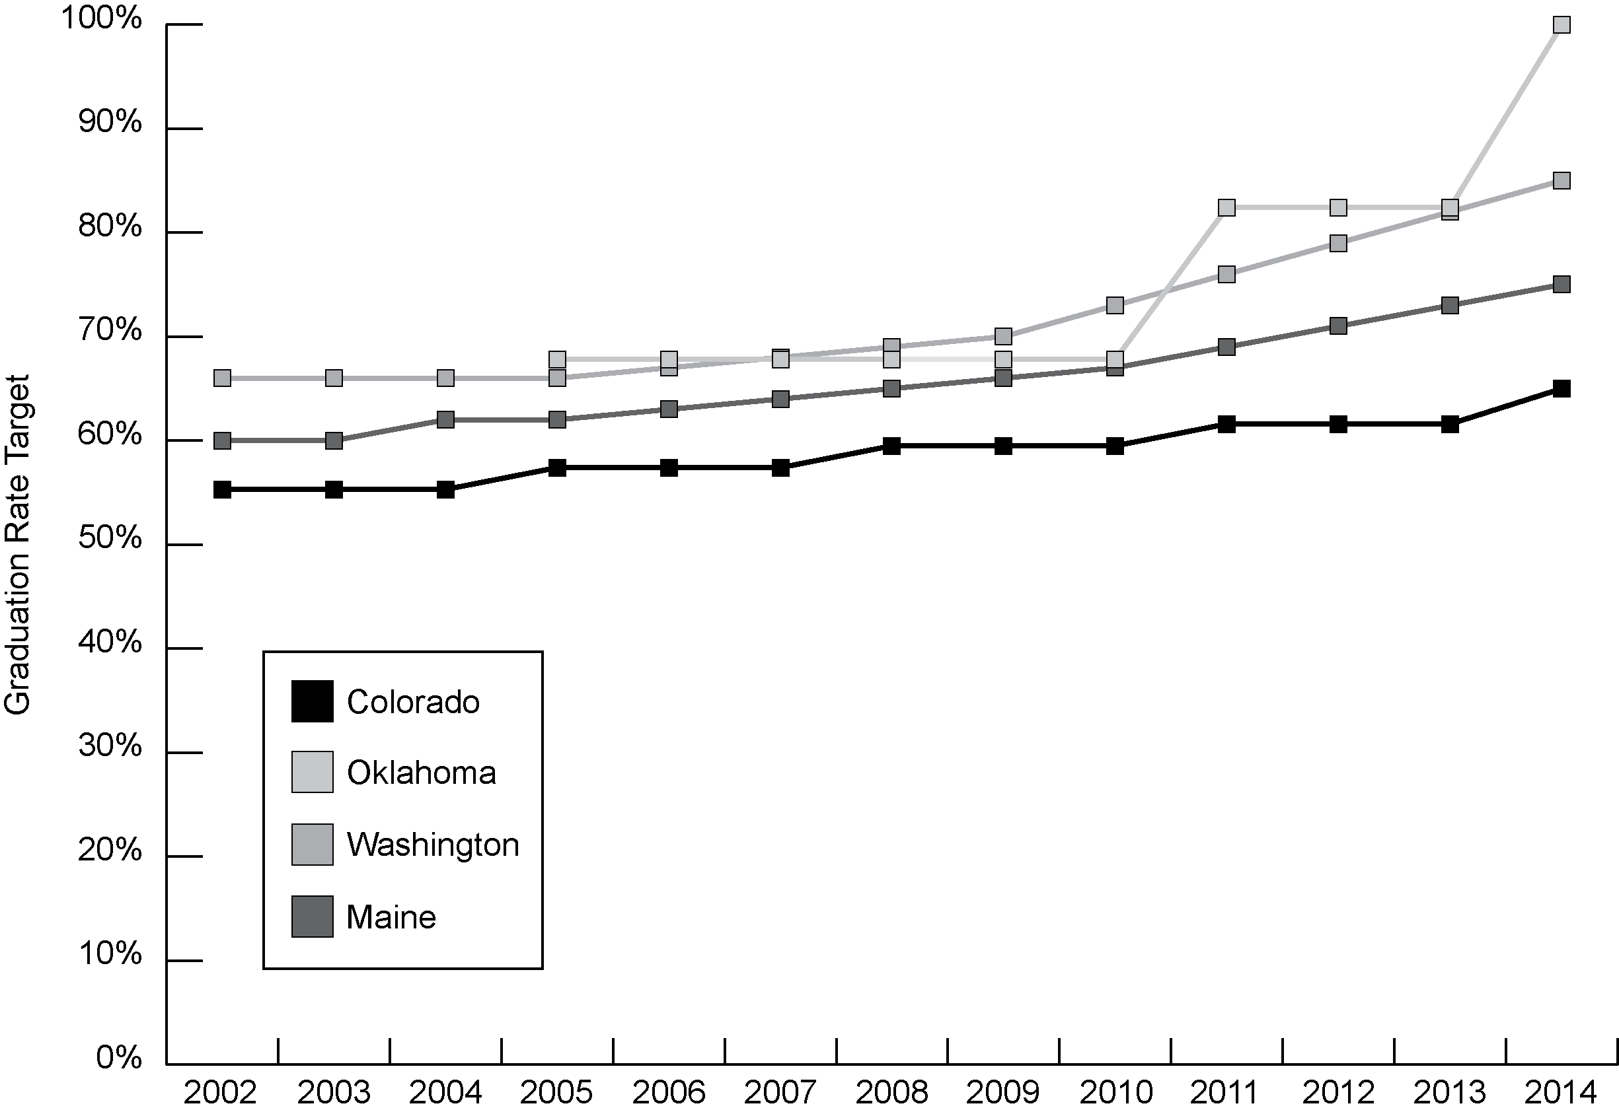
Exhibit reads: Colorado’s graduation rate target was 55.3 percent in 2002 and progresses to a target of 65 percent in 2014, while Maine starts at 60 percent in 2002 and progresses to 75 percent in 2014.
Source: SSI-NCLB, Analysis of State Accountability Workbooks.
Of the states that had approved amendments in 2006 and 2007, 23 states allowed more than four years to graduation (for students with such provisions written into their individualized education programs, or for LEP students). Finally, as in prior years, several states have amended their AYP definitions in 2006 and 2007 to permit progress toward the attainment of graduation targets, rather than actual attainment of those targets.

Setting targets for performance
NCLB requires states to set proficiency targets in increments from the percentage of students scoring proficient at the point at which NCLB went into effect in 2001–02 to the ultimate goal of 100 percent in 2014. Targets give systems near-term goals to shoot for and also allow them to determine whether the progress being made at any point in time is sufficient for reaching their long-term objective.

Establishing a Starting Point
One of the states’ first required tasks, after defining their AYP indicators, was to establish starting points with respect to the percentage of students scoring proficient on state tests in reading and mathematics at the outset of NCLB implementation, as well as trajectories of expected progress toward the goal of 100 percent proficiency in each subject by 2013–14.
Under NCLB, states with appropriate data from 2001–02 were required to use those results to determine their starting points for establishing AYP targets in reading and mathematics. As required by statute, starting points were to be the higher of the percentage of students at the proficient level in (1) the state’s lowest-achieving subgroup, or (2) the school at the 20th percentile among all schools based on enrollment, ranked by the percentage of proficient students. In most states, this latter process yielded the higher percentage. Thus, the percentage of students scoring at the proficient level in the school at the 20th percentile of enrollment became the AYP starting point for the state. States were allowed—but not required—to establish different starting points by grade span (for example, grades 3–8), by school level (elementary, middle, high school), or by grade. The same starting points had to be used for all subgroups and for all schools within the state.
The resulting starting points used to develop the AYP targets for each subject varied among states. For example, starting points for elementary reading ranged from 14 percent of students proficient in California to 77 percent of students proficient in Colorado. In elementary mathematics, the range was greater: from 8 percent of students proficient in Missouri to 75 percent of students proficient in North Carolina. Twenty states and the District of Columbia had starting points lower than 50 percent in elementary reading; 29 states, the District of Columbia, and Puerto Rico were below this mark in elementary mathematics. High schools are furthest from the target, with 29 states, the District of Columbia, and Puerto Rico having starting points of less than 50 percent proficiency, and 13 states and the District of Columbia starting with fewer than 30 percent proficient.
This variation in starting points has implications for evaluating progress across states. Because states did not start at the same place (as indicated by the ranges noted above), some have much farther to go to realize the goal of 100 percent proficiency. For example, in ten states and the District of Columbia, the starting point for mathematics was below 20 percent proficient. In contrast, North Carolina’s starting point was 75 percent proficient (thus far fewer students need to increase their performance to the proficient level in North Carolina than in other states).
The variation in AYP starting points—and hence in how much progress a state must make by 2014—is strongly related to how high the states set their academic achievement standards for proficiency.
As discussed earlier, one way to measure the variation in academic achievement standards across states is to compare each state’s cut score for determining proficient performance relative to the proficiency score used by NAEP. There is a negative correlation (r = –0.55 for eighth-grade mathematics to –0.74 for eighth-grade English language arts) between states’ academic achievement standards (converted to the NAEP scale) and starting points for NCLB accountability. In other words, states that set higher academic achievement standards tend to have a lower percentage of students scoring at the proficient level and therefore must make greater progress in student achievement by 2013–14 (see Exhibit 15). States with higher performance standards in mathematics, for example, must realize an average increase of 77 percentage points in the share of students who are proficient by 2013–14, while states with lower performance standards have to realize an average increase of 43 percentage points.

Annual Measurable Objectives
Under NCLB, each state must set statewide annual measurable objectives (AMOs) for mathematics and reading assessments. AMOs identify the minimum percentage of students (among those enrolled for a full academic year) required to meet or exceed the proficient level on the academic assessments in a given year. AMOs may vary by grade span or by grade, and they are not required to apply to the same interval from year to year. The first increase was required in two years or less after NCLB implementation (by 2004–05), and the subsequent increases must occur at not more than three-year intervals.
Exhibit 15
Improvement Needed to Reach 100 Percent Proficient by 2013–14,
by Level of Difficulty of State Academic Achievement Standards,
for Eighth-Grade Mathematics
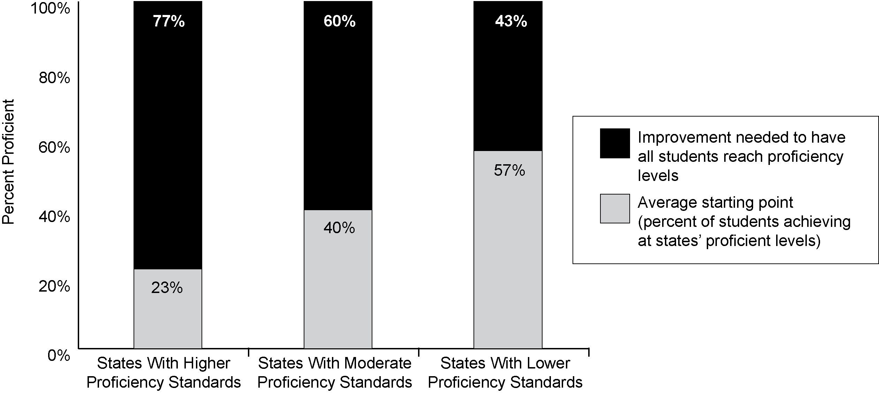
Exhibit reads: States that set higher standards for proficiency relative to other states had an average starting point for their AYP target for eighth-grade mathematics of 23 percent; they need to increase the percentage of students achieving at the state proficiency level by 77 percentage points, on average, in order to achieve the goal of all students achieving at the state’s proficient level by 2013–14.
Sources: SSI-NCLB analyses (n = 34 states and the District of Columbia).
In 2006–07, state approaches to setting their AMOs and intermediate goals fell into one of three common types of trajectories—linear, stair-step, or mixed (see Exhibit 16). Most states chose to start their trajectories with little or no growth required in the first two to three years after NCLB implementation, but after this initial period of time:
- nine states had linear growth plans that expect roughly equal increments of progress each year;
- fourteen states, the District of Columbia, and Puerto Rico had “stair-step” plans in which the AMO remains the same for two or three years before increasing, and this pattern is repeated until the AMO equals 100 percent proficient);
- twenty-seven states had a “mixed pattern” plan in which AMOs follow a stair-step pattern for a few years, then switch to a linear trajectory.
Exhibit 16
Examples of Stair-Step, Linear, and Mixed-Pattern AMO Trajectories (Mathematics)
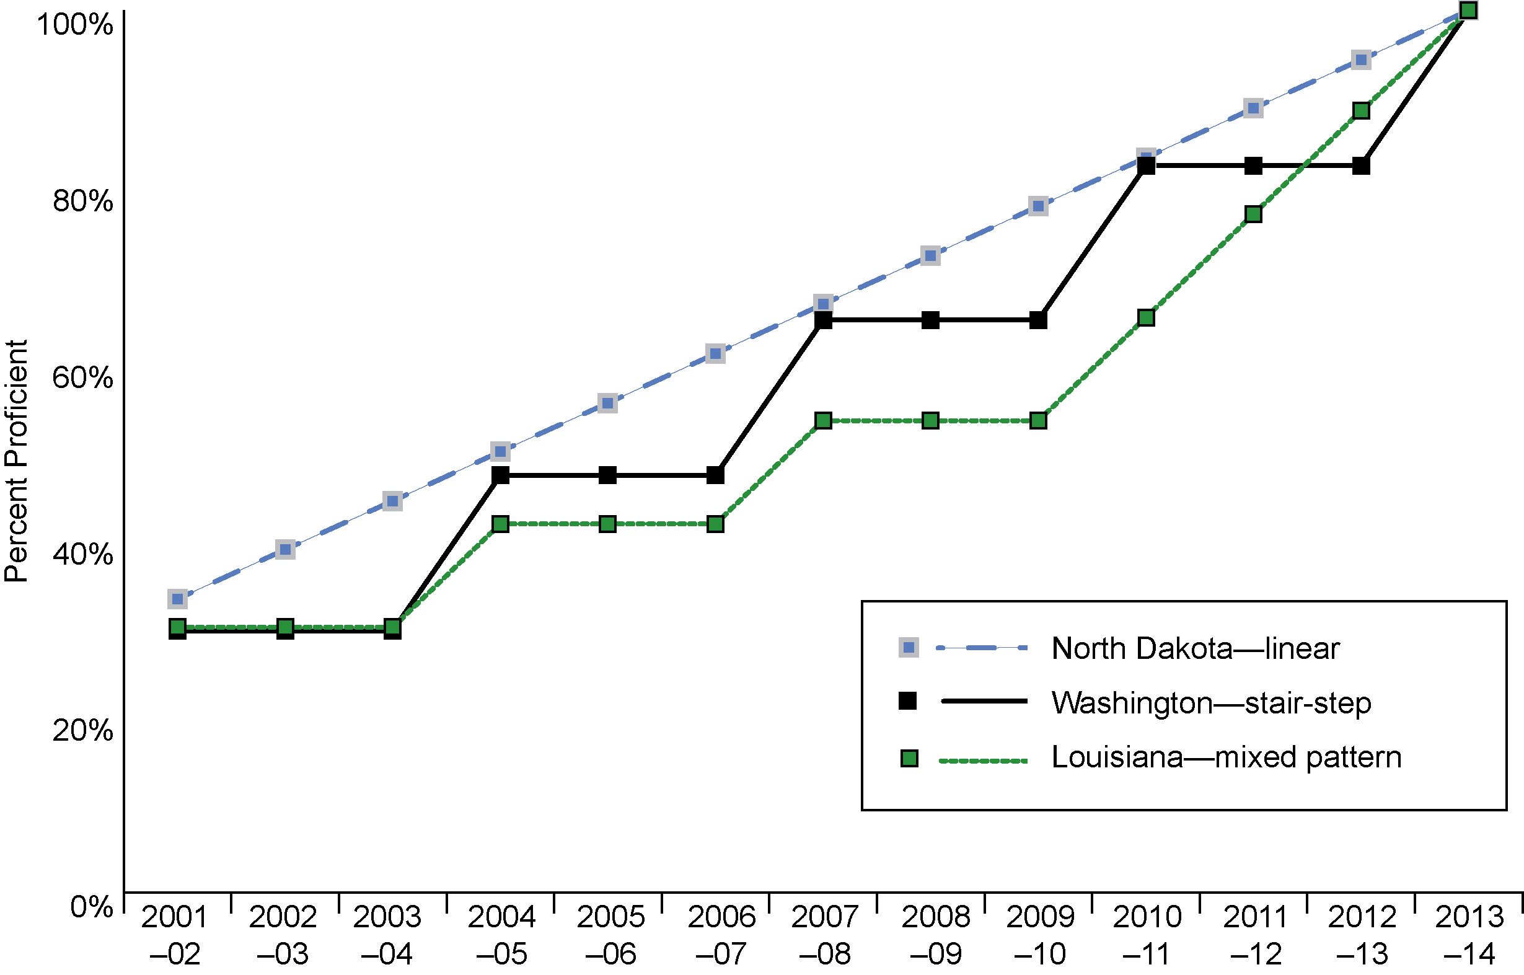
Exhibit reads: North Dakota’s mathematics trajectory exemplifies a linear pattern; Washington’s is stair-step; and Louisiana’s is a mixed-pattern trajectory.
Source: SSI-NCLB, Analysis of State Accountability Workbooks.
In setting AMOs for achievement growth, 27 states start with small increments then increase growth expectations after 2009.
An important feature of the “mixed pattern” trajectories established by many states is that, on average, they project a more rapid increase in the latter years of NCLB implementation than in the initial years. Indeed, among these states, the average required annual growth in the initial (stair-step) part of the trajectory is only 3 percentage points; when the trajectory becomes linear, however, the annual expected growth is 8 percentage points. In other words, the rate of growth is expected to accelerate in the latter half of the NCLB time period.
In the “mixed-pattern” states, only 28 percent of the total required growth is expected to occur in the first half of the trajectory (from 2004 to 2009), while 72 percent of the achievement growth is expected in the last five years (from 2009 to 2014) (see Exhibit 17). This means that these states expect achievement to increase twice as fast between 2009 and 2014 as it is expected to increase between 2004 and 2009. In contrast, the linear and stair-step states expect consistent increases over the full 12-year period.

Methods to ensure the validity and reliability of AYP determinations
Exhibit 17
Expected Achievement Growth Based on Different AMO Trajectory Types
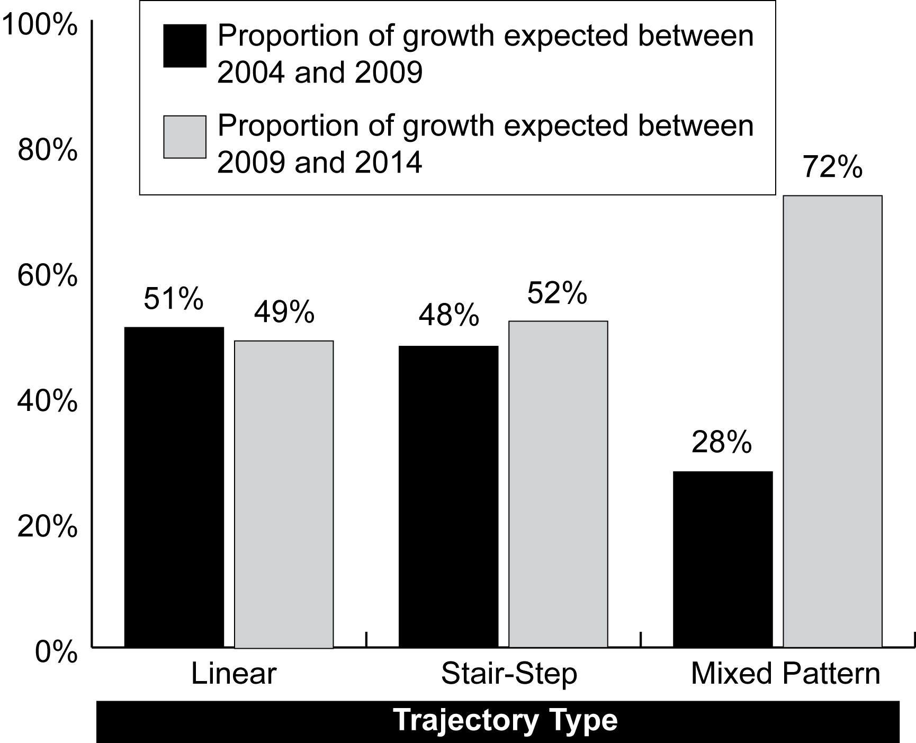
Exhibit reads: On average, in states with a linear trajectory, at least 51 percent of the expected growth must take place between spring 2004 and spring 2009, and 49 percent must occur between spring 2009 and spring 2014.
Note: Because states were not required to increase AMOs for the first years of NCLB implementation, the calculations were conducted using state AMOs from 2004 through 2014.
Sources: SSI-NCLB, Review of State Accountability Workbooks and SEA Web sites (n = 49 states, District of Columbia, and Puerto Rico).
It is important to ensure that AYP calculations are valid (i.e., measure the right things) and reliable (i.e., avoid year-to-year fluctuations not related to changes in student achievement). To the extent practicable, AYP designations should not be the result of random fluctuations in the individual students tested, the specific questions included in the assessment, or the peculiarities of the testing situation. Nor should AYP designations—and ultimately, the identification of schools for improvement—be determined by the performance of students who did not receive at least one year of instruction in the school. Some of the most common means for ensuring the validity and reliability of AYP determinations include the following (see Appendix B, Exhibits B.5 and B.6 for information on the scope of key AYP provisions):
- using the provision known as “safe harbor” by which schools may be considered as having met AYP if the schools have significantly decreased the percentage of students not proficient;
- establishing a minimum number of students (“minimum n”) in a subgroup needed to constitute a subgroup for inclusion as a separate group in AYP determinations;
- applying a confidence interval or standard error of measurement to account for sampling error or measurement error;
- providing guidelines to ensure schools are held accountable only for students receiving instruction at the same school for a full academic year;
- averaging data over time, whether for proficiency or participation rates;
- setting rules for identifying schools and districts for improvement based on missing AYP in the same indicator for two consecutive years (reading, mathematics, other academic indicator).
While state efforts have focused on reducing the likelihood that high-performing schools or districts are mistakenly counted as having not made AYP, the methods also may increase the likelihood that truly low-performing schools and districts will make AYP. Analyses presented in Chapter III discuss the relationship between state reliability adjustments and the rates at which schools make or do not make AYP targets.

Safe Harbor
NCLB requires that states establish criteria and conditions that make their AYP models valid and reliable. NCLB includes a “safe harbor” provision used by all states: schools may make AYP if the percentage of students scoring below proficient decreases by 10 percent from the preceding school year and if the school makes AYP for the relevant group or subgroup for the other academic indicator and participation rate. (See Appendix B, Exhibit B.5 for information on each state’s safe harbor policy.)
Exhibit 18
States With Various Minimum n Sizes for Calculating Proficiency of the “All Students” Subgroup, 2006–07
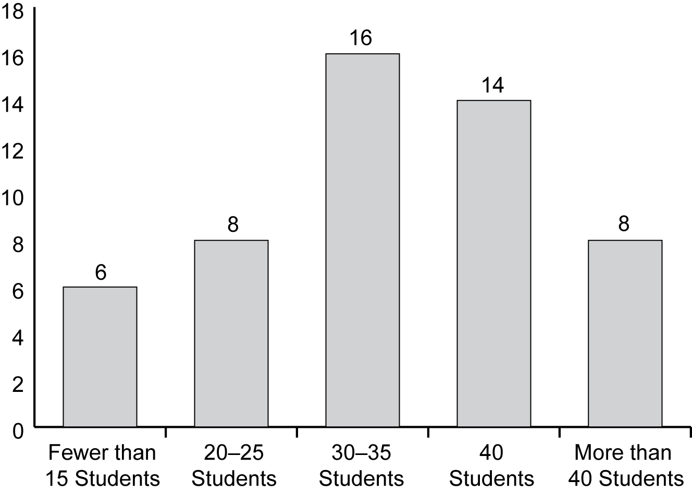
Exhibit reads: In 2006–07, six states adopted a minimum n size of 15 students or fewer for the purposes of determining proficiency of the “all students” subgroup for AYP.
Note: States in which the minimum n varies by student enrollment are included in the category which reflects the smallest number indicated in their formula (30 students, for example, in the case of Florida). North Dakota, which does not have a minimum n size, is excluded.
Source: SSI-NCLB, Title I Assessment and Accountability Interviews with Analysis of SEA Documents (n = 49 states, the District of Columbia, and Puerto Rico).
Number of States

Setting Minimum Sizes for Subgroups
Under NCLB, states are required to determine minimum sizes (“minimum n”) for groups to be included in calculations of AYP. Setting a minimum size reduces statistical error due to small sample size. For example, if a state sets a minimum n at 30 students, a school must have 30 or more students enrolled for a full academic year in a given group (e.g., LEP students) for that group to count separately in the school’s AYP calculation. States set the same minimum n’s for their schools and districts; in 2006–07, 11 states set separate n’s for proficiency rates and test participation rates. (See Appendix B, Exhibits B.6 and B.7 for information on each state’s minimum n.) In 2006–07, the minimum n size for proficiency ranged from five (in Maryland) to 50 students (in Virginia and West Virginia), with more than half of all states choosing either 30 or 40 as the threshold number (see Exhibit 18). North Dakota does not have a minimum n size for all students, having established a policy of conducting a test of statistical significance instead (however, North Dakota has set a minimum n of 10 for subgroups). In the case of small schools whose total enrollment in tested grades falls below the overall minimum n, the state may determine AYP using an alternate, small-school AYP formula. In either case—subgroup or overall minimum n—the purpose is to avoid misclassifying a school or district based on an unreliable estimate of performance.
Although the majority of states employed a single number as their n size, in 2006–07, 12 states had adopted an approach that takes into account the size of a subgroup in proportion to the total enrollment. For example, Florida adopted a minimum n size that largely corresponded to the overall student population in AYP grades. As described in Florida’s accountability workbook: “For accountability purposes, the minimum group size shall be at least 30 students and more than 15 percent of the total school population or 100 students for the subgroups for performance criteria (not participation).”
As early as 2003, states requested permission to set a different minimum n size for the LEP and students with disabilities subgroups as for other subgroups of students. For example, a state could have set the minimum n for the LEP subgroup and the students with disabilities subgroup at 40, while the minimum n for other subgroups could be set at 30. Thus, fewer schools would be held accountable for the first two subgroups. However, non-regulatory guidance issued on July 20, 2007, prohibited states from establishing a different minimum number of students for separate subgroups. Accordingly, in 2008, nine states were required to amend their accountability plans to establish a uniform minimum n for all subgroups.

Using Confidence Intervals
Another strategy states use to avoid misclassifying schools is to construct a confidence interval around the observed percentage of students who scored proficient or above in a given year. Confidence intervals take into account the fact that the students tested in any particular year might not be representative of students in that school across the years—that is, that there is some degree of sampling error, particularly in schools with untested grades. A confidence interval is a statistical calculation that provides an estimated range of values that includes the observed performance plus an allowance for this sampling error. The size of that range depends upon the degree of confidence desired—for example, a 99 percent confidence interval will produce a larger range of acceptable scores than a 95 percent confidence interval. As the New Mexico State Department of Education explained:
As the number of test scores and students diminishes so does our confidence in interpreting results. The U.S. Department of Education has allowed us to apply a 99% confidence interval. If the AYP target is 35% proficient in Mathematics, for example, and 101 students are tested, then the target lowers to 24.97, which is the lower bound of the confidence interval. This is similar to the margin of error mentioned in surveys and election results (“give or take 3%”). The smaller the number of scores used in an analysis the wider the confidence interval (margin of error).
The use of confidence intervals is designed to reduce the likelihood that schools will be incorrectly labeled as not making AYP, and by 2006–07, the majority of states (40 states and Puerto Rico) had received approval to apply confidence intervals to AYP calculations, most often at the 95 or 99 percent levels. In general, the larger the confidence interval, the more likely it is that truly low-performing schools will be misclassified as making AYP and the less likely it is that higher performing schools will be misclassified as not making AYP. (See Appendix B, Exhibit B.8 for information on each state’s use of confidence intervals.)
A few other states (Hawaii, Michigan, South Carolina) apply a related statistical procedure—the standard error of measurement. For example, through its 2005 accountability amendment, Michigan received approval to apply an error band of two standard errors to each student’s score. Student scores that fall within this error band will be counted as proficient for AYP.

Defining Full Academic Year
Under NCLB, schools are held accountable for the proficiency of students who were enrolled in a school for a full academic year, as defined by the state. Only students enrolled for a full academic year are to be included in school AYP calculations for proficiency—thus, schools are held accountable for those students that have received a significant amount of instruction at the school, which helps to support the overall validity of the system. Each state defines it own full academic year. In 2004–05, state definitions of full academic year fell into four main categories; these general categories remained similar in 2006–07. The most frequently used definition (40 states in 2004–05) was the time from a target date in the fall through a test date in the spring. Four states identified one specific date during the year, five established a minimum number of days of enrollment, and three required continuous enrollment from one test administration to the next (for example, spring 2003 testing through spring 2004 testing).
In 2007, seven states requested permission to modify their definitions of full academic year—among these states three had also opted to move their high school assessment from the spring to the fall. One such modification (Michigan) entailed “basing the full academic year on two-semi-annual student count days—the fourth Wednesday in September and the second Wednesday in February. For schools and school districts, students must be enrolled for the three most recent semi-annual official count days.”

Averaging Scores Over Time
Under NCLB, states can average scores from the current year with scores from either the previous year or the previous two years when calculating the score that will be compared to the state performance target for the purposes of determining AYP. As specified in a 2004 notice from the U.S. Department of Education entitled Charting the Course: States Decide Major Provisions under No Child Left Behind, “states have the flexibility to determine how many years of data will be used to make an AYP determination. States may use one, two, or three years of data in calculating AYP. Further, states have the flexibility to compare one year of data to two or three years of data in making final AYP determinations. This flexibility enables a state to give schools the benefit of recent improvements (with one year) or limit the effect of a poor achievement in one year (with two or three years).” For example, one of Kentucky’s accountability amendments approved in 2005 clarified that “Kentucky will use multi-year averaging when calculating annual measurable objectives (AMOs) for reading and math. That is, if a school does not meet an AMO based on the current year aggregated average of the performance of elementary, middle, or high school students, the aggregated average may be computed based on the most recent two or three years of student performance data in reading and/or mathematics.”

Identification for Improvement
Use of the same indicator for two consecutive years. NCLB requires that schools or districts that do not make AYP for two consecutive years be identified for improvement. By 2008, all states, the District of Columbia, and Puerto Rico specified that they would identify schools for improvement only if they missed AYP in the same subject or other academic indicator for two consecutive years.
Use of all three school levels in the same content area for district identification. In 2004, 18 states received approval to limit identification of districts for improvement to those that did not make their AYP targets at each of the three school levels (elementary, middle, and high school) in the same content area (reading or mathematics) for two consecutive years. In 2005, 14 additional states were approved to do so, and in 2006, 10 states received approval for similar amendments. For example, Louisiana was approved for the following: “Louisiana will identify districts for improvement only when they do not make AYP in the same subject or other indicator in all grade spans (i.e., elementary, middle school and high school) for two consecutive years. In implementing this provision, Louisiana should monitor districts that have not made AYP in one grade span but have not been identified for improvement to ensure they are making the necessary curricular and instructional changes to improve achievement.”
Definition of a “new” or “restructured” school. For accountability purposes, states may be compelled to determine when a school can legally qualify as a new school. For example, a school in restructuring status that experiences significant change in the school population may seek to “reset” the accountability timeline. Likewise, normal population shifts many propel districts to consolidate existing schools, calling their accountability designation into question. To address these issues, two states sought accountability amendments to clarify their definition of a new school in 2006; while three states did so in 2007 and six in 2008. For example, Iowa clarified that “a school is considered a ‘new’ school if there is an increase or decrease in the enrollment (due to realignment of grade structures) of at least 50 percent compared to the previous year. In such situations, the timeline for being identified for improvement will start over.” Similarly, in 2008 New Jersey “established the following criteria to recognize a restructured school as new: 1) the restructured school must now serve grade levels that are at least 50 percent different than the grade levels the school previously served; and 2) the school's staff must include 50 percent more new staff members.”

Including Growth Measures in AYP
Although NCLB requires that all students reach the proficient level or above in reading and mathematics by the year 2014, the question of how best to measure progress toward state and national proficiency goals has prompted analysis and debate since the law’s initial passage. Each district and school is expected to make AYP towards proficiency for all students collectively and for each identifiable subgroup of students. Under the current structure of the law, progress is defined by the percentage of students achieving at or above the proficiency level for that particular year. So long as the proficiency levels within a school meet or exceed these state-defined annual objectives, the school is determined to have made AYP, even if the overall level of achievement actually declined. In fact, some schools that significantly raise student achievement scores would still not meet AYP if they do not meet all state proficiency targets, although such a school may make AYP through the safe harbor provision.
Many education stakeholders have argued that the current approach to AYP (sometimes referred to as the “status model”) does not adequately recognize progress made by schools that begin with large numbers of low-performing students. To better gauge the academic growth of individual students, numerous groups, including the National Conference of State Legislatures, the Council of Chief State School Officers, and the American Association of School Administrators, issued statements championing the use of growth-based accountability models as an alternative or valuable addition to the status model of progress. (NCSL, 2005; Olson, 2004; Schwartzbeck, 2005). In response to the considerable support for acknowledging student growth in AYP determinations, U.S. Secretary of Education Margaret Spellings announced the creation of the Growth Model Pilot Program in November 2005. This program initially allowed up to ten states to implement newly designed accountability models that incorporate growth models into state accountability systems. In December 2007, Secretary Spellings announced that the growth model program would be open to “all eligible states.”
The Department implemented a two-stage review process to ensure an objective and transparent selection process for all participating states. To be considered, states must first demonstrate how their growth model proposal meets a set of core principles outlined by the U.S. Department of Education. These principles require that states:
- establish annual growth targets to ensure that all students are proficient by 2013–14, and that the achievement gap is closing among all student subgroups;
- set expectations for annual achievement based on meeting grade-level proficiency, and not on student demographics or school characteristics;
- set separate achievement goals for reading language arts and mathematics;
- include all schools and districts in the assessment and accountability system;
- have at least two years of disaggregated student assessment data for grades 3–8 and in high school in reading language arts and mathematics, and produce comparable results from grade to grade and year to year;
- have the data capacity to track individual student progress from year to year; and
- include student participation rates and student achievement on an additional academic indicator in the state accountability system.
States proposals were reviewed by a panel of nationally recognized experts. As of December 2007, nine states had approved growth model proposals: North Carolina, Tennessee, Delaware, Arkansas, Florida, Iowa, Ohio, Alaska, and Arizona. In June 2008, Michigan and Missouri’s growth model proposals were approved, and in January 2009, the growth models of Minnesota, Colorado, Pennsylvania, and Texas were approved.

State Accountability Systems Beyond NCLB
Many states established systems of accountability in the 1990s, prior to NCLB, and some have maintained these prior initiatives after NCLB implementation. The presence of dual accountability systems was noted during the IASA era (Goertz and Duffy, 2001; O’Day, 1999), when many states had a system that applied to all schools as well as a Title I system charting the AYP of schools that received Title I funds. NCLB was intended to reconcile these systems, and states have worked to integrate state accountability practices with new federal requirements.
By 2006–07, a total of 27 states had accountability requirements that went beyond, or were used in addition to, what is required of these states under NCLB.
By 2006–07, three states phased our their pre-NCLB systems, and six states had added new accountability provisions in addition to what is required under NCLB. One other state reported plans to implement an accountability system beyond NCLB in 2007–08. States that developed systems since the passage of NCLB indicated that they were building on the NCLB requirements to make more coherent statewide systems that incorporated local priorities. One official, whose state is considering adding accountability requirements beyond NCLB explained,
“We are investigating having a state accountability piece to coexist with AYP but we don’t have it in place right now.… [W]e’re interested in including all of our assessments like our writing, our science, a few other things in an accountability system that are not a part of AYP.… We have five subject areas that students are required to pass to get a diploma. We would like somehow to include that, the students passing all five in the accountability some way. So… there are assessment data and other things that we think are important to include in an accountability system that NCLB does not include.”

In 2006–07, all state accountability programs that went beyond NCLB used designations of school performance that differed somewhat from those of NCLB or reported their results in different ways. For example, some used letter grades, others identified “high-improving” schools, and so forth. Another notable difference was that many state programs (15) relied on growth measures to track progress toward accountability targets instead of an absolute target (percent reaching a set proficiency level) as in NCLB. As one state official explained, his state system was designed to hold schools accountable for the performance of students below proficiency, as well as above, “It’s not good enough to just have students meet the standard. For those students who are meeting the standards, [we want to know] what are schools doing to help them be performance level four or five years in the future. And then for students who are below the bar, what are schools doing? AYP focuses so much on students below the bar that we wanted to make sure that we were not losing and not forcing schools to not pay attention to those other students.”
Fourteen states used different (or additional) measures of student achievement in their state accountability system (for example, tests in subjects not required under NCLB), and two had different inclusion rules for LEP students. As a result of these alternate measures, 15 states that maintain their pre-NCLB accountability programs reported that different schools were identified for improvement under NCLB than those identified under the state’s other initiative. Of the six states with post-NCLB accountability systems, four states identified different schools for improvement under the state system than under NCLB.
Earlier in the implementation of NCLB, observers reported tensions between the prior state accountability systems and the newer, less familiar NCLB accountability requirements, particularly with respect to the identification of low-performing schools based on AYP. For example, in some cases, state accountability designations from spring 2003 testing differed from AYP determinations for the same schools. Reportedly, some schools that did not make AYP targets received high marks under the state system (Hoff, 2004).
NCLB and other state or district accountability initiatives did not commonly generate conflicting designations of high- and low-performing schools, according to principal reports for 2004–05.
In 2006–07, such discrepancies appeared limited. For example, only 2 percent of schools that were identified for improvement under NCLB were identified as high-performing under a state or district accountability system. Conversely, only 3 percent of schools that were not identified by the NCLB system received a separate state designation as low-performing (see Exhibit 19).
Exhibit 19
Percentage of Schools Identified and Not Identified for Improvement Under NCLB, by Accountability Designations Under State or District Accountability Initiatives, 2006–07
Designation Under State or District Accountability Initiative | Schools Identified  Under NCLB  (n = 469) | Schools Not Identified Under NCLB  (n = 918)
Low-performing | 34% | 3%
No special designation | 11% | 33%
High-performing | 2% | 18%
Other/not sure | 14% | 9%
No other system (other than NCLB) | 39% | 37%
Exhibit reads: Thirty-four percent of schools identified for improvement under NCLB were also designated as low-performing under a state or district accountability system.
Note: Analysis includes principal survey respondents in jurisdictions that had a state or district accountability initiative in 2006–07.
Source: NLS-NCLB, Principal Surveys.

Overall, most respondents reported success in incorporating NCLB requirements into state systems, but over one-third of district officials and principals believed that this additional system resulted in staff confusion about targets.
In 2006–07, a majority of both district administrators and principals agreed that having a state or district program in addition to NCLB gives a more complete picture of effectiveness. Nearly three-quarters of district officials also agreed that having a state or district accountability program also helped to make effective decisions about student achievement. Nonetheless, over one-third of district officials and principals believed that this additional system resulted in staff confusion about targets, and about one-fifth believed that the dual system reduced community support for public schools (see Exhibit 20).
By 2006–07, state officials reported that they had managed to integrate NCLB requirements with state accountability initiatives and had reconciled conflicts that were apparent earlier in the NCLB implementation process. As one state official commented, “the [state level staff] really work hard to make sure the two systems are integrated and that they support each other and are not at odds.”
Exhibit 20
Perceived Benefits and Drawbacks of Having State and/or District Accountability Initiatives in Addition to NCLB, in Districts and Schools That Report Having Them, 2006–07
Perceived Benefit and Drawback | Percent of Districts Agreeing  (n = 154) | Percent of Schools Agreeing  (n = 832)
Gives us a more complete picture of our effectiveness than a single accountability system | 69% | 65%
Results in staff confusion about our targets for student achievement | 46% | 37%
Reduces community support for public schools | 23% | 24%
Allows us to focus on the goals that are most important to us | 56% | 52%
Helps us make effective decisions about how to improve student achievement | 71% | 60%
Exhibit reads: Sixty-nine percent of district administrators agree that having a dual accountability system gives a more complete picture of effectiveness than a single accountability system.
Source: NLS-NCLB, District and Principal Surveys.

Discussion
Three themes are apparent in state policy responses to the standards, assessment, and improvement targets required by NCLB.
First, by 2006–07, states had made substantial progress toward compliance with NCLB accountability requirements. For the most part, the standards, assessments and AYP provisions had been established, often (though not always) within the time frame stipulated in the law. This is particularly true in the areas in which states had prior compatible policies, such as previously established standards and assessments in reading and mathematics.
Second, states displayed variation in the specifics of their policies—from setting academic achievement standards in reading and mathematics to issues of reliability and assessment of LEP students. In comparison to a nationwide benchmark, the 2005 National Assessment of Educational Progress (NAEP), state NCLB academic achievement standards for proficiency in grade 8 mathematics ranged from a low NAEP equivalent score of 230 to a high NAEP equivalent score of 311, a difference of 72 points. This variation must be taken into account in any cross-state or national examination of the number and percentages of schools that make AYP, as discussed in Chapters III and IV of this report.
Third, the resulting state accountability systems reflect complex and changing policy choices. In 2006–07, states were continuing to refine and adopt new standards, assessments, and AYP procedures as new requirements and flexibility were announced. In addition, where prior state accountability programs were well established and differed from NCLB requirements, states made a number of adjustments to integrate the two approaches into a single system. While a majority (65 percent) of school principals believed that the combination of state and federal accountability programs provided a more complete picture of school effectiveness, a large minority believed that this combination resulted in staff confusion about targets.
Thus, as states make—and revise—choices about the interconnected elements of NCLB accountability, they create complicated policies that are unique from state to state.

III. Meeting AYP Targets: Results From Evolving Systems
Under NCLB, each state must establish a definition of adequate yearly progress (AYP) that is used to determine the annual status of each public school and school district. To make AYP, schools and districts are required to meet their state’s performance targets for all students and for each required subgroup of students in reading and mathematics, test participation, and one other academic indicator. Schools and districts that do not make AYP for two consecutive years are identified for improvement and receive the supports and interventions associated with that status. This chapter primarily presents information on schools and districts that reflects the AYP status of schools for 2005–06.

Key Findings
- Approximately three-quarters of the nation’s schools and districts made AYP in 2005–06, nearly identical proportions as in 2003–04 and 2004–05. The proportion of schools that made AYP varied across states, ranging from less than 30 percent in two states to 90 percent or more in five states.
- Stable national rates of making AYP over the past three years mask the fact that some states’ rates of making AYP rose substantially while others’ rates fell substantially. Seven states’ proportions of schools making AYP rose by more than 10 percent from 2003–04 to 2005–06.
- High-poverty, high-minority and urban schools continued to be less likely to make AYP in 2005–06. Schools that were held accountable for greater numbers of subgroups, secondary schools, and large schools were also less likely to make AYP.
- More than half of the schools that did not make AYP in 2005–06 missed because either the “all students” group or two or more student subgroups did not meet achievement targets. About one-quarter of schools that did not make AYP, missed targets for one subgroup only. The pattern of targets missed by schools that did not make AYP has been stable over the past three years.
- Four-fifths of schools had the same AYP designation in 2005–06 as in 2004–05. Two-thirds (65 percent) made AYP in both 2004–05 and 2005–06, and 16 percent did not make AYP in both years.
State definitions of AYP have evolved as the law has been in force over the past several years (Forte and Erpenbach, 2006). The Department of Education has provided additional flexibility concerning AYP determinations for LEP students and students with disabilities. As discussed in Chapter II, states have also adjusted the AYP definitions and their procedures for calculating AYP (e.g., increases in the minimum n size for subgroups, expanded use of confidence intervals, and a growth models pilot program). The results presented in this chapter reflect the effect of changes in states’ implementation of AYP that were in effect in 2005–06. The 2005–06 results presented in this chapter only reflect the use of growth models in the two states that had been approved to use growth models in that year—North Carolina and Tennessee.

School and District Adequate Yearly Progress
Approximately three-quarters of the nation’s schools and districts made AYP in 2005–06, nearly identical proportions as in 2003–04 and 2004–05.
In 2005–06, 73 percent of the nation’s schools met all applicable AYP targets as defined by their states—compared to 75 percent in 2003–04 and 74 percent in 2004–05. Seventy-one percent of districts made AYP in 2005–06, holding steady from 71 percent in 2003–04 and 72 percent in 2004–05.
States varied greatly in the proportion of schools and districts that made AYP.
The proportion of schools that made AYP in 2005–06 ranged from 95 percent of schools in Wisconsin to 14 percent of schools in the District of Columbia (see Exhibit 21). In five states, 90 percent or more of schools made AYP, while less than 30 percent of schools made AYP in two states. Similarly, the proportion of districts that made AYP ranged from 100 percent of districts in Alabama, Michigan, and Wisconsin, to less than 10 percent of districts in Florida, North Carolina, South Carolina and West Virginia. This variability across states does not necessarily imply great variation in student performance; rather, it may reflect the variation in states’ implementation of the NCLB accountability requirements (see Chapter II). For example, states used different proficiency standards for their assessments. Forty-two percent of middle schools made AYP in 2004–05 in the eight states that had the highest proficiency standards in eighth-grade mathematics (using NAEP to benchmark the states against a common metric as described in Chapter II), compared with 65 percent of middle schools in the eight states that had the lowest proficiency standards relative to NAEP. Findings were similar for fourth-grade mathematics, fourth-grade reading, and eighth-grade reading. States also set different trajectories of annual measurable objectives for reaching the goal of 100 percent proficiency in 2013–14. Furthermore, states varied in their use of other academic indicators (e.g., writing assessments rather than attendance rates). Minimum student subgroup sizes varied across states as well; some states counted smaller student subgroups for AYP than did other states, and, as a result, schools in these states were likely to have more subgroup targets to meet.
Exhibit 21
Percentage and Number of Schools That Made AYP, by State, 2005–06
States | Percent making AYP | Number making AYP | States | Percent making AYP | Number making AYP | States | Percent making AYP | Number making AYP
Total | 73% | 63,847 | Kentucky | 66% | 799 | Ohio | 61% | 2,349
Alabama | 88% | 1,195 | Louisiana | 89% | 1,048 | Oklahoma | 90% | 1,545
Alaska | 38% | 308 | Maine | 75% | 380 | Oregon | 70% | 856
Arizona | 67% | 1,244 | Maryland | 77% | 1,035 | Pennsylvania | 83% | 2,539
Arkansas | 61% | 674 | Massachusetts | 59% | 1,043 | Puerto Rico | 44% | 698
California | 66% | 6,297 | Michigan | 92% | 2,720 | Rhode Island | 66% | 191
Colorado | 72% | 1,202 | Minnesota | 74% | 1,291 | So. Carolina | 40% | 420
Connecticut | 66% | 643 | Mississippi | 84% | 714 | So. Dakota | 83% | 591
Delaware | 82% | 157 | Missouri | 70% | 1,465 | Tennessee | 82% | 1,302
D.C. | 14% | 25 | Montana | 84% | 407 | Texas | 92% | 6,516
Florida | 28% | 855 | Nebraska | 83% | 680 | Utah | 84% | 791
Georgia | 79% | 1,612 | Nevada | 64% | 367 | Vermont | 76% | 235
Hawaii | 35% | 100 | New Hampshire | 59% | 274 | Virginia | 83% | 1,509
Idaho | 66% | 409 | New Jersey | 72% | 1,583 | Washington | 84% | 1,736
Illinois | 82% | 2,942 | New Mexico | 47% | 371 | West Virginia | 86% | 604
Indiana | 49% | 888 | New York | 74% | 3,290 | Wisconsin | 95% | 2,047
Iowa | 84% | 1,269 | North Carolina | 44% | 924 | Wyoming | 85% | 296
Kansas | 83% | 1,019 | North Dakota | 91% | 392
Exhibit reads: Based on testing during the 2005–06 school year, 63,847 schools made AYP representing 73 percent of all schools (including Title I and non–Title I schools)
Source: SSI-NCLB, National AYP and Identification Database (based on data reported by 50 states, the District of Columbia, and Puerto Rico for 87,896 schools in these states).
Stable national rates of making AYP from 2003–04 to 2005–06 mask the fact that some states’ rates of making AYP rose substantially while other states’ rates fell substantially.
Although the national rate of making AYP remained stable from 2003–04 to 2005–06, states moved in different directions. The share of schools that made AYP rose by more than 10 percent in seven states, while in 15 states, this share dropped by more than 10 percent from 2003–04 to 2005–06 (see Exhibit 22).
By reviewing state accountability workbooks and interviewing state officials, we identified a variety of reasons why the percentage of schools making AYP rose more than 10 percent between 2003–04 and 2005–06 in these seven states. Illinois and Oklahoma revised their definitions of AYP by widening the confidence intervals applied to AYP and safe harbor calculations. Illinois, Michigan, and Virginia increased their minimum n for subgroups between 2003–04 and 2005–06. Alabama reported that the state was allowed to count a “partially proficient” student as half a proficient student in AYP calculations beginning in 2005–06 but attributed the rest of the improvement in the percentage of schools making AYP to hard work at the local level and students’ increased familiarity with open-ended and gridded-response test item formats. West Virginia attributed the increase in the percentage of schools making AYP to an increasingly strong state capacity to respond to and assist with assessment and accountability measures through staff development, programs, and audits. South Dakota reported that the introduction of new standards and a new assessment in mathematics in 2005–06 made comparison across years ambiguous.
Exhibit 22
States With the Largest Changes in the Percentage of Schools That Made AYP,
2003–04 to 2005–06
States | Number of Schools Making AYP |  |  | Percent of Schools Making AYP |  |  | Percentage Point Change
 | 2003–04 | 2004–05 | 2005–06 | 2003–04 | 2004–05 | 2005–06 | Percentage Point Change
Rose more than 10 percentage points
Alabama | 319 | 729 | 1,195 | 23% | 43% | 88% | +55%
Illinois | 2,712 | 2,775 | 2,942 | 71% | 74% | 82% | +11%
Michigan | 2,745 | 2,729 | 2,720 | 77% | 92% | 92% | +15%
Oklahoma | 1,315 | 1,756 | 1,545 | 75% | 97% | 90% | +15%
South Dakota | 485 | 589 | 591 | 67% | 82% | 83% | +16%
Virginia | 1,356 | 1,347 | 1,509 | 72% | 75% | 83% | +11%
West Virginia | 504 | 580 | 604 | 72% | 83% | 86% | +14%
Dropped more than 10 percentage points
Arizona | 1,446 | 1,561 | 1,244 | 83% | 87% | 67% | -16%
Arkansas | 801 | 595 | 674 | 77% | 58% | 61% | -16%
Connecticut | 786 | 786 | 643 | 81% | 80% | 66% | -15%
District of Columbia | 64 | 81 | 25 | 41% | 47% | 14% | -27%
Hawaii | 147 | 94 | 100 | 52% | 34% | 35% | -17%
Idaho | 596 | 346 | 409 | 84% | 57% | 66% | -18%
Indiana | 1,340 | 1,085 | 888 | 75% | 59% | 49% | -26%
Massachusetts | 1,259 | 1,239 | 1,043 | 72% | 71% | 59% | -13%
New Hampshire | 318 | na | 274 | 71% | na | 59% | -12%
New Mexico | 519 | 372 | 371 | 68% | 47% | 47% | -21%
North Carolina | 1,608 | 1,317 | 924 | 71% | 58% | 44% | -27%
Ohio | 3,244 | 2,982 | 2,349 | 83% | 76% | 61% | -22%
Rhode Island | 259 | na | 191 | 83% | na | 66% | -17%
South Carolina | 582 | 502 | 420 | 56% | 48% | 40% | -16%
Vermont | 272 | na | 235 | 89% | na | 76% | -13%
Exhibit reads: In Alabama, the number of schools that made AYP rose from 319 in 2003–04 to 1,195 in 2005–06, and the percentage of schools making AYP rose from 23 percent in 2003–04 to 88 percent in 2005–06, an increase of 55 percentage points.
Notes: “na” means not available. Comparable 2004–05 AYP data are not available for New Hampshire, Rhode Island and Vermont due to a change in their accountability testing.
Source: SSI-NCLB, National AYP and Identification Database (based on data reported by 50 states and the District of Columbia for 87,896 schools in these states).
In nine of the 15 states where the percentage of schools making AYP dropped more than 10 percent between 2003–04 and 2005–06, the drop in the rate of schools making AYP was likely to be associated with an increase in their AMOs. In five of these states, state officials directly attributed the drop in the percentage of schools making AYP to an increase in annual targets. As one official explained, “The targets have to be adjusted every couple years and they just went in [effect]. The target, of course, means that more schools will fail, have failed so far.” For example, AMOs increased between 2003–04 and 2004–05 in Hawaii (from 30 percent to 44 percent in reading and from 10 percent to 28 percent in mathematics), Indiana (from 59 percent to 66 percent in reading and from 57 percent to 64 percent in mathematics) and Idaho (66 percent to 72 percent in reading and 51 percent to 60 percent in mathematics) but remained stable between 2004–05 and 2005–06. Other states such as Massachusetts experienced an increase in AMOs between 2004–05 and 2005–06 (from 76 percent to 81 percent in reading and from 61 percent to 69 percent in mathematics).
Officials in the other six states reported that decreases in the percentage of schools making AYP were associated with an increase in the number of tested grades and therefore the calculation of AYP for a greater number of student subgroups (New Mexico and Ohio), a change in proficiency cut scores (North Carolina), or the phasing in of new tests (New Hampshire, Rhode Island, and Vermont).

The role of state accountability policy in AYP results
Changes in state policies from year to year can influence the percentage of schools that make AYP. State definitions of AYP have many moving parts, making it very difficult to determine which policy changes are responsible for changes in the rates at which schools make AYP. The analyses in this section are not causal but do examine the association between certain state policies and practices and changes in the percentage of schools making AYP. Specifically, we examine three types of state policy changes: increases in AMO targets, AYP features approved to increase the reliability of AYP determinations, and the use of the 2 percent proxy for students with disabilities.
In states where AMO targets rose from 2004–05 to 2005–06, there was a slight decline in the percentage of schools making AYP, while in states with unchanged or reduced AMO targets, the percentage of schools that made AYP remained unchanged.
Looking across three years of accountability data, states with increases in AMO targets were more likely to have experienced a decline in the number of schools that made AYP. From 2003–04 to 2004–05, the states in which AMO targets increased (43 states and Puerto Rico) showed a slight decline in the percentage of schools that make AYP, from 77 percent to 75 percent. In contrast, in states in which the AMO targets remained the same from 2003–04 to 2004–05, the percentage of schools making AYP rose from 65 percent to 76 percent. From 2004–05 to 2005–06, 16 states and the District of Columbia had increases in AMO targets, while 32 states and Puerto Rico had the same AMO targets in both years, and two states had AMO targets for 2005–06 that were lower than in 2004–05. In states where AMO targets increased in 2005–06, there was a slight decline in the percentage of schools that made AYP, from 71 percent in 2004–05 to 68 percent in 2005–06. In contrast, in states where the AMO targets declined or remained the same as in the prior year, the percentage of schools making AYP was 76 percent in both 2004–05 and 2005–06.
The results of the interim policy of using a 2 percent proxy for the students with disabilities subgroup varied greatly by state.
In May 2005, the U.S. Department of Education offered three interim policy options for states prior to the release of federal guidance on modified achievement standards. The first of these options, known generally as the 2 percent proxy option, was available only to schools and districts that did not make AYP solely for the achievement of students with disabilities. In order to be eligible to use the 2 percent proxy, states had to show the Department that the performance of students with disabilities in that state was improving. In general, eligible states could calculate a proxy to determine the percentage of special education students that was equivalent to 2 percent of all students assessed. The proxy was then added to the percentage of students with disabilities who were considered proficient. This adjusted percentage was what a state could use to determine if the school made AYP. The other policy options included use of an alternate assessment based on modified standards (option 2) or a method proposed by states (option 3).
Twenty-five states chose the first option of applying the 2 percent proxy for 2004–05 AYP calculations. Twelve states chose either option 2 or option 3 and 15 other states did not use any of the three policy options. Note that these policy options were only available to states for calculating AYP based on 2004–05, 2005–06 and 2006–07 testing, and were incorporated into regulations allowing their use through 2008–09.
Across the 28 states with available longitudinal AYP data, both states using the 2 percent proxy and states using other policy options generally experienced a decline in the percentage of schools not making AYP due solely to the students with disabilities subgroup (Elledge et al., 2008). Among the 13 states using the 2 percent proxy that were able to provide data, 8 percent of schools that did not make AYP missed targets only for the students with disabilities subgroup in 2004–05, down from 13 percent in 2003–04. Nine of the 13 states reduced their percentage of schools that did not make AYP only for the students with disabilities subgroup. Similarly, among the four states with longitudinal AYP data that used policy options 2 or 3, the proportion of schools that did not make AYP only for students with disabilities declined from 17 percent in 2003–04 to 13 percent in 2004–05. Looked at another way, almost two-thirds (64 percent) of the schools that did not make AYP only for the students with disabilities subgroup in 2003–04, made AYP for that subgroup in 2004–05 in the states that used one of the three policy options, compared with about half (53 percent) of schools in states that did not use any of the three policy options (Elledge et al., 2008). In sum, states generally experienced a decline in the percentage of schools that did not make AYP solely for the students with disabilities subgroup, but the effects of the interim policy of using the 2 percent proxy and other policy options are ambiguous because not all states experienced a decline and there were several other contemporaneous policy changes for which these analyses do not control.

School demographics and AYP results
High-poverty, high-minority, and urban schools continued to be less likely to make AYP in 2005–06.
In 2005–06, schools with higher proportions of low-income and minority students were less likely to make AYP than schools with lower proportions of such students (see Exhibit 23), as was the case in the previous two years. Fifty-seven percent of schools at the highest poverty level made AYP. The percentage increased to 70 percent and, subsequently, 83 percent as the level of poverty decreased. Similarly, 54 percent of schools with high concentrations of minority students made AYP, compared with 84 percent of schools with low concentrations of minority students. Sixty-two percent of schools in central cities made AYP, compared with 76 percent of schools in urban fringe areas and large towns and 80 percent in rural areas and small towns.
Exhibit 23
Percentage of Schools Making AYP, by School Poverty Level, Minority Level,
and Urbanicity, 2005–06
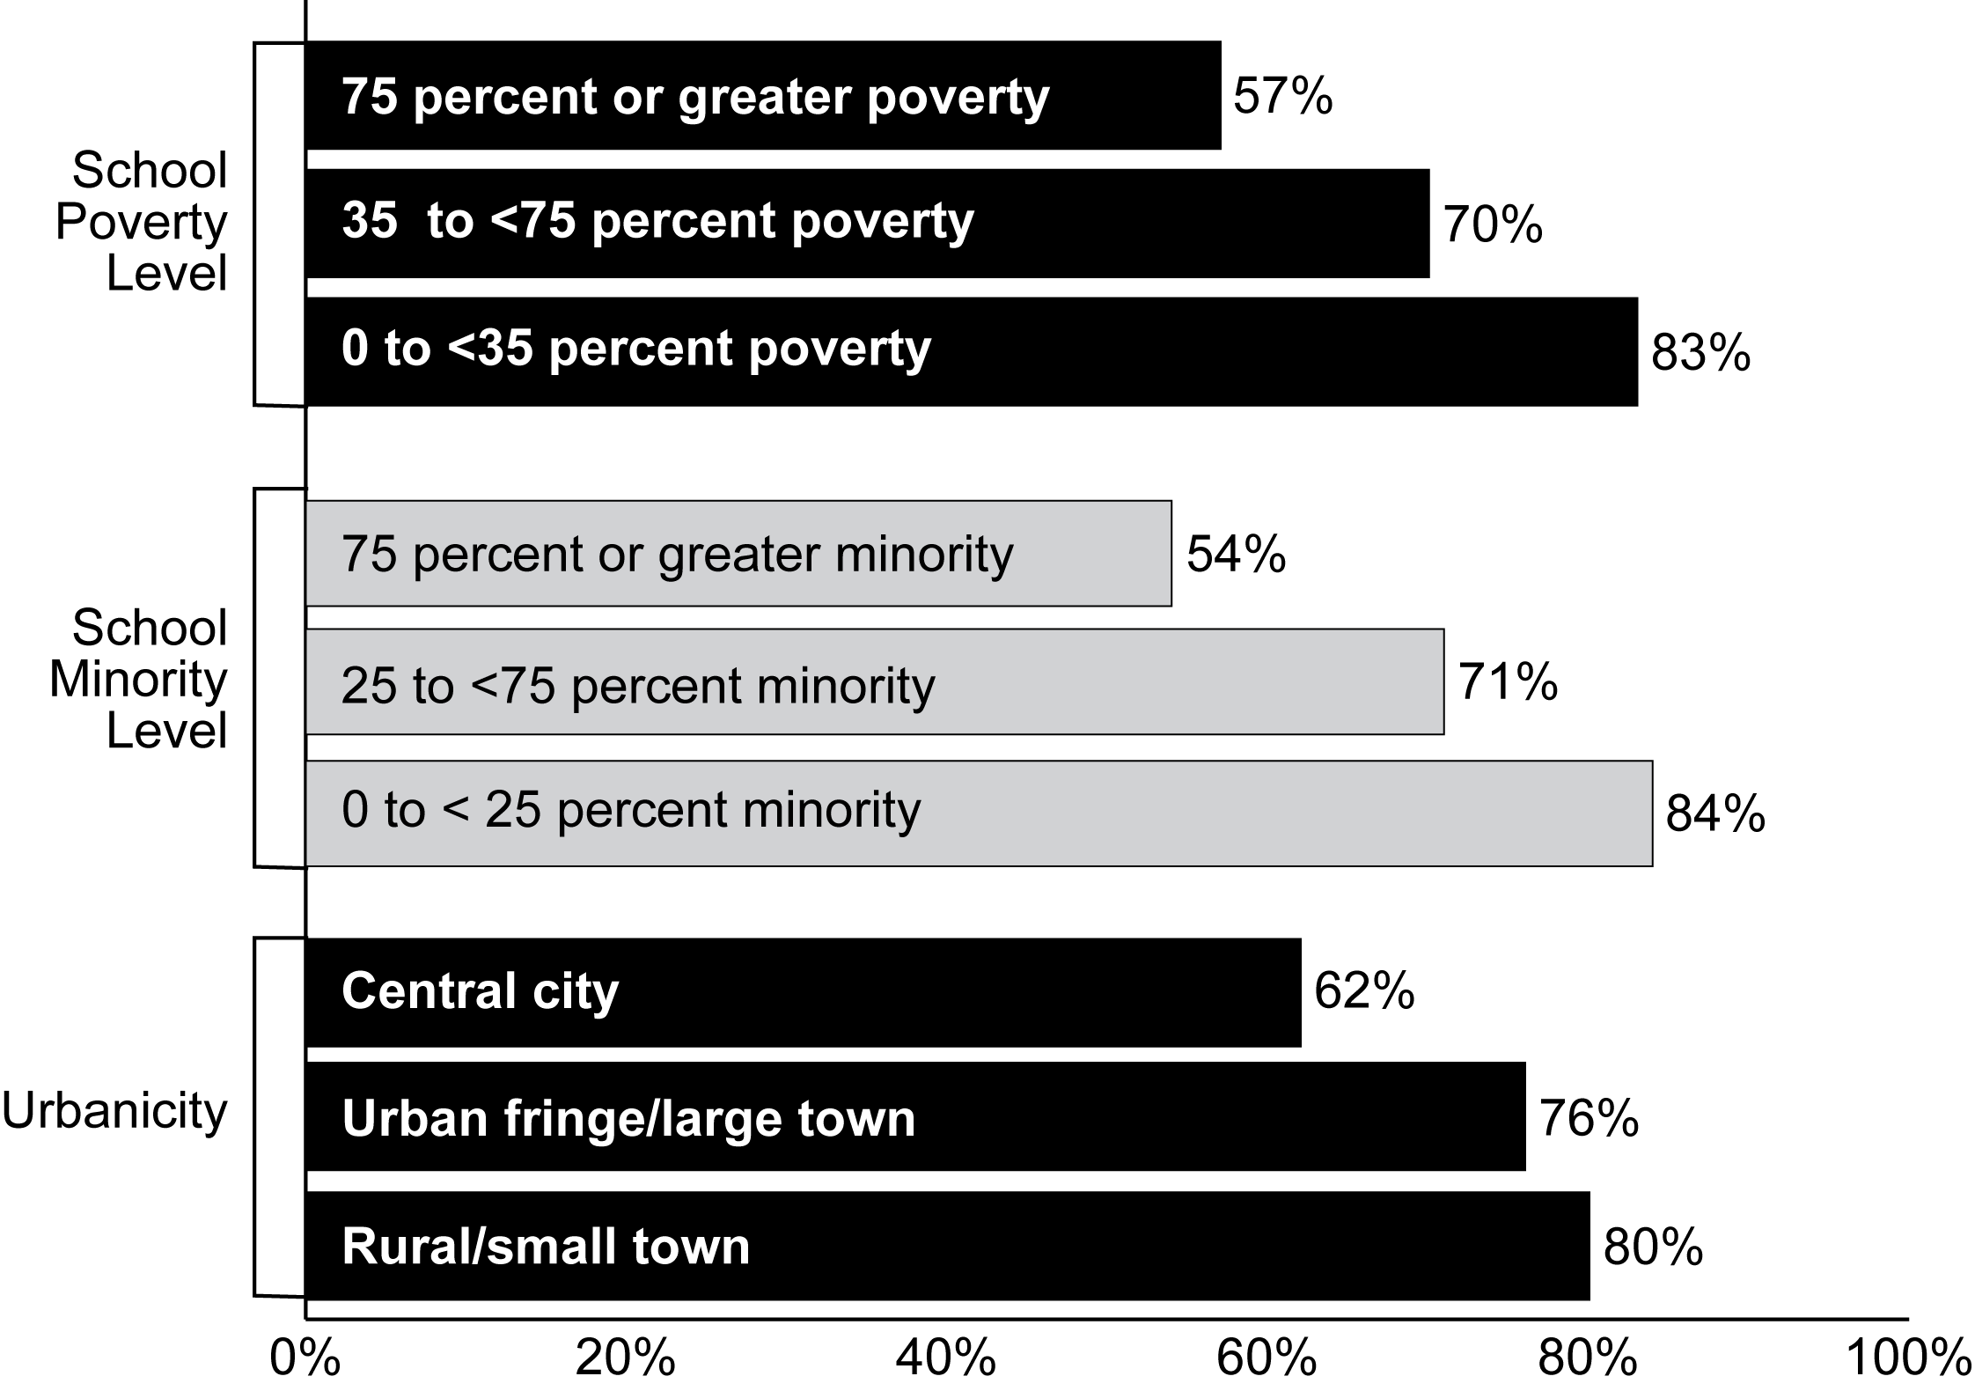
Percentage of Schools
Exhibit reads: Fifty-seven percent of schools with more than 75 percent of students from low-income families made AYP in 2005–06.
Source: SSI-NCLB, National AYP and Identification Database and Common Core of Data (based on data reported by 50 states, the District of Columbia, and Puerto Rico for 90,309 schools in these states).
Secondary schools and larger schools continued to be less likely to make AYP.
As in prior years, in 2005–06 middle and high schools were less likely to make AYP than elementary schools and, at each level, larger schools were less likely to make AYP than smaller schools (see Exhibit 24). Eighty-one percent of elementary schools made AYP, compared with 59 percent of middle schools and 66 percent of high schools. Smaller schools were much more likely to make AYP than larger schools. For instance, 75 percent of middle schools with enrollments of 400 or fewer students made AYP compared with 48 percent of middle schools with 801 or more students.
Schools that were accountable for greater numbers of subgroups continued to be less likely to make AYP in 2005–06.
AYP may be calculated for up to eight student subgroups: up to five state-determined major racial and ethnic groups, economically disadvantaged students, students with disabilities, and LEP students. States define a minimum subgroup size that must be met before AYP is calculated for a subgroup in a school or district. Schools with larger and more diverse student populations can be expected to have more subgroup targets, and, therefore, can be expected to be less likely to make AYP. However, the analyses presented here could not determine whether the number of subgroups is actually a determinant of AYP.
Exhibit 24
Percentage of Schools Making AYP, by School Grade Level and School Size, 2005–06
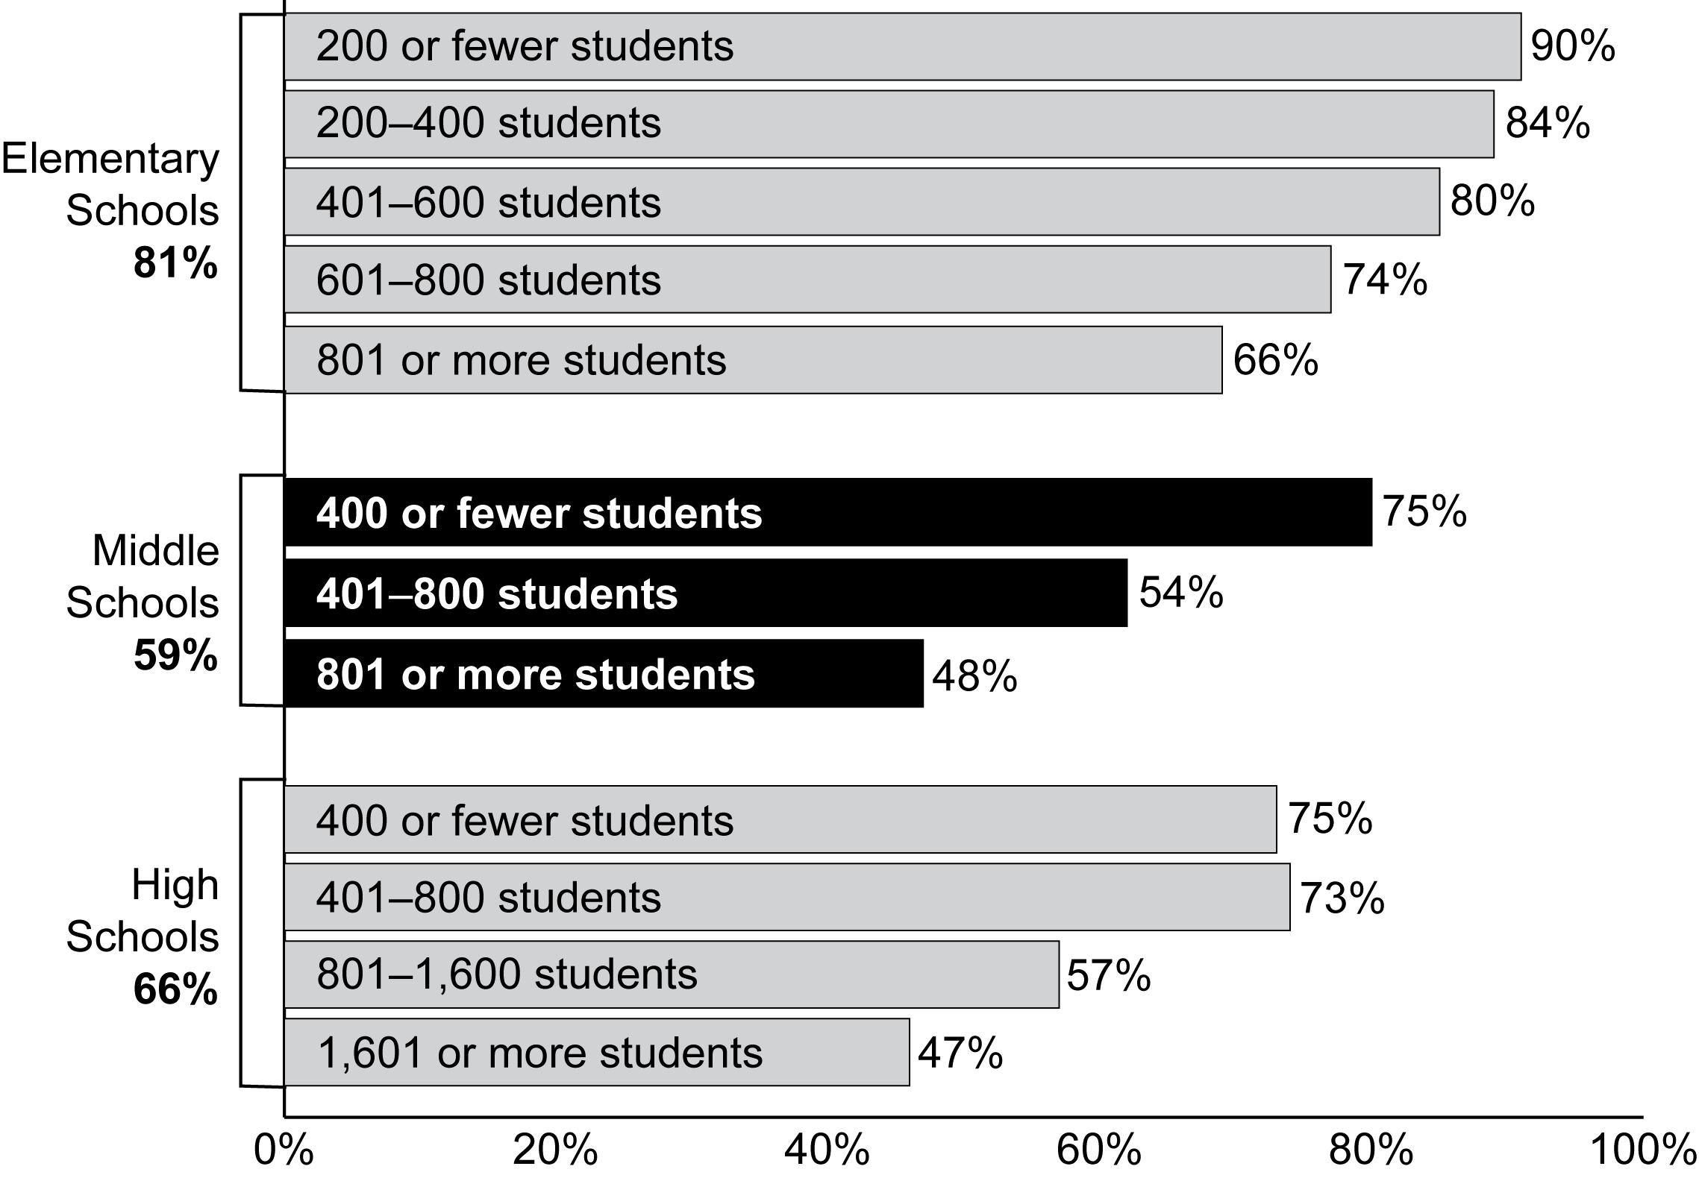
Percentage of Schools
Exhibit reads: Eighty-one percent of elementary schools made AYP in 2005–06. Ninety percent of small elementary schools (with enrollments of 200 or fewer students) made AYP in 2005–06, compared with 66 percent of large elementary schools (with enrollments of 801 or more students).
Source: SSI-NCLB, National AYP and Identification Database and Common Core of Data (based on data reported by 50 states, the District of Columbia, and Puerto Rico for 84,643 schools in these states).

As in previous years, schools with more student subgroups were less likely to make AYP in 2005–06 than schools with fewer subgroups. Among schools for which AYP was calculated for six or more subgroups, 66 percent made AYP, compared with 93 percent of schools for which AYP was calculated for one subgroup. Even after controlling for the level of poverty, schools with more subgroups were less likely to make AYP (see Exhibit 25). At every level of poverty, schools with six or more student subgroups made AYP at a rate 17 to 28 percent lower than those with only one subgroup.

Exhibit 25
Percentage of Schools That Made AYP, by School Poverty Level and
Number of Subgroups, 2005–06
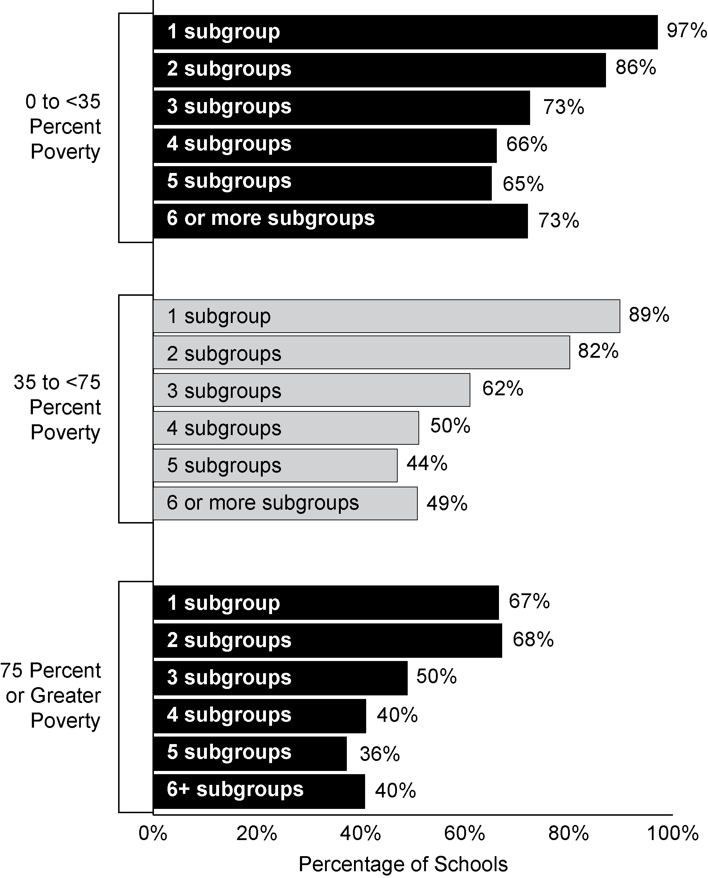
Exhibit reads: Among schools with poverty levels below 35 percent, schools for which AYP was calculated for only one subgroup were much more likely to make AYP (97 percent) than were schools where AYP was calculated for six or more subgroups (73 percent).
Sources: SSI-NCLB, National AYP and Identification Database and Common Core of Data (based on data reported by 45 states and the District of Columbia for 69,195 schools in these states).

Inclusion of student subgroups in AYP determinations
Not all schools have AYP calculated for all of the possible subgroups listed in NCLB. In some cases, a school may have no students in a particular subgroup, while other schools may have a small number of students such that they do not meet the “minimum n size” established by their state for AYP calculations. Calculating AYP for small subgroups is problematic because the results may be unreliable and fluctuate from year to year due to changes in student composition, rather than real changes in student performance. However, there is no universal definition for what size is too small to produce reliable calculations, and states varied considerably in the minimum n sizes that they set, ranging from a low of 1 in North Dakota to a high of 50 in California, Texas, Virginia and West Virginia; most states used a minimum n size of 30 to 40 students.
Most African-American, Hispanic, and white students, and most students from low-income families, attended schools in which AYP was calculated for their respective subgroup because the minimum n of students needed to constitute a subgroup was met.
In 41 states with available data, at least 83 percent or more of all white, African-American, and Hispanic students, as well as students from low-income families, attended schools in which AYP was calculated for these subgroups in 2005–06 (see Exhibit 26). However, only about half of Native American and Asian students attended schools in which AYP was calculated for their subgroups (46 percent and 55 percent, respectively); these two groups are smaller in size and less geographically concentrated and thus were less likely to meet state minimum n sizes at the school level. Available data did not permit making similar estimates for the students with disabilities and LEP subgroups.

Exhibit 26
Percentage of Students in Each Subgroup in Schools Held Accountable for Their Subgroup, by Student Subgroup, 2005–06
Student Subgroup | Total number of students in this subgroup in grades used to calculate AYP (a) | Number of students in this subgroup in schools held accountable for this subgroup (b) | Percent of students in each subgroup in schools held accountable for their subgroup (b/a)
African-American | 3,733,587 | 3,084,523 | 83%
American Indian/Alaskan Native | 222,057 | 102,318 | 46%
Asian/Pacific Islander | 1,053,416 | 578,128 | 55%
Hispanic | 3,866,759 | 3,305,620 | 85%
White | 12,480,628 | 12,100,036 | 97%
Total across these five major racial/ethnic categories in 41 states | 21,356,447 | 19,170,625 | 90%
Estimated total across these five major racial/ethnic categories for all 50 states, the District of Columbia, and Puerto Rico | 25,372,574 | 22,730,412 | 90%
Low-income students for all 50 states, the District of Columbia, and Puerto Rico | 19,593,343 | 17,513,800 | 89%
Exhibit reads: Eighty-three percent of African-American students attended schools for which AYP was calculated for the African-American subgroup.
Note: The numbers of students in the racial or ethnic subgroups are based on 2005–06 CCD enrollment figures by race or ethnicity in those grades 3–8 and 10 that were used in AYP calculations in 2005–06 by each of the 41 states. The estimated total for all states is based on the assumption that the percent of students held accountable for each racial/ethnic category was the same for the 11 states lacking data as for those 41 states for which data were available. The numbers of low-income students are based on number of students eligible for free or reduced-priced lunches across all grades in the 2005–06 CCD. CCD data did not permit making similar estimates for students with disabilities and LEP student subgroups. Only schools with valid AYP status assigned (i.e., made or did not make AYP) were included.
Source: SSI-NCLB, National AYP and Identification Database (n = 41 states).

Across all five racial/ethnic subgroups, 90 percent of students were in schools for which AYP determinations were made for their subgroup in 2005–06, amounting to an estimated 22.7 million students in grades that were used to calculate AYP (based on data for 50 states and the District of Columbia). The remaining 10 percent (2.6 million students) did not have school-level AYP determinations calculated for their racial/ethnic subgroup. However, they would have been included in the school’s overall AYP calculation for the “all students” group, may have been included in other school-level calculations for other subgroups (e.g., students from low-income families), and may have been included in racial/ethnic subgroup calculations for determining district-level AYP.
Overall, schools were most likely to have AYP calculated for the white and low-income subgroups (71 percent and 65 percent, respectively). Thirty percent of all schools had AYP calculated for African-American students, Hispanic students, and students with disabilities. A smaller percentage of schools had AYP calculations made for LEP students (20 percent), Asian students (13 percent), or American Indian students (9 percent) (see Exhibit 27).

Reasons Schools Did Not Make AYP
Schools did not make AYP in 2005–06 for a wide variety of reasons. For example, of schools that did not make AYP in 2005–06, 67 percent missed for a reading achievement target and 58 percent missed for a target in mathematics, while 42 percent did not make AYP in both subjects. (However, just 15 percent missed for the school as a whole (the “all students” group) in both subjects.) Of schools that did not make AYP in 2005–06, 17 percent of schools missed the 95 percent test participation requirement and 22 percent missed a target for their state’s other academic indicator.
Exhibit 27
Number and Percentage of Schools Required to Calculate AYP for Each Student Subgroup, 2005–06
Student Subgroup | Schools Required to Calculate AYP for Subgroup
Student Subgroup | Number of Schools | Percentage of All Schools
African-American | 25,807 | 30%
American Indian /  Alaskan Native | 7,503 | 9%
Asian/Pacific Islander | 11,338 | 13%
Hispanic | 25,602 | 30%
White | 60,371 | 71%
Low-income students | 55,646 | 65%
Students with disabilities | 25,491 | 30%
LEP students | 17,126 | 20%
Exhibit reads: Thirty percent of schools had a sufficient number of African-American students to require calculation of AYP for this subgroup.
Source: SSI-NCLB, National AYP and Identification Database (based on data reported by 50 states and the District of Columbia for 85,435 schools in these states).
Similarly, some schools did not make AYP due to the reading or mathematics proficiency of the “all students” group or due to the reading or mathematics proficiency of two or more student subgroups, whereas others did not make AYP for one subgroup or because they missed the 95 percent test participation requirement. Not making AYP due to the achievement of the “all students” group or due to the achievement of two or more student subgroups suggests that schools are being held accountable for widespread low performance. On the other hand, making AYP for the “all students” group and not making AYP for a single subgroup typically suggests a difference between the school’s overall performance and the performance of a very specific subgroup of its students. NCLB’s requirement to disaggregate achievement data by subgroup makes possible the identification of such differences.
Over half of the schools that did not make AYP in 2005–06 missed because the “all students” group or two or more subgroups of students did not meet achievement targets.
Schools most commonly did not make AYP for the achievement of all students or multiple subgroups in 2005–06; only in a minority of cases did schools miss just one AYP target. Based on data from 43 states, among schools that did not make AYP in 2005–06, 35 percent did not meet achievement targets for the “all students” group in reading and/or mathematics (see Exhibit 28). An additional 20 percent of these schools did not make AYP for the achievement of two or more subgroups although they made AYP for the “all students” group. One-quarter (24 percent) did not make AYP solely due to the achievement of a single subgroup. The remaining schools did not make AYP solely due to the “other academic indicator” (6 percent); solely because of their test participation rates (4 percent); or for other reasons, such as combinations of the achievement of a single subgroup, the other academic indicator, and test participation, or the alternate AYP determination for small schools and schools without tested grades (11 percent).
Exhibit 28
AYP Targets Missed by Schools That Did Not Make Adequate Yearly Progress, 2005–06
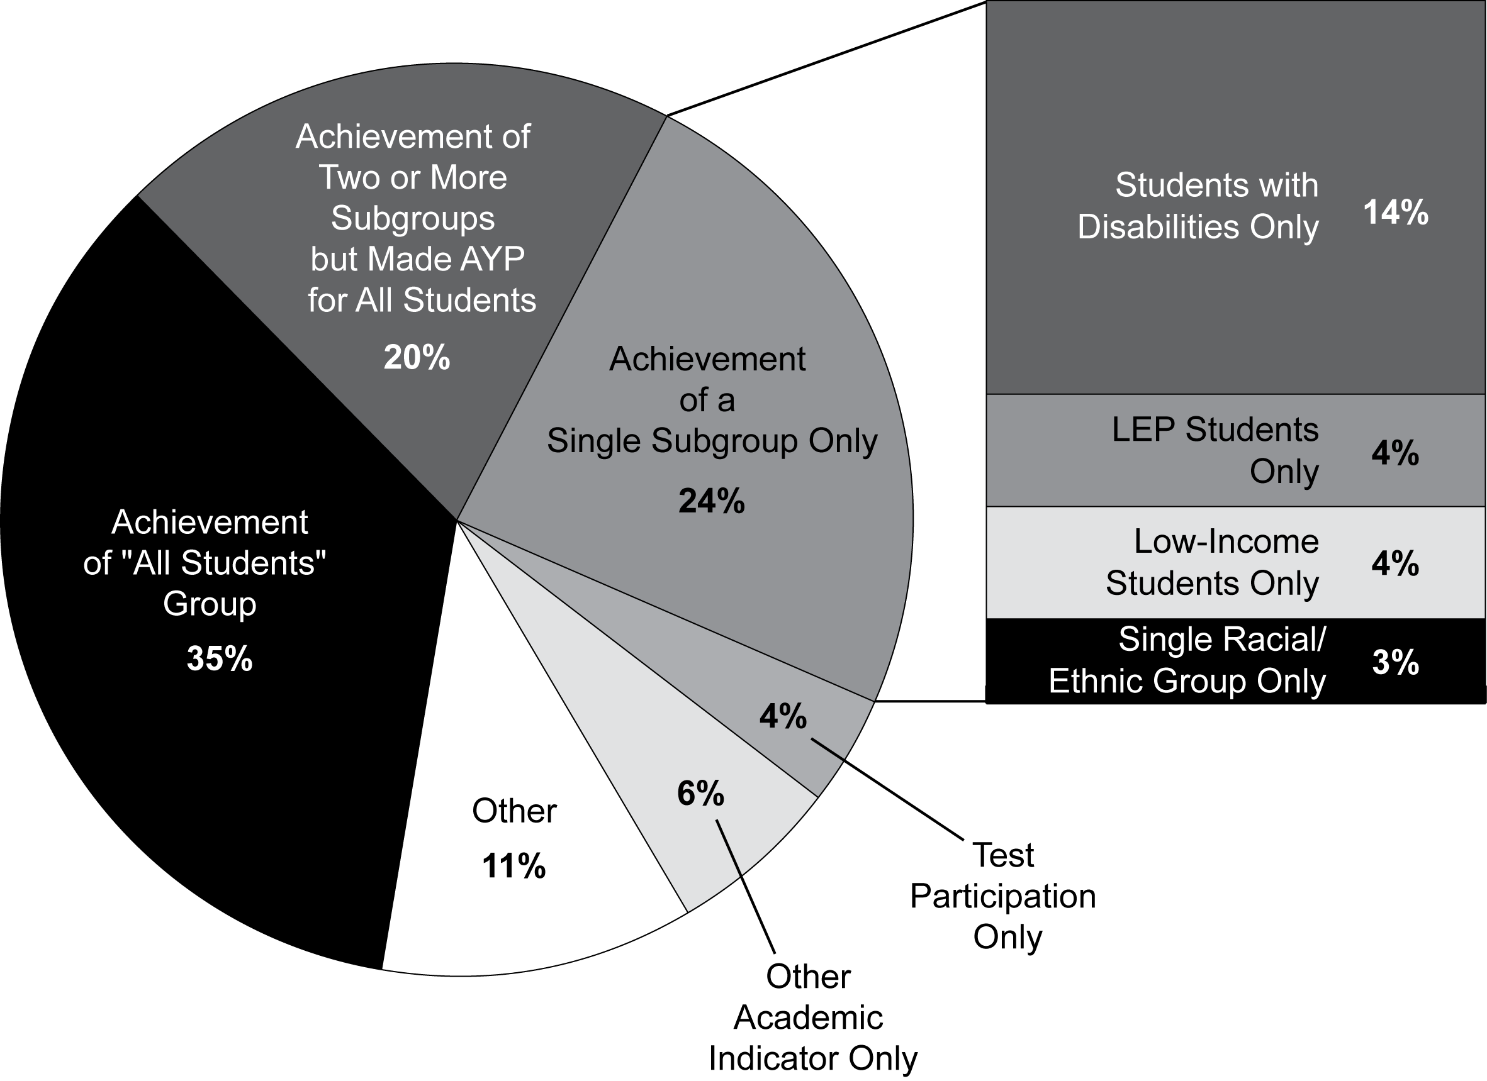
Exhibit reads: In 2005–06 testing, 35 percent of schools that did not make AYP missed targets for the achievement of the “all students” group in reading and/or mathematics.
Notes: The sum of the subcategories of the “Single Subgroup Only” category does not equal 24 percent due to rounding. Schools included in the “Achievement of the ‘All Students’ Group” and the “Achievement of Two or More Subgroups” segments of the graph may have also not made AYP for test participation or the other academic indicator. However, schools included in the “Achievement of a Single Subgroup Only” segment are those that did not make AYP for that factor alone and did not miss any other AYP targets. “Other” includes schools that did not make AYP for combinations of the achievement of a single subgroup, test participation, and/or the other academic indicator, or through a small school analysis.
Source: SSI-NCLB, National AYP and Identification database (based on data reported by 43 states for 20,463 schools that did not make AYP in these states).
About one quarter of the schools that did not make AYP met reading and mathematics proficiency targets for the school as a whole but missed for one subgroup.
A key feature of the NCLB accountability system is the disaggregation of achievement test data by subgroups in order to identify differences in proficiency between subgroups and the school as a whole. Twenty-four percent of schools that did not make AYP missed targets due to low levels of proficiency in a single subgroup. More than one-half of these schools did not make AYP solely for the students with disabilities subgroup (this represents 14 percent of schools that did not make AYP).
The pattern of targets missed by schools that did not make AYP has been remarkably stable over the past three years (see Exhibit 29). Looking at a consistent set of 26 states for which data were available across 2003–04, 2004–05 and 2005–06, the only change in the pattern is a small increase in the percentage of schools that did not make AYP due to the achievement of the “all students” group (increasing from 31 percent in 2003–04 to 41 percent in 2004–05 to 35 percent in 2005–06).
Exhibit 29
AYP Targets Missed by Schools That Did Not Make Adequate Yearly Progress,
2003–04 to 2005–06
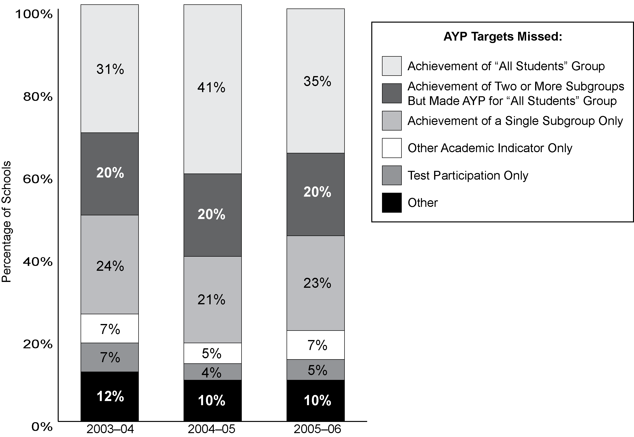
Exhibit reads: In 2003–04 testing, 31 percent of schools that missed AYP missed targets for the achievement of the “all students” group in reading, mathematics, or both.
Notes: Schools included in the “Achievement of ‘All Students’ Group” and the “Achievement of Two or More Subgroups” segments of the graph may have also not made AYP for test participation or the other academic indicator. However, schools included in the “Achievement of a Single Subgroup Only” segment are those that did not make AYP for that factor alone and did not meet any other AYP targets. “Other” includes schools that did not make AYP for combinations of the achievement of a single subgroup, test participation, or the other academic indicator, or through a small school analysis. Percentages may not add to 100 percent because of rounding.
Source: SSI-NCLB, National AYP and Identification database (based on 26 states with sufficient data in 2003–04, 2004–05, and 2005–06 and 13,497 schools that did not make AYP in 2003–04, 14,458 schools in 2004–05, and 14,981 schools in 2005–06 in these states).
The subgroups most likely to miss AYP targets were students with disabilities, LEP students, and African-American students.
The rates at which specific subgroups did not make AYP varied dramatically. Among schools for which AYP was calculated for the subgroup of students with disabilities, 43 percent did not make AYP achievement targets for the students with disabilities subgroup. (These schools may have also not made AYP for other reasons, such as other subgroups, test participation, attendance or graduation rates.) Similarly, 30 percent and 25 percent of schools for which AYP was calculated for the LEP and African-American subgroups, respectively, did not make AYP for those subgroups (see Exhibit 30). Schools held accountable for subgroups of students from low-income families and Hispanic students were somewhat less likely to have not made AYP for those subgroups (20 percent and 18 percent, respectively). Schools held accountable for Asian (2 percent) and white (3 percent) and Native American (8 percent) subgroups were much less likely to have not made AYP for those subgroups.
Exhibit 30
Percentage of Schools Held Accountable for a Subgroup That Did Not Make AYP for That Subgroup, 2005–06
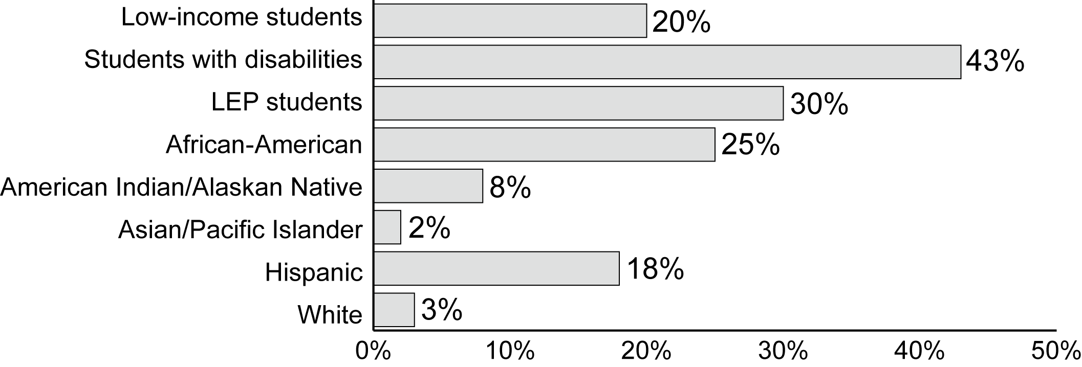
Percentage of Schools
Exhibit reads: In 2005–06 testing, 20 percent of schools that had the minimum number of students from low-income families necessary for AYP to be calculated for this subgroup at the school did not make AYP for this subgroup.
Note: See Exhibit 27 for the number of schools required to calculate AYP for each student subgroup.
Source: SSI-NCLB, National AYP and Identification Database (based on data reported by 50 states and the District of Columbia for 85,440 schools in these states).
Looking at individual subgroups, each subgroup was more likely to not make AYP when it was in a school with a higher poverty level or a higher concentration of minority students. For example, the African-American subgroup did not make AYP in 2005–06 in 11 percent of low-poverty schools in which the subgroup was of sufficient size to be calculated, but it did not make AYP for 34 percent of high-poverty schools in which the subgroup was of sufficient size to be calculated (see Exhibit 31). Similarly, the students with disabilities subgroup did not make AYP in 32 percent of low-poverty schools, compared with 61 percent of high-poverty schools.
Exhibit 31
Percentage of Schools That Did Not Make AYP for Individual Student Subgroups, by School Poverty Rate, 2005–06
Student Group | Less Than 35% Poverty | 35-50% Poverty | 50-75%  Poverty | 75% or More Poverty
African-American | 11% | 22% | 31% | 34%
Asian | 2% | 8% | 17% | 25%
Hispanic | 8% | 17% | 23% | 32%
Native American | 7% | 14% | 23% | 43%
White | 1% | 2% | 5% | 12%
Low-income students | 12% | 17% | 22% | 31%
Students with disabilities | 32% | 45% | 50% | 61%
LEP students | 13% | 26% | 38% | 49%
Exhibit reads: In 2005–06, among low-poverty schools for which AYP was calculated for African-American students, 11 percent did not make AYP for that subgroup.
Source: SSI-NCLB, National AYP and Identification Database (based on data reported by 47 states for 81,836 schools in these states).
Not making AYP due to the other academic indicator was more prevalent at the high school level.
States commonly selected attendance as the other academic indicator for elementary and middle schools. High schools were required to use graduation rates. In December 2008, after these analyses were conducted, the U.S. Department of Education issued new non-regulatory guidance on high school graduation rates. Of the schools that did not make AYP in 2005–06, 22 percent missed the other academic indicator. The rates varied by school level: 14 percent of elementary schools, 13 percent of middle schools, and 40 percent of high schools (see Exhibit 32). However, only 6 percent of schools that did not make AYP missed solely due to the other academic indicator. Thirteen percent of the high schools that did not make AYP missed solely due to the graduation rate.

Exhibit 32
Percentage of Schools That Did Not Make AYP That Missed Due to the
Other Academic Indicator, by School Grade Level, 2005–06
 | Schools Did Not Make AYP for:
Grade Level | Other Academic Indicator | Other Academic Indicator Only
Total (n = 16,713) | 22% | 6%
Elementary (n = 9,003) | 14% | 3%
Middle (n = 6,047) | 13% | 1%
High (n = 5,376) | 40% | 13%
Other (n = 1,266) | 50% | 18%
Exhibit reads: Of the schools that did not make AYP, 22 percent of schools did not make AYP for the other academic indicator.
Note: Grade levels were defined using Common Core of Data (CCD) codes. The “other” category includes any grade configuration not falling in the CCD elementary, middle, or high school codes, including ungraded schools.
Source: SSI-NCLB, National AYP and Identification Database (based on data reported by 47 states and the District of Columbia for 21,722 schools that did not make AYP in these states).

Across states, the percentage of high schools that did not make AYP because they missed graduation rate targets ranged from 0 to 94 percent. States calculate graduation rates in different ways and set their target graduation rates at different levels: targets ranged from 50 to 97 percent in 2003–04 and will range from 65 to 100 percent in 2013–14 (see Chapter II, Exhibit 14, for examples of four state trajectories). For elementary and middle schools, the percentage that missed due to their other academic indicators ranged from 0 to 81 percent across states. In 31 states out of the 48 reporting, less than 10 percent of the elementary and middle schools that did not make AYP missed because of the other academic indicator.

Stability of the reasons schools did not make AYP
Four-fifths of schools had the same AYP designation from one year to the next.
Eighty-one percent of schools had the same overall AYP designation in 2003–04 and 2004–05. The majority of schools, 66 percent or 54,012, made AYP in both years, but 15 percent or 12,491 did not make AYP in both years (and were potentially subject to identification for improvement if their reasons for not making AYP were within the same subject in both years). Schools whose AYP designations changed were evenly split between those whose designation “worsened” (i.e., moved from making AYP in 2003–04 to not making AYP in 2004–05) and those whose designation “improved”; 9 percent of schools’ designations worsened and 10 percent of schools’ designations improved. The results were similar for 2004–05 to 2005–06 (see Exhibit 33).
Exhibit 33
Percent and Number of Schools With Consistent AYP Designations in
2003–04, 2004–05 and 2005–06
 |  | Did Not Make AYP | Made AYP
AYP Status |  | AYP 2004–05
AYP 2003–04 | Did not make AYP | 15%  (12,491) | 9%  (7,457)
AYP 2003–04 | Made AYP | 10%  (8,143) | 66%  (54,012)
 |  | AYP 2005–06
AYP 2004–05 | Did not make AYP | 16%  (12,846) | 9%  (7,359)
AYP 2004–05 | Made AYP | 10%  (8,394) | 65%  (52,583)
Exhibit reads: Fifteen percent or 12,491 schools did not make AYP in both 2003–04 and 2004–05.
Note: Numbers in parenthesis indicate number of schools.
Source: SSI-NCLB, National AYP and Identification Database, 2003–04 and 2004–05 (based on 81,203 schools in 50 states and the District of Columbia for 2003–04 to 2004–05 and 81,212 schools in 50 states and the District of Columbia for 2004–05 and 2005–06).
More than half of the schools that did not make AYP in 2003–04 missed fewer AYP targets in 2004–05.
Fifty-six percent of the schools that did not make AYP in 2003–04 missed fewer targets in 2004–05. Fourteen percent missed the same number of targets and 30 percent missed more targets in 2004–05 (see Exhibit 34). All schools that missed the same or fewer targets in 2004–05 continued to not make AYP overall. In addition, most of the schools that missed fewer targets in 2004–05 also continued to not make AYP overall because they did not make all targets. Typically, most attention has been paid to schools’ overall AYP designations, and the extent to which schools have reduced the number of targets they missed has been largely ignored other than in some states’ AYP reporting. However, reductions in the number of targets schools missed may represent substantial improvement in specific subjects for specific groups. Schools that missed more AYP targets in 2003–04 were more likely to miss fewer targets in the following year. Results were similar for 2004–05 to 2005–06.
A key question about the stability of AYP designations is whether schools that did not make AYP for particular reasons in 2003–04 continued to not make AYP in 2004–05 and 2005–06 for those same reasons. In this analysis, we followed the schools that did not make AYP in 2003–04 for particular reasons for the next two years. We began by looking at the four general sets of reasons schools do not make AYP: reading proficiency, mathematics proficiency, participation rate, and the other academic indicator, rather than the specific subgroup targets that were missed. That is, if a school did not make AYP because it missed a reading proficiency target for any group or subgroup in 2003–04, that school was examined to determine if it continued to miss any reading proficiency targets for any group or subgroup in 2004–05 and 2005–06. Because a school may have several subgroup reading targets as well as an “all students” reading target, some of the schools classified as not making AYP in multiple years may have missed for the reading proficiency of one subgroup in 2003–04 and for the reading proficiency of a different subgroup in 2004–05 or 2005–06.
Exhibit 34
Percent of Schools That Missed Fewer, the Same, and More AYP Targets Than They Did in the Prior Year, by Number of Targets Missed in the Prior Year
 |  | Percentage of Schools in 2004–05 That
AYP Target(s) Missed | Number of Schools that Missed AYP in 2003–04 | Missed Fewer Targets | Missed Same Number of Targets | Missed More Targets
1 | 2,715 | 45% | 15% | 40%
2–3 | 3,835 | 51% | 15% | 34%
4–7 | 3,091 | 61% | 12% | 26%
8–11 | 1,175 | 71% | 11% | 18%
12–15 | 401 | 81% | 10% | 10%
16–19 | 155 | 90% | 5% | 5%
20–27 | 48 | 87% | 2% | 10%
28–37 | 0 | na | na | na
Total  (any number of targets) | 11,420 | 56% | 14% | 30%
 |  | Percentage of Schools in 2005–06 That
AYP Target(s) Missed | Number of Schools that Missed AYP in 2004–05 | Missed Fewer Targets | Missed Same Number of Targets | Missed More Targets
1 | 2,987 | 53% | 21% | 26%
2–3 | 4,008 | 57% | 18% | 25%
4–7 | 3,954 | 62% | 16% | 22%
8–11 | 1,285 | 59% | 22% | 19%
12–15 | 301 | 67% | 16% | 16%
16–19 | 72 | 69% | 17% | 14%
20–27 | 23 | 74% | 9% | 17%
28–37 | 7 | na | na | na
Total  (any number of targets) | 12,673 | 58% | 19% | 23%
Exhibit reads: Of schools that missed one target in 2003–04, 45 percent missed zero targets in 2004–05, while 15 percent missed one target again in 2004–05, and 40 percent missed more than one target in 2004–05.
Notes: Percentages may not add to 100 percent because of rounding. “na” means not applicable.
Source: SSI-NCLB, National AYP and Identification Database (based on 11,420 schools in 26 states in first panel and 12,673 schools in 26 states in second panel).

Schools that did not make AYP for test participation or the other academic indicator were more likely to improve their AYP results for those indicators over time than schools that did not make AYP for reading or mathematics proficiency.
Schools that did not make AYP targets for reading or mathematics proficiency in 2003–04 were more likely to not make AYP targets again in 2004–05 or 2005–06 for those same reasons than schools that did not make AYP targets for test participation or the other academic indicator. In reading, 57 percent of schools that missed a reading proficiency target in 2003–04 missed a reading proficiency target again in 2004–05. In mathematics, 63 percent of the schools that missed for mathematics in 2003–04 missed again for mathematics in 2004–05 (see Exhibit 35). In contrast, 25 percent of schools that did not make AYP because they did not meet the required 95 percent test participation rate did not meet the required rate again in 2004–05.
Exhibit 35
Number and Percentage of Schools That Did Not Make AYP, by Type of AYP Targets That They Missed, 2003–04, 2004–05 and 2005–06
AYP Targets Missed | Number of Schools that Missed in  2003–04 | Percentage of Schools That Missed Again in 2004–05 | Percentage of Schools That Missed Again in 2005–06
Any reading proficiency target | 9,464 | 57% | 42%
Any mathematics proficiency target | 8,421 | 63% | 45%
Any participation target | 3,891 | 25% | 15%
Any other academic indicator target | 2,109 | 33% | 18%
Exhibit reads: Fifty-seven percent of schools that missed a reading proficiency target in 2003–04 missed a reading proficiency target again in 2004–05. Forty-two percent of schools that missed a reading proficiency target in 2003–04 missed a reading proficiency target again in 2005–06.
Source: SSI-NCLB, National AYP and Identification Database (based on 11,420 schools in 26 states with all necessary data in all three years).
There were similar results regarding the state-defined other academic indicator; 33 percent of schools that missed the other academic indicator in 2003–04 missed it again in 2005–06. The percentage of schools that did not make the other academic indicator again was lower than the percentage that did not make their proficiency targets again. However, analyses by grade level revealed that elementary and middle schools were less likely than high schools to miss the other academic indicator targets again because they used different other academic indicators. Fourteen percent of elementary schools and 22 percent of middle schools that did not make their other academic indicator (state-defined but often attendance rate) in 2003–04 missed again in 2004–05. In contrast, 37 percent of high schools that did not make their other academic indicator (graduation rate) in 2003–04 missed again in the following year (see Appendix C, Exhibit C.7). The same pattern of results was found when schools were followed for another year into 2005–06. These results indicate that it may be easier for schools to remedy problems with test participation or other academic indicators than it is to remedy problems with reading or mathematics proficiency.
Schools that did not make AYP for the Asian and white subgroups were more likely to improve their AYP results for those subgroups over time than schools that did not make AYP for other subgroups.
Thirty-one percent and 37 percent of schools that did not make a reading proficiency target in 2003–04 for the Asian and white subgroups, respectively, missed the same target again in 2004–05 (see Exhibit 36). By contrast, approximately half of the schools that missed a reading proficiency target in 2003–04 for the “all students” (57 percent), low-income students (56 percent), Hispanic (56 percent), African-American (54 percent), and LEP student (53 percent) subgroups missed the same target in 2004–05. This higher likelihood of change in status in the Asian and white subgroups may be due in part to the small number of schools that did not make AYP for each of these groups. It is important to note that in the years analyzed not all states were using assessment data from all grades 3–8 and one secondary grade for AYP determinations; therefore, some change in status may also be due to cohort changes or changes in policies regarding subgroups. A similar pattern of results was found in mathematics and when schools were followed for another year into 2005–06.
Exhibit 36
Number and Percentage of Schools That Did Not Make AYP Consistently for
Each Subgroup, 2003–04, 2004–05, and 2005–06
 | Reading Proficiency |  |  | Mathematics Proficiency
Student Group | Number of Schools that Missed in 2003–04 | Percentage of Schools That Missed Again in 2004–05 | Percentage of Schools That Missed Again in 2005–06 | Number of Schools that Missed in 2003–04 | Percentage of Schools That Missed Again in 2004–05 | Percentage of Schools That Missed Again in 2005–06
“All students” group | 2,628 | 57% | 40% | 2,728 | 61% | 41%
American Indian | 96 | 45% | 31% | 79 | 37% | 23%
Asian | 165 | 31% | 18% | 56 | 36% | 25%
Hispanic | 1,658 | 56% | 44% | 1,410 | 55% | 38%
African American | 2,108 | 54% | 33% | 2,794 | 59% | 38%
White | 205 | 37% | 26% | 268 | 37% | 22%
Low-income Students | 2,850 | 56% | 41% | 1,845 | 53% | 35%
Students with Disabilities | 5,400 | 46% | 32% | 4,921 | 52% | 36%
LEP Students | 3,259 | 53% | 37% | 3,141 | 58% | 37%
Exhibit reads: In 2003–04, 2,628 schools missed the “all students” reading proficiency target; of those schools, 57 percent missed the same target again in 2004–05 and 40 percent missed the same target again in 2005–06.
Source: SSI-NCLB, National AYP and Identification Database (based on 11,420 schools in 26 states).

AYP Appeals
Approximately one in ten schools that did not make AYP in 2005–06 appealed the determination to their state. Almost 40 percent of these appeals were successful. The rates for appeal applications and approval varied sharply across states.
NCLB includes provisions that allow local education agencies (LEAs) the opportunity to appeal AYP determinations on behalf of their schools. LEAs appealed in 38 of the 42 states that reported appeals data. AYP determinations were appealed for approximately 2,306 schools (11 percent of all schools that did not make AYP in 2005–06). The number of appeals ranged from two in Rhode Island to 525 in Arizona. The states with the highest numbers of AYP appeals (100 or more) were Arkansas, Arizona, California, Maryland, Tennessee and Texas. Of the appeals following 2005–06 testing, 38 percent were approved. The rate at which states approved appeals ranged from 0 percent in Louisiana to 100 percent in Montana and New Mexico. Among the states with the highest numbers of appeals listed above, approval rates ranged from 23 percent in Arkansas to 62 percent in Maryland. Similarly, districts could appeal their own district AYP determinations. Of the approximately 356 appeals by districts, 43 percent were approved.
Most successful appeals involved either errors in data or the misclassification of students to subgroups. However, states noted a long list of reasons for successful appeals, including graduation rate recalculations, safe harbor recalculations, small schools issues, test administration errors, and extraordinary circumstances beyond school control affecting testing. A large majority of states (32 of 42 responding) indicated that they did not face any challenges tracking AYP appeals. However, four states emphasized that tracking appeals was a time- and resource-consuming process, three other states noted a large variation in the quality of district reporting of data for appeals determinations, and three more states reported that it was a challenge to accurately track all the necessary data.

Discussion
The differences in the ways in which states have implemented the accountability provisions of NCLB (described in Chapter II), combined with differences in student demographics and student performance, have led to marked state-to-state differences in the proportion of schools and districts making AYP. In some states, nearly all schools and districts made AYP, while in a few states, large majorities of schools and districts did not. These differences also help to explain why some states’ proportions of schools making AYP rose while other states’ proportions dropped.
Schools did not make AYP for a range of different reasons and therefore face quite different school improvement tasks. Schools most commonly did not make AYP due to the low achievement of students in the school as a whole or across multiple subgroups, rather than solely due to factors such as test participation, attendance, or graduation rates. These schools may require an intervention that involves multiple components and addresses the full student population. However, about one-quarter of schools did not make AYP due to a single subgroup. These schools may require an intervention that is targeted to the school’s particular areas of weakness. Many reauthorization proposals of the No Child Left Behind Act of 2001 recognize this fact and seek to differentiate accountability through a more thorough examination of the particular reasons each school did not make AYP and the use of that information to better target supports and sanctions related to identification for improvement (Sparks, 2007).
While four-fifths of schools had the same overall AYP designation from one year to the next, the specific AYP targets that schools missed shifted over the years. Most schools missed fewer targets over the years and most schools that missed for insufficient participation or the other academic indicator moved from missing to making those targets. Challenges remained, however, with schools that did not make targets for reading or mathematics proficiency and those that did not make targets for historically disadvantaged subgroups being less likely to improve their AYP results than were schools that missed other targets.
States continued to make substantial progress toward the goal of counting the achievement of every child. States implemented testing in more grades and continued to disaggregate data by student subgroup so that the performance of children from minority and low-income families could not be obscured by the overall performance of the school. As a result, nearly half of the schools that did not make AYP did not make AYP targets for one or more subgroups, though they made AYP for the school as a whole. To fulfill the promise of NCLB, districts and schools must now respond to the needs of these low-performing subgroups; this may constitute one of the most challenging tasks confronting administrators and educators.

IV. Identifying Schools and Districts
for Improvement
A key component of NCLB accountability is the identification of schools and districts for improvement. Under NCLB, states are required to identify for improvement any Title I school that does not meet state-defined AYP targets in the same subject or indicator for two consecutive years. In addition, 34 states have opted to identify non–Title I schools through a similar process. Identification is used both to target assistance to schools and districts and for other interventions. Each additional year in which a school does not make AYP triggers increasingly more extensive interventions, as described in Chapter II. An identified school exits improvement status if it makes AYP for two consecutive years.

Key Findings
- After a large increase from 2003–04 to 2004–05, the percentage of Title I schools identified for improvement increased more gradually from 2005–06 to 2006–07. Fifteen percent of the nation’s schools (including Title I and non–Title I schools) were identified for improvement for 2006–07. Title I schools accounted for 83 percent of all identified schools, and the 10,781 identified Title I schools represented 20 percent of all Title I schools.
- Almost half (46 percent) of Title I schools that had been identified for improvement for 2004–05 were in the more advanced stages of identification status—corrective action and restructuring—in 2006–07.
- There has been a decline over time in the proportion of identified Title I schools annually exiting from improvement status. The percentage of Title I schools exiting from improvement status declined from 23 percent in 2004–05 to 17 percent in 2005–06 to 12 percent in 2006–07.
- In 2006–07, the majority of identified Title I schools were concentrated in just over 1 percent of the nation’s Title I districts. Over half (53 percent) of all Title I schools identified for improvement were located in the 177 districts that each had 10 or more identified schools in 2006–07. Four-fifths of districts contained no identified schools and most of the rest contained only one or two identified schools.
- High-poverty, high-minority, and middle schools, and large schools in urban areas, were more likely than other Title I schools to be identified for improvement for 2006–07.
- Title I schools in the more advanced stages of improvement status during 2006–07 were most likely to have missed AYP for the achievement of “all students” or for two or more subgroups than other Title I schools.
- Although 13 percent of Title I districts (1,728) were identified for improvement for 2006–07, these districts enrolled 40 percent of the nation’s students, or about 18 million students. The number of districts identified for improvement for 2006–07 was similar to the previous year, but the number of districts identified for corrective action increased five-fold.

Schools and Districts Identified for Improvement
A total of 13,103 schools (15 percent of all schools, both Title I and non–Title I) were identified for improvement for 2006–07 (based on test scores from 2005–06 and earlier years). Title I schools accounted for more than four-fifths of all identified schools. The remainder of this section focuses primarily on Title I schools.
After a large increase between 2003–04 and 2004–05, the percentage of Title I schools identified for improvement increased more gradually between 2005–06 and 2006–07.
The percentage of Title I schools identified for improvement increased from 18 percent in 2005–06 to 20 percent in 2006–07. This increase was gradual compared to the large jump from 12 percent to 18 percent between 2003–04 and 2004–05. The number of Title I schools identified for improvement for 2006–07 (10,781) was about 1,000 greater than the number of identified schools for 2005–06 (see Exhibit 37). Overall, 9.0 million students attended identified schools in 2006–07, up from 7.3 million in 2004–05.

Exhibit 37
Number and Percentage of Title I Schools Identified for Improvement
1996–97 to 2006–07
na
na
Exhibit reads: In 2006–07, 10,781 Title I schools were identified for improvement based on test scores from 2005–06 and earlier years; identified schools represented 20 percent of all Title I schools in 2006–07.
Notes: The first year that schools were identified for improvement based in part on NCLB AYP definitions was 2003–04, based on assessments administered in 2002–03. However, schools are identified when they do not make AYP for two consecutive years, and 2004–05 was the first year that includes schools identified because they did not make AYP targets for two consecutive years. Data for 2002–03 are not available due to a change in reporting requirements that was implemented beginning with the 2002–03 Consolidated State Performance Report.
Source: Consolidated State Performance Reports (n = 50 states, the District of Columbia, and Puerto Rico).

In 2006–07, 46 percent of identified Title I schools were in either corrective action or restructuring.
Forty-six percent of all identified Title I schools in 2006–07 were in either corrective action or restructuring, up from 33 percent in 2005–06 and 23 percent in 2004–05. The number of Title I schools in corrective action more than doubled, from 1,223 in 2005–06 to 2,663 in 2006–07 (25 percent of identified Title I schools), while the number in restructuring status rose from 1,683 to 2,270 (21 percent of identified Title I schools) (see Exhibit 38).
Exhibit 38
Number of Title I Schools Identified for Improvement, by Identification Status
2004–05 to 2006–07
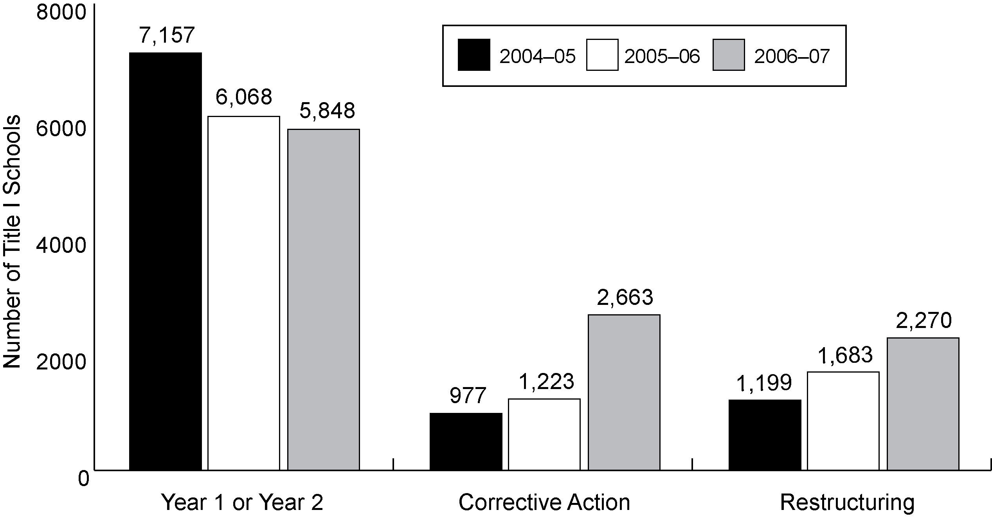
Exhibit reads: The number of Title I schools in the first or second year of school improvement status declined from 7,157 in 2004–05 to 5,848 in 2006–07.
Sources: Consolidated State Performance Reports and SSI-NCLB, National AYP and Identification Data Base (n = 50 states, the District of Columbia, and Puerto Rico).

Changes in improvement status
To exit improvement status, schools are required to make AYP for two consecutive years. It can be challenging to achieve this level of improvement because the annual measurable objectives upon which AYP is based rise gradually over the years, essentially “raising the bar” over time.
There has been a decline over time in the proportion of identified Title I schools exiting improvement status.
The percentage of Title I schools exiting from improvement status declined from 23 percent in 2004–05 to 17 percent in 2005–06 to 12 percent in 2006–07. As a result of this decline, 12 percent (1,169 schools) of the Title I schools that were identified for improvement for 2005–06 were no longer identified for 2006–07 because they made AYP for two consecutive years or for other reasons (see Exhibit 39). Of the schools that were in corrective action and restructuring for 2005–06, 6 percent and 4 percent, respectively, exited improvement status for 2006–07.
Exhibit 39
Number and Percentage of Title I Schools Identified for Improvement for 2005–06
That Exited Improvement Status in 2006–07
School Improvement Status for 2005–06 | Number of Schools Identified in 2005–06 | Schools No Longer Identified for 2006–07
School Improvement Status for 2005–06 | Number of Schools Identified in 2005–06 | Number |  | Percent
Total | 9,676 |  | 1,169 | 12%
Year 1 | 3,848 |  | 793 | 21%
Year 2 | 2,893 |  | 242 | 8%
Corrective action | 1,189 |  | 71 | 6%
Restructuring | 1,746 |  | 63 | 4%
Exhibit reads: Of the 9,676 schools that were identified for school improvement status for 2005–06, 1,169 schools, or 12 percent, were no longer identified for 2006–07.
Source: SSI-NCLB, National AYP and Identification Database (n = 9,676 Title I schools identified in 2004–05 with data for both years).

To examine changes in identification status over a longer period of time, we followed the cohort of Title I schools that were identified in 2004–05 to see what their improvement status was in 2006–07. Most Title I schools that were identified for improvement for 2004–05 remained in improvement status two years later, and most of these had progressed to more advanced stages of improvement status. Nearly three-fourths (72 percent) of the Title I schools identified for 2004–05 continued to be identified schools in 2006–07, while 28 percent had exited school improvement status (see Exhibit 40). About half of the 2004–05 cohort of identified Title I schools were in corrective action (25 percent) or restructuring status (22 percent) by 2006–07; about one quarter of the 2004–05 cohort of identified schools were in Year 1 or Year 2 of school improvement status (8 percent and 17 percent, respectively) in 2006–07.

Exhibit 40
Percentage of Title I Schools Identified for Improvement for 2004–05 That Were in
Various Stages of School Improvement Status for 2006–07
School Improvement Status for 2004–05 | n | School Improvement Status in 2006–07
School Improvement Status for 2004–05 | n | No Longer Identified for Improvement | Year 1 of Improvement Status | Year 2 of Improvement Status | Corrective Action | Restructuring (Year 1) | Restructuring (Year 2)
Total | 9,767 | 28% | 8% | 17% | 25% | 10% | 12%
Year 1 | 5,895 | 29% | 12% | 25% | 34% | 1%* | 1%*
Year 2 | 1,454 | 23% | 2%* | 10% | 23% | 42% | 0%
Corrective Action | 911 | 20% | 2%* | 2%* | 11% | 23% | 43%
Restructuring | 1,069 | 19% | 1%* | 1%* | 0% | 7% | 71%
Exhibit reads: Of the Title I schools that were identified for improvement for 2004–05, 28 percent were no longer identified for improvement two years later in 2006–07.
* indicates that according to standard identification progressions, no schools should have appeared in this cell. The small numbers of schools that do appear likely were incorrectly classified in 2004–05, or have experienced a nonstandard reclassification by their state, such as an appeal or redesignation based on transfer of student population.
Sources: Consolidated State Performance Reports and SSI-NCLB, National AYP and Identification Database (n = 50 states, the District of Columbia, and Puerto Rico).

Two-thirds (66 percent) of the Title I schools in corrective action in 2004–05 had moved into restructuring status by 2006–07. Over three-fourths (78 percent) of the Title I schools in restructuring status in 2004–05 were still in restructuring status in 2006–07. Nearly all (93 percent) of the Title I schools that were not identified for improvement in 2004–05 continued to be non-identified schools in 2006–07.

Exhibit 41
Number and Percentage of Schools Identified for Improvement, by State, 2006–07
 | All Schools |  | Title I Schools |  | Title I Schools By Improvement Status
States | Number | Percent | Number | Percent | Year 1 | Year 2 | Corrective Action | Restructuring
 |  |  |  |  |  |  |  | Year 1 | Year 2
Total | 13,103 | 15% | 10,781 | 20% | 3,527 | 2,321 | 2,663 | 999 | 1,271
Alabama | 459 | 34% | 289 | 33% | 209 | 54 | 3 | 5 | 18
Alaska | 229 | 46% | 113 | 41% | 12 | 24 | 35 | 30 | 12
Arizona | 161 | 9% | 161 | 14% | 75 | 24 | 36 | 12 | 14
Arkansas | 209 | 18% | 209 | 25% | 69 | 63 | 54 | 19 | 4
California | 2,240 | 23% | 2,240 | 37% | 719 | 339 | 482 | 343 | 357
Colorado | 112 | 7% | 112 | 17% | 36 | 25 | 21 | 16 | 14
Connecticut | 162 | 17% | 110 | 23% | 23 | 17 | 63 | 1 | 6
Delaware | 34 | 18% | 7 | 7% | 2 | 1 | 3 | 0 | 1
District of Columbia | 103 | 53% | 103 | 53% | 17 | 53 | 33 | 0 | 0
Florida | 1,004 | 31% | 1,004 | 72% | 128 | 302 | 544 | 30 | 0
Georgia | 380 | 19% | 175 | 15% | 51 | 34 | 23 | 19 | 48
Hawaii | 174 | 61% | 143 | 71% | 38 | 14 | 38 | 3 | 50
Idaho | 282 | 45% | 98 | 26% | 77 | 9 | 12 | 0 | 0
Illinois | 581 | 16% | 575 | 24% | 82 | 85 | 93 | 177 | 138
Indiana | 157 | 8% | 157 | 20% | 99 | 25 | 18 | 6 | 9
Iowa | 18 | 1% | 11 | 2% | 4 | 3 | 4 | 0 | 0
Kansas | 25 | 2% | 25 | 4% | 12 | 8 | 3 | 2 | 0
Kentucky | 158 | 13% | 158 | 19% | 69 | 27 | 56 | 1 | 5
Louisiana | 87 | 7% | 72 | 8% | 32 | 33 | 3 | 4 | 0
Maine | 166 | 32% | 20 | 5% | 13 | 3 | 4 | 0 | 0
Maryland | 181 | 13% | 96 | 25% | 20 | 13 | 15 | 2 | 46
Massachusetts | 613 | 35% | 455 | 45% | 203 | 73 | 129 | 24 | 26
Michigan | 403 | 14% | 154 | 8% | 21 | 34 | 46 | 16 | 37
Minnesota | 63 | 5% | 63 | 7% | 23 | 27 | 10 | 3 | 0
Mississippi | 57 | 7% | 57 | 9% | 23 | 21 | 12 | 0 | 1
Missouri | 105 | 5% | 105 | 10% | 24 | 64 | 17 | 0 | 0
Montana | 52 | 11% | 52 | 8% | 5 | 11 | 4 | 1 | 31
Nebraska | 1 | <1% | 1 | <1% | 0 | 0 | 0 | 1 | 0
Nevada | 70 | 12% | 70 | 52% | 25 | 18 | 18 | 9 | 0
New Hampshire | 88 | 19% | 34 | 14% | 17 | 15 | 2 | 0 | 0
New Jersey | 424 | 19% | 424 | 34% | 147 | 112 | 100 | 16 | 49
New Mexico | 346 | 43% | 262 | 45% | 106 | 62 | 29 | 17 | 48
New York | 513 | 12% | 513 | 17% | 110 | 93 | 67 | 77 | 166
North Carolina | 299 | 13% | 299 | 26% | 163 | 65 | 59 | 10 | 2
North Dakota | 19 | 5% | 19 | 6% | 0 | 0 | 3 | 2 | 14
Ohio | 704 | 18% | 472 | 22% | 252 | 92 | 76 | 19 | 33
Oklahoma | 37 | 2% | 37 | 3% | 10 | 12 | 10 | 3 | 2
Oregon | 44 | 3% | 44 | 7% | 20 | 14 | 9 | 0 | 1
Pennsylvania | 455 | 15% | 176 | 10% | 45 | 24 | 29 | 15 | 63
Puerto Rico | 837 | 53% | 799 | 76% | 184 | 207 | 316 | 62 | 30
Rhode Island | 61 | 20% | 24 | 17% | 1 | 10 | 9 | 2 | 2
South Carolina | 187 | 17% | 187 | 37% | 53 | 28 | 69 | 27 | 10
South Dakota | 45 | 6% | 45 | 13% | 10 | 14 | 7 | 12 | 2
Tennessee | 171 | 11% | 70 | 8% | 17 | 23 | 10 | 1 | 19
Texas | 291 | 4% | 291 | 5% | 186 | 70 | 33 | 2 | 0
Utah | 10 | 1% | 10 | 4% | 5 | 4 | 0 | 0 | 1
Vermont | 23 | 7% | 15 | 7% | 1 | 12 | 2 | 0 | 0
Virginia | 62 | 4% | 62 | 8% | 17 | 29 | 12 | 2 | 2
Washington | 100 | 5% | 100 | 11% | 47 | 15 | 26 | 4 | 8
West Virginia | 23 | 3% | 23 | 6% | 7 | 9 | 6 | 0 | 1
Wisconsin | 50 | 2% | 33 | 3% | 15 | 6 | 7 | 4 | 1
Wyoming | 28 | 8% | 7 | 4% | 3 | 1 | 3 | 0 | 0
Exhibit reads: For 2006–07, 13,103 schools were identified for improvement (both Title I and non–Title I, representing 15 percent of the nation’s schools.)
Sources: Consolidated State Performance Reports and SSI-NCLB, National AYP and Identification Database (n = 50 states, District of Columbia, and Puerto Rico).

State-to-state differences in identification rates
States continue to vary greatly in the percentage of Title I schools identified for improvement.
Rates of identification of Title I schools ranged from less than 1 percent in Nebraska to more than 70 percent in Florida, Hawaii, and Puerto Rico in 2006–07 (see Exhibit 41). Nine states identified 5 percent or fewer of their Title I schools, while 12 states identified more than one-third of their Title I schools. Similarly, the numbers of Title I schools in corrective action or restructuring status varied by state, from fewer than five in several states to more than 200 in a few states. As with AYP, it is important to consider the variability in the level of each state’s standards, assessments, and actual student achievement when reviewing states’ proportions of schools identified for improvement.
Non–Title I identified schools represented 18 percent of all identified schools nationwide, but they accounted for more than half of all identified schools in 11 states. Twenty-eight states reported that they identified non–Title I schools for improvement for 2006–07 (reporting a total of 2,322 non–Title I identified schools). Fewer states had assigned non–Title I schools to corrective action status (18 states) or restructuring status (16 states). Overall, states had placed about 550 non–Title I schools in corrective action or restructuring. Few states required the NCLB consequences of public school choice and supplemental educational services for identified non–Title I schools (three states each).
In most states, a similar percentage of their Title I schools were identified for improvement annually between 2004–05 and 2006–07, but the proportion of identified schools changed substantially in some states. In eight states, at least 10 percent more of their Title I schools were identified for 2006–07 than for 2004–05; in Georgia, 10 percent fewer were identified (see Exhibit 41 compared to Appendix C, Exhibits C.9 and C.10). The number of states that identified substantial proportions of their Title I schools for improvement grew from 2004–05 to 2006–07. Eleven states identified 25 percent or more of their Title I schools for 2004–05, 14 did so for 2005–06, and 16 states did so for 2006–07.

Clustering of identified schools within districts
Fourth-fifths of Title I districts continued to have no Title I schools that were identified for improvement. In 2006–07, 19 percent of Title I districts (2,618 of 13,997) had at least one identified Title I school, nearly the same proportion of districts as in the previous two years (see Exhibit 42). A previous longitudinal study found that 21 percent of Title I districts had at least one identified school in 2001–02; in 2002–03, this proportion was 16 percent, and in 2003–04, this proportion decreased further to 14 percent (Padilla et al., 2006). This percentage increased in 2004–05 and has been relatively constant since, likely due to the large increase in the number of identified Title I schools in 2004–05 and the relative stability of that number in 2005–06 and 2006–07.
Exhibit 42
Percentage of Districts That Had At Least One
Title I School Identified for Improvement,
2001–02 to 2006–07
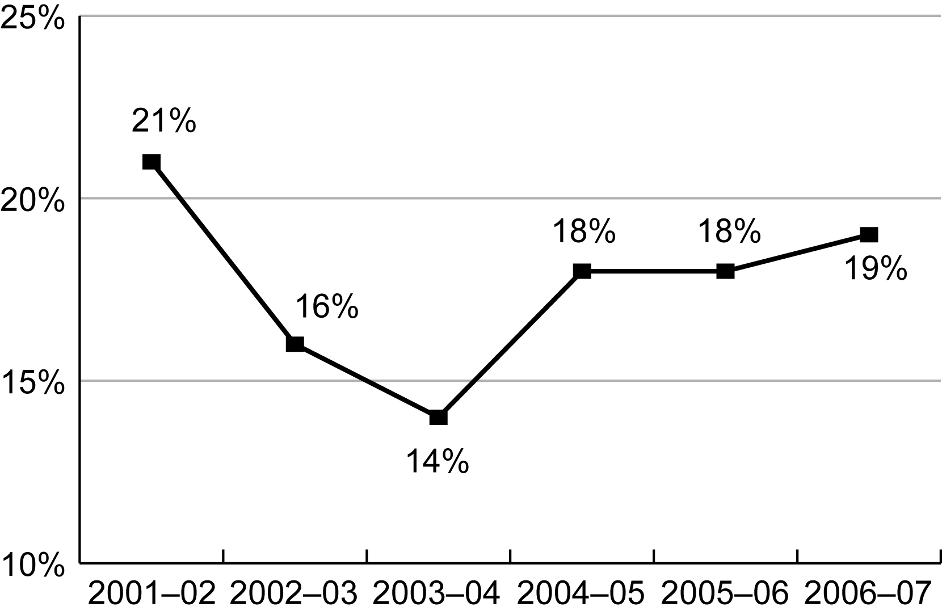
Exhibit reads: Twenty-one percent of districts with Title I schools had at least one Title I school that was identified for improvement for 2001–02.
Sources: Evaluation of Title I Accountability Systems and School Improvement Efforts (2001–02 to 2003–04) and SSI-NCLB (n = 13,997 districts with at least one Title I school).
Over the past five years, most of the districts that had at least one identified Title I school have very few identified schools. Of the 2,618 districts that had one or more identified Title I schools in 2006–07, 71 percent of these (1,871 districts) had only one or two identified Title I schools (see Exhibit 43).

Exhibit 43
Percentage of Districts With At Least One Title I School Identified for Improvement
by Number of Identified Schools, 2002–03 to 2005–06
Number of Identified  Schools in the District | 2002–03 | 2003–04 | 2004–05 | 2005–06 | 2006–07
1 school | 58% | 31% | 56% | 58% | 54%
2 schools | 15% | 16% | 17% | 17% | 17%
3 or 4 schools | 13% | 17% | 14% | 12% | 13%
5 to 12 schools | 10% | 23% | 9% | 9% | 11%
13 or more schools | 2% | 12% | 4% | 4% | 5%
Exhibit reads: In 2002–03, 58 percent of districts with at least one identified Title I school had a single identified Title I school.
Note: This exhibit includes only districts with at least one identified Title I school.
Sources: Evaluation of Title I Accountability Systems and School Improvement Efforts (2002–03 and 2003–04) and SSI-NCLB National AYP and Identification Database (n = 2,618 districts with at least one identified Title I school).
The majority of identified Title I schools were concentrated in just over 1 percent of the nation’s Title I districts.
With four-fifths of districts containing no identified schools and most of the rest containing only one or two identified schools, most identified Title I schools were concentrated in a small number of districts. Over half (53 percent) of all Title I schools identified for improvement were located in the 177 districts that each had 10 or more identified schools in 2006–07.
Furthermore, about one-fifth (19 percent) of all Title I identified schools were located in just 15 school districts (see Exhibit 44). These districts were typically among the largest districts in the nation, and they also had relatively high proportions of their schools identified for improvement. Often, more than half of Title I schools in these districts were identified for improvement. In California, Florida, Massachusetts, and Alaska, there was one district with 10 or more Title I schools where 100 percent of Title I schools were identified for improvement for 2006–07.
Schools in restructuring status were particularly likely to be concentrated in a small set of districts; the 15 districts with the most Title I schools in restructuring status accounted for 37 percent of all Title I schools in restructuring status in 2006–07 (see Exhibit 44). Again, the districts with the largest number of restructuring schools were often the districts with the largest number of schools overall. This fact could be interpreted as an indication that large districts had the largest school improvement needs, but the story is more complex. For instance, if one looks at the percentage of schools in each district that were in restructuring, some very large districts like New York and Los Angeles had fewer than 1 out of 5 of their Title I schools in restructuring while moderate size districts like Gallup-McKinley and Buffalo had higher proportions (1 out of 2) of their schools in restructuring.
Exhibit 44
Number and Percentage of Title I Schools Identified for Improvement and Restructuring in the 15 Districts With the Largest Numbers of Such Schools, 2006–07
Title I Schools Identified for Improvement |  |  | Title I Schools in Restructuring Status
District | n | Percentage | District | n | Percentage
Chicago, Ill. | 343 | 77% | Chicago, Ill. | 225 | 51%
New York, N.Y. | 337 | 28% | New York, N.Y. | 182 | 15%
Los Angeles, Calif. | 309 | 49% | Los Angeles, Calif. | 79 | 15%
Hawaii | 143 | 17% | Hawaii | 53 | 26%
Dade County, Fla. | 139 | 56% | Philadelphia, Pa. | 49 | 19%
Washington, D.C. | 103 | 53% | Baltimore City, Md. | 42 | 37%
Boston, Mass. | 89 | 71% | Detroit, Mich. | 28 | 14%
Hillsborough County, Fla. | 88 | 72% | Fresno, Calif. | 28 | 30%
Palm Beach County, Fla. | 77 | 75% | San Bernardino, Calif. | 24 | 39%
Philadelphia, Pa. | 75 | 29% | Memphis, Tenn. | 22 | 12%
Detroit, Mich. | 70 | 36% | Denver, Colo. | 21 | 18%
Columbus, Ohio | 67 | 49% | San Diego, Calif. | 20 | 13%
Fresno, Calif. | 63 | 68% | Buffalo, N.Y. | 20 | 46%
Broward County, Fla. | 60 | 52% | Oakland, Calif. | 18 | 18%
Oakland, Calif. | 58 | 57% | Gallup-McKinley Co., N.M. | 18 | 53%
Percentage of all identified schools | 19% of 10,781 |  | Percentage of all restructuring schools | 37% of 2,270
Exhibit reads: In 2006–07, Chicago, Ill., had 343 Title I schools identified for improvement representing 77 percent of all Title I schools in the district.
Source: SSI-NCLB, National AYP and Identification Database (based on 50 states, the District of Columbia, and Puerto Rico).

Differences in school identification rates by school characteristics
Previous studies have found that the probability that a school was identified for improvement varied significantly by such characteristics as grade level, poverty level, minority level, size, and urbanicity. The U.S. Government Accountability Office (GAO) reported that proportionately more middle and high schools than elementary schools were identified for improvement for 2003–04 (GAO, 2004). The GAO also found that proportionately more schools in urban and suburban areas than in rural areas were identified for improvement and that identified schools enrolled larger proportions of minority students and students from low-income families than other schools. Padilla et al. (2006) also found that the probability of a school being identified for improvement was higher for schools in large, urban, and high-poverty districts. Novak and Fuller (2003) found that the greater racial or ethnic diversity of students in a district translates into districts being held accountable for more subgroups, resulting in a lower likelihood of making AYP and, eventually, a greater likelihood of being identified. This study’s findings for 2004–05 (LeFloch et al., 2007), 2005–06 (Stullich et al., 2007), and again for 2006–07 are consistent with these previous studies.
High-poverty, high-minority, and middle schools, and large urban schools, were most likely to have been identified for improvement for 2006–07.
The same types of schools that were most likely not to make AYP (see Chapter III) were also most likely to be identified for improvement. Title I schools with higher proportions of low-income and minority students were more likely to have been identified for improvement than Title I schools with lower proportions of such students (see Exhibit 45). Thirty-seven percent of the high-poverty schools were identified for improvement, compared with 4 percent of low-poverty schools. Similarly, 38 percent of schools with a high concentration of minority students were identified for improvement, compared with 5 percent of low-minority schools. Urban Title I schools located in central cities (25 percent) were more likely to be identified for improvement than their counterparts in suburban and large towns (12 percent) or rural areas and small towns (9 percent).

Exhibit 45
Percentage of Title I Schools Identified for Improvement, by
School Poverty Level, Minority Level, and Urbanicity, 2006–07
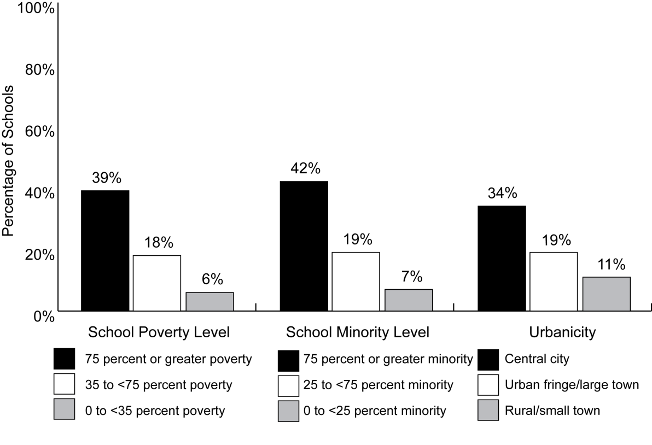
Exhibit reads: Thirty-nine percent of Title I schools with poverty rates of 75 percent or greater were identified for improvement for 2006–07, compared with 6 percent of schools with poverty rates below 35 percent.
Sources: SSI-NCLB, National AYP and Identification Database, and Common Core of Data, 2005–06 (based on data from 50 states, the District of Columbia, and Puerto Rico for 53,599 schools).

Students from low-income families, minority students, and students from urban areas were more likely to attend schools identified for improvement than were other students. Twenty-six percent of students from low-income families attended schools identified for improvement for 2006–07, compared with 18 percent of all students. Similarly, 29 percent of African-American students, 32 percent of Hispanic students, and 22 percent of Native American students attended schools identified for improvement for 2006–07, compared with 9 percent of white students. Twenty-eight percent of students from urban areas attended schools identified for improvement for 2006–07, compared with 14 percent of suburban students and 12 percent of rural students (see Appendix C, Exhibit C.11). In absolute numbers, the largest subgroup of students in identified schools was students from low-income families (5.2 million), followed by Hispanic students (3.2 million), white students (2.5 million), and African-American students (2.4 million). Overall, 8.6 million students attended identified schools in 2006–07 (see Appendix C, Exhibit C.12).
Middle schools were more likely than elementary and high schools to be identified for improvement. Twenty-two percent of middle schools were identified for improvement, compared with 13 percent and 14 percent of elementary and high schools, respectively (see Appendix C, Exhibit C.13, for this and other demographic analyses).
Large Title I schools were more likely than small Title I schools to be identified for improvement. For example, schools with 601 or more students were much more likely to be identified than were schools with fewer than 600 students (see Exhibit 46). The likelihood of identification increased fairly steadily as the size of the school increased.
Exhibit 46
Percentage of Title I Schools Identified for Improvement, by School Size, 2006–07
School Size | Not Identified | Identified | Year 1 | Year 2 | Corrective Action | Restructuring
200 or fewer students  (n = 9,143) | 90% | 10% | 5% | 3% | 2% | 1%
201 to 400 students  (n = 16,250) | 84% | 16% | 6% | 4% | 3% | 3%
401 to 600 students  (n = 14,621) | 78% | 22% | 8% | 5% | 5% | 4%
601 or more students  (n = 13,548) | 62% | 38% | 11% | 7% | 10% | 9%
Exhibit reads: In 2006–07, 90 percent of Title I schools with 200 or fewer students were not identified for improvement, and 10 percent were identified.
Note: Percentages may not add up to 100 percent because of rounding.
Sources: SSI-NCLB, National AYP and Identification Database, and Common Core of Data (based on data reported by 50 states, the District of Columbia, and Puerto Rico for 53,562 schools in these states).
Title I schools in the more advanced stages of improvement status were more likely to not make AYP for “all students” or for two or more subgroups than other Title I schools.
Title I schools in corrective action or restructuring status were more likely than other Title I schools to not make AYP for the achievement of the “all students” group or for the achievement of two or more subgroups. Specifically, 58 percent of Title I schools identified for corrective action for 2006–07, and 65 percent of Title I schools identified for restructuring, did not make AYP for the “all students” group (based on 2005–06 assessments), compared with 39 percent of schools that were identified for improvement for the first time, and 25 percent of schools that did not make AYP but were yet not identified for improvement. Conversely, 13 percent of Title I schools in corrective action and restructuring status did not make AYP for the achievement of a single subgroup, compared with 35 percent of non-identified schools that did not make AYP for this reason (see Exhibit 47).
Exhibit 47
AYP Targets Missed by Title I Schools That Did Not Make AYP in 2005–06,
by Stage of School Improvement Status for 2006–07
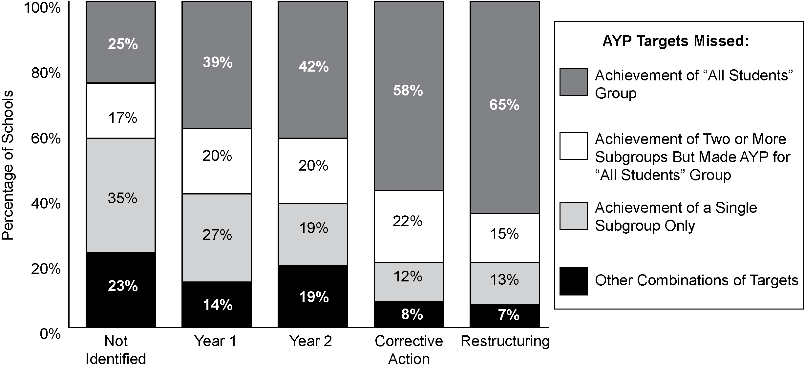
Exhibit reads: Among schools that did not make AYP based on 2005–06 assessments and were not identified for improvement in 2006–07, 25 percent missed an achievement target for the “all students” group.
Note: Percentages may not add up to 100 percent because of rounding.
Sources: SSI-NCLB, National AYP and Identification Database, and Common Core of Data (based on data reported by 50 states, the District of Columbia, and Puerto Rico for 12,785 Title I schools that did not make AYP in 2005–06 in these states).

Districts Identified for Improvement
The number of districts identified for improvement for 2006–07 was similar to the previous year, but the number of districts identified for corrective action increased five-fold.
Although only 13 percent of Title I districts (1,728) were identified for improvement for 2006–07, these districts enrolled 40 percent of the nation’s students, or about 18 million students; a similar percentage of districts (10 percent) was identified in 2004–05 and 2005–06. However, in 2006–07 many more of these identified Title I districts moved into corrective action. Among the identified districts, 381 districts in 26 states were identified for corrective action for 2006–07, a five-fold increase over 2005–06.
The rates at which states identified districts for improvement varied, ranging from no districts in five states to all districts in Florida (see Exhibit 48). Twenty-six states identified 10 percent or fewer of their districts, while twelve states identified a third or more of their districts. This variability reflects state differences in academic achievement standards, assessments, proficiency levels, district identification policies (e.g., districts are identified only if the district does not make AYP for two consecutive years at elementary, middle, and high school grade levels), district characteristics, levels of performance, and perhaps other factors.
Exhibit 48
Number and Percentage of Title I Districts Identified for Improvement, by State, 2006–07
State | Number | Percent | State | Number | Percent
Total | 1,728 | 13%
Alabama | 43 | 34% | Montana | 44 | 13%
Alaska | 29 | 57% | Nebraska | 0 | 0%
Arizona | 54 | 14% | Nevada | 3 | <1%
Arkansas | 2 | 1% | New Hampshire | 20 | 2%
California | 192 | 20% | New Jersey | 58 | 4%
Colorado | 63 | 36% | New Mexico | 34 | 66%
Connecticut | 28 | 20% | New York | 54 | 5%
Delaware | 2 | 11% | North Carolina | 64 | 56%
District of Columbia | 1 | 100% | North Dakota | 15 | 8%
Florida | 77 | 100% | Ohio | 69 | 12%
Georgia | 19 | 10% | Oklahoma | 7 | 2%
Hawaii | 0 | 0% | Oregon | 10 | 6%
Idaho | 67 | 60% | Pennsylvania | 19 | 4%
Illinois | 175 | 22% | Puerto Rico | 1 | 100%
Indiana | 32 | 11% | Rhode Island | 6 | 18%
Iowa | 15 | 4% | South Carolina | 27 | 32%
Kansas | 11 | 4% | South Dakota | 5 | 3%
Kentucky | 92 | 53% | Tennessee | 7 | 5%
Louisiana | 0 | 0% | Texas | 56 | 5%
Maine | 0 | 0% | Utah | 15 | 32%
Maryland | 2 | 8% | Vermont | 38 | 22%
Massachusetts | 149 | 43% | Virginia | 1 | 1%
Michigan | 12 | 2% | Washington | 32 | 11%
Minnesota | 48 | 12% | West Virginia | 21 | 38%
Mississippi | 5 | 4% | Wisconsin | 2 | 1%
Missouri | 0 | 0% | Wyoming | 2 | 4%
Exhibit reads: In 2006–07, 1,728 Title I districts were identified for improvement, representing 13 percent of all Title I districts.
Sources: Education Data Exchange Network, Consolidated State Performance Reports, and SSI-NCLB, National AYP and Identification database (n = 13,327 Title I districts in 50 states, the District of Columbia, and Puerto Rico).
One quarter of identified districts contained no identified schools.
Approximately 25 percent of identified districts in 2006–07 (431 districts) had no schools identified for improvement. Because district-level AYP calculations include students from all schools, districts may meet the minimum n sizes to calculate AYP for specific subgroups even if its schools do not. If such subgroups, when aggregated, do not make AYP at the district level but are too small to be counted at the school level, the result will be that districts with no identified schools will be identified for improvement.
Such identification of districts ensures that an educational jurisdiction is held accountable for low rates of proficiency among these subgroups of students. On the other hand, because assistance is commonly focused on schools, this situation raises questions about how to provide support to identified districts which have no schools that have been identified for improvement. For instance, Title I school improvement funds are directed only to districts with schools that have been identified for improvement (see Chapter VIII for more information on state assistance to districts).

Discussion
Nationally, the numbers of schools and districts identified for improvement increased only slightly from 2005–06 to 2006–07. However, both the number and percentage of identified schools and districts and the change in rate of identification differed from state to state. Some states identified one of every 20 of their schools, while others identified one out of every two. Although most districts with identified schools had only one or two identified schools, the 177 districts that each had more than 10 identified schools contained nearly half of all identified schools, and the 15 districts with the highest numbers of identified Title I schools contained a sixth of identified schools. These heavy concentrations of schools in need of improvement will test state and local improvement capacity.
Although the total number of Title I schools identified for improvement increased only slightly, identified schools have shifted into the more advanced stages of improvement status—corrective action and restructuring. Nearly three-fourths (72 percent) of the schools that were identified for improvement for 2004–05 remained in improvement status in 2006–07, and most of these had progressed to more advanced stages of improvement status. We also observed a decline in the proportion of identified Title I schools that exited improvement status over these three years. The percentage of schools exiting from improvement status decreased from 23 percent in 2004–05 to 17 percent in 2005–06 to 12 percent in 2006–07. These trends have altered the distribution of identified schools across the various stages of improvement status, such that for 2006–07 almost half of identified Title I schools were in corrective action or restructuring status. These schools in the more advanced stages of improvement were more likely than other schools to not make AYP for the achievement of the “all students” group or for the achievement of two or more subgroups. Unfortunately, there is little evidence on which strategies are effective in improving these persistently low-performing schools. Similarly, little is known about what exiting schools did to improve their AYP results or about what support they needed or received after exiting improvement status.
Forty percent of the nation’s students attended schools in the 13 percent of districts that were identified for improvement. One-quarter of these identified districts did not include any identified schools; because district-level AYP calculations included students from all schools, low-performing subgroups may have been large enough to be counted at the district level, but too small to be counted at the school level. This way, school districts were held accountable for the achievement of student subgroups even when schools were small or the concentrations of students from low-income families, minority students, disabled students, or LEP students were small.

V. Ensuring Progress for Students With Limited English Proficiency: Title III Accountability
Over the past decade, concern over how best to meet the needs of students with limited proficiency in English (LEP students) has increased along with the number of these students in U.S. schools. To address the growing numbers, and the linguistic and academic needs of LEP students, NCLB includes provisions to ensure that LEP students gain the English language skills they need to meet state standards and be successful in school. Title III of the Elementary and Secondary Education Act (ESEA) contains specific requirements to address the needs of LEP students.

Key Findings
- All states had implemented English language proficiency (ELP) standards by 2006–07, with the majority implementing their current standards after the 2003–04 school year.
- By 2006–07, nearly all states reported that they had implemented ELP assessments aligned with state ELP standards; almost half of the states developed their ELP assessments in collaboration with a multistate consortium.
- By 2006–07, 12 states had finalized their AMAO targets, while over half were in the process of revising them. Nearly half the states calculated and reported AMAOs for all districts with LEP students rather than only those receiving Title III funds.
- In 2006–07, over half the states were applying accountability actions to districts that had not met their AMAO targets for consecutive years. However, due to delays in the development of ELP standards, assessments, and AMAOs, some states were not yet imposing consequences.
- Although the majority of states provided technical assistance (to some or all districts) to improve education for LEP students in 2006–07, half of all schools that reported needing such assistance did not have their needs met.
In 2004–05, an estimated 5.1 million LEP students were enrolled in U.S. public schools, an increase of 61 percent over 1994–95. NCLB mandates that students meet state standards, that classrooms in core subjects be staffed with highly qualified teachers, and that parents be notified of their child’s progress, to the extent practicable, in a language that the parents can understand. These requirements may present unique challenges in curriculum and assessment design, professional development, human and financial resource allocation, teacher certification, and communication between the school and LEP family members. These challenges can be magnified by the sheer numbers of LEP students to be served. California alone, for example, educates more than 1.5 million such students. In other cases, the challenges may derive less from the total number of LEP students than from a sharp increase in the percentages of students for whom appropriately trained staff and materials may be lacking.
Public schools in every state enroll LEP students, although the percentages vary across states. In 2004–05, LEP students constituted more than 10 percent of total enrollment in 12 states, 5–10 percent in 11 states, and 1–5 percent in 25 states. California had the largest number of LEP students (approximately 1.5 million), as well as the largest percentage of students who were LEP (31 percent). New York, Florida, and Texas followed with approximately 234,578; 253,165; and 640,749 LEP students respectively (see Exhibit 49).
Exhibit 49
Total Number of Enrolled LEP Students, by State, 2005–06
State | 2005–06 | State | 2005–06
Alabama | 16,520 | Montana | 6,952
Alaska | 20,514 | Nebraska | 14,966
Arizona | 152,962 | Nevada | 74,305
Arkansas | 20,320 | New Hampshire | 4,179
California | 1,571,463 | New Jersey | 42,940
Colorado | 84,049 | New Mexico | 64,860
Connecticut | 27,678 | New York | 234,578
Delaware | 6,015 | North Carolina | 83,627
District of Columbia | 4,485 | North Dakota | 5,529
Florida | 253,165 | Ohio | 24,361
Georgia | 56,465 | Oklahoma | 31,011
Hawaii | 16,190 | Oregon | 65,824
Idaho | 18,588 | Pennsylvania | 41,097
Illinois | 204,803 | Puerto Rico | na
Indiana | 36,208 | Rhode Island | 10,000
Iowa | 14,742 | South Carolina | 20,013
Kansas | 25,995 | South Dakota | 5,275
Kentucky | 10,171 | Tennessee | 20,901
Louisiana | 7,740 | Texas | 640,749
Maine | 3,146 | Utah | 52,582
Maryland | 29,778 | Vermont | 1,564
Massachusetts | 47,397 | Virginia | 72,380
Michigan | 42,007 | Washington | 78,236
Minnesota | 58,727 | West Virginia | 1,224
Mississippi | 4,866 | Wisconsin | 40,522
Missouri | 17,263 | Wyoming | 2,057
Note: “na” means not available.
This exhibit does not include Puerto Rico where most students are native Spanish speakers and the target Title III population is limited Spanish proficient students.
Source: Consolidated State Performance Reports, 2005–06 (n = 50 states, the District of Columbia, and Puerto Rico).

In addition to the aggregate size of the LEP populations, increased growth rates in localities ordinarily without large populations of LEP students are becoming more common. The growth of LEP populations (as a proportional increase) has shifted from the states that traditionally have had larger LEP groups and thus may be more experienced in meeting their needs—such as California, Florida, and Texas—to states in the Southeast, Midwest, and interior West, for whom these issues are relatively more recent. For example, Michigan’s LEP population grew at a rate of 62 percent in just one year (2004–05 to 2005–06). In Louisiana, Mississippi, and West Virginia, where LEP students made up less than 1 percent of the total enrollment, the growth rate for this same period was 17, 41 and 45 percent, respectively.
Many states face the additional challenge of burgeoning numbers of LEP students at the secondary level. During the 1990s, the secondary school LEP population grew by 64 percent, compared with 46 percent growth at the elementary school level. However, data from the NCES Schools and Staffing Survey indicate that LEP students at the secondary level are less likely to receive English as a Second Language (ESL) instruction or bilingual instruction than are elementary students.
Another educational challenge is the linguistic composition of the LEP students in a state, district, or school—ranging from extreme linguistic diversity in some locales to comparative language isolation and de facto segregation in others. More than 400 languages are spoken by LEP students across the United States. The majority speak Spanish (79 percent) followed by Vietnamese (2 percent); Hmong (1.6 percent); Chinese, Cantonese (1.0 percent); Korean (1 percent), and other languages (15.4 percent). In some locales, certain languages may predominate, and in other areas the number of languages might be quite diverse. An individual school in some districts, for example, may enroll students speaking over 20 languages, a situation that increases the complexity of communication with both students and parents. The communication difficulties can be particularly pronounced if students come from linguistically isolated households (i.e., households where one language is spoken) or communities. In 2000, six out of seven LEP children in grades 1 to 5 lived in linguistically isolated households; in secondary school, two out of three LEP children did so.
Finally, many LEP students face not only the challenges of learning a new language, but also those that derive from poverty as well. In 2000, 68 percent of LEP children in grades PK–5 were low-income, as were 60 percent of LEP children in grades 6–12. These rates were nearly twice as high as the rates for English proficient children in comparable grades.
To address the growing numbers and the linguistic and academic needs of LEP students, NCLB includes provisions to ensure that students with limited English proficiency gain the English language skills they need to meet the state standards and be successful in school. This chapter describes these provisions, and the state implementation of these provisions during the 2005–06 school year.

Title III Provisions Under NCLB
NCLB is not the first attempt to address the needs of LEP students through ESEA. In 1968, three years after its initial passage, ESEA was amended to include Title VII, the Bilingual Education Act. Federal policy recognized bilingual education as a viable instructional method for economically disadvantaged language minority students and drew attention to the unique educational challenges of non-English speaking students with the passage of Title VII. Title VII underwent several amendments through the 1970s, 80s, and 90s, expanding funding within the competitive grant structure by increasing emphasis on professional development for teachers and by moving toward a focus on the acquisition of English and away from bilingual education.
In 2001, NCLB replaced the Title VII provisions with Title III, changing the funding structure from competitive grants to formula grants to states and adding provisions focused on “promoting English acquisition and helping English language learners meet challenging content standards.”
Explicit accountability for outcomes of LEP students is a new requirement of ESEA and is incorporated in both Titles I and III of NCLB. Title I requires that states develop and implement academic standards, aligned assessments, and AYP targets in reading and mathematics (see Chapter I of this report). LEP students are to be included in these state assessments and in the “all students” category for evaluating school and district attainment of AYP targets. In addition, schools and districts with sufficiently large LEP student populations are held accountable for ensuring that the LEP subgroup also meets AYP targets. Title III provisions may be seen to parallel Title I regulations, with the goal of LEP students attaining both English language proficiency and academic achievement. In order to determine whether or not LEP students are making sufficient progress in learning English, NCLB requires states to establish English language proficiency (ELP) standards and aligned assessments (distinct from state academic content standards and assessments in English language arts) and to measure progress toward, and attainment of, those standards for their LEP student populations. District and state progress is evaluated against Annual Measurable Achievement Objectives (AMAOs), and all districts receiving Title III funds are to be held accountable for meeting state-established AMAO targets each year (see Exhibit 50).

English language proficiency standards
States’ ELP standards differ from English Language Arts (ELA) standards in both their purpose and their content. Designed to guide development of English proficiency for students from a different primary language background, ELP standards must define competence in speaking, listening, reading, and writing in English and must set clear levels of progress (English proficiency levels) that reflect the differences in each student’s grade level and English language abilities. Proficiency levels must include a descriptor (such as novice or intermediate) and there must be an assessment cut score corresponding to each level.
Exhibit 50
Title I and Title III Provisions Under NCLB
Provision | Title I | Title III
Standards | English Language arts, mathematics, and science | English language proficiency for LEP students
Assessments | Academic assessments AND an ELP assessment | ELP assessment (can be same instrument used for Title I)ª
Measuring progress | Adequate Yearly Progress (AYP)  (to measure progress of all students toward meeting the state’s standards in English language arts and Mathematics) | Annual Measurable Achievement Objectives (AMAOs)  (to measure progress of LEP students in Title III districts toward meeting ELP proficiency and subject matter standards)
ª While the ELP assessment used for Title III may be the same instrument used for Title I purposes, Title III requires that the assessment be aligned with the state’s ELP standards. No such explicit requirement exists for Title I, as there are no ELP standards required under Title I.
Source: Title III Non-regulatory Guidance, U.S. Department of Education (2003).
NCLB requires that the ELP standards be aligned with the achievement of state academic standards in the content areas. The goal is to ensure that LEP students are learning the type of academic English necessary to make progress in core content.

Assessments
NCLB requires states to assess LEP students in English language proficiency in the four domains of reading, listening, speaking, and writing. As for ELP standards, NCLB initially required states to have their ELP assessment(s) in place during the 2002–03 school year, but this deadline was extended by the U.S. Department of Education to spring 2006.
Another important change in the testing requirements involves the time when students are required to take the ELA assessment in English. Initially, all students were required to participate in their state academic assessment system once they had enrolled in school. However, the U.S. Department of Education, “in support of state and local efforts for LEP students to achieve at high levels and to adjust to new surroundings,” ruled that a recently arrived LEP student (a LEP student who has attended schools in the United States for less than 12 months) may be exempt from one—and only one—administration of the state’s reading assessment. A newly arrived student must take the state’s ELP assessment, however, and must take the state’s mathematics or science assessments.

Annual measurable achievement objectives
States must report the progress of their LEP students in learning English, as defined by the state’s ELP standards and measured by the state ELP assessment. Progress is to be reported relative to the state’s AMAOs, which include three criteria:
- annual increases in the number or percentage of students showing progress in learning English;
- annual increases in the number or percentage of students attaining ELP by the end of the school year; and
- attainment of AYP targets in reading and mathematics for the LEP subgroup.
The AMAOs hold districts receiving Title III funds accountable for improving levels of English proficiency and academic performance of their LEP students. If a state determines that an applicable district has not met its AMAOs for two consecutive years, the district must develop an improvement plan with support from the state. If the district has not met AMAOs for four consecutive years, it must modify its curriculum, program, and method of instruction, or the state must assess whether the district should continue to receive funds and must also require the district to replace personnel relevant to the district’s failure to meet AMAOs.

Implementing ELP Standards, ELP Assessments, and AMAOs
The goal of Title III provisions under NCLB is to ensure that LEP students gain English language proficiency to keep pace with their English-speaking peers in academic content areas. To this end, NCLB legislated that states develop and implement ELP standards, ELP assessments, and AMAOs for LEP students. This section discusses how the law has been implemented across the states.

Implementing ELP standards
Before the 2001 passage of NCLB, ELP standards were not required and very few states had developed them. Indeed, only 14 states reported that they had some form of such “standards” in place when the law was passed. Moreover, in each of these 14 states, Title III directors reported that ELP standards were not binding but instead served merely as guidance or curriculum aids.
All states had implemented ELP standards by 2006–07, with the majority implementing their current standards after the 2003–04 school year.
NCLB required states to establish ELP standards before or during the 2002–03 school year. Because so few states had prior experience setting such standards, very few were able to meet this deadline. Recognizing the need for flexibility, the U.S. Department of Education extended the deadline to the 2005–06 school year. By 2004–05, after a slow start, 41 states had implemented ELP standards, and by 2006–07, all states, the District of Columbia, and Puerto Rico had implemented their ELP standards (see Exhibit 51).
Three states implemented their ELP standards during the 1998–99 and 1999–2000 school years, three states implemented them during the 2002–03 school year, 13 states implemented in 2003–04, while the majority of states implemented their standards after the 2003–04 school year (29 states, the District of Columbia, and Puerto Rico). In 2006, state directors indicated that after their ELP standards were put in place, changes to these standards might include small revisions to ensure alignment with other content and academic standards as well as larger periodic revisions similar to those for other state standards (generally every five to seven years).
Exhibit 51
Number of States, by First Year ELP Standards Were Implemented
Source: SSI-NCLB, Title III Interviews (n = 48 states, the District of Columbia, and Puerto Rico. Data were not available for two states).
Enhanced Assessment Grant Consortia provided support to some states in the development of ELP standards. In March 2003, the U.S. Department of Education awarded Enhanced Assessment Grants under Section 6112 of ESEA. The purpose of these grants was to help states improve the quality of state assessments, with award preference going to states targeting assessments for LEP students and students with disabilities. Four of the recipients were multistate consortia that included approximately 38 states as of 2004–05:
- The World-class Instructional Design and Assessment (WIDA) consortium;
- The State Collaborative on Assessment and Student Standards (SCASS) Limited English Proficient (LEP) consortium (otherwise known as the LEP-SCASS);
- The English Proficiency for All Students (EPAS) consortium; and
- The Mountain West Assessment Consortium (MWAC).
In addition to providing support to states in developing their ELP assessments, some of the consortia assisted states in developing their ELP standards. For example, states participating in the WIDA consortium actively used the consortium for the development of ELP standards as well as the ELP assessment. The LEP-SCASS and MWAC consortia also provided some support in developing standards, while EPAS concentrated on the development of state assessments.
In 2004–05, more than half of state directors indicated that they were participating in one of the four consortia for ELP standards or assessment development. By 2006–07, 20 states and the District of Columbia had developed ELP standards with the support of a consortium. These states reported that they had either used a consortium as a resource, adopted a consortium’s ELP standards, or had adapted a consortium’s ELP standards for their own needs. Thirty states and Puerto Rico indicated that they had not used support from a consortium to develop their ELP standards.
NCLB requires that the ELP standards be aligned with the achievement of state academic standards in the content areas. The goal is to ensure that LEP students are making progress not only in learning English in general but in learning the type of academic English that will lead to success in the content areas. Some state directors reported that they linked their ELP standards with state content and academic achievement standards with the support of entities such as state advisory board members, outside consultants, or consortia. The approach and methods used for this alignment differed widely across the states.

Implementing ELP assessments
By 2006–07, nearly all states reported that they had implemented ELP assessments aligned with state ELP standards; almost half the states developed their ELP assessments in collaboration with a multistate consortium.
NCLB requires states to provide for an annual assessment of ELP in reading, writing, speaking, and listening. In 2004–05, implementation of ELP assessments was incomplete in 27 states. Although many states had some type of proficiency test for LEP students prior to NCLB, these tests were generally designed for placement purposes rather than to measure progress in acquiring language proficiency. Therefore, new tests had to be developed and implemented to meet NCLB requirements in many states.
By 2006–07, 49 states, the District of Columbia, and Puerto Rico had implemented their ELP assessment(s) in compliance with NCLB requirements. One state anticipated implementing its ELP assessment in the 2007–08 school year. Forty-four states, the District of Columbia, and Puerto Rico implemented their current assessments during or after 2004–05. Prior to 2004–05, only five states had implemented their current ELP assessments (see Exhibit 52).
Exhibit 52
Number of States by First School Year Assessments Were Implemented
Source: SSI-NCLB, Title III Interviews (n = 50 states, the District of Columbia, and Puerto Rico).
States had several available means for developing their assessments: states adopted an ELP assessment from an out-of-state source (four states and the District of Columbia); adapted assessments for their state from an out-of-state source (eight states and Puerto Rico); developed assessments specifically for or by the state (13 states); or developed their assessments in collaboration with a multistate consortium (23 states). Two states used multiple sources to develop their assessments. In the fall 2006–07, state directors considered their ELP assessments to be in place and anticipated making only small revisions to them or otherwise updating or further aligning them, when needed.
To ensure that ELP assessments measured ELP standards, states conducted alignment studies. Twenty-six states conducted an independent study on the alignment of ELP standards, while 20 states did not. Further, 20 states (not all of the same 20 states) also indicated that they conducted other alignment studies.

Measuring progress for LEP students through AMAOs
States must report the progress of their LEP students in learning English, as defined by the state’s ELP standards and measured by the state-adopted ELP assessment. Progress is to be reported relative to the state’s AMAOs. These AMAOs must apply at least to all districts receiving Title III funds and must encompass progress covering both core content and English language proficiency.
Since the passage of Title III provisions under NCLB, it was difficult for states to set AMAO targets as states faced challenges in implementing valid and reliable ELP assessments and ELP standards that were linked or aligned with state academic content standards, both of which are important in determining reasonable growth targets. Additionally, most states were using ELP assessments that were not designed to measure growth in language acquisition as required by NCLB, but developed for the placement of LEP students in classes specifically designed for LEP students. States that had no prior ELP assessment had to adopt an interim test that would assess LEP students annually while working on the development of assessments that were in line with NCLB requirements, most of which took several years to develop. Even though many states had such assessments in place in 2004–05 or were planning to have them in 2005–06, most states indicated that their AMAOs would change in the next few years as they received new test data and created new baselines.
By 2006–07, 12 states had finalized their AMAO targets, while over half were in the process of revising them.
Title III directors in 11 states and the District of Columbia reported that their state’s AMAOs were put in place during the 2002–03 school year; 10 directors indicated that their state’s AMAOs were first established in 2003–04; five in 2004–05; seven each in 2005–06 and 2006–07; and two states AMAOs were to be implemented in the upcoming 2007–08 school year. However, most states have been making revisions to their AMAOs. In 2006–07, over half of states and the District of Columbia were in the process of revising their AMAOs, while only 12 state directors reported they had finalized these targets. In developing and revising their AMAOs, state directors reviewed several years of assessment data to determine how much progress an LEP student can be expected to make in a year’s time. Thirty-seven states still anticipate amending their AMAOs.

Calculating and Reporting AMAOs
Nearly half the states calculated and reported AMAOs for all districts with LEP students rather than only those receiving Title III funds.
States are required to calculate AMAOs for all districts receiving Title III funds. However, 25 states calculated and reported AMAOs for all districts with LEP students while fewer than half restricted the calculations only to districts receiving Title III funds. One state calculated and reported AMAOs for both Title I and Title III districts. Twenty-five states reported AMAO data to the public.
Twenty-five states defined their AMAO cohorts by grade span or level (e.g., states could set targets for grades spans such as K–2, 3–5, 6–8 or individual grade levels), although six states and the District of Columbia used proficiency level, and four states used length of time in the U.S. or a formal schooling system to define their cohorts. The remaining states used other measures to define their cohorts, such as including all LEP students in the cohorts, comparing students across years, or using multiple measures such as grade level and length of time.

Accountability for Meeting AMAO Targets
Over half the states were applying accountability actions to districts that had not met their AMAO targets for consecutive years. However, due to delays in the development of ELP standards, assessments, and AMAOs, some states were not yet imposing consequences.
The AMAOs hold districts receiving Title III funds accountable for improving levels of English proficiency. If a state determines that an applicable district has not met its AMAOs for two consecutive years, the district must develop an improvement plan with support from the state. If the district has not met AMAOs for four consecutive years, the state must require the district to modify its curriculum, program, and method of instruction or assess whether the district will receive additional funds and be required to replace educational personnel relevant to not meeting these objectives.
Nineteen state directors said they reported their AMAOs to the U.S. Department of Education and were aware of consequences for districts not meeting AMAOs. Due to the delay in the implementation of ELP standards, ELP assessments, and AMAOs as well as the questionable validity of the original AMAOs developed from inappropriate and nonaligned assessments, these 19 state directors were not holding districts accountable for missing AMAO targets. However, they indicated their intent to implement accountability measures once they have accurate data.
All state directors were aware that if districts did not meet their AMAOs for two consecutive years, states would require districts to develop an improvement plan, provide technical assistance, and provide professional development as required by NCLB. If districts did not meet their AMAOs for four consecutive years, states directors indicated they would provide specific program interventions, discontinue funding, replace educational personnel, and provide improvement grants as outlined under NCLB. For states that are holding districts accountable, 11 were applying actions to all districts that did not meet their targets for the specified period, and 16 states were applying actions only to Title III districts under these conditions. One state was targeting a subgroup of districts with a subgroup of actions.

Providing State-Supported Technical Assistance
Under NCLB’s Title III provisions, the responsibilities of the state education agencies are to provide technical assistance to subgrantees in implementing Title III program services. States are to provide technical assistance to subgrantees in:
- identifying and implementing language instruction education programs (LIEP) and curricula that are based on scientific research;
- helping LEP children meet the same challenging state academic content and student academic achievement standards as all children are expected to meet;
- identifying or developing, and implementing, measures of English proficiency; and
- promoting parental and community participation in programs.
Although the majority of states provide technical assistance (to some or all districts) to improve education for LEP students, half of all schools that reported needing such assistance did not have their needs met.
In 2006–07, Title III directors from 45 states reported that their state provided technical assistance for improving education for LEP students. Technical assistance was provided primarily by state departments of education (in 45 states), but also included external contractors used by the state (28 states), districts (22 states), and regional teams in the state (18 states). Assistance was also provided by Title III directors, state service centers, and universities (8 states).
Targets for this technical assistance differed somewhat across the states. Thirty-eight states provided support to all districts with LEP students; five provided it only to Title III districts, and five said they provided assistance regardless of LEP population. No state reported that it restricted technical assistance to districts with a specified number or percentage of LEP students. Technical assistance was also provided by states at the district and school levels to district administrators (45 states), school administrators (40 states), and teachers (25 states). The majority of technical assistance was given based on the needs of the districts (42 states).
Most states reported that the focus of their technical assistance included understanding and using assessments (44 states), managing and interpreting data (42 states), complying with NCLB requirements relevant to LEP students (40 states), providing professional development for teachers (26 states), improving instructional methods (4 states), and selecting and identifying effective curriculum (1 state). The mechanisms for the delivery of this technical assistance varied, but generally included multiple formats: visits to districts (46 states), conferences, meetings, or institutes (46 states), the Web (42 states), and telephone and e-mail contact (34 states).
Although Title III only requires states to provide technical assistance to Title III sub-grantees (districts), the results of the NLS-NCLB survey provide insight into the need and availability of such assistance at the school level as well. About one-third of schools nationwide reported needing technical assistance to meet the needs of LEP students in 2005–06 or 2006–07, about one-quarter of these schools did not receive such assistance (from any source), and about one quarter of the schools that did receive it were not satisfied that the assistance they received was sufficient to meet their needs (see Appendix C, Exhibit C.13). Overall, about one-half of the schools that needed technical assistance to improve services for LEP students did not have their needs met.
Schools identified for improvement under Title I were more likely to report needing assistance to meet the needs of LEP students than were non-identified schools in 2005–06 or 2006–07 (see Exhibit 53). Similarly, schools with the higher proportions of low-income students reported needing this technical assistance at higher rates than schools with lower proportions. Schools that needed technical assistance in this area were equally likely to receive it regardless of their characteristics.
Exhibit 53
Percentage of Schools Needing Technical Assistance in 2005–06 or 2006–07 to Meet the Needs of Limited English Proficient Students, by School Characteristic
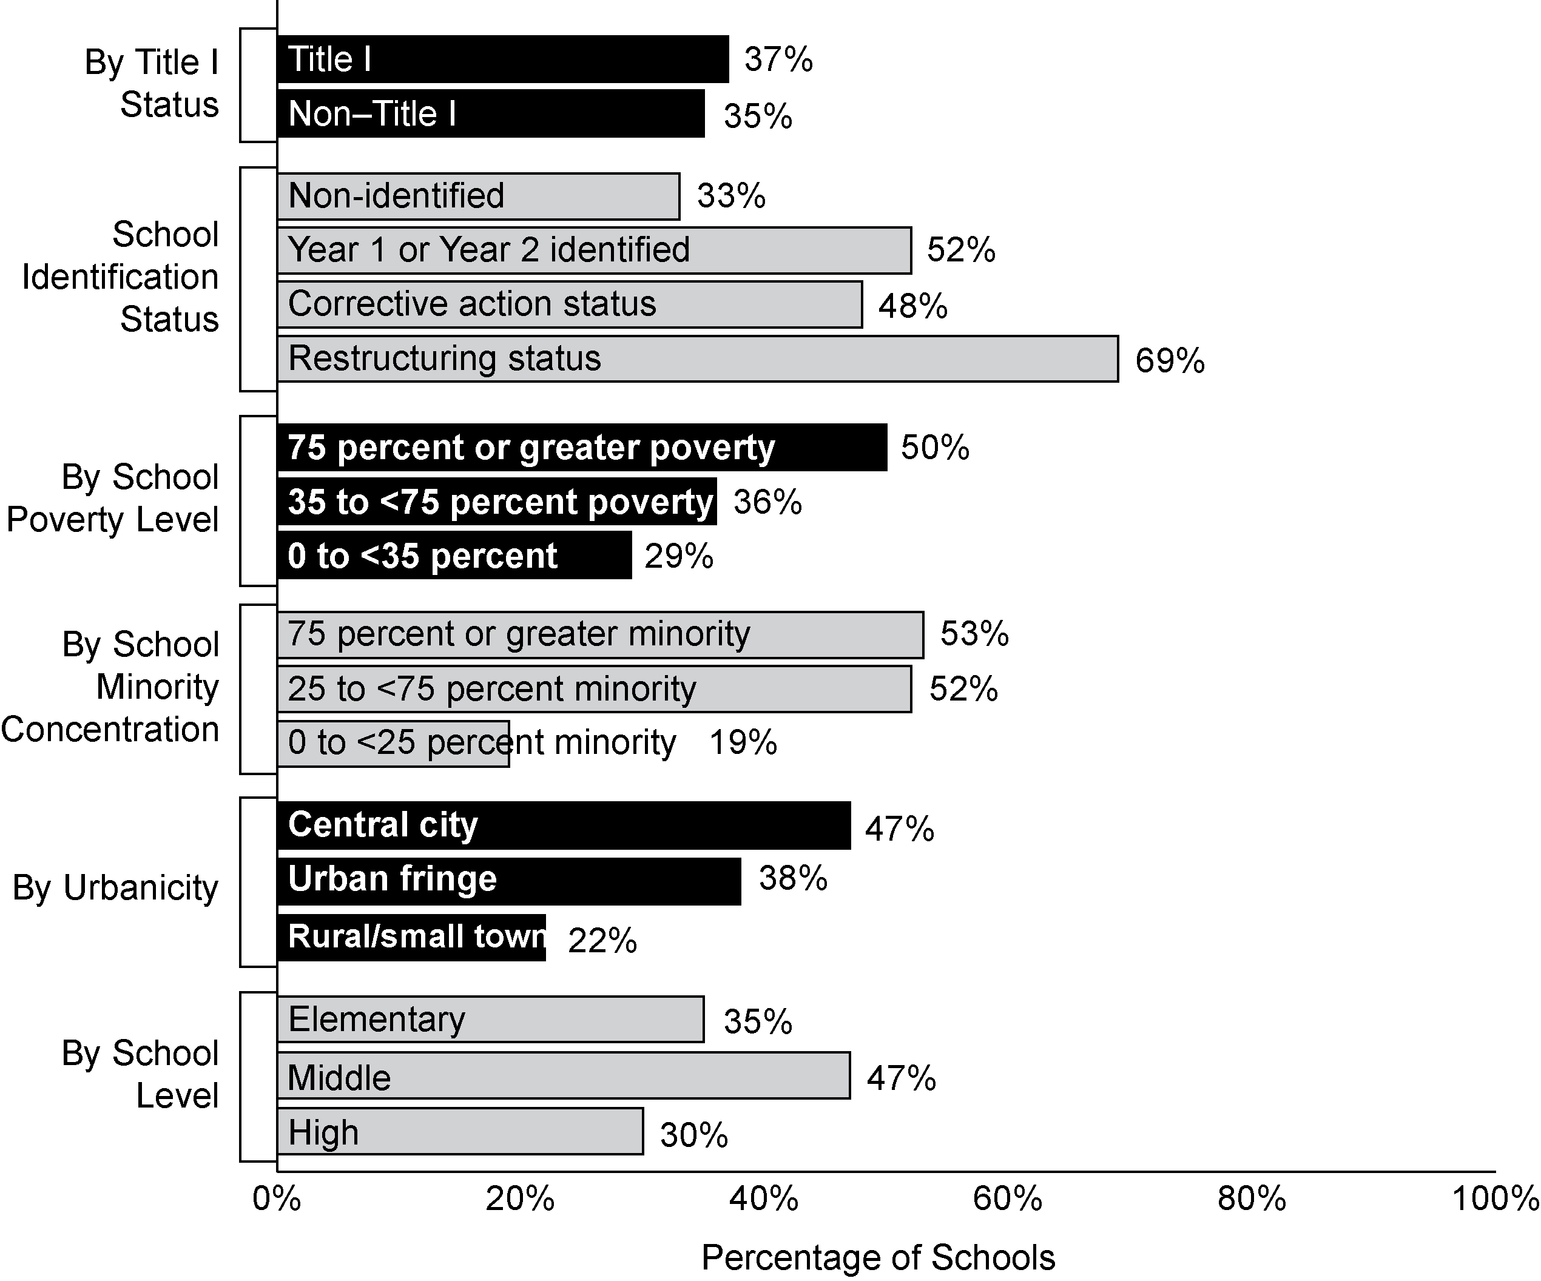
Exhibit reads: Thirty-three percent of non-identified schools reported needing technical assistance addressing the needs of LEP students, compared with 52 percent of schools in Year 1 or Year 2 of being identified for improvement.
Source: NLS-NCLB, Principal Survey (n = 1,392 schools).
In 2006–07, 50 percent of teachers in identified elementary schools reported receiving assistance to meet the needs of LEP students but only 36 percent of teachers in non-identified elementary schools reported receiving such assistance. There were no differences between identified and non-identified schools in the percentage of secondary English teachers (44 percent), secondary mathematics teachers (37 percent), and special education teachers (31 percent) who received professional development assistance related to LEP students.

Discussion
States have been moving forward in their development and implementation of the Title III provisions and have made considerable effort toward putting statewide processes in place for meeting the needs of LEP students. Despite this progress, implementation of the standards-based components of Title III—ELP standards, aligned ELP assessments, and AMAO targets and accountability actions—has not yet caught up with the implementation of similar provisions in the content areas covered by Title I. The differences in implementation trajectories between the two Titles can be attributed to a number of factors and challenges. Chief among these is the fact that very few states had ELP standards and aligned assessments in place prior to the enactment of NCLB. By contrast, states had at least seven years working toward this goal with respect to reading and mathematics under IASA. Moreover, before 2002, even states that did have ELP standards were mostly using them for general guidance or as curricular aids rather than for accountability purposes. As for ELP assessments, states often administered multiple assessments to place LEP students in courses. Many of these assessments were not valid or reliable for measuring progress in acquiring English as required by NCLB. Finally, states reported that they had not received consistent methods or specific criteria for developing key Title III provisions.
Although these challenges delayed implementation of Title III, states did move forward to finalize their ELP standards and assessments and revise their AMAOs based on valid and reliable assessments. By 2006–07, all states had their ELP standards in place and nearly all had finalized their ELP assessments. Lacking sufficient accumulation of data on student progress using these assessments, most states were still in the process of revising their AMAO targets. Because of this delay in finalizing valid AMAOs, some states had not begun imposing consequences on districts for not meeting AMAO targets, but planned to do so once the AMAO targets become finalized.

VI. Providing Information About School Performance To Stakeholders
To help schools and districts reach NCLB accountability goals, clear and accurate information about performance must be communicated in a timely manner to key stakeholders (including district and school personnel, parents, policymakers, and the public). Key NCLB information includes whether or not students met state academic achievement standards during a specific school year and whether a school made AYP and for which groups and indicators. Stakeholders also need to know whether or not a school has been identified for improvement, corrective action, or restructuring, so that appropriate actions can be taken. In addition, improvement efforts can be more appropriately targeted if stakeholders have all pertinent information sufficiently before the school year begins so that action can be taken. The responsibility for producing and distributing this information falls on states and districts; the responsibility for acting on the information is shared by states, districts, schools, teachers, and parents.

Key Findings
- States reported performance results from 2005–06 more quickly than for 2003–04. Forty-four states, the District of Columbia, and Puerto Rico delivered preliminary notification to schools identified for improvement before September 2006, an increase from 31 states in 2003–04.
- States have made progress since 2004–05 in developing systems capable of measuring the progress of individual students. In 2006–07, 41 states had data systems with both student identifiers and the ability to evaluate test scores in multiple years.
- Since 2003–04, states have continued to enhance their reporting capabilities to align their practices with NCLB requirements. However, disaggregated graduation rates and teacher quality data remained absent from many state report cards.
- While 2005–06 state report cards proved easier to find online and to understand than those from 2003–04, district reports remained challenging to locate online.
- In 2006–07, nearly all principals knew whether their schools made AYP (90 percent) or were identified for improvement (94 percent). Teachers, although more alert to their schools’ accountability status in 2006–07 than in 2004–05, remained less knowledgeable than principals about their school’s status.

State Data Systems and Reporting
Providing the necessary information to stakeholders about school performance and other key factors requires data management systems that can track student characteristics, enrollment, achievement, and graduation, as well as other variables. States must also be able to administer and score assessments, conduct AYP calculations, and report these results between their testing periods and the start of the following school year. Districts, too, must issue report cards that include data on assessment results, accountability, and teacher quality.
Accurate and timely information brings transparency to educational policies, uncovers academic problems and deficits, and highlights areas in which schools have made gains. When parents have information about the schools their children attend, they can make better decisions concerning their children’s educational futures, become more effective advocates for their children’s schools and school systems, assuage their own concerns, and bolster their demands for change. When taxpayers are informed about the schools they fund, they can celebrate progress, pinpoint problems, and determine to their own satisfaction whether or not public funds have been well spent. And when administrators and teachers have access to accurate performance data, they can focus on the areas in which there are problems and tailor their improvement efforts to those concerns.
By 2006–07, states had increased the capacity of their data systems to generate the information required by NCLB, improved the timeliness of their data reporting, and advanced their capacity to report disaggregated achievement data compared to 2004–05.
States reported performance results from 2005–06 more quickly than for 2003–04.
To take appropriate action most efficiently in response to being identified for improvement, schools, districts, and parents must receive this information prior to the start of the school year. As underscored by one state official, “[Timely release of performance data] allows [districts and schools] to respond very quickly once they get our data because then they know, [for example], if they’re going to have to get choice letters and those kinds of things accomplished in a very quick fashion.”
For the accountability information based on 2005–06 testing, 44 states, the District of Columbia, and Puerto Rico delivered preliminary notification to schools identified for improvement before September 2006, an increase from 31 states in 2003–04 (see Exhibit 54). Likewise, states improved the timeliness of final determinations of schools identified for improvement. Twenty-six states and the District of Columbia released final data to schools before September 2006. Seventeen states and Puerto Rico provided final data to schools in October or later, down from 33 states in 2004–05. While the improved timeliness represents an encouraging development, roughly one-third of states were still finalizing calculations and processing appeals well into the school year.
In 40 states and the District of Columbia, final determinations were rendered within two months of the release of preliminary notifications. Seven states reported having different notification dates for elementary and middle schools and high schools. In all but one of these states, elementary and middle schools were informed before high schools—typically one to two months earlier. In the lone instance in which high schools were notified prior to elementary and middle schools, there was a gap of four months.
The reports from school principals indicated a similar trend: nearly two-thirds of principals (62 percent) reported that they were first notified of their school’s AYP status before September 2006, compared to 56 percent in 2004–05 (see Exhibit 55).
Exhibit 54
Number of States Providing Preliminary and Final Notification of School
Improvement Status, by Month of Notification, 2004–05 and 2006–07
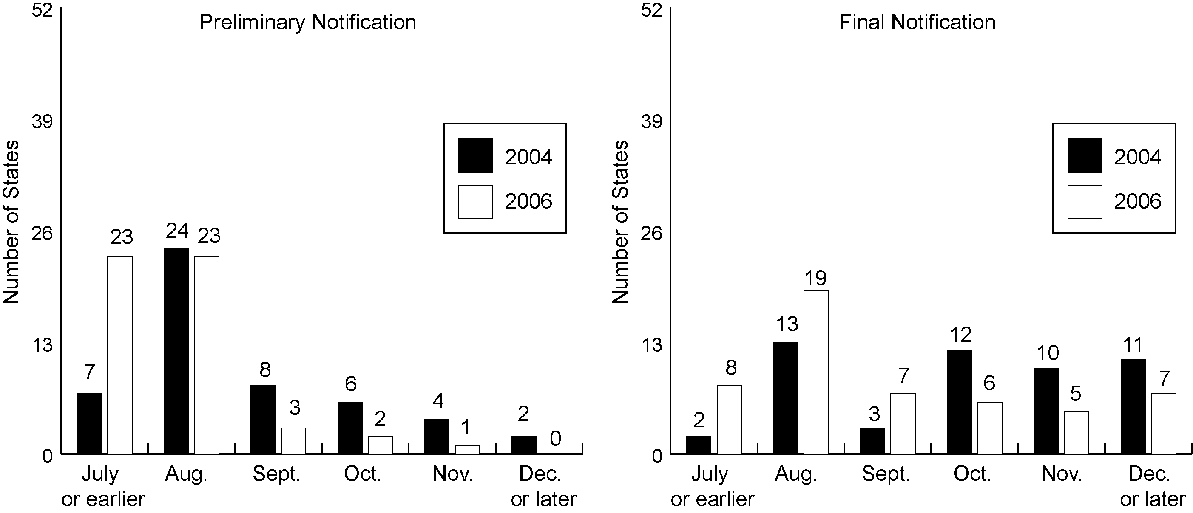
Exhibit reads: Seven states released preliminary accountability designations to schools in July 2004 or earlier and 24 states released preliminary designations in July 2006 or earlier.
Note: If states released accountability results at different dates for elementary and high schools, the earlier month was counted for the purpose of this chart.
Source: SSI-NCLB accountability interviews and extant sources (n = 50 states and Puerto Rico in 2004–05; n = 50 states, the District of Columbia, and Puerto Rico in 2006–07).

Exhibit 55
Percentage of Schools Notified of Their AYP and Improvement Status by Month, 2006–07
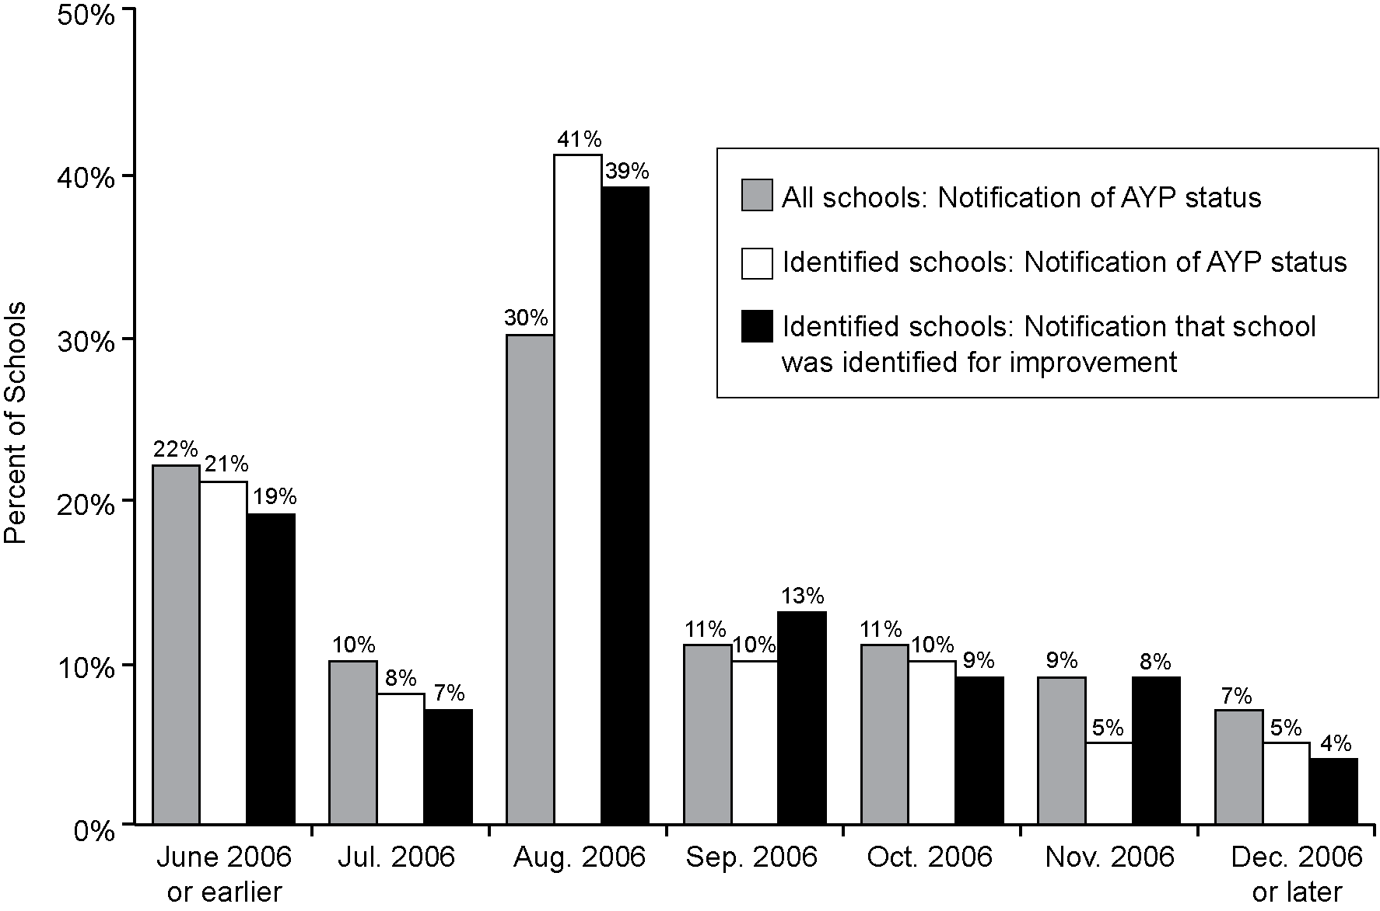
Exhibit reads: Twenty-two percent of all schools were notified of their AYP status in June 2006 or earlier.
Source: NLS-NCLB, Principal Survey (n = 1,392 schools).
States have made progress since 2004–05 in developing student data systems to measure the progress of individual students.
In accordance with NCLB requirements, states must collect and disseminate disaggregated student achievement and school accountability results once each year. Although not mandated by NCLB, the capacity to track the progress of individual students has garnered increased attention in recent years. Providing data on academic growth provides more substantial insight on which to base instructional and other policy-related decisions. To this end, states must have the ability to link individual student test scores over time. This requires data systems with two critical elements: (1) unique student identifiers (e.g., identification codes for each student) that follow students across years and (2) the ability to match individual students’ test records from year to year (Data Quality Campaign, 2006).
In 2006–07, 41 states had data systems with both necessary components, up from 32 states in 2005–06 and 16 in 2004–05 (see Exhibit 56). An additional seven states had data systems with one of the two elements in 2006–07; four used student identifiers and three had the ability to evaluate test scores in multiple years. The inclusion of these elements offers tangible benefits to key stakeholders. As one state official explained:
[We are] so glad that we have a unique student ID system and the data infrastructure that we have…[I]t has forced our schools to make…good and appropriate use of data…In the past, [data provided to schools] have been [disjointed]. This system, what we’ve done is we’ve kind of captured all of the data for them and put it in a cohesive system that they can use in better and more appropriate ways.
Exhibit 56
Number of States With Data Systems With the Ability to Track Individual Student Test Scores Over Time, 2004–07
Exhibit reads: In 2003–04, 14 states had data systems with the ability to track individual student test scores over time.
Source: Data Quality Campaign (2004–2006) (n = 48 states, the District of Columbia, and Puerto Rico).

State Report Cards
Under NCLB, states are required to produce annual state-level report cards, which should include assessment trend data, graduation rates, district accountability information, school-level accountability information (names of schools and overall numbers), percentage of classes taught by highly qualified teachers, and percentage of teachers on emergency credentials—with most variables disaggregated by student subgroup. In addition, states “shall ensure that each local educational agency collects appropriate data and includes in the local educational agency’s annual report” the data required by NCLB (Title I, Sec. 1111). Hence, the legal responsibility for ensuring full compliance with NCLB state, district, and school-level reporting requirements lies with the state.
Since 2003–04, states continued to enhance their reporting capabilities to align their practices with NCLB requirements, demonstrating progress in reporting data disaggregated by student subgroups and district AYP performance. However, disaggregated graduation rates and teacher quality data remained absent from many state report cards.
Inclusion of achievement data disaggregated by student subgroups was nearly a universal practice in 2005–06 state report cards. Fifty states, the District of Columbia, and Puerto Rico reported on student performance in mathematics and English language arts for all students, economically disadvantaged students, students with disabilities, white non-Hispanic students, and Hispanic or Latino students; only Puerto Rico did not provide data on African-American students. Forty-eight states and the District of Columbia reported on the percentage of limited English proficient students achieving at the proficient level, and 45 states and the District of Columbia reported on the performance of American Indian, Native American and Asian students. In addition, student assessment results were provided by 45 states, the District of Columbia, and Puerto Rico; 43 states and the District of Columbia reported on migrant students. Eleven states and Puerto Rico provided data on students classified as multiracial or other.
Several other indicators were featured commonly in state report cards. For instance, NCLB requires state report cards to include data on district AYP performance, an element which 46 states, the District of Columbia, and Puerto Rico provided in 2005–06, compared to 31 states and Puerto Rico in 2003–04. Reporting on the names of schools identified for improvement has remained consistently high: Forty-two states and the District of Columbia in 2003–04 and 40 states, the District of Columbia, and Puerto Rico in 2005–06.
Data on teacher quality and other NCLB requirements, although reported in more state report cards in 2005–06 than in 2003–04, continued to lag behind other indicators. In 2005–06, 37 states, the District of Columbia, and Puerto Rico provided information on the percentage of core academic area classes that were not taught by highly qualified teachers, an increase from 18 states in 2003–04. Comparisons of student achievement to AYP targets were offered by 29 states and the District of Columbia in 2005–06 compared to only 16 states in 2003–04. Fewer states did not offer data on disaggregated graduation rates: twenty-five states, the District of Columbia, and Puerto Rico did not provide graduation rates by subgroups.
While 2005–06 state report cards proved easier to find online and to interpret than those from 2003–04, they remained challenging to locate online.
A review of state education agency Web sites conducted by the SSI-NCLB team in spring 2007 revealed that state report cards were more accessible and clear than they had been at the time of the previous review, conducted in summer 2005. For example, 46 states provided a direct link to the state report card on their state department of education home page by spring 2007, an increase from 26 states in 2005. Similarly, 44 states and the District of Columbia included all state report card information in a single location (i.e., in a single file or with all relevant links on a single Web page) and 40 states, the District of Columbia, and Puerto Rico offered straightforward online access to state report cards (i.e., files available in PDF format or required minimal navigation) in 2007, compared to 40 and 24 states, respectively, in 2005. State report cards in languages other than English, required to the extent practicable, were posted on the Web sites of seven states, the District of Columbia, and Puerto Rico.
District-level report cards, conversely, remained difficult to find online. Through 2007, among the Web sites of the 25 largest school districts, ten included a direct link to the district report card on their home pages. Other district report cards required navigation through several layers of the Web site. As was true in 2005, nearly all district Web sites continued to include a link for parents in 2007, but in many cases, test results were not prominently displayed information. Overall, individual school reports were easier to locate than were district reports. From 2005 to 2007, an additional five districts made school reports (or profiles) accessible within one or two links, bringing the total to 23 out of the largest 25 districts. Data over the last two years also suggest that districts are increasingly making their school report cards accessible to non-English speaking populations. As of 2007, 14 of these 25 school districts translated portions of their Web sites into other languages, most frequently Spanish, but also Creole, Korean, French, Chinese, Portuguese, Vietnamese, Arabic, Urdu and Farsi. Links to translated Web pages were prominently displayed.
Although state and district report cards can be generally informative, parents are likely to be most interested in reports of their own child’s assessment performance. Under the “Parents Right-to-Know” section (Section 1111(h)(6)) each district must provide the parents of students in Title I schools with “information on the level of achievement of the parent’s child on each of the State academic assessments required under this part.” These parent reports are often provided by a state assessment contractor. A review of a subsample of 25 parent reports indicated that they were often difficult to understand. While all states, the District of Columbia, and Puerto Rico reported student performance in terms of state proficiency levels (advanced, proficient, basic), four of those states indicated performance levels by a number without any associated word or phrase to help decode the meaning. Of the 21 states that did include proficiency level descriptions, a third were either very limited or laden with jargon. For example, one state’s parent report card included text that was moderately difficult to understand:
“High school students performing at the Proficient Level demonstrate a developed understanding of various genres. These students are able to draw and support conclusions using textual evidence. They identify, respond to, and evaluate problems or solutions. These students are able to recognize and evaluate a writer’s position within a text. They also differentiate among literal, connotative, and figurative meanings, and are able to make logical inferences. These students analyze information and interpret critical details. Proficient level students communicate and organize their ideas coherently, demonstrating what is relevant and accurate.”
By comparison, a different state’s report described the overall “Meets Standards” student achievement designation for high school clearly and succinctly, yet lacking details: “Student work demonstrates proficient knowledge and skills in the subject. Students effectively apply knowledge and skills to solve problems.”
Overall, the reading level of the parent reports was above the eleventh-grade reading level, as measured by the Flesch-Kincaid readability test. However, there was a wide range among the states, from 4.5 in Texas to 14.6 in Minnesota and Mississippi.
In terms of providing context for individual scores, ten reports did not include information comparing the student’s score to any other group—for example, other students in the state, district, or school. Twenty-one states included a graphic depiction of the child’s score within a full scale intended to help parents better understand the data. Twenty of these graphs were judged easy to comprehend and informative; 19 of the reports provided graphs that presented data not available within the text alone. Additionally, many states opted to personalize their parent reports, although to varying degrees. For instance, while 23 parent reports broke down the questions in each subject test (i.e., reading or mathematics) by their specific content standards, three states took this one step further by suggesting specific exercises the student could complete to improve performance in areas of weakness. Only one state, Florida, showed change over time, enabling parents to determine if their child was making progress. From an aesthetic standpoint, nine states employed color in their reports while six utilized illegible font size.
States with additional accountability systems generally integrated the two systems in state report cards and press releases.
Twenty-seven states had additional accountability systems. Of these, 15 states and the District of Columbia provided information from both systems together in the state report cards. In publicizing accountability results, 12 states issued press releases that discussed school performance in relation to both NCLB and the additional accountability systems. Four states provided separate press releases for results based on their additional accountability system and nine presented information on NCLB accountability only.

Principal and Teacher Knowledge of the Status of Their Schools
Nearly all principals knew whether their schools made AYP (90 percent) or were identified for improvement (94 percent).
For NCLB accountability to have its desired effect, principals and teachers must be aware of their progress and status, not only overall but also of individual indicators and by subgroups. Most principals correctly reported whether their schools had made AYP and whether they were identified for improvement based on 2005–06 test results. Overall, 90 percent of principals were able to correctly report their schools’ AYP status in 2005–06, and 94 percent knew whether their schools had been identified for improvement for 2006–07 (see Exhibit 57).
Among Title I schools, 95 percent of principals of non-identified schools correctly reported their school’s improvement status, compared with 87 percent of principals of schools identified for improvement (see Exhibit 58). For principals of identified Title I schools, this is an improvement over 2004–05, when 78 percent incorrectly reported their school’s improvement status or reported that they did not know their school’s status. This improvement also represents a narrowing of the gap in school status awareness between principals of non-identified and identified schools, a difference of 8 percentage points in 2006–07 compared to 19 percentage points in 2004–05. Principals of schools that exited identification status during the period 2004–05 to 2006–07 were more likely to correctly report their status in 2006–07 than were principals of schools that entered identification status during this period (46 percent compared with 78 percent).
Exhibit 57
Percentage of School Staff Correctly Reporting Whether Their School Had Made AYP in 2003–04 and 2005–06 or Was Identified for Improvement for 2004–05 and 2006–07
Exhibit reads: Eighty-eight percent of principals correctly reported whether their school made AYP in 2003–04. Ninety-two percent of principals knew whether their school was identified for improvement for 2004–05.
Note: Correctly reporting status indicates that the school status reported by staff (making AYP or not, identified for improvement or not) agrees with the official status of the school in the state records.
Source: NLS-NCLB, Principal and Teacher Surveys (n = 1,316 principals, 4,089 elementary teachers, 3,305 secondary teachers, and 1,191 special education teachers for 2004–05; n = 1,392 principals, 4,162 elementary teachers, 3,483 secondary teachers, and 1,194 special education teachers for 2006–07; the surveys asked about AYP determination for the previous year).
More teachers knew whether their schools made AYP or were identified for improvement in 2006 than in 2004 but remained less knowledgeable about their schools’ status than principals.
Teachers, although increasingly alert to their schools’ status, lagged behind principals in terms of awareness. Between 63 and 73 percent of teachers correctly reported their schools’ AYP status in 2005–06 compared with 90 percent of principals (see Exhibit 57). Similarly, between 57 and 66 of teachers correctly reported their schools’ improvement status in 2006–07 versus 94 percent of principals.
Secondary and special education teachers reported the largest increases in awareness of their schools’ accountability status. The percentage of secondary and special education teachers that correctly reported their schools’ AYP status increased by 5 and 6 percentage points, respectively, from 2004–05 to 2006–07. Likewise, the percent of secondary and special education teachers that knew whether their schools had been identified for improvement improved by 5 and 4 percentage points, respectively. However, secondary teachers remained less knowledgeable than special education and elementary teachers about their schools’ status. Based on 2005–06 data, 63 percent of secondary teachers correctly reported their schools’ AYP status, compared with 73 percent of elementary teachers and 71 percent of special education teachers. Similarly, 57 percent of secondary teachers correctly reported their schools’ improvement status, compared with 66 percent of elementary teachers and 64 percent of special education teachers.
Among Title I schools, teachers in schools identified for improvement were more likely to be aware of the status of their schools than were teachers in non-identified schools. Between 64 and 76 percent of teachers in identified schools correctly reported their schools’ status, compared to 55 and 63 percent of teachers in non-identified schools (see Exhibit 58).
Principal and teacher knowledge of school status did not appear to be related to the presence of an additional state accountability system. In 2005–06, 27 states maintained accountability initiatives that went beyond the requirements of NCLB, and some reports suggest that this situation might send mixed messages to stakeholders which could affect their understanding of their school’s identification status. However, the amount of disagreement between principals’ status reports and official school classifications was comparable in states in which NCLB was the only accountability initiative and in states in which a state accountability initiative was used in addition to NCLB (see Chapter III).
Exhibit 58
Percentage of Staff in Title I Schools Correctly Reporting Whether Their Schools Were Identified for Improvement, 2006–07
Exhibit reads: Eighty-seven percent of principals of identified Title I schools knew whether their schools were identified for improvement for 2006–07.
Note: Correctly reporting status indicates that the school status reported by staff (making AYP or not, identified for improvement or not) agrees with the official status of the school in the state records.
Source: NLS-NCLB, Principal and Teacher Surveys (n = 1,083 principals, 3,705 elementary school teachers, 2,216 secondary school teachers, and 928 special education teachers).
Parents in a sample of eight large, urban school districts were much less likely to know whether their child’s school had been identified as low performing than were either principals or teachers. Parents of students in identified schools remained largely uninformed of the improvement status of their child’s school. In 2006–07, 19 percent of the parents of students in identified schools said their child’s school was on the state’s list of low-performing schools, 13 percent incorrectly said their school was not on the list of low-performing schools, and 68 percent said they were not sure. Parents of children in non-identified schools were more likely to accurately report that their school was not on a list of low-performing schools (43 percent), while one-third (35 percent) were not sure.

Discussion
States continued to enhance their ability to produce and disseminate key NCLB information about school performance to stakeholders. First, and as evidence of progress, only six states rendered preliminary determinations of schools identified for improvement after September for 2006–07 compared to 19 for 2004–05. Second, by 2006–07, most state student data systems went beyond NCLB requirements, generating information to measure the progress of individual students. Forty-one states had data systems with unique student identifiers and the ability to match individual students’ test records from year to year. Third, most 2005–06 state report cards included achievement data disaggregated by student subgroups and district AYP performance and were straightforward to find online and to understand. Parallel to these advances in state communication on school performance, principals and teachers demonstrated greater awareness of their school AYP and identification status in 2006–07 than in 2004–05. Over 90 percent of principals and the majority of teachers knew whether their schools made AYP or were identified for improvement for 2006–07.
Timeliness of final notification, although improved since 2004–05, remained a challenge for several states: nearly one-third of states finalized school improvement decisions in October 2006 or later. Reporting data on disaggregated graduation rates and teacher quality proved difficult as well. One-fourth of states did not report on the percentage of core academic area classes that were taught by non–highly qualified teachers; one-half did not report on disaggregated graduation rates.

VII. School Improvement
NCLB contains a number of provisions to encourage schools and districts to increase the achievement of students. This chapter describes improvement efforts with respect to schools, beginning with a discussion of state systems of support for schools identified for improvement and schools in corrective action and restructuring. Following that, the chapter contains information about schools’ technical assistance needs and services received, schools’ own improvement efforts, and required interventions for identified schools. Data on improvement efforts for districts are presented in the next chapter. These two chapters describe the type and amount of services provided to schools and districts, but generally we do not have information about the quality of the services described.

Key Findings
- By 2006–07, all states established systems of support for school improvement; most reported providing some level of support to all identified schools. Others targeted support to a subset of identified schools. Support teams were the most common mechanism for delivering support to schools identified for improvement in 2006–07, and were used in 42 states, the District of Columbia, and Puerto Rico.
- In 2006–07, 40 states had tiered systems of support, compared to 18 in 2004–05. All states focused on diagnostic aspects of the school improvement process: data analysis and developing a school improvement plan. Fewer states provided sustained assistance through implementation of improvement strategies.
- Both identified and non-identified schools reported needing and receiving technical assistance in many areas in 2006–07, but the need was greater among identified schools. In most areas, principals reported that the technical assistance received met their needs. However, one-third of the schools that needed technical assistance to improve services to students with disabilities, and one-half of schools needing technical assistance to improve services for limited English proficient students, did not have their needs met.
- Improving curriculum and instruction was a major focus of school improvement in 2006–07 in both identified and non-identified schools, and almost all teachers had access to materials to align curriculum with standards. In addition, almost all teachers reported using state test results to improve student learning, and about two-thirds of schools reported using periodic progress assessments as well.
- Almost three-quarters of schools offered extended-time instructional programs in 2006–07, which served a small but increasing percentage of students. Identified schools were more likely to offer extended time programs than non-identified schools. On average, third-grade students spent about 20 minutes more in reading and about 10 minutes more in mathematics in 2006–07 than in 2004–05, although time devoted to other subjects was virtually unchanged. At the secondary level, about one-half of schools reported increasing instructional time in reading and mathematics for low-achieving students from 2004–05 to 2006–07.
- In 2006–07, required interventions occurred in most Title I schools in year 1 or year 2 of identification or in corrective action. However, many Title I schools in restructuring did not experience any of the specific interventions listed in the law.

State Support for School Improvement
NCLB requires states to develop systems of support for Title I schools that have been identified for improvement, corrective action, or restructuring. We first describe state systems in general and the support provided for identified schools, and then we describe state strategies for working with schools in corrective action and restructuring. State support for districts is described in the next chapter.
State efforts to support struggling schools are not unique to NCLB; indeed, by 1999–2000, at least 20 states described strategies to assist schools that were identified for improvement under IASA (Goertz and Duffy, 2001). However, NCLB codified specific requirements for states: Section 1117(a)(4) specifies that these systems of support are to include the following approaches:
- Establishing school support teams for assignment to schools identified for improvement;
- Designating and using distinguished teachers and principals who are chosen from schools that have been especially successful in improving academic achievement;
- Devising additional approaches to providing assistance, such as providing assistance through institutions of higher education, education service agencies, and private providers of scientifically based technical assistance.
Under NCLB, state support systems have become more comprehensive and more complex, including multiple support structures and layers of support that are designed to provide more intense assistance for schools and districts that face the most substantive challenges. Although states vary in the architecture of their support systems, they share some common elements.
The most common mechanisms of state support are those that also existed prior to NCLB, and are outlined in the law: support teams and distinguished educators. In 2006–07, 42 states, the District of Columbia, and Puerto Rico reported using support teams and 26 states reported using distinguished principals and teachers as either a primary support mechanism or as an important component of their support system. Other mechanisms of support included regional centers as well as outside consultant groups to outsource some or all of the support to schools and districts. Notably, many states provided differentiated support through “tiered systems.” In tiered systems, the intensity of support and the mechanisms through which the state provided support varied by the number of years a school or district had been identified for improvement or the subgroups for which schools or districts did not make AYP.

State systems of support for schools identified for improvement
By 2006–07, all states had established systems of support for school improvement; most reported providing some level of support to all schools identified for improvement. Others targeted support to a subset of identified schools.
In 2006–07, 43 states, the District of Columbia, and Puerto Rico reported that they provided or offered some level of support to all Title I schools identified for improvement during the 2006–07 school year. Thirty-six states, the District of Columbia, and Puerto Rico provided support to both Title I and non–Title I schools that were identified for improvement, and of those, 30 states, the District of Columbia, and Puerto Rico provided support to all Title I and non–Title I identified for improvement. Nine states indicated that they prioritized schools in the later stages of improvement and provided more intensive support to these schools.
The most common support mechanisms used by states were two of those mandated by NCLB: school support teams and distinguished teachers or principals. Most states identified one of five common approaches as the primary mechanism used to support schools in the state (see Exhibit 59), with many states using more than one mechanism. In 2006–07, 14 states and the District of Columbia reported that support teams were the primary form of support; in 14 other states, school improvement specialists were the primary form of support. Decentralized structures, such as regional centers or county offices, were the primary support mechanisms in eight states and Puerto Rico. In five states, support was relatively limited, consisting of statewide meetings or simply the provision of information about available resources and grants. These states convened statewide meetings for identified schools to review NCLB accountability requirements, discuss improvement strategies, provide feedback on the development of a school improvement plan, offer advice to facilitate the school improvement process, and ensure appropriate disbursement of improvement funds. In 2006–07, seven states reported that districts were the primary source of support for identified schools, and the state assumed a very minimal role in school support.
In 2006–07, states were more likely to delegate responsibility for supporting schools to districts than in 2004–05.
Exhibit 59
Number of States, by Primary Mechanisms of Support, 2006–07
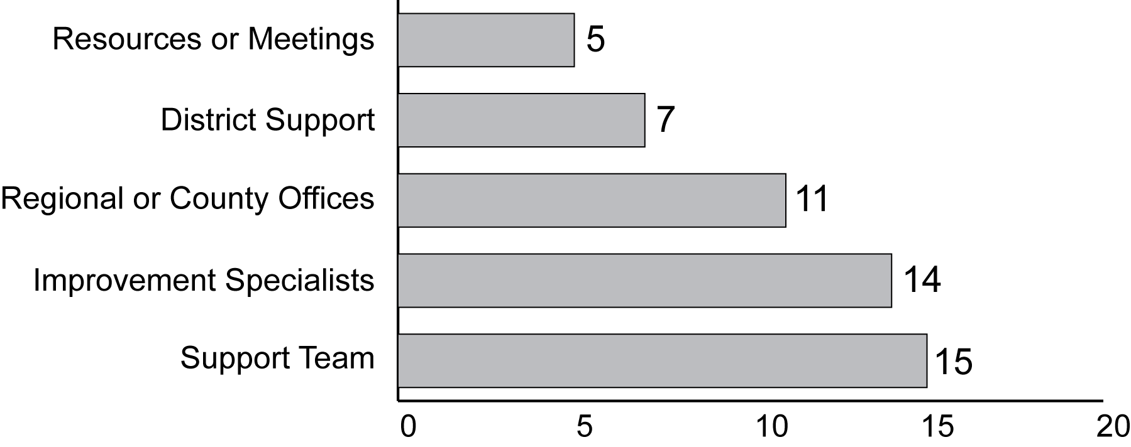
Exhibit reads: In 2006–07, 14 states reported the primary mechanism of support was improvement specialists and 15 states reported the primary mechanism of support was support teams.
Sources: SSI-NCLB, Accountability Interviews 2006–07 and analysis of state documents (n = 50 states, the District of Columbia, and Puerto Rico).
States’ approaches to supporting schools identified for improvement changed between 2004–05 and 2006–07. In 2006–07, states were more likely to delegate the responsibility for supporting schools to other levels of government (e.g., county, regional entities, districts), with a particular emphasis on districts providing support to schools. (Districts’ reports of their technical assistance efforts are described on page 131). At the same time, states were less reliant upon school support teams as the primary mechanism of support to schools identified for improvement. In many states, regional authorities are a significant resource: For example, the Wayne County Regional Educational Service Agency (RESA), which includes Detroit, Mich., has more employees than the Michigan Department of Education.
In 2006–07, 40 states had tiered systems of support, compared to 18 in 2004–05.
An increasing number of states reported having tiered systems of support for schools, in which the intensity and focus of support varied as schools progressed to more severe accountability levels. In 2004–05, 18 states reported having such systems. In 2006–07, 38 states, the District of Columbia, and Puerto Rico reported having a tiered system in which the level of support was determined by the number of years a school had not made AYP, a school’s Title I status, or supplementary accountability measures, such as a state accountability index. Most of the states with tiered systems of support used the number of years a school had been identified for improvement to gauge the intensity of support. Four states prioritized Title I schools before supporting non–Title I schools and eight states reported providing different types of support to Title I and non–Title I schools.
For example, Georgia developed a continuum of services consisting of nine levels of “Needs Improvement” (NI) through which schools receive progressively more intense services. In NI1 and NI2, a school improvement leadership facilitator visits the school three times each nine weeks throughout the school year, in addition to assistance provided through the Regional School Improvement Core Team and staff training on the Georgia Learning Frameworks. For schools in NI3–4, visits from the leadership facilitator increase to once a week; by NI5 the facilitator is on site twice a week, and the school is required to implement an improvement contract that is signed by the Georgia state school superintendent and monitored by the state education agency. In addition, the amount of school improvement funds for which schools are eligible increases each year that a school is identified for improvement.
Likewise, Nevada reported that, while all schools have access to an improvement planning tool available online, schools that are identified for improvement for one, two or three years receive the assistance of an external school facilitator. Subsequently, schools that continue to be identified for improvement (restructuring) receive support from a school support team comprised of a team leader, a district level administrator, a principal from an effective school, a teacher from an effective school, and a parent. The support team spends concentrated time with these schools through the entire school year. The decisions made by the school support team supersede those of the district.

State Use of Support Teams
Support teams were the most common mechanism for delivering support to schools identified for improvement in 2006–07, and were used in 42 states, the District of Columbia, and Puerto Rico.
Under NCLB, school support teams are to include highly qualified or distinguished teachers and principals, pupil services personnel, parents, representatives of institutions of higher education, representatives of outside consultant groups, representatives of regional education laboratories or comprehensive regional technical assistance centers, or other individuals deemed appropriate by the state. State officials reported that the composition of support teams varied widely but generally consisted of education officials or consultants with expertise in areas such as Title I, curriculum and instruction, data analysis, special needs populations, and implementation of improvement strategies in low-performing schools. Team members came from a range of backgrounds and organizations, including the state education agency, regional or county offices, consultant groups or individual experts, high-performing schools, and networks of retired educators and administrators. During 2006–07, 42 states, the District of Columbia, and Puerto Rico provided support to identified schools through some type of support team. Additionally, two states reported that they were piloting support teams in 2006–07 and another state planned to implement support teams in 2007–08. Fourteen states and the District of Columbia relied on support teams as a primary mechanism of support.
Support teams shared the feature of being external to the school, potentially affording a new perspective on strategies for school improvement. However, they varied in a number of ways, including the organizations from which they originated, their role in the improvement process, the target of their support, and the schools or districts to which they provided support. In 2006–07, school support teams originated at the state level in 21 of the 42 states that reported using them. That is, the teams consisted of individuals who were employed by the state education agency or served as consultants. Many states drew support team members from various departments within the state education agency, bringing complementary perspectives to the challenges of school improvement. In 17 states, support teams were developed and operated by regional education organizations; in four states, the teams were the responsibility of districts. In the case of regional systems, the regional units were still under the purview of the state education agency and part of an overall “state system” even if the staff was focused on only one region of the state. District teams were mandated by the state, which often oversaw their training and appropriate assignment to schools and provided supplementary personnel if there was not adequate staffing at the district level. Nine states reported hiring consultants either to supplement expertise on support teams or to comprise the entire support team.
As a mechanism of support, support teams are ultimately aimed at stimulating improvement in identified schools; however, the support was not always targeted solely at schools. In 27 states, the District of Columbia, and Puerto Rico, support teams worked directly with schools, but in 15 states, support teams worked with districts, which in turn were expected to work with schools identified for improvement. In 11 of the states in which support teams worked with districts, the teams were deployed when schools within the district were identified for improvement. Moreover, states often targeted their support to specific types of identified schools—in 20 states, support teams worked with a subset of schools or districts identified for improvement, prioritizing schools based on the number of years identified for improvement.
The number of support teams in each state varied greatly. In 2006–07, seven states reported having one support team based at the state level. For example, in Wisconsin, there is one large support team, from which individuals are selected and deployed to schools identified for improvement based on particular needs of the schools. Other states reported having as many as 50 support teams.
Likewise, the intensity of support provided by these teams varied across and within states. While seven states reported that support teams were on-site at least weekly, officials in nine states reported that support teams visited identified schools fewer than ten days each year. In some cases, less intense activity on the part of teams may be part of the design of a tiered state system of support. For example, in Michigan, audit teams are on site just twice a year, and mentor teams visit identified schools eight times each year. But when schools reach higher levels of the accountability system, they receive services from principal mentors who provide 100 days of support.

State Use of “School Improvement Specialists” to Provide Support
In 2006–07, 26 states engaged school improvement specialists to assist schools identified for improvement.
Individuals who provide support for school improvement did not lend themselves to simple categorizations: across different states, they were called school improvement specialists, principal mentors, exemplary educators or coaches. Few states, in fact, used the NCLB terminology of distinguished principals and distinguished teachers, and few defined the role of these individuals in a manner strictly aligned with NCLB. Many states relied on retired teachers and school administrators; some states selected individuals from other fields if these individuals had appropriate expertise (for example, financial expertise). Of the 26 states that engaged school improvement specialists in 2006–07, 19 reported that at least some of the time they contracted with consultants to provide this support to schools identified for improvement. Many states used school improvement specialists to participate in other support mechanisms. For example, California identified skilled educators (whether currently in the classroom or retired) with appropriate expertise to participate on support teams. Nineteen states reported that specialized individuals worked with both Title I and non–Title I schools that were identified for improvement in 2006–07.
In 18 states, school improvement specialists supported data analysis and improvement planning in 2006–07. Additionally, nine states reported that specialized individuals provided needs-based support to schools and to districts (which may include support throughout the implementation of a school improvement plan) and seven states reported that specialized support was content focused—that is, with an explicit focus on reading or mathematics. In Alabama, for instance, school improvement specialists were part of a tiered system of support provided to schools. The role of these specialists was to guide school-level teams not only in analysis and planning but also to support school leadership in monitoring implementation, continuously improving plans and studying and sharing the craft of successful teaching.
Alaska developed a different model for using improvement specialists. Alaska’s mentor program was designed to support both teachers and principals in ways that foster and sustain school improvement. The teachers and principals that were selected for the Alaska Statewide Mentor Project (ASMP) went through a rigorous application and selection process conducted by the Commissioner of Education, Deputy Commissioner, and ASMP Project Directors. Many of those who were selected to mentor and coach were recognized by their home district or at the state level for their expertise and service. In 2006–07, the third full year of implementation of the ASMP, Alaska had 27 teacher mentors serving 400 beginning teachers and 9 principal coaches serving 85 principals across the state. The principal coaches worked specifically on leadership skills, using data to make instructional decisions and changes in the classroom, implementing formative assessments in the school, and identifying effective instructional practices.

Content of Support Provided by States
In 2006–07, all states focused on providing assistance on diagnostic aspects of the school improvement process: Data analysis and development of school improvement plans. Fewer states provided sustained assistance through implementation of improvement strategies.
In about half of the states, the emphasis of support was primarily diagnostic: in 28 states, the providers of support assist in the analysis and planning process, leaving the implementation and monitoring of the improvement strategies to local officials. In contrast, 22 states, the District of Columbia, and Puerto Rico had designed state systems of support intended to go beyond diagnostic interventions into support for implementation. Alaska and Alabama (described above) had two such systems; another state was Vermont where the improvement specialist acted as a coordinator who facilitated improvement throughout the implementation process. The coordinators worked with identified schools to develop required actions for improvement and to ensure that Title I improvement funds supported these actions for school improvement. Additionally, the coordinator worked to identify additional resources and was the main contact for all providers working with the school identified for improvement.

In 2006–07, the type of support most frequently provided by states was assistance with data analysis (47 states, the District of Columbia, and Puerto Rico). Nearly as many states (44 states, the District of Columbia, and Puerto Rico) described their support as “needs-based” (see Exhibit 60). Indeed, the focus of school support was often determined by the situational factors of a particular school. For example, in 2006–07, Idaho used a three-tiered model that relied on an online tool for schools identified for improvement and for districts with schools identified for improvement. The tool provided information to schools and districts by matching local needs to supports offered by the state. Within this system, for example, if a school did not make AYP because of insufficient scores of students with disabilities, it was referred for intensive Response to Intervention training. Similarly, a Michigan state official explained that their special education division used a state grant to develop an extensive support program “that is specifically designed for schools that have missed AYP strictly on the basis of the achievement of students with disabilities.”
Exhibit 60
Number of States, by Focus of Support They Provided, 2006–07
Exhibit reads: In 2006–07, 49 states reported that at least part of their support to schools was focused on data analysis.
Sources: SSI-NCLB, Accountability Interviews, 2006–07 and state policy documents (n = 50 states, the District of Columbia, and Puerto Rico).
In 2006–07, 14 states described their support role as that of a resource broker—they ensured that the schools were informed of and had access to the improvement funds and grants competitions for which they were eligible. Eighteen states focused at least some support on a content area, such as literacy or mathematics. This represents an increase from 2004–05, when only five states provided support with an explicit content focus.

Comprehensiveness of State Support
Support systems were judged to be comprehensive in 25 states, moderate in 22 states, and limited in five states.
Some states were engaged in multiyear efforts to develop comprehensive systems that supported schools at various levels of improvement. To capture this variation, the SSI-NCLB research team classified state systems of support into three levels—comprehensive, moderate, and limited—based on the breadth of the support structures, the proportion of identified schools that received support, the background and training required of individuals who provided support, the presence of complementary layers of support, and the existence of a statewide research-based improvement process (such as the SAGE process in Nevada or Michigan’s school improvement framework). The states with comprehensive systems provided direct assistance to schools, procedural steps that articulated and defined the improvement process, and tools to engage and inform schools as they considered improvement options. Although some systems of support may be judged to be more “comprehensive” than others, this does not imply that they have proven more effective in improving students’ academic achievement. Many of the states with moderate or limited systems were building their systems and working to incorporate structures that were more consistent with the NCLB requirements (e.g., they added school support teams or distinguished teachers to their support systems). However, some states provided only minimal support, limited to a few voluntary statewide meetings or the provision of information to districts and schools about federal grants that might stimulate improvement. From 2004–05 to 2006–07, the number of states with comprehensive systems of support increased, while the number of states with limited systems of support decreased (see Exhibit 61).
Exhibit 61
Number of States, by Extent of Comprehensiveness of
Their Systems of Support for Schools, 2004–05 and 2006–07
Exhibit reads: In 2004–05, nine states had limited systems of support for schools, compared to five states in 2006–07.
Sources: SSI-NCLB, Accountability Interviews 2006–07 and state policy documents (n = 50 states, the District of Columbia, and Puerto Rico).
Overall, states with comprehensive systems of support for their low-performing schools tended to be the states with higher concentrations of schools identified for improvement. For example, 12 percent of schools in states with comprehensive systems of support were in the first year of improvement, whereas only 5 percent of schools in states with limited systems were in the first year of improvement. It may be that states with high proportions of schools identified for improvement were also most likely to perceive an acute need to develop support systems. Also, states with fewer schools identified for improvement may have faced fewer capacity challenges, and were able to provide support to all identified schools through a simpler model.

Strategies to Expand State Capacity for Supporting Schools
States reported challenges associated with increases—or anticipated increases—in the number of schools identified for improvement.
State officials frequently expressed concern about their capacity to provide continued support to the increasing number of schools being identified for improvement and the growing number of schools moving into corrective action and restructuring. One official elaborated:
“This year as we’ve had growing numbers of schools to review and a growing number of schools and districts that are in the more extreme status, corrective action and restructuring…we’ve had to use more funds to purchase third party services to provide more intensive support in those schools and districts, leaving less money for what I’ll call the more ‘preventive medicine’ side of the work which is … being there onsite to help a school that’s identified for improvement before it gets to corrective action and restructuring.”
The anticipation of growing numbers of schools being identified for improvement led states to identify ways to expand capacity for improvement within the constraints of available resources. States attempted to strike this balance through measures focused on 1) providing differentiated support to schools of higher priority, or 2) expanding capacity within other levels of the educational system.
As noted earlier, in 2006–07, 38 states, the District of Columbia, and Puerto Rico reported having tiered systems of support that provided differentiated levels of support to schools based on the severity of their accountability designation. Such systems enabled states to focus the most intense assistance—and hence, more resources—on the schools that needed it most, while assuring at least a minimal level of support for other identified schools.
In addition, some states shifted their support to districts and counties in order to expand capacity for improvement. Indeed, in 2006–07, 28 states indicated that they intended to build district capacity to better support schools identified for improvement. For example, in Louisiana, the state trains individuals in each district to be members of Districts Assistance Teams (DATs) that are responsible for working with schools identified for improvement. In Tennessee, state officials changed the structure of the support system after 2004–05: previously, the support system bypassed the district, but state officials concluded that they were not building adequate capacity at the local level. Following modifications to the statewide system of support, district officials play a more integral role, particularly through the Tennessee Comprehensive Planning Process.
As of 2006–07, another 23 states and Puerto Rico opted to build in a secondary layer of support provided by using the existing infrastructure of regional centers, area education agencies, or county-level offices. In Maine, for example, the state employed an external consultant as an improvement specialist to work with schools, and this specialist is responsible for coordinating a team from the region to support schools identified for improvement based on their needs. In Oregon, the state worked with Title I schools identified for improvement, but support for non–Title I schools identified for improvement comes from the regional Education Service Districts. The secondary layer allowed for states to either supplement or enhance support for schools identified for improvement.
Finally, in 2006–07, 32 states used outside consultants or organizations to complement their statewide system of support. For example, Arkansas relied on the organization America’s Choice to implement its comprehensive school reform model and Utah reported using consultants to supplement the available expertise on individual support teams. Another two states reported using outside consultants to train members of their support teams or their improvement specialists. As one state official commented, “You can’t have enough staff to deal with these situations. It comes down to outside consultants.”

State Strategies for Schools in Corrective Action and Restructuring
As reported in Chapter IV, the number of states with schools in corrective action and restructuring status increased from 2004–05 to 2006–07. In 2004–05, 37 states had schools in corrective action, which increased to 48 states, the District of Columbia, and Puerto Rico in 2006–07. Likewise, 29 states had schools in restructuring in 2004–05, which increased to 43 states, the District of Columbia, and Puerto Rico in 2006–07.
The most popular state corrective action strategy in 2006–07 was implementation of a new curriculum, as it had been in 2004–05. However, states were more likely to replace all or most of the school staff as a restructuring strategy in 2006–07 than in 2004–05.
As expected, the number of states that reported using specific corrective action and restructuring strategies increased from 2004–05 to 2006–07. However, in 2006–07, as in 2004–05, implementation of a new curriculum was the most frequently reported approach to corrective action, followed by appointment of an outside advisor. There was a notable increase in the number of states that decreased the management authority of the school, from 17 to 31 states (see Exhibit 62).
With regard to restructuring, the most frequently cited option, again, was “other major restructuring of school governance.” States reported that this included activities such as implementing a new curricular program, providing instructional coaching, establishing a school improvement council, implementing a comprehensive school reform model, offering merit pay to retain exemplary staff, or reconfiguring the school day or school year. One state reported dissolving old schools and opening new schools with different grade spans.
Some corrective action and restructuring strategies were excluded by state laws. In 15 states, the state education agency was prohibited from taking over schools. Other options for which states faced legal barriers included entering into a contract with a private entity (prohibited in eight states), replacing school staff (prohibited in seven states), and reopening the school as a public charter school (prohibited in seven states). Even in states that had no legal barriers to state takeover of schools, state officials were reluctant to do so. As one state official explained, “Takeover of the school by the state has not been used in any way shape or fashion. There is no plan to do that in the state. There is nothing in state law that would prohibit [taking over the school] but there really is no mechanism to enable [the state to take over the school].” An official from a different state explained that they had tried school takeover but did not find it effective, while another state official commented that they lacked adequate capacity at the state level. Likewise, some states had no legal prohibitions against replacing staff, but said this action could prove difficult because of collective bargaining agreements or union presence.
Exhibit 62
Number of States Using Specific Corrective Action and Restructuring Strategies,
2004–05 and 2006–07
Strategies | 2004–05 | 2006–07
Corrective Action Strategies | (n = 37) | (n = 50)ª
Replacement of staff relevant to failure to make AYP | 20 | 33
Implementation of a new curriculum | 35ª | 42
Significant decrease in management authority at the school | 17 | 31
Appointment of an outside advisor | 29ª | 40
Extension of the school year or school day | 26 | 32
Restructuring the internal organization of the school | 23 | 33
Restructuring Strategies | (n = 29) | (n = 45)ª
Reopening the school as a public charter school | 4 | 12
Replacing all or most of the school staff | 9 | 23
Hiring a private management contractor | 7 | 8
State takeover of a school | 2 | 2^{b}
Other major restructuring of school governance | 18 | 29
Exhibit reads: Twenty states reported replacing school staff relevant to the failure to make AYP as an intervention for schools in corrective action status.
Note: The number of states includes all states with schools in corrective action and restructuring who responded to this survey question.
ª Indicates that the District of Columbia, and Puerto Rico are included.
^{b} Note that state takeovers are authorized through Louisiana’s accountability mechanisms that pre-date NCLB. Hence, while the state has taken over schools, it is not exclusively in the context of NCLB accountability.
Source: SSI-NCLB, Accountability Interviews.
When selecting corrective actions, “the districts are in the driver’s seat.” However, states played an active role in determining restructuring strategies.
In the majority of states with schools in corrective action (30 states and the District of Columbia), the corrective actions for specific schools were determined at the district level. In the remaining states, the state education agency either collaborated with the district to select options, or made the determination entirely at the state level. In many cases of collaboration, the district conducted the needs assessment and made initial recommendations, which were then approved by the state education agency. In some cases, the selection of corrective action strategies was fairly prescribed—in Hawaii, the state developed a Framework for School Improvement, which is a system of support as well as consequences. As schools move from one level of accountability to the next, both support and the required consequences change. Arkansas employed one primary intervention—all schools in corrective action or restructuring were encouraged to participate in the America’s Choice comprehensive school reform model. In other states, the determination of consequences was less structured. For example, in Indiana, optional corrective actions included “an open discussion [between the state and] the superintendent.”
By the time a school reached restructuring status, the state played a more active role. The majority of states with schools in restructuring status were involved in both the restructuring planning process and the restructuring implementation process (28 states, the District of Columbia, and Puerto Rico). A Massachusetts state official explained, “When we take a school into corrective action or restructuring status, they become a Commonwealth priority school… the state board of education ultimately can direct for any school that’s in restructuring.” However, there were some exceptions to this general pattern: In North Carolina, for instance, the state opted to focus on schools in corrective action, rather than restructuring, in an effort to prevent them from entering the more severe improvement status. In addition, even when states were more active in the restructuring stage, districts were still involved—in 21 states with schools in restructuring, the local education agency played an active role in planning and implementing improvement strategies. Other organizations that participated in this process included school support teams (10 states), regional agencies (six states), and school improvement specialists (seven states). In Montana, the National American Indian School Boards Association was involved with the restructuring process, because 90 percent of Montana schools in restructuring are Indian schools.
While states must ensure that schools implement interventions in accordance with NCLB, they have a more pressing concern: identifying strategies that will ensure that schools with a persistent pattern of low performance improve. As one state official commented, “we need real-world examples of what’s working.” Examples from two states are illustrative of the strategies states are undertaking to reach the most challenging schools.
Virginia’s Turnaround Specialist Program, a partnership between the business and education schools at the University of Virginia, has been receiving attention within and outside of the state. The program is described as “an executive education program specifically designed for the needs of a cadre of experts who are charged with turning around consistently low-performing schools in the commonwealth.” The training focuses on leadership challenges, strategic change, data-based decision-making, communications, conflict-management, sustaining transformations, and leveraging resources. The performance-based Turnaround Leadership Credential is awarded at the end of the two-year program after the turnaround has occurred and there is satisfactory evidence of sustained improvements. Participants are placed in schools in corrective action, and are expected to ensure that at the end of two years of training, the Turnaround Specialist’s school has made AYP.
Similarly, North Carolina launched its High School Turnaround during the 2005–06 school year. This initiative is designed to address the special needs of high schools that are identified as low performing because of the large number of students performing below proficient or because of a history of below-average performance. Based on each school’s “Framework for Action,” each receives support from trained leadership facilitators, customized professional development for principals, and professional development for teachers. In addition, each school is required to adopt a reform model, either America’s Choice, the New Schools Project, or Talent Development High Schools. In order to sustain improvement efforts, district offices are expected to work closely with each participating school.
Twenty-two states and Puerto Rico reported that at least one school had exited restructuring status since NCLB was enacted.
Officials from 15 states reported that schools were able to improve performance and therefore exit restructuring status because of a substantive change in school practices, such as new leadership, instruction that was more closely aligned to standards, or a schoolwide focus. As one state official explained: “the staff and faculty at the school came together.” Among these 15 states, others attributed the improved performance to the presence of a school support team or exemplary educators. In two states, officials noted that some schools in restructuring had been so identified for a specific subgroup, and when the school and district deployed resources to target this group, the schools were able to raise achievement levels. However, state officials in three states reported that schools exited restructuring status because they had closed, were consolidated, or were annexed by other schools. By contrast, nearly half of the states with schools in restructuring (21 states and the District of Columbia), reported that no schools within this group had ever exited restructuring status.

Technical Assistance for Schools
NCLB contains specific requirements regarding the provision of technical assistance to identified schools, assigning responsibility to both states and districts for providing assistance to schools in a variety of areas. States and districts were free to provide the required assistance themselves or to contract with other organizations, such as regional offices, nonprofit organizations, or individual consultants, to provide some or all of the technical assistance to schools. As a result, schools did not always know the ultimate source of the technical assistance they received. States and districts reported on the types of technical assistance they provided but not the location or number of schools that received each type of assistance. Hence, we cannot directly connect state, district, and principal reports. In addition, schools were often motivated to undertake their own improvement efforts, which could include seeking assistance from outside providers.

Schools’ technical assistance needs
Principal survey results confirmed that schools had broad needs for technical assistance, that a wide range of technical assistance was provided, and that most assistance met schools’ needs. Principals indicated whether or not they needed assistance in 13 areas that are commonly the focus of school support efforts. If such assistance was needed, principals indicated whether or not it was received, and if received, whether or not it was sufficient to meet their needs.
Both identified and non-identified schools reported the need for technical assistance in many areas, but the need was greater among identified schools.
Principals indicated whether they needed technical assistance in 13 areas that are commonly emphasized in such programs. They also indicated whether such assistance was received, and if so, whether it met their needs. Most principals reported that their school needed technical assistance related to some area of NCLB implementation in either 2005–06 or 2006–07 (see Exhibit 63). For example, more than one-half of all schools reported needing assistance to improve the quality of teachers’ professional development but only about one-quarter reported needing assistance with school improvement planning. This is consistent with the emphasis states have placed on support for school improvement planning reported above.
Principals in identified schools were more likely to report needing assistance than were principals of non-identified schools in each of 13 areas surveyed. For example, 77 percent of identified schools reported needing technical assistance to identify effective curricula, instructional strategies or school reform models, compared with 47 percent of non-identified schools. On average, schools in Year 1 or Year 2 of identification reported that they needed assistance in eight of the 13 areas, compared with five areas for non-identified schools. The number of areas of need is an imperfect measure because it does not capture the intensity of a school’s need for assistance; one school might have acute needs in one or two areas while another might have limited needs in several areas.

Exhibit 63
Percentage of Non-Identified and Identified Schools That Reported Needing and Receiving Various Types of Technical Assistance, 2005–06 or 2006–07
 | Percent of Non-Identified Schools That Needed Assistance  (n = 918) | Percent of Identified Schools That Needed Assistance  (n = 469) | Percent of Identified Schools Needing Assistance That Received It  (n = 292) | Percent of Identified Schools Reporting That Assistance Received When Needed Was Sufficient  (n = 243)
Type of Technical Assistance
Improve quality of teachers’ professional development | 53% | 77%ª | 82% | 73%
Get parents more engaged in their child’s education | 46% | 72%ª | 52% | 65%
Address instructional needs of students with individualized educational programs (IEPs) | 51% | 69%ª | 68% | 76%
Identify effective curricula, instructional strategies, or school reform models | 48% | 77%ª | 84% | 82%
Improve students’ test-taking skills | 29% | 63%ª | 61% | 86%
Analyze assessment results to understand students’ strengths and weaknesses | 41% | 62%ª | 93% | 81%
Identify or develop detailed curriculum guides, frameworks, pacing sequences, and/or model lessons aligned with state standards | 43% | 68%ª | 79% | 83%
Develop or revise school improvement plan | 26% | 55%ª | 91% | 89%
Recruit, retain, or assign teachers in order to staff all classes with a teacher who is highly qualified | 30% | 56%ª | 71% | 75%
Address problems of student truancy, tardiness, and discipline, and of dropouts | 40% | 60%ª | 68% | 61%
Implement the provisions of NCLB relating to qualified paraprofessionals | 26% | 52%ª | 82% | 95%
Address instructional needs of LEP students | 33% | 45%ª | 74% | 70%
Analyze and revise school budgets to allocate resources more effectively | 27% | 50%ª | 66% | 84%
Exhibit reads: Fifty-three percent of schools not identified for improvement reported needing technical assistance to improve the quality of teachers’ professional development in 2005–06 or 2006–07.
ª Indicates statistically significant difference between identified and non-identified schools (p<.05).
Source: NLS-NCLB, Principal Survey.

In addition, the need for technical assistance was greater among those categories of schools that were more likely to be identified for improvement. For example, a greater percentage of high-poverty and high-minority schools reported a need for four selected types of technical assistance than schools with low concentrations of such students (see Exhibit 64).
Exhibit 64
Percentage of Schools Needing Technical Assistance in Four Areas,
by School Characteristic, 2005–06 or 2006–07
School Characteristic | Develop or Revise the School’s Improvement Plan | Analyze Assessment Results to Understand Students’ Strengths and Weaknesses | Get Parents Engaged in Their Child’s Education | Improve the Quality of Teachers’ Professional Development
All Schools (n = 1,392) | 30% | 44% | 49% | 56%
Title I Status
Title I | 35% | 44% | 56% | 60%
Non–Title I | 23% | 44% | 39% | 50%
School Identified for Improvement Status
Not identified | 26% | 41% | 46% | 53%
Year 1 and Year 2 of identified for improvement status | 56% | 59% | 75% | 78%
Corrective action status | 48% | 58% | 58% | 61%
Restructuring status | 63% | 72% | 85% | 83%
School Poverty Level
High poverty | 46% | 57% | 70% | 72%
Medium poverty | 34% | 44% | 55% | 58%
Low poverty | 19% | 39% | 33% | 46%
School Minority Concentration
High minority (75% or more) | 42% | 57% | 72% | 70%
Moderate minority (25–75%) | 25% | 42% | 44% | 56%
Low minority (less than 25%) | 29% | 41% | 43% | 50%
Urbanicity
Central city | 36% | 48% | 61% | 60%
Urban fringe/large town | 31% | 45% | 48% | 55%
Rural/small town | 24% | 39% | 41% | 54%
Exhibit reads: Twenty-six percent of non-identified schools reported needing technical assistance to develop or revise their school improvement plan in 2005–06 or 2006–07, compared with 56 percent of schools in Year 1 or Year 2 of being identified for improvement.
Source: NLS-NCLB, Principal Survey.

Meeting schools’ technical assistance needs
Schools received technical assistance from a variety of sources, including their state department of education, regional education providers, independent organizations, and their own district offices. District responses, reported below, indicate that districts provided technical assistance in many areas. Principals’ survey responses did not identify the providers of technical assistance, just whether or not the assistance was received.
In most areas, principals reported receiving the technical assistance their schools needed and indicated that it met their needs.
A majority of principals who said their schools needed technical assistance in a variety of areas also reported that they received the assistance they needed. In 10 of 13 areas, non-identified schools reported receiving the needed technical assistance at rates similar to those of identified schools, (see third column of Exhibit 63). Similarly, with only one exception, there was no evidence that other school characteristics, including parent income level, minority enrollment, size, or location, influenced the likelihood that a school received needed technical assistance. The greatest unmet need was for assistance to increase parental involvement in their children’s education; only about half of the schools that needed assistance in this area received it.
However, principals in identified schools reported receiving more days of assistance from their districts than did principals in non-identified schools. On average, identified schools reported receiving about eight days of technical assistance, compared with four days for non-identified schools. For the 2005–06 school year and the summer of 2006, 42 percent of identified schools reported receiving six or more days of assistance from their districts, 27 percent received at least 11 days of assistance, and 11 percent received more than 25 days of technical assistance.
The majority of principals reported that the technical assistance they received met their schools’ needs. For example, at least 70 percent of all identified schools receiving technical assistance in 10 of 13 topics surveyed were satisfied that the assistance met their needs (see final column of Exhibit 63). While it is difficult to assess the quality of assistance provided to schools without observing these activities directly, these principal reports indicate that in the recipients’ view the technical assistance was sufficient to meet their needs.
The percentage of identified or non-identified schools needing technical assistance in any given area did not change significantly from the 2004 survey to the 2006 survey. Similarly, in most cases, the percentage of identified schools that reported they received the technical assistance they needed did not change during this period. Finally, with two exceptions, the percentage of identified schools reporting that the assistance they received was sufficient to meet their needs did not change from 2004 to 2006.
The technical assistance needs of schools that entered improvement status between 2004–05 and 2006–07 and schools that exited improvement status during this period were notably similar. In nearly all cases, schools that entered improvement status between 2004–05 and 2006–07 and schools that exited improvement status during that period were equally likely to report receiving technical assistance and finding it sufficient to meet their needs. However, some areas did appear more challenging for schools that became identified for improvement during this period, compared to schools that managed to exit school improvement status during this period; the “entering” schools were more likely to report needing technical assistance in six of the 13 areas, including improving the quality of teachers’ professional development (63 percent versus 33 percent), getting parents more engaged in their child’s education (68 percent versus 36 percent), and addressing instructional needs of students with individualized education programs (IEPs) (66 percent versus 34 percent).
There were three areas of technical assistance in which schools’ needs were not satisfied in a substantial minority of schools. These areas were providing services for students with disabilities, providing services for limited English proficient (LEP) students (discussed in Chapter V), and providing technical assistance to identify effective curriculum.
Of all schools that reported needing technical assistance to improve services to students with disabilities, more than one-third did not have their needs fully met.
In 2006–07, more than half of all schools reported needing technical assistance during the previous two years to address the needs of students with disabilities. Seventy-seven percent of schools that needed this assistance received it, and 81 percent of the schools that received technical assistance related to students with disabilities reported that the assistance was sufficient to meet their needs (see Appendix C, Exhibit C.14). Thus, only 62 percent of schools that needed such assistance had their needs met. Schools in restructuring status were least likely to receive needed assistance in this area—55 percent of schools in restructuring status that needed assistance to improve services for students with disabilities actually received it.
Schools identified for improvement were more likely to report needing technical assistance relating to students with disabilities than were non-identified schools (see Exhibit 65), and they were less likely to receive such assistance when they needed it. Schools with the highest proportions of minority or poor students also were more likely to report a need for technical assistance related to students with disabilities, and they were less likely to receive such assistance when needed.
However, in 2006–07, teachers in identified schools reported receiving professional development related to students with disabilities at similar rates as their peers in non-identified schools. Fifty-four percent of elementary school teachers in identified schools received some professional development to meet the needs of students with disabilities. Similarly, 59 percent of secondary English teachers and 53 percent of secondary mathematics teachers in identified schools received professional development to meet the needs of students with disabilities. As would be expected, a large majority (90 percent) of special education teachers received professional development assistance related to students with disabilities.
Of the identified schools that reported needing technical assistance to identify effective curriculum, instructional strategies, or school reform models, about one-third did not have their needs fully met.
About three-quarters of identified schools and about one-half of non-identified schools reported needing technical assistance identifying effective curricula, instructional strategies, or school reform models that have been shown to be effective in increasing student achievement in 2005–06 or 2006–07. Technical assistance was available to help most of these schools. However, 16 percent of the identified schools that needed such assistance did not receive it, and, of those that did receive it, 18 percent reported that the assistance was not sufficient to meet their needs. Thus, about one-third of identified schools that reported needing assistance with such curriculum development either did not receive it or did not find the assistance they received to be sufficient.
Exhibit 65
Percentage of Schools Needing Technical Assistance in 2005–06 or 2006–07 to
Meet the Needs of Students with Disabilities, by School Characteristic
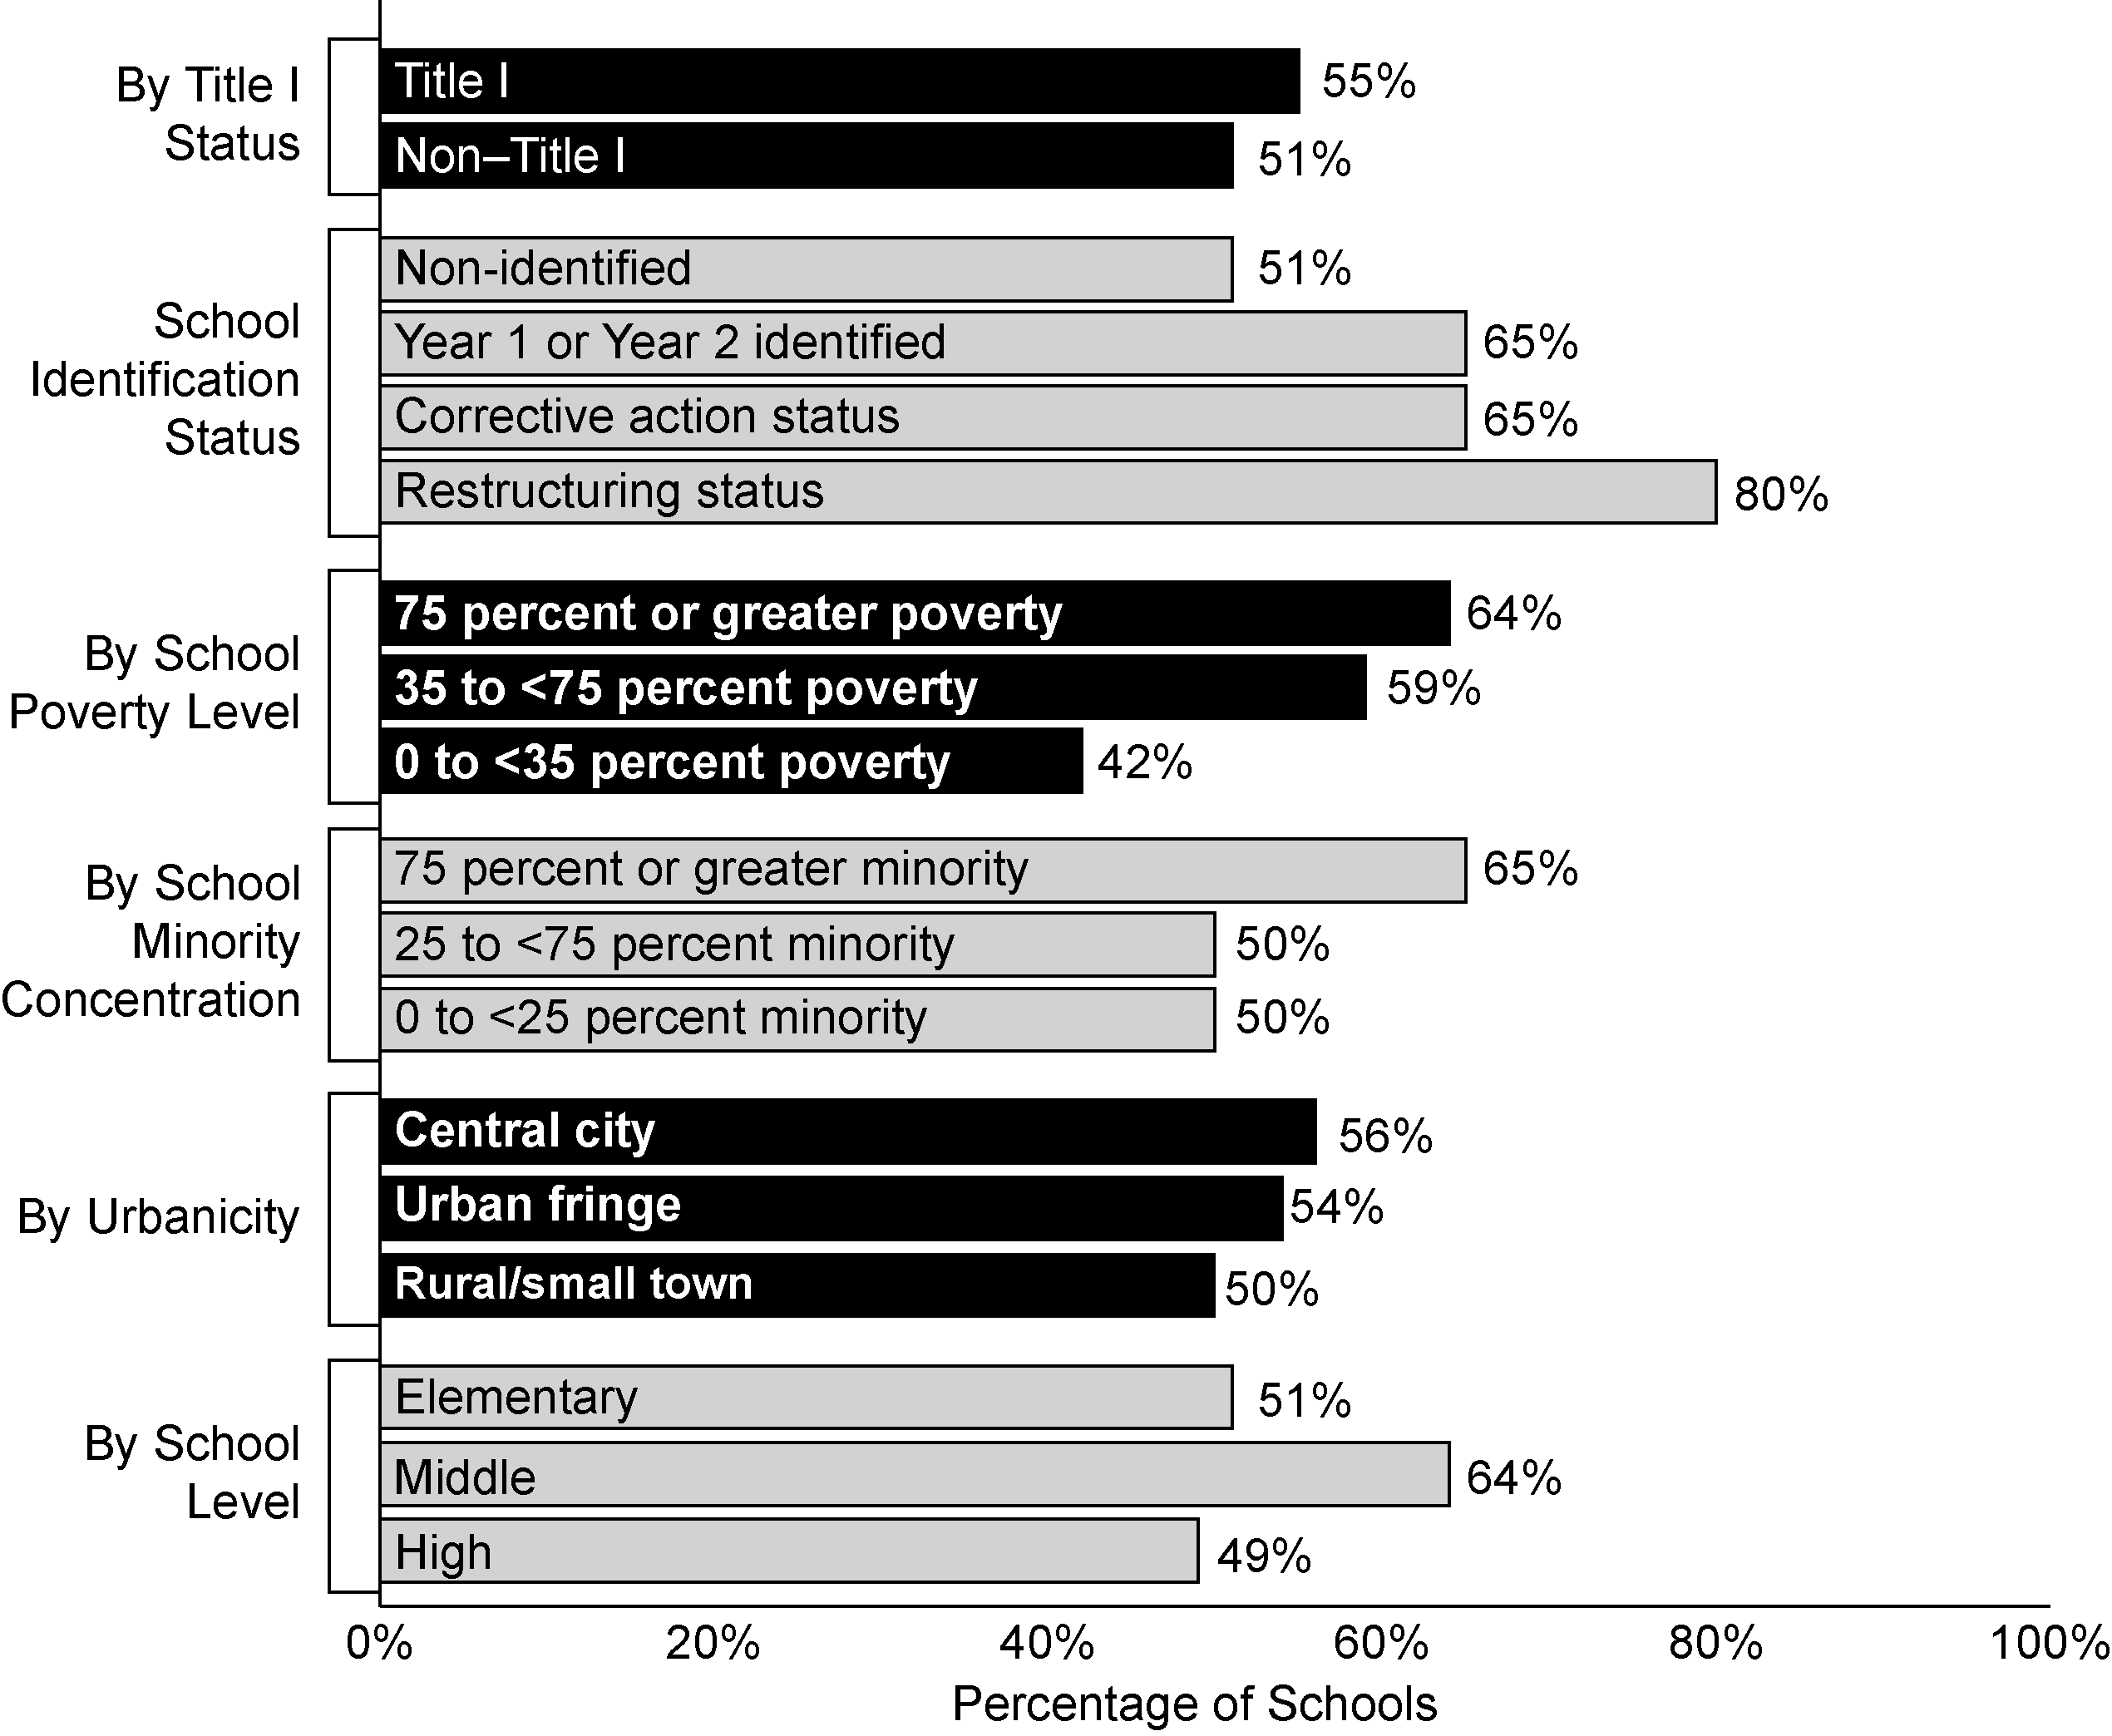
Exhibit reads: Fifty-one percent of non-identified schools reported needing technical assistance addressing the needs of students with disabilities, compared with 65 percent of schools in Year 1 or Year 2 of being identified for improvement in 2005–06 or 2006–07.
Source: NLS-NCLB, Principal Survey (n = 1,392 schools).
Districts provided technical assistance in many areas to both identified and non-identified schools.
As noted on page 115, in 2006–07, many states delegated the provision of technical assistance to other levels of government, particularly to districts, and districts indicated that they were a major provider of technical assistance to schools. Although schools did not report the sources of the technical assistance they received, reports from districts (with identified schools) about they types of assistance they provided were similar to reports from schools about they types of assistance they received. Most districts with identified schools (in either 2005–06 or 2006–07) reported providing a broad range of technical assistance, both to identified schools and to other schools (see Exhibit 66). These results are consistent with findings from 2001 to 2004 (Padilla et al., 2006) and with findings from 2004–05 (Le Floch et al., 2007) that districts with identified schools were not focusing assistance on a subset of schools.
Exhibit 66
Percentage of Districts With Identified Schools Reporting That They Provided Technical Assistance to Various Types of Schools in Either 2005–06 or 2006–07
Type of Technical Assistance | All or Some Identified Schools | Other  Schools | District Did Not Provide
Develop or revise school improvement plan | 78% | 58% | 10%
Analyze assessment results to understand students’ strengths and weaknesses | 84% | 72% | 3%
Address instructional needs of students with IEPs | 79% | 72% | 7%
Implement NCLB provisions relating to “qualified” paraprofessionals | 75% | 71% | 11%
Address problems of student truancy, tardiness, discipline, and dropout | 78% | 68% | 8%ª
Identify and implement curricula, instructional strategies, or school reform models that have been shown to be effective in increasing students’ achievement | 73% | 70% | 14%
Recruit, retain, or assign teachers in order to staff all classes with a teacher who is “highly qualified” | 82% | 70% | 6%ª
Get parents more engaged in their child’s education | 73% | 66% | 19%
Improve students’ test-taking skills | 65% | 51% | 30%
Address instructional needs of LEP students | 61% | 67% | 19%
Develop and implement detailed curriculum guides, frameworks, pacing sequences, and/or model lessons aligned with state standards | 74% | 71% | 15%
Provide professional development to help teachers improve student performance | 87% | 77% | 0%
Analyze and revise school budgets so that resources are allocated more effectively | 67% | 63% | 27%
Exhibit reads: Seventy-eight percent of districts with identified schools reported that they provided assistance to all or some of those schools to develop or revise their improvement plans in 2005–06 or 2006–07.
ª Significantly lower than 2004–05 at alpha= .05.
Source: NLS-NCLB, District Survey (n = 155 districts).

Consistent with the above results, only a few districts reported that they did not provide technical assistance to schools in each of the 13 areas surveyed. The most common areas in which districts did not provide assistance were improving students’ test-taking skills (31 percent), analyzing and revising school budgets (27 percent), and addressing the instructional needs of LEP students (19 percent). Again, with two exceptions, results from 2006 were similar to results from 2004.
In most of the 13 areas of technical assistance surveyed, district characteristics (i.e., district identification status, size, location, poverty level, minority level) were not related to the provision of technical assistance to identified schools..
However, district characteristics were related to the provision of technical assistance to non-identified schools. In particular, small districts, high-minority districts, high-poverty districts, and identified districts were less likely to provide most types of technical assistance to non-identified schools. This suggests that these districts may be focusing their resources more on schools that have greater needs. In contrast, Padilla et al. (2006) found that larger districts, rather than smaller districts, provided technical assistance to identified schools related to planning and data use at higher rates than did other districts, and that larger districts were more likely to sponsor professional development on an extensive range of topics between 2001 and 2004.
Finally, in 2004, identified schools in states with comprehensive support systems received technical assistance in many areas at higher rates than did schools in states with limited or moderately comprehensive support systems. By 2006, there were very few remaining differences in the receipt of technical assistance among identified schools in states with comprehensive support systems and identified schools in states with limited or moderately comprehensive support systems.

Improvement Initiatives by Schools
Schools were engaged in a variety of efforts to improve student performance. This section begins with information about the range of improvement initiatives that were occurring in schools and then explores improvement efforts focused on curriculum and instruction, the amount of instructional time, and the use of assessment results.
Nearly all schools were making improvement efforts. Identified schools emphasized more areas of improvement than did non-identified schools.
Almost all schools were engaged in their own improvement initiatives, and most principals reported placing a major focus on multiple school improvement strategies during 2006–07 (see Exhibit 67).
Exhibit 67
Percentage of Schools Reporting a Major Focus
on Various School Improvement Strategies, 2006–07
School Improvement Strategy | 2006–07 Status
School Improvement Strategy | Identified Schools |  |  |  | Not Identified Schools  (n = 918)
School Improvement Strategy | All Identified  (n = 469) | Year 1 or Year 2 Only  (n = 188) | Corrective Action Only  (n = 114) | Restructuring Only  (n = 167) | Not Identified Schools  (n = 918)
Using student achievement data to inform instruction and school improvement | 88% | 88% | 91% | 83% | 67%
Providing additional instruction to low-achieving students | 77% | 75% | 83% | 73% | 65%
Aligning curriculum and instruction with standards and/or assessments | 81% | 79% | 79% | 85% | 65%
Implementing new instructional approaches or curricula in reading/language arts | 66% | 61% | 74% | 64% | 48%
Increasing the intensity, focus, and effectiveness of professional development | 63% | 59% | 72% | 58% | 41%
Implementing new instructional approaches or curricula in mathematics | 64% | 52% | 78% | 68% | 41%
Restructuring the school day to teach core content areas in greater depth (e.g., establishing a literacy block) | 62% | 54% | 73% | 61% | 33%
Providing extended-time instructional programs (e.g., before-school, after-school, or weekend instructional programs) | 52% | 47% | 55% | 56% | 33%
Implementing strategies for increasing parents’ involvement in their children’s education | 28% | 24% | 32% | 32% | 18%
Increasing instructional time for all students (e.g., by lengthening the school day or year, shortening recess) | 33% | 31% | 29% | 40% | 13%
Exhibit reads: Eighty-eight percent of all identified schools gave major attention to using achievement data to inform instruction and school improvement.
Source: NLS-NCLB, Principal Survey.

The results are similar to those reported in 2004–05 (Le Floch, et al., 2007). Eighty-nine percent of schools placed a major focus on at least one improvement strategy, and more than 60 percent of schools reported a major focus on at least four of ten strategies surveyed. Although the number of improvement strategies that were emphasized is not necessarily an indication of the intensity or the quality of the improvement efforts, identified schools were using more improvement strategies than were non-identified schools. On average, identified schools reported a major focus on six improvement strategies compared with four in schools that were not identified. Schools in corrective action and restructuring status reported a major focus on between six and seven different improvement strategies. There were almost no significant differences in the use of specific improvement strategies between schools that entered improvement status and schools that existed improvement status between 2004–05 and 2006–07, nor did they differ in the number of strategies that were a major focus of their improvement efforts.
Little can be said about the quality of school improvement efforts in 2006–07 in most areas, but responses from parents, teachers and principals may expand our understanding about some of these areas. For example, although parent engagement was a major focus of school improvement efforts in less than one-third of the schools, parents reported that schools did very well at providing them with ways to help their students. Specifically, parents in eight large, urban districts were asked about their school’s efforts to help them become more involved in their child’s education. Approximately three-fourths of parents reported that the school did “very well” or “just okay” at offering workshops, materials or advice about how to help their child learn at home (77 percent), providing information about how parents could help their child with his or her homework (72 percent), and informing parents of chances to volunteer at the school (70 percent). Parents in identified schools were less likely than parents in non-identified schools to report that the school did well at informing them of chances to volunteer.
Similarly, ratings from parents may provide an indirect indication of the success of some aspects of school improvement. Parents of students in identified schools were less likely than parents of students in non-identified schools to rate highly many aspects of their child’s school. In the same survey of eight districts, only 60 percent of parents in identified schools said they would give their child’s school an A or B grade, compared with 83 percent of parents in non-identified schools, and 10 percent said they would give the school a D or F grade, compared with 3 percent of parents in non-identified schools. Parents also gave identified schools lower ratings on a number of specific factors such as academic quality, their child’s current teacher, school safety, and discipline.
Reports from principals and teachers provided additional information about the focus of local improvement initiatives in the areas of curriculum and instruction, the amount of instructional time, and the use of assessments and assessment results.

Curriculum and instruction
Improving curriculum and instruction was a major focus of school improvement in both identified and non-identified schools.
Most schools were involved in one or more efforts to improve curriculum and instruction in 2006–07. Sixty-seven percent of all schools reported placing a major emphasis in their improvement efforts on aligning curriculum and instruction with state standards, and about one-half placed a major emphasis on improving instructional approaches or curriculum in reading and mathematics. Identified schools were more likely than non-identified schools to place a major emphasis on alignment and on improving curriculum in reading and mathematics. In addition, 39 percent of identified districts reported enacting districtwide changes to curriculum in reading, and 33 percent reported enacting districtwide changes to curriculum in mathematics in response to being identified for improvement. As noted in Chapter VIII, 35 states reported providing technical assistance to all districts to identify and implement effective curricula, instructional strategies, or school reform models, and 11 other states provided such assistance to all identified districts.
Almost all teachers had access to materials to align curriculum with standards.
According to previous studies of NCLB implementation, aligning curriculum and instruction with standards and assessments was a major focus of district assistance to Title I schools. Padilla et al. (2006) found that more that 90 percent of districts provided professional development in aligning curriculum and instruction as of 2003–04. They also found that, of seven improvement strategies and supports analyzed, aligning curriculum and standards, accompanied by professional development efforts in this area, was the only one that contributed over and above context factors to the prediction of a school’s exiting improvement status by 2003–04.
The NLS-NCLB probed further about materials to improve alignment in 2006–07 and found that almost all teachers had access to supplemental materials to help them align curriculum and instruction to state standards. The most common materials were district or school standards that augmented state standards and curriculum guides or pacing sequences (see Exhibit 68). However, slightly more than one-half of the teachers had access to more detailed standards-based instructional support materials, including model lessons and guides that cross-referenced textbooks to state standards and assessments. Teachers in identified and non-identified schools reported similar access to detailed standards-based instructional support materials.
Exhibit 68
Percentage of General Elementary Teachers Reporting Availability of
Various Resources for Aligning Curriculum and Instruction With
State Academic Content Standards, 2006–07
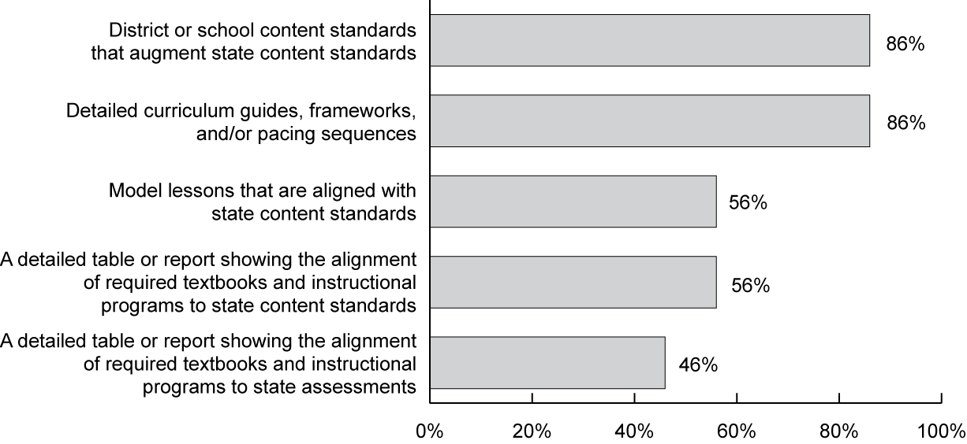
Exhibit reads: Eighty-six percent of all general elementary teachers had access to district or school content standards that augmented state academic content standards.
Source: NLS-NCLB, Teacher Survey (n = 7,645 teachers).

About one-third of teachers in identified schools reported that inadequate numbers of textbooks and instructional materials presented a major challenge to improving student performance.
Teachers reported a number of challenges to improving student performance; the most common were: insufficient parent involvement, low student motivation, and large class size (see Exhibit 69). In 2006–07, as in 2004–05, teachers in identified schools were more likely to report that each of these conditions posed moderate or major challenges to improving student achievement than teachers in non-identified schools. It is noteworthy that, despite the availability of materials to help teachers align curriculum and instruction with state academic content standards, having too few textbooks and other instructional materials presented a moderate or major challenge to 37 percent of teachers in identified elementary schools and 22 percent of teachers in non-identified elementary schools, and not having textbooks that were aligned with standards presented a challenge for 23 percent of teachers in identified schools and 17 percent of teachers in non-identified schools. There were no significant differences in teachers’ reports about challenges to improving student performance between schools that entered improvement status and schools that exited improvement status between 2004–05 and 2006–07.
Exhibit 69
Percentage of General Elementary Teachers Reporting Moderate or Major Challenges
to Improving Student Performance, 2006–07
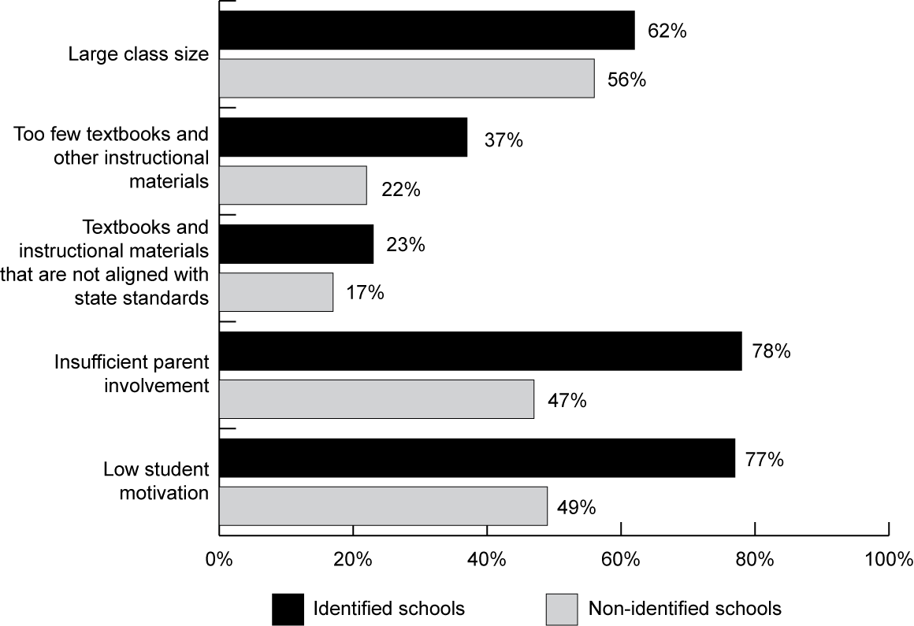
Exhibit reads: Fifty-six percent of elementary teachers in non-identified schools reported that large class size was a moderate or major challenge in their efforts to improve student performance, compared with 62 percent of elementary teachers in identified schools.
Source: NLS-NCLB, Teacher Survey (n = 7,645 teachers).

Instructional time
NCLB-mandated interventions for identified schools include increasing the amount of time students spend in school, and research supports this emphasis on academic learning time (Aronson, Zimmerman and Carlos, 1999).
To increase instructional time for students in reading and mathematics, districts and schools followed two main strategies: implementing extended-time instructional programs outside of the normal school day, and reorganizing the school day to increase or decrease the amount of instructional time for specific subjects. Both strategies were popular; about one-third of schools reported that their improvement efforts placed a moderate or major emphasis on increasing instructional time during the school day, and two-thirds reported their improvement efforts emphasizing extended-time instructional programs.
In 2006–07, almost three-quarters of schools offered extended-time instructional programs, which served a small, but increasing, percentage of students. Identified schools were more likely to offer extended-time programs than were non-identified schools.
Seventy-two percent of all schools implemented some kind of extended-time instructional program during 2006–07; this was the same percentage of schools that reported offering extended time instructional programs in 2004 (Le Floch, et al. 2007) and an increase over the 63 percent that reported offering extended time programs in 1997–98 (Chambers, Lieberman, Parrish, Kaleba, Van Campen, and Stullich, 2000). After-school programs were the most common, with 66 percent of schools reporting after-school tutorials or instruction, up from 57 percent in 1997–98 (see Exhibit 70). Before-school and weekend programs were less common, but their availability also increased during the past decade.
Overall, after-school programs served 9 percent of all students nationally in 2006–07, double the proportion reported in 1997–98 (Chambers, Lieberman, Parrish, Kaleba, Van Campen, and Stullich, 2000) (see Exhibit 70). Similarly, 3 percent of all students were served by before-school programs nationally in 2006–07, an increase from 1 percent nine years ago; the proportion of students served by weekend programs nationally remained stable at about 1 percent.

Exhibit 70
Percentage of Schools Offering Extended Time Instructional Programs and Percentage of Students Served by Such Programs, 1997–98 and 2006–07
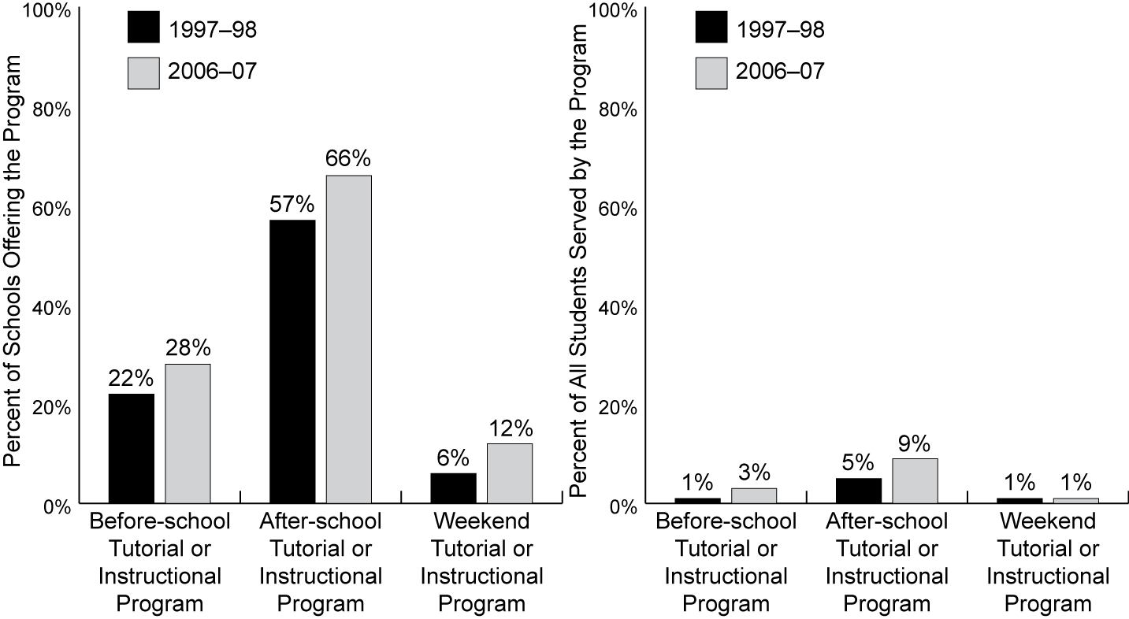
Exhibit reads: Twenty-two percent of schools offered before-school tutorial or instructional programs in 1997–98 and 28 percent offered such programs in 2006–07.
Sources: NLS-NCLB, Principal Survey (n = 1,392 schools); Study of Educational Resources and Federal Funding (2008).

In schools that implemented after-school programs, 17 percent of students participated in these programs, up from 9 percent in 1997–98 (see Appendix C, Exhibit C.15). Where implemented, after-school programs provided students an average of 121 additional hours of instructional time per year; before-school programs added 95 hours. The comparable figures for 1997–98 were 111 hours and 77 hours, respectively. By comparison, weekend programs added 47 hours of instructional time, on average, in 2006–07, about the same amount as in 1997–98.
As in the 1997–98 study, after-school and weekend extended-time instructional programs were more frequent in 2006–07 among Title I schools, urban schools, and schools with higher proportions of poor and minority students. In Title I schools that offered supplemental educational services (SES), there was no relationship between the provision of after-school and weekend extended-time instructional programs and the percentage of students participating in SES. Before-school programs were more evenly distributed across these types of schools. Furthermore, a higher proportion of schools identified for improvement reported implementing extended-time instructional programs (83 percent) than did non-identified schools (70 percent, see Exhibit C.15 in Appendix C). However, in 2006–07, there were no differences in extended-time programs between schools that entered identification status during the 2004–05 to 2006–07 period and schools that exited from identification status during this period. In addition, after-school programs in identified schools served a higher proportion of students (22 percent) than after school programs in non-identified schools (16 percent), although the number of hours of service provided was the same. In addition, weekend programs in identified schools provided a larger number of hours of service per year on average (65 hours) than did weekend programs in non-identified schools (38 hours), although the percentage of students served were the same. When asked about strategies for school improvement, 52 percent of principals in identified schools reported a major focus on using extended-time instructional programs, compared with 33 percent of principals in non-identified schools.
One-third of schools reported focusing improvement efforts on increasing instructional time during the school day for all students in 2006–07.
Thirty-two percent of schools reported that a moderate or major focus of their schools improvement efforts was increasing the length of the school day or the school year to provide more instructional time for all students. Consistent with school reports, about one-quarter of districts with identified schools reported that they required both identified and non-identified schools to increase the amount of time spent on mathematics or reading instruction in 2006–07. In addition, about 20 percent of districts with identified schools reported extending the school day or year in those schools. By comparison, the Center on Education Policy (CEP) reported that only 9 percent of all districts had increased the length of the school day since NCLB was enacted (Center on Education Policy, 2007).
On average, third grade students spent about 20 minutes more per week in reading and about 10 minutes more per week in mathematics in 2006–07 than in 2004–05, but the time devoted to other subjects was virtually unchanged.
Elementary schools reported increasing the amount of time devoted to reading instruction an average of 24 minutes per week between 2004 and 2006 and the amount of time devoted to mathematics instruction an average of 10 minutes per week. For other subjects (including science, social studies, art and music, physical education and health, and other), the average time did not increase or decrease by more than two minutes per week per subject (see Exhibit 71). On average, identified schools reported increasing the time spent on mathematics and reading almost twice as much as non-identified schools during this period.
Exhibit 71
Average Change in Minutes Per Week for Third-Grade Students, by Academic Subject,
2004–05 to 2006–07
Academic Subject | All Schools  (n = 771) | Identified Schools (n = 219) | Non-Identified Schools  (n = 551)
Mathematics | 10 | 24 | 9
Reading | 24 | 40 | 22
Science | 1 | 2 | 1
Social studies | -2 | 1 | -2
Art/music | -1 | -1 | -1
Physical education/health | 1 | 7 | 0
Other | 1 | 6 | 0
Exhibit reads: On average, schools with third-grade students increased the amount of time those students spent studying mathematics by 10 minutes per week from 2004–05 to 2006–07.
Source: NLS-NCLB, Principal Survey.
A small percentage of schools reported increasing instructional time in reading or mathematics by 90 minutes per week or more between 2004–05 and 2006–07, while most schools reported no changes during that period.
Although the average changes in minutes per week by subject across all schools were small, a few schools made large changes. Among the 13 percent of schools that increased instructional time in mathematics for third-grade students, the average increase was 90 minutes per week (see Exhibit 72). Among the 19 percent of schools that increased instructional time in reading for third-grade students, the average increase was 129 minutes per week. Reports from elementary teachers were similar (see Appendix C, Exhibit C.16).
Exhibit 72
Percentage of Principals Reporting Changes in Instructional Time for
Third-Grade Students, by Academic Subject, 2004–05 to 2006–07
Academic Subject | Increase in Time | No Change in Time | Decrease in Time
Mathematics | 13% | 83% | 4%
Reading | 19% | 78% | 3%
Science | 5% | 88% | 7%
Social studies | 2% | 90% | 8%
Art/music | 1% | 93% | 5%
Physical education/health | 3% | 91% | 6%
Other | 2% | 95% | 2%
Exhibit reads: Thirteen percent of principals in schools with third-grade students reported increasing the amount of time those students spent studying mathematics between 2004–05 and 2006–07.
Source: NLS-NCLB, Principal Survey (n = 771 elementary schools).
For the most part, identified elementary schools and non-identified elementary schools were equally likely to report increases or decreases in instructional time in these seven subject areas. However, identified schools were more likely than non-identified schools to report increases of more than 30 minutes in mathematics, as had been the case in 2004 (Le Floch, et al., 2007) (see Appendix C, Exhibit C.17). Schools that entered identification status during the period 2004–05 to 2006–07 and schools that exited identification status during this period were equally likely to report increased instructional time in each subject.
The increases in time for reading and mathematics from 2004–05 to 2006–07 were not offset by similar decreases in time in other subjects. The average decrease in time in all other subjects combined was just two or three minutes. Even when we restrict the sample to just those schools that reported an increase in mathematics or reading, we do not find comparable decreases in time in other subjects. The reported decreases in this restricted set of schools were only 8 to 12 minutes in all other subjects combined. It is possible that the increases were accomplished through lengthening the school day, through more focused use of existing classroom time, through decreases in lunch periods or other noninstructional activities, or that the principal was unaware of reductions in other subjects that teachers made on an individual basis. Similar discrepancies have been reported in other studies, although direct comparison is difficult because of differences in the respondents (principals compared to district staff) and in the exact wording of the questions. For example, in 2007, CEP reported that 62 percent of districts had increased time for reading or math in elementary schools since 2002 and 20 percent reported increasing time for these subjects in middle schools since 2002 (Center on Education Policy, 2007). However, the percentage of districts that reported reductions in time to offset these increases was lower than the percentage reported increases in time. Specifically, only 44 percent of districts reported reducing time in one or more other subjects to accommodate the increases in math and reading at the elementary level. Moreover, the size of the increases was not matched by the size of the reductions; the reported increases were substantial, amounting to 42 percent of the time devoted to both subjects in 2002 but the reported decreases amounted to 31 percent of the time devoted to the other subjects in 2002.
About one-half of secondary schools reported increasing instructional time in reading and mathematics for low-achieving students from 2004–05 to 2006–07.
At the secondary level, 54 percent of identified schools reported increasing instructional time in reading for low-achieving students and 55 percent reported increasing instructional time in mathematics for low-achieving students between 2004–05 and 2006–07. About one-quarter or fewer of identified schools reported increasing instructional time for low-achieving students in science (26 percent), social studies (23 percent) or other subjects (physical education, health, art, music, etc.) (14 percent). Identified secondary schools were more likely than non-identified schools to increase instructional time for low-achieving students in social studies and in “other” subjects (see Exhibit 73); however, none of the other differences was statistically significant.
Fewer than 3 percent of secondary schools, regardless of identification status, reported decreasing instructional time for low-achieving students in reading, mathematics, science, social studies, or other subjects.

Use of assessment results
NCLB requires that test results be used to determine whether schools have made adequate yearly progress, but tests results have the potential to be useful for instructional improvement as well. The information contained in annual state assessments may help teachers and administrators select better materials, plan better instruction, and provide more appropriate professional development.

Exhibit 73
Percentage of Secondary Schools Increasing Instructional Time for Low-Achieving Students in Various Academic Subjects Between 2004–05 and 2006–07
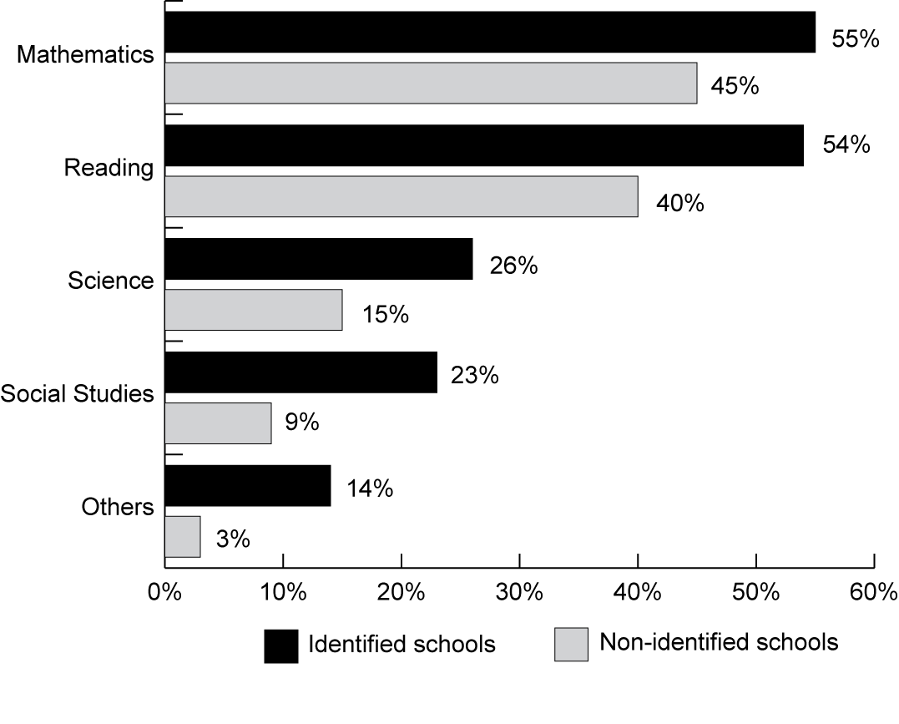
Exhibit reads: Fifty-five percent of identified secondary schools reported increasing the amount of time low-achieving students spent learning mathematics between 2003–04 and 2004–05, compared with 40 percent of non-identified secondary schools.
Source: NLS-NCLB, Principal Survey (n = 496 secondary schools).
Increasing the use of student assessment results was a common focus of schools to guide improvement efforts.
The majority of principals in identified schools and non-identified schools (as well as schools that entered identification status and schools that exited identification status) reported using student achievement data moderately or extensively for a variety of school improvement efforts in 2006–07 (see Exhibit 74). For example, more than 80 percent of all principals reported moderate or extensive use of state test results to develop or revise their school improvement plans, correct gaps in curriculum, and identify students who need additional instruction.
Almost all schools, regardless of improvement status, had access to additional resources to help them use test results, and most were making moderate to extensive use of these resources. For example, as reported in Exhibit 68, in 2006–07, 84 percent of districts reported providing assistance to identified schools to help them analyze assessment results to understand students’ strengths and weaknesses, and 71 percent provided such assistance to other schools. Over 90 percent of schools reported having access to additional resources to help them understand and use test results, including information from workshops, information on how to use test results for instructional planning and school improvement, comparative test results from other schools, and computerized databases.

Exhibit 74
Percentage of Schools Reporting Moderate or Extensive Use of
State Achievement Tests for Various Purposes, 2006–07
Purpose | Identified Schools  (n = 469) | Non-Identified Schools  (n = 918)
Develop or revise our school improvement plan | 95% | 81%ª
Identify and correct gaps in the curriculum | 87% | 82%
Plan professional development activities for teachers | 91% | 79%ª
Identify students who need additional instructional support | 94% | 86%ª
Tailor instruction to individual students’ needs | 88% | 79%ª
Group students for instruction (either within or across grade levels) | 85% | 67%ª
Improve or increase the involvement of parents in student learning | 65% | 55%
Exhibit reads: Ninety-five percent of identified schools reported making moderate or extensive use of state achievement tests to develop or revise their school improvement plans.
ª Indicates statistically significant difference between identified and non-identified schools (p<.05).
Source: NLS-NCLB, Principal Survey.

However, some schools were more likely to use these test-related resources than they were others. For example, in 2006–07, 73 percent of all schools made moderate or extensive use of information on how to use test results for instructional planning or school improvement, but only 45 percent made at least moderate use of comparative test results from other schools. Identified schools were more likely than non-identified schools to report moderate or extensive use of information from workshops on test results and information on using tests results for instructional planning. Similarly, schools with high concentrations of students from low-income families were more likely to use test results in this manner than schools with low concentrations of students from low-income families, as were schools with high concentrations of minority schools (compared to schools with low concentrations of minority students).
Almost all teachers reported using state test results to improve student learning in one or more ways.
Most teachers made moderate or extensive use of state test results for one or more instructional purposes in 2006–07. Overall, 83 percent of elementary teachers, 80 percent of secondary English teachers, and 83 percent of secondary mathematics teachers reported that they had access to state test results. Over 90 percent of teachers with access reported that they reviewed the test results, and, of those, 88 percent of all elementary and secondary English teachers and 85 percent of elementary and secondary English teachers in identified schools reported using state reading test results moderately or extensively for one or more purposes. For example, 77 percent of elementary teachers and secondary English teachers in identified schools who had access to and reviewed state reading test results used those results to identify areas in which they needed to strengthen their content knowledge or teaching skills (see Exhibit 75). Teachers in identified schools were more likely to use state reading test results than were teachers in non-identified schools. Similar patterns were found for the use of mathematics assessments: eighty-five percent of all mathematics teachers, and 84 percent of mathematics teachers in identified schools who had access to and reviewed state mathematics test results, reported moderate or extensive use of those results for one or more purposes. There were no significant differences in teachers’ reported use of assessment results between teachers in schools that entered improvement status and teachers in schools that exited improvement status between 2004–05 and 2006–07.
Exhibit 75
Percentage of General Elementary Teachers and Secondary English Teachers
Using State Reading Assessment Results Moderately or Extensively for
Various Purposes, 2006–07
Exhibit reads: Seventy-one percent of elementary teachers and secondary English teachers in non-identified schools and 77 percent of these teachers in identified schools used the results of state reading tests moderately or extensively to identify areas where they need to strengthen their content knowledge or teaching skills.
Note: The last item was asked of secondary English teachers, but not general elementary teachers.
Source: NLS-NCLB, Teacher Survey (n = 3,099 general elementary teachers and 1,318 secondary English teachers).
Similarly, more than 80 percent of principals reported making moderate or extensive use of the state test results for identifying students who need additional instructional support, identifying and correcting gaps in the curriculum, and planning professional development activities for teachers.
Principals and teachers also reported on the format in which test results were presented. In 2006–07, over 90 percent of principals reported having access to state test results in mathematics and reading summarized in a number of ways, including results for individual students, subgroups, and grade levels. The results included both scale scores and the percent of students at each performance level, as well as information on topics or skills within reading or mathematics and trends in school scores across years. Over 85 percent of principals also reported having results summarized by classroom and having access to trends in individual student results across years. Furthermore, most principals reported making moderate or extensive use of all these types of student test data. Among the teachers who had access to student test results, at least 50 percent said they made moderate or extensive use of most types of data. Results for individual students and results on specific reading or mathematics topics or skills were the most widely used by teachers; about 60 percent of teachers of each subject said they used these two types of results moderately or extensively.
One might expect to find greater access to, and use of, test results in states with more comprehensive systems of support for school improvement or in states with additional accountability systems beyond NCLB. The former was more common than the latter. Elementary teachers’ use of test results in mathematics and reading was more prevalent in states with comprehensive systems of support than in states with limited or moderately comprehensive systems of support. For example, 70 percent of elementary teachers in states with comprehensive systems of support reported using mathematics test results moderately or extensively for assigning or reassigning students to classes or groups compared with 60 percent of elementary teachers in states with limited or moderate systems of support. Similar differences were found among elementary school teachers for almost all the other types of test use included in the survey. In 2004, there were also differences in principals’ reported test use and in secondary teachers’ reported test use associated with the comprehensiveness of the state system of support, but these differences were no longer present in 2006.
On the other hand, there were very few differences in access to, or use of, test results between teachers in states with additional accountability systems and teachers in states with only the NCLB accountability system. One significant difference was that teachers in states that had an additional accountability system in 2006–07 were more likely to have access to test results that were summarized by classroom than did teachers in other states. However, there were not many differences in how the test results were used.
About two-thirds of schools used periodic progress assessments.
About two-thirds of the schools supplemented annual state assessments with “progress assessments” or “progress tests,” i.e., required assessments that are administered periodically throughout the school year and scored rapidly to provide feedback for teachers’ instructional planning. Progress tests were more prevalent in reading (71 percent of schools) than in mathematics (61 percent of schools). In both reading and mathematics, progress tests were more common in identified schools than in non-identified schools and in elementary schools than in secondary schools (see Exhibit 76). Progress tests also were more common in schools with high concentrations of students from low-income families and high concentrations of minority students. There were no significant differences in the use of progress tests between schools that entered improvement status and schools that existed improvement status between 2004–05 and 2006–07.
Progress tests were administered at different intervals, ranging from two to three times per year to once or more a month. Forty-one percent of teachers who administered progress tests in reading administered them two to three times per year, 42 percent administered progress tests every six to eight weeks and 17 percent administered progress tests once a month or more often. (The results were almost identical for mathematics progress tests.)

Exhibit 76
Percentage of Schools Administering Progress Tests,
by School Characteristic, 2006–07
Characteristic | Reading Tests | Mathematics Tests
All schools (n = 1,392) | 71% | 61%
Title I Status
Title I | 76% | 63%
Non–Title I | 63% | 58%
School Identification Status
Not identified | 68% | 58%
Year 1 and Year 2 of identified for improvement status | 88% | 77%
Corrective action status | 93% | 89%
Restructuring status | 88% | 77%
School Poverty Level
High poverty | 89% | 78%
Medium poverty | 76% | 68%
Low poverty | 56% | 45%
School Minority Concentration
High minority (75% or more) | 91% | 80%
Moderate minority (25-75%) | 79% | 73%
Low minority (less than 25%) | 56% | 45%
Urbanicity
Central city | 87% | 22%
Urban fringe | 67% | 58%
Rural/small town | 63% | 51%
School Level
Elementary | 78% | 65%
Middle | 65% | 60%
High | 53% | 50%
Exhibit reads: Seventy-one percent of all schools administered progress tests in reading, compared with 61 percent that administered progress tests in mathematics.
Source: NLS-NCLB, Principal Survey.
Almost all teachers who administered progress tests reported that they used the results to improve student learning.
A large majority of teachers in schools that administered reading progress tests in 2006–07 used the results moderately or extensively for several purposes. For example, 89 percent of teachers in identified schools and 86 percent of teachers in non-identified schools who administered progress tests in reading used the results to tailor instruction to individual students’ needs (see Exhibit 77). The results were similar for progress tests in mathematics. The results for both subjects are also similar to those reported by teachers in 2004–05 (Le Floch et al., 2007).
Exhibit 77
Percentage of General Elementary Teachers and Secondary English Teachers Administering Progress Tests in Reading Who Use Results
Moderately or Extensively for Various Purposes, 2006–07
Exhibit reads: Ninety-two percent of general education teachers in non-identified schools who administered reading progress tests used the results from these tests moderately or extensively to identify individual students needing remedial assistance, compared with 91 percent of general education teachers in identified schools.
Source: NLS-NCLB, Teacher Survey (n = 4,061 general elementary teachers and secondary English teachers).

Interventions For Identified Schools
The required interventions for schools identified for improvement under NCLB escalated as schools moved from Year 1 of improvement to Year 2 of improvement, and then to corrective action and restructuring. Initial requirements include notifying parents about the status of the school, joint planning for school improvement between the school and district, and allowing parents to transfer their children to a non-identified school in the district with transportation provided. In Year 2 of improvement, schools also have to offer supplemental educational services to low-performing schools. When schools enter corrective action or restructuring, they are subject to additional, more serious interventions, including replacement of all school staff, or state takeover of the operation of the school. States and districts must take at least one of the more serious mandated actions for schools in corrective action and restructuring status.
Required interventions occurred in most, but not all, Title I schools in Year 1 or Year 2 of identification for improvement or in corrective action.
The three interventions required of all identified Title I schools (regardless of how many years they had been identified for improvement) were widely implemented in 2006–07: 97 percent of identified Title I schools (and 97 percent of all identified schools) notified parents of the school’s improvement status; 89 percent of identified Title I schools (and 89 percent of all identified schools) developed a joint improvement plan with the district or state; and 82 percent of identified Title I schools (and 79 percent of all identified schools) offered parents the opportunity to transfer their child to a non-identified school (i.e., Title I public school choice). However, among those identified schools in Year 1 of improvement, only 71 percent of Title I schools offered parents the option of transferring their children to a non-identified school, although that percentage rose among schools that had been identified for more than one year and were in subsequent stages of improvement (see Exhibit 78). This means, however, that close to 30 percent of schools required to offer Title I public school choice in Year 1 did not do so. Padilla et al. (2006) reported slightly higher compliance numbers for the years 2002–03 and 2003–04, but noted that some districts and schools faced important challenges in implementing choice—such as expanding capacity, time to set up the program, availability of alternatives, and transportation—and that for some schools there were simply no choices available for transfer (especially to higher performing schools) (see also Vernez et al., 2008).
In 92 percent of Title I schools in Year 2 of improvement in 2006–07, students were offered supplemental educational services. This represents an increase in access to supplemental services over prior years; 58 percent of schools required to offer supplemental services in 2002–03 actually made them available; 83 percent offered them in 2003–04 (Padilla et al., 2006); and 90 percent reported offering supplemental educational services in 2004 (Le Floch et al, 2007). Supplemental educational services were also offered to students from low-income families by almost all Title I schools in corrective action and restructuring status.
Similarly, 88 percent of Title I schools in corrective action status for 2006–07 experienced at least one of the NCLB-defined interventions. As noted on page 123, some states have laws that prohibit certain actions, such as taking over schools, so there were fewer corrective action options available in those states. The most common interventions involved implementing a new research-based curriculum and the appointment of outside advisors (see Exhibit 78). Two-thirds of schools in corrective action were required to implement a new curriculum; one-quarter had an outside expert or advisor assigned to them. These two actions were the most common corrective actions reported in previous studies of Title I (Shields et al., 2004; Le Floch et al., 2007). Researchers in the past also found that districts with identified schools often required the adoption of a new curriculum for reasons other than being identified for improvement; for example, the regular textbook adoption cycle drove the decision more often than did being identified for improvement (Shields et al., 2004). In 2006–07, only 21 percent of schools in corrective action status reported that relevant staff members were replaced, and only 2 percent reported a reduction in management authority in the school. These results are also consistent with findings from Padilla et al. (2006), who reported that 12 percent of districts with schools in corrective action required either of these changes.
There were significant declines from 2004 to 2006 in the percentage of schools in corrective action that were required to implement a new curriculum, decrease management authority, have an outside expert or adviser appointed or extend the length of the school year. The changes in the prevalence in specific interventions are somewhat difficult to interpret because the group of schools in corrective action in 2006 is not the same as the group of schools that were in corrective action in 2004. As reported earlier in this chapter, each corrective action option was used by 30 or more states in 2006, an increase from 2004 that probably reflects the increase in the number of schools in corrective action.

Exhibit 78
Percentage of Title I Schools Experiencing Various Types of Interventions
From Their State or District, 2006–07
NCLB-Mandated Interventions | Schools in Year 1 of Improvement  (n = 102) | Schools in Year 2 of Improvement  (n = 63) | Schools in Corrective Action  (n = 99) |  |  | Schools in Restructuring 1  (n = 66) | Schools in Restructuring 2  (n = 97)
Actions Required for All Identified Schools
Parents notified of school’s improvement status | 94% | 100% | 100% |  |  | 100% | 94%
District or state developed a joint improvement plan with the school | 83% | 96% | 94% |  |  | 94% | 81%
Students offered the option to transfer to a higher-performing school, with transportation provided | 71% | 80% | 85% |  |  | 86% | 94%
Action Required for Identified Schools That Did Not Make AYP After Identification (Year 2 of Improvement)
Students offered supplemental educational services (e.g., tutoring) from a state-approved provider | 53% | 92% |  | 100% |  | 100% | 91%
Corrective Actions (At Least One Required for Schools in Corrective Action Status)
Required implementation of a new research-based curriculum or instructional program | 54% | 60% |  |  | 67% | 76% | 83%
Significantly decreased management authority at the school level | 4% | 17% |  |  | 1% | 7% | 17%
Appointed outside expert to advise the school | 34% | 35% |  |  | 26% | 41% | 60%
Extended length of school day | 15% | 26% |  |  | 22% | 65% | 30%
Extended length of school year | 6% | 7% |  |  | 9% | 21% | 13%
Restructured internal organization of the school | 10% | 12% |  |  | 21% | 31% | 45%
Replaced school staff relevant to school’s low performance | 4% | 11% |  |  | 21% | 25% | 33%
Replaced principalª | 13% | 24% |  |  | 29% | 35% | 43%
Restructuring 1 Interventions (Required for Schools in Restructuring 1 Status)
Planned for restructuring to take place the following year | 8% | 10% |  |  | 5% | 37% | 53%
Restructuring 2 Interventions (At Least One Required for Schools in Restructuring 2 Status)
Reopened the school as a public charter school | 2% | 7% |  |  | 0% | 0% | 1%
Entered into a contract with a private entity to manage the school | 2% | 1% |  |  | 0% | 2% | 1%
State takeover | 2% | 2% |  |  | 0% | 3% | 3%
Replaced all or most of the school staff (which may include the principal) | 5% | 11% |  |  | 4% | 4% | 17%
Exhibit reads: Ninety-four percent of Title I schools identified for improvement under NCLB for the first year reported that parents had been notified of the school’s improvement status.
Note: The results refer to Title I schools exclusively because NCLB mandates apply only to these schools. However, some states identify and intervene in non–Title I schools as well.
ª Replacing the principal is not a mandated intervention for schools in corrective action, but the principal may be thought of as the staff person responsible for the school’s performance, so replacing the principal was included as a separate item on the survey.
Source: NLS-NCLB, Principal Survey.
Many of the interventions that NCLB defines as corrective actions were also implemented in schools in earlier stages of identification for improvement. For example, 60 percent of schools in Year 2 of improvement were required to implement new research-based curricula or instructional programs. Replacing the principal was also a common action reported by schools; although it is not specified as a required intervention option under NCLB, it may well be the way some districts choose to “replace school staff” relevant to the school’s low performance. The percentage of schools in which the principal was replaced rose consistently from 13 percent of schools in Year 1 of identification to 43 percent of schools in Restructuring 2.
Reports from districts corroborate these reports from schools. Many districts reported that they required some or all identified schools to undertake specific improvement efforts. The most common district interventions focused on identified schools were to implement focused test preparation activities (28 percent), assign a specialist or coach to support instruction in mathematics or literacy (27 percent), increase the amount of time spent on mathematics or reading (27 percent), and administer progress tests (27 percent) (see Exhibit 79). It was also common for districts to require some improvement efforts from all their schools, both identified and non-identified. For example, 36 percent of districts with identified schools required all of their schools to implement focused test preparation activities, and 32 percent required all schools to adopt progress tests.
Exhibit 79
Percentage of Districts with Identified Schools Requiring Schools to Enact Various Improvement Efforts, 2006–07
Required Action | Some or All Identified Schools | Both Identified and Non-Identified Schools | Action Not Required
Assign a school-site instructional specialist or coach to support mathematics or literacy instruction | 26% | 25% | 43%
Increase the amount of time spent on mathematics or reading instruction | 26% | 23% | 38%ª
Implement focused test preparation materials or activities | 28%ª | 37%ª | 33%ª
Adopt a new reading curriculum or instructional program | 23% | 9%ª | 62%
Administer common interim or progress tests every few weeks to monitor student progress | 26% | 32% | 28%
Adopt a new mathematics curriculum or instructional program | 17% | 20% | 47%ª
Assign a school-site instructional specialist or coach to support instruction for students with limited English proficiency | 9% | 7% | 83%
Adopt a new English language instruction program for students with limited English proficiency | 13% | 12% | 74%
Exhibit reads: Twenty-six percent of districts with identified schools assigned a school-site mathematics or literacy instructional specialist or coach to some or all of these schools
Note: Identified schools include those designated identified for improvement Year 1, Year 2, corrective action, or restructuring. The district survey does not differentiate among schools based on Title I status, so results refer to all schools not just Title I schools.
ª Significantly different from 2004–05 at alpha=.05.
Source: NLS-NCLB, District Survey (n = 155 districts).
Many Title I schools in restructuring status did not experience any of the specific interventions listed in the law.
Restructuring is implemented in two stages: Title I schools that reach this improvement level spend the first year planning for restructuring (Restructuring 1) and the subsequent years implementing their restructuring plan (Restructuring 2). The most recent data show that 44 percent of Title I schools in restructuring status in 2006–07 were in Restructuring 1 and 56 percent were in Restructuring 2 (U.S. Department of Education, 2005–06). Surprisingly, only 37 percent of Title I schools in Restructuring 1 reported that they actually planned for restructuring to be implemented the next year (see Exhibit 78). This response may mean that most schools in their first year of restructuring are not being required to develop restructuring plans in a timely manner. As one might expect, many Title I schools in Restructuring 1 experienced interventions defined for schools in corrective action, including implementing a new curriculum (76 percent) and extending the school day (65 percent). In addition, the principal was replaced in about one-third of schools in the restructuring planning stage.
Title I schools in Restructuring 2 also frequently reported that they had been subject to interventions associated with Corrective Action, including implementing a new research-based curriculum or instructional program (83 percent) or appointment of an outside expert to advise the school (60 percent). These results are consistent with those reported previously by Shields et al. (2004) and Le Floch et al. (2007). However, few of the interventions required for Restructuring 2 were reported by Title I schools in Restructuring 2. Although more than half of the schools in Restructuring 2 reported that they had planned for restructuring, very few schools reported any of the named interventions, including replacing all or most of the school staff (17 percent), state take-over of the school (3 percent), reopening of the school as a public charter school (1 percent), or contracting with a private entity to manage the school (1 percent). Based on these results, it would appear that states were not fully implementing the requirements associated with the Restructuring 2 stage. This interpretation is consistent with a recent Government Accountability Office report that found that about 40 percent of schools in restructuring had not taken any of the five restructuring options in the law (GAO, 2007).
However, it should be noted that the law also includes a district-defined intervention for schools in Restructuring 2, which was not directly assessed on the survey. NCLB permits districts to make “any other major restructuring of the school’s governance arrangement that makes fundamental reforms, such as significant changes in the school’s staffing and governance.” As reported earlier in this chapter, the option “other major restructuring” was reportedly used by 29 states. Thus, it is possible that schools in Restructuring 2 in these states may have experienced such an intervention and not reported it specifically on the survey. One indication of such “other major restructuring” might be the replacement of the school principal, and 43 percent of the schools in Restructuring 2 reported that a new principal had been appointed. On the other hand, as noted above, principals were replaced in 20 to 30 percent of schools in other stages of improvement as well as in 15 to 18 percent of non-identified schools, so it is difficult to know whether replacing the principal was part of a “major restructuring” in schools in Restructuring 2.
The number of interventions a school experienced increased as its level of identification increased. On average, Title I schools in Year 1 of identification reported four interventions since they were first identified for improvement. Title I schools in Year 2 of identification and schools in corrective action reported six interventions, on average, while those in restructuring-planning or restructuring-implementation reported that they had received seven interventions since they had been identified for improvement. These results are consistent with the idea that these schools are engaged in “other major restructuring.”

Use of Section 1003(a) set-aside for school improvement
Under Section 1003(a) of ESEA, states are generally required to reserve 4 percent of their Title I allocations for school improvement activities listed in Section 1003(a)–(b). At least 95 percent of these funds must be used for the activities in Section 1003(b) and up to 5 percent may be used by the state to carry out its responsibilities under Sections 1116 and 1117. In 2004–05, 37 states reported that they retained the maximum amount permissible to support state-level activities (see Exhibit 80).
Exhibit 80
State Uses of Section 1003(a) Funds for State-Level Activities, 2004–05
Use of Section 1003 Set-Aside for State-Level Activities | Number of States
Number of states that retained up to the maximum allowable amount of Section 1003 funds (5%) | 37
Number of states that retained between 1% and 4% of Section 1003 funds | 4
Number of states that did not retain any of the funds | 10
Exhibit reads: Thirty-seven states retained up to the maximum allowable amount of Section 1003 funds.
Source: NLS-NCLB, state resource allocation data, 2004–05 (n = 50 states and the District of Columbia).
In 21 states, all schools identified for improvement were eligible for Section 1003(a) funds in 2006–07, but Ohio and New Jersey officials cautioned that they would not be able to support all identified schools in the future. In 29 states, officials reported that they restricted the use of Section 1003(a) funds in 2006–07. Some states restricted such funds to schools that were in corrective action or beyond, and in one state, only the newest schools in improvement status were eligible for funds.
Formulas were by far the most common method of distributing Section 1003(a) funds in 2006–07. Only two states reported using a competitive method of distributing funds and three states and the District of Columbia reported a hybrid approach of distributing funds. Among the states that used formulas, the approaches varied, from an emphasis on enrollment, percent of students eligible for free- and reduced-price lunches, the number of schools identified for improvement in the state or district, or the AYP targets that a school missed. For example, Alaska developed a weighted formula that considered school size, the number of AYP targets missed, and the distance from school proficiency levels to state targets. In five states, funding levels were associated directly with school improvement levels. For example, in New York, schools in Year 1 or Year 2 of improvement received $75,000; schools in Years 3 through Year 5 of improvement received $85,000; and schools in Year 6 of improvement received $95,000. Funding levels in New Mexico were somewhat lower, in which schools identified for improvement or corrective action received $30,740, and schools in restructuring status received $50,000 (based on 2004–05 dollars).
As noted above, under Section 1003(a) states must generally reserve 4 percent from their Title I, Part A, allocations for school improvement activities listed in Sections 1003(a)–(b). In 2004–05, California reserved over $70 million and New York almost $50 million, while 16 states reserved between $1 and $2 million. Some states may be unable to reserve the full 4 percent in a given year because Section 1003(e) prohibits states from reducing a district’s allocation below its prior year’s amount when making the Section 1003(a) reservation. For example, Kansas reserved $35,937 under Section 1003(a) for 2004–05 (see Appendix B, Exhibit B.9). Without the stipulation in Section 1003(e), Kansas would reserve approximately $3,300,000.
In 2006–07, the activities for which states used these funds fell into a very broad category of “activities that are identified in the school improvement plan” (19 states). For example, the Mississippi respondent specified that, “the activities supported by the 1003(a) funds are based on strategies within the state-approved school improvement plan.” Likewise, the New Hampshire respondent noted that, “funds are designed to be available to support the improvement plan, and not just to expand or augment the existing Title I program.” In addition, 14 states used their funds to pay for professional development activities, and 12 states noted that funds could be used to support individuals (such as instructional coaches or school improvement specialists) who would provide direct assistance to schools. Two states said that their Section 1003(a) funds were used to support supplemental educational services, and in Arkansas, the funds pay exclusively for the implementation of the America’s Choice comprehensive school reform model (see Exhibit 81).
Exhibit 81
Types of Activities Funded by Section 1003(a) Set-Aside, 2006–07
Exhibit reads: Nineteen states funded general school improvement activities with their section 1003(a) funds in 2006–07.
Note: Categories are not mutually exclusive.
Source: SSI-NCLB, Accountability Interviews (n = 48 states, the District of Columbia, and Puerto Rico).
Thirty-one states imposed restrictions on the use of schools’ Title I improvement dollars. The most common requirement was that all funded activities be aligned with an approved school improvement plan. Other restrictions included the prohibition of using Section 1003(a) funds to purchase equipment, to pay paraprofessionals, or to pay for administrative or indirect costs. Two state-specific restrictions were of particular interest: in Ohio, coaching must be included in the use of Section 1003(a) funds, and Florida required funds to be used close to the classroom—for example, off-site professional development would not be permitted.

Discussion
In the NCLB accountability system, the responsibility for improving school performance is shared by states, districts, and schools. In 2006–07, states faced new challenges to their systems of support as they confronted (or anticipated) higher numbers of schools identified for improvement, corrective action, and restructuring. By 2006–07, however, most states were no longer novices in the provision of support, and, having learned from their own experiences as well as from other states, they were in a position to develop strategies to meet emergent challenges. Thus, states’ systems of support have evolved in three important respects: first, more states sought to build district capacity to assist their schools; second, more states provided differentiated support through tiered systems; and third, states increasingly focused support on the subjects and subgroups for which schools experienced the greatest need.
Also, in what appears to be an emergent trend, states focused support on academic content, as well as specific subgroups for whom AYP targets prove challenging. For example, some states developed needs assessments and intervention strategies specifically for schools in which LEP students have not met performance objectives; other states noted that schools exited improvement status when interventions focused on specific subgroups. And, 18 states indicated that their support to low-performing schools included a content focus.
But, while states have refined their systems of support, they still struggle to find appropriate strategies to meet the most challenging schools. When schools continue to not make AYP targets after six or seven years, what kind of state interventions, supports, or programs will stimulate and sustain improvement student achievement? How can states break the cycle in which school failure has become institutionalized?
In 2006–07, as in 2004–05, a wide range of improvement efforts occurred at the school level. Almost all schools were engaged in improvement efforts, including seeking and receiving technical assistance, implementing local initiatives involving curriculum, assessment, or other activities, and, in the case of identified schools, participating in NCLB-mandated interventions.
Schools reported needing technical assistance in a dozen different areas, with identified schools reporting a greater need for such assistance than non-identified schools. Needed technical assistance was available to most schools from state, district, or other sources, and for the most part, schools were satisfied with the assistance they received. Districts reported making their support services widely available. Most districts provided technical assistance to all of their schools, but principals in identified schools reported receiving more hours of technical assistance from their districts than did principals in non-identified schools. The greatest unmet needs for technical assistance were in the areas of addressing the instructional needs of students with disabilities and LEP students.
In addition, all schools were engaged in local improvement reforms in 2006–07, with identified schools reporting undertaking more of their own improvement initiatives than did non-identified schools. These school improvement initiatives focused on changes in curriculum and instruction, greater use of assessment, reallocation of instructional time, and other areas. Extended time programs (before- or after-school, or on weekends) were found in three-quarters of identified schools, although they served a small percentage of students. In addition, the average elementary school student received 20 minutes more instruction per week in reading and 10 minutes more instruction per week in mathematics in 2006 than in 2004. Most schools reported having access to and using state test results to guide their school improvement activities. Use of periodic “progress” tests was also widespread, and teachers who administered such tests reported using them in a variety of ways to improve student performance.
Identified schools were subject to interventions from states and districts in 2006–07, as required by NCLB. In the case of schools in corrective action and restructuring, most states and districts did not apply the most intensive or restrictive interventions, such as changing governance structures or replacing large numbers of staff. States and districts did not always provide basic resources to schools; about one-third of teachers in schools identified for improvement reported lacking adequate numbers of textbooks and instructional materials.

VIII. District Improvement
NCLB contains a number of provisions to encourage districts to increase the achievement of students. This chapter describes improvement efforts for districts, complementing the previous chapter that examined improvement efforts for schools. The chapter contains information about state support for districts, districts’ technical assistance needs and services received, districts’ own improvement efforts, and required interventions to foster improvement.

Key Findings
- Forty-seven states had systems of support for districts in 2006–07, 28 of which were first implemented between 2004–05 and 2006–07. In 35 states, state staff provided support to district; in 10 states, regional or county offices provided support to districts.
- In 2006–07, most states continued to provide a broad range of technical assistance to all districts. Compared to 2004–05, more states reported providing assistance to improve parent involvement activities and to address the needs of LEP students.
- Three-quarters of districts reported that they received the technical assistance they needed in most areas in 2006–07 and that the assistance they received met their needs. However, technical assistance was not always sufficient to meet district needs relating to LEP students, students with disabilities, and professional development for schools that did not make AYP.
- More than one-half of districts in corrective action in 2006–07 reported receiving none of the mandated interventions. The number of states with districts in corrective action has grown substantially since 2004, and it may be the case that many of these states are not ready to intervene with districts.

State Support for Districts
Although schools have received most of the attention under NCLB to date, growing attention has been paid to districts since 2004–05. The attention reflects both the fact that districts themselves are being identified for improvement under NCLB—in 2006–07, 12 percent of Title I districts were identified for improvement, and 3 percent were in corrective action status (see Chapter IV) (U.S. Department of Education, 2005–06)—and the fact that districts play an important role in helping their schools improve. The two aspects of the districts’ role in NCLB accountability are inextricably linked, and this section encompasses both aspects of district improvement.
Efforts to improve the performance of school districts include specific systems of support targeted at districts, technical assistance to districts, voluntary district improvement initiatives, and required corrective actions for districts that continue to perform inadequately.

Systems of support for districts identified for improvement
Forty-seven states had systems of support for districts in 2006–07, 28 of which were implemented between 2004–05 and 2006–07.
In 2006–07, systems of support for districts identified for improvement varied among states and appeared to be evolving as more districts were identified for improvement. Forty-five states reported having systems designed to support districts identified for improvement as of 2006–07. Three states had no districts identified for improvement or corrective action, but at least one of those states anticipated implementing a system of support for districts identified for improvement in 2007–08. Since 2004–05, 28 states have implemented new district support strategies or have enhanced existing school support strategies to encompass support for districts identified for improvement (see Exhibit 82).
Of the 47 states that reported having a system of support for districts identified for improvement, 28 states described a district support strategy that was distinct from state support for schools identified for improvement. The other 19 states reported the system of support was “the same as support for schools” or was a slight variation of the support for schools. That is, if the primary support mechanism in a given state was a team of improvement specialists, then districts identified for improvement would receive support from this team, as would schools identified for improvement. For example, in South Dakota the support system for districts and schools identified for improvement is the same; however, once a district is in corrective action, “assistance from the school support team [to the district] is mandatory.”
Exhibit 82
Number of States, by Year in Which They Implemented a Support System for Districts
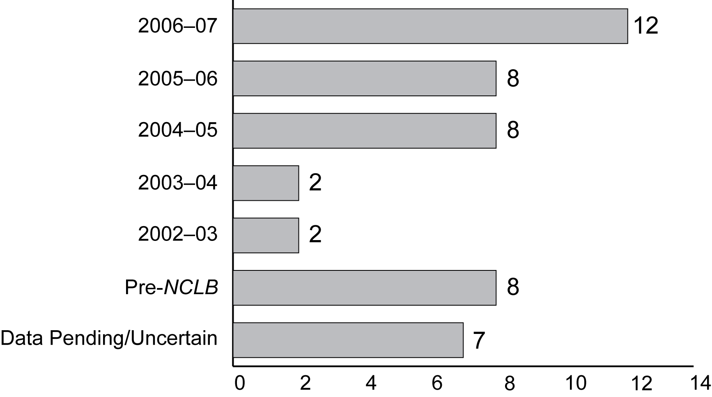
Exhibit reads: In 2006–07, 12 states implemented their current support system for districts identified for improvement.
Sources: SSI-NCLB, Accountability Interviews, 2006–07 and state policy documents (n = 47 states).
Number of States
In 35 states, state staff provided support to districts, and in 10 states, regional or county office staff provided support to districts.
In addition to support provided by state, regional, or county staff, five states noted that they used external organizations to provide technical assistance to districts identified for improvement. External providers included private foundations or regional technical assistance centers funded by the U.S. Department of Education. Officials in 20 states reported that they leveraged resources from different levels to ensure adequate capacity for district support. For example, in Kentucky, achievement gap coordinators from the state education agency and district support facilitators from the regional offices together provided support to districts identified for improvement. In Indiana, state education agency staff collaborated with the Great Lakes East Comprehensive Center to provide support to districts identified for improvement.
The primary support mechanisms for districts were generally the same as those used for schools identified for improvement. Support teams assisted districts identified for improvement in 16 states. Some support teams were part of a state’s system of support for schools; other states developed support teams specifically for districts. For example, North Carolina’s LEAP (local education agency performance) teams work solely with districts identified for improvement. Improvement specialists who assisted districts included states’ distinguished educators, improvement facilitators trained by the state, or individual consultants.

Technical Assistance for Districts
The study provides two perspectives on technical assistance for districts—state reports about the technical assistance services they provide and district reports about the technical assistance services they need and receive.

Technical assistance provided by states
In 2006–07, most states continued to provide a broad range of technical assistance to all districts. Compared to 2004–05, more states reported providing assistance for parent involvement activities and to support the needs of LEP students.
Forty-four responding states provided technical assistance to all districts on accountability system rules and requirements and four more states did so for all districts identified for improvement (see Exhibit 83). These findings reflect the NCLB requirement that all districts be provided with basic information about accountability rules and requirements and the interpretation of student achievement data (the topics addressed by the largest number of states). However, slightly fewer states reported providing this basic type of assistance in 2006–07 than in 2004–05. This may be due to a perception by state officials that district officials understood the core requirements of NCLB, and instead needed technical assistance in more focused areas. Indeed, states reported an increase in the provision of technical assistance in areas of NCLB implementation that are perceived as challenge areas, including parent involvement (an increase of six states provided such assistance to all districts) and technical assistance to address the needs of LEP students (five additional states provided assistance to all districts). There was a notable increase in the number of states that supported improved professional development (eight additional states).
In states that provided technical assistance specifically to districts identified for improvement, the most common type of technical assistance was developing and implementing district improvement plans (23 states), aligning professional development with the districts’ high need areas (17 states), and analyzing budgets to align spending with improvement priorities (11 states).
Six states provided technical assistance to Title I districts exclusively and another 16 states provided assistance to a subset of districts identified for improvement. States used different strategies to prioritize districts. Some states restricted technical assistance to those in corrective action (three states). Other states made determinations as to which districts were in the greatest need and provided technical assistance accordingly (two states). In a few states, support to districts was determined by the number of schools that were identified for improvement within the district (two states) or by district request (three states).

Exhibit 83
Number of States Providing Technical Assistance to Districts,
by Focus of Technical Assistance, 2006–07
Focus of Technical Assistance | All Districts | All Identified Districts | Some Identified Districts | Support Not Provided | No Response
Clarify accountability system rules and requirements | 44 | 4 | 2 | 0 | 0
Analyze student assessment data | 39 | 8 | 2 | 0 | 1
Develop and implement a district improvement plan | 18 | 23 | 3 | 3 | 3
Identify parent involvement strategies | 35 | 8 | 4 | 1 | 2
Identify and implement effective curricula, instructional strategies, or school reform models | 35 | 11 | 2 | 0 | 2
Identify and implement strategies to address the needs of LEP students | 31 | 8 | 5 | 1 | 5
Identify and implement strategies to address the needs of students with IEPs | 38 | 6 | 1 | 0 | 5
Improve the quality of professional development in areas in which schools did not make AYP | 28 | 17 | 3 | 0 | 2
Analyze and revise budgets to use resources more effectively | 21 | 11 | 4 | 7 | 5
Develop strategies to recruit and retain more teachers who are “highly qualified” under NCLB | 30 | 5 | 6 | 5 | 4
Exhibit reads: Forty-four of the 49 states and the District of Columbia responding provided technical assistance to all districts to clarify accountability system rules and requirements; four states provided such assistance to all districts identified for improvement and two provided assistance to some districts identified.
Source: SSI-NCLB, Accountability Interviews (n = 49 states and the District of Columbia).

Districts’ technical assistance needs
Districts needed technical assistance in many areas, and identified districts needed more assistance than non-identified districts.
Three-quarters of all districts reported needing technical assistance regarding some aspect of NCLB implementation in 2005–06 or 2006–07. Seventy-one percent of districts reported needing technical assistance on at least one of the surveyed topics; the median number of topics on which assistance was needed was three. One-quarter of the districts reported needing technical assistance on six or more of the 10 topics. Districts’ most frequent needs related to meeting the instructional needs of students with disabilities (51 percent), identifying effective curricula and instruction (48 percent), and understanding the rules and requirements of their states’ accountability systems (45 percent) (see Exhibit 84). In addition, over 40 percent of districts reported needing technical assistance in analyzing assessment data.
Exhibit 84
Percentage of Districts Needing and Receiving Mandated Technical Assistance
and Finding It Sufficient to Meet Their Needs, 2005–06 or 2006–07
Type of Technical Assistance | Needed  (n = 288) | Received Where Needed  (n = 168) | Sufficient Where Needed and Received  (n = 134)
Clarify accountability system rules and requirements | 45% | 97% | 84%
Analyze student assessment data to understand program strengths and weaknesses | 44%ª | 80% | 90%
Identify and implement effective curricula, instructional strategies, or school reform models | 48%ª | 96% | 75%
Identify and implement strategies to address the instructional needs of students with disabilities | 51% | 73% | 77%
Develop and implement a district improvement plan | 29% | 87% | 95%
Identify parental involvement strategies | 31% | 81% | 93%
Identify and implement strategies to address the instructional needs of LEP students | 32%ª | 67% | 40%
Improve the quality of professional development in areas in which schools did not meet AYP | 20% | 79% | 66%
Develop strategies to recruit and retain more teachers who are “highly qualified” under NCLB | 16% | 54% | 82%
Analyze and revise budget to use resources more effectively | 19% | 80% | 86%
Exhibit reads: Forty-five percent of districts reported that they needed technical assistance to clarify accountability system rules and requirements; 97 percent of districts needing this type of assistance received it, and 84 percent of districts that received this assistance reported that it was sufficient to meet their needs.
ª More than 10 percent of surveys were missing responses to this item.
Source: NLS-NCLB, District Survey.

In 2005–06 or 2006–07, identified districts were more likely to report that they needed technical assistance in some areas than were non-identified districts. For example, 67 percent of identified districts reported needing technical assistance to improve the quality of professional development in areas in which schools did not make AYP, compared with 14 percent of non-identified districts. Identified districts were also more likely than non-identified districts to need technical assistance in recruiting and retaining highly qualified teachers, identifying parental involvement strategies, and developing and implementing an improvement plan.
Other demographic factors were also associated with districts’ need for technical assistance in a few areas. Districts with high levels of poverty were more likely than districts with medium or low levels of poverty to need assistance in improve the quality of professional development in areas in which schools did not make AYP, recruiting and retaining highly qualified teachers, and developing and implementing an improvement plan. Large districts were more likely than medium or small districts to need technical assistance in meeting the needs of LEP students, recruiting and retaining highly qualified teachers, and developing and implementing an improvement plan.

Meeting districts’ technical assistance needs
In 2006–07, three-quarters of districts reported receiving the technical assistance they needed in most areas and reported that the assistance they received met their needs.
For eight of the 10 topics included in the survey, more than 70 percent of all districts that reported needing assistance received it. Districts were least likely to receive assistance with strategies to recruit and retain highly qualified teachers; only 54 percent of districts needing this type of assistance received it (see Exhibit 84).
Similarly, for eight of the 10 topics, more than 70 percent of districts that needed and received assistance reported that the assistance met their needs. For example, about 50 percent of districts reported needing technical assistance to identify and implement effective curricula, instructional strategies, or school reform models. Nearly all (96 percent) of the districts that needed such assistance received it, and 75 percent reported that the assistance was sufficient to meet their needs. Thus, 28 percent of districts needing assistance to identify and implement effective curricula, instructional strategies, or school reform models did not have their needs met.
Technical assistance was not always sufficient to meet district needs relating to LEP students, students with disabilities, and professional development for schools that did not make AYP.
NCLB places special emphasis on providing districts with technical assistance to improve professional qualifications of teachers and to meet the needs of students with disabilities and LEP students. Twenty percent of districts reported that they needed technical assistance to improve the quality of their professional development in areas in which schools did not make AYP and 16 percent reported needing assistance in recruiting and retaining highly qualified teachers. Of those districts that needed such assistance, about one-half reported that their needs were fully met.
Districts also needed technical assistance to meet the needs of students with disabilities, but such assistance was not always provided. When it was provided, it was not always sufficient to meet districts’ needs. Fifty-one percent of districts reported needing technical assistance to help them meet the needs of students with disabilities. Seventy-three percent of these districts received such assistance, and 77 percent of the recipients reported that it met their needs (see Exhibit 84). However, this means that about one-half of districts that needed this kind of assistance reported that their needs were not met.
In addition, 32 percent of districts reported that they needed technical assistance to help them meet the needs of LEP students. Of these, 67 percent received such assistance, but only 40 percent of the recipients reported that the assistance was sufficient to meet their needs—that is, about one-quarter of the districts that reported needing assistance regarding LEP students also reported that their needs were met. This occurred despite the fact that, as reported in Chapter VII, 31 states provided technical assistance to all districts to meet the needs of LEP students; 13 other states targeted such assistance to some or all districts identified for improvement.
Districts with high rates of poverty were more likely than districts with low or medium rates of poverty to need technical assistance to improve students’ test-taking skills, get parents more engaged in their child’s education, and address problems of student truancy, tardiness, discipline, and dropout. They were also more likely to receive such technical assistance when needed. Middle and large size districts were more likely than small districts to need technical assistance to improve students’ test-taking skills, address the instructional needs of students with IEPs, and address problems of student truancy, tardiness, discipline, and dropout. Large, medium and small districts were equally likely to receive such assistance when needed.

Improvement Initiatives by Identified Districts
As noted earlier in this chapter, 12 percent of Title I districts nationally were identified for improvement in 2006–07. NCLB requires that identified Title I districts develop and implement an improvement plan containing a number of elements including incorporating scientifically based research strategies, spending at least 10 percent of their Title I, Part A, Subpart 2, funds to improve professional development, and incorporating before-school, after-school and summer activities (as appropriate). The plan must include specific measurable achievement goals and strategies to promote effective parental involvement.
Almost all identified districts were engaged in improvement efforts.
Districts implemented a wide range of improvement initiatives in response to being identified for improvement, including providing specific technical assistance for teachers, distributing test preparation materials and increasing their monitoring of instruction and school performance (see Exhibit 85). In fact, 54 percent of identified districts took seven or more of the initiatives included in the survey. There was only one district improvement effort that showed a significant change between 2004 and 2006—36 percent of identified districts reported that they hired a consultant to advise them in 2006–07, an increase from 11 percent in 2004–05. There were no significant differences in district actions associated with being in a state with a comprehensive system of support or with being in a state with an additional accountability system.

Interventions for Title I Districts in Corrective Action
Like schools, Title I districts are identified for corrective action under NCLB if they continue to miss their AYP targets after they are identified for improvement. As is the case with schools, at least one of a series of stronger interventions must be implemented for Title I districts in corrective action status. Only 3 percent of Title I districts in the country were in corrective action status for 2006–07, as was the case in 2004–05.
Exhibit 85
Percentage of Identified Districts Implementing Various Initiatives in Response to Being Identified for Improvement, 2006–07
Focus of Voluntary District Improvement Initiatives | Percentage of Identified Districts
Offered/required specific professional development for teachers | 91%
Distributed test preparation materials to some or all schools | 49%
Increased district monitoring of instruction and student performance at school sites | 85%
Offered/required specific professional development for principals | 70%
Reallocated fiscal resources to target specific needs (e.g., particular groups of students, subjects, or schools) | 64%
Implemented a districtwide curriculum in reading | 40%
Developed or revised district content standards | 39%
Reorganized district office staff to increase efficiency or focus on instruction | 29%
Implemented a districtwide curriculum in mathematics | 32%
Changed the budget allocation formula for schools | 21%
Hired a consultant to advise district administrators on effective strategies | 36%ª
Created smaller schools, or schools-within-schools | 12%
Implemented new personnel procedures for hiring or assigning principals and teachers | 22%
Developed a district improvement plan | 82%
Allocated 10 percent of Title I allocation for professional development | 95%
Exhibit reads: Ninety-one percent of identified districts reported that they offered or required specific professional development for teachers in response to being identified for improvement.
ª Significantly greater than 2004–05 at alpha=.05.
Source: NLS-NCLB, District Survey (n = 95 districts).

State strategies for Title I districts in corrective action
In 2006–07, 26 states reported that they had Title I districts in corrective action status, compared with seven states in 2004–05. As such, states became more active in prescribing corrective actions. As with schools, the corrective action most frequently reported by state officials was implementation of a new curriculum based on state standards. Relatively fewer states reported enacting the most punitive corrective actions, such as abolishing the district (two states) or appointing a receiver or trustee to administer the affairs of the district (three states). However, 13 states reported that there were cases in which they had deferred or reduced programmatic or administrative funds for the district (see Exhibit 86).
Exhibit 86
Number of States Using Specific Strategies for Title I Districts in
Corrective Action, 2006–07
Strategy | Number of States 2006–07
Implemented new curriculum based on state standards | 19
Deferred programmatic funds or reduced administrative funds | 13
Authorized students to transfer from district schools to higher-performing schools in a neighboring district | 9
Restructured the district | 5
Replaced district personnel who are relevant to the failure to make adequate yearly progress (AYP) | 5
Appointed a receiver or trustee to administer the affairs of the district | 3
Abolished the district | 2
Removed one or more schools from the jurisdiction of the district | 1
Exhibit reads: Nineteen states reported replacing school staff relevant to the failure to make AYP as an intervention for schools in corrective action status.
Notes: States could provide multiple responses.
Source: SSI-NCLB, Accountability Interviews (n = 26 states).
More than one-half of Title I districts in corrective action reported receiving none of the mandated interventions.
Fifty-nine percent of Title I districts in corrective action status reported that no corrective actions were taken in 2006–07. The number of states with Title I districts in corrective action grew substantially since 2004, and it may be the case that many of these states were not ready to intervene with districts. Three corrective actions were most commonly imposed on districts in 2006–07 (see Exhibit 87). About one-third of Title I districts in corrective action reported that the state deferred programmatic funds (or reduced administrative funds). Over 20 percent reported being required to authorize students to transfer to higher-performing schools in neighboring districts or being required to implement a new curriculum based on state standards. The other corrective actions were rarely used. This is consistent with the reports from states; the most frequent corrective actions reported by states were to require implementation of a new curriculum (19 states), defer programmatic funds (13 states), and permit students to transfer from district schools (9 states).

Exhibit 87
Percentage of Title I Districts in Corrective Action Experiencing
Mandated State Interventions, 2006–07
Actions Required for Districts in Corrective Action | Percentage of Districts in Corrective Action
Authorized students to transfer from district schools to higher-performing schools in a neighboring district | 21%
Implemented a new curriculum based on state standards | 26%
Deferred programmatic funds (or reduced administrative funds) | 31%
Replaced district personnel who are relevant to the failure to make adequate yearly progress (AYP) | 4%
Removed one or more schools from the jurisdiction of the district | 0%
Appointed a receiver or trustee to administer the affairs of the district | 3%
Required restructuring of the district | 0%
Exhibit reads: Twenty-one percent of identified districts were required by their state education agency to authorize students to transfer from district schools to higher-performing schools in a neighboring district.
Source: NLS-NCLB, District Survey (n = 32 districts).

Discussion
In 2006–07, states increased their emphasis on the district role in NCLB accountability. Between 2004–05 and 2006–07, the development of state systems of support for districts was noteworthy, with 28 additional states having established a support system. In addition, states refocused their systems of support such that districts would assume primary responsibility for school improvement, and the state would no longer provide direct assistance to schools.
Most states offered a wide range of support to districts ranging from assistance to analyze student assessment results to assisting districts to strategize to address the needs of LEP students and students with disabilities, and to involve parents.
Like schools, districts reported needing technical assistance in many areas, and like schools, most reported receiving the assistance they needed and were satisfied that it met their needs. The greatest unmet need was for help in identifying and implementing strategies to meet the needs of students with disabilities and LEP students.
Districts, particularly identified districts, were engaged in many improvement initiatives as well. The most common emphases included professional development, increased monitoring of instruction and student performance, and improvement planning. Although only about 3 percent of Title I districts in the country were subject to corrective action, less than half of those districts received any of the mandated interventions from the state.

IX. Conclusions
The evaluation studies reported on here were designed to answer six main questions about the implementation of state accountability systems under NCLB. The six questions and brief summaries of the study results are as follows:
- How have states implemented the standards, assessment, and accountability provisions of Title I?
In 2006–07, all states had content standards in reading, mathematics and science, but many continued to revise their standards or adopt new ones. As of 2006–07, most states (37, the District of Columbia, and Puerto Rico) developed entirely new tests or modified existing assessments in grades 3–8 to comply with NCLB. To develop reading and mathematics assessments in grades 3–8, states spent a median $9.6 million per state. To administer reading and mathematics tests required under NCLB in grades 3–8 and high school, states spent a median $25 per pupil in 2006–07. The variation in AYP starting points—and hence in how much progress a state must demonstrate by 2014—is strongly related to how high the states set their academic achievement standards for proficiency. In 2006–07, dual federal-state accountability initiatives continued in 21 states. Since 2004–05, three states eliminated pre-NCLB elements of their state systems, but an additional six states developed new initiatives that went beyond NCLB.
- How are schools and districts performing with respect to making AYP? What are the reasons why schools do not make AYP? Are there common characteristics among districts and schools identified for improvement?
About three-quarters of the nation’s schools and districts made AYP in 2005–06. Stable national rates mask the fact that some states’ rates of making AYP rose substantially while others’ rates fell substantially. Overall, 81 percent of schools had the same AYP designation in 2004–05 and 2005–06. High-poverty, high-minority and urban schools were less likely to make AYP. Schools that were held accountable for greater numbers of subgroups were less likely to make AYP. More than half of the schools that did not make AYP did not do so because the “all students” group or two or more student subgroups did not meet achievement targets. Most African-American, Hispanic and white students, and most students from low-income families, attended schools with sufficient numbers of similar students to require the school to compute AYP for their respective subgroups. Students with disabilities, LEP students, and African-American students were the subgroups most likely not to make AYP.
After a large increase between 2003–04 and 2004–05 from 12 to 18 percent, the percentage of Title I schools identified for improvement increased only slightly in 2005–06 to 20 percent. About two-thirds (68 percent) of the identified Title I schools were in their first year or second year of improvement, with another 14 percent in corrective action and 19 percent in restructuring status. The 15 districts with the highest numbers of identified Title I schools contained a fifth of all identified Title I schools. The 15 districts with the highest numbers of restructuring schools contained nearly half of all schools in restructuring. Ten percent of districts were identified for improvement for 2005–06. States varied greatly in the percentage of Title I schools and districts identified for improvement. High-poverty, high-minority, and middle schools, and large schools in urban areas, were more likely than other schools to be identified for improvement for 2005–06. Nearly one in five identified Title I schools exited improvement status in 2005–06.
- How have states implemented the English language proficiency standards, assessment, and accountability provisions of Title III?
All states had implemented ELP standards by 2006–07, with the majority implementing their current standards after the 2003–04 school year. Nearly all states had implemented ELP assessments by 2006–07, and almost half the states developed their ELP assessments in collaboration with a multi-state consortium. By 2006–07, 12 states had finalized their AMAOs, while over half were in the process of revising them. Nearly half the states calculate and report AMAOs for all districts with LEP students rather than only those receiving Title III funds. Over half the states were applying accountability actions to districts that had not met their AMAO targets for consecutive years. However, due to delays in the development of ELP standards, assessments, and AMAOs, some states were not yet imposing consequences. The majority of states provided technical assistance to improve education for LEP students. However, half of all schools that reported needing such assistance did not have their needs met.
- How is information about NCLB, AYP, and identification for improvement communicated to stakeholders, and how well do district- and school-staff understand the status of their districts and schools?
States reported performance results from 2005–06 more quickly than for 2003–04. States had made progress since 2004–05 in developing student data systems to measure the progress of individual students. Since 2003–04, states continued to enhance their reporting capabilities to align their practices with NCLB requirements. However, disaggregated graduation rates and teacher quality data remained absent from many state report cards. While 2005–06 state report cards proved easier to find online and to interpret than those from 2003–04, district reports remained challenging to locate online. Nearly all principals knew whether their schools made AYP (90 percent) or were identified for improvement (94 percent) in 2006–07. Teachers, although more alert to their schools’ accountability status in 2006–07 than in 2004–05, remained less knowledgeable than principals in terms of awareness.
- In what ways do states support improvements in district and school performance?
All states reported having a system of support for schools identified for improvement, as required under NCLB. Most states (40) reported providing some level of support to all schools identified for improvement. Support teams were the most common mechanism for delivering support to schools identified for improvement in 2006–07 and were used in 42 states, the District of Columbia, and Puerto Rico. In 2006–07, the number of states that reported having tiered systems of support (in which the intensity of support increases as schools move into later phases of accountability) more than doubled since 2004–05. By 2006–07, states had intensified their focus on districts: more than half of the states (28) reported either developing or modifying the system of support available to districts since 2004–05: In addition, states were more likely to engage districts in supporting schools. Finally, states reported challenges associated with increases—or anticipated increases—in the number of schools identified for improvement.
- What efforts are being made to improve district and school performance, including, technical assistance, mandated interventions, and local initiatives?
For the most part, reports of efforts to improve school and district performance changed little from 2004–05 to 2006–07. Both schools and districts reported that they needed technical assistance in many areas, and there was greater need among identified than non-identified schools. In most areas, the districts and schools received the technical assistance they needed, and reported that the assistance met their needs. In addition, nearly all school were making improvement efforts on their own, including improvements to curriculum and instruction, increased use of test results, and increased instructional time for some or all students. While most teachers reported having materials to align curriculum and instruction with standards, about one-third of teachers in identified schools reported that inadequate numbers of textbooks and instructional materials presented a major challenge to their improvement efforts. Almost all teachers reported using state test results to improve student learning, and about two-thirds reported using periodic progress assessments, as well. Almost three-quarters of schools offered extended-time instructional program (before- or after-school or on weekends), which served a small but growing number of students. On average, principals reported that third-grade students spent about 20 minutes more per week in reading and about 10 minutes more per week in mathematics in 2006–07 than in 2004–05. Required interventions occurred in most, but not all, Title I schools in Year 1 or Year 2 of identification or in corrective action. However, many Title I schools in restructuring status did not experience any of the specific interventions listed in the law. Similarly, more than one-half of districts in corrective action reported that they did not receive any of the mandated interventions.
Overall, the findings paint a picture of considerable activity and rapid implementation; states are generally complying with NCLB’s immediate accountability requirements. The findings also identify areas in which limited implementation and information present challenges to achieving the goal of proficiency for every student in reading and mathematics by 2014.
The numbers and percentages of identified schools and districts varied considerably across states, in part due to differences in state standards, assessments, and AYP targets. The flexibility in the law was designed to allow states to build systems that were responsive to local conditions. However, this flexibility has allowed states to establish academic standards and student performance criteria that require significantly different levels of student achievement. In some states, nearly all schools made AYP in 2004–05, while in others, a large proportion did not. Similarly, some states identified less than 2 percent of schools and districts for improvement for 2005–06, while other states identified more than 50 percent.
The law seems to have heightened states’ attention to the progress of LEP students, but states have struggled to meet NCLB accountability deadlines in this area and to address the needs of schools and districts for assistance. Lacking prior standards and assessments to guide and monitor progress in students’ English acquisition, states have made considerable progress in developing this needed foundation. However, several years of test data are required for states to gauge challenging but realistic targets for progress. In many states, because of the initial development period, those data are just becoming available, and AMAO targets are under revision. The implementation of consequences for districts not making progress has thus been delayed. Perhaps more importantly, schools report that they are less likely to have their technical assistance needs met in the area of LEP instruction than in other topical areas. This fact, and the high percentage of schools with an LEP subgroup that fail to meet AYP targets for this group, suggest the need for further attention in this area. Alignment of ELP and subject matter standards, development of states’ technical assistance expertise and resources, research on effective designs for AMAO targets, and development and dissemination of research-based approaches to English language development are areas needing further work and progress.
The increasing number of schools in corrective action and restructuring presents challenges to state and district support systems. Many identified schools improved sufficiently to exit improvement status. However, increasing numbers of schools and districts remained identified for improvement with many moving into levels of school improvement—corrective action and restructuring—that entail a need for more serious interventions.
Schools are engaged in multiple improvement efforts, but little is known about the quality of these efforts, the effectiveness of the assistance schools receive from states and districts, or the impact of the interventions required by NCLB. Schools are responding to NCLB by obtaining technical assistance, making efforts to improve instructional programs, and, where required, receiving interventions from states and districts: however, it is not yet clear which of these strategies work, and under what conditions. So it is difficult to offer guidance to maximize the value of improvement efforts. For example, most schools received the technical assistance they needed and reported that it met their needs. Yet, there is little evidence whether or not the technical assistance helped schools improve. Similarly, schools are changing curriculum and instruction to try to be more effective. Many schools are offering extended-time instructional programs for students who are most in need, and many schools are increasing instructional time during the day in reading and mathematics for low-performing students or for all students. The impact of these changes is uncertain. Similarly, although many schools are placing increased emphasis on data-driven decision making, we do not have evidence to judge its effectiveness. Perhaps more importantly, guidance cannot be offered for districts that have to choose among alternative interventions for schools identified for improvement or for schools placed in corrective actions or restructuring. To date, they have chosen the options that are less serious, but they may be facing harder choices in the future, and at present there is limited evidence to guide these choices.
Although we found many changes in state accountability systems between 2004–05 and 2006–07, there were very few noteworthy changes in reports of district and school improvement efforts. For example, the percentages of schools needing and receiving technical assistance did not change during this two-year period; neither did the most popular strategies schools were using to promote student improvement. Furthermore, interventions for identified schools in 2006–07 were of the same nature as in 2004–06. And, as previously, the most intensive sanctions were unlikely to be applied, even to schools in restructuring. Although most principals knew their school’s accountability status, only 60 percent to 70 percent of teachers knew this information. The one notable change in practices was an increase in instructional time in reading and mathematics in some schools. It is possible that our surveys did not detect important changes that have occurred, but in the areas we investigated it appears that district and school improvement efforts are the same now as they were two years ago.

In summary, states, districts, and schools have engaged in a high level of activity through 2006–07 to implement the NCLB accountability system requirements and to endeavor to improve educational outcomes for students. The effects of these efforts on student achievement remain to be seen.

References
Aronson, J., Zimmerman, J. and Carlos, L. (1999). It’s just a matter of time: Extending student achievement by extending school. San Francisco, Calif.: WestEd.
Birman, B., Le Floch, K.C., Klekotka, A., Ludwig, M., Taylor, J., Walters, K., Wayne, A., and Yoon, K.S. (2007). State and Local Implementation of the No Child Left Behind Act: Volume II—Teacher Quality under NCLB: Interim Report http://www.ed.gov/about/offices/list/opepd/ppss/reports.html#tq).
Bitter, C., Perez, M., Parrish, T., Gonzalez, R., Socias, M., Salzfass, L., Chaney, K., Gubbins, P., Anand, P., Dawson, K., Yu, V., Delancey, D., and Esra, P. (2005). Evaluation Study of the Immediate Intervention/Underperforming Schools Program of the Public Schools Accountability Act of 1999. Palo Alto, Calif.: American Institutes for Research http://www.air.org/publications/documents/ IIUSP%20Report%20FINAL%209-30-05.pdf (accessed May 31, 2006); Appendices from http://www.air.org/publications/documents/IIUSP%20Report%20Appendix%20FINAL%209-30-05.pdf.
Burton, R. F. (2001). “Quantifying the Effects of Chance in Multiple Choice and True/False Tests: Question Selection and Guessing of Answers.” Assessment & Evaluation in Higher Education, 26(1), 41–50.
Burton, R. F. (2005). “Multiple-choice and true/false tests: myths and misapprehensions.” Assessment & Evaluation in Higher Education, Vol. 30, No. 1, February 2005, pp. 65–72.
Capps, R., Fix, M., Murray, J., Ost, J., Passel, J. S., and Herwantoro, S. (2005). The New Demography of America's Schools: Immigration and the No Child Left Behind Act. The Urban Institute Web site, http://www.urban.org/UploadedPDF/311230_new_demography.pdf.
Center on Education Policy (CEP) (2005a). From the Capital to the Classroom: Year 3 of the No Child Left Behind Act. Washington, D.C. http://www.cep-dc.org/pubs/NCLBy3/press/cep-NCLBy3_21Mar2005.pdf (accessed May 31, 2006); Errata from http://www.cep-dc.org/pubs/ NCLBy3/press/NCLBy3_errata_10.21.05.pdf.
Center on Education Policy (CEP) (2005b). Identifying School Districts for Improvement and Corrective Action: Under the No Child Left Behind Act. Washington, D.C. http://www.cep-dc.org/NCLB/ identifying_school_districts.pdf (accessed May 31, 2006).
Center on Education Policy (2006). From the Capital to the Classroom: Year 4 of the No Child Left Behind Act. Washington, D.C. http://www.cep-dc.org/NCLB/Year4/CEP-NCLB-Report-4.pdf (accessed May 31, 2006).
Center on Education Policy (2007). Choices, changes, and challenges: Curriculum and Instruction in the NCLB Era. Washington, DC: Author.
Chambers, J., Lieberman, J., Parrish, T., Kaleba, D., Van Campen, J., and Stullich, S. (2000). Study of Education Resources and Federal Funding: Final Report. Washington, D.C.: U.S. Department of Education, Office of the Under Secretary, Planning and Evaluation Service.
Chudowsky, N. and Chudowsky, V. (2005). States Test Limits of Federal AYP Flexibility. Washington, D.C.: Center on Education Policy. http://www.cep-dc.org (accessed April 29, 2008).
Clapper, A. T., Morse, A. B., Lazarus, S. S., Thompson, S. J., and Thurlow, M. L. (2005). 2003 State Policies on Assessment Participation and Accommodations for Students with Disabilities (Synthesis Report 56) [Electronic version]. Minneapolis, Minn.: University of Minnesota, National Center on Educational Outcomes. http://education.umn.edu/NCEO/OnlinePubs/Synthesis56.html (accessed July 28, 2005).
Coladarci, T. (2003). Gallup Goes to School: The Importance of Confidence Intervals for Evaluating “Adequate Yearly Progress” in Small Schools. Policy Brief. Washington, D.C.: Rural School and Community Trust.
Cosentino de Cohen, C., Deterding, H., and Clewell, B. C. (2005). Who’s Left Behind? Immigrant Children in High and Low LEP Schools. The Urban Institute Web site, http://www.urban.org/UploadedPDF/411231_whos_left_behind.pdf
Curran, B. (2006). Implementing Graduation Counts: State Progress to Date. http://www.nga.org/files/pdf/ 0608GRADPROGRESS.pdf (accessed April 10, 2008).
Davey, T., and Parshall, C. G. (1995). New Algorithms for Item Selection and Exposure Control with Computerized Adaptive Testing. Paper presented at the Annual Meeting of the American Educational Research Association, San Francisco, Calif.
Davis, J. and Ferdous, A. (2005). Using Item Difficulty and Item Position to Measure Test Fatigue. Paper presented at the annual meeting of the American Educational Research Association, Montreal, Quebec.
de Vise, D. (2007). Educational Triage. Washington Post, March 4, 2007.
Elledge A., Carlson Le Floch, K., Falato, C., Zhang, Y., Taylor, J. E., and Anderson, L. (2008). Including Students With Disabilities in Adequate Yearly Progress: Implementation of the “1 Percent” and “2 Percent” Rules. Washington, D.C.: U.S. Department of Education, Office of Planning, Evaluation and Policy Development, Policy and Program Studies Service.
Erpenbach, W. J., and Forte, E. (2005). Statewide Educational Accountability Under the No Child Left Behind Act—A Report on 2005 Amendments to State Plans. Washington, D.C.: Council of Chief State School Officers (CCSSO). http://www.ccsso.org/Publications/Download.cfm?Filename=2005 Statewide Educ Acct Under the NCLB Act - FINAL.pdf (accessed May 31, 2006).
Erpenbach, W. J., Forte-Fast, E., and Potts, A. (2003). Statewide Educational Accountability Under NCLB: Central Issues Arising from an Examination of State Accountability Workbooks and U.S. Department of Education Reviews Under the No Child Left Behind Act of 2001. Washington, D.C.: Council of Chief State School Officers (CCSSO) http://www.ccsso.org/content/pdfs/ StatewideEducationalAccountabilityUnderNCLB.pdf (accessed May 31, 2006).
Forte E. and Erpenbach, W. (2006). Statewide Educational Accountability Under the No Child Left Behind Act: A Report on 2006 Amendments to State Plans. A Summary of State Requests in 2005–06 for Amendments to Their Educational Accountability Systems Under NCLB. Washington D.C.: Council of Chief State School Officers http://www.ccsso.org/Publications/details.cfm?PublicationID339 (accessed April 29, 2008).
GAO—see U.S. Government Accountability Office.
Gill, B., McCombs, J.S., Naftel, S., Ross, K., Song, M., Harmon, J., and Vernez, G. (2008). State and Local Implementation of the No Child Left Behind Act, Volume IV—Title I School Choice and Supplemental Educational Services: Interim Report, Washington, D.C.
Goertz, M. E., and Duffy, M. (with LeFloch, K. C.) (2001). Assessment and Accountability in the 50 States, 1999–2000. CPRE Research Report RR-046. Philadelphia, Pa.: Consortium for Policy Research in Education http://www.cpre.org/Publications/rr46.pdf (accessed May 31, 2006).
Hambleton, R.K. (1987). “Determining Optimal Test Lengths With a Fixed Total Testing Time.” Educational and Psychological Measurement, Vol. 47, No. 2, 339–347.
Hamilton, L. (2004). “Assessment as a policy tool.” Review of Research in Education, Volume 23.
Hamilton, L. and Stecher, B. (2006). Measuring Instructional Responses to Standards-Based Accountability. Paper presented at the annual meeting of the American Educational Research Association, San Francisco, Calif.
Hill, R. (2002). Examining the Reliability of Accountability Systems. Paper presented at the annual meeting of the American Educational Research Association, April 2002, New Orleans, La.
Hoff, D.J. (2004). “Accountability Conflicts Vex Schools.” Education Week, 23 (26), 1.
Klein, S. P., and Bolus, R. (1983). The Effect of Item Sequence on Bar Examination Scores. Paper presented at the Annual Meeting of the National Council on Measurement in Education, Montreal, Quebec.
Lamb, J. H. (2007). “The Testing Culture in One Rural Mississippi School.” The High School Journal, Vol. 90, No. 4, April-May 2007, pp. 32–43.
Lazarus, S.S., Thurlow, M.L., Lail, K.E, Eisenbraun, K.D., and Kato, K. (2006). 2005 State Policies on Assessment Participation and Accommodations for Students with Disabilities, Synthesis Report 64. National Center on Educational Outcomes: University of Minnesota
Le Floch, K. C., Martinez, F., O’Day, J., Stecher, B., Taylor, J., and Cook, A. (2007). State and Local Implementation of the No Child Left Behind Act. Volume III—Accountability under NCLB: Interim Report. The U.S. Department of Education Web site: http://www.edgov/about/offices/list/opepd/ppss/reports.html.
Linn, R. L. (2005). “Conflicting Demands of No Child Left Behind and State Systems: Mixed Messages About School Performance.” Education Policy Analysis Archives, 13(33) http://epaa.asu.edu/ epaa/v13n33/ (accessed May 31, 2006).
McLaughlin, D., Bandeira de Mello, V., Blankenship, C., Chaney, K., Hikawa, H., Willliam, P., and Wolman, M. (2005). Comparison Between NAEP and State Reading Assessment Results: 2003. Manuscript in preparation.
McLaughlin, D., Bandeira de Mello, V., Blankenship, C., Chaney, K., Hikawa, H., Rojas, D., William, P., and Wolman, M. (2007). Comparison Between NAEP and State Mathematics Assessment Results: 2003 (NCES 2007-471). U.S. Department of Education. Washington, D.C.: National Center for Education Statistics.
Meier, D., and Wood, G. (eds.) (2004). Many Children Left Behind: How the No Child Left Behind Act is Damaging our Children and our Schools. Boston: Beacon Press.
Mitzel, H. C. (2005). Consistency for State Achievement Standards Under NCLB. Washington, D.C.: Council of Chief State School Officers (CCSSO).
National Center for Education Statistics (2007). Mapping 2005 state proficiency standards onto the NAEP scales (NCES 2007-482). Washington, D.C.: U.S. Department of Education.
National Clearinghouse for English Language Acquisition and Language Instruction Educational Programs (NCELA) Web site, December 2002 http://www.ncela.gwu.edu/expert/faq/05toplangs.html.
National Clearinghouse for English Language Acquisition and Language Instruction Educational Programs (NCELA) Web site, November 2006 http://www.ncela.gwu.edu/policy/states/ reports/statedata/2004LEP/GrowingLEP_0405_Nov06.pdf.
National Conference of State Legislators (NCSL) (2005). NCSL Task Force on No Child Left Behind Final Report. Washington, D.C.: National Conference of State Legislatures.
National High School Center (2007). Issue Brief: State Approaches to More Reliable and Uniform Dropout and Graduation Data. Washington, D.C.: National High School Center.
Novak, J. R., and Fuller, B. (2003). Penalizing Diverse Schools? Policy Brief 03-4. Berkeley, Calif.: Policy Analysis for California Education http://pace.berkeley.edu /policy_brief_03-4_Pen.Div.pdf (accessed May 31, 2006).
O’Day, J. (with Gross, B.) (1999). One System or Two? Title I Accountability in the Context of High Stakes for Schools in Local Districts and States. Washington, D.C.: U.S. Department of Education http://www.ed.gov/rschstat/eval/disadv/onesystem/1system2.pdf (accessed May 31, 2006).
Olson, L. (2005). “State Test Programs Mushroom as NCLB Mandate Kicks In.” Education Week, Nov. 30, 2005.
Olson, L. (2002). “Inadequate yearly gains are predicted.” Education Week, 21(29), pp1, 24–26.
Padilla, C., Skolnik, H., Lopez-Torkos, A., Woodworth, K., Lash, A., Shields, P. M., Laguarda, K. G., and David, J. L. (2006). Title I Accountability and School Improvement from 2001 to 2004. Washington, D.C.: U.S. Department of Education, Office of the Deputy Secretary, Policy and Program Studies Service http://www.ed.gov/rschstat/eval/disadv/tassie3/tassie3.pdf (accessed May 31, 2006).
PISA. (2000). PISA 2000 Technical Report—Magnitude of Booklet Effects. Paris, France: OECD Programme for International Student Assessment (PISA).
Porter, A. C., Linn, R. L., and Trimble, C.S. (2005). “The Effects of State Decisions About NCLB Adequate Yearly Progress Targets.” Educational Measurement: Issues and Practice 24(4), 32–39.
Rebarber, T., and McFarland, T. (2002). Estimated Costs of the Testing Requirements of the No Child Left Behind Act. Paper presented to the Education Leaders Test Council Summit, Accountability Works. February 2002.
Rubin, L. S., and Mott, D. E. (1984). The Effect of the Position of an Item Within a Test on the Item Difficulty Value. Paper presented at the Annual Meeting of the American Educational Research Association, New Orleans, La.
Ruiz-de-Velasco, J., Fix, M., and Clewell, B.C. (2000). Overlooked and Underserved: Immigrant Students in U.S. Secondary Schools. Washington, D.C.: The Urban Institute.
Seastrom, M., Hoffman, L., Chapman, C., and Stillwell, R. (2006). The Averaged Freshman Graduation Rate for Public High Schools from the Common Core of Data: School Years 2002–03 and 2003–04. Washington D.C.: U.S. Department of Education, National Center for Education Statistics.
Schwartzbeck, T.D. (2005). “Will the Winds of Change Bring a Growth Model?” School Administrator, August 2005.
Shields, P. M., Esch, C., Lash, A., Padilla, C., Woodworth, K., Laguarda, K. G., and Winter, N. (2004). Evaluation of Title I Accountability Systems and School Improvement Efforts (TASSIE): First-Year Findings. Washington, D.C.: U.S. Department of Education, Office of the Under Secretary, Policy and Program Studies Service http://www.ed.gov/rschstat/eval/disadv/tassie1/tassie-short.pdf (accessed May 31, 2006).
Sparks, S. (2007) “Congress, ED seek out struggling schools.” Education Daily. Palm Beach Gardens, Fla.: LRP Publications.
Stocking, M. L., and Lewis, C. (1998). “Controlling Item Exposure Conditional on Ability in Computerized Adaptive Testing.” Journal of Educational and Behavioral Statistics, 23(1), 57–75.
Stullich, S., Eisner, E., and McCrary, J. (2007). National Assessment of Title I Final Report: Volume I: Implementation. Washington, D.C.: National Center for Education Evaluation and Regional Assistance, Institute of Education Sciences, U.S. Department of Education http://www.ies.ed.gov/ncee/pdf/20084012_rev.pdf (accessed April 29, 2008).
Stullich, S., Eisner, E., McCrary, J., and Roney, C. (2006). National Assessment of Title I Interim Report to Congress: Volume I: Implementation of Title I. Washington, D.C.: U.S. Department of Education, Institute of Education Sciences.
U.S. Department of Education (2003). Part II: Final Non-Regulatory Guidance on the Title III State Formula Grant Program—Standards, Assessments and Accountability. Washington, D.C. http://www.ed.gov/policy/elsec/guid/saaguidance03.doc (accessed July 5, 2005).
U.S. Department of Education (2005a). Standards and Assessments: Non-Regulatory Guidance. Washington, D.C. http://www.ed.gov/programs/nfdp/NRG1.2.25.03.doc (accessed July 5, 2005).
U.S. Department of Education (2005b). Letter to Title III State Directors. Washington, D.C.: Office of English Language Acquisition, Language Enhancement, and Academic Achievement for Limited English Proficient Students.
U.S. Department of Education (2005c). Evaluation of Title I Accountability Systems and School Improvement Efforts: 2002–03 Findings. Washington, D.C.: Policy and Program Studies Service.
U.S. Department of Education. 2005–06. EDFacts Consolidated State Performance Reports 2005–06.
U.S. Government Accountability Office (2003). Characteristics of Tests Will Influence Expenses; Information Sharing May Help States Realize Efficiencies. Washington D.C.: U.S. Government Accountability Office.
U.S. Government Accountability Office (2004). No Child Left Behind Act: Education Should Clarify Guidance and Address Potential Compliance Issues in Corrective Action and Restructuring Status. Report to Congressional Requestors. GAO-07-1035. Washington, D.C.: U.S. Government Accountability Office.
U.S. Government Accountability Office (2007). No Child Left Behind Act: Education Needs to Provide Additional Technical Assistance and Conduct Implementation Studies for School Choice Provision. Report to the Secretary of Education. GAO-05-7. Washington, D.C. http://www.gao.gov/new.items/d057.pdf (accessed May 31, 2006).
van der Linden, W. J. (1980). “Decision Models for Use With Criterion-Referenced Tests.” Applied Psychological Measurement, 4, 469–492.
Vernez, G., Naftel, S., Ross, K., Beighley, C., and Gill, B. (2009). State and Local Implementation of the No Child Left Behind Act. Volume VII—Title I School Choice and Supplemental Services: Final Report. http://www.ed.gov/about/offices/list/opepd/ppss/reports.html#title.
Wise, L. L., Chia, W. J., and Park, R. (1989). Item Position Effects for Test of Word Knowledge and Arithmetic Reasoning. Paper presented at the annual meeting of the American Educational Research Association, San Francisco, Calif.
Zwick, R. (1991). “Effects of item order and context on estimation of NAEP reading proficiency.” Educational Measurement: Issues and Practices, 10(3), 10-16.

Appendix A
Description of NLS-NCLB and SSI-NCLB Methodologies
The purpose of the NLS-NCLB and SSI-NCLB is to provide an integrated longitudinal evaluation of the implementation of No Child Left Behind by states, districts and schools, focusing primarily on NCLB provisions in the following four areas: accountability, teacher quality, parental choice and supplemental educational services, and targeting and resource allocation.
Data collection for NLS-NCLB and SSI-NCLB was coordinated to ensure coverage of the same set of questions as well as questions pertinent to each state, district and school level. Taken together, the linked dataset on state policies, district policies, school strategies, teacher qualifications, parental choice activities, provision of supplemental educational services, resource allocation and student achievement that was developed provides a unique resource for understanding the implementation of the key provisions of No Child Left Behind in Title I and non–Title I schools. Two waves of data were collected: the first in the 2004–05 school year and the second in the 2006–07 school year.

Sample and Response Rates
The nationally representative sample selected for NLS-NCLB included 300 districts plus three replacement districts. The sampling frame included all districts with at least one public and regular school in the 2001 National Center for Education Statistics Common Core of Data school database. The sample was selected using a probability proportional to size scheme in which the measure of size was district enrollment; 36 very large districts were selected with certainty. To ensure sufficient sample sizes of schools identified for improvement under Title I, the study oversampled high-poverty districts, defined as those in the highest poverty quartile. District poverty quartiles were based on Census Bureau estimates of the number of school-age children and poor children living in each district (2002 Small-Area Income and Poverty Estimates). The poverty quartiles were created by ranking all districts by the percentage school-age children who were poor and then dividing these districts into quartiles that each contains 25 percent of the school-age children. The same 300 districts were surveyed in 2004–05 and 2006–07.
The 2004–05 school sample included 1,502 schools randomly sampled from strata within sampled districts. Title I schools, high-poverty schools, and elementary schools with Comprehensive School Reform (CSR) programs were oversampled. Title I status and the percentage of students eligible for free or reduced-price lunches in schools were taken from the Common Core of Data maintained by the National Center for Education Statistics. The eligibility threshold for the subsidized lunch program is lower than the official poverty definition. Elementary CSR schools were identified through the Southwest Educational Development Laboratory database on CSR schools. The sample of schools was designed so, on average, two non-CSR schools, one CSR school, one middle school, and one high school were selected from each district. The same schools were surveyed in both waves. The Wave 2 school sample (1,487) that was surveyed was slightly larger than the Wave 1 sample (1,483) because (a) some schools changed status between waves, resulting in splits and mergers, and (b) our sampling rules called for maintaining in the Wave 2 sample the Wave 1 schools and their immediate successors.
The teacher samples included approximately seven teachers per school (six classroom teachers and one special education teacher). School staff rosters were collected and divided into teacher strata by grade level taught; a stratum of Title I paraprofessionals was also created. After school rosters were stratified, independent random sampling took place within each stratum. At the elementary level, one teacher was selected per grade. At the secondary level, about three math teachers and three English teachers were selected per school. One Title I paraprofessional was selected from each Title I school. A different sample of teachers was drawn in 2004–05 and in 2006–07, with an effort not to select the same teachers in both waves. The resulting 2004–05 sample included a total of 8,791 classroom teachers (4,772 elementary teachers, 2,081 secondary English teachers and 1,938 secondary mathematics teachers), 1,408 special education teachers and 950 paraprofessionals. The 2006–07 sample included a total of 8,919 classroom teachers (4,783 elementary teachers, 2,116 English teachers and 2,020 mathematics teachers), 1,416 special education teachers and 820 paraprofessionals. Both waves of the study used a system of Permanent Random Numbers for purposes of selecting teachers within grade and subject specific teacher strata (Ohlsson 1995). The method minimized the overlap between the sets of teachers selected in 2004–05 and 2006–07, thus controlling response burden and potential conditioning effects.
Of the 303 districts initially selected as the 2004–05 sample, 300 districts agreed to participate. The project achieved a cooperation rate of 99 percent in 2004–05. Of the 300 Title I coordinators that received a district official survey within the cooperating districts, 289 responded by returning completed surveys in 2004–05, yielding a completion rate of 96 percent. In 2006–07, continued participation was agreed on by all 300 districts; two Title I coordinators did not return completed surveys in 2006–07 for a completion rate of 99 percent. The completion rate for principal surveys in sampled schools in 2004–05 was 89 percent and in 2006–07, 94 percent. Among teachers, completion rates were highest for elementary teachers at 86 percent (2004–05) and 87 percent (2006–07) while English and mathematics teachers responded at rates of 82 percent to 85 percent in both waves (see Exhibit A.1).
Exhibit A.1
Sample Sizes and Survey Completion Rates for National Longitudinal Study of
NCLB Surveys, 2004–05 and 2006–07
 | Sample Size |  | Completed Surveys |  | Survey Completion Rate
 | 2004–05 | 2006–07 | 2004–05 | 2006–07 | 2004–05 | 2006–07
Districts | 300 | 300 | 289 | 298 | 96% | 99%
School principals | 1,483 | 1,487 | 1,315 | 1,392 | 89% | 94%
Elementary teachers | 4,772 | 4,783 | 4,089 | 4,162 | 86% | 87%
English teachers | 2,081 | 2,116 | 1,707 | 1,777 | 82% | 84%
Mathematics teachers | 1,938 | 2,020 | 1,598 | 1,706 | 82% | 85%
Special education teachers | 1,408 | 1,416 | 1,191 | 1,194 | 85% | 84%
Paraprofessionals | 950 | 820 | 828 | 746 | 87% | 91%

Exhibit A.2 presents characteristics of the 2004–05 district and school samples compared with the universe of districts and schools based on the Common Core of Data files. As intended, the sample contains higher proportions of high-poverty districts and schools compared with the universe.
Exhibit A.2
Characteristics of National Longitudinal Study of NCLB District and School Sample Compared With the Universe of Districts and Schools, 2004–05
 |  | Sample |  | Universe
 |  | Number | Percentage | Number | Percentage
Districts, by poverty quartile (census poverty) |  | 300 |  | 14,972
 | Highest poverty quartile | 163 | 54% | 3,743 | 25%
 | Second highest poverty quartile | 41 | 14% | 3,743 | 25%
 | Second lowest poverty quartile | 50 | 17% | 3,743 | 25%
 | Lowest poverty quartile | 46 | 15% | 3,743 | 25%
Schools, by poverty level |  | 1,502 |  | 83,298
 | 75–100% eligible for free or reduced-price lunches | 596 | 40% | 11,282 | 13%
 | 50–74% eligible for free or reduced-price lunches | 363 | 24% | 15,461 | 19%
 | 35–49% eligible for free or reduced-price lunches | 106 | 7% | 12,844 | 15%
 | < 35% eligible for free or reduced-price lunches | 291 | 19% | 33,884 | 41%
 | Data missing | 146 | 10% | 9,827 | 12%
Schools, by Title I status |  | 1,502 |  | 83,298
 | Title I | 1,163 | 77% | 46,048 | 55%
 | Non–Title I | 259 | 17% | 31,312 | 38%
 | Data missing | 80 | 5% | 5,938 | 7%
Schools, by grade level |  | 1,502 |  | 83,298
 | Elementary | 906 | 60% | 50,597 | 61%
 | Middle | 298 | 20% | 15,700 | 19%
 | High | 298 | 20% | 17,001 | 20%
Note: Percentages may not add to 100 percent because of rounding.
Source: Sample and universe based on 2001–02 National Center for Education Statistics Common Core of Data.

In addition, a subsample of nine large, urban districts was selected for additional data collection focused on student-level demographic and achievement data as well as a survey of parents. The nine districts were selected based on (a) availability of the necessary longitudinal individual student achievement data and (b) sufficient numbers of students participating in the Title I public school choice and supplemental educational services options to enable sampling of about 100 parents in each district who had children participating in the Title I public school choice option and an additional 100 parents with children receiving Title I supplemental educational services. Because these districts were all large, urban districts, they do not reflect the diversity of Title I districts. In 2004–05, only eight districts could provide the necessary information to sample parents (one of the original nine districts selected in Wave 1 did not provide the data needed to select a parent sample). In 2006–07, separate sets of parents were sampled in these same eight districts.
A stratified simple random sample of about 400 parents was selected in each of the eight districts in 2004–05 and 2006–07. In each district, four strata were created for use in sampling parents. Three of the strata included parents of children in elementary schools identified for improvement. Depending on what action was taken by the parents of these children who were all eligible to transfer, receive supplemental educational services or both, the parents fell into one of three strata: Stratum 1— parents of children who transferred under NCLB; Stratum 2— parents of children who did not transfer, but who received supplemental educational services; or Stratum 3— parents of children who did not transfer or receive supplemental educational services. Stratum 4 included parents of children who were in elementary schools not identified for improvement.
Sample sizes of 100 students were randomly selected with equal probabilities from each stratum within each district. Districts generally fell short of the 100 sample size within the transfer stratum, and thus the total sample size in some districts was fewer than 400. One district did not distinguish transfers under NCLB from other transfers in their district and thus had a sample equally distributed within strata 1, 2 and 3. In 2004–05, a total of 3,094 parents were sampled of whom 1,866 completed surveys for a response rate of 60 percent, and in 2006–07, 3,051 parents were sampled of whom 1,876 completed surveys for a response rate of 61 percent.
Exhibit A.3
Sample Sizes and Response Rates
for National Longitudinal Study of NCLB Parent Surveys
 | Sample Size |  | Completed Surveys |  | Survey Completion Rate
 | 2004–05 | 2006–07 | 2004–05 | 2006–07 | 2004–05 | 2006–07
Parents of children who transferred under NCLB | 602 | 538 | 403 | 337 | 67% | 63%
Parents of children in identified schools participating in supplemental educational services under NCLB | 839 | 833 | 493 | 512 | 59% | 61%
Parents of children in identified schools who did not transfer or participate in supplemental educational services under NCLB | 798 | 842 | 439 | 458 | 55% | 54%
Parents of children who were in schools not identified for improvement | 855 | 838 | 531 | 569 | 62% | 68%
All parents | 3,094 | 3,051 | 1,866 | 1,876 | 60% | 61%

Supplemental educational service providers were also surveyed in these eight districts and in an additional eight districts where supplemental educational services were being offered in both 2004–05 and 2006–07. The additional eight districts were randomly selected in 2004–05 from high-poverty districts distributed across regions and across mid-sized cities and suburban and rural areas. Ten supplemental educational service providers were randomly chosen in each of the 16 districts, except in districts with fewer than 10 providers, where all providers were surveyed. In districts where the district itself was providing supplemental educational services, the district was surveyed in addition to the 10 other providers. In 2004–05, a total of 125 providers were surveyed and 103 surveys were completed for a response rate of 82 percent. In 2006–07, a total of 130 providers were surveyed (drawn separately from the 2004–05 sample) and 107 surveys were completed for a response rate of 82 percent.
In the above 16 districts, plus nine additional districts, again randomly selected from the study sample of districts, various documents were collected in 2004–05 only, including district improvement plans, district report cards, parental choice notification letters, and school improvement plans for selected schools. All of these districts cooperated with the document collection activities.
Across all survey items, nonresponse was generally very low. That is, respondents tended to answer all questions in the surveys. Survey items with item nonresponse rates greater than 10 percent are generally not included in the report. When items with high nonresponse are reported, the nonresponse rate is reported and discussed in the text.
Item-level imputations for missing data were made in only one instance in 2004–05. Missing data were imputed for principal survey data on the total number of elementary classroom teachers and secondary classes, which were used as denominators for calculating the percentage of elementary teachers who were considered highly qualified under NCLB and the percentage of secondary classes that were taught by highly qualified teachers, respectively. Out of 930 elementary school principals, 18 did not answer the survey item asking about the total number of classroom teachers at their schools, and 36 out of 385 secondary school principals did not answer the survey item about the total number of class sections. Data for elementary classroom teachers were imputed by taking the student-to-teacher ratios for the principals who answered the item and then fitting a regression model onto this ratio using the total number of students enrolled and the school poverty level as the predictors. Using the regression coefficients, the predicted student-teacher ratio was computed for each of the 18 schools and then converted to the estimated number of classroom teachers in the school. Data on the total number of secondary class sections were imputed in a similar manner. There were two elementary school principals and five secondary school principals whose values could not be imputed because of missing values in the predictor variables.
The interview sample for the SSI-NCLB was straightforward, including all 50 states plus the District of Columbia, and Puerto Rico. The response rate for all four types of interviews (accountability, teacher quality, supplemental educational services and Title III) was 100 percent. However, responses for some specific variables were occasionally less than 100 percent if respondents did not respond to the interview question or if data were absent from state documentation.

Data Collection
NLS-NCLB data used in this report were gathered using instruments that included mail surveys of district federal program coordinators, school principals, classroom teachers, Title I paraprofessionals, parents and supplemental educational service providers. In some instances, parents were surveyed by telephone. Survey administration for Wave 1 began in October 2004 and was completed in March 2005, except for the parent and supplemental educational service provider surveys that began in early 2005 and extended into October 2005. Survey administration of the second wave began in October 2006 and was completed in April 2007, except for the parent and supplemental educational service providers that extended into May 2007. Topics covered in the survey questionnaires included accountability systems, AYP and school and district identification for improvement, technical assistance, improvement strategies, use of assessment results, Title I public school choice and supplemental educational services, teacher quality, and professional development. In addition, in 2004–05, NLS-NCLB gathered pertinent documents, including district and school improvement plans and school report cards, parental notifications about choice options, teacher qualifications and achievement test scores of children.
The SSI-NCLB relied on interviews with state education officials and extant data. Interviews were conducted between September 2004 and February 2005 with state officials who had primary responsibility for accountability, teacher quality, supplemental educational services, and Title III implementation. A second wave of interviews was conducted in the 2006–07 school year. The interview protocols addressed topics including assessments, AYP definitions, state support for schools identified for improvement, sanctions for schools in corrective action and restructuring, state data systems, state definitions of highly qualified teachers, professional development, technical assistance for teacher quality, monitoring of supplemental educational service providers, and state approaches to the implementation of NCLB provisions related to English language proficiency. Each interview included a short section of survey questions to which state officials responded in writing (these were referred to as “Introductory Materials”) and a document request, if necessary.
States are required to submit much documentation to the U.S. Department of Education, and the SSI-NCLB collected documents such as the Consolidated State Applications under NCLB (primarily the state accountability workbooks) and the annual Consolidated State Performance Reports (CSPRs). In addition, state education agency Web sites were an important source of data on topics including high objective uniform state standard of evaluation policies, assessment systems and technical assistance.
A national database of the AYP and improvement statuses of all schools in the country was created from data provided by state education officials, located on state education agency Web sites, reported on the CSPRs and (for approximately half of the states in 2005–06) provided by state education officials through the Education Data Exchange Network (EDEN). The database contains AYP results from 2003–04, 2004–05, and 2005–06 and identification for improvement statuses for 2004–05, 2005–06, and 2006–07. The resulting database contains over 89,000 schools (including both Title I and non–Title I schools) in 50 states, the District of Columbia, and Puerto Rico. It does not include approximately 3,500 schools for which states reported AYP as “not determined,” and about 4,000 schools that were not included in state-provided data files. Although they were not available when analyses were conducted for this report, more recent 2006–07 AYP data are now available at www.ed.gov/nclb/accountability/results/progress/index/html.

Sample Weights for NLS-NCLB Survey Data
Survey data were weighted to adjust for differences between the composition of the sample and the composition of the population of interest. These differences arose partly by design—for example, differential sampling rates for high- and low-poverty districts. However, differences between the composition of the sample and that of the population also arose because of differences in cooperation rates. Not every district, school or teacher agreed to participate in the survey, and members of some groups cooperated at higher rates than members of other groups. Differences between the composition of the sample and that of the universe may also arise because of various forms of under-coverage. Weights were used to compensate for all of these differences between the samples and the defined survey population, and the weights were controlled to the population counts of districts and schools.
Two sets of weights were created for districts and schools: A-weights and B-weights. The A-weights were used to compute enrollment-weighted estimates (i.e., the percentage of students enrolled in districts or schools that have specific features), and the B-weights were used to compute estimates of the percentage of districts or schools. B-weights also were calculated for teachers.
In addition to the weights mentioned above, several sets of longitudinal weights were calculated. Although all 300 Wave 1 districts also cooperated in Wave 2, there was differential nonresponse with respect to the number of Title I coordinators who returned completed questionnaires. For 11 districts, the Title I coordinator responded in Wave 2 but not in Wave 1, and in one district, the Title I coordinator did not respond in either wave, leaving 288 longitudinal district weights.
There were 1,363 schools that continued from Wave 1 to Wave 2 without any major status changes and that had a principal respondent, teacher respondent or both in both waves. Three sets of school level weights were used as base weights for calculating principal and teacher weights for respective respondents in these 1,363 longitudinal schools. There were 1,165 longitudinal schools that had survey responses from principals in both waves (not necessarily the same individuals) and 1,326 longitudinal schools that had responses from teachers or paraprofessionals in both waves. School-level base weights for 1,315 responding Wave 1 principals, already adjusted for nonresponse and forced to add up to the Wave 1 control total of 83,298 schools (principals), were used as input to calculate the 1,165 longitudinal principal weights. Base weights used for calculating weights for the 8,488 (Wave 1) and 8,623 (Wave 2) teachers in these schools were already adjusted for school-level nonresponse related to the appropriate wave before multiplying by their respective conditional teacher weights. The calculation methods for the sets of Wave 2 cross-sectional and all longitudinal weights for districts, schools and teachers are described below.

District Weights—2004–05
Step 1. Base weights were computed as the reciprocal of the inclusion probability, corresponding to the original sample of 300. The frame included all districts with at least one public and regular school in the 2001 National Center for Education Statistics Common Core of Data school database, stratified by region (NE, MW, S, W) crossed with poverty status (high, low). The sample was selected using a probability proportional to size scheme, in which the measure of size was district enrollment; however, 36 very large districts were selected with certainty.
Step 2. After substitution for three noncooperating districts, revised base weights corresponding to the expanded sample of 303 districts were computed.
Step 3. Noncooperation-adjusted weights were computed. Because there were only three noncooperating districts, response rates approached 100 percent. The noncooperation adjustment cells were defined by crossing district certainty status (certainty, noncertainty) by stratum. Because all certainty districts responded, no nonresponse adjustment was made to them.
Step 4. A second adjustment was made for nonresponse, accounting for 11 cooperating districts that did not complete and return the district questionnaire. Similar to the noncooperation adjustment in Step 3, response rates approached 100 percent. The nonresponse cells were defined by crossing district certainty status (certainty, noncertainty) by region (NE, MW, S, W) and poverty status (high, low). Because all certainty districts responded, no nonresponse adjustment was made to them.
Step 5. A Winsorization adjustment was applied to four district outlier weights.
Step 6. The weights were raked to control totals for number of districts in the universe on three dimensions: district size (four categories), region by poverty strata (eight categories) and Metropolitan Status Code 2001 (three categories). With a tolerance level set at 0.001, convergence was satisfied after six iterations. It should be noted that raking of district weights was applied only to the noncertainty districts. The certainty districts maintained their original weights of 1.0.
Step 7. Three noncertainty districts had a raked weight of less than 1.00. The raked weight was reset to 1.00 for these three districts to produce the final raked B-weights for districts.
Step 8. The final raked weights were then multiplied by district enrollment.
Step 9. Finally, those weights were raked to enrollment totals on three dimensions: district size (four categories), region by poverty strata (eight categories) and Metropolitan Status Code 2001 (three categories). With a tolerance level set at 0.001, convergence was satisfied after eight iterations. These raked weights are the final raked district A-weights that represent the population of students. One may use these weights to estimate the number or proportion of students who are in districts with a certain attribute.

District Weights—2006–07
Step 1. All 300 Wave 1 cooperating districts also cooperated in Wave 2. So beginning with the noncooperation-adjusted weights discussed under district weights for 2004–05, a second adjustment was made, accounting for two cooperating districts whose Title I coordinators did not complete and return their questionnaires (recall that there were 11 such districts in Wave 1). Similar to the noncooperation adjustment, response rates approached 100 percent. The nonresponse cells were defined by crossing district certainty status (certainty, noncertainty) by region (NE, MW, S, W) and poverty status (high, low). Because all certainty districts responded, no nonresponse adjustment was made to them.
Step 2. A Winsorization adjustment was applied to three district outlier weights for the Wave 2 cross-sectional weights.
Step 3. Raking to district totals was based on three dimensions: district size (four categories), region by poverty strata (eight categories) and Metropolitan Status Code 2001 (three categories). With a tolerance level set at 0.0001, convergence was satisfied after eight iterations. Note that raking applied only to the noncertainty districts.
Step 4. Five noncertainty Wave 2 districts had a raked weight of less than 1.00. The raked weights were reset to 1.00 for these five districts to produce final district B-weights. These weights are to be used for the cross-sectional Title I coordinator analyses.
Step 5. The final district level raked cross-sectional B-weights were then multiplied by district enrollment (obtained from the district level 2001–02 Common Core of Data file).
Step 6. Finally, those weights were raked to enrollment totals on three dimensions: district size (four categories), region by poverty strata (eight categories) and Metropolitan Status Code 2001 (three categories). With a tolerance level set at 0.0001, convergence was satisfied after 10 iterations (for each set). These raked weights are the final district level A-weights that represent the population of students. One may use these weights to estimate the number or proportion of students who are in districts with a certain attribute.

Title I Coordinator Survey Longitudinal Weights—2006–07
Step 1. Longitudinal district weights for the NCLB Title I Coordinator Longitudinal Survey began with the noncooperation-adjusted district weights calculated for 2004–05.
Step 2. One of the 2 districts whose Title I coordinator did not complete and return the questionnaire for Wave 2 was also among the 11 nonresponding districts in Wave 1. Thus, 12 of 300 districts did not respond in either Wave 1 or Wave 2, leaving 288 districts whose Title I coordinators responded in both waves. Similar to the noncooperation adjustment, response rates approached 100 percent. The nonresponse cells were defined by crossing district certainty status (certainty, noncertainty) by stratum. Because all certainty districts responded, no nonresponse adjustment was made to them.
Step 3. A Winsorization adjustment was applied to three district outlier weights for the longitudinal weights.
Step 4. Raking to district totals was based on three dimensions: district size (four categories), region by poverty strata (eight categories) and Metropolitan Status Code 2001 (three categories). With a tolerance level set at 0.0001, convergence was satisfied after eight iterations. Note that raking applied only to the noncertainty districts.
Step 5. Four noncertainty longitudinal districts had a raked weight of less than 1.00. The raked weights were reset to 1.00 for these four districts to produce the final district level B-weights for longitudinal Title I coordinator analyses.
Step 6. The final district-level raked longitudinal A-weights were then multiplied by the corresponding district enrollment (obtained from the district level 2001–02 Common Core of Data file).
Step 7. Finally, those weights were raked to enrollment totals on three dimensions: district size (four categories), region by poverty strata (eight categories) and Metropolitan Status Code 2001 (three categories). With a tolerance level set at 0.0001, convergence was satisfied after 10 iterations. These raked weights are the final district-level A-weights that represent the population of students. One may use these weights to estimate the number or proportion of students who are in districts with a certain attribute.

School Weights—2004–05
Step 1. Principal (school level) weights began with the 2004–05 noncooperation adjusted district weights.
Step 2. The conditional school (principal) base weight was computed as the reciprocal of the school inclusion probability after allowing for replacement schools, mergers, splits and any other status changes.
Step 3. School base weights were computed by multiplying the district weights (Step 1) by the Step 2 school conditional weights.
Step 4. A Winsorization adjustment was applied to four outliers.
Step 5. Schools that were closed were given a weight of zero.
Step 6. An adjustment was made to the weights for the remaining (open) schools, accounting for noncooperating schools.
Step 7. Using the noncooperation-adjusted school weight from Step 6, a second nonresponse adjustment was made for responding principals, accounting for 168 missing principal questionnaires.
Step 8. A Winsorization adjustment was made for seven extreme principal weights, resulting in preliminary principal B-weights.
Step 9. These weights were raked to school (principal) totals on four dimensions: school size (four categories), region by poverty strata (eight categories), Metropolitan Status Code 2001 (three categories) and school type (four categories). With a tolerance level set at 0.001, convergence was satisfied after seven iterations. The result is called the preliminary raked principal B-weight.
Step 10. Two cases had weights Winsorized. The result is called the outlier adjusted raked principal B-weight.
Step 11. Ten principals had a raked weight of less than 1.00. They were reset to 1.00 while the rest of the principal sample maintained its weights from Step 11. The result is the final raked principal B-weights.
Step 12. These raked B-weights were multiplied by school enrollment (obtained from the school-level Common Core of Data file).
Step 13. A Winsorization adjustment was made for seven extreme weights. The result is called the preliminary A-weights.
Step 14. Finally, these weights were raked to school enrollment on four dimensions: school size (four categories), region by poverty strata (eight categories), Metropolitan Status Code 2001 (three categories) and school type (four categories). With a tolerance level set at 0.001, convergence was satisfied after eight iterations. The resulting weights are the final raked principal A-weights that represent the population of students. One may use these weights to estimate the number or proportion of students who are in schools with a certain attribute.

School Weights—2006–07
Step 1. Principal (school level) cross-sectional weights for Wave 2 began with the 2006–07 noncooperation-adjusted district weights.
Step 2. A Winsorization adjustment was applied to four district outliers.
Step 3. The conditional school (principal) base weight was computed as the reciprocal of the final 1,483 Wave 1 school inclusion probabilities after allowing for Wave 2 splits, merges, redistricting and any other status changes that resulted in the 1,488 schools eligible to participate in Wave 2. Only one of these 1,488 Wave 2 schools failed to cooperate.
Step 4. The school base weight was computed by multiplying the Step 2 district level weights by the Step 3 school conditional weights.
Step 5. Schools determined to be closed since Wave 1 were given a weight of zero if one or more successors had been identified; that is, the probabilities of selection were updated for the successor schools. Schools determined to be out-of-scope in Wave 1 or since Wave 1 were given missing weights.
Step 6. An adjustment distributing the weights of the closed schools that did not have successors identified and of the weight of the one noncooperating school was made to the weights for the remaining (open) schools.
Step 7. Using the adjusted school weight from Step 6, a second nonresponse adjustment was made, accounting for 95 missing Wave 2 principal questionnaires from the 1,487 Wave 2 schools that had agreed to cooperate (recall that there were 168 principals with missing questionnaires—1,315 principal respondents—in Wave 1).
Step 8. A Winsorization adjustment was made for four extreme principal weights resulting in preliminary principal B weights.
Step 9. Step 8 weights were raked to school (principal) totals on four dimensions: school size (four categories, imputed for nonlongitudinal Wave 2 schools using the previous record’s school size value after sorting the dataset by imputed school level—elementary, middle and high school—region and poverty level, district size, metropolitan status, district, low and high grade and school unidentifiable identification code), region by poverty strata (eight categories), Metropolitan Status Code 2001 (three categories) and school type (four categories based on imputed school level and CSR/Title I status). With a tolerance level set at 0.001, convergence was satisfied after six iterations.
Step 10. Four extreme principal weights were Winsorized.
Step 11. Finally, 15 principals had a raked weight of less than 1.00. They were reset to 1.00 while the rest of the principal sample maintained its weights from Step 10. The result is the final Wave 2 principal B-weight. Note that the sums of the Wave 1 and Wave 2 B-weights differ little (83,298 in Wave 1 versus 83,301.38 in Wave 2).
Step 12. These principal B-weights were then multiplied by school enrollment (obtained from the school level 2001–02 Common Core of Data file).
Step 13. A Winsorization adjustment was made for one extreme weight.
Step 14. Finally, these weights were raked to school enrollment on four dimensions: imputed school size (four categories), region by poverty strata (eight categories), Metropolitan Status Code 2001 (three categories) and imputed school type (four categories as described above). With a tolerance level set at 0.001, convergence was satisfied after seven iterations. The resulting weights are the final principal A-weights that represent the population of students. One may use these weights to estimate the number or proportion of students who are in schools with a certain attribute.

Principal Survey Longitudinal Weights—2006–07
Step 1. Longitudinal principal survey weights began with 1,315 final Wave 1 weights already adjusted for nonresponse and forced to add up to the Wave 1 control total of 83,298 schools (principals).
Step 2. Using the nonresponse-adjusted principal weight from Step 1, a second nonresponse adjustment was made, accounting for 150 of the 1,315 Wave 1 principals that either were missing a questionnaire from Wave 2 or were not in one of the 1,363 longitudinal schools (of which 1,287 had principals who responded in either Wave 1 or Wave 2).
Step 3. A Winsorization adjustment was made for four extreme principal weights.
Step 4. Step 3 weights were raked to school (principal) totals on four dimensions: school size (four categories, imputed for nonlongitudinal Wave 2 schools using the previous record’s school size value after sorting the dataset by imputed school level—elementary, middle and high school—region and poverty level, district size, metropolitan status, district, low and high grade, and school unidentifiable identification code), region by poverty strata (eight categories), Metropolitan Status Code 2001 (three categories) and school type (four categories based on imputed school level and CSR/Title I Status). With a tolerance level set at 0.001, convergence was satisfied after six iterations.
Step 5. Four cases had weights Winsorized.
Step 6. Fifteen principals had a raked weight of less than 1.00. They were reset to 1.00 while the rest of the principal sample maintained its weights from Step 5. The result is the final longitudinal principal B-weight. Note that both Wave 1 and Wave 2 B-weights totaled 83,298.
Step 7. These principal B-weights were then multiplied by school enrollment (obtained from the school level 2001–02 Common Core of Data file).
Step 8. A Winsorization adjustment was made for one extreme weight.
Step 9. Finally, these weights were raked to school enrollment on four dimensions: imputed school size (four categories), region by poverty strata (eight categories), Metropolitan Status Code 2001 (three categories) and imputed school type (four categories as described above). With a tolerance level set at 0.001, convergence was satisfied after seven iterations. The resulting weights are the final A-weights that represent the population of students. One may use these weights to estimate the number or proportion of students who are in schools with a certain attribute.
Teacher Weights—2004–05
Step 1. Teacher weights began with the noncooperation-adjusted school weight from Step 6 of the 2004–05 principal (school) B-weights.
Step 2. A Winsorization adjustment was applied to seven extreme school weights.
Step 3. Those weights were then raked to school totals on four dimensions: school size (four categories), region by poverty strata (eight categories), Metropolitan Status Code 2001 (three categories) and school type (four categories). With a tolerance level set at 0.001, convergence was satisfied after six iterations.
Step 4. Two cases had weights Winsorized.
Step 5. Fifteen schools had a raked weight of less than 1.00. These weights were reset to 1.00, while the rest of the school sample maintained the weight from Step 4.
Step 6. The conditional teacher base weight was computed as the reciprocal of the teacher probability of selection.
Step 7. The teacher base weight was calculated by multiplying the Step 5 weight by the Step 6 conditional weight.
Step 8. Teachers determined to be ineligible or out of scope (assuming no permanent replacement teacher was available) were given a weight of zero.
Step 9. A nonresponse adjustment was made for teachers who refused to complete the questionnaire and for a proportion of the teachers with unknown eligibility (this weight adjustment was implemented in two steps, first, adjusting for nonresolution of eligibility status and, second, adjusting for nonresponse). Nonresponse adjustment cells were defined by crossing region by poverty strata (eight categories) by teacher strata (14 categories), with the collapsing of a few small cells (those with fewer than 30 cases). Collapsing of small cells involved cells for sixth-grade classroom teachers, seventh- and eighth-grade mathematics teachers, and seventh- and eighth-grade English language arts teachers.
Step 10. The nonresponse adjusted weights were then adjusted for outliers. Outliers were defined to be any weights that were at or above the 99.5 percentile within a nonresponse adjustment cell. Fifty-one outliers were flagged and Winsorized.

Longitudinal Teacher Survey Weights—2004–05
Step 1. Longitudinal teacher survey weights began with the raked Winsorized noncooperation-adjusted school weight from Step 5 of the 2004–05 teacher B-weights.
Step 2. Selecting only the weights from the 1,326 longitudinal schools that had a teacher, paraprofessional or both who responded in both waves, these weights were renormalized so they total 82,838.65, the sum of the raked school weights in Wave 1.
Step 3. The conditional teacher base weight was computed as the reciprocal of the teacher probability of selection.
Step 4. The teacher base weights were calculated by multiplying the Step 2 weights by the Step 3 conditional weights.
Step 5. Teachers determined to be ineligible or out of scope (assuming no permanent replacement teacher was available) were given a weight of zero.
Step 6. A nonresponse adjustment was made for teachers who refused to complete the questionnaire and for a proportion of the teachers with unknown eligibility (this weight adjustment was implemented in two steps, first, adjusting for nonresolution of eligibility status and, second, adjusting for nonresponse). Nonresponse adjustment cells were defined by crossing region by poverty strata (eight categories) by teacher strata (14 categories), with the collapsing of a few small cells (those with fewer than 30 cases). Collapsing of small cells involved cells for seventh- and eighth-grade mathematics teachers, and seventh- and eighth-grade English language arts teachers.
Step 7. The nonresponse adjusted weights were then adjusted for outliers. Outliers were defined to be any weights that were at or above the 99.5 percentile within a nonresponse adjustment cell. Forty-six outliers were flagged and Winsorized.
Step 8. Finally, the above weights are renormalized so they add to the sum of the final Wave 1 weights within each teacher stratum.

Teacher Weights—2006–07
Step 1. Teacher weights began with the noncooperation-adjusted school weight from Step 6 of the 2006–07 principal (school) B-weights.
Step 2. Using the noncooperation-adjusted school weight from Step 1, a second adjustment was made, accounting for five rostered Wave 2 schools that had agreed to cooperate, but in the end did not complete and return any type of questionnaire for the principal or any teacher (or paraprofessional).
Step 3. A Winsorization adjustment was applied to four extreme school weights.
Step 4. Those weights were then raked to school totals on four dimensions: school size (four categories, imputed for nonlongitudinal Wave 2 schools using the previous record’s school size value after sorting the dataset by imputed school level—elementary, middle and high school—region and poverty level, district size, metropolitan status, district, low and high grade, and school unidentifiable identification code), region by poverty strata (eight categories), Metropolitan Status Code 2001 (three categories) and school type (four categories based on imputed school level and CSR/Title I Status). With a tolerance level set at 0.001, convergence was satisfied after six iterations.
Step 5. Four cases had weights Winsorized.
Step 6. Fifteen schools had a raked weight of less than 1.00. These weights were reset to 1.00 while the rest of the school sample maintained the weight from Step 4. Note that the sums of the Wave 1 and Wave 2 B-weights differ very little (83,298 in Wave 1 versus 83,301.28 in Wave 2).
Step 7. The conditional teacher base weight was computed as the reciprocal of the teacher probability of selection.
Step 8. The teacher base weight was calculated by multiplying the Step 5 weight by the Step 6 conditional weight.
Step 9. Teachers determined to be ineligible or out of scope (assuming no permanent replacement teacher was available) were given a weight of zero.
Step 10. A nonresponse adjustment was made for teachers who refused to complete the questionnaire and for a proportion of the teachers with unknown eligibility (this weight adjustment was implemented in two steps, first, adjusting for nonresolution of eligibility status and, second, adjusting for nonresponse). Nonresponse adjustment cells were defined by crossing region by poverty strata (eight categories) by teacher strata (14 categories), with the collapsing of a few small cells (those with fewer than 30 cases). Collapsing of small cells involved cells for sixth-grade classroom teachers, seventh- and eighth-grade mathematics teachers, and seventh- and eighth-grade English language arts teachers.
Step 11. The nonresponse adjusted weights were then adjusted for outliers. Outliers were defined to be any weights that were at or above the 99.5 percentile within nonresponse adjustment cell. Fifty outliers were flagged and Winsorized.
Step 12. Finally, the above weights are renormalized so they add to the sum of the final Wave 1 teacher weights within each teacher stratum.

Longitudinal Teacher Survey Weights—2006–07
Step 1. Longitudinal teacher survey weights began with the raked Winsorized noncooperation-adjusted school weight from Step 5 of the 2006–07 teacher B-weights.
Step 2. Selecting only the weights from the 1,326 longitudinal schools that had a teacher, paraprofessional or both who responded in both waves, these weights were renormalized so they total 82838.65, the sum of the raked school weights in Wave 1.
Step 3. The conditional teacher base weight was computed as the reciprocal of the teacher probability of selection.
Step 4. The teacher base weights were calculated by multiplying the Step 2 weights by the Step 3 conditional weights.
Step 5. Teachers determined to be ineligible or out of scope (assuming no permanent replacement teacher was available) were given a weight of zero.
Step 6. A nonresponse adjustment was made for teachers who refused to complete the questionnaire and for a proportion of the teachers with unknown eligibility (this weight adjustment was implemented in two steps, first, adjusting for nonresolution of eligibility status and, second, adjusting for nonresponse). Nonresponse adjustment cells were defined by crossing region by poverty strata (eight categories) by teacher strata (14 categories), with the collapsing of a few small cells (those with fewer than 30 cases). Collapsing of small cells involved cells for sixth-grade classroom teachers, seventh- and eighth-grade mathematics teachers, and seventh- and eighth-grade English language arts teachers.
Step 7. The nonresponse adjusted weights were then adjusted for outliers. Outliers were defined to be any weights that were at or above the 99.5 percentile within a nonresponse adjustment cell. Forty-eight outliers were flagged and Winsorized.
Step 8. Finally, the above weights are renormalized so they add to the sum of the final Wave 1 weights within each teacher stratum.

Standard Errors
Design-appropriate standard errors were estimated using SAS statistical software that makes use of the Taylor expansion method. The standard errors provide an indicator of the reliability of each estimate. For example, if all possible samples of the same size were surveyed under identical conditions, an interval calculated by adding and subtracting 1.96 times the standard error from a particular estimate would include the population value in approximately 95 percent of the samples.

Statistical Tests
All comparisons between groups discussed in the text and all comparisons over time have been tested for statistical significance, using a significance level of 0.05. The significance level, or alpha, reflects the probability that a difference between groups as large as the one observed could arise simply because of sampling variation, if there were no true difference between groups in the population.

The approach to significance testing differed for cross-sectional comparisons (e.g., comparisons among subgroups within either the 2004–05 or 2006–07 of the survey) and longitudinal comparisons (e.g., comparisons between results in 2004–05 and 2006–07). Cross-sectional differences between subgroup means or ratios were tested by calculating a t-statistic based on the following formula:

$$t=\frac{{\bar{x}}_{1}−{\bar{x}}_{2}}{\sqrt{{\text{SE}}_{1}^{2}+{\text{SE}}_{2}^{2}}}$$

where ${\bar{x}}_{1}$ and ${\bar{x}}_{2}$ are the estimated means or ratios being compared and ${\text{SE}}_{1}$and ${\text{SE}}_{1}$are their corresponding standard errors. The t value was then compared with the critical value for an alpha level of 0.05, which was set conservatively at 2.0. Differences between proportions were tested using a design-adjusted chi-square statistic.

When more than two groups were compared (for example, high-, medium- and low-poverty districts), comparisons were conducted separately for each pair of groups (for example, high- versus medium-poverty districts, medium- versus low-poverty districts, and high- versus low-poverty districts).

We used several approaches to test differences in responses between Wave 1 and Wave 2. For the district survey data, we restricted the sample to the 288 districts that responded in both waves. All differences discussed in the text change in percentage for dichotomous outcomes, so we used a design-adjusted McNemar test for these analyses.
For comparisons of outcomes in Wave 1 and Wave 2 relying on principal survey data, we used the full sample of respondents at each wave, and we conducted statistical tests assuming independence between waves, using either a design-adjusted t-test or chi-square. These tests are likely to be slightly conservative if responses across the two waves are positively correlated. We explored restricting the analyses to data from schools that provided responses in both waves and taking the dependence between waves into account, but the reduction in sample size resulted in standard errors that were approximately the same as those we obtained using the full sample.
For comparisons of teacher outcomes in Wave 1 and Wave 2, we also used the full sample of respondents at both waves, and we conducted statistical tests assuming independence between waves, using either a design-adjusted t-test or chi-square. Like the tests for principles, these tests are likely to be slightly conservative because they ignore the dependence resulting from the fact that teachers were sampled from the same schools at Wave 1 and Wave 2. (As described above, the sampling design did not involve following teachers longitudinally; instead, schools were followed over time, and a separate random sample of teachers was drawn at each time point, minimizing the number of teachers sampled in Wave 1 that would be drawn in Wave 2.)
National AYP and Identification Databases
The Study of State Implementation of Accountability and Teacher Quality under NCLB National AYP and Identification Database contains more than 89,000 schools (Title I and non–Title I) with valid improvement status and AYP status located in approximately 15,000 districts across 50 states, the District of Columbia, and Puerto Rico. The Common Core of Data indicated that there were approximately 97,000 public schools in the 50 states, the District of Columbia, and Puerto Rico. When merged with the SSI-NCLB National AYP and Identification Database, there were 3,500 of these 97,000 schools for which states reported AYP as “not determined,” or “not relevant,” or for which there were “no data.” Another 4,000 of these 97,000 schools were not reported in state-provided AYP files because some states were not explicit about schools for which AYP was not determined or were not reported in identification files; that is, none of these schools appeared on state identified-for-improvement lists provided as a part of their respective state’s Consolidated State Performance Report. These 4,000 schools do not have uniform characteristics, but many are coded as “Other/Alternative” type schools or they reported zero students enrolled.

Appendix B
State Policy Tables

Exhibit B.1
Features of State Assessment Systems, 2005–06
State | Item Type, Reading and Mathematics Test Used for AYP,  2005–06 |  | Test Duration,  4th Grade Mathematics (minutes) |  | Test Duration,  4th Grade Reading (minutes) |  | Test Duration,  7th Grade Mathematics (minutes) |  | Test Duration,  7th Grade Reading (minutes) |  | Item Release Practices,  2005–06 |  | Testing Window,  2005–06
AL | mix of item types |  | na |  | na |  | na |  | na |  | unable to find evidence of item release for 2005–06 |  | April
AK | mix of item types |  | na |  | na |  | na |  | na |  | item samplers available, but no item release for 2005–06 |  | April
AZ | multiple choice only |  | 135 |  | 180 |  | 135 |  | 180 |  | some items released annually |  | April
AR | mix of item types |  | na |  | na |  | na |  | na |  | all items released |  | April
CA | multiple choice only |  | na |  | na |  | na |  | na |  | some items released annually |  | April, May
CO | mix of item types |  | 195 |  | 180 |  | 195 |  | 180 |  | math items released annually |  | March, April
CT | mix of item types |  | na |  | na |  | na |  | na |  | some items released annually |  | March
DE | mix of item types |  | 150 |  | 150 |  | 150 |  | 150 |  | item samplers available |  | March
DC | mix of item types |  | na |  | na |  | na |  | na |  | unable to find evidence of item release for 2005–06 |  | March, April
FL | mix of item types |  | 240 |  | 190 |  | 190 |  | 190 |  | some items released |  | February, March
GA | multiple choice only |  | 120 |  | 120 |  | 120 |  | 120 |  | some items released annually |  | April, May
HI | mix of item types |  | 120 |  | 150 |  | 120 |  | 150 |  | some items available (relatively new test) |  | April
ID | multiple choice only |  | 60 |  | 60 |  | 60 |  | 60 |  | practice tests available on-line |  | Sept, Oct, Nov, April, May
IL | mix of item types |  | 135 |  | 135 |  | 135 |  | 135 |  | annual "sample tests" available |  | March
IN | mix of item types |  | na |  | na |  | na |  | na |  | annual "sample tests" available |  | September
IA | multiple choice only |  | na |  | na |  | na |  | na |  | unable to find evidence of item release for 2005–06 |  | LEAs select testing dates
KS | multiple choice only |  | 135 |  | 135 |  | 135 |  | 135 |  | unable to find evidence of item release for 2005–06 |  | April
KY | mix of item types |  | 210 |  | 210 |  | 210 |  | 240 |  | unable to find evidence of item release for 2005–06 |  | April, May
LA | mix of item types |  | 225 |  | 195 |  | na |  | na |  | some items released annually |  | March
ME | mix of item types |  | 105 |  | 120 |  | 120 |  | 150 |  | some items released annually |  | March
MD | mix of item types |  | na |  | na |  | na |  | na |  | few items released |  | March
MA | mix of item types |  | 120 |  | 135 |  | 120 |  | 135 |  | all items released annually |  | March, April, May, June
MI | mix of item types |  | 135 |  | 225 |  | 135 |  | 225 |  | all items released annually |  | October, March
MN | mix of item types |  | na |  | na |  | na |  | na |  | item samplers available |  | April, May
MS | multiple choice only |  | na |  | na |  | na |  | na |  | some sample items released |  | January
MO | mix of item types |  | 170 |  | 176 |  | 140 |  | 245 |  | practice tests released annually |  | March, April, May
MT | mix of item types |  | 170 |  | 165 |  | 170 |  | 165 |  | entire test forms released annually |  | March, April
NE | mix of item types |  | na |  | na |  | na |  | na |  | n/a - local assessments |  | LEAs select testing dates
NV | mix of item types |  | na |  | na |  | na |  | na |  | some items released |  | March, April
NH | mix of item types |  | 270 |  | 270 |  | 270 |  | 270 |  | entire test forms released annually |  | October
Continued next page
Exhibit B.1
Features of State Assessment Systems, 2005–06 (continued)
State |  | Item Type, Reading and Mathematics Test Used for AYP,  2005–06 |  | Test Duration,  4th Grade Mathematics (minutes) |  | Test Duration,  4th Grade Reading (minutes) |  | Test Duration,  7th Grade Mathematics (minutes) |  | Test Duration,  7th Grade Reading (minutes) |  | Item Release Practices,  2005–06 |  | Testing Window,  2005–06
NJ |  | mix of item types |  | na |  | na |  | 89 |  | 135 |  | sample items released annually |  | March
NM |  | mix of item types |  | 180 |  | 150 |  | 180 |  | 150 |  | some items released annually (including items in Spanish) |  | February, March
NY |  | mix of item types |  | na |  | na |  | na |  | na |  | few items released (including several languages) |  | January, March
NC |  | multiple choice only |  | 195 |  | 115 |  | 195 |  | 115 |  | unable to find evidence of item release for 2005–06 |  | May, June
ND |  | mix of item types |  | 100 |  | 275 |  | 105 |  | 280 |  | unable to find evidence of item release for 2005–06 |  | October, November.
OH |  | mix of item types |  | 150 |  | 150 |  | 150 |  | 150 |  | Most items released annually |  | April, May
OK |  | multiple choice only |  | 60 |  | 95 |  | 60 |  | 95 |  | One test form released annually |  | April
OR |  | multiple choice only |  | 50 |  | 50 |  | 50 |  | 50 |  | Few items released |  | May
PA |  | mix of item types |  | 170 |  | 180 |  | 170 |  | 180 |  | "item bank" available to public |  | March
PR |  | mix of item types |  | na |  | na |  | na |  | na |  | unable to find evidence of item release for 2005–06 |  | April
RI |  | mix of item types |  | 270 |  | 270 |  | 270 |  | 270 |  | practice tests released annually |  | October
SC |  | mix of item types |  | na |  | na |  | na |  | na |  | some items released |  | May
SD |  | multiple choice only |  | 180 |  | 240 |  | 150 |  | 240 |  | unable to find evidence of item release for 2005–06 |  | April
TN |  | multiple choice only |  | 98 |  | 132 |  | 98 |  | 132 |  | item samplers available |  | April
TX |  | multiple choice only |  | na |  | na |  | na |  | na |  | all test items released alternate years |  | April
UT |  | multiple choice only |  | na |  | na |  | na |  | na |  | unable to find evidence of item release for 2005–06 |  | April
VT |  | mix of item types |  | 270 |  | 270 |  | 270 |  | 270 |  | one quarter of items released annually |  | October
VA |  | multiple choice only |  | na |  | na |  | na |  | na |  | some items released annually |  | April, May, June
WA |  | mix of item types |  | 270 |  | 140 |  | 180 |  | 180 |  | item samplers released annually |  | April
WV |  | mix of item types |  | 86 |  | 115 |  | 86 |  | 115 |  | some items released |  | May
WI |  | mix of item types |  | 150 |  | 105 |  | 150 |  | 125 |  | one test form released |  | October, November.
WY |  | mix of item types |  | na |  | na |  | na |  | na |  | some items released |  | January, March, April
Note: “na” means not available.
Sources: SSI-NCLB, Title I Assessment and Accountability Interviews with Analysis of SEA Documents (n = 50 states, the District of Columbia, and Puerto Rico).

Exhibit B.2
Federal Assessment Grants to States Under Section 6111,
Fiscal Years 2002–2008
Fiscal Year | State Assessment Grant
2008 | $408,732,000
2007 | $407,563,000
2006 | $407,563,000
2005 | $411,680,000
2004 | $390,000,000
2003 | $384,484,000
2002 | $387,000,000
Total | $2,797,022,000
Note: State allocations for fiscal year 2008 are preliminary estimates based on currently available data. Allocations based on new data may result in significant changes from these preliminary estimates.
Source: U.S. Department of Education, http://www.ed.gov/about/ overview/budget/statetables/09stbyprogram.pdf, p. 17 (accessed February 2009).

Exhibit B.3
Federal Assessment Grants to States Under Section 6111, Fiscal Year 2008 and 2002–2008, by State
State | 2008 | 2002–2008
Alabama | $6,627,911 | $45,400,442
Alaska | 3,582,506 | 25,139,278
Arizona | 8,207,500 | 53,529,242
Arkansas | 5,231,827 | 35,902,804
California | 32,918,202 | 226,508,317
Colorado | 6,750,164 | 45,818,050
Connecticut | 5,710,938 | 39,599,364
Delaware | 3,653,124 | 25,305,379
District of Columbia | 3,344,879 | 23,338,943
Florida | 15,883,630 | 106,414,081
Georgia | 10,983,721 | 71,002,744
Hawaii | 3,885,522 | 27,327,545
Idaho | 4,286,349 | 29,244,147
Illinois | 13,269,377 | 91,364,303
Indiana | 8,112,893 | 55,789,075
Iowa | 5,293,799 | 36,567,200
Kansas | 5,224,636 | 36,188,997
Kentucky | 6,228,945 | 42,683,954
Louisiana | 6,477,064 | 46,290,765
Maine | 3,928,770 | 27,546,131
Maryland | 7,369,906 | 51,165,837
Massachusetts | 7,698,993 | 53,350,583
Michigan | 11,071,168 | 77,395,049
Minnesota | 7,033,188 | 48,727,313
Mississippi | 5,444,802 | 37,599,325
Missouri | 7,590,619 | 52,018,829
Montana | 3,713,659 | 25,896,247
Nebraska | 4,407,681 | 30,617,643
Nevada | 5,070,705 | 33,636,983
New Hampshire | 3,992,570 | 27,911,709
New Jersey | 9,706,321 | 67,321,712
New Mexico | 4,581,141 | 31,987,479
New York | 17,313,693 | 121,180,305
North Carolina | 10,030,709 | 66,131,848
North Dakota | 3,457,530 | 24,280,027
Ohio | 11,968,326 | 83,086,800
Continued next page
Exhibit B.3
Federal Assessment Grants to States Under Section 6111, Fiscal Year 2008 and 2002–2008, by State (continued)
State | 2008 | 2002–2008
Oklahoma | $5,840,560 | $40,106,191
Oregon | 5,787,861 | 39,773,865
Pennsylvania | 12,151,657 | 84,784,653
Puerto Rico | 6,371,840 | 44,399,566
Rhode Island | 3,764,106 | 26,409,085
South Carolina | 6,397,912 | 43,497,723
South Dakota | 3,624,926 | 25,305,350
Tennessee | 7,725,238 | 51,789,680
Texas | 23,621,959 | 154,131,874
Utah | 5,496,829 | 36,667,615
Vermont | 3,440,162 | 24,168,279
Virginia | 8,819,272 | 59,951,570
Washington | 7,953,805 | 54,334,554
West Virginia | 4,258,969 | 29,673,503
Wisconsin | 7,293,993 | 50,617,806
Wyoming | 3,398,143 | 23,720,236
Note: State allocations for fiscal year 2008 are preliminary estimates based on currently available data. Allocations based on new data may result in significant changes from these preliminary estimates.
Source: U.S. Department of Education, http://www.ed.gov/about/ overview/budget/statetables/09stbystate.pdf, pp. 119 (accessed February 2009).

Exhibit B.4
State Implementation of the “1 Percent Rule,” 2003–04 and 2005–06
 | AYP Based on 2003–04 Testing |  | AYP Based on 2005–06 Testing
 | State included scores of students taking alternate assessments based on alternate achievement standards | State granted exceptions to districts to exceed 1% cap | State included scores of students taking alternate assessments based on alternate achievement standards | State granted exceptions to districts to exceed 1% cap | Number of districts granted exceptions
Total | Yes = 49  No = 3 | Yes = 19  No = 29  Other = 4 | Yes = 51  No = 1 | Yes = 22  No = 28  Other =2 | ~394
AL | Yes | Yes | Yes | Yes | 9
AK | Yes | Noª | Yes | No | na
AZ | Yes | Yes | Yes | No | na
AR | Yes | Yes | Yes | No | na
CA | Yes | Yes | Yes | Yes | ~35
CO | Yes | Yes | Yes | Yes | ~2
CT | Yes | Yes | Yes | No | na
DE | Yes | Noª | Yes | No | na
DC | Yes | No | Yes | No | na
FL | No | na | No | na | na
GA | Yes | Yes | Yes | Yes | ~15
HI | No | No | Yes | No | na
ID | Yes | No | Yes | Yes | “Very few”
IL | Yes | Yes | Yes | Yes | Respondent unsure
IN | Yes | Noª | Yes | No | na
IA | Yes | Yes | Yes | Yes | 63
KS | Yes | Yes | Yes | Yes | 2
KY | Yes | No | Yes | Yes | >20
LA | Yes | Yes | Yes | Yes | 4
ME | Yes | No | Yes | No | na
MD | Yes | No | Yes | No | na
MA | Yes | Yes | Yes | No | na
MI | Yes | Yes | Yes | Yes | 30
MN | Yes | Yes | Yes | Yes | 21
MS | Yes | No | Yes | No | na
MO | No^{b} | na | Yes | Yes | 7
MT | Yes | Yes | Yes | Yes | >10
NE | Yes | No | Yesª | No | na
NV | Yes | No | Yes | No | na
NH | Yes | No | Yes | No | na
NJ | Yes | Respondent unsure^{c} | Yes | Yes | 8
NM | Yes | No | Yes | No | na
NY | Yes | Yes | Yes | No | na
Continued next page
Exhibit B.4
State Implementation of the “1 Percent Rule,” 2003–04 and 2005–06 (continued)
 | AYP Based on 2003–04 Testing |  | AYP Based on 2005–06 Testing
 | State included scores of students taking alternate assessments based on alternate achievement standards | State granted exceptions to districts to exceed 1% cap | State included scores of students taking alternate assessments based on alternate achievement standards | State granted exceptions to districts to exceed 1% cap | Number of districts granted exceptions
NC | Yes | No | Yes | Yes | 5
ND | Yes | No | Yes | No | na
OH | Yes | Yes | Yes | Yes | ~100
OK | Yes | No | Yes | No | na
OR | Yes | No | Yes | Respondent unsure | na
PA | Yes | No | Yes | No | na
PR | Yes | No | Yes | No | na
RI | Yes | No | Yes | No | na
SC | Yes | No | Yes | No | na
SD | Yes | No | Yes | Yes | 14^{d}
TN | Yes | No | Yes | No | na
TX | Yes | Yes | Yes | Yes | Respondent unsure
UT | Yes | No | Yes | No | na
VT | Yes | No | Yes | No | na
VA | Yes | Yes | Yes | Yes | 53
WA | Yes | No | Yes | Yes | Respondent unsure
WV | Yes | na | Yes | No | na
WI | Yes | No | Yes | Yes | Respondent unsure
WY | Yes | No | Yes | No | na
Note: “na” means not available.
ª In Alaska, Delaware, Indiana, and Nebraska, no districts exceeded the 1 percent cap this year.
^{b} Missouri’s alternate assessment is not based on alternate achievement standards.
^{c} In New Jersey, a few districts exceeded the 1 percent cap, but the respondent was unsure if exceptions were granted.
^{d} In South Dakota, this number does not count the districts that were given a statewide exception to allow districts with fewer than 200 students to automatically be granted a waiver to count up to 2 students.
Source: SSI-NCLB Accountability Interviews, Fall 2004 and Fall 2006 (n = 50 states, the District of Columbia, and Puerto Rico).

Exhibit B.5
State Use of Other Academic Indicators and Safe Harbor to Determine 2005–06 AYP
State | Elementary Indicator | Middle School Indicator | High School Indicator | Safe Harbor Definition
AL | Attendance rate | Attendance rate | Dropout rate | If in any particular year, a student subgroup does not meet the annual measurable objectives, the public school or LEA may be considered to have made adequate yearly progress if the percentage of students in that subgroup who did not meet or exceed the proficient level of academic achievement on the State assessments decreases by 10% of that percentage from the preceding school year’s score; that subgroup shows progress toward or meets one or more of the other academic indicator(s); and that subgroup has at least 95% participation rate on the statewide assessments. (Since 2004 will be the baseline year, safe harbor will be phased in as data are available.) This will increase the reliability of the decisions made for accountability. This element of the accountability program will be implemented in August 2004, as reflected in the Compliance Agreement entered into by the Alabama State Department of Education and the United States Department of Education on April 8, 2002 (Attachment D).
AK | Average daily attendance | Average daily attendance | Graduation rate | If the calculated Performance Score of a subgroup fails to fall within the confidence interval of the AMO in a particular content area, the subgroup can be said to have made Adequate Yearly Progress if the subgroup Performance Score shows a reduction of at least 10% in the percent of students not proficient from the previous year’s Performance Score in that content area for that subgroup. If the calculated Performance Score of a subgroup fails to fall within the confidence interval of the AMO in a particular content area, but that subgroup did meet the improvement condition for safe harbor, that subgroup must also meet the threshold level (or show improvement from the prior year) on the other academic indicator appropriate for the grade configuration of the school. For schools with grade 12 that other indicator is graduation rate, for all other schools the other indicator is student average daily attendance.
AZ | Attendance rate | Attendance rate | Graduation rate | If a school or LEA fails to meet the annual measurable objective, or if one or more subgroups fail to meet the annual measurable objectives, then a school or LEA is considered to have made AYP if both of the following criteria are met: 1) the percentage of tested students in a particular subgroup, school, or LEA below the proficient (meets or exceeds the standard) achievement level decreases by at least ten percent (10%) from the preceding year, and 2) the students in a particular subgroup, school, or LEA either make progress on the additional academic indicator; or meet the threshold for the other academic indicator.
AR | Percentage of attendance | Percentage of attendance | Graduation rate | Safe Harbor requires that the combined group or any subgroup meet the secondary indicator (percent of attendance for elementary and middle grade schools and graduation rate for high schools) and document that at least 95% of the eligible members of the group participated in the assessment. The combined group or any subgroup makes Safe Harbor when it decreases the percent of students performing below proficient by 10%. In determining the percent of decrease in students performing below proficient a positive only confidence interval shall be established at the 0.75 level. The application of the confidence interval intends to assure greater reliability and validity of results when a school makes positive increases in student performance. (Approved July 2004)
CA | Academic Performance Index (API) | Academic Performance Index (API) | Academic Performance Index and Graduation rate | na
CO | Percentage of students in the advanced category on CASP | Percentage of students in the advanced category on CASP | Graduation rate | In calculating AYP, any student sub-population that did not meet the AYP goal, but did decrease the percentage of students in the applicable student sub-group by 10% or more, the school or district will then be judged to have made AYP if the LEA or school also meets the state’s other criteria when using the safe harbor provision (graduation rate for high school and the appropriate percent of students scoring ""advanced"" on CASP in elementary and middle schools).
Continued next page
Exhibit B.5
State Use of Other Academic Indicators and Safe Harbor to Determine 2005–06 AYP (continued)
State | Elementary Indicator | Middle School Indicator | High School Indicator | Safe Harbor Definition
CT | Writing assessment | Writing assessment | Graduation Rate (Safe Harbor: CAPT writing assessment) | If a school, or subgroup within a school, does not meet the reading or the mathematics annual AYP objective, the school may still be considered to have made adequate yearly progress under the “safe harbor” provision of NCLB. Under this provision, the percentage of non-proficient students in the group (subgroup or entire school) that did not meet the objective must have been reduced by 10 percent from the previous year, and the group must also have met the requirement for the additional indicator (writing for CMT and for CAPT until 2006, when the graduation rate will be available by subgroup for CAPT) and the 95 percent participation rate.
DE | Percent of students meeting/ exceeding standards in science and social studies assessments | Percent of students meeting/ exceeding standards in science and social studies assessments | Graduation rate | Safe harbor will be used when the percentage of students not meeting or exceeding the standards decreases by at least 10% when compared with the previous year’s data, the participation rate for that population is at least 95%, and the subgroup shows progress on the other academic indicator. Further, a confidence interval of 75% will be used for determining whether or not a subgroup meets required decrease.
DC | Attendance | Attendance | Graduation | na
FL | FCAT writing assessment | FCAT writing assessment | Graduation rate, Grade 10 writing assessment | na
GA | 10 on Report Card | Attendance rate (2002–03), Menu from which each LEA must choose  (2004–05) | Graduation rate | Georgia will apply the “safe harbor” method to those subgroups not meeting the state’s annual measurable objectives in mathematics and/or reading/English language arts. Thus, in order for subgroups to meet the “safe harbor” requirement, the percentage of students not meeting proficient or advanced levels on state assessments must decrease by 10 percent or more from the preceding school year. In addition, any subgroup using “safe harbor” must meet the additional academic indicator requirement (i.e., if in any particular year one or more subgroups does not meet the annual measurable objective on State assessments, the subgroup, public school, LEA, or the State may still make AYP if it meets “safe harbor” requirements. In other words, AYP is met if the percentage of students in that subgroup not scoring proficient decreases by 10% from the preceding school year and the subgroup meets the State’s requirement for progress on another academic indicator.) Georgia will not average previous year’s data for the safe harbor calculation.
HI | Retention rate | Retention rate | Graduation rate | During SY 2004–05, with the approval of USDOE, Hawaii implemented the ""Anchored Safe Harbor"" procedure. Thus, if one or more subgroups within a school or the LEA/SEA, or if a school or the LEA/SEA as a whole fail to meet the annual measurable proficiency objective, then the subgroup, school, or LEA/SEA still makes Adequate Yearly Progress if both of these conditions are met: (a) the percentage of students in the subgroup, school, or LEA/SEA who are not proficient decreases (improves) by at least 10% from the preceding year, or 19% from two years prior, or 27% from three years prior. In calculating the percentage decrease, Hawaii will compute the average difference between the current year's percent not proficient and the preceding three year's percent not proficient consecutively to determine whether the subgroup, school, or LEA/SEA achieved the criterion of a 10%, 19%, or 29% reduction, and (b) retention/graduation rate must be met.
Continued next page
Exhibit B.5
State Use of Other Academic Indicators and Safe Harbor to Determine AYP (continued)
State | Elementary Indicator | Middle School Indicator | High School Indicator | Safe Harbor Definition
ID | Potential measures: Language arts ISAT or a student growth (Compass Learning Assessment Program) | Potential measures: Language arts ISAT or a student growth (Compass Learning Assessment Program) | Graduation Rate, (Safe harbor: Language arts ISAT, Student growth assessment, 2002-2006) | If any student subgroups do not meet or exceed the Idaho’s annual measurable objectives, the public school or LEA may be considered to have achieved AYP if the percent of students in the non-proficient subgroup: 1. Decreased by 10% from the preceding school year on the reading and mathematics indicators. 2. Made progress on one or more of the other indicators, or is at/above the target goal for that indicator. 3. Achieved 95% participation rate.
IL | Attendance rate | Attendance rate | Graduation rate | All subgroups (meeting or exceeding the minimum size of 40) and aggregate groups must meet the annual measurable objectives in the percent of scores that meet or exceed state standards for reading and mathematics. Any subgroup that does not meet the annual measurable objective in reading or mathematics can make AYP for that subgroup by meeting the safe harbor requirements. Safe harbor targets are based on decreasing by 10% the percentage of scores that did not meet state standards from the previous year. The only data from previous years that is used in the AYP calculations, other than the baseline, is for determining safe harbor.
IN | Attendance rate | Attendance rate | Graduation rate | Na
IA | Average daily attendance | Average daily attendance | Graduation rate | If an entity whose proportion of proficient students is statistically significantly different from (below) the state’s trajectory target, the SEA will determine if the entity qualifies for safe harbor. The entity will need to have reduced the percent of non-proficient students by 10% or more, need to have met the target for the other academic indicator (for the disaggregated group), and have tested not less than 95% of the students enrolled in each group.
KS | Attendance rate | Attendance rate | Graduation rate | Apply a confidence interval of 75% to the safe harbor formula at the school, district and state levels whenever the decrease in the percent proficient is less than 10%. In order to qualify for safe harbor, a subgroup must first meet the participation rate, and where applicable, attendance and graduation goals.
KY | CATS biennial classification or CATS mid-point classification | CATS biennial classification or CATS mid-point classification | Graduation rate | At its February 2004 meeting, the Kentucky Board of Education finalized the policy for ""safe harbor"" in regulation, (703 KAR 5:001, Assessment and Accountability Definitions), stating that if a school or district does not meet the reading or mathematics annual measurable objectives (AMO), the school or district is considered to have met the annual measurable objective in reading or mathematics if the school or district reduces its percent of total students or subpopulation(s), (whichever group(s) did not meet the reading or mathematics annual measurable objective), scoring below proficient by 10%; and students in the same population or subpopulation(s) demonstrate improvement or obtain a 100 or higher on the prior year academic index. Since disaggregation of data for graduation rate and accountability indices cannot yet occur due to technical issues and cost/budget shortages affecting upgrading the capacity of the student data system for this purpose, Kentucky will use the academic index for safe harbor purposes in the interim. It is hoped that the tracking system will be implemented by the end of the 2004–05 school year; however, technical issues and budget shortages could further delay the date of implementation.
LA | Attendance | Attendance | Non-dropout rate | If 95% of the students within the subgroup participated in the assessments, and it meets the Safe-Harbor requirements: - the percentage of non-proficient students within the subgroup reduced by at least 10% of previous year’s value AND - the subgroup improved or met the criterion on the other academic indicator, attendance rate for elementary and middle schools and graduation rate for high schools.
Continued next page
Exhibit B.5
State Use of Other Academic Indicators and Safe Harbor to Determine 2005–06 AYP (continued)
State | Elementary Indicator | Middle School Indicator | High School Indicator | Safe Harbor Definition
ME | Average daily attendance | Average daily attendance | Graduation rate | Any school, school subgroup, or, if a school subgroup is too small to be reported, school administrative unit subgroup that is below the state performance target that improves by decreasing the percentage of students who did not meet or exceed the standard by 10% can be considered to have met AYP under Safe Harbor, provided the school has met applicable attendance and graduation rate requirements.
MD | Attendance | Attendance | Graduation rate | For any subgroup failing to meet the annual measurable objective, the percentage of students achieving below the proficient level decreases by 10% provided that the subgroup meets or exceeds the annual measurable objective for the applicable other academic indicator of attendance or graduation rate (safe harbor). Statistical tests of the safe harbor criteria to determine if the percentage of students within a subgroup performing below the proficient level decreased by 10% from the previous year will be conducted using the same approach.
MA | Attendance rate | Attendance rate | Competency Determination (Percent of 12th-graders who have passed Grade 10 ELA/Math MCAS) | We measure the extent to which the school’s or district’s performance in that subject for that student group improved relative to its “baseline” performance in the previous two years. We determine whether the group, although performing below the applicable state target, has either a) decreased the percentage of students in that group who did not meet or exceed the proficient level of academic achievement on the State assessments for that year by 10% of that percentage from the preceding public school year.
MI | Attendance rate | Attendance rate | Graduation rate | If in any particular year all students tested or the student subgroup does not meet these annual measurable objectives, the public school or LEA will be considered to have made AYP if: 1. That group had at least 95% participation rate on the State assessments. 2. The percentage of students in that group who did not meet or exceed the proficient level of academic achievement on that State assessments for that year decreased by 10% of that percentage from the preceding year; and 3. That group made progress on the State’s additional academic indicator.
MN | Attendance rate | Attendance rate | Graduation rate | Any group that does not meet the annual measurable objectives by generating the required number of index points may still make AYP if the number of non-proficient students is reduced by 10 percent compared to the previous year. The number of additional index points the school or district needs to reach the goal of 100 (all students proficient) represents the non-proficient students. Schools and districts must reduce the additional number of index points needed to make the goal of 100 index points by 10 percent. This number is added to the index rate earned the previous year. If the current year’s index rate meets or exceeds this figure (last year’s rate plus 10% of the number needed to meet the goal of 100 index points) the school or district can make AYP if the group is also making AYP in attendance and/or graduation. Attendance and graduation rates are disaggregated for use with the safe harbor calculation.
MS | Attendance rate/  Growth index | Attendance rate/  Growth index | Graduation rate, (Safe Harbor: Growth Index, 2002-2005) | If the percentage of student in the subgroup who did not meet or exceed the proficient level of academic achievement on the state assessments for that year decreased by 10% of that percentage from the preceding year; that group made progress on one or more of the state's academic indicators; and that group had at least a 95% participation rate on the statewide assessments that group has met AYP.
MO | Attendance | Attendance | Graduation rate | If a building or district or a subgroup of either fails to meet the measurable annual objective, then the building or district makes AYP if all of the following are met: 1) the percentage of tested students in the pertinent group below the proficient level decreases by at least 10 percent from the preceding year. 2) students in the district, building or subgroup make progress on the “other indicator.” 3) at least 95 percent of the students in the district, building, or subgroup participate in the assessment.
Continued next page
Exhibit B.5
State Use of Other Academic Indicators and Safe Harbor to Determine 2005–06 AYP (continued)
State | Elementary Indicator | Middle School Indicator | High School Indicator | Safe Harbor Definition
MT | Attendance rate | Attendance rate | Graduation rate | If any student sub-groups do not meet or exceed the state annual measurable objectives, the public school or LEA may be considered to have met AYP if the percent of students in the non-proficient subgroup: 1) Decreased by 10% on the reading and mathematics indicators from the preceding school year, and 2) Made progress on the other indicator, or is at/above the target goal for that indicator. 3) Meets the participation rate.
NE | Statewide Writing Assessment | Statewide Writing Assessment | Graduation rate | If in any particular year, an accountability group fails to meet or exceed the progress goal but has decreased by 10% the percentage required to be considered proficient, and that group has at least 95% participation rate in the assessments, and meets the goal for the other academic indicator, that accountability group will be considered to have made adequate yearly progress.
NV | Average daily attendance | Average daily attendance | Graduation rate | Student subgroups, including the school/school district as a whole, are held to status and relative growth requirements as outlined in NCLB. For those subpopulations not making the status threshold, a comparison will be made of the percentage of proficient students in the current year to the percentage of proficient students in the prior year. If the change reflects a 10% or greater reduction in the percentage of non-proficient students, the school/subpopulation will have made the relative growth requirement (safe harbor). For relative growth comparisons (step 3 in the sequence), the standard error of the difference between proportions will be used. In making these comparisons, a z-score transformation controlling the one-tailed 75% confidence limit will be used. (Note that accounting for sampling error for safe harbor is critical. “Gain” scores or “difference” scores are known to be less reliable than static observations. Reliable interpretation of gain must take into account error). It is understood that the impact on 2002–03 classifications of using the confidence interval for the relative growth comparisons will be studied jointly by USED and the Nevada Department of Education.
NH | Retention rate | Retention rate | Graduation rate | If a school or district fails to meet the annual measurable objective, or if one or more of the subgroups fail to meet the annual measurable objective, then the school or district makes adequate yearly progress if the percentage of students in that group who did not meet or exceed the proficient level of academic achievement of the State assessments for the year decreased by 10% of that percentage from the preceding year; that group made progress on the additional indicators and had at least a 95% participation rate on the state assessment. Most New Hampshire schools have small subgroups. The situation at the district level is not significantly different since many districts have only one school for each grade level. To keep these subgroups as visible as possible without compromising confidentiality of results, New Hampshire will use a cell size of 11 for safe harbor. This poses a problem in detecting with confidence a 10% reduction in the percent of students not meeting proficiency given the nature of cohort variation and measurement error. We will gather data to decide whether anchored subgroup performance will result in a cumulative improvement. This cumulative improvement is figured by reducing by 10% each year from the starting point the percent of students failing to meet proficiency expectations. After two years of data, the NH TAC we will make a recommendation on any adjustments to our method of calculating safe harbor.
NJ | Attendance | Attendance | Dropout rate (Interim) | In New Jersey, safe harbor is defined as a provision to assist and reward schools for making substantive progress toward improving student achievement. If a school or district does not meet the standard for a particular subgroup, then it must be determined whether the school or district reached “safe harbor” for that group by reducing the failure rate for them by at least 10 percent over the prior year, met the threshold of other academic indicators, or made progress on one or more of the other academic indicators. Schools attaining these pass rates or reaching safe harbor for their total student population and each subgroup, will have made AYP for the year of that analyses or review.
Continued next page
Exhibit B.5
State Use of Other Academic Indicators and Safe Harbor to Determine 2005–06 AYP (continued)
State | Elementary Indicator | Middle School Indicator | High School Indicator | Safe Harbor Definition
NM | Attendance rates (interim) | Attendance rates (interim) | Graduation rate | Use of safe harbor: If a subgroup or all students in a school or district does not meet annual measurable objectives, a safe harbor test will be applied to determine if AYP has been met. Operationally, if the percentage of students in the subgroup meeting proficient levels of performance represents a decrease of at least 10 percent in the percent of students not meeting proficient levels of performance in the previous year, and the subgroup makes progress on one or more of the other indicator(s) or is at or above the target, the subgroup will be considered to have met AYP [34 CFR 200.20]. To qualify for safe harbor, all groups and subgroups must have tested at least 95% of the students in the groups and subgroups. All indicators will be disaggregated by subgroup to be used with safe harbor.
NY | Attendance rate | Attendance rate | Graduation rate | New York State has established learning standards in grades 3-8 for English language arts and math. Achievement on these grade by grade standards will be first assessed in 2005-2006. Based on the test results, the State will adjust AMOs and Safe Harbor targets.
NC | Attendance rate | Attendance rate | Graduation rate | If in any particular year a student subgroup does not meet annual measurable objectives, the public school or LEA will be considered to have made AYP, if the percentage of students in that group who did not meet or exceed the proficient level of academic achievement on the State assessments for that year decreased by 10% of that percentage from the preceding public school year; that group made progress on the applicable academic indicator; and that group had at least 95% participation rate on the statewide assessment.
ND | Attendance rate | Attendance rate | Graduation rate | The State will determine whether each subgroup within each school and LEA achieved the annual measurable objective, or met the “Safe Harbor” provision, and met the 95% participation rate criteria. For a school or LEA to make AYP, every group for which a school or LEA is accountable must make AYP. Any subgroup that makes AYP based on the safe harbor provision must also make AYP based on the appropriate secondary indicator (i.e., graduation rate or attendance rate). The rules for statistical reliability will apply in reviewing and determining subgroup accountability.
OH | Attendance rate | Attendance rate | Graduation rate | If a school building or district fails to meet the annual measurable objective, or if one or more subgroups fail to meet the annual measurable objective, then the school building or district makes adequate yearly progress if both of these conditions are met: 1) the percentage of tested students in that school building, district, or subgroup below the proficient achievement level decreases by at least ten (10) percent from the preceding year. In calculating the percentage decrease, Ohio will average the most recent three years of test scores, including the current year scores, and compare the results to the current year test scores. The highest score will be used to determine whether the school building, district, or subgroup achieved the ten (10) percent reduction from the previous year. 2) the students in that school building, district, or subgroup: a) meet the threshold for the other academic indicators or b) make progress on one or more of the other academic indicators.
OK | School Completion Component | School Completion Component | Graduation rate | July 2004: Approved Amendment to Safe Harbor Provision Including an Option of Demonstrating Growth on the School/District’s Mathematics and/or Reading/Language Arts Academic Performance Index (API) Score(s) This amendment adds an option for a any student subgroup in a school or district to meet Safe Harbor criteria in the following manner: to demonstrate a 10 percent increase in the difference between the previous year’s math and/or reading/language arts API score(s) and the maximum score of 1,500, and to meet or exceed the state standard or make progress on one or more of the academic indicators.
OR | Attendance | Attendance | Graduation rate | A school may meet AYP if the percent meeting for each subgroup is within the 99% confidence interval of the target or the percent not meeting was reduced by 10% from the previous year (safe harbor). The additional indicator (graduation rate for high schools and attendance for middle and elementary schools) must also meet or exceed the minimum standard and at least 95% of the students must be tested.
Continued next page
Exhibit B.5
State Use of Other Academic Indicators and Safe Harbor to Determine 2005–06 AYP (continued)
State | Elementary Indicator | Middle School Indicator | High School Indicator | Safe Harbor Definition
PA | Attendance | Attendance | Graduation rate | Pennsylvania’s accountability system will utilize both the percent of students proficient in reading or mathematics method and the 10% reduction in non-proficient students method, as outlined in the legislation, effective with our determination of AYP status for the 2002-2003 school year. Because of Pennsylvania’s commitment to measuring both absolute achievement levels and growth, and because NCLB requires that “adequate yearly progress shall be defined by the State in a manner that … results in continuous and substantial progress for all”, Pennsylvania believes that it is crucial that progress be measured in a way that is sensitive to academic growth all along the achievement scale. Therefore, Pennsylvania will use a performance index as part of its overall state accountability plan, for such purposes as allocating awards and informing technical assistance strategies. However, PDE also would like to incorporate the performance index into its system of determining whether educational units are considered to have made adequate yearly progress for NCLB. Toward this end, PDE will continue to work to develop a methodology that is mutually satisfactory to both PDE and USDOE. Our intent is to finalize these discussions by July 1, 2003, in order to incorporate the performance index in our 2002-2003 AYP determination process. At the same time, PDE will continue to explore the use of confidence intervals to increase the validity and reliability of our decisions regarding accountability, as referenced in Section 9.2, and will submit illustrative data requested by USDOE and seek resolution within the above time frame. PDE recognizes that this issue, too, must be mutually agreed to by both parties.
PR | Proficiency in English as a second language | Proficiency in English as a second language | Graduation rate | Each student subgroup that meets the minimum size requirement for accountability, and all students in the aggregate, will be compared to the annual measurable objectives for that year. Each subgroup that achieves the year’s objective, or meets the criteria for the “safe harbor provision,” will be deemed as having made AYP. Whenever a school fails to make AYP in any comparison, PRDE will examine if there has been an improvement in performance, in particular whether there has been at least a 10 percent increase in proficiency between the current and the previous year, and progress on one of the additional academic indicators.
Continued next page
Exhibit B.5
State Use of Other Academic Indicators and Safe Harbor to Determine 2005–06 AYP (continued)
State | Elementary Indicator | Middle School Indicator | High School Indicator | Safe Harbor Definition
RI | Attendance rate | Attendance rate | Graduation rate | Rhode Island uses a process for Safe Harbor review that is more stringent than the statutory definition. An entire school (or district) or any of the designated subgroups within the schools (or district) may fail to meet their Annual Measurable Objective (AMO). Such a school (or district) is considered to have failed ""status review"" and may be identified for improvement. However, the provisions of NCLB gives this school (or district) and many others like it the opportunity for further review of their performance before a final decision is made on their status. The first of these reviews is Safe Harbor. Safe Harbor review is available for schools as well as districts. To benefit from this review the school or district must: a) Have a graduation rate (high schools) or an attendance rate (elementary and middle schools) at or above the annual measurable objective or improving at an adequate rate of progress, and b) Have an assessment participation rate of at least 95 percent. Just as in status review, three years of aggregate data will be used and minimum n condition will be imposed for reliability purposes. If current year's data provides information more favorable to the school, then one year of data will be used instead of the three-year aggregated data. Aggregate data for 2000, 2001 and 2002 is used to set starting points for this year. Next year, aggregate data for 2001, 2002 and 2003 will be used if a three-year aggregate is required. This is just for Safe Harbor review only. The school will still be assigned its three-year aggregated data for historical purposes. For a school to pass the third test of Safe Harbor review it must: Decrease the percent of students who are not proficient by 10 percent. If in the prior year a district, school or subgroup has an Index Proficiency equal to P, then the Safe Harbor target score in the current year required by the group in order to meet Safe Harbor provisions is given by: T=P+0.1*(100-P). Rhode Island, like many other states, uses an Index score to measure school and subgroup proficiency rates. There is no direct translation from the number of students required in the original Safe Harbor definition in the statute and the Index Proficiency score. Simulations using different models of Safe Harbor were carried-out before settling on our current method. Our aim has been to select a model that closely identifies schools and subgroups, which are identified by the definition of Safe Harbor in the statute and regulations. To illustrate that our method yields similar results to the definition in statute, we have applied both definitions to aggregate English language arts test data from 1999 to 2001 and to 2002. Out of a total of 111 schools identified by statute for meeting Safe Harbor provisions, 97 were identified by our procedure. That is an 87% success rate. A final provision for further review of schools and districts, which have failed both status review and Safe Harbor review, is the appeal process. Schools and districts have 30 days from the date of notification to challenge their proposed placement due to data errors and statistical reasons.
SC | Attendance rate | Attendance rate | Graduation rate | If students in any subgroup in a school or school district fail to meet the annual measurable objectives, the school or district will be determined to have made AYP provided: the percentage of students in that group below the State’s proficient achievement level decreased by at least 10 percent from the preceding year; at least 95 percent were assessed; and that group made progress on one or more of the academic indicators.
SD | Attendance rate | Attendance rate | Graduation rate | If in any particular year the student subgroup does not meet those annual measurable objectives, the public school or LEA may be considered to have made AYP, if the percentage of students in that group who did not meet or exceed the proficient level of academic achievement on the State assessments for that year decreased by 10% of that percentage from the preceding public school year; that group made progress on one or more of the State’s academic indicators; and that group had at least 95% participation rate on the statewide assessment.
Continued next page
Exhibit B.5
State Use of Other Academic Indicators and Safe Harbor to Determine 2005–06 AYP (continued)
State | Elementary Indicator | Middle School Indicator | High School Indicator | Safe Harbor Definition
TN | Attendance | Attendance | Graduation rate | When a school or LEA fails AYP as determined above, a school or LEA will make AYP if the subgroup not making AYP reduces the percent of below proficient students by 10% from the previous year’s number and reaches performance objectives for at least one of the other indicators as identified below: a. High School annual graduation rate; and, b. Elementary and middle school attendance. The State will not be able to employ the Safe Harbor provision above until Spring 2004 as that will be the first year of the implementation of its standards-based assessments. In addition, by Spring 2004 the State will be able to disaggregate at the school level both graduation and attendance rates. No new schools will be identified for school improvement based on Spring 2003 data so Safe Harbor calculations are not crucial until Spring 2004.
TX | Attendance rate | Attendance rate | Graduation rate | For all students and each student group that fails to meet the performance standard on the assessment measure, AYP performance requirements are met if there is (1) a 10-percent decrease from the prior year in percentage of students failing to perform at the proficient level on the assessment measure and (2) improvement on the other performance measure. NOTE: In 2004–05, performance gains included comparison of 2004–05 TAKS with performance on 2003–04 TAKS scored at 1 SEM Panel Recommendation.
UT | Attendance rate | Attendance rate | Graduation rate; Attendance (proxy) | If a student subgroup, school, or LEA fails to meet or exceed the annual measurable objective, it must have reduced the percent of students not proficient by the appropriate percentage (safe harbor). Through U.S. Department of Education directive, Utah, for the 2003 data year only, will employ a test of statistical significance using a one-tailed alpha of 0.25 for determining schoolwide safe harbor (improvement). Based on that discussion and Department approval, it is Utah’s intention to implement the following multi-year plan in 2004–2014 of implementing NCLB. In the first year of NCLB implementation, reduction in percent not proficient (improvement) will be compared to the baseline year. The LEA, school, or student subgroup will make AYP if the null hypothesis is not rejected. For the second year of NCLB implementation, improvement will be measured from the previous year and from two years previous. Any school or subgroup will make AYP if (a) the null hypothesis is not rejected at the 0.01 level that the portion of students not proficient has been reduced by 19 percent over two years OR (b) the observed portion of students not proficient over the past year has been reduced by 10 percent. The test of statistical significance will be calculated on the two-year data only. For the third and all subsequent years of NCLB implementation, improvement will be measured from the previous year, from two years previous and previous three years. The LEA, school, or student subgroup will make AYP if (a) one does not reject the null hypothesis at the 0.01 level that the portion of students not proficient has been reduced by 27.1 percent over three years, OR (b) the observed portion of students not proficient over the past two years has been reduced by 19 percent, OR (c) the observed portion of students not proficient over the past year has been reduced by 10 percent. Note that the test of statistical significance will be calculated on the three-year data only.
VT | NECAP reading test | NECAP reading test | Graduation rate | Because Vermont has just this year implemented the NECAP assessments, we are unable to apply Safe Harbor in 2006.
VA | Attendance rate | Attendance rate | Graduation rate | If in any particular year the student subgroup does not meet the annual measurable objectives for the English/reading and Mathematics Standards of Learning assessments, the public school or school division may be considered to have made AYP, if the percentage of students in that subgroup who did not meet or exceed the proficient level of academic achievement on the Standards of Learning assessments for that year decreased by 10% from the preceding year and that subgroup made achieved a score of 70 percent or made progress on the Science Standards of Learning. Additionally, the subgroup must have had a 95% or better participation rate on the statewide assessments.
Continued next page
Exhibit B.5
State Use of Other Academic Indicators and Safe Harbor to Determine 2005–06 AYP (continued)
State | Elementary Indicator | Middle School Indicator | High School Indicator | Safe Harbor Definition
WA | Unexcused absences | Unexcused absence | Graduation rate | If in any particular year any student subgroup does not meet the State annual measurable objectives, the public school or LEA will have made AYP if the percentage of students in the group(s) who did not meet or exceed the proficient level of academic achievement on the State assessments for that year decreased by 10% of that percentage from the preceding school year; the group(s) had at least 95% participation rate on the statewide assessments; and the group(s) met the goal of the additional indicator.
WV | Annual attendance rate | Annual attendance rate | Graduation rate | If any student sub-groups do not meet or exceed the state annual measurable objectives, the public school or LEA may be considered to have met AYP if the percent of students in the non-proficient subgroup: 1) Decreased by 10% on the reading/language arts and mathematics indicators from the preceding school year, and 2) Made progress on one or more of the other indicators, or is at/above the target goal for that indicator.
WI | Attendance | Attendance | Graduation rate | If a group of students in a school or district does not meet the annual measurable objectives (AMO) for Reading or Mathematics, the school (or district) makes AYP if they satisfy the following conditions: (1) 95% test participation (2) The percentage of students in a group below the proficient achievement level is decreased by at least 10 percent from the preceding year; and (3) That group made progress on another academic indicator (Graduation/Attendance or Science). Any public school or public school district that meets or exceeds the annual measurable objectives for all students and appropriate subgroups (or makes safe harbor provision as prescribed under NCLB), has 95% WSAS test participation rate, and meets the all student other academic indicator is classified as making AYP. Public schools or public school districts that do not meet any one of these annual progress requirements are considered as not making AYP. Complete data required for disaggregation of Attendance Rates will be available in 2005–06 and 2007–08 for graduation rates. Science proficiency is also considered another academic indicator for the safe harbor provision.
WY | Reduction in percentage of students scoring in the novice performance category | Reduction in percentage of students scoring in the novice performance category | Graduation rate | Schools and districts are required to meet the performance (status) targets or safe harbor requirements for all required subgroups as specified in Section 1111. Wyoming proposes to use the reduction in the percentage of students scoring in the novice performance category (our lowest category) in reading as the additional academic indicator for elementary and middle schools. A school will not be able to make safe harbor if it has a statistically significant increase in the percentage of students scoring in the lowest performance category. Therefore, Wyoming uses the reduction in the percentage of students scoring in the below basic performance category (the state’s lowest category) in reading as the additional academic indicator for elementary and middle schools. A school will not be able to make safe harbor if it has a statistically significant increase in the percentage of students scoring in the lowest performance category in reading.
Note: na means not available.
Sources: SSI-NCLB and CCSSO Profiles of State Accountability Systems, http://accountability.ccsso.org/index.asp (accessed February 2007) (n = 50 states, the District of Columbia, and Puerto Rico)

Exhibit B.6
Key State AYP Provisions, 2005–06
State | Minimum n for proficiency, “all students” subgroup | Use of confidence intervals | Use of multiyear averaging for determining proficiency | Use of 2 percent proxy
Alabama | 40 | 99 | Yes – 3 years | Yes
Alaska | 25 | 99 | No | No
Arizona | 40 | 99 | No | No
Arkansas | 40 | One standard deviation | No | No
California | 100 students or 50 students that comprise 15% of the valid scores | 95 (Only applied to schools and LEAs with fewer than 100 valid test scores.) | No | Yes
Colorado | 30 | 95 | No | Other – Option 3
Connecticut | 40 | 99 | No | No
Delaware | 40 | 98 | No | Yes
District of Columbia | 25 | No | No | No
Florida | 30 and 15% of School's Population | 95 (If AYP is not met, then the CI is applied to the percent proficient) | No | Yes
Georgia | 40 or 10% of students enrolled in AYP grades whichever is greater, with 75 student cap | No | Yes – 3 years | Yes
Hawaii | 40 | No | Yes – 2 years | Yes
Idaho | 34 | 95 | Yes | Yes
Illinois | 45 | 95 | No | Yes
Indiana | 30 | 95 | Yes – 3 years | Yes
Iowa | 30 | 98 | No | No
Kansas | 30 | 95-99 | No | Other
Kentucky | 10/60/15% | 99 | No | No
Louisiana | 10 | 99 | No | Other
Maine | 20 | 95 | Yes – 3 years | No
Maryland | 5 | 95 | No | Other
Massachusetts | 40 | No | Yes – 2 years | Other
Michigan | 30 | No | Yes | Yes
Minnesota | 20 | 95-99 (Depending on the total number of decisions to be made for a school or district pending approval from the USDOE and N<20) | No | No
Mississippi | 40 | 99 | No | Yes
Missouri | 30 | 99 | Yes – 3 years | No
Continued next page
Exhibit B.6
State Key AYP Provisions, 2005–06 (continued)
State | Minimum n for proficiency, “all students” subgroup | Use of confidence intervals | Use of multiyear averaging for determining proficiency | Use of 2 percent proxy
Montana | 30 | 99 | No | Yes
Nebraska | 30 | 99 | No | No
Nevada | 25 | 95 | Yes | Yes
New Hampshire | 11 | 99 | No | Yes
New Jersey | 20 | 95 | No | No
New Mexico | 25 | 99 | No | No
New York | 30 | No | No | Yes
North Carolina | 40 | 95 | No | Other
North Dakota | No minimum n | 99 | Yes – 3 years | Other
Ohio | 30 | N/A | Yes – 3 years | No
Oklahoma | 30 | 99 - Subgroups; 95 - All Students (95% CI used when n < 30 and aggregation and pairing/sharing not possible) | No | Yes
Oregon | 42 over two years (21 per year) | 99 | No | No
Pennsylvania | 40 | 95 | Yes | Yes
Puerto Rico | 30 | No | Yes – 3 years
Rhode Island | 45 | 95 | No | No
South Carolina | 40 | 1 SEM | No | No
South Dakota | 10 | 99 | No | Yes
Tennessee | 45 or 1% | 95 | Yes | Yes
Texas | Greater of 50 or 10% (up to 2000) | No | No | No
Utah | 10 | 99 | No | No
Vermont | 40 | 99 | No | No
Virginia | 50 | No | No | Yes
Washington | 30 or 1% | 99 | No | No
West Virginia | 50 | 99 | No | Yes
Wisconsin | 40 | 1 SEM | Yes – 2 years | No
Wyoming | 30 | 95 | No | No
Sources: SSI-NCLB and CCSSO Profiles of State Accountability Systems, http://accountability.ccsso.org/index.asp (accessed February 2007) (n = 50 states, the District of Columbia, and Puerto Rico).

Exhibit B.7
State Minimum n Size for AYP Proficiency, Participation and Reporting, 2006–07
State | All Students Proficiency | Limited English Proficient Students Proficiency | Students with Disabilities Proficiency | Participation rate group size | Small Schools | Reporting
AL | 40 | -- | -- | 40 | n-2 | 10
AK | 25 | -- | -- | 40 | Due to the fact that no subgroups will have enrollments of more than 20 students in these very small schools/districts, no analysis of subgroup information shall be conducted. | 20
AZ | 40 | -- | -- | 40 | na | 10
AR | Greater of 40 or 5% | -- | -- | 40 | 40 | 10
CA | 100 students or 50 students that comprise 15% of the valid scores | -- | -- | 50 and 15%  (up to 100) | 100 students or 50 students that comprise 15% of the valid scores | 11 or more valid scores
CO | 30 | -- | -- | 30 | na | 16
CT | 40 | -- | -- | 40 | na | 20
DE | 40 | -- | -- | 40 | na | 15
DC | 25 | -- | -- | 40 | na | 10
FL | Greater of 30 or 15% (up to 100) | -- | -- | 30 | na | 10
GA | Greater of 40 or 10% (up to 75) | -- | -- | 40 | 40 (will apply confidence interval for schools with less than 40) | 10
HI | 40 | -- | -- | 40 | na | 10
ID | 34 | -- | -- | 34 | na | 10
IL | 45 | -- | -- | 45 | 45 | 10
IN | 30 | -- | -- | 40 | na | 10
IA | 30 | -- | -- | 40 | na | 10
KS | 30 | -- | -- | 30 | 30 | 10
Continued next page
Exhibit B.7
State Minimum n Size for AYP Proficiency, Participation and Reporting, 2006–07 (continued)
State | All Students Proficiency | Limited English Proficient Students Proficiency | Students with Disabilities Proficiency | Participation rate group size | Small Schools | Reporting
KY | Lesser of 60 (10 per grade) or 15% | -- | -- | 60 (10/grade) | 10/60/15% (each subpopulation must have at least 10 students in a subpopulation in each grade in which NCLB assessments are administered and 60 students in the subpopulation in these grades combined or the subpopulation constitutes at least fifteen percent (15%) of the students in these grades combined) | 10
LA | 10 | -- | -- | 40 | 10 (40 for participation) | 10
ME | 20 | -- | -- | 41 | na | 10
MD | 5 | -- | -- | 30 (1 grade);  60 (2+ grades) | na | 5
MA | 40/5% | -- | -- | 40 | 20 | 10
MI | Greater of 30 or 1% | -- | -- | 30 | 30 | 10
MN | 20 | -- | -- | 40 | 20 | 10
MS | 40 | -- | -- | 40 | 40 | 10
MO | 30 | 50 | 50 | 30 | 30 | 30
MT | 30 | 40 | 40 | 40 | 30 | 10
NE | 30 | -- | -- | 30 | 30 | 10
NV | 25 | -- | -- | 20 | 25 | 10
NH | 11 | -- | -- | 40 | 11 | 11
NJ | 20 | -- | 35 | 40 | 20 | 12
NM | 25 (40 for Participation Rate) | -- | -- | 40 | 25 (40 for Participation Rate) | 10
NY | 30/40 (30 for AYP calculations,  40 for participation rates) | -- | -- | 40 | na | 5
NC | 40 or 1% | -- | -- | 40 | 40 | 5
Continued next page
Exhibit B.7
State Minimum n Size for AYP Proficiency, Participation and Reporting, 2006–07 (continued)
State | All Students Proficiency | Limited English Proficient Students Proficiency | Students with Disabilities Proficiency | Participation rate group size | Small Schools | Reporting
ND | No minimum n | -- | -- | n/a | 10 | 10
OH | 30,40 for Participation | -- | 45 | 40 | 30 | 10
OK | 30 | 52 | 52 | 40 | 30 | 5
OR | 42 over 2 years (21 per year) | -- | -- | -- | 42 | 6
PA | 40 | -- | -- | 40 | 40 | 10
PR | 30 | -- | -- | 30 | 30 | 20
RI | 45 | -- | -- | 45 | 45 | 10
SC | 40 | 50 | 50 | 40 | 40 | 10
SD | 10 | -- | -- | 40 | 10 | 10
TN | 45 or 1% | -- | -- | 45 | 45 or 1% | 10
TX | Greater of 50 or 10% (up to 200) | -- | -- | 40 | Greater of 50 or 10%  (up to 200) | 5
UT | 10 | -- | -- | 40 | na | 10
VT | 40 | -- | -- | 40 | 40 | 10
VA | Greater than 50 or 1% (up to 2000) | -- | -- | 50 | na | 10
WA | 30 or 1% for schools > 3000 | 40 or 1% of enrollment when >4000 | 40 or 1% of enrollment when >4000 | 30 | 10 and 30 | 10
WV | 50 | -- | -- | 50 | 50 | 10
WI | 40 | -- | 50 | 40 | 40 | 5
WY | 30 | -- | -- | 30 | 30 | 6
Note: “na” means not available. “ – ” indicates that the minimum n size does not change for subgroups.
Sources: SSI-NCLB and CCSSO Profiles of State Accountability Systems, http://accountability.ccsso.org/index.asp (accessed November 2008)
(n = 50 states, the District of Columbia, and Puerto Rico).

Exhibit B.8
State Use of Confidence Intervals in 2005–06 AYP Determination
State | Confidence Intervalsª
State | All AYP Calculations | Percent Proficient | Participation | Graduation Rate | Safe Harbor
Alabama |  | 99
Alaska |  | 99 |  |  | 75
Arizona |  | 99
Arkansas |  | One standard deviation |  | One standard deviation | 75
California |  | 95 (Only applied to schools and LEAs with fewer than 100 valid test scores.) |  |  | 75
Colorado |  | 95
Connecticut |  | 99
Delaware |  | 98 |  |  | 75
District of Columbia
Florida
Georgia
Hawaii
Idaho |  | 95
Illinois |  | 95
Indiana | 99 | 95 | 95
Iowa |  | 98
Kansas |  | 95-99 |  |  | 75
Kentucky |  | 99
Louisiana |  | 99 |  |  | 99
Maine |  | 95 |  |  | 75
Maryland |  | 95
Massachusetts |  |  |  |  | Varies by sample size
Michigan | Michigan applies an error band of 2 standard errors
Minnesota |  | 95-99 (Depending on the total number of decisions to be made for a school or district pending approval from the USDOE and n<20)
Mississippi |  | 99
Missouri |  | 99 |  |  | 75
Montana |  | 99 |  |  | 75
Nebraska |  | 99 |  |  | 75
Continued next page
Exhibit B.8
State Use of Confidence Intervals in 2005–06 AYP Determination (continued)
State | Confidence Intervalsª
State | All AYP Calculations | Percent Proficient | Participation | Graduation Rate | Safe Harbor
New Hampshire |  | 99
New Jersey |  | 95
New Mexico |  | 99
New York
North Carolina |  | 95
North Dakota | 99 | 99 | 99 | 99 | 99
Ohio
Oklahoma |  | 99 - Subgroups; 95 - All Students (95% CI used when n<30 and aggregation and pairing/sharing not possible) |  |  | 75
Oregon |  | 99
Pennsylvania |  | 95 |  |  | 75
Puerto Rico
Rhode Island |  | 95
South Carolina | 1 standard error of measure
South Dakota |  | 99 |  |  | 75
Tennessee |  | 95
Texas
Utah |  | 99 |  |  | 75
Vermont | 99 | 99
Virginia
Washington |  | 99
West Virginia |  | 99
Wisconsin | 99 (Implemented 2004–05) | 1 SEM |  |  | 75 (Must show growth)
Wyoming |  | 95 |  |  | 75
Note: Blank means not applicable.
ª Confidence intervals are used to estimate the range of values within which it can be assumed with some degree of confidence (e.g., 95 percent) where the true percent proficient lies. The use of a confidence level is designed to reduce the likelihood that schools will be incorrectly labeled as not making AYP.
Sources: SSI-NCLB and CCSSO Profiles of State Accountability Systems, http://accountability.ccsso.org/index.asp, retrieved February 2007 (n = 50 states, the District of Columbia, and Puerto Rico).

Exhibit B.9
State Allocation of Section 1003(a) School Improvement Funds, 2004–05
State | Section 1003(a) Funds Received by the State | Amount Allocated to Districts and Schools | Amount Retained at the State Level
AK | $1,300,086 | $1,300,086 | $0
AL | 7,483,325 | 7,109,159 | 374,166
AR | 4,749,798 | 4,512,309 | 237,489
AZ | 9,195,321 | 8,735,555.66 | 459,766
CA | 70,621,505 | 69,344,692 | 1,286,813
CO | 4,296,432 | 4,296,432 | 0
CT | 4,363,408 | 4,145,237 | 218,170
DC | 1,974,888 | 1,876,144 | 98,744
DE | 1,070,151 | 1,016,643 | 53,508
FL | 20,220,921 | 20,117,500 | 103,421
GA | 15,277,633 | 14,513,752 | 763,882
HI | 1,731,764 | 1,690,202 | 41,562
IA | 1,118,930 | 1,062,983 | 55,946
ID | 1,663,701 | 714,880 | 83,185
IL | 20,930,100 | 19,883,595 | 1,046,505
IN | 6,697,248 | NR | NR
KS | 35,937 | 34,140 | 1,797
KY | 5,436,420 | 5,164,599 | 271,821
LA | 10,704,033 | 10,168,831 | 535,202
MA | 9,361,574 | NR | NR
MD | 6,549,541 | 6,318,070 | 231,471
ME | 278,285 | 278,285 | 0
MI | 11,604,760 | NR | NR
MN | 658,792 | $658,792 | 0
MO | 3,197,057 | 3,037,204 | 159,853
MS | 3,144,316 | 1,675,900 | 157,215
MT | 1,620,957 | 1,539,909 | 81,048
NC | 10,850,265 | 10,307,752 | 542,513
ND | 1,144,502 | 762,148 | 684,276
NE | 1,833,194 | NR | 96,484
Continued next page
Exhibit B.9
State Allocation of Section 1003(a) School Improvement Funds, 2004–05 (continued)
State | Section 1003(a) Funds Received by the State | Amount Allocated to Districts and Schools | Amount Retained at the State Level
NH | $1,170,569 | NR | NR
NJ | 10,657,366 | $10,124,498 | $532,868
NM | 4,588,251 | 4,358,838 | 229,413
NV | 2,560,285 | 2,432,271 | 128,014
NY | 49,678,177 | 47,194,268 | 2,483,909
OH | 14,252,368 | 13,549,581 | 702,787
OK | 5,642,400 | 5,331,222 | 282,120
OR | 5,259,911 | NR | NR
PA | 17,308,175 | 16,442,766 | 865,409
RI | 1,830,932 | 1,739,386 | 91,546
SC | 6,668,558 | 6,335,131 | 333,427
SD | 1,384,094 | 1,314,889 | 69,205
TN | 7,989,074 | NR | NR
TX | 44,428,221 | 42,198,364 | 2,221,411
UT | 1,929,645 | 112,292 | NR
VA | 6,420,933 | 6,420,933 | NR
VT | 1,116,769 | 994,234 | 55,838
WA | 6,826,035 | 3,040,000 | 313,076
WI | 6,427,030 | 6,105,678 | 321,352
WV | 1,883,356 | 1,787,950 | 95,406
WY | 1,191,520 | 1,191,520 | 0
Notes: NR means “not reported”.
Source: NLS-NCLB, fiscal data (n = 50 states and the District of Columbia).

Appendix C
Supplemental Exhibits

Exhibit C.1
Percentage and Number of Districts That Made AYP, by State, 2005–06
State | Percentage  of Districts  That Made AYP | Total Number  of Districts
Total | 71% | 14,558
Alabama | 100% | 132
Alaska | 46% | 54
Arizona | 61% | 534
Arkansas | 98% | 252
California | 63% | 1,034
Colorado | 60% | 183
Connecticut | 81% | 171
Delaware | 89% | 19
District of Columbia | 6% | 52
Florida | 0% | 77
Georgia | 35% | 184
Hawaii | 0% | 1
Idaho | 52% | 123
Illinois | 77% | 872
Indiana | 73% | 293
Iowa | 96% | 365
Kansas | 88% | 300
Kentucky | 44% | 176
Louisiana | 61% | 67
Maine | 98% | 261
Maryland | 88% | 24
Massachusetts | 36% | 379
Michigan | 100% | 541
Minnesota | 54% | 513
Mississippi | 52% | 141
Missouri | 62% | 527
Montana | 84% | 430
Nebraska | 71% | 260
Nevada | 88% | 17
New Hampshire | 68% | 162
New Jersey | 87% | 617
New Mexico | 24% | 89
New York | 55% | 727
North Carolina | 3% | 115
North Dakota | 89% | 197
Ohio | 32% | 613
Continued next page
Exhibit C.1
Percentage and Number of Districts That Made AYP, by State, 2005–06 (continued)
State | Percentage  of Districts  That Made AYP | Total Number  of Districts
Oklahoma | 81% | 429
Oregon | 37% | 196
Pennsylvania | 95% | 501
Rhode Island | 61% | 36
South Carolina | 0% | 85
South Dakota | 96% | 165
Tennessee | 93% | 139
Texas | 87% | 1,227
Utah | 85% | 81
Vermont | 74% | 240
Virginia | 63% | 132
Washington | 75% | 296
West Virginia | 9% | 55
Wisconsin | 100% | 426
Wyoming | 90% | 48
Sources: Consolidated State Performance Reports (n = 50 states and the District of Columbia).

Exhibit C.2
Percentage of Schools That Missed Various Targets
(Among Schools That Did Not Make AYP), by State, 2005–06
State | Did Not Make AYP For:
State | Achievement of All Students | Achievement of Two or More Subgroups but Made AYP for All Students |  | Achievement of Any One Racial Subgroup Only |  | Achievement of Poor Students Only |  | Achievement of LEP Students Only |  | Achievement of SWD Only |  | Additional Academic Indicator Only |  | 95 Percent Testing Requirement Only | Other
Total | 35% | 20% |  | 3% |  | 4% |  | 4% |  | 14% |  | 6% |  | 4% | 11%
AL | 5% | 2% |  | 0% |  | 0% |  | 0% |  | 2% |  | 49% |  | 24% | 18%
AK | 39% | 12% |  | 3% |  | 3% |  | 1% |  | 11% |  | 19% |  | 6% | 6%
AZ | 34% | 22% |  | 0% |  | 0% |  | 1% |  | 1% |  | 1% |  | 22% | 20%
CA | 32% | 19% |  | 4% |  | 2% |  | 15% |  | 0% |  | 13% |  | 9% | 6%
CO | 45% | 19% |  | 3% |  | 4% |  | 2% |  | 16% |  | 7% |  | 1% | 4%
CT | 55% | 20% |  | 1% |  | 5% |  | 0% |  | 19% |  | 0% |  | 0% | 0%
DE | 9% | 21% |  | 3% |  | 12% |  | 6% |  | 32% |  | 0% |  | 15% | 3%
FL | 45% | 28% |  | 2% |  | 1% |  | 1% |  | 4% |  | 9% |  | 0% | 11%
GA | 28% | 13% |  | 5% |  | 8% |  | 4% |  | 25% |  | 5% |  | 1% | 11%
HI | 66% | 11% |  | 1% |  | 16% |  | 0% |  | 1% |  | 2% |  | 1% | 2%
ID | 27% | 26% |  | 5% |  | 15% |  | 2% |  | 13% |  | 3% |  | 0% | 8%
IL | 36% | 8% |  | 1% |  | 0% |  | 0% |  | 44% |  | 0% |  | 3% | 7%
IN | 17% | 23% |  | 2% |  | 4% |  | 0% |  | 41% |  | 5% |  | 2% | 7%
KS | 52% | 29% |  | 0% |  | 1% |  | 0% |  | 6% |  | 0% |  | 0% | 11%
KY | 22% | 29% |  | 4% |  | 10% |  | 0% |  | 30% |  | 4% |  | 0% | 2%
ME | 40% | 7% |  | 0% |  | 3% |  | 0% |  | 40% |  | 2% |  | 0% | 9%
MD | 46% | 16% |  | 2% |  | 2% |  | 4% |  | 26% |  | 3% |  | 0% | 1%
MA | 46% | 16% |  | 2% |  | 2% |  | 4% |  | 26% |  | 3% |  | 0% | 1%
MI | 32% | 7% |  | 1% |  | 6% |  | 0% |  | 16% |  | 7% |  | 16% | 15%
MN | 43% | 17% |  | 3% |  | 9% |  | 0% |  | 2% |  | 1% |  | 1% | 24%
MS | 8% | 3% |  | 1% |  | 2% |  | 0% |  | 14% |  | 4% |  | 1% | 68%
MO | 36% | 15% |  | 0% |  | 0% |  | 0% |  | 0% |  | 13% |  | 0% | 36%
MT | 49% | 12% |  | 0% |  | 10% |  | 0% |  | 13% |  | 0% |  | 0% | 17%
NE | 49% | 12% |  | 0% |  | 10% |  | 0% |  | 13% |  | 0% |  | 0% | 17%
NV | 30% | 29% |  | 2% |  | 0% |  | 19% |  | 2% |  | 0% |  | 8% | 9%
NH | 16% | 19% |  | 0% |  | 9% |  | 1% |  | 45% |  | 0% |  | 0% | 11%
NJ | 48% | 16% |  | 1% |  | 2% |  | 0% |  | 27% |  | 2% |  | 1% | 3%
NM | 30% | 21% |  | 2% |  | 1% |  | 8% |  | 28% |  | 4% |  | 1% | 4%
NY | 30% | 20% |  | 2% |  | 2% |  | 3% |  | 23% |  | 1% |  | 3% | 17%
Continued next page
Exhibit C.2
Percentage of Schools That Missed Various Targets
(Among Schools That Did Not Make AYP), by State, 2005–06 (continued)
State | Did Not Make AYP For:
State | Achievement of All Students | Achievement of Two or More Subgroups but Made AYP for All Students | Achievement of Any One Racial Subgroup Only |  | Achievement of Poor Students Only |  | Achievement of LEP Students Only |  | Achievement of SWD Only |  | Additional Academic Indicator Only |  | 95 percent Testing Requirement Only |  | Other
NC | 33% | 27% | 7% |  | 6% |  | 1% |  | 15% |  | 0% |  | 3% |  | 8%
ND | 36% | 15% | 5% |  | 3% |  | 0% |  | 38% |  | 0% |  | 3% |  | 0%
OK | 44% | 11% | 7% |  | 15% |  | 1% |  | 7% |  | 10% |  | 1% |  | 6%
OR | 35% | 36% | 0% |  | 2% |  | 2% |  | 12% |  | 2% |  | 5% |  | 5%
PA | 43% | 11% | 3% |  | 11% |  | 0% |  | 18% |  | 1% |  | 1% |  | 10%
RI | 28% | 17% | 1% |  | 5% |  | 2% |  | 37% |  | 2% |  | 4% |  | 4%
SC | 29% | 30% | 4% |  | 2% |  | 0% |  | 8% |  | 2% |  | 14% |  | 10%
SD | 39% | 22% | 3% |  | 1% |  | 0% |  | 34% |  | 0% |  | 0% |  | 2%
TN | 10% | 23% | 4% |  | 5% |  | 0% |  | 23% |  | 25% |  | 0% |  | 10%
TX | 15% | 15% | 6% |  | 3% |  | 11% |  | 26% |  | 4% |  | 6% |  | 13%
VA | 8% | 22% | 4% |  | 3% |  | 0% |  | 4% |  | 2% |  | 1% |  | 56%
WA | 35% | 16% | 5% |  | 10% |  | 1% |  | 7% |  | 25% |  | 0% |  | 2%
WV | 4% | 1% | 3% |  | 14% |  | 0% |  | 0% |  | 11% |  | 3% |  | 64%
WI | 22% | 8% | 0% |  | 1% |  | 0% |  | 25% |  | 14% |  | 8% |  | 22%
WY | 39% | 20% | 0% |  | 11% |  | 0% |  | 24% |  | 4% |  | 2% |  | 0%
Note: Schools included in the "Achievement of the ‘All Students’ Group” and the "Achievement of Two or More Subgroups" categories may have also not made AYP for test participation or the other academic indicator. However, schools included in the "Achievement of a Single Subgroup Only" category are those that did not make AYP for that factor alone and did not make any other AYP indicators. “Other” includes: schools that did not make AYP for combinations of the achievement of a single subgroup, test participation, and/or the other academic indicator, or for alternate AYP determinations for small schools and schools without tested grades. Row figures may not sum to 100 percent because of rounding.
Source: SSI-NCLB National AYP and Identification Database (n = 44 states).

Exhibit C.3
Percentage of Schools That Missed the Additional Academic Indicator (Among Schools That Did Not Make AYP), by Type of School and by State, 2005–06
State | All Schools | High Schools | Elementary and Middle Schools
State | All Schools | High Schools | All Elementary and Middle Schools | In States Where Additional Academic Indicator is Attendance | In States Where Additional Academic Indicator is Not Attendance | Additional Academic Indicator if Not Attendance
Total | 22% | 40% | 14% | 19% | 10%
Alabama | 66% | 80% | 32% | 32%
Alaska | 46% | 46% | 0% | 0%
Arizona | 16% | 45% | 2% | 2%
Arkansas | 27% | 94% | 0% | 0%
California | 23% | 62% | 6% |  | 6% | Academic Performance Index
Colorado | 20% | 38% | 3% |  | 3% | Percentage of students in the advanced category on CASP
Connecticut | 1% | 8% | 0% |  | 0% | Writing Assessment
Delaware | 0% | 0% | 0% |  | 0% | Percent of students meeting/exceeding standards on grades 4, 6, and 8 DSTP science and social studies assessments
District of Columbia | 9% | 33% | 0% | 0%
Florida | 63% | 76% | 59% |  | 59% | Writing Assessment
Georgia | 16% | 18% | 12% | 12%
Hawaii | 5% | 18% | 1% |  | 1% | Retention Rates
Idaho | 22% | 17% | 26% |  | 26% | Language arts ISAT or student growth on Compass Learning Assessment Program
Illinois | 31% | 86% | 4% | 4%
Indiana | 10% | 38% | 2% | 2%
Kansas | 4% | 17% | 2% | 2%
Kentucky | 14% | 10% | 17% |  | 17% | Kentucky Academic Index
Louisiana
Maine | 2% | 0% | 4% | 4%
Maryland | 14% | 29% | 8% | 8%
Massachusetts | 17% | 21% | 16% | 16%
Michigan | 25% | 31% | 2% | 2%
Minnesota | 55% | 30% | 81% | 81%
Mississippi | 5% | 14% | 2% |  | 2% | Growth Index
Missouri | 42% | 67% | 31% | 31%
Continued next page
Exhibit C.3
Percentage of Schools That Missed the Additional Academic Indicator (Among Schools That Did Not Make AYP), by Type of School and by State, 2005–06 (continued)
State | All Schools | High Schools | Elementary and Middle Schools
State | All Schools | High Schools | All Elementary and Middle Schools | In States Where Additional Academic Indicator is Attendance | In States Where Additional Academic Indicator is Not Attendance | Additional Academic Indicator if Not Attendance
Montana | 13% | 35% | 3% | 3%
Nebraska | 9% | 22% | 3% | 3%
Nevada | 4% | 24% | 0% | 0%
New Hampshire | 2% | 6% | 1% |  | 1% | Retention Rates
New Jersey | 12% | 38% | 3% | 3%
New Mexico | 15% | 34% | 6% | 6%
New York | 6% | 20% | 2% |  | 2% | Science Assessment
North Carolina | 3% | 5% | 2% | 2%
North Dakota | 10% | 24% | 0% | 0%
Ohio | 8% | 24% | 5% | 5%
Oklahoma | 17% | 46% | 10% |  | 10% | School Completion Component
Oregon | 16% | 14% | 15% | 15%
Pennsylvania | 34% | 40% | 30% | 30%
Rhode Island | 11% | 41% | 3% | 3%
South Carolina | 19% | 66% | 4% | 4%
South Dakota | 23% | 13% | 24% | 24%
Tennessee | 47% | 84% | 15% | 15%
Texas | 7% | 11% | 0% | 0%
Utah
Vermont | 11% | 8% | 9% |  | 9% | VT—Developmental Reading Assessment, Reading: Basic Understanding
Virginia | 11% | 8% | 11% | 11%
Washington | 38% | 32% | 33% | 33%
West Virginia | 13% | 40% | 3% | 3%
Wisconsin | 29% | 36% | 12% | 12%
Wyoming | 19% | 27% | 13% |  | 13% | Reduction in percentage of students scoring in the novice performance category
Note: Blank means not available.
Source: SSI-NCLB National Database of School AYP and Identification (n = 49 states and the District of Columbia).

Exhibit C.4
Percentage of Schools That Missed At Least One Target for Achievement (Among Schools That Did Not Make AYP), by Subject and by State, 2005–06
State | Did Not Make AYP for Reading Achievement | Did Not Make AYP for Math Achievement | Did Not Make AYP for Reading and Math Achievement
Total | 67% | 58% | 42%
Alabama | 21% | 5% | 4%
Alaska | 51% | 58% | 38%
Arizona | 68% | 55% | 51%
Arkansas | 60% | 49% | 44%
California | 66% | 36% | 27%
Colorado | 75% | 77% | 62%
Connecticut | 91% | 89% | 80%
Delaware | 76% | 41% | 32%
District of Columbia | 58% | 63% | 53%
Florida | 73% | 85% | 68%
Georgia | 37% | 68% | 17%
Hawaii | 72% | 92% | 66%
Idaho | 79% | 54% | 40%
Illinois | 83% | 67% | 54%
Indiana | 82% | 55% | 46%
Iowa | 85% | 65% | 52%
Kansas | 80% | 81% | 72%
Kentucky | 76% | 76% | 55%
Louisiana | 71% | 55% | 54%
Maine | 83% | 37% | 29%
Maryland | 85% | 67% | 56%
Massachusetts | 81% | 83% | 65%
Michigan | 11% | 68% | 10%
Minnesota | 49% | 81% | 35%
Mississippi | 10% | 23% | 4%
Missouri | 73% | 53% | 39%
Montana | 49% | 81% | 45%
Nebraska | 46% | 45% | 22%
Nevada | 66% | 66% | 46%
New Hampshire | 74% | 62% | 47%
New Jersey | 93% | 76% | 71%
New Mexico | 80% | 76% | 61%
Continued next page
Exhibit C.4
Percentage of Schools That Missed At Least One Target for Achievement (Among Schools That Did Not Make AYP), by Subject and by State, 2005–06 (continued)
State | Did Not Make AYP for Reading Achievement | Did Not Make AYP for Math Achievement | Did Not Make AYP for Reading and Math Achievement
New York | 88% | 25% | 23%
North Carolina | 63% | 74% | 46%
North Dakota | 82% | 51% | 36%
Ohio | 84% | 56% | 49%
Oklahoma | 51% | 49% | 17%
Oregon | 89% | 58% | 55%
Pennsylvania | 71% | 56% | 31%
Rhode Island | 72% | 59% | 40%
South Carolina | 71% | 61% | 51%
South Dakota | 60% | 99% | 60%
Tennessee | 56% | 47% | 29%
Texas | 49% | 56% | 23%
Utah | 96% | 79% | 76%
Vermont | 85% | 81% | 69%
Virginia | 34% | 32% | 20%
Washington | 22% | 74% | 21%
West Virginia | 15% | 11% | 4%
Wisconsin | 47% | 35% | 24%
Wyoming | 83% | 50% | 39%
Source: SSI-NCLB National Database of School AYP and Identification (n = 50 states and the District of Columbia).

Exhibit C.5
AYP Targets Missed by Schools That Did Not Make Adequate Yearly Progress,
2003–04, 2004–05, and 2005–06
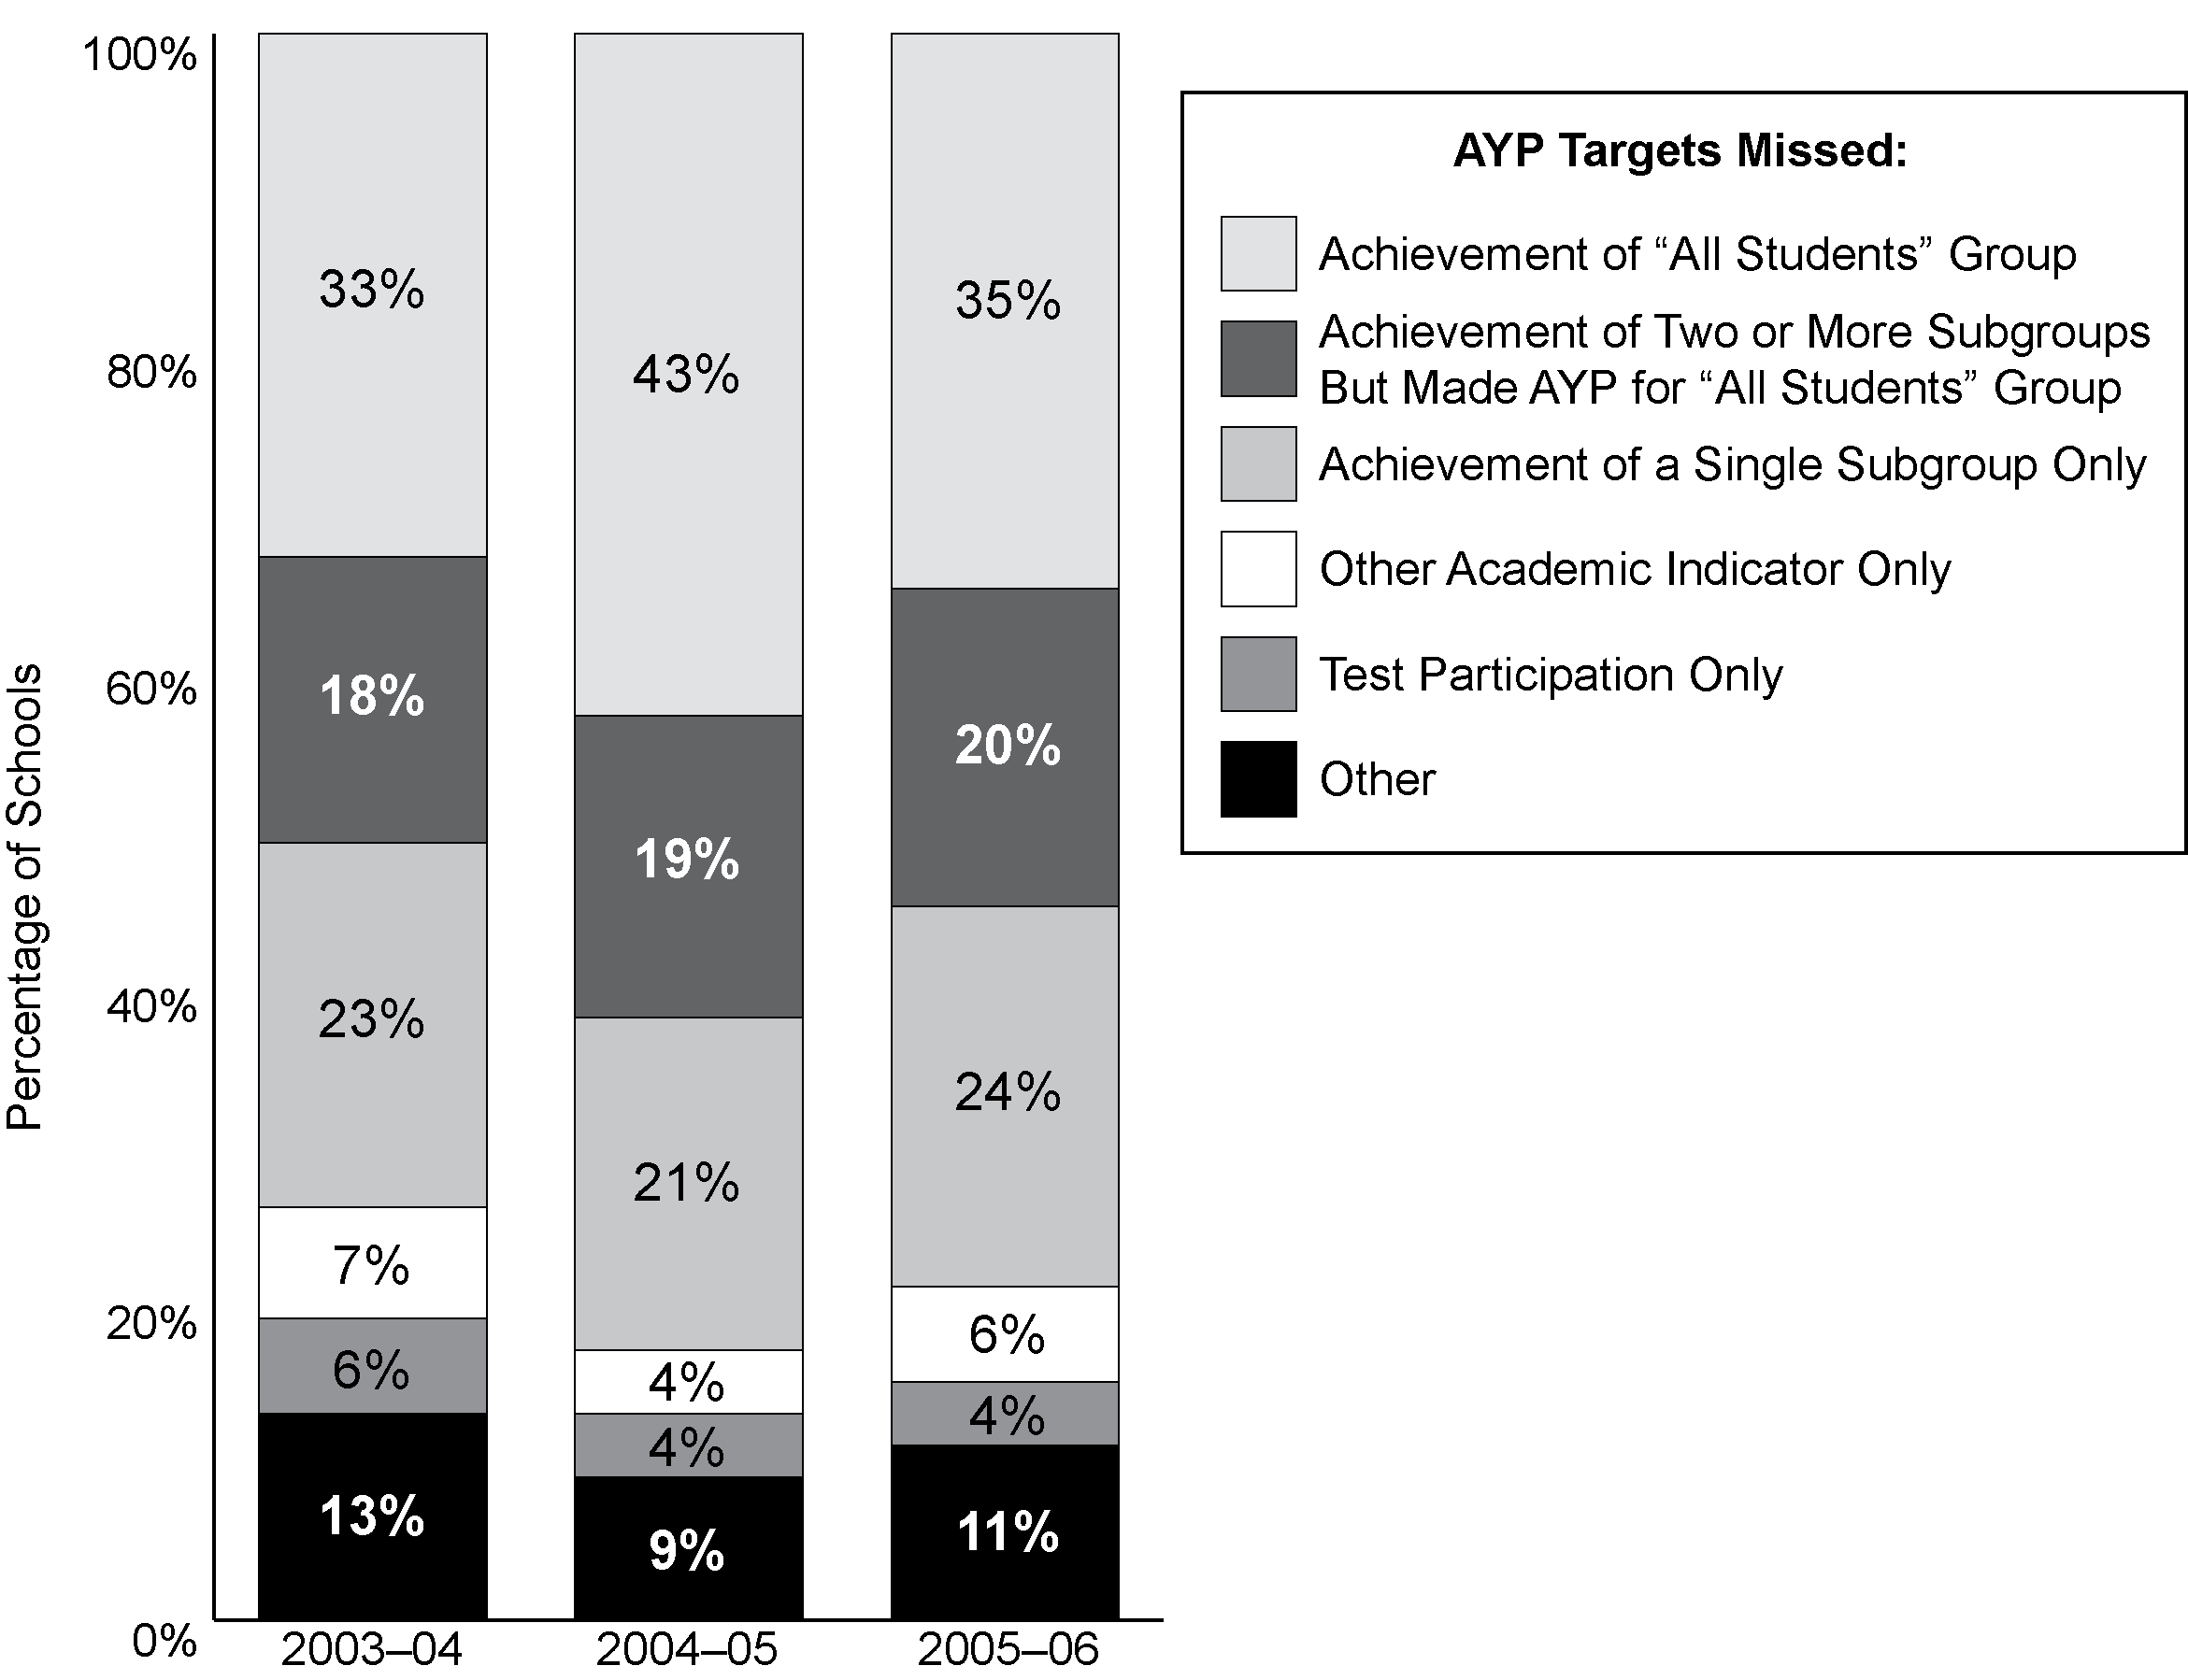
Notes: Schools included in the “Achievement of ‘All Students’ Group” and the “Achievement of Two or More Subgroups” segments of the graph may have also not made AYP for test participation or the other academic indicator. However, schools included in the “Achievement of a Single Subgroup Only” segment are those that did not make AYP for that factor alone and did not make any other AYP targets. “Other” includes schools that did not make AYP for combinations of the achievement of a single subgroup, test participation, or the other academic indicator, or through a small school analysis.
Source: SSI- NCLB National AYP and Identification database (2003–04 cross-section based on 33 states and 15,731 schools that did not make AYP in these states, 2004–05 cross-section based on 38 states and the District of Columbia and 19,474 schools, and 2005–06 cross-section based on 43 states and 20,463 schools).

Exhibit C.6
Percentage of Schools That Missed AYP Due to Subgroup Achievement and
Solely Due to Subgroup Achievement (Among Schools Held Accountable for Subgroup and At Least One Other Subgroup), by Student Subgroup, 2005–06
Student Subgroup | Number of Schools Held Accountable for Subgroup and At Least One Other Subgroup | Schools Missing AYP for Subgroup Achievement Among Other Reasons |  | Schools Missing AYP for Subgroup Achievement Only
Student Subgroup |  | Number | Percentage of Schools Held Accountable for Subgroup | Number | Percentage of Schools Held Accountable for Subgroup
African-American | 23,115 | 5,610 | 24% | 383 | 2%
American Indian/Alaskan Native | 4,929 | 471 | 10% | 24 | 0%
Asian/Pacific Islander | 8,820 | 256 | 3% | 2 | 0%
Hispanic | 25,218 | 4,667 | 19% | 207 | 1%
White | 43,327 | 1,238 | 3% | 13 | 0%
Low-income students | 51,898 | 9,705 | 19% | 872 | 2%
Students with disabilities | 23,617 | 10,031 | 42% | 3,538 | 15%
LEP students | 15,695 | 5,047 | 32% | 834 | 5%
Source: SSI-NCLB National AYP and Identification Database (n = 44 states).

Exhibit C.7
Number and Percentage of Schools That Did Not Make AYP for the Other Academic Indicator Target by Grade Level, 2003–04, 2004–05 and 2005–06
Grade Level | Number of Schools that Missed in  2003–04 | Percentage of Schools That Missed Again in 2004–05 | Percentage of Schools That Missed Again in 2005–06
Elementary | 249 | 14% | 6%
Middle | 391 | 22% | 7%
High | 1,119 | 37% | 22%
Other | 349 | 47% | 27%
Source: SSI-NCLB, National AYP and Identification Database (based on 11,420 schools in 26 states with all necessary data in all three years).

Exhibit C.8
Percentage and Number of Schools That Did Not Make AYP That Appealed AYP, by State, 2005–06
State | Percentage  of Schools  That Did Not Make AYP That Appealed | Number  of Schools That Appealed
Total | 11% (out of 24,049) | 2,306
Alabama | 17% | 29
Alaska | 2% | 4
Arizona | 87% | 525
Arkansas | 23% | 100
California | 3% | 100
Colorado | na | na
Connecticut | 2% | 5
Delaware | 82% | 28
District of Columbia | 0% | 0
Florida | 2% | 33
Georgia | 21% | 89
Hawaii | 10% | 18
Idaho | na | na
Illinois | 11% | 71
Indiana | na | na
Iowa | 0% | 0
Kansas | na | na
Kentucky | na | na
Louisiana | 2% | 3
Maine | 48% | 60
Maryland | 76% | 236
Massachusetts | 3% | 19
Michigan | na | na
Minnesota | 13% | 57
Mississippi | na | na
Missouri | na | na
Montana | 18% | 14
Nebraska | 0% | 0
Nevada | na | na
New Hampshire | 8% | 15
New Jersey | 5% | 30
New Mexico | 7% | 30
New York | na | na
North Carolina | 0% | 0
North Dakota | 31% | 12
Ohio | 2% | 30
Continued next page
Exhibit C.8
Percentage and Number of Schools That Did Not Make AYP That Appealed AYP, by State, 2005–06 (continued)
State | Percentage  of Schools  That Did Not Make AYP That Appealed | Number  of Schools That Appealed
Oklahoma | 9% | 16
Oregon | 3% | 13
Pennsylvania | 6% | 30
Puerto Rico | 7% | 60
Rhode Island | 2% | 2
South Carolina | 2% | 14
South Dakota | 13% | 16
Tennessee | 71% | 207
Texas | 43% | 233
Utah | 32% | 48
Vermont | 0% | 0
Virginia | 28% | 86
Washington | 12% | 41
West Virginia | 20% | 20
Wisconsin | 6% | 6
Wyoming | 11% | 6
Sources: SSI-NCLB State interviews (n = 40 states, the District of Columbia and Puerto Rico).

Exhibit C.9
Number and Percentage of Identified Title I Schools, by State, 2004–05
State | Number | Percent | Identified Improvement Status
State | Number | Percent | Year 1  or  Year 2 | Corrective Action | Restructuring
Total | 9,333 | 18% | 7,157 | 977 | 1,199
Alabama | 79 | 9% | 34 | 7 | 38
Alaska | 125 | 40% | 109 | 8 | 8
Arizona | 135 | 13% | 87 | 37 | 11
Arkansas | 203 | 24% | 198 | 4 | 1
California | 1,618 | 29% | 1,167 | 173 | 278
Colorado | 87 | 10% | 57 | 27 | 3
Connecticut | 93 | 20% | 85 | 0 | 8
Delaware | 18 | 15% | 15 | 3 | 0
District of Columbia | 75 | 45% | 61 | 14 | 0
Florida | 965 | 68% | 965 | 0 | 0
Georgia | 285 | 30% | 154 | 27 | 104
Hawaii | 84 | 62% | 24 | 6 | 54
Idaho | 28 | 6% | 28 | 0 | 0
Illinois | 660 | 27% | 400 | 238 | 22
Indiana | 77 | 7% | 49 | 18 | 10
Iowa | 13 | 2% | 13 | 0 | 0
Kansas | 21 | 3% | 17 | 3 | 1
Kentucky | 135 | 13% | 129 | 6 | 0
Louisiana | 64 | 7% | 48 | 11 | 5
Maine | 20 | 5% | 20 | 0 | 0
Maryland | 115 | 24% | 51 | 7 | 57
Massachusetts | 288 | 24% | 244 | 20 | 24
Michigan | 267 | 14% | 106 | 46 | 115
Minnesota | 48 | 4% | 40 | 8 | 0
Mississippi | 71 | 10% | 67 | 2 | 2
Missouri | 132 | 10% | 124 | 8 | 0
Montana | 68 | 10% | 31 | 4 | 33
Nebraska | 9 | 2% | 8 | 1 | 0
Nevada | 49 | 20% | 47 | 2 | 0
New Hampshire | 27 | 9% | 26 | 1 | 0
New Jersey | 368 | 27% | 271 | 97 | 0
New Mexico | 121 | 20% | 57 | 35 | 29
New York | 508 | 19% | 272 | 53 | 183
North Carolina | 159 | 14% | 153 | 6 | 0
North Dakota | 21 | 5% | 8 | 6 | 7
Ohio | 304 | 12% | 214 | 31 | 59
Oklahoma | 111 | 9% | 96 | 4 | 11
Oregon | 35 | 6% | 31 | 2 | 2
Pennsylvania | 323 | 15% | 247 | 1 | 75
Puerto Rico | 598 | 40% | 598 | 0 | 0
Rhode Island | 39 | 21% | 34 | 5 | 0
Continued next page
Exhibit C.9
Number and Percentage of Identified Title I Schools, by State, 2004–05
(continued)
State | Number | Percent | Identified Improvement Status
State | Number | Percent | Year 1  or  Year 2 | Corrective Action | Restructuring
South Carolina | 207 | 39% | 186 | 10 | 11
South Dakota | 59 | 16% | 55 | 2 | 2
Tennessee | 128 | 16% | 86 | 0 | 42
Texas | 199 | 4% | 197 | 2 | 0
Utah | 16 | 7% | 14 | 2 | 0
Vermont | 16 | 8% | 13 | 3 | 0
Virginia | 111 | 14% | 103 | 8 | 0
Washington | 72 | 8% | 57 | 15 | 0
West Virginia | 37 | 9% | 36 | 0 | 1
Wisconsin | 35 | 3% | 18 | 14 | 3
Wyoming | 7 | 4% | 7 | 0 | 0
Notes: Data for this exhibit were collected between October 2004 and April 2005. Some states decided appeals prior to this data collection, and others made appeal decisions later; for example, Texas later approved more than 100 appeals, resulting in a final count of 91 identified schools. This exhibit uses the numbers that states reported during the data collection period. Pennsylvania does not use the term “restructuring,” but the 75 Pennsylvania schools in “corrective action II” experience the supports and interventions associated with NCLB restructuring.
Sources: Consolidated State Performance Reports and SSI-NCLB, National AYP and Identification Database (based on data reported by 50 states, the District of Columbia, and Puerto Rico).

Exhibit C.10
Number and Percentage of Identified Schools, by State, 2005–06
State | All Schools |  | Title I Schools |  | Title I Schools By Improvement Status
State |  |  |  |  | Year 1 | Year 2 | Corrective Action | Restructuring
State | Number | Percent | Number | Percent | Year 1 | Year 2 | Corrective Action | Planning | Implementing
Total | 11,531 | 13% | 9,694 | 18% | 3,104 | 2,850 | 1,223 | 781 | 902
Alabama | 470 | 34% | 308 | 35% | 242 | 24 | 1 | 13 | 28
Alaska | 189 | 38% | 118 | 41% | 23 | 47 | 34 | 6 | 8
Arizona | 149 | 8% | 149 | 14% | 56 | 42 | 27 | 20 | 4
Arkansas | 263 | 25% | 252 | 30% | 69 | 140 | 38 | 4 | 1
California | 1,746 | 19% | 1,746 | 30% | 400 | 538 | 407 | 154 | 247
Colorado | 105 | 6% | 105 | 16% | 36 | 31 | 22 | 13 | 3
Connecticut | 157 | 16% | 98 | 20% | 16 | 72 | 4 | 0 | 6
Delaware | 33 | 18% | 10 | 10% | 2 | 4 | 2 | 2 | 0
District of Columbia | 89 | 40% | 89 | 49% | 41 | 0 | 48 | 0 | 0
Florida | 776 | 25% | 776 | 57% | 103 | 640 | 33 | 0 | 0
Georgia | 367 | 18% | 210 | 18% | 49 | 47 | 29 | 19 | 66
Hawaii | 135 | 48% | 112 | 20% | 12 | 44 | 2 | 13 | 41
Idaho | 40 | 6% | 37 | 8% | 19 | 18 | 0 | 0 | 0
Illinois | 798 | 20% | 625 | 26% | 128 | 115 | 151 | 211 | 20
Indiana | 85 | 5% | 85 | 11% | 41 | 20 | 10 | 8 | 6
Iowa | 14 | 1% | 14 | 2% | 8 | 6 | 0 | 0 | 0
Kansas | 15 | 1% | 15 | 2% | 8 | 5 | 0 | 2 | 0
Kentucky | 132 | 11% | 132 | 16% | 53 | 70 | 3 | 6 | 0
Louisiana | 154 | 12% | 154 | 17% | 107 | 17 | 24 | 6 | 0
Maine | 72 | 13% | 24 | 5% | 21 | 3 | 0 | 0 | 0
Maryland | 104 | 7% | 95 | 25% | 18 | 18 | 8 | 7 | 44
Massachusetts | 320 | 18% | 320 | 30% | 259 | 0 | 32 | 29 | 0
Michigan | 394 | 13% | 238 | 11% | 59 | 58 | 22 | 40 | 59
Minnesota | 79 | 4% | 79 | 9% | 55 | 16 | 7 | 1 | 0
Mississippi | 80 | 9% | 80 | 12% | 54 | 24 | 0 | 1 | 1
Missouri | 126 | 6% | 126 | 12% | 119 | 0 | 0 | 7 | 0
Montana | 70 | 8% | 66 | 10% | 23 | 9 | 1 | 0 | 33
Nebraska | 5 | 0% | 5 | 1% | 0 | 3 | 0 | 2 | 0
Nevada | 56 | 9% | 55 | 42% | 13 | 24 | 16 | 2 | 0
New Hampshire | 108 | 23% | 28 | 11% | 25 | 2 | 1 | 0 | 0
New Jersey | 386 | 18% | 386 | 28% | 119 | 170 | 35 | 62 | 0
New Mexico | 389 | 49% | 156 | 53% | 63 | 24 | 16 | 28 | 25
New York | 504 | 11% | 504 | 17% | 131 | 84 | 95 | 43 | 151
North Carolina | 194 | 8% | 194 | 17% | 96 | 80 | 12 | 6 | 0
North Dakota | 18 | 4% | 18 | 5% | 1 | 4 | 5 | 2 | 6
Ohio | 532 | 14% | 291 | 24% | 116 | 97 | 25 | 24 | 29
Oklahoma | 104 | 6% | 100 | 8% | 72 | 18 | 3 | 3 | 4
Oregon | 41 | 3% | 41 | 7% | 26 | 14 | 0 | 1 | 0
Pennsylvania | 297 | 10% | 198 | 12% | 21 | 58 | 30 | 5 | 84
Puerto Rico | 834 | 56% | 834 | 56% | NA | NA | NA | NA | NA
Rhode Island | 30 | 9% | 28 | 19% | 14 | 6 | 6 | 2 | 0
South Carolina | 167 | 16% | 167 | 25% | 36 | 88 | 28 | 6 | 9
South Dakota | 91 | 13% | 53 | 16% | 26 | 12 | 13 | 0 | 2
Tennessee | 128 | 7% | 114 | 13% | 61 | 16 | 0 | 13 | 24
Continued next page
Exhibit C.10
Number and Percentage of Identified Schools, by State, 2005–06 (continued)
State | All Schools |  | Title I Schools |  | Title I Schools By Improvement Status
State |  |  |  |  | Year 1 | Year 2 | Corrective Action | Restructuring
State | Number | Percent | Number | Percent | Year 1 | Year 2 | Corrective Action | Planning | Implementing
Texas | 176 | 2% | 176 | 3% | 115 | 58 | 3 | 0 | 0
Utah | 16 | 2% | 16 | 7% | 12 | 2 | 1 | 1 | 0
Vermont | 20 | 6% | 16 | 8% | 14 | 2 | 0 | 0 | 0
Virginia | 108 | 8% | 108 | 14% | 65 | 31 | 9 | 3 | 0
Washington | 271 | 11% | 66 | 7% | 20 | 29 | 8 | 9 | 0
West Virginia | 36 | 5% | 36 | 9% | 22 | 12 | 1 | 0 | 1
Wisconsin | 45 | 2% | 38 | 4% | 15 | 5 | 11 | 7 | 0
Wyoming | 13 | 3% | 3 | 2% | 0 | 3 | 0 | 0 | 0
Sources: Consolidated State Performance Reports and SSI-NCLB, National AYP and Identification Database (based on data reported by 50 states, the District of Columbia, and Puerto Rico).

Exhibit C.11
Percentage of Students in Identified Schools, by Urbanicity Locale, 2006–07
Urbanicity Locale | Identification (Title I and non–Title I) | Percent of Students in Locale that Attended Schools Identified for Improvement in 2006–07 | Number of Students | Number of Schools (Title I and non–Title I)
Urban (Central city) | Identified | 28% | 4,034,093 | 5,692
Urban (Central city) | Non-Identified |  | 10,288,472 | 17,323
Suburban (Urban fringe) | Identified | 14% | 3,629,107 | 4,896
Suburban (Urban fringe) | Non-Identified |  | 22,125,984 | 37,269
Rural | Indentified | 12% | 945,197 | 2,026
Rural | Non-Identified |  | 6,621,115 | 20,708
Sources: SSI-NCLB National AYP and Identification database and Common Core of Data (CCD) 2006–07 (based on all 50 states, the District of Columbia, and Puerto Rico).

Exhibit C.12
Number of Schools Identified for Improvement, and Percentage of Students in
Identified Schools, by Subgroups and by State, 2006–07
 | Number of Schools Identified for Improvement (in analysis) | Percent of All Students in Identified Schools | Percent of Poor Students in Identified Schools | Percent of American Indian Students in Identified Schools | Percent of Asian Students in Identified Schools | Percent of Black Students in Identified Schools | Percent of Hispanic Students in Identified Schools | Percent of White Students in Identified Schools
Total schools | 13,103 | 18% | 26% | 22% | 17% | 29% | 32% | 9%
Total students | 48,244,343 | 8,595,757  out of 48,244,343 | 5,225,060 out of 19,887,188 | 128,955  out of 576,316 | 365,398  out of 2,200,887 | 2,362,059 out of 8,088,060 | 3,170,314 out of 10,061,671 | 2,518,138 out of 27,002,554
AL | 459 | 39% | 43% | 30% | 23% | 35% | 49% | 33%
AK | 229 | 54% | 53% | 67% | 58% | 51% | 59% | 47%
AZ | 166 | 9% | 15% | 29% | 3% | 14% | 9% | 2%
AR | 209 | 19% | 24% | 11% | 12% | 17% | 37% | 13%
CA | 2,374 | 30% | 47% | 24% | 17% | 45% | 37% | 12%
CO | 124 | 7% | 17% | 8% | 4% | 20% | 12% | 2%
CT | 162 | 22% | 47% | 15% | 15% | 52% | 47% | 10%
DE | 34 | 29% | 30% | 20% | 28% | 29% | 35% | 26%
DC | 112 | 65% | 69% | 28% | 42% | 72% | 67% | 28%
FL | 1,362 | 36% | 54% | 36% | 23% | 42% | 51% | 27%
GA | 380 | 21% | 26% | 20% | 14% | 23% | 29% | 16%
HI | 174 | 72% | 77% | 75% | 74% | 74% | 66% | 66%
ID | 282 | 54% | 60% | 61% | 51% | 70% | 53% | 52%
IL | 581 | 22% | 41% | 15% | 12% | 39% | 54% | 6%
IN | 172 | 8% | 14% | 7% | 4% | 19% | 19% | 6%
IA | 18 | 2% | 3% | 2% | 4% | 7% | 7% | 1%
KS | 25 | 3% | 6% | 2% | 5% | 8% | 11% | 1%
KY | 158 | 15% | 19% | 17% | 14% | 19% | 28% | 13%
LA | 87 | 7% | 9% | 5% | 4% | 3% | 14% | 1%
ME | 166 | 47% | 45% | 58% | 50% | 50% | 56% | 47%
MD | 181 | 12% | 22% | 11% | 5% | 15% | 22% | 4%
MA | 613 | 39% | 66% | 49% | 43% | 72% | 66% | 29%
MI | 403 | 18% | 26% | 11% | 15% | 25% | 45% | 10%
MN | 81 | 4% | 11% | 8% | 12% | 12% | 20% | 1%
MS | 59 | 7% | 9% | 9% | 2% | 4% | 13% | 2%
MO | 150 | 7% | 14% | 7% | 6% | 20% | 27% | 2%
MT | 52 | 7% | 13% | 42% | 4% | 5% | 2% | 2%
NE | 1 | 0% | 0% | 0% | 0% | 1% | 0% | 0%
NV | 70 | 11% | 22% | 13% | 5% | 20% | 12% | 4%
NH | 88 | 34% | 38% | 34% | 28% | 46% | 39% | 33%
NJ | 424 | 23% | 42% | 29% | 13% | 36% | 44% | 13%
NM | 346 | 60% | 63% | 81% | 46% | 61% | 57% | 49%
Continued next page

Exhibit C.12
Number of Schools Identified for Improvement, and Percentage of Students in
Identified Schools, by Subgroups and by State, 2006–07 (continued)
 | Number of Schools Identified for Improvement (in analysis) | Percent of All Students in Identified Schools | Percent of Poor Students in Identified Schools | Percent of American Indian Students in Identified Schools | Percent of Asian Students in Identified Schools | Percent of Black Students in Identified Schools | Percent of Hispanic Students in Identified Schools | Percent of White Students in Identified Schools
NY | 517 | 16% | 28% | 19% | 14% | 36% | 28% | 5%
NC | 337 | 11% | 16% | 29% | 8% | 18% | 16% | 7%
ND | 26 | 4% | 9% | 33% | 0% | 1% | 1% | 2%
OH | 704 | 21% | 35% | 26% | 12% | 35% | 52% | 14%
OK | 37 | 3% | 5% | 2% | 3% | 7% | 10% | 1%
OR | 44 | 5% | 7% | 8% | 7% | 10% | 10% | 3%
PA | 455 | 21% | 32% | 21% | 23% | 49% | 49% | 13%
PR | 837 | 65%
RI | 61 | 22% | 44% | 23% | 31% | 56% | 47% | 10%
SC | 222 | 17% | 23% | 24% | 9% | 18% | 24% | 11%
SD | 45 | 10% | 16% | 36% | 13% | 14% | 12% | 5%
TN | 171 | 13% | 18% | 8% | 11% | 18% | 33% | 6%
TX | 291 | 6% | 8% | 3% | 3% | 9% | 9% | 1%
UT | 10 | 1% | 2% | 6% | 1% | 2% | 1% | 1%
VT | 23 | 17% | 21% | 58% | 18% | 24% | 23% | 17%
VA | 66 | 3% | 5% | 3% | 1% | 3% | 5% | 2%
WA | 100 | 6% | 12% | 11% | 4% | 23% | 8% | 2%
WV | 23 | 2% | 2% | 0% | 1% | 2% | 1% | 2%
WI | 50 | 3% | 6% | 1% | 3% | 6% | 16% | 1%
WY | 28 | 23% | 21% | 40% | 23% | 23% | 32% | 22%
Note: Figures are not available for SWD and LEP because the CCD collects the numbers of SWDs and LEPs only at the district level. Blank means not available.
Sources: SSI-NCLB National Database of School AYP and Identification and Common Core of Data, 2005–06 (based on data from 50 states, District of Columbia, and Puerto Rico).

Exhibit C.13
Percentage of Identified Schools,
by Other Demographic Characteristics, 2006–07
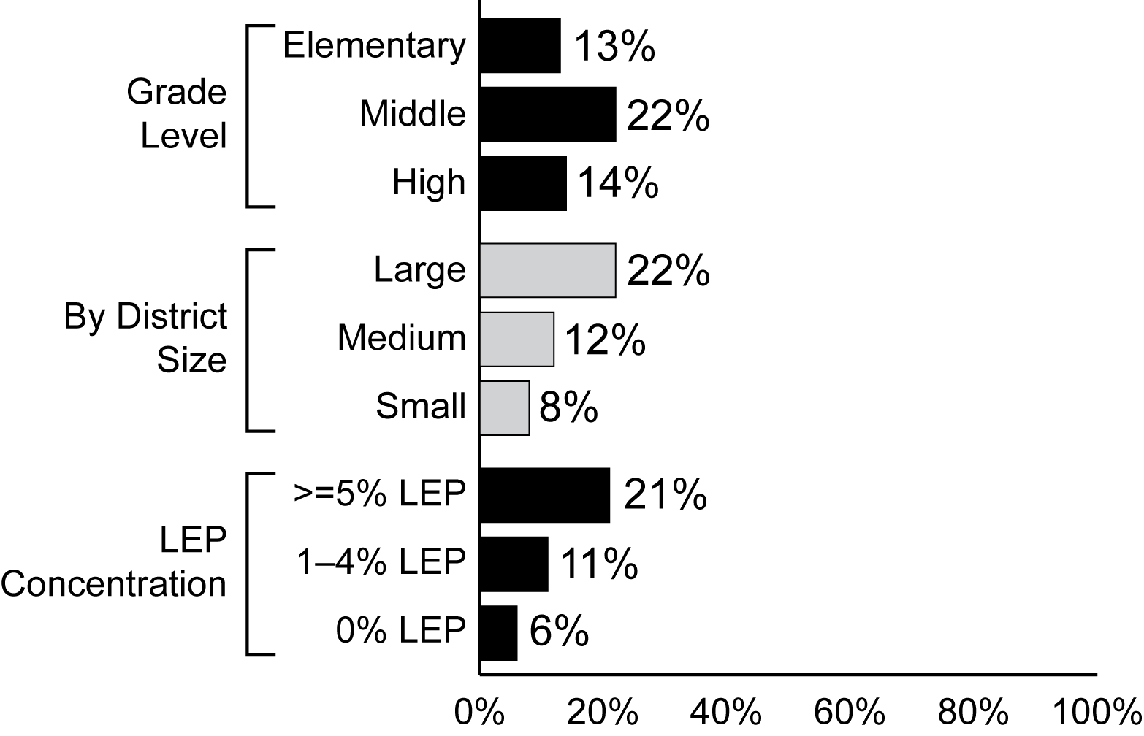
Sources: SSI-NCLB, National AYP and Identification Database and Common Core of Data (based on data reported by 50 states, and the District of Columbia for 90,309 schools in these states).

Exhibit C.14
Percentage of Schools Needing and Receiving Technical Assistance to Meet the Needs of LEP Students and Percentage Finding It Sufficient to Meet Their Needs,
by School Characteristic, 2006–07
Characteristic | Needed | Received Where Needed | Sufficient Where Needed and Received
All schools | 36.0 (2.7) | 73.1 (3.3) | 71.6 (4.7)
Title I Status
Title I | 34.6 (4.0) | 71.6 (6.0) | 68.6 (9.7)
Non-Title I | 36.9 (3.3) | 74.1 (3.7) | 73.5 (4.0)
School Identification Status
Not identified | 32.8 (3.0) | 73.0 (4.0) | 72.2 (5.7)
Year 1 Year 2 of being identified for improvement | 52.3 (6.3) | 76.5 (5.7) | 69.3 (7.5)
Corrective action status | 48.2 (12.0) | 75.7 (8.5) | 79.9 (7.8)
Restructuring status | 68.5 (5.9) | 68.2 (7.7) | 62.0 (10.7)
School Poverty Level
High poverty | 50.0 (4.0) | 70.0 (5.2) | 65.6 (5.3)
Medium poverty | 36.2 (4.8) | 76.4 (5.1) | 71.0 (7.1)
Low poverty | 28.9 (4.0) | 71.4 (6.1) | 77.0 (7.3)
School Minority Concentration
High minority (75% or more) | 53.2 (3.6) | 76.1 (3.8) | 63.4 (7.2)
Moderate minority (25–75%) | 52.3 (4.9) | 74.3 (5.2) | 72.8 (7.0)
Low minority (less than 25%) | 18.6 (3.1) | 68.4 (6.7) | 80.4 (5.1)
Urbanicity
Central city | 47.3 (4.9) | 69.6 (5.57) | 71.0 (5.6)
Urban fringe | 37.9 (3.9) | 73.6 (4.2) | 67.5 (7.1)
Rural/small town | 21.7 (5.6) | 79.3 (9.7) | 88.0 (6.4)
School Level
Elementary | 34.7 (3.1) | 74.7 (4.2) | 73.4 (5.2)
Middle | 47.1 (5.0) | 69.4 (7.0) | 72.4 (9.2)
High | 30.0 (4.6) | 71.9 (7.0) | 61.4 (11.1)
Source: NLS-NCLB, Principal Survey (n = 1,392 schools).

Exhibit C.15
Percentage of Schools Needing and Receiving Technical Assistance in 2005–06 or
2006–07 to Meet the Needs of Students with Disabilities and Percentage Finding It Sufficient to Meet Their Needs, by School Characteristic
Characteristic | Needed | Received Where Needed | Sufficient Where Needed and Received
All schools (n=1,392) | 53.3 (3.0) | 77.2 (2.8) | 80.8 (2.7)
Title I Status
Title I | 54.9 (3.6) | 78.6 (3.2) | 80.9 (2.7)
Non-Title I | 51.0 (4.2) | 75.0 (5.4) | 80.7 (5.2)
School Identification Status
Not identified | 50.8 (3.3) | 79.1 (3.2) | 81.7 (3.1)
Year 1 and Year 2 of being identified  for improvement | 65.0 (5.6) | 71.1 (5.5) | 72.2 (8.3)
Corrective action status | 64.5 (14.6) | 76.9 (7.0) | 83.2 (6.3)
Restructuring status | 80.3 (5.4) | 54.9 (8.9) | 72.6 (7.2)
School Poverty Level
High poverty | 64.1 (3.4) | 65.3 (5.2) | 75.8 (3.9)
Medium poverty | 58.7 (5.2) | 79.0 (4.4) | 81.2 (3.7)
Low poverty | 41.8 (4.5) | 82.6 (4.3) | 82.9 (5.0)
School Minority Concentration
High minority (75% or more) | 65.1 (2.9) | 65.6 (4.9) | 75.8 (4.4)
Moderate minority (25–75%) | 50.4 (5.1) | 70.9 (5.6) | 88.7 (4.2)
Low minority (less than 25%) | 50.4 (5.4) | 87.2 (4.0) | 75.8 (4.4)
Urbanicity
Central city | 55.5 (5.3) | 65.3 (5.0) | 75.9 (4.4)
Urban fringe | 54.0 (4.2) | 79.3 (3.9) | 79.1 (4.1)
Rural/small town | 49.6 (7.3) | 85.7 (5.8) | 89.3 (4.1)
School Level
Elementary | 51.5 (3.7) | 77.4 (3.8) | 86.9 (2.3)
Middle | 63.7 (4.9) | 75.9 (5.6) | 74.7 (6.2)
High | 49.4 (6.0) | 76.5 (5.8) | 67.6 (9.3)
Source: NLS-NCLB Principal survey (n=1,392 schools).

Exhibit C.16
Existence of and Participation in Extended Time Instructional Programs, 2006–07
Type of Instructional Programs | Percent of Schools Offering Each Type of Program | Percent of Children Served in Schools Offering Each Type of Program | Number of Hours of Service per Year in Schools Offering Each Type of Program
 | All Schools (n = 1,392)
Before-school tutorial or instructional program | 27.8 (2.4) | 9.4 (1.3) | 94.8 (7.6)
After-school tutorial or instructional program | 66.2 (2.6) | 16.8 (1.1) | 121.1 (6.5)
Weekend tutorial or instructional program | 12.1 (1.5) | 12.3 (1.5) | 46.8 (4.6)
Any program | 72.1 (2.5)
 | Identified Schools (n = 469)
Before-school tutorial or instructional program | 25.0 (3.1) | 10.3 (2.2) | 115.4 (10.2)
After-school tutorial or instructional program | 79.9 (5.2)ª | 22.2 (1.8)ª | 136.6 (9.4)
Weekend tutorial or instructional program | 24.2 (3.7)ª | 13.0 (1.2) | 65.4 (6.3)ª
Any program | 83.1 (5.2)ª
 | Non-Identified Schools (n = 918)
Before-school tutorial or instructional program | 28.3 (2.7) | 9.3 (1.5) | 91.8 (8.6)
After-school tutorial or instructional program | 64.0 (3.0) | 15.6 (1.3) | 118.0 (7.5)
Weekend tutorial or instructional program | 10.1 (1.6) | 11.9 (2.1) | 37.6 (4.9)
Any program | 70.4 (2.8)
Note: Numbers in parenthesis are standard errors.
ª Indicates statistically significant difference between identified and non-identified schools (p<.05).
Source: NLS-NCLB, Principal Survey.

Exhibit C.17
Percentage of Elementary Teachers Who Reported Changing the Amount of Instructional Time That They Spent on Various Subjects From 2004–05 to 2006–07
 | Increase in Time | No Change | Decrease in Time
Reading/English/language arts | 22% | 76% | 3%
Mathematics | 18% | 78% | 4%
Science | 6% | 82% | 12%
Social studies | 5% | 83% | 12%
Art/music | 4% | 90% | 6%
Physical education/health | 5% | 89% | 6%
Other | 6% | 89% | 5%
Source: National Longitudinal Study of NCLB, Teacher Survey (n = 3,043 teachers).

Exhibit C.18
Percentage of Elementary Schools Reporting Increases and Decreases in Instructional Time in Various Subjects Between 2004–05 and 2006–07
 | All Schools (n = 895)
 | Increased More Than 30 Minutes | Increased Less Than 30 Minutes | Stayed the Same | Decreased Less Than 30 Minutes | Decreased More Than 30 Minutes
Reading | 18.2 (2.8) | 1.4 (1.1) | 77.6 (3.0) | 2.3 (0.6) | 0.5 (0.3)
Mathematics | 11.3 (1.9) | 1.7 (1.7) | 83.0 (2.5) | 3.4 (0.9) | 0.7 (0.5)
Science | 4.2 (1.3) | 1.1 (0.6) | 87.1 (2.5) | 6.5 (2.1) | 1.2 (0.6)
Social studies | 1.7 (0.6) | 0.3 (0.2) | 89.4 (2.2) | 6.7 (2.0) | 1.8 (0.7)
Art/music | 1.4 (0.7) | 0.0 (0.0) | 93.0 (1.8) | 5.2 (1.6) | 0.3 (0.2)
Physical education/health | 3.1 (1.1) | 0.0 (0.0) | 90.6 (2.1) | 5.8 (1.8) | 0.5 (0.2)
Other | 2.2 (1.0) | 0.0 (0.0) | 95.4 (1.6) | 1.4 (0.7) | 1.0 (0.6)
 | Identified Schools (n = 266)
 | Increased More Than 30 Minutes | Increased Less Than 30 Minutes | Stayed the Same | Decreased Less Than 30 Minutes | Decreased More Than 30 Minutes
Reading | 21.9 (4.4) | 0.0 (0.0) | 75.3 (4.5) | 2.2 (0.8) | 0.7 (0.5)
Mathematics | 20.0 (4.5) | 0.8 (0.8) | 73.6 (5.0) | 5.5 (3.2) | 0.1 (0.1)
Science | 4.4 (1.4) | 1.7 (1.4) | 90.0 (2.6) | 1.6 (0.9)ª | 2.5 (1.5)
Social studies | 2.9 (1.0) | 1.4 (1.4) | 92.3 (2.4) | 0.8 (0.4)ª | 2.7 (1.5)
Art/music | 0.7 (0.5) | 0.0 (0.0) | 97.3 (1.3)* | 0.4 (0.3)ª | 1.6 (1.2)
Physical education/health | 4.7 (2.4) | 0.0 (0.0) | 90.1 (3.1) | 3.2 (1.6) | 2.0 (1.1)
Other | 9.0 (5.2) | 0.0 (0.0) | 89.1 (5.3) | 1.4 (0.8) | 0.5 (0.5)
 | Non-Identified Schools (n = 625)
 | Increased More Than 30 Minutes | Increased Less Than 30 Minutes | Stayed the Same | Decreased Less Than 30 Minutes | Decreased More Than 30 Minutes
Reading | 17.8 (3.2) | 1.6 (1.2) | 77.8 (3.4) | 2.3 (0.6) | 0.5 (0.4)
Mathematics | 10.2 (2.1) | 1.8 (1.2) | 84.2 (2.7) | 3.1 (0.9) | 0.7 (0.5)
Science | 4.2 (1.5) | 1.0 (0.6) | 86.7 (2.8) | 7.1(2.3) | 1.0 (0.6)
Social studies | 1.6 (0.7) | 0.1 (0.1) | 89.1 (2.4) | 7.4 (2.2) | 1.8 (0.8)
Art/music | 1.5 (0.8) | 0.0 (0.0) | 92.5 (2.0) | 5.8 (1.8) | 0.2 (0.2)
Physical education/health | 2.9 (1.2) | 0.0 (0.0) | 90.7 (2.4) | 6.2 (2.0) | 0.3 (0.2)
Other | 1.4 (0.9) | 0.1 (0.5) | 96.0 (1.7) | 1.5 (0.8) | 1.0 (0.7)
Note: Numbers in parenthesis are standard errors.
ª Indicates statistically significant difference between identified and non-identified schools (p<.05).
Source: National Longitudinal Study of NCLB, Principal Survey.

Appendix D
Standard Error Exhibits
Note: In Appendix D exhibits, standard errors are provided in parenthesis after each estimate.
Exhibit D.1
Percentage of Schools Identified and Not Identified for Improvement Under NCLB That Reported Various Accountability Designations Under State or District Accountability Initiatives, 2006–07
Designation Under State or District Accountability Initiative | Schools Identified Under NCLB  (n = 469) | Schools Not Identified Under NCLB  (n = 918)
Low-Performing | 34.0% (4.3) | 3.0% (0.7)
No Special Designation | 10.9% (2.3) | 33.4% (3.0)
High-Performing | 2.0% (0.9) | 17.8% (2.4)
No Other System (other than NCLB) | 38.8% (5.1) | 36.9% (3.1)
Other/Not Sure | 14.4% (2.2) | 8.9% (1.4)
Source: NLS-NCLB, District and Principal Surveys.

`
Exhibit D.2
Perceived Benefits and Drawbacks of Having State and/or District Accountability Initiatives in Addition to NCLB, in Districts and Schools That Report Having Them, 2006–07
Benefits and Drawbacks Perceived | Percent of Districts Agreeing  (n = 154) | Percent of Schools Agreeing  (n = 832)
Gives us a more complete picture of our effectiveness than a single accountability system | 69.1 (7.9) | 65.0 (3.6)
Results in staff confusion about our targets for student achievement | 45.8 (10.1) | 36.9 (3.6)
Reduces community support for public schools | 22.7 (6.5) | 24.2 (3.3)
Allows us to focus on the goals that are most important to us | 55.6 (10.1) | 52.5 (3.7)
Helps us make effective decisions about how to improve student achievement | 71.7 (7.5) | 59.6 (3.7)
Source: NLS-NCLB, District and Principal Surveys.

Exhibit D.3
Percentage of Schools Receiving Notification of AYP Status, by Month
Date | All Schools notification  of AYP status  (n = 1,392) | Identified Schools notification  of AYP status  (n = 469) | Identified Schools notification of Identification for Improvement  (n = 392)
June 2006 or earlier | 22.2 (2.8) | 21.4 (4.0) | 19.3 (4.4)
July 2006 | 10.4 (1.7) | 8.1 (1.8) | 7.0 (1.8)
August 2006 | 29.6 (2.9) | 40.6 (5.3) | 39.2 (4.8)
September 2006 | 11.4 (1.6) | 10.2 (2.1) | 12.9 (2.5)
October 2006 | 10.7 (1.5) | 9.9 (2.5) | 9.2 (2.1)
November 2006 | 9.1 (2.3) | 5.2 (2.0) | 8.5 (3.9)
December 2006 or later | 6.6 (1.2) | 4.6 (1.3) | 4.0 (1.4)
Source: NLS-NCLB, Principal Survey.

Exhibit D.4
Percentage of Staff Correctly Reporting Whether Their School Made AYP or
Was Identified for Improvement Based on 2005–06 Test Results
Staff | Did School Make Adequate Yearly Progress in 2005–06?
Staff | Reported  Correct Status | Reported  Incorrect Status | Don’t know
Principals (n = 1,392) | 89.6 (1.6) | 7.4 (1.5) | 2.9 (0.8)
Elementary teachers (n = 4,162) | 73.2 (2.1) | 8.4 (1.2) | 18.5 (1.9)
Secondary teachers (n = 3,483) | 62.8 (2.3) | 13.2 (1.4) | 24.0 (2.1)
Special education teachers (n = 1,194) | 71.5 (2.4) | 8.1 (1.2) | 20.4 (2.3)
 | Is School Identified for Improvement in 2006–07?
 | Reported  Correct Status | Reported  Incorrect Status | Don’t know
Principals (n = 1,392) | 94.0 (1.2) | 5.2 (1.0) | 0.7 (0.6)
Elementary teachers (n = 4,162) | 66.3 (1.9) | 9.1 (1.0) | 24.6 (1.8)
Secondary teachers (n = 3,483) | 57.0 (2.8) | 11.2 (1.4) | 31.9 (1.9)
Special education teachers (n = 1,194) | 64.0 (2.7) | 11.3 (1.7) | 24.6 (2.3)
Note: Correct status indicates that the school status reported by staff (making AYP or not, identified for improvement or not) agrees with the official status of the school in the state records.
Source: NLS-NCLB, Principal and Teacher Surveys.

Exhibit D.5
Percentage of Staff in Title I Schools Correctly Reporting Whether
Their Schools Were Identified for Improvement, 2006–07
Staff | Schools Identified for Improvement | Schools Not Identified  for Improvement
Principals (n = 1,083) | 87.1 (2.6) | 95.3 (1.6)ª
Elementary Teachers (n = 3,705) | 71.6 (3.0) | 62.7 (2.7)ª
Secondary Teachers (n = 2,216) | 64.4 (3.1) | 54.9 (4.3)
Special Ed. Teachers (n = 928) | 76.1 (3.7) | 63.3 (4.1)ª
Note: Correctly reporting status indicates that the school status reported by staff (making AYP or not, identified for improvement or not) agrees with the official status of the school in the state records.
ª Indicates statistically significant difference between identified and non-identified schools (p<.05).
Source: NLS-NCLB, Principal and Teacher Surveys.

Exhibit D.6
Percentage of Non-Identified and Identified Schools Reported Needing and
Receiving Various Types of Technical Assistance, 2005–06 or 2006–07
Technical Assistance | Percent of Non-Identified Schools That Needed Assistance | Percent of Identified Schools That Needed Assistance | Percent of Identified Schools Needing Assistance That Received It | Percent of Identified Schools Reporting That Assistance Received When Needed Was Sufficient
 | (n = 918) | (n = 469) | (n = 292) | (n = 243)
Improve quality of teachers’ professional development | 53.2 (3.2) | 73.5 (5.9)ª | 82.2 (3.7) | 73.2 (4.0)
Get parents more engaged in their child’s education | 45.6 (3.3) | 72.0 (5.9)ª | 52.2 (4.2) | 64.7 (5.9)
Address instructional needs of students with IEPs | 50.8 (3.3) | 68.6 (5.4)ª | 68.0 (4.0) | 75.8 (4.5)
Identify effective curricula, instructional strategies, or school reform models | 47.5 (3.3) | 76.7 (5.7)ª | 83.6 (3.6) | 81.8 (2.8)
Improve students’ test-taking skills | 29.1 (2.7) | 63.1 (5.6)ª | 61.5 (4.7) | 86.2 (3.2)
Analyze assessment results to understand students’ strengths and weaknesses | 41.4 (2.9) | 61.8 (5.5)ª | 93.3 (2.0) | 81.2 (4.3)
Identify or develop detailed curriculum guides, frameworks, pacing sequences, and/or model lessons aligned with state standards | 42.9 (3.0) | 67.9 (5.7)ª | 78.9 (4.7) | 83.3 (2.8)
Develop or revise school improvement plan | 26.2 (3.1) | 54.8 (5.2)ª | 91.3 (2.7) | 89.2 (2.6)
Recruit, retain, or assign teachers in order to staff all classes with a teacher who is highly qualified | 29.6 (2.9) | 56.3 (5.0)ª | 70.7 (4.5) | 75.3(4.8)
Address problems of student truancy, tardiness, and discipline, and of dropouts | 39.9 (3.0) | 59.7 (5.2)ª | 67.5 (4.3) | 61.4 (5.8)
Implement the provisions of NCLB relating to qualified paraprofessionals | 26.2 (2.6) | 51.7 (4.8)ª | 82.3 (4.0) | 94.7 (1.9)
Address instructional needs of LEP students | 32.8 (3.0) | 45.2 (5.4)ª | 73.6 (3.9) | 69.8 (5.1)
ª Indicates statistically significant difference between identified and non-identified schools (p<.05).
Source: National Longitudinal Study of NCLB, Principal Survey.

Exhibit D.7
Percentage of Schools Needing Technical Assistance in Four Areas,
by School Characteristic, 2005–06 or 2006–07
Characteristic | Develop or Revise the School’s Improvement Plan | Analyze Assessment Results to Understand Students’ Strengths and Weaknesses | Get Parents Engaged in Their Child’s Education | Improve the Quality of Teachers’ Professional Development
All Schools | 30.3 (2.7) | 44.4 (2.7) | 49.5 (3.0) | 56.1 (2.9)
Title I Status
Title I | 35.1 (3.5) | 44.5 (3.3) | 56.3 (3.5) | 60.3 (3.6)
Non-Title I | 23.5 (3.8) | 44.2 (4.0) | 39.1 (4.4) | 50.0 (4.3)
School Identified for Improvement Status
Not identified | 26.2 (3.1) | 41.4 (2.9) | 45.6 (3.3) | 53.2 (3.2)
Year 1 and Year 2 of identified for improvement status | 55.6 (6.0) | 59.3 (6.4) | 74.6 (5.4) | 77.8 (5.0)
Corrective action status | 47.7 (11.9) | 57.9 (13.4) | 58.3 (13.5) | 61.0 (14.0)
Restructuring status | 63.0 (7.4) | 71.9 (6.1) | 84.8 (5.0) | 82.6 (4.9)
School Poverty Level
High poverty | 45.9 (3.6) | 57.4 (3.7) | 69.9 (3.8) | 72.3 (3.3)
Medium poverty | 33.7 (5.1) | 43.6 (4.3) | 54.8 (5.4) | 57.9 (4.9)
Low poverty | 18.7 (3.3) | 39.2 (4.2) | 33.2 (4.1) | 46.2 (4.6)
School Minority Concentration
High minority (75% or more) | 41.6 (4.2) | 57.1 (3.1) | 72.5 (3.4) | 69.5 (3.2)
Moderate minority (25–75%) | 24.5 (3.7) | 41.8 (4.9) | 44.4 (5.1) | 56.3 (5.1)
Low minority (less than 25%) | 28.8 (4.7) | 41.0 (4.3) | 42.8 (5.1) | 50.5 (5.0)
Urbanicity
Central city | 35.6 (4.2) | 48.1 (4.9) | 61.1 (5.7) | 59.8 (5.6)
Urban fringe/large town | 30.7 (4.3) | 45.2 (3.7) | 48.0 (4.3) | 55.4 (4.2)
Rural/small town | 24.0 (4.9) | 38.8 (5.8) | 40.9 (6.3) | 53.9 (6.7)
Source: NLS-NCLB, Principal Survey (n = 1,392 schools).

Exhibit D.8
Percentage of Districts With Identified Schools Reporting That They Provided
Technical Assistance to Various Types of Schools in Either 2005–06 or 2006–07
Type of Technical Assistance | All or Some Identified Schools | Other schools | District Did Not Provide
Develop or revise school improvement plan | 78.4 (7.4) | 58.0 (7.4) | 9.5 (5.6)
Analyze assessment results to understand students’ strengths and weaknesses | 84.3 (6.3) | 71.8 (6.7) | 3.0 (2.3)
Address instructional needs of students with IEPs | 79.4 (6.6) | 71.9 (6.7) | 7.1 (3.7)
Implement NCLB provisions relating to “qualified” paraprofessionals | 75.5 (7.5) | 71.0 (6.7) | 11.4 (5.9)
Address problems of student truancy, tardiness, discipline, and dropout | 77.9 (6.6) | 68.4 (6.9) | 7.9 (3.5)
Identify and implement curricula, instructional strategies, or school reform models that have been shown to be effective in increasing students’ achievement | 73.5 (7.7) | 70.2 (6.7) | 14.1 (6.2)
Recruit, retain, or assign teachers in order to staff all classes with a teacher who is “highly qualified” | 81.7 (6.4) | 70.3 (6.7) | 5.9 (2.9)
Get parents more engaged in their child’s education | 73.3 (7.6) | 65.6 (7.7) | 18.6 (7.6)
Improve students’ test-taking skills | 65.2 (7.8) | 50.8 (7.9) | 30.0 (7.8)
Address instructional needs of LEP students | 61.2 (8.0) | 67.0 (7.1) | 19.3 (6.9)
Develop and implement detailed curriculum guides, frameworks, pacing sequences, and/or model lessons aligned with state standards | 73.5 (7.7) | 71.0 (6.8) | 14.7 (6.3)
Provide professional development to help teachers improve student performance | 87.1 (6.0) | 77.2 (6.4) | 0.0 (0.0)
Analyze and revise school budgets so that resources are allocated more effectively | 67.1 (7.7) | 62.8 (7.7) | 27.0 (7.7)
Source: NLS-NCLB, District Survey (n = 155 districts).

Exhibit D.9
Percentage of Schools Reporting Major Focus
on Various School Improvement Strategies, 2006–07
School Improvement Strategy | 2006–07 Status
School Improvement Strategy | Identified Schools |  |  |  | Non- Identified Schools  (n = 918)
School Improvement Strategy | All Identified (n = 469) | Year 1 or Year 2 Only (n = 188) | Corrective Action Only (n = 114) | Restructuring Only  (n = 167) | Non- Identified Schools  (n = 918)
Using student achievement data to inform instruction and school improvement | 87.7 (2.3) | 87.7 (3.1) | 91.2 (5.0) | 83.4 (4.5) | 67.3 (2.8)ª
Providing additional instruction to low-achieving students | 77.2 (4.1) | 75.2 (4.9) | 83.1 (6.2) | 73.5 (6.1) | 65.0 (2.7)ª
Aligning curriculum and instruction with standards and/or assessments | 80.6 (3.6) | 79.4 (4.3) | 78.7 (7.9) | 85.4 (3.5) | 65.2 (2.7)ª
Implementing new instructional approaches or curricula in reading | 65.7 (4.0) | 60.7 (5.6) | 74.5 (7.5) | 64.0 (5.0) | 47.9 (3.1)ª
Increasing the intensity, focus, and effectiveness of professional development | 62.7 (4.2) | 58.7 (5.8) | 72.1 (8.4) | 58.5 (6.2) | 41.2 (3.0)ª
Implementing new instructional approaches or curricula in mathematics | 64.0 (4.3) | 52.5 (5.9) | 77.8 (6.9) | 68.1 (4.6) | 41.0 (2.7)ª
Restructuring the school day to teach core content areas in greater depth (e.g., establishing a literacy block) | 61.6 (4.5) | 54.4 (5.8) | 72.9 (7.5) | 61.0 (5.6) | 32.7 (2.5)ª
Providing extended-time instructional programs (e.g., before-school, after-school, or weekend instructional programs) | 51.5 (4.8) | 47.2 (5.2) | 54.5 (12.3) | 55.8 (5.8) | 32.8 (2.7)ª
Implementing strategies for increasing parents’ involvement in their children’s education | 28.2 (3.8) | 24.1 (4.8) | 31.5 (9.1) | 31.5 (5.2) | 18.2 (2.9)ª
Increasing instructional time for all students (e.g., by lengthening the school day or year, shortening recess) | 32.8 (4.3) | 31.3 (5.0) | 29.0 (9.5) | 40.2 (6.2) | 13.0 (2.1)ª
ª Indicates statistically significant difference between identified and non-identified schools (p<.05).
Source: NLS-NCLB, Principal Survey.

Exhibit D.10
Percentage of General Elementary Teachers Reporting Availability of
Various Resources for Aligning Curriculum and Instruction With
State Academic Content Standards, 2006–07
Resource | General Education Teachers
District or school content standards that augment state academic content standards | 86.3 (0.9)
Detailed curriculum guides, frameworks, and/or pacing sequences | 86.1 (1.0)
Model lessons that are aligned with state academic content standards | 55.9 (1.4)
A detailed table or report showing the alignment of required textbooks and instructional programs to state academic content standards | 56.2 (1.4)
A detailed table or report showing the alignment of required textbooks and instructions programs to state assessments | 45.6 (1.3)
Source: NLS-NCLB, Teacher Survey (n = 7,645 teachers).

Exhibit D.11
Percentage of General Elementary Teachers Reporting Moderate or
Major Challenges to Improving Student Performance, 2006–07
Challenge | General Education Teachers  (n = 7,645)
Challenge | Identified Schools | Non-Identified Schools
Large class size | 61.6 (2.3)ª | 55.6 (1.8)
Too few textbooks and other instructional materials | 36.6 (2.5)ª | 22.1 (1.6)
Textbooks and instructional materials that are not aligned with state standards | 23.4 (2.1)ª | 16.8 (1.3)
Insufficient parent involvement | 78.1 (1.8)ª | 47.3 (2.1)
Low student motivation | 77.4 (1.9)ª | 49.2 (1.9)
ª Indicates statistically significant difference between identified and non-identified schools (p<.05).
Source: NLS-NCLB, Teacher Survey.

Exhibit D.12
Average Change in Minutes Per Week for Third-Grade Students
From 2004–05 to 2006–07, by Subject
Subject | All Schools  (n = 771) | Identified Schools (n = 219) | Non-Identified Schools  (n = 551)
Mathematics | 10.4 (1.7) | 23.8 (6.5) | 8.6 (1.2)
Reading | 24.1 (4.0) | 39.7 (12.4) | 22.1 (4.2)
Science | 1.0 (1.1) | 2.1 (1.3) | 0.9 (1.2)
Social Studies | -1.8 (0.9) | 0.9 (1.1) | -2.1 (1.0)
Art/Music | -0.6 (0.5) | -0.5 (0.7) | -0.6 (0.6)
Physical education/Health | 0.8 (1.0) | 7.0 (5.6) | 0.0 (0.8)
Other | 0.7 (1.2) | 5.6 (3.3) | 0.2 (1.2)
Source: NLS-NCLB, Principal Survey.

Exhibit D.13
Percentage of Schools Changing Instructional Time for Third-Grade Students
From 2004–05 to 2006–07, by Subject
Subject | Increase in Time | No Change in Time | Decrease in Time
Mathematics | 12.7 (2.1) | 83.4 (2.4) | 3.9 (1.2)
Reading | 19.3 (2.9) | 78.0 (3.0) | 2.7 (0.7)
Science | 5.1 (1.4) | 87.5 (2.4) | 7.4 (2.0)
Social Studies | 1.9 (0.6) | 89.8 (2.1) | 8.3 (2.0)
Art/Music | 1.4 (0.7) | 93.2 (1.7) | 5.4 (1.6)
Physical education/Health | 3.1 (1.1) | 90.7 (2.1) | 6.2 (1.8)
Other | 2.2 (1.0) | 95.4 (1.6) | 2.4 (1.2)
Source: NLS-NCLB, Principal Survey (n = 771 elementary schools).

Exhibit D.14
Percentage of Secondary Schools Increasing Instructional Time for
Low-Achieving Students in Various Subjects Between 2004–05 and 2006–07
Subject | Identified Schools  (n = 203) | Non-Identified Schools  (n = 293)
Mathematics | 55.3 (9.6) | 44.6 (4.2)
Reading | 53.7 (9.4) | 39.7 (4.0)
Science | 25.6 (6.7) | 14.7 (3.6)
Social studies | 22.9 (6.5) | 9.2 (2.2)ª
Other (e.g., Art/music, Physical education/health) | 14.0 (4.6) | 3.2 (1.2)ª
ª Indicates statistically significant difference between identified and non-identified schools (p<.05).
Source: NLS-NCLB, Principal Survey.

Exhibit D.15
Percentage of Schools Reporting Moderate or Extensive Use of
State Achievement Tests for Various Purposes, 2006–07
Purpose | Identified Schools  (n = 469) | Non-Identified Schools  (n = 918)
Develop or revise our school improvement plan | 95.0 (1.4) | 80.6 (3.1)
Identify and correct gaps in the curriculum | 87.4 (2.7) | 82.0 (2.5)
Plan professional development activities for teachers | 91.2 (2.5) | 79.4 (3.3)
Identify students who need additional instructional support | 93.7 (2.5) | 86.5 (2.5)
Tailor instruction to individual students’ needs | 88.2 (2.7) | 78.8 (3.0)
Group students for instruction (either within or across grade levels) | 85.4 (2.9) | 66.6 (2.9)
Improve or increase the involvement of parents in student learning | 64.7 (4.1) | 54.5 (3.0)
Source: NLS-NCLB, Principal Survey.

Exhibit D.16
Percentage of General Elementary Teachers and Secondary English Teachers
Using State Reading Assessment Results Moderately
or Extensively for Various Purposes, 2006–07
Use of Reading Assessments | Identified Schools | Non-Identified Schools
Identify individual students who need remedial assistance | 79.2 (1.9) | 70.2 (1.7)ª
Tailor instruction to individual students’ needs | 76.0 (2.1) | 66.3 (1.7) ª
Identify and correct gaps in the curriculum for all students | 75.4 (2.1) | 69.7 (1.8) ª
Improve or increase parent involvement in student learning | 41.0 (3.2) | 37.8 (1.6)
Recommend tutoring or other educational services to students or their parents | 64.4 (2.8) | 48.7 (1.8) ª
Identify areas where I need to strengthen my content knowledge or teaching skills | 77.1 (2.0) | 70.5 (1.4) ª
Assign or reassign students to classes or groups | 60.5 (2.7) | 45.4 (1.9) ª
Develop or revise IEPs^{b} | 31.0 (5.3) | 21.7 (2.1)
ª Indicates statistically significant difference between identified and non-identified schools (p<.05).
^{b} Asked of secondary English teachers only
Source: NLS-NCLB, Teacher Survey (n = 1,383 secondary English teachers and 3,099 general elementary teachers).

Exhibit D.17
Percentage of Schools Administering Progress Tests,
by School Characteristic, 2006–07
Characteristic | Reading Tests | Mathematics Tests
Title I Status
Title I | 75.8 (3.5) | 63.3 (3.5)
Non-Title I | 63.2 (4.2) | 57.5 (4.6)
School Identification Status
Not identified | 67.8 (3.1) | 57.8 (3.4)
Year 1 and Year 2 of identified for improvement status | 88.1 (3.5) | 76.6 (4.5)
Corrective action status | 92.9 (2.8) | 89.3 (3.7)
Restructuring status | 87.8 (4.0) | 77.3 (6.1)
School Poverty Level
High poverty | 88.7 (2.0) | 78.0 (2.6)
Medium poverty | 76.1 (4.1) | 67.7 (4.7)
Low poverty | 55.7 (4.9) | 44.8 (4.8)
School Minority Concentration
High minority (75% or more) | 91.4 (2.0) | 79.7 (2.8)
Moderate minority (25-75%) | 79.4 (3.9) | 73.1 (4.7)
Low minority (less than 25%) | 56.0 (4.9) | 44.6 (5.2)
Urbanicity
Central city | 87.2 (3.3) | 22.0 (4.2)
Urban fringe | 66.7 (4.2) | 57.9 (4.5)
Rural/small town | 63.3 (6.6) | 51.1 (7.5)
School Level
Elementary | 78.4 (3.2) | 64.9 (3.4)
Middle | 65.3 (4.4) | 60.0 (4.7)
High | 52.6 (6.2) | 49.7 (6.2)
Source: NLS-NCLB, Principal Survey (n = 1,392 schools).

Exhibit D.18
Percentage of General Elementary Teachers and Secondary English Teachers Administering Progress Tests in Reading Who Use Results Moderately or
Extensively for Various Purposes, 2006–07
Purpose | General Elementary Teachers
Purpose | Identified Schools | Non-Identified Schools
Identify individual students who need remedial assistance | 90.7 (1.4) | 91.5 (1.0)
Tailor instruction to individual students’ needs | 86.0 (1.6) | 88.6 (1.4)
Identify and correct gaps in the curriculum for all students | 83.1 (1.6) | 83.8 (1.4)
Improve or increase parent involvement in student learning | 48.4 (2.5) | 54.2 (2.1)
Recommend tutoring or other educational services to students or their parents | 68.9 (2.3) | 68.2 (1.9)
Identify areas where I need to strengthen my content knowledge or teaching skills | 82.2 (1.7) | 85.5 (1.3)
Assign or reassign students to classes or groups | 70.4 (2.7) | 67.6 (2.1)
Develop or revise individualized education programs | 35.4 (2.8)ª | 45.9 (2.4)
ª Indicates statistically significant difference between identified and non-identified schools (p<.05).
Source: NLS-NCLB, Teacher Survey (n = 4,061 general elementary schools).

Exhibit D.19
Percentage of Title I Schools Experiencing Various Types of Interventions
From Their State or District, 2006–07
NCLB-Mandated Interventions | Schools in Year 1 of Improvement  (n = 102) | Schools in Year 2 of Improvement  (n = 63) | Schools in Corrective Action  (n = 99) | Schools in Restructuring 1  (n = 66) | Schools in Restructuring 2  (n = 97)
Actions Required for All Identified Schools
Parents notified of school’s improvement status | 94.3 (3.3) | 100 (0.0) | 100 (0.0) | 100 (0.0) | 93.7 (3.8)
District or state developed a joint improvement plan with the school | 82.7 (5.8) | 95.9 (2.4)^{b} | 94.1 (2.7)^{b} | 93.7 (3.9) | 80.9 (10.6)
Students offered the option to transfer to a higher-performing school, with transportation provided | 70.9 (9.6) | 80.1 (11.1) | 85.3 (7.4) | 85.6 (6.8) | 93.7 (3.6)
Action Required for Identified Schools That Did Not Make AYP After Identification (Year 2 of Improvement)
Students offered supplemental educational services from a state-approved provider | 52.8 (10.0) | 92.0 (4.8) | 100 (0.0) | 100 (0.0) | 90.5 (6.8)
Corrective Actions (At Least One Required for Schools in Corrective Action Status)
Required implementation of a new research-based curriculum or instructional program | 53.7 (9.8) | 60.3 (11.9) | 67.0 (9.5)^{b} | 76.5 (9.2) | 83.4 (7.2)
Significantly decreased management authority at the school level | 3.9 (2.3) | 16.7 (8.8) | 1.5 (0.7)^{b} | 6.9 (4.4) | 17.3 (5.9)
Appointed outside expert to advise the school | 34.4 (8.5) | 35.2 (10.8) | 25.6 (6.1)^{b} | 41.4 (9.1) | 59.8 (8.7)
Extended length of school day | 14.8 (4.9) | 26.4 (9.5) | 22.0 (9.8) | 65.4 (8.9) | 30.3 (7.5)
Extended length of school year | 6.2 (3.2) | 6.9 (4.1) | 8.8 (4.1)^{b} | 20.8 (8.8) | 13.3 (5.0)
Restructured internal organization of the school | 10.4 (4.2) | 11.9 (6.3) | 20.8 (7.3) | 30.9 (8.8) | 44.6 (8.9)
Replaced school staff relevant to school’s low performance | 4.2 (2.2) | 10.9 (7.0) | 20.8 (8.1) | 24.9 (10.0) | 33.0 (8.5)
Planned for restructuring to take place the following year | 8.1 (3.3) | 9.5 (3.9) | 4.6 (2.2) | 37.1 (9.0) | 53.3 (8.9)
Replace the principalª | 13.3 (4.7) | 24.3 (8.1) | 29.5 (8.2) | 35.4 (10.6) | 43.3 (9.1)
Restructuring Interventions
Reopened the school as a public charter school | 1.8 (1.8) | 7.3 (6.9) | 0.0 (0.0) | 0.4 (0.4) | 1.0 (1.0)
Entered into a contact with a private entity to manage the school | 1.8 (1.8) | 1.5 (1.5) | 0.0 (0.0) | 1.7 (1.4) | 1.2 (1.0)
State takeover | 1.8 (1.8) | 2.2 (2.1) | 0.1 (0.1) | 3.2 (2.6) | 2.9 (1.8)
Replaced all school staff | 5.0 (2.7) | 10.7 (7.4) | 4.4 (2.7) | 4.2 (2.1) | 16.9 (6.2)
ª Replacing the principal is not a mandated intervention for schools in corrective action, but the principal may be thought of as the staff person responsible for the school’s performance, so replacing the principal was included as a separate item on the survey.
^{b} Significantly different from 2004–05 estimate.
Source: NLS-NCLB, Principal Survey.

Exhibit D.20
Percentage of Districts With Identified Schools Requiring Schools to
Enact Various Improvement Efforts, 2006–07
Required Action | Some or All Identified Schools | Both Identified and Non-Identified Schools | Action Not Required
Assign a school-site instructional specialist or coach to support mathematics or literacy instruction | 25.8 (7.2) | 25.2 (5.9) | 42.8 (8.0)
Increase the amount of time spent on mathematics or reading instruction | 26.2 (7.0) | 22.6 (5.4) | 38.3 (7.5)
Implement focused test preparation materials or activities | 28.3 (7.3) | 36.7 (7.3) | 33.3 (7.6)
Adopt a new reading curriculum or instructional program | 22.8 (7.3) | 9.4 (3.1) | 61.9 (7.8)
Administer common interim or progress tests every few weeks to monitor student progress | 26.4 (7.2) | 32.1 (6.3) | 27.7 (6.9)
Adopt a new mathematics curriculum or instructional program | 17.3 (6.0) | 19.8 (6.3) | 47.3 (7.8)
Assign a school-site instructional specialist or coach to support instruction for students with limited English proficiency | 8.6 (5.3) | 7.4 (2.5) | 82.8 (5.7)
Adopt a new English language instruction program for students with limited English proficiency | 12.6 (6.7) | 12.4 (3.6) | 74.0 (7.0)
Source: NLS-NCLB, District Survey (n = 155 districts).

Exhibit D.21
Percentage of Districts Needing and Receiving Mandated Technical Assistance and
Finding It Sufficient to Meet Their Needs, 2005–06 or 2006–07
Type of Technical Assistance | Needed  (n = 288) | Received Where Needed  (n = 168) | Sufficient Where Needed and Received  (n = 134)
Clarify accountability system rules and requirements | 45.3 (6.8) | 96.8 (2.1) | 84.4 (7.4)
Analyze student assessment data to understand program strengths and weaknesses | 44.2 (7.1) | 80.1 (12.5) | 90.1 (4.1)
Identify and implement effective curricula, instructional strategies, or school reform models | 48.5 (6.8) | 95.7(2.7) | 74.8 (10.3)
Identify and implement strategies to address the instructional needs of students with disabilities | 51.3 (6.8) | 73.3 (10.1) | 77.1 (6.9)
Develop and implement a district improvement plan | 28.6 (5.6) | 87.7 (5.8) | 94.5 (3.1)
Identify parental involvement strategies | 30.6 (6.3) | 80.6 (7.5) | 93.0 (3.5)
Identify and implement strategies to address the instructional needs of LEP students | 32.3 (6.4) | 67.1 (14.2) | 40.4 (13.3)
Improve the quality of professional development in areas in which schools did not meet AYP | 20.2 (3.9) | 78.8 (7.9) | 66.3 (10.0)
Develop strategies to recruit and retain more teachers who are “highly qualified” under NCLB | 16.2 (3.3) | 54.3 (9.6) | 82.3 (9.2)
Analyze and revise budget to use resources more effectively | 19.4 (4.8) | 79.9 (9.6) | 86.3 (7.6)
Source: NLS-NCLB, District Survey.

Exhibit D.22
Percentage of Identified Districts Implementing Various Initiatives in
Response to Being Identified for Improvement, 2006–07
Focus of Voluntary District Improvement Initiatives | Percentage of Districts
Offered/required specific professional development for teachers | 91.2 (4.8)
Distributed test preparation materials to some or all schools | 48.6 (8.9)
Increased district monitoring of instruction and student performance at school sites | 84.7 (6.5)
Offered/required specific professional development for principals | 70.1 (9.4)
Reallocated fiscal resources to target specific needs (e.g., particular groups of students, subjects, or schools) | 64.4 (8.9)
Implemented a districtwide curriculum in reading | 39.6 (8.0)
Developed or revised district content standards | 39.4 (9.9)
Reorganized district office staff to increase efficiency or focus on instruction | 29.0 (7.0)
Implemented a districtwide curriculum in mathematics | 32.3 (7.4)
Changed the budget allocation formula for schools | 21.4 (6.2)
Hired a consultant to advise district administrators on effective strategies | 35.8 (9.3)
Created smaller schools, or schools-within-schools | 12.3 (4.7)
Implemented new personnel procedures for hiring or assigning principals and teachers | 22.5 (6.9)
Developed a district improvement plan | 82.1 (9.6)
Allocated 10% of title I allocation for professional development | 95.1 (3.8)
Source: NLS-NCLB, District Survey (n = 95 districts).

Exhibit D.23
Percentage of Districts in Corrective Action
Experiencing Mandated State Interventions, 2006–07
Actions Required for Districts in Corrective Action | Percentage of Districts in Corrective Action
Authorized students to transfer from district schools to higher-performing schools in a neighboring district | 20.8 (8.8)
Implemented a new curriculum based on state standards | 25.3 (13.2)
Deferred programmatic funds (or reduced administrative funds) | 30.9 (13.4)
Replaced district personnel who are relevant to the failure to make adequate yearly progress (AYP) | 4.2 (3.6)
Removed one or more schools from the jurisdiction of the district | 0.4 (0.1)
Appointed a receiver or trustee to administer the affairs of the district | 2.9 (2.9)
Required restructuring of the district | 0.4 (0.7)
Source: NLS-NCLB, District Survey (n = 32 districts).



Data reported from the NLS-NCLB sample represent national estimates for districts and schools. Data reported on teachers are representative of the teachers sampled—elementary classroom teachers, secondary English teachers, and secondary teachers of mathematics. For simplicity, this report uses the term “all teachers” to refer to this sample. The study also surveyed a sample of special education teachers (both elementary and secondary) and data for these teachers are reported separately.
For simplicity, the term “reading” is used throughout this report to refer to the set of subjects that may be variously known as reading, English, or language arts.
States may elect to add expectations to their existing standards delineating which of the standards students should know and be able to meet at the end of each grade and to what level of performance.
The state must select one “other academic indicator” to be used for AYP calculations for each level of schooling. For high schools, the other indicator must be graduation rate. For elementary and middle schools, states have the flexibility to choose their own indicators (see Chapter II).
See Erpenbach, Forte-Fast and Potts (2003) for a description of this process.
Special education teachers are those who teach students with disabilities, including any part-time or itinerant special education teachers who might share their time with another school.
Each state may determine what is a major racial or ethnic group for the state, so some of these may not be considered major in some states.
Cut scores are the minimum scores required for students to demonstrate proficiency—or other designated levels of achievement—on assessments.
See, for example, Hamilton, 2004; Hamilton and Stecher, 2006; Meier and Wood, 2004; de Vise, 2007, Lamb, 2007.
These results include elementary and middle school reading and mathematics tests for AYP purposes; they do not include extended writing tests that do not count for AYP, nor do they include science or social studies tests that are not required for AYP. Moreover, some states include short answer or extended response questions for high school but not elementary and middle grades. Finally, California is counted as having both types of items although state officials report that 99 percent of the items on the reading assessment are multiple choice.
The number of test forms in each state varies greatly depending on the number of tested students and test design decisions. In Michigan, in 2005–06, for example, the state administered 216 test forms across all grades.
See, for example, ruling from Arizona: http://www.caselaw.lp.findlaw.com/data2/arizonastatecases/app1/cv/ cv000284.pdf (accessed August, 2007).
Burton (2001, 2005) posits that 60 items is insufficient for measuring a large knowledge domain. However, other research suggests that tests shorter than 60 items perform similarly to longer tests (Kim et al, 1994). Although researchers have developed a variety of algorithms for identifying the ideal test length, none has come to be widely used (Hambleton, 1987, van der Linden, 1980).
See Educational Testing Service (2007).
The states that reported in 2006–07 that they “kept existing” tests are: Arkansas, California, Delaware, Florida, Georgia, Indiana, Iowa, Nebraska, New Mexico, North Carolina, North Dakota, Tennessee, and Texas.
These costs are comparable to those reported by other studies that provide national estimates of test development costs. For example, the National Association of State Boards of Education reported per-pupil test development costs of $25–$125 (the average per-pupil cost of test development, based on the data collected through SSI-NCLB would be $68), and the U.S. Government Accountability Office (2003) reported per-state average costs of $13.6 million, assuming states retained their current item type.
Some readers may note that Vermont and New Hampshire reported different costs even though these two states collaborated, together with Rhode Island, on developing a joint set of assessments (the New England Common Assessment Program). The state assessment directors for these two states indicated that not all costs were shared equally and that New Hampshire paid for a larger share of these costs. Rhode Island, the third state in this collaborative, is not included in Exhibit 6 because that state did not report the requested data.
These costs are comparable to those reported by other studies that provide national estimates of test administration costs. For example, Accountability Works reported a range of per-pupil test administration costs of $5–$15, the National Association of State Boards of Education reported per-pupil administration costs of $25–$50, and the Educational Testing Services estimated costs in the range of $15–$35 per pupil.
This study did not track the frequency of use of specific accommodations.
U.S. Department of Education, (2005). Non-Regulatory guidance: Alternate achievement standards for the students with the most significant cognitive disabilities. Washington, D.C.: Author. p. 15. http://www.ed.gov/policy/elsec/guid/altguidance.doc (accessed October 2008).
Based on a review of policy documents available on state education agency Web sites, January 2007.
In February 2004, the U.S. Department of Education announced new flexibility (formalized through regulation in 2006) allowing LEP students, in their first year of enrollment in U.S. schools, to take an English language proficiency assessment instead of the state reading assessment, permitting states to exclude those students’ reading and mathematics scores from AYP calculations, and permitting states to retain formerly LEP students in the LEP subgroup for AYP calculations for up to two years after they attain English proficiency.
These figures are drawn from responses of State Title III Directors to a set of pre-interview questionnaire items in fall 2004; responses did not indicate the nature of the accommodations included.
U.S. Department of Education (2003). Non-regulatory guidance: Standards and assessments. Washington, D.C.: Author. p.1. http://www.ed.gov/policy/elsec/guid/saaguidance03.doc (accessed October 2008).
Such variation does not imply that states are out of compliance with NCLB. The law does not define either state content standards or academic achievement standards.
Equipercentile mapping is a process in which the percentages of students meeting the state proficiency standards in schools participating in NAEP in each state were matched with the distribution of performance on NAEP of students in those same schools. The accuracy of this metric depends on the correlations between NAEP and state assessment results. In the majority of the states examined, the standards were sufficiently correlated to warrant reporting the NAEP equivalents. Exhibit 14 displays data only for those states with sufficiently high correlation between NAEP and the state assessment.
Note that the state rankings reported in Exhibit 14 are slightly different from those reported in Le Floch et al., 2007. Because the interim report reflected data collected in the fall of 2004, its analyses of state proficiency definitions employed the then-current 2003 proficiency levels. The current report, which focuses on the fall 2006 data collection uses equating analyses conducted on the 2005 state proficiency levels. As some states recalibrated the level at which they set student proficiency between 2003 and 2005, the relative positioning of states changed slightly between the two reports.
See Appendix B, Exhibit B.3, for information on key features of state approaches to AYP in 2003–04.
National Center for Educational Accountability state data collection survey results. http://www.dataqualitycampaign.org/survey_results/state_specific_survey_responses.cfm (accessed December 2008).
Curran (2006).
Note that the calculation of graduation rates is a different issue than the determination of whether a school has made or not made AYP targets for graduation.
Arizona Consolidated State Application Accountability Workbook. http://www.ed.gov/admins/lead/account/stateplans03/azcsa.doc (accessed March 2009).
Michigan Consolidated State Application Accountability Workbook. http://www.ed.gov/admins/lead/account/stateplans03/micsa.doc (accessed October 2007).
Oklahoma Consolidated State Application Accountability Workbook. http://www.ed.gov/admins/lead/account/stateplans03/okcsa.pdf (accessed October 2007).
Intermediate goals, as specified under NCLB, may be set at a maximum of three-year intervals and must increase in equal increments over the 12-year period (2001–02 through 2013–14).
Because states were not required to increase their AMOs for the first two years of NCLB implementation, these analyses were conducted starting from spring 2004.
Under NCLB, states are required to determine the AYP status of all schools, even those in special circumstances—that is, schools that are very small and do not meet the minimum n size, or schools that do not have tested grades (such as K-2 schools). States have developed specific strategies to ensure that such schools receive an AYP designation. In Alabama, for example, a school with untested grades may be linked with the school to which it feeds and will have the same AYP status as the receiving school. In Colorado, AYP for such schools may be determined through locally administered assessments. To determine AYP of small schools, Montana uses state assessment data as well as a broader, “qualitative review” of other performance data and information related to student achievement. Other states, such as New Hampshire, aggregate data from small schools across years to determine AYP.
State of Florida Consolidated State Application Accountability Workbook. http://www.ed.gov/admins/lead/account/stateplans03/flcsa.doc (accessed October 2008).
New Mexico Public Education Department Questions and Answers about Adequate Yearly Progress, 2008. http://www.ped.state.nm.us/ayp2008/faq.html (accessed December 2008).
U.S. Department of Education decision letter to the Michigan Department of Education, July 16, 2007. http://www.ed.gov/admins/lead/account/letters/acmi6.html (accessed February 2007).
U.S. Department of Education, Charting the course: States decide major provisions under No Child Left Behind. http://www.ed.gov/news/pressreleases/2004/01/01142004.html (accessed December 2008).
U.S. Department of Education decision letter to the Kentucky Department of Education, August 15, 2005. http://www.ed.gov/admins/lead/account/letters/acky4.html (accessed December 2008).
U.S. Department of Education decision letter to the Louisiana Department of Education, August 2, 2006. http://www.ed.gov/admins/lead/account/letters/acla6.html (accessed February 2007).
U.S. Department of Education decision letter to the Iowa Department of Education, May 18, 2007. http://www.ed.gov/admins/lead/account/letters/acia6.htm (accessed December 2008).
U.S. Department of Education decision letter to the New Jersey Department of Education, July 16, 2008. http://www.ed.gov/admins/lead/account/letters/acnj9.html (accessed December 2008).
“Secretary Spellings Invites Eligible States to Submit Innovative Models for Expanded Growth Model Pilot.” http://www.ed.gov/news/pressreleases/2007/12/12072007.html (accessed October 2008).
See Linn (2005) for a more extensive discussion of differences between pre-NCLB state accountability provisions and NCLB requirements.
See Bitter et al. (2005) for an analysis of similar reported confusion among low-performing schools identified in the Immediate Intervention/Underperforming Schools Program in California.
The eight student subgroups in standard use in the state-reported data were: (1) white, (2) African-American, (3) Hispanic, (4) Asian, (5) American Indian, (6) students with disabilities, (7) students from low-income families, and (8) limited English proficient students.
Flexibility for LEP students, which became effective in February 2004, allows states to exempt LEP students in their first year of enrollment in U.S. schools from taking an English language proficiency assessment instead of the state reading assessment, exclude those students’ reading and mathematics scores from AYP calculations, and retain formerly LEP students in the LEP subgroup for AYP calculations for up to two years after they attain English proficiency (final regulations codifying this flexibility were published in September 2006). Flexibility for students with disabilities, announced in May 2005, allows eligible states to make adjustments to their AYP decisions to reflect the need for modified achievement standards for students with disabilities who may not be able to reach grade-level standards in the same timeframe as other students. In December 2005, the U.S. Department of Education published a notice of proposed rulemaking to permit states to adopt modified achievement standards and assessments for certain students with disabilities; the Department issued final regulations on modified achievement standards and assessments based on those standards in April 2007.
The SSI-NCLB National AYP and Identification Database contains 87,892 schools for 2003–04, 89,828 schools for 2004–05, and 87,896 schools for 2005–06 with valid AYP statuses located in approximately 15,000 districts across 50 states, the District of Columbia, and Puerto Rico.
For percentage of districts that made AYP by state, see Appendix C, Exhibit C.1.
Additional policy changes took place during the time period that was analyzed. For example, states were first required to test students in all grades 3–8 in 2005–06, so some states added grades to their assessments during this period.
The lower AMO targets were associated with the adoption of new assessments.
Note that to take advantage of these policy options, states must have fulfilled specific core requirements of NCLB, including participation rates above 95 percent, appropriate accommodations, and subgroup size for students with disabilities equal to that of the overall group size. Thus, not all states were in a position to request this flexibility.
Only eight of these states could report the number of schools in 2004–05 that initially did not make AYP for the students with disabilities subgroup only but made AYP after application of the 2 percent proxy. Of these states, the number of schools ranged from no schools in Delaware, North Dakota, and Tennessee to 150 schools in Florida.
This analysis uses the SSI-NCLB national database to replicate an analysis of AYP in California conducted by Novak and Fuller and reported in Table 1 of the Policy Analysis for California Education (PACE) brief, Penalizing Diverse Schools? (Novak and Fuller, 2003).
For distribution of schools by reasons they did not make AYP by states, see Appendix C, Exhibits C.2, C.3, and C.4.
For cross-sectional results for these three years, see Appendix C., Exhibit C.5.
See Appendix C, Exhibit C.6 for percentage of schools that did not make AYP for subgroup achievement targets only, by student subgroup.
Results for poverty level are shown as an example. Results by minority level are not shown but are similar.
High School Graduation Rate Non-Regulatory Guidance. http://www.ed.gov/policy/elsec/guid/hsgrguidance.pdf (accessed June 2009).
When schools that did not make AYP in 2003–04 made AYP in 2004–05, it was not always because their students’ proficiency improved; approximately a fifth of the schools did not need to calculate AYP for the subgroup in 2004–05 and reported the subgroup as not applicable. The students with disabilities subgroup was the most likely subgroup to change status from not making AYP in 2003–04 to not applicable in 2004–05. Thirty-seven percent of the schools that missed for this subgroup in 2003–04 did not calculate AYP for the group in 2004–05. Again, small numbers of students and cohort changes may contribute to this instability in these schools’ need to calculate AYP for this subgroup, but changes in the minimum n size or changes in the rules for including students with disabilities in testing may also be contributing factors.
This analysis includes 40 states, the District of Columbia, and Puerto Rico. See Appendix C, Exhibit C.8.
The SSI-NCLB National AYP and Identification Database contains 89,828 schools (Title I and non–Title I) with valid improvement status located in 50 states, the District of Columbia, and Puerto Rico (see Appendix A for more information about the National AYP and Identification Database).
The data do not allow us to distinguish schools in restructuring that are planning for restructuring from those that are implementing restructuring.
These analyses include both Title I and non–Title I schools.
This figure does not include Puerto Rico because most of the Puerto Rican student population is made up of native Spanish speakers. In Puerto Rico, Title III primarily targets students with limited Spanish proficiency. Even though Title III in Puerto Rico differs significantly from Title III in the other 50 states and the District of Columbia, the basic NCLB requirements for non-native-language-speaking students are the same, so Puerto Rico is included in this report’s discussion of the implementation of Title III program.
While this section provides background information on LEP students in U.S. schools more generally, the focus for this chapter is primarily on those LEP students served by Title III—that is, LEP students enrolled in districts receiving Title III funds.
Cosentino de Cohen, Deterding and Clewell (2005).
National Clearinghouse for English Language Acquisition and Language Instruction Educational Programs Web site (accessed October 2007), and Consolidated State Performance Reports, 2004–05 and 2005–06.
Capps et al. (2005).
Ruiz-de-Velasco, Fix, and Clewell. (2000).
National Clearinghouse for English Language Acquisition and Language Instruction Educational Programs Web site. (accessed October 2007)
Capps et al. (2005).
Cosentino de Cohen et al. (2005).
A person or language community that is not from the dominant language group. In the U.S., a language-minority child may be bilingual, limited-English proficient, or English monolingual. National Clearinghouse for English Language Acquisition and Language Instruction Educational Programs. http://www.ncela.gwu.edu/expert/glossary.html#L (accessed October 2007).
National Clearinghouse for English Language Acquisition and Language Instruction Educational Programs. http://www.ncela.gwu.edu/policy/1_history.htm (accessed October 2007).
Ibid
Competitive grants usually are replaced by formula grants when available funds are increased.
National Clearinghouse for English Language Acquisition and Language Instruction Educational Programs. http://www.ncela.gwu.edu/policy/1_history.htm (accessed October 2007)
States must also establish standards and aligned assessments in science, but these are not currently included in AYP targets.
States may establish a minimum number of students required for determining subgroup accountability. See Chapter II for a discussion of minimum n policies across the states.
Comprehension, as exhibited through reading and listening, must be considered when states develop their English language proficiency standards (U.S. Department of Education, 2003b).
Comprehension need not be assessed separately but may be reported as a composite of student scores in listening and reading.
Title III Non-regulatory Guidance: U.S. Department of Education, March 2003. http://www.ed.gov/print/programs/sfgp/nrgcomp.html (accessed June 2007).
Does not have to be a consecutive 12 months but can be 12 months total (Assessment and Accountability for Recently Arrived and Former Limited English Proficient (LEP) Students: Non-Regulatory Guidance, U.S. Department of Education, May 2007. http://www.ed.gov/policy/elsec/guid/lepguidance.doc (accessed October 2007)).
The term annual measurable achievement objective refers to performance targets set specifically for LEP students served through Title III. This should not be confused with AMOs (annual measurable objectives), which are AYP targets for all students.
Source: Consolidated State Performance Reports, 2005–06; item 1.6.2.
Source: Fall 2006 NLS-SSI interviews with state Title III directors.
There can be an overlap of all districts with LEP students and districts receiving Title III funds.
The Title III Notice of Final Interpretations released by the U.S. Department of Education on Oct. 17, 2008, specifies that states may now “set separate targets for separate groups or ‘cohorts’ of LEP students served by Title III” based only on the amount of time (for example, number of years) such students have had access to language instruction educational programs. In addition, the Notice of Final Interpretations indicates that states will not be allowed to apply minimum group sizes to separate cohorts for the purposes of Title III accountability.
The study defined “state-supported technical assistance” as assistance that is funded by the state, but it can also include assistance delivered by organizations on behalf of the state, such as regional agencies. Professional development focuses directly on improving teachers’ knowledge, skills, and instructional practices in the core content areas. For more information on professional development, see Birman et al. (2007). See Chapter VII for a discussion of general technical assistance provided by the state.
Note that this technical assistance may have been provided either through Title I funds or in conjunction with technical assistance for Titles I and II.
These states were: Connecticut, Illinois, Maryland, Michigan, New York, Rhode Island, and Vermont. For reporting and analysis purposes, in these instances in which elementary, middle, and high schools were notified in different months, the earlier of the two notification dates were used for each state in the analyses for this report.
Puerto Rico provided student data by limited Spanish proficiency in place of limited English proficiency. Note that Spanish is the most commonly used language in Puerto Rico.
Spanish versions of state report cards were made available in all seven states, the District of Columbia, and Puerto Rico. The District of Columbia also provided some additional documentation in Amharic, Chinese, French, and Vietnamese.
The SSI-NCLB collected document data from a sample of 25 states, including interpretive guides and parent reports on student assessment results. These reports were evaluated by the SSI-NCLB research team using a rubric with categorizations, including use of graphics, explanation of proficiency levels, personalization of reports, and reading level.
Parent reports were judged to include jargon when they used extensive quotations from the law, failed to explain legal terminology in lay terms, or otherwise used specialized language unlikely to be familiar to parents.
To compare principal and teacher knowledge regarding their schools’ status with the official designation obtained from the state department of education, NLS-NCLB survey respondents in 2004–05 were asked whether their school made AYP in 2003–04, and whether, on the basis of those results, the school was identified for improvement for 2004–05. This process was duplicated in 2006–07.
The NLS-NCLB surveyed a subsample of parents in nine districts regarding their experience with Title I school choice and supplemental educational services in 2004–05 and 2006–07. One district did not provide the data needed to draw a sample of parents.
The description of state systems of support in the following sections are not intended to imply compliance under NCLB.
The remaining three states that reported providing “needs-based” support to schools identified for improvement may implicitly use data analysis and improvement planning to identify needs; however, based on the data collected, this was difficult to determine.
These classifications do not necessarily reflect statutory requirements but are intended to reflect the variation in state implementation of systems of support for schools identified for improvement.
Virginia State Department of Education. http://www.doe.virginia.gov/VDOE/Instruction/OCP/vstsp.html (accessed February 2008).
NCLB does not require specific types of technical assistance, although it does require that priority be given to schools identified for improvement for the greatest number of years.
To obtain more complete information, respondents were asked about technical assistance during “the last school year (2005–06, including the summer of 2006) or the present school year (2006–07).” All results reflect this time period.
Non-identified schools were more likely to receive assistance to address the needs of students with disabilities—79 percent versus 68 percent—and to recruit, retain, or assign highly qualified teachers—84 percent versus 71 percent.
The exception was technical assistance to address the needs of students with disabilities; if needed, such assistance was more likely to be received by low-poverty schools, low-minority schools, and rural and suburban schools.
There were two exceptions: the percentage of identified schools receiving needed technical assistance to improve teacher professional development declined from 91 percent to 82 percent, and the percentage receiving needed technical assistance to identify or develop curriculum aligned with state standards declined from 93 percent to 79 percent.
The exceptions were an increase of 19 percentage points in the percent of identified schools that received sufficient technical assistance to meet their needs regarding the problems of student truancy, tardiness, and discipline, and a decrease of 13 percentage points in the percentage of identified schools that received sufficient technical assistance to meet their needs for analyzing assessment results.
District coordinators were asked about technical assistance provided during “the last school year (2005–06, including summer 2006) or the current school year (2006–07).”
NCLB does not require specific types of technical assistance; districts were asked about 13 types of technical assistance that are commonly provided in the context of standards-based accountability.
The only difference between findings from the 2004 and 2006 surveys is that the percentage of districts providing assistance to develop and implement curriculum guides, frameworks, pacing sequences and/or model lessons aligned with state standards increased from 46 percent to 72 percent. [Note: the wording of this survey item was revised in 2006 to make it clearer, which may account, in part, for the differences in responses in 2004 and 2006.]
The two significant differences were that 19 percent of districts reported that they did not provide technical assistance to school to address the instructional needs of LEP students in 2006 (compared with 48 percent in 2004), and 16 percent of districts reported not providing technical assistance to develop and implement curriculum aligned with state standards in 2006 (compared with 45 percent in 2004). The 2006 results are consistent with earlier evidence that alignment was a major focus for school improvement in more than three-quarters of districts between 2001 and 2004 (Padilla et al., 2006).
The exceptions included the following: identified districts were more likely than non-identified districts to provide technical assistance in school improvement planning, recruiting or retaining highly qualified teachers and ensuring qualified paraprofessionals; and high-minority districts were more likely than moderate-minority districts to provide technical assistance in school improvement planning, recruiting, or retaining highly qualified teachers, and promoting parent engagement.
The only remaining differences were that: (a) 88 percent of schools in states with comprehensive support systems reported receiving technical assistance to develop and implement curriculum and/or model lessons aligned with state standards compared with 63 percent of schools in states with limited or moderately comprehensive systems of support, and (b) schools in states with limited systems of support were more likely to receive technical assistance related to allocating budget resources effectively and meeting the NCLB requirements for qualified paraprofessionals than schools in states with moderately comprehensive or comprehensive systems of support.
Respondents were asked whether each condition presented a major challenge, moderate challenge, minor challenge, or was not a challenge to efforts to improve student performance.
Principals were asked separately about NCLB-related supplemental educational services from state-approved providers.
In the other subjects, the percentages of schools reporting an increase or decrease is quite small, and the average sizes of the increases or decreases vary widely.
. The NLS-NCLB survey included the option “replaced the principal,” which is not an intervention specified in the law but is a common district improvement strategy.
Only 7 percent of the schools in the survey sample that were corrective action in 2004 were still in corrective action in 2006.
The NLS-NCLB principal survey did not include an option for “any other major restructuring of the school’s governance” which is a restructuring option provided in the law.
District analysis is based on a total of 49 states. Hawaii, the District of Columbia, and Puerto Rico are not included because each is essentially a single-district jurisdiction.
All identified districts in our sample were Title I districts.
There are no restructuring requirements for districts.
We implemented the McNemar test using SAS Proc SurveyFreq.

