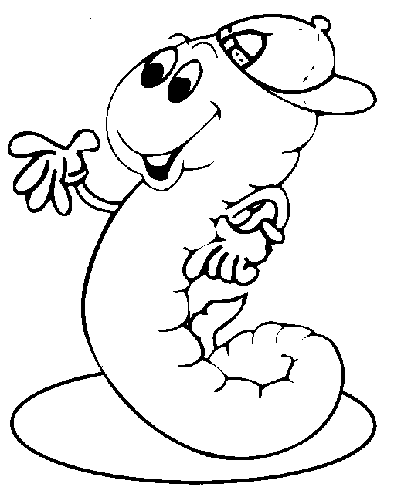

United States Department of Agriculture
South Dakota Natural Resources Conservation ServiceJuly 2003

