Providing Content for the Building America Solution Center

This document provides guidance on submitting content for the Building America Solution Center.

Most Solution Center content is in the form of Guides, which provide information for builders, contractors, and others on how to install various energy–efficiency measures and other aspects of home construction. Each Guide describes one topic or measure. Most guides contain ten tabs. (These tabs are described in detail in the sections below.)

- Scope of Work
- Description
- Ensuring Success
- Climate
- Training (Right and Wrong Images, Presentations, Videos)
- Architectural CAD Files
- Compliance (Codes, Standards, and Program Criteria)
- Existing Home
- More Info (Case Studies and References and Resources)
- Sales.

Please submit each Guide as a separate Microsoft Word document with no EERE formatting. Please provide content for all of the tabs listed above for each guide.

Building America Research Teams:
Before preparing a guide for submission, if you have not already done so, please contact your research coordinator, Stacey Rothgeb at NREL, 303-275-4361, Stacey.Rothgeb@nrel.gov to indicate the guide you would like to submit. Once the guide is prepared, please submit your content, including the Word file, graphics files, and any CAD files and case studies, to Stacey at NREL. NREL will facilitate the peer review of the guide and will forward the final files to PNNL. To submit a full guide, content for Scope of Work, Description, Ensuring Success, Climate, Compliance, and Existing Home are required. Training, CAD, and More Info are optional but encouraged. If you cannot provide content for all of the tabs for a Guide, please discuss this with Stacey prior to preparing the guide. If you are submitting the guide with an accompanying technical report, the guide may be an appendix to the report.

National Laboratories, Contractors to National Laboratories, and Other Submitters
Before preparing content for submission, please check with Theresa Gilbride at PNNL, 503-417-7563, Theresa.gilbride@pnnl.gov. Please review and clear any content for submission to the Building America Solution Center using your organization’s internal peer review process. Please send the final reviewed and approved Solution Center content and image files to Rose Bartlett (rosemarie.bartlett@pnnl.gov, 509-375-6606) and copy Theresa Gilbride. Contractors, please submit your content to your national laboratory contact for review and submission to PNNL. If your submission includes numerous files and/or large files, contact Rose to send you a link for transmitting files via PNNL’s file transfer tool. PNNL staff cannot access DropBox.

PNNL maintains a master list (or “taxonomy”) of all of the guides in the Building America Solution Center, showing what content has already been posted. This taxonomy can be viewed at https://basc.pnnl.gov/building-america-team-taxonomy-terms-and-keywords.

Time-Saving Tips for Submitting Solution Center Content

- Avoid formatting the Word document for BASC content. Avoid the EERE template, don’t center images or text, avoid using different colored fonts – none of this formatting will be used by PNNL.
- Keep it simple. The scope is a bullet list of what needs to be done to complete the measure. The first half of the description can often be pulled from a report introduction related to the technology or method.
- Don’t duplicate effort. Copy and paste relevant compliance or climate information from similar guides that are already in the Solution Center.
- Avoid typing full references. If the reference is already in the BASC, PNNL just needs the reference title. To search in the BASC use the search box (filter by clicking on “reference” in the right nav).
- Don’t provide an exhaustive list of resources. Name a few of your favorite related resources and move on. Use resources that are less than 10 years old if at all possible.
- Use images from Building America, DOE, EPA, or other government programs so you don’t need to fill out a permission form.
- Avoid follow up after your final deliverable. Provide all the relevant image files with your final report.

Submitting Images

Research Teams - After the peer review of a Guide is completed, the Team should send the Word document and any image files to the NREL research coordinator, who will forward these files to PNNL. Name your image files using the file naming guidance shown below.

National Laboratories and Contractors – Submit image files directly to Rose Bartlett of PNNL (rosemarie.bartlett@pnnl.gov).

Submit images as PNG, JPG, or GIF files. Photographs are typically best in JPG format. All images should be cropped, if necessary, to eliminate excessive space around the image. Image files will typically be 50 kb to 5 mb. There is a system maximum file size limit of 500 mb.

The images should also be inserted in the Guide document where you would like them to appear in text. In the Word file, immediately after the image, please include the following information:

- a full-sentence caption
- the file name (using the file-naming convention shown below)
- the image title (may be the same as the caption or a 5- to 10-word shortened version of caption)
- the image source (see below).

Image titles can be brief (5 to 10 words) but should be descriptive enough to make this title unique from titles for other similar images. These image titles appear as roll-over text and under the image when it is opened in the Image Gallery. They are also used by the CAD File browser and word search feature.

Figure captions will appear under the images used in the Description tab. These full-sentence titles can be the same as the image title or they can be more descriptive to the situation being described in the Guide.

Image File Naming Conventions

Here is an example of an image file name:

HVAC114_CondBoiler-1_DS_4-3-14.jpg

Where
- HVAC114 is the taxonomy number HVAC 1.1.4.
- CondBoiler is an abbreviation for the guide name Condensing Boilers.
- -1 means this is the first figure used in the guide (if it was a right or wrong image it would be -1W or -1R. If it was a scope figure it would be –S.)
- DS is the initials of the team or person who provided the figure.
- 4-3-14 is the date you prepared or provided the figure.
Image Source

Published Images

If the image has been used in a published report or article, cite the report or article as the source. If the reference is already in the Solution Center, just list the exact report title and the Solution Center url. For example

Figure Source: Duct Sealing, https://basc.pnnl.gov/resources/duct-sealing

If the source is not in the Solution Center, please provide the full title, author, organization, date, and url to the document here. (It’s ok to provide this in reference citation format, just make sure to include the author’s organization, a url to the report or article, and a one-line summary of the report or article.)

Figure Source:
Title: Low-Cost Interior Duct Systems for High-Performance Homes in Hot Climate
Authors: Fonorow, Jenkins, Thomas-Rees, Chandra
Organization: FSEC
Publication Date: October 2010
URL: http://www.fsec.ucf.edu/en/publications/pdf/FSEC-PF-451-10.pdf
One-liner: Report describing a cost effective method used by four Gainesville, FL, builders to construct interior ducts in over a dozen site-built homes.

If the image is not from a government source or was not produced with federal funds, a copyright permission form must be submitted to PNNL confirming that we have permission to use the image in the Solution Center; see Permission Forms below.

Unpublished Images

If the image is unpublished, after “Figure Source:” please note “unpublished figure” and provide the name of the organization (or individual) who prepared the image and a url to their home page. List your own company or team name if you took the photo or drew the image, or use the name of the organization or individual from whom you obtained the image. If the image is not from a government source or was not produced with federal funds, a copyright permission form must be submitted to PNNL to confirm that we have permission to use the image in the Solution Center; see Permission Forms below.

Figure Source: unpublished figure, Calcs Plus, www.calcs-plus.com

Permission Forms

All images in the Solution Center are available to the public for free download. A permission form (Appendix B) must be filled out for any figure or picture that was not created using federal government dollars. Stock images or images randomly pulled from the Internet cannot be used. If you would like to use an image (photograph, drawing, CAD file) that was produced by your team for a nongovernment-funded project, please fill out the permission form. If you would like to use an image that was produced by another nongovernment-funded source, please use the permission form to obtain permission from the image creator allowing DOE to use and share the image. To help save time, forms can be filled out with inclusive language to cover multiple images from the same source.

Writing your Guide

Here are general tips for writing Building America Solution Center content:

- Use Microsoft Word for the text.
- If there is no content for an element, such as CAD files, state “None Available” after that heading in the Word file.
- If tables are to be included, type them in the Word file, rather than inserting as an image.
- Avoid using brand names.
- If you would like any text to be a link (for example, a link to another Solution Center guide, to a program, or to a reference) use MS Word’s hyperlink feature to hyperlink the text and include the url in brackets after the hyperlink.

An example of a completed Guide submission is provided in Appendix A of this document.

Please include the following information at the beginning of the Guide document.

Item | Example | Explanation
Guide Title: | Air Seal HVAC Cabinet Seams | Use the title exactly as it appears in the taxonomy. If you want to change the title, use the comment feature in MS Word to explain why a change is necessary.
Taxonomy Number | HVAC 2.2.7 | Use the taxonomy number in the current version of the Solution Center taxonomy at https://basc.pnnl.gov/building-america-team-taxonomy-terms-and-keywords
Keywords | Air Sealing, HVAC Equipment | Use terms from the Solution Center Keyword list at https://basc.pnnl.gov/building-america-team-taxonomy-terms-and-keywords
Climate Zone | All climate zones | Most guides will be All Climate Zones. If this guide pertains only to certain climate zones, list those climate zones by Building America climate zone name and by IECC climate zone number.
Construction Type | Both | Specify New Construction, Existing Homes, or Both
One liner | “Guide describing air sealing of the seams and holes in HVAC air handler and furnace cabinets.” | A one-line description, starting “Guide describing…”
Author: | CARB/Steven Winter Associates, Karla Donnelly, kdonnelly@swinter.com | Organization, author’s name and email
Date | 8/12/14 | The date the content was provided to NREL. Update after peer review comments are added.

Specific instructions regarding content for each Guide tab are provided below.

Scope Tab

Write the scope to clearly define and limit the measure. Tell builders and remodelers how to perform the work with wording they could use to contractually obligate their subcontractors. Specify the quantity and quality of work expected. The scope should identify the best practice for implementing this measure.

If the Guide describes a measure that is a requirement in the ENERGY STAR National Program Requirements, the DOE Zero Energy Ready Home National Program Requirements, the EPA Indoor airPlus Construction Specifications, include the requirements language in the Compliance tab. If specific program or code requirements are included in the Scope, you can cite these with a reference callout, for example “(ENERGY STAR Rev. 08)” or “(IRC 2012).”

Please provide one figure or photo clearly depicting the measure. Include the image title, file name, and source in the text immediately after the image, as described above; no caption is needed.

Include the following line at the end of each Scope:
“See the Compliance Tab for related codes and standards, and criteria to meet national programs such as ENERGY STAR, DOE’s Zero Energy Ready Home program, and EPA’s Indoor airPLUS.“

Description Tab

Provide an overall explanation of the measure, including an introduction, issues, pros and cons, materials to use, and what contractor does the work.

If the guide is a guide specifically for existing homes, include in the Description how you will access the area of the home that will be renovated as described in the measure.

Under a “How to ….” heading, write out specific numbered steps for implementing the measure. Use drawings and/or photos to illustrate the steps. See the section above, Submitting Images, for guidance on submitting images. Use the Scope to focus your description.

In some instances, there may be more than one technique for implementing the same measure. In these circumstances, the techniques are typically treated as separate guides. There are rare instances where both techniques are treated in one guide; for example in the guide “Capillary Break Beneath Slab – Polyethylene Sheeting or Rigid Insulation over Aggregate” where the ENERGY STAR checklist offers either option for one checklist item.

Ensuring Success Tab

List any health, safety, durability, and performance issues, and test-in/test-out requirements that need to be considered when completing this measure. If the guide is a guide specifically for existing homes, you can address assessment of the home’s current condition by referencing one or more of several Assessment Guides for Existing Homes that will be added to the BASC:
- Assess and correct moisture/structural/electrical problems in
  - foundations/floors,
  - walls/windows/doors;
  - ceilings/attics/roofs;
- Assess and correct combustion safety
- Assess and remediate hazardous materials
- Assess and provide healthy ventilation.

You can refer any of these guides that are appropriate to the retrofit topic, rather than taking the time to describe the assessment steps. PNNL will add the hyperlinks.

Climate Tab

Note climate-specific guidance related to the topic. Include climate-specific requirements from codes and standards, and DOE programs such as ENERGY STAR and DOE Zero Energy Ready Home. Some of the content provided in the Climate tab may be repeated in other tabs such as the Compliance tab or the Scope tab.

If there is no climate-specific information for the topic, state “No climate-specific information applies” after the Climate heading.

If implementation of a measure varies significantly based on the climate zone (e.g., vapor barriers), make these climate distinctions clear in the Description tab, as well as in the Climate and other tabs, by including in the Description tab subheadings for each climate variation and instructions for each climate zone. If implementation of the measure varies greatly by climate zone, ask PNNL about making separate guides for each distinct climate zone application and identifying the climate zone in the guide title.

Training Tab

Training materials consist of right and wrong images, presentations, and videos.

Right and Wrong Images

Provide photographs showing the building concept applied correctly and incorrectly. Arrows or circles may be included on the image to draw attention to the specific problem or solution, but these details must be incorporated in the image file and not separately applied. Insert the image in the Word file and follow with the file name, image title, and source (as noted above). The image title should start with the word “Right -...” or “Wrong - …” and the title should clearly say what is right or wrong in the image. Also provide the image file as a separate JPG, PNG, or GIF file.

PowerPoint Presentations

Provide publically available presentations about this topic from sources in which copyright and use will not be an issue. This would include .gov websites and presentations your team or other teams have produced with government funding.

In the Guide document please include the following information for each presentation:

- A url link to the presentation
- Title
- Author
- Organization
- Publication Date
- A one-line description starting “Presentation about…”

If the presentation is not posted to an accessible internet site, you may provide the presentation to NREL/PNNL as a PDF.

508 Compliance. To make your PDF accessible for people with disabilities in compliance with Section 508 of the Rehabilitation Act, please do the following:

- For PDF files, set the 508 compliance settings in the Document Properties window of the file, as described in http://www1.eere.energy.gov/communicationstandards/finalizing_pdfs.html
- Identify alternative (alt) text for any non-text items.
  - To add alt text to PDFs where the original PowerPoint is not available, use Adobe Acrobat Pro. Open the PDF, choose Tools, Action Wizard, Create Accessible PDFs, Add Tags to Document. The wizard will walk you through the process.

Videos and Webinars

Provide videos about this topic from sources in which copyright and use will not be an issue. This would include .gov websites, video content your team or others have produced with government funding, or video from other sources such as industry associations from which you have obtained written permission to use the video or webinar (please use the permission form in Appendix B).

In the Guide document please include the following information for each video:

- A link to the video
- Title
- Author
- Organization
- Publication Date
- A one-line description starting “Video about…”
- An image file (JPG or PNG) representing the video that we can use as a thumbnail icon for the video.
- A transcript of the video (see below under 508 Compliance).

The best way to provide the video to NREL or PNNL is as a link (to the .gov website where you found the video or to your organization’s website or youtube channel if you created the video). If the video is not located at an accessible or stable url, then you may contact PNNL about saving the video to the Solution Center video repository. Please submit videos and webinars in Quicktime (AVI), Windows Media Video (WMV), or Flash (FLV or SWF) formats.

508 Compliance - To meet Section 508 accessibility compliance requirements, all videos must be accompanied by a transcript file (TXT, DOC, or PDF formats are all acceptable). For new videos, closed captions should also be provided, synchronized with the soundtrack.

CAD Tab

For each CAD image, please provide the image in the following three file formats; all three should have the same file name but different extensions:

- the .DWG CAD file
- a PDF of the CAD image
- a JPG, PNG, or GIFF image of the CAD file suitable for display in the Guide.

Insert a copy of the display image in the Guide document and add the following information after it:
- the image title
- the file name of the CAD file
- the file name of the PDF
- the author of the image
- the organization
- the image source (see guidance above regarding image sources and references).

If the CAD file was not produced with government funding, please provide a completed permission form for its use. Please remove company names from the CAD image.

Compliance Tab

List codes, standards, and programs that have requirements relevant to the Guide topic, including requirements from the International Energy Conservation Code (2009, 2012, and 2015 IECC), the International Residential Code (2009, 2012, and 2015 IRC), other applicable I Codes, other standards (e.g., ANSI, ASHRAE), and relevant program criteria from the DOE Zero Energy Ready Home program, ENERGY STAR Certified Homes, EPA Indoor airPLUS, etc. Please provide a url for the code or standard document. If the code or standard itself is available by purchase only, then provide a url for the organization.

When providing compliance information, include the name of the program, code, or standard and its version or edition year in the title. Include any applicable section titles and section numbers directly below the title. DOE and EPA program requirements can be included verbatim. For codes and standards, if the text is protected by copyright (which is true for all I codes, among others), summarize the requirements in your own words.

If there are any codes or standards issues that would pose a barrier to the measure described in your guide, identify those barriers and any work-around solutions in the Compliance tab. Please also notify the Building America Codes and Standards Innovation (CSI) Team of the potential barrier and solution by contacting Pam Cole at PNNL, 509-375-6787, pam.cole@pnnl.gov.

Existing Home Tab

This tab will appear on all full new home guides. The purpose of this existing home tab is to provide information when the installation procedures for a retrofit project are very similar to those for new construction with a few changes in details. The amount of content on the tab will vary. It could be as brief as “The information in this guide is applicable to existing homes as is.” Even where a topic applies as is to both, we still need to pay attention to health and safety issues.
Under the heading Existing Home Tab, list subheadings for each tab in a full new home guide: Scope, Description, Success, Climate, Training, CAD, Compliance, and More. Under each of these subheadings, list whatever differs from guidance for a new home installation of the measure. If there is no change for a heading, just say no change. Under Scope, include any differences from the original scope, the location in the house and what equipment may be affected, potential access issues, health or safety concerns for the installer and occupants, and other measures to look at while there. See the Standard Work Specifications tool https://sws.nrel.gov/ for specifications that may be helpful in composing your scope and description. PNNL will draft assessment guides identifying the steps needed to assess, identify and correct ancillary health and safety issues that may be related to the retrofit activity, so you do not need to explain these procedures in your content, but do identify the assessments needed and PNNL will add the appropriate links to those guides.
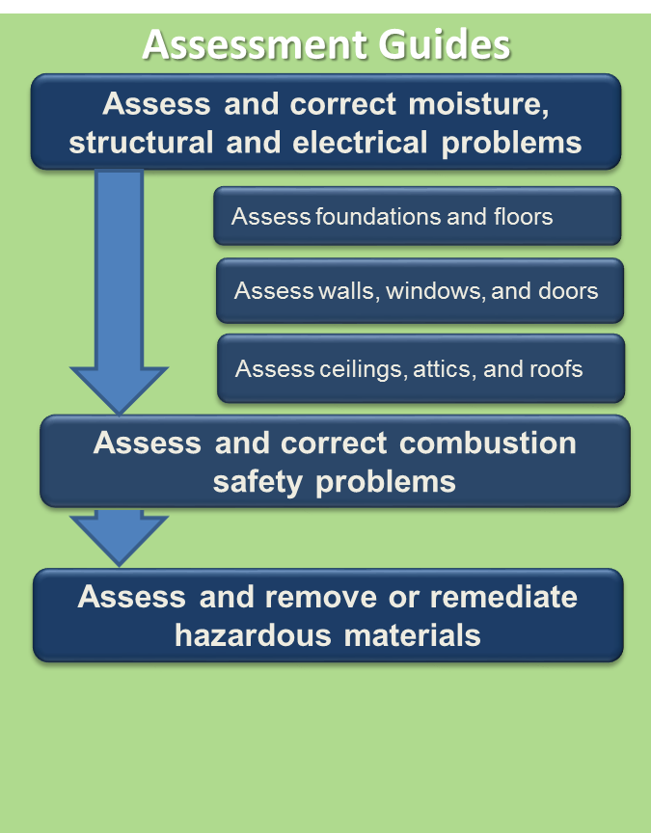
For the Description subheading, there is no need to repeat all of the installation steps, just note any differences from the original instructions, including changes in materials and sequencing, or additional steps. Note where the additional steps fall in relation to the original numbered steps, e.g., “Before step 1…” or “Between steps 1 and 2.”
Under Training, include any additional videos or right/wrong images that are specific to retrofits. See the Standard Workforce Specifications Flickr account for good retrofit images that are free to use. www.flickr.com/groups/2451319@N24/. For images, videos, and CADS, please include the image source information as noted above and provide a permission form for not government sources that you did not produce yourself.

More Info Tab

Contributors

Please list your name and the name of any other organizations who contributed significantly to the information in this guide. Hyperlink, or provide in parentheses after your company name, the best url for your company.

Case Studies and References and Resources

Case Studies and References and Resources appear on the More Info tab in alphabetical order by title. For both Case Studies and References and Resources, only peer-reviewed documents should be referenced. Websites to be referenced would generally be limited to those with a “.gov” extension.

Case Studies

List Building America case studies that specifically describe or mention the measure. You may reference case studies that are already in the Building America Solution Center, or already in the Building America Publications Library or Building America Climate Guidance pages, or prepare a new case study specific to this topic.

If you list a case study already in the Solution Center, Building America Publications Library, or Building America Climate-Specific Guidance page, please include the full title, author, organization and url. Any case study that does not use standard EERE 2- or 4-page formats will treated as a report rather than a case study and should be listed on the Resources list instead.

If you wish to create a new case study for this Guide topic, contact your contract coordinator, Stacey Rothgeb.

Teams. To prepare a case study draft, follow the Building America format for either measure-specific (technology solution) or whole-house case studies. Measure-specific case studies focus on research about the measure itself while whole-house case studies describe the measure as it is applied in the context of a whole house or housing development. Provide the Word file draft of your case study to Stacey Rothgeb at NREL for peer review and formatting. Good examples of technology-specific case studies and whole-house case studies for new and for existing homes are provided at the links below. Word templates are also provided. Feel free to use these templates when preparing your case study or provide your text in a simple, unformatted Word file. Just clearly identify sidebars, captions, etc. NREL Communications will do final formatting of your case studies in Indesign.

Whole-House Solutions for New Homes Template Word doc

Whole-House Solutions for New Homes Example pdf

Whole-House Solutions for Existing Homes Template Word doc

Whole-House Solutions for Existing Homes Example pdf

Technology Solutions for New and Existing Homes Template Word doc

Technology Solutions for New and Existing Homes Example pdf

National Laboratories and Other Submitters. Please prepare case studies in Indesign using the templates listed above for formatting guidance. Provide a PDF of your Indesign file and jpg versions of image files to Rose Bartlett (rosemarie.bartlett@pnnl.gov)

References and Resources

List all references and resources together in alphabetical order by title under the References and Resources subheading under the More Info heading in your document. When citing references and resources, please use the most recently published information available, preferably publications that are less than 10 years old. Peer-reviewed reports and articles are preferable to self-published reports. Use Building America-sponsored research publications when possible.

In-Text References include any document or online resource that is directly referenced in the text. Hyperlink the program or document title or author-date citation to the document url or highlight the author-date callout in blue in the text and put the url after it in parentheses.

For references to programs and organizations, include a link to the most relevant page for the program or organization. Please use the blue highlighter feature in Word to indicate program titles that should be linked. See example below:

“The U.S. Department of Energy’s DOE Zero Energy Ready Home program (http://energy.gov/eere/buildings/zero-energy-ready-home) requires labeled homes to be certified to the U.S. Environmental Protection Agency’s Indoor airPLUS program (http://www.epa.gov/indoorairplus/).”

For references to documents, search the Solution Center to see if the document is already in the Solution Center Reference List. (See the figures below for tips on searching the Solution Center for references.)

If the document is in the Solution Center, after the information to be referenced, include the author-date citation and hyperlink it to the reference in the Solution Center or include the url in parentheses.

For example:
…The only place air should be able to enter the return duct system and the furnace or air handling unit is at the return grilles (BSC 2009) (https://basc.pnnl.gov/resources/duct-sealing).

If the document is not already in the Solution Center, after the author-date callout, insert the url for the document in parentheses.

ENERGY STAR-rated exhaust fans should be selected that have low sone ratings, low power draw, and in some cases multiple speeds for spot exhaust and continuous ventilation (EPA 2013). (http://www.energystar.gov/products/certified-products/detail/fans-ventilating?fuseaction=find_a_product.showProductGroup&pgw_code=VF).

Include the full reference on the References and Resources list with the information shown in the example below.

Resources include other pertinent materials that relate to the Guide topic such as reports, articles, websites, presentations, online calculators, and software tools that were not specifically called out in the text. Include the resource on the References and Resources list under the More Info tab with the information shown in the example below.

For resources that are already in the Solution Center, just list the title; please list it exactly as it appears in the Solution Center. Before the title, note “In BASC.” After the title, add the url where it appears in the BASC. For example:

(in BASC) Field Performance of Heat Pump Water Heaters in the Northeast, https://basc.pnnl.gov/resources/field-performance-heat-pump-water-heaters-northeast

For resources that are not in the Solution Center, include the following information: the title, author names (may be same as organization), organization, publication date, the url where the document resides, and a one-sentence description starting “Report describing…” or “Article describing…” If the document is located in the Building America Publications Library (http://www1.eere.energy.gov/library/), use the same title as is used in the Library and provide the Library URL.

Searching for References in the Solution Center

Use the search box in the upper right-hand corner to search for references. You are not limited to the Solution Center Keyword list. Any words can be entered here.

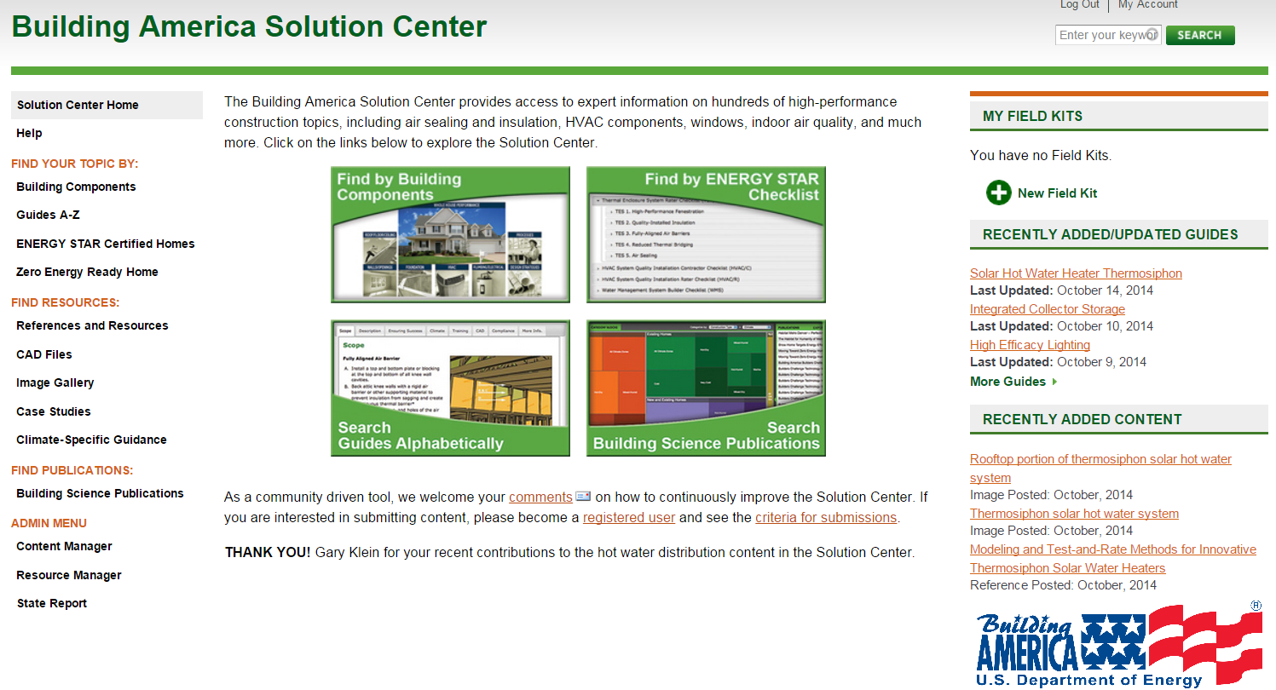

Select “Reference” in the right sidebar “Filter by Content Type” to narrow your search results to just references.

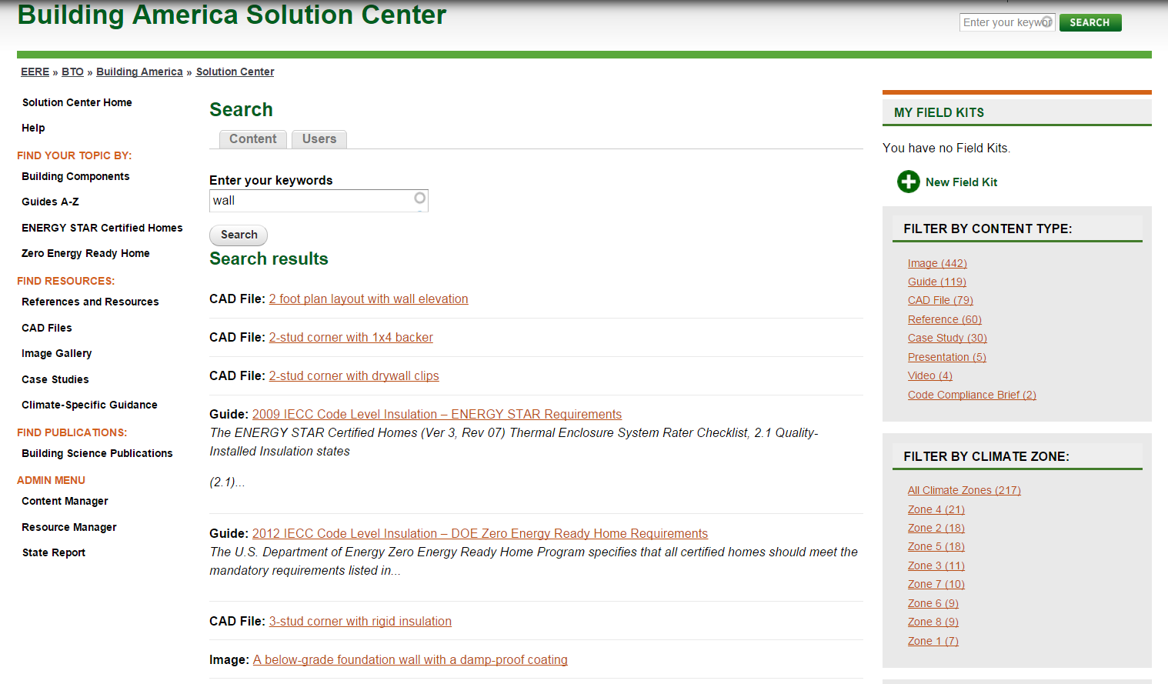

Appendix A: Example Solution Center Guide Submission

This Appendix provides an example of how to format and submit content for each of the eight tabs within a Guide. Format the text in an MS Word file as you would like to see it in the Solution Center. See the finished product for reference in the Solution Center here: https://basc.pnnl.gov/resource-guides/air-seal-hvac-cabinet-seams .

The following guide is for example purposes only. For questions related to Building America Solution Center (BASC) content formatting, contact Theresa Gilbride at PNNL, 503-417-7563, Theresa.gilbride@pnnl.gov.

Guide Title: Air Seal HVAC Cabinet Seams
Taxonomy Number: HVAC 2.2.7
Keywords: Air Sealing, HVAC Equipment
Climate Zone: All Climate Zones
Construction Type: New Construction, Existing Homes, or Both.
One liner: Guide describing air sealing of the seams and holes in HVAC air handler and furnace cabinets.
Author: PNNL, Theresa Gilbride, Theresa.gilbride@pnnl.gov,
Date: 6-12-14

Scope

Seal seams and holes in the air handler or furnace cabinet of central forced air HVAC systems to prevent the loss of conditioned air.
- Select an air handler with a manufacturer’s designation showing that air leakage is ≤2% of the design air flow rate.
- Use mastic, mastic plus embedded fiberglass mesh fabric, or UL 181A or B tape to seal all cabinet seams and junctures between the air handler or furnace cabinet and the evaporator coil cabinet, the supply plenum and the return plenum.
- Use putty around all conduit and wiring holes.
- Use UL-approved gaskets to seal cabinet doors and access panels.
- Seal all unused conduit knockouts with UL-listed tape or mastic.
- Seal all fixed seams in the cabinets and all seams between the cabinet and the supply or return plenums with mastic or mastic and fiberglass mesh fabric.
- Use a sealing putty to seal the inside of the high-voltage wire conduit termination point in the air handler after the wiring has been installed.
- Check the insulation inside the air handler where the conduit enters. If the insulation has been compromised, repair it with approved spray glue and additional insulation.
- Use a duct blower tester to test the airtightness of the air handler/furnace cabinet and ducts. Verify that the duct system meets code or program airtightness requirements.
See the Compliance Tab for related codes and standards, and criteria to meet national programs such as ENERGY STAR, DOE’s Zero Energy Ready Home program, and EPA’s Indoor airPLUS.

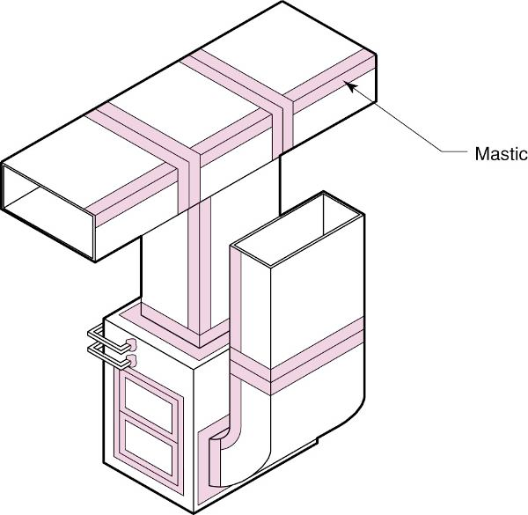

Image Title: Seal all holes and seams in furnace and air handler cabinets.
File name: HVAC 2-2-7 Air Seal Cabinet-S_BSC-2009.jpg
Figure Source: Duct Sealing, https://basc.pnnl.gov/resources/duct-sealing

Description

Many homes are equipped with central forced air systems that rely on ducts to transport heated or cooled air from a furnace or heat pump to the rest of the home. If the ducts are leaky, they can be a source of energy loss through loss of heated or cooled air, poor HVAC performance through loss of air pressure in the ducts, and comfort problems. Air leakage problems can be the worst at the HVAC furnace or air handler cabinet, where air pressures are highest. Cabinet seams, holes, and junctions should be sealed to prevent air leakage. The only place air should be able to leave the supply duct system and the furnace or air handling unit is at the supply registers. The only place air should be able to enter the return duct system and the furnace or air handling unit is at the return grilles (BSC 2009) (https://basc.pnnl.gov/resources/duct-sealing).

In high-performance homes, all HVAC equipment, including the furnace or heat pump air handler and any ducts, should be located within the thermal envelope of the home. When the air handler is located within the conditioned space, it is tempting to think that sealing the cabinet is not that important because conditioned air will leak into the home rather than being lost to an attic or crawlspace. However, sealing cabinet air leaks is still very important for maximizing the performance of the HVAC equipment because it helps to ensure maximum air flow to the ducts. In a central forced air system, the highest air pressures are experienced at the air handler, with pressures increasing the closer one gets to the air handler fan. It is common for air pressures in the supply and return plenum at the air handler to equal or exceed 0.5-inches water column (125 Pascals). Therefore, it is critical to seal up the knockouts, seams, and slots in the air handler cabinet.

Gas- or oil-fired furnaces are often equipped with an add-on refrigerant coil (called the evaporator coil) to provide cooling during the summer months (Figure 1). The connection between the evaporator coil cabinet and the furnace cabinet is likely the highest point of pressure in the system and can be a large source of leakage if care is not taken to properly seal this juncture during installation. Refrigerant coil cabinets do not always fit directly on top of the furnace; many coil cabinets have a larger footprint than the furnace so the seam between the two boxes is uneven. The coil cabinet should be sealed to the furnace using mastic or an Underwriters Laboratories (UL) 181 approved foil tape. For larger gaps (greater than 3/8 inch) mastic and fiberglass mesh tape should be used.

Air handlers (Figure 2), furnaces, and evaporator coil cabinets come from the factory with holes in the form of knockouts, penetrations, and slots for installing piping and wiring. These holes are there for ease of installation and service. However, when installation is completed, any unused holes should be sealed, along with gaps around wiring and piping. Holes where the condensate line and refrigerant lines penetrate the evaporator coil cabinet will be the next highest pressure point, and depending on the model may be a point of negative pressure. Seal around these lines with non-hardening putty. Use non-hardening putty to seal around pipes, tubing, and conduit penetrations in the air handler cabinet as well. This putty comes in strips, slugs, and cords (see Figure 3) and does not dry out, but remains pliable so it can be removed and reapplied. Seal unused electrical and piping knockouts with mastic.

The third point of high (negative) pressure is the area of the cabinet that houses the indoor blower fan. With respect to indoor air quality, this may be considered the most concerning area for air leakage, especially if the furnace is located in a garage or any other area where chemicals are stored or where there is exposure to carbon monoxide. Any seams or unused holes should be sealed with mastic.

The connections with the supply and return plenums are additional areas that experience high pressures. These seams and other cabinet seams should be sealed with mastic, mastic and fiberglass mesh tape, or UL-approved tape.

There are some penetrations in a furnace cabinet that are not considered leakage points. The furnace in Figure 1 is a condensing gas furnace. The penetrations for the condensate line for the condensing gas furnace, vent pipes, gas line, and high voltage wiring (not shown) are not connected to the conditioned air stream and therefore are not areas of concern for leakage.

Regarding cabinet panels that must be periodically removed for routine maintenance of the HVAC equipment, some HVAC technicians suggest using cloth-backed duct tape to seal the panel seams because it is easy to remove or cut through.

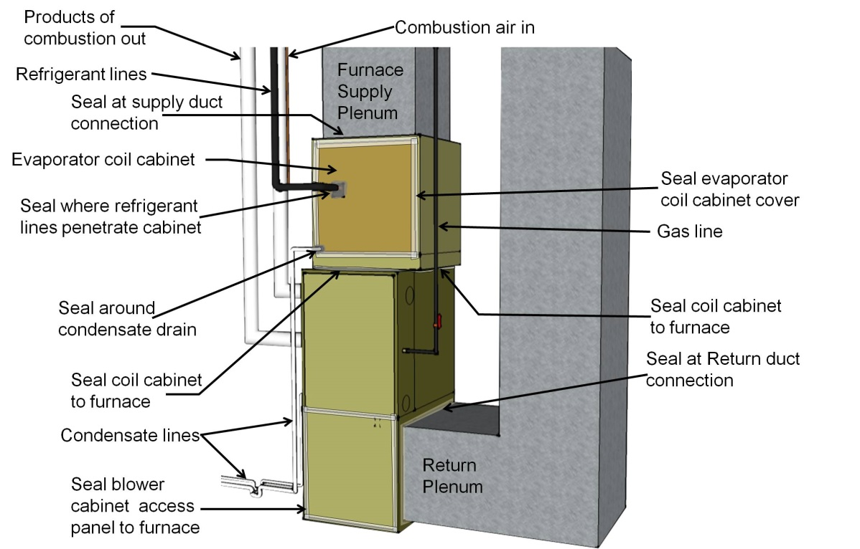

Figure 1. Air seal all holes and seams in the furnace cabinet with mastic, foil tape, or putty. Pay special attention to sealing the junction between the furnace cabinet and the evaporator coil cabinet.
Image Title: Air seal all holes and seams in the furnace cabinet with mastic, foil tape, or putty.
File Name: HVAC 2-2-7 Air Seal Cabinet-1_DS 6-12-14.jpg
Figure Source: unpublished figure, Calcs Plus, http://www.calcs-plus.com/ (Signed permission form attached)

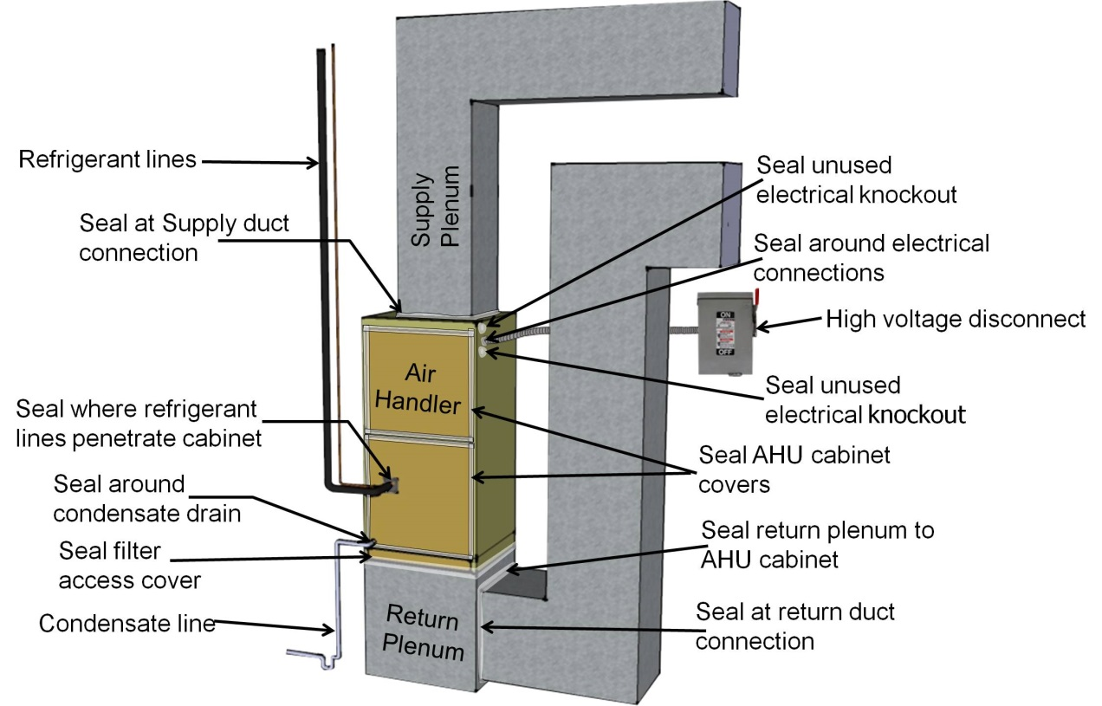
Figure 2. Air seal a heat pump or air conditioner air handler cabinet at all seams, holes, and junctions.
Image Title: Air seal heat pump or air conditioner air handler.
File Name: HVAC 2-2-7 Air Seal Cabinet-2_DS 6-12-14.jpg
Figure Source: unpublished figure, Calcs Plus, http://www.calcs-plus.com/ (Signed permission form attached)

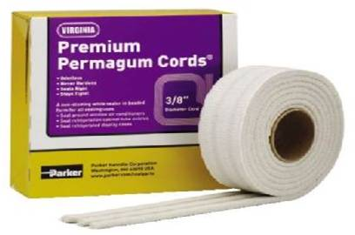

Figure 3. Non-hardening removable putty can be used to seal around wiring holes in the HVAC cabinet.
Image Title: removable putty can be used to seal around wiring holes.
File Name: HVAC 2-2-7 Air Seal Cabinet-3_DS 6-12-14.jpg
Figure Source: unpublished figure, Parker Hannifin Corp, http://www.parker.com, (Signed permission form attached)

How to Air Seal the HVAC Cabinet

1. Install the furnace or air handler and all associated ducting within the conditioned space of the home. Select an air handler with a manufacturer’s designation showing that air leakage is no more than 2% of the design air flow rate when tested in accordance with ASHRAE 193 (per 2012 IECC R403.2.2.1).

2. Use Underwriters Laboratory (UL) approved gaskets, mastic, mastic plus embedded fiberglass mesh fabric, or UL 181A or B tape to seal all cabinet seams and junctures between the air handler or furnace cabinet and the evaporator coil cabinet, the supply plenum and the return plenum.

3. Use putty around all conduit and wiring holes.

4. Seal all unused conduit knockouts with UL-listed tape or mastic. Seal all fixed seams in the cabinets and all seams between the cabinet and the supply or return plenums with mastic or mastic and fiberglass mesh fabric.

5. Use gaskets, removable putty, or metal tape that can be cut through to seal cabinet access doors.

6. Use a sealing putty to seal the inside of the high-voltage wire conduit termination point in the air handler after the wiring has been installed.

7. Check the insulation inside the air handler where the conduit enters. If the insulation has been compromised, repair it with approved spray glue and additional insulation.

8. Use a duct blower tester to test the airtightness of the air handler/furnace cabinet and ducts. Verify that the duct system meets code or program airtightness requirements.

Ensuring Success

Install the air handler within the conditioned space of the home.

Seal all seams and holes in the air handler cabinet.

Test the airtightness of the cabinets and ducts with a duct blower test. Verify that the duct system meets code or program airtightness requirements.

Climate
No climate-specific information applies.

[For good examples of climate-specific guidance,
see the guide “Anti-Freeze-Solar Hot Water”
https://basc.pnnl.gov/resource-guides/anti-freeze%E2%80%93-solar-hot-water#block-views-guide-static-blocks-block-4

or the guide “2012 IECC Code Level Insulation”
https://basc.pnnl.gov/resource-guides/2012-iecc-code-level-insulation-%E2%80%93-doe-zero-energy-ready-home-requirements#block-views-guide-static-blocks-block-4]

Training

Right/Wrong Images
None available.

[For good examples of Right/Wrong Images,
See the guide “Duct Leakage to Outdoors”
https://basc.pnnl.gov/resource-guides/duct-leakage-outdoors]

Presentations
None Available.

[For a good example of a presentation,
See the guide “Ducts Buried in Attic Insulation and Encapsulated”
https://basc.pnnl.gov/resource-guides/ducts-buried-attic-insulation-and-encapsulated#block-views-guide-static-blocks-block-5]

Videos
None available.

CAD
None available.

[For a good example of CAD files
See the guide “Cantilevered Floor”
https://basc.pnnl.gov/resource-guides/cantilevered-floor#block-views-guide-static-blocks-block-6]

Compliance

2009 IECC

403.2.2 Ducts. Sealing (Mandatory). All ducts, air handlers, filter boxes, and building cavities used as ducts should be sealed. Duct tightness should be verified by duct leakage testing (testing is not required if the air handler and all ducts are in conditioned space.) Testing can be done at rough-in or when construction is complete.

If testing is done at rough in, total leakage must be <= 6 cfm/100 sq. ft. of conditioned floor area when tested at a pressure difference of 25 Pascals (Pa) across the roughed in system, including the manufacturer’s air handler enclosure, with all register boots sealed. If the air handler is not installed at the time of the test, total air leakage must be <= 4 cfm/100 sq. ft. of conditioned floor area.

If testing is done post construction: Leakage to outdoors must be <= 8 cfm/100 sq. ft. of conditioned floor area or total leakage must be <=12 cfm/100 sq. ft. of conditioned floor area at 25 Pa across the system including the air handler enclosure.

2012 IECC

R403.2.2 Ducts. Sealing (Mandatory). All ducts, air handlers, and filter boxes should be sealed. Duct tightness should be verified by duct leakage testing (testing is not required if the air handler and all ducts are in conditioned space). Testing can be done at rough-in or when construction is complete.

If testing is done at rough-in, total leakage must be <= 4 cfm/100 sq. ft. of conditioned floor area when tested at a pressure difference of 25 Pa across the roughed in system including the manufacturer’s air handler enclosure, with all register boots sealed. If the air handler is not installed at the time of the test, total air leakage must be <= 3 cfm/100 sq. ft. of conditioned floor area.

If testing is done post construction, leakage to outdoors must be <= 4 cfm/100 sq. ft. of conditioned floor area or total leakage must be <=12 cfm/100 sq. ft. of conditioned floor area at 25 Pa across the system including the air handler enclosure.

R403.2.2.1 Sealed air handler. The air handler should have a manufacturer’s designation showing that air leakage is no more than 2% of the design air flow rate when tested in accordance with ASHRAE 193.

2015 IECC

R403.3.2 Ducts. Sealing (Mandatory). All ducts, air handlers, and filter boxes should be sealed. The air handler should be designated by the manufacturer of having air leakage of ≤ 2% of the design air flow rate.
R403.3.3 and 4 Duct Leakage Testing
Duct tightness should be verified by duct leakage testing (testing is not required if the air handler and all ducts are in conditioned space). Testing can be done at rough-in or when construction is complete. If testing is done at rough-in, total leakage must be <= 4 cfm/100 sq. ft. of conditioned floor area when tested at a pressure difference of 25 Pa across the roughed in system including the manufacturer’s air handler enclosure, with all register boots sealed. If the air handler is not installed at the time of the test, total air leakage must be <= 3 cfm/100 sq. ft. of conditioned floor area. If testing is done post construction, total leakage must be <= 4 cfm/100 sq. ft. of conditioned floor area at 25 Pa across the system including the air handler enclosure.

2009 IRC

M1601.4.1 Duct Installation: Joints and Seams
The joints of duct systems shall be made airtight by means of tapes, mastics, liquid sealants, gasketing, or other approved closure systems.

2012 IRC

M1601.4.1 Duct Installation: Joints, Seams, and Connections
The joints of duct systems should be sealed with welds, gaskets, mastics, mastic plus embedded fabric, or tape.

2012 International Mechanical Code

603.9 Joints, seams and connections. Securely fasten all joints, seams, and connections with welds, gaskets, mastics, mastic plus embedded fabric, liquid sealants, or tapes that are listed and in accordance with Underwriters Laboratory: For connecting rigid duct use UL 181A products marked "181A-P” for pressure-sensitive tape, "181 A-M” for mastic, or "181 A-H” for heat-sensitive tape. For flexible ducts use UL 181B sealants marked "181B-FX” for pressure-sensitive tape or "181B-M” for mastic. The connections of ducts to the flanges of air distribution system equipment should be sealed and mechanically fastened.

U.S. Department of Energy Zero Energy Ready Home

The U.S. Department of Energy’s DOE Zero Energy Ready Home National Program Requirements (https://basc.pnnl.gov/resources/doe-challenge-home-national-program-requirements) includes, as a mandatory requirement (Exhibit 1, Item 6) that all labeled homes be certified to the U.S. Environmental Protection Agency’s Indoor airPLUS criteria. Indoor airPLUS requires that homes meet ENERGY STAR for Homes criteria including the requirement that all duct systems are installed to be substantially airtight and properly balanced. Indoor airPLUS also advises that seams in the HVAC cabinet, plenum, and adjacent ductwork should be sealed with mastic systems, tape that meets the applicable requirements of UL 181a or UL 181b, or gasket systems.

Another mandatory requirement (Exhibit 1, Item3) of DOE’s Zero Energy Ready Home program is that duct systems be located within the home’s thermal and air barrier boundary.

DOE Zero Energy Ready Home Footnotes

(16) Exceptions and alternative compliance paths to locating 100% of forced-air ducts in home’s thermal and air barrier boundary are:
a. Up to 10’ of total duct length is permitted to be outside of the home’s thermal and air barrier boundary.
b. Ducts are located in an unvented attic, regardless of whether this space is conditioned with a supply register
c. Ducts are located in a vented attic with all of the following characteristics:
  - In Moist climates (Zones 1A, 2A, 3A, 4A, 5A, 6A and 7A per 2012 IECC Figure R301.1) and Marine climates (all “C” Zones per 2012 IECC Figure R301.1), minimum R-8 duct insulation with an additional minimum 1.5” of closed-cell spray foam insulation encapsulating the ducts; total duct leakage <= 3 CFM25 per 100 sq. ft. of conditioned floor area; and ductwork buried under at least 2” of blown-in insulation.
  - In Dry climates (all “B” Zones per 2012 IECC Figure R301.1), minimum R-8 duct insulation; total duct leakage <= 3 CFM25 per 100 sq. ft. of conditioned floor area; and ductwork buried under at least 3.5” of blown-in insulation.
Note that in either of these designs the HVAC equipment must still be located within the home’s thermal and air barrier boundary.
d. Jump ducts which do not directly deliver conditioned air from the HVAC unit may be located in attics if all joints, including boot-to-drywall, are fully air sealed with mastic or foam, and the jump duct is fully buried under the attic insulation.
e. Ducts are located within an unvented crawl space
f. Ducts are located in a basement which is within the home’s thermal boundary
g. Ductless HVAC system is used.

State-Specific Criteria – please see the DOE Zero Energy Ready Home website for state-specific requirements [http://energy.gov/eere/buildings/guidelines-participating-doe-challenge-home].

ENERGY STAR Certified Homes

The ENERGY STAR Certified Homes National Program Requirements (https://basc.pnnl.gov/resources/energy-star-certified-homes-version-3-rev-08-national-program-requirements) lists the following criteria related to air handlers.
HVAC System Quality Installation Rater Checklist:
4.1 Total Rater-measured duct leakage meets one of the following two options: (16)
4.1.1 Rough-in: <= 4 CFM25 per 100 sq. ft. of CFA with air handler and all ductwork, building cavities used as ductwork, & duct boots installed. In addition, all duct boots sealed to finished surface, Rater-verified at final.
4.1.2 Final: <= 8 CFM25 per 100 sq. ft. of CFA with the air handler and all ductwork, building cavities used as ductwork, duct boots, & register grilles atop the finished surface (e.g., drywall, flooring) installed.
4.2 Rater-measured duct leakage to outdoors <= 4 CFM25 per 100 sq. ft. of conditioned floor area. (16,19)

ENERGY STAR Footnotes
(16) Duct leakage shall be determined and documented by a Rater using a RESNET-approved testing protocol. Leakage limits shall be assessed on a per-system, rather than per-home, basis…

(19) For homes that have <= 1,200 sq. ft. of conditioned floor area, measured duct leakage to outdoors shall be <= 5 CFM25 per 100 sq. ft. of conditioned floor area. Testing of duct leakage to the outside can be waived if all ducts and air handling equipment are located within the home’s air and thermal barriers AND envelope leakage has been tested to be less than or equal to half of the Prescriptive Path infiltration limit for the Climate Zone where the home is to be built. Alternatively, testing of duct leakage to the outside can be waived if total duct leakage is <= 4 CFM25 per 100 sq. ft. of conditioned floor area, or <= 5 CFM25 per 100 sq. ft. of conditioned floor area for homes that have <= 1,200 sq. ft. of conditioned floor area.

Many states have adopted state- or region-specific ENERGY STAR Certified Homes criteria - Please see the ENERGY STAR Certified Homes website for regional specifications [https://www.energystar.gov/index.cfm?c=bldrs_lenders_raters.nh_v3_regional_specs].

Existing Home Tab

Scope
Link to “Assess and correct combustion safety problems.”

Description
No changes.

Ensuring Success
No change.

Climate
No changes

Training
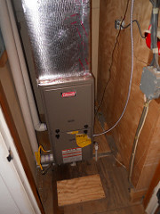
Right – All seams in the furnace cabinet are sealed with mastic or tape.
File Name: HVAC227_AirSealCab_REx1_SWS_4-29-16.jpg
Figure Source: NREL Standard Work Specifications Flickr https://www.flickr.com/photos/117168856@N06/14284613442/in/pool-sws_field_guide/

CAD
No changes.

Compliance
No change.

More Info
No change.

More Info

Case Studies

In BASC: Building America Top Innovations 2012: Moisture and Ventilation Solutions in Hot, Humid Climates: Florida Manufactured Housing

In BASC: Technology Solutions Case Study: Sealed Air-Return Plenum Retrofit, https://basc.pnnl.gov/case-studies/technology-solutions-case-study-sealed-air-return-plenum-retrofit

References and Resources (Example purposes only)

In BASC: 2012 International Mechanical Code, https://basc.pnnl.gov/resources/international-mechanical-code-80438-mechanical-draft-systems-manually-fired-appliances-and

In BASC: ACCA Standard 9: HVAC Quality Installation Verification Protocols, https://basc.pnnl.gov/resources/acca-standard-9-hvac-quality-installation-verification-protocols

In BASC: ACCA Standard 5: HVAC Quality Installation Specification, https://basc.pnnl.gov/resources/acca-standard-5-hvac-quality-installation-specification

Title: Application of Spray Foam Insulation Under Plywood and Oriented Strand Board Roof Sheathing
Author: Grin, Smegal, Lstiburek
Organization: BSC
Publication Date: December 2013
Url: http://apps1.eere.energy.gov/buildings/publications/pdfs/building_america/spray_foam_insulation_osb.pdf
One liner: Report describing moisture and leakage issues associated with spray foam insulation application to the underside of roof sheathing.

In BASC: Duct Sealing

In BASC: Technician’s Guide for Quality Installation

Content Provided by:
Your company name here

BASC Copyright Permission Form

Please use this form for all images that are not publicly available, or funded by the U.S. Government, and that are to be used in websites or documents produced by the U.S. Department of Energy’s Building America and Building Technology Programs.

The undersigned, as owner of all rights, including, copyrights, in the work entitled
____________________________________________________________________________________________________________________________________________________ (the “work”), does hereby irrevocably grant permission to the U.S. Department of Energy and its contractors to use this work (including any photographs and graphic images) on websites or in documents, and hereby grants an irrevocable license to third-party entities public and private to view and use or modify the work for other uses (e.g., images and text are available for download into other applications for third-party use). To the best of your knowledge, this permission and the license granted herein do not infringe on any third-party rights.

Should the submitted material be used in a U.S. Department of Energy Building Technologies or Building America website or document, the Contributor agrees that it will not claim or imply any endorsement by DOE of any of its products or processes.

Permission and license granted:

By (signature):
Printed Name:
Title (if signing on behalf of a Company or Institution):

Date:

Company/Institution Name (if Applicable) and Address:

Telephone: ________________________________________Fax:
Email:
Requested Credit Line (if applicable; for example, “Courtesy of ABC Company”):

Please scan or pdf and email this completed Copyright Permission Form to:

The Building America Solution Center Files
c/o Rose Bartlett, Pacific Northwest National Laboratory
rosemarie.bartlett@pnnl.gov
Phone: 509-375-6606

Building America Solution Center Submission Form

Use this form to submit content to the Building America Solution Center. See the Solution Center for criteria used in selecting content. Please email form and files to basc@pnnl.gov
Name: ___________________________________________________________________
Email: ___________________________________________________________________
Telephone: _______________________________________________________________
Organization: _____________________________________________________________
Address: _________________________________________________________________

Photo, Images, CAD, and Video Files
Please fill in the information in the table below for each file submitted, replacing the three examples provided. For images that have been used in a publication, please include a citation. For unpublished images, please indicate a desired photo credit. Remember to include a signed copyright permission form giving DOE permission to make your photo, drawing, or video publically available. For images and CAD files, please email image files with this form and the completed copyright permission form. For videos, please provide a url to the video location (e.g., on YouTube or your company website).
Type | File Name | Proposed Caption | Citation or Credit
Example: CAD | AdvFraming2ft_GBA_2013.dwg, .pdf, .jpg | With advanced framing wall studs and windows align on a 2-foot grid. | Green Building Advisor. 2013. Building Plans for Advanced Framing, http://www.greenbuildingadvisor.com/cad/building-plans-advanced-framing
Example: Photo | Airsealcomwall-1_Smith_2014.jpg | Air sealing at common wall between dwelling units. | Source: Smith Engineering. 2014. Unpublished.
Example: Photo | Airsealgarage-4_CAA_2012.jpg | Right-Air barrier is present between garage and floor system [for right or wrong images, start the caption with “Right-” or “Wrong-” and say what is correct or incorrect. | Jones, JA. 2012. Healthier Homes, Clean Air Association, theassociationswebsite.org

Documents
Please list documents including file name, url, and full reference citation.
File Name | Link (URL) | Citation
Example1.pdf | www.example.com | Full title, author, author affiliation, publisher, date published, proceedings title or journal name, volume, and issue number

Thank you for sharing your knowledge with us and the greater building science community!

http://www.energystar.gov/index.cfm?c=bldrs_lenders_raters.nh_v3_guidelines
http://energy.gov/eere/buildings/guidelines-participating-doe-zero-energy-ready-home
http://www.epa.gov/iaplus01/construction_specifications.html

