Overview
The Better Building Residential Program Implementation Plan Template will help you develop a strategy for planning, operating, and evaluating a successful residential energy efficiency program. This document identifies the key implementation steps involved with the six program components typically overseen by a program administrator:

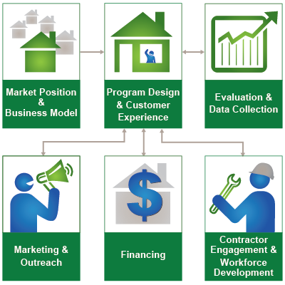

How to Use this Template
The 1st column (Step-by-Step) lists implementation steps to consider in each stage of your planning process. The 2nd column (Activities) provides space to brainstorm the activities required for completing each step. The 3rd column (Duration) provides space to define and track internal and external targets. Note: Launching and improving an energy efficiency program is an iterative process that may not always lend itself to concrete start and end dates for each step provided in the template.

Additional Information
Hyperlinks take you to detailed information about each step, found in the Better Buildings Residential Program Solution Center.
Contractor Engagement & Workforce Development
Engage your most important partners, the workforce that delivers your program’s products and services in customers’ homes. Identify what kinds of support local contractors need to help achieve your program’s goals.
Step-by-Step | Activities | Duration
Assess the Market
- Identify existing home performance contractors in your market
- Find other contractors that could expand their services to include energy upgrades
- Assess the need for new skills and certifications for contractors
- Evaluate existing training and education providers who could become workforce development partners
- Identify organizations that can help find workers and match them to jobs
Set Goals & Objectives
- Review program goals related to contractor engagement and workforce development
- Establish specific contractor engagement and workforce development objectives
- Discuss and refine the goals and objectives with potential contractor and workforce development partners
Identify Partners
- Assess potential contractor partners
- Develop strategies for contractor recruitment
- Establish ongoing relationships with contractors
- Engage and recruit workforce development partners
- Evaluate potential workforce development and employment partners
- Establish partnership agreements with workforce development partners
Make Design Decisions
- Establish standards for ensuring quality work
- Determine contractor participation requirements
- Set guidelines for how your program will interact with contractors
- Decide on contractor incentives and financial support
- Outline contractor engagement and support activities
- Decide on the content and approach for training
- Outline workforce development activities
- Collaborate with contractors and workforce development partners to develop program design
Develop Implementation Plans
- Plan contractor recruitment and enrollment activities
- Plan for program process and business support for contractors
- Outline contractor training, incentives, and financial support
- Establish contractor participation procedures
- Define the quality assurance plan for your program
- Create a workforce development plan
- Plan for ongoing coordination and feedback with contractors and workforce development partners
- Develop a staffing plan, timeline, and budget
Develop Evaluation Plans
- Establish metrics and qualitative evaluation questions based on goals and objectives
- Design measurement strategies and a process and schedule for data review and assessment
- Design an approach for managing and sharing data internally and with partners
- Integrate these metrics and strategies into your overall evaluation plan
Develop Resources
- Hire and train program staff
- Create program forms and materials for contractors
- Create contractor recruitment and enrollment materials
- Plan for regular contractor meetings
- Develop training resources for participating contractors
- Create other resources and processes to support contractors
- Develop contractor marketing support materials
- Develop process evaluation materials
Deliver Program
- Ensure that your program partners, procedures, plans, and resources are ready
- Consider a soft launch or pilot to test systems, workflows, and processes
- Recruit and bring contractors onboard
- Provide program delivery support for participating contractors
- Verify the quality of your program services
- Integrate workforce development with contractor engagement
Assess & Improves Processes
- Track program operations and external feedback from program partners, contractors, and customers
- Review and evaluate the collected data
- Share performance data and feedback
- Make improvement decisions with relevant partners and stakeholders
- Communicate decisions and changes to contractors
Communicate Impacts
- Highlight contractor and workforce development successes
- Communicate program impacts to contractors and training provider partners

