PROPOSAL SUMMARY

PROGRAM ELEMENT: LWS

TITLE OF INVESTIGATION: 3D Reconstruction of White Light Coronagraph Images
from Two Viewpoints

PRINCIPAL INVESTIGATOR/INSTITUTION: John W. Cook / Naval Research Laboratory,
Jeffrey S. Newmark (Co-I), Paulett C. Liewer (Co-I)

SUMMARY OF PROPOSED INVESTIGATION:

Proposal Objectives: We propose to systematically investigate the 3D electron density distribution reconstructions from white light coronagraph images, and their limitations, which are achievable from only two solar viewpoints in the ecliptic plane. The future STEREO mission, due for launch in 2005, will carry twin copies of the SECCHI experiment, each with three white light coronagraphs, onboard two spacecraft. The coronagraph reconstructions have the special difficulties of minimally determined solutions (only two viewpoints) and optically thin lines-of-sight. We employ a reconstruction technique using the PIXON algorithm, a mathematically sophisticated method whose execution time scales only as the number of voxels N, not as a power of N, and which should produce reconstructions from 1024x1024 CCD white light images in less than a day. We will study a progressive series of scientific problems for reconstruction, using both synthetic CCD images from model electron density distributions, and also existing SOHO LASCO coronagraph observations to attempt reconstruction of long-lived structures where solar rotation can mimic the effect of two viewpoints with images taken at different times.

Research plan: We will apply our reconstruction technique to synthetic test data and to existing solar observations for scientific investigation of polar plumes, equatorial streamers, and CMEs. In particular, we will develop our 3D reconstruction technique to incorporate the geometry and physics of solar coronal observations from arbitrary vantage points; investigate initial reconstructions from simple geometrical volumes; use reconstructions of existing SOHO LASCO data to investigate geometry and hydrostatic equilibrium of polar plumes; use reconstructions of existing SOHO LASCO data to study the evolution of equatorial streamers, their relationship to active regions, and their comparison to extrapolated magnetic fields; and investigate the effects of noise, velocity, viewing angle (elongation), image contrast, and background models on the reconstructions of synthetic CMEs produced from MHD models.

Relevance to NASA programs: STEREO is one of the first space missions of the Living With A Star program, and it is imperative that techniques for analysis of the STEREO observations, including those from the SECCHI coronagraphs, be available and well-understood before actual launch of the spacecraft. 3D reconstruction of coronal and heliospheric structures from coronagraph images supports the development of “new techniques and models for predicting solar/geospace disturbances which affect human technology,” where it can be used to distinguish and model Earth-directed CMEs observed by future missions such as STEREO.

TABLE OF CONTENTS

Cover Page/Proposal Summary

Table of Contents

Summary of Personnel and Work Efforts

Scientific/Technical /Management Section

Introduction

Description of the Scientific Investigation

Geometrical Considerations
Synthetic Coronagraph Observations
The PIXON Method
Initial Work with our Reconstruction Technique
Scientific Investigations using our Reconstruction Technique

Description of the Proposed Work

Management Approach

Relevance of the Anticipated Results to NASA Programs

References

Facilities and Equipment

SCIENTIFIC/TECHNICAL/MANAGEMENT SECTION

Introduction

Volumetric reconstruction of structures using imaging from multiple viewpoints has been a major scientific endeavor for many years now. Applications arise in medical, industrial, and scientific contexts. Analysis of solar and heliospheric stereoscopic observations has also been a topic of current interest, especially with the coming launch in 2005 of the STEREO mission, a pair of spacecraft which will gradually separate, behind and ahead of Earth’s orbital position, over the course of several years, obtaining pairs of images from the two viewpoints.

Both STEREO spacecraft will carry twin copies of the SECCHI (Sun Earth Connection Coronal and Heliospheric Investigation) experiment (Howard et al., 2001), which contains three white light coronagraph instruments and an EUV disk imager, EUVI. It is imperative that by launch it is well understood how to best analyze such stereoscopic data.

Stereoscopic analysis can mean one of several different techniques. Binocular stereoscopic visualization of the solar disk has been achieved by simultaneous viewing of images of the solar disk which are slightly separated in angular viewpoint, with each image displayed using a separate color table or polarization state. Viewing simultaneously both images using glasses with different color filters or polarizers produces a very convincing 3D viewing effect (Batchelor, 1994 with Yohkoh SXT images; Artzner, 2001 with SOHO EIT images).

More scientifically interesting, stereoscopic tie point methods of actual 3D volumetric reconstruction have been applied to, for example, LASCO coronagraph images (Liewer et al., 2000). This requires the identification in two or more 2D images from different viewpoints of positions of individual identical points (tie points), where the application of simple trigonometry then provides their 3D locations in space. This method has also been used by Aschwanden and collaborators with EUV images of coronal loops from EIT and TRACE (Aschwanden, 1999, 2000a), and is being adapted to 3D reconstruction of images from the SECCHI EUVI instrument on STEREO.

Finally, it is mathematically possible to invert the individual (CCD) images to obtain an optimal 3D distribution of matter that would best reproduce the observed images, usually called tomographic analysis.

In this proposal we describe an investigation to study the 3D tomographic reconstruction of coronal structures seen in white light coronagraph observations from two viewpoints, such as the STEREO mission will obtain from the SECCHI coronagraphs COR 1, COR 2, and HI (Heliospheric Imager) (Howard et al., 2001). We will discuss our reconstruction technique, using the PIXON algorithm, and show first results from our preliminary work. There are severe limitations on the reconstructions achievable from only two viewpoints. The main goal of our proposal is to systematically examine these limitations by analyzing a progressive series of scientific problems, starting with modeled simple geometrical structures of increasing complexity and realism, going on to actual LASCO coronagraphic observations to reconstruct long-lived structures where the one LASCO viewpoint and solar rotation can mimic simultaneous observations from multiple viewpoints (polar plumes, equatorial streamers), and finally, reconstruction of theoretical MHD models of coronal mass ejections (CMEs). The study of Earth-directed CMEs is the primary scientific goal of the STEREO mission.

Our tomographic reconstruction problem with white light images has several special features which separate it from most existing tomographic applications. The most important are an optically thin integration along the lines-of-sight for each pixel in the brightness image from any given viewpoint, and the limitation, often, to reconstruction with images from only two individual viewpoints, resulting in a minimally determined solution.

The physics of the brightness integration along lines-of sight is well understood (Billings, 1966): K corona brightness at visible wavelengths (white light) arises from Thomson scattering by hot electrons of the incident photospheric spectrum. There is a complicated geometry of solar surface contributions to the light scattered into the lines-of-sight toward the detector, and the scattered light is polarized into radial and tangential components. The angular dependence of the scattering weights the brightness contributions from each voxel along the lines-of-sight to emphasize structures nearest the plane of the sky seen from the given viewpoint. For white light input images, a 3D reconstruction consists of the electron density distribution within the spatial volume observed.

Presently, most 3D solar corona reconstruction techniques fall under the loose term of solar rotational tomography (SRT). Frazin (2000) provides an excellent review of the history of 3D reconstructions of the white light corona and the use of SRT. For our concerns, the main limitation of the various SRT techniques is that they all require many (>>3) viewpoints and assume limited evolution of the reconstructed object throughout the observation period. Frazin and Janzen (2001) show reconstructions of the large-scale electron density distribution derived from LASCO C2 images using SRT. These reconstructions used data taken over half a solar rotation, and in order to make the problem tractable by their method used 4x4 binned images of the original 512x512 observations. These authors specifically point out the difficulty that SRT has in reconstructing dynamic phenomena such as CMEs, and in fact delete frames containing CME’s from their reconstructions. A second variation of SRT has been used in a series of papers (e.g. Jackson and Hick, 2000, 1997) in reconstruction of co-rotating structures in the interplanetary medium using Helios Photometer and Interplanetary Scintillation (IPS) velocity data. These reconstructions use solar rotation (time series) and solar wind flow to provide the multiple viewpoints necessary to constrain the models, and are limited to only the co-rotating, slowly evolving structures, i.e. not dynamically changing CMEs. Jackson and Froehling (1995) used a combination of Solwind coronagraph observations and data from the two Helios spacecraft to perform a low resolution (40x10x10 elements) reconstruction of a CME.

For our problem, the limitation to only a few viewpoints, often only two, fundamentally affects the tomographic reconstruction, and this has not been studied carefully in the context of white light coronagraph observations. The above examples of reconstructions with SRT techniques have several limitations for our purposes: they have studied problems using input images from a number of individual viewpoints, and their reconstruction calculations take an amount of time, even with severely reduced 3D volume array sizes, which would be impractical for 1024x1024 pixel CCD array reconstructions (with order 10⁹ volume elements or voxels), as with SECCHI observations.

We make no claim that the 3D electron density reconstructions we obtain using the PIXON algorithm are necessarily superior to reconstructions with other algorithms. The critical point is that the reconstruction calculation is quick, and scales only as the total number of voxels N, not as a power of N. Our method offers the promise of achieving tomographic reconstructions during the STEREO mission at high resolution in a practical (less than a day of computation) amount of time.

STEREO is one of the first space missions of the Living With A Star program, and it is imperative that techniques for analysis of the STEREO observations, including those from the SECCHI coronagraphs, be available and well-understood before actual launch of the spacecraft. 3D reconstruction of coronal and heliospheric structures from coronagraph images supports the LWS goal of development of “new techniques and models for predicting solar/geospace disturbances which affect human technology,” where it can be used to distinguish and model Earth-directed CMEs observed by future missions such as STEREO.

We will make publicly available the reconstruction techniques and results developed in this proposal, and will produce a series of test problems with starting model coronagraph CCD images and our reconstructed electron density distribution solutions. These should be useful for any independent efforts to study the optimal analysis of white light coronagraph observations from multiple viewpoints.

Description of the Scientific Investigation

We propose to develop our existing technique for the 3D reconstruction of the electron density of coronal structures from white light coronagraph observations to investigate the reconstructions, and understand their limitations, which are possible from only two viewpoints. We will begin with initial work to further develop our reconstruction program. We will then apply our reconstruction technique to synthetic test data and to existing solar observations for scientific investigation of polar plumes, equatorial streamers, and CMEs. In particular we will:

- Develop our 3D reconstruction technique to incorporate the geometry and physics of solar coronal observations from arbitrary viewpoints;
- Investigate initial reconstructions of simple geometrical volumes;
- Use reconstructions of existing SOHO LASCO data to investigate geometry and hydrostatic
equilibrium of polar plumes;
- Use reconstructions of existing SOHO LASCO data to study the evolution of equatorial streamers over the solar cycle, their relationship to active regions, and their comparison to extrapolated magnetic fields;
- Investigate the effects of noise, velocity, viewing angle (elongation), image contrast, and background models on the reconstructions of synthetic CMEs produced from MHD models.

We discuss next the further development of our reconstruction technique in the areas of geometry and white light rendering. We use a reconstruction algorithm based on “minimum complexity” to reconstruct a model of the coronal density which is consistent with the white light observations. We explain this PIXON algorithm, which is the engine of our reconstruction technique. We discuss our initial calculations for geometrical cylinders (“polar plumes”) and hemispherical shells (“CMEs”), which illustrate several points we wish to make about reconstructions from only two viewpoints. This powerful tool will allow us to perform a number of scientific investigations. We discuss our planned analyses using synthetic models and existing LASCO observations to study polar plumes, equatorial streamers through the solar cycle, and CMEs.

To explore the reconstruction of CMEs, more sophisticated models are needed. We will use CME models computed using the BATS-R-US time-dependent 3D MHD model developed at the University of Michigan (Gombosi et al., 1994, and references therein). This code, which runs on parallel computers, has recently been applied to the study of CME propagation from the Sun to 1 A.U. (Groth et al., 1999). We will model CME propagation through a background corona and create a time series of stereoscopic white light images using the density structure from the MHD model. The block-adaptive-grid BATS-R-US code is well suited to CME modeling because of the many different spatial scales spanned by this problem. The adaptive grid allows the user to place high-resolution grid blocks only in the regions where they are needed.

Geometrical Considerations

The STEREO observations are obtained from two viewpoints (perhaps using images taken from one moving viewpoint, at different times, with existing LASCO observations) in approximately circular orbits around the Sun at a distance of 1 A.U. The fields-of-view of the instruments (real or synthetic observations) may extend from the Sun to the Earth’s orbit; such large fields-of-view require a full spherical geometry treatment. Determining the geometrical relations (see Figures 1 and 2) between the spacecraft observations and the coronal and heliospheric structures is our first step. We can then define the volume of interest, and determine the sampling of each voxel in the lines-of-sight.

Synthetic Coronagraph Observations

To perform the reconstructions, it is necessary to calculate (render) from starting electron density distributions the resulting synthetic coronagraph images. Coronagraphs measure the total brightness or the polarization brightness pB integrated over the line-of-sight through the optically thin corona. The polarization brightness is given by:

where B, K, and F are the intensities of the total corona, the K corona, and the F corona, respectively, and p, p_{k}, and p_{f} are the percentage polarizations of the total corona, the K corona, and the F corona, respectively. An F corona model has been developed (Lamy et al., 1997) which is an extension of the F model developed after the Skylab mission (Saito et al., 1977) and the model of Koutchmy and Lamy (1985). Neglecting the F corona term results in the familiar formula:

pB = B_{t} – B_{r} = C ∫ N_{e}(x,y,z) G(x,y,z) dz

where B_{t} and B_{r} are the tangential and radial components of the polarized intensity, C is a constant involving the Thomson cross-section for electron scattering and various scaling factors, N_{e} is the electron density at a point in the corona, G is a geometric function to the point along the line-of-sight and involves the solar surface limb darkening coefficients, and z is the distance along the line-of-sight (Billings, 1966).
Figure 2. Geometry viewed from the north ecliptic pole.

Figure 1. Geometry and perspective viewed from near the ecliptic plane.

The PIXON Method

We employ the PIXON algorithm in our reconstruction technique. The tomographic reconstruction of the electron density in each voxel in the volume of interest is a computationally intensive problem. The number of voxels N can be 10⁹ for 1024x1024x1024 resolutions. The problem is difficult because for most methods (i.e. FFT) the number of operations scales as N². The techniques that can be used for such reconstructions are in their infancy. In the past, maximum entropy methods have been used in astronomical problems. For example, the international radio astronomy community uses maximum entropy methods for the reconstruction of large images based upon incomplete Fourier-synthesis observations.

The PIXON method utilizes model reconstructions based upon sets of spatially extended, overlapping, and transparent components called “pixons” (see Figure 3). Furthermore, by minimizing the number of degrees of freedom used through constructing the simplest model (minimum complexity), the PIXON solutions will have less noise and fewer artifacts than those found with other methods. By applying strict statistical criteria, the PIXON method minimizes the number of pixons needed to describe the structure, and is able to achieve better sensitivity and resolution than other methods.

The PIXON method is an iterative algorithm. With each iterationis calculated from the differences between the synthetic coronagraph observations and the actual observations. The PIXON method differs from maximum entropy in the goodness-of-fit metric, which is defined in terms of the pixon number. The final solution has the lowest pixon count. At each step strict statistical acceptance criteria are applied and pixons that do not meet them are rejected. This is done using a locally adaptive technique. In this manner, the number of pixons, parameters, and degrees of freedom used to describe the reconstruction is optimized. The reconstruction itself is derived by summing the contributions of the various pixons that overlap the voxels of interest. Finally, the computation time scales as N, not as a power of N.

This description of the PIXON method is necessarily brief. The formalism and methodology are described in detail by Richard Puetter and his collaborators (Pina and Puetter, 1993; Puetter, 1995; Puetter, 1996; Puetter, 1997; Puetter and Yahil, 1999). A previous application of the PIXON method to solar data can be found in Metcalf et al. (1996), who applied it to Yohkoh HXT data.
Figure 3. Use of pixons to model a conical structure.

The PIXON algorithm is a general-purpose reconstruction package. For our application it needs the geometrical, physical, and rendering additions described above. The package itself must be customized for our problem in at least four aspects: the definition of the pixon set; acceptance criteria for retaining pixons; weights for additional constraints (Lagrange multipliers); and the initial models, which may be uniform, the result of a prior reconstruction, a physical model, etc.

Initial Work with our Reconstruction Technique

PIXON software is being commercially developed by the company PIXON LLC. We have obtained the PIXON software package and have begun the process of understanding and utilizing the code, with very useful help from PIXON LLC. We discuss some of our initial work, which will illustrate aspects of reconstruction from two viewpoints which we discussed above.

We illustrate 3D 64x64x64 reconstructions of simple geometrical objects. We can use real physics with two polarization states, but currently only a point source Sun and geometry for viewing from infinity (all lines-of-sight from viewpoints in the ecliptic plane are parallel). Starting model objects have uniform density inside, while outside array densities are zero. We use some specific PIXON jargon to describe our work. The CCD white light 2D observation rendered from an electron density distribution is called the DATA; the 3D electron density distribution itself is called the IMAGE.

We reconstructed two model tilted cylinders of uniform density (toy “polar plumes”) using the “standard” PIXON code before any customization was performed. In this early calculation we used only a linear integration along the line-of-sight with no polarization (no physics). The input data to PIXON consisted of the 2D rendered views (DATA) as seen from two viewpoints (x,y axes) at 90 degrees. The PIXON code then reconstructs a 3D density distribution solution (IMAGE). This reconstruction process is shown in Figures 4 (rendered DATA views of the starting model and final solution) and 5 (IMAGE 3D electron density distribution visualizations of the starting model and final solution). The IMAGE visualization uses the IDL SHADE_VOLUME procedure with a chosen view angle which effectively shows the structure. We also show in Figure 4 a z axis viewpoint DATA rendering of the IMAGE. Because this is not actually used in the reconstruction, a comparison of the z axis DATA rendered from the starting model and the DATA rendered from the final reconstruction shows the difference between the starting and reconstructed IMAGE along the viewpoint from which the reconstruction was least constrained.

The initial and reconstructed DATA from the x,y axes viewpoints are near-identical. However, the z axis DATA, and the reconstructed IMAGE, show that the solution found from two input viewpoints consists of four separate structures, not the initial two cylinders. The reconstructed IMAGE is a perfectly real solution, and renders a near-identical DATA to the input DATA. For two input viewpoints, it is actually a simpler solution than the initial two cylinders.

Figures 6 (DATA) and 7 (IMAGE) demonstrate a reconstruction using DATA rendered from the same two cylinders model, but this time using three viewpoints (0, 40, 90 degrees). The third viewpoint was added as a test of our reconstruction technique and to aid in our understanding of the previous calculation. Now we find a solution IMAGE which is much more like the initial IMAGE. This illustrates clearly the limitations of reconstructions from only two viewpoints, where the solution is only minimally determined. Later in this proposal we will briefly discuss several ideas we intend to investigate to guide the two viewpoint reconstruction to a solution which, perhaps, makes more physical sense. But it is important to realize that the counter-intuitive four structure solution for two viewpoints is in fact a mathematically justified solution. In addition, we note that the third viewpoint input DATA might be provided during the STEREO mission from a still-operating SOHO LASCO coronagraph.

Finally, Figures 8 (DATA) and 9 (IMAGE) illustrate reconstruction of a hemispherical shell (toy “CME”) at an oblique (30,30 degrees) angle from the Sun as seen from two viewpoints (x,y axes) at 90 degrees. In this reconstruction we included the physics of Thomson scattering of photons from a point source Sun, and tangential and radial polarization states. The DATA renderings for simplicity show just the total intensity, not the polarization components. The inputs to this reconstruction then are four CCD images, two polarizations each from two viewpoints (x,y axes) at 90 degrees. The superposed circles represent on the scale of this calculation the solar diameter and a representative occulter at 1.3 R_{O}. Again, the difference between the initial model IMAGE and the final IMAGE solution, seen in the z axis DATA in Figure 8 and the IMAGE visualizations in Figure 9, this time from two representative view angles, shows the limitation of reconstructions from only two viewpoints.

Although these results are preliminary, they give us confidence that our reconstruction technique can accomplish the difficult tasks we propose.

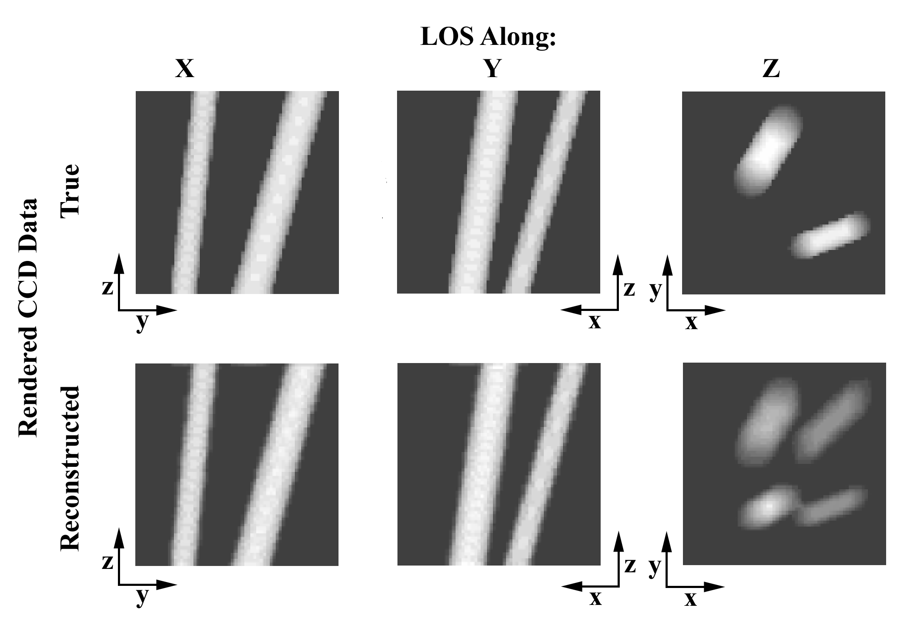

Figure 4. Starting (True) and Reconstructed DATA, from x, y, and z axis viewpoints, for the two tilted cylinders. Reconstruction uses two input viewpoints separated by 90 degrees.
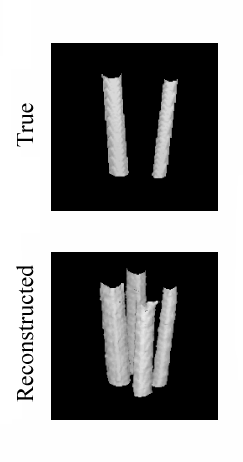

Figure 5. Visualization of the 3D starting (True) and Reconstructed IMAGE, for the two tilted cylinders. Reconstruction uses two input viewpoints separated by 90 degrees.

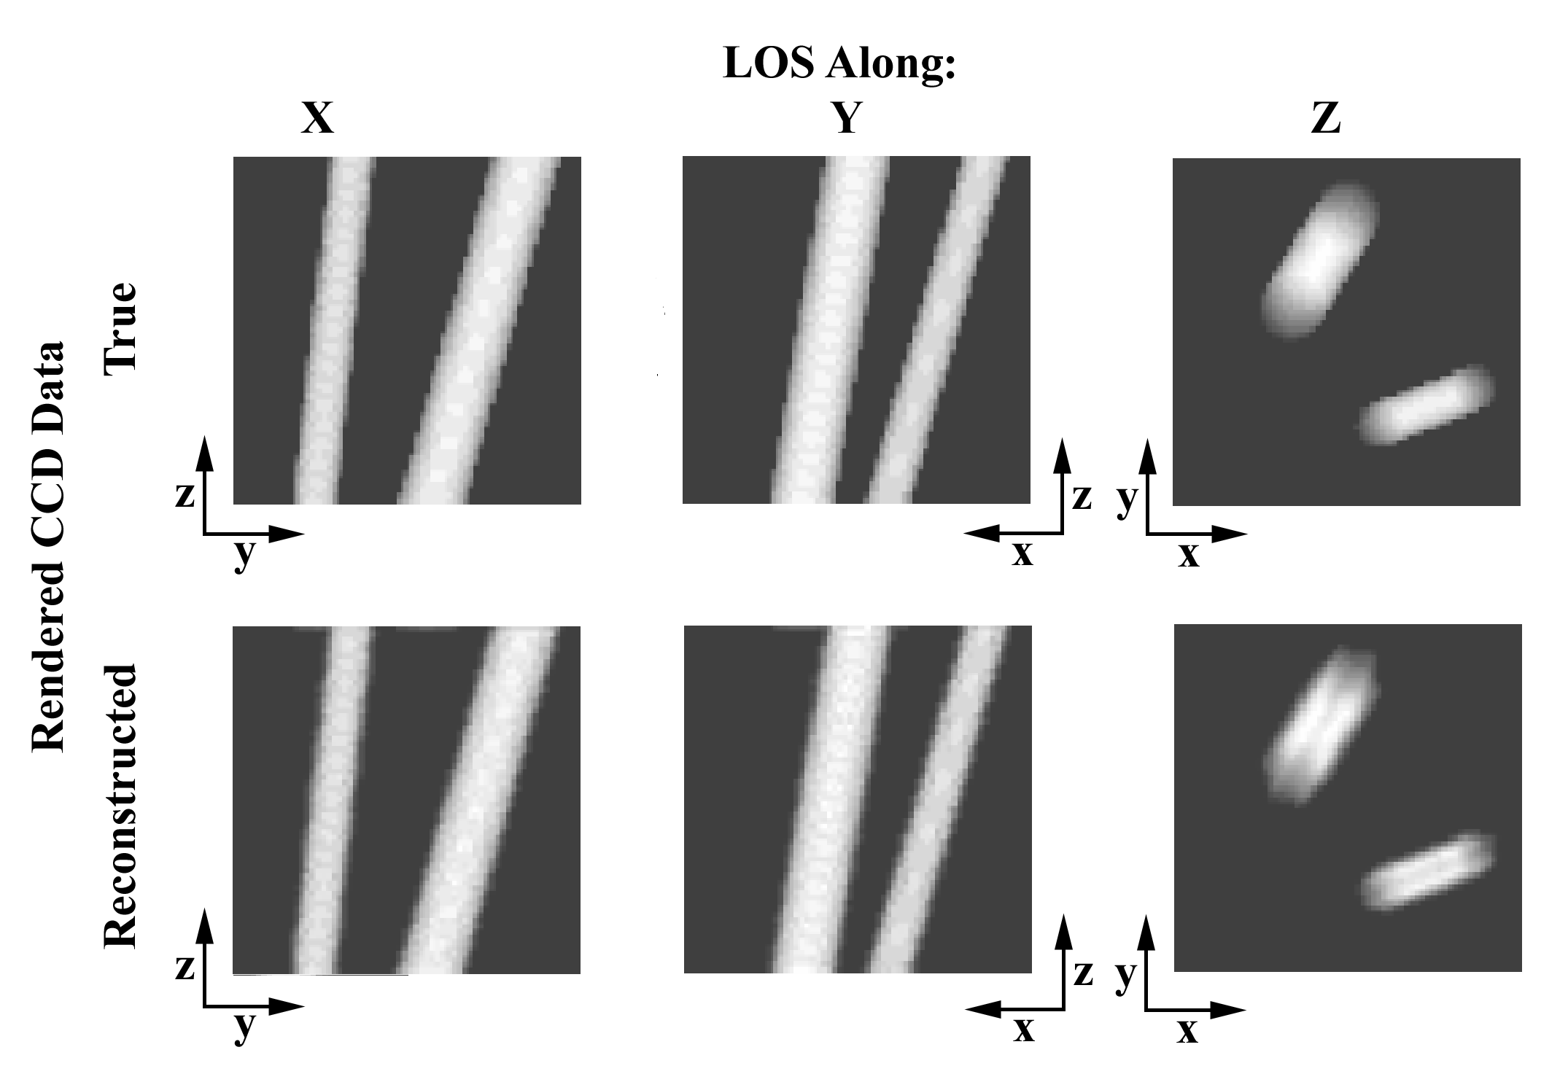

Figure 6. Starting (True) and Reconstructed DATA, from x, y, and z axis viewpoints, for the two tilted cylinders. Reconstruction uses three input viewpoints separated by 40 and 90 degrees.
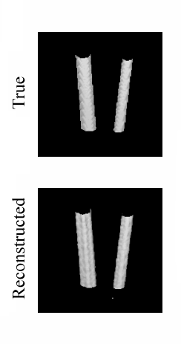

Figure 7. Visualization of the 3D starting (True) and Reconstructed IMAGE, for the two tilted cylinders. Reconstruction uses three input viewpoints separated by 40 and 90 degrees.

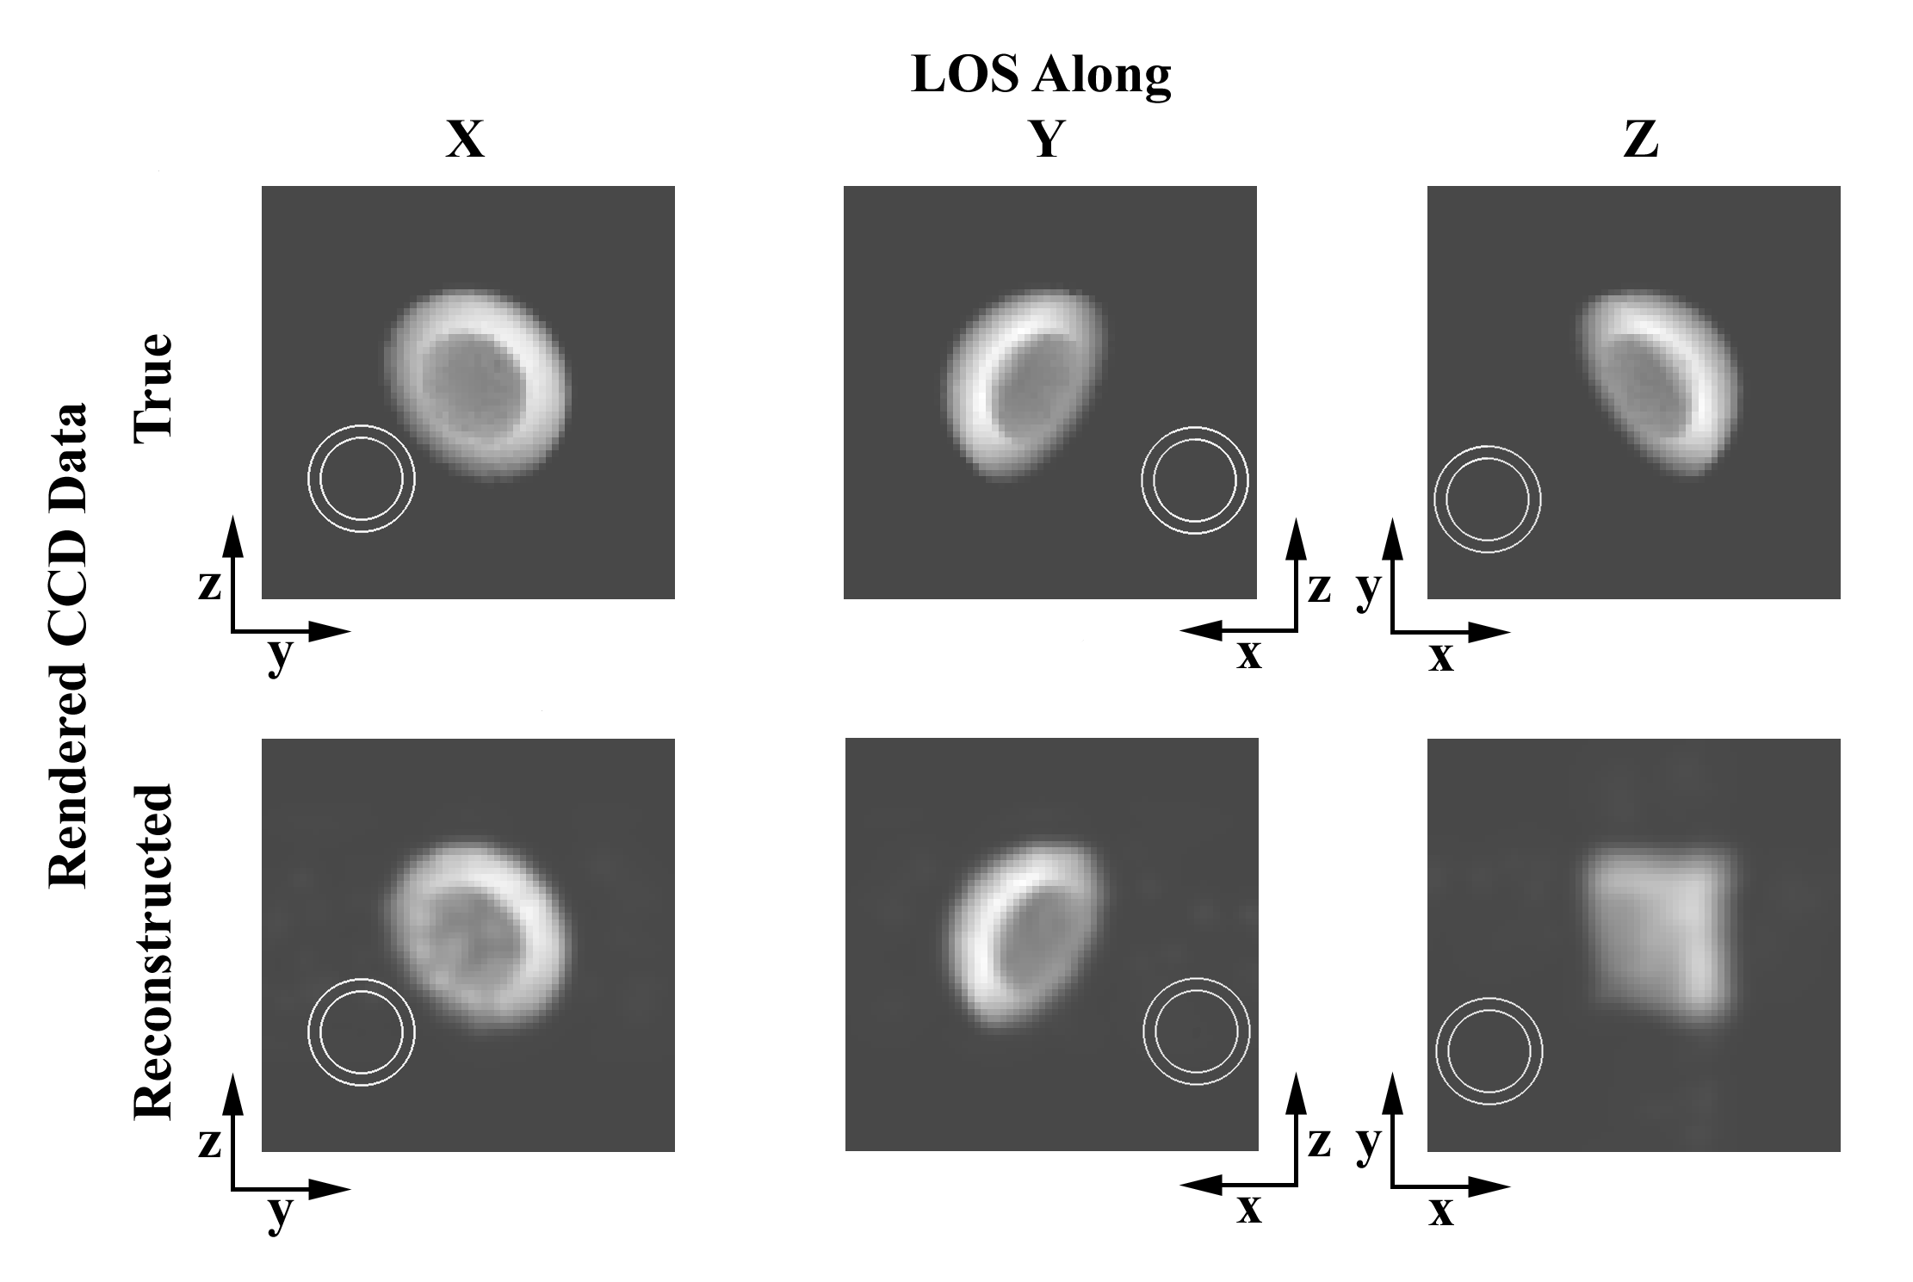

Figure 8. Starting (True) and Reconstructed DATA, from x, y, and z axis viewpoints, for the hemispherical shell. Reconstruction uses two input viewpoints separated by 90 degrees.
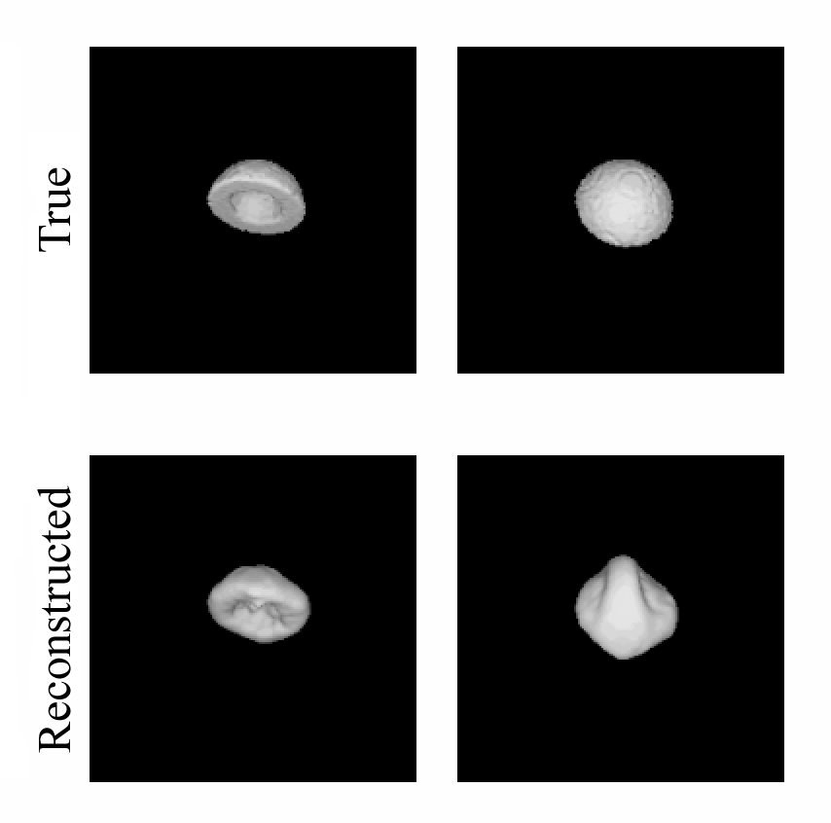

Figure 9. Visualization of the 3D starting (True) and Reconstructed IMAGE, for the hemispherical shell, for two representative viewing angles on the 3D IMAGE. Reconstruction uses two input viewpoints separated by 90 degrees.

The execution times we found were consistent with the scaling, using current notebook PCs as the platform, suggested to us by PIXON LLC: 64x64x64 reconstructions in 2 minutes. This scales to 2 min x 16³ for a 1024x1024x1024 reconstruction. We assume that a factor of 4 improvement in chip speeds is reasonable by 2005, which would then give 34 hours execution time. We have so far made no attempt to optimize our calculations. Remembering that some fraction of the coronagraph field is occupied by the occulter, and that many white light scenes have only a limited area of detailed structures, it is reasonable that we can speed the calculations by a factor of two from applying numerical techniques for sparse arrays, and perhaps from computational acceleration by use of a Beowulf network. Our goal is to achieve a practical computational scheme which performs a 1024x1024x1024 reconstruction in 16 hours or less.

Scientific Investigations using our Reconstruction Technique

We will apply our reconstruction technique to synthetic test models and to existing solar observations for scientific investigation of polar plumes, equatorial streamers, and CMEs. We discuss the science goals which we believe that we can achieve with 3D reconstructions, as well as some of the associated analysis techniques which we hope to employ.

SOHO LASCO coronagraph observations. For sufficiently long-lived structures, a series of observations from one vantage point can be used to mimic pairs of observations from two separated viewpoints. In particular, LASCO coronagraph observations over rotational time periods can be used to mimic pairs of simultaneous images from two viewpoints in the ecliptic plane. LASCO images should yield meaningful reconstructions for polar plume and equatorial streamer observations. Because of their rapid temporal evolution, LASCO observations of CMEs cannot mimic two separated vantage points.

Background components. We will examine division of the observed intensities between a slowly evolving background component, effectively constant on the time scale of interest, and a primary, perhaps evolving, structure. Background does not refer to emission from structures behind the structure of primary interest, but instead to a constant specified component of the total intensity of the heliosphere. In particular cases the background might be a constant F corona model (Koutchmy and Lamy, 1985); or F corona plus a general ellipsoidal global heliospheric electron density as a function of radius, polar angle, and activity level (e.g., Saito, 1950, Saito et al., 1977), to model equatorial streamers; or F corona, ellipsoidal heliospheric corona, and equatorial streamers, to model CMEs.

Extrapolated coronal magnetic fields. We will use extrapolated coronal potential field calculations from photospheric magnetograms to better understand the physical significance of the reconstructed solutions, and would expect to achieve plausible consistency of the reconstruction and the extrapolated coronal fields. Specifically, we expect that equatorial streamers will lie along the coronal current sheet as determined from a potential field calculation. However, the extrapolated fields are not accurate enough to use as an actual constraint, since they are calculated from the longitudinal, not vector, magnetogram, and often disagree in the low corona with actual observations of the positions of coronal loops (see illustration in Aschwanden et al., 2000b).

The plasmas in the solar corona and heliosphere are organized into a variety of morphological structures, which evolve over a range of time scales. We propose to apply our 3D reconstruction work to the study of three types of coronal structures: polar plumes, equatorial streamers, and CMEs. The physical understanding of all three structures can be greatly furthered by the simple geometrical determination of their morphologies, which is the most direct product of 3D reconstruction. In addition, each will aid in the development and testing of our reconstruction algorithm.

(1) Polar plumes appear to be linear tubes, anchored in polar coronal holes, which do not appreciably expand in diameter with increasing radial distance (Karovska et al., 1999). Plumes appear in 2D images to converge to a common interior point between disk center and the pole, and are not truly radial. They often can be observed as an individual structure over at least a solar rotation.

Science: With a true 3D reconstruction, we will re-examine the above claims. Does the reconstruction support a hydrostatic equilibrium solution of density vs. height? If so, for what temperature? How far can individual streamers be traced outward? Is there any detectable expansion of the tube? Using the Carrington map technique to aid in following the histories of individual plumes as far as possible until disappearance, can we establish statistical properties of lifetimes? The extrapolated coronal field is usually taken to be radial outward from the potential source surface, at approximately 2.5 R_{O}. Yet the polar plumes do not appear to be radial, even at these distances. Can we reconcile these two points, and are there any implications for extrapolation models?

LASCO provides plentiful observational material; we will select observations from early in the SOHO mission at solar minimum when the plumes are most visible and the global structure simplest.

(2) Equatorial streamers are usually assumed to be projections of sheets, extending into the heliosphere, of enhanced density along the global magnetic field neutral surface (coronal current sheet) (i.e., Pneuman and Kopp, 1971, Wang et al., 1997). The coronal current sheet is more equatorially symmetric at solar minimum, but is deformed at higher activity levels by the strong active region magnetic fields to form a more folded, complex structure. The appearance of equatorial streamers viewed from Earth depends upon the exact line of sight through a complex structure. In existing LASCO coronagraph observations individual streamers can be observed, in the long lines of sight above or below the solar poles, out to at least 60 R_{O}. They are approximately constant on solar rotation time scales.

We first illustrate an impressive example of work already done that incorporates the tie point methods we have earlier described. Figure 10 shows results by Liewer et al. (2000), using LASCO coronagraph images and a coronal potential field calculation at the time of Carrington rotation 1935. The heliospheric coordinates of 8 individual radial equatorial streamers were determined from synoptic coronagraph observations. At top left is a Carrington format map of the coronal field at 2.5 R_{O}, taken as the potential source surface, where the dark band is the coronal current sheet. The positions at 2.5 R_{O} of the 8 equatorial streamers are shown. At bottom left the coronal field at 2.5 R_{O} is shown on a sphere together with the projected radial paths of the 8 streamers. At top right the synoptic photospheric magnetogram is shown, while at bottom right the synoptic magnetogram is re-mapped onto the 1 R_{O} solar sphere. Again, the same 8 streamers are shown on both. The paths of the flux lines located on the source surface at 2.5 R_{O} at the 8 points are followed along the extrapolated field back to the photospheric surface. (Note that the x-y planes of the two bottom figures are rotated!) This is a beautiful 3D geometric illustration that equatorial streamers at 2.5 R_{O} are connected by field lines tracing back to flux concentrations at the photosphere.

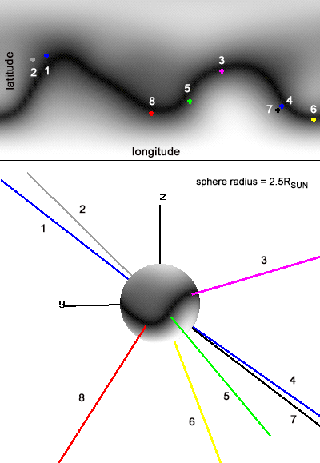
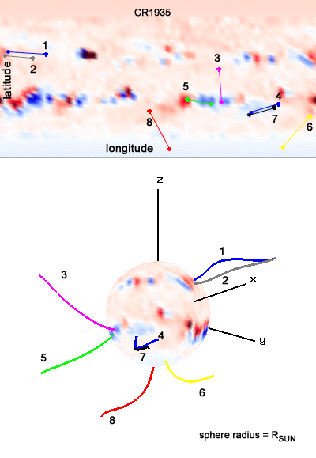

Figure 10. Carrington map and streamer reconstruction.

In our study of limitations on tomographic reconstructions from only two viewpoints, we intend to investigate whether it may be possible to incorporate tie point identifications into the reconstruction as additional constraints on the solution.

Science: We will study the evolution over the solar cycle of our reconstructions of the equatorial streamer, and in particular, the relationship with the coronal global magnetic field from extrapolated photospheric magnetograms. Are the reconstructed equatorial streamers along the global coronal current sheet throughout the solar cycle? How do active regions complicate the streamer geometry? What is the relative importance in streamer visibility between local density enhancement in the streamer, perhaps associated with active regions (Liewer et al., 2000), vs. lines of sight through multiple streamer folds (Wang et al., 1997)? The synoptic LASCO observations throughout the mission cover solar minimum in 1996 to the current peak activity levels of this cycle. Using observations over a solar rotation to mimic two vantage points, we can produce a series of streamer reconstructions and extrapolated coronal magnetic fields for every Carrington rotation.

(3) Coronal mass ejections (CMEs) are disturbances originating from the lower solar atmosphere which travel outwards through the heliosphere. They are often viewed by the outer C3 coronagraph on LASCO at up to 30 R_{O}, but clearly continue to travel to much greater distances. They evolve at very short time scales.

Observation and understanding of CMEs is really the principal goal of the upcoming STEREO mission. The primary difficulty in the 3D reconstruction of CMEs is their rapid evolution and high speeds. Although LASCO has obtained extensive observations of CMEs over a range of activity levels, here observations over a rotational cycle cannot substitute for simultaneous observations from two viewpoints. Instead, we will generate synthetic CME images, with and without added noise various backgrounds, and image constrasts, for use in testing our reconstruction technique. The advantage is that we know in this case the exact solution. We described earlier in our Introduction the calculational effort for the MHD CME models.

CMEs which are directed toward Earth can have major terrestrial effects. The Heliospheric Imagers of the SECCHI experiment on STEREO are intended to view at two orbital positions the Sun-Earth line from 12 – 318 R_{O} (well past Earth at 215 R_{O}), specifically to study the propagation of CMEs which are Earth-directed. 3D reconstructions at these great elongations push the geometrical and other constraints to extremes, and we will investigate the accuracy of reconstructions from such high elongation observations.

Science: We will examine with synthetic data the effect of rapid temporal evolution and high outward velocities (1000 km s⁻¹) on the reconstruction. We will examine the degree of agreement of a modeled CME structure, such as an evolving Chen model CME flux rope (Chen et al., 1999, Wood et al., 1999), with existing LASCO CME observations. We will investigate model accelerations and trajectories into the outer corona and heliosphere using synthetic CME observations, and the reliability of reconstructions in matching the known model solution. What are the constraints on the viewpoint separation needed to best reconstruct the model from the synthetic observations?

DESCRIPTION OF THE PROPOSED WORK

This proposal will fund a three year effort. The goals for each year are:

1. In the first year we will complete development of our reconstruction program. We have already included the Thomson scattering physics for both polarization states, but are using a point source Sun and geometry for viewing from infinity (all lines-of-sight are parallel). We will:

- Include a real solar and heliospheric geometry, and incorporate the solar photospheric spectral distribution observed through a model instrumental passband;
- Incorporate the true heliospheric lines-of-sight geometry for arbitrary viewpoints;
- Investigate reconstructions using input model DATA generated from simple geometrical model structures such as cylinders and hemispherical shells;
- Organize the effort for the MHD model CME calculations.

2. The focus of the second year will be on the application of our reconstruction technique to LASCO observations of polar plumes and equatorial streamers. We will:

- Investigate questions of geometry and hydrostatic equilibrium within polar plumes;
- Investigate the reconstruction of equatorial streamers over the solar cycle, and their responses to increasing levels of solar activity. We will compare the streamer results with extrapolated coronal field calculations;
- Produce the CME models.

3. In the third year we will investigate the reconstructions of our model CMEs using the input synthetic CME observations and compare with the initial model CME, including the quality of the reconstructions at large elongations, out to 1 A.U. (i.e., Earth). Other aspects of the importance of stereographic angle on these more complicated structures, including the improvement to be gained by adding a third vantage point (e.g. STEREO plus LASCO, SDO, ground-based coronagraphs and eclipse observations, solar sentinels), will be examined.

MANAGEMENT APPROACH

All members of the proposal team are very experienced with coronal physics, coronagraph observations, and scientific analysis of coronal observations, and have participated in the LASCO and EIT experiments on SOHO. The proposal team members also are closely associated, as Co-I’s, with the SECCHI investigation on the STEREO mission.

John Cook is a member of the Solar Physics Branch of the Space Science Division at NRL and head of the Solar Radiation Section. He has worked on both LASCO and EIT scientific investigations over the last several years, and especially on emission measure analyses of coronal temperature structure and instrumental calibration, using EIT observations, in collaboration with Jeff Newmark. He will work on development of the 3D reconstruction program and of model input observations. His main focus during the second and third years will be the scientific interpretation of the polar plume, streamer, and CME reconstructions. He will be responsible for the execution of the effort outlined for this proposal, but will work closely with the proposal co-investigators in all phases to make best use of the extensive knowledge of the individual team members. This proposal would fund three months for this work for three years.

Jeff Newmark is a member of the Solar Physics Branch of the Space Science Division at NRL. He is a Co-Investigator on the SOHO EIT experiment, and a Co-Investigator on the SECCHI instrument for STEREO. He developed the in-flight calibration of SOHO EIT, and has worked on emission measure analyses of coronal observations, both in collaboration with John Cook. He will work on development of the 3D reconstruction program, supervise most of the numerical calculations, and participate in the interpretation of the reconstruction results at all stages of the effort. This proposal would fund three months for this work for three years.

Paulett Liewer is in the Space Physics Element, and Deputy Program Manager for Space Physics, at JPL. Her principal task is to provide the MHD theoretical model of a CME to use in our CME reconstruction work. She will organize her calculational effort in the first year, produce the CME models the second year, and participate the third year in the analysis of the reconstructed CME structures and comparison with the initial model CMEs. This proposal would fund two weeks for this work for three years.

RELEVANCE OF THE ANTICIPATED RESULTS FOR NASA PROGRAMS

This proposal will systematically investigate the 3D reconstructions possible with white light coronagraph observations from two viewpoints, which will be available from the SECCHI instrument on the STEREO mission. STEREO is one of the first space missions of the Living With A Star program, and it is imperative that techniques for analysis of the STEREO observations, including those from the SECCHI coronagraphs, be available and well-understood before actual launch of the spacecraft. 3D reconstruction of coronal and heliospheric structures from coronagraph images supports the development of “new techniques and models for predicting solar/geospace disturbances which affect human technology,” where it can be used to distinguish and model Earth-directed CMEs observed by future missions such as STEREO.

This proposal is not intended to develop the actual code that will perform the SECCHI-specific reconstruction analysis. That will be done using the experiment development funding. We will investigate our approach to reconstruction techniques which must be implemented by the SECCHI software before launch, and develop the understanding necessary to make scientifically optimized observing plans for the SECCHI coronagraphs over all phases, and associated viewpoint angles, of the STEREO mission.

This LWS Targeted Research and Techniques opportunity calls for the exploitation of data from present and past missions to improve knowledge. Our study of equatorial streamers over a solar cycle addresses the LWS science objectives “How and why does the Sun vary?” and “To improve knowledge of space environmental conditions and variations over solar cycle”.

PROPOSAL REFERENCES

Artzner, G. 2001, LASCO/EIT Consortium Meeting.
Aschwanden, M.J., Newmark, J.S., et al.: 1999, "3-D-Stereoscopic Analysis of Solar Active Region Loops: I. SOHO/EIT 171 A Observations at Temperatures of 1.0-1.5 MK," Ap. J. 515, 842.
Aschwanden, M.J., Nightingale, R.W., and Alexander, D., 2000a, “Evidence for Nonuniform Heating of Coronal Loops Inferred from Multithread Modeling of TRACE Data,” Ap. J. 541, 1059.
Aschwanden, M.J., Hurlburt, N., Alexander, D., Newmark, J.S., Neupert, W.M., Klimchuck,
J.A.,& Gary, G.A., 2000b, "3D-Stereoscopic Analysis of Solar Active Region
Loops: II. SOHO/EIT Observations at Temperatures of 1.5-2.5 MK," Ap. J., 531, 1129.
Batchelor, D.: 1994, “Quasi-Stereoscopic Imaging of the Solar X-Ray Corona”, Solar Phys. 155,
57-61.
Billings, D. E.: 1966, A Guide to the Solar Corona, New York: Academic.
Chen, J., Howard, R.A., Brueckner, G.E. Santoro, R., Krall, J., Passwaters, S.E., St. Cyr, O.C., Schween, R., Lamy, P., and Simnett, G.M.: 1999, “Evidence of a Erupting Magnetic Flux Rope: LASCO Coronal Mass Ejection of 1997 April 13”, Ap. J. 490, L191-L194.
Frazin, R.A. 2000, Tomography of the Solar Corona I. A Robust, Regularized, Positive
Estimation Method, Ap. J. 530, 1026.
Frazin, R.A. and Janzen, P., 2001, Tomography of the Solar Corona II. RRPE Reconstruction
of the 3D Electron Density Distribution from LASCO-C2 Polarized White-Light Images, Ap. J. submitted.
Gombosi, T.L., K.G. Powell, and D.L. De Zeeuw, "Axisymmetric modeling of cometary mass
loading on an adaptively refined grid: MHD results", J. Geophys. Res. 99, 21525, 1994.
Groth, C.P.T., D.L. De Zeeuw, K.G. Powell, T.L. Gombosi, and Q.F. Stout, "A parallel
solution-adapter scheme for ideal magnetohydrodynamics", in Proc. AIAA 14th Computational Fluid Dynamics Conference, AIAA Paper No. 99-3273, 1999.
Howard, R.A., Moses, J.D., Socker, D.G., Dere, K.P., Cook, J.W., 2001, Sun Earth Coronal and
Heliospheric Investigation (SECCHI), Adv. Space Res., in press.
Jackson, B.V. and Hick, P.L., 2000, Three Dimensional Tomography of Heliospheric Features
Using Global Thomson Scattering Data, Adv. Space Res. 25, No. 9, 1875.
Jackson, B.V. and Hick, P.L., 1997, Heliospheric Tomography Using Interplanetary Scintillation
Observations, Physics and Chemistry of the Earth 22 (5), 425-434.
Jackson, B.V. and Froehling, H.R., 1995, Three Dimensional Reconstruction of a Coronal Mass
Ejection, A&A 299, p. 885.
Karovska, M., Wood, B., Cook, J.W., Brueckner, G.E.: 1999, “Study of Dynamical Properties of
Coronal Structures in the Polar Regions”, Space Sci. Rev. 87, 219.
Koutchmy, S., and Lamy, P.L.: 1985, “The F-Corona and the Circum-Solar Dust Evidences and Properties”, in Properties and Interactions of Interplanetary Dust, ed. Giese, R.H. and Lamy, P., New York: Reidel, pp. 63-74.
Lamy, P., Quemerais, E., Llebaria, A., Bout, M., Howard, R, Schwenn, R., and Simnett, G.: 1997
"Electron densities in coronal holes from LASCO-C2 images", in Proceedings of the 5th SOHO Workshop, ESA SP-404, p 491.
Liewer, P.C., Hall, J.R., De Jong, E.M., Socker, D.G., Howard, R.A., Vourlidas, A., Crane, P., Reiser, P., and Rich, N.,: 2000, “Determination of three-dimensional structure of coronal streamers and relationship to the solar magnetic field”, JGR, in press.

Metcalf, T.R. et al.: 1996, “PIXON-BASED Multiresolution Image Reconstruction for
YOHKOH’S Hard X-Ray Telescope,” Ap.J. 466, 585.
Pina, R.K., and Puetter, R.C.: 1993, “Bayesian Image Reconstruction: The Pixon and Optimal Image Modeling,” Pub. Astron. Soc. Pac. 105, 630-637.
Pneuman, G.W., and Kopp, R.A.: 1971, “Gas-Magnetic Field Interactions in the Solar Corona”, Solar Phys. 18, 258-270.
Puetter, R.C.: 1995, “ Pixon-Based Multiresolution Image Reconstruction and the Quantification of Picture Information Content,” Int. J. Image Sys. & Tech. 6, 314-331.
Puetter, R.C.: 1996, “Information, Language, and Pixon-Based Bayesian Image Reconstruction,” in Digital Image Recovery and Synthesis III, P.S. Idell and T.J. Schulz, eds., Proc. S.P.I.E. 2827, 12-31.
Puetter, R.C.: 1997, “Modern methods of image reconstruction,” in Instrumentation for Large Telescopes, J.M. Rodríguez Espinosa, A. Herrero, and F. Sánchez, eds., Cambridge University Press, New York, 75-122.
Puetter, R.C., and Yahil, A.: 1999, “The Pixon Method of Image Reconstruction,” in Astronomical Data Analysis Software and Systems VIII, D.M. Mehringer, R.L. Plante, and D.A. Roberts, eds., ASP Conference Series 172, 307-316.
Saito, K.: 1950, “Brightness and Polarization of the Solar Corona”, Ann. Tokyo Astr. Obs., 3, 3.
Saito, K., Poland, A.I., and Munro, R.H.: 1977, “A Study of the Background Corona Near Solar Minimum”, Solar Phys. 55, 121-134.
Wang, Y.-M., Sheely, Jr., N.R., Howard, R.A., Kraemer, J.R., Rich, N.B., Andrews, M.D., Brueckner, G.E., Dere, K.P., Kooman, M.J., Korendyke, C.M., Michels, D.J., Moses, J.D., Passwaters, S.E., Socker, D.G., Wang, D., Lamy, P.L., Llebaria, A., Vibert, D., Schween, R., and Simnett, G.M.: 1997, “Origin and Evolution of Coronal Streamer Structure During the 1996 Minimum Activity Phase”, Ap.J. 485, 875-889.
Wood, B.E., Karovska, M., Chen, J., Brueckner, G.E., Cook, J.W., and Howard, R.A.: 1999, “Comparison of Two Coronal Mass Ejections Observed By EIT and LASCO With A Model Of An Erupting Magnetic Flux Rope”, Ap. J. 512, 484.

FACILITIES AND EQUIPMENT

Naval Research Laboratory

At NRL we have access to existing computer resources, which include a network of Sun workstations with a large amount of disk space, CDROM writing and storage (jukebox carousel) capabilities, and networked printers. A high end (e.g. Pentium 4, 2 GHz, 2 GB RAM, networked) dedicated PC is being purchased from another funded NRL project. The initial software development and testing will use this machine. It is possible as the project matures beyond the initial software development that we will take advantage of additional NRL facilities. A resource co-located in the NRL Space Science Division and available to us will be a Large Memory Computer which is an 8 Alpha processor Compaq computer with approximately 128 GB of memory. This workstation is intended for large data sets, including assembling large CCD images into movies or data cubes and 3D modeling and reconstruction.

Jet Propulsion Laboratory

All of the computational resources necessary for this project, including workstations and parallel supercomputers, are available to Liewer through JPL without additional investments. Most of the computations will be done on the JPL 128 processor SGI Origin 2000 or the JPL Cray SV1 16 processor vector computer. The JPL Solar System Visualization Project 40-node Beowulf cluster (2 cpu/node, 1 GHz/cpu, 1 GB/node) is also available to us for this project. JPL also has several SGI workstations available for analysis.

