
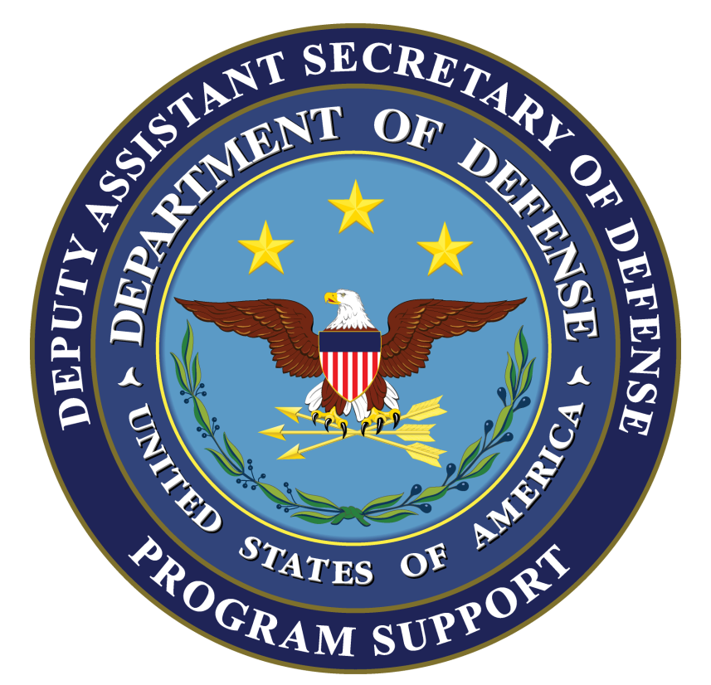
CONTRACTOR SUPPORT OF U.S. OPERATIONS IN THE USCENTCOM AREA OF RESPONSIBILITY,

IRAQ, AND AFGHANISTAN

BACKGROUND: This update reports DoD contractor personnel numbers in theater and outlines DoD efforts to improve management of contractors accompanying U.S. forces. It covers DoD contractor personnel deployed in Iraq (Operation New Dawn (OND)), Afghanistan (Operation Enduring Freedom (OEF)), and the U.S. Central Command (USCENTCOM) area of responsibility (AOR).

KEY POINTS:

In 4th quarter FY 2011, USCENTCOM reported approximately 175,000 contractor personnel working for the DoD in the USCENTCOM AOR. The number of contractors outside of Iraq and Afghanistan make up about 12% of the total contractor population in the USCENTCOM AOR. A breakdown of DoD contractor personnel is provided below:

DoD Contractor Personnel in the USCENTCOM AOR
 | Total Contractors | U.S. Citizens | Third Country Nationals | Local/Host Country Nationals
Afghanistan Only | 101,789 | 23,190 | 27,912 | 50,687
Iraq Only | 52,637 | 16,054 | 29,213 | 7,370
Other USCENTCOM Locations | 20,619 | 5,684 | 14,727 | 208
USCENTCOM AOR | 175,045 | 44,928 | 71,852 | 58,265

Iraq Summary

- The main categories of contracts in Iraq and the percentages of contractors working on them are displayed below:

Base Support: 31,317 (59.5 %)
Security: 9,554 (18.2%)
Translator / Interpreter 2,684 (5%)
Transportation: 924 (1.8%)
Logistics / Maintenance 842 (1.7%)
Communication Support: 526 (.9%)
Construction: 473 (.9%)
Training: 316 (.6%)
Other: 6,001 (11.4%)
Total: 52,637

- OND Contractor Posture Highlights:
- There are currently approximately 52.7K DoD contractors in Iraq. This represents a 19% decrease as compared to the 3rd quarter 2011. The contractor to military to ratio in Iraq is now 1.13 to 1 (based on 46.7K military).
- In Iraq there is a focus on consolidating, de-scoping and cancelling contracts. We anticipate a continued steep decline in the overall number of contractors through December, 2011 as FOBs close and the military footprint is reduced.
- DoD and DoS continue to refine the detailed planning for post-2011 contract support. Since our last report, we now project that approximately 14K-15K contractors will remain at the end of fiscal year 2012 under the Economy Act in support of the enduring diplomatic and security assistance mission. Approximately 4,000 of the total will be directly supporting DOD mission areas and funded accordingly; the remaining contractor personnel are provided to support the Chief of Mission, Iraq, on a reimbursable basis

Afghanistan Summary

- The main categories of contracts in Afghanistan are similar to those shown in the Iraq summary. We are currently capturing data by contracting activity as follows:

Theater Support - Afghanistan: 18,002 (17.7%)
LOGCAP: 29,263 (28.7%)
U.S. Army Corps of Engineers: 13,528 (13.3%)
Other:* 40,996 (40.3%)
Total: 101,789
*Includes Defense Logistics Agency, Army Materiel Command, Air Force External and Systems Support contracts, Special Operations Command and INSCOM.

- OEF Contractor Posture Highlights:
- There are currently approximately 101.8K DoD contractors in Afghanistan. The overall contractor footprint has increased 9.3% from the 3rd quarter FY11
- The contractor to military ratio in Afghanistan is 0.97 to 1 (based on 104.9K military).
- Recent efforts to develop strategies to improve the viability of business in Afghanistan include developing a more skilled workforce, increasing business opportunities, increasing community cash flow, improving public infrastructure such as roads and utilities and community organizational capacity to maintain economic governance. All of these initiatives have a direct influence on the hiring of Afghan local nationals.
- Local Nationals make up 49.8% of the DoD contracted workforce in Afghanistan.

General Data on DoD Private Security Contractor Personnel in Iraq and Afghanistan

- Private security contractors perform personal security, convoy security, and static security missions. Not all private security contractor personnel are armed.
- USCENTCOM reports, as of 4th quarter FY 2011, the following distribution of private security contractors in Afghanistan and Iraq:
DoD Private Security Contractor Personnel in Iraq and Afghanistan
 | Total** | U.S. Citizens | Third Country National | Local/Host Country National
DoD PSCs in Afghanistan* | 21,544 | 603 | 948 | 19,993
DoD PSCs in Iraq | 9,554 | 844 | 8,293 | 417
Note: These numbers include most subcontractors and service contractors hired by prime contractors under DoD contracts. They do not include approximately 3K PSCs working under DoS and USAID contracts.
* There was a significant increase in the number of PSCs due to the resolution of issues with the Ministry of the Interior concerning PSC licensing and the addition of 20 private security companies related to the award of the National Afghan Trucking Contract in August.
** Numbers include both armed and unarmed contractors employed on contracts providing private security services.

General Conditions Regarding Contracts and Contractor Personnel

- The Combatant Commander has provided specific guidance on arming contractor personnel and private security contractors in the USCENTCOM AOR through a series of Fragmentary Orders (FRAGOs) and other authoritative guidance, including the following:

- Private security contractor personnel are not authorized to participate in offensive operations and must comply with specific USCENTCOM Rules for the Use of Force (RUF). Under these RUF, private security contractor personnel are authorized to use deadly force only when necessary in: self-defense, defense of facilities / persons as specified in their contract; prevention of life-threatening acts directed against civilians; or defense of Coalition-approved property specified within their contract. U.S. Forces-Iraq (USF-I) issues to approved private security contractor personnel a weapons card authorizing them to carry a weapon. This weapons card also contains the guidance for the RUF and the contractor personnel’s signature acknowledging the difference between the RUF and the Rules of Engagement.

  - Private security contractor personnel in Iraq and Afghanistan must be properly licensed to carry arms in accordance with host nation law and must receive USCENTCOM / Coalition Forces’ approval of their operations. DoD contractor personnel armed by DoD authority must report any use of force, including the firing of a weapon. This requirement and the required information to be submitted are identified within the terms of the contract, MNF–I FRAGO, 09-109, and USFOR-A OPLAN 09-01.

Improvements to Management and Oversight of DoD Contractors

- Defense Standards for Security Services. NDAA FY 2011 broadens the provisions of section 862 of NDAA FY 2008 (which established the requirement for standard USG regulations relating to armed contractors in designated combat operations) expanding the requirement for common standards to significant military operations not rising to the level of major combat. Standards and provision for third party certification in section 833 will facilitate identifying technically acceptable contractors and best value which: enables expedited contract award; mitigates risk of delay of services due to contract award protests; and, mitigates risk of contractor non-performance or misconduct in critical early phases of contingency operations.

- Joint Theater Support Contracting Command (JTSCC). JTSCC has centralized oversight and authority to ensure all contracts executed in Iraq, Afghanistan, Pakistan and Kuwait are visible and in compliance with contracting policy and procedures. JTSCC headquarters relocated to Qatar in December 2010 and facilitated broader theater contracting oversight functions. There are now two Flag/GO officers assigned to JTSCC; the Commander and the Senior Contracting Officer (SCO) in Afghanistan.

- Task Force 2010. Recognizing that contracting is not the root cause of corruption, but corruption clearly feeds off contract money, Task Force 2010 was established to more effectively link US contracting dollars to a winning COIN strategy in Afghanistan. TF 2010 focuses on gaining visibility of USG contracting funding flows in Afghanistan in order to ensure that the billions of US dollars being spent are used as an effective tool in the COIN campaign.

- JP 4-10 (Operational Contract Support). The Joint Staff J4 has established a working group to embark on the revision of JP 4-10 (Operational Contract Support) which serves as the doctrine for planning, conducting, and assessing operational contract support integration and contractor management functions in support of joint operations. The kick-off workshop for working group is being held on 19-20 October. The goals of the kick-off meeting include: establishing the JP 4-10 revision timeline; obtaining feedback on key issues and suggested changes identified to date; and, identifying additional changes or new constructs that may need to be incorporated into the revised JP 4-10.

- DoD Directive (DoDD) 3020.49 on Orchestrating, Synchronizing, and Integrating Program Management of Contingency Acquisition Planning and its Operational Execution was signed on March 24, 2009. It establishes policy and assigns responsibilities for program management for the preparation and execution of acquisitions for contingency operations, and for the accountability, integration and management of all contractors supporting the DoD and all USG PSCs operating in an area of contingency operations.

- Rewrite of DoD Instruction (DoDI) 3020.41. A revised version of DoDI 3020.41, “Operational Contract Support,” formerly entitled “Contractor Personnel Authorized to Accompany the U.S. Armed Forces,” has been prepared for signature, but cannot proceed until it is approved for publication in the Federal Register – a process that will take several additional months. This version contains significant changes to the existing instruction including: (1) incorporation of lessons learned from current operations; (2) requirements for the development of contractor oversight plans; (3) requirements for adequate military personnel necessary to execute contract oversight; and, (4) standards of medical care for deployed contractors. Further, it reiterates the importance of the use of a common database for the accountability and visibility of contractors supporting DoD contingency operations.

- DoDI 3020.50, “Private Security Contractors (PSCs) Operating in Contingency Operations, Humanitarian or Peace Operations, or Other Military Operations or Exercises” was signed on August 1, 2011. On August 11, 2011, a final rule entitled “U.S. Government Private Security Contractors Operating in a Contingency Operations, Combat Operations or Other Significant Military Operations,” applying to all US Agencies, was published in the Federal Register. This Rule / DoDI prescribes the selection, accountability, training, equipping, and conduct of personnel performing private security functions under a covered contract in a designated area of combat operations for both DoD and other agency PSCs. It also prescribes incident reporting, use of and accountability for equipment, RUF, and a process for the discipline or removal, as appropriate, of USG PSC personnel. The DoDI responds to requirements of section 862 of the FY 2008 NDAA as amended.

- Establishment of the Operational Contract Support (OCS) Functional Capability Integration Board (FCIB). The Under Secretary of Defense for Acquisition, Technology and Logistics signed the OCS FCIB charter. This Board consolidates the statutory duties of the 854 General Officer Steering Committee (GOSC), the responsibility of the 849 Contingency Contracting Administrative Services (CCAS) Executive Steering Committee (ESC), into one forum, with both Principal and Associate members to accomplish duties and responsibilities described in both. Combining related bodies into a single Board increases our ability to optimize investments across the defense enterprise (both materiel and non-materiel) and minimize risk in meeting the Department’s capability needs in support of an OCS strategy.

- Joint Contingency Acquisition Support Office (JCASO). DASD (Program Support) has institutionalized this organization to perform program management of OCS policy and doctrine, as well as operational synchronization of theater related contracting support planning efforts. JCASO has Policy and Operations sections to perform these functions. As a part of the Operations section, OCS planners are embedded with each of the Combatant Commands. JCASO may also be called upon for future contingencies to assist a Combatant Command or Joint Task Force in establishing a joint construct for contracting support. Earlier this fiscal year, RDML Ron MacLaren was assigned as the JCASO Director. JCASO is currently assisting USCENTCOM with two critical functions. The first is in synchronizing the transition of contracting support in Iraq from DoD to DoS by 31 Dec 11. Specifically, the JCASO leads an interagency coordination forum called the Iraq Contract Transition Working Group (ICTWG) and recently completed a coordination visit in Kuwait and Iraq. Secondly, JCASO is facilitating USCENTCOM’s theater engagement strategy in the South Caucuses and Central Asian States by assisting in the expansion of contract support in those countries, which enhances USCENTCOM’s use of a Northern Distribution Network (NDN) to support OEF.

- JCASO Planners. Fourteen (14) JCASO planners are allocated among the Geographic Combatant Commands to assist the commander in identifying gaps where contractor support capability may be required. They then help to integrate required contractor support into operational plans and synchronize requirements with subordinate commands, the Military Departments, Defense Agencies, other USG Agencies, and coalition partners. The Department permanently resourced the planners and placed them under the authority of JCASO. As part of this decision, the planners are being converted from contractor to civil service positions to allow for enhanced continuity over the long term. The Secretary further directed an additional 146 planners / analysts to be integrated into the total force. The planners have been instrumental in integrating OCS into Combatant Command plans. In USCENTCOM alone, the planners were fundamental in the establishment of the JTSCC, planning the DoD to DoS transition in Iraq, Pakistan humanitarian efforts, increased operations in Afghanistan, as well as other critical operations supporting USCENTCOM’s theater engagement strategy.

- Memorandum of Understanding between DoS, DoD and USAID Relating to Contracting in Iraq and Afghanistan. Section 861 of the NDAA for FY 2008 requires the identification of common databases among the DoD, DoS, and USAID to serve as repositories of information on contracts and contractor personnel in Iraq and Afghanistan. The Memorandum of Understanding (MOU) was signed on July 8, 2008. In it, the Agencies agreed that SPOT will serve as the single interagency database for information on contractor personnel. An updated MOU was signed on April 7, 2010 which incorporates legislative requirements from sections 854 of the FY 2009 NDAA and 813 of the FY 2010 NDAA.

- Synchronized Predeployment and Operational Tracker (SPOT). We continue our transition from manual accounting of contractor personnel to SPOT, a web-based, database tool designed to track contractor personnel and contractor capability in theater. A SPOT-generated Letter of Authorization (LOA) is required for contractors receiving government furnished services in the USCENTCOM AOR. Deployment of Joint Asset Management and Movement System (JAMMS) scanners to Kuwait, Iraq, and Afghanistan is complete. This scanning equipment captures movements of contractor personnel through key life support and movement nodes using their LOA or other identification cards. SPOT is being used to manage the drawdown of both contractor and DoD civilians personnel in Iraq.

DoS will continue to utilize SPOT as the primary automated program management tool as they assume the lead for all USG contractors in Iraq.

- Programs of Instruction for the non-acquisition workforce. Contingency Contracting is taught by the Defense Acquisition University (DAU) as a special subject for key acquisition personnel. We have developed Programs of Instruction (POI) on contingency acquisition for our non-acquisition workforce to be taught at military staff and senior staff colleges. This training focuses all leaders on determining requirements, translating those requirements into Statements of Work (SOW), and then overseeing work. Additionally, JFCOM has developed a ‘Joint Knowledge Online’ program which provides globally available web-based individual training and knowledge services. Online courses currently available include an ‘Intro to Operational Contract Support (OCS) Commander and Staff Course’ for our deployed Commander/Staff Officers and an ‘OCS FO/GO Essentials Course’ for our Flag and General Officers. An OCS Planners Course has been added for the non-acquisition military planner.

- Operational Contract Support Concept of Operations (CONOPS). The CONOPs, signed on March 31, 2010, outlines how the operational and acquisition communities plan and execute OCS during complex operations involving support, not just to the joint force, but to our multinational, other government agency and interagency partners as well. The Joint Requirements Oversight Council (JROC) has endorsed the CONOPS.

- Increase in staffing to strengthen pre- and post-award contract oversight. We are continuing to maintain a high fill rate of Contracting Officer Representatives (CORs) across Iraq. Emphasis is on maintaining CORs during the drawdown of forces from Iraq. In Iraq, the JTSCC reports approximately 247 CORs and DCMA reports 217. In Afghanistan, the number of CORs on hand continues to improve. JTSCC reports approximately 2,732 CORs and DCMA reports 441. The COR focus is: appointing CORs in the right areas (Key Service Areas), CORs performing audits and completing them in a timely manner, and performing solid audits (valuable input).

