
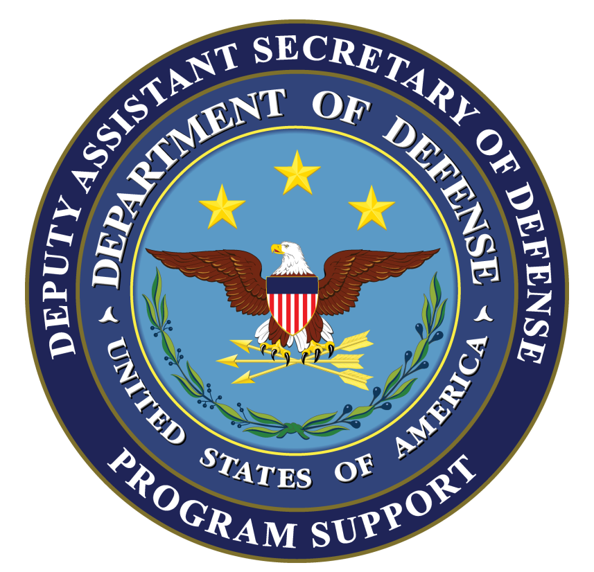
CONTRACTOR SUPPORT OF U.S. OPERATIONS IN THE USCENTCOM AREA OF RESPONSIBILITY TO INCLUDE

IRAQ AND AFGHANISTAN

BACKGROUND: This report updates DoD contractor personnel numbers in theater and outlines DoD efforts to improve management of contractors accompanying U.S. forces. It covers DoD contractor personnel deployed in Afghanistan (Operation Enduring Freedom (OEF); Iraq; and, the U.S. Central Command (USCENTCOM) area of responsibility (AOR).

KEY POINTS:

In 1st quarter FY 2013, USCENTCOM reported approximately 136,000 contractor personnel working for the DoD in the USCENTCOM AOR. This total reflects a slight decrease from the previous quarter. The number of contractors outside of Afghanistan and Iraq make up about 12.7% of the total contractor population in the USCENTCOM AOR. A breakdown of DoD contractor personnel is provided below:

DoD Contractor Personnel in the USCENTCOM AOR
 | Total Contractors | U.S. Citizens | Third Country Nationals | Local/Host Country Nationals
Afghanistan Only | 110,404 | 33,444 | 35,714 | 41,246
Iraq Only* | 8,449 | 2,356 | 4,029 | 2,064
Other USCENTCOM Locations | 17,351 | 7,968 | 6,051 | 3,332
USCENTCOM AOR | 136,204 | 43,768 | 45,794 | 46,642
*Includes DoD contractors supporting U.S. Mission Iraq and/or Office of Security Cooperation-Iraq

Afghanistan Summary

- The distribution of contractors in Afghanistan by mission category are:

Base Support: 13,261 (12%)
Commo Support 3,300 ( 3%)
Construction: 10,064 ( 9%)
Logistics/Maintenance 23,688 (21%)
Security 19,197 (17%)
Training 3,711 ( 4%)
Translator/Interpreter 5,796 ( 5%)
Transportation 6,178 ( 6%)
Other* 25,209 (23%)
Total: 110,404
*Includes Defense Logistics Agency, Army Materiel Command, Air Force External and Systems Support contracts, Special Operations Command and INSCOM.

- OEF Contractor Posture Highlights:
- There are currently approximately 110.4K DoD contractors in Afghanistan. The overall contractor footprint in Afghanistan increased by .8% from 4th quarter FY12.
- The contractor to military ratio in Afghanistan is 1.46 to 1 (based on 75.7K military). While the military footprint was reduced over the last quarter, the contractor footprint remained relatively constant due to temporary and time-limited increases in transportation, translators and support services. There will be substantial contractor reductions over this fiscal year, especially as a result of targeted reductions in LOGCAP personnel.
- Local Nationals currently make up 37.4% of the DoD contracted workforce in Afghanistan.

Iraq Summary

- Contractor Posture Highlights:
- The total number of contractors supporting the U.S. Government in Iraq (DoD + DOS) is now approximately 12.1K. There will be substantial contractor reductions in 2013 reflecting consolidation of sites, completion of ongoing activity, and increased utilization of host country service and labor.

- The Department of Defense and Department of State continue to refine the requirements for contract support. Some contractor personnel employed under DoD contracts are supporting State Department and other civilian activities under the Chief of Mission, Iraq. These DoD contractors are provided on a reimbursable basis.

General Data on DoD Private Security Contractor Personnel in Iraq and Afghanistan

- Private security contractors perform personal security, convoy security, and static security missions. Not all private security contractor personnel are armed.

- USCENTCOM reports, as of 1st quarter FY 2013, the following distribution of private security contractors in Afghanistan and Iraq:
DoD Private Security Contractor Personnel in Iraq and Afghanistan
 | Total | U.S. Citizens | Third Country National | Local/Host Country National
DoD PSCs in Iraq* | 2,281 | 235 | 1,926 | 120
DoD PSCs in Afghanistan* | 19,414 | 2,094 | 1,558 | 15,762
*These numbers include most subcontractors and service contractors hired by prime contractors under DoD contracts. They include both armed and unarmed contractors.

- In Afghanistan, the Afghan Public Protection Force (APPF) Advisory Group is developing the planning for contracts to transition to the APPF in accordance with Presidential Decree 62. The original intent was for all convoy and development contracts to transition by 20 March 2012 however, this timeline has been extended to enable the APPF to come to full operational capability. The APPF Advisory Group has established a transition plan to facilitate the transition of security for development sites and convoys. Presently, International Security Assistance Force (ISAF) fixed site and military construction PSC contracts have until 20 March 2013 to be transitioned to the APPF.
Afghan Public Protection Force
 | Total*
Afghan Public Protection Force (APPF) | 2,732
Risk Management Consultants | 220
* These numbers reflect APPF and RMC supporting DOS and USAID contracts. DoD has not yet begun transitioning to the use of APPF guards.

General Conditions Regarding Contracts and Contractor Personnel

- The Combatant Commander has provided specific guidance on arming contractor personnel and private security contractors in the USCENTCOM AOR through a series of Fragmentary Orders (FRAGOs) and other authoritative guidance, including the following:

- Private security contractor personnel are not authorized to participate in offensive operations and must comply with specific USCENTCOM Rules for the Use of Force (RUF). Under these RUF, private security contractor personnel are authorized to use deadly force only when necessary in: self-defense, defense of facilities / persons as specified in their contract; prevention of life-threatening acts directed against civilians; or defense of Coalition-approved property specified within their contract.

  - Private security contractor personnel in Afghanistan and Iraq must be properly licensed to carry arms in accordance with host nation law and must receive USCENTCOM / Coalition Forces’ approval of their operations. DoD contractor personnel armed by DoD authority must report any use of force, including the firing of a weapon. This requirement and the required information to be submitted are identified within the terms of the contract, USFOR-A OPLAN 09-01, and Office of Security Cooperation-Iraq (OSC-I) policy.

Improvements to Management and Oversight of DoD Contractors

- Operational Contract Support Drawdown Cell (OCSDC). The United States Forces-Afghanistan Operational Contract Support Drawdown Cell (OCSDC) was stood up in August 2012 with a mission to manage the drawdown of contracts, the contractor workforce and associated equipment in the Combined Joint Operations Area-Afghanistan. This includes synchronizing and aligning the contractor drawdown commensurate with base closures. Since August 2012, the OCSDC has published a Concept of Operations (CONOPS) and executed the first phase of contractor drawdown, which focuses on reducing the footprint of Afghanistan's largest DoD contract, the Logistics Civil Augmentation Program (LOGCAP). Working in partnership with Army Materiel Command and the 1st Theater Sustainment Command (1st TSC), the Cell expects to achieve a 25% reduction in LOGCAP personnel and 30% reduction in LOGCAP equipment by 1 May 2012.

- CENTCOM Joint Theater Support Contracting Command (C-JTSCC). C-JTSCC has centralized oversight and authority to ensure all contracts executed in Afghanistan are visible and in compliance with contracting policy and procedures. C-JTSCC headquarters has been re-located to Afghanistan with a small support staff remaining in Qatar and facilitates broader theater contracting oversight functions. The command transitioned from two General Officers to one general officer.
- JP 4-10 (Operational Contract Support). The Joint Staff J4 is revising JP 4-10 (Operational Contract Support) which serves as the doctrine for planning, conducting, and assessing operational contract support integration and contractor management functions in support of joint operations. The first draft review package is currently out for review with comments due mid-February. The original version was published in October, 2008.
- Defense Standards for Security Services.
  - Business and operational standards for private security contractors (which were required by Section 833 of the FY2011 NDAA) are now complete and were validated by the American National Standards Institute (ANSI) in early March 2012. The associated conformity assessment to enable third party certification was published in April 2012.
  - On May 22, 2012, DoD issued instructions (PGI) to the DFARS requiring compliance with the ANSI PSC standard for combat operations and other contingency operations
  - Standards and provision for third party certification in Section 833 of the FY 2011 NDAA will facilitate identifying technically acceptable contractors and best value which: enables expedited contract award; mitigates risk of delay of services due to contract award protests; and, mitigates risk of contractor non-performance or misconduct in critical early phases of contingency operations.
  - The United Kingdom has adopted the PSC ANSI standards as their national standard ensuring continuity between the key allies.

- Operational Contract Support (OCS) Functional Capabilities Integration Board (FCIB).
This senior executive-level governance forum was chartered by the Under Secretary of Defense (Acquisition, Technology & Logistics), in March 2010 to provide strategic leadership to multiple stakeholders working to institutionalize OCS. Co-chaired by the Deputy Assistant Secretary of Defense (Program Support) [DASD(PS)] and Joint Staff, Vice Director J-4, the FCIB convenes quarterly (or as required) to address strategic issues directly impacting current and future contingency operations. During the 1st quarter FY13 meeting (November 27, 2012) the Board reviewed status of the McCaskill-Webb Comprehensive Contingency Contract Reform Act of 2012, the DoD to Department of State (DoS) Transition in Afghanistan; and Joint Staff (J-4) efforts to establish an OCS Learning Framework. The next quarterly OCS FCIB Principal’s meeting will be held on February 26, 2012 in the Army Conference Center. For additional information please contact the Board Secretariat at PS_FCIB@osd.mil.

- Joint Contingency Acquisition Support Office (JCASO). DASD (Program Support) has institutionalized this organization to perform program management of Operational Contract Support (OCS) and to provide a pre-planned approach for planning and implementing OCS policy and doctrine. JCASO provides a joint enabling capability to integrate, coordinate and synchronize OCS during peacetime, contingency operations, and post-conflict operations. Planning, implementation, and oversight of OCS are Commander's responsibilities and are essential to establishing a strategy for managing contractors on the battlefield as part of the DoD Total Force. JCASO has a deployable capability known as the Mission Support Teams and may be requested to provide OCS planning and PgM during peacetime, contingency and post-conflict operations. JCASO is also an essential part of DLA's combat support agency (CSA) role to support the mission objectives of the combatant commands, the Chairman, Joint Chiefs of Staff Title 10 responsibilities, as well as the Office of the Secretary of Defense for OCS policy and joint doctrine development and implementation. Examples of JCASO engagements include: a) initial staffing of the USFOR-A OCSDC; b) leading and managing the economic development initiative (i.e., local procurements) in the Central Asian States in support of the Northern Distribution Network (NDN) strategy in the USCENTCOM AOR; c) leading and managing the Afghanistan Contracting Transition Workgroup (ACTW) to facilitate the interagency coordination for planning and transitioning OCS from DoD to DoS; d) deploying a team to Afghanistan to assist with the OCS drawdown effort in support of Operation Enduring Freedom, and; e) participating in joint exercises in 2012 (e.g., PANAMAX, Ulchi Freedom Guardian) to integrate OCS in training and validate the effectiveness of OCS plans.

- Chairman of the Joint Chiefs of Staff Notice (CJCSN) 4130.01, "Guidance for Combatant Commander Employment of Operational Contract Support Enabler-Joint Contingency Acquisition Support Office (JCASO)" was signed on December 20, 2011. It recognizes the role of JCASO as providing Geographic Combatant Commands and their subordinate commands with a capability to integrate, implement, manage, and execute OCS activities to improve DoD efficiency and effectiveness across the Total Force.

- JCASO Concept of Operations (CONOPS). A detailed CONOPS was signed on 27 June 2012, which further conveys JCASO's mission, role, and responsibility in OCS, to satisfy Combat Support Agency Review Team findings, and to complement the CJCSN 4130.01. It will detail how JCASO engagement can help improve effectiveness and efficiency in managing OCS across DoD and whole of government.

- JCASO Contingency Contracting Office (CCO): JCASO is establishing a Defense Logistics Agency (DLA) contingency/expeditionary contracting capability that responds to demand signals from Combatant Commands and deployed forces; complements Services’ contracting capabilities; extends and leverages existing DLA/JCASO capabilities; develops common operating pictures to support synchronization of all DLA contracting efforts; takes a programmatic approach to contracting, supporting any part of the acquisition cycle (policy, planning, requirements development, market research, contracting, or transition to civil authority); focuses on whole-of-government humanitarian assistance, disaster recovery (HA/DR) and counter-insurgency (COIN) operations; furthers best practices and use of Contingency Business Environment (CBE) tools, such as the Synchronized Pre-Deployment & Operational Tracker (SPOT), the Government Purchase Card (GPC), and the Joint Contingency Contracting System (JCCS); and supports SECDEF OCS and budget initiatives. CCO Initial Operating Capability is planned in October 2012.

- JCASO Planners. Seventeen (17) JCASO planners are allocated among the Geographic Combatant Commands to assist the commander in identifying gaps where contractor support capability may be required. They then help to integrate required contractor support into operational plans and synchronize requirements with subordinate commands, the Military Departments, Defense Agencies, other USG Agencies, and coalition partners. The Secretary further directed an additional 146 planners / analysts to be integrated into the total force. The planners have been instrumental in integrating OCS into Combatant Command plans. In USCENTCOM alone, the planners were fundamental in the establishment of the JTSCC, planning the DoD to DoS transition in Iraq, Pakistan humanitarian efforts, increased operations in Afghanistan, as well as other critical operations supporting USCENTCOM’s theater engagement strategy. Based on demonstrated need for OCS planning capability in the Combatant Commands, DLA recently authorized JCASO to place a planner at forward locations in USFK and USFJ.

- Synchronized Predeployment and Operational Tracker Enterprise Suite (SPOT-ES). It is the joint enterprise suite of systems employed for the management, tracking and visibility of contracted capability and contractors authorized to accompany the US forces during contingency operations. SPOT-ES is comprised of four systems that collectively provide leadership with awareness of the contractor footprint and contracted capability in the Area of Operations. SPOT (NIPRNet and SIPRNet) is the authoritative system of record personnel accountability database. SPOT automatically generates a Letter-of Authorization (LOA) which identifies government furnished services authorized under the contract. JAMMS captures movement and location information via an automated scan at key life support collection points. JAMMS can read a variety of formats, such as a Common Access Card (CAC), LOA, biometric credentials, driver’s license and passport. TOPSS is the business intelligence and reporting tool that integrates data from SPOT, JAMMS, and various other systems. It has the ability to accept and convert manual files to full web services. TOPSS currently includes 28 pre-generated standard reports as well as an ad hoc reporting capability. It includes customizable geospatial mapping of data points and trend analysis. SPOT-ES capability is continually evaluated to identify enhancements that will improve functionality and ease of user interface. DoS is utilizing SPOT as the primary automated program management tool for all USG contractors in Iraq.

- SPOT Configuration Control Board (CCB). ODASD(PS), as the functional sponsor for SPOT, chairs a quarterly CCB. This Board evaluates proposed enhancements to SPOT and prioritizes implementation to ensure consistency within funding parameters. Membership includes participants from across the DoD OCS community, Department of State, and U.S. Agency for International Development. The next CCB will be held on 24 January, at which time the members will validate and prioritize enhancements for version 8.2.
- Transition of Responsibility for SPOT Operational Execution. In January 2012 the USD(P&R) assumed operational control, responsibility, support, custody and management of SPOT, specifically within the Defense Manpower Data Center (DMDC) under the Defense Human Resources Activity (DHRA). This creates synergies between SPOT and the Joint Personnel Accountability Reconciliation and Reporting (JPARR) tool.
- Operational Contract Support (OCS) Learning Framework. The requirement to educate, train and sustain a deployable contingency acquisition workforce and senior leaders to manage this force has long been recognized by DoD. Ongoing contingencies have stressed the military and civilian acquisition workforce, necessitating the deployment of personnel with limited experience in the execution of contracts in a contingency environment. Similarly, senior planners, program managers, and operational leaders deployed to the area of responsibility have limited experience in managing the large number of contractors accompanying the force. To correct this deficiency, the Department is striving to effectively educate and train operational military leaders, both officer and enlisted personnel across all grades, on operational contract support to include the management of contractors deploying with forces.
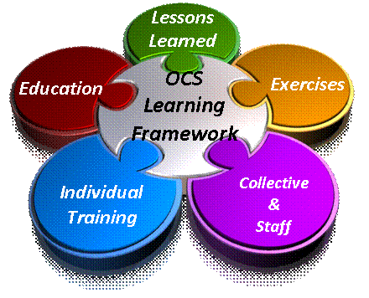
In keeping with the Secretary’s and the Chairman's vision for OCS education and training, several parallel efforts are underway to incorporate OCS into a holistic learning framework depicted here that includes education, individual and collective training, exercises, lessons learned, and an on-line body of knowledge primarily aimed at non-acquisition personnel.
- OCS in JPME. OCS has been a Chairman’s joint professional military education (JPME) Special Area of Emphasis (SAE) each year since 2009. In 2012, under the Chairman's authority, the Joint Staff (J4) partnered with ODASD (PS), Joint Staff (J7), the Center for Joint and Strategic Logistics, and various Service and JPME schools to assess the degree that OCS is currently taught in JPME. The study observed a general lack of uniformity and depth in OCS content and the broad OCS learning objectives in the OCS SAE may have contributed to this lack of uniformity.

To rectify this, an OCS Curriculum Development Guide (CDG) was developed to augment the Chairman’s SAE by providing specific OCS learning objectives, tailored to the framework of the Chairman’s Officer Professional Military Education Policy (OPMEP), to help JPME faculty create and integrate effective OCS learning into all five JPME levels and to facilitate consistent and uniform interpretation and application of OCS learning outcomes. Version 2.0 of the CDG was completed in October 2012 and includes authoritative reference material for each OCS learning objective to assist faculty in creating specific OCS curricula. The OCS CDG and a CD ROM with all the authoritative OCS reference material were distributed to JPME institutions in December 2012. The OCS CDG also incorporates distance learning through the three Joint Knowledge Online (JKO) OCS courses.
The focus of the CDG and JKO courses are on the professional military education and individual training components of the larger OCS learning framework. Going forward, the other components of the OCS Learning Framework, to include adaption and creation of collective OCS training courses and injection of OCS into joint exercises, are being pursued in 2013.

- DoD Directive (DoDD) 3020.49 on Orchestrating, Synchronizing, and Integrating Program Management of Contingency Acquisition Planning and its Operational Execution was signed on March 24, 2009. It establishes policy and assigns responsibilities for program management for the preparation and execution of acquisitions for contingency operations, and for the accountability, integration and management of all contractors supporting the DoD and all USG PSCs operating in an area of contingency operations.

- DoD Instruction (DoDI) 3020.41. A revised version of DoDI 3020.41, “Operational Contract Support,” formerly entitled “Contractor Personnel Authorized to Accompany the U.S. Armed Forces,” was signed on December 20th, 2011. It was also published as 32 CFR Part 158. This version contains significant changes to the previous instruction including: (1) incorporation of lessons learned from current operations; (2) requirements for the development of contractor oversight plans; (3) requirements for adequate military personnel necessary to execute contract oversight; and, (4) standards of medical care for deployed contractors. Further, it reiterates the importance of the use of a common database for the accountability and visibility of contractors supporting DoD contingency operations.

- DoDI 3020.50, “Private Security Contractors (PSCs) Operating in Contingency Operations, Humanitarian or Peace Operations, or Other Military Operations or Exercises” was signed on August 1, 2011. On August 11, 2011, a final rule entitled “U.S. Government Private Security Contractors Operating in a Contingency Operations, Combat Operations or Other Significant Military Operations,” applying to all US Agencies, was published in the Federal Register (32 CFR Part 159). This Rule / DoDI prescribes the selection, accountability, training, equipping, and conduct of personnel performing private security functions under a covered contract in a designated area of combat operations for both DoD and other agency PSCs. It also prescribes incident reporting, use of and accountability for equipment, RUF, and a process for the discipline or removal, as appropriate, of USG PSC personnel. The DoDI responds to requirements of section 862 of the FY 2008 NDAA as amended.

- Operational Contract Support Concept of Operations (CONOPS). The CONOPs, signed on March 31, 2010, outlines how the operational and acquisition communities plan and execute OCS during complex operations involving support, not just to the joint force, but to our multinational, other government agency and interagency partners as well. The Joint Requirements Oversight Council (JROC) has endorsed the CONOPS.

