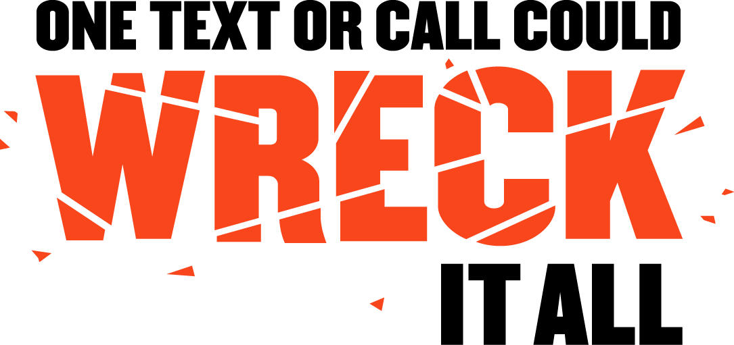

SAMPLE DROP-IN
NEWS ARTICLE

With ever increasing demands on our personal and professional time in today’s busy society, learning to juggle multiple tasks at once is something we all face daily. As a result, a new traffic safety epidemic has emerged on America’s roadways that demand immediate attention: distracted driving.

In 2014, 3,179 people were killed in crashes involving a distracted driver. One of the most alarming and widespread forms of distracted driving is cell phone usage. According to a study by the Virginia Tech Transportation Institute (VTTI), sending or receiving a text takes a driver's eyes off the road for an average of 5 seconds, the equivalent of driving blind at 55-mph for the length of an entire football field. And a 2014 special article in the New England Journal of Medicine found that the risk of a crash or near-crash among novice drivers increased with the performance of many secondary tasks, including texting and dialing cell phones.

Text messaging is of heightened concern because it combines three types of distraction – visual, manual and cognitive. In other words, texting involves taking your eyes off the road, your hands off the wheel, and your mind off the task of driving.

To tackle this ever-increasing problem, NHTSA is focusing on ways to change the behavior of drivers through legislation, enforcement, public awareness and education—the same tactics that have curbed drinking and driving and increased seat belt use.

NHTSA’s message is simple – “One Text or Call Could Wreck it All.” With supporters ranging from President Obama to Adam Levine and legislation being passed across the nation to discourage distracted driving, we hope drivers get the message loud and clear.


So the next time you are pressed for time, and it seems like multitasking in the car is the best decision, remember those 3,179 lives that were taken because someone decided they could do two things at once. A text or call is not worth your life, or anyone else’s.

