Browser Settings Documentation for Internet explorer 11

Express instructions | More detailed instructions

Browser Settings Documentation for chrome
This process required for documents to open in a new Tab. (Note: this process only needs to be followed, if you don’t want to download every document you would like to view)

Step C1: Click on the right corner icon | Look in the right hand corner for the following icon.
Step C2: Click on Settings | Select Settings
Step C3: Click on Show advanced settings | Scroll down to the end of the box and click on Show advanced settings
Step C4: Scroll down and find privacy. Click on Content Settings
Step C5: Scroll down and find plugins: Click on the Manage individual plugins | Click on the Manage individual plugins hyperlink.
Step C: Look for Chrome PDF Viewer. | Verify that the Chrome PDF Viewer status is Disable. It should have an hyperlink that shows Disable in a blue hyperlink. If the Adobe Reader is greyed out click Enable.  Close the Tab  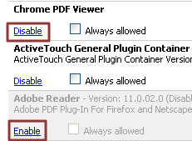

Configure Firefox
- In Firefox, choose Tools > Options.
- In the Options dialog, click Applications.
- In the Applications tab, type PDF in the search field.
- For Portable Document Format (PDF) content type in the search result, select Use Adobe Acrobat (in Firefox) from the Action drop-down list.
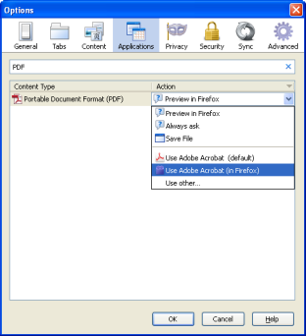
- Click OK.
- Restart Firefox.

