ACAT I/II MAJOR PROGRAM MANAGER/DEPUTY PROGRAM MANAGER (MPM/DPM)

SLATING PANEL GUIDELINES & PACKAGE CONTENTS

1. The Commanders for each of the Systems Commands retain the authority to conduct Major Program Manager (MPM) slating panels.
2. **Membership:** At a minimum, membership should include Flag/General Officers, Senior Executive Service (SES), Program Executive Office representatives, ASN(RD&A)/DASN representative, and Navy DACM (Advisor). Optional additional members include Fleet representatives, OPNAV representatives, or acquisition command representatives as required.
3. **ACAT I /II** **MPM Slating Timelines:** MPM positions should be slated 6-12 months prior to position availability to allow lead time for selection approval and for the selected individual to obtain necessary acquisition training. IAW DAWIA Operating Guide, System Commands are required to submit to the DACM on 1 Oct of each year, a forecast of anticipated vacancies for the upcoming 12 months.
4. **Precepts:** The precepts for each slating panel will include at a minimum the following elements:

* Slating Panel Membership
  + Name
  + Position title
  + Organization

* Position Billets in the slate
  + Position Title
  + Program Name
  + Program Office (i.e., PMS XXX)
  + ACAT Level
  + Targeted Fill Date
* DAWIA Statutory Requirements
  + Level 3 certified in Program Management
  + Acquisition Corps Membership
  + Appropriate minimum experience (8 years including 2 in a program office for ACAT I/IA; 6 years for ACAT II)
  + Completion of PMT 401 (10 weeks) and PMT 402 (4 weeks)
* Screening criteria specific to the position such as specialized experience or additional considerations.

1. In addition to the statutory requirements, two years of program office experience is required for Department of the Navy ACAT II PMs.
2. PMT 401 and PMT 402 must be completed within 6 months of the tenure start date. Contact the DACM office for recommended timing and class convening dates.
3. Provide annual charter initially and then only when an update occurs.
4. Panels must have a minimum of three applications to slate an ACAT I/II PM position. The Slating Panel Chair must brief extenuating circumstances to ASN (RD&A) after the board if less than three candidates apply.
5. Slating panels are expected to submit one primary nominee and two alternates to ASN (RD&A) for ACAT I/II MPM positions. If unable to provide two qualified and capable alternates, the Slating Panel Chair must be prepared to explain the circumstances to ASN (RD&A).
6. While not required for ASN (RD&A) approval, all ACAT I/IA and ACAT II DPM selections require DACM notification for tracking and reporting consistency.
7. Slating Panel Chairs shall debrief ASN (RD&A) on panel results and any extenuating circumstances once panel packages have been processed through the DACM and the Principal Military Deputy/Principal Civilian Deputy.
8. Slating panel packages will be concurrently routed through the Vice Chief of Naval Operations (for Navy programs) and the Assistant Commandant of the Marine Corps (for Marine Corps programs) prior to ASN (RD&A) approval.
9. **Acquisition Experience Assessment Guidance**:

* The slating panel process must accurately and consistently identify those experiences that are considered “core” acquisition experience. These experiences expose candidates to the key program management competencies of financial management, technical/engineering, contracting, and logistics to ensure that they are prepared to execute the cost, schedule, and performance trade-offs required by PMs.
* The following are the minimum requirements for acquisition experience:
* 50% of the required acquisition experience shall be core acquisition experience with at least 2 years of that in a program office. For example, an ACAT I program requires 8 years of acquisition experience with 2 years in a program office, therefore at least 4 years must be core experience (which includes the 2 years in a program office).
* 50% of the required acquisition experience in a related acquisition experience position.
* Core Acquisition Experience
  + Core acquisition positions are *acquisition designated positions* in the following commands: Program Offices, PEOs, SYSCOMs, Developmental Test Commands, Warfare Centers, Contracting Field Activities, or Supervisor of Ship Building.
  + A minimum of 2 years program office experience is required for ACAT I/IA and ACAT II programs. This time counts as core acquisition experience.
* Related Acquisition Experience
  + *Acquisition designated* positions at commands not identified as “core” are considered related acquisition experience at 100% credit.
  + *Non-acquisition designated* positions that provide acquisition related experience: OPTEVFOR, Operations Test Commands, Maintenance Commands, and HQ Marine Corps are considered related acquisition experience at 50% credit.
  + Command tours (Commanding Officer time only) are credited a maximum of 18 months of related acquisition experience.
* Acquisition education is credited a maximum of 12 months of related acquisition experience if one of the following applies:
* A Masters Degree in hard sciences or business (e.g. Engineering, Computer Science, MBA)
* Acquisition Related Education (i.e. ICAF [Acquisition Track], Nuclear Power training, Test Pilot School)
* It is understood that there are positions not designated as acquisition positions that may meet “core” requirements. The Acquisition Experience Assessment Tree in Figure #1 below is a guide to determining the category in which experience should be applied. For consistent experience assessments, it is recommended that all commands conducting PM slating panels keep track of which category (core, acquisition-related, no acquisition credit) a billet falls under if it is not in a typical core assignment.

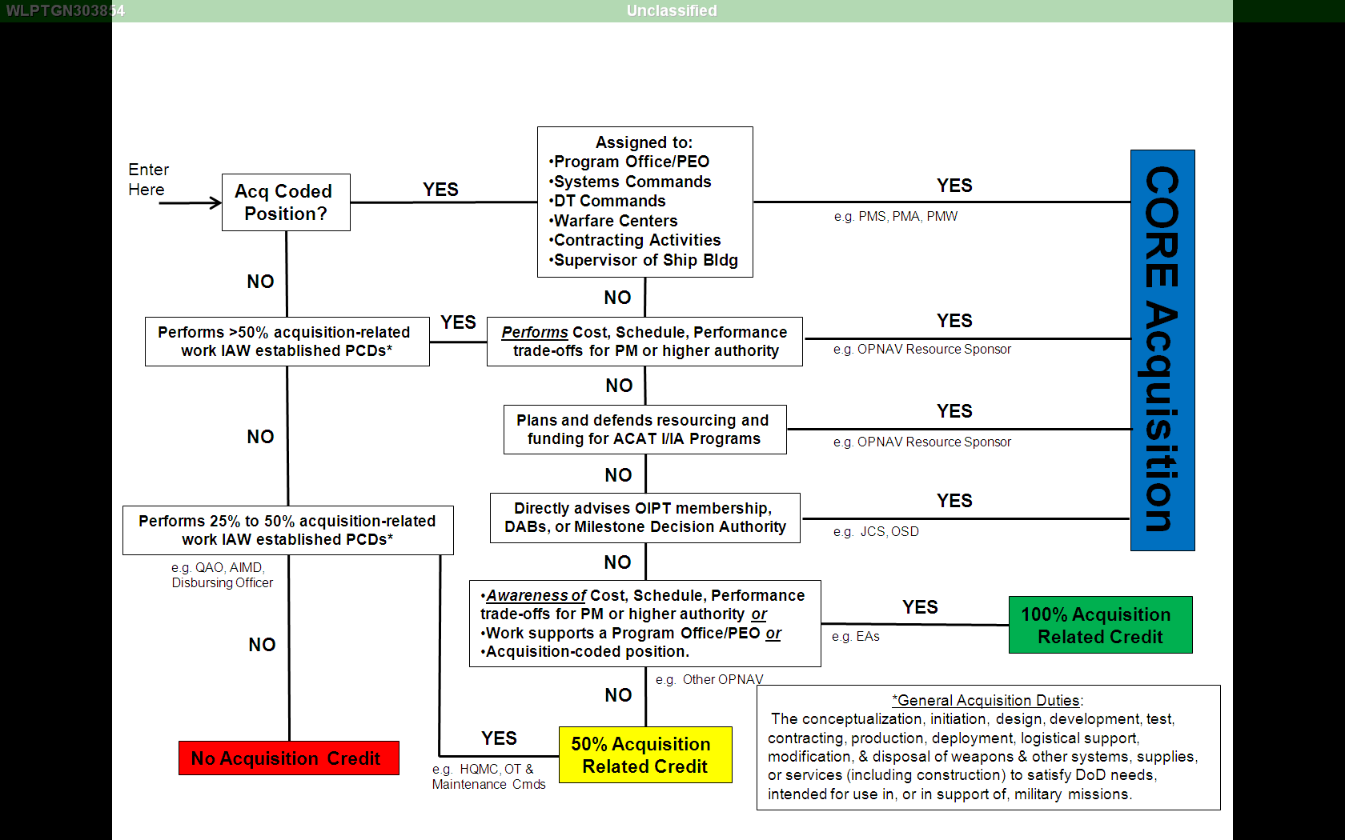

Figure #1

Acquisition Experience Assessment Tree

1. **Slating Panel Selection Package:** The following is a list of contents (at a minimum) that each package forwarded to ASN (RD&A) via DACM should contain and the proper order. Information should be provided for both the primary nominee and the two alternates.

* PEO/Command MPM Selection Endorsement Memo using the template at attachment (c):
  + Date of Panel
  + Membership of Panel
  + Total number of applicants, civilian/military breakout by number best qualified/qualified/requiring waivers
  + Recommended selection and two alternates
  + Narrative justification of selected candidate and alternates based on programmatic, technical and operational capabilities
* Slating Panel Results Memo (i.e., the memo that is signed by all panel members)
* Position Description, Precepts, and Organizational Charts (both PEO and Program)
* Slating Panel Metrics Sheet (attachment (3))
* Candidate Information Sheet (attachment (4))
  + Standardized format used to assess a candidate’s acquisition education, training, certification, and experience
  + Sent out with announcement and completed by applicant and validated by Slating Coordinator
* Biography/Resume for each candidate
* DAWIA Transcript for each candidate (available via eDACM) <https://www.atrrs.army.mil/channels/navyedacm>)
* Contact Information (include PEO, DPEO, Slating Panel Chair, Chief of Staff, and Selectee).