GUARANTEED LOANS
Farm Loan Program

Nebraska State FSA Office Mark Wilke Tim Reimer
7131 A Street Farm Loan Chief Guaranteed Loan Specialist
Lincoln, NE 68510-4202 (402) 437-5595 (402) 437-5455
General Guaranteed Loan Information for ALL LENDERS  General Information | Overview of the  Guaranteed Loan  Program  Guaranteed Loan Overview
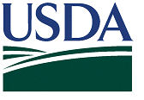  Locate the Office  And FSA Personnel for  Your County  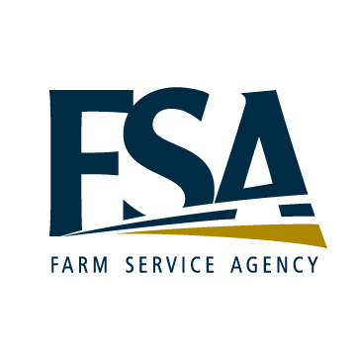  Nebraska USDA Service Center Locator  & Personnel Locator  Nebraska’s Farm Loan Staff  National Map Locator | Farm Loan Program  Fact Sheets  FLP Program Fact Sheets
 Nebraska FSA  Commodity Prices  FSA Commodity Prices | FSA Spreadsheets  Interest Assistance Calculator  Line of Credit - Tracking
View or Download 2-FLP Handbook and National Amendments  Scroll down select “2-FLP Handbook”. You will be limited to the most recent Amendment; all other Amendments are included in the 2-FLP handbook. | View and Download  National Notices  (Select Farm Loan under Subject)  National Notices  Select “Farm Loan Program Notices”
View and Download State 2-FLP Amendments and Notices

State Amendments State Notices

2-FLP (Rev. 1) Amendment 1 FLP 13-01 Credit Quality Notice
Exhibit A
2-FLP Rev. 1) Amendment 2 Exhibit A, Attachment 1
Exhibit A, Attachment 2
Exhibit A, Attachment 3
Exhibit A, Attachment 4
Exhibit A, Attachment 5
Exhibit A, Attachment 6
Exhibit A, Attachment 7
Exhibit A, Attachment 8
Exhibit A, Attachment 9

Lender Security Administrator’s  Electronic Reporting within the Guaranteed Loan System  Lender Sign-up for  eAuthentication ID  How To Sign Up For E-Auth  STEP ONE - Sign up for eAuth  STEP TWO – Visit your local USDA Service Center in person for identity proof  STEP THREE - Contact  Coreen Carnes (402)437-5884  Tim Reimer (402)437-5455 or  Provide the following:  *Identify Lender Security  Administrator Name  *Provide Administrator eAuth ID  Filing Guaranteed Loan  Applications on Line  Access eForms  Requires Level 2 eAuth  eForms  Select - Browse Forms (upper left hand corner)  Agency Name - select “Farm Service Agency”  Program Name – select “Guaranteed Loans”  or “Farm Loan Program”  Click – “Search” | Lender Security  Administrator adding  additional bank employees  as Lender Representatives  Adding Additional Lender Representatives  Lender Representative must obtain an  eAuth account and visit your local  USDA Service Center in person for  identity proof.  Lender Loan  Application Checklist  SEL & CLP Checklist  Accessing Loan Application  and Loan Servicing Forms  Loan Application & Servicing Forms  Loan Narrative Template  (optional)  PLP Example  SEL-CLP Example  Real Estate Appraisal  Engagement Letter for  FSA Guaranteed Loans  Optional Engagement Letter
The Lender Interactive Network Connection (LINC) System allows for electronic reporting by Guaranteed Lenders to USDA agencies, including FSA.

LINC’s primary electronic reporting functions for FS are:

- Submit status reports (semiannual and default).
- Add loan closing.
- View loans.
- Lender Pre-Authorized Debit (PAD).

The NEW FSA LINC User Guide provides step by step instructions for FSA’s Guaranteed Lenders in completing these reporting functions that reside in the new LINC system. Click on the link blow to access the guide:
LINC User Guide

Land Contract Guarantee Program  General Program Information  Fact Sheet  6-FLP (see Part 8) |  | Paying Guarantee Fees Electronically

