

GSA FLEET

ALTERNATIVE FUEL VEHICLE (AFV)

INFORMATION

AFV LEGISLATION

Energy Policy Act (EPACT) of 1992 – 42 USC 13212
The Energy Policy Act (EPACT) of 1992 was passed by Congress to reduce the nation's dependence on imported petroleum. Federal fleets are required to acquire AFVs under EPACT:

- Requires all Federal fleets of 20 vehicles or more located in Metropolitan Statistical Areas (MSAs) to obtain at least 75% of annual light duty fleet acquisitions as AFVs. AFVs acquired out of MSAs also count towards the final percentage.
- Excludes law enforcement vehicles, emergency vehicles, vehicles over 8,500 lbs. GVWR, and vehicles located outside MSAs.

To read the section (42 USC 13212) of EPACT pertaining to the minimum AFV Federal fleet requirement, visit the following website:
http://www4.law.cornell.edu/uscode/42/13212.html

Energy Policy Act of 2005 (EPACT 2005)
The Energy Policy Act of 2005 (EPACT 2005) keeps the elements of EPACT 1992 listed above in tact, but adds on additional AFV requirements for Federal fleets:
- Requires GSA and any Federal agency that procures vehicles for distribution to other Federal Agencies to allocate the incremental cost of AFVs over the entire fleet of vehicles distributed by such agency.
- Requires 100% alternative fuel use in dual fueled vehicles unless a waiver is acquired from the Department of Energy (DOE)
- Exempts vehicles directly used in the emergency repair of transmission lines and in the restoration of electricity service following power outages, as determined by the DOE Secretary, from the AFV requirement.
- Requires Federal agencies that operate light or heavy-duty fleets to acquire fuel cell vehicles and hydrogen energy systems no later than January 1, 2010. DOE will pay the incremental cost between the fuel cell vehicle and a feasible alternative vehicle, as well as the difference between hydrogen energy systems and feasible alternatives. If the DOE Secretary finds an agency cannot find an efficient and reliable fuel cell vehicle or hydrogen energy system, the agency shall be exempted from the requirement.
For the full text of the Act, visit the Thomas Register on the Library of Congress Web site, and search by Bill Number for HR 6.

Executive Order 13423- Strengthening Federal Environmental, Energy, and Transportation Management
Executive Order 13423, Strengthening Federal Environmental, Energy, and Transportation Management, requires Federal agencies to exercise leadership in petroleum reduction through improvements in fleet efficiency and the use of AFVs and alternative fuels:

- Requires Federal agencies operating 20 or more motor vehicles within the United States to reduce their entire vehicle fleet's annual petroleum consumption by at least 2% percent annually through FY 2015, compared with FY 2005 petroleum consumption levels.
- Requires an annual 10% increase in the use of alternative fuels through FY2015.
- Seeks to increase the number of AFVs and the use of alternative fuels in agency fleet vehicles.
- Restates that agencies can receive one EPACT credit for every 450 gallons of pure biodiesel (B100) used in diesel vehicles.

To read Executive Order 13423, visit the following website:
http://a257.g.akamaitech.net/7/257/2422/01jan20071800/edocket.access.gpo.gov/2007/pdf/07-374.pdf

National Defense Authorization Act for Fiscal Year 2002 – Public Law 107-107 Section 318
Section 318 of Public Law 107-107 requires the Department of Defense to replace light duty trucks in non MSAs and non law enforcement fleets as hybrid electric vehicles (HEVs) and exceed EPACT AFV requirements:

- Requires non-EPACT light duty trucks be replaced with HEVs, beginning in FY 2005.
- Exempts fleets of the HEV requirement for national security reasons, if the HEVs are not commercially available, or not available through the standard Federal Government procurement process.
- Requires in FY 2005 and 2006 that five percent of the total number of EPACT covered light duty trucks are acquired as AFVs or HEVs.
- Requires in FY 2007 and beyond that ten percent of the total number of EPACT covered light duty trucks are acquired as AFVs and HEVs.

To read Public Law 107-107, visit the following website:
http://frwebgate.access.gpo.gov/cgi-bin/getdoc.cgi?dbname=107_cong_public_laws&docid=f:publ107.107

GSA FLEET’S POSITION ON ALTERNATIVE FUELS

GSA Fleet maintains a fuel neutral position, and therefore does not advocate the use of any one particular alternative fuel or AFV. GSA Fleet will provide any AFV a customer requests provided the customer can cover the incremental cost of the vehicle and the vehicle is available for purchase on GSA Contract. GSA Fleet does not allow its conventionally fueled vehicles to be converted after-market to an AFV. In addition these types of vehicles will not be consolidated into the GSA fleet. GSA Fleet leases only original equipment manufacturer AFVs. While GSA Fleet provides vehicles to the customer, we rely on the private sector to expand and improve the refueling infrastructure and maintenance and repair for AFVs.

GSA FLEET ANNUAL TIMELINE

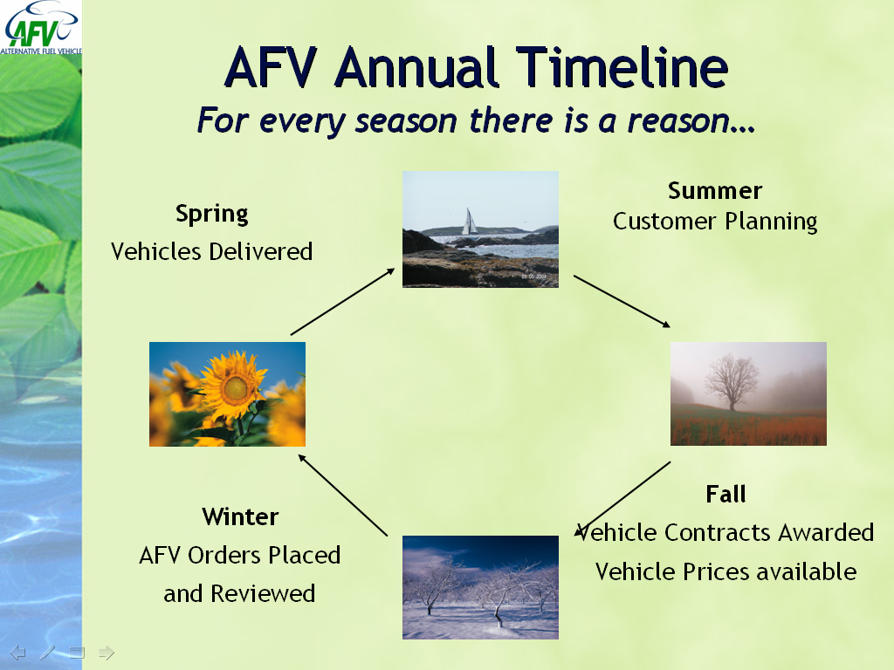
Figure 1: GSA Fleet Annual Timeline

Figure 1 shows GSA Fleet’s annual timeline. Customers are invited to attend planning meetings in the summer for the upcoming fiscal year. GSA Fleet Central Office meets with agency headquarters to discuss goals and policies. Any information supplied to Central Office will be distributed to GSA Fleets regional representatives. In order for the process to work, the agency needs to share information with their representatives as well. In the fall, vehicle contracts are awarded and vehicle prices are available. This also allows GSA to determine the incremental cost of AFVs. Orders begin to be placed in early December. In late January agency headquarters are able to review their orders and request changes. In the spring, vehicles begin to be delivered.

GSA Fleet Order Review Process
The goal of the order review is to help agencies meet their EPACT and E.O. 13423 requirements. Agencies may review their estimated vehicle orders at the headquarter level, before they are sent to the manufacturer. The order review typically takes place in January. An agency must sign up prior to November 1st in order to participate in the order review. Requested changes are not guaranteed, because the local Agency representative must accept the change. The agency must also be able to pay for the incremental costs of AFVs. An agency has 5 business days to review orders and request changes.

AFV INCREMENTAL COSTS AND PAYMENT METHOD

Definitions
AFV Incremental Cost – Difference between the AFV costs as compared to the lowest bid vehicle cost.

Lowest Bid Vehicle – Least expensive vehicle on the GSA schedule that meets vehicle class requirements.

AFV Surcharge
EPAct 2005 requires GSA Fleet to spread the incremental cost of AFVs across the entire fleet. Beginning in fiscal year 2007, every agency that leases vehicles from GSA Fleet is assessed a surcharge. Surcharges are determined at the headquarters level. All agencies are encouraged to meet with GSA Fleet Central office to discuss their AFV goals and surcharge.

Agencies that are required to comply with EPAct are charged an individual surcharge that covers at least 75% AFV replacements. An agency may choose to increase their surcharge to cover more than 75% AFV replacements or to also cover the incremental cost of hybrids.

Agencies that are not required to comply with EPAct will be charged a flat rate surcharge to cover the cost of the AFVs that are purchased.

Beginning Month | Vehicles | Surcharge | Money Generated | Months of Surcharge | Total Money Available for Fiscal Year
October | 10,000 | $ 5 | $ 50,000 | 12 | $ 600,000

LINKS TO AFV WEB SITES

Alternative Fuels Data Center Home http://www.eere.energy.gov/afdc/index.html
The Alternative Fuels Data Center is a one-stop shop for all your alternative fuel and alternative fuel vehicle information needs. This site has more than 3,000 documents in its database, an interactive fuel station mapping system, listings of available alternative fuel vehicles, links to related web sites, and much more.

Energy Efficiency and Renewable Energy (EERE) Home Page http://www1.eere.energy.gov/vehiclesandfuels/
Organizational information including strategic plan, contacts, office information, success stories, papers, and transportation data/analysis. Easy to understand technical overviews as well as detailed information on technical programs related to vehicles, fuels, and emissions.

National Ethanol Vehicle Coalition (NEVC) and E85 http://www.e85fuel.com/
The NEVC’s mission is “to promote the use of 85 percent ethanol as a renewable form of alternative transportation fuel while enhancing agricultural profitability, advancing environmental stewardship and promoting national energy independence.”

NGVAmerica http://www.ngvc.org
NGVAmerica was formerly the Natural Gas Vehicle Coalition. NGVAmerica provides information on natural gas vehicles (NGVs) and their benefits. Not only do NGVs help clean the air, they also displace petroleum in America's transportation system, thereby decreasing our dependence on imported oil and bolstering our national security.

Biodiesel Web Site http://www.nbb.org/
The NBB’s site is a comprehensive listing of biodiesel information.

Hybrid Electric Vehicle Program http://www.nrel.gov/vehiclesandfuels/hev/
Describes the program, auto manufacturer HEV accomplishments, current activities and technical information on HEVs.

Alternative Fuel Vehicle Institute http://www.afvi.org
Alternative Fuel Vehicle Institute (AFVI) is the education provider and information link between the alternative fuels and vehicles industry and public/private fleets and other proponents of alternative fuels. AFVI is fuel and technology neutral.

Mapquest http://mapquest.com
Mapquest has a feature that allows you to search for alternative fuel stations and get driving directions from your location.

GSA Fleet AFV Program www.gsa.gov/afv
Information on GSA Fleet’s AFV Program, including current FY Product Guide and frequently asked questions.

GSA FLEET POINT OF CONTACTS

Alternative Fuel Vehicle Team
AFVTeam@gsa.gov 703-605-5630

Federal Automotive Statistical Tool (FAST) Data
George Schaubhut 703-605-2949 george.schaubhut@gsa.gov

