StreamStats User Instructions


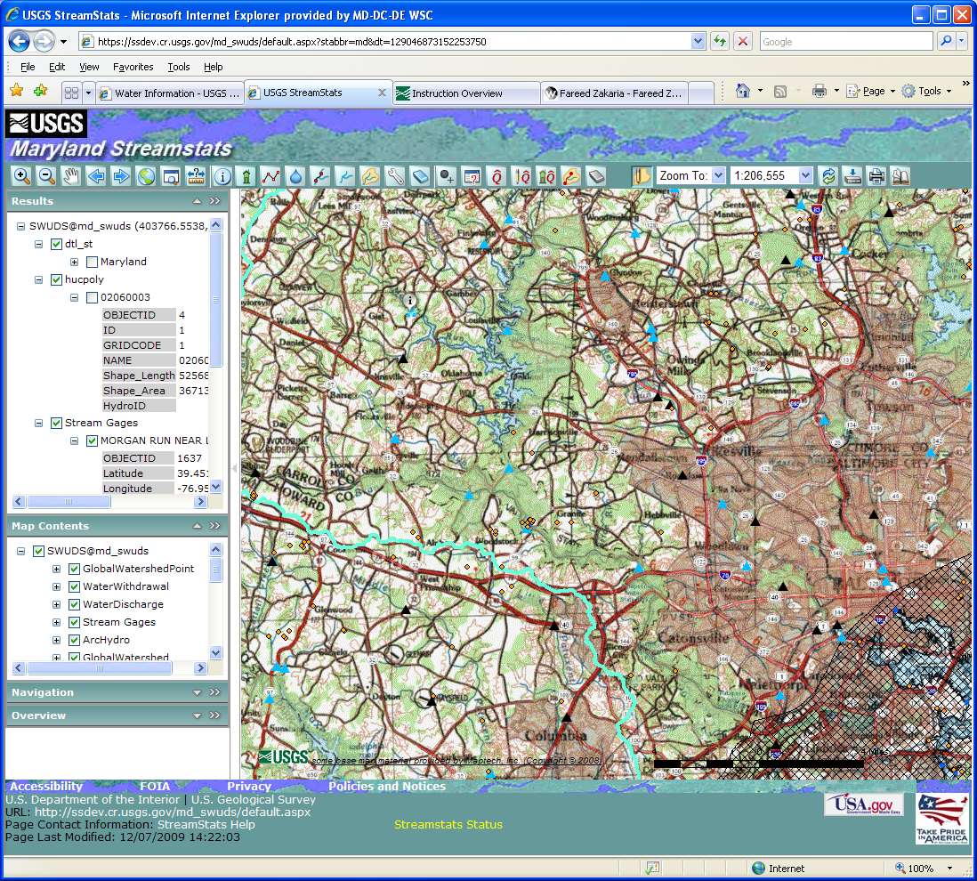

These user instructions are applicable to all StreamStats state applications, with the exception of the log-in instructions and the water-use summaries, which are unique to Maryland.

Table of Contents
Table of Contents 2
Introduction 4
Access to the National Application for Streamgages 5
Access to the State Introductory Pages 5
The User Interface 8
Getting Help 10
Moving Around on the Map 10
Use of the Zoom In Button: 11
Use of the Zoom Out Button: 11
Use of the Pan Button: 11
Use of the Zoom To Tools: 12
Zooming to a Specified Scale: 13
Obtaining Information for a USGS Data-Collection Station: 13
Selecting an Ungaged Site and Delineating a Watershed: 13
Editing Watershed Boundaries: 14
Getting Streamflow Statistics and Water-Use Summaries for an Ungaged Site: 15
To Obtain Estimates Based on USGS Regression Equations: 15
Water-Use Summaries for Maryland 16
To Obtain Estimates Based on Flows at Nearby Similar Gages: 16
Editing Parameters and Recomputing Flows: 17
Getting Additional Basin Characteristics for an Ungaged Site: 18
Downloading Shapefiles: 18
Stream Network Navigation (Network Tracing): 19
Raindrop Trace to Network: 20
Show Network Path Profile: 20
Trace Network Path within Watershed and Show Profile: 21
Terrain Profile: 23
Show Main Channel Flow Path and Profile 25
Brief descriptions of other buttons on the Toolbar are on the Help Button. 27
The Magnifier Button 27
The Measure Button 27
The Identify Button 28
The Refresh Button 28
The Print Button 28
Reporting Problems: 29

Introduction
The StreamStats home page can be accessed at:

http://streamstats.usgs.gov
The home page provides a brief description of the application. A gray box on the left side of the page provides links to the individual state applications, a national application that provides statistical information only for USGS data-collection stations, documentation for use of StreamStats, news items, contact information, and current streamflow conditions at USGS data-collection stations.
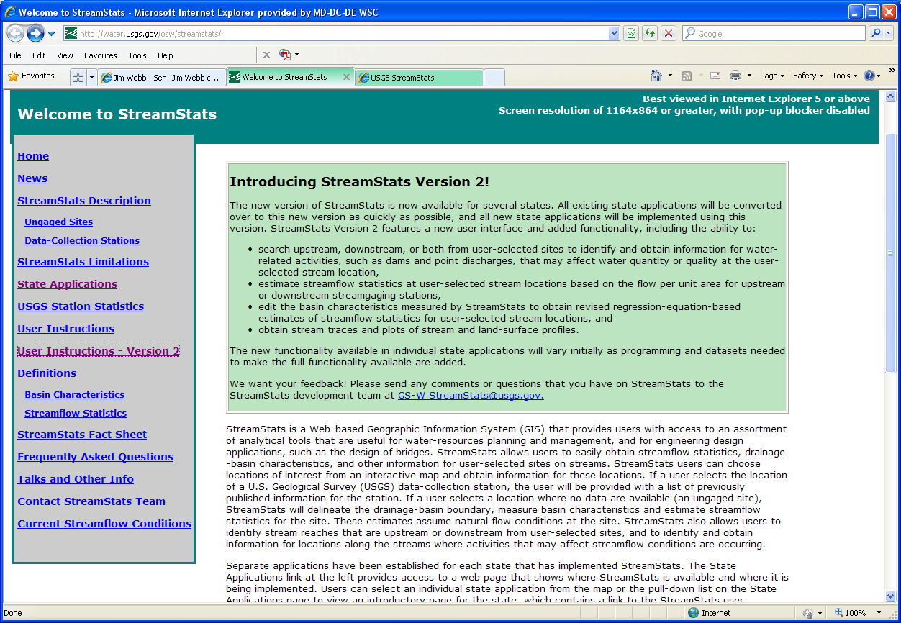
Users should read and be familiar with the descriptions of the StreamStats output pages and user instructions before attempting to use the application. The Definitions pages give detailed definitions for the abbreviated names of basin characteristics and streamflow statistics that appear in the output pages.

Access to the National Application for Streamgages
The national application that provides statistical information for USGS data-collection stations can be accessed by selecting the USGS Station Statistics link on the left side of StreamStats home page or by typing the URL http://streamstatsags.cr.usgs.gov/gages/index.htm into the address area in your web browser window. Instructions for use of the national application are found by selecting the Help button 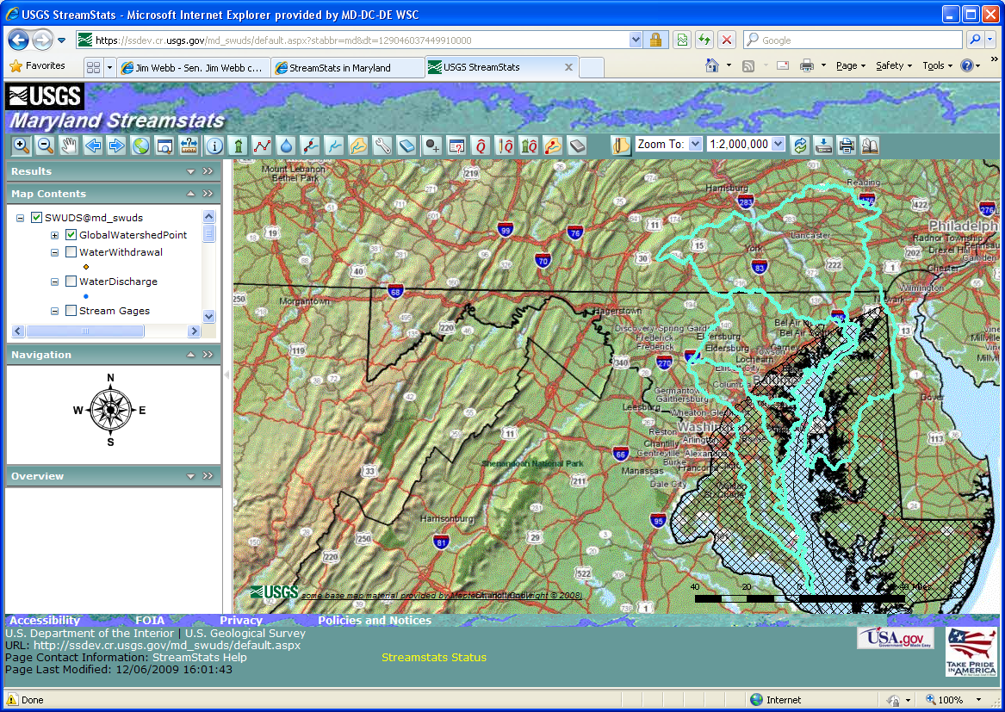 in the top right corner of the user interface. Information on individual streamgages that is provided by the national application also is provided through the individual state applications where they are available.

Access to the State Introductory Pages
Access to the various state applications is gained by clicking on the State Applications link in the gray links box on the home page. The page that then appears has a pull-down list of state names near the top and a colored map. Applications are available for states colored in green on the map. Clicking on the state name from the pull-down list or clicking on a state on the map causes an introductory page for the selected state to appear. It is suggested that frequent users of a state application should bookmark the state introductory page for quick future access. The Maryland introductory page, for example, can be accessed directly at http://water.usgs.gov/osw/streamstats/maryland.html. Other state introductory pages can be accessed directly by changing the state name in this URL to the name of the desired state.
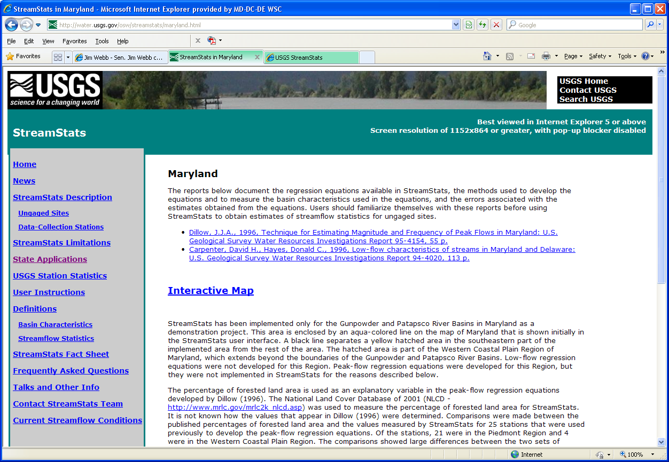
This page describes the reports from which the regression equations used to estimate streamflow statistics for ungaged sites were taken and provides links to those reports. The page also describes some issues with measuring basin characteristics that affect how StreamStats works and the accuracy of the results. Please be sure to read this discussion and review the reports before using the Maryland application.
Clicking on the Interactive Map link on the introductory page for most states will cause a new web browser window to appear that will display the StreamStats user interface for that state. When the Interactive Map link is clicked on the Maryland introductory page, a new web page will appear that allows users to login to the Maryland application.
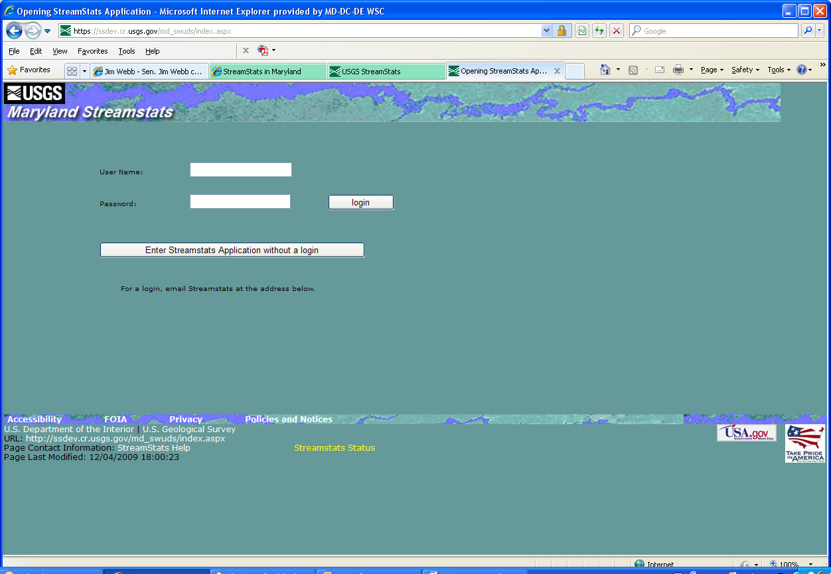
Maryland users who choose to login will have access to site-specific water-use information when they obtain estimates of flow statistics for locations on streams that they select. Users who do not login will be able to obtain a summary of water upstream from their selected sites, but not site-specific information. A link is provided on the page for users to request login information. The user interface will appear after the user either enters a login ID and password, and then clicks on the login button, or after the user clicks on the button that allows entering the application without logging in.

The User Interface

The user interface is composed of three main parts: a map, a toolbar, and a console. The map displays digital map layers that assist users in locating sites of interest. It also can be used to display point and spatial information that can be useful for various analyses. For example, point locations of streamgages, ground-water observation wells, and waste-water discharges can be displayed on the map. In addition, spatial information such as surficial geology and land cover can be displayed.
The console area to the left of the map contains a series of panel banners that can be expanded to provide additional information. These include the Results, Map Contents, Navigation, and Overview panels. On the right side of each panel banner is a down-pointing arrowhead 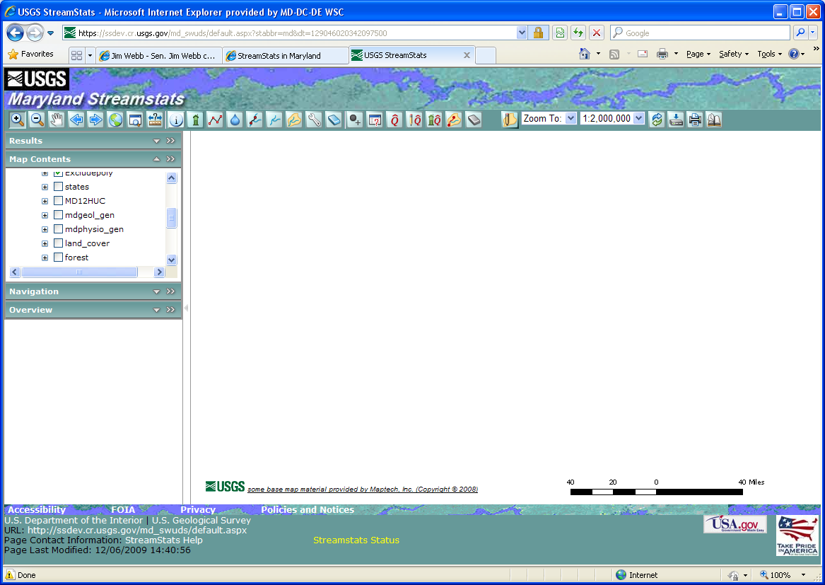 and a pair of greater-than symbols . Clicking on the arrowhead will reveal the contents of the panel. Clicking on the greater-than symbols will move the panel over the map, where it can be resized by clicking and holding down on the bottom right corner of the panel and then dragging downward and to the right until the desired size of the panel is attained.
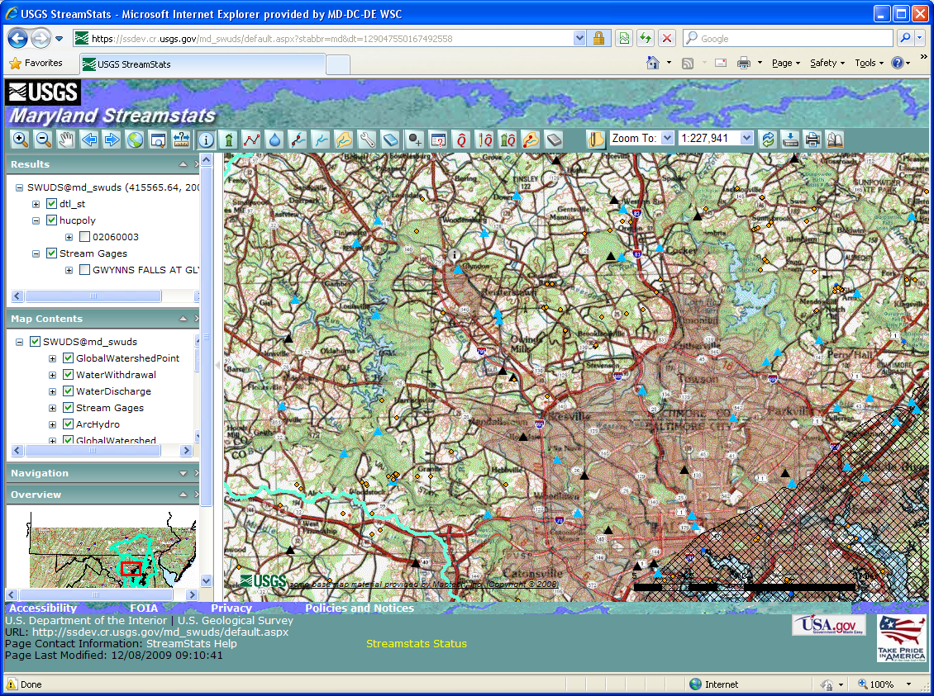
The Results panel is used to display the results that are generated when the Identify tool is used. The panel is empty initially. Typically the Results panel will contain lists found features, along with field names and values for the features. The Help facility (described below) contains a detailed description for use of the Results panel. A direct link to this description is https://ssdev.cr.usgs.gov/md_swuds/Help/UsingResults.htm
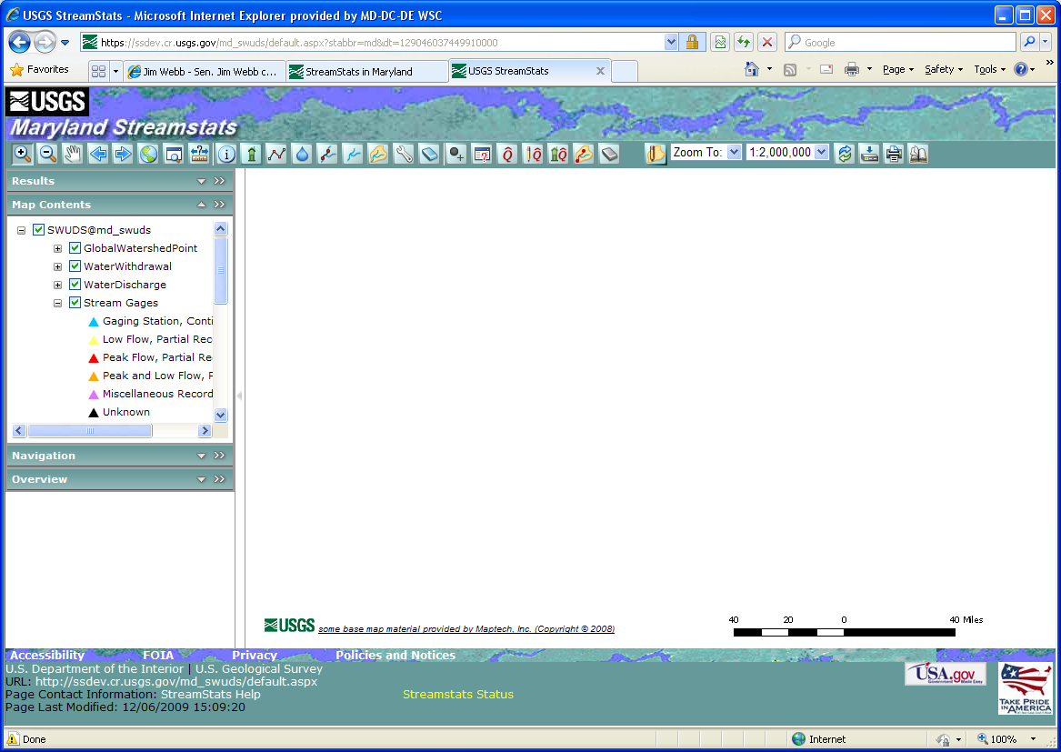
The Map Contents panel provides a list of the layers that can be displayed on the map. It works in a manner that is similar to the display of folders and files in Microsoft Windows Explorer. Initially upon expanding the panel, only a single line of text is shown. In the case of the Maryland application, the displayed text is “SWUDS@md_swuds”, which is meaningless to the user. To the left of this text are a small box with a plus sign in it and a larger box with a green check mark in it . Clicking on the plus sign will cause a list of the layers that can be displayed to appear, and the plus sign will change to a minus sign 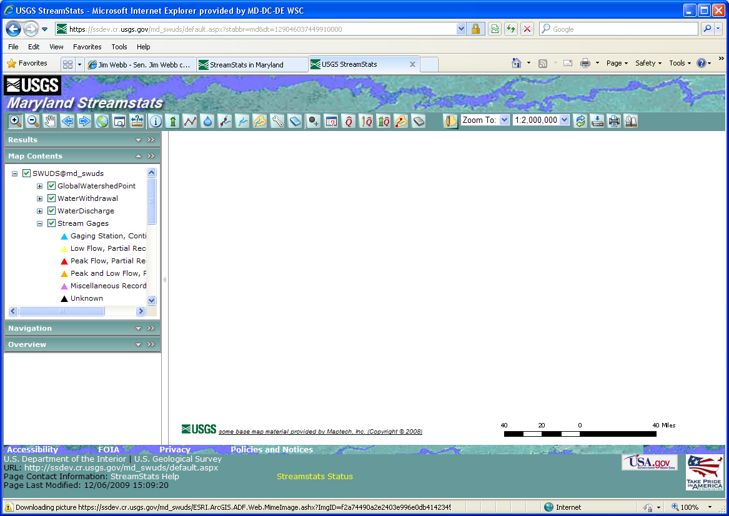. Clicking on the minus sign will cause the list of layers to disappear.
Each layer listed in the Map Contents panel also has a small box with a plus sign and a larger box that may be empty or may contain a green check mark. Layers with a green check mark are displayed on the map, whereas layers with an empty box are not displayed on the map. Clicking on an unchecked box will cause a check to appear in the box and the map to be redrawn with the selected layer displayed. Clicking on the plus sign for a layer will cause display in the Map Contents panel of an explanation of the symbols that appear on the map for the layer, and the plus sign will change to a minus sign. Clicking on the minus sign will cause the layer explanation to disappear.
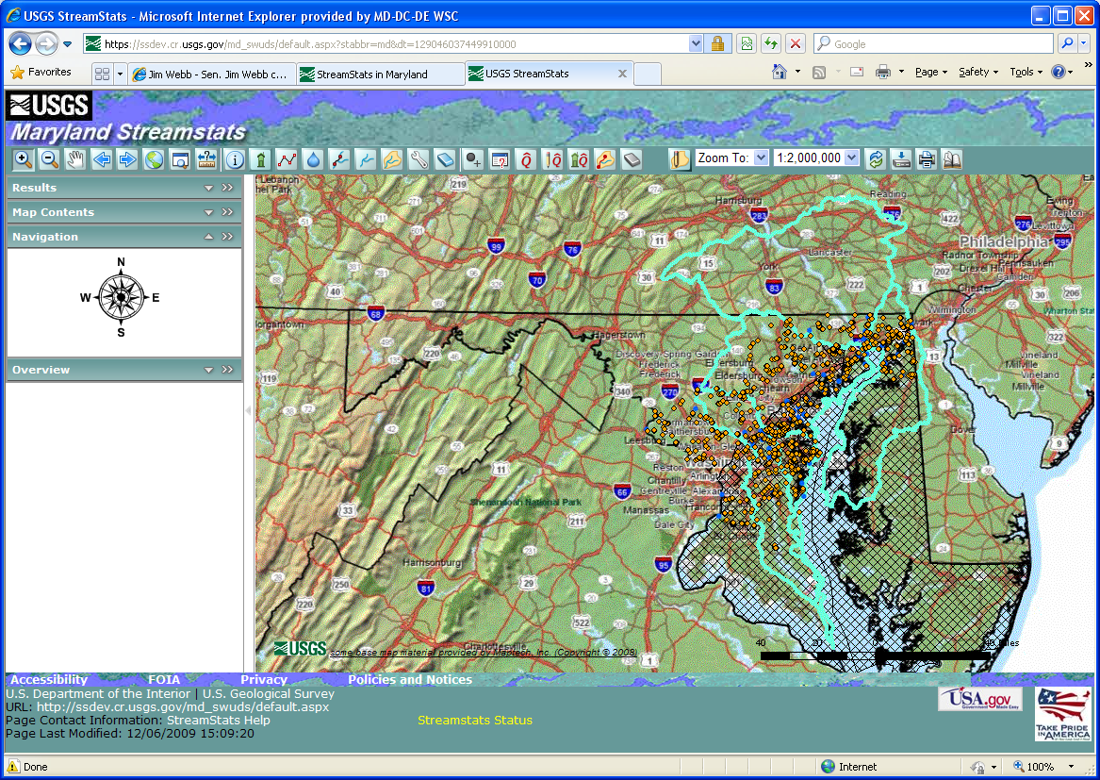
The Navigation panel displays a compass rose. Clicking on any of the points on the compass will cause the center of the map to move in the selected direction.
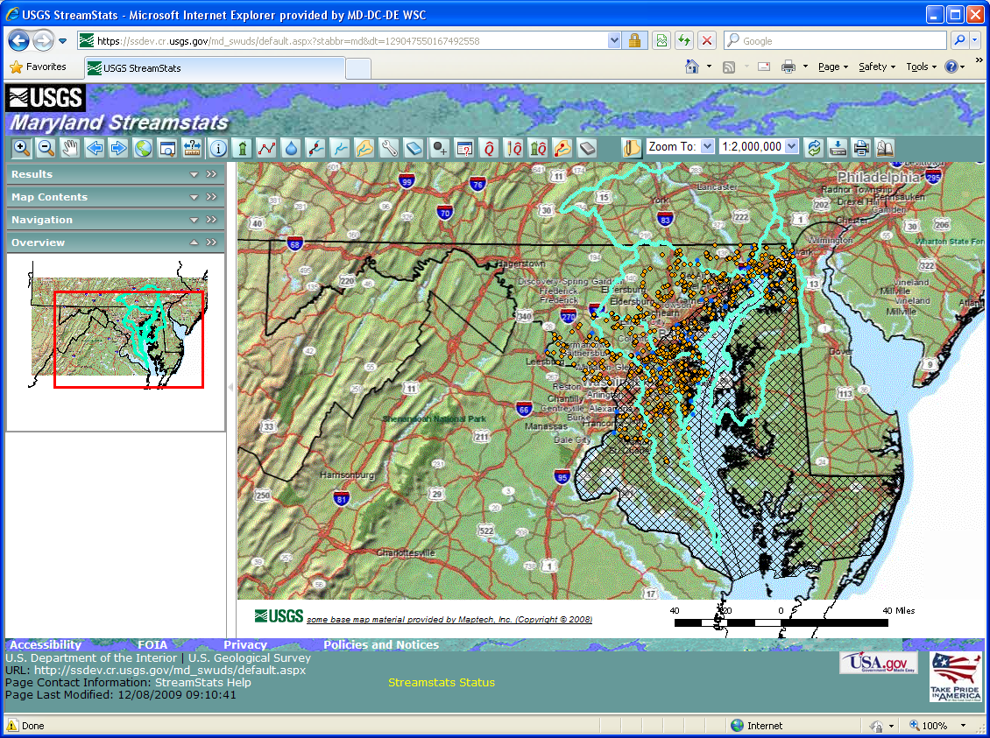
The Overview panel shows a small-scale map of the general area. A red rectangle shown on the small-scale map corresponds to the display area of main map on the user interface. Clicking on and dragging the red rectangle in the Overview map will change the center of focus on the main map.
The toolbar above the map contains a series of buttons that allow moving around on the map and accessing custom functionality developed for StreamStats. Each button is explained further below.

Getting Help
The far right button on the toolbar is the Help button. Clicking on this button launches a new window that contains a help facility that provides detailed instructions on of StreamStats. The top line on this page contains a link to the specific user instructions for StreamStats, most of which is reproduced in this document. The remaining links on the page provide general instructions for use of the interface, such as using the toolbar, identifying features, using the magnifier, displaying map layers, etc. Users should review this information before attempting to use StreamStats. The information provided through the Getting Started and Quick Tour links in the help facility are particularly helpful.
NOTE: Users should always wait until processing is completed and the map is re-drawn before attempting to do additional work with StreamStats. In addition, please help us conserve our server system resources and close the Interactive Map window when you are finished using it. Doing so will help ensure system availability for all users. Thank you.

Moving Around on the Map
Moving around on the map can be done in numerous ways. The first six buttons on the left of the toolbar are common to many other internet mapping applications. These include the Zoom In , Zoom Out , Pan , Previous Extent , Next Extent , and Full Extent buttons. The Zoom In and Zoom Out buttons allow changing of the map scale. The Zoom In button causes the map to be drawn to a larger scale, meaning that when the map is redrawn a smaller area will be shown. The Zoom Out button has the opposite effect. The Pan button recenters the map at a new selected location. The Previous Extent button redraws the map to the same area that was shown before the map was last re-sized. The Next Extent button works only after the Previous Extent button was used, and redraws the map to the same area that was shown before the Previous Extent button was used. The Full Extent button redraws the map to the scale that was shown when the application was first started. In addition to these buttons, the toolbar contains a Zoom To tool and a pull-down list for scale selection, both of which are explained below.

Use of the Zoom In Button:
- Click on the Zoom In button.
- Move the cursor over the map, then hold down the left mouse button and drag the cursor to outline a box over an area of interest.
- Release the left mouse button and wait for the map to re-draw.
- When zooming in to select a site where drainage-basin delineation is desired, the scale of the map must be at 1:24,000 or greater before a delineation can be obtained.

Use of the Zoom Out Button:
- Click on the Zoom Out button.
- Move the cursor over the map, then hold down the left mouse button and drag the cursor to outline a box.
- Release the left mouse button and wait for the map to re-draw.
- The map will be redrawn so that the current map area will fit into the rectangle drawn. The smaller the rectangle that is drawn, the more the map will zoom out.

Use of the Pan Button:
- Click on the Pan button.
- Move the cursor over the map, then click and hold down the left mouse button.
- Drag the mouse to a new location, release the left mouse button, and wait for the map to re-draw.
- The map will be redrawn so that the location at which the mouse button was released will be the same on the map.

Use of the Zoom To Tools:
The Zoom To pull-down list is toward the right side of the toolbar. It provides access to three separate tools for zooming in to specified locations. These tools allow users to zoom into a provided latitude and longitude, a place name, or a National Hydrography Dataset (NHD) reach code. To use one of these tools:
- Click on the down arrow at the right side of the Zoom To pull-down menu to select the desired mode for zooming.
- If a latitude and longitude is selected, a pop-up window will appear that contains boxes in which the latitude and longitude of the desired location can be entered, in decimal degrees. Click on the Zoom To button in the pop-up window to zoom to the desired location. Although longitudes in the Western Hemisphere are negative, type the longitude in as a positive value.
- If a place name is selected, a pop-up window will appear that contains a box in which the user can enter all or part of the desired name. Below this box is a pull-down list of feature types on which the search will be done. Select the feature type that is most closely associated with the desired place name. For example, users should select a feature type of populated place if they want to zoom into a city or town. The search can be further refined by selected the appropriate state and county from the available pull-down lists. When all selections have been made then click on the Submit Query button. If only one place matches the name given, the map frame will zoom to the location. If more than one place matches the given name, a list will be provided of the names of all places matching the given name. Determine from the Feature Name the entry that most closely matches the desired location, and then click on Zoom in the first column of the table in the row for the selected entry to cause the map to zoom into the location.
- If a reach code is selected, then a pop-up window will appear in which the code can be entered. Users should first select the resolution of the NHD dataset to which the site of interest is referenced (medium, high, or local), and then enter the 14-digit reach code and the measure (percentage along the reach). Click on the Zoom To button in the pop-up window to zoom to the specified location.

Zooming to a Specified Scale:
To the right of the Zoom To pull-down list is another pull-down list in which the current scale is shown. To change scales with the map centered on the present location, click on the down arrow to the right side of the pull-down list and select the desired scale. Note that to delineate a drainage-basin boundary for an ungaged site, the map must be zoomed into a scale of at least 1:24,000.

Obtaining Information for a USGS Data-Collection Station:
USGS station location must first be displayed on the map before information can be obtained for a particular station. Make sure that a green check mark appears in the check box on the Stream Gages layer in the Map Contents panel. To get information for a station:
- Zoom in to the area in which the station of interest is located.
- Click on the Gaging Station Information tool button when using a state application or on the StationInfo button when using the national data-collection station application.
- Click on a triangle on the map that indicates the station location.
- A pop-up Web-browser window will appear with the available information for the selected station. The Data-Collection Stations description page at http://water.usgs.gov/osw/streamstats/gaged_output.html explains the information to be found on the output pages for data-collection stations.

Selecting an Ungaged Site and Delineating a Watershed:
When an appropriate scale of 1:24000 or greater is reached, the map frame displays either a dark blue grid or a dark blue line to represent the stream network, depending on which state application is used and the spatial data on which it is based. The stream network was derived entirely or in part from digital elevation data, and does not always agree exactly with the streams shown on the topographic base map. To determine the watershed boundary for a selected site:
- Click on the Watershed Delineation from a Point button. .
- Click on the stream network grid cell or a point on the line that is closest to the stream site of interest.
- StreamStats will begin processing to delineate the drainage boundary for the site of interest. When finished, the basin will be highlighted in magenta on the map.
- A quick check of the boundary can be done by turning off the basemap layer and turning on the NHDFlowline or Dendritic Stream Network layer to assure that no streams cross the basin boundary, which is an indication that something may be wrong.
- A detailed check of the boundary can be done by use of the Zoom to Previous Extent and Pan buttons to compare the delineated boundary to the topography and streams shown on the base map.
- Users should particularly examine the delineation in the area nearest the selected point, as that is where problems are most likely to occur. An error is indicated if the delineated boundary does not follow the topographic divide or a stream on the base map crosses the boundary.
- If an error has occurred, see below to learn how to notify the StreamStats team about it. It may be possible to eliminate the error by using the Hide/Show Last Delineation button to clear the boundary and selecting a new point for delineation just upstream or downstream from the previously selected point. If possible, avoid flat areas, such as the middles of lakes, wetlands, or broad valleys.

Editing Watershed Boundaries:
Watershed (basin) boundaries determined by StreamStats can be edited to add or remove parts of the delineated drainage basin. Users may want to modify the boundaries to correct errors in the delineations resulting from inaccuracies in the spatial data used to determine them, or they may want to determine the effects of proposed land-use changes or changes that were already made but are not reflected in the topographic map and spatial data.
After the initial basin delineation is completed, zoom in closely to the area that needs to be edited. If editing of the basin boundary is desired, click on the Edit a Delineated Basin button .
- Select Add Shape or Remove Shape and click OK in the pop-up window that will appear.
- Visualize a polygon (a 2-dimensional shape) that will entirely enclose the area to be added or removed.
- Click the left mouse button once at a vertex (corner) of the desired polygon, and then once on each successive vertex. The sides of the polygon will be drawn as the mouse is moved from vertex to vertex.
- Click twice on the final vertex to end editing. StreamStats will then begin processing and re-draw the basin area to reflect the changed boundary.
- If the basin is large, then to assure accurate editing, complete a series of small edits while zoomed in closely rather than relying on a single edit while zoomed far out.
- After editing the basin boundary, the Basin Characteristics, Estimate Flows Using Regression Equations, and Estimate Flows Based on Similar Gages tools will operate using the edited basin. Reports will indicate that the basin was edited.

Getting Streamflow Statistics and Water-Use Summaries for an Ungaged Site:
Estimates of streamflow statistics for user-selected ungaged sites can be obtained by two methods in StreamStats. The Watershed Delineation from a Point button must be used first to obtain the drainage-basin boundary for the point of interest before either of the flow-estimation tools may be used. The Estimate Flows Using Regression Equations button provides estimates by measuring needed basin characteristics and solving USGS-developed regression equations. For Maryland, this tool also provides summaries of water withdrawals and return flows. The Estimate Flows Based on Similar Streamgaging Stations button estimates streamflow statistics by applying the flows per unit area for streamflow statistics at a nearby gaging station to the drainage area for the ungaged site. The theoretical basis for these methods and the outputs provided by StreamStats are explained in more detail on the Ungaged Sites page.

To Obtain Estimates Based on USGS Regression Equations:
- After basin delineation and any editing are complete, click on the Estimate Flows Using Regression Equations button . StreamStats will determine what regression equations are available to estimate the streamflow statistics for the region.
- A pop-up window will appear showing descriptive information for the site, measured basin characteristics, estimated streamflow statistics, and indicators of the errors associated with the estimates.
- The output should be printed or saved to a file as a record of the analysis. Click on the File menu of the browser window, and then click on Print to print the output, or click on Save As to save the output to a file on your computer.

Water-Use Summaries for Maryland
StreamStats for Maryland also includes summaries of water use in the reports produced by the Estimate Flows Using Regression Equations process. All Maryland users will see a summary of ground-water and surface-water withdrawals, return flows, and net flows with monthly and annual average values.
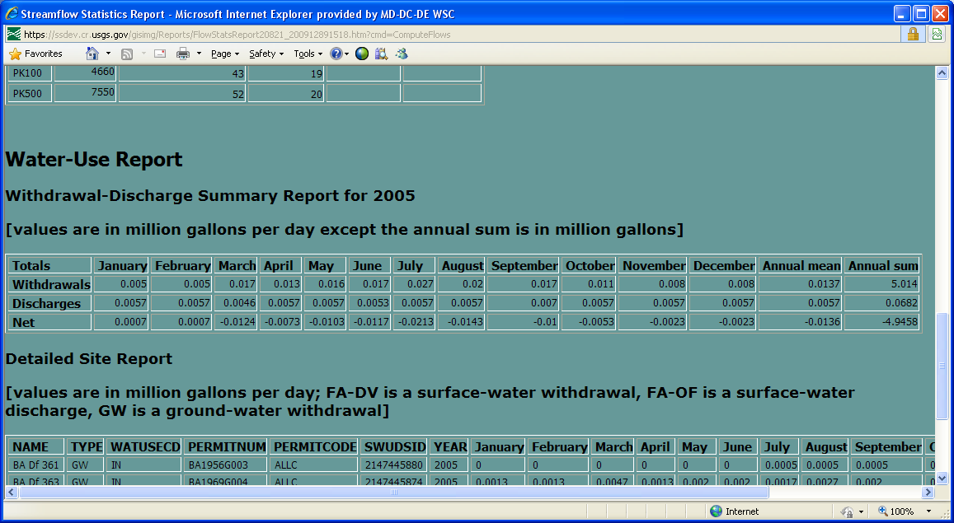
Maryland users who login will see, in addition to the summary report, a listing of detailed information for each withdrawal and return-flow site that is upstream from the delineated point. Users who login also can display the water-withdrawal sites on the map. Users who do not login do not have access to that information.

To Obtain Estimates Based on Flows at Nearby Similar Gages:
- After basin delineation and any editing are complete, click on the Estimate Flows Based on Similar Streamgaging Stations button . A dialogue window will appear that has a check box allowing the user to choose whether on not to allow use of regulated gaged sites in the analysis.
- Choose whether or not to allow use of regulated gaged sites, and then click on Estimate flows to get estimates or on Close if flow estimates are not desired.
- The decision of whether or not to use regulated sites in the analysis should be made carefully. If estimates of natural flows are desired, then regulated stations should not be used. If the user-selected site is downstream from a dam, a diversion, or some other activity that has a major effect on streamflow, then estimates based on regulated streamgaging stations may provided more realistic estimates of actual flow conditions at the user-selected site than natural flow estimates.
- If regulated stations are used in the analysis, then users should also get a StreamStats report of the published streamflow statistics for the streamgaging station and review the publication from which the statistics were obtained to understand any special conditions used to compute the statistics for the station. In some cases, the computed statistics may have been determined from a period during which the streamflow was unregulated at the station. Directions for obtaining reports of streamflow statistics for USGS data-collection stations are provided below.
- Estimates usually will be provided only if the drainage area for the user-selected site is within 0.5 to 1.5 times the drainage area for an upstream or downstream streamgaging station.
- This process usually should be done after regression estimates are obtained because if regression estimates have been obtained first, then StreamStats will combine the regression estimates with the estimates based on the nearby streamgaging stations to provide improved estimates. Improved estimates are available only when the years of record are available in the StreamStats database of streamflow statistics for the streamgaging station and the equivalent years of record are also available for the regression estimates.

Editing Parameters and Recomputing Flows:
The Edit Parameters and Recompute Flows button allows users to modify the basin characteristics that were measured by StreamStats in the Estimate Flows Using Regression Equations, which must be completed before the Edit Parameters and Recompute Flows tool can be used. Upon selecting this tool, a pop-up window will appear that lists all of the basin characteristics that were used to solve the regression equations for the selected location. Users can type in new values for any of the basin characteristics. Click on the Recompute Flows button and a new ungaged site report will appear that looks the same as the report from the Estimate Flows Using Regression Equations process except that the title indicates that edited parameters were used to obtain the flow estimates.
The Edit Parameters and Recompute Flows process is useful for testing the sensitivity of the regression equations to changes in the basin characteristics used as parameters in the equations. Multiple scenarios can be tested in succession by (1) clicking with the right mouse button on the output window to cause a menu to appear, (2) selecting Back from the menu to cause the parameter editing window to reappear, (3) modifying the characteristics again, and (4) clicking on the Recompute Flows button to obtain new estimates. The Edit Parameters and Recompute Flows process also can be used to determine changes in flow that can be expected due to a planned or natural change in a parameter. For example, the drainage area could change as a result of mining operations, or a change in mean annual precipitation could be expected as a result of anticipated climate change.

Getting Additional Basin Characteristics for an Ungaged Site:
The basin characteristics provided in the output from the Get Statistics tool are limited to those needed to solve the regression equations that are available at the user-selected point. Often, additional basin characteristics can be obtained by use of the Basin Characteristics tool button .
- After basin delineation and any editing are complete, click on the Basin Characteristics tool button. A pop-up window will appear, providing a list of the basin characteristics that are available for the location.
- A pop-up window will appear showing descriptive information for the site, measured basin characteristics, estimated streamflow statistics, and indicators of the errors associated with the estimates. For a more in-depth discussion of the output, click here.
- The output should be printed or saved to a file as a record of the analysis. Click on the File menu of the browser window, and then click on Print to print the output, or click on Save As to save the output to a file on your computer.

Downloading Shapefiles:
The StreamStats application allows the user to download shapefiles of the delineated watershed and point. The shapefiles can be displayed and used for further analysis in other GIS applications. Shapefiles should be retained to serve as documentation of the exact point that was used in the delineation and the resulting watershed polygon. These shapefiles will be needed to verify what was done if there is any reason to question the results from StreamStats.
- After first thoroughly checking the delineated basin polygon and getting the streamflow estimates, click on the Download button . A dialog window will appear.
- Enter a watershed name in the dialogue window and then click on the Download button to download a zip file that contains the shapefile for the site or click on the Close button to exist without obtaining a shapefile.
- After clicking on the Download button, the name of the zip file will appear in the dialogue window. Click on the name and save the file to a location on your computer.

Stream Network Navigation (Network Tracing):
The theory of network navigation is explained on the Network Navigation page. StreamStats contains three tools for network navigation, Configure NHD, Trace From Outlet, and Ad Hoc Trace. The stream network on which the trace is to be performed should be displayed in the user interface before attempting a trace. If a site already has been selected and a drainage-basin boundary has been obtained:
- Click on the Configure NHD Trace button to display a dialogue window that allows specification of the network upon which tracing (searching upstream or downstream) will be done, the direction of the trace, and the map layers of events that will participate in the trace.
- Select the network, trace direction, and map layers, and then click on the OK button.
- Click on the Trace from Outlet button to perform the trace and wait for the results.
- A pop-up Web-browser window will appear with the results from the trace, and the map frame will redraw, with the stream reaches identified in the trace highlighted.
- Click on the fields with hyperlinks in the output tables to obtain additional information.
If a watershed basin has not already been delineated:
- Click on the Configure NHD Trace button and select the network, trace direction, and map layers, as described above.
- Click on the Ad Hoc Trace button .
- Click on any point on the stream network and wait for the results. (You should be zoomed in to scale at which the stream network can be clearly defined before doing this.)
In either case, after the network trace has been completed a pop-up Web-browser window will appear with the results from the trace, and the map frame will redraw, with the stream reaches identified in the trace highlighted. Click on the fields with hyperlinks in the output tables to obtain additional information.
To clear all network trace results, click on the 'Clear Selected Features from NHD Trace' button .

Raindrop Trace to Network:
This tool traces the path that a drop of water or a spilled contaminant would follow from the point chosen by the user until intersecting the current active network layer; the trace then follows the network downstream to the outlet.
To use this tool:
- Click the Raindrop Trace to Network button () to activate the tool.
- Click on the map at the location where you want to start the trace.
The tool uses the underlying flow-direction grid to determine the flow path to the point at which it intersects the active stream network. It then traces downstream along the network. A blue dot appears at the point selected by the user. A green appears at the location where the trace first intersects the network.
The function also displays the NHD reach code and measure of the location where the trace first intersects the network layer.
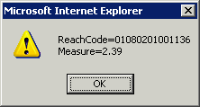

Show Network Path Profile:
This tool traces the network path and generates the profile between two user-specified points on the stream network. The points have to be on the same stream network but not on the same stream. For example, the selected points can be on separate tributaries to a larger stream.

To use this tool:
- Zoom in on the map to an area that encompasses the two points of interest.
- Click on the Show Network Path and Profile button .
- Click on the map at the location where you want to start the trace. The map will re-drawn and highlight the selected point as a blue dot.
- Click on the map at the location where you want to end the trace.
The tool displays the path in red between the user specified (blue point) and the watershed outlet (yellow star).

Trace Network Path within Watershed and Show Profile:
This tool traces the network path and generates the profile along the main flow path from the user specified trace point to the watershed outlet. The watershed must be entirely located within one HUC.
To use this tool:
- Delineate a watershed first that it is located entirely within one HUC.
- Click the Trace Network Path within Watershed and Show Profile button .
- Click on the map at the location where you want to start the trace.
The tool displays the path in red between the user specified (blue point) and the watershed outlet (yellow star).
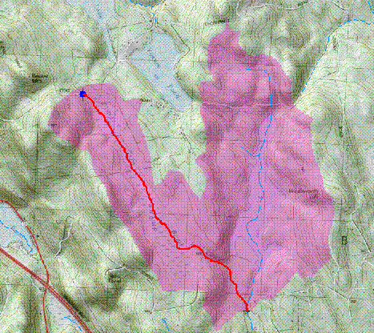
Also, a graph is generated that shows the profile corresponding to the flow path.
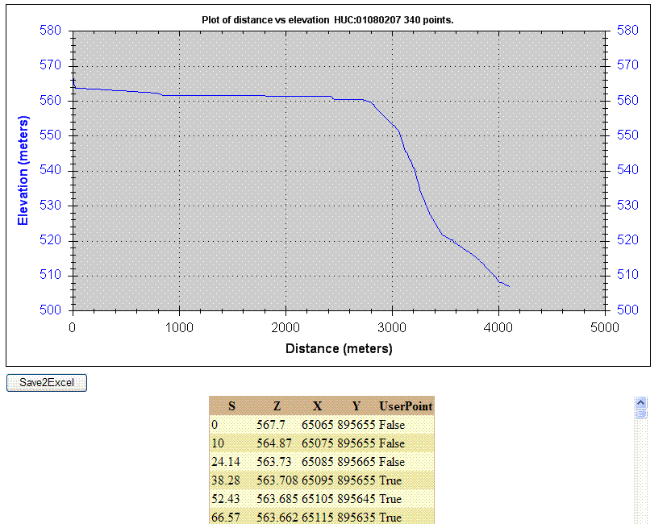

Terrain Profile:
This tool generates the terrain profile of the user specified points using the underlying Digital Elevation Model (DEM) grid.
To use this tool:
- Click the Terrain Profile button.
- Click points on the map that will be used to generate profile.
This tool displays the profile path in red, with user-specified points along the line shown as green points.
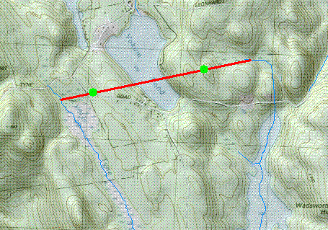
Also, a graph is generated that shows the profile corresponding to the user specified points. Below the graph is a button that allows saving of the points along the line in an Excel file. The points also are displayed in a table below the graph.
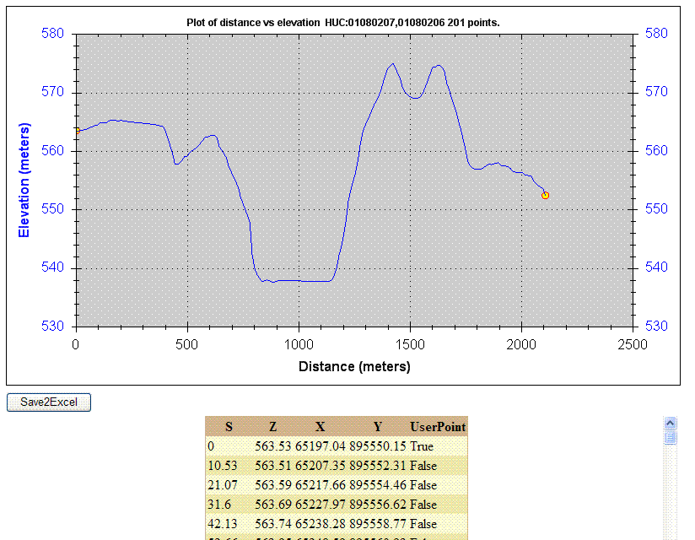

Show Main Channel Flow Path and Profile
This tool works for only some StreamStats applications. When selected, the tool determines the main channel within a delineated basin. It then uses the flow-direction grid to extend the flow path from the upstream end shown on the map to the basin divide. The tool then creates a plot of the elevation profile along the stream from the basin divide to the delineated point.
To use this tool:
- First, use the Watershed Delineation from a Point button to delineate a watershed that it is located entirely within one HUC.
- Next, use the Basin Characteristics button to compute basin characteristics for the selected site. This step is needed because StreamStats needs to compute the 10-85 slope based on longest flow path before it can create the profile. (The 10-85 slope measure is based on first determining the length of the main channel and then points at 10 and 85 percent of the length from the downstream end. The slope is then determined by subtracting the elevation at the 10-percent point from the elevation at the 85-percent point and dividing by the distance between the points.)
- Finally, click on the Show Main Channel Flow Path and Profile button 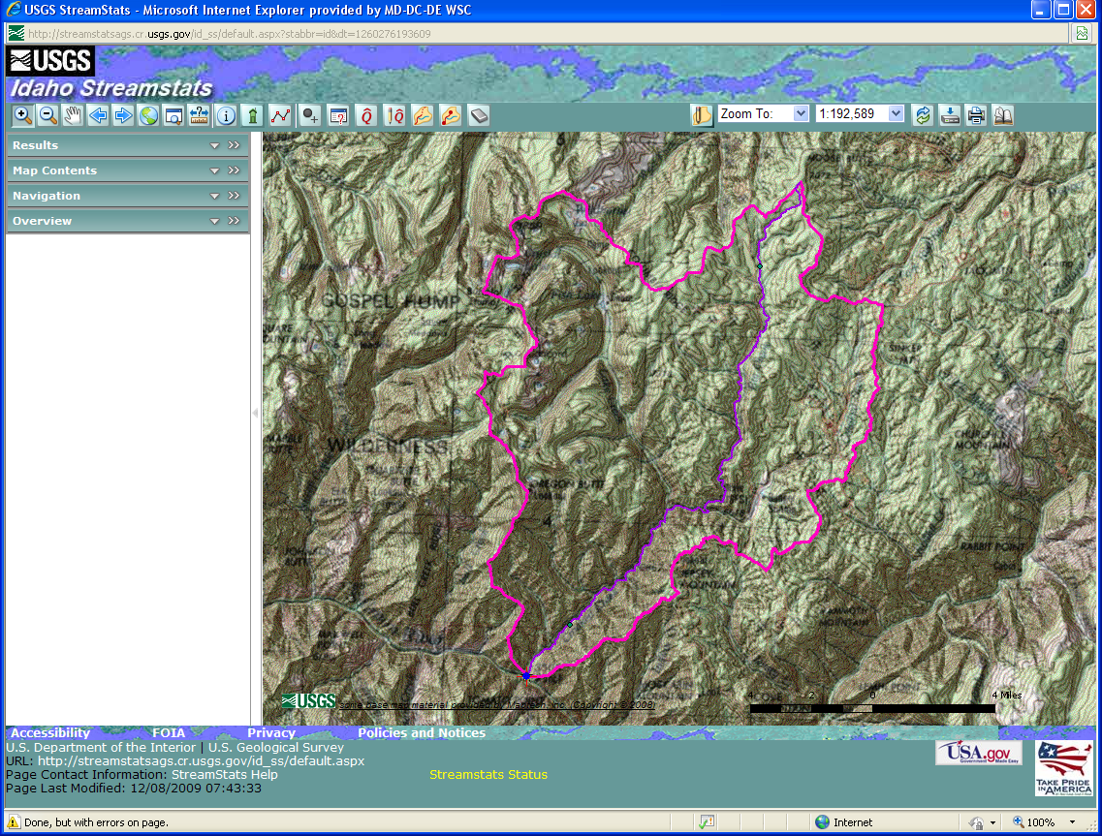.
Initially, the map will be redrawn, showing the delineated basin and the main path highlighted in purple. A green dot will appear on the main channel at the upstream end of the existing stream network. The channel above that point was determined from the flow-direction grid.
After the map redraws, a window will appear that shows a graph of the stream profile. Below the graph is a button that allows saving the data that are plotted on the graph to an Exel file. In addition, a table of the data points is provided.

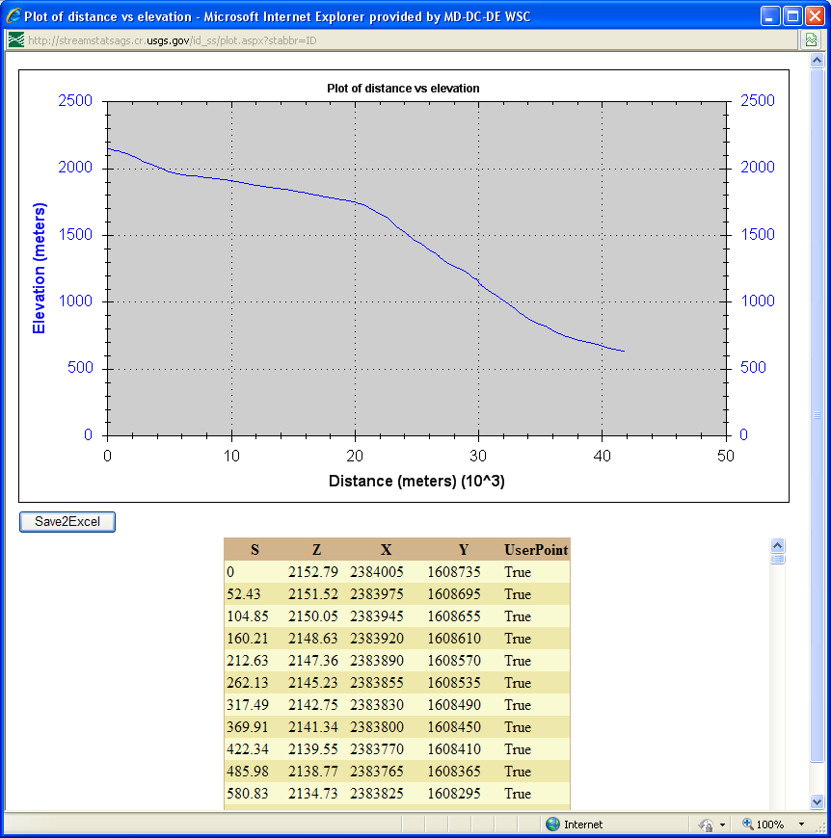

The stream profile is determined by overlaying the stream network vector layer on a digital elevation model (DEM), which is an evenly-spaced grid of elevations. DEM grid cells that align with the stream network vector layer are used to define a stream network grid, and then the elevations from the DEM are extracted to define the elevation profile. In StreamStats, usually (but not always) the DEM was derived from 1:24,000-scale topographic maps and has 10-meter grid-cell spacing. Streams from the vector layer often do not align exactly with stream channels that can be derived from the DEM because of the limited resolution of the DEM and sometimes because of differences in the source material of the two datasets.
A stream profile derived from this process often will appear to have unrealistic peaks in the downstream direction in locations where the stream network vector layer coincides with the stream bank or valley side instead of with the stream channel from the DEM. StreamStats uses a smoothing process to eliminate these unrealistic peaks. The profile plot is produced using a process that begins at the upstream end of the main channel and a test determines if the elevation for the next downstream cell is equal to or less than the current cell. If yes, the process steps to the next cell and repeats the test. If no, the process tests each subsequent downstream cell until it finds a cell that passes the test. The process then interpolates new elevations for the cells that failed the test based on the difference in elevation between the current cell and the next downstream cell that passes the test. In this way, StreamStats produces a stream profile without increases in stream elevation in the downward direction.

Brief descriptions of other buttons on the Toolbar are on the Help Button.

The Magnifier Button
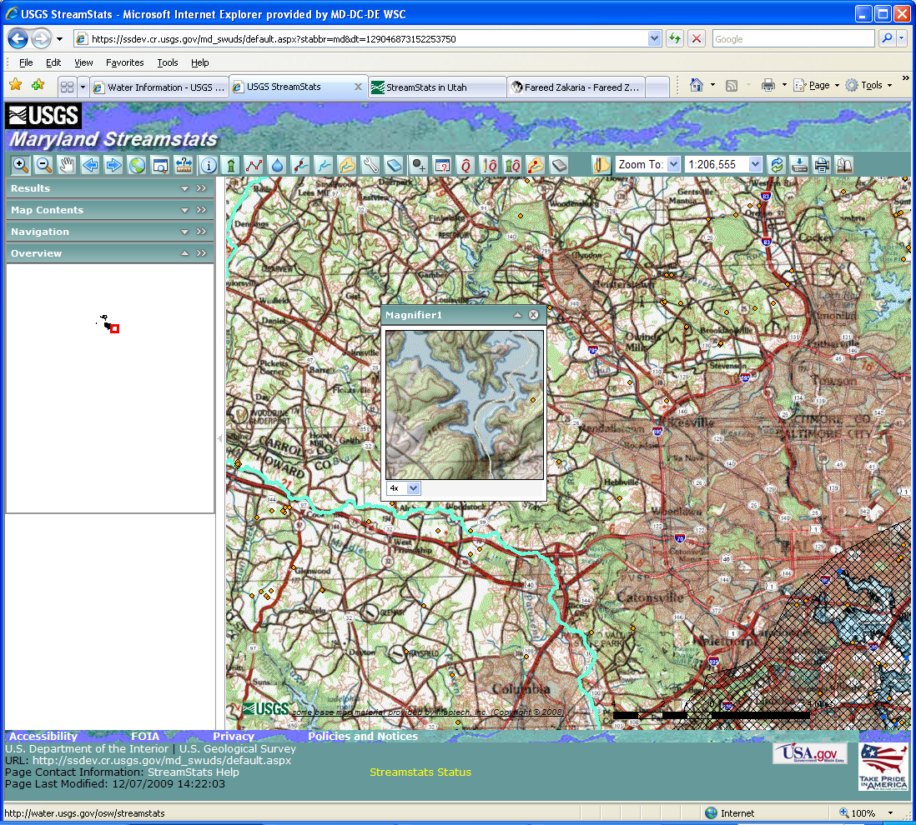
The Magnifier button shows a close-up view of an area of the main map. Clicking on the Magnifier button will cause display of the Magnifier panel, which can be moved, collapsed and closed as desired. Initially, the Magnifier panel is blank, with a dashed red square and a cross-hair in it. Clicking and holding on the panel bar and then moving it will cause the base map to appear in the background. Letting go of the panel bar will cause the image in the Magnifier panel to be magnified by the amount selected in the pull-down list below the map in the Magnifier panel. The magnified image will be centered on the location of the cross-hair before letting go of the panel bar. Like other panels, the Magnifier panel can be resized, minimized, closed, or moved onto the console area.

The Measure Button
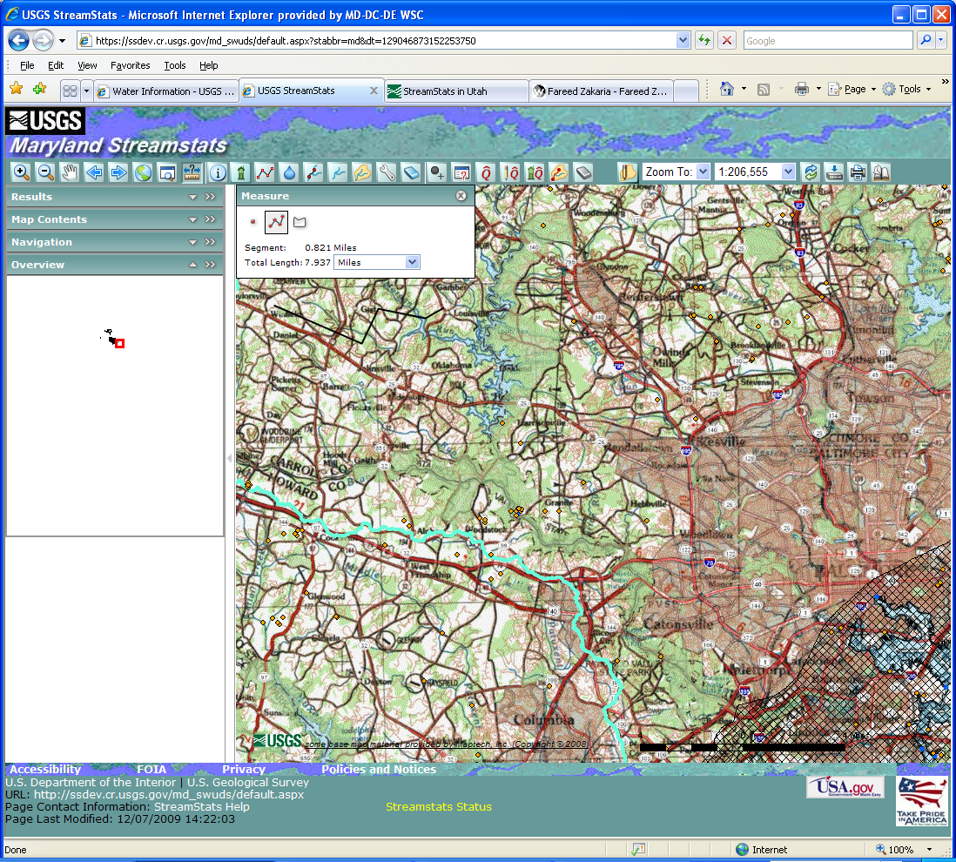
The Measure button has the ability to measure distances on the map in feet, kilometers, meters, or miles. Clicking on the Measure button causes the Measure panel to open over the map. This panel gives instructions for using the tool, allows selection of the length scale from a pull-down list, and presents results. Users initially select a point on the map from which they want to determine a distance. Users can then click on numerous intermediary points, if desired. Segments between selected points are shown on the map as a black line. The end point is selected by clicking twice, after which the distance is displayed in Measure panel.

The Identify Button
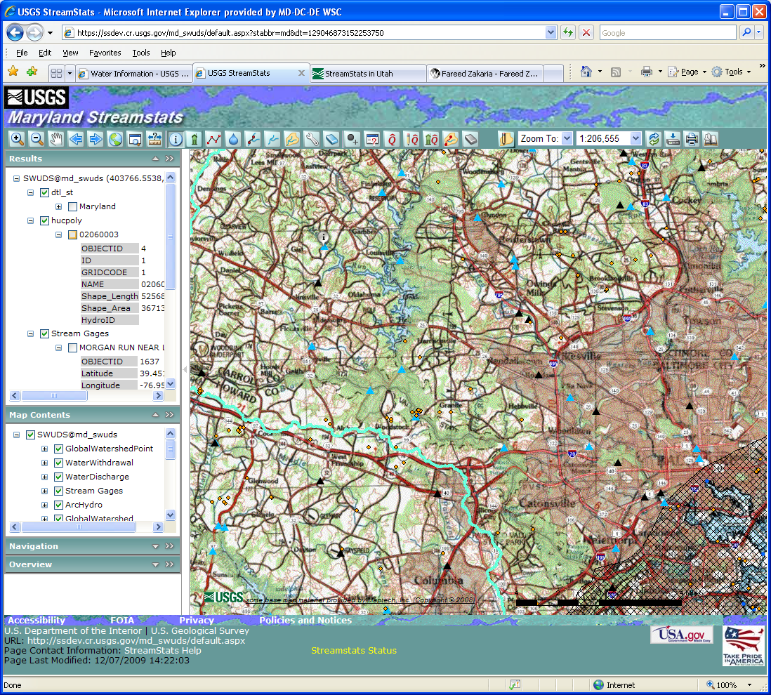
The Identify button allows users to obtain information on point and vector layers that are displayed on the map. To use this tool, first click on the Identify button and then click on the location of interest. The identified features will be displayed in the Results panel. Typically the results will contain lists of field names and values for any found features. The Help facility contains a detailed description for use of the Results panel. A direct link to this description is https://ssdev.cr.usgs.gov/md_swuds/Help/UsingResults.htm.

The Refresh Button
The Refresh button causes the map to be redrawn.

The Print Button
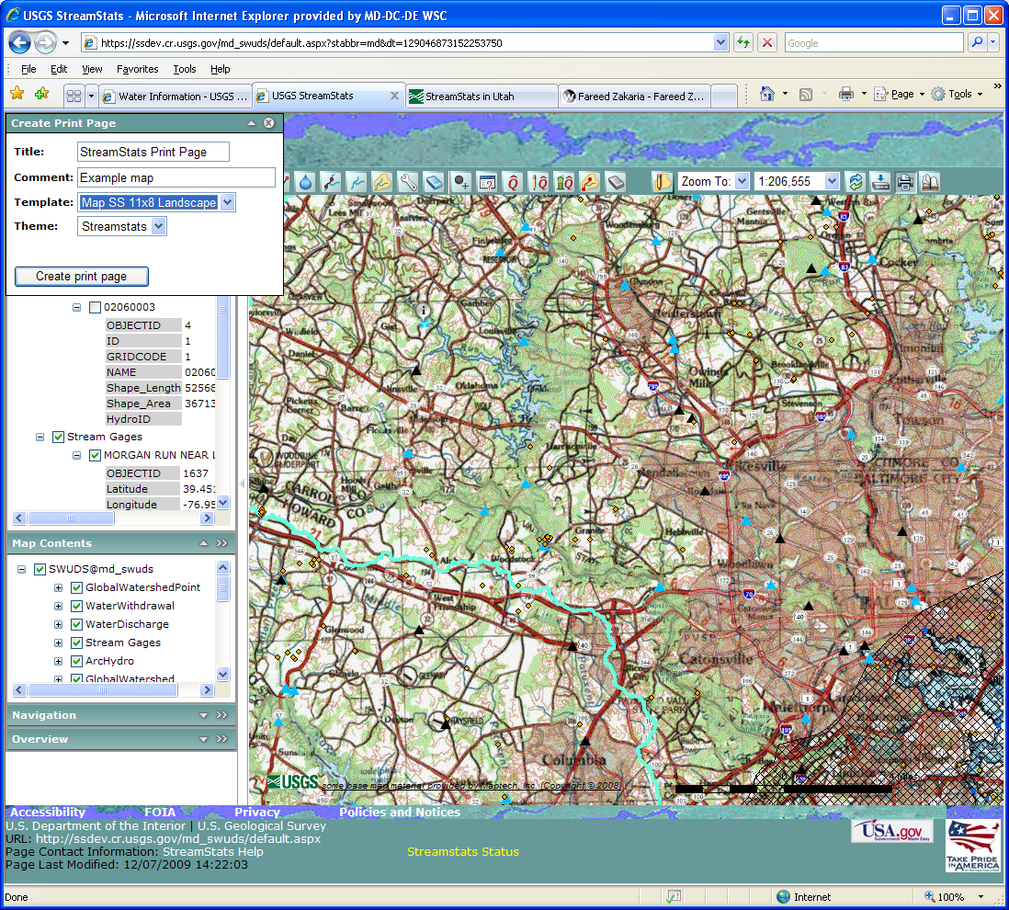
- The Print button enables printing of whatever is shown in the map frame. After clicking on the button, the Create Print Panel will appear on top of the map. Users can change the title that will appear on the printed map, add a comment, select the page to be printed in landscape or portrait orientation, and select a theme. The only theme choice currently is StreamStats. Click on the Create Print Page button in this window after the selections are made. Another pop-up window will appear showing the view from the Map Frame and a legend of the displayed map layers. The map can be printed by clicking on the Print button on the map or selecting File and then Print from the web browser menu bar at the top of the window.

Reporting Problems:
If any problems are encountered with StreamStats, please send email to GS-W_StreamStats_help@usgs.gov. This email address is monitored by during regular working hours by several people. Users usually receive responses to their questions within minutes after they are received. Please address any general comments or suggestions on GS-W StreamStats@usgs.gov.

