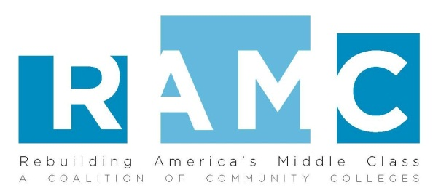
Rebuilding America’s Middle Class
Response to U.S. Department of Education Request for Information (RFI) on Promising and Practical Strategies to Increase Postsecondary Success

On Ramp

Organization Name: Virginia’s Community Colleges

Organization address: 101 N 14th Street Richmond, VA 23219 15th Floor

Contact Name: Scott Kemp

Title: Career Coaches Coordinator

Email address: skemp@vccs.edu

Telephone Number: 804-819-4968

Contact Name: Craig Herndon

Title: Vice Chancellor for Workforce Development

Email address: cherndon@vccs.edu

Telephone Number: 804-819-4782

Program Name: On Ramp

Promising or Practical Strategy Abstract:

The On Ramp program is a Virginia Community College System workforce initiative to improve the employment rate of workers in areas who have been dislocated out of the job market. On Ramp provides certificate programs, job credentials and degree attainment with little or no cost to the student. On Ramp is offered at 16 of Virginia’s Community Colleges that serve regions with the highest unemployment rates or which have been impacted by a significant layoff event. In the program’s first year, it served over 1,000 students who obtained more than 350 credentials identified as “in demand” by the local economies. Funded by the Workforce Investment Act, the program is a collaboration of workforce services, career coaches and the local community colleges.

- Promising or Practical Strategy Description:

The On Ramp program was developed in 2010 by the Virginia Community College System using support from the Workforce Investment Act program. Large employment centers in small regions are closing down because of the economic downturn and leaving hundreds of people out of work. Many of these dislocated workers have no transferable skills or access to postsecondary education. On Ramp assists these workers in finding community college courses and certifications that will make them more attractive applicants in the job market, while removing the often heavy financial burden of having to pay for training out of their own pocket. The program is unique in that it provides financial aid which may be applied to credit and noncredit workforce instruction leading to an in demand credential. Moreover, the program affords coaching services to facilitate the success of dislocated workers in obtaining needed credentials and finding employment.

The Virginia Community College System is the state entity with the primary responsibility for coordinating workforce training at the postsecondary level in Virginia. The colleges in that system can provide training in practical skills for “in demand” fields like nursing, shipyard building, mining, and machining technology in two years or less. These courses and others have a higher success rate of students finding jobs after completion because they now possess a specialized skill set that is demanded by the market. An excellent example is the machining technology program at Danville Community College. In its four decade existence, the program has had 100 percent of the students offered job placement.

On Ramp aligns career pathways into the VCCS Achieve 2015 plan, a six year strategic plan developed to address unmet needs in Virginia postsecondary education. Key objectives of the 2015 Plan include access, affordability, and workforce development. By eliminating costs for students, On Ramp allows adults who have been out of school to access and afford an education they may not have considered and empowers them for their own success while serving the needs of local employers.

- Challenges:

The success of the program is determined by the amount of communication between the participant, the career coaches, financial aid offices, local one-stop workforce centers, and employers. On campus career coaches are a key to overcoming communication gaps by helping the students feel engaged in the program and discourage them from dropping out. The coaches ensure that the student is getting the experience and training that will prepare them for a specific in demand job skill in their regional area. Coaches assist students in obtaining the financial assistance needed to sustain their education and training and work closely with their local one-stop workforce centers and employers to identify those occupations and skills that are in greatest demand.

During the initial state wide deployment, uniform program guidelines were given across colleges to remove any ambiguity from the process. In addition, monthly webinars provided by the VCCS allowed open communications across colleges and with the VCCS to ensure program success.

- Assessment, Evaluations, and Outcomes:

On Ramp is a new program at the VCCS and a large amount of data is not yet available about the success rates of students taking part in this program. In its first year, On Ramp served 1,037 individuals who have been awarded an average of $1,423 in awards and earned 357 credentials. The full performance report can be found here.

Colleges participating in On Ramp are responsible for semi-annual reporting that is assessed by the VCCS. They colleges are evaluated on; number of unemployed served, career and college plans developed, persistence in selected program of study, credentials attained, job placement and increase in wage earnings following program exit.

- Recommendations for Replication:

The Workforce Investments Act has been the main funding source for the On Ramp program. Please contact Scott Kemp for additional information.

Tags
• Adult Education
• Career Pathways
• Certificate Attainment
• Cost Savings
• Degree Attainment
• Industry-Recognized Credentials
• Job Placement
• Non-Traditional Age Students

