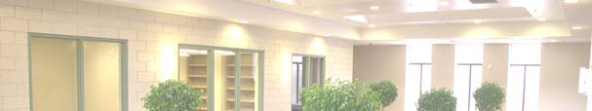
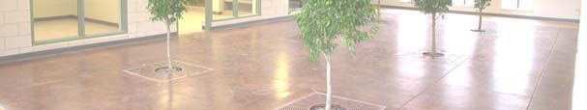
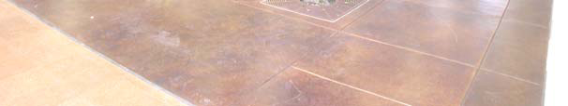
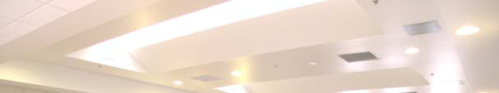
Highland Gardens

“Highland Gardens represents my vision for Milwaukee. We must approach our challenges as a city through aggressive collaboration with public and private partners. The best ideas and the best solutions come from partnerships. Highland Gardens is a solution that improves the quality of life for our residents as it conserves our resources.”—Mayor Tom Berrett

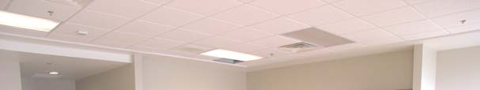
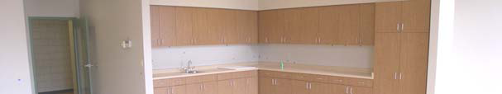
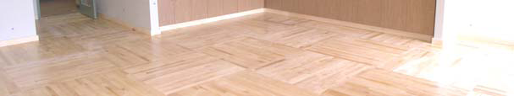

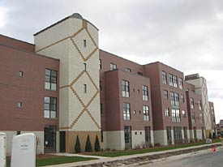
Description:
Highland Gardens is another significant attempt for the city of Milwaukee to embrace green building techniques. In the design of Highland Gardens, developers incorporated a substantial number of green components establishing it as an important benchmark for energy conservation in residential buildings. The most daunting component is the 20,032 square foot green roof, which at the time was the nation’s largest. In addition to energy saving components, developers “exceeded mandated accessibility features and created humanity in the details (Ryan, Sean Highland Gardens Caters to it Residents).” Highland Gardens was built to accommodate low-income residents with disabilities and the elderly, and surpassed the requirements of the Americans With Disabilities Act to such a degree, warranting the high praise cited above. Highland Gardens offers its residents the necessary amenities and more. Residents enjoy on-site health-care, billiards, a movie theatre, common rooms, meditation rooms, a beauty and parlor shop, and an exercise facility. Twenty million dollars in funds will guarantee the continuation of these services, as well as programs that allow the elderly and disabled to live independently.
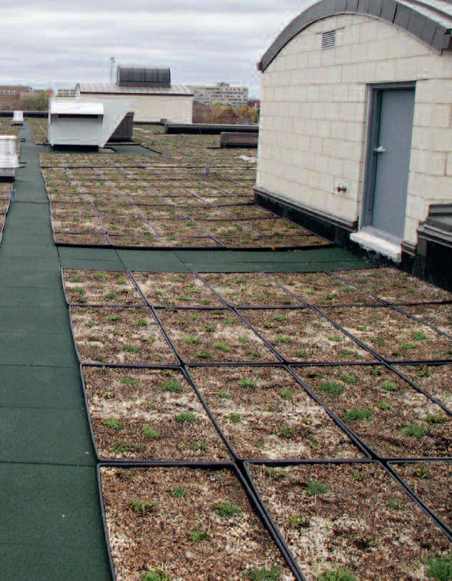
Environmental Complications and Solutions:
The only significant environmental concern on the site was asbestos. The extent of the contamination was concentrated particularly in the floor tile and corresponding mastic as well as in numerous pipefittings. The mitigation measures taken to remedy this problem involved the abatement of all contaminated materials. As a further precaution, all materials within the building were abated to prevent the transfer of asbestos into the new Highland Gardens facility through the reuse of concrete.

Green Components:
Highland Gardens:
• Green Roof
- Absorbs rain water
- Insulates building
- Reduces heat emissions (better air quality)
- Reduces run off into sewage system
- Energy Efficient Designs
- Two Rain Gardens
- Use of recycled building materials
- Windows
- Cement
- Wooden Gym Floors
Highland Homes
- Energy Efficient Heating, Ventilation and Cooling
- Energy Efficient Windows
- Soy-based insulation
- Rain Gardens
- Rain water disposal to grades rather than sewage

Financial Structure:

HOPE VI $19,000,000
Wisconsin Housing and Economic Development $8,250,000
U.S. Bancorp Community Development Corporation $9,090,000

Total $38,000,000

Developer/Sponsor:
Housing Authority City of Milwaukee (HACM)

