STATEMENT OF
DOUGLAS DUNCAN
RESEARCH GEOLOGIST
U.S. GEOLOGICAL SURVEY
U.S. DEPARTMENT OF THE INTERIOR
BEFORE THE
COMMITTEE ON NATURAL RESOURCES
SUBCOMMITTEE ON ENERGY AND MINERAL RESOURCES
JUNE 4, 2009

Mr. Chairman and Members of the Subcommittee, thank you for the opportunity to appear here today to discuss with you the U.S. Geological Survey’s role in studying, understanding, and assessing the unconventional gas resources of the Nation (exclusive of the Federal offshore) and the World.
Introduction
Adequate, reliable, and affordable energy supplies obtained using environmentally sustainable practices are essential to economic prosperity, environmental and human health, and political stability. National and global consumption of fossil fuels are projected to increase over the next several decades, though at a slower rate than in recent years. The projected increase in U.S. consumption is due, in part, to greater anticipated domestic unconventional gas supplies. The Energy Information Administration (EIA) Annual Energy Outlook 2009 projects substantial increases in domestic production of oil, natural gas, and coal, with renewable resources accounting for a rapidly increasing, but still smaller, proportion of the total energy mix under the current policy baseline. Although the impact of new policies aimed at creating a low-carbon economy may increase the speed of this transition to renewable sources, conventional energy resources are expected to remain an important component of our energy mix for some time to come.

The United States currently consumes about 21 % of the energy resources produced in the world. Thus, the volumes, quality, and availability of domestic and foreign energy resources are of critical importance to the United States. The Nation continues to face important decisions regarding the competing uses of public lands and offshore waters, the supply of energy to sustain development and enable growth, and the environmental effects of energy resource development.

Role of the U.S. Geological Survey
The U.S. Geological Survey (USGS) Energy Resources Program (ERP) provides the information needed to address these challenges by conducting scientific investigations of geologically based energy resources, including research and assessment on the geology of conventional oil, gas, and coal resources; emerging resources such as gas hydrates; underutilized resources such as geothermal; and unconventional resources such as shale gas and oil shale, as well as research on the environmental effects associated with energy resource occurrence, production, and (or) utilization. The mission of the ERP is: (1) to understand the processes critical to the formation, accumulation, occurrence, and alteration of geologically based energy resources; (2) to conduct scientifically robust assessments of those resources; and (3) to study the impact of energy resource occurrence and (or) production and use on both environmental and human health. The results from these geoscientific studies are used to evaluate the quality and distribution of energy resource accumulations and to assess the energy resource potential of the Nation (exclusive of Federal offshore waters) and the World. (Federal offshore waters are assessed by the Minerals Management Service of the Department of the Interior.)
The results from these USGS studies provide impartial, robust scientific information about energy resources that directly supports the U.S. Department of the Interior’s (DOI’s) mission of protecting and responsibly managing the Nation’s natural resources; USGS information is used by policy and decision makers, land and resource managers, other federal and state agencies, the domestic energy industry, foreign governments, nongovernmental groups, academia, other scientists, and the public. As one example, current findings from the USGS National Oil and Gas Assessment (NOGA) provide updated scientific information on the mean estimates for undiscovered, technically recoverable oil and gas resources underlying the onshore U.S. and State-owned waters. They indicate that the total 47.5 billion barrels of oil and 743 trillion cubic feet of gas, respectively (Figure 1A & B).

Collectively, information from USGS research advances the scientific understanding of energy resources, contributes to plans for a balanced and secure energy future, and facilitates the strategic use and evaluation of resources.

USGS National Resources Research and Assessment Activities
The overall goal of USGS domestic energy activities is to conduct research and assessments of all geologically based energy resources. This includes undiscovered, technically recoverable oil and natural gas resources, both conventional and continuous (also referred to as unconventional), of the United States (exclusive of the Federal offshore). These are resources that have yet to be found (drilled), but if found, could be recovered using currently available technology and industry practice (without regard to economic viability). The purpose of USGS assessments is to develop robust, geology-based, statistically sound, well-documented estimates of quantities of energy resources having the potential to be added to reserves, and thus contribute to the overall energy supply. The USGS uses resource assessment methodologies that are thoroughly reviewed and externally vetted so as to maintain the transparency and robustness of the assessment results.

In recent years, the USGS has distinguished between conventional and continuous petroleum accumulations for purposes of research and resource assessment (Figure 2). Briefly stated, conventional accumulations are described in terms of discrete fields or pools localized in structural or stratigraphic traps by the buoyancy of oil or gas in water. In contrast, continuous accumulations are petroleum accumulations (oil or gas) that have large spatial dimensions and indistinctly defined boundaries, and which exist more or less independently of the water column. Examples of continuous accumulations are shale gas and coalbed gas, which are among the fastest growing domestic energy resources.

The current USGS effort to update national (onshore and State waters) assessments of oil and gas resources is done in support of the Energy Policy and Conservation Act (EPCA) Amendments of 2000 (P.L. 106–469 §604). The USGS assesses the potential volumes of conventional and continuous (unconventional) resources (e.g. coalbed gas, shale gas, tight gas sands) in each priority province using established, externally reviewed and vetted methodologies, and provides this information to the appropriate land and resource management agencies for subsequent analysis. The Energy Policy Act of 2005 (P.L. 109-58) re-authorized EPCA 2000 assessment activities by the USGS, emphasizing the unique role of the USGS, and specifically mandated that “the same assessment methodology across all geological provinces, areas, and regions [be used] in preparing and issuing national geological assessments to ensure accurate comparisons of geological resources.” The current mean estimate for the United States as a whole for undiscovered, technically recoverable continuous gas resources is 364 trillion cubic feet (Figure 3).

The amount of undiscovered, technically recoverable resources changes over time. There are several reasons for this, including scientific and technological developments regarding petroleum resources in general, improvements to the geologic understanding in numerous settings, and reserve growth. These advances in geologic understanding, as well as changes in technology and industry practices, necessitate that resource assessments be periodically updated. This is especially true for continuous (unconventional) resources. New technological developments increase the recoverability of this challenging resource, and our geologic understanding of these resources is evolving. One example of this change is the recently updated USGS assessment of the Bakken Formation in the U.S. portion of the Williston Basin. This assessment, released in 2008, shows an estimated 3.0 to 4.3 billion barrels of undiscovered, technically recoverable, continuous oil compared to the agency's 1995 mean estimate of 151 million barrels of oil. Assessments of unconventional natural gas resources, including the Barnett Shale, the Marcellus Shale, and others, have shown the same type of increase as our understanding of the geology increases. Much of the technology developed for production of the gas in the Barnett Shale is being used to extract the oil in the Bakken Formation, and these technological advances accounted for the large change in what was considered technically recoverable. The Barnett Shale Newark East field now ranks second in the United States in terms of annual gas production (EIA, http://www.eia.doe.gov/pub/oil_gas/natural_gas/data_publications/crude_oil_natural_gas_reserves/current/pdf/appb.pdf ). Cumulative gas production from January 1993 to January 2006 from the Barnett Shale Newark East field was about 1.8 trillion cubic feet; in 2005, gas production was about 480 billion cubic feet compared to less than 11 billion cubic feet in 1993 (Texas Railroad Commission, 2006, available at http://www.rrc.state.tx.us/data/fielddata/barnettshale.pdf ).

U.S. Geological Survey International Energy Studies
Our Nation depends heavily on imported energy resources: about 57 percent of the oil and 16 percent of the natural gas consumed in the United States come from imports. Given the significance of imported oil and gas to the U.S. energy mix, scientifically valid, unbiased assessments of the world’s remaining endowment of petroleum accumulations are very important. For this reason, global petroleum resource assessments are a core USGS research activity and have significant global visibility. The USGS world oil and gas resource estimates are used as a standard reference by many organizations including the Energy Information Administration (EIA) and the International Energy Agency (IEA).

The overall objectives of USGS studies of international petroleum resources are to continue providing high-quality, comprehensive petroleum assessments and to update previous assessments as needed. A major focus of recent USGS research in this area is the global Circum-Arctic Resource Appraisal, the primary emphasis of which is to provide a comprehensive, unbiased probabilistic estimate of potential future additions to conventional oil and gas reserves in the high northern latitudes. The Arctic is an area of high petroleum resource potential, low data density, high geologic uncertainty, and sensitive environmental conditions. The assessment is the first publicly available petroleum resource estimate of the entire area north of the Arctic Circle. Results indicate that the area north of the Arctic Circle has an estimated mean of 90 billion barrels of undiscovered, technically recoverable oil, 1,670 trillion cubic feet of technically recoverable natural gas, and 44 billion barrels of technically recoverable natural gas liquids in 25 geologically defined areas thought to have potential for petroleum. These resources account for about 22 percent of the undiscovered, technically recoverable resources in the world. The Arctic accounts for about 13 percent of the undiscovered oil, 30 percent of the undiscovered natural gas, and 20 percent of the undiscovered natural gas liquids in the world. About 84 percent of the estimated resources are expected to occur offshore.

Outside of the United States, the USGS has conducted assessments on conventional oil and gas resources only, as little data exist on global continuous (unconventional) accumulations. Currently the USGS is conducting a screening exercise to evaluate the availability of information for resource estimates of continuous petroleum resources outside the United States. Continuous resources have the potential to significantly contribute to global petroleum resources, but scientifically-vetted characterization and quantitative estimates of these resources must be available before their true potential can be evaluated.

Conclusion
During the next decade, the Federal Government, industry, and other groups will need to better understand the domestic and global distribution, genesis, use, and consequences of using geologically based energy resources to address national security issues and climate change, manage the Nation’s domestic supplies, predict future needs, anticipate as well as guide changing patterns in use, facilitate creation of new industries, and secure access to appropriate supplies. Energy resources research and assessments are a traditional strength of the USGS, and these activities provide impartial, robust information necessary for the many needs just outlined. As the Nation’s energy mix evolves, the USGS will continue to adapt its research and assessment portfolio to include a comprehensive suite of energy sources that reflects the highest priority needs of the nation. USGS resource assessments and research are an integral part of the public and government discourse about the energy resource future of the Nation, and allow science to inform, advise, and engage decision makers. The USGS stands ready to assist Congress as it examines these challenges and opportunities.

Thank you for this opportunity to provide an overview of USGS research and assessments of natural gas and other energy resources. I would be happy to answer your questions.

A
B
Figure 1. Current mean estimates from the USGS NOGA Project for undiscovered, technically recoverable resources of (A) oil and (B) natural gas. Additional information from the USGS NOGA project is available from: http://energy.cr.usgs.gov/oilgas/noga/ .

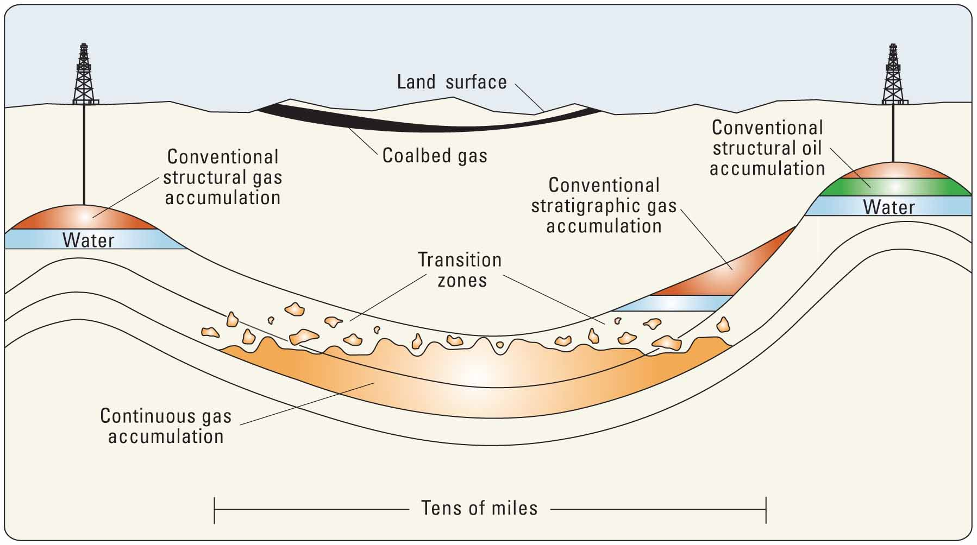

Figure 2. Conceptual diagram illustrating the different geologic settings between conventional and continuous resource accumulations.

Figure 3. Current mean estimates from the USGS NOGA Project for undiscovered, technically recoverable continuous natural gas. Additional information from the USGS NOGA project is available from: http://energy.cr.usgs.gov/oilgas/noga/ .

