


Maxi-Vac Alternative

Draft: Beta Test Version, August 2005

Software and manual to help state and local-level public health officials plan for setting up smallpox vaccination clinics.

Contents

Introduction 4
Overview of Maxi-Vac
Description of the Simulation Model
Data sources
Modeling philosophy: Sensitivity analyses and overall objectives
Additional Reference
Disclaimer
Help and feedback
Differences between Version 1 and Alternative version 7
System Requirements 10
Installation 10
Common Buttons and Menu Items 11
Enter Personnel 14
Enter Clinic Activities 16
Enter Percents of Families Affected 18
Scenario Summary 20
Results – Number of People Vaccinated and Optimal Staff Allocation 21
Results – Staff Utilization 23
Results – Impact of Removing One Person at Each Station 25
Results – Impact of Adding One Person at Each Station 27
Results – Average Time Spent at Each Station 29
Results – Other Support Staff 31
Technical Appendix 32
Model Assumptions
Diagram of Model Vaccination Clinic
Input Probabilities
Input Distributions
Authors:
Project Leader: Martin Meltzer, PhD, MS, Office of Surveillance, Office of the Director, National Center for Infectious Diseases

Modelers/Analysts/Program Developers: Michael L. Washington, PhD, Health Services Research and Evaluation Branch, Immunization Services Division, National Immunization Program; Jacquelyn Mason, PhD, Division of Emergency and Environmental Health Services, National Center for Environmental Health;

Programmer: Ricky Freyre, Office of the Director, Information Resources Management Office, Office of Program Services and Frederick C. Benoit, Office of the Director, National Immunization Program

Centers for Disease Control and Prevention, U.S. Department of Health and Human Services, Atlanta, GA.

Suggested Citation:

Meltzer MI, Mason J, Washington ML, Freyre R, Benoit FC. 2005. Maxi-Vac 2.0: A manual to aid state and local-level public health officials plan, prepare and practice for large-scale smallpox vaccination (Beta test version). Centers for Disease Control and Prevention, U.S. Department of Health and Human Services.

Date Written: 3 December, 2002
Date Modified: 8 July 2005

Introduction

The World Health Organization formally declared the eradication of smallpox on May 8, 1980. Following this major public health accomplishment, smallpox vaccinations were ceased throughout the world. Because of the cessation of vaccination, millions of Americans and people around the world have no immunity to the smallpox virus. Although the last recorded natural case of smallpox occurred in 1977, the intentional release of the smallpox virus has emerged as a potentially devastating bioterrorism threat. Given the vulnerability of the world population to smallpox, such an attack could have devastating consequences.

To help states and local communities prepare to respond to a smallpox attack should one occur, the Centers for Disease Control and Prevention of the U.S. Department of Health and Human Services has released generic guidelines on how to set-up a smallpox vaccination clinic (see www.cdc.gov/agent/smallpox/response-plan/index.asp to view the plan). However, individual states and communities have differing numbers of qualified personnel that would be available in such an event.

Overview of Maxi-Vac

Maxi-Vac helps a public health official answer the following question: “How can I allocate the limited number of personnel available so that the maximum number of people are vaccinated in a 24 hour period?”

Maxi-Vac was developed by first building a computer model using both Arena® simulation software (version 6.0, Rockwell Software, Inc. Sewickley, PA) and an add-on optimization program (OptQuest®, version 6.0, OptTek Systems, Inc., Boulder, CO). The objective of the mathematical model was to allocate personnel such that a maximum number of people could be vaccinated in a clinic during a 24 hour-period. Built into the model was the stipulation that the average time spent in the clinic by the patients was less than or equal to 90 minutes. The data generated by each run of the model was stored in Maxi-Vac’s database. Based on your inputs (e.g., the number of personnel available for each shift in a clinic), the appropriate set of data is accessed in the database and displayed in the “Results” section of Maxi-Vac. Technical details on the underlying assumptions used in Maxi-Vac are provided in the Appendix of this manual.

Description of the Simulation Model

A smallpox vaccination clinic consists of a number of “stations,” or activities, that a patient may “visit.” The actual number of stations that a given patient “visits” will depend upon that patient’s personal circumstance (e.g., history of a possible pre-existing medical condition indicating that they should not be vaccinated unless exposed to somebody who was infectious) and the actual requirements for giving smallpox vaccinations. Each station must have one clinic personnel present, unless the user decides not to have that station. The stations, or activities, are:

- Triage: Before patients enter the clinic they go through a triage point where they are triaged by a medical provider for illness and/or to determine whether they have been in contact with at least one confirmed case of smallpox. This checkpoint is to screen out those individuals that may be ill or contacts of those who were suspected smallpox cases from the rest of the individuals at the clinic so as not to expose the clinic population. Examples of persons who will not be treated in the clinic after being triaged are those that are ill and therefore require treatment at another site, and those that are identified as contacts.
- Orientation: During this optional station, individuals will view a video that contains a variety of information, such as care of the vaccination site, possible side-effects, when and how to seek treatment for such side effects, and (where necessary) the essential elements of informed consent as promulgated in 21 CFR 50.25.
- Medical Forms: All individuals (contacts and mainstream) will receive an information packet that will include medical screening and consent forms (where necessary) to be filled out for each family member.
- Referral: The completed medical screening forms mentioned above will be reviewed by non-medical personnel to see if the patients have self-reported any history of a possible pre-existing medical condition indicating that they should not be vaccinated unless exposed to somebody who was infectious (contraindications). Patients with potential contraindications will then proceed to the medical screening area; all others go directly to the vaccination area.
- Medical Screening: Patients who self-reported contraindicating conditions on their screening forms will receive screening and information from a medical professional. If the person conducting the screening is uncertain, or the patient wishes more information, that patient will be referred for additional screening to a qualified physician.
- Physician Evaluation: Patients with self-reported contraindicating conditions receive a more detailed screening if deemed necessary by the medical screener.
- Vaccination/Witness: Patients receive their smallpox vaccinations from an approved medical provider. A second medical provider acts as a witness. To limit fatigue, the medical providers can, during the course of their shift, switch occupations. Having a witness in this station can be optional.
- Exit Review: This is the final station in the clinic. Patients can have any remaining questions answered, and the personnel staffing this station can ensure that each patient exits with their information sheets and instructions.

Modification from Version 1: Options exist not to have an orientation station and/or a witness during the vaccination station.

Data sources

Much of the data required to run this model were obtained from a mass smallpox vaccination exercise in Arlington, DC in April 2003. The times are noted in the Technical Appendix. Your health department will need to research to find data such as the number of health care providers, number of support staff, etc. Where appropriate, we have included a list of suggested data sources that may help you in this process.

Modeling philosophy: Sensitivity analyses and overall objectives

Much of the input data required for the model came from a mass smallpox vaccination exercise in Arlington DC in April 2003. At the time of this Alternative version, these were the best and most reliable data we could find to use in the model. However, we still encourage you to be realistic when interpreting the results obtained from this software.

We also encourage you to run the model several times. Once you have become adept at using the software, you may wish to consider a plan wherein you systematically alter the values of input variables. You may alter one variable at a time (univariate sensitivity analysis), or alter the values of two or more variables simultaneously (multivariate sensitivity analysis). Different results due to using different values for the various input variables will help you obtain a sense of the relative importance of each staff type in determining the number of people that can be treated in a 24-hour period. We have included in the results the impact of adding or removing one of each type of staff, which again, will give you a sense of the relative importance of increasing or decreasing staff at a specific station.

Additional Reference

Washington ML, Mason J, and Meltzer MI (2005). Maxi-Vac: A tool to assist in planning mass smallpox vaccination clinics. Journal of Public Health Management and Practice, in press.

Disclaimer

Please keep in mind that this is a test version of the software and a draft version of the manual. The numbers generated through use of the software should not be considered predictions of what will definitely occur whilst running a mass immunization clinic. Rather, they are estimates of what could happen. The findings and conclusions of this manual and software are those of the authors and do not necessarily represent the views of the Centers for Disease Control and Prevention.

Help and feedback

For help using Maxi-Vac and/or interpreting the results, please e-mail your questions to Dr. Martin Meltzer at qzm4@cdc.gov. Please note that we are not commercial developers of software, and we ask for your patience if it takes us some time to reply to your requests.

We also would appreciate any comments and suggestions as to how we could improve the software. For example, we would be interested in receiving suggestions for additional input/ output screens. What other data regarding impact would you like to see included in the software? If you have data that we could use, that would also be welcomed.

Differences between Version 1 and Alternative version

Although we list all the differences in this section, we also listed these differences in sections where they occur.

Enter Personnel Tab
Number of Personnel
- Version 1
  - Physician (1, 3, 5, and 9)
  - Nurses (15, 30, and 45)
  - Other staff (5, 10, and 15)
- Alternative version
  - Physician (1 and 3)
  - Nurses (5, 15, and 30)
  - Other staff (5 and 10)

Enter Activities Tab
- Version 1
  - You can select the size of the orientation room (30 or 75 seats)
  - You have to operate all stations
- Alternative version
  - You cannot select the size of the orientation room. The only size is 30 seats.
  - You can decide not to have orientation.
  - You can decide not to have a witness.

Enter % of Families Tab
- Version 1
You cannot modify anything on this page.
- Alternative version
You can only change “Percentage of families sent to medical screeners (20% and 40%)

Scenario Summary Tab (no change)

See Results Tab
- People Treated Sub-Tab
  - Version 1
Where you see 0, no person from that category of personnel will be assigned to that station.
  - Alternative version
Where you see NA, no person from that category of personnel will be assigned to that station.
- Staff Utilization Sub-Tab
  - Version 1
    - Where you see 0, no person from that category of personnel will be assigned to that station.
    - No immediate way to identify potential bottlenecks in the system
  - Alternative version
    - Where you see NA, no person from that category of personnel will be assigned to that station.
    - Numbers in red identify bottlenecks in the system.
- Impact/Minus One Sub-Tab
  - Version 1
Where you see 0, either no person from that category of personnel was assigned to that station, thus a person could not be removed; no change in people being vaccinated occurred when one person was removed; or a person could not be removed from that station.
  - Alternative version
Where you see NA, either no person from that category of personnel was assigned to that station, thus a person could not be removed or a person could not be removed from that station.
- Impact/Plus One Sub-Tab
  - Version 1
Where you see 0, either no person from that category of personnel was assigned to that station, thus a person could not be added or no change in people being vaccinated occurred when one person was added.
  - Alternative version
Where you see NA, either no person from that category of personnel was assigned to that station, thus a person could not be added or a person could not be removed from that station.
- Average Time Spent Sub-Tab (no change in either version)
- Others Sub-Tab (no change in either version)

Version button
- Version 1
No button exists.
- Alternative version
It provides a summary of all the differences between Version 1 and Alternative version

Processing times
The main difference between the two versions is the time to complete a task. Times that are different in Alternative version came from a report by Brian G. McCue and Monica J. Giovachino titled “A field test of the CDC smallpox vaccination clinic model” completed in April 2003. The bold font numbers are what come from the data analyses. The other numbers are from expert opinions. More detailed information about the times can be found in the manual.

 | Average Times (in minutes)
Process | Version 1 | Alternative version
Triage (per family member) | 1.0 | 1
Orientation | 25.0 | 14
Fill-out forms w/o help (per family member) | 1.0 | 2.53
Fill-out forms w/ help (per family member) | 1.0 | 2.53
Referral (per family member) | 0.5 | 0.5
Medical screening (per family member) | 10.0 | 0.86
Physician evaluation | 10.0 | 0.5
Vaccination (per family member) | 1.0 | 1.6
Exit review (per family member) | 3.0 | 0.3

System Requirements

This software (Maxi-Vac Alternative) requires an IBM-compatible computer system that runs on MS Windows95* (or higher). We recommend that the IBM-compatible computer have at least a 486 or Pentium microprocessor chip. Since Maxi-Vac requires the use of Windows95, we recommend that the computer have at least 128MB of installed RAM.

NOTE: Maxi-Vac requires up to 1.4 megabytes of storage space on the computer’s hard drive.

*Windows95 is a copyrighted product produced by Microsoft Corporation, WA. Use of trade names and commercial sources is for identification only and does not imply endorsement by the U.S. Department of Health and Human Services.

Installing Maxi-Vac

The Maxi-Vac application may be installed from the Internet.

To install from the Internet:

Use your internet browser to login to the Maxi-Vac web site. The following download options will be presented:

VBRun60sp5.exe - If you do not already have the Visual Basic 6.0 run-time files installed in your computer, you must then download and execute the file VBRun60sp5.exe. This is a self-extracting executable file that installs the latest versions of the Microsoft Visual Basic run-time files required by all applications created with Visual Basic 6.0.
Note: The files include the fixes shipped with Visual Studio 6.0 Service Pack 5.

Maxi-Vac application - This is the actual Maxi-Vac installation module. You must already have the Visual Basic 6.0 run-time files installed in your computer in order to install and run the Maxi-Vac application. Download the Maxi-Vac install file to a directory in your hard drive and double-click on the downloaded file to commence the installation.

Common Buttons and Menu Items

The following buttons are found on every screen of the software:

This button allows you to run a new scenario, starting from the beginning. You will be asked if you want to save your previous scenario and results to a file. To do so, select “Yes” and provide a name and location for the saved file. If you do not wish to save the previous scenario and results, select “No.”


This button allows you to select a previously run scenario. A screen will open showing all files in the folder you last used to save a scenario. Click on or type in the name of the file you wish to use, then click on the “Open” button shown on the screen. Inputs and results in this file will be restored in Maxi-Vac.



This button allows you to save the inputs and results from the current scenario. You will be asked to name the file and indicate the location of the file. You can later select this named file by clicking on the “Open” button. Be sure to save your inputs and results before closing the application, if you do not wish to loose the current scenario and results.

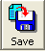

The print button allows you to print an output report of the current scenario and results. The print button is only active when you are in the “See Results” section.


By clicking on this button, you will get additional information that is related to the current screen.
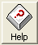

This button will display the authors’ contact information in the event you would like to send a feedback or have a question that was not addressed in the current manual.
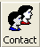

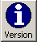
Pressing this button allows you to see differences between the two versions of Maxi-Vac for the current tab or sub-tab that you are viewing..

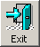
This button allows you to exit the Maxi-Vac application.


This button allows you to advance to the next page.

On some tabs, you have the following button:


After pressing this button, a window will appear. This will giving you detailed information to help you better understand what you see.

The following tabs are available on every page of the software:

Enter Personnel This tab takes you to the screen where you selected the number of staff in each category: physicians, other medical professionals, and support staff.

Enter % of Families This tab takes you to the screen where you can select the proportion of families that fall in each of the categories displayed.

Scenario Summary This tab offers you a visual display of all of the inputs you selected for your review.

Results This tab takes you to the “Results” page. On the “Results” page, you can go to the desired page by selecting the appropriate sub-tab. The following sub-tabs are available on the “Results” page: People Treated; Staff Utilization; Impact/Minus One; Impact/Plus One; and Average Time Spent. For detailed descriptions on the screens associated with each of these sub-tabs, please refer to the appropriate section in this manual.
Page 1: Enter Personnel

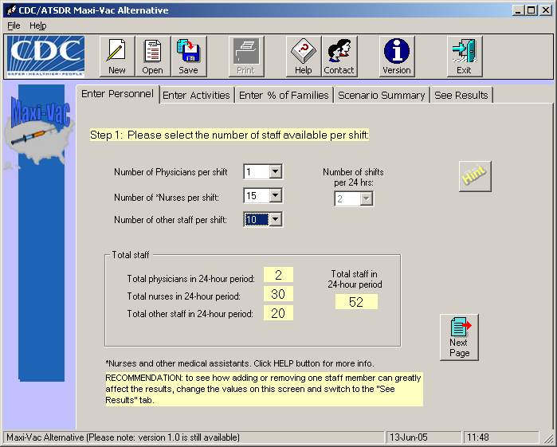

This page allows you to enter input values for the number of each staff type and the number of shifts to be worked during a 24-hour period.

Number of each type of staff available to work on each shift: Select the total number of physicians, other medical staff, and non-medical support staff estimated to be available to work each shift at the vaccination center from the pull-down menu under each category.

Number of shifts in a 24-hour period: Select whether the clinic staff will work in two12-hour shifts or three 8-hour shifts. Note: In Maxi-Vac Alternative version, the only (default) value is 2 shifts per 24-hour period. The assumption can be made that each shift will only run for 8 hours (i.e., clinic will be open 16 hours per 24 hour period). The clinic director may need to adjust the length of each shift to allow for changes in patient arrivals and the actual amount of time in the clinic taken by a “typical” patient.

Note: You may want to obtain composite estimates of the number of personnel available to work at the clinics from appropriate sources such as local/regional health departments, state licensing organizations, hospitals, professional societies, support organizations (e.g. Red Cross), etc. Reasonable estimates of the number of staff at any particular locations will be constrained by the number of staff available and the physical space in which the clinic will be setup.

HINT: Note that the term “Nurses” refers to any medically-trained staff (other than physicians) who are qualified to work in the clinic—EMTs, for example.

Differences between version 1 and Alternative version
- Version 1
- Physician (1, 3, 5, and 9)
- Nurses (15, 30, and 45)
- Other staff (5, 10, and 15)
- Alternative version
- Physician (1 and 3)
- Nurses (5, 15, and 30)
- Other staff (5 and 10)

Page 2: Enter Clinic Activities

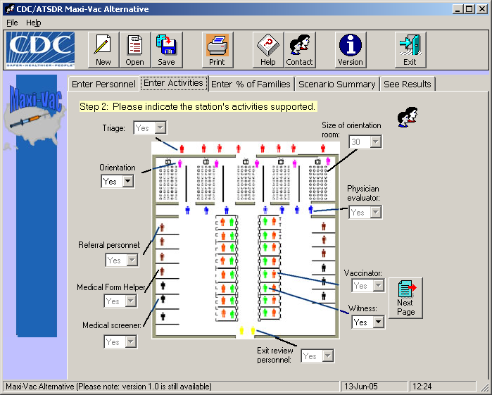

Enter the activities that will be included in your clinic on this screen. Certain activities (e.g. Triage, Referral, Vaccinations) must be included and cannot be set to “No.” The default value for all stations is “Yes”, but for those stations that can be omitted in the clinic design, you may select the “No” options. One difference between version 1 and Alternative version is that in Alternative version, you will not be able to change the size of the orientation room. It has a maximum capacity of 30. Please see the Appendix for additional technical details.

In Alternative version, you can decide to have an orientation or not and if you want a witness for the vaccination process. The orientation room can only seat 30. No other options are available to change at this time.

Difference between Version 1 and Alternative version
- Version 1
  - You can select the size of the orientation room (30 or 75 seats)
  - You have to operate all stations
- Alternative version
  - You cannot select the size of the orientation room. The only size is 30 seats.
  - You can decide not to have orientation.
  - You can decide not to have a witness.
Page 3: Enter Percents of Families Affected

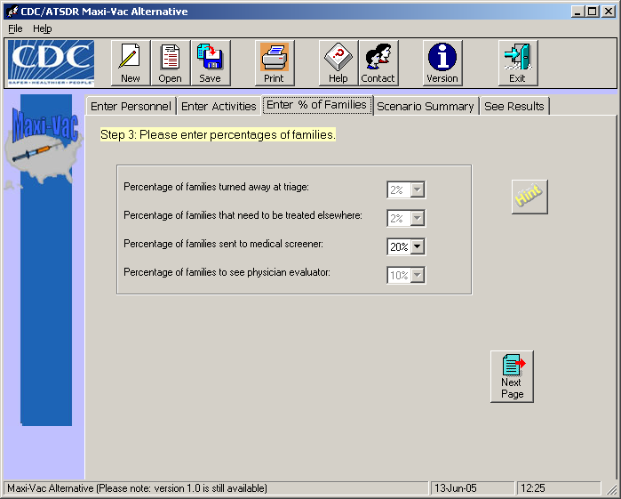

Select the percentage of families falling in the following categories:
- Percentage of families turned away at triage: This is the percent of the total population where at least one family member is either sufficiently ill or shows symptoms of smallpox and therefore requires treatment at another site. If a family member does show possible symptoms of smallpox (or, perhaps, self-identifies as having been in lose contact with a known smallpox victim) then it is quite likely that the entire family will be moved to another site for a medical exam, vaccination, and perhaps quarantine (as appropriate).
- Percentage of families that need to be treated elsewhere: This is the percent of the total population where the physician evaluator determines that at least one family member requires treatment at another site.
- Percentage of families to see a medical screener: This is the percent of the total population where at least one family member has a condition noted on the screening form that should be reviewed by a medical professional such as a nurse or EMT.
- Percentage of families to see a physician evaluator: This is the percent of the total population where at least one family member has a potentially serious contraindication that can best be determined by a physician.

HINT: You may want to experiment with how changing these values affects the number of staff allocated at each station and the number of people that can be vaccinated in a 24-hour period. In the Alternative version, the only option available to change is the “Percentage of families sent to medical screener.”

Difference between version 1 and Alternative version
- Version 1
You cannot modify anything on this page.
- Alternative version
You can only change “Percentage of families sent to medical screeners (20% and 40%)

Page 4: Scenario Summary

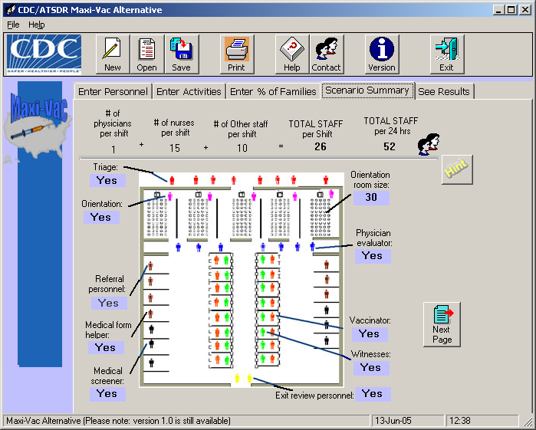

This screen displays your selections for the setup of the smallpox vaccination for your review. You may make changes to your inputs by clicking on the appropriate tab, e.g. “Enter Personnel.” If there are no changes to be made, proceed to the next screen by clicking on the “Next Page” button or the “See Results” tab. Note that in Alternative version, the following can be changed: deciding to have an orientation room or not, deciding to have a witness, and choosing the percentage of families that need to see the medical.

HINT: You may want make multiple runs to see how removing one or more optional stations affects the results.

Difference between version 1 and Alternative version (None)

Page 5: Results – Number of People Vaccinated and
Optimal Staff Allocation

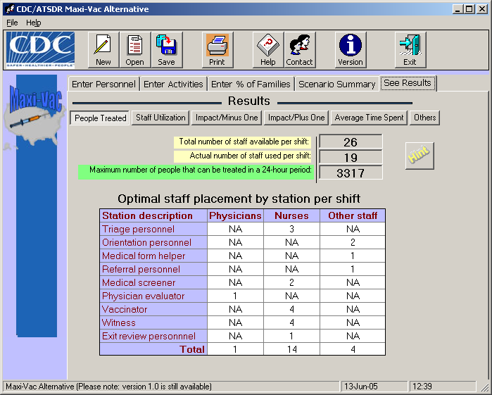

This screen displays the results from the simulation and optimization runs based on the inputs you chose. The top two boxes show the number of total staff available and total staff used. The third box presents the maximum number of people that can be vaccinated at the clinic using the staff as shown in the table, based on the model assumptions. (The model assumptions are presented in the technical appendix of this manual). You should be aware that the results might be significantly different for another set of model assumptions. The table displays the number of specific types of personnel needed at each station. When a particular staff type is not used at a station, “NA” is shown in the table. If the total number of people that can be treated is too low, you may be able to increase patient flow by adding additional staff. Reviewing the “Impact” results will provide some insights into the potential benefit of adding or removing one staff person at specific stations. Also, note that the “Actual number of staff used per shift” might be less than the “Total number of staff available per shift.” Although you might have more people available to work, the minimum number of staff was chosen to run the clinic and still vaccinate the same number of people compared to having more staff in the model. This insures that you do not overstaff the clinic and gives you the option to assign those staff to float and help within the clinic.

HINT: The placement of specific staff types at each station is based on recommendations made by medical professionals familiar with mass vaccination procedures. You should determine whether there are any difference between the suggested type of personnel at each station and those called for in your community’s smallpox response plan.

Difference between version 1 and Alternative version
- Version 1
Where you see 0, no person from that category of personnel will be assigned to that station.
- Alternative version
Where you see NA, no person from that category of personnel will be assigned to that station.

Page 6: Results – Staff Utilization

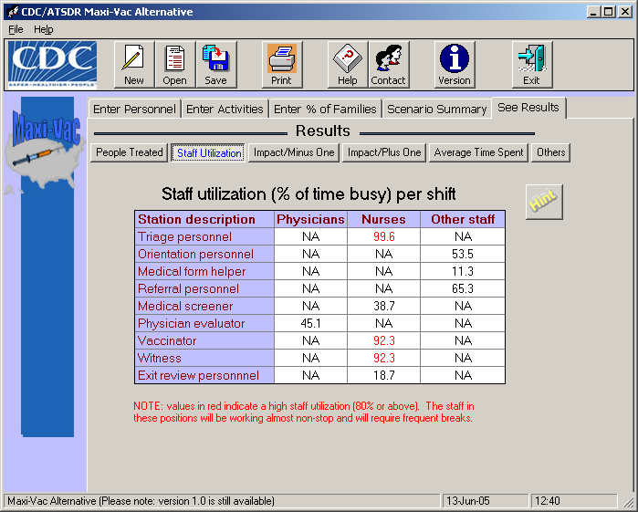

This screen displays the percent of time each type of personnel is busy seeing a patient during his or her shift. When a particular staff type is not used at a station, “NA” for ‘not applicable’ is displayed in the table.

In general, you want the system to be “balanced” so that the majority of staff is kept sufficiently busy, and they are working at a pace that be sustained throughout their shift. Keep in mind that the tool does not consider staff breaks of any type. To account for breaks, additional staff will be required to relieve workers for staff whose utilization rate is high. Also note that staff utilizations may be low at stations where only a small percentage of people are seen (e.g. physician evaluation). However, low utilizations may be an indication of having more staff than needed at the affected stations. Also, note that low utilizations do not necessarily correspond to short patient wait times.

HINT: Utilization is the amount of time that an individual spends actively working. For example, a utilization of 100% corresponds to a person who works non-stop (no breaks of any kind) for the entire shift. You might consider having additional personnel to provide relief for staff who are busy more than 80% of the time, and/or having these staff work fewer hours. Those that are busy more than 80% of the time are highlighted in red.

Difference between version 1 and Alternative version
- Version 1
  - Where you see 0, no person from that category of personnel will be assigned to that station.
  - No immediate way to identify potential bottlenecks in the system
- Alternative version
- Where you see NA, no person from that category of personnel will be assigned to that station.
- Numbers in red identify bottlenecks in the system.

Page 7: Results - Impact of Removing One Person at Each Station

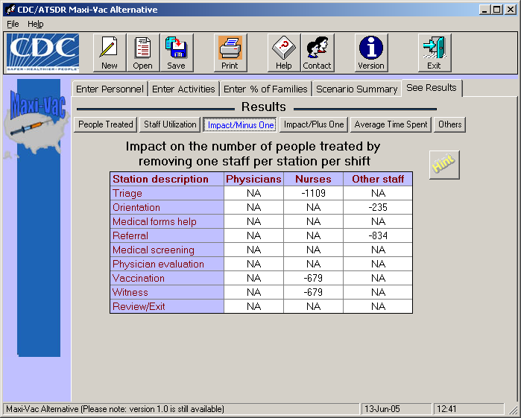

The table on this screen displays the impact of removing one person at each station where the optimum allocation of staff is greater than one. For stations where the optimal allocation is one or a staff type is not assigned to that station, “NA” is shown in the table to indicate that it was inappropriate or not possible to reduce the number of staff at these stations. The values shown in the table are the differences between the maximum numbers of people that can be vaccinated if the clinic is fully staffed based on results for your specific inputs and the number that can be treated if the optimal number of staff at that specific station is decreased by one. Small changes in the number of people treated, say differences of around 10% or less, are not of interest here. What is of interest is when a reduction in the number of staff at a station by one results in a substantial decrease in the number of people that can be vaccinated in 24 hours. The size of the decrease (or increase) is related to the relative importance of having sufficient personnel at a particular station. In general, it is important to have a sufficient number of staff for those stations through which the majority of people must pass (e.g., triage, vaccination, etc). For example, in this scenario, removing anyone would greatly decrease the number of people vaccinated. This is due to the optimization routine in the model. Any deviation from the placement of personnel can greatly affect the model.

HINT: Small increases (or decreases) in the number of people vaccinated when the number of staff at a particular station is decreased are not practically significant.

Difference between version 1 and Alternative version
- Version 1
Where you see 0, either no person from that category of personnel was assigned to that station, thus a person could not be removed; no change in people being vaccinated occurred when one person was removed; or a person could not be removed from that station.
- Alternative version
Where you see NA, either no person from that category of personnel was assigned to that station, thus a person could not be removed or a person could not be removed from that station.

Page 8: Results – Impact of Adding One Person at Each Station

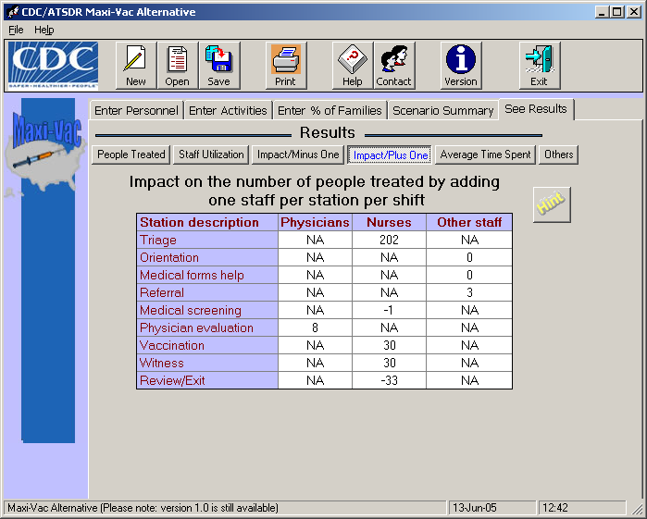

The table on this screen displays the impact of adding an additional person at each station. The values shown in the table are the differences between the number that can be treated if the optimal number of staff at that specific station is increased by one and the number of people that can be vaccinated if the clinic is fully staffed based on results for your specific inputs. The size of the increase (or decrease) is an indication of the relative benefit (or cost) of adding an additional person at a particular station. In general, there will be little benefit in adding additional staff at any one station because the allocation of staff has already been optimized. In addition, added another person could possible violate one of the original constraints in the model. For example, adding one extra nurse in the triage area increases the number of people vaccinated by 202; however, patients, on average, spend more than 90 minutes in the clinic, which is a violation of one constraint. When a particular type of staff is not used at a station, “NA” is displayed in the table.

Due to the time associated with running each combination of inputs long enough to obtain the “true” optimal allocation of resources given the constraints inputted, it may be possible that there are other arrangements that might result in more people vaccinated than is shown on “People Treated” tab of the Results file. You might be tempted to use the Impact Results to find a “better” arrangement. For example, if the combined results of adding and removing staff suggests that moving one or more persons from one position (say medical screening) to another position for which she/he is qualified to work (say triage), it might be possible to treat more people. However, such an arrangement might not satisfy one or more of the constraints (e.g. patient time in the clinic ≤ 90 minutes; see “Model Assumptions” in the Technical Appendix), therefore caution must be used in attempting to combine the impact of adding and removing staff. This is especially true in the example used in the manual.

HINT: Small increases (or decreases) in the number of people vaccinated when the number of staff at a particular station is increased are not practically significant.

Difference between version 1 and Alternative version
- Version 1
Where you see 0, either no person from that category of personnel was assigned to that station, thus a person could not be added or no change in people being vaccinated occurred when one person was added.
- Alternative version
Where you see NA, either no person from that category of personnel was assigned to that station, thus a person could not be added or a person could not be removed from that station.
Page 9: Results – Average Time Spent at Each Station

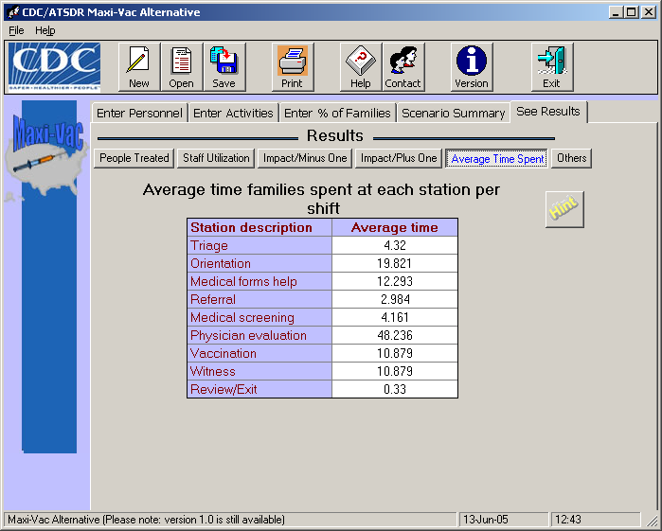

This screen shows the average amount of time patients spend at each station. In general, longer times indicate either a process that requires a significant amount of time (e.g. orientation) or a bottleneck in the system. Whereas orientations represent an unavoidable bottleneck (because they do not start until there are enough people waiting inside the orientation room – an input value), bottlenecks at other stations may result because of the time it takes for the service to be administered and/or the sheer volume of people that must be seen at a specific station (e.g. triage, clerk). The size of these bottlenecks will greatly depend on the number of personnel available to work at the affected station(s).

Often there are tradeoffs to be made when there is a limited number of each staff available to work in the clinic. For example, medical professionals (other than physicians) staff 5 of the 9 stations in this model: triage, medical screening, vaccination/witness and exit review. In order to move the maximum number of people through the clinic, it is important to allocate a sufficient number of medical staff to work at these stations since all patients that come to the clinic must go through these stations. Consequently, the number of staff allocated to these stations must be “balanced” to allow patients to move through the clinic at the maximum rate possible given the input constraints (see the technical appendix for a list of constraints used).

HINT: Average times shown on this screen include processing time at the station and the time spent waiting in the queue for service. Times spent in the clinic do not include any waiting time experienced before entering the clinic or station-to-station transit time.

Difference between Version 1 and Alternative version (None)
Page 10: Results – Other Support Staff

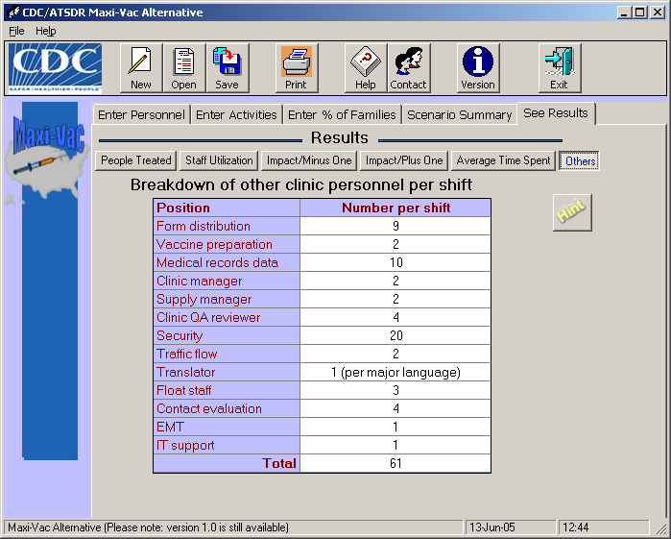

This screen shows estimates of the number of various types of clinic support staff. These are the suggested values given in the CDC Smallpox Response Plans and Guidelines (Version 3.0), Annex 3. Please be aware that the numbers of staff and the activities included in this table have not been optimized.

HINT: This table contains suggested numbers of various types of personnel based on approximately 5000 people being treated as contained in the CDC Smallpox Response and Guidance Plan (Version 3.0), Annex 3. To our knowledge, no actual data exists to corroborate these suggested values – the values are based on expert opinion. As such, clinic planners may wish to increase (or decrease) the numbers of “Other Clinic Personnel” as they deem needed. appropriate.

Difference between version 1 and Alternative version (None)
Technical Appendix

Model Assumptions
- The following assumptions were used to develop this Alternative version
of the simulation model:
- Each scenario is run for a period covering 24 hours.
- One average, patients spend no more than 90 minutes in the clinic (constraint).
- An unlimited number of people are outside of the dispensing center waiting for treatment at all times – a worst-case scenario.
- All family members move together through the center.
- All family members have the same level of potential exposure.
- No family has priority over another family (e.g., first family in line, first family served).
- Sufficient resources are available to keep each station fully staffed and functioning at 100% efficiency during the 24 hours.
- A linear relationship exists between mean provider service time and the number of people in a family.
- A maximum of five orientation rooms will be set up at each vaccination clinic (constraint).
- Patient transit times between stations are about 20 seconds, on average.

Input Probabilities*

Percent of families in which all have previously been vaccinated* | 2
Percent symptomatic/contact (exit clinic); these families exit the clinic after being triaged | 1
Percent identified as not treatable at the clinic site; these families exit the clinic after being triaged | 2
Percent of people who need help with filling out their medical/consent forms | 2
Percent with complicating health factors; these families require additional medical screening beyond that given at the referral station | 20 or 40
Percent with complicating health factors that are identified by the medical screener and who are not treatable on site; these families will exit the clinic after seeing a medical screener and will exit the clinic before receiving a vaccination | 10
Percent with complicating health factors that are identified by the physician evaluator and who are not treatable on site; these families will exit the clinic after seeing the physician evaluator and will exit the clinic before receiving a vaccination | 5
- Note: These are assumed values only. This Alternative version of the model assumes that even if a single member of a family meets a given criteria (e.g., at triage sent to another site for treatment), then the entire family will accompany that one person.
* Previously vaccinated during current vaccination campaign, such as at another clinic. The term “previously vaccinated” does not include those vaccinated, say, 30 years ago.

*Note – This figure has been slightly modified from Figure 1 presented in the CDC Smallpox Response Plan and Guidelines (Version 3.0), Annex 3.
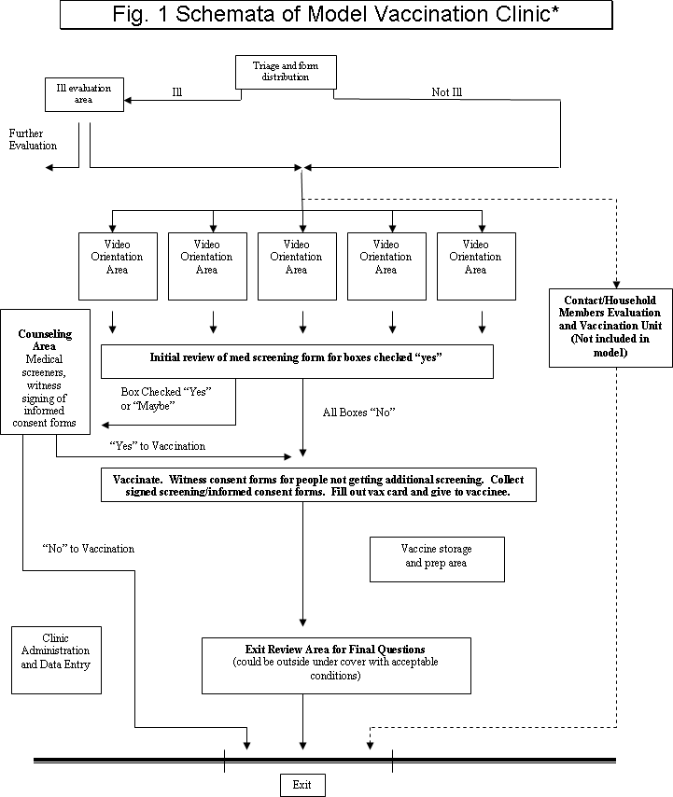

Input Distributions*

 | Version 1 | Alternative version
Process | Triangular Distribution (Minimum, Most Likely, Maximum)  (minutes) | Unless specified below, the distribution is triangular
Triage (per family member) | (0.5, 1.0, 2) | (0.5, 1.0, 2)
Orientation | (20, 25,30) | (13, 14,15)
Fill-out forms w/o help (per family member) | (0.5, 1.0, 1.5) | 33 * BETA(0.518, 6.25)
Fill-out forms w/ help (per family member) | (0.3, 1.0, 1.5) | 33 * BETA(0.518, 6.25)
Referral (per family member) | (0.4, 0.5,0.75) | (0.4, 0.5,0.75)
Medical screening (per family member) | (5, 10, 15) | -0.001 + LOGN(0.859, 0.508)
Physician evaluation | (5, 10, 15) | (0.1,0.5,0.75)
Exit review (per family member) | (2, 3, 5) | ERLA(0.0599, 5)
Vaccination (per family member) | (0.5, 1, 1.5) | 1+ ERLA(0.3,2)
Note: The values in this table may differ from those given in the CDC Smallpox Response Plans and Guidelines (Version 3.0), Annex 3. These values may change in later versions if and when additional new data become available.
Times that are different in Alternative version came from a report by Brian G. McCue and Monica J. Giovachino titled “A field test of the CDC smallpox vaccination clinic model” completed in April 2003.
BETA means beta distribution.
LOGN means lognormal distribution
ERLA means Erlang distribution

