Burrows Elementary School
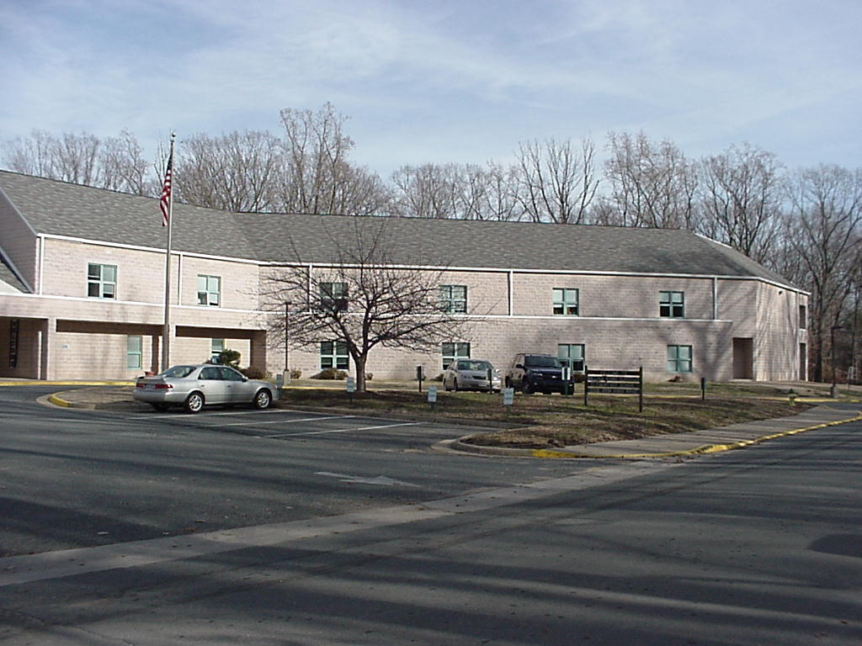

School Improvement Plan
Goal 2
School Year 2010-2011

BURROWS ELEMENTARY SCHOOL ACTION PLAN
TARGET SMART GOAL STATEMENT:  By 2012, all students at Burrows Elementary School will increase reading comprehension by constructing meaning from text as measured by the selected system-wide assessment (TerraNova Reading Subtest 3rd edition-4th and 5th grade), the SRI and local assessments.  GOAL STATEMENT ESSENCE:  The essence of our goal will focus on vocabulary learning and development  Committee Chair: Chad Ankersen | SUPPORT DATA USED TO SELECT GOAL  Standardized  - Terra Nova Achievement scores, 5th Edition- 4th/5th grade, Reading Evaluate/Extend meaning subtest score.  - Terra Nova Achievement scores, 5th Edition- 4th/5th grade, Mathematics Communication subtest score.  Criterion Referenced  Scholastic Reading Inventory
Assessments to Measure the Goal |  | Research to Support the Intervention
Standardized  - Terra Nova, 3rd Edition- 4th and 5th Grade, reading subtest score | Local/Classroom  - SRI administered 3x annually  - Monthly vocabulary assessment-  in development | - Building Background Knowledge for Academic Achievement (Marzano,2004)  - A Focus on Vocabulary  (Lehr, 2004)  Summaries of research  located in School Profile

Intervention 1 – Students will follow the six step process for building academic vocabulary created by Robert J. Marzano and Debra J. Pickering

Activities

Activities and Assessments | Person(s) Accountable | Timeline Start | Timeline Complete | Resources Needed | Staff Development Outcome
1.1 Marzano’s method and refresher training will be conducted for returning and new staff members. | SIP Chairperson | Sept 10 | Oct 10 | Computer lab, access to entire staff, copies of text and introductory video  Support from DDESS | Staff will be aware of the program and open to new information and techniques as they become available. Staff will be able to communicate SIP goals and components to students and parents
1.2 Staff will complete development of and adapt existing common assessments to assess progress of the goal. | Entire staff, SIP chair person, bldg admin | Sept 10 | May 11 | Completed lists of academic vocabulary and folio of assessments | Staff will have a resource for assessments and further instruction
1.3 Baseline data will be collected using local assessment | SIP steering committee | Sept 10 | Oct 10 | Locally produced assessment | Staff will have data for future decision making and instruction
1. 4 Students will maintain a vocabulary journal in the prescribed format | Students  Classroom Teachers  bldg. admin | Sept 10 | June 11 | Journals/binders  Vocabulary Lists | Teachers will continually observe and practice additional, culminating activities as needed.
1.5 Students and teachers will create and maintain word walls in each class | Students  Classroom Teachers  Bldg. Administrator | Sep 10 | June 11 | Graphic Organizers  Clerical Supplies | Teachers will observe and practice additional activities.

