OMB Control Number 1205-0420

Expiration Date 09/30/2005

Workforce Investment Act Quarterly Report:
General Reporting Instructions and ETA Form 9090
Revised 2005

Prepared By
Performance and Technology Office
Employment and Training Administration

This reporting requirement is approved under the Paperwork Reduction Act of 1995, OMB Control No. 1205-0420, expiring 09/30/2005. Persons are not required to respond to this collection of information unless it displays a currently valid OMB number. Public reporting burden for this collection of information is estimated to average 160hours per quarterly report per state, including time for reviewing instructions, searching existing data sources, gathering and reviewing the collection of information. Respondent’s obligation to reply is mandatory. The reason for the collection of information is general program oversight, evaluation and performance assessment. Send comments regarding this burden estimate or any other aspect of this collection, including suggestions for reducing this burden, to the U. S. Department of Labor, Office of Performance and Technology, Room S-5206, Washington, D.C. 20210 (Paperwork Reduction Project 1205-0420).

GENERAL INSTRUCTIONS

Each state must submit an ETA Form 9090 (WIA Quarterly Report) to provide DOL with the most recent performance information available. The aggregate performance data contained in this WIA Quarterly Report are used to determine the levels of participation and program accomplishments for the most recent quarter and four-quarter period. This rolling four-quarter data collection methodology provides ETA and the grantees with greater flexibility in discussing annual performance results according to any four-quarter reporting period (e.g., Calendar Year, Program Year, and Federal Fiscal Year). Reports must include a “snapshot” of the most recent performance data available for each performance item included on the WIA Quarterly Report for the current quarter, and then a cumulative total that includes the current quarter and the last three quarters prior to the current quarter.

To allow for the data collection delays inherent in many of the performance measures, particularly those that utilize UI wage records, the WIA Quarterly Report collects information on each performance item depending on when outcome data become available. For instance, because the total count of participants is available without any delay, grantees will be able to report this performance information through the end of the most recent reporting quarter. Alternatively, measures that make use of wage records, such as the adult entered employment rate or youth placement in employment or education, will use exit cohorts from the third complete quarter prior to the reporting quarter. This situation exists because relatively complete wage records for any quarter are not available for up to another two quarters afterward. In this case, the reporting schedule allows states six and one-half months to process wage record reports from employers, merge the wage data with participant files, and generate the WIA Quarterly Report.

COVERED PROGRAMS

The WIA Quarterly Report will cover participants who receive services financially assisted by formula or statewide reserve funds under the following ETA programs:

- WIA Adult Program
- WIA Dislocated Worker Program
- WIA Youth Program
- National Emergency Grants

Performance information about all participants who receive services financially assisted by National Emergency Grants will be included. Statewide activities that are included in the Quarterly Report are those statewide activities that involve the enrollment of individuals eligible to receive WIA Title I-B services (e.g., adult, dislocated worker, or youth). Conversely, if state or local activities do not involve the enrollment of individuals to receive services, performance information is not included in the WIA Quarterly Report. Examples of such exceptions include activities where (a) the state is conducting a statewide activity that does not involve direct services (e.g., research or evaluation), or (b) the statewide activity is structured to provide services that are highly specialized, such as in a pilot or demonstration activity (e.g., incumbent worker training, project for chemically dependent TANF recipients).

QUARTERLY REPORT SPECIFICATIONS

The Quarterly Report reflects performance outcome information that becomes available by the time the Quarterly Report is due to ETA. Appendix A outlines the applicable four quarter reporting periods that states should use when preparing performance information for the WIA Quarterly Report.

The reporting format for the WIA Quarterly Report can be found under Appendix B. In addition to the value of each performance item, the state must report both the numerator and denominator for the current quarter and cumulative totals for the four quarter reporting period. This detail is needed so that the information can be aggregated over states to provide national estimates. Reporting specifications for preparing all calculations of numerators and denominators that support the performance measurement values can be found under Appendix C.

DUE DATE

The report is due no later than 45 days after the end of each report quarter. The table below shows the expected due dates for each reporting quarter.

Report Quarter | Due Dates
January – March | May 15th
April – June | August 14th
July – September | November 14th
October – December | February 14th

Should the due date of the report fall on a Saturday or Sunday, the quarterly report is due the Friday before

SUBMISSION PROCEDURES

Information contained on the WIA Quarterly Report must be submitted directly to ETA’s Enterprise Business Support System (EBSS) (formerly called the Enterprise Information Management System (EIMS)) via technical instructions available through the appropriate Regional Office or the ETA performance website (www.doleta.gov/performance).

APPENDIX A

Time Periods for Reporting Performance Information on the

WIA Quarterly Report

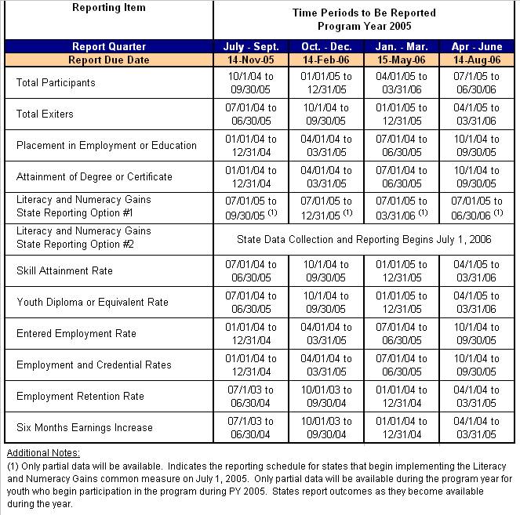

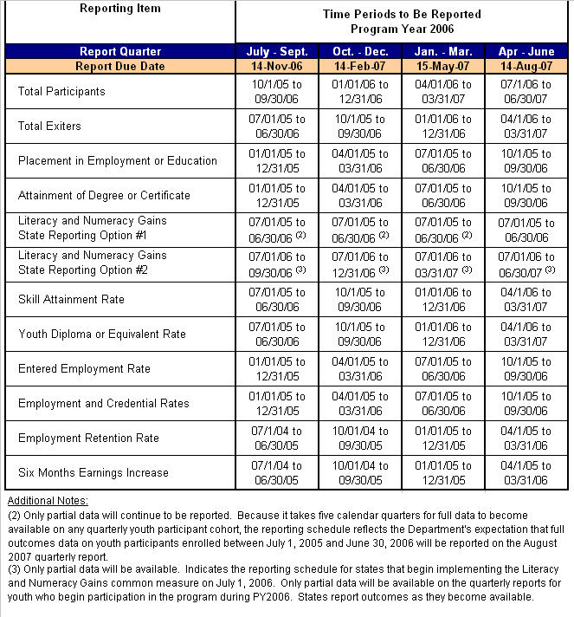

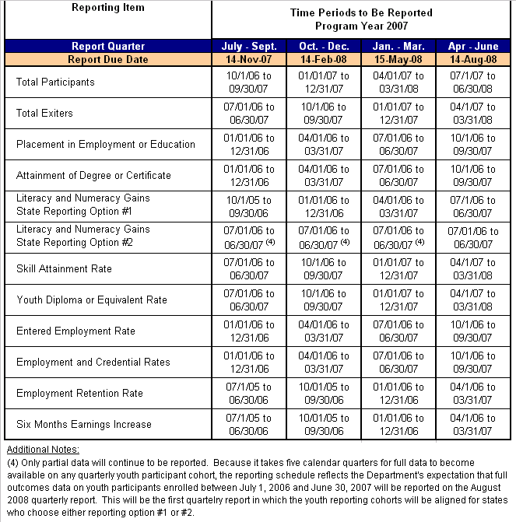

APPENDIX B
WIA Quarterly Report Format (ETA Form 9090)

