Assessment of the New National Geoid Height Model, GEOID03

Daniel R. Roman¹, Yan Ming Wang¹, William Henning², and John Hamilton³
NOAA’s National Geodetic Survey ¹ GWS, Inc. ² Terrasurv ³

Abstract. The GEOID03 model was developed in the same manner as GEOID99 using an underlying gravimetric geoid, USGG2003, and updated GPS ellipsoidal heights on leveled Bench Marks (GPSBMs). USGG2003 is similar to G99SSS, however, it included an updated model for gravity anomalies in the deep ocean areas, GSFC00.1. The conversion surface for GEOID03 was developed from 14,185 GPSBMs at a 5 arc-minute grid interval, which provided a substantial increase in the spatial coverage and reduced errors due to interpolation. The fit to these same points afterwards was 4.8 cm (2σ), which is comprised of both correlated (attributable to GEOID03) and uncorrelated (GPS observation error) signal. The uncorrelated signal is 4.2 cm (2σ), and the correlated signal is 2.0 cm (2σ) with a 3.5 km correlation wavelength. This last comparison indicates that GEOID03 had a very good fit with the GPSBMs, and can be relied upon to convert between the NAD 83 and NAVD 88 datums to the centimeter level.

1 Introduction
As shown in Smith and Milbert (1999) and Smith and Roman (2001), the misfit between geoid height information contained in GPS-derived ellipsoidal heights on leveled Bench Marks (GPSBMs) and that in a gravimetric geoid may be used to create a hybrid geoid model, such as GEOID03. The relationship between the ellipsoidal height (h), orthometric height (H) and geoid height (N) is expressed as:

(1)

Note that both sides of Equation (1) may be arrived at by separate means. A gravimetric geoid model can give one estimate of geoid height, while removing the orthometric height from an ellipsoidal height will yield another. The residual difference between these two estimates was processed to develop a model of the correlated signal according to:

(2)

This process involved determining a conversion surface that approximated the correlated signal existing in the GPSBM residuals (r_{GPSBM}) using Least Squares Collocation (LSC) and applying that surface to the gravimetric model to create a hybrid geoid. This hybrid geoid retained the short wavelength character of the gravimetric geoid model but had been modified to reflect the signal occurring at the GPSBMs. For more background on this approach see the Appendix.

The intent of such a hybrid model is to provide a ready and reliable mechanism for transferring between an ellipsoidal datum, such as NAD 83, and a vertical datum, such as NAVD 88, not only at the GPSBMs but also in the areas in between them. The ability to transform NAD 83 heights (easily obtained from GPS) to NAVD 88 heights using a geoid model is extremely desirable due to the large cost savings from the elimination of traditional leveling work (Henning et al. 1998). This approach is even more useful if the transformation captures nearly all the correlated signal.

For both GEOID96 and GEOID99, only single Gaussian functions were fit to the empirical data using correlation lengths of 400 km (left panel of Figure 1). This effectively treats as noise any signal at shorter wavelengths and results in a significant correlated residual signal (right panel of Figure 1). A more complicated analytic function was developed for GEOID03 that better incorporated more of the correlated signal. Hence GEOID03 provides an improved estimate of the signal necessary to convert between NAD 83 and NAVD 88 in the Conterminous United States (CONUS), which is necessary to support the Height Modernization initiative of the National Geodetic Survey (NGS).

Figure 1 The left panel shows the fit of the analytic signal (line) for GEOID99 compared to the empirical data (+) represented by 50 km bins of the residual signal between GPSBMs and G99SSS geoid heights. The right panel shows a grid of the remaining misfit at the GPSBM locations for GEOID99. Since the analytic signal only poorly fits the empirical data, significant systematic signal is left out of the GEOID99.

This initiative focuses on establishing vertical control of GPS observations at the 2-5 cm level (Zilkoski et al., 1997) but also points to the need to establish similar accuracy in a geoid height model for use in high-accuracy GPS-leveling. The Height Modernization initiative directly supports efforts at improving the National Spatial Reference System, a part of the National Spatial Data Infrastructure mandated by Executive Order 12906 (Clinton, 1994).

2 USGG2003
The United States Gravimetric Geoid model for 2003 (USGG2003) was generated in the same manner as G96SSS and G99SSS. For specific details on the generation of these models, the reader should refer to Smith and Milbert (1999) and Smith and Roman (2001). For general information referenced as a guideline in making gravimetric geoids see Heiskanen and Moritz (1967) and Moritz (1989). The principal difference between USGG2003 and G99SSS is the replacement of KMS98 (Andersen and Knudsen 1998) offshore Free-air gravity anomaly (FAGA) field with the GSFC00.1 model (Wang 2001). Switching these models resulted in significant geoid height changes in coastal regions (left panel of Figure 2). For Florida, these changes reach about 10 cm in magnitude. By comparing gravimetric geoid models generated using each FAGA data set, it was determined that the GPSBM residuals were reduced from 40 cm using KMS98 to 30 cm using GSFC00.1. Hence the substitution of the GSFC00.1 data was beneficial in that it provided an improved gravimetric geoid model (right panel of Figure 2).

These changes are long wavelength in nature and thus easily absorbed into the conversion surface developed using Least Squares Collocation (LSC). None the less, reducing errors in the gravimetric model both by improving the data quality and process refinement represent long term NGS goals. The generation of a gravimetric geoid model that is accurate to the centimeter level without incorporating leveling information is critical to meeting the standards set forth in Height Modernization.

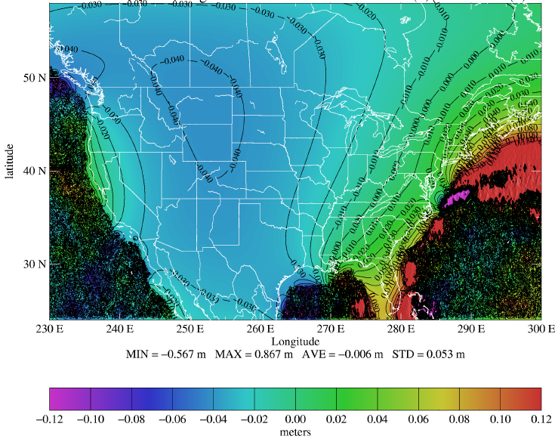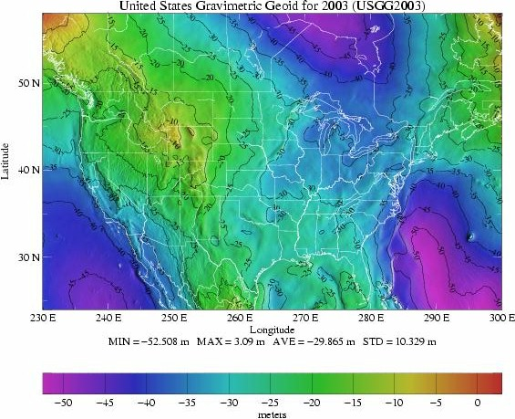

Figure 2 Shown in the left panel is the effect on geoid heights caused by switching from KMS98 to GSFC00.1 Free-Air gravity anomalies in ocean areas typically more than 100 km offshore. The 10 cm geoid height differences in Florida represent an improvement based on the reduction of the mismatch with GPSBMs. However, the scale of the geoid undulations seen in USGG2003 (right panel) dwarfs these differences.

3 GPSBM2003
Only 6169 GPSBMs were used to create GEOID99 from G99SSS, and almost all were prior to re-adjustments of state HARN’s to the Continuously Operating Reference Station (CORS) Network. GEOID03 was created from 14,185 points including 579 in Canada, which also refer to NAVD 88, to better control the behavior of the model near the northern border. The GPSBM spatial distribution is shown in Figure 3. Although data located in Canada were used to constrain the modeling, the GEOID03 model should still only be used within CONUS. GEOID03 converts between the NAD 83 and NAVD 88 datums, but the Canadian vertical datum is CGVD28, not NAVD 88. While no such data were available from Mexico for the southern border, such data is being investigated for incorporation into future models.

The GPSBM data represent control points to which a gravimetric geoid (USGG2003 for GEOID03) can be adjusted to create a better datum conversion. The gravimetric geoid provides much of the short wavelength signal from terrain models and local gravity, while the GPSBMs warp the fit to the local NAVD 88 surface. To do this, the geoid heights interpolated from USGG2003 are removed from the implied geoid heights given by the GPSBMs pulled from the NGS database on December 19, 2003 (GPSBM2003). These data derive from those locations where GPS observations have been made on leveled bench marks. Note that A, B and 1st order GPS data only are used on 1st, 2nd, and 3rd order leveling. This selection of data reduced random and systematic errors but still provided a good distribution as seen in Figure 3. In addition to the improved data content in terms of both coverage and quality, modeling of the data was further refined from the approach taken for GEOID99.

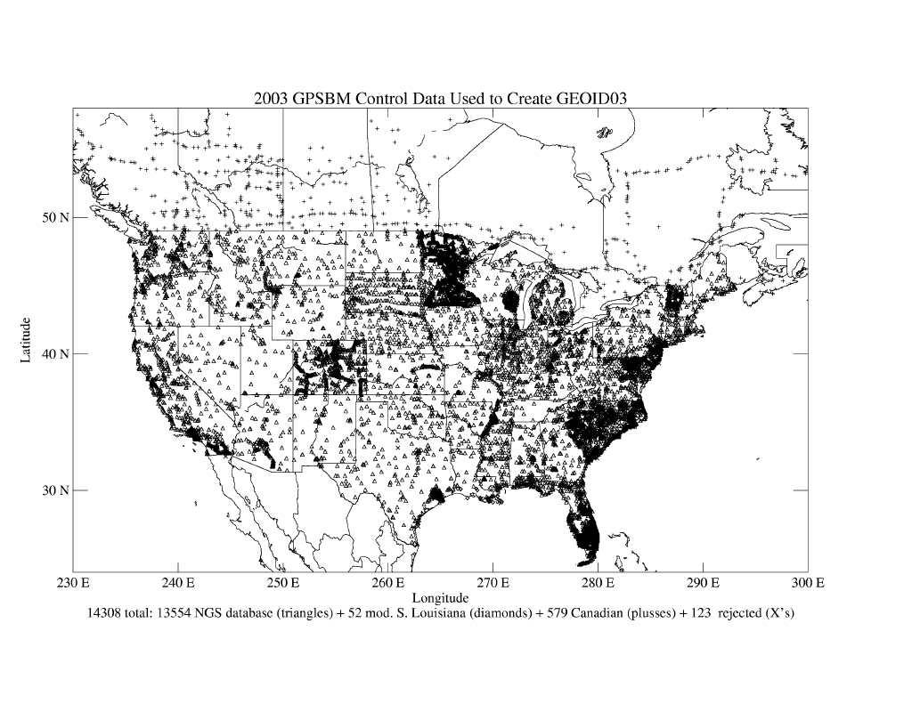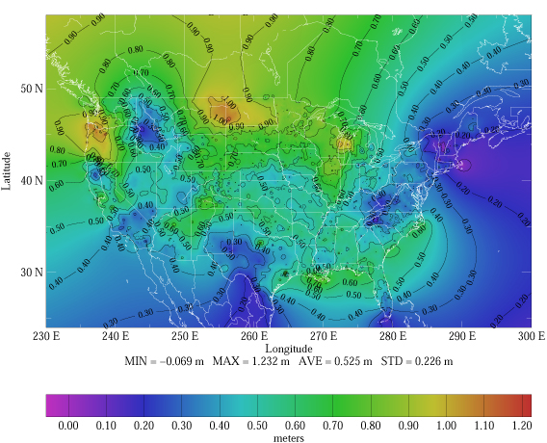
Figure 3 The left panel shows the spatial distribution of the control data used to warp USGG2003 to fit the NAD 83 and NAVD 88 datums. The gridded mismatch (r) between the USGG2003 (N) and GPSBM2003 (h – H) geoid height estimates is shown in the right panel. The residuals follow Equation (2) in that: h – H – N = r. Random GPS observation errors are not removed, hence this simple gridding approach is insufficient to determine a hybrid geoid.

4 Single Gaussian versus Multi-Matrix Analytic Functions
Least Squares Collocation (LSC) is used to determine and analytically model the character of the correlated signal in the residual signal. Implementation of LSC has been covered extensively (Farebrother 1988, Moritz 1989, Koch 1987). The Gaussian model used to create the analytic signal for GEOID96 and GEOID99 is:
(3)

This analytic signal is then implemented into LSC according to a relationship expressed by Moritz (1989):
(4)

These residuals derive from random and systematic errors in the leveling, GPS and gravimetric geoid. The purpose of this approach is not to attribute the source of the error but to create a model of the correlated signal to incorporate into a final hybrid geoid. The approach that has been postulated here is to use multiple positive definite matrices to model the complex empirical signal represented by the GPSBMs and gravimetric geoid height differences shown in the left panel of Figure 1. The same data will be used with both a single Gaussian function and a multi-matrix model that stacks Gaussian functions to model both the short and long wavelengths of the signal.

Previous approaches (GEOID96 and GEOID99) used only a single Gaussian function to model the analytic signal between points. Such a function generated a positive-definite matrix, which is the actual requirement for creating an inverse solution using LSC (Moritz 1989). Noting that addition of multiple positive-definite matrices results in another positive-definite matrix, a new approach was devised using multiple Gaussian functions. Equation (3) was used twice to create two models determined using different amplitudes and correlation lengths:

(5)

The addition of these two models created a combined analytic signal, which defined an approach referred to as Multi-Matrix LSC (MMLSC). The resulting analytic signal more closely matched the empirical signal given by the residual geoid heights between GPSBM2003 and USGG2003. Accurately capturing this signal is fundamental to improving the fit of the resulting hybrid geoid model to the bench mark heights in the NGS database.

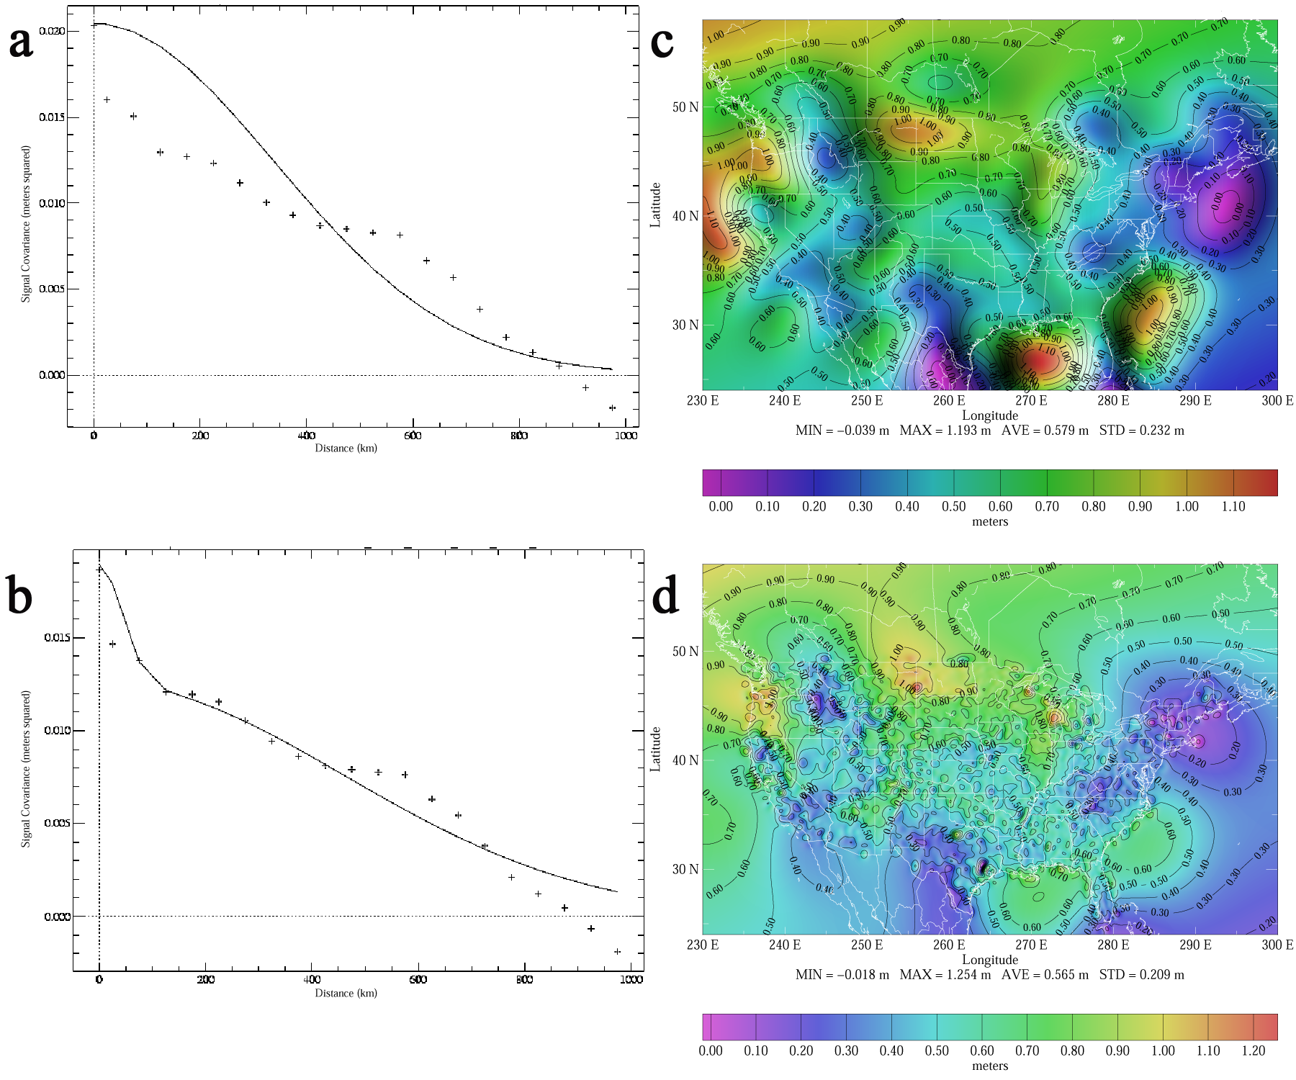
Figure 4 Panel a shows an analytic fit similar to that used to make GEOID99. Panel b shows the fit from GEOID03, which more closely approximates the empirical signal of the GPSBMs (+'s). Panels c and d show the resulting models for the analytic signals in panels a and b, respectively.

Figure 4 shows the correlative signal strength at various distances of the empirical data (residual GPSBMs), and a best-fit analytic signal is determined based on the type of function used: single Gaussian or MMLSC. In panels 4.a and 4.b, the correlation of the empirical data was determined and binned in 50 km intervals (+’s) and analytic models fit to them (lines). In panel 4.a, the analytic model is a single Gaussian function with a correlation length of 400 km and amplitude of (14.3 cm)², which is similar to that used to make GEOID99. The analytic signal for this single matrix doesn’t fit extremely well and the resulting modeled signal seen in panel 4.c is fairly smooth in character. In panel 4.b, the signal is derived using MMLSC in accordance with Equation (5). The first matrix had a correlation length of 650 km and amplitude of (11.2 cm) ², while the second had a correlation of 60 km and amplitude of (8.1 cm) ². The fit between the MMLSC analytic signal and the GPSBM signal is better than in panel 4.a, and the resulting model incorporates more local features. Because the MMLSC approach models shorter wavelength signal, it was also necessary to grid the conversion surface at closer spacing (5’) than was used for the single matrix model (30’). The single matrix method could also be gridded at the closer interval, however, the 400-km correlation length cannot model shorter wavelength signal and use of a closer interval doesn’t improve the resulting conversion surface.

The smooth character of the single-Gaussian conversion surface (panel 4.c) meant that local features were largely unmodeled and remained in the misfit as was the case after GEOID99 (right panel of Figure 1). The single-Gaussian analytic signal (panel 4.a) deviated significantly from the empirical data when compared to the MMLSC analytic signal (panel 4.b). While it is not desirable to incorporate all correlated signal, signal of a sufficient wavelength and power should be accounted for to derive a better local fit. As an example, Tuolumne County in California had significant residual signal (20-cm amplitude) across about 120 km after GEOID99. Using MMLSC, this signal was reduced to only a few centimeters. In the MMLSC model presented here, the shortest correlation length was 60 km. This corresponds to the point where the power (amplitude) has fallen in half. It roughly correlates to the half-wavelength signal. Hence a 60-km correlation length models features of about 120 km spatially. Such features are significant enough in scale and power that they need to be accounted for to derive a better local transformation between NAD 83 and NAVD 88. Hence, the use of multiple models allowed a better fit to the complicated nature of the residual signal at various wavelengths. Both models (single-matrix and MMLSC) were removed from USGG2003 to create new hybrid geoids that better reflect the GPSBMs and the difference between NAD 83 and NAVD 88.

In Figure 5, the GPSBMs were compared to the hybrid geoid models resulting from the analytic signals. As with the gravimetric geoid, the hybrid geoids were interpolated to the GPSBM locations and these final residual values used to determine their misfit. The misfit for the single matrix method was (4.6 cm)2, similar to that for GEOID99. The misfit for the MMLSC method was about (2.4 cm)2 – roughly half. The misfit has both correlated (remaining geoid error) and uncorrelated (GPS observation error) components. For both models, the uncorrelated signal is about (2.1 cm)2. Note that the scale is necessarily different for panels 5.a and 5.b because the magnitudes of the residual signals are very different. The amplitude of the correlated component is about (3.2 cm)2 with a characteristic length of 25 km in panel 5.a. In panel 5.b, it is (1.0 cm)2 with a characteristic length of 3.5 km. To enhance understanding of this numeric result, the final residuals were gridded and are displayed at the same color scale in panels 5.c and 5.d.

Use of MMLSC accounts for random errors most likely associated with the GPS observations, and correlated errors in the residual GPSBMs occurring at significant spatial extents (120 km). Not all the correlated signal may be attributable to systematic differences between the datums employed here. However if a residual signal occurs over a sufficient spatial extent, such as 120 km, then the greater likelihood is that the signal is systematic for the region and not just correlated random errors. This assumption can be problematic in regions where the GPSBMs are spatially undersampled with respect to the shortest correlation length used in MMLSC. With that caveat, the model determined using MMLSC was adopted as GEOID03.

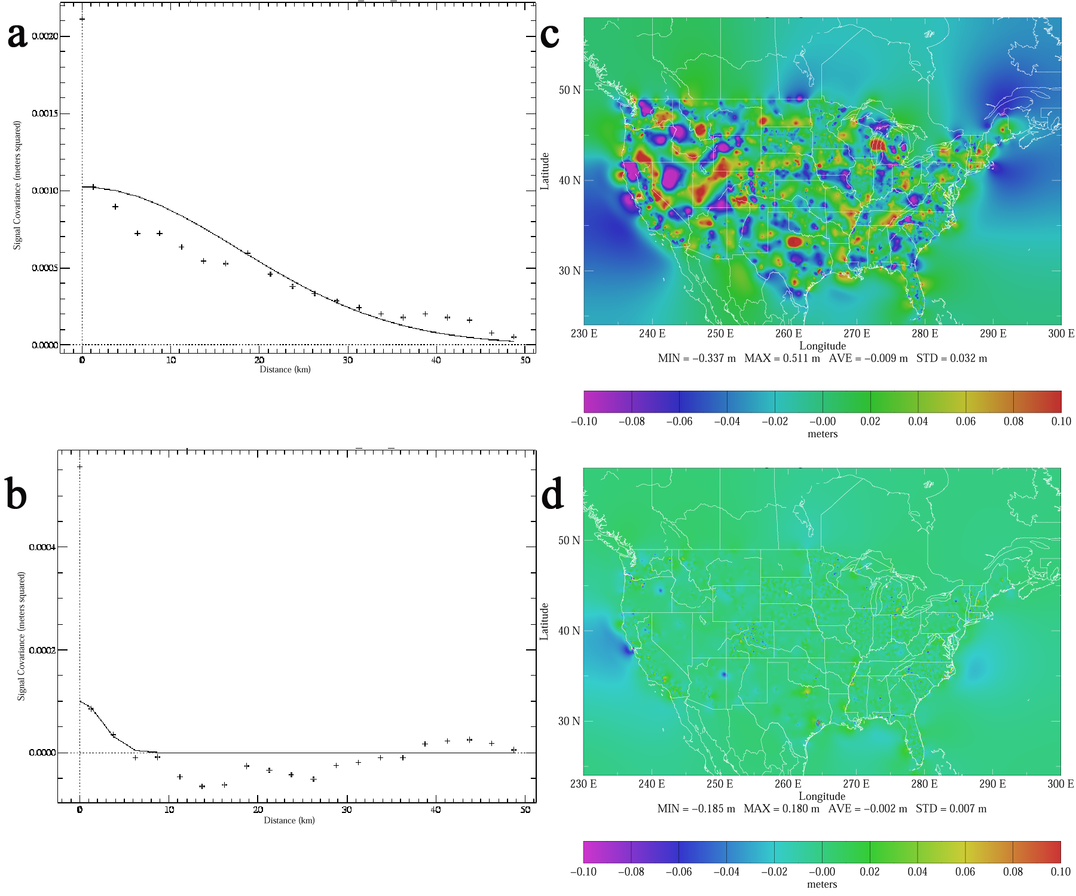
Figure 5 Panel a shows an analytic fit to the final residuals from the single matrix hybrid geoid (similar to GEOID99). Panel b shows the fit from GEOID03, which is at a different scale because of the magnitude of the improvement. For both panels a and b, the spikes at the y-axes represent the uncorrelated error associated with GPS observations. Panels c and d show grids of the final residuals at the same scale to emphasize the improvement in GEOID03.
5 GEOID03
The United States Hybrid Geoid model for 2003 (GEOID03) is shown in Figure 6 along with differences between it and GEOID99. GEOID03 and GEOID99 are statistically very similar; however, their differences are relevant to local determination of orthometric heights. Differences between 10 and 15 cm can be seen in coastal and mountainous regions. Many of the major differences occur outside CONUS and arise from the several sources including the use of GSFC00.1 instead of KMS98, inclusion of Canadian GPSBMs, and truncation of the extrapolated signal due to the short wavelength matrix in the MMLSC approach.

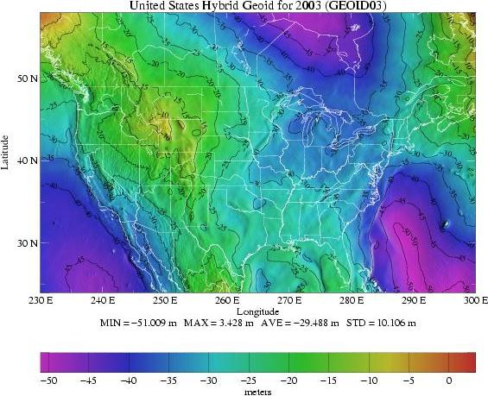
Figure 6 Left panel is the final United States Hybrid Geoid model for 2003 (GEOID03). Right panel shows the difference between GEOID03 and GEOID99. Note that most differences are very short wavelength and low in amplitude. However, they do account for the short wavelength signal left over after GEOID99 modeling. The offshore differences occurred due to differences from GSFC00.1 and the behavior of the LSC model outside of the range of the data.

Note that regions that contain a denser distribution of GPSBMs (see the left panel of Figure 3) will actually be better modeled. The analytic signal modeled by MMLSC depends on a sufficient sample of GPSBMs over the wavelengths to be resolved. For the longer wavelength signal, this is easily met everywhere. For the shorter wavelength signal, regions exist where the sparseness of the GPSBMs may not provide sufficient information to adequately model the true local behavior. This is particularly true in western states, but also true for many eastern states. GEOID03 will show good agreement at and near such points, but the reliability will fall when the distance between such points increases. This results in a globular or bubble-shaped features forming around the isolated points in the western states, as opposed to the more regional fields seen in the eastern states (right panel of Figure 6). This does not reduce the internal accuracy of GEOID03 nor should GEOID03 not be adopted in those regions. It merely reflects the limitations of the data available to create geoid height models.

In the Table 1, statistical values are given for all states in CONUS and the District of Columbia. Note that the national average is 0.0 cm and the national standard deviation is 2.4 cm (1σ). States with red values show those with worse averages than the national value. Abnormally high average values are also noted in some states, but this may be due to statistics, because many of these states also have few points to define these values.

In Texas, the standard deviation of 5.8 cm is more than twice the national average and results primarily from GPSBMs in the Houston-Galveston Subsidence District. GPSBMs are routinely screened to remove points that disagree too much with adjacent points. The guidance for this removal is that geoid height changes do not occur too rapidly over short distances. Normally a point can be isolated and removed. However, GPSBMs in this region show no consistency due to the differences in observation times and locations between GPS observations and leveling determinations in a region that is subsiding over time. The net effect was to create a much higher standard deviation with much of that being uncorrelated in the GEOID03 model. Examination of this region in the right panel of Figure 6 reveals an almost cratered appearance where this has occurred. Resolving this will require new and simultaneous measurements of ellipsoidal and orthometric heights or some type of subsidence model to apply corrections over time to the leveled heights. Such a step has been partially investigated for a region experiencing similar problems in southern Louisiana.

Table 1 Use the two character state codes to identify the number of points, average value (cm), and standard deviation (1σ) of the GEOID03 misfit (cm). This misfit includes both correlated and uncorrelated signal remaining when the GPSBMs were compared to GEOID03.
State Code | No. of points | Ave.  (cm) | St. Dev.  (cm) |  | State Code | No. of points | Ave.  (cm) | St. Dev.  (cm)
AL | 178 | 0.0 | 1.8 |  | ND | 44 | 0.2 | 1.8
AR | 86 | 1.1 | 2.7 |  | NE | 142 | 0.2 | 2.2
AZ | 148 | 0.0 | 3.0 |  | NH | 16 | 0.5 | 3.8
CA | 549 | 0.0 | 3.2 |  | NJ | 275 | 0.0 | 1.5
CO | 514 | 0.0 | 3.3 |  | NM | 76 | -0.1 | 1.6
CT | 20 | 0.0 | 1.3 |  | NV | 57 | 0.1 | 1.6
DC | 18 | 0.7 | 1.9 |  | NY | 130 | 0.0 | 1.8
DE | 33 | 0.0 | 2.4 |  | OH | 254 | 0.1 | 3.2
FL | 1727 | 0.0 | 2.3 |  | OK | 78 | 0.1 | 2.1
GA | 109 | 0.0 | 2.3 |  | OR | 160 | 0.2 | 2.1
IA | 89 | -0.2 | 2.6 |  | PA | 98 | 0.1 | 2.4
ID | 97 | 0.0 | 1.7 |  | RI | 22 | -0.1 | 2.3
IL | 276 | 0.1 | 2.3 |  | SC | 822 | 0.0 | 2.0
IN | 106 | 0.0 | 2.1 |  | SD | 242 | 0.0 | 2.6
KS | 101 | 0.0 | 2.0 |  | TN | 158 | -0.1 | 2.2
KY | 107 | -0.4 | 2.4 |  | TX | 354 | 0.0 | 5.8
LA | 97 | 0.0 | 3.6 |  | UT | 34 | 0.0 | 1.6
MA | 40 | 0.0 | 2.0 |  | VA | 173 | 0.0 | 2.5
MD | 400 | -0.1 | 2.0 |  | VT | 327 | 0.0 | 1.8
ME | 66 | 0.1 | 2.4 |  | WA | 229 | -0.1 | 2.8
MI | 310 | 0.0 | 2.7 |  | WI | 255 | 0.0 | 1.7
MN | 2856 | 0.0 | 1.5 |  | WV | 48 | -0.1 | 2.1
MO | 102 | -0.1 | 2.0 |  | WY | 93 | 0.0 | 2.7
MS | 170 | -0.4 | 3.8 |  | CD | 581 | 0.0 | 2.1
MT | 166 | 0.0 | 2.3 |  | Total | 14185 | 0.0 | 2.4
NC | 1152 | 0.0 | 2.2

In the southern Louisiana region, 132 points were removed and 52 (1st order leveling data only) of them replaced with data derived from a model of the subsidence (Shinkle and Dokka 2004). The intent of this is to estimate the subsidence rate on the measured elevations. The primary difficulty, as seen in Texas, is that differences in time in an actively subsiding region create a false signal in the geoid height determination. Bringing the two separate observations into the same epoch, removes this systematic effect. The net effect of this subsidence modeling is still being investigated to determine if it will be used in future geoid models for this and other regions.

6 Conclusions and Recommendations
GEOID03 represents a significant step forward as a model from the National Geodetic Survey (NGS) for use in GPS/leveling surveys. The enhancements derived from use of updated GPS on Bench Mark (GPSBM) information since the release of GEOID99, as well as a refinement to the modeling technique. Use of Multi-Matrix Least Squares Collocation (MMLSC) better incorporated signal at shorter wavelengths (60-km correlation length) and long wavelength (650 km) together. As a result, GEOID03 has a national error of 1.0 cm (1σ) or 2.0 cm (2σ). Assuming that GPS observations are made consistent with Zilkoski et al. (1997, users of GEOID03 should be able to convert between NAD 83 and NAVD 88 to 2.4 cm (1σ) or 4.8 cm (2σ) nationally or at the same level as seen by their state in Table 1.

Limitations in GEOID03 occur in some western states, where the sparseness of the data restricts the ability to model between them. More significant problems may arise in regions experiencing significant subsidence rates and where significant time gaps exist between GPS observation of ellipsoidal elevations and leveling derived orthometric heights. The primary limitation of GEOID03 is that it is only applicable for the Conterminous United States. GEOID99 models are still valid in other areas and DEFLEC99 remains valid for all areas, however, newer models will be generated next year for all U.S. regions as a part of a broader update (USGG2004, GEOID04 and DEFLEC04).

Ultimately, the use of gravimetric instead of hybrid geoid models is desired to provide a better reference surface. A high accuracy gravimetric geoid would provide a better and cheaper means of obtaining orthometric heights that would facilitate surveying, commerce, and coastal egress during emergencies. The impending national readjustment (Milbert 2004) of GPS-derived ellipsoidal heights held by NGS should reduce significant correlated signal (Smith and Roman 2001) in the residual signal from that source by normalizing all GPS-derived observations to the CORS network. Continued research to find better gravity and terrain data sets as well as improvements in methodology will also generate better gravimetric geoids. However, the readjustment of the NAVD 88 network is unlikely due to great expense and personnel limitations.

Development of a centimeter level accurate gravimetric geoid will eliminate the need to generate a hybrid geoid. Instead, orthometric heights will be determined directly from GPS observations tied into the CORS network and by removal of the gravimetric geoid height. Such models would be based on future Earth Gravity Models based on the ongoing gravity satellite missions such as CHAMP and GRACE. A United States gravimetric geoid derived from such an EGM would be consistent with those from other countries and facilitate scientific and commercial opportunities, especially near and over national borders. For now though, GEOID03 represents the best means of converting between NAD 83 and NAVD 88.

Acknowledgments
Special thanks to Dr. Dru Smith for ideas and discussions centered on refining the Least Squares Collocation approach to better model local geoid height signals. Thanks also to Bill Henning and John Hamilton for being on the panel discussion and providing their assessments of GEOID03.

Addendum
Geoid height models provide a mechanism for converting ellipsoidal heights (easily obtained using GPS) into more useful orthometric heights. The first and most important lesson to understand about using a geoid height model, such as GEOID03, is that it is relevant only between one specific ellipsoidal datum and one specific orthometric datum. In the left panel of Figure A, a simple sketch describes the relationship between these various surfaces. The geoid is one of an infinite number of geopotential surfaces that surround the Earth. These surfaces do not intersect and are irregular due to the irregular distribution of mass about the Earth (continents and ocean basins are large-scale examples of this). The one equipotential surface that best approximates Mean Sea Level (MSL) is selected as the geoid. Differences can and do arise as to which is the best gauge of MSL, but the intent of a geoid surface is to approximate the ocean – even under the land so as to provide a common datum. Because orthometric heights are tied to the Earth’s geophysical structure, they are often referred to as natural heights.

Ellipsoidal heights refer to a mathematical model based on major characteristics of the Earth such as the mass, equatorial radius, and flattening. An ellipsoidal reference frame is relevant to tracking satellites, because shorter wavelength features attenuate at satellite elevations leaving only the effects of the major characteristics. Hence, location vectors determined from GPS satellites are also in an ellipsoidal reference frame. Each ellipsoidal model is defined exactly and, therefore, has only one datum surface. A geoid height model is then the difference between a specific ellipsoidal datum and a specific orthometric datum.

A gravimetric geoid (height) model can be determined by many sources of gravity field information including digital elevation models, altimeter-implied gravity, global Earth Gravity Models, and gravity observations on land, air and sea. The gravity field and geoid undulations can both be mathematically related to the same irregularities in the Earth’s masses. Typically, the amount of information available to generate a gravimetric geoid is very large (millions of observations) and results in a high-resolution model. This is desirable to resolve the short wavelength features of the geoid when interpolating the model.

Another means of estimating geoid heights is by taking the difference between directly measured orthometric and ellipsoidal heights. This second method provides an exact measure of the geoid height at the specific location. However there are substantially fewer points where GPS-derived ellipsoidal heights on leveled bench marks (GPSBMs) are available, and they are not well distributed spatially. However if you have geoid heights from both a gravimetric geoid and GPSBMs, then their difference can be modeled. Incorporating these modeled differences with the original gravimetric geoid would result in a useful hybrid geoid model. It would have the short wavelength character of the gravimetric geoid but warped to fit the desired datums expressed at the GPSBMs, which act as control points for the warping. Least Squares Collocation (LSC) is one method that can be employed to determine the correlative components in the residual signal.

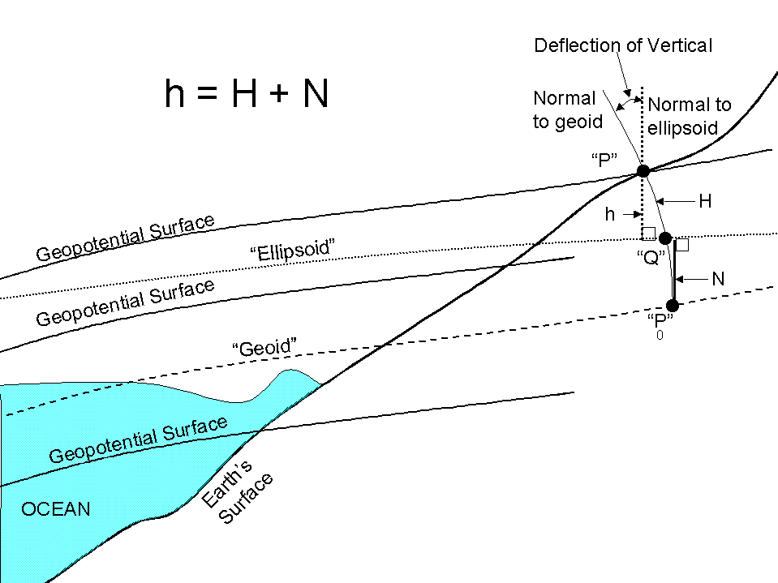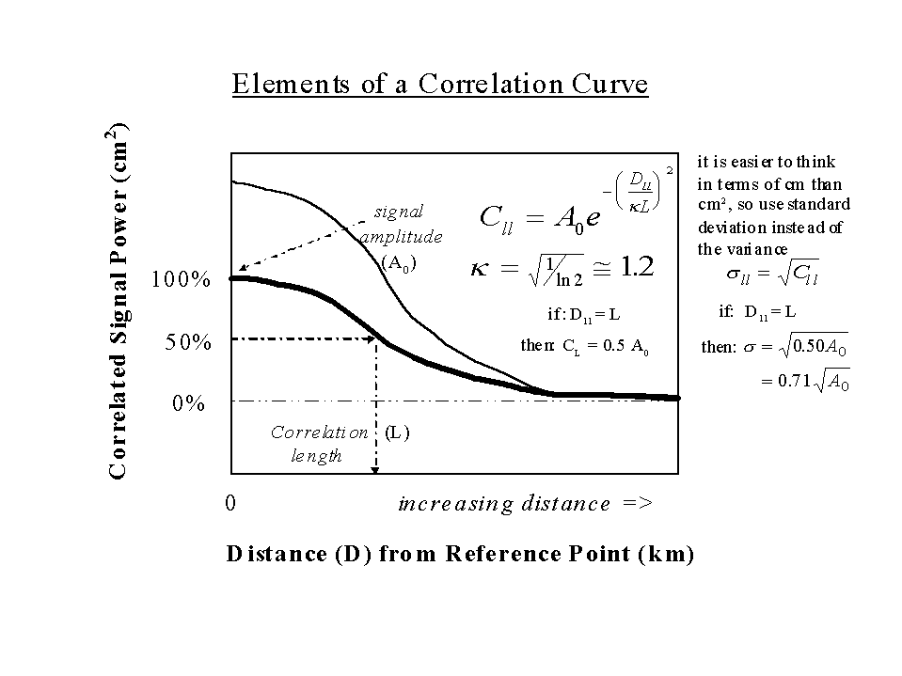
Figure A Depiction of the relationship between geopotential surfaces, the geoid and the ellipsoid (left panel). Mathematical relationships of the analytic model (Gaussian) used in Least Squares Collocation (right panel).

In the right panel of Figure A, the general layout describes the determination of an analytic signal that describes how point data correlate to each over distance. By modeling this correlative signal to fit the empirical signal determined by the residual data, a general model can be created. The difficulty with this approach is in determining how much of the residual signal to incorporate. Given good data distribution and quality, it would be desirable to match as much of the empirical signal as possible that occurs at significant wavelengths. Determination of what level is significant enough to incorporate requires some judgement with regard to the quality of the data and its distribution. It would not be desirable to incorporate correlated signal at wavelengths that are too short, because they may represent only locally correlated random features. Hence, judicious use of MMLSC instead of simply gridding the data eliminates locally correlated random errors and uncorrelated errors. By not incorporating such features into the modeling, the resulting hybrid geoid model transforms those features that represent correlated features at significant wavelengths that likely represent systematic differences in the datums or gravimetric geoid. Adequately modeling these differences then provides a hybrid geoid model that accurately transforms between NAD 83 and NAVD 88.

References

Anderson O.B., Knudsen P., 1998, Global marine gravity field from the ERS-1 and Geosat geodetic mission altimetry, J. Geophys. Res., vol. 103, no. C4, pp:8129-8137.

Clinton, W., April 13, 1994, Coordinating Geographic Data Acquisition and Access: The National Spatial Data Infrastructure, Executive Order 12906, Federal Register, 59 (71), pp.17671-17674.

Farebother, R. W., 1988, Linear Least Squares Computations, Marcel Dekker, Inc. New York.

Heiskanen, W. A,. and H. Moritz, 1967, Physical Geodesy, W. H. Freeman and Company, San Francisco.

Henning, W. E., E. E. Carlson, and D. B. Zilkoski, 1998, Baltimore County, Maryland, NAVD 88 GPS-derived Orthometric Height Project, Surv. Land Info. Sys., vol. 58, no. 2, pp. 97-113.

Koch, K.-R., 1987, Parameter Estimation and Hypothesis Testing in Linear Models, Springer-Verlag, New York.

Milbert, K., 2004, The Readjustment of the National Spatial Reference System, NGS Webpage, http://www.ngs.noaa.gov/NationalReadjustment.

Moritz, H., 1989, Advanced Physical Geodesy, Herbert Wichmann Verlag, Karlsruhe.

Shinkle, K. D., and R. K. Dokka, 2004, Subsidence Rates at Benchmarks in the Lower Mississippi Valley and Northern Gulf Coast, NOAA Technical Memorandum, NOS, NGS, Silver Spring, MD,
(in review).

Smith, D. A., and D. G. Milbert, 1999, The GEOID96 high resolution geoid height model for the United States, J. Geod., vol. 73, pp. 219-236.

Smith, D. A., and D. R. Roman, 2001, GEOID99 and G99SSS: One arc-minute models for the United States, J. Geodesy, vol. 75, pp. 469-490.

Wang, Y.-M., 2001, GSFC00 mean sea surface, gravity anomaly, and vertical gravity gradient from satellite altimeter data, J. Geophys. Res. Vol. 106 , No. C12 , p. 31167-31174.

Zilkoski, D. B., J. D. D'Onofrio, and S. J. Frakes, 1997, Guidelines for Establishing GPS-derived Ellipsoid Heights (Standards: 2 cm and 5 cm), NOAA Technical Memorandum, NOS, NGS-58, Silver Spring, MD.

