National Register of Historic Places: GIS Webinar
Cultural Resource GIS Facility
National Park Service
DRAFT!!! June 2012

National Register Draft Electronic Map Policy Factsheet
Required:
- WGS/NAD datum
- A map that very clearly labels the property being nominated. The point or district should be instantly distinguishable from the rest of the map.
- A scale.
- A north arrow.
- Reproducibility in black and white (same standards for black and white reproducibility as a site map.)
- Decimal degrees for each point, extending to at least six decimal places.
- It can be, but does not have to be on a continuation sheet.

(Note: It is still acceptable to use hardcopy USGS maps and follow the previous map standard.)

In February and March 2012 the National Register of Historic Places held webinars in conjunction with the National Park Service, Cultural Resource GIS Facility to discuss the use of Geographic Information Systems (GIS) to help produce paper locational maps and defining coordinates for submittal with nominations. The webinars discussed the draft policy change currently being implemented by the National Register program outlining options and alternatives for submitting UTM coordinates and paper USGS quadrangle maps. The draft policy allows for the inclusion of latitude/longitude coordinates instead of or in addition to UTM coordinates. The policy also allows for the submission of computer generated locator maps instead of USGS quadrangle maps.

The webinars provided examples of three different, free, internet-based tools to acquire coordinates and generate the necessary maps. Using a full GIS software package, such as ESRI’s ArcGIS, would allow for the most flexibility in generating the required paper maps or coordinates for a nomination. The expense of full GIS software however is sometimes prohibitive for casual users. The intent of the National Register GIS webinars is to offer alternatives that will produce the required maps and coordinates for a nomination, taking advantage of other available free alternatives. All of the applications discussed in the webinars can produce the required locational information for a nomination, however some function better for resources represented by a single point, while others function better for resources over 10 acres that require bounding coordinates.

BING Maps (http://www.bing.com/maps/)
BING Maps, much like Google Maps, use an internet browser to provide basic street maps, navigation directions and other viewing tools. Because many users do not have administrative rights on their computers, BING Maps is a good, quick, source for generating latitude/longitude coordinates, without having to install any software or download anything. The National Register draft policy allows for the inclusion of latitude/longitude coordinates in the form of decimal degrees, or a decimal format of the typical degrees, minutes, seconds usually displayed with latitude/longitude. Storing decimal degree coordinates instead of UTM coordinates will allow the National Register program to easily view National Register sites nationwide using GIS software.

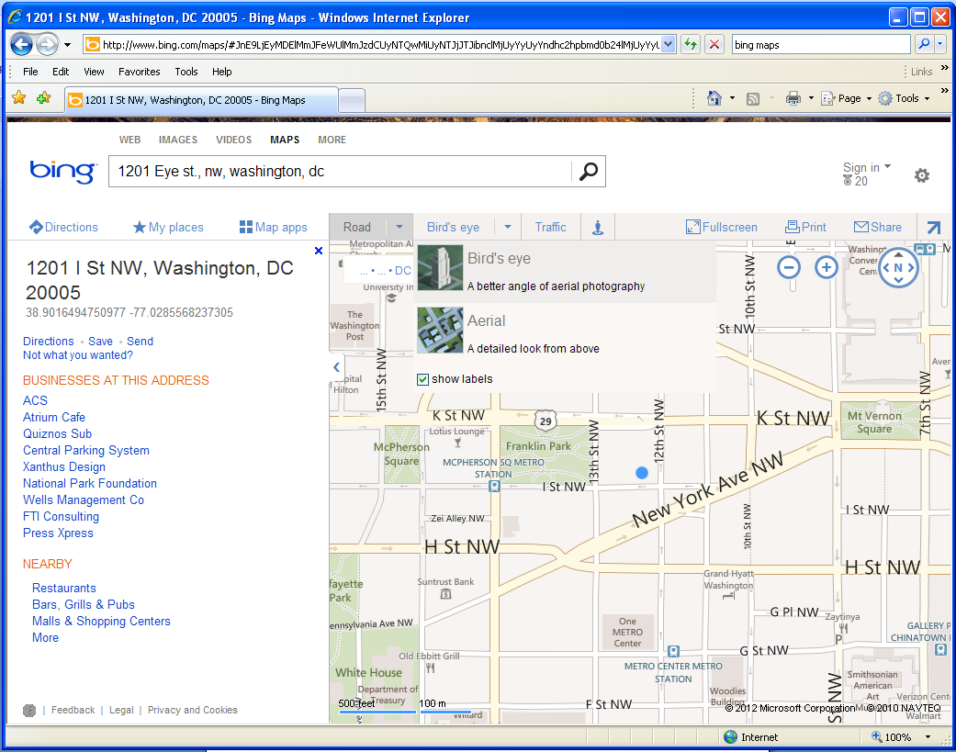
With BING Maps, typing an address into the search box at the top of the browser finds the location of the building, and displays the decimal degree coordinates associated with that location. BING Maps also allows users to add locations as points or draw boundaries, such as an historic district. These point and area locations can be saved and exported to a file format, such as a .kml or .kmz, which can be read or used by Google or other GIS software. Further, background imagery in BING can be changed from simple roads to more detailed aerial photography, helping the user to better identify an historic resource. Once the user has identified the resource of interest with either a point or a boundary, BING Maps can produce a paper map, with a scale and basic information required for a nomination locator map.
Note display of coordinates in the proper format
Type in the address to search
Use the menus to change the background from roads to aerial images
BING Maps provide basic information and functions extremely well to get coordinates for single buildings and urban resources. Providing bounding coordinates for an area larger than 10 acres, as required for a National Register nomination, is much more difficult. BING only supplies coordinates when an address is typed into the search. Other requirements for a nomination, such as acreage for a site, can be calculated with BING Maps, however; the units of that measure cannot be changed.

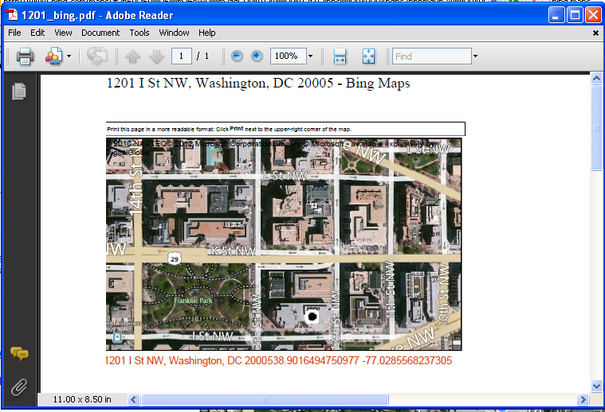
From the File and Print menus, users can choose to print out a paper map directly, or print to a .pdf file. The image of your point location and the background you choose will be automatically placed on the paper, along with the decimal degree coordinates and the address that you typed in to the search box.

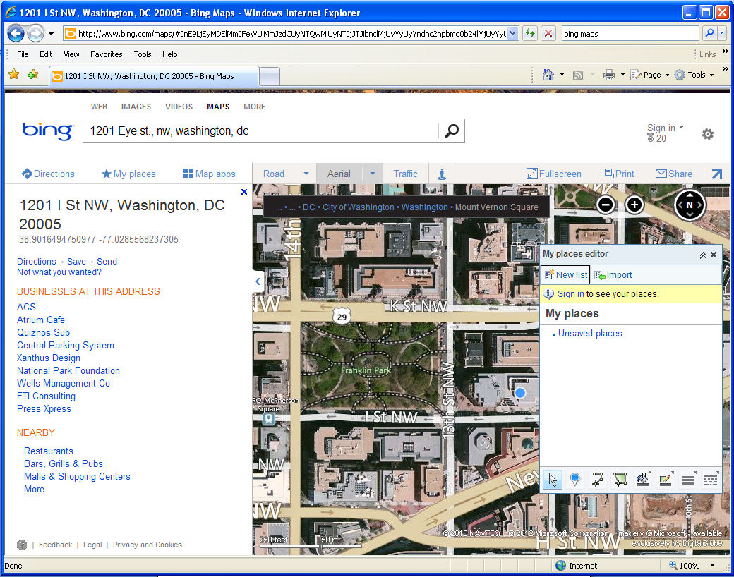
Clicking on the My Places menu option at the top of the browser will open a small dialog box that allows the user to place a push pin directly on the map, or draw an area feature.

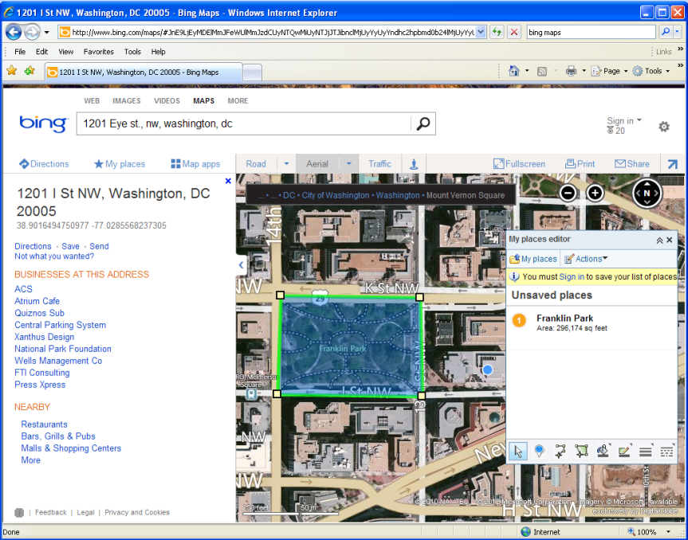
Drawing an area feature using the tools in the My Places dialog box will allow users to define district or site boundaries and generate area figures, however, the area is always calculated in square feet. It is important to note that coordinates are not provided for the various points identified as corners when drawing the area feature. This will make it difficult to provide the bounding coordinates for an area for a National Register nomination.
Area feature

Square feet calculations

Clicking Actions and Export from the My Places dialog allows users to export the data

Google Earth (http://www.google.com/earth/index.html)
Google Earth, unlike BING Maps or Google Maps, uses an internet based application to provide aerial photographs, navigation directions, drawing tools and other geographic searching mechanisms. Google Earth is a very familiar application to many users and is relatively intuitive to use. As a separate application, it does require users to download and install the application, which can lead to problems with administrative rights. As an independent application however, it offers more flexibility than BING Maps or Google Maps, particularly in finding or generating latitude/longitude coordinates.

With Google Earth, typing an address into the search box at the top of the application window finds the location of the building. Moving the cursor on the screen updates the display with coordinates for where ever the cursor moves. Unlike BING Maps, with a static display and only a set of coordinates based on address, Google Earth constantly displays coordinate information on the screen, updating and moving with the user as the display is manipulated. Rather than generating a single latitude/longitude pair, Google Earth always indicates the coordinates of the cursor, whether the user searched for the location or is just exploring the map.

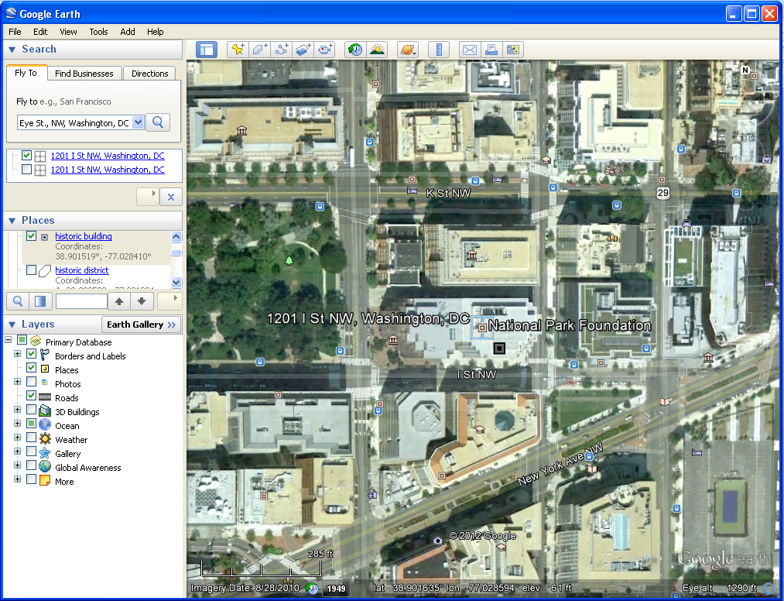
Google Earth will provide the same basic information as BING Maps or Google Maps, although it will make finding coordinates for bounding areas, contributing resources, or multiples resources much easier for the user. Simply moving the cursor to the appropriate location will generate a coordinate which can be marked on the map or copied into a document for submission to the National Register. Other requirements for a nomination, such as acreage for a site, cannot be calculated, however; paper maps are easily produced and the data can be exported as a .kml or .kmz file, like BING Maps.

Type in the address to search, or a city name, keyword, etc.

Unlike BING Maps, the background display will always be aerial photography, although historic aerial imagery can be examined also.

Note the display of coordinates, always on screen

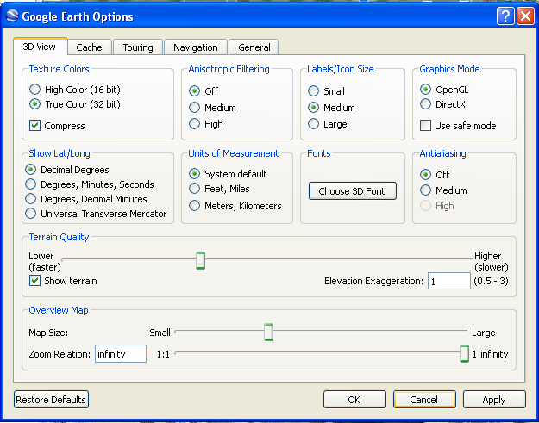
Users can choose how the coordinates are displayed in the application interface, either as decimal degrees, traditional degrees/minutes/seconds or even UTM coordinates. Clicking the Tools menu and selecting Options opens a dialog box that allows the user to change coordinate systems. Select the radio button next to Decimal Degrees.

Similarly, clicking the View menu and selecting Scale Legend will add a scale bar to the map display window, as well as any paper map you produce.
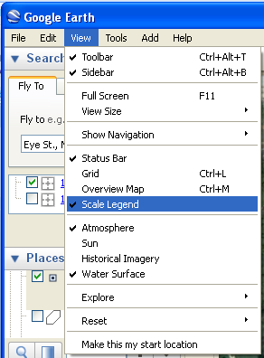

Tools at the top of the application interface allow users to create placemarks (points) or to draw area feature or measure distances. Placemarks or area features created by a user can be named and labeled for the map display or the paper maps produced. Once these features have been created, they will also appear on the left side of the screen in the Places window. There, the user can turn the features on and off, change the colors or symbols and otherwise edit the features.
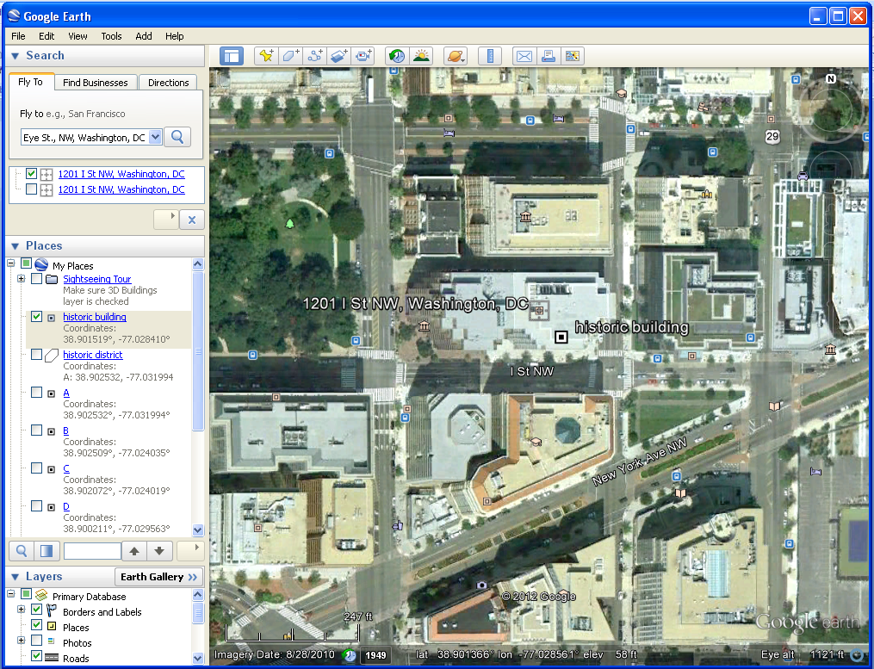
Placemark, labeled
Drawing tools

Places window, with placemark and area features listed, along with labels

Scale legend

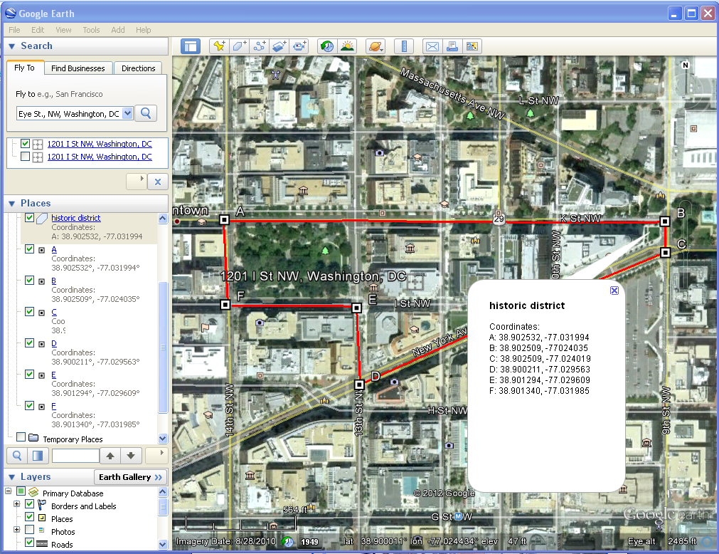
Note that area features can be easily drawn and labeled like a traditional National Register nomination locator map, with each coordinate labeled clockwise around the feature.

Editing the properties of a placemark or area feature allows the user to create labels, change colors and alter symbols. Right click on the feature in the Places window and select Properties to open the dialog box.
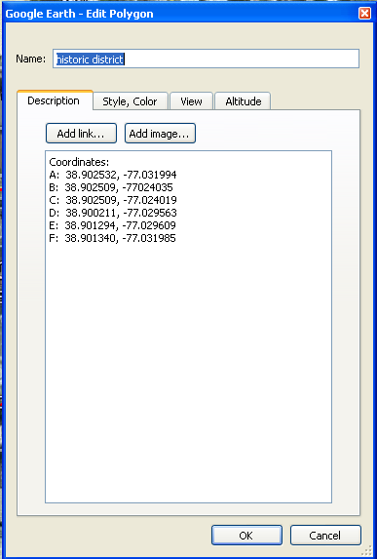
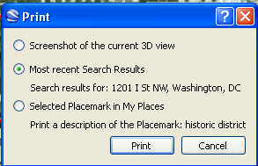
Regardless of whether the user uses searching to find a location, creates placemarks or draws an area feature, all can be printed directly or to a .pdf file. From the File and Print menus, users can choose whether to print the screen shot (as you see the screen now), or select specific features in your Places window to focus on.

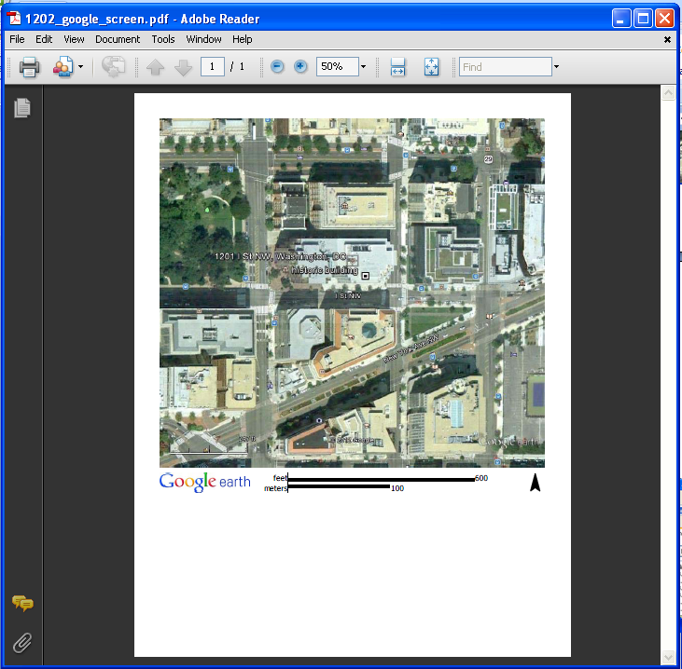

This .pdf shows a screen shot. Note the scale and north arrow addition to the page, which are required for a National Register nomination submission.

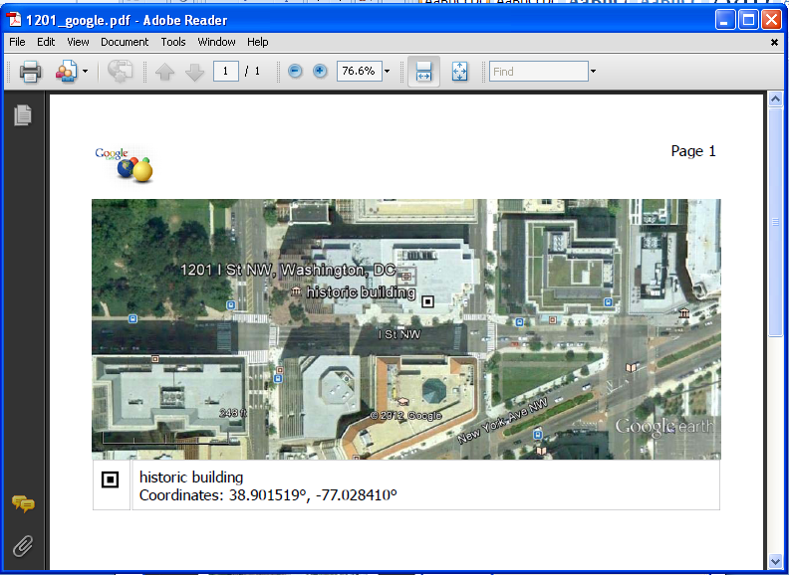
This .pdf shows a selected placemark. Note the name of the feature and label at the bottom of the image, which also has the scale legend.

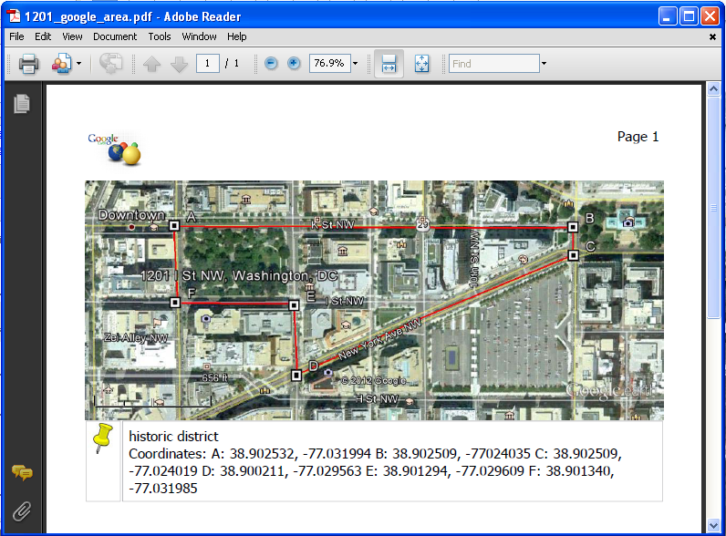
Note that choosing an area feature to print out will also produce the labels and scale bar. These images would replace the regular USGS quadrangle map required for a nomination.

Like BING Maps, users can save the data produced when making placemarks or area features as .kml or .kmz files. Right click on the feature in the Places window and select, Save Place As to open the Save dialog box. These files can be submitted with the electronic nomination, when this option becomes available.

ArcGIS Explorer (http://www.esri.com/software/arcgis/explorer-online/index.html)
(http://www.esri.com/software/arcgis/explorer/index.html)
Made by Environmental Systems Research Institute (ESRI), the same company that produces the primary full GIS software used, ArcGIS Explorer is a free GIS application. Like Google Earth, users may download the application and install it. However, like BING Maps, an internet based version that works through a browser is also available. If users have administrative rights conflicts, the ArcGIS Explorer Online option will avoid any download. Both versions of ArcGIS Explorer are more like a true GIS software, offering much more functionality than BING Maps or Google Earth. All of the same options, in terms of collecting coordinates and producing paper maps or electronic files that could be accepted as part of a National Register nomination are included, along with other analysis functions and background data.
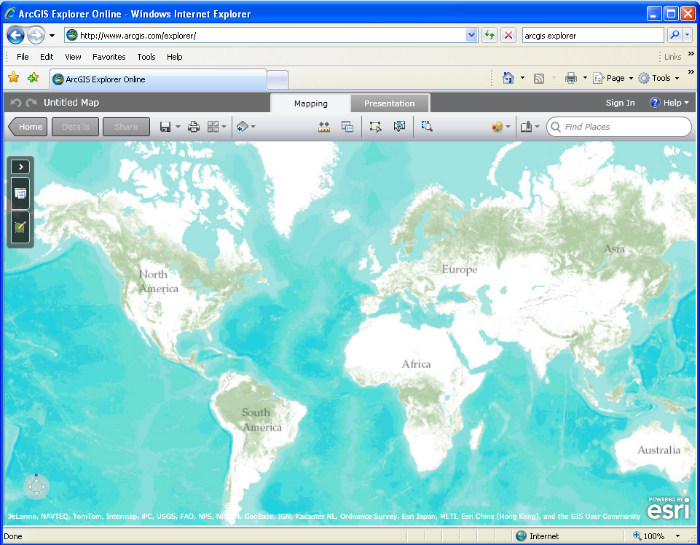
ArcGIS Explorer Online

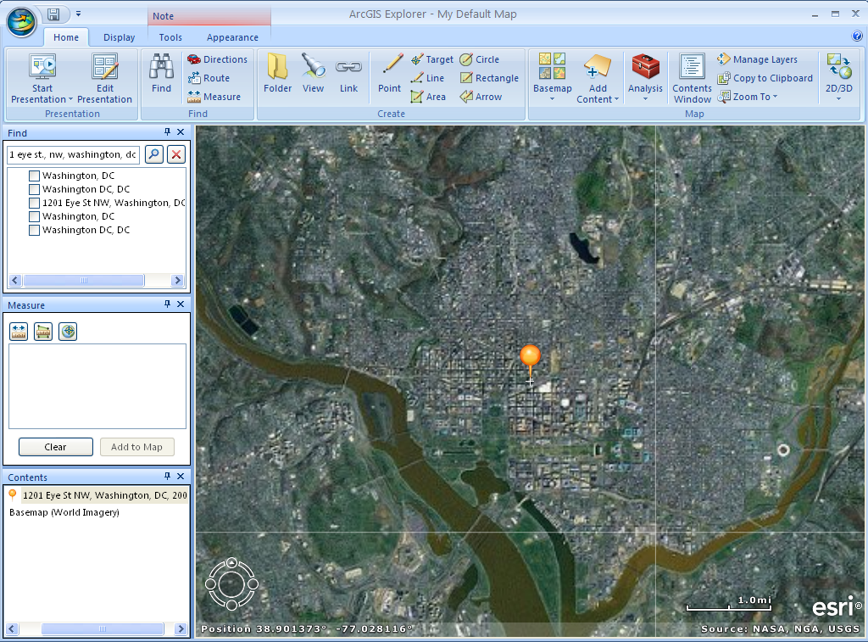
ArcGIS Explorer Application
Because the ArcGIS Explorer application is more sophisticated, it will take a little more time to work with, however the quality of paper maps that can be produced is much higher. The application is not quite as intuitive as Google Earth or BING Maps, however the enhanced functionality balances the time needed to learn all of the tools.
Contents window
Search box

With ArcGIS Explorer, typing an address, keyword, city or other geographic term into the search box at the top of the application window finds the location and marks it with a pin. To edit the location, get information about it, change the symbol or perform any analysis, users must select the right search item, right click on the item and select Move to Map. This action transfers the item found to the temporary map being created, moving it as a data layer to the Contents window. Once in the Contents window, users right click on the item and select Go To, to zoom into the area of interest. From this same menu, users can change the symbol associated with a feature or add a label for the feature.

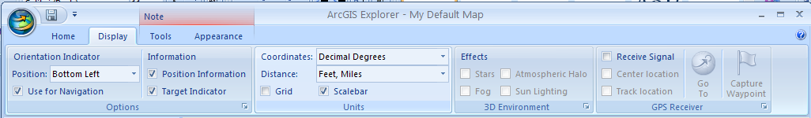
Like Google Earth, users can easily find coordinates associated with a point, line or area feature drawn on the map. Also Google Earth, users need to define what coordinate system those coordinates will be displayed as on the screen, add scale information and other map elements. Unlike Google Earth, where the cursor moving changed the coordinates, ArcGIS Explorer always displays the coordinates associated with the center of the map view. Moving the map image, as opposed to moving the cursor will update the coordinates displayed at the bottom of the screen.
Click on the Display tab at the top of the application to select the map elements and details that are needed. Click in the box next to Position Information to make sure coordinates display on your screen. Click in the box next to Target Indicator to display the crosshair at the center of the map display that will correspond to the coordinates being displayed on the map. Select Decimal Degrees as the Coordinate system to make sure that the position information is displayed in the right format. Choose the type of distance measure (English or metric) that the application will use to display any calculations made when drawing features.
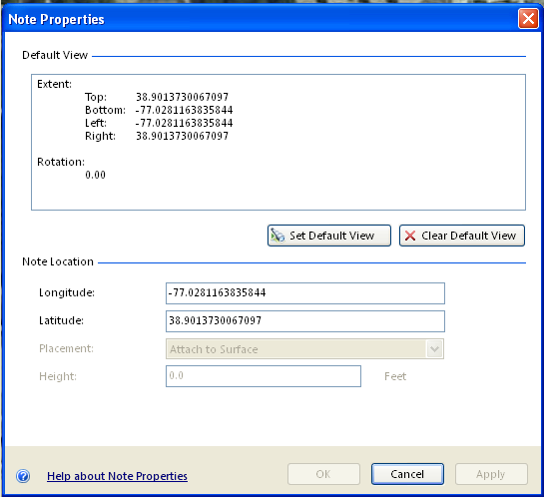
Before drawing any permanent point, line or area features, users can right click on the pin placed in the map based on a search to get the Properties of a feature, listing the coordinates in decimal degrees. This will be sufficient for resources under 10 acres, where only a single coordinate is required by the National Register program.

Like Google Earth, tools at the top of the application window allow users to create points, lines or area features. For each feature drawn, users may enter label information, popup window text or change the feature symbol and color. Once these feature have been created, they will also appear as layers in the Contents window at the left of the application.

Drawing tools
Labeled feature

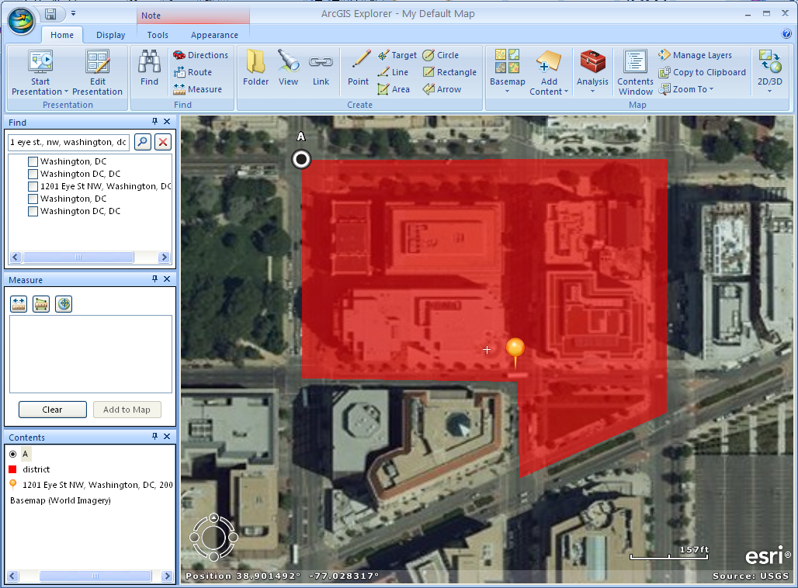

New features added to map contents

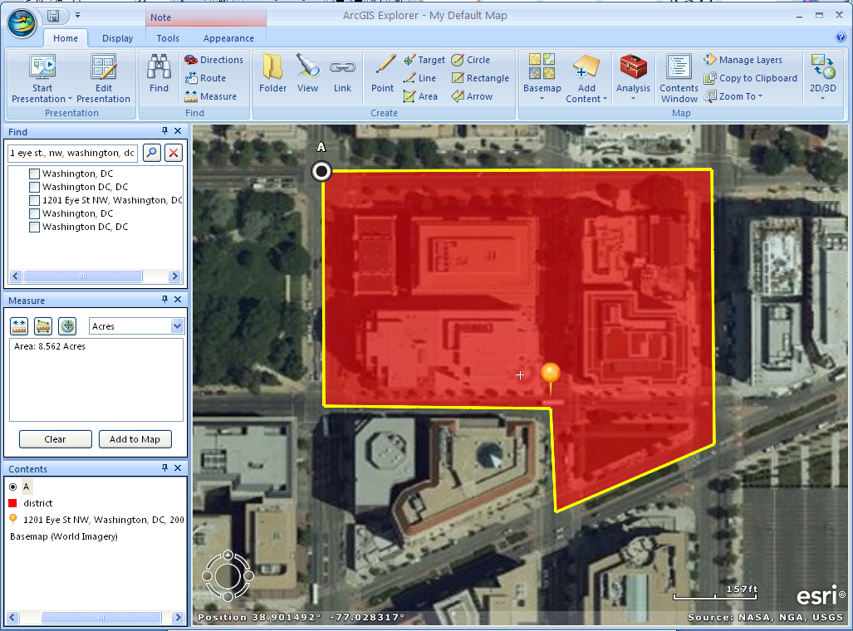
With ArcGIS Explorer, user options to measure distances and calculate areas are significantly enhanced. Clicking on the Measure tool at the top of the application window opens a Measure window at the left side of the application. From this window, users can measure distances or areas and even find coordinates for individual points. Results from any of the measurements are listed in the window. Users may also change the units of their measurements at any point. This function will allow users to calculate the acreage figures required for a National Register nomination.

Measure window with results

Other tools at the top of the application window allow users to change the basemap or background data from aerial imagery to something more familiar for a National Register nomination, like a digital quadrangle topographical map. Clicking on the Basemap menu and selecting Physical, should load new data into the map display.
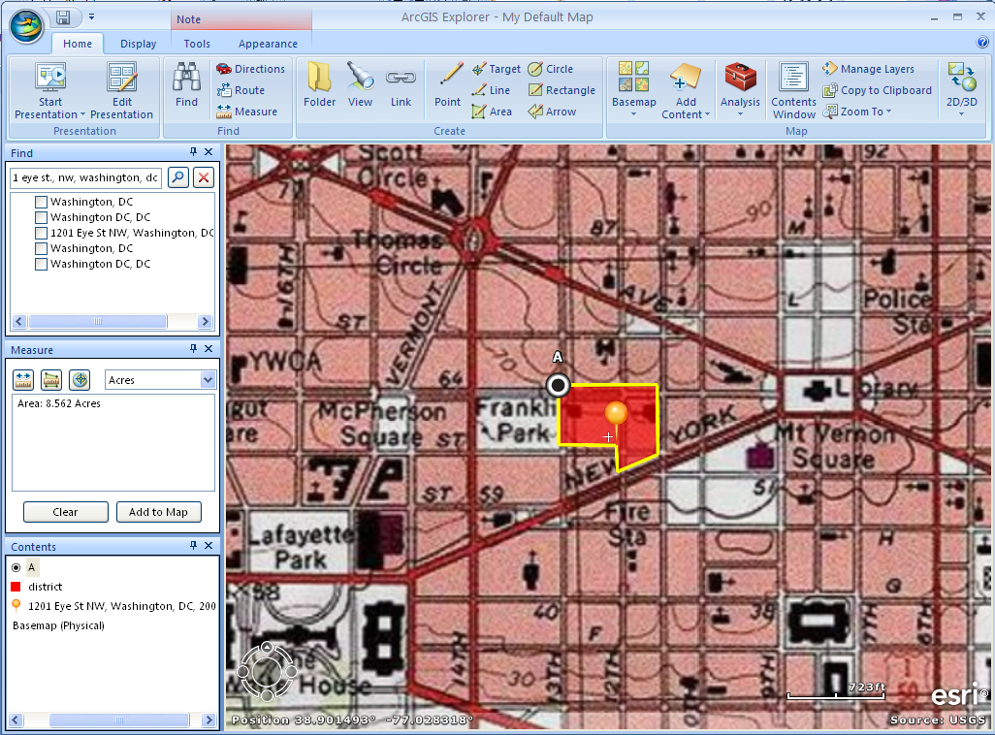
Users have many options of alternate basemaps to choose from in ArcGIS Explorer. Users may also add in other GIS data or other .kml or .kmz files created in other applications like Google Earth.

However, users change the display with different symbols, labels, background information, etc., everything can be printed out on a paper map, sent to a .pdf, or exported as a .kml or .kmz file.

From the File and print menus, users can choose whether to print the map created directly or to a .pdf file. Information on the screen, such as labels (which could contain the appropriate coordinates or property names) will all be included on the paper map along with scale and other information. Users can choose to save the map itself in order to return to it at a later point, or they can save the individual data layers as separate files.
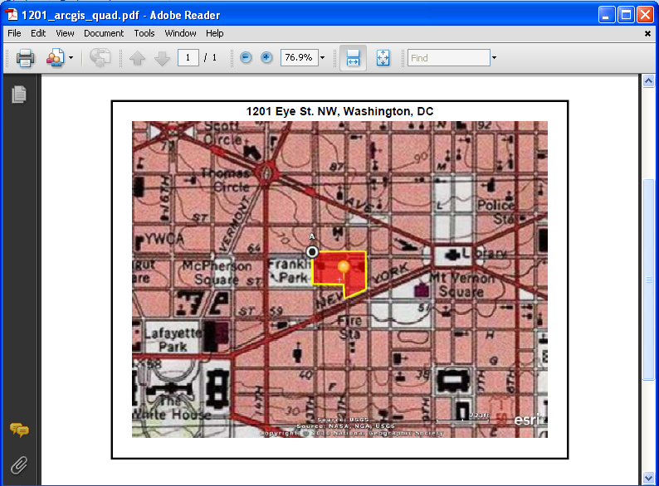

All three of these options will produce the main requirements part of the draft National Register policy: coordinates (either UTM or decimal degrees) and a paper locator map with scale, labels and coordinate information contained on it. The method used to create these products depends on the user, the resource type and the needs for the paper map in particular.

Note: The National Register nomination form will be including space for decimal degree coordinates in addition to UTM coordinates. Datum information is also being requested. All of the internet based applications described here are generating coordinates based on a World Geodetic System 1984 datum (WGS84). This is common for data with world coverage, such as GPS data as well. Datum information for UTM coordinates generated off of paper quadrangle maps should be located in the collar of the map and be either North American Datum 1927 (NAD27) or North American Datum 1983 (NAD83). Decimal degree coordinates entered onto the National Register nomination form should be carried out 6 decimal places.

BING Maps
Pros
- Decimal degree coordinates easily produced from typing in an address
- Point, line and area features can be drawn on the map using intuitive tools
- Perimeter and area figures will be automatically generated when an area feature is drawn
- Background data can be changed from streets to aerial imagery to assist in finding locations
- Maps produced can be easily printed directly to paper or to a .pdf file
- Point, line and area features drawn can be exported as .kml or .kmz files
Cons
- Decimal degree coordinates can not be defined without an address to type into the search box
- Although area features can be drawn on the map, getting bounding coordinates is difficult
- Although perimeter and area figures are automatically calculated for area features, the units can not be changed to show acreage
- Adding labels to the map display, changing the symbols of features in the map or changing colors of symbols is not possible

Google Earth

Pros
- Coordinates constantly displayed on the screen and updated as the user moves the cursor
- Coordinate format can be changed from UTM to decimal degrees
- Scale bar information can be added to the display
- Point, line and area features can be drawn on the map using intuitive tools
- Point, line and area features can be labeled easily
- Point, line and area symbols can be changed easily
- Point, line and area features added to the display can be turned “off” in the display easily
- Historic aerial imagery can be displayed, in addition to “street view” data
- Maps produced can be easily printed directly to paper in multiple formats or to a .pdf file
- Point, line and area features drawn can be exported as .kml or .kmz files
Cons
- Users without administrative rights on their computers can not install the application
- Area and perimeter figures are not calculated
- Background data can not be changed from imagery
- Getting bounding coordinates will require manually moving the cursor to the appropriate location to display coordinates, but these can be easily copied into labels or points can be created

ArcGIS Explorer

Pros
- Users can choose to install the application or use it through an internet browser, depending on whether they have administrative rights on their computers
- ArcGIS Explorer has many more functions and analysis capabilities
- Coordinates constantly displayed on the screen and updated as the user moves the display past the center point indicator
- Coordinate format can be changed from UTM to decimal degrees
- Scale bar information can be added to the display
- Point, line and area features can be drawn on the map using intuitive tools
- Point, line and area features can be labeled easily
- Point, line and area symbols can be changed easily
- Point, line and area features added to the display can be turned “off” in the display easily
- Distance, area and perimeter figures can be easily calculated, in a variety of units selected by the user
- Background data can be changed from imagery to a variety of other options, including the familiar USGS quadrangle map
- Other data files generated by GPS or through a full GIS can be added to the map view
- Maps created can be saved for use, edit or update at a later time
- Maps produced can be easily printed directly to paper in multiple formats or to a .pdf file
- Point, line and area features drawn can be exported as .kml or .kmz files

Cons
- Because ArcGIS Explorer is more sophisticated and has more functionality, it is less intuitive and may take more time to work with

For further information, contact the Cultural Resource GIS Facility at deidre_mccarthy@nps.gov.

