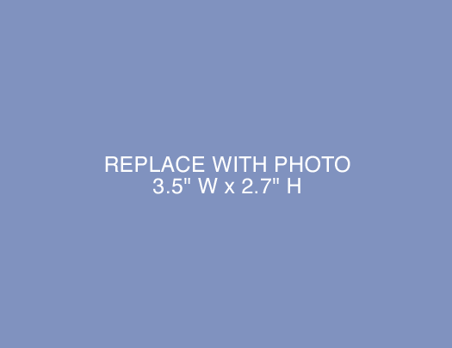
[Insert Photo Credit]
[Insert Photo Credit]
BEFORE [Insert “Before” text]
AFTER [Insert “After” text]

