

22 July 2004
(Revised 15 March 2007)


Defense Logistics Management Standards Office (DLMSO)

DLA Systems Integration Office
DSIO-P
Prepared by: Linda Formelio DSIO-PCA 700 Robbins Ave.
Linda.Formelio@dla.mil Buidling 26-2
215-737-4613 Philadelphia, PA 19111

Table of Contents

Introduction …………………………………………………………………………...3

Accessing DED via the World Wide Web ….………………………………….......3

DED Home Page …………………………………………………………………… 4

Inquiry Overview ……………………………………………………………………..4

Enterprise Level (Core/Root) Inquiry……………………………………………… 5

Domain (Data Code) Inquiry……………………………………………………….. 6

DLMS Data Element Inquiry………………………………………………………...8

DS Supplement/XML Schema Data Inquiry……………………………………8 – 9

Introduction

The DLMS Data Element Dictionary/Directory (DED) is a web application that supports the DLMSO office in maintaining the capability to communicate standard logistics information requirements while expanding support to new initiatives that facilitate enterprise integration of process improvements to logistics management and operations. It is the central repository for all DoD data elements used in the DLMS. It identifies enterprise level (core/root) data elements and related DoD/DLMS data elements. It identifies location(s) of DLMS data elements within each DLMS supplement/XML schema by each DLMS Supplement Identifier.

Accessing Data Element Dictionary/Directory via the World Wide Web

The DLMS Data Element Dictionary / Directory is a web based server application that enables system users to view DLMS (Defense Logistics Management) data at any time, via the World Wide Web (WWW). In order to access DED, users will first open their internet browser, and then enter the following Uniform Resource Locator (URL) information:

https://www.dla.mil/j-6/dlmso/eapplications/LogDataAdmin//CorpLogData/DED/Def.ASP

After the user enters this URL, they must press the <Enter> key. This action will direct you to the main home page of the DED web application. The DED application consists of inquiry and maintenance applications. Access to the maintenance application is limited to the DLMS DED/D system administrator and is accessible by a secure log in and password. .

DED Home Page

From this main home page, the customer has the option to perform inquiries against enterprise level (core/root) and DLMS data elements, data domains (data codes) in addition to related DLMS supplement and XML schema data. Drop down boxes are provided to the enterprise (core/root) and DLMS data element Inquiry areas. The DLMS supplement/XML schema data Inquiry search requires entering a 16 or 19 position alpha-numeric DLMS supplement Identification (DS ID) Number. Once an element in the dropdown box is selected, the user need only to click on the <Search> button to initiate the query.

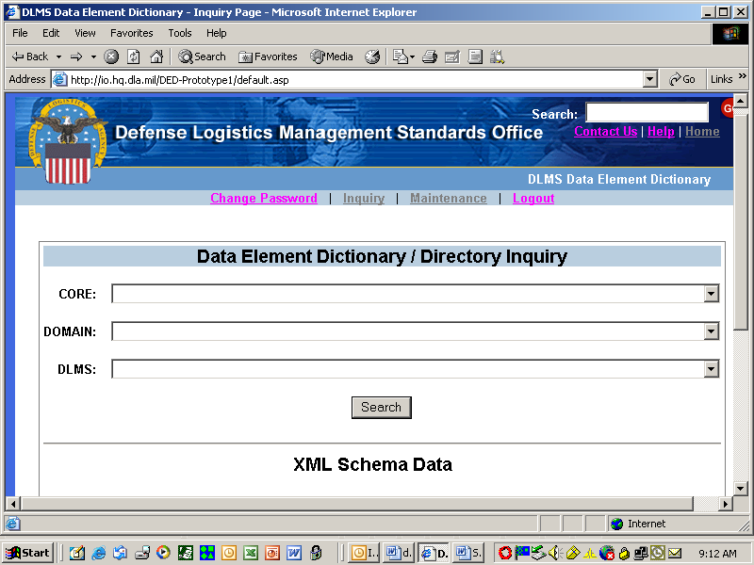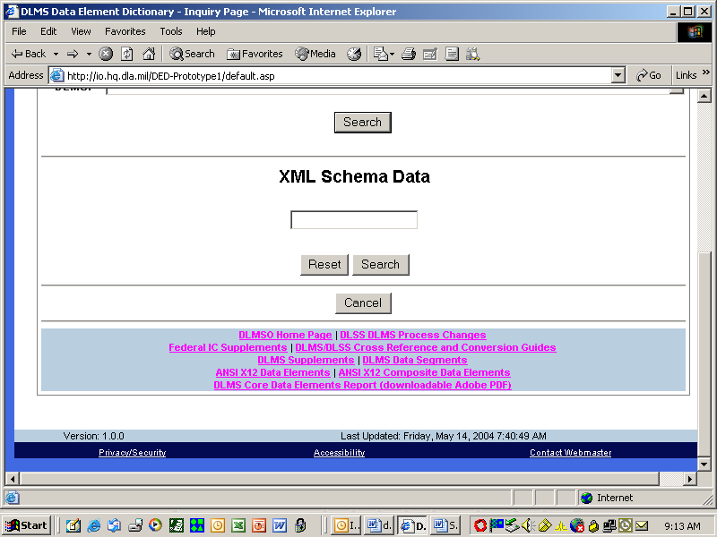
Core Inquiry

In this example, the user is selecting a particular enterprise (core/root) level data element from the dropdown box. Once the selection is made, the user presses the <Search> button located directly under the three dropdowns to initiate the query. This action will display associated data about the enterprise (core/root) data element that was selected. Since the enterprise (core/root) data element is at the top of the hierarchy for transactions, this page will display the applicable enterprise (core/root) data element, related DLMS data elements, and applicable domain data (data codes) in addition to associated DLMS 16-19 position DLMS supplement numbers with identified location(s) within each supplement. The results of the enterprise level (core) inquiry will be displayed in the following manner:
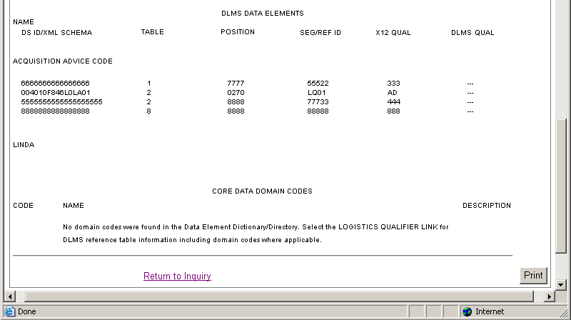
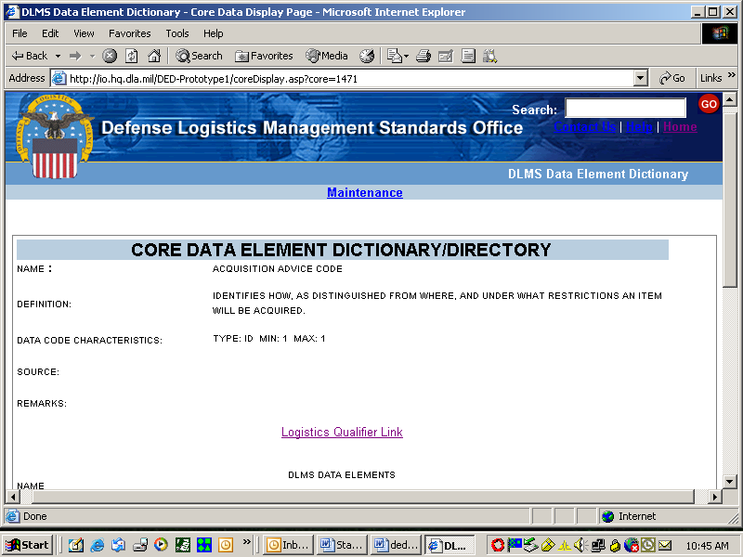
In addition, if a DLMS reference table (logistics qualifier) exists, there is a “Logistics Qualifier Link” that is accessible from the results page of the enterprise level (core/root) inquiry. By clicking on this link, a complete reference table replete with dictionary/directory information applicable to the enterprise level (core/root) data element will be displayed. Since this link takes you out of the DED web site and opens another browser window you will need to either close the browser window that contains the logistics qualifier information or minimize it before returning to the DED web application browser window. The page will appear as follows:

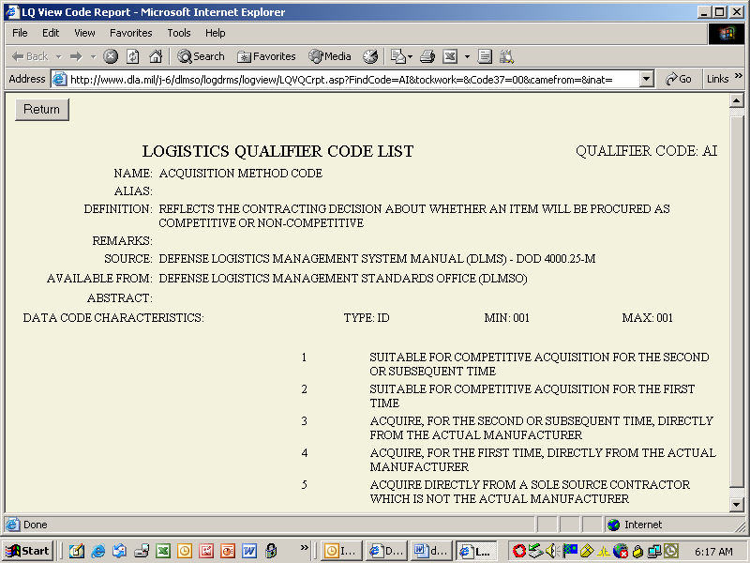

Click on <Return to Inquiry> button on the bottom of the page to return to the Data Element Dictionary/Directory Inquiry main page.

Data Domain (Data Code) Inquiry

In this example the user selects a particular enterprise level (core/root) data element from the dropdown box. Once the selection is made, the user will activate the <Search> button, which is located directly under the three dropdowns to initiate the query. This search will provide the entire data domain (data codes) applicable to the data element. The results of the data domain inquiry will be displayed in the following manner:

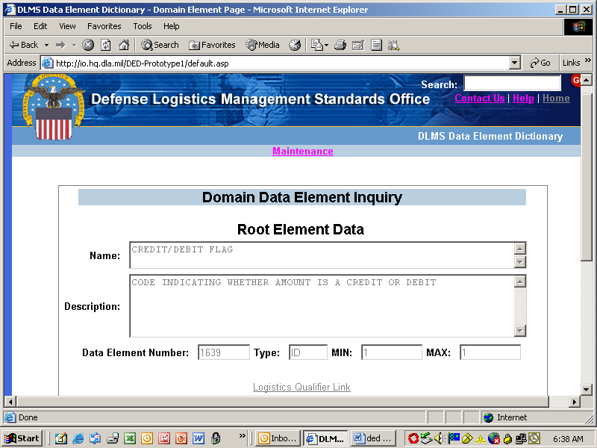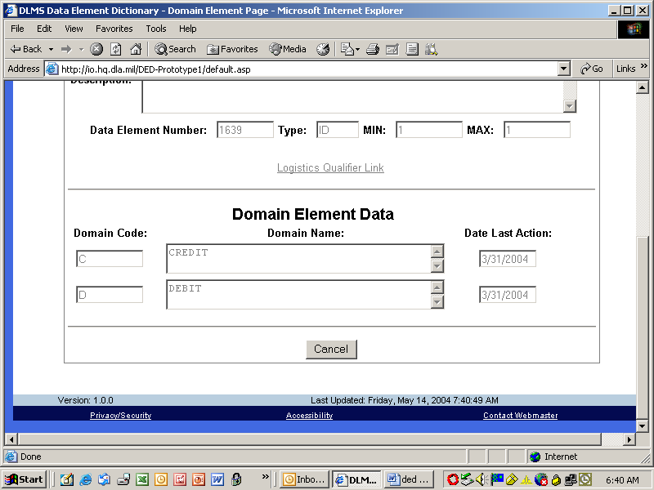

Click on the <Cancel> button to return to the Data Element Dictionary/Directory Inquiry menu.

DLMS Inquiry

In this example the user is selecting a particular DLMS Data Element from the dropdown box. Once the selection is made, the user will need to press the <Search> button, as shown on the screen on page 4, which is located directly under the three dropdowns to initiate the query. This search will return DLMS element data as well as DLMS supplement data if any records are associated with the DLMS element. The results of the DLMS Inquiry will be displayed in the following manner:

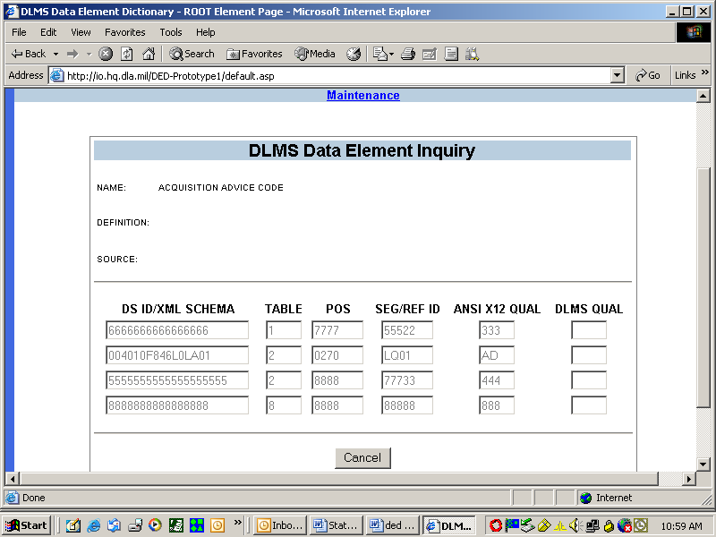

Click on the <Cancel> button to return to the Data Element Dictionary/Directory Inquiry menu.

DLMS Supplement/XML Schema Data Inquiry

In this example the user needs to enter a 16 or 19 position alpha-numeric value. Once this value is entered and the <Search> button is pressed under the input box the results are displayed in the following manner:

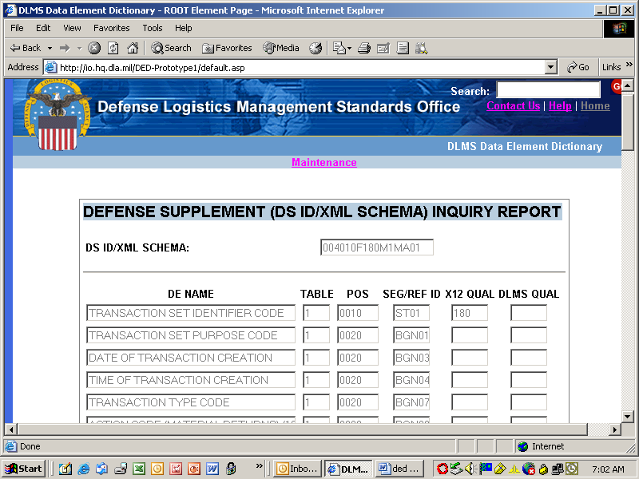
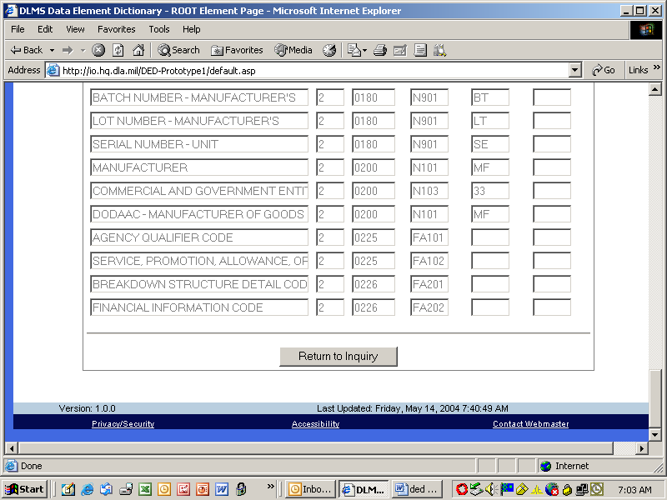

Click on the <Return to Inquiry> button to return to the Data Element Dictionary/Directory Inquiry menu.

LEFT BLANK

LEFT BLANK

LEFT BLANK

LEFT BLANK

LEFT BLANK

