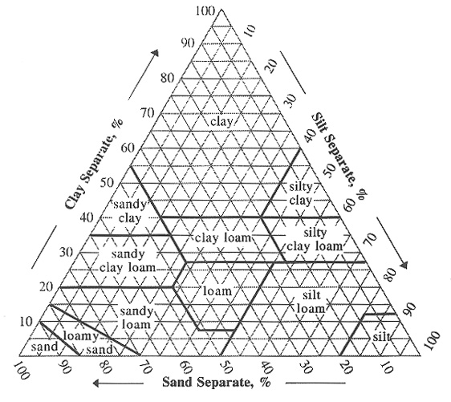
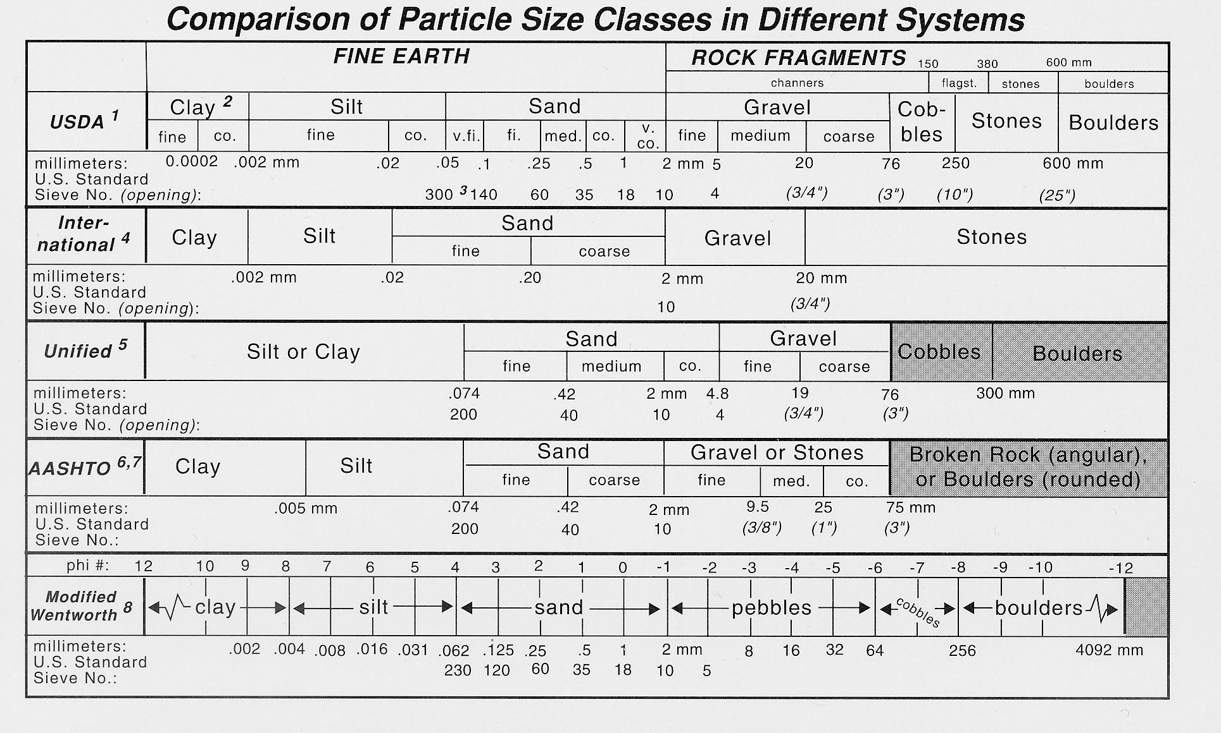
clayey
(very fine)
clayey
(fine)
fine-loamy
fine-
silty
coarse-silty
coarse-loamy
sandy

