MO6 GUIDELINES FOR POPULATING LANDFORMS IN NASIS

At this time (Aug. 2004) MO6 only requires that the Component Geomorphic Description Table be populated. The Component Two Dimensional Surface Morphometry Table should also be populated but only when “hills” is the landform. It should not be populated for other landforms. Although, not currently required for the MUG report, you are encouraged to populate the Component Three Dimensional Surface Morphometry Table and the Component Slope Shape Surface Morphometry Table.

Below are examples of how landforms with feature modifiers and landforms that are “stacked” should be populated in NASIS 5.2.

Using Feature Modifier
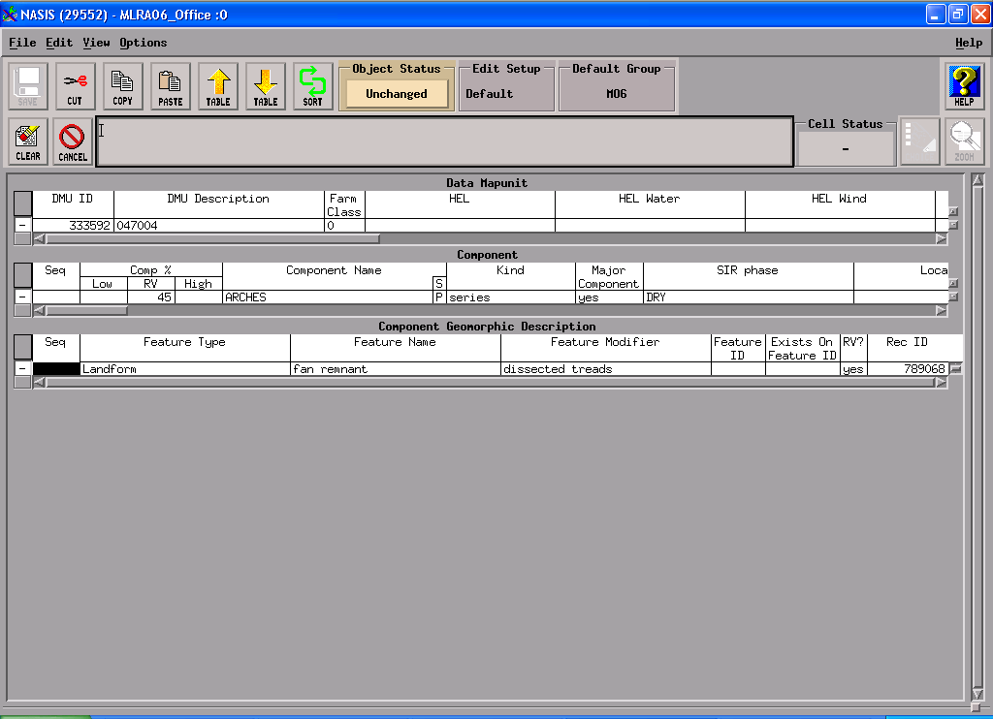
Above example will produce a landform of “dissected treads on fan remnants”.

Using “Stacked” Landforms and Feature Modifier
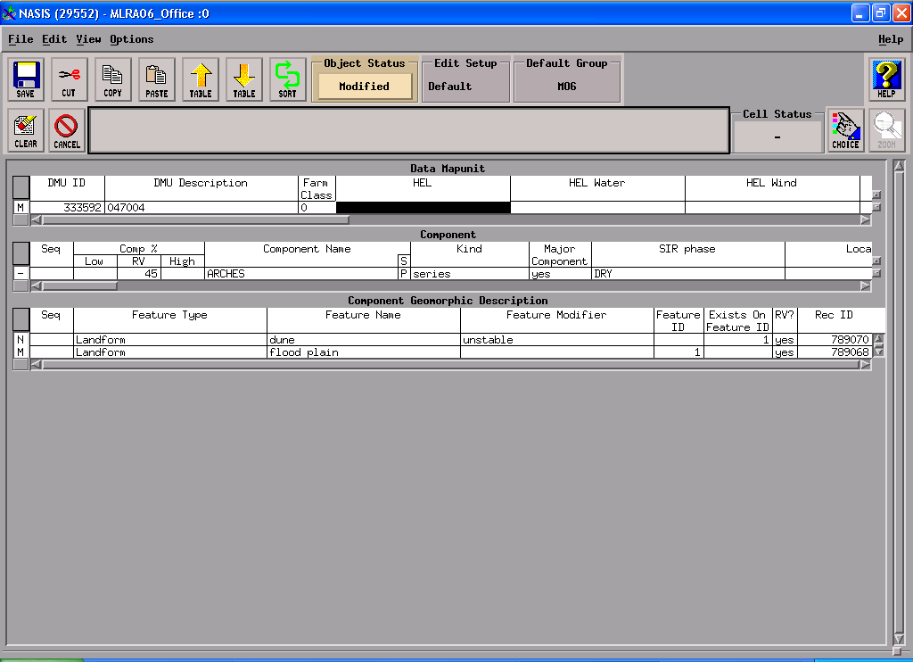
Above example produces a landform of: “unstable dunes on flood plains”
Hills and Hillslope Profile
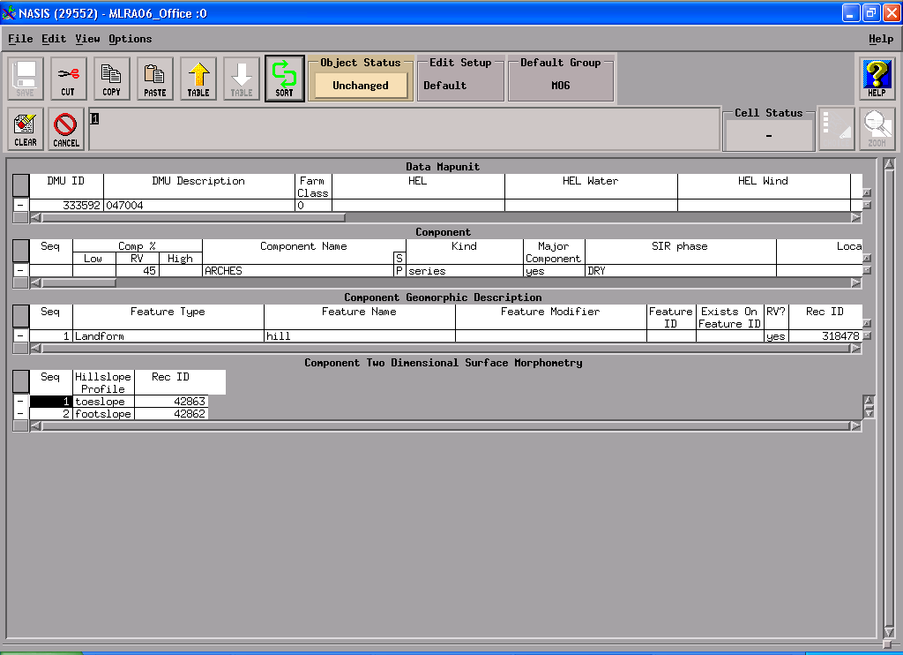
Above examples produces a landform of: “toeslopes and footslopes of hills”

