MO6 GUIDE FOR DETERMINING TEXTURE MODIFIERS
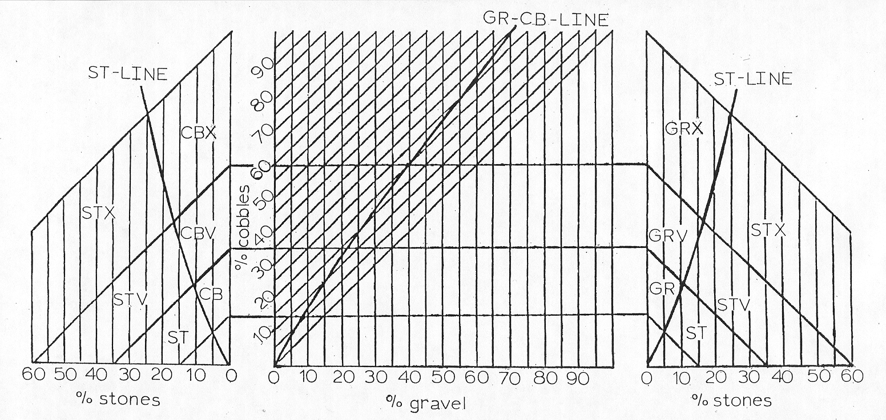
Instructions:
- Find gravel percentage line (vertical)
- Find cobble percentage line (slanted at 45º)
- Find intersect of gravel and cobble percentage lines
- If intersect is: (a) left of the GR-CB line go horizontally left
(b) right of the GR-CB line go horizontally right
- To intercept of stone percentage line (vertical) and name after symbol in area of intercept
- If intercept falls exactly on a line between classes use the modifier of the higher class, i.e. use CBX when point falls on line between CBX and CBV; or use STX when point falls on line between CBX and STX.
- When boulders are present add their percentage to the stone percentage and follow the chart. If a “stony” modifier is then determined, and the % stones is ≥ 2X the % boulders, use the “stony” modifier. Otherwise, use a “bouldery” modifier.
- When there is a mixture of rock and pararock fragments, do not combine rock and pararock percentages to determine the modifier. Rock fragment modifiers have precedence when the percentage of rock fragments is ≥ 15% regardless of the percent pararocks. Use pararock modifiers when the percent pararocks is ≥ 15% and the percent rock fragments is < 15%.
- Substitute channer (CN), flagstone (FL) and pararock (PGR, PCB, PST, PBY, PCN, PFL) modifiers when appropriate.
- When there is ≥90% rock fragments (< 10% fine earth) no modifiers are used. Instead, use the appropriate “In Lieu of Texture” term of the dominant size class, i.e. gravel, cobbles, stones, boulders.

The ratios of GR:CB and GR:ST contained in this guide are the same ratios identified in exhibit 618-11 of the 2001 NSSH. The original authors of this guide are unknown. This guide was updated by the MO6 staff March 2002.

