Hazardous Weather Testbed – Final Evaluation

**Project Title:** 2010 Spring Experiment

**Organization:** NOAA’s Hazardous Weather Testbed (HWT)

**Evaluator(s):** National Weather Service (NWS) Forecasters, Storm Prediction Center (SPC), National Severe Storms Laboratory (NSSL), Hydrometeorological Prediction Center (HPC), Aviation Weather Center (AWC)

**Duration of Evaluation:** 17 May 2010– 18 June 2010

**Prepared By:** Chris Siewert (OU-CIMMS / NOAA SPC) and Kristin Kuhlman (OU-CIMMS / NSSL)

**Overview:**

This report summarizes the activities and results from the 2010 GOES-R Proving Ground Spring Experiment which took place at NOAA’s HWT and SPC in Norman, OK. This year 20 visiting scientists and 15 NWS forecasters invited by the GOES-R Proving Ground participated in real-time forecasting and warning exercises using a variety of experimental GOES-R products within the Spring Experiment’s Experimental Forecast Program (EFP) and Experimental Warning Program (EWP) hosted by NSSL, SPC and the Norman, OK WFO. Chris Siewert (OU-CIMMS / NOAA SPC) provided overall project coordination and oversight for the GOES-R Proving Ground’s efforts at the HWT and SPC. Kristin Kuhlman (OU-CIMMS / NSSL) provided coordination for the GOES-R Proving Ground’s efforts within the EWP.

Products generated from current satellite-based, land-based and numerical model-based datasets such as convective initiation nowcasting, overshooting top and thermal couplet detection, total lightning detection and simulated satellite imagery helped demonstrate GOES-R baseline and option-2 products to operational forecasters and the broader scientific community. Other products including a 0-3 hour severe hail probability and simulated lightning threat also helped demonstrate the utility of satellite data in combination with other datasets to provide unique decision aids. Forecasters and participants provided feedback via daily briefings, online surveys and real-time blogging throughout the experiment. The feedback gathered and discussed below was essential in identifying potential improvements and uses of the GOES-R products prior to their deployment once GOES-R becomes operationally available.

**Products Evaluated:**

* 1. **University of Wisconsin Convective Initiation (UWCI)** – University of Wisconsin Cooperative Institute of Meteorological Satellite Studies (UW-CIMSS)

The UWCI and associated cloud-top cooling rate product has been delivered to the SPC since the 2009 Spring Experiment. The product is currently provided within SPC operations and was provided within the HWT via the EFP in N-AWIPS gridded format, and the EWP in AWIPS gridded format for the 2010 Spring Experiment. The product utilizes GOES-13 infrared (IR) window brightness temperature changes based on an operational day/night cloud mask to infer cloud-top cooling as a proxy for vertical development in growing cumulus clouds as described by Sieglaff et al. (2010). UWCI is generated at the University of Wisconsin for each GOES-13 scan, including rapid-scans, and distributed via LDM in GRIB2 format to AWIPS and N-AWIPS systems.

National Weather Service (NWS) forecasters within the EWP evaluated the UWCI product during real-time forecasting exercises and an archive case event. The forecasters were able to develop their own displays within the Advanced Weather Interactive Processing System (AWIPS), often choosing to overlay the UWCI product on visible or IR satellite imagery. The product was also often also displayed as a 4-panel to combine information from all of the GOES-R products in one window (see Fig. 1). Real-time operations were focused on areas where convective development was expected to occur and possibly develop into severe weather later on in the day. Most often, UWCI was evaluated during the first half of the EWP operations period to better capture the pre-convective development since once the storms became severe the forecasters would switch into radar warning mode and evaluation of the satellite products would be limited. Also, during much of the second half of the EWP operations period the satellite products would be unavailable for extended periods of time during a period of back-to-back full-disk and calibration scans that limited satellite data to 30-minute temporal resolution. During this period of time forecasters became disinterested in all satellite data since it provided very limited information for them during warning operations.

During periods when weather was inactive, an archive case (simulated real-time) was set up using the AWIPS Warning Event Simulator (WES) with the help of NWS Warning Decision Training Branch employees. Each forecaster issued warnings (Severe and Tornado) for storms that occurred in central Oklahoma on 24 May 2008 from 1700-2100 UTC (see Fig. 1). This provided forecasters with the opportunity to become familiar with the UWCI and other products in a controlled event, and also to gather feedback during these inactive weather periods. Each forecaster participated in the archive case event once during each week and the same archive case was used each week so that the feedback gathered from it was easily comparable.

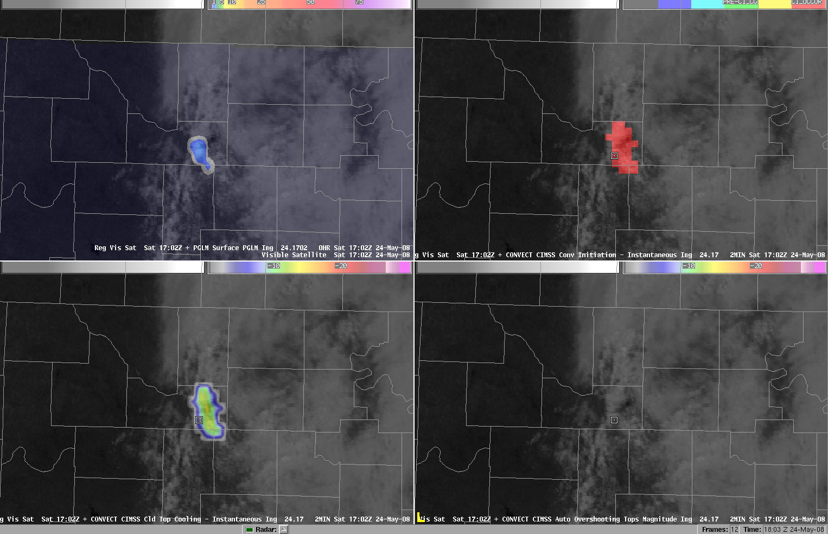

**Figure 1** – 4-panel display within AWIPS of the GOES-R products provided within the EWP including 8-km Psuedo-GLM (top left), UWCI convective initiation (top right), UWCI cloud-top cooling rate (bottom left), and overshooting-top magnitude (bottom right) for the 24 May 2008 archive case event.

Feedback from the real-time and archive case events were usually discussed the following morning during the EWP daily briefing, with some significant events discussed immediately following EWP operations. All forecasters also completed online surveys immediately following a shift where they used the UWCI data. Summary information from these surveys is available online at:

<http://www.zoomerang.com/Shared/SharedResultsPasswordPage.aspx?ID=L24E52GPZQ4T>

In general, forecasters found that the UWCI products are a useful tool to help them increase situational awareness prior to warning operations during severe weather days. One particular comment from the online survey echoed the UWCI potential:

“Areal descriptions of convective initiation described by UWCI could be added to short term forecasts, or even significant weather advisories/warnings if quick development is expected.”

Forecasters also noticed lead-times on their subjective interpretation of convective initiation based on signals from radar generally of about 5 to 30 minutes. There were occasions where the UWCI had negative lead-times, but this was usually due to cirrus contamination, satellite scan time limitations or varied definitions of “convective initiation” by the forecasters. When comparing UWCI to the first occurrence of CG lightning detected by the NLDN, forecasters found that UWCI lead times extended, often to 60 minutes. However, there were occasions where convection would develop and radar reflectivities would reach in excess of 55 dBZ, but no CG lightning would be detected, so determining a lead time was difficult and forecasters became confused on how they were supposed to evaluate the product.

The forecasters were well aware of the effect that cirrus had on the UWCI product following the training sessions and through direct interactions with the visiting scientists and would generally not use the product in cirrus contaminated scenes. There were times when the forecasters could not be certain if cirrus was contaminating the scene because it was very thin or during nighttime periods, and they were confused why the UWCI was not showing signals. In these cases, we would pull up the UWCI webpage (at <http://cimss.ssec.wisc.edu/snaap/convinit/quicklooks2.php>) and show what the cloud typing output used by the product was showing. The forecasters mentioned it would be useful to provide this information alongside UWCI within AWIPS so it was easier for them to access during active forecasting/warning periods.

Forecasters did mention some frustration with the temporal resolution of the product as provided from GOES-13. Since the current observational system is limited and only simulates temporal resolutions similar to that which will be available on GOES-R when rapid-scan operations (RSO) are called, it is hard to simulate a true GOES-R proxy product at all times. The forecasters mentioned it would be nice to see this product provided in some WES case events when RSO data was available.

There were several instances where UWCI showed no signals where convective development occurred, or showed signals where no convective development occurred over cirrus-free areas. One comment captured from the online survey may help explain the situations where this occurred most often:

“In this situation, there was a fairly strong CAP. Because of that, there were several instances when the UWCI product indicated CI, yet no storm developed. Or, perhaps a small storm would develop but it would quickly dissipate due to the CAP. There were also several times in which the UWCI product did not indicate CI, yet it did develop. This appeared to be in areas that were not covered by cirrus.”

Forecasters mentioned that “it was also nice to see the actual values of cloud top cooling” since it provides them with a more physical interpretation of what is going on with the developing convection. Also, forecasters mentioned that the cooling rate product provided more signal than the more stringent convective initiation nowcast, which, as mentioned above, missed some instances of initiation due to various reasons. The forecasters requested that a cloud-top cooling rate track be provided. Similar to those produced by NSSL within the Warning Decision Support System – Integrated Information (WDSS-II) to produce rotation and hail tracks, cooling rate tracks would be very useful in determining cloud-top trends. This would allow forecasters to determine whether the convective storm growth is weakening, strengthening or remaining constant over 30 to 60 minute periods.

The UWCI products will continue to flow within the SPC N-AWIPS systems, including operations, and will also be available for evaluation within the HWT AWIPS systems when needed.

* 1. **Overshooting-top and Thermal Couplet detection (OTTC)** – UW-CIMSS

The OTTC product is a new addition within the 2010 Spring Experiment. The product utilizes GOES-13 IR window brightness temperature spatial testing to identify overshooting-top and thermal couplet (also known as enhanced-V) features within mature convective storm cloud-tops as described by Bedka et al. (2010). The OTTC product provides detections and relative magnitudes of overshooting-top and thermal couplet features in real-time. Similar to the UWCI product, the OTTC product is generated at the University of Wisconsin for each GOES-13 scan, including rapid-scans, and distributed via LDM in GRIB2 format to AWIPS and N-AWIPS systems.

NWS forecasters evaluated the OTTC product within the EWP in real-time operations and within the same archive case event as UWCI. Real-time evaluations occurred during EWP warning operations in combination with radar and lightning data when the convection was mature to evaluate the use of the OTTC product towards increasing warning lead-time and confidence (see Fig. 2). Feedback from the real-time and archive case events were usually discussed the following morning during the EWP daily briefing, with some significant events discussed immediately following EWP operations. All forecasters also completed online surveys immediately following a shift where they used the OTTC data. Summary information from these surveys is available online at:

<http://www.zoomerang.com/Shared/SharedResultsPasswordPage.aspx?ID=L24E52GPZQ4T>

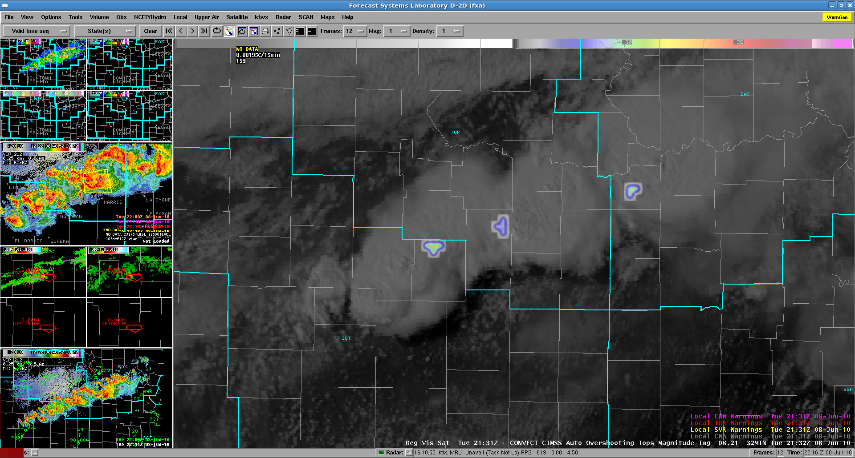

**Figure 2** – Overshooting-top magnitudes overlaid on visible satellite imagery within AWIPS at 2131 UTC on 8 June 2010.

In general, while forecasters found the idea of the OTTC product exciting, the limitations of the current observational system severely limited the OTTC product as demonstrated in severe weather warning operations. There were instances of “many overshooting tops were observed on visible satellite that were not detected by the OTTC product” mentioned within the online surveys and during EWP daily briefings. Since the OTTC product relies on spatial tests to detect IR features associated with overshooting-tops and thermal couplets, the coarse IR resolution of GOES-13 was often unable to detect these features since they are generally smaller than the GOES-13 IR footprint. The product has been shown to work well on current low-earth orbiting satellite instruments, such as MODIS on NASA’s Terra and Aqua satellites (see Bedka et al. 2010), whose spatial resolution is better suited to detect these features. The forecasters would like to see the product demonstrated using these high spatial resolution datasets in an operational sense, but unfortunately that is not currently possible as MODIS data is only available twice a day.

The temporal resolution of the current observational systems also limited the evaluation of the OTTC product in severe weather warning operations. Since the OTTC product was evaluated while the forecasters were issuing warnings, high temporal resolution datasets such as radar and lightning became the primary tool for warning decision support. While GOES-13 was in RSO mode the product was utilized more often, but the spatial resolution limitations still lingered.

Forecasters mentioned that OTTC detections would provide a useful tool in identifying the most intense storms within a scene without having to interrogate radar or base satellite data, as shown in this response from the online survey:

“The OTTC product was most useful in indicating locations where storm strength was at a relative maximum… Quickly highlighting the strongest thunderstorms on the visible satellite imagery where it can be hard to distinguish storms due to similar brightness.”

Forecasters also mentioned that the product “may be useful to verify strong updrafts in MCS's” that may be hard to detect using radar or other satellite techniques, as shown in this online survey response:

“Not really a helpful tool for isolated supercells, because the overshooting top is fairly obvious in visible/IR imagery and easy to diagnose. For this reason, I think it would be more useful in MCS's when the overshooting tops are less obvious.”

Forecasters voiced their concern on multiple occasions during EWP daily briefings regarding their limited amount of space within their AWIPS displays for products, mentioning that it is hard for them to evaluate the multitude of experimental products provided to them. Comments such as “the more we can combine the better” were regularly offered during the EWP daily briefings. Currently the overshooting-top and thermal couplet detections are offered as separate fields within the AWIPS systems. It should be considered to combine the two fields into one display as forecasters were often only looking at one of the two, and therefore possibly missing signals.

The OTTC products will continue to flow within the SPC non-operational N-AWIPS systems and will also be available for evaluation within the HWT AWIPS systems when needed.

* 1. **Pseudo-Geostationary Lightning Mapper (PGLM)** – OU-CIMMS/NSSL and NASA Short-term Prediction Research and Transition Center (SPoRT)

A PGLM product was created for testing in the HWT during the 2010 Spring Experiment. This product utilizes total lightning data from three Lightning Mapping Array (LMA) networks (Central Oklahoma, Northern Alabama, and Washington DC) and the Lightning Detection and Ranging (LDAR) network (Kennedy Space Center, Florida) that detect VHF radiation from lightning discharges. The real-time lightning data was available in 1 or 2-minute intervals, depending on the network, and sorted into flashes using algorithms available through Warning Decision Support System – Integrated Information (WDSS-II). Following flash sorting, a Flash Extent Density product was created at 8-km resolution to match that expected by the GOES-R GLM.

NWS forecasters evaluated the PGLM product during both real-time operations and for an archive event. The PGLM product was available as a running 2-minute average at 1-minute updates within AWIPS. Forecasters were able to choose their own display options, often overlaying the PGLM product with radar and satellite products (see Fig. 3). Real-time operations focused on regions where activity was expected to be at least marginally severe and preference was given to areas that contained a LMA or LDAR network in order to get the maximum number of PGLM cases possible.

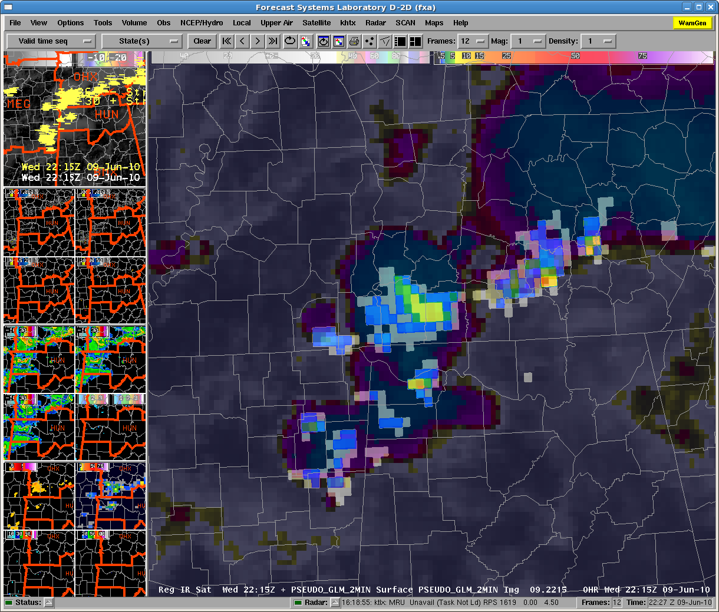

**Figure 3** - Forecaster AWIPS display of PGLM flash extent density product and IR image over Central Tennessee and Northern Alabama at 2215 UTC on 9 June 2010. The overlay of PGLM on IR allowed the forecaster to focus on the most active convective cores.

Similar to the UWCI and OTTC evaluations, an archive event running at simulated-real-time was examined by each of the forecasters. Each forecaster issued warnings (Severe and Tornado) for supercell storms that occurred in central Oklahoma on 24 May 2008 from 1700-2100 UTC. The archive event gave a baseline for comparison of use and thoughts of the PGLM product across all forecasters and also allowed for more detailed examination of the product than typically made during real-time operations.

Activities and events that occurred during the previous shift were discussed at the start of each day to get additional feedback on the forecasters’ thoughts and experience with the PGLM product. Particularly interesting case events that occurred while either the forecasters were not on shift or only a subset of the visiting forecasters worked were discussed during this daily discussion as well (see Fig. 4). All forecasters completed online surveys following a shift where they used the PGLM data. Summary information from these surveys is available online at:

<http://www.zoomerang.com/Shared/SharedResultsPasswordPage.aspx?ID=L24DY529G2ZG>

In general, the PGLM products provided a strong support tool for the forecasters and helped increase forecaster confidence to warn or not warn on a storm. The lightning data was often noted as perhaps being more important with pulse storms or near-severe situations where lightning would be more clearly indicative of important updraft fluctuations. Forecasters viewed future GLM data as a “great tool” or a possible “mainstream product” for “situational awareness” in “making sure no dangerous cells are being missed.” Forecasters also found the PGLM data particularly useful when blended with other products derived from radar, satellite, and the National Lightning Detection Network (NLDN) to provide a complete view of the storm.

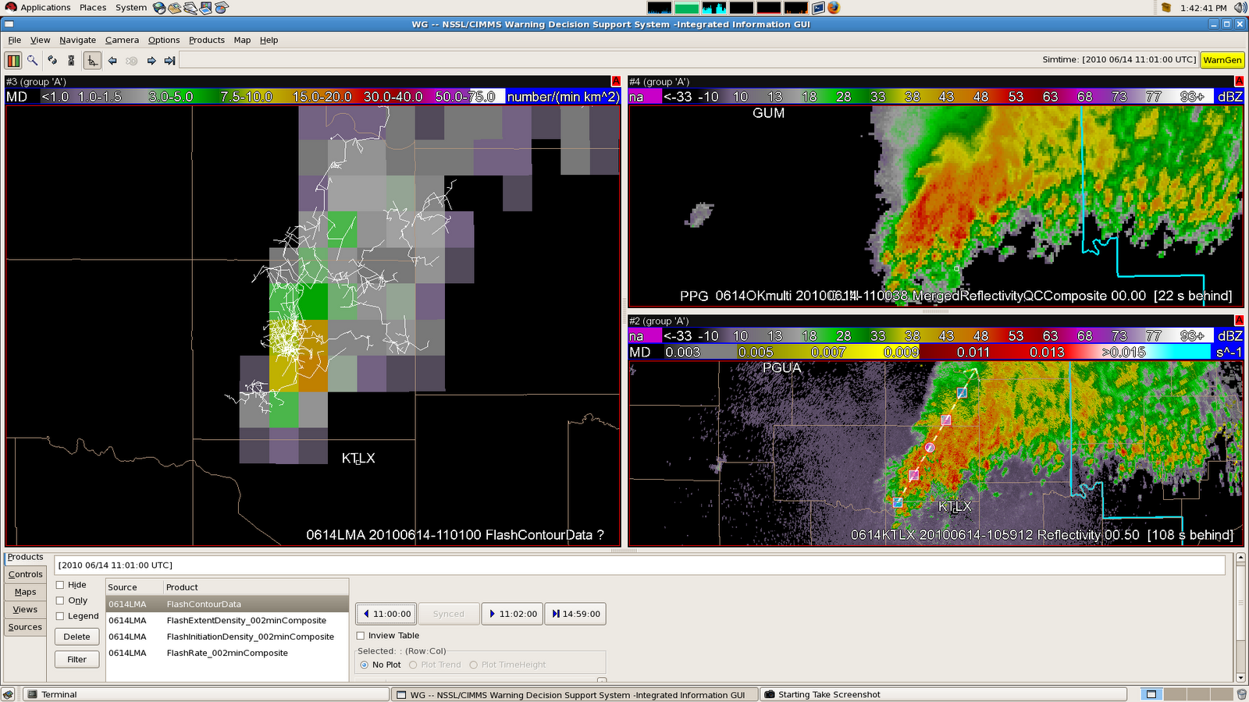

**Figure 4** - Flooding Event on 15-16 June 2010 in Oklahoma City Metro region. PGLM total lightning flash extent density overlaid with OKLMA flash contours at 1100 UTC on 16 June (left). Merged radar reflectivity composite (top right) and low-level reflectivity from KTLX (bottom right) at corresponding time. Forecasters noted that the continued convective redevelopment on western side of system was depicted well by higher total lightning activity there signaling an increased threat of flooding in the region.

Multiple forecaster comments echoed the idea of using the GLM data as an additional tool to radar, particularly during the early stages of storm development. Forecaster evaluations also revealed that high temporal resolution (1 minute) of the product was useful, but many felt the spatial resolution was too coarse when compared with the available radar data. Still, the PGLM data was found to be “complimentary to the warning process” and forecasters “would like to have it within operations.” Specifically, one forecaster noted following a real-time event:

“The total lightning product gave lead time to a cell that had become electrically active over both traditional radar interrogation methods as well as the ground based lightning network. This is very important since many lightning fatalities are recorded with the first strike. It will also prove very beneficial as we get more into decision support services, especially to support the safety of responders to incidents who are exposed to lightning hazards.”

Feedback from both the surveys and forecaster discussion provided a few reoccurring ideas for modifications in future experiments. First, a majority of the forecasters stated that they would like a product depicting the rate of change of the flash rate of a particular storm. The preference was that this product be gridded in plan view or map mode (not a line graph). This product could be either a plot of (1) the flash rate derivative or (2) the number of standard deviations (possibly fractional, e.g., 1.5) relative to the running mean of the current storm flash rate. This could be implemented using the WDSS-II using k-means cell clustering and coloring the cell shape according to the above trend metrics. Another product suggested by forecasters that could help visualize this was a 30 or 60-minute track swath, similar to that available in WDSS-II for maximum rotation and hail values.

Forecasters saw the applicability of GLM data to wide array of weather events and wanted to see more examples of the data. In particular, forecasters were interested in examining: mini-supercells, winter weather and convective snow bands, and land-falling tropical cyclones including tornadic cells in the outer rainbands. These could be included as archive events in future years.

Forecasters would also like to have increased knowledge base from research studies including more background information regarding lightning data. Specifically, what flash rates are expected with different types of convection (e.g., supercell, multicell, squall line) and what correlations do lightning rates and density have with severe weather occurrence. Also, forecasters desired more information on particular lightning signatures and their relationship with radar signatures associated with severe weather.

Due to the computational resources required to produce the PGLM product, it is only available in real-time during the Spring Experiment.

* 1. **Satellite-based Convection Analysis and Tracking (SATCAST)** – University of Alabama in Huntsville (UAH)

SATCAST is a proxy for the AWG version of the GOES-R convective initiation algorithm. The product has been flowing since the beginning of the 2010 Spring Experiment directly to SPC via the NASA SPoRT LDM feed. It is then converted into N-AWIPS gridded format at SPC and provided on the non-operational workstations within the HWT (see Fig. 5). The product was evaluated separately from the EWP and EFP since it is very experimental and not ready to be shown to forecasters to avoid pre-mature opinions of the product being made.

The product provides a yes/no nowcast of whether an individual cloud object will develop into deep convection within the next 60 minutes as described by Mecikalski and Bedka (2006, Mon. Wea. Rev.). The product uses a day-only cloud typing algorithm described by Todd Berendes et al. (2008, J. Geophys. Res.). Future plans to use the official AWG day/night cloud typing product are expected, but currently the product only works from 1200 UTC to 2300 UTC daily. Since SATCAST currently only runs on 15 minute satellite data, it uses mesoscale atmospheric motion vectors (MAMV) to predict the future position of cloud objects. This requires a significant amount of computational resources and slows the delivery of the product. The MAMV method will eventually be substituted by an overlapping technique that requires much less computational resources once higher temporal resolution satellite data becomes more readily available.

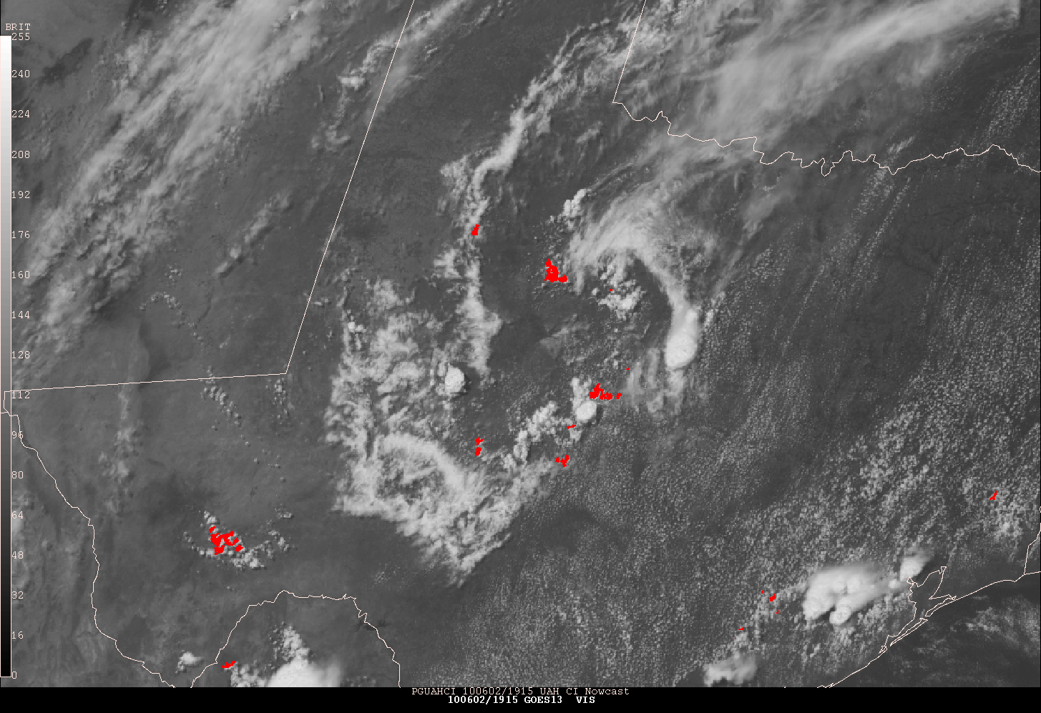

**Figure 5** – SATCAST convective initiation nowcast overlaid on visible satellite imagery displayed within the SPC and HWT N-AWIPS workstations at 1915 UTC on 2 June 2010.

Typical lead times of 15 to 30 minutes and occasionally beyond were observed based on the first occurrence of base radar reflectivity reaching 35 dBZ. The product does become more diagnostic in cases of extremely high CAPE, uncapped environments, such as in the Southeastern US. There were occasions when SATCAST seemed to identify many cloud objects that never developed into convective storms. This is likely due to the current thresholds set for the individual interest fields, which will need adjusting pending further operational testing. Data latency has been an issue throughout, with the product arriving about 12 to 13 minutes past image stamp time, but this appears to be a computer resource issue due to the amount of resources currently required to employ the MAMV technique. It has also been noticed that the object tracking technique currently employed sometimes identify some awkwardly large objects (see Fig. 6). The lack of product output during nighttime periods was also a limiting factor. Many forecasters from this and last year’s experiments noticed that a CI product may be more useful to them at night since they have visible imagery during the day.

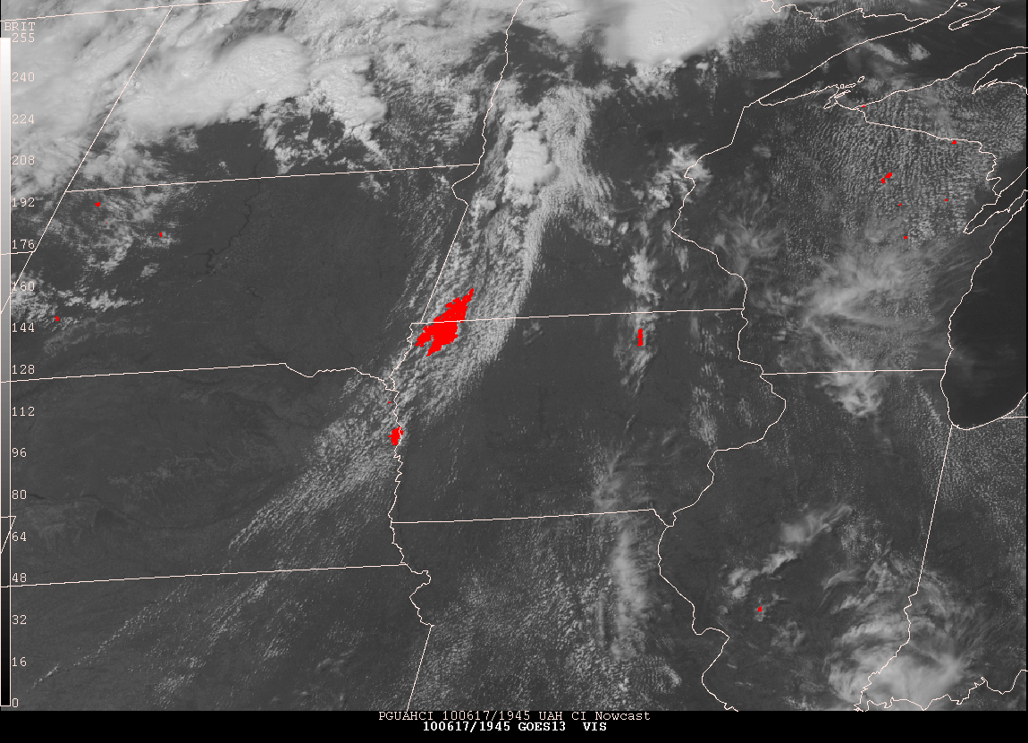

**Figure 6** – SATCAST convective initiation nowcast overlaid on visible satellite imagery at 1945UTC on 13 June 2010. Occasionally SATCAST identifies large areas of growing cumulus clouds as one cloud object.

SATCAST continues to flow within the SPC non-operational N-AWIPS workstations. Limited evaluation will occur throughout the year and it is expected that a more in-depth evaluation can occur next year once improvements can be made with the latency and day/night issues.

* 1. **Simulated Satellite Imagery** - Cooperative Institute for Research in the Atmosphere (CIRA) / UW-CIMSS

Simulated GOES-R ABI imagery generated from the NSSL-WRF 00Z 4km model run was provided within the HWT N-AWIPS systems from two separate sources, UW-CIMSS and CIRA (see Figs. 7 and 8). UW-CIMSS provided simulated satellite data for all GOES-R ABI IR bands from the 12 Z through 03 Z forecast times. CIRA provided simulated satellite data for the three GOES-R ABI water vapor bands and the standard IR window band from the 12 Z through 00 Z forecast times, as well as providing one water vapor and the IR window band extended out to the 06 Z forecast time. Data from both UW-CIMSS and CIRA arrived locally at SPC by 9:15am CDT out to the 00 Z forecast time. An update at 11am CDT pulled in the bands extended out to the 03Z forecast time from UW-CIMSS and the 06 Z forecast time from CIRA.

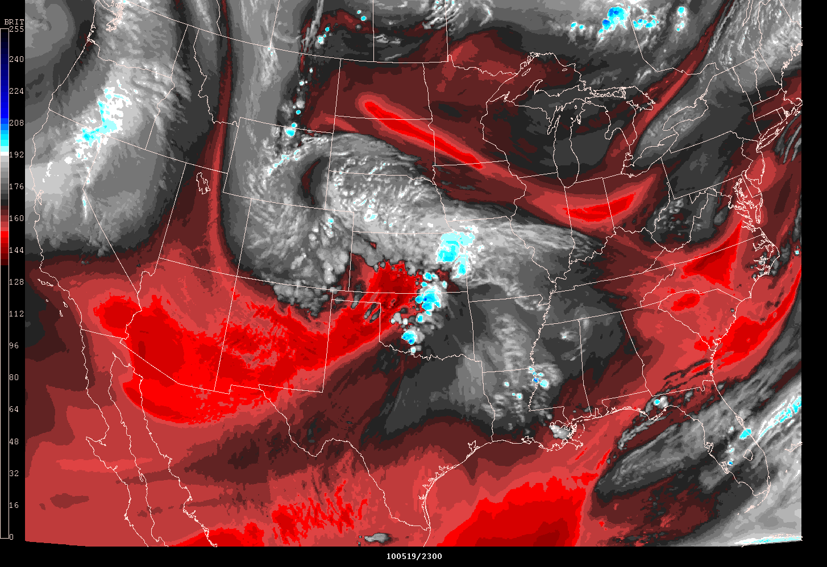

**Figure 7** – UW-CIMSS NSSL-WRF simulated GOES-R ABI band 9 imagery for 2300 UTC on 19 May 2010.

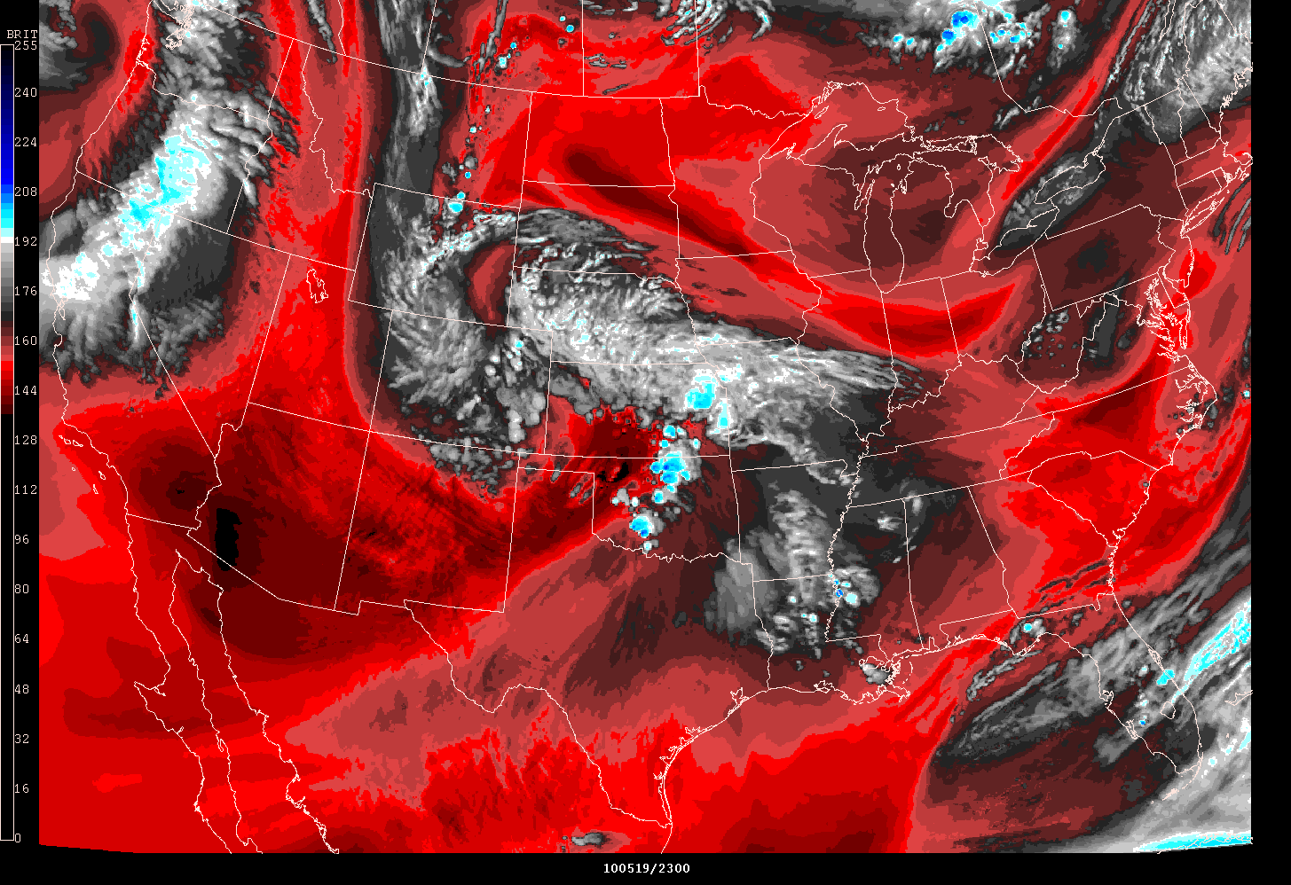

**Figure 8** – CIRA NSSL-WRF simulated GOES-R ABI band 9 imagery for 2300 UTC on 19 May 2010.

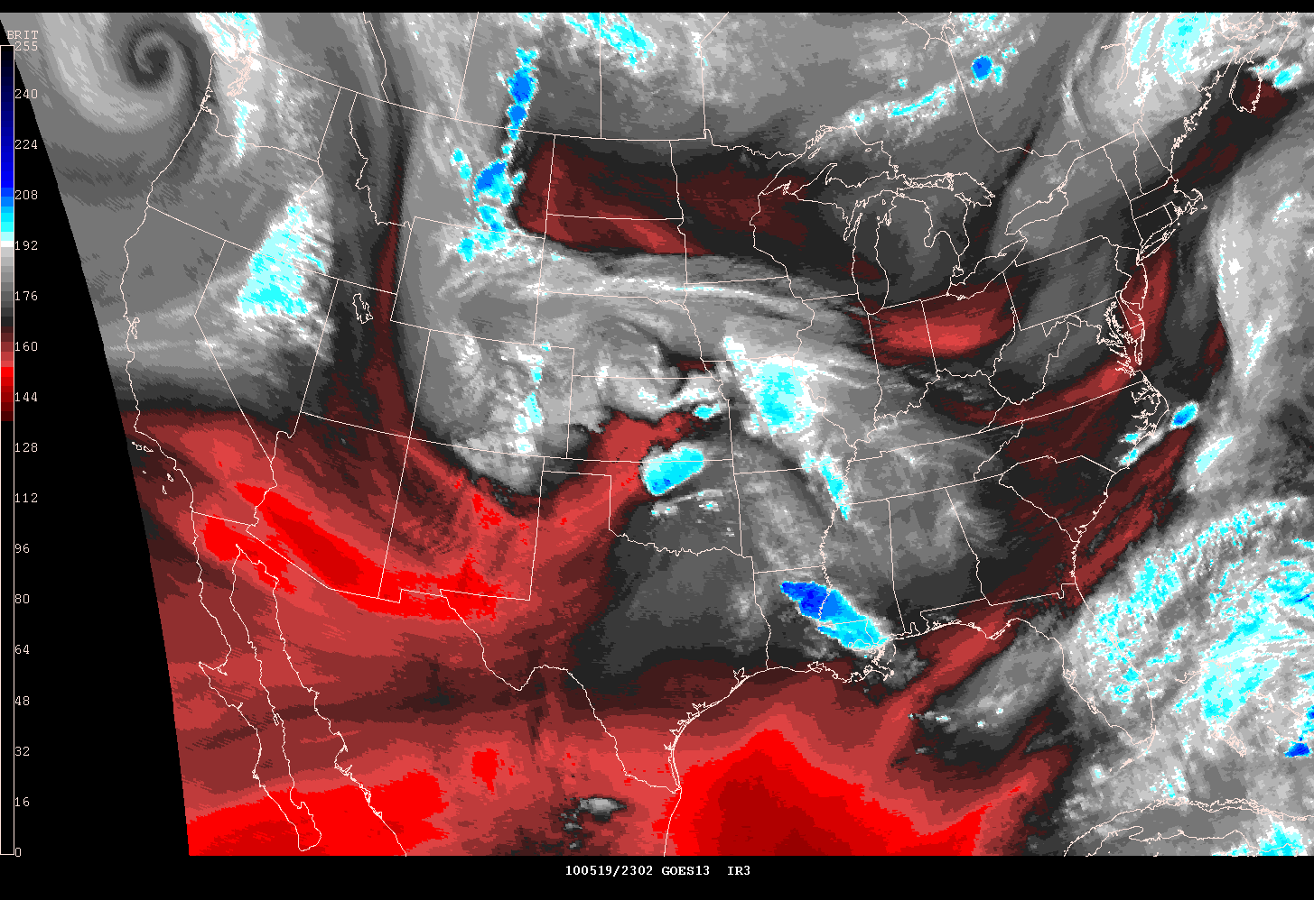

**Figure 9** – Observed GOES-13 water vapor imagery for 2300 UTC on 19 May 2010.

Unfortunately because the EFP started at 7:00am CDT and began issuing its morning forecasts by 8:30am CDT out to 06 Z, the arrival of the simulated satellite data was not fully utilized during the morning forecast time periods when they would have been most useful. However, once the simulated satellite data has fully arrived during the EFP afternoon forecast update, the simulated satellite imagery was used to evaluate the performance of the NSSL-WRF for that day by comparing the output side-by-side to observed satellite imagery provided on a website developed by the SPC Science Support Branch (see Figs. 7, 8 and 9).

We have shown the simulated satellite imagery as a proof-of-concept of what is possible for new methods of displaying model output. There is much excitement regarding the possibilities of making simulated satellite imagery readily available alongside all the traditional and other experimental model fields. During the daily EFP briefings, participants were introduced to the idea of being able to sample three levels of water vapor from a geostationary instrument. While participants were excited by the availability of the three levels of water vapor information, they were unsure as to how this would be utilized operationally. This is something that we need to communicate further to the operational community during future experiments and demonstrations.

There is also a strong push for simulating GOES-R products and channel differences using the simulated satellite imagery as a decision aid. This is the single most captured comment from the participants regarding the simulated satellite imagery within the 2010 Spring Experiment. In the future we expect to leverage other high resolution model runs, such as the High Resolution Rapid Refresh (HRRR) model, to better simulate the GOES-R ABI temporal and spatial resolutions. The participants mentioned they would like to see product developers use this high resolution output to better simulate GOES-R products rather than using current observational datasets which do not have the spatial, temporal or spectral resolutions necessary to provide an in depth demonstration of these products.

The simulated satellite imagery from the NSSL-WRF continues to flow into the SPC and is expected to be provided within operations for year round demonstration in the coming months.

* 1. **Simulated Lightning Threat** – NASA SPoRT and UAH

Prior to the 2010 Spring Experiment, NASA SPoRT provided code to NSSL for generating experimental total lightning threats, following the technique described in McCaul et al. (2009, Wea. Forecasting). The lightning threats were included in the 4-km CONUS NSSL daily WRF runs and demonstrated within the EFP. Unlike the simulated satellite imagery, the lightning threat output was provided for the entire NSSL-WRF forecast time period.

In this year's EFP, additional tasks besides severe weather included aviation and quantitative precipitation forecasts. The busy schedule and additional forecast products limited the examination of individual, deterministic forecast model members due to time constraints. As a result, most participants relied heavily on ensemble output from the 26-member CAPS ensemble runs. In addition, the performance of the NSSL-WRF run was sub-par on one day during Dr. McCaul's visit and participants were discouraged from examining the NSSL-WRF output, which further limited the demonstration of the total lightning threat output during that week. Based on NASA SPoRT's assessment from this year, the most impact of future experimental model products would be realized by implementing the products into CAPS ensemble runs.

However, during several side demonstrations with participants invited by GOES-R to the EFP and EWP, the NSSL-WRF lightning threat output was examined in more detail towards other forecast strategies. In particular, Mark Burger from WFO Eureka suggested we examine the lightning threat forecasts over the western US as a fire weather decision aid. Figure 10 shows an example of this that occurred on 9 June 2010. Lightning threat forecasts from the NSSL-WRF were compared to CG detections from the NLDN and it was seen that on multiple occasions the lightning threat forecasts provided fairly accurate representation of lightning activity over areas where fire weather threats were present. This shows the utility of the total lightning threat forecasts extends beyond severe weather applications.

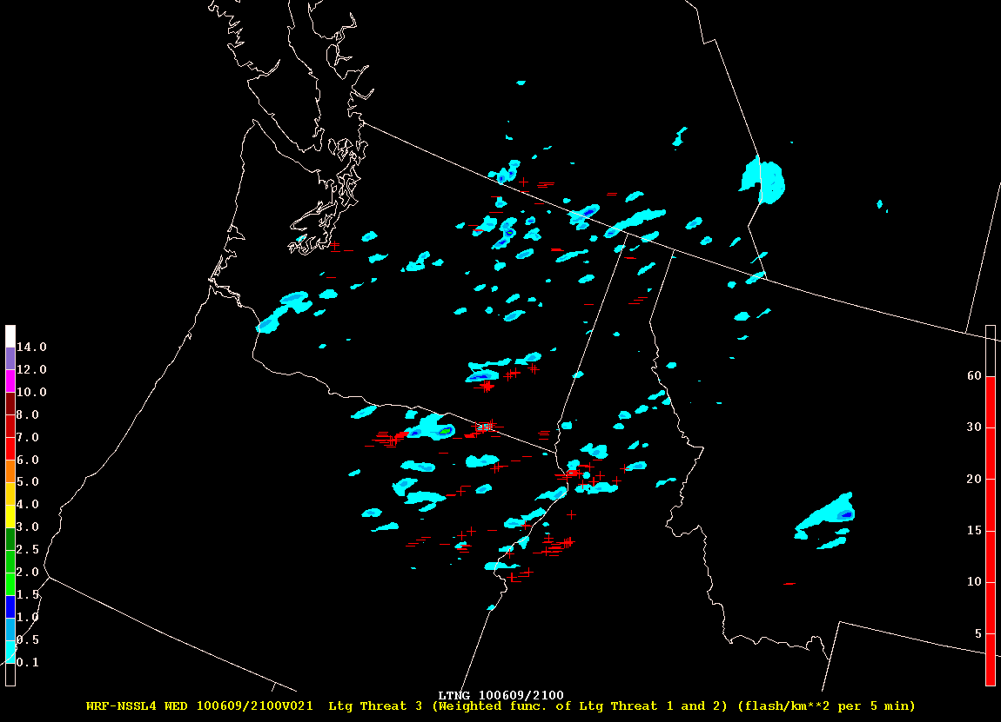

**Figure 10** – 21-hour forecast NSSL-WRF simulated lightning threat (contoured) and hourly NLDN lightning detections valid at 2100 UTC (red symbols) on 9 June 2010.

NSSL continues to generate the total lightning threat forecasts and they are provided within SPC N-AWIPS workstations. It is expected that these data will provide a valuable tool within operations and future experiments, including next year’s Spring Severe Weather and Summer Fire Weather experiments.

* 1. **0-3 Hour Severe Hail Probability** – CIRA

The severe hail probability product from Dan Lindsey at CIRA has been provided within the SPC and HWT N-AWIPS systems since the 2009 Spring Experiment, and since has been expanded from a 1-hour to a 3-hour forecast based on feedback from that experiment (see Fig. 11). The product was informally evaluated during the 2010 Spring Experiment since it did not directly fit into the EFP or EWP frameworks.

The product did well in forecasting the occurrence of severe hail 1-2 hours in the future, but it did not seem as if the 3-hour forecast was truly realized due to the reliance of the product on observational data. The product does seem to have similar probabilities for storms that do not produce hail to those that do, which provides some uncertainty in the forecasts. Therefore, the product may be most useful in combination with other observational datasets such instability indices.

The product will continue to flow within the HWT and SPC non-operational systems.

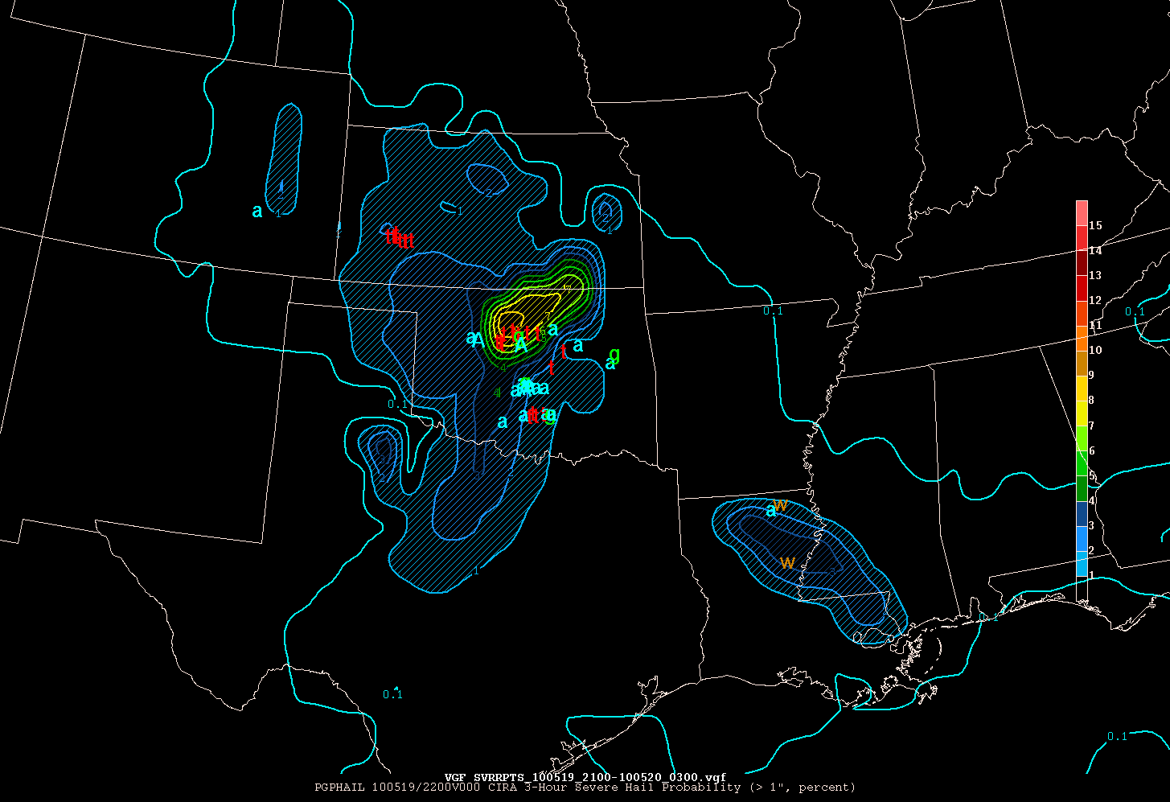

**Figure 11** – 3-hour severe hail probability at 2200 UTC (contours) and severe weather reports from 2100 through 0300 UTC (letters) on 19 and 20 May 2010.

**Conclusion**

The forecasters in the EWP often stated their appreciation for the ability to overlay the products on radar and satellite imagery within AWIPS. As a contoured display format, the GOES-R products provided this year within the EWP dim the image below significantly when overlaid which makes cloud and radar features very hard to see underneath. The contoured GOES-R products are also not able to be displayed with each other in the same panel. Making the contoured GOES-R products within AWIPS systems more readily able to be overlaid on other imagery in future experiments should be investigated. It should be noted that the products were also provided in icon format within AWIPS that could be overlaid on other imagery. However, the icons only provide detections and not magnitudes, so physical interpretation of the signals, which forecasters prefer, is not possible.

EWP participants also requested that more case events be presented, especially during the beginning of the week. This year, only one was presented and the forecasters did not feel completely comfortable with all of the products prior to using them in real-time operations. They suggested that during the first day, even if interesting weather is occurring, that they run through controlled case events so that the visiting scientist participants can explain how the products work in greater detail. The forecasters mentioned that because they were not always fully comfortable with the products by the time that high pressure decisions needed to be made, they would end up falling back to what they were comfortable with, which limited the evaluation of the experimental products during these important periods.

Overall, the new format for the GOES-R Proving Ground’s involvement in the Spring Experiment’s EFP and EWP has been very fruitful, providing much more detailed feedback than the previous year. Including the Proving Ground products within the EWP specifically has been very successful and forecasters are very open to evaluating the products and providing detailed feedback. The feedback surveys originally provided in paper following every EWP operations period were too tedious for forecasters to fill out. The surveys were provided in online form halfway through the experiment and greatly increased forecaster participation and feedback detail. Capturing feedback in real-time via online blog was also very useful, which encouraged participants to share their experiences.

More detailed feedback from the 2010 Spring Experiment can be found on the blog at: <http://goesrhwt.blogspot.com>

**References**

Bedka, K., J. Brunner, R. Dworak, W. Feltz, J. Otkin, and T. Greenwald, 2010: Objective Satellite-Based Detection of Overshooting Tops Using Infrared Window Channel Brightness Temperature Gradients. J. Appl. Meteor. Climatol., 49, 181-202.

Berendes, T. A., J. R. Mecikalski, W. M. MacKenzie, K. M. Bedka, and U. S. Nair, 2008: Convective cloud identification and classification in daytime satellite imagery using deviation limited adaptive clustering. J. Geophys. Res., Vol. 113.

McCaul, E. W., S. J. Goodman, K. M. LaCasse, and D. J. Cecil, 2009: Forecasting Lightning Threat Using Cloud-Resolving Model Simulations. Wea. Forecasting, 24, 709-729.

Mecikalski, J. R. and K. M. Bedka, 2006: Forecasting Convective Initiation by Monitoring the Evolution of Moving Cumulus in Daytime GOES Imagery. Mon. Wea. Rev., 134, 49-78.

Sieglaff, J.M., L.M. Cronce, W.F. Feltz, K.M. Bedka, M.J. Pavolonis, and A. Heidinger 2010: Nowcasting convective storm initiation using box-averaged cloud-top cooling and microphysical phase trends. Submitted to J. Appl. Meteor. Climatol. January, 2010.