February, 2010

Data Center Consolidation Initiative
Agency Consolidation Plan Template

Contents
1 Introduction 3
2 Program Goals and Objectives 4
2.1 Program Goals 4
2.2 Data Center Consolidation Approach 5
2.3 Four Key Impact Areas 6
2.4 Strategic Objectives and Tactical Opportunities 6
2.5 Government-wide Data Center Consolidation Time Table 8
3 Agency Consolidation Plan Template 10
3.1 Primary Focus Areas, Consolidation Approaches and Constraints 10
3.2 Agency Consolidation Plan – Utilization Improvement Metrics 12
3.3 Agency Consolidation Plan – Projected Savings Metrics 14
4 Data Center Consolidation Phases 16
4.1 Phase 1 – IT Asset Inventory Baseline & Quick Wins 16
4.1.1 Preliminary IT Asset Inventory Assessment & Quick Wins 18
4.1.2 IT Software Assets and Utilization Template & Objectives 20
4.1.3 IT Hardware Assets and Utilization Template & Objectives 23
4.1.4 IT Facilities, Energy, Storage and Telecom Template & Objectives 25
4.1.5 Geographic Location and Real Estate Template & Objectives 27
4.2 Phase 2 – Application Mapping 29
4.3 Phase 3 – Analysis & Strategic Decisions 29
4.4 Phase 4 – Consolidation Design & Transition Plan 32
4.5 Phase 5 – Consolidation & Optimization Execution 32
4.6 Phase 6 – Ongoing Optimization Support 34
Appendix A – Data Center Consolidation Metrics Descriptions 35

Introduction

The Federal Data Center Consolidation initiative is targeted to reduce the overall cost of data center operations and energy consumption by Federal Agencies. Currently, there are over 1,100 data centers in use across the federal government with little reuse or sharing of resources within or across Agencies. In addition, data centers consume a growing portion of the Nation’s energy/electricity supply due to growing demand for the services they provide. Data centers used about 61 billion kWh of electricity in 2006, representing 1.5% of all U.S. electricity consumption and double the amount consumed in 2000. It is projected that data center usage will exceed 100 billion kWh by 2011, or 2.5% of total U.S. electricity consumption. This very extensive and continuously growing consumption of energy by data centers in the US emphasizes the very real need to achieve significant improvements in efficiency of Federal data center operations.

This initiative is based on the OMB findings from Budget Data Request (BDR) No. 09-41 from August 8th, 2009 which was aimed at establishing a comprehensive, government-wide inventory of data center activity by federal agency. The terms used in this document are consistent with those defined in the BDR as follows:

- Agency - The term agency means any executive department, military department, or any independent regulatory agency.

- Agency Data Center - A data center is a repository (room or building) for the storage, management, and dissemination of data and information. This repository houses computer systems and associated components, such as telecommunications and storage systems. It generally includes redundant or backup power supplies, redundant data communications connections, environmental controls (air conditioning, fire suppression, etc.), and special security devices housed in leased, owned, collocated, or standalone facilities.

In the context of modernization, an agency data center is defined as any automated information processing and data storage operation that performs one or more of the following functions: processes agency-approved automated applications systems, affords time-sharing services to agency personnel, provides office automation and records management services through a centralized processor, and/or provides network management support for agency wide area networks.

Data center Tier classification:

- Tier I: composed of a single path for power and cooling distribution, without redundant components, providing 99.671% availability.
- Tier II: composed of a single path for power and cooling distribution, with redundant components, providing 99.741% availability
- Tier III: composed of multiple active power and cooling distribution paths, but only one path active, has redundant components, and is concurrently maintainable, providing 99.982% availability
- Tier IV: composed of multiple active power and cooling distribution paths, has redundant components, and is fault tolerant, providing 99.995% availability.

According to the OMB Passback Considerations for FY2011 the Data Center Consolidation and the Cloud Computing Issue Areas will be government-wide priorities for all agencies (including the Intelligence Community) beginning in FY2010. As stated in the Passback document, the goal of the Data Center Consolidation initiative is the development of a government-wide strategy and accompanying agency data center consolidation plans to optimize the number and cost of Federal data centers, reducing the associated energy costs and physical space allocations.

Program Goals and Objectives

Program Goals

The overall goals of the Government-wide Data Center Consolidation Initiative are as follows:

- Consolidate data centers across the Federal Government in order to achieve cost savings, energy consumption reductions, optimal space utilization and improvements in IT asset utilization.
- Use automation, standardization and security ‘hardening’ of Hardware and Software platforms, including virtual hosts and virtual machines to improve upon the implementation and monitoring of NIST 800-53 controls and FISMA compliance.
- Define and monitor standard operational metrics across Agencies (see Section 4.1), achieve efficiency gains and realize operational cost savings by improving:
  - Server (CPU) Utilization (%)
  - Rack Space Utilization (%)
  - Rack Floor Utilization (%)
  - Power Usage / Square Foot
  - Power Usage Efficiency (PUE)

- Maintain cross-agency goals for highly available, scalable, and redundant data center infrastructure that will substantially reduce the Government’s risk and provide for future IT growth.

Data Center Consolidation Approach

The Data Center Consolidation initiative is broken down into 6 key phases and is designed to first assess and inventory the current agency environment and then establish a plan for achieving significant reductions in data center build through the use of server virtualization and Cloud Computing technologies. Additionally, this initiative aims to reduce overall energy consumption by data centers across the Federal Government, while reducing the physical real estate and other key costs drivers associated with data centers. The Data Center Consolidation Initiative consists of the following phases:

- Phase 1 – IT Asset Inventory Baseline (incl. Preliminary Assessment & Quick Wins)
- Phase 2 – Application Mapping
- Phase 3 – Analysis & Strategic Decisions
- Phase 4 – Consolidation Design & Transition Plan
- Phase 5 – Consolidation & Optimization Execution
- Phase 6 – Ongoing Optimization Support

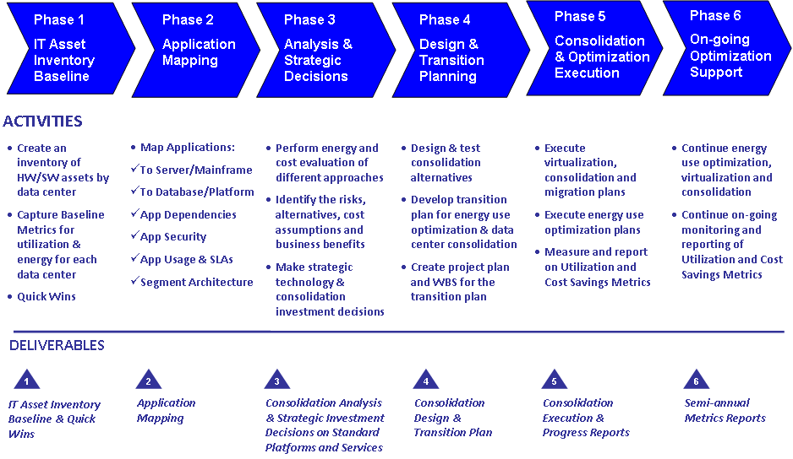
The six phases and related data collection templates are discussed in detail in Section 4 Data Center Consolidation Phases.

Four Key Impact Areas

There are four distinct areas affecting data center optimization that need to be considered in parallel (typically by different teams - Building Facilities, IT Facilities, IT Operations, IT Development):
- Geographic Location and Real Estate (Assess disaster/cost risk)
- IT Facilities & Energy Usage (Consider alternatives for retrofitting existing space, upgrading power/cooling options)
- IT Hardware Assets & Utilization (HW Asset inventory and utilization - i.e. prioritize consolidation based on age/refresh schedule)
- IT Software Asset & Utilization (SW Asset inventory and utilization metrics - i.e. prioritize by app usage/mission requirements)

Strategic Objectives and Tactical Opportunities

The primary goal of the Data Center Consolidation Initiative is to improve the Federal Government’s data center efficiencies and capabilities while reducing costs. The related strategic objectives are summarized below:

  - Reduce Cost
    - Reduce Energy Use
    - Reduce Operational Costs
    - Limit Long-term Capital Investments
  - Reduce Environmental Impact
    - Reduce Power Consumption per Processing Capacity
    - Optimize Cooling, Power Distribution, Cable Plant
  - Improve Efficiency & Service Levels via Automation
    - Maintain Security: Availability, Integrity, Confidentiality
    - Guarantee Performance: Redundancy, Load Balancing, COOP
  - Enhance Business Agility & Effectively Manage Change
    - Implement ITSM Best Practices – ITIL, CMMI-Svc
    - Implement SDLC Best Practices – CMMI-Dev, CMMI-Acquisition

The tactical opportunities for achieving the goals of the Data Center Consolidation Initiative across all four key impact areas are multifaceted as illustrated in the diagram below:

Government-wide Data Center Consolidation Time Table

Key dates in the Data Center Consolidation initiative as outlined by OMB in the Passback Considerations for FY2011 include:

- By 1/15/2010 – OMB will provide agencies with guidance on creating agency data center consolidation plans;
- By 4/30/2010 – Agencies must identify and provide OMB with a list of all data center construction, expansion and/or consolidation activities currently planned or under way;
- By 4/30/2010 – Agencies shall partner with OMB to develop Agency-wide Data Center Consolidation Plans;
- By 6/30/2010 – OMB will provide approved data center consolidation plans to all Agencies, which they need to integrate in their FY2012 budget submissions.

The timeline below provides the high-level guideline that Agencies must follow for developing Agency-specific Data Center Consolidation Plans. It includes key Data Center Consolidation activities to be performed by the Agencies and the support provided by OMB and the PMO team during each of the critical phases.

Agency-driven Activities
- Identify and empower responsible parties/offices/staff positions to lead the project teams, secure resources, report progress
- Establish Data Center Baseline by Conducting Hardware and Software Inventory
- Develop Agency Data Center Consolidation Plan and Schedule
- Map, Analyze Systems and Make Strategic Long-term Investment Decisions
- Design, Implement and Test Agency-specific Consolidation Solutions
- Execute the Agency Data Center Consolidation Plan

OMB-driven Activities
- Identify Strategic Goals & Define Government-wide Metrics and Target Objectives
- Collect Agency Data, Derive Criteria and Analytics for Utilization & Savings
- Analyze Critical Success Factors in all Four Key Impact Areas
- Based on Comparative Analysis Approve Agency Data Center Consolidation Plans
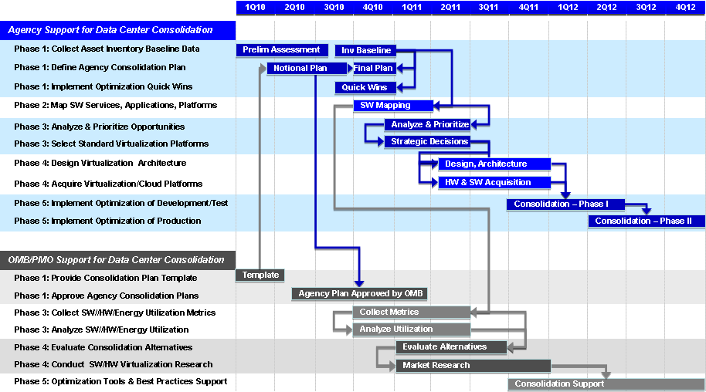

Agency Consolidation Plan Template

Primary Focus Areas, Consolidation Approaches and Constraints

Key Factors, Metrics and Objectives will be defined for each of the four focus areas described in section 2.3 and corresponding Consolidation Plan Templates will be specified that would be completed typically by different teams within an agency (i.e. Building Facilities for location /facility details, including information on whether the asset is leased or owned; IT Facilities for floor space, rack utilization, power, cooling, cable plant; IT Operations for server, storage, network utilization; and IT Development for Application portfolio mapping and prioritization.

The key for these detailed metrics is their relevance for Data Center Consolidation and Energy Cost Reduction, e.g.:
- Rental cost per sq. ft. (based on the Gross Floor Area only) would be a more informative Location / Real Estate metric than Total Operations Cost;
- Floor Space and Rack Space utilization (taking into account power and cooling constraints) in addition to CPU utilization would provide better visibility into actual data center utilization;
- A prioritized SW portfolio, supported by a data center, would provide insights into availability, security, performance requirements and potential for virtualization and server consolidation.

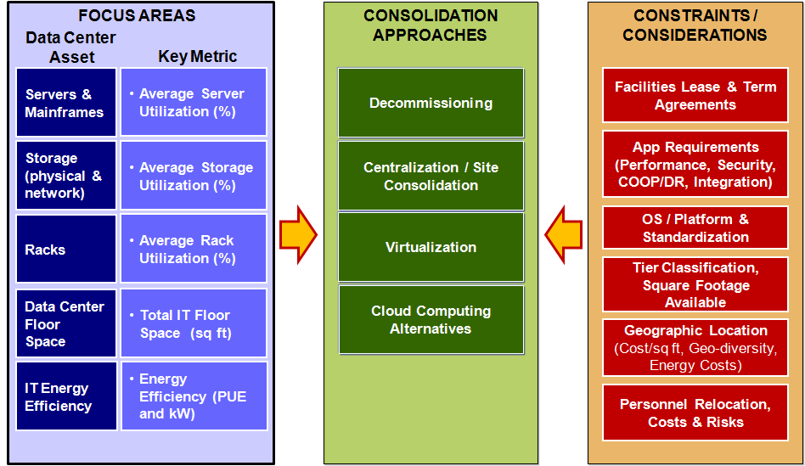

The major constraints and related considerations that could impact the Data Center Consolidation Initiative are highlighted in the diagram above and include the following areas:
- Contractual constraints: existing facility leases, IT hardware and software contracts;
- Application constraints: performance, security (FISMA compliance), COOP, integration;
- Platform constraints: HW/OS/platform standardization, security, interoperability;
- Facilities constraints: data center Tier, available data center floor space/power;
- Geographic constraints: cost, energy/bandwidth resources, personnel relocation.

Based on the defined metrics and the outlined constraints and considerations OMB would offer a template describing strategies and guidelines to help agencies develop and fill-out data center consolidation plans that would improve on these metrics. Once such plans are submitted by the agencies OMB would make specific recommendations and assist agencies in the implementation, e.g.:
- Implement consolidation program around data centers with strategic low-cost, low-risk locations;
- Optimize energy/cooling utilization via equipment location (row/rack cooling), implementing various Density Zones - high, medium, low (at different tiers) within existing data centers, etc.;
- Conduct virtualization and server consolidation analysis, design, prioritization and migration;
- Implement and manage on an on-going basis application tier categorization and alignment (i.e. run high-availability apps only in a high tier data center or 'zone/pod' and the remaining apps in a low tier data center/zone/pod).
- Consider migration to Cloud Computing solutions, when appropriate security and operational requirements are met. Such migration to standard vendor supported enterprise platforms or services in the cloud (i.e. Infrastructure, Platform or Software as a Service) can reduce operational risk while lowering both the Total Cost of Ownership (TCO) and Total Cost of Service Delivery (TCSD).

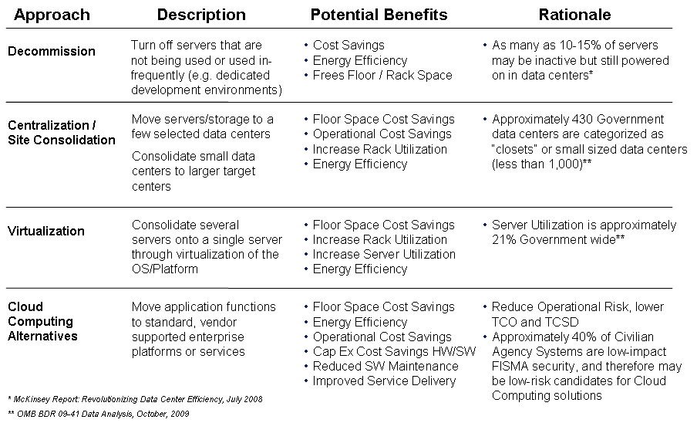

Agency Consolidation Plan – Utilization Improvement Metrics

The Agency-level Utilization Improvement Metrics are a collection of best industry practices in assessing various aspects of Data Center Utilization – from Virtualization and Server / Rack Space Utilization to Power Usage Efficiency.

The Typical and Target Results listed in the table below represent broad industry findings and shall serve as overall utilization benchmark guidance to the Agencies. The actual Agency Utilization Metrics will be filled-out by the Agencies via their Asset Inventory Baseline analysis, as described in detail in section 4.1.

Improving IT equipment utilization is the key driver for reducing energy consumption per unit of performance. This can be achieved primarily by:
- Server Virtualization (increasing the number of virtual servers per hosts)
- Server Consolidation (decommissioning underutilized physical servers)
- Rack Space Consolidation (reallocating underutilized racks)
- Data Center Facilities Consolidation (shutting down underutilized facilities)

The table below offers standardized average utilization metrics to support Data Center Consolidation decision making. Such metrics will help also identify existing facilities constraints (space, power, cooling) and augment the aggregate usage metrics introduced in Section 4.1. IT Asset Inventory Baseline. In particular the Average Power Usage Equivalent metric is based on the standard industry assumption of 25 sq. ft. per rack, and constitutes a normalized metric for equivalent Power Usage per Square Foot. It is used also in the IT Facilities Template and it is defined in Appendix A.

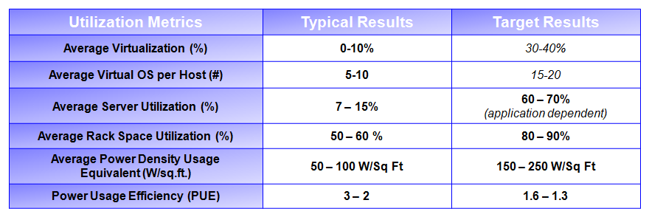
The Agency-Wide Utilization Plan is one of the two key components of the Agency Data Center Consolidation plan. Agencies need to provide baseline values (as of 4Q10) for their utilization metrics and incremental annual target projections thereafter. In recognition of work-in-progress virtualization and consolidation projects that are already underway in FY10, agencies may use FY10 baseline data collected at the beginning of such initiatives.

The process and data templates for collecting the asset inventory baseline are described in section Section 4.1. IT Asset Inventory Baseline. The first step in this process is the collection of a Preliminary Inventory Assessment, which agencies must submit by April 30, 2010, in line with the OMB Passback Considerations for FY2011. The final Asset Inventory Baseline must be submitted by agencies by 9/30/2010. In addition, agencies must submit a Notional Data Center Consolidation Plan by June 30, 2010 and a Final Data Center Consolidation Plan by September 30, 2010, which must be approved by OMB no later than December 31, 2010.

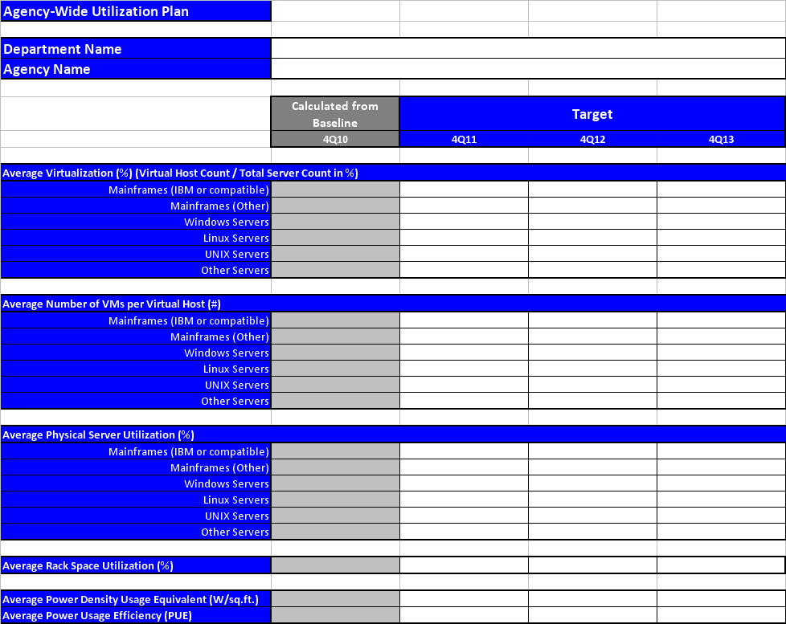

Agency Consolidation Plan – Projected Savings Metrics

The Agency-level Projected Savings Metrics are a collection of best industry practices in capturing various dimensions of Data Center Cost Savings – from Data Center Count and Gross Floor Area Reduction to Rack and Server Count Reduction and finally to Energy Usage and Cost Reduction.

The Planned Program Cost savings by 4Q2012 shall be filled out by agencies based on their Asset Inventory Baseline analysis, as described in detail in section 4.1.

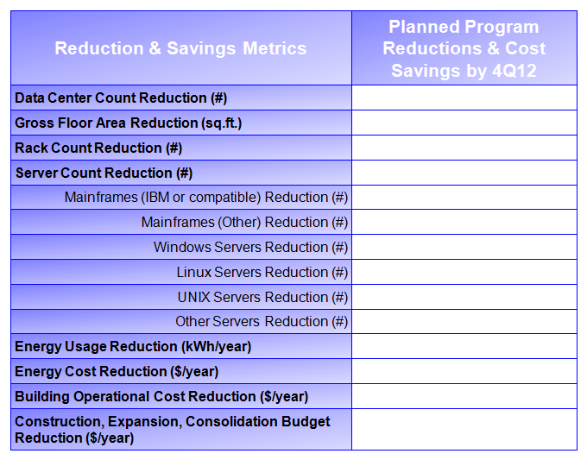

The primary benefit from improved IT equipment utilization is reduced overall energy consumption which leads to significant energy cost savings (up to 90% for virtualized IT equipment).

Additional benefits from Virtualization & Data Center Consolidation include:
- Reduced Facilities Maintenance & Operations costs
- Reduced Server Maintenance & Operations costs
- Improved Automation for Server Management & Provisioning

The Agency-Wide Savings Plan is the second key component of the Agency Data Center Consolidation plan. Agencies need to provide baseline values as of 2Q10 (and no earlier than 1Q10 for virtualization/consolidation projects that are already underway) for their Total Number of Data Centers, Operating Costs of those Data Centers, the Legal Interest of the Data Centers (i.e. leased or owned) Aggregate Gross Floor Area, Total Number of Racks, Total Number of Servers, Aggregate Data Center Energy Use and Aggregate Data Center Energy Costs. Agencies need to provide also incremental annual target projections for the same metrics with a final target date of 4Q12.

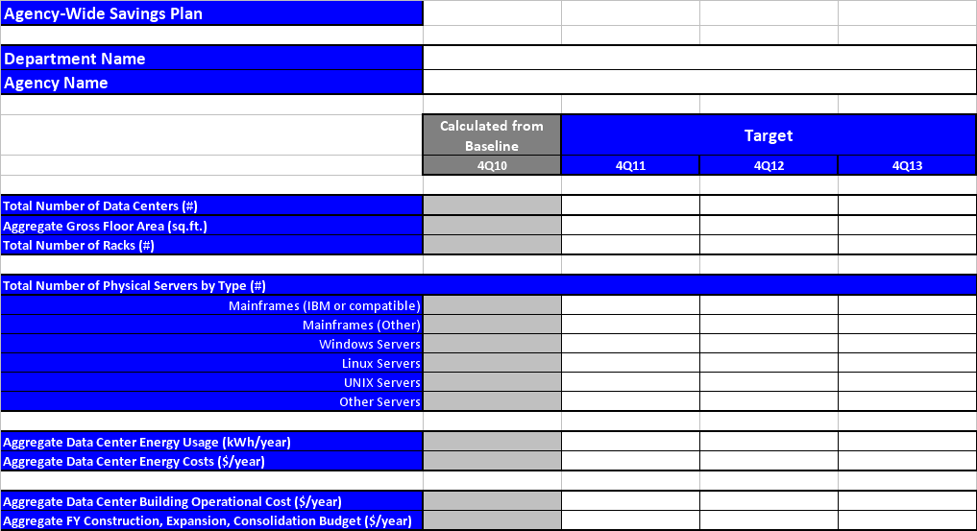

Data Center Consolidation Phases

As introduced in Section 2.2 Data Center Consolidation Approach, the Data Center Consolidation Initiative consists of the following six phases, which are discussed in detail in this section:

- Phase 1 – IT Asset Inventory Baseline (incl. Preliminary Assessment & Quick Wins)
- Phase 2 – Application Mapping
- Phase 3 – Analysis & Strategic Decisions
- Phase 4 – Consolidation Design & Transition Plan
- Phase 5 – Consolidation & Optimization Execution
- Phase 6 – Ongoing Optimization Support

Phase 1 – IT Asset Inventory Baseline & Quick Wins

Within the first phase of the data consolidation initiative agencies will perform metrics gathering across four primary areas in order to derive a baseline state of their current data center environment. This baseline set of measurements will focus on the following four key impact areas, illustrated in the table below:

- IT Software Assets and Utilization
- IT Hardware Assets and Utilization
- IT Facilities and Energy Use
- Geographic Location and Real Estate

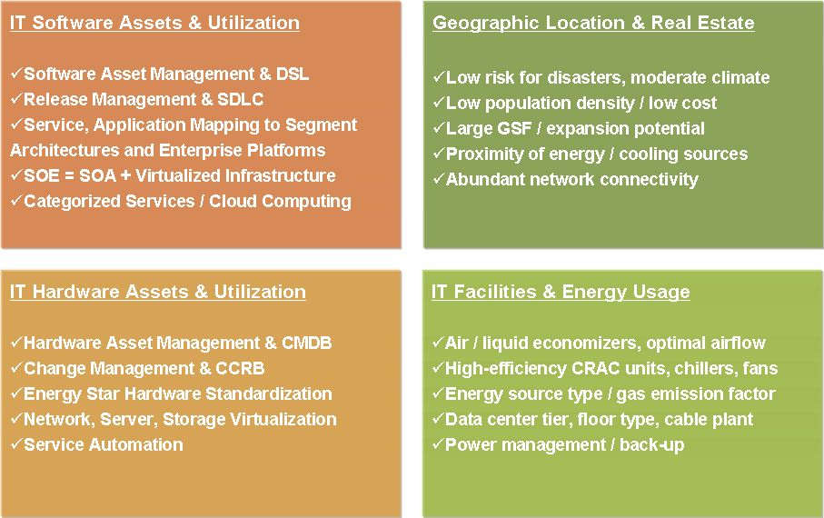

Within these categories several metrics will be gathered to measure the overall baseline of the agencies’ current data center environments (see the following subsections for detailed templates). During Phase 1 of the data center consolidation initiative, Agencies will identify and document an inventory of their data center assets across the four areas described above. The four detailed data collection and reporting templates presented in the following subsections will provide the foundation that Agencies would use to complete the baseline inventory of their data center assets and to document and analyze it within each of the four areas.

The diagram below illustrates the four areas of focus and the associated data center metric components:

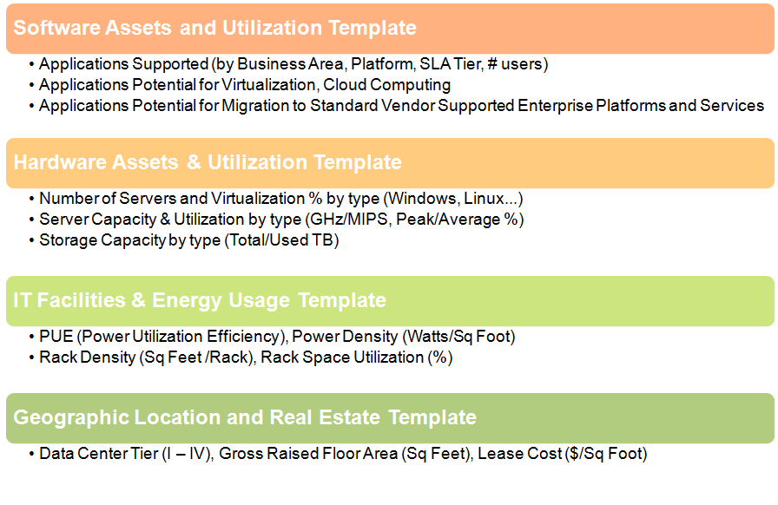
After the initial baseline data collection for all four templates is completed, agencies will conduct ongoing periodic annual data updates for all four templates and will use them as the foundation for completing the agency-level consolidation reporting roll up as described in section 3.2 Utilization Improvement Metrics and section 3.3 Projected Savings Metrics.

Preliminary IT Asset Inventory Assessment & Quick Wins

Given the historic complexity in the development of agencies IT infrastructure, the constraints imposed on them by contractual obligations to partners and suppliers, and their dependencies on other federal agencies and/or government-wide initiatives, the collection of detailed and actionable agency-wide Data Center baseline data can often present both technical and management challenges. Therefore a Preliminary IT Asset Inventory Assessment is the necessary first step in producing a successful agency-wide Data Center baseline. The following simplified data template collects basic facilities (Tier and # of racks), hardware (server count by type) and software (Major Systems, are business applications as defined in OMB Circular A-11, Part 7, Exhibit 300) data for systems hosted in a data center.

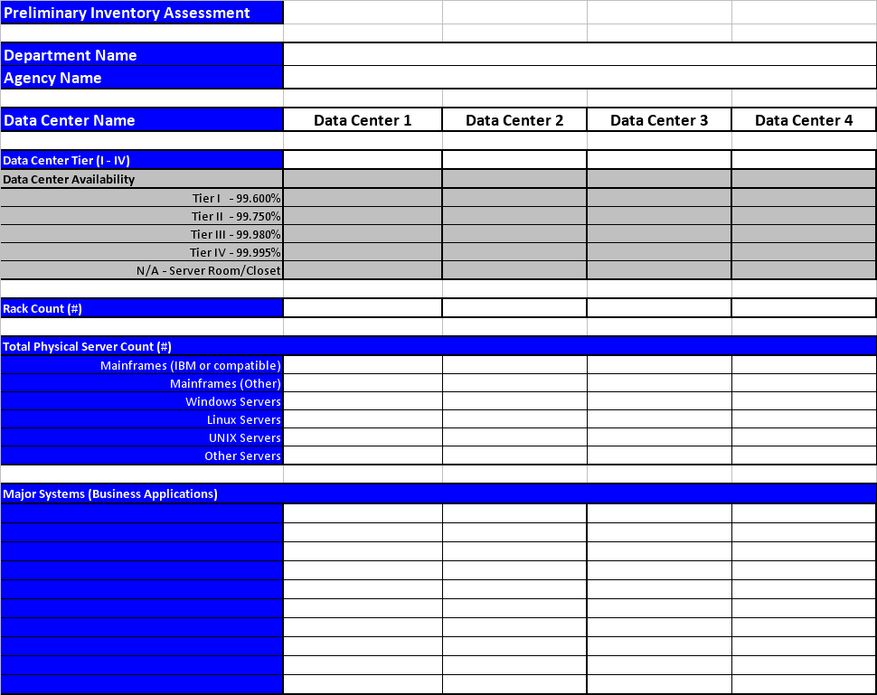

Quick Wins:

As an additional activity in Phase 2 Agencies will leverage the already collected Software Asset Inventory and Hardware Asset Inventory information as well as the application mapping work products in order to identify and implement specific opportunities for immediate quick wins for Data Center Optimization, e.g.:

IT Software Assets and Utilization Template & Objectives

The purpose of the Software Assets Template is to document all Major Systems (as defined in OMB Circular A-11, Part 7, Exhibit 300) hosted in a data center, their key elements (e.g. platform, server, etc.) and to evaluate the feasibility of their consolidation via one of the four approaches discussed in section 3.1 (Decommission, Consolidation, Virtualization or Cloud Computing).

For consistency with ongoing OMB reporting activities by the Agencies, the Software Assets Template classification follows the Federal Enterprise Architecture (FEA) specifications of the Technical Reference Model (TRM) to map all Major Systems hosted within a data center to the TRM Service Standards, as defined in the FEA Consolidated Reference Model Document Version 2.3.

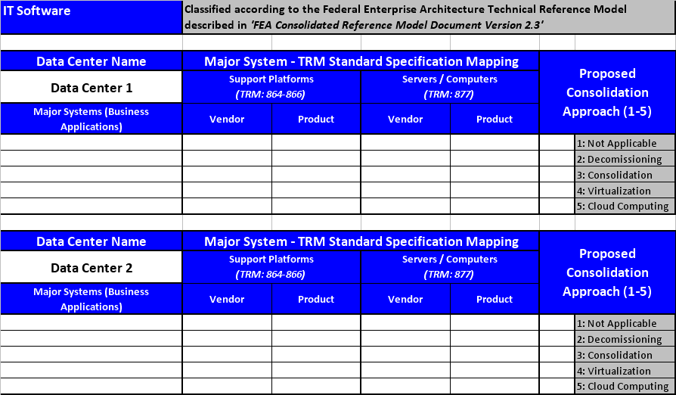
The specific TRM Service Area used in this mapping is ‘Service Platform and Infrastructure’, which includes the following TRM Service Categories:

- Support Platforms (e.g. Linux/J2EE, Windows Server 2008 / .Net etc.)
- Software Engineering (e.g. Integrated Development Environment – IDE, etc.)
- Database / Storage (e.g. Relational Data Base Management System – RDBMS, etc.)
- Delivery Servers (e.g. Application Servers, Web Servers, etc.)
- Hardware / Infrastructure (e.g. Enterprise Servers, Mainframes)

As described in the FEA Consolidated Reference Model, Service Standards define the standards and technologies that support a Service Category and many of the Service Standards provide illustrative specifications or technologies as examples. The actual Service Standards pertaining to the ‘Service Platform and Infrastructure’ Service Area with their corresponding identifiers (#864 – 877) and descriptions can be found in the FEA Consolidated Reference Model mentioned earlier (a reference worksheet is included also in the data collection Excel template).

Using this FEA-based approach, the Software Asset Template captures all critical technical characteristics for Major Systems, starting from Servers and Operating Systems/Platforms through software engineering and database/storage to delivery servers. The Proposed Consolidation Approach (last column) would become the leading driver for decommissioning, consolidating, virtualizing or migrating to cloud computing of major systems (applications), thereby facilitating the reduction in server hardware as captured by the IT Hardware Asset & Utilization Template described in the next section.

Later on in the data center consolidation process the Software Asset Inventory will serve as the basis for the Application Mapping & Quick Wins phase described in Section 4.2, for the Analysis & Strategic Decisions phase (Section 4.3), for the detailed Design and Transition Plan phase (Section 4.4) and finally for the actual Consolidation Execution phase (Section 4.5).

Program Objectives for IT Software Assets and Utilization:

IT Software Asset & Configuration Management Objectives:

- Establish/Optimize the Software Asset Management Function
- Conduct Software Asset Inventory
- Implement Definitive Software Library (DSL)
- Implement Software License Management & Compliance

Software Development Lifecycle (SDLC) & IT Service Management (ITIL, CMMI-Dev) Objectives:
- Optimize the Software Development Lifecycle (SDLC) Processes
- Establish/Strengthen the Release & Change Management functions associated with SDLC
- Optimize the Release Management Processes which should be closely integrated with Change Management
- Optimize the Incident and Problem Management Processes

IT Hardware Assets and Utilization Template & Objectives

The purpose of the IT Hardware Assets and Utilization Template is to document all physical servers and mainframes hosted in a data center, their count, CPU and power capacity and utilization, the available/used storage and finally the degree to which server utilization has been implemented within a data center. The degree of virtualization is measured by two metrics:

- Virtualization (%) = Virtual Host Count / Total server Count (%); and
- Average Number of VM OS per Virtual Host (#).

These server/mainframe utilization metrics are included in the agency-level roll up as described in section 3.2 Utilization Improvement Metrics and section 3.3 Projected Savings Metrics. In order to allow Agencies to leverage their previous work within the IT Infrastructure Line of Business (ITI LoB) as well as any similar on-going data collection work, the classification of server/mainframe types and breakdown of utilization metrics aligns well with the classification used by the ITI LoB. The data collected by the IT Hardware Asset and Utilization Template is only a limited subset of the ITI LoB collected data and its objectives are more narrowly focused on server utilization and virtualization levels, while targeting overall energy usage reduction.

The specific server/mainframe categories used are:

- Mainframes (IBM or compatible)
- Mainframes (Other)
- Windows Servers
- Linux Servers
- UNIX Servers
- Other Servers

The only differentiator between the mainframe categories and the server categories is the way each of the two groups account for Average CPU Capacity, i.e. in MIPS for all mainframes and in MHz for all servers.
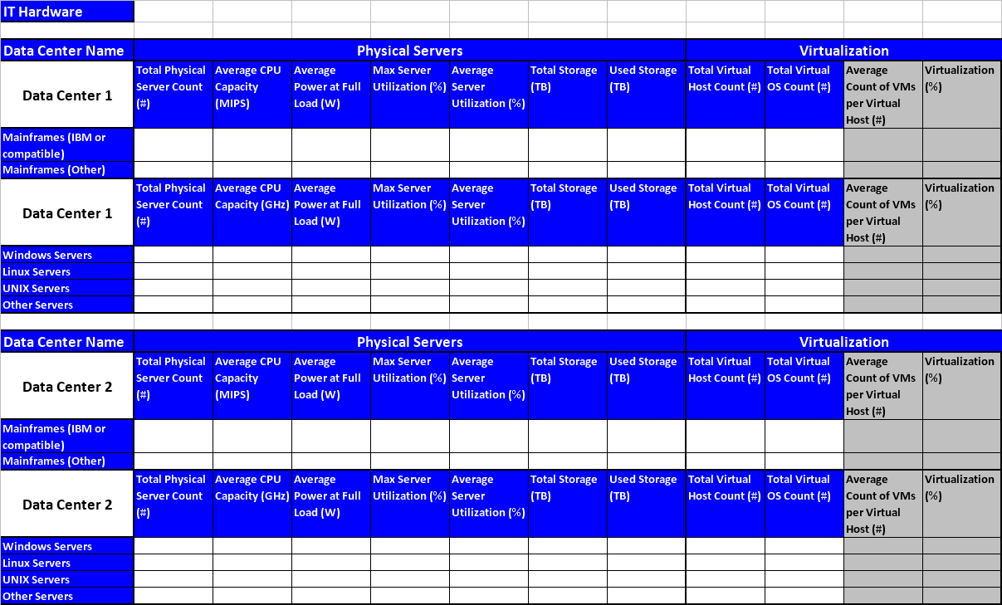
Program Objectives for IT Hardware Assets and Utilization:

IT Hardware Asset & Configuration Management Objectives:
- Establish/Strengthen the Hardware Asset Management Function
- Conduct periodic Asset Inventory – an initial baseline and subsequent annual Inventory Reports
- Implement Configuration Management Data Base (CMDB)
- Implement Asset & Configuration Management Processes

IT Service Management (ITIL, CMMI-Svc) Objectives:
- Establish/Strengthen the Change Management function and the Change Control Review Board (CCRB)
- Optimize the Change Management processes
- Optimize the Incident and Problem Management processes

IT Facilities, Energy, Storage and Telecom Template & Objectives

The purpose of the IT Facilities, Energy and Telecom Template is to document electricity usage and cost, power capacity, rack count & utilization, total storage capacity and utilization and telecom connectivity as designed, implemented and used within a data center. The template is designed to enable consistent IT Facilities data collection across data centers and across Agencies. It also aims to leverage only a few key foundational data elements (e.g. Total Data Center IT Power Capacity and Power Usage, Rack Count and Rack Utilization) in order to derive automatically more informative data center utilization metrics, such as:

- Average Power Capacity per Rack (kW);
- Rack Floor Utilization (%); and
- Power Density Capacity and Usage Equivalents (W/sq.ft.).

Some of these metrics are included in the agency-level roll up as described in section 3.2 Utilization Improvement Metrics and section 3.3 Projected Savings Metrics. Agencies can leverage their work on related initiatives such as Green IT since the selected metrics align well with leading industry research in this area by government agencies (EPA and DOE), non-profit organizations (The Green Grid), leading analyst firms (Gartner, Forrester, McKinsey) and by industry leaders in the Server, Power Equipment and Facilities Management space.

Regarding IT Power metering, the EPA recommendations from the November 12, 2009 Web Conference are as follows:
- Measurements of IT Power should be made at the output of the UPS meter;
- If a data center does not have a UPS meter, then IT Power should be measured at the PDU meter or at a location closer to the racks;
- If a data center has more than 10% non-IT load on a UPS meter it should measure IT Power at the PDU meter or a location closer to the racks, or it can sub-meter the non-IT load;
- If a data center prefers to measure IT Power at the PDU meter, EPA allows tracking of IT Power at both the UPS and PDU meters, but reporting preference is given to the UPS data.

As IT Power metering technology evolves and reaches wider adoption over time, measurements at the rack or even at the server level will become more feasible and routine, offering the best visibility into IT power usage patterns and savings opportunities.

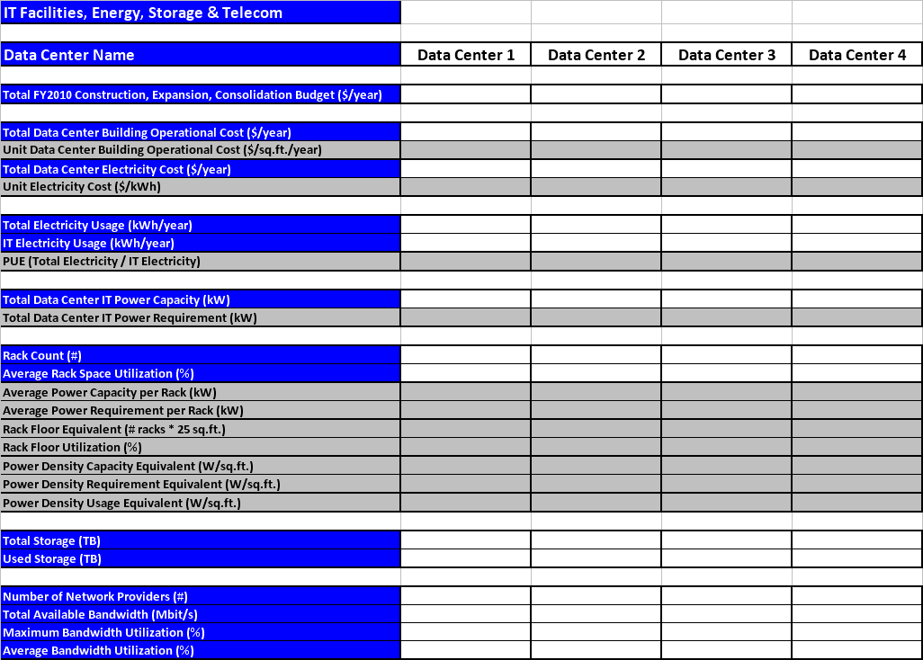

Program Objectives for IT Facilities, Energy, Storage and Telecom:

Cooling Optimization Objectives:
- Effective use of air and/or liquid economizers (use outdoor air, water where possible)
- Optimal data center airflow configuration (rack configuration / server density)
- Use of high-efficiency Computer Room Air Conditioning (CRAC) units, variable speed chillers, air-handler fans, chilled water pumps

Power Usage Optimization Objectives:
- Deploy high-efficiency power distribution and UPS units
- Implement digital control of power supplies (including DC -DC conversion)
- Enable power management on all IT hardware equipment

Geographic Location and Real Estate Template & Objectives

The purpose of the Geographic Location and Real Estate Template is to characterize the geographic location according to population density (city tier), geography (climate and seismic zones) and energy sources (eGRID sub-region), as well as the type of real estate – by data center tier, ownership model, gross floor area and cost.

Some of these metrics are included in the agency-level roll up as described in section 3.2 Utilization Improvement Metrics and section 3.3 Projected Savings Metrics.

Agencies can readily align their work on complying with Executive Orders 13514 and 13423 with the Data Center Consolidation initiative since the selected metrics include EPA's Emissions & Generation Resource Integrated Database (eGRID) energy grid Sub-regions. Also the metrics take into account the Commercial Buildings Energy Consumption Survey (CBECS) US Climate Zones, as defined by the National Oceanic and Atmospheric Administration (NOAA) and published by the US Energy Information Administration and the National Seismic Hazard Maps – 2008, published by the USGS.

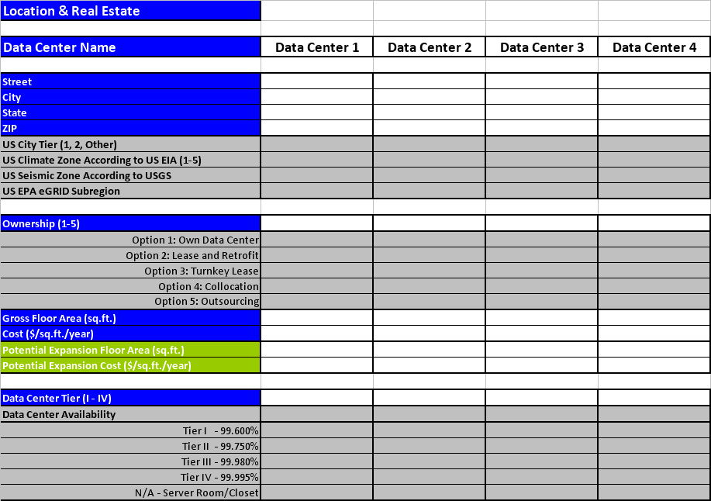

Program Objectives for Geographic Location and Real Estate:
Geographic Location Optimization Objectives:
- Reduced risk of disasters (natural or man-made)
- Consider energy source type by location and the indirect greenhouse gas emissions factor (EPA eGRID)
- Evaluate proximity of energy and cooling sources and corresponding costs
- Consider moderate climate (avoid climate extremes for better cooling/heating efficiency)
- Ensure abundant network connectivity, redundancy, and bandwidth capacity (availability and cost of network backbone are critical for supporting data centers)
- Look for lower population density, leading to lower real estate & operational costs (availability of highly skilled work force - trained IT staff in the area is essential in order to avoid potential relocation costs)
Real Estate Optimization Objectives:
- Optimize the use of Gross Floor Area , leveraging data center economies of scale
- Evaluate available expansion potential to accommodate long-term growth in demand
- Conduct market research to reduce real estate acquisition and/or leasing costs

Phase 2 – Application Mapping

Application Mapping

Within Phase 2 – Application Mapping, Agencies will perform an important step of application profiling in the current state. To ensure that Agencies consolidation project is successful, an IT service-centric approach is utilized, instead of optimizing individual infrastructure resources. The Software Asset Inventory and Hardware Asset Inventory as established previously and described in section 4.1 will be the basis for conducting the Application Mapping process.

The following key application mapping steps needs to be performed and documented by the Agencies during this phase:

- Application-to-Server/Mainframe mapping
- Application-to-Database/Platform mapping
- Application Dependency mapping
- Application Security requirements
- Applications Usage & SLAs

The resulting application mapping work products will be the blueprint on which subsequent decommissioning, virtualization, consolidation or migration to cloud computing analysis, plans and actions will be based on. As such the work products from the application mapping phase will be critically important for the success of all future phases and especially so for developing the Design and Transition Plan and for the Consolidation Execution.

Phase 3 – Analysis & Strategic Decisions

The Analysis & Strategic Decisions Phase of the Data Center Consolidation Initiative establishes a catalog of Major Systems and their associated target state including server virtualization, storage solutions, and data center facilities consolidation. This detailed analysis will be conducted based on the templates for IT consolidation described in section 4.1. Furthermore in this Analysis portion of the initiative, Agencies will identify strategies for achieving optimal server utilization through server virtualization and consolidation and/or through the use of cloud computing services to achieve the Utilization and Cost Savings targets outlined in sections 3.2 and 3.3.

During the analysis and strategic decision making Agencies should also assess the security profile of systems and applications to ensure that security requirements can be maintained with alternative virtualization and/or Cloud Computing solutions. This analysis should include the application of NIST SP800-30 Risk Management Guide for Information Technology Systems and NIST SP800-60 Volume I and II – Guide for Mapping Types of Information and Information Systems to Security Categories to the Agency systems considered for virtualization or migration to Cloud Computing.

Additionally, Agencies are strongly encouraged to analyze how common IT services, including the list below, can be centralized into an Agency Community cloud or within a Cross Agency Government Community Cloud. Some key services identified as good candidates for Cloud Computing are:

- Communication Tools: centralized Email, messaging
- Collaboration / Productivity Tools: Web 2.0, Website hosting, Knowledge Mgmt, Document Mgmt, Data/File Storage, Network Storage capabilities
- Identify & Access Management: shared security identity access management system

Strategic Decisions will be made by Agencies for each of the four Data Center areas focusing on key considerations critical to data center consolidation as follows:

IT Software Assets and Utilization Decisions

- IT Service Orientation (SOA) and Potential for Virtualization & Cloud Computing:

- Define common enterprise and business services
- Map services, applications and platform dependencies into the CMDB
- Leverage service-centered applications and virtualized infrastructure into creating a Service Oriented Enterprise
- Categorize application services for potential use of public, private, or community clouds

IT Hardware Assets and Utilization Decisions

- Server, Network, Storage Virtualization, Optimization & Service Automation:

- Select ENERGY STAR rated hardware with optimal power usage/performance
- Standardize hardware configurations, operating systems
- Asses the feasibility for virtualization and select standard virtual platforms
- Select server virtualization platforms & service automation tools
- Select storage virtualization platforms & service automation tools
- Select network virtualization platforms & service automation tools

IT Facilities, Energy &Telecom Decisions

- Facilities, Power & Telecom Optimization:

- Select appropriate data center tier
- Select power back-up strategy (e.g. on-site generation)
- Select appropriate floor type & cable plant layout for optimal air circulation
- Ensure sufficient and redundant telecom connectivity

Geographic Location and Real Estate Decisions

- Geographic Location & Real Estate Optimization:
- Select consolidation locations based on reduced risk, moderate climate, energy & cooling source proximity, abundant network access
- Select real estate options based on low population density resulting in lower real estate acquisition or leasing costs and in reduced operational costs
- Determine the optimal use of gross square footage area to leverage economies of scale and consider the available expansion potential for accommodating long-term growth in demand (data center lifespan could be well over 20-30 years)

Phase 4 – Consolidation Design & Transition Plan

The Consolidation Design will focus on developing technical standards and architectures as well as identifying opportunities for leveraging shared Cloud Computing solutions within Agencies and across Agencies. The Cloud Computing solutions should focus on systems with FISMA / NIST 800-53 low and moderate security requirements. Systems with low and moderate security requirements should be strongly considered for Cloud Computing either via Software as a Service (SaaS), Platform as a Service (PaaS) or Infrastructure as a Service (IaaS) solutions.

The Agency Transition Plan will define the steps that the Agency will take to migrate applications, consolidate servers through virtualization, deploy shared services and employ the use of Cloud Computing solutions to reduce data center operational costs and energy usage. All Agencies are required to create such Transition Plans for reaching the target state for servers, storage, databases and integration layer platforms, as well as IT Facilities set-up and any potential site migrations/consolidations based on real estate or geographic advantages. Furthermore within their Transition Plans, agencies will specify which servers will be decommissioned and consolidated onto either a virtual server or moved to the Cloud.

The Agency Transition Plan will provide the following outcomes:

- Agency Consolidation Strategy & Design
- IT Software and Hardware Consolidation Architecture
- IT Facilities Recommendations
- Geographic Location and Real Estate Recommendations
- Detailed Timetable, Milestones and Work Breakdown Structure (WBS) for Agency Consolidation Execution

Phase 5 – Consolidation & Optimization Execution

Phase 5 Consolidation and Optimization Execution is the actual fulfillment of the Agency Data Center Consolidation Plan and the execution of the Agency Transition Plan. This phase will focus on implementing the designed architecture solutions for the virtualization of servers, migration of application to a virtual environment, moving applications and infrastructure to cloud computing alternatives (IaaS, PaaS or SaaS), as well as on the implementation of any planned IT Facilities optimization activities or site migration efforts, e.g. rack space consolidation, air flow optimization, cooling/ power system redesign, site consolidation/relocation, etc.

During this phase Agencies are required to report annually their progress on the Data center Consolidation Plan as outlined in Sections 3.2 Utilization Improvement Metrics and 3.3 Projected Savings Metrics. This includes the number of data centers that have been consolidated, the reduction in data center floor space, energy consumption and the adoption of virtualization and/or cloud technology solutions to offload the data center space and capacity within Agency data centers.

The diagram above illustrates sample work-streams for the execution of the Agency Transition Plan for Data center Consolidation. The execution of coordinated Agency Program Management activities across all Software Development, Server Operations, IT Facilities and Real Estate Operations teams that support the Data Center consolidation effort will be essential for the program’s success. The continuous cost-benefit analysis, communications and training activities are also a key component for the effective organizational transition associated with the Data Center Consolidation Initiative.

Once the initial Data center Consolidation effort is completed, the newly instituted best practices for energy efficient and cost effective operations should continue into an ongoing Optimization Support Program which is described in the next section.

Phase 6 – Ongoing Optimization Support

Phase 6, the ongoing Optimization Support Program would include the continual monitoring of application usage and SLAs, server utilization and virtualization levels, rack and floor space utilization, energy usage and the related cost savings. All data center-level metrics introduced in Section 4.1 IT Asset Inventory Baseline and all Agency-level metrics introduced in Section 3.2 Utilization Improvement Metrics and Section 3.3 Projected Savings Metrics should continue to be collected and progress on them should be monitored on an ongoing basis.

Therefore, after the initial consolidation is performed, it is required that Agencies would continue to adopt and implement best practices that will allow for optimal server utilization and cost and energy effective data center implementation solutions, which will maintain consistently high levels of server and rack utilization. Additionally, it is expected that Agencies would continue to evaluate and promote the further adoption of Cloud Computing alternatives as demand for agile IT services continues to increase. Annual reporting for data center consolidation and optimization activities will continue on an ongoing basis.

Appendix A – Data Center Consolidation Metrics Descriptions

