DEPARTMENT OF AGRICULTURE CHIEF FREEDOM OF INFORMATION ACT OFFICER REPORT

Date: March 2013



# Table of Contents

**SECTION** **PAGE**

EXECUTIVE SUMMARY 3

SECTION I: STEPS TAKEN TO APPLY THE PRESUMPTION OF OPENNESS .3

SECTION II: STEPS TAKEN TO ENSURE YOUR AGENCY HAS AN EFFECTIVE SYSTEM FOR RESPONDING TO REQUESTS .6

SECTION III: STEPS TAKEN TO INCREASE PROACTIVE DISCLOURES …7

SECTION IV: STEPS TAKEN TO GREATER UTILIZE TECHNOLOGY .10

SECTION V: STEPS TAKEN TO IMPROVE TIMELINESS IN RESPONDING TO

REQUESTS AND REDUCE BACKLOGS .13

**EXECUTIVE SUMMARY**

The mission of the United States Department of Agriculture’s (USDA) is to provide leadership on food, agriculture, natural resources, and related issues based on sound public policy, the best available science, and efficient management. Upon its creation in 1862, President Abraham Lincoln called USDA “the people’s department,” because it affects so many people’s lives in so many different ways, and earlier, President Thomas Jefferson, a farmer, noted that “cultivators of the earth are the most valuable citizens.” USDA works hard to keep these sentiments alive as it pursues its mission to provide leadership on food, agriculture, natural resources, and related issues based on sound public policy, the best available science, and efficient management.

USDA programs and activities affect every American, every day, by providing a safe and stable food supply, nutrition assistance, renewable energy, rural economic development, care for forest and conservation lands, and global opportunities for farm and forest products. USDA holds answers to some of the most pressing problems faced by our Nation and world—from meeting needs for renewable energy, and increasing crop yields to fight hunger, protecting the food supply to improving our environment and optimizing international trade. To successfully accomplish its mission, USDA operates 300 programs worldwide through an extensive network of Federal, State, and local cooperators. The USDA delivers more than $170.5 billion in budgetary resources to provide public services worldwide.

USDA has a decentralized FOIA Program under the direction of the Chief FOIA Officer. There are twenty-one FOIA Officers at the mission area and agency levels. Because we are such a large Department, with offices in every county of the United States, our FOIA programs differ greatly in scope and size from one agency to another.

The FOIA Service Center is the focal point for the coordination of USDA’s FOIA program. The FOIA Service Center provides agency-wide oversight to ensure compliance with FOIA. In FY2011 and FY2012, the FOIA Service Center spearheaded several initiatives to increase transparency, timeliness and quality of FOIA responses. The largest of the FOIA Service Center initiatives is the launch and migration of data to the agency wide tracking database. As of September 30, 2012, seventeen (17) of the twenty-one (21) service agencies have completely migrated its data to the agency-wide tracking system. Other notable FOIA Service Center initiatives included the creation of an online FOIA training module, revisions to USDA regulations and the launch of our newly designed FOIA website.

### ****Section I: Steps Taken to Apply the Presumption of Openness****

**The guiding principle underlying the President’s FOIA Memorandum and the Attorney General’s FOIA Guidelines is the presumption of openness.**

**Describe the steps your agency has taken to ensure that the presumption of openness is being applied to all decisions involving the FOIA.  To do so, you should answer the questions listed below and then include any additional information you would like to describe how your agency is working to apply the presumption of openness.**

1. **Did your agency hold an agency FOIA conference, or otherwise conduct training during this reporting period? Did your FOIA professionals attend any FOIA training, such as that provided by the Department of Justice?**

Yes. On January 6, 2012, USDA charted a USDA-wide internal FOIA Council. The Council was assembled to provide a centralized forum for USDA’s FOIA community to (a) streamline inter and intra agency FOIA operations; (b) strengthen USDA’s FOIA regulations, policies and procedures; and (c) provide FOIA training and announce external training opportunities at the Department of Justice (DOJ), the Office of Government Information Services (OGIS) as well as those conducted by commonly known access training providers.

The Council has established a few subcommittees comprised in large part by service agency FOIA Officers. All subcommittees are chaired by the Acting Department FOIA Officer and co-chaired by members of the FOIA Service Center staff. Unlike the Council which meets monthly, subcommittees convene on either a weekly or bi-weekly basis. Subcommittee initiatives during this reporting cycle are described in more detail below.

Since its creation in early 2012, the Council established a nine member subcommittee to develop both a lite and extended FOIA training module for use on the Department’s learning management tool and repository, AgLearn. The lite module will provide USDA’s community at large with an overview of FOIA, legislative authorities, and key FOIA resources for those called upon to respond to FOIA requests.

The extended version is being developed for USDA’s FOIA specialists involved in the day-to-day processing of FOIA requests. This training is intended to provide the specialists with an in-depth training session on the statutory exemptions and there application. The anticipated target date for implementation of both modules is May 2013.

A second five member subcommittee was formed in early May 2012 to revise USDA’s FOIA regulations. The FOIA Service Center anticipates a release of the draft regulations for internal clearance and coordination in 2013.

As for training, multiple members of the USDA FOIA Community reported attending DOJ’s annual two day seminar for FOIA attorneys and access professional, DOJ’s advanced FOIA seminar, DOJ’s Annual FOIA and Chief FOIA Officer’s Reports seminar and OGIS’ dispute resolution skills training.

**In his 2009 FOIA Guidelines, the Attorney General strongly encouraged agencies to make discretionary releases of information even when the information might be technically exempt from disclosure under the FOIA.  OIP encourages agencies to make such discretionary releases whenever there is no foreseeable harm from release.**

1. **Did your agency make any discretionary releases of otherwise exempt information?**

Yes. Multiple USDA FOIA officers reported making discretionary releases of otherwise exempt information in fiscal year 2012.

1. **What exemptions would have covered the information that was released as a matter of discretion?**

In reviewing all agency responses in the FOIA tracking tool, the Department FOIA Officer determined that Exemptions 5 U.S.C. §§ 552 (b)(4), (b)(5) and (b)(7) would have covered the information that was released as a matter of discretion.

**5.  Provide a narrative description, or some examples of, the types of information your agency released as a matter of discretion.**

Some examples of records released as a matter of discretion include materials related to USDA personnel rules and practices, inter and intra agency memorandums, USDA briefings, talking points, notes taken during enforcement proceedings and draft letters. The table below illustrates a few of the discretionary releases made by USDA’s FOIA officers and specialists.

|  |  |  |  |  |  |
| --- | --- | --- | --- | --- | --- |
| **Action Office** | **Tracking Number** | **Exemption Codes** | **Comments** | **Received Date** | **Closed Date** |
| FAS | 2012-FAS-01164-F | (b)(5) | could have invoked b5 in many more passages released instead | 01/05/2012 | 09/28/2012 |
| FSIS | 2011-FSIS-00166-F | (b)(4);(b)(7)(C) | The FOIA was negotiated to release Rocky Mountain Meats FSA. | 04/13/2011 | 08/30/2012 |
| REE | 2012-REE-02538-F | (b)(5) | a determination was made that no foreseeable harm would result if the information was released | 05/30/2012 | 09/13/2012 |
| 2012-REE-03357-F | (b)(5) | a determination was made that no foreseeable harm would result if the information was released | 08/21/2012 | 09/19/2012 |

**6.  Describe any other initiatives undertaken by your agency to ensure that the presumption of openness is being applied.**

The FOIA Service Center revamped the USDA FOIA website in an effort to ensure that the presumption of openness is being applied. Please see <http://www.dm.usda.gov/foia/index.htm>. Beginning September 2012, FOIA requesters could submit their requests through the USDA’s public access link (PAL) in addition to the other traditional methods of submitting a request. Once the requester completes registration, they can quickly submit a request, check the status of FOIA(s) submitted online and retrieve responsive records in connection with any of their online requests.

Reading rooms on the site were also revised to incorporate recommendations provided in the July 2012 Government Accountability Office Report titled “Freedom of Information Act – Additional Actions Can Strengthen Agency Efforts to Improve Management” (GAO Report). In addition to the items required by the Electronic Freedom of Information Act Amendments, there is now a link to the USDA site providing summaries of each opinion in fiscal year 2012 and 2013. USDA also made a concerted effort to group its frequently requested records into categories as well as include more links for records maintained by external offices.

### ****Section II: Steps Taken to Ensure that Your Agency Has an Effective System in Place for Responding to Requests****

1. **Do FOIA Professionals within your agency have sufficient IT support?**

Yes. USDA has two primary information technology service providers to assist employees. Both provide comprehensive information technology, security and a range of technical support services. In addition to the above two primary information technology service providers, the FOIA community has a dedicated help desk for resolving IT issues related to the Department’s automated FOIA tracking tool.

1. **Do FOIA professionals work with your agency’s Open Government team?**

Yes. As in previous years, FOIA professionals collaborated with the Open Government team to identify datasets for public release as well as enhancements to high-valued datasets set forth below.

* [Supplemental Nutrition Assistance Program Participation and Cost Data](https://explore.data.gov/Health-and-Nutrition/Supplemental-Nutrition-Assistance-Program-Particip/mu6q-p54u)
* [MyPyramid Raw Food Data](https://explore.data.gov/Health-and-Nutrition/MyPyramid-Food-Raw-Data/b978-7txq)
* [Farmers Markets Geographic Data](https://explore.data.gov/Agriculture/Farmers-Markets-Geographic-Data/wfna-38ey)
* [Biotechnology Regulatory Services public data file (permits, notifications, and petitions)](http://www.data.gov/raw/3980)
* [Census of Agriculture Race, Ethnicity and Gender Profile Data](http://www.data.gov/raw/1425)
* [Federal Cost of School Food Program Data](http://www.data.gov/raw/2626)
* [Meat, Poultry, and Egg Inspection Directory by Establishment Name](http://www.data.gov/raw/2213)
* [Agricultural Research Service (ARS) Available Technologies](https://explore.data.gov/Agriculture/AVAILABLE-TECHNOLOGIES/g99s-xgrw)

1. **Has your agency assessed whether adequate staffing is being devoted to FOIA administration?**

Yes. Agency directors allocate staff based on the amount of requests received, the complexity of requests received and available resources. In FY2012, AMS, FSIS, FS, GIPSA, OCFO, OIG, and OSEC/OCIO increased its total number of “Full-Time FOIA Staff” servicing there mission areas.

Conversely, the total number of Full-Time FOIA Staff decreased in FAS, FSA, NRCS, RD and RMA. The remaining agencies’ total number of Full-Time FOIA Staff remained constant.

Overall, there was a 28% reduction in the USDA’s Full-Time FOIA Staff.

1. **Describe any other steps your agency has undertaken to ensure that your FOIA system operates efficiently and effectively, such as conducting self-assessments to find greater efficiencies, improving search process, streamlining consultations, eliminating redundancy, etc.**

In October 2012, a Lean Six Sigma initiative was implemented to review the FOIA process, resources, and barriers to success. Subcommittee co-chairs are currently conducting interviews with USDA FOIA Officers and other FOIA professionals from agencies processing the largest percentage of incoming requests, agencies with an increase in processing times and agencies routinely processing requests within the required statutory period. Once interviews are complete, the subcommittee will reconvene, address agency findings and begin proposing recommendations to improve efficiency, accountability and transparency in USDA’s FOIA Program.

**Section III: Steps Taken to Increase Proactive Disclosures**

* 1. **Provide examples of material that your agency has posted this past year.**

|  |  |
| --- | --- |
| **BLOG TITLE** | **LINK** |
| [USDA Announces Effort to Enhance Department Efficiency, Improve Access to Programs](http://blogs.usda.gov/2012/12/21/usda-announces-effort-to-enhance-department-efficiency-improve-access-to-programs/) | http://blogs.usda.gov/2012/12/21/usda-announces-effort-to-enhance-department-efficiency-improve-access-to-programs/ |
| [Secretary’s Column: An Update on Exports](http://blogs.usda.gov/2012/12/14/secretarys-column-an-update-on-exports/) | <http://blogs.usda.gov/2012/12/14/secretarys-column-an-update-on-exports/> |
| [Forest Service Waives Fees on National Public Lands Day](http://blogs.usda.gov/2012/09/21/forest-service-waives-fees-on-national-public-lands-day/) | <http://blogs.usda.gov/2012/09/21/forest-service-waives-fees-on-national-public-lands-day/> |
| [Bringing Federal Partners to the Local Foods Table](http://blogs.usda.gov/2012/11/20/bringing-federal-partners-to-the-local-foods-table/) | http://blogs.usda.gov/2012/11/20/bringing-federal-partners-to-the-local-foods-table/ |
| [A Paradox: Cooling Streams in a Warming Climate?](http://blogs.usda.gov/2012/05/08/a-paradox-cooling-streams-in-a-warming-climate/) | http://blogs.usda.gov/2012/05/08/a-paradox-cooling-streams-in-a-warming-climate/ |
| [Mount St. Helens Videos Receive National Awards](http://blogs.usda.gov/2012/04/03/mount-st-helens-videos-receive-national-awards/) | http://blogs.usda.gov/2012/04/03/mount-st-helens-videos-receive-national-awards/ |

|  |  |
| --- | --- |
| **YOUTUBE TITLE** | **LINK** |
| Agriculture Secretary Tom Vilsack On 2012 And Looking Ahead | http://www.youtube.com/watch?v=30CzGJKRQWc&list=UUPtmylrUkGoDkAAWMaUH91A&index=7 |
| USDA Economist Says Higher Food Prices in 2013 | http://www.youtube.com/watch?v=NuMSALx7mFs |
| Mild, Dry Winter for Much of the Nation | <http://www.youtube.com/watch?v=QwFnK8H0LwE> |
| New Markets, New Understanding, Unlimited Opportunity | <http://www.youtube.com/watch?v=w3jYCfoRdug> |
| USDA NRCS On-boarding Video | <http://www.youtube.com/watch?v=P5NE9jmzHuA> |
| USDA Surveying Conservation Programs | <http://www.youtube.com/watch?v=j03O60UNs6Q> |
| USDA Helping Private Landowners Increase | <http://www.youtube.com/watch?v=slq8AxQxZkc&list=UUPtmylrUkGoDkAAWMaUH91A&index=17> |

* 1. **Beyond posting new material, is your agency taking steps to make the posted information more useful to the public, especially to the community of individuals who regularly access your agency’s website, such as soliciting feedback on the content and presentation of the posted material, improving search capabilities on the site, creating mobile applications, providing explanatory material, etc.?**

USDA uses a variety of social media and digital information services to ensure the public is aware of our activities, resources and latest news. Announcements, blog posts and popular resources are regularly shared through the Department's and agency Twitter accounts, as well as the USDA Facebook page. These channels allow the public to access our information through tools and services they are familiar with and can use on any device. We offer a variety of e-mail subscription options based on topic and type of information that allows the user to define what updates they would like to receive and how often. This service helps USDA focus outreach and immediately deliver information when made available. USDA uses [Storify](http://www.storify.com/usda) to curate social media and other digital content shared over various channels that can be difficult to find after released. Storify creates story boards that allows USDA communicators to aggregate content based on a topic or event, while adding important context to provide a broader view of issues, policy and activities in support of the USDA mission. Illustrated below are a few of Department’s social media applications to make information more useful to the public and encourages community feedback. To access storify, please visit <http://storify.com/USDA>.

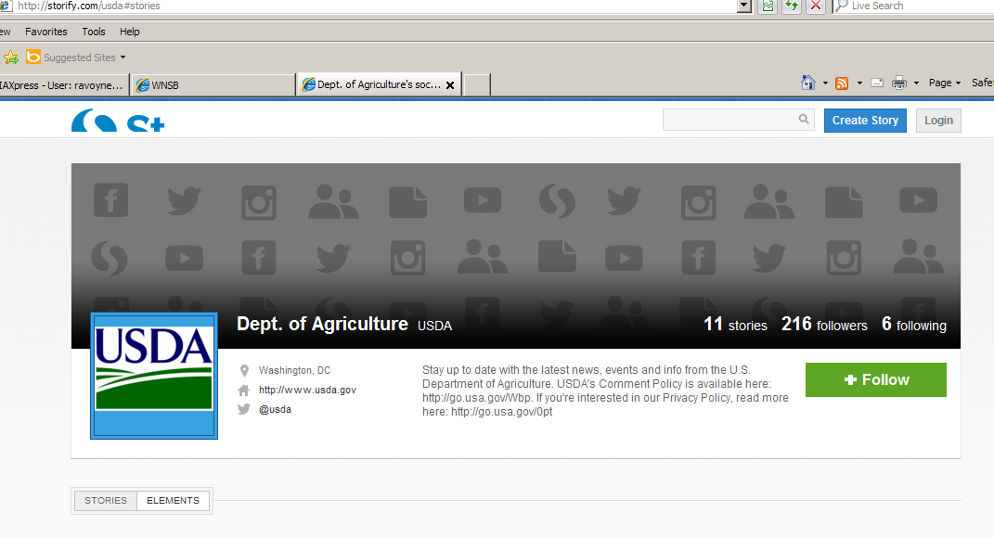



The USDA FOIA Service Center continually researches solutions and practices that promote FOIA efficiency. Based on requester feedback and FOIA case studies, the FOIA Service Center identified key areas that can be improved through new technology.

* 1. **If so, provide examples of such improvements.**

**Improved communication.** The FOIA Service Center implemented PAL to allow requesters to easily file and track the status of their requests. Given the success of PAL, the FOIA Service Center is continuing its search for new ways to engage the public.

**Simplify access to other USDA websites.** The FOIA Service Center is currently coordinating with the Office of the Administrative Law Judges (OALJ). In addition to linking the OALJ decision page to the USDA FOIA page the two offices are researching tools that would allow a requester to quickly search within all posted OALJ decisions.

**Easy website search capabilities.** The FOIA Service Center is conducting market research on leveraging applications already in use at USDA which may provide the requester with better research results. This new search technology would render information to requesters based on frequently requested records and most popular search terms used on the USDA FOIA website. This technology would also give users the ability to search for documents within the system knowledge base, and across USDA agencies’ FOIA web sites using keywords. For example, a “*most popular answers”* section could display the most popular answers prominently on USDA’s FOIA website.

**Better Search Results**. Search results could be implemented to display results based on keyword matches and a weights system.

* The ability to search for key words within PDF documents would increase the number of records the requester can search and achieve positive results without submitting a FOIA request or performing extensive searches.
* A “*guided assistance”* tab would allow the FOIA requester to narrow the scope of their search by providing user input. The FOIA requester would also have the capability to view related and previously viewed answers.

* 1. **Describe any other steps taken to increase proactive disclosures at your agency.**

As mentioned previously, USDA currently uses several popular social media tools such as blog posts, Twitter, Facebook, Flickr, RSS feeds, Storify and GovDelivery to inform the public about agency programs, policies, regulations and decisions. The use of these tools allowed USDA to expand its public outreach and initiate dialogue with the general public. Examples of our proactive disclosure using social tools are illustrated in Section III, question number 1, and Section III, question number 2.

**Section IV: Steps Taken to Greater Utilize Technology**

1. **Can a FOIA requests be made electronically to your agency?**

Yes. Registered requesters can now use the public access link on our new FOIA website to submit, check the status, and download responsive records. Please see <https://efoia-pal.usda.gov/palMain.aspx>.

1. **If your agency is decentralized, can FOIA requests be made electronically to all components of your agency?**

A FOIA request can be made electronically to all component agencies with the exception of Forest Services (FS). Requests to FS can be submitted via email at [wo_foia@fs.fed.us](mailto:wo_foia@fs.fed.us), by fax at 202-260-3245 or in writing to the FS’ FOIA Officer at 1400 Independence Avenue, S.W., Yates Building, First Floor, Ag Stop 1143, Washington, D.C. 20250. Efforts are underway to allow FOIA requesters to submit FOIA requests to FS via the public access link. The FOIA Service Center anticipates this functionality to be available later this fiscal year.

1. **Can a FOIA requester track the status of his/her FOIA request electronically?**

Yes. A requester can track the status of a FOIA request submitted via USDA’s public access link.

1. **If so, describe the information that is provided to the requester through the tracking system. For example, some tracking systems might tell the requester whether the request is open or closed, while others will provide further details to the requester throughout the course of the processing, such as search commenced or documents currently in review. List the specific types of information that are available through your agency’s tracking system.**

A registered requester can “sign in” to view the status of his/her request. The status field will indicate whether an assignment is received, assigned, perfected, whether a request for records has been sent and when the request is closed. USDA’s public access link also allows a requester to send a message to the FOIA Office or download responsive records once they are delivered.

If the requester is not a registered requester, he/she can still check the status of his/her request by clicking on “Check Request Status” on the left panel of the screen shown below.

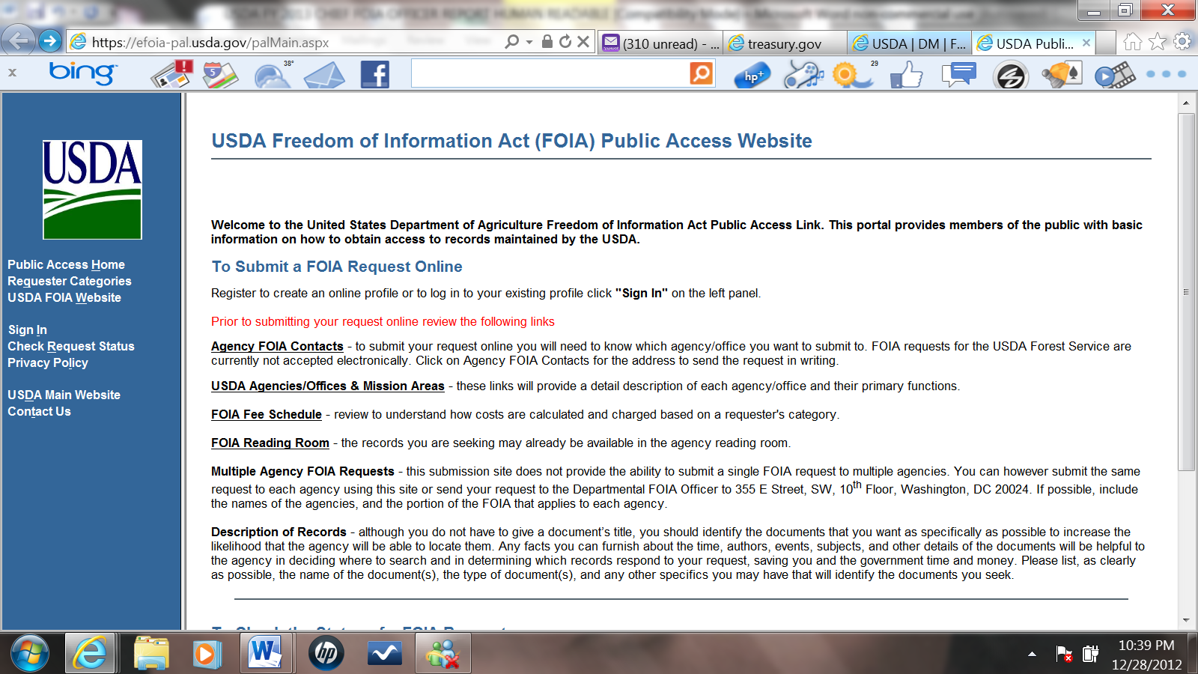

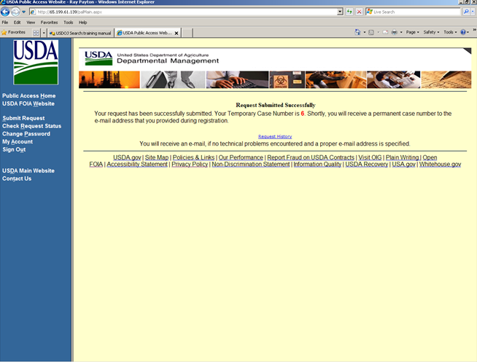

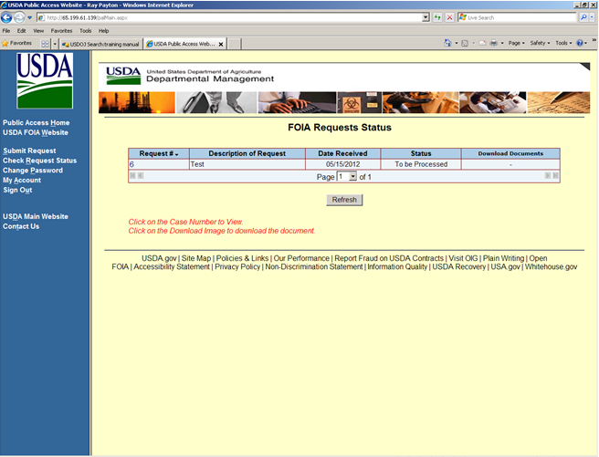

1. **In particular, does your agency tracking system provide the requester with an estimated date of completion for his or her request?**

No. The public access link does not provide the requester with an estimated date of completion for FOIA requests. PAL only provides the requester with a preset status designation, of Received, Assigned for Processing, In Process, Hold-Need Information/Clarification or On Hold – Other, Documents Delivered, and Closed.

1. **If your agency does not provide online tracking of requests, is your agency taking steps to establish this capability.**

Not applicable. USDA currently provides a public access link to track FOIA requests.

1. **Beyond using technology to redact documents, is your agency taking steps to utilize more advanced technology to facilitate overall FOIA efficiency, such as improving record search capabilities, utilizing document sharing platforms for consultations and referrals, or employing software that can sort and de-duplicate documents?**

Yes. USDA is taking steps to utilize more advanced technology to facilitate overall FOIA efficiency.

1. **If so, describe the technological improvements being made.**

In October 2012, USDA purchased an online legal search service to assist FOIA specialists with FOIA related analysis. The service provides direct access to case law, state and federal statutes, administrative codes and hundreds of other secondary sources. Each service agency was issued two licenses in addition to unlimited access to the service provider’s help desk.

USDA uses de-duplication software to assist in the efficient processing of voluminous records. In the addition to the de-duplication, the FOIA Service Center is also researching an eCase/eDiscovery tool as a means to improve accuracy and request response times. eCase/eDiscovery would provide FOIA specialist with tools to filter out non-responsive and duplicative records prior to its upload to the enterprise wide tracking system in addition to a document review process that would ensure consistency in the redaction process.

The FOIA Service Center is researching the use of an internal SharePoint site in an effort to assist its Acting Chief FOIA Officer, Acting Department FOIA Officer and FOIA specialists with the coordination and monitoring of multi-agency requests. Specifically, the SharePoint site would feature a web based dashboard that will quickly display the status of any multi-agency request. If an agency has responded to the requester, a green light will appear. Conversely, if an agency has not responded, a red light will appear. If a partial response has been provided, a yellow light will appear by the agency’s name. To ensure its accuracy, the dashboard is distributed to the USDA FOIA community on a bi-weekly basis.

If approved, the SharePoint site would also feature an online repository for FOIA records. The online repository will allow for better accessibility to records under review. It will also allow for a more efficient retrieval system for records already released but may be of interest to future requesters.

**Section V: Steps Taken to Improve Timeliness in Responding to Requests and Reduce Backlogs**

**The President and the Attorney General have emphasized the importance of improving timeliness in responding to requests. This section addresses both time limits and backlog reduction. Backlog reduction is measured both in terms of numbers of backlogged requests or appeals and by looking at whether agencies closed their ten oldest requests and appeals. *For the figures required in this Section, please use those contained in the specified sections of your agency’s 2012 Annual FOIA Report.***

1. **Section VII.A of your agency’s Annual FOIA Report, entitled “FOIA Requests – Response Time for All Processed Requests,” includes figures that show your agency's average response times for processed requests. For agencies utilizing a multi-track system to process requests, there is a category for “simple” requests, which are those requests that are placed in the agency’s fastest (non-expedited) track, based on the low volume and/or simplicity of the records requested. If your agency does not utilize a separate track for processing simple requests, answer the question below using the figure provided in your report for your non-expedited requests.**

**a. Does your agency utilize a separate track for simple requests?**

Yes. USDA utilizes a separate track for simple requests.

**b. If so, for your agency overall, for Fiscal Year 2012, was the average number of days to process simple requests twenty working days or fewer?**

No. The average number of days to process simple requests is 33.12 days.

**c. If your agency does not track simple requests separately, was the average number of days to process non- expedited requests twenty working days or fewer?**

Not applicable. USDA tracks simple requests separately.

1. **Sections XII.D.(2) and XII.E.(2) of your agency’s Annual Report, entitled “Comparison of Number of Requests/Appeals from Previous and Current Annual Report – Backlogged Requests/Appeals,” show the numbers of any backlog of pending requests or pending appeals from Fiscal Year 2012 as compared to Fiscal Year 2011. You should refer to those numbers when completing this section of your Chief FOIA Officer Report. In addition, Section VII.E, entitled “Pending Requests – Ten Oldest Pending Requests,” and Section VI.C.(5), entitled “Ten Oldest Pending Administrative Appeals,” from both Fiscal Year 2011 and Fiscal Year 2012 should be used for this section.**

**a. If your agency had a backlog of requests at the close of Fiscal Year 2012, did that backlog decrease as compared with Fiscal Year 2011?**

No. The overall number of backlogged requests increased by 14% in fiscal year 2012.

|  | Number of Backlogged Requests  as of End of the Fiscal Year from  Previous Annual Report | Number of Backlogged Requests  as of End of the Fiscal Year from  Current Annual Report |
| --- | --- | --- |
| USDA  OVERALL | **650** | **741** |

**b. If your agency had a backlog of administrative appeals in Fiscal Year 2012, did that backlog decrease as compared to Fiscal Year 2011?**

No. The overall number of backlogged administrative appeals increased by 11.6% in fiscal year 2012.

|  | Number of Backlogged Appeals as of End of the Fiscal Year from Previous Annual Report | Number of Backlogged Appeals as of End of the Fiscal Year from Current Annual Report |
| --- | --- | --- |
| USDA  OVERALL | **146** | **163** |

**c. In Fiscal Year 2012, did your agency close the ten oldest requests that were pending as of the end of Fiscal Year 2011?**

No. USDA did not close its ten oldest pending requests from the previous fiscal year. Although USDA as a whole did not close its ten oldest pending requests, several agencies within the Department closed their agencies’ ten oldest requests.

**d. In Fiscal Year 2012, did your agency close the ten oldest administrative appeals that were pending as of the end of Fiscal Year 2011?**

No. Although USDA did not close the overall ten oldest pending appeals from the previous fiscal year, there were several agencies that did successfully close its ten oldest appeals.

1. **If you answered “no” to any of the above questions, describe why that has occurred. In doing so, answer the following questions then include any additional explanation:**

**Request Backlog:**

**a. Was the lack of a reduction in the request backlog a result of an increase in the number of incoming requests?**

No. The lack of reduction cannot be attributed to the increase in the number of requests as the overall number of incoming requests decreased in fiscal year 2012.

**b. Was the lack of a reduction in the request backlog caused by a loss of staff?**

Yes. The lack of reduction can be attributed to the decrease in full-time FOIA staff in fiscal year 2012. There was a 28% reduction in the total number of full-time FOIA staff.

**c. Was the lack of a reduction in the request backlog caused by an increase in the complexity of the requests received?**

Yes. Most agencies reported an increase in the complexity of the requests received.

**d. What other causes, if any, contributed to the lack of a decrease in the request backlog?**

Another factor contributing to the decrease in the number of requests processed is the increase in the number of records to be reviewed for each request. In fiscal year 2012, the FOIA Service Center estimates its average number of records requiring review to be 1,000 pages.

**Administrative Appeal Backlog:**

**a. Was the lack of a reduction in the backlog of administrative appeals a result of an increase in the number of incoming appeals?**

No. The lack of reduction in the backlog of administrative appeals is not the result of an increase in the number of incoming appeals as the overall number of appeals in fiscal year decreased.

**b. Was the lack of a reduction in the appeal backlog caused by a loss of staff?**

Yes. The lack of reduction in the appeal backlog was due to the loss of full-time FOIA staff. There was a 28% reduction in the total number of full-time FOIA staff.

**c. Was the lack of a reduction in the appeal backlog caused by an increase in the complexity of the appeals received?**

Yes. Service agencies reported an increase in the complexity of appeals received.

**d. What other causes, if any, contributed to the lack of a decrease in the appeal backlog?**

The USDA FOIA Service Center noted a number of appeals received this fiscal year required an increased level of coordination between USDA offices. This compounded by the decrease in full time equivalents impacted the appeal backlog.

1. **OIP has issued guidance encouraging agencies to make interim releases whenever they are working on requests that involve a voluminous amount of material or require searches in multiple locations. By providing rolling releases to requesters agencies facilitate access to the requested information. If your agency had a backlog in Fiscal Year 2012, please provide an estimate of the number of cases in the backlog where a substantive, interim response was provided during the fiscal year, even though the request was not finally closed.**

USDA estimates it sent 300 substantive interim responses in connection with backlogged requests in fiscal year 2012.

### ****Use of FOIA’s Law Enforcement “Exclusions”****

**In order to increase transparency regarding the use of the FOIA’s statutory law enforcement exclusions, which authorize agencies under certain exceptional circumstances to “treat the records as not subject to the requirements of [the FOIA],” 5 U.S.C. § 552(c)(1), (2), (3), please answer the following questions:**

1. **Did your agency invoke a statutory exclusion during Fiscal Year 2012?**

No. USDA did not invoke 5 U.S.C. § 552(c)(1), (2) or (3) in Fiscal Year 2012.

1. **If so, what was the total number of times exclusions were invoked?**

Not applicable. USDA did not invoke any statutory exemptions.

### ****Spotlight on Success****

**Out of all the activities undertaken by your agency since March 2012 to increase transparency and improve FOIA administration, describe here one success story that you would like to highlight as emblematic of your agency’s efforts. The success story can come from any one of the five key areas.**

**Food Nutrition and Consumer Services (FNCS):**

As part of its FNCS management review, FNCS’ FOIA program was selected to participate in the Lean Six Sigma (LSS) process. LSS is a process improvement framework that improves quality and efficiency of outputs by identifying and finding solutions for the removal of waste.

FNCS’ FOIA program began this initiative by conducting interviews with the staff, mission offices and record holders in February 2012. During interviews, the FNCS FOIA Office identified several areas for improvements. Top on the list however, was a 20% reduction in processing times.

After a lengthy review and analysis, FNCS implemented a LSS process improvement plan. The plan reduced the average processing time from 21 days to 16 days.

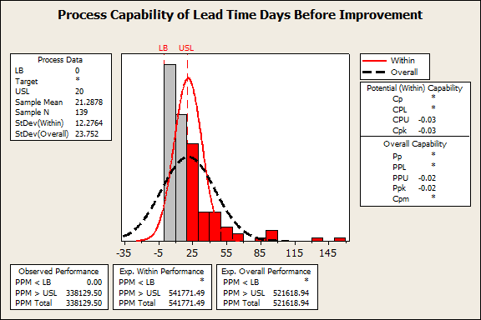

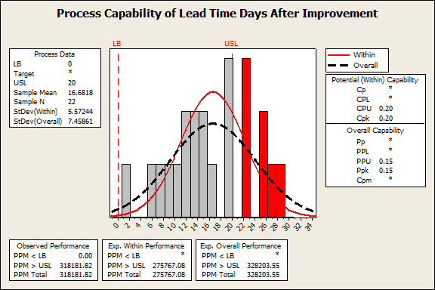

In addition to the LSS initiative, FNCS admirably closed out nine of its ten oldest appeals, and conducted specialized FOIA training for the FNCS Contracting/Acquisition Division. FNCS also implemented policy and implemented standards to ensure that FOIA fees are accurately calculated and assessed.

**Office of the Secretary/Office of the Chief Information Officer (OSEC/OCIO):**

In fiscal year 2012, OSEC/OCIO prepared and executed a strategy to reduce its backlog and close it ten oldest pending perfected requests and appeals. The plan turned out to be a great success as OSEC/OCIO increased the number of requests processed by more than 50% in fiscal year 2012 despite receiving 24% more requests.

|  |  |  |  |  |
| --- | --- | --- | --- | --- |
| **FY** | **Number of Requests Pending as of Start of Fiscal Year** | **Number of Requests Received in Fiscal Year** | **Number of Requests Processed in Fiscal Year** | **Number of Requests Pending as of End of Fiscal Year** |
| **FY2011**  **OSEC/OCIO** | 26 | 89 | 52 | 63 |
| **FY 2012 OSEC/OCIO** | 65 | 111 | 144 | 32 |

**Note**: The number of FOIA requests pending as of the start of FY2012 differs from the number of FOIA requests pending as of the end of FY2011 due to a recent migration initiative.

As for its 10 oldest pending perfected requests, OSEC/OCIO was able to close eight of the ten from the previous fiscal year. All the pending appeals with the exception of one were also closed.

Most requests and appeals processed required the review of several thousand pages of potentially responsive records and/or coordination between multiple offices within the Office of the Secretary. In any instance where substantive interim responses could be provided, FOIA specialist worked with requesters to establish a delivery schedule.

**Research, Education and Economics (REE):**

REE provides FOIA program support services to the Agricultural Research Service, Economic Research Service, the National Agricultural Library, National Institute of Food and Agriculture. The following spotlights on success are from agencies serviced by REE.

**Agricultural Research Service (ARS) Spotlight on Success:**

“Your Two Cents” (Y2C), an “uncensored direct communication line” to senior leadership for ARS employees, received the USDA Secretary’s Award in September 2012 for this culture-changing employee feedback and communications forum, which facilitates inclusion for employees and continuous improvements for ARS.  This initiative was designed by REE mission area leaders to solicit ideas and input about work and organization from ARS employees across the organization.  This website tool, a program for ARS employees only, allows direct access to Agency leaders to share information on current business processes, work challenges and/or concerns.  The hope is that Y2C will, through the sharing of employees’ ideas and vision, continue to help transform ARS into the 21st Century scientific enterprise it can and should be.  Other agencies in USDA have taken note of the Y2C program, offering it as a model program for employee engagement and transparency.  As of December 1, 2012, Y2C has received over 1,309 total individual ideas (increase of 46 percent from 2011 total) and 1,506 total comments on those ideas (increase of 79 percent over 2011 total). Perhaps most importantly, there are currently 154 actions on the site, 125 (81 percent) of which are completed.  The ‘Completed’ list consists of a myriad of items from minor facility issues to substantive, high-level, Agency-wide policy change and implementation.



**Agricultural Research Service (ARS), National Agricultural Library (NAL), Spotlight on Success:**

Consumers’ interest in how agricultural products are grown and made is on the rise along with concern for the environment. Researchers and members of the food industry are gathering data about these products and processes using the Life Cycle Assessment. This widely used tool assesses potential environmental impacts for a given product, process, or activity throughout its entire life span. But few information resources exist to share these assessments.  In response, the National Agricultural Library has launched the LCA Digital Commons.  This website offers the public access to a broad inventory of peer-reviewed, standard-formatted United States Life Cycle Assessment data.  Data for 536 U.S. commodity crop unit processes including corn, wheat, soybeans, cotton, oats, peanuts, and rice have been uploaded and are fully searchable. The LCA Digital Commons offers the best quality, and most accurate data representative of U.S. agricultural production practices. The sharing of this information will allow consumers and businesses to make informed decisions about changing processes or the materials that go into them to reduce the burden on the environment.

For more information, visit the LCA Digital Commons: <http://www.lcacommons.gov>

**Economic Research Service (ERS) Spotlight on Success:**

In the summer of 2012, the U.S. experienced one of the most severe and extensive droughts in 25 years.  A group of ERS economists and IT professionals rapidly compiled information on the impacts of the ongoing drought on food prices and consumers, farms, and the crop and livestock sectors. The initial version of the web page “U.S. Drought 2012: Farm and Food Impacts” was posted within two days of the initial meeting of the development team, and has since been updated continuously to reflect changing conditions.  One goal of the project was to rapidly and widely disseminate key ERS research findings, data, and analysis to the public to provide information on a high-visibility issue of the day.  The rapid response enabled the Department to quickly provide information on the economic dimensions of the ongoing drought through links from the main USDA website.  Information from the Drought Page supported Departmental decision-making on responses to the drought, and was widely cited in news media, providing a wide audience for the latest ERS economic information.  By the end of 2012, the Drought Page received over 25,000 page views on the ERS website, and was the most frequently visited page of the Website in November 2012.  An example of the information provided in the drought 2012: Farm and Food Impact is provided below (<http://www.ers.usda.gov/topics/in-the-news/us-drought-2012-13-farm-and-food-impacts.aspx>).

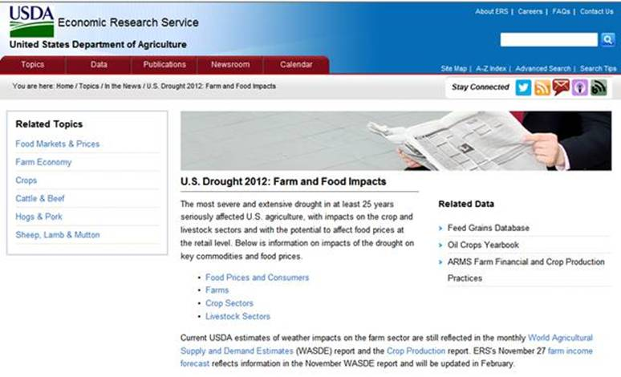

**National Agricultural Statistics Service (NASS) Spotlight on Success:**

The USDA’s National Agricultural Statistics Service (NASS) conducts hundreds of surveys every year and prepares reports covering virtually every aspect of U.S. agriculture. Production and supplies of food and fiber, prices paid and received by farmers, farm labor and wages, farm finances, chemical use, and changes in the demographics of U.S. producers are only a few examples.

In order to streamline operations and to improve statistical services, NASS enhanced its Quick Stats 2.0 data query tool and introduced its new Quick Stats Lite tool.  Quick Stats 2.0 is the most comprehensive tool for accessing NASS published agricultural data.  The system allows the user to discover exactly the information they desire, whether it is based on commodity, location, or time period. The user can visualize the data on a map, manipulate and export the results, or save a link for future use.  NASS also introduced its new Quick Stats Lite tool (an interface to Quick Stats 2.0) that offers a more guided approach to NASS’ most common data requests.  These tools will allow NASS to publish all of its available data online, ensuring quick and easy access for the public.  In addition to its surveys, the Spatial Analysis Research Section within the Research and Development Division of NASS has produced a yearly Cropland Data Layer (CDL) product based on mid-resolution satellite data and high quality ground truth since 1997.  This agricultural geospatial data is a crop and other specific land cover classification encompassing the entire contiguous United States.  To effectively and efficiently meet the growing needs of our customers, CropScape was developed to query, visualize, disseminate, and analyze CDL data geospatially through standard geospatial Web services in a publicly accessible online environment. CropScape not only offers the online functionalities of interactive map operations, data customization and downloading, crop acreage statistics, charting and graphing, and multitemporal change analysis as well in an interoperable manner, but also provides Web geoprocessing services such as automatic data delivery and on-demand crop statistics for uses in other applications. This system delivers dynamic user experiences with its comprehensive capabilities in an open geospatial context, and facilitates delivery and analysis of geospatial cropland information for decision support and various research endeavors. More than 17,000 users around the world have visited CropScape in its first 5 months of availability.