Statement of Findings
Executive Order 11990: Protection of Wetlands
INDU 211(1), Rehabilitation of East State Park Road, Realignment of Mt. Baldy Entrance, and Miscellaneous Improvements

Indiana Dunes National Lakeshore
Porter and La Porte Counties, IN

Introduction

The Indiana Dunes National Lakeshore (National Lakeshore) has prepared and made available an Environmental Assessment (EA) for proposed roadway improvements at East State Park Road and the Mt. Baldy Entrance Road. Executive Order 11990: Protection of Wetlands requires the National Park Service (NPS) and other federal agencies to evaluate the likely impacts of action in wetlands. NPS Director’s Order #77-1: Wetland Protection and Procedural Manual #77-1 provide NPS policies and procedures for complying with Executive Order 11990. This Statement of Findings (SOF) documents compliance with these NPS wetland protection procedures.

The alternatives analyzed in the EA were divided under two locations, East State Park Road (Route 211) and the Mt. Baldy Entrance Road (Route 209). At the Mt. Baldy Entrance Road location, the Build Alternative was determined to be the preferred alternative in the EA. The Build Alternative would have no impact on wetlands because the relocation of the intersection would be on the north side of U.S. Route 12, and the wetland is located on the south side of U.S. Route 12. Therefore, this SOF for the Protection of Wetlands analyzes only the East State Park Road location.

The EA was released for public comment from September 18, 2006 through October 17, 2006 without identifying the preferred alternative because the property west of the East State Park Road is owned by the State of Indiana and managed by the Indiana Dunes State Park, not the National Lakeshore. The Town of Beverly Shores owns the roadway itself; however the NPS owns the land east of the East State Park Road and has authority to maintain the roadways through the National Lakeshore. This SOF also documents the determination of the preferred alternative.

Through coordination with the Indiana Dunes State Park, the Town of Beverly Shores, and the National Lakeshore following the public comment period, the Multiple Trench Drain Alternative was determined to be the preferred alternative for the East State Park Road location. The Multiple Trench Drain Alternative best addresses the standing water on the roadway while impacting the least acreage of wetlands. The removable grates of the trench drain would allow for easier maintenance than culverts, which could easily become clogged with sediment and organic debris. The Obliteration Alternative and Flow-Control Berm Alternative would not adequately address the standing water on the roadway.

Proposed Action

Under the Multiple Trench Drain Alternative, the existing concrete and asphalt pavement of East State Park Road and Beverly Drive would remain in place. In order to widen the roadway to current design standards, the material east of East State Park Road and on either side of Beverly Drive would be excavated, and rip-rap would be placed up to the elevation of the roadway. Multiple trench drains would be placed on top of the roadway in order to allow water to mimic its existing flow across the roadway. Fill material would be placed between the trench drains and asphalt pavement would be placed on top of the fill material and adjacent to the trench drains, so that the metal grate of the trench drains and asphalt surface would create a continuous driving surface. If determined as necessary during the design process, a headwall may be constructed on each side of the trench drain. The number of trench drains would be determined during the design process. The raised surface with trench drains across the roadway would extend no longer than 1,000 feet along East State Park Road, and no longer than 300 feet along Beverly Drive. These distances would also be determined during the design process. The new roadway would be constructed according to current design standards; therefore the raised roadway would be approximately 28 feet wide (two ten-foot lanes with 4-foot shoulders), which is 10 feet wider than the existing pavement. The roadway would be raised approximately 24 inches. In order to calculate the impact areas to compare the alternatives the following assumptions were used: a roadway height of 2.0 feet above existing, a length of 1,300 feet for the raised roadway, and a slope ratio of 4:1 to the existing ground elevation.
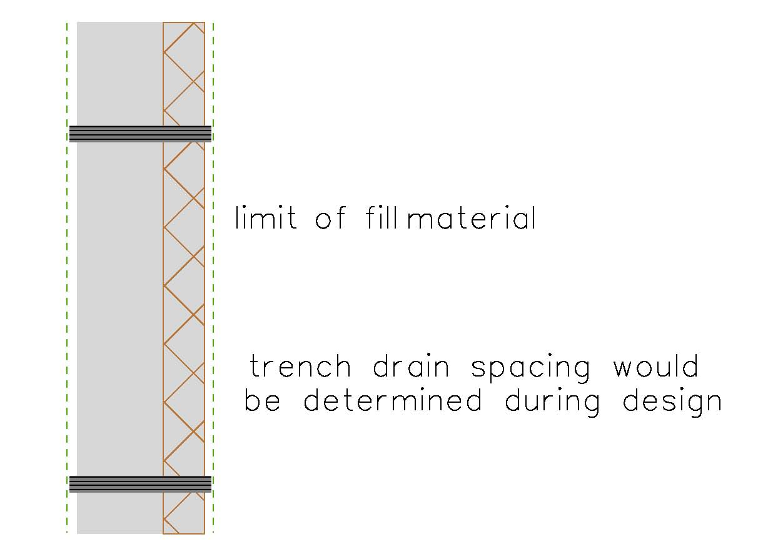

Figure 1: Multiple-Trench Drain Alternative

Site Description

To determine if potential wetlands exist within the study area, National Wetland Inventory (NWI) mapping and the National Resources Conservation Service’s (NRCS) Soil Survey were reviewed for Porter and La Porte Counties and a wetland delineation was performed to delineate the boundaries of “waters of the United States,” including wetlands, which occur within the National Lakeshore rights-of-way along the intersection of East State Park Road and Beverly Drive in Porter County and the intersection of the Mt. Baldy Entrance Road and U.S. Route 12 in La Porte County.

Figure 2: The study area is comprised mostly of wetlands.

During the wetland delineation in June of 2005, 6 wetlands totaling 15.41 acres and 2 ditches, both within wetlands, were identified on the Porter County site. NWI maps show that the area surrounding East State Park Road at the intersection of Beverly Drive is surrounded by palustrine emergent semipermanently flooded (PEMF) and palustrine forested broad leaf deciduous seasonally flooded (PFO1C) Cowardin classifications of wetlands. Dominant vegetation in the PEMF wetland includes hybrid cattail, lesser duckweed (Lemna minor, OBL), and silky dogwood (Cornus amomum ssp. obliqua, FACW+). The area is inundated with up to 4 inches of water. Dominant vegetation in the PFO1C wetland includes green ash (Fraxinus pennsylvanica, FACW), red maple (Acer rubrum, FAC), slippery elm (Ulmus rubra, FACW-), spicebush (Lindera benzoin, FACW-), skunk cabbage (Symplocarpus foetidus, OBL), marsh marigold (Caltha palustris, OBL), swamp star sedge (Carex seorsa, FACW+), and spotted touch-me-not (Impatiens capensis, FACW). Soils were saturated at the surface, and there was free water at a depth of 4 inches in the test pit. Soils in the test pit were muck with a matrix color of 10YR 2/1 in the upper 14 inches, and sand with a matrix color of 2.5Y 4/1 at a depth of 14 to 18 inches. The soils contained a high level or organic material. The delineation verifies the presence of United States Army Corps of Engineers jurisdictional wetlands.

The wetlands in the project area are part of a larger context of the Great Marsh, an extensive wetland complex. The Great Marsh consists of approximately 3,270 acres. This area has historically been ditched and drained however several efforts in the area have been in the process of restoring the Great Marsh. In conjunction with these efforts, the National Lakeshore is in the process of restoring portions of the Great Marsh south of the primary dunes in the eastern half of the Park. The goal is to re-create a diverse and attractive ecosystem by plugging ditches, restoring the area's hydrology, removing invasive plants, and planting native species.

Wetlands Functional Assessment

These wetlands function as flood attenuation and wildlife habitat, and provide recreational opportunities for National Lakeshore visitors. These emergent wetlands do not provide habitat for any federally-listed threatened or endangered species. However, they do provide habitat for a wide variety of mammals, birds, reptiles and amphibians. Bird watching is widely enjoyed in this part of the National Lakeshore, and a higher volume of amphibian calls has been recorded in the northeast quadrant of the intersection of East State Park Road and Beverly Drive. These wetlands also maintain plant communities and provide for nutrient cycling between the plant community, animal community and detritus/decomposers.

Surface water was present within the wetland areas and most of the project area soils were saturated within 12 inches of the surface at the time of delineation. During high precipitation events, the wetlands likely provide limited floodwater detention. Some portion of any floodwater volume detained is likely to be evaporated or transpired, which would reduce the overall volume of floodwater. The detention of water also allows for the retention of particulates such as nutrients, minerals, heavy metals, and sediment deposition; which all influence downstream water quality. These wetlands are abundant throughout the National Lakeshore.

Impacts to Wetlands

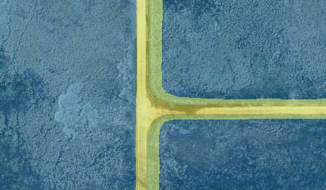
Figure 3: The wetlands surrounding the study area (highlighted in blue) would be impacted through the widening of East State Park Road and Beverly Drive (highlighted in yellow) to accommodate raising the roadway to construct trench drains and constructing the road to current design standards.
In order to access the project area and construct the Multiple Trench Drain Alternative, heavy construction equipment would access the area, causing the trampling of vegetation and compaction of soils. The excavation and placement of rip-rap in order to widen the roadway and construct shoulders for the installation of the trench drains would directly impact approximately 0.78 acres of primarily PEMF wetlands. A negligible area (less than 0.10 acre) of the PFO1C wetlands may be impacted in the area south of the intersection, however impacts to these wetlands would be avoided to the maximum extent possible. The PFO1C wetlands are located approximately 225 feet south of the intersection, and may be impacted during construction or the tapering of the new widened roadway portion to tie into the existing roadway. The roadway widening would only extend south from the intersection a maximum of approximately 200 feet. Approximately 0.30 acres of impact would be permanent due to the placement of asphalt to widen the roadway, however portions of the 0.48-acre slopes to the existing ground elevation may return to wetlands. The Multiple-Trench Drain Alternative would have a long-term minor adverse impact to wetlands because of the direct impact to the wetlands adjacent to East State Park Road and Beverly Drive.

Justification for Use of the Wetlands

The purpose of this project is to improve safe access for vehicles along East State Park Road and Beverly Drive while minimizing disruption to the surrounding wetland environment, and improve safety at the intersection of the Mt. Baldy Entrance Road and U.S. Route 12. The improvements must be done to the existing roadways; therefore there are no alternate sites.

Investigation of Alternative Sites

In addition to the preferred alternative, three action alternatives and a no action alternative were considered. The purpose of the project is to improve safety at this intersection of East State Park Road and Beverly Drive; therefore the use of an alternative site is not feasible. All of the action alternatives are located at this intersection. The Multiple Trench Drain Alternative and the Multiple Culvert Alternative include widening the existing 18 foot roadways by 10 feet in the vicinity of the intersection to meet current safety standards.

No Action - No pavement rehabilitation would take place on East State Park Road. Flooding would continue to occur on the roadway and likely worsen over time. Maintenance activities would continue on the roads. Without addressing the deteriorated roadway, the safety hazard of standing water on the roadway, and the unsafe intersection; the NPS would be unable to ensure that visitors would be able to safely access the National Lakeshore.

Multiple Culvert Alternative – Culverts would be placed at the current elevation of the road, and a new roadway surface would be constructed on top of the culverts. Approximately 1.50 acres of wetlands would be impacted as a result of widening and raising the roadway. The Multiple-Culvert Alternative would address the deteriorating roadway and the safety hazard of standing water on the roadway, however this alternative would introduce the largest amount of fill and impact the most wetlands in order to raise the roadway and provide for appropriate road shoulders.

Multiple Trench Drain Alternative, Proposed Action – Trench drains would be placed at the current elevation of the road, and a new roadway surface would be constructed between the trench drains. Approximately 0.78 acres of wetlands would be impacted as a result of widening and raising the roadway. The Multiple-Trench Drain Alternative would address the deteriorating pavement and the safety hazard of standing water on the road. The roadway would be raised less by the Multiple-Trench Drain Alternative than the Multiple-Culvert Alternative, which lessens the impacts to the wetlands and vegetation, while achieving the same end result of keeping water off of the roadway. This alternative would also allow for the movement of water similar to the existing conditions without impacting the water elevations of the surrounding wetlands.

Obliteration Alternative – Approximately 200 feet of Beverly Drive from the East State Park Road intersection eastward would be obliterated, and so Beverly Drive would become a dead end at the existing parking area that serves the paved bird-watching trail. Water would flow freely from the area northeast of the intersection to the area southeast of the intersection. Approximately 0.08 acres of wetland would be created by removing a portion of the roadway. The Obliteration Alternative would address the deteriorating pavement and decrease the amount of standing water on the road. However, this alternative would affect the water level and therefore the bird and amphibian habitat in the area northeast of the intersection, because with a portion of Beverly Drive removed water would be able to flow south and equalize. This alternative would also impact visitor use and experience because visitors would no longer be able to access East State Park Road via Beverly Drive.

Flow-Control Berm Alternative – An earth berm would be constructed parallel to East
State Park Road, and a second berm parallel to Beverly Drive. A ditch would be constructed between the berm and road shoulder. Excavation would be required so that stronger impermeable fill material could be used to construct the berm and ditch. The height of the berm would equal the desired maximum water elevation that is preferred for the northeast wetland area. The berms would retain surface water in the wetland up to the maximum level, then would allow overflow to enter the ditch. A gate or alternative adjustable mechanism could be installed to allow the adjustment of the water level behind the berm. Approximately 0.25 acres of wetland would be impacted by the berm. The Flow-Control Berm Alternative would address the deteriorating pavement and decrease the amount of standing water on the road. This alternative would be difficult to construct due to the sandy organic composition and saturation of the soils in the project area. Water levels may rise in the wetland area behind the berm, which may impact vegetation, wildlife, and the functions of the surrounding wetlands.

Other Permits

In order to construct the project, permits relating to the wetland impacts would be necessary. The United States Army Corps of Engineers (Corps) has authority over the discharge of fill or dredged material into “waters of the United States.” This includes authority over any filling, mechanical land clearing, or construction activities that occur within the boundaries of any “water of the United States,” which includes wetlands. Clean Water Act Section 401 Water Quality Certification must be obtained from the Indiana Department of Environmental Management, ensuring that proposed that would result in discharges to surface water are consistent with the Clean Water Act. Also, the Indiana State Wetland Permit Program requires that any activity that may affect a state regulated isolated wetland be permitted as outlined in HEA 1798. For regulated wetland activities in state regulated wetlands, compensatory mitigation is required.

Mitigative Actions

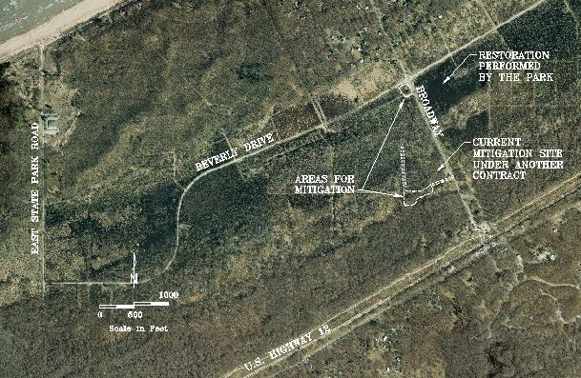
Figure 4: The areas proposed for wetland mitigation are located east of the proposed roadway improvements.

The wetland mitigation would be designed to address all compensatory mitigation requirements of the applicable regulatory agencies. The Chicago District of the Corps typically requires that a minimum of 1.5 acres mitigated for every 1.0 acre of wetland impacted. Using this ratio, approximately 1.17 acres of wetland restoration would be required, assuming the entire 0.78 acres of wetland are impacted. Wetland mitigation would focus on old homesites and abandoned roadbeds immediately east of Broadway in the eastern section of the Great Marsh, all within the boundaries of the National Lakeshore. Two previous homesites have been identified as mitigation areas, and total approximately 2.5 acres. The wetland restoration would focus on returning this area to palustrine emergent sedge meadow/prairie wetlands. Restoration would include the removal of weedier upland species, trees, garlic mustard and other non-desirable vegetation. Existing fill would be removed and neighboring ditches plugged resulting in a return to the original wetland hydrology. A wide selection of native plants would be installed, managed and monitored for a minimum of five years. The end product would be a species diverse wetland with natural ecosystem processes, which is expected to fully function within three years of the completion of restoration. The wetland mitigation would be funded by the Park Roads and Parkways Program and constructed as part of the proposed roadway improvement project to limit the temporal loss of wetland acreage. The restoration of these previously developed sites would provide additional wildlife habitat, recreational opportunities, and limited water quality improvement and flood water storage; the functions lost through the impact of the proposed action.

Conclusion

The NPS concludes that there is no practical alternative to improve safe access for vehicles along East State Park Road and Beverly Drive while minimizing disruption to the surrounding wetland environment, and improve safety at the intersection of the Mt. Baldy Entrance Road and U.S. Route 12. The preferred alternative would substantially improve safety as there would no longer be standing water on the roadway while continuing the existing flow of water. Mitigation and compliance with regulations and policies to prevent impacts to wetlands and water quality would be strictly adhered to during and after the construction. Individual permits with other federal and cooperating state and local agencies would be obtained prior to construction activities. No long-term major adverse impacts would occur from the Preferred Alternative. Therefore, the NPS finds the Preferred Alternative to be acceptable under Executive Order 11990 for the protection of wetlands.

References

Cowardin, L.M., V. Carter, F.C. Golet, and E.T. LaRoe. 1979. Classification of Wetlands and Deepwater Habitats of the United States. U.S. Fish and Wildlife Service.
National Park Service, U.S. Department of Interior. 1998. Director’s Order #77-1: Wetland Protection. Washington, D.C.
National Park Service, U.S. Department of Interior. 2001. Director’s Order #77-2: Floodplain Management. Washington, D.C.

