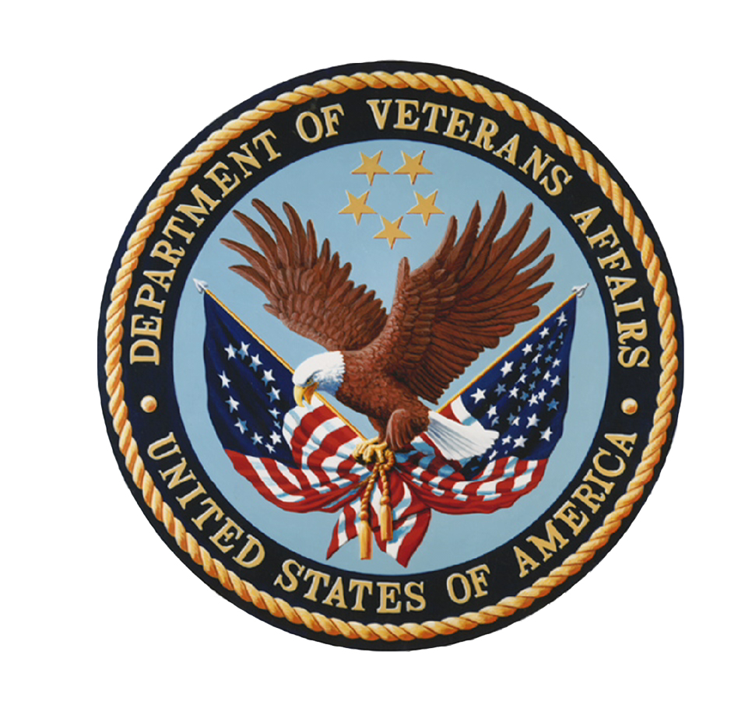

The Department of Veterans Affairs Diversity Council (VADC) Quarterly Meeting
VACO, 810 Vermont Avenue, NW, Conference Room 830
1-800-767-1750, Access Code 79443
Wednesday, October 3, 2012
1:00–3:00 PM (Eastern Time)
Program Agenda

1:00 (5 min.) Introductions & Welcome (Ralph Torres, Acting Assistant Secretary for Human Resources and Administration [HR&A] and VADC Co-chair; and/or Georgia Coffey, Deputy Assistant Secretary for Diversity and Inclusion, Office of Diversity and Inclusion [ODI], and VADC Co-chair)

1:05 (10 min.) Diversity Council Operations
- Approval of June 6, 2012, VADC Meeting Minutes (Georgia Coffey)
- Status of Secretary’s Third Annual Diversity and Inclusion Excellence Awards Program (Yvonne Rannels, ODI)

1:15 (10 min.) Emerging Issues in Diversity and Inclusion Committee
- National Center for Organization Development (NCOD) Qualitative Secondary Analysis Proposal (Kelley Carameli, Health Science Specialist, VHA NCOD)

1:25 (5 min.) Management Directive 715 Data Call (Thomas Middleton, Analyst, ODI)

1:30 (20 min.) Hispanic Employment Program (HEP) (Arlene Gonzalez, National Hispanic Employment Program Manager, ODI)
- Strategic Plan for Hispanic Employment, Outreach and Retention
- Call for Committee Members

1:50 (60 min.) Diversity and Inclusion Strategic Plan Reports
- Veterans Health Administration (Audrey Oatis-Newsome, Director, VHA EEO/Affirmative Employment Office)
- Veterans Benefits Administration (Bonnie Miranda, Associate Deputy Under Secretary for Management)
- National Cemetery Administration (Perdita Johnson-Abercrombie, EEO Manager)
- Staff Offices (Open)

2:50 (10 min.) New Business (Open Forum)
- Executive Training (Carolyn Wong, Director, Training and Communications, ODI)
- Corporate Recruitment Outreach Group (VESO, CMV, SCOS & ODI) (Tinisha Agramonte, Director, Outreach and Retention, ODI)

3:00 Meeting Adjourn: Next Meeting January 16, 2013

