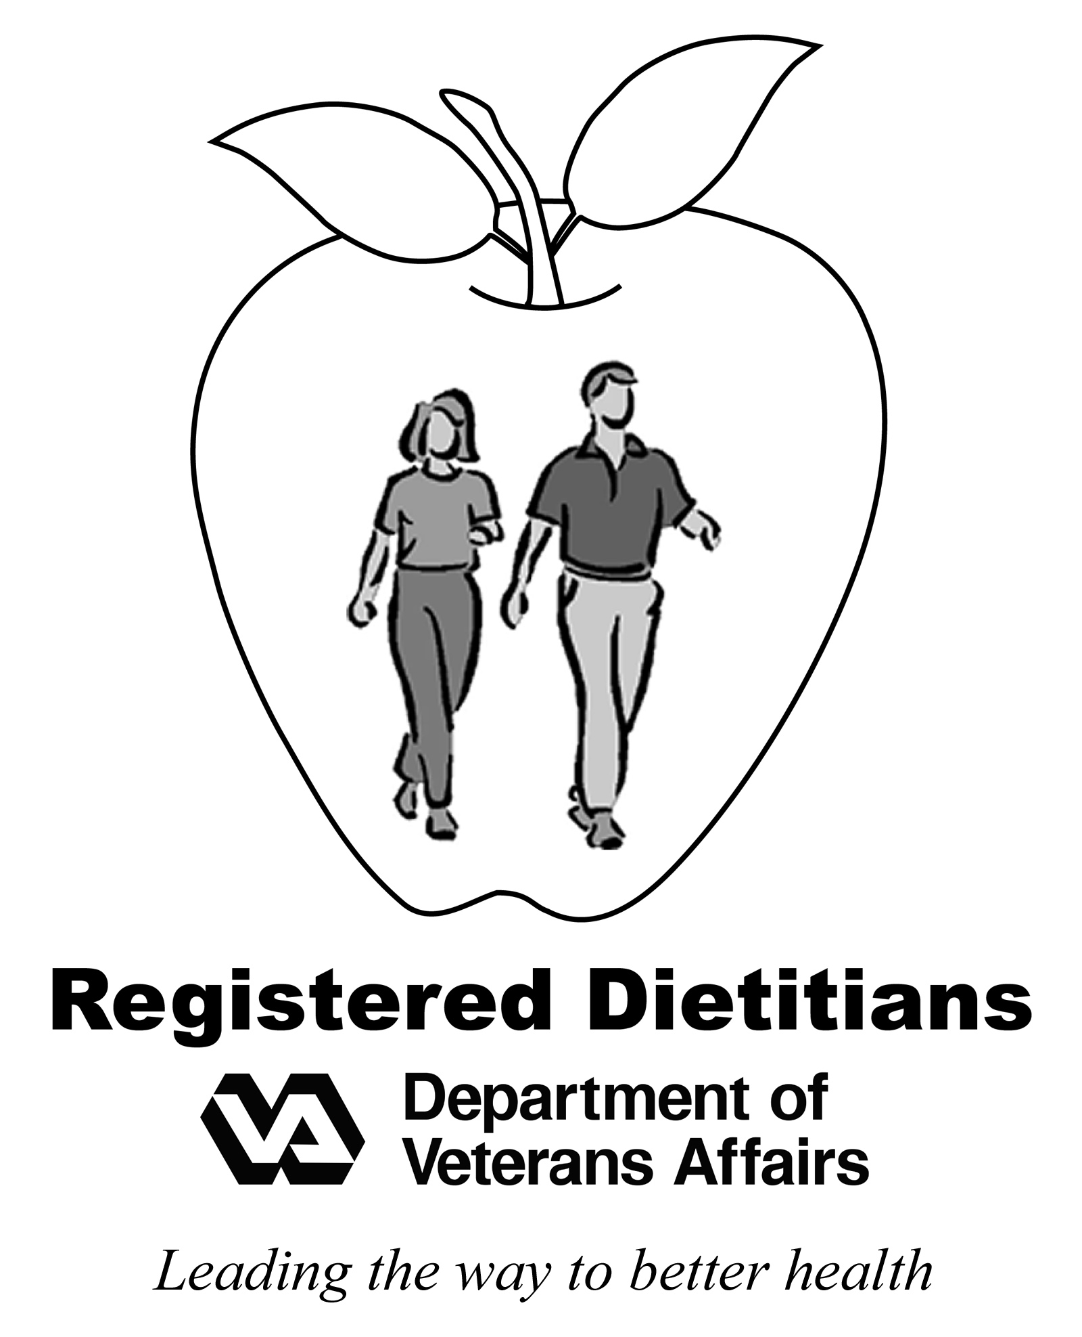

**Vitamin K Content**

**of Foods**

MCj03312570000[1]

|  |  |  |  |  |  |
| --- | --- | --- | --- | --- | --- |
| High Vitamin K Foods (more than 100 mcg) | | | | | |
| **Food** | **Serving** | **mcg** | **Food** | **Serving** | **mcg** |
| Broccoli | 1/2 cup | 110 | Greens, turnip, frozen | 1/2 cup | 425 |
| Brussels sprouts | 1/2 cup | 150 | Kale, fresh or frozen | 1/2 cup | 550 |
| Endive, raw | 1 cup | 116 | Kale, raw | 1/2 cup | 274 |
| Greens, beet | 1/2 cup | 350 | Onions, green or scallion | 1/2 cup | 103 |
| Greens, collard | 1/2 cup | 418 | Parsley, raw | 10 sprigs | 164 |
| Greens, collard, frozen | 1/2 cup | 530 | Spinach | 1/2 cup | 444 |
| Greens, mustard | 1/2 cup | 210 | Spinach, raw | 1 cup | 145 |
| Greens, turnip | 1/2 cup | 265 | Swiss chard | 1/2 cup | 287 |

|  |  |  |  |  |  |
| --- | --- | --- | --- | --- | --- |
| **Moderate Vitamin K Foods (25-100 mcg)** | | | | | |
| **Food** | **Serving** | **mcg** | **Food** | **Serving** | **mcg** |
| Asparagus | 5 spears | 38 | Lettuce, green leaf | 1 cup | 97 |
| Asparagus, frozen | 1/2 cup | 72 | Lettuce, romaine | 1 cup | 57 |
| Broccoli, raw | 1/2 cup | 45 | Noodles, spinach | 1/2 cup | 81 |
| Cabbage, coleslaw | 1/2 cup | 37 | Okra, frozen | 1/2 cup | 44 |
| Cabbage, green | 1/2 cup | 82 | Prunes, dried | 5 each | 25 |
| Dried peas, black-eyed | 1/2 cup | 32 | Tuna, light, canned in oil | 3 oz. | 37 |
| Kiwi fruit | 1 medium | 31 | Watercress, raw | 1 cup | 85 |

MCj02508110000[1]

|  |  |  |  |  |  |
| --- | --- | --- | --- | --- | --- |
| Low Vitamin K Foods (less than 25 mcg) | | | | | |
| **Food** | **Serving** | **mcg** | **Food** | **Serving** | **mcg** |
| Artichoke | 1 medium | 18 | Nuts, pine, cashews | 1 oz. | 15 |
| Avocado, raw | 1 oz. | 6 | Oil, olive | 1 tbsp | 8 |
| Beans, green or yellow | 1/2 cup | 10 | Oil, soybean, canola, salad type | 1 tbsp | 10-25 |
| Blackberries or blueberries | 1/2 cup | 14 | Papaya | 1 medium | 8 |
| Cabbage, raw | 1/2 cup | 21 | Parsley, dried | 1 tbsp | 18 |
| Carrots and carrot juice | 1/2 cup | 11-18 | Pear | 1 medium | 8 |
| Cauliflower | 1/2 cup | 9 | Peas, green | 1/2 cup | 19 |
| Celery, raw | 1/2 cup | 18 | Pickles, dill or kosher | 1 spear | 14 |
| Cucumber, with peel | 1/2 cup | 9 | Salad dressings | 1 tbsp | 15 |
| Dried beans and peas, most types | 1/2 cup | 5-9 | Sauerkraut | 1/2 cup | 16 |
| Grapes | 1/2 cup | 12 | Seeds, pumpkin | 1 oz. | 13 |
| Lettuce, iceberg | 1 cup | 13 | Soy beans | 1/2 cup | 16 |
| Mango | 1 medium | 9 | Soy milk | 1 cup | 7 |
| Margarine-blend, tub or stick | 1 tbsp | 13-15 | Tomato, raw | 1 medium | 10 |
| Mayonnaise | 1 tbsp | 6 | Tomato sauce: spaghetti, marinara, or paste | 1/2 cup | 17 |

|  |  |  |  |
| --- | --- | --- | --- |
| Vitamin K Free Foods (less than 5 mcg) | | | |
| **Food** | **Serving** | **Food** | **Serving** |
| Bread and cereal products | 1 oz. or  1/2 cup | Fruit: whole, canned, or juice, not listed elsewhere | 1 each or 1/2 cup |
| Cheese, all types | 1 oz. | Nuts, not listed elsewhere | 1 oz. |
| Eggs | 1 large | Seeds, sunflower | 2 tbsp |
| Fish and shellfish not listed elsewhere | 3 oz. | Vegetables, and vegetable juice not listed elsewhere | 1/2 cup |
| Meat and poultry, all types | 1 oz. | Milk and dairy products, all type | 1 cup (8 oz.) |

MCj02376660000[1]

Nutrient Data Source: U.S. Department of Agriculture, USDA National Nutrient Database for Standard Reference, Release 21: accessed April 9, 2009. MCj02376660000[1]

MCj01499050000[1]**Important Things to Remember:**

* Pay attention to serving sizes. If you eat more than one serving of a moderate high vitamin K food, it may equal one high vitamin K food.
* Unless otherwise noted, all foods are cooked; meat is roasted, fish is cooked with dry heat, vegetables are cooked from fresh, and fruit is raw
* The actual values of foods listed can vary depending on how the food was processed. For example, vegetables that are cooked from frozen may have a higher vitamin K amount.
* Keep your vitamin K intake the same each week. Any changes in your diet should be discussed with your doctor and pharmacist.

**Contact your local VA dietitian for more information.**