Gradespeed Student Access


1. Double click Internet Explorer

2. In the address bar type the following web address:

http://dodpacific.gradespeed.net/pc/studentlogin.aspx

3. Press Enter
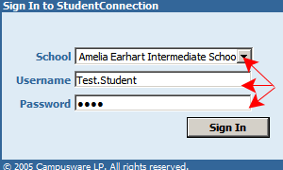

4. In the Sign In window, enter the correct information.
- Select “Your School”
- Type your Firstname.Lastname
- Type your four-digit pass number
(same as school log on)

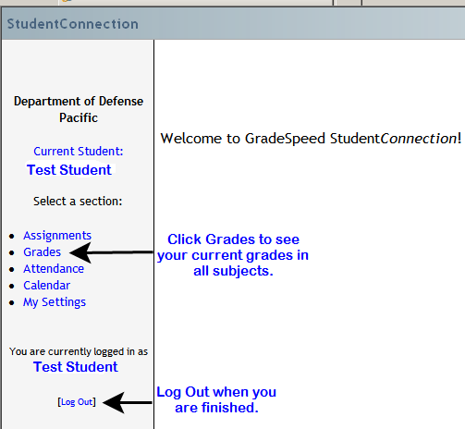

5. Click Grades on the left
to see your current grades.

6. Log Out when finished.

