SAMPLE PRESS RELEASE
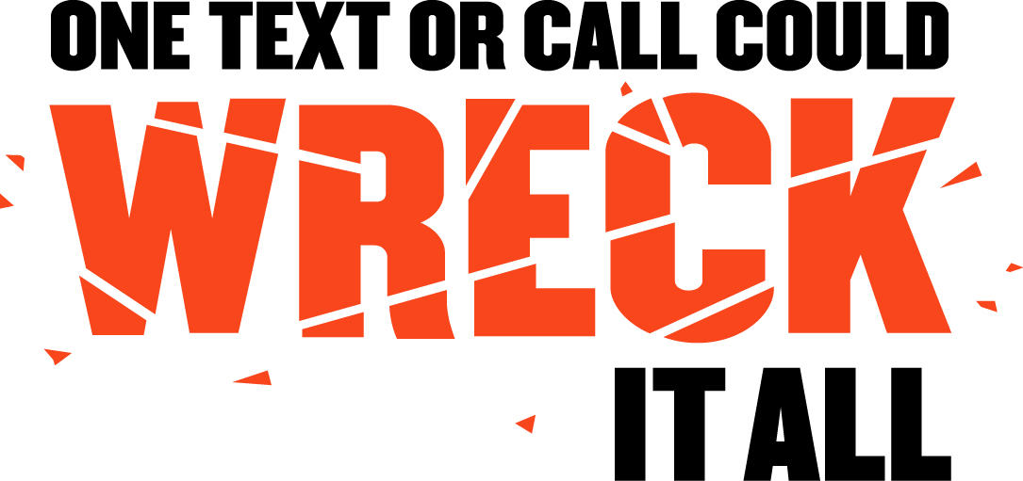
FOR DISTRACTED DRIVING
CAMPAIGN LAUNCH

FOR IMMEDIATE RELEASE: [Date]
CONTACT: [Name, Phone Number, E-mail address]

Note: Before filling in the names of the organization and organization spokesperson, you MUST contact them to obtain their permission to use their names in this press release. You must get their approval for the language of their quotations and any changes or additions they may require. Only after this is done can you send out the press release.

[COMMUNITY AND/OR PARTNER] Joins the
“One Text or Call Could Wreck It All” Campaign to
Educate Area Drivers About Distracted Driving

[City, State] – In an effort to make our roads safer, [Community/Partner] announced today that they have joined the National Highway Traffic Safety Administration’s “One Text or Call Could Wreck It All” campaign to stop distracted driving. [Group/Organization] has pledged their support to help spread the message that distracted drivers are not only a danger to themselves, but everyone else on the road.

“We all know that talking on our cell phones while driving is distracting, but that doesn’t stop most people from continuing to do it,” said [Local Spokesperson, title with organization]. “This effort is intended to educate our community about the dangers of cell phone use and other distractions while driving. We hope that once people see the statistics and realize the danger involved, they will change their driving habits to help protect themselves, their families, and others on the road.”

In 2010, 3,092 people were killed in crashes involving a distracted driver and an estimated additional 416,000 were injured in motor vehicle crashes involving a distracted driver. That same year, eleven percent of fatal crashes were reported as distraction-affected crashes.

While anything that takes your eyes off the road, hands off the wheel, or mind off the task of driving is a hazard, there is heightened concern about the risks of texting while driving because it combines all three types of distraction – visual, manual and cognitive.

The national distracted driving effort focuses on ways to change the behavior of drivers through legislation, enforcement, public awareness and education – the same activities that have curbed drunk driving and increased seat belt use.

[COMMUNITY]’s campaign will [GIVE EXAMPLES HERE OF THE LOCAL CAMPAIGN AND WHAT IT WILL INCLUDE, AND INCLUDE ANY PARTNERS IN THE CAMPAIGN AND WHAT THEY WILL DO].

“Every driver in [COMMUNITY] has a role in this effort,” said [Spokesperson]. “However, we especially want to reach out to parents with teen drivers because we know that statistically, the under-20 age group had the highest proportion of distracted drivers involved in fatal crashes.”

[COMMUNITY]’s goal with this campaign is simple – save lives by getting drivers to remember that “One Text or Call Could Wreck It All.”

“Distracted driving is an epidemic on America’s roadways, and we’re doing our part to help put an end to it,” said U.S. Secretary of Transportation Ray LaHood. “Texting and cell phone use while driving is extremely dangerous, and we know simply getting drivers to turn their phones off when they get behind the wheel will make our roads significantly safer. Efforts like this one will help us put an end to distracted driving, and we encourage your support of this program to help save lives in your community.”

For more information about distracted driving, please visit www.distraction.gov, or you can contact [LOCAL CONTACT at PHONE/EMAIL].

###

