**Attachment 1: Areas of Potential Effect**

**Route 1 Improvements at Fort Belvoir, Fairfax, Virginia**

**Archaeological APE**

The Area of Potential Effects (APE) for archaeological resources is considered the area with potential direct effects. The archaeological APE generally includes those areas extending 100 feet on either side of existing roadway pavement, as well as extended areas for 1) intersections at Telegraph Road, Old Colchester Road, Fairfax County Parkway, Pohick Road, and Mount Vernon Memorial Highway; 2) a  shifted alignment section in the vicinity of the Woodlawn Baptist Church and Cemetery; and 3) proposed stormwater management facilities.  Exceptions to the general direct APE width, including a shift to the northern side of Route 1 near Davison Army Airfield, are shown in the attached figure.

**Architectural APE**

For indirect effects (also see attached figure), the APE encompasses all above-ground resources (dwellings, buildings, bridges, culverts, etc.) in those areas extending 500 feet on either side of existing pavement and from the Woodlawn Baptist Church Cemetery avoidance alignment, as well as the boundary areas for adjacent National Register of Historic Places listed or eligible properties/districts.  The APE for indirect effects takes into account that there are concerns, as expressed in consulting party comments, over access to and use of historic properties, as well as potential visual and auditory effects.

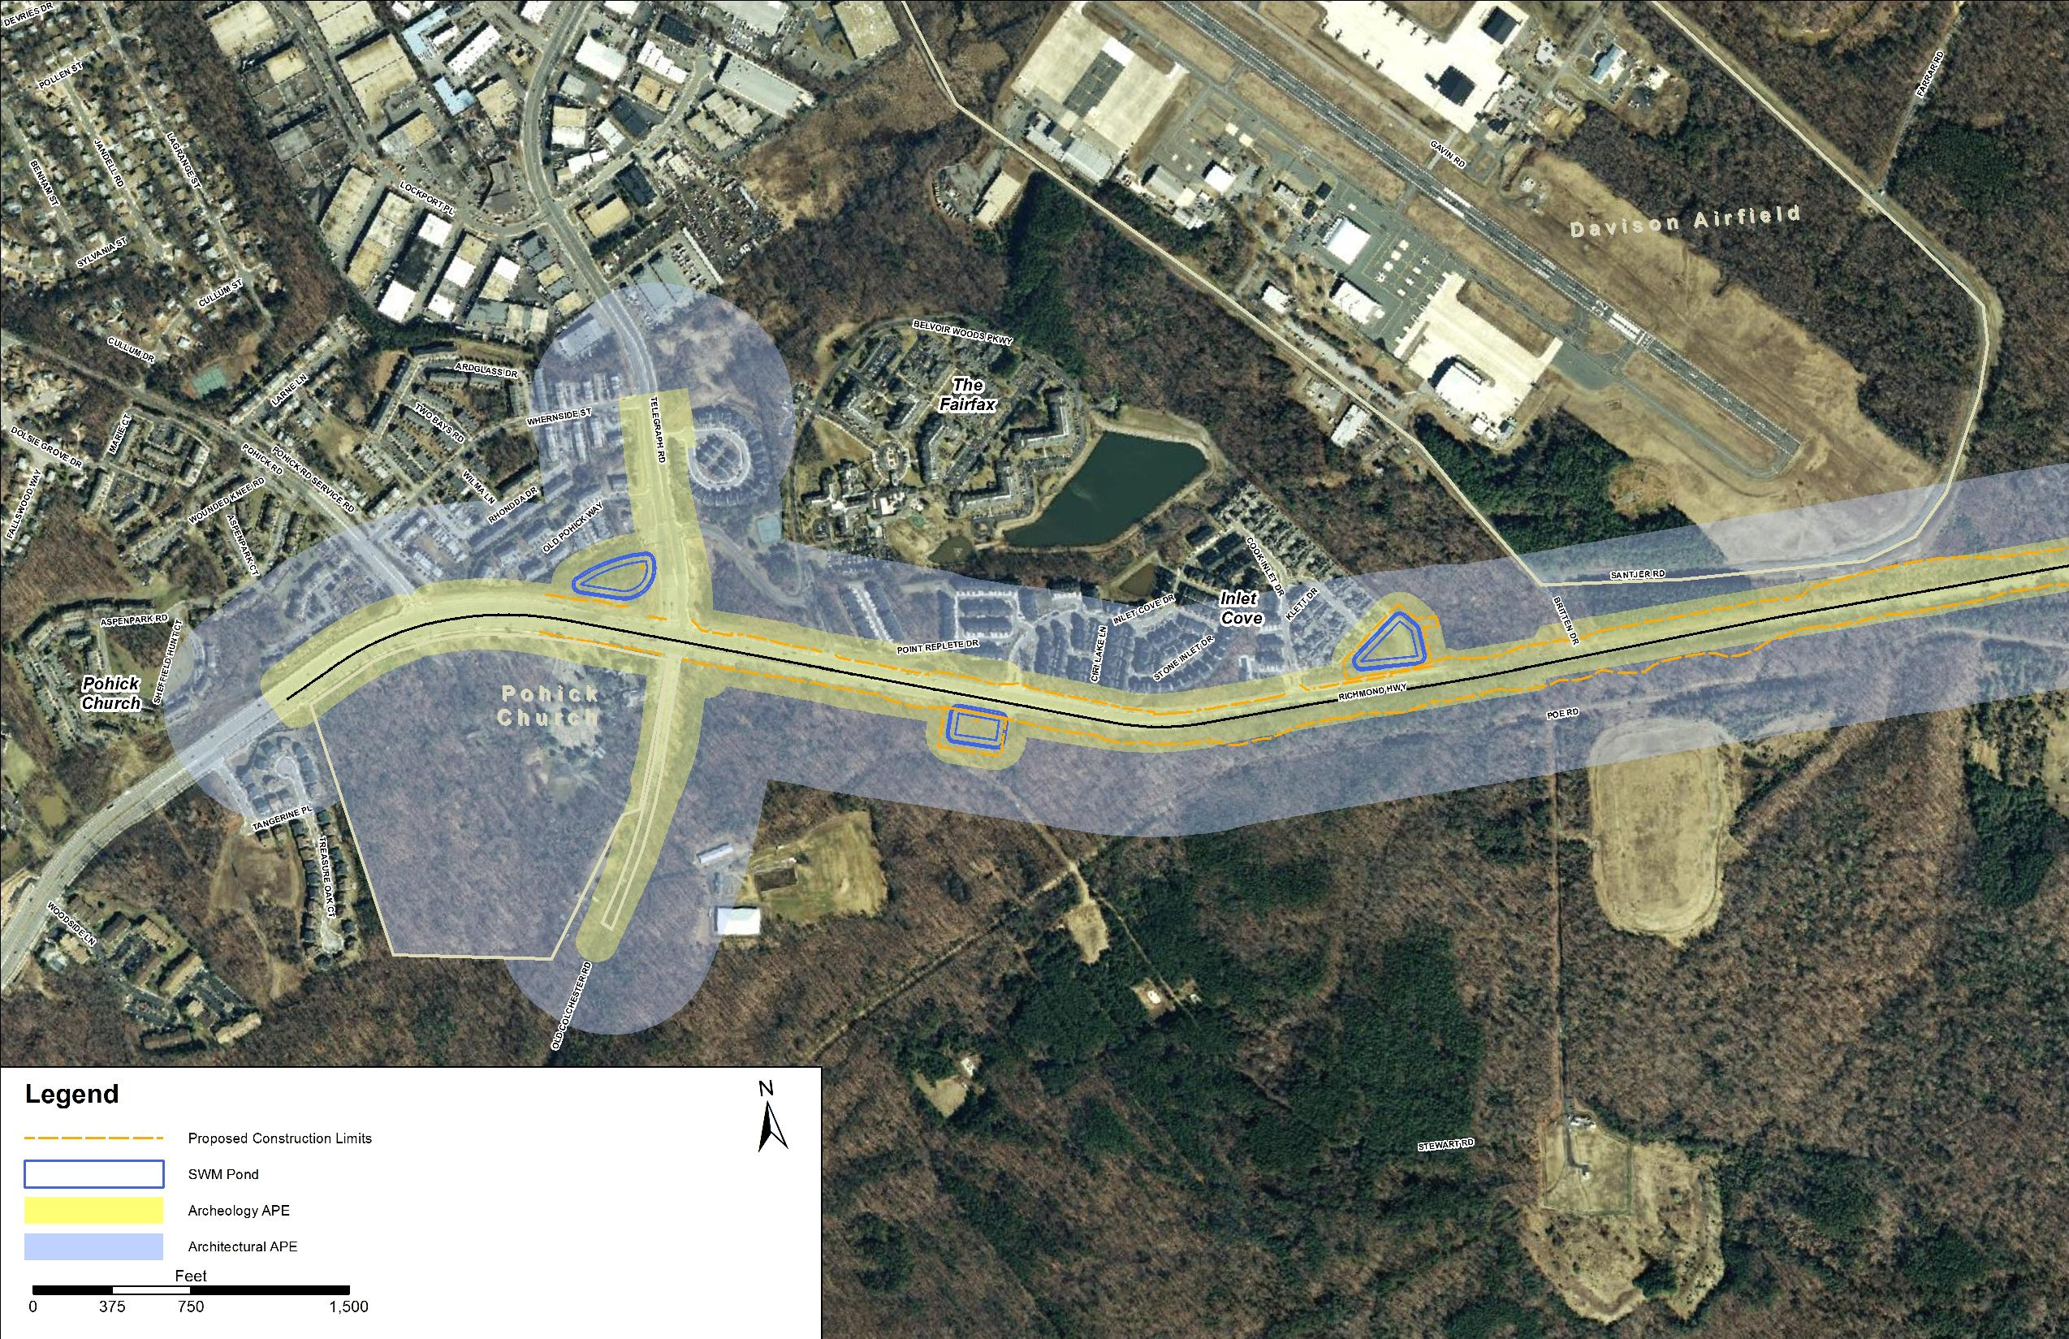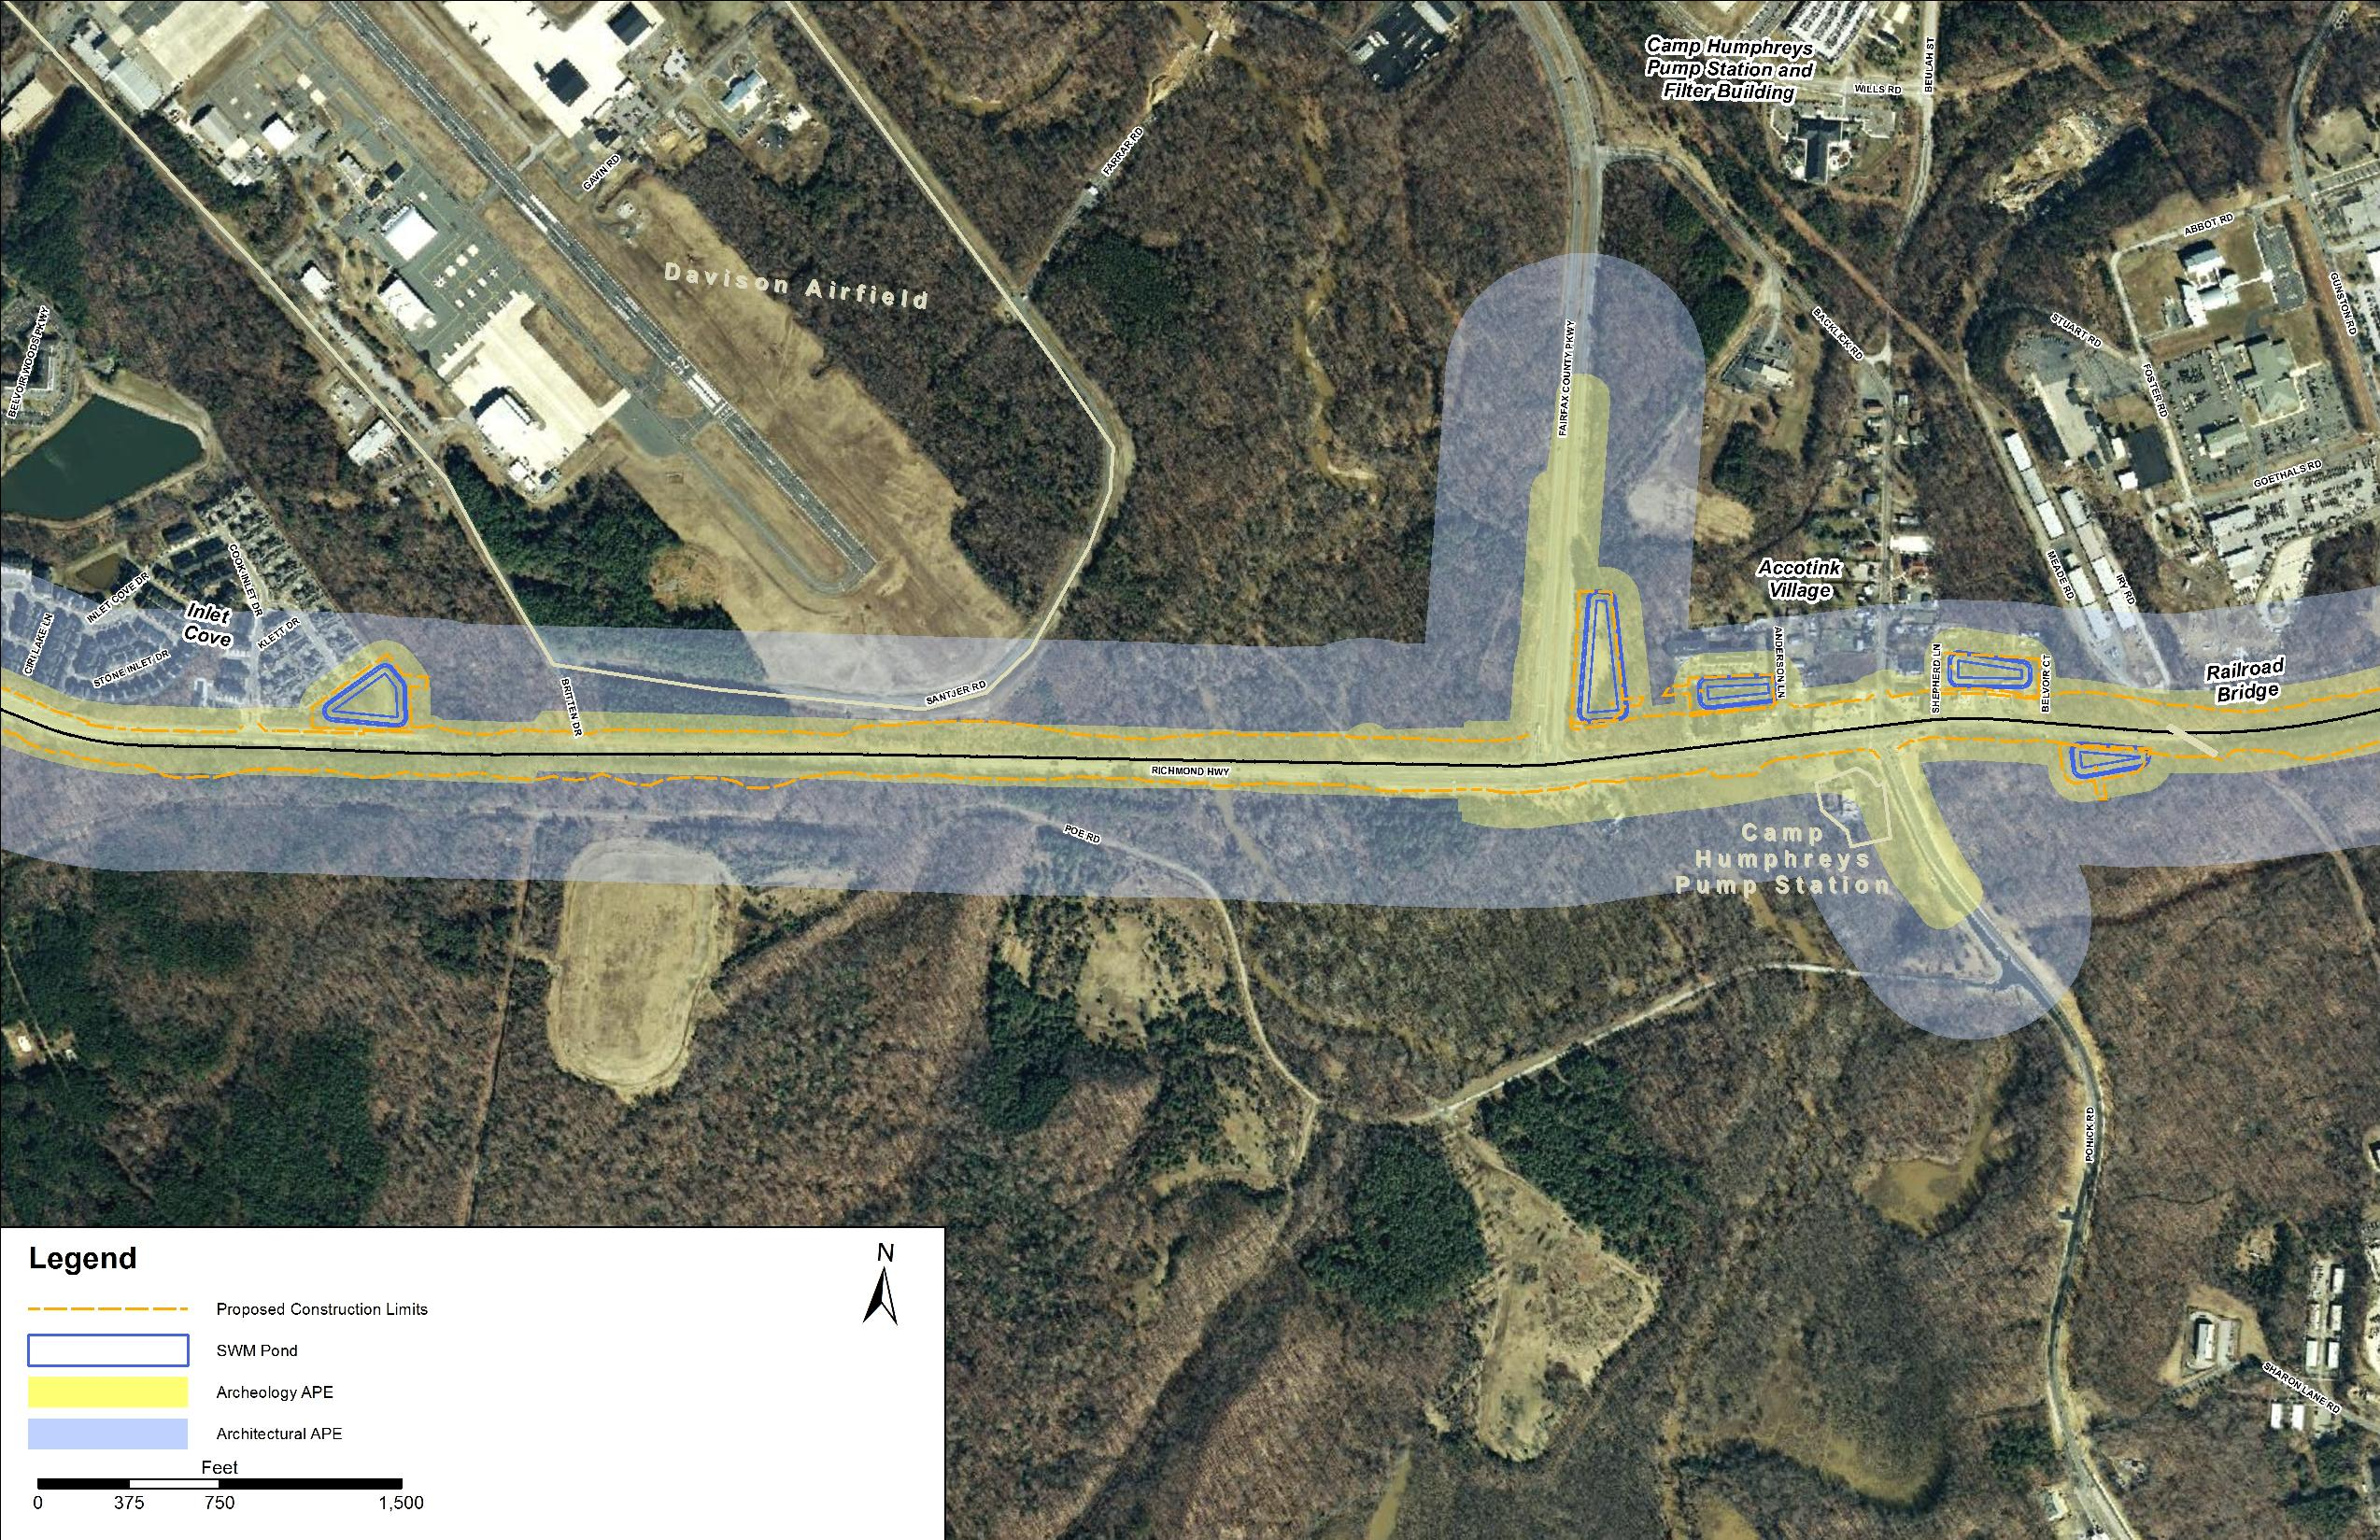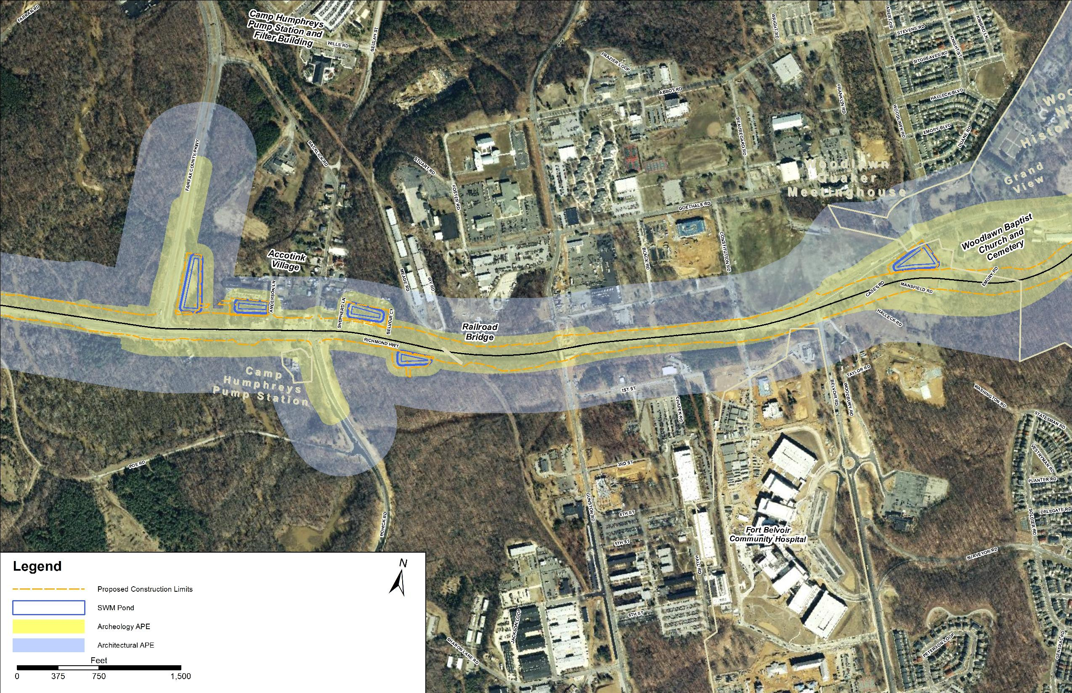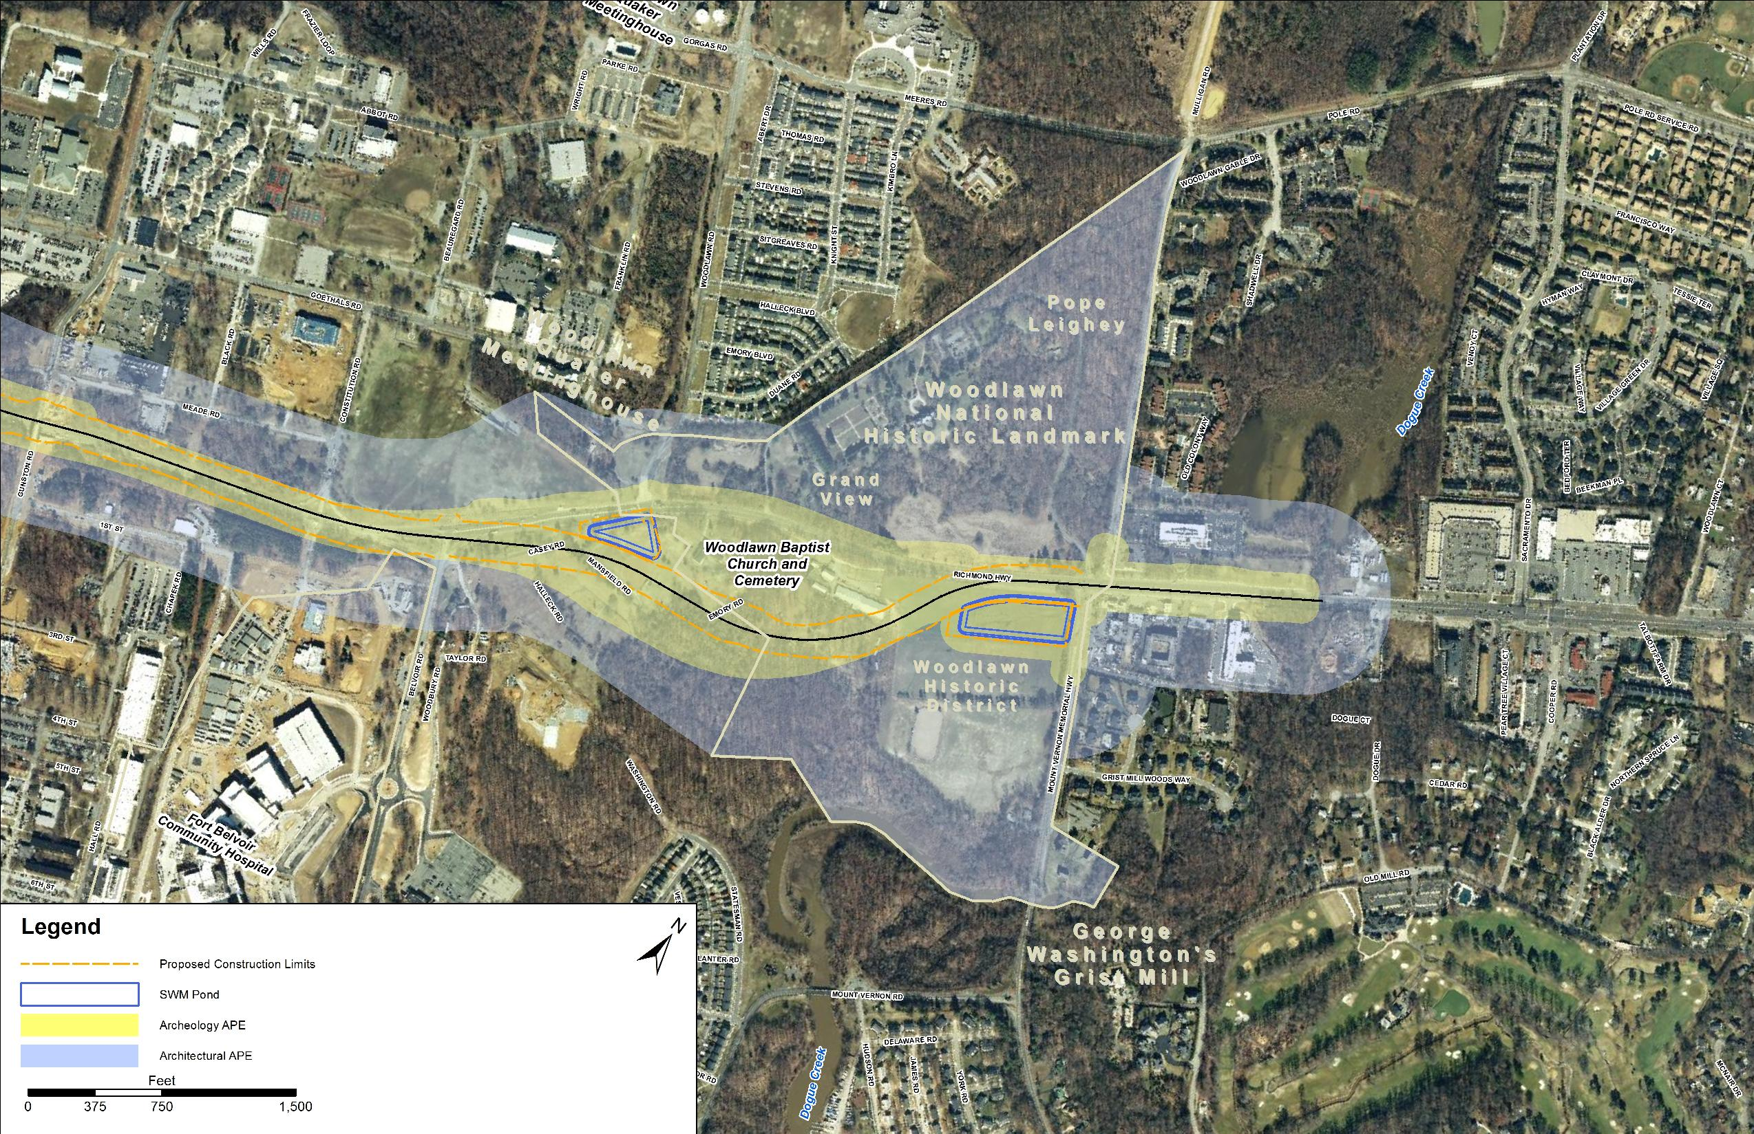

**Attachment 2: Properties Recommended as Not Eligible for Inclusion on the NRHP**

1. House, 9036 Telegraph Road (029-5680)
2. House, 9300 Old Colchester Road (029-5681)
3. The Courts at Belvoir, 9140 Richmond Highway (029-5682)
4. Commercial Building, 9150 Richmond Highway (029-5683)
5. House, 9170 Richmond Highway (029-5684)
6. House, 9111 Anderson Lane (029-5685)
7. House, 9116 Anderson Lane (029-5686)
8. House, 9117 Anderson Lane (029-5687)
9. House, 9119 Anderson Lane (029-5688)
10. House, 9121 Anderson Lane (029-5689)
11. House, 9135 Anderson Lane (029-5690)
12. House, 9014 Backlick Road (029-5692)
13. House, 9020 Backlick Road (029-5693)
14. House, 9026 Backlick Road (029-5694)
15. House, 9034 Backlick Road (029-5695)
16. House, 9042 Backlick Road (029-5696)
17. House, 9104 Backlick Road (029-5698)
18. House, 9108 Backlick Road (029-5699)
19. House, 9112 Backlick Road (029-5700)
20. House, 9120 Backlick Road (029-5701)
21. House, 9121 Backlick Road (029-5702)
22. House, 9124 Backlick Road (029-5703)
23. House, 9123 Shepherd Lane (029-5704)
24. Commercial Building, 8853-59 Richmond Highway (029-5705)
25. Commercial Building, 8853-59 Richmond Highway (029-5706)
26. Garage, 8853A Richmond Highway (029-5706)
27. Commercial Building, 5638-40 Mt. Vernon Memorial Hwy (029-5707)
28. Route 1 between Woodlawn and Accotink (029-5708)
29. Route 1 Bridge over Accotink Creek (029-5709)
30. Culvert under Route 1 near Davison Army Airfield (029-5710)
31. Culvert under Route 1 near Accotink (029-5711)
32. Culvert under Route 1 at Railroad Bridge (029-5712; 029-5424)

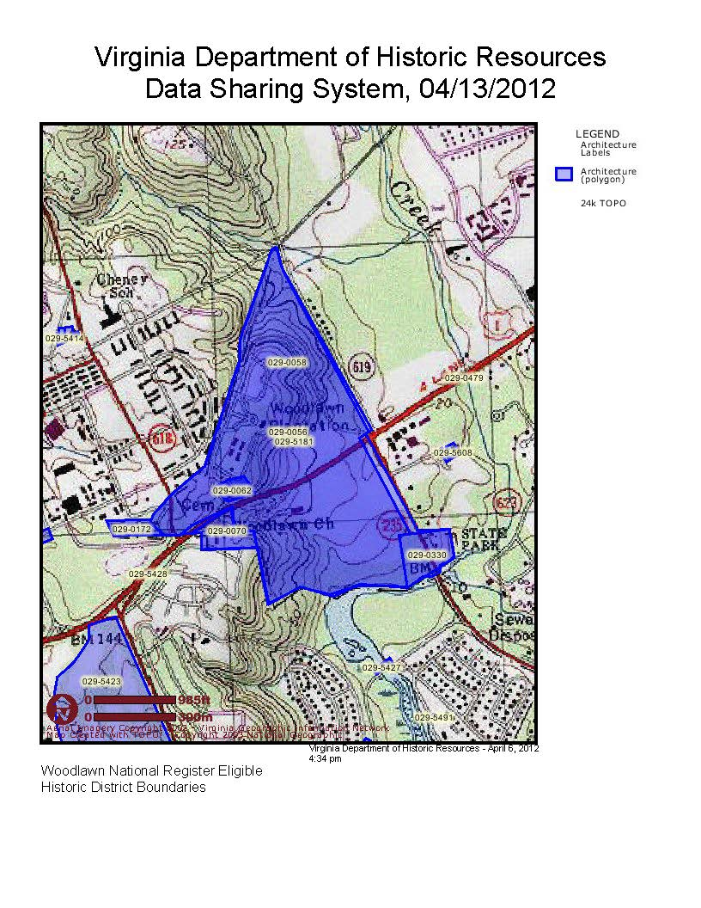

**Attachment 3**