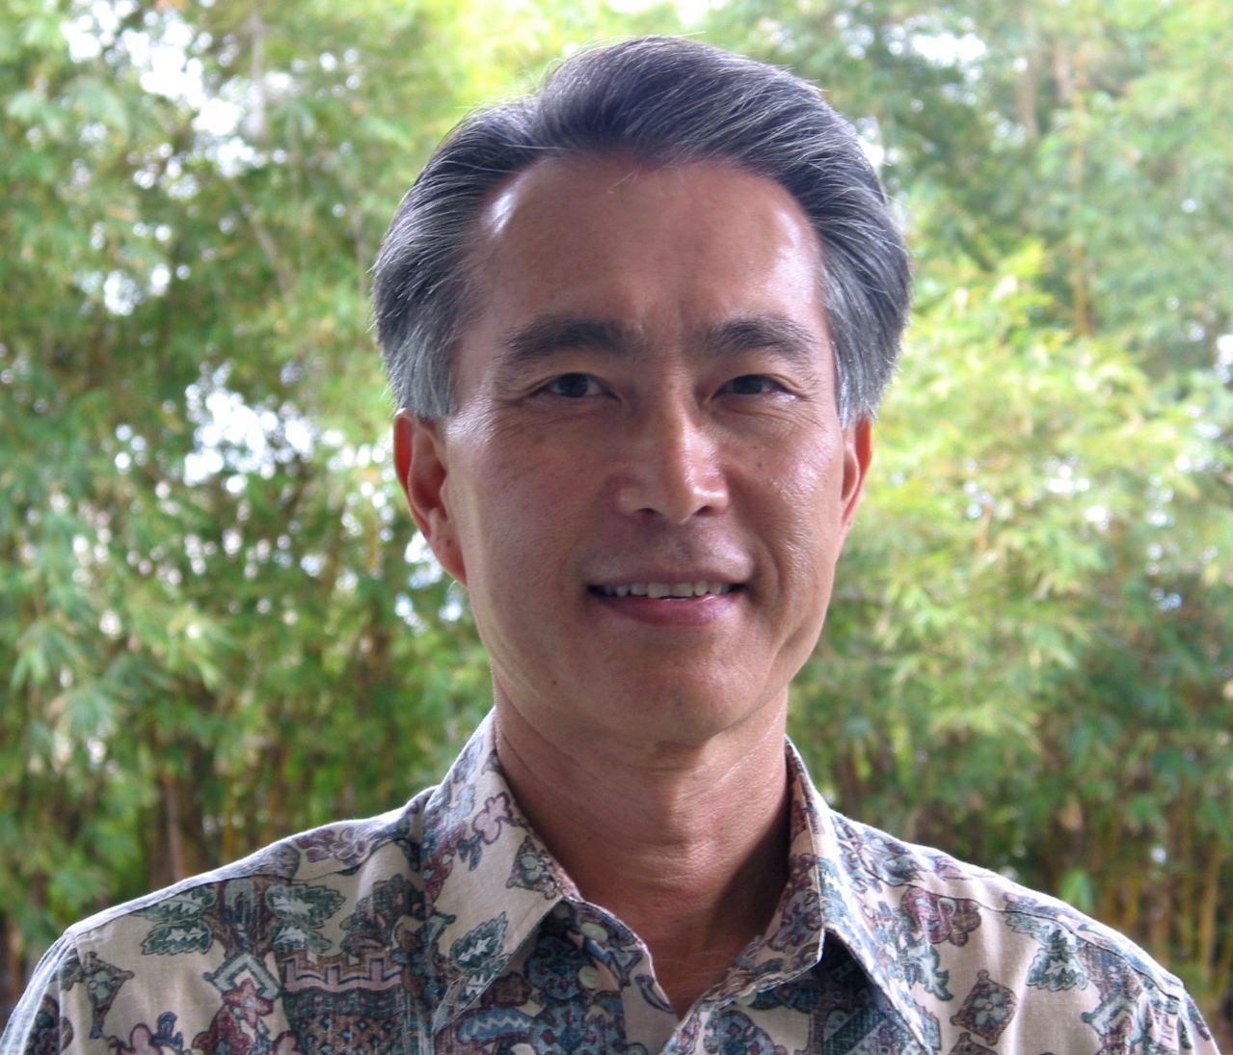
Maurice Kaya

Strategic Energy Consultant,
Project Director, Pacific International Center for High Technology Research (PICHTR)
Project Director,Hawaii Renewable Energy Development Venture (HREDV)

Mr. Kaya serves as Project Director for the Pacific International Center for High Technology Research and the Hawaii Renewable Energy Development Venture. Mr. Kaya also consults on clean energy policies, investments, and management strategies to clients in Hawaii and the United States mainland.

He previously served as Chief Technology Officer (CTO) for the Hawaii Department of Business, Economic Development and Tourism. As CTO, Mr. Kaya led efforts to diversify the statewide economy, developing programs to increase investment in strategic technologies through public-private partnerships with a major focus on clean energy technology.

Among his significant achievements, he developed a comprehensive energy policy strategy for the State of Hawaii. The integrated strategy, known collectively as Energy for Tomorrow, forms the basis for the Hawaii Clean Energy Initiative, a unique partnership between Hawaii and the US Department of Energy to transform markets and deploy clean energy resources in significant quantities in Hawaii.

As Chief Technology Officer he served as principal advisor to the Hawaii Governor on clean energy. He currently serves as a board member of Energy Industries, a leading clean energy project integrator in the US. The US Secretary of Energy appointed him to the State Energy Advisory Board and the Hydrogen and Fuel Cell Technical Advisory Committee. He is also a former board member of the National Association of State Energy Officials.

The Hawaii Governor, Hawaii Legislature, the US Secretary of Energy, the Blue Planet Foundation, and the Hawaii Institute of Public Affairs have recognized him with numerous awards. He is a Distinguished Alumnus of the University of Hawaii, Hilo.

A registered professional engineer, he received a Masters Degree in Environmental Engineering and Bachelors Degree in Civil Engineering from the University of Hawaii.

