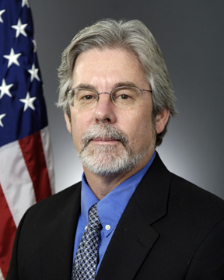

Richard T. Carlin, Ph.D.

Department Head
Sea Warfare and Weapons Department
Office of Naval Research

Dr. Richard T. Carlin is Department Head for the Sea Warfare and Weapons Department at the Office of Naval Research (ONR). As Department Head, Dr. Carlin overseas a broad range of S&T programs for surface ships, submarines, and undersea weapons with an annual budget of approximately $400M per year. Immediately prior to his current position, he was the Director for the Undersea Weapons and Naval Materials Division with responsibilities in undersea weapons and countermeasures, advanced energetics, structural materials, materials for power systems, and maintenance reduction technologies. During his career at ONR, he also served as the Acting Chief Scientist in 2004 and as Director for the Mechanics and Energy Conversion Division from 2001 to 2005. Dr. Carlin joined ONR in 1997 as the Program Officer for Electrochemistry S&T and Undersea Weapons Propulsion with programs covering numerous electrochemical and thermal power technologies. Dr. Carlin serves as the Department of the Navy’s Power & Energy S&T Focus Area executive and is the Navy S&T representative on various energy advisory groups, including Naval Task Force Energy. In September 2010, he was appointed to the DoE Hydrogen and Fuel Cell Technical Advisory Committee.

Before joining ONR, Dr. Carlin held several positions in academia, industry, and government. These included Senior Research Chemist at Air Products and Chemicals carrying out research on gas-separation membranes; a chemistry faculty appointment at the University of Alabama in Tuscaloosa performing research on ionic liquids as solvents and electrolytes; and federal service as the Electrochemistry Division Chief at the Frank J. Seiler Research Laboratory located at the United States Air Force Academy leading research on the use of ionic liquids as electrolytes for batteries, supercapacitors, and metal-alloy electrodeposition.

Dr. Carlin received his B.S. in Honors Chemistry from the University of Alabama in 1977, and his Ph.D. in Inorganic Chemistry from Iowa State University in 1982. Additionally, he was a postdoctoral fellow in Prof. Robert A. Osteryoung’s electrochemistry research group at the State University of New York at Buffalo. He has published over 100 technical papers including 57 reviewed papers and one book chapter, and he is also co-inventor on 7 United State patents.

His awards include the Senior Executive Service Presidential Meritorious Rank Award; Department of the Navy Superior and Meritorious Civilian Service Medals; 2010 Fuel Cell Seminar and Exposition Award; Assistant Secretary of the Navy (RD&A) Awards for the Rapid Transition of Foreveready Missile Battery & Lithium-Ion Polymer Battery; and the United States Air Force Material Command Science and Technology Achievement Award for the development of a novel dual graphite-intercalation battery concept.

