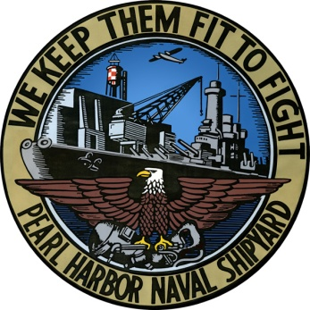
PEARL HARBOR NAVAL SHIPYARD

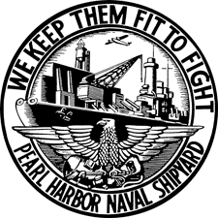
& INTERMEDIATE MAINTENANCE FACILITY PUBLIC AFFAIRS

667 Safeguard St., Suite 100 (Code 1160)

Joint Base Pearl Harbor-Hickam, HI 96860-5033

Phone: (808) 474-0272 Fax: (808) 474-0269

Website: www.navsea.navy.mil/shipyards/pearl/default.aspx

For Immediate Release---001 Jan. 11, 2013

Shipyard sets new contribution record with CFC donations

By David Tomiyama

Pearl Harbor Naval Shipyard & Intermediate Maintenance Facility Public Affairs

JOINT BASE PEARL HARBOR-HICKAM, Hawaii – Helping one another is a common trait in military communities. However, Pearl Harbor Naval Shipyard & Intermediate Maintenance Facility civilians and Sailors took the practice to another level raising $723,953 for the 2012 Combined Federal Campaign (CFC), a new record for the command.
“I’m absolutely impressed by our final CFC numbers,” said Shipyard Commander Capt. Brian Osgood. “For the Shipyard to set a record number in giving during these trying times shows the quality of people we have here. I’m proud to lead people who are so willing to help others.”
According to their website, CFC is the world’s largest and most successful annual workplace charity campaign with more than 200 CFC campaigns throughout the country and internationally to help to raise millions of dollars each year. Pledges made by Federal civilian, postal and military donors during the campaign season (Sept. 1 to Dec. 15) support eligible non-profit organizations that provide health and human service benefits throughout the world.
The Shipyard surpassed its 2012 goal by $10,262. This comes on the heels of breaking 2011’s contribution of $715,451, then a record total for the Shipyard. For Brendan Cravalho, Shipyard CFC coordinator since 2001, raising a record amount is a reflection on the ohana spirit Shipyarders live by.
“Even through personal adversity (i.e., shrinking budgets, lack of pay raises, etc…), Shipyard employees continue to demonstrate a willingness to help out others who are less fortunate,” he said. “The ohana spirit is alive and well here at the Shipyard.”
Monetary goals are now being replaced each campaign season by communication and awareness goals. Contacting each and every worker on the options of how to give and the charities that stand to benefit are now being stressed over amounts raised. For the Shipyard, 100 percent contact was made with the more than 5,000 civilian and military personnel throughout the command on the CFC drive.
That communication paid off with the rise of online donations. This past CFC season was the second in which people could contribute online. The Shipyard saw a 416 percent increase from a year ago of online donors whom raised $58,166, said Cravalho.
The hard work and dedication of Shipyarders is what makes each CFC campaign a success.
“Mahalo to the unit project officers and key persons whose personal dedication and involvement is the key ingredient to the Shipyard's CFC success,” said Cravalho. “I would like to recognize Yvette Flynn, Code 1140 administrative officer, who worked diligently behind the scenes and helped me keep track of all CFC material, audited each packet for completeness and verified amounts raised prior to submitting them to CFC headquarters for final processing. Her efforts have been invaluable over the years.”
For its CFC contributions, the Shipyard was presented with a silver level award at an awards and recognition ceremony at the Battleship Missouri Memorial, Jan. 16. The tiered award is given to organizations based on CFC participation and amount given.
The Shipyard is a field activity of Naval Sea Systems Command and a one-stop regional maintenance center for the Navy's surface ships and submarines. It is the largest industrial employer in the state of Hawaii with a combined civilian and military workforce of about 5,000. Strategically located in the mid-Pacific, the Navy’s largest ship repair facility between the West Coast and the Far East is about a week of steam time closer to potential regional contingencies in East Asia than sites on the West Coast.
Additional information on the Shipyard can be found on social media sites:
Facebook at https://www.facebook.com/PearlHarborNavalShipyard?ref=hl
Flickr at http://www.flickr.com/photos/phnsy/
YouTube at https://www.youtube.com/watch?feature=player_embedded&v=oikFeybsdSM

-30-

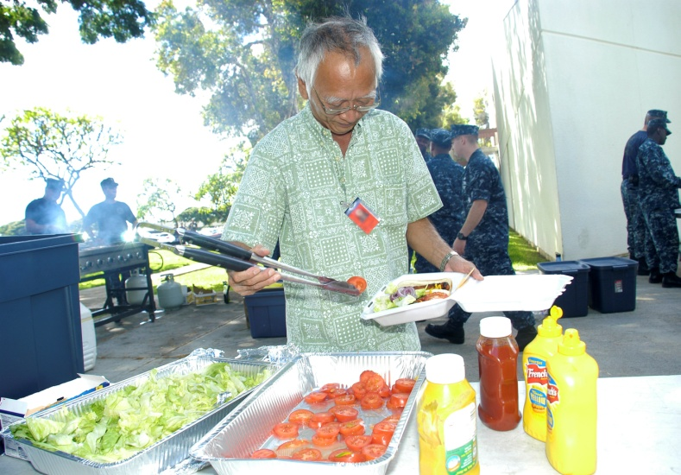
12109-N-YN449-008 JOINT BASE PEARL HARBOR-HICKAM, Hawaii (Nov. 9, 2012)
Project Engineer Steven Tsuru assembles his hamburger during a Combined Federal Campaign (CFC) fund-raiser at Pearl Harbor Naval Shipyard & Intermediate Maintenance Facility. The Shipyard’s First Class Petty Officer Association organized the lunchtime barbecue and raised $383 to donate to CFC. (U.S. Navy photo by Marshall Fukuki/Released)

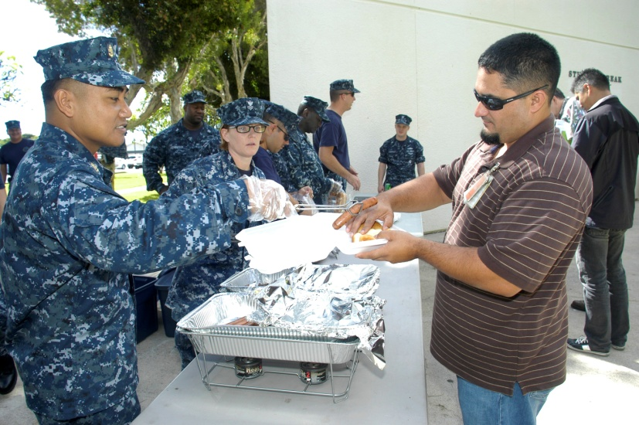

12109-N-YN449-009 JOINT BASE PEARL HARBOR-HICKAM, Hawaii (Nov. 9, 2012)
Chief Gas Turbine System Technician (Mechanical) Virgilio Martinez, left, command Combined Federal Campaign (CFC) coordinator, adds a hot dog to the plate lunch of Crane Operations Supervisor Clayton Silva during a CFC fund-raiser at Pearl Harbor Naval Shipyard & Intermediate Maintenance Facility. The Shipyard’s First Class Petty Officer Association raised $383 from the barbecue to donate to CFC. (U.S. Navy photo by Marshall Fukuki/Released)

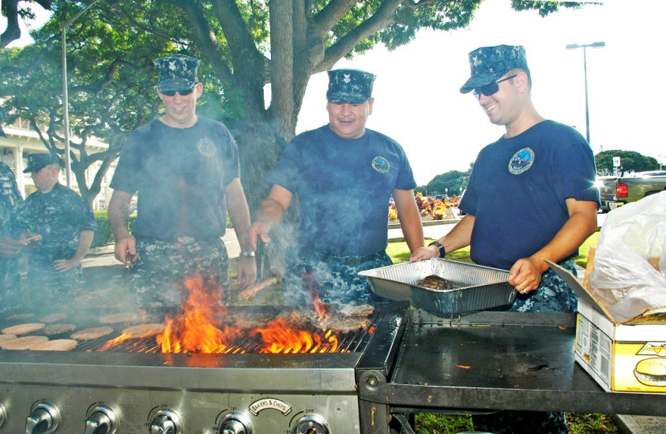
12109-N-YN449-003 JOINT BASE PEARL HARBOR-HICKAM, Hawaii (Nov. 9, 2012)
MM1 (SS) Tim Hanley, left, MM1 Nickolas Miller and ET1 Jesse Holland of Pearl Harbor Naval Shipyard & Intermediate Maintenance Facility grill hamburgers and hot dogs at a lunchtime fund-raiser to support the Combined Federal Campaign (CFC). The barbecue, organized by the Shipyard’s First Class Petty Officer Association, raised $383 for CFC. (U.S. Navy photo by Marshall Fukuki/Released)

