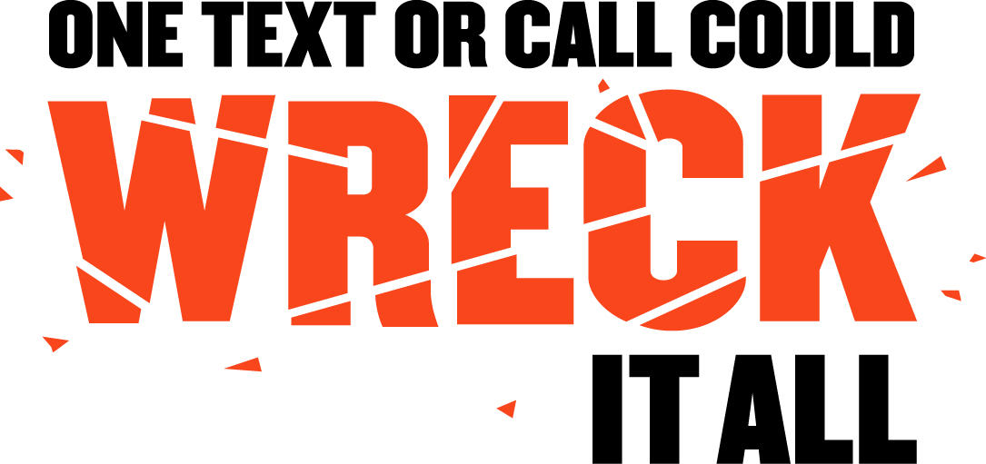

SAMPLE NEWSPAPER OP-ED
ON DISTRACTED DRIVING

One Text or Call Could Wreck It All

Did you know that “distracted driving” was the 2009 word of the year according to Webster’s Dictionary? But unfortunately, this is no passing fad. Distracted driving has become a trend with deadly, real consequences.

For anyone who thinks they can talk on their phone, text, apply make-up, or do any other distracting activity while driving, it’s time for a crash course in reality from the National Highway Traffic Safety Administration (NHTSA):

- In 2010, 3,092 people were killed in crashes involving a distracted driver and an estimated additional 416,000 were injured in motor vehicle crashes involving a distracted driver. (NHTSA)
- Drivers who use hand-held devices are four times as likely to be involved in a serious crash. (Insurance Institute for Highway Safety)
- Nine percent of fatal crashes in 2010 were reported as distraction-affected crashes. (NHTSA)
- Eleven percent of all drivers under the age of 20 involved in fatal crashes were reported as distracted at the time of the crash. This age group has the largest proportion of drivers who were distracted. (NHTSA)

While those numbers may sound like just statistics, they’re anything but. They could be parents, children, neighbors and friends from right here in [Community]. There are too many sad tales of deaths and injuries that could have been prevented had drivers been paying attention to the road instead of someone or something else.

So, why do so many people participate in this dangerous behavior? With more technology now than ever, driver distractions have risen to unprecedented levels. We live in a world where people expect instant, real-time information 24 hours a day, and those desires don’t stop just because they get behind the wheel. Drivers simply do not realize – or choose to ignore – the danger they create when they take their eyes off the road, their hands off the wheel, and their focus off driving.

People often say, “I can do two things at once. I’ve memorized where the numbers are on my phone, so I don’t have to look.” Or, “Sending or reading one text is pretty quick – that should be okay.” They couldn’t be more wrong.

For those who think they can do two things at once, think about this: According to a study by Carnegie Mellon, driving while using a cell phone reduces the amount of brain activity associated with driving by 37 percent. Can you really afford to lose that much brainpower? Driving is an activity that requires your full attention and focus in order to keep yourself and others safe.

Yes, this is a national problem, but it also affects us right here in [Community]. No one is immune from the dangers of distracted driving. So please remember: One text or call could wreck it all.



