Hands-on Exercise Using DataFerrett
Current Population Survey –
Annual Social and Economic (ASEC) Supplement



U.S. Census Bureau

DataFerrett Help
http://dataferrett.census.gov/
1-866-437-0171 (toll free)
dsd.ferrett@census.gov

Question: What are the rates of health care coverage for children by sex and race?

Start DataFerrett


- Double-click the DataFerrett icon on the Desktop
- Enter your e-mail address when prompted

Note: The DataFerrett Team only uses the email address when returning downloaded data or responding to help messages and on occasion to send out an announcement regarding special notices. It does not give your email address out.
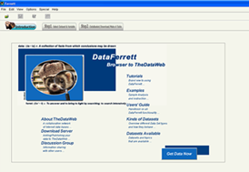

The Introduction Tab is the screen you arrive at after you log in. Step 1 and Step 2 are the other two tabs.

The Introduction Screen has the Get Data Now link to go straight into the DataFerrett application.

Note: Select the links to access the users’ guide, tutorials, frequently asked questions and other information about using DataFerrett.

Step1: Select Dataset & Variable tab

- 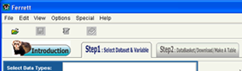Select the Step 1 Select Dataset & Variables tab.
- Click on the plus sign next to the Current Population Survey folder.
- 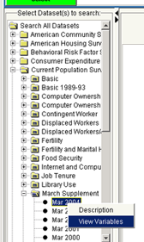Click on the plus sign next to the March Supplement folder.
- Click the Mar 2008 bullet.
- A Description / View Variables fly-out will allow you to choose the Dataset Description or to View Variables.

View Variables will bring up the topics pertinent to your highlighted dataset.
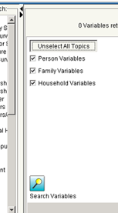
- Click on the Select All Topics button.
- Click the Search Variables button.
.

Variables will be listed on the right as seen below.

A variable list appears which includes the follow columns:
Topic - type of variable.
Name - of the variable.
Availability - the period of time for when the variable is valid.
Variable Label - short description of the variable.

- By clicking on the arrows indicated below, you can open up the list of Datasets pane or click the other arrow and see the full description of the variables.
Managing the variable window
- Clicking in the gray header box you can drag "columns" into view or any order you choose.
- Also, by clicking in the gray header box of each "column" you can alphabetize by that column.
- The "Availability" column shows a year and a hyphen. If there is another year after the hyphen it means that the variable was available ONLY during those years. If there is no year after the hyphen then the variable is still being asked exactly the same way today.

Sort the NAME column (click the NAME column header)

Highlight the A_AGE variable
Once you highlight a variable the Browse / Select Highlighted Variables button becomes active.
3. Click the Browse / Select Highlighted Variables button as shown above.

Note: You can also double click on a variable to pop up the Browse Variable window.

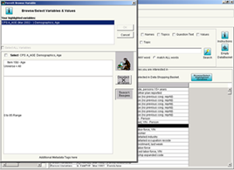Selecting the Browse/Select Highlighted Variables button will open a new window that allows you to browse variable descriptions and values for all items that you selected in the Select Dataset & Variables tab. This is also called the Codebook. This window also allows you to select the variables (and their values) that you want to be put into your Data Basket where you can recode, modify, or delete a variable.

1. Click the box marked Select CPS A_AGE Demographics, Age

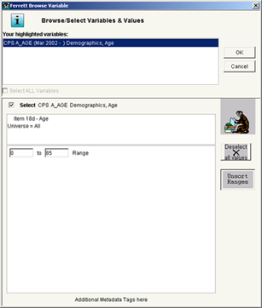

2. Change the age range to 0 to 15
3. Click OK

You have added A_AGE to your data basket and you have restricted the universe to kids 15 and younger.

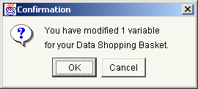

Choose your remaining variables.

1. With your list still sorted by NAME, scroll down and highlight the A_SEX variable.
2. Scroll down until you see the CH_HI variable (child covered by health insurance). Hold down the control key and highlight it.
3. Click the Browse / Select Highlighted Variables button.

In the Ferrett Browse Variable window this time, you will see the two variables you have chosen in the Your highlighted variables: box. You can click on either of them to see its’ codebook information.

4. Click the box marked Select ALL Variables

Note: Click Select <variable name> if you want to add only one variable to your Data Basket, click the Select ALL Variables box if you want to keep all the variables in your list.

5. Click OK

You get a message: “You have added 2 variables to your data shopping basket.”
__________________________________

Back on Step 1 you can search for a variable through the labels, names, topics, full descriptions and values.

- Check the boxes of Variable Search to include LABELS, and NAMES.
- Type the word RACE in the box located above match ANY word.
- Click the Search button.

The list of variables is reduced to those that have the word race in the selected search options. In our example PRDTRACE is the only variable returned.

- Highlight PRDTRACE and
- click the Browse / Select Highlighted Variables button.
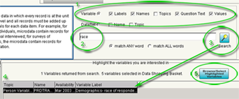
6. Check the box to select CPS PRDTRACE and click OK.

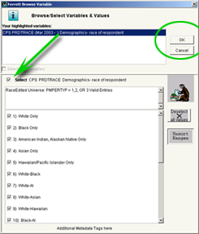

You have added this variable to your databasket.

Note: If you were searching multiple words, the system default is to search on any of the words. You also have the option to match ALL words.

Note: Want to make a change? Simply clear your text from the search and begin another text search.

To get all of the variables back in the Dataset window re-open the Mar 2007 dataset from the dataset list on the left side.

STEP 2: Data Shopping Basket/Download/Make A Table

1. Click the STEP 2: Data Shopping Basket / Download / Make A Table tab
2. Highlight the race variable PRDTRACE

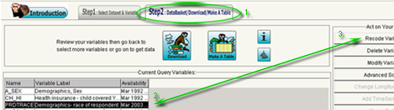

Selecting a variable from your list of Current Query Variables will activate the following options: Recoding, Deleting and Modifying the variables.

Recode Variable(s)
3. Click on the Recode Variable(s) button located at the top right side of the screen.
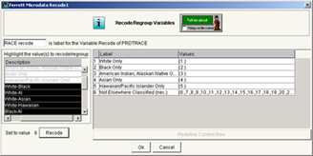

4. Assign a label to the recode in the box labeled Recode1 at the top left.
5. Highlight the first category, White Only and click the Recode button at the bottom left.

Notice the right hand side of the screen displays 2 categories for the new recoded variable:
1 White Only (1)
2 Not elsewhere classified (2,3,4,5,6,7,8,9,10,11,12,13,14,15,16,17)
6. Highlight the Black Only and click the Recode button at the bottom left.
Black Only has been assign to value 2 in the recode.
7. Continue by assigning the remaining categories to the following values:
value category
3 American Indian, Alaskan Native Only
4 Asian Only
5 Hawaiian Pacific Islander Only
6 All remaining categories
8. Type a new label by double clicking the label for the recoded value called Not Elsewhere Classified (nec.). Type the word OTHER and make sure to hit the Enter key.
9. Finish by clicking the OK button at the bottom of the screen.

Delete Variable(s)
This function allows you to remove variable(s) from the Data Basket. Highlight the variable(s) you want to delete and click "Delete Variable(s)" button.

Modify Variable(s)
Modify will open the Browse Variables window again and you can change values that were previously selected.

Advanced SQL Option
This function allows you to show the SQL routine that will be used to run your query. Advanced SQL opens the Advanced sql options to change clauses and add conditions in an SQL-like syntax.

Save Selected Variable(s) Codebook
This allows you to save the documentation for the variables in your Data Basket to an ascii text or html file. The documentation includes the variable name, label and value descriptions.

STEP 3: Download / Make a Table

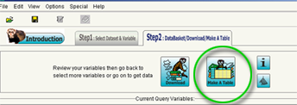

1. Click on the Make A Table button

You will see the following pop-up window. These are directions for making a table.

Read and close.

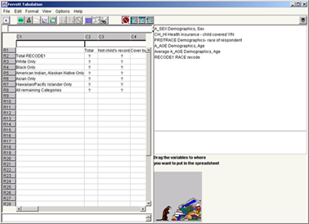

Make a 3-way table.

2. Drag the recoded RACE variable to the R2,C1 cell

3. Drag the variable A_SEX to the R1,C2 cell

4. Drag the CH_HI variable to the R1,C2 cell also

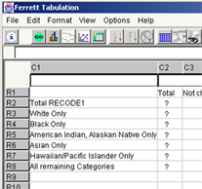

5. Click the GO Get Data button on the menu bar

Note: No need to do anything about a weight variable, it is automatically applied.

6. To save the table Click FILE > SAVE AS on the menu bar.
7. Save as an HTML, Text (tab delimited or comma delimited), PDF or Ferrett Tabulation File.

Note: The menu bar has a "Clear Table" button.

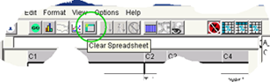

The DataFerrett Tabulation screen is a separate screen that can be left open or closed. If you wish to add variables from Step 1, they will always be reflected in the list of variables on your DataFerrett Tabulation screen.

DataFerrett Resources

Accessing the DataFerrett Software

Go to http://dataferrett.census.gov/ and then click on the “Get Data~Run: DataFerrett” link in the right hand column to access the launch page.

DataFerrett Help Desk

For technical assistance in using DataFerrett, you can call the help desk toll-free at 1-866-437-0171.

The help desk can assist you with issues concerning the use of the DataFerrett software, but not with questions regarding the subject matter contained in the datasets. The help desk can, however, usually direct you to the appropriate subject matter experts.

