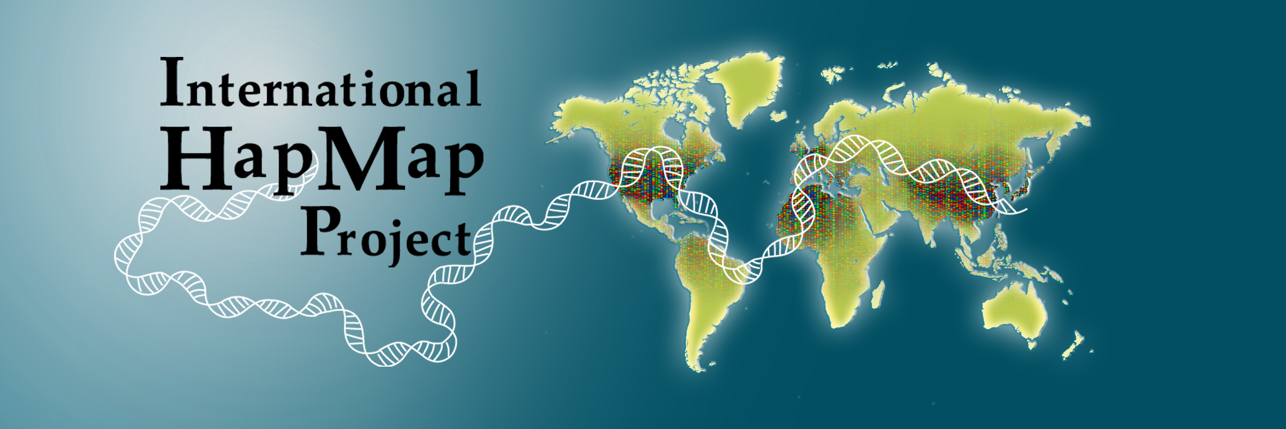

HapMap Tutorial Session: How to Use the HapMap Data

Thursday, October 27, 6:30 - 8:30 pm, ASHG 2005 Annual Meeting, Salt Lake City, Utah.

All the material from this tutorial will be available at www.hapmap.org/tutorials.html.en, including the slides, PDFs, and the web cast link

Moderator:
Dr. Aravinda Chakravarti (Johns Hopkins University):
- The long history of gene-based association studies in humans
- Association studies for gene identification of Mendelian traits and their modifiers
- Association studies for gene identification of complex traits and diseases
- The need for the HapMap Project

Instructors:
Dr. Mark Daly (Broad Institute)
- Introduction to the HapMap design and data
- Genome-wide performance of uses of the HapMap data
- Theory, implementation and performance of HapMap data for:
  - Selecting tag SNPs
  - Association study coverage evaluation
  - Association study analysis (can the empirical patterns help guide our analysis better than the traditional LD-agnostic sliding window?)
  - Association study interpretation: how many/which SNPs/genes/putatively functional regions/structural variants are implicated (via LD) around a positive result; optimal fine mapping design; using the HapMap to integrate/resolve/meta-analyze multiple association studies with different marker sets
  - Additional uses of HapMap data for studying LOH (loss-of-heterozygosity), admixture, and selection

Dr. Lincoln Stein (CSHL):
- Using the HapMap web site (www.hapmap.org) to view patterns of diversity in a region of interest
- Generating customized tag SNP sets from the web site
- Downloading HapMap data in bulk

Speakers:
Dr. Michael Boehnke (University of Michigan)
- HapMap data provide an excellent basis for tag SNP selection for a SNP type 2 diabetes association study in Finnish subjects
- Two-stage designs provide an efficient basis for genome-wide association studies and are facilitated by the availability of HapMap data
- Given fixed costs and numbers of subjects, the optimal design of two-stage association studies depends on several factors including per genotype costs in stages 1 and 2
- Joint analysis of stage 1 and 2 data is nearly always more efficient than treating stage 2 as an independent replication study

Dr. Augustine Kong (deCODE)
- The search for the causal variant for a phenotype after association to a marker allele has been firmly established.
- A disease variant exhibiting strikingly different relative risks in populations of different ethnic backgrounds: How to identify and interpret effects of genetic background

Dr. Toshihiro Tanaka (RIKEN):
Are the HapMap data practically useful for disease association studies? Three cases from the SNP Research Center, RIKEN

