“SCIENCE TO IMPROVE MANAGEMENT OF UNDERWATER ECOSYSTEMS”

Mission Beneath the Sea
NOAA is the federal agency charged with stewardship of our nation’s ocean environments and resources. A critical requirement to fulfill this mission is a presence beneath the sea and Great Lakes capable of supporting a variety of scientific investigations from the coast to the abyss. NOAA’s Undersea Research Program (NURP) develops and provides technologies that enable the nation’s science community to go underwater - either directly with submersibles and SCUBA, or virtually, using robots and observatories - to acquire observations and data that lead to solutions needed to address a variety of NOAA’s priority goals, including:

NOAA Priority | NURP Response
Protect, restore, and manage the use of coastal and ocean resources through ecosystem-based management | Provide data on commercial fisheries, fishery impacts, essential fish habitats, recruitment, biodiversity and ecosystem alteration; coastal hazards for mitigation; important underwater habitats and their associated organisms, including shallow coral reefs, deep-sea corals, gas hydrates and hydrothermal vents
Understand climate variability and change to enhance society’s ability to plan and respond | Describe past climate and climate change using underwater paleoceanographic data; understand the role of oceans and subsea vents and seeps in global and regional climate and the carbon cycle
Serve society’s needs for weather and water information | Help sustain an Integrated Global Environmental Observation and Data Management System
Environmental Literacy, Outreach, and Education | Work in partnership with educators and institutions to enrich science and math education and public awareness of the oceans and Great Lakes
Sound, State-of-the-Art Research | Use advanced underwater technologies such as, submersibles, remotely operated vehicles, autonomous underwater vehicles, and advanced scuba diving techniques to allow scientists to observe, sample and conduct experiments underwater
Homeland Security | Develop and transfer advanced undersea technologies to security agencies.
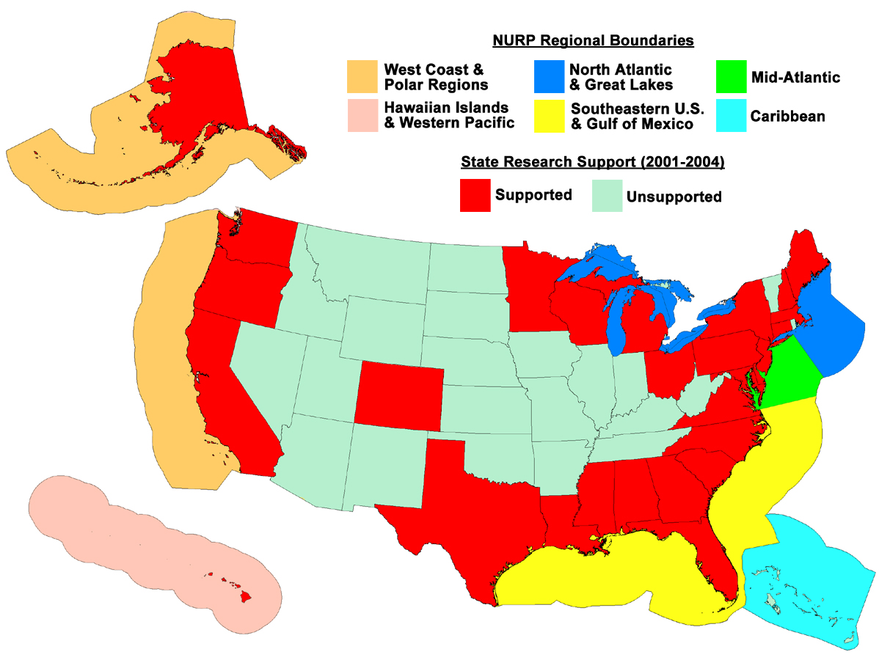

NURP Regional Network
NURP is comprised of a network of regional centers of undersea science and technology excellence located primarily at major universities. This extramural network facilitates collaborations with programs outside NOAA, leverages external funds and infrastructure and provides access to world-class expertise and students. Federal grants support six regional centers and a national technology institute that undergo periodic external review. NURP supports over 100 projects each year that involve hundreds of scientists and students from across the country. A rigorous peer-review process is used to select NURP projects based on scientific merit and relevance to NOAA and national research requirements. These projects produce peer-reviewed publications that are added to the scientific literature.
Five year summary of NURP dive operations, projects and publications.
Subs | ROVs | SCUBA | Participants | Institutions | Projects | Publications
1,063 | 1,334 | 53,461 | 4,169 | 1,041 | 539 | 516

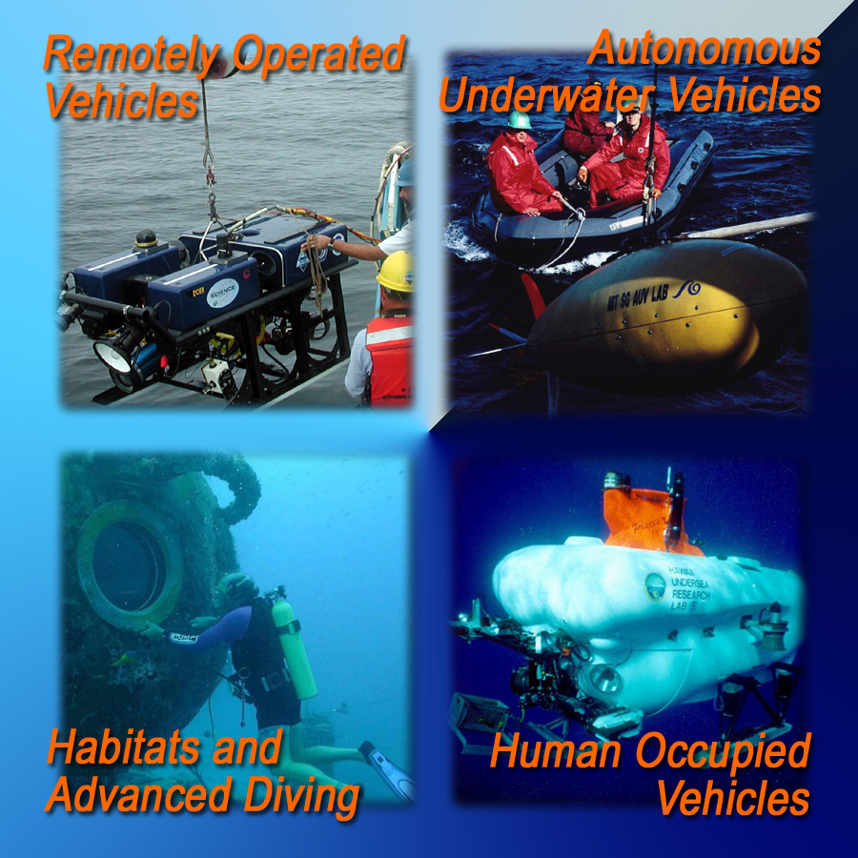
Safely Advancing Underwater Technologies
NURP has helped sustain U.S. leadership in ocean technology through development and application of advanced diving and observing technologies that enable researchers to sample and sense the ocean at wider and finer time and space scales. These include the Alvin and Pisces deep submergence vehicles; the world’s only underwater laboratory, Aquarius; the LEO-15 Observatory; remotely operated vehicles Kraken, Jason II, Ventana, and Tiburon; advanced scuba diving to 100 m; and a variety of other data gathering and mapping technologies. Over its 20 year history NURP has maintained an impeccable safety record.

NURP Research Provides Answers
Over the past 25 years, NURP has improved our fundamental understanding of marine and Great Lakes ecosystems in direct support of NOAA goals. Strategic research results include:
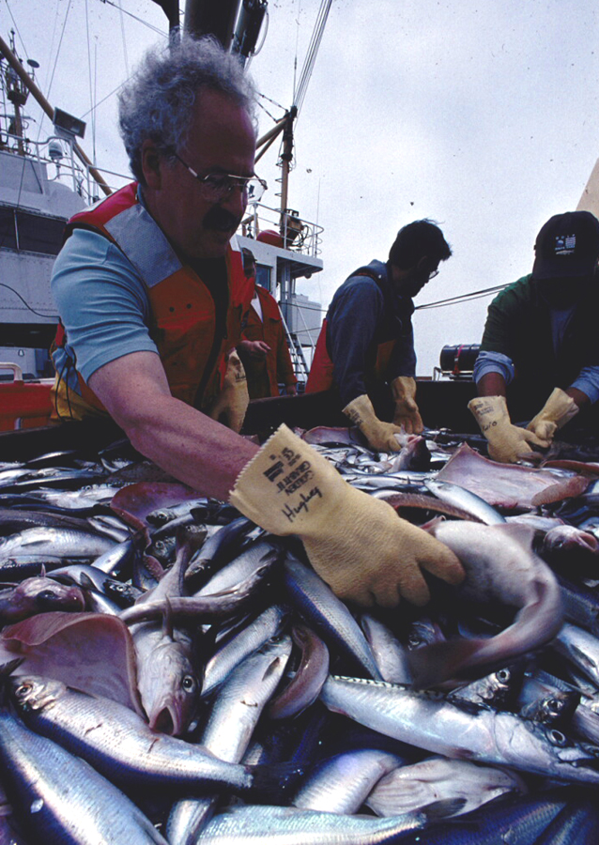
- Determined impacts of trawling and other fishing gear types on seafloor essential fish habitats—results improved fisheries management and contributed to the recent Pew Oceans report on fishing gear impacts;
- Contributed to new national effort to design and establish protected areas that will help restore fish stocks in continental shelf areas around the country;
- Defined essential fish habitat for several species of economically important finfish and shellfish—results contributed to fishery management plans for many fish stocks, especially in deep water reef systems where trawls are ineffective;
- Devised new and better (e.g., non-destructive) methods to improve stock assessments and reduce by-catch of non-target species;
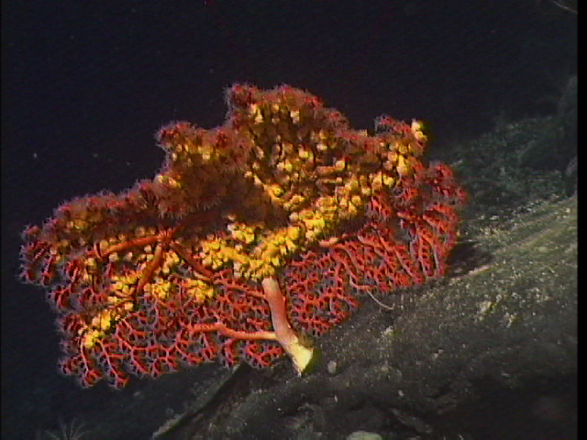
- Led the nation in ground-breaking research on factors affecting coral reef health, such as coral bleaching, water quality, over-fishing, and climate change—results helped restore and sustain healthy reef ecosystems that contribute billions annually in economic benefits;
- Supported research to better understand deep-sea corals, including their dispersal, genetics, associated fauna and fish;

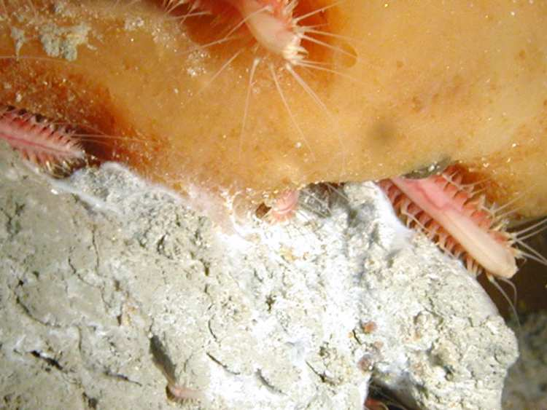
- First federal program to identify and describe frozen methane hydrates exposed at the seafloor—subsequent research has described their role as extreme ecosystems, potential future energy source, and a possible factor in abrupt climate change;
- Partnered with NSF and MMS to better understand life at deep-sea chemosynthetic communities located at seafloor vents and seeps;
- Leader in investigating coastal earthquake and tsunami hazards through investigation of submarine fault systems and undersea landslides;
- Discovered novel bio-compounds for pharmacological and other benefits to society;
- Developed innovative educational programs to provide hands-on learning opportunities for teachers and students using underwater vehicles and data from seafloor observatories.

