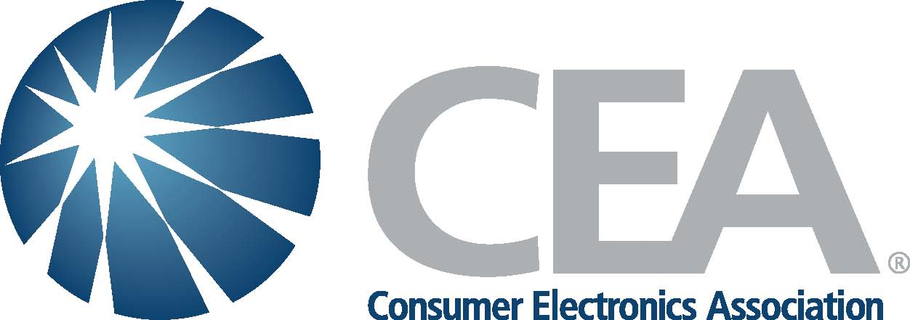





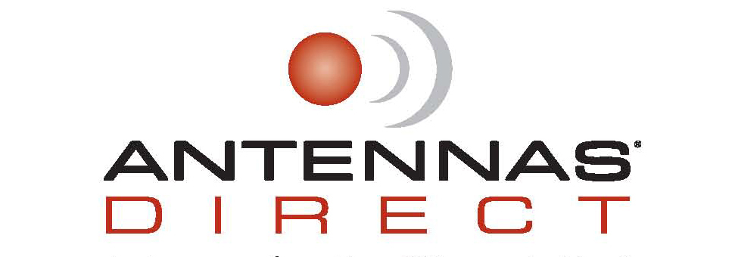




For Immediate Release

GOVERNMENT & INDUSTRY PUBLISH CONSUMER TIPS ON USE OF INDOOR ANTENNAS FOR VHF DTV RECEPTION

Washington, DC, November 19, 2009: Television broadcasters, antenna manufacturers, consumer electronics retailers and the consumer electronics industry today announced the creation of two documents to help consumers improve their over-the-air digital TV reception. Working with the Federal Communications Commission, the group’s Tip Sheet and Advisory provide information on antennas, ranging from where they should be placed to what the consumer should look for in buying a new antenna.

While the DTV transition has been a tremendous success, there are instances where viewers with an indoor antenna have been unable to receive some local over-the-air stations broadcasting on VHF channels 2-13. The two documents are based on the group’s collective experience helping consumers to resolve their particular antenna-related reception issues.

The participants represent the Association for Maximum Service Television, Inc. (MSTV), the National Association of Broadcasters (NAB), the Consumer Electronics Association (CEA), the Consumer Electronics Retailers Coalition (CERC), the Federal Communications Commission (FCC), Audiovox, Antennas Direct, Channel Master, and Winegard. The new consumer Tip Sheet and Advisory are available on the following websites:

Federal Communications Commission: www.dtv.gov
National Association of Broadcasters: (NAB): www.dtvanswers.com
Association for Maximum Service Television, Inc. (MSTV): www.mstv.org

Consumer Electronics Retailers Coalition: www.ceretailers.org
Consumer Electronics Association: www.digitaltips.org

Relying on recent data and consumer experiences, the group provides a number of tips to consumers.

- Consumers should make sure their antenna receives all the signals being broadcast in their market. In most places, consumers have both VHF channels 2-13 and UHF channels 14-51 available to them. Therefore, they must make sure their antenna receives both UHF and VHF channels.

- Consumers should move indoor antennas away from household electronics -- including the TV set -- as these devices may interfere with indoor reception. In addition, consumers experiencing reception problems are advised to experiment and reposition their antennas. Indoor antennas should be placed in or near a window, if possible.

- To help consumers, the group plans to inform consumers that the Consumer Electronics Association (CEA) has adopted performance specifications for indoor antennas. Antennas meeting or exceeding these specifications will display a logo indicating they meet these recommendations.

- The group plans on providing additional outreach to consumers and community groups.

Commenting on today’s announcement, and representing television broadcasters, David Donovan, President of the Association for Maximum Service Television, Inc. (MSTV), stated, “We are delighted to have worked cooperatively with our government and private sector partners. Informing consumers about the proper use of indoor antennas constitutes an important step in ensuring the American public can enjoy all the benefits of free, over-the-air digital television.”

“The NAB remains committed to ensuring that all Americans have continued access to free, local over-the-air broadcast television," said NAB Executive Vice President Dennis Wharton. "We are proud to partner with the FCC and our electronics industry friends to ensure that TV viewers have the needed information to continue receiving our high-quality, free programming.”

Hank Caskey, Vice President, Reception, Audiovox Accessories Corporation, an antenna manufacturer participating in the effort, stated, “Through the combined efforts of all industry participants, we will be better able to ensure that our retail partners have the appropriate antennas available in their stores for their individual markets. Indoor reception has always been challenging. Working with broadcasters, retailers and the FCC, will help us to even better serve our customers with concise, accurate and reliable information.”

Christopher McLean, Executive Director of the Consumer Electronics Retailers Coalition, noted, “Our members are anxious to help consumers optimize their television viewing experience. CERC members stock a variety of antenna, converter box and connection gear as well as an array of digital televisions to meet every budget and need. The jointly developed antenna tips will also help guide consumers to the solution that works best for them.”

Brian Markwalter, Vice President of Technology and Standards at the Consumer Electronics Association, said, “We are happy to continue our efforts with industry and government partners to help consumers enjoy the benefits of the digital television transition. Through CEA’s Digital Tips.org website and our Antennaweb partnership with NAB, we provide consumers with valuable information about the reception of free, over-the-air digital television. We are confident that referencing CEA’s indoor antenna performance requirements on packaging and materials will help consumers select the antenna that is right for them.”

The Chief of the FCC’s Media Bureau, William Lake, expressed appreciation for the work of the ad hoc group and said, “We have posted on our DTV.gov website the materials developed by this group representing broadcasters, manufacturers, and retailers working in collaboration with FCC staff. The guides for use of indoor antennas represent the best advice we have developed so far to help consumers who rely on indoor antennas to get the most out of their DTV equipment.”

For Further Information Contact:

Federal Communications Commission: Janice Wise, Janice.Wise@ FCC.gov
Consumer materials found at www.DTV.gov

Association for Maximum Service Television Inc. (MSTV): David Donovan, ddonovan@mstv.org
Consumer materials found at www.mstv.org

National Association of Broadcasters (NAB): Dennis Wharton, dwharton@nab.org
Consumer materials found at www.DTVanswers.com

Consumer Electronics Association (CEA): Jason Oxman, joxman@ce.org
Consumer materials found at www.digtaltips.org

Consumer Electronics Retailers Coalition (CERC): Chris McClean, Christopher.mclean@e.copernicus.com
Consumer materials found at www.ceretailers.org

Audiovox Accessories Corporation: Sandy Whicker, swhicker@audiovox.com
Consumer materials found at www.staytuned2tv.com

Antennas Direct: Katie Brady, Katie@kolbeco.net or Scott Kolbe, scott@kolbeco.net
Consumer materials found at www.antennasdirect.com

Channel Master: Wayne Massengill, wmassengill@channelmaster.com
Consumer materials found at www.channelmaster.com

Winegard Antenna: Hans Rabong, hrabo@winegard.com

Consumer materials found at www.winegard.com/offair/index.php

-- 30 --

