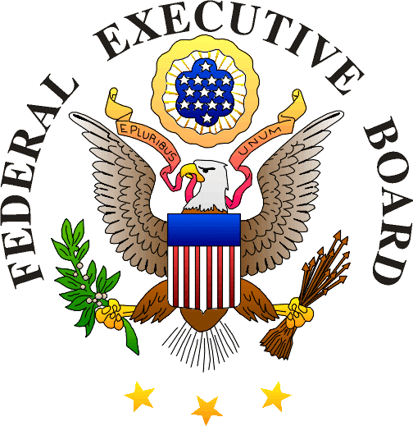

Federal Executive Board (FEB) Overview

What are the FEBs?
The Federal Executive Boards (FEBs) were created by Presidential Directive in 1961 to foster communication, coordination and collaboration among Federal field agencies. FEBs build interagency partnerships and community involvement to create and nurture working relationships that address issues of shared interest. Currently, approximately 88% of Federal employees are located outside the Washington, DC area. Across the nation, in 28 locations with a high concentration of Federal agencies and Federal employees, FEBs provide a forum for local Federal leaders to share management challenges and strategies to meet agency missions and goals, identify common issues, develop collaborative efforts to address those issues, and share best practices among their peers.

How many Agencies/Federal employees are covered by the FEBs?
Each FEB represents up to 300 Federal agencies, depending upon its geographic area of responsibility. Approximately 704,000 Federal civilian employees are served in the FEB National Network.

Who is involved in the FEB?
Each Board is made up of the highest ranking Federal leaders in each geographic area of responsibility. Members represent civilian, military, postal, and law enforcement agencies, both small and large in size.

What happens at Board meetings?
The Board meetings provide a forum for local Federal leaders to pinpoint local priorities and needs, and work together to design strategies to tackle them. Additionally, the Boards will often host experts from Federal agencies, the Presidential administration, and business or non-governmental organizations to share pertinent information with the local Federal leadership.

What do the FEBs do?
While FEB activities are dependent upon the desires of each Board and thus vary across the National Network depending upon local needs, the FEB Network delivers services in three categories of emphasis: Emergency Preparedness, Security and Employee Safety; Human Capital Readiness; and Intergovernmental and Community Initiatives.

How are FEBs involved in emergency preparedness?
FEBs increase emergency preparedness of Federal communities by facilitating planning, training, and coordination among Federal agencies to ensure continuity of operations, and assuring Federal community awareness by providing timely and accurate communication of emergency information.

How are FEBs involved in human capital readiness?
FEBs conduct outreach to inspire and educate key pools of talent needed by government; provide cost-effective services to resolve disputes and preserve working relationships through Alternative Dispute Resolution (ADR) programs; and develop the Federal workforce by providing critical training opportunities and learning experiences.

What are the benefits of the FEBs organizing trainings and programs, rather than agencies organizing their own programs?
FEBs organize and offer programs leveraging agency resources to produce maximum public value. Through active membership and coordination by Federal leaders, agencies are able to reduce duplicative efforts and achieve increased efficiencies.

How are FEBs involved in intergovernmental and community activities?
FEBs improve communications among Federal agencies within each FEB, across the nationwide FEB Network, and with headquarters’ agencies in Washington, DC. They serve as a focal point for State and local governments planning emergency response for the Federal workforce; cultivate community relations by coordinating Federal participation in local events; and support the Combined Federal Campaign (CFC) by providing Federal employees the opportunity for local charitable-giving.

What is the size of each FEB office?
Each FEB office is authorized for up to two full-time equivalent (FTE) Federal employees (Executive Director and Assistant) who manage the daily operations of the Board, including programs and activities implemented through the FEB’s Committee/Council structure.

How are the FEBs funded?
Administrative funding is provided by a voluntary host department or agency.

