Re-enabling USDA Split Disbursement

Background:
On November 24, 2008, the GovTrip split disbursement functionality for USDA was temporarily disabled to facilitate the SmartPay 2 conversion to US Bank combined with enhanced security initiatives, and the Financial Management Modernization Initiative (FMMI) Implementation.

During this time period, an interim solution was implemented associating all GovTrip expenses to a single defaulted Method of Reimbursement (MOR) of PERSONAL. It has been the employee’s personal responsibility to settle all charges made with their Government issued Charge Card (Individually Billed Account) for all expenses incurred during travel. As a safeguard, any attempt to change the defaulted MOR of PERSONAL to GOVCC (Government Charge Card) would result in a pre-audit flag identifying the expense whose MOR had been changed from the default of PERSONAL. Any expenses with MORs of GOVCC would reject in the GovTrip system, not allowing these expenses to process to FFIS or FMMI during this interim period.

Preparations to re-enable USDA Split Disbursement:
The intent of this whitepaper is to address questions and concerns about re-enabling the split disbursement process and how it will affect current and future documents processed in GovTrip.

The first change to the system with split disbursement is that all expenses will be set back to their original defaults as they were prior to November 24, 2008. For example: Currently, if a traveler uses their GOVCC to purchase Airfare in GovTrip, the MOR defaults to personal. When split disbursement is re-established, the MOR will default to GOVCC.

Every expense category has a default Method of Reimbursement established by the department. If the traveler changes the default MOR on their authorization or voucher they will receive a Pre-Audit Flag indentifying the change, however no documents will reject in the GovTrip system due to this change.

As previously discussed, it is the traveler’s responsibility to make payments to their Government Charge Card even when split disbursement is enabled in GovTrip. Please keep in mind when processing documents in GovTrip that the MOR associated to each expense on the voucher is the MOR that will process for payment to the traveler or US Bank into FFIS or FMMI. An MOR of PERSONAL will identify those expenses that should be directly disbursed to the traveler via EFT/Check in FFIS or FMMI. An MOR of GOVCC will identify those expenses that will be directly disbursed back to the traveler’s bank card with US Bank in FFIS or FMMI.

Outlined below are some “issues” that may arise with existing documents after split disbursement is enabled in the GovTrip system:

Existing Authorization-Established prior to split disbursement
When these authorizations were created, split disbursement had not been enabled, so all expenses had a default MOR of PERSONAL. Now that split disbursement has been enabled ALL MORs can be changed on the document except the reservation MORs. The MOR of the Airfare and Rental Car can be changed on the voucher, but not on the authorization once the reservation has been saved. If an MOR is changed from the established default of PERSONAL, a pre-audit flag will occur on the document for the traveler to justify. The document WILL NOT REJECT! The MORs of the expenses do not have to be changed on the authorization, but can be changed when the traveler creates their voucher.

Existing Authorization-Approved prior to split disbursement
There is no need to Amend the authorization to make changes to MORs. Just wait until the traveler creates their voucher to make direct changes.

New Authorization-Established after split disbursement enabled
All new authorizations will have the Department specified default for each expense category:
- If the traveler uses their IBA (Government Charge Card) to book Airfare Reservations the MOR will default to GOVCC.
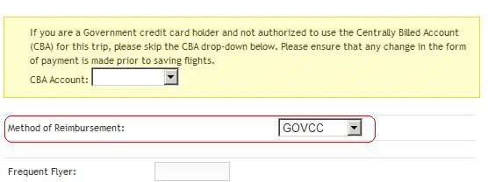
- If the traveler uses the CBA to book Airfare Reservations, the MOR will default to CBA, as it currently does now.
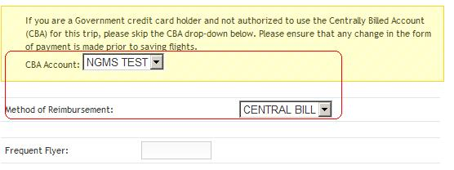
- When the traveler books Rental Car Reservations in GovTrip, the default MOR will be GOVCC.
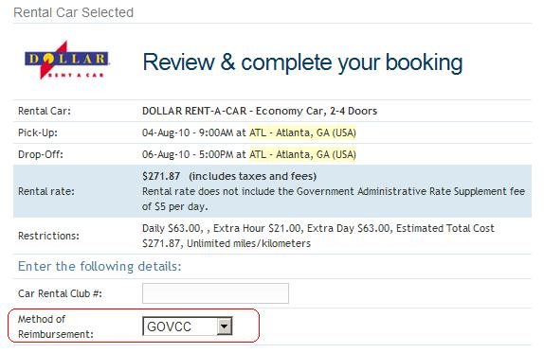
- When the traveler selects CP-Air Fare (GOVCC-I) or CR-Train Fare (GOVCC-I) under the Other Transportation screen, the MOR will default to GOVCC.
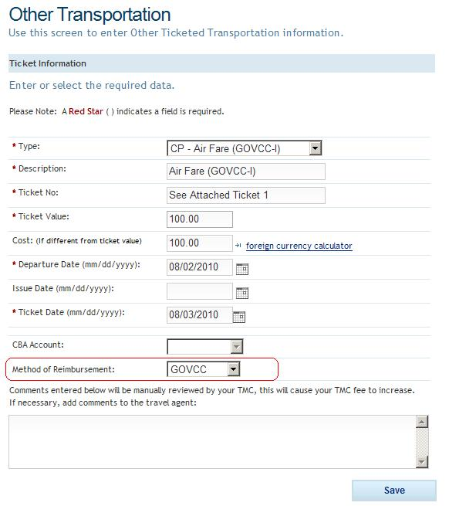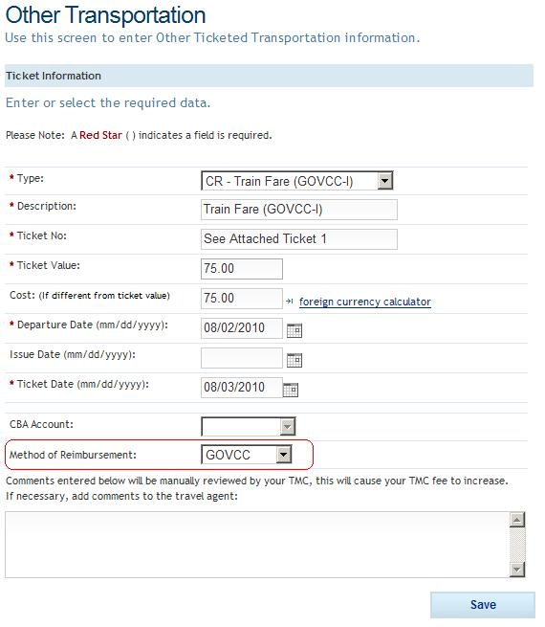
- When the traveler selects expenses, they will default according to the parameters set by the department for each individual expense category.
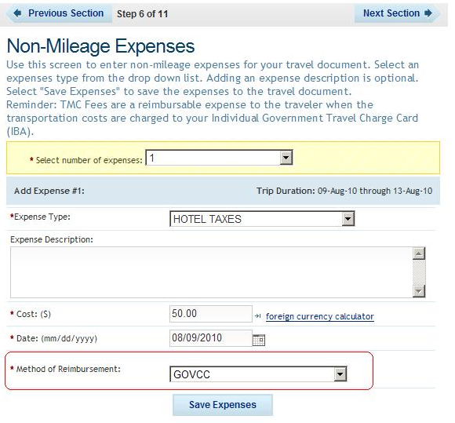
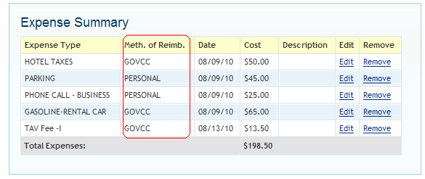
- Per Diem will automatically default to the MORs specified by the Department: GOVCC for Lodging and PERSONAL for M&IE.
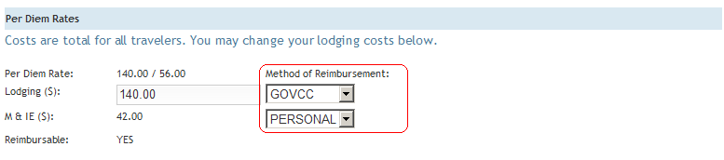
- If the traveler changes the default MOR for any expenses, GovTrip will prompt the traveler with a Pre-Audit Flag. The document WILL NOT Audit Fail when Split Disbursement is enabled if the traveler changes the default MOR.
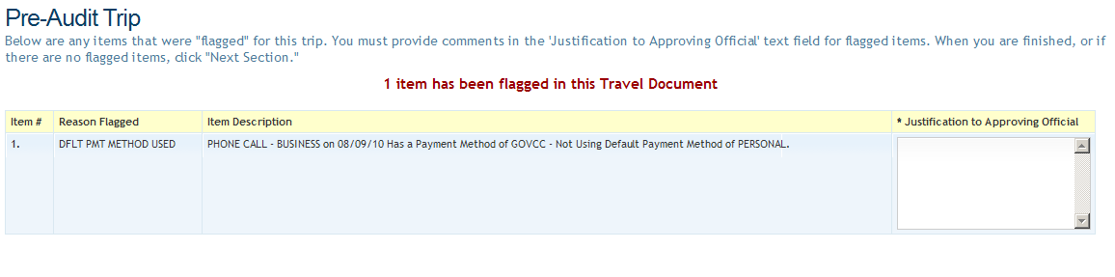

Existing Voucher-Established prior to split disbursement
Any new expenses added to the voucher will have the correct split disbursement MOR default associated to it. All expenses that transferred from the Authorization will have an MOR of PERSONAL. All MORs can be changed on the voucher to reflect proper disbursement of expenses for the traveler. If an MOR is changed the traveler will receive a pre-audit flag that will NOT cause the document to REJECT! The Payment Distribution on the Traveler’s Preview Trip Screen will reflect the totals being disbursed to the bank (all expenses with an MOR of GOVCC) and to the traveler (all expenses with an MOR of PERSONAL).
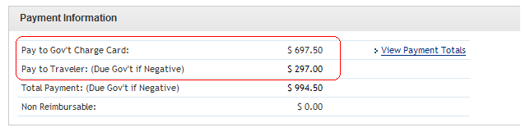
Voucher-Authorization was established prior to split disbursement
Any new expenses added to the voucher will have the correct split disbursement MOR default associated to it. All expenses that transferred from the Authorization will have an MOR of PERSONAL. All MORs can be changed on the voucher to reflect proper disbursement of expenses for the traveler. If an MOR is changed the traveler will receive a pre-audit flag that will NOT cause the document to REJECT! The Payment Distribution on the Traveler’s Preview Trip Screen will reflect the totals being disbursed to the bank (all expenses with an MOR of GOVCC) and to the traveler (all expenses with an MOR of PERSONAL).
New Voucher from New Authorization after split disbursement enabled
- If the traveler changes the default MOR for any expenses, GovTrip will prompt the traveler with a Pre-Audit Flag. The document WILL NOT Audit Fail when Split Disbursement is enabled if the traveler changes the default MOR.
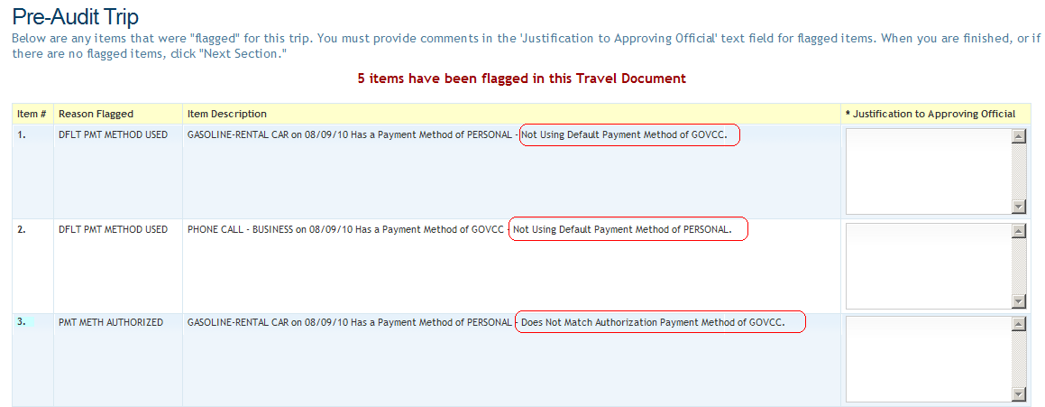
- The Payment Distribution on the Traveler’s Preview Trip Screen will reflect the totals being disbursed to the bank (all expenses with an MOR of GOVCC) and to the traveler (all expenses with an MOR of PERSONAL).
- The Payment Totals screen under Review & Sign on the Voucher will show the break down of the amount being reimbursed directly back to the traveler and the amount being sent to the bank to directly pay off the traveler’s GOVCC.
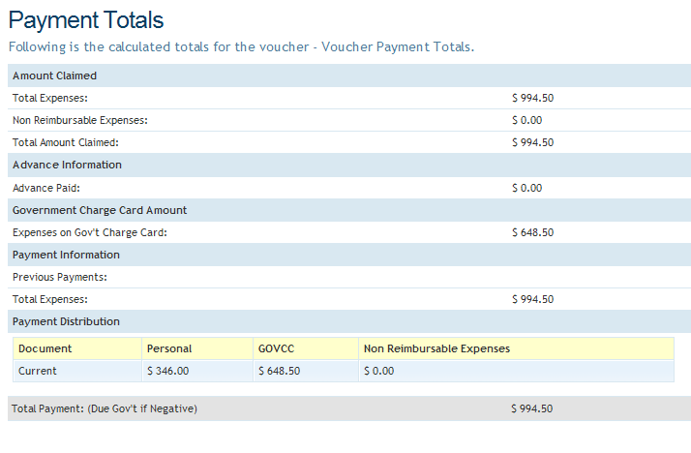

If a traveler forgets to change the MOR to GOVCC on any of their documents, there is no need to worry, the traveler will receive the reimbursement via EFT/Check and be responsible for paying off their US Bank statement when received. Once a voucher goes PAYMENT SUBMITTED in GovTrip it has processed to FFIS or FMMI for disbursement, an MOR cannot be edited once disbursed!

