How to Sign In with a Common Access Card (CAC)

- Users can now Sign In using their Common Access Card (CAC). The CAC is a Department of Defense issued smartcard used for various tasks, including user authentication, email encryption, and secure computer log-ins.
- To Sign In using a CAC you must have both the DoD Root Certificate and your CAC identity certificate installed on your workstation. These certificates are digital documents that provide the identity of a web site or an individual. If you do not have the DoD Root Certificate or your CAC certificate installed, you should contact your system administrator. If at any time during Sign In you are prompted for a missing certificate (see Figure 1) or you are requested to choose a certificate where no certificate exists (see Figure 2), contact your system administrator for assistance.
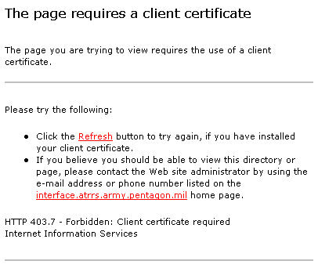
Figure 1: Missing DoD Root Certificate
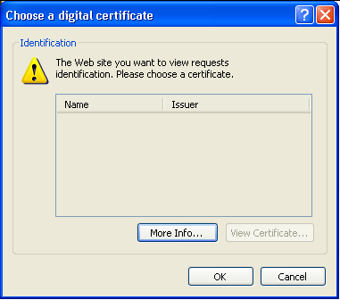
Figure 2: Missing Client Certificate

- Ensure that your CAC reader software is running on your workstation. This guide illustrates the use of ActivCard Gold, an example of CAC reader software widely used by DoD agencies. If you require assistance in setting up and installing ActivCard Gold or any other CAC reader software, contact your system administrator for assistance.
- Insert your CAC card into the reader attached to your workstation.

- Enter the home page or Sign In page of the website you wish to access.

- If a choice is offered, select CAC as your logon method.

- An alert box opens to ask for a valid digital certificate. Select your valid identity certificate from those listed in the Choose a digital certificate alert box and click OK (see Figure 3). Be aware you may have more then one certificate displayed (e.g. an Email certificate for Encryption or Signature). If you select the wrong certificate, and the system does not allow you to Sign In, you must Close your existing browser and Open a new one to be able to reselect the appropriate certificate.
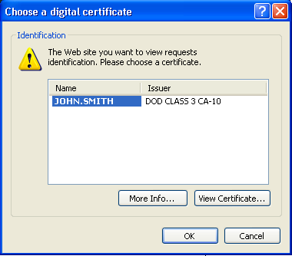
Figure 3: Choose a Digital Certificate
- The CAC Reader Software – Enter PIN dialog box opens (see Figure 4). Enter your PIN (Personal Identification Number) and click the OK button.

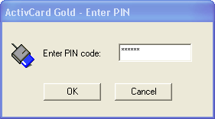
Figure 4: CAC Reader Software - Enter PIN dialog box
- You may be prompted to review your social security number and date of birth, before you are signed in to the system.

